MAROTEAUX - LAMY SYNDROME: REPORT OF TWO CASES IN SIBLINGS

Introduction:

Mucopolysaccharidosis is a rare autosomal dominant recessive inherited glycosaminoglycan storage disease caused by the deficiency of arylsulfatase., also known as N acetyl glucosaminoglycans. Maroteaux- Lamy syndrome is one of the rare mucopolysaccharidosis disorder. It takes its name from the two French doctors Maroteaux and Lamy who first described the condition in 1963 as Hurler like MPS I condition but with the preservation of intelligence and increased urinary excretion of GAG dermatan sulphate(DS)¹ . It has been estimated that about 1 in 1,300,000 births are affected by MPS VI ^{1,2}. MPS VI patients may present with a varying spectrum of clinical phenotypes. At least 3 distinct ages of onset have been differentiated a severe infantile form , characterized by early onset and rapid disease progression ;an intermediate type is characterized by onset of disease in late childhood ; and a mild or adult form demonstrates onset after second decade. Disease progression in the juvenile and adult form is typically slower than in infantile form^{3.} Affected individual usually have retarded growth ranging from 90 to 140 cm, intelligence is not affected large head, short neck,

chubby cheeks, broad nose with flat bridge and wide nostrils. The shoulders are narrow and rounded and the stomach tends to protrude. The hair on the body is coarser and more abundant than usual,and the eyebrows are bushy. Skin may become thickened and less elastic than usual. Neck is short contributing to breathing problems. Individuals with MPS VI may end up with secondary bacterial infections. Thick lips and enlarged tongue, broad alveolar ridges, widely spaced teeth with fragile enamel are some of intraoral features⁴. Individuals with the syndrome may develop heart failure and may have problem with aortic and mitral valve. General manifestations include hepatosplenomegaly, umbilical or inguinal hernia, bowel problems like diarrhea significant problems with bone formation and growth called dysostosis multiplex, spine abnormalities like kyphosis, scoliosis, joint stiffness, short and broad hands with stubby fingers. Fingers stiffen and gradually become curved due to limited joint movement giving claw like appearance. Many people with MPS VI stand and walk with their knees and hips flexed. These combined with a tight Achilles tendon may cause them to walk on their toes and sometime have knock knees. The syndrome can cause hydrocephalus. Cloudy corneas due to storage of GAG, conductive deafness and carpel tunnel syndrome due to compression of nerve^{1,2,,3}. Due to presence of multiple disease manifestations, patients with MPS VI require an integrated program of care. Surgical, medical, physical therapy can considerably alleviate symptoms of MPS VI, but do not affect the underlying cause of the disease, that is accumulation of GAG in cells and tissue. The regular degradation of GAG in the body can only be restored by therapies that are based on the replacement or delivery of the missing defective enzyme. Currently available MPS VI therapies include hematopoietic stem cells transplantation (HSCT) where ASB is delivered by transplanted donor cells and Enzyme replacement therapy (ERT) which involves infusion with recombinant enzymes ^{4,5}. Although HSCT has been shown effective in some cases, its use is limited by an increased morbidity and mortality risk and the need for healthy stem cell donors⁶.

CASE REPORT:

A 11-year male patient and female patient as a twins of normal intelligence of a consanguineous married parents came to the Outpatient Department with the chief complaint of his retained root stumps. Both were suffering from respiratory obstructive disorders and cardiac valvular disease (mitral valve) since early child hood. The girl patient had blurred vision since 4 General physical examination revealed

noisy breathing and high respiratory rate of 24 cycles/min in female patient and 27 cycles/min in ma le. Patients had distended abdomen with umbilical hernia, retarded growth (height being 142 cm of female patient and 140 cm of male patient) restricted joint movements of elbows and phalanges .Patient had spine abnormalities with droopy shoulders (Fig.1). Extraorally patients had large head, macrognathia, frontal bossing, and saddle nose with wide nostrils coarse and bushy eyebrows coarse facial hair, incompetent lips, cloudy corneas and short neck (Fig.2), (Fig.3). Intraorally patients had high arched palate with linear grooving at the center, macroglossia, fissured tongue, spacing between teeth, open bite with over retention of deciduous dentition in the female patient (Fig.4). On radiographic investigation panoramic radiographs were taken, which showed unerupted anterior teeth, incomplete root development of permanent anterior teeth, condylar aplasia, prominent gonial angle and increased follicular spaces having dentigerous cyst like appearances around uneruted molars of male patient. (Fig.5) The panoramic radiograph of female patient showed unerupted second molars, incomplete root development of lower anteriors, dentigerous cyst like follicular spaces around unerupted molars, condylar aplasia,prominent gonial angle. In consultation with pediatrician patients were diagnosed with mucopolysaccharidosis. Patients were referred by pediatrician for lab investigations for urine analysis which revealed abnormally high levels of GAG concentration in urine which was 594.7073 mg gag / g creatinine (normal= 19.97- 110.53) Enzyme assay revealed abnormally low levels of aryl sulfatase B that was 15.42 N mol./mg proton/hr( normal >120n mol/hr)which is pathgnomonic sign of MPS VI.

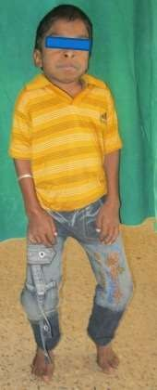
Figure 1 showing stunted growth, Bow like legs, Claw like fingers

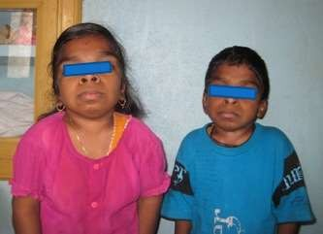
Figure 2 showing Flarred nostril, chubby cheek

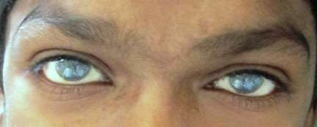

Figure 3 showing depressed nose, Frontal Bosing, Widened eyebrows

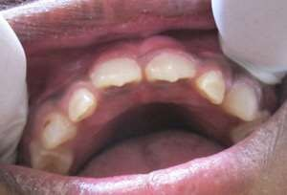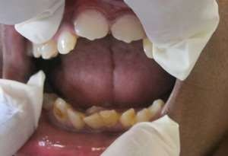

Figure 4 showing intra oral photos

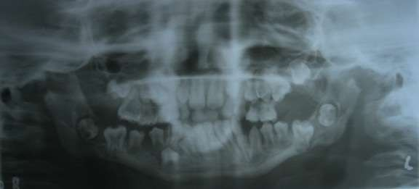

Figure 5 Demonstrating Panoramic Radiograph

Treatment plan:

- Prompt treatment of respiratory infections from pulmonologist

- Prophylaxis against infective endocarditis before any dental or surgical procedure.

- Annual checkup with the cardiologist.

Dental Care:

- Extraction of root stumps i.r.t 84

2.Preventive care: flouride application 3.Maintenance of oral hygiene 4.Regular dental check up

Discussion:

Maroteaux-Lamy syndrome is also known as mucopolysaccharidosis type VI. First described from the two French doctors Dr. Maroteaux and Dr. Lamy who described the condition in 1963 as Hurler like MPS I conditions. It is a rare autosomal recessive inherited GAG storage disease caused by the deficiency of the enzyme Aryl sulfatase B also known as N acetylglycosamine glycans. Aryl sulfatase B is enzyme required for the degradation of GAG like dermatan sulphate and chondritin-4-sulphate. Aryl sulfatase B deficiency results in the accumulation of dermatan sulphate in tissue results in their excretion in urine. The deposition of mucopolysaccharides leads to progressive disorders involving the multiple organs that results in death in the second decade of life. The estimated birth incidence of MPS VI ranges from 1 in 100,000 to 1 in 1,300,000 in various populations. Race is panethnic and it appears equally in males and females ⁷. This paper reports the classic clinical features, oral manifestations and radiographic features of the Maroteaux-Lamy syndrome. Two siblings of consanguinous parents of age 16yrs female and 11 yrs male who presented similar classical features as in other cases and similar radiographical features and oral manifestations. Systemic manifestations of the patients were similar to other cases reported. Rare radiographic features like delayed root development of erupted permanent teeth, dentigerous cyst like follicles around unerupted permanent teeth was present in the two siblings as reported in other cases⁸. Lab investigations revealed high levels of GAG concentrations in urine which was 594.7073mg gag/g creatinine. And abnormally low levels of Arylsulfatase B that was 15.42 N mol/mg protons/ hr which is pathognomonic sign of MPS VI. Patients with MPS VI require ongoing medical care from numerous subspecialist. Patients should receive pediatric care including immunizations. Tracheostomy can be performed in patients with obstructive airway disease and tonsillectomy and adenoidectomy can be performed to relieve airway obstructions. Nerve decompression is required in patients who develop carpel tunnel syndrome. Enzyme replacement therapy with

galsulfase (Naglazyme) has been shown to improve walking and stair climbing capacity and decreased urine GAG levels in patients with MPS VI. Bone marrow transplantation has been attempted in a number of patients with MPS who are at risk for neurological disease(MPS 1H).Bone marrow transplant has been limited by association with mortality risk and need for an appropriately matched donor⁵.General treatment and management include change in diet physical therapy. Change in child’s diet can ease problems such as diarrhea GIT hyperactivity. Reduced intake of milk and dairy product and sugar as well as avoiding foods with too many additives and coloring can relieve symptoms. Range of motion exercises with passive stretching and bending of the legs may offer some benefits in preserving joint function and should be started early. Pediatrician or physiotherapist may be able to suggest ways of achieving this through a combination of daily activities and passive range of motion exercises. Giving an anesthetic to an MPS VI individual requires skill and should be undertaken by an experienced anesthetist. Maroteaux- Lamy syndrome does not affect puberty and fertility. If parents already have a child with MPS VI. It’s possible to have tests during subsequent pregnancy. Both amniocentesis and chorionic villous sampling can be done to diagnose MPS VI in utero.

Conclusion:

Although Maroteaux-Lamy syndrome is considered rare, these disorders are devastating for individuals and their families and result in considerable use of resources from healthcare systems; however the magnitude of the problem is not well defined⁹.The introduction of ERT with galsulfase has been a milestone in the treatment of MPS VI patients. This therapy opens the door to a more proactive approach of managing the disease,i.e.slowing down the accumulation of GAG rather than alleviating the resulting clinical manifestations¹⁰.

References:

- Antonio Cardoso-Santos,Ana C.M.M.Azevedo,Simone Fagondes,Maria G.Burin,Roberto Giuliani,Ida V.D.Schwartz.Mucopolysaccharidosis type VI(Maroteaux- Lamy syndrome):assessment of joint mobility and grip and pinch strength, J Pediatr(Rio J).2008;84(2):130-135.
- Deepak TA,Soumya Krishna,Rangoli Taretia.Maroteaux-Lamy Syndrome:A rare case of Mucopolysaccharidosis,J.Int Oral Health 2010,vol2(issue2).
- Dirk Isbrandt, Gabriele Arlt,Doug A.Brooks, John J.Hopwood, Kurt von Figura and Christph Peters, Mucopolysacchridosis VI (Maroteaux-Lamy syndrome): Six unique Arylsulfatase B gene alleles causing variable disease phenotypes. Am J.Hum.Genet.54:454-463,1994.
- Ali Riza Alpoz, Mahmut Coker, Elif, Celen, Nazan Kocatas, Ersin, Damla Gokcen, Otto P et al. The oral manifestations of Maroteaux-Lamy syndrome (mucopolysaccharidosis VI): A case report, (Oral Surg Oral Med Oral Pathol Oral Radiol Endod 2006;101:632-7)
- Paul Harmatz, Roberto Giugliani, Ida Schwartz, Nathalie Guffon, ElisaLeao Teles,M.Clara Sa Miranda et al, Enzyme Replacement Therapy for MucopolysaccharidosisVI:A Phase 3, Randomised, double –blind,placebo-controlled, Multinational study of Recombinant Human N-Acetylgalactosamine 4 Sulfatase (Recombinant Human Arylsulfatase B or RHASB) and follow-on, open-label extension study, J Pediatr 2006;148:533-9.
- P Harmatz, W.G.Kramer, J.J.Hopwood, J.Simon, E.Butensky & S.J.Swiedler, Pharmakokinetic profile of recombinant human N-acetylgalactsamine 4-sulfatase enzyme replacement therapy in patients with mucopolysaccharidosisVI (Maroteaux-Lamy syndrome): a phaseI/II study,Acta Pediatrica,2005;94 (suppl 447):61-68.
- Rui Pinto, Carla Caseiro, Manuela Lemos, Lurdes Lopes, Augusta Fontes, Helena Ribeiro et al. Prevalence of lysosomal storage diseases in Portugal, European Journal of Human Genetics (2004) 12,87-92.

- Michael W.Roberts, Norman W.Barton, George Constantopoulos, Donald P.Butler and Agnes
H. Donahue, Bethesda, Occurrence of multiple dentigerous cysts in a patient with the Maroteaux-Lamy syndrome (mucopolysaccharidosis typeVI),Oral Surg.58:169-175,1984.
- Peter J.Meikle,John J. Hopwood, Alan E.Clague,William F.Carey.Prevalence of Lysosomal Storage Disorders,JAMA,January 20,1999-Vol281,No3.
- Harmatz,Paul.The Turkish Journal of Pediatrics,Sept 2010.

