**Breaking the outer layer of the “virus (Covid-19)” with the help of electrical stimulation and protect the Human body against virus (Covid-19) infection.**

**Dr. Mamataben Soni, Dr. Bhavinkumar Soni**

**GRAPHICAL ABSTRACT**

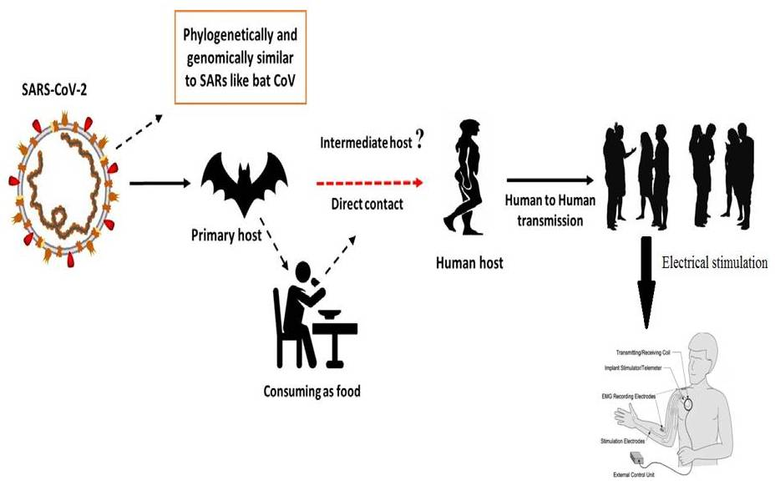

**KEY WORDS**

Electrical stimulation, Covid-19, Current, Voltage, SARS-CoV, MERS-CoV,

**INTRODUCTION**

Corona viruses are part of the Corona virus family of the order Nidovirales. The name Corona is derived from the crown-shaped spikes on the outer surface of the virus; hence the name Corona virus. Corona viruses are small (Diameter 65-125 nm) and contain a nucleocapsid of 26-32kbs (see Fig. 1). Corona viruses are divided into alpha (a) subgroup, beta (b) subgroup, gamma (c) subgroup, and delta (d) subgroup. SARS-CoV causes acute lung injury (ALI). ARDS causes acute respiratory distress syndrome (ARDS). H5N1 Influenza A causes acute respiratory distress. H1N1 2009 causes acute respiratory distress (ARDS) caused by corona virus. Middle East Respiratory Syndrome Corona virus causes acute respiratory failure (ARDS) which can lead to lung failure and death. It was thought that corona virus was primarily an animal-borne virus until 2002 when the world witnessed the world-wide outbreak of severe acute respiratory syndrome (SARS) in Guangdong (China) due to corona virus [Zhong et al., 2003]. Just 10 years later, another major corona virus, MERS-CoV, caused an outbreak in the Middle East [Wang et al., 2013].

A new coronavirus outbreak in Wuhan, China's rapidly expanding commercial hub, has claimed the lives of more than 18,500 people and infected over 70,000 in the first half of the year.The corona virus has been identified as part of the corona virus b family. Chinese researchers named the virus Wuhan corona virus or 2019 novel corona virus (2019-n Cov). The International Committee on the Taxonomy of Viruses (ICTV) has classified the corona virus as a SARS-CoV- 2 virus and the disease as a COVID-19. [Cui et al, 2019; Lai et al., 2019;WHO 2020]. SRAS-CoV has infected 8098 cases with a 9% mortality rate in 26 countries as of this writing while new corona virus (2019) has infected 120,000 cases with 2.9% mortality rate in 109 countries. The above table shows the transmission rate of SARS-Co virus is higher than that of SRAS-CoV-2 virus. This could be due to the genetic recombination of the S protein in the RBD region of SARS virus, which may have enhanced the transmission capacity of SARS CoV-2 virus.

**Figure:1.** The structure of the respiratory illness caused by the human corona virus History of the electrical stimulation therapy use in various “diseases”

One of the problems in this case relates to the use of Black Boxes and Magnetic Pulse Generators for blood electrification. They claim that these devices can treat infections like viruses, bacteria and yeast as well as diseases like cancer. These claims have a long history in scientific literature. Lyman and colleagues reported in 1990 that the delivery of 50-100 microamperes direct current through blood infected with the Aids virus inactivated the virus and stopped viral proliferation (Lyman et al., 1990). The study was published in the Journal of Apioids on 14 March 1991. The paper was presented at the 1st International Symposium (AIDS conference) on Combination Therapy in Washington, D.C.

Antibacterial have revolutionized the treatment of bacterial infections and dramatically reduced mortality due to microbial diseases over the past few decades. But because antibacterial agents have been used so much, bacteria have developed resistance to them.This poses a serious threat to the treatment options for bacterial infections (Castro et al., 2002; Silveira et al.,2006). Bacteria classified as part of the genera *enterobacter* and *staphylococcus aureus*, are prominent in the global landscape of bacterial resistance, and the drugs employed to control them are frequently ineffective, making them difficult to treat. (Martins et al.,2012).*Enterobacter* are Gram-Negative, facultative, anaerobic Bacilli. *Enterobacter* are a group of Gram-positive, anaerobic bacteria that have evolved as opportunistic infections in critical care units (CCUs) where they are able to develop β-lactam(Regli et al., 2015).

The higher the gene expression of the *Enterobacter* Amp-C, the more resistant the bacteria are to certain antibiotics (e.g., cefalozporin-resistant) and there have been reports of infections caused by bacteria that produce carbapenems (Tuon et al., 2015). *Staphylococcus aureus*, on the other hand, is “gram-positive” *cocci* Bacteria are present in the skin and nasal passages of healthy individuals; they are the most common etiological cause of skin infections because they can break down the skin barrier. *S. aureus* infections can be fatal, causing “pneumonia, meningitis, endocarditis, septicemia, and even systemic infections.” In addition, infections due to this agent are associated with high mortality and mortality rates in both inpatient and outpatient settings (Martins et al.,2012).

Because of its resistance to antibiotics, this bacterium has become one of the leading causes of hospital infections and has become a global health threat (Almeida et al., 2007; Zavadinack et al., 2001). Resistant bacteria, viruses and parasites have *S. aureus* caused a number of hospital and community-acquired infections since treatment-resistant infections were first identified in the 1950s (Barradas et al., 1997In reality, *S aureus*-induced discolored skin infections are very common practice and the emergency department are two areas of expertise in this field. (Sukumaran et al.,2016). In addition, antimicrobial drug resistance (AMDR) plays a critical role in disease epidemiology, increasing the prevalence and mortality of diseases once thought to be treatable (Barradas et al., 1997). The development of microbial resistance is critical, and the prevention of hospital- and non-hospitals-acquired infections necessitates the development of new antibacteriostatic and bactericidal agents to treat sick patientsHFE (high frequency equipment) is one of the possible solutions. HFE creates high voltage low intensity alternating current (HVLP). The electrode in HFE is either a vacuum or a gas glass electrode. The current conducts through the electrode and ionizes the air molecules, causing fluorescence.The physiological effects observed are caused by the synthesis (O3) of ozone (O2) the current produced by the spark as it flows through the electrode.The equipment also heats up by creating an electric field. Local peripheral vasodilatation improves blood flow and increases oxygenation (Martins et al.,2012;Korelo et al., 2013). Physiotherapists, Aestheticians, and Dermatologists use the device for skin treatment, anesthetic, anti-inflammatory, and most importantly, to speed up the cycle.(Martins et al.,2012;Korelo et al., 2013; Sa HP et al., 2010).

When O3 is exposed to the skin, it undergoes oxidative metabolism, resulting in the conversion of molecular oxygen (O2) to atomic oxygen (O). The mechanism of action of O3 on bacteria is based on its action on the bacterial membrane. O3 disrupts enzyme function, reduces cell permeability, and causes amino acid oxidation and nucleic acid oxidation, resulting in bacterial necrosis (Martins et al.,2012;Korelo et al., 2013; Oliveira et al., 2011). In this context, this study evaluated the bactericidal activity (HFE) of HFE in conventional strains (*S. aureus*) and strains (*E. aerogenes*) of these bacteria multiple times and at different concentrations as well as the susceptibility of this Etherapeutic Resource on these bacteria.Figure 2a illustrates the bacterial growth of *E. aerogene* after irradiation for 30 seconds, 60 seconds, 90 seconds, 120 seconds and 180 seconds at 6, 8 and 10 mA high flux fractions (HFEs). The 6 mA spark had no bactericidal effect compared to the controls. However, there was a significant decrease in bacterial growth at 8 mA at 120 and 180 seconds intervals, and at 10 mA, the reduction was confirmed at 30 seconds.However, the total inhibition of bacterial growth at the 180 second interval was only 10 mA.

At all intensities evaluated, *S. aureus* growth was severely reduced; however, no bacterial growth was seen after 120 and 180 seconds at 6 mA. When we increased the flashing intensity to 8/10 mA, the microbe growth decreased after 30 seconds (Figure 2b). This means that the more intense the irradiation, the less time the equipment takes to kill the bacteria.

|  |  |
| --- | --- |
|  |  |
| **Figure: 2a.** The antibacterial activity of high frequency equipment at different time intervals (seconds) on the growth of an average culture of *E. aerogenes.*  **Notes:** Results are presented as mean ± standard error of mean. Results are presented as a single-sided, one-way analysis of variance (ANOVA) followed by a Tukey post-hoc analysis. * p<0.05 compared to control. | **Figure: 2b.** The “antimicrobial” properties of high frequency equipment in relation to the growth of a standardized culture of *S. aureus* at various time intervals (seconds).  **Notes:** Results are presented as Mean standard ± error of mean. One-way ANOVA was used and Tukey post hoc analysis was conducted. * p0.01 vs. control. # p<0.05 vs. 6mA in 30 seconds. |

**DISCUSSION**

Electrical stimulation devices, in our opinion, have a solid basis for usage in the treatment of numerous disorders. Like cancer, AIDS, Herpes and many more. So here, we discuss that current Global epidemic covid-19 were spread on the earth. For this epidemic covid-19 we also use this method and break the outer surface of the corona virus and burst its cell. Use of this method to stop the replication of cell. In some case electrical stimulation can suppress the activity of cell.

**ACKNOWLEDGEMENT**

We will gratitude **Evellyn Claudia Wietzikoski Lovato and his team** who published research article on **“High frequency equipment promotes antibacterial effects dependent on intensity and exposure time”** its published in journal **Clinical, Cosmetic and Investigational Dermatology** in **2018**. This article helps the analysis of result in my review article.

**REFERENCES**

* Almeida, M. D. C., Simões, M., & Raddi, M. S. G. (2007). Ocorrência de infecção urinária em pacientes de um hospital universitário. *Revista de Ciências Farmacêuticas Básica e Aplicada*, 215-219.
* Barata, R. D. C. B. (1997). O desafio das doenças emergentes e a revalorização da epidemiologia descritiva. *Revista de Saúde Pública*, *31*, 531-537.
* Castro, M. S. D., Pilger, D., Ferreira, M. B. C., & Kopittke, L. (2002). Tendências na utilização de antimicrobianos em um hospital universitário, 1990-1996. *Revista de Saúde Pública*, *36*, 553-558.
* Cui, J., Li, F., & Shi, Z. L. (2019). Origin and evolution of pathogenic coronaviruses. *Nature reviews microbiology*, *17*(3), 181-192.
* Davin-Regli, A., & Pagès, J. M. (2015). Enterobacter aerogenes and Enterobacter cloacae; versatile bacterial pathogens confronting antibiotic treatment. *Frontiers in microbiology*, *6*, 392.
* de Oliveira, L. M. N. (2011). Utilização do ozônio através do aparelho de alta frequência no tratamento da úlcera por pressão. *Revista de Atenção à Saúde*, *9*(30).
* Korelo, R. I. G., Oliveira, J. J. J. D., Souza, R. S. A., Hullek, R. D. F., & Fernandes, L. C. (2013). Gerador de alta frequência como recurso para tratamento de úlceras por pressão: estudo piloto. *Fisioterapia em Movimento*, *26*, 715-724.
* Lai, C. C., Shih, T. P., Ko, W. C., Tang, H. J., & Hsueh, P. R. (2020). Severe acute respiratory syndrome coronavirus 2 (SARS-CoV-2) and coronavirus disease-2019 (COVID-19): The epidemic and the challenges. *International journal of antimicrobial agents*, *55*(3), 105924.
* Lyman, W. D., Hatch, I. R. M. W. C., & Kaali, S. C. (1991). Lab test results of HIV inactivation by electric current. Reporting inactivation of AIDS virus by electric current. In *First International Symposium on Combination Therapies*.
* Martins, A., Silva, J. T. D., Graciola, L., Fréz, A. R., Ruaro, J. A., & Marquetti, M. D. G. K. (2012). Efeito bactericida do gerador de alta frequência na cultura de Staphylococcus aureus. *Fisioterapia e Pesquisa*, *19*, 153-157.
* Sá, H. P., Nunes, H. M., do Santo, L. A. E., de Oliveira Júnior, G. C., da Silva, J. M. N., Carvalho, K. C., & dos Santos Alves, W. (2010). Estudo comparativo da ação do laser GaAlInP e do gerador de alta frequência no tratamento de feridas cutâneas em ratos: estudo experimental. *ConScientiae saúde*, *9*(3), 360-366.
* Silveira, G. P., Nome, F., Gesser, J. C., Sá, M. M., & Terenzi, H. (2006). Estratégias utilizadas no combate a resistência bacteriana. *Química Nova*, *29*, 844-855.
* Sukumaran, V., & Senanayake, S. (2016). Bacterial skin and soft tissue infections. *Australian prescriber*, *39*(5), 159.
* Tuon, F. F., Scharf, C., Rocha, J. L., Cieslinsk, J., Becker, G. N., & Arend, L. N. (2015). KPC-producing Enterobacter aerogenes infection. *Brazilian Journal of Infectious Diseases*, *19*, 324-327.
* Wang, N., Shi, X., Jiang, L., Zhang, S., Wang, D., Tong, P., ... & Wang, X. (2013). Structure of MERS-CoV spike receptor-binding domain complexed with human receptor DPP4. *Cell research*, *23*(8), 986-993.
* World Health Organization. (2020). *Laboratory testing for coronavirus disease 2019 (COVID-19) in suspected human cases: interim guidance, 2 March 2020* (No. WHO/COVID-19/laboratory/2020.4). World Health Organization.
* Zavadinack Netto, M., Herreiro, F., Bandeira, C. O. P., Ito, Y., Ciorlin, E., Saqueti, E. E., ... & Siqueira, V. L. D. (2001). Staphylococcus aureus: incidência e resistência antimicrobiana em abscessos cutâneos de origem comunitária. *Acta sci*, 709-712.
* Zhong, N. S., Zheng, B. J., Li, Y. M., Poon, L. L. M., Xie, Z. H., Chan, K. H., ... & Guan, Y. (2003). Epidemiology and cause of severe acute respiratory syndrome (SARS) in Guangdong, People's Republic of China, in February, 2003. *The Lancet*, *362*(9393), 1353-1358.