Grid Computing

M.K.Vedhasree (Author)
BCA LLB(HONS)
School Of Excellence In Law,
Chennai, India

ABSTRACT
The grid idea is inspired by a real and specific problem – the corresponding resource sharing and problem solving of dynamic, multi-institutional virtual establishment. Now, a amalgamation of technology trends and research growth results in an enlarged focus on grid technology industry and commercial domain. Know-hows have enabled the co-operative use of a extensive variety of geologically distributed resources as a single more dominant computer. Grid computing is one of the latest methods of merging resources so as to unravel large-scale complications. This chapter enlightens the concepts underlying Grid computing.

Keywords— Grid Computing, Data, Computing, Resources

- INTRODUCTION

The term “the grid” has emerged in the mid-1990s to denote a proposed distributed computing organization which emphases on large-scale resource sharing, inventive applications, and high-performance synchronization [Foster et al., 2001]., The expression "grid computing" was used as an analogy for interpreting computational power as reachable as an electricity network. Ian Foster and Steve Tuecke of University of Chicago and Carl Kesselman of the university of Southern California's Computer Science Institute collected and composed the Grid’s concepts. These three are universally considered as the "Fathers of the grid".

- GRID COMPUTING

Grid computing is the gathering up of computer resources from numerous positions or locations to achieve a mutual goal. It is a computer network wherein each individual computer’s resources can be shared with every other computer elsewhere. In grid computing the mainframe works on a assignment or tasks together, thus working as a supercomputer .We can refer to grid computing as a scattered system with a non-interactive work load that includes a wide amount of files. It is a kind of management and saleable substructure, designed as sustenance predominantly for science research. General-purpose grid network application suites are regularly used to generate grids. The magnitude of the grid may be tremendously vast. It is a class of parallel processing that uses intact devices connected to a network association (either private or public) through a traditional network connection, alike Ethernet, for explicit applications. A classic grid computing network involves three device types:
- Control node/server: A control node is a server or a set of servers that manages the whole network plus upholds the record for resources in the network world.
- Provider/grid node: A provider or grid node is a processor that donates its resources to the network resource world.
- Users: A user denotes to the computer that uses the resources scheduled in the network to finish the mission or task.

- KEY COMPONENTS IN GRID COMPUTING

1. User interface
Nowadays, users are knowledgeable with the web portals. They offer a single interface that permits the users to outlook a wide variety of data. Likewise, a grid portal compromises of interfaces that empower the operators to promote applications with resources delivered by the grid.
The interface contains a portal style that helps the operator’s queries and executes numerous purposes on the grid efficiently. A grid operator observes a single and great virtual processor contributing computing resources, likewise to internet operators who views a amalgamated instance of content on the web.

2. Security
Security is one and only of the main concerns for grid computing surroundings. Security instruments can include verification, authorization, information encryption, and others. Grid Security Infrastructure (GSI) is one of the most important components here. It summaries specifications that establishes a secret and temper proof communication among software entities functioning in a grid computing.
It comprises of OpenSSL application and offers a single sign-on mechanism for the users to achieve actions inside the grid. It deals with robust security by offering substantiation and authorization mechanisms for system defence.
3. Scheduler
On recognizing the resources, the following step is to program the tasks to run on them. A scheduler may not be required if standalone tasks are to be performed that do not display interdependencies. Nevertheless, if you want to run precise tasks alongside that require inter-process communication, the job scheduler would serve to organize the implementation of dissimilar subtasks.
Furthermore, schedulers of dissimilar levels function in a grid atmosphere. For instance, a cluster might signify an independent resource with its individual scheduler to achieve the nodes it contains. Henceforth, a high-level scheduler might occasionally be required to achieve the job done on the cluster, while the cluster works its own distinct scheduler to handle work on its separable nodes.
4. Data management
Data management is vital for griding environment. A protected and dependable mechanism to change or make any data or application element that is reachable to many nodes within the grid is essential. Consider the Globus toolkit, an open-source toolkit aimed at grid computing.
It offers a data management constituent called Grid Access To Secondary Sources [GASS]. It comprises GridFTP constructed on the standard FTP procedures and uses GSI for user verification and authorization. After verification, the user can change files by means of the GridFTP ability without going through the login procedure at each node.
5. Workload & resource administration
The job and resource constitutes the enabling the actual launch of a task on a specific resource, verifies its position, and recovers the outcomes when the task is completed. Say an operator needs to perform an application towards the grid. On that account, the application must be conscious of the accessible resources happening on the grid to commence the workload.
Therefore, it interrelates with the workload manager to control the resource obtainability and inform the status accordingly. This aids in well-organized workload and resource organization for numerous nodes on the grid.

- CLASSIFICATION OF GRID SYSTEM

1. Computational grid
It denotes to the organization of that harness machines of an managerial domain in a ‘cycle-stealing’ method to have advanced computational capacity than the capacity of any essential machine in the structure.

2. Data grid
It denotes systems which offer a hardware and software organization for producing new information from data sources that are circulated in a wide area network.

3. Service grid
It denotes to structure that deliver services that are not provided by any single local machine. This group is further alienated as on request (total resources to offer new services), and multimedia.

Figure 1: Types of Grid computing

- APPLICATIONS OF GRID COMPUTING

1. Financial services
Financial institutions use grid computing primarily to solve problems involving risk management. By harnessing the combined computing powers in the grid, they can shorten the duration of forecasting portfolio changes in volatile markets.

2. Gaming
The gaming industry uses grid computing to provide additional computational resources for game developers. The grid computing system splits large tasks, such as creating in-game designs, and allocates them to multiple machines. This results in a faster turnaround for the game developers.

3. Entertainment
Some movies have complex special effects that require a powerful computer to create. The special effects designers use grid computing to speed up the production timeline. They have grid-supported software that shares computational resources to render the special-effect graphics.

4. Engineering
Engineers use grid computing to perform simulations, create models, and analyze designs. They run specialized applications concurrently on multiple machines to process massive amounts of data. For example, engineers use grid computing to reduce the duration of a Monte Carlo simulation, a software process that uses past data to make future predictions.

- DIFFRENCE BETWEEN CLOUD AND GRID COMPUTING

S.NO | Cloud Computing | Grid Computing
1. | Cloud computing is a Client-server computing architecture. | While it is a Distributed computing architecture.
2. | Cloud computing is a centralized executive. | While grid computing is a decentralized executive.
3. | In cloud computing, resources are used in centralized pattern. | While in grid computing, resources are used in collaborative pattern.
4. | It is more flexible than grid computing. | While it is less flexible than cloud computing.
5. | In cloud computing, the users pay for the use. | While in grid computing, the users do not pay for use.
6. | Cloud computing is a high accessible service. | While grid computing is a low accessible service.
7. | It is highly scalable as compared to grid computing. | While grid computing is low scalable in comparison to cloud computing.
8. | It can be accessed through standard web protocols. | While it is accessible through grid middleware.
9. | Cloud computing is based on service-oriented. | Grid computing is based on application-oriented.
10. | Cloud computing uses service like IAAS, PAAS, SAAS. | Grid computing uses service like distributed computing, distributed pervasive, distributed information.

- HOW GRID COMPUTING WORKS

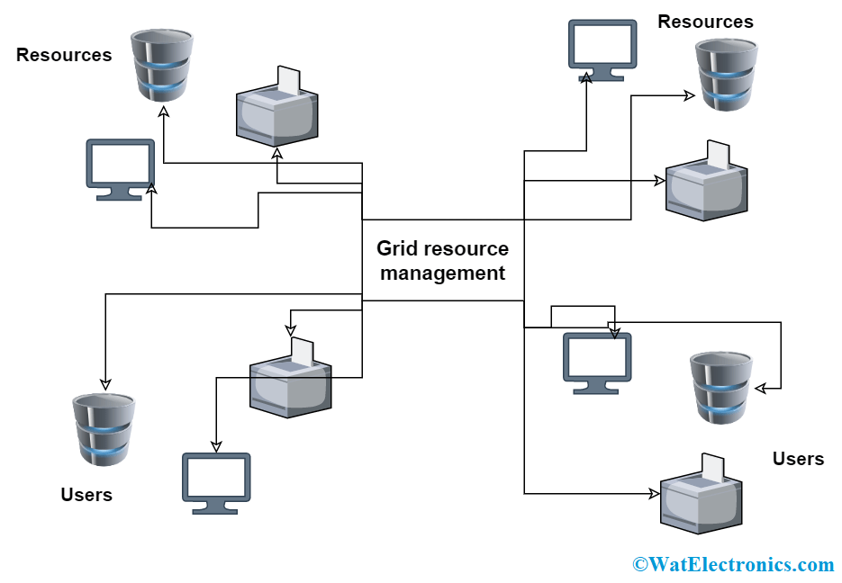
Figure 2: How Grid computing works

1.Task Submission
A user submits a computational task or job to the grid network through the control node. The task can be a complex calculation, data analysis, simulation, or other computationally intensive work.

2.Task Segmentation
The control node receives the submitted task and breaks it into smaller subtasks. These subtasks are designed to be independent and can be executed in parallel.

3.Subtask Assignment
The control node assigns each subtask to different provider nodes within the grid network. The assignment is based on resource availability, capability, and workload balancing.

4.Parallel Execution
Each provider node receives its assigned subtask and executes it in parallel with others. The provider nodes work simultaneously on their respective subtasks using their local computing resources.

5.Communication and Coordination
During the execution phase, the provider nodes communicate with each other and the control node. This communication enables them to share information about the progress of their subtasks, exchange data, and synchronize their activities.

6.Aggregation of Results
Once the provider nodes complete their subtasks, they return the results to the control node. The control node collects and aggregates these results to obtain the final output of the main task.

- BENEFITS OF GRID COMPUTING

- One of the basic uses of grid computing is to run an existing application on a different machine.
- The potential for massive parallel CPU capacity is one of the most common visions and attractive features of a grid.
- Another capability enabled by grid computing is to provide an environment for collaboration among a wider audience.
- In addition to CPU and storage resources, a grid can provide access to other resources as well.
- A grid federates a large number of resources contributed by individual machines into a large single-system image.
- High-end conventional computing systems use expensive hardware to increase reliability. The goal to virtualize the resources on the grid and more uniformly handle heterogeneous systems will create new opportunities to better manage a larger, more distributed IT infrastructure.

- STANDARDS OF GRID COMPUTING ENVIRONMENT

1.Open Grid Service Architecture (OGSA) defines requirements for these core capabilities and thus provides general reference architecture for grid computing environments.

2.Open Grid Service Infrastructure (OGSI) As grid computing has evolved it has become clear that a service-oriented architecture could provide many benefits in the implementation of a grid infrastructure. The Global Grid Forum extended the concepts defined in OGSA to define specific interfaces to various services.

3. OGSA- Data Access and Integration The OGSA-DAI (data access and integration) is concerned with building middleware to support with access and integration of data from distinct data sources through the grid.

4. GridFTP is a secure and reliable data transfer protocol providing high performance and optimized for wide area networks that have high bandwidth It uses basic Grid security on both control and data channels.

- ADVANTAGES OF GRID COMPUTING

1. It is not centralized, as there are no servers required, except the control node which is just used for controlling and not for processing.
2. Multiple heterogeneous machines i.e. machines with different Operating Systems can use a single grid computing network.
3. Tasks can be performed parallelly across various physical locations and the users don’t have to pay for them (with money).

- DISADVANTAGES OF GRID COMPUTING

- The software of the grid is still in the involution stage.
- A super-fast interconnect between computer resources is the need of the hour.
- Licensing across many servers may make it prohibitive for some applications.
- Many groups are reluctant with sharing resources.
- Trouble in the control node can come to halt in the whole network.

- CONCLUSION

Grid computing is quickly developing to perform new science and develop new applications. It is a promising trend for some reasons they are, its capability to produce more cost-effective use of a given quantity of computer resources, then as a way to solve problems that cannot be dissolve computing power, and it suggests that the resources of many computers which are not in use can be utilize for other computational task. In this we have described about grid computing and its architecture methods and standards. Grid computing offers storage capabilities and the processing power for data processing. For the grid to support big data management and processing certain requirements based on big data concept have to be considered. Although grid computing provides technology to overcome the hardware limitation in term of storage space, processing power and memory capacity, Implementation of big data processing and management using grid computing requires additional techniques for managing the huge data effectively. In future we will discuss about the issues in security of grid computing and stab to deliver specific key for the problem of security and memory storage.

REFERENCES

Mishra, M. K., Patel, Y. S., Ghosh, M., & Mund, G. B. (2017). A review and classification of grid computing systems. International Journal of Computational Intelligence Research, 13(3), 369-402.
Refrence of an article from
https://www.geeksforgeeks.org/
Frederic Magoules,”Fundamentals of Grid Computing”.
“A Review on Wireless Grid Computing” S. S. Manvi, Member, IACSIT and M. N. Birje, International Journal of Computer and Electrical Engineering, Vol. 2, No. 3, June, 2010
Article referance https://aws.amazon.com/what-is/grid-computing/

