Energy Optimization in Heterogenous Wireless Sensor Networks Using Hybrid Diffusion Clustering Scheme
Dr. Gurupriya M K C Rohit
Sr.Assistant Professor Associate Vice-President
New Horizon college of Engineering Standard Chartered Bank
Bangalore, India. Bangalore, India.
E-mail: nhcegurupriya@gmail.com E-mail:rohit.kc88@gmail.com

ABSTRACT
Heterogenous Wireless sensor network (HWSN) resolves issue of unnoticeable problems in the design of real-life application with sensors and actuators. Balancing energy efficiency at cluster head (CH) using clustering algorithm is the best outcome for extending the lifetime of network. Due to excessive energy dissipation at cluster head and border nodes cannot transmit data directly to base station (BS), as they are overlapped in more than one cluster. The existing clustering algorithm faces a complicated issue in maintaining efficiency of HWSN. Inorder to overcome the drawback of isolated CH selection and manage energy efficiency in HWSN, a brand new algorithm based on TDMA-Hybrid Diffusion Clustering Scheme (HDCS) has been proposed. Communication in TDMA-HDCS is designed between neighbour CHs without any intermediate nodes. Clusters are formed by diffusing outlying nodes from base station (BS) in hop-to-hop pattern. The parameters for CH selection include residual energy, number of neighbour nodes lying out of clusters and depth of the nodes are included in clustering phase. Intercluster and intracluster transmission of data happens in Time division multiple access (TDMA) pattern. The proposed protocol is compared with existing Diffusion Cluster Routing Protocol(DCRP),Energy Efficient Unequal Clustering( EEUC) and MOCH. The lifetime of TDMA-HDCS has been increased approximately by 75%
Keywords-Heterogenous wireless sensor networks (HWSN), Time division multiple access (TDMA), Hybrid Diffusion clustering scheme (HDCS), Intercluster, Intracluster.
- INTRODUCTION
Sensing an event in remote areas is carried out by Heterogenous Wireless sensor network (HWSN), which is composed of huge number of sensors deployed randomly in remote environment. The recorded real time information obtained from sensor nodes are transmitted to base station (BS). The main demerits of WSN include less storage, decreased processing power, low energy backup or battery and low bandwidth for communication [1]. The well-known application of WSN is in surveillance, landslide detection, habitat detection in forest areas, weather forecasting, monitoring volcano activity, identifying a target in military application, inventory systems and biomedical application [1-3]. The sensor nodes act as an event detector and packet router. The sensor nodes are deployed in victim areas to collect data and monitor specified targets. The obtained data is routed to base station (BS) or sink nodes [4-5]. Designing and implementing an energy efficient clustering protocol
In real time is a risky job with limited energy resources at sensor nodes. The long-time goal of researchers is to prolong the lifetime of a network [1,2]. S.A.Nikolidakis et al. proposed an energy efficient clustering by initiating load balancing among all sensor nodes [3].In this paper, CH is selected based on routing energy cost available at sensor nodes after transmission of data to BS. Gaussian elimination method is used to select best path to reach the BS[3].The major criteria discussed in this paper is cluster head(CH) near to BS is nominated as first level CH and CH located away from BS is elected as lower level CH. This protocol enhances energy efficiency, improves stability and increases lifetime of a network. The major drawback of this approach is there is a high chance of unanticipated breakage of stability and hence reduces network lifetime [3].
To achieve high energy efficiency and minimize internal overhead Rana and Zaveri proposed a new approach by dividing the network into several sub-clusters [6]. In this scheme the least loss energy path is chosen for the role of CH with references to nodes. Information about energy is updated on regular basis in order to make best decisions. However, in the case of scalable routing it adds extra load. The CH may be located at greater distance in some case, as a result of BS which causes an increase in energy consumption.
To assist energy management and load balancing in clustering phase, Heinzelman et al.[7] proposed homogenous WSN. This is the efficient protocol for achieving load balancing in a cluster. Each node in the cluster will get a chance to become cluster head in a particular round. The node elected as a CH will never become CH in future 1/n rounds, with probability of CH as n. A random number 0 to 1 is generated for each CH[7]. If the energy of a particular CH is less than threshold then that node is chosen as CH for that particular round. The elected CH announces its identity to other cluster members via ADV message. TDMA approach has been used in this work. Cluster members transmit data only in their reserved slot and enters into sleep state in non-transmission phase. The main demerit of this approach is residual energy is not considered for selection and rotation of CH[7].
Wang et al.[8] presented a work based on LEACH as per random approach. The calculation of death troll and consideration of residual energy from BS is obtained. Final decision is made before energy gets depleted in CH thereby, increases stability and lifetime of devices. Another alternative for LEACH protocol is designed by Heinzelman et al.[9] widely known as LEACH-C(Centralized LEACH).This protocol reduces energy efficiency for transmitting data between cluster member and cluster head. However, nodes which lie outside the cluster does not participate in communication and hence there is a data loss and overall performance of network is affected.
The variation of LEACH-C protocol is LEACH-f (fuzzy LEACH) [10]. In this approach base station (BS) offers a generated list of CH nodes to every cluster member. Nodes are elected based on the list. There are high chances that node with less power become CH, therefore network lifetime is degraded. Energy-efficient LEACH(EE-LEACH) [11] provides better PDR (packet delivery ratio) with minimum energy consumption. This approach suffers from confidentiality issues. The clustering schemes of WSNs such as P-SEP [12-14], DEBR[15],MOCH[16],DFCR[17-18].Consider that all of sensor nodes are capable of communicating with BS directly. However, the radius, transmission power and cost of sensor nodes are limited, the protocol described above must be modified to adapt to large scale multi-hop WSN. In the above-mentioned approaches, there is a probability that isolated CH may appear in clustering phase. These CH uses relay nodes for data transmission to BS.
GADA-LEACH [19] strengthens the CH selection method by using an evolutionary genetic algorithm. The relay nodes facilitate communication between cluster head and base station. The scheme proposed in [20] split the entire hierarchical network into several inner clusters. Clusters in turn divide into cell-shaped areas, where cell nodes (CNs) act as a relay node and obtain information from cluster members and forward it to cluster head (CH).
The work represented in [21] improves network reliability and lifetime of the network by using adaptive cross-layer intra-cluster scheduling as well as inter-cluster relay nodes. The scheduling is determined by the number of available data packets and source node’s energy level (SN). This helps to reduce control packet overhead by minimizing idle listening to nodes with no data to transmit.
In [17] the researchers described two distributed fault tolerant algorithm. One for clustering phase and other for routing phase. In clustering phase, cluster members select their cluster head based on cost function, distance between cluster member and cluster head, distance between cluster head and base station. If there is an isolated CH then it selects relay node with high energy and transfer via that node to BS.
By retaining k-coverage, the paper [13] identifies a number of scattered targets in the environment with a correlation between coverage nodes and sink. Nodes are split into 2 groups namely coverage nodes and communicative nodes and then they are reclassified into clustering nodes and dynamic nodes. Following that CH are chosen by considering parameters such as residual energy and distance to sink nodes. Prolong-stable election protocol(P-SEP) proposed by Paola.G et al. [12]. This protocol extends lifetime and maintains load in fog support sensor network. Fog nodes in the network are aware of their location to process information. The electoral algorithm works based on distance consumption and energy consumption. There are high chances that isolated nodes appear in infrastructure because of random distribution nodes.
Hybrid energy-efficient distributed clustering (HEED)protocol proposed by Younis and Fahmy [22]. This approach considers parameters such as residual energy, node degree and relative distance for electing CH. Fuzzy logic recalculates CH for every round in the network. There are 27 rounds of CH selection which increases energy consumption for CH selection. The above protocol is less faithful for HWSN. For an energy efficient IOT Shalli et al.[14] innovated a scheme with tiered framework.BS is positioned in higher layer for easy access of internet. Cluster members, cluster heads and relay nodes are positioned in lower layer. Communication is done through bottom-up approach. Finally a minimum energy consumption chain-based cluster co-ordinator algorithm (ME-CBCCP)[14] is executed. In a physical environment when isolated CH is about to transfer data to BS, using relay nodes it requires extra energy to forward packets. Thereby it leads to earlier death of nodes.
In addition to improve the lifespan of network and growing stability PEGASIS(Power efficient gathering in sensor information system),a chain based clustering algorithm is introduced[23].CCM(Chain cluster-based mixed)routing[24] and CCMAR(Cluster-chain mobile agent routing)[25].The foremost advantage of chain based routing protocol is to significantly increase lifetime of network and reduce energy overhead and premature death of nodes [26].For both block clustering and chain clustering ,increasing energy efficiency is major concern. S.Rani et al.[27] proposed a new protocol based on cluster head rotating election routing protocol(CHRERP).
The main benefaction of this study is summarized as follows.
1.To reduce energy overhead in sensing area, the entire heterogenous network is segmented into multiple clusters from BS in hop-by-hop pattern.
2. There is no isolated CHs in clustering algorithm and border nodes can transmit packets to BS without redundancy. We propose a brand-new algorithm Hybrid Diffusion clustering Scheme (HDCS).
3.Communication in Intercluster and Intracluster is done by Time division multiple access (TDMA) fashion.
4.Node depth and residual energy is calculated for CH selection. Shortest path is selected for data aggregation and transmission from CH to BS. HDCS guarantees low delay by maintaining minimum clusters.
The rest of this paper is organized as follows .The problem statement are given in section 2.The network organization and energy consumption model are discussed in section 3.The Hybrid diffusion clustering scheme(HDCS) is proposed and analyzed in section 4.Discussions about CH selection, energy consumption are conducted in section 5.Simulation and evaluation results of key parameters are presented in section 6.Finally conclusions are drawn out in section While future work is depicted at the end.
II.PROBLEM STATEMENT
In HWSN, the node which bridges a gap between CH and nearby CHs are called as relay nodes. The main functionality of relay nodes is to forward packet from isolated CH to BS. As represented in figure 1(a) CH1, CH2and CH3 are intact with each other whereas CH4 and CH5 are isolated CHs. They cannot forward their data packets to BS directly as they are out of coverage area.
CH4 and CH5 elect an intermediate node 2d from cluster2 and forward data packet to BS via relay node 2d. For the time being, there is no doubt that relay node can assist isolated CHs in forwarding packets to BS. However, the relay node 2d will significantly consume more energy than other nodes in order to forward these extra packets from CH4 and CH5 to BS resulting in earlier death of a node. Thereby CH4 and CH5 becomes an isolated island. Although border node improve reliability by providing multiple paths for inter-cluster communication. Large number of border nodes in same cluster can degrade overall performance of that cluster. In the figure 1(a) node 2d act as a relay node and border node. Therefore, energy level of node 2d gets depleted earlier than other nodes, resulting in extra rounds of cluster formation. The proposed clustering scheme HDCS avoids isolated CH’s and relay nodes are engaged in HWSN. Our brand-new clustering algorithm increases lifespan of the network and load is distributed evenly.
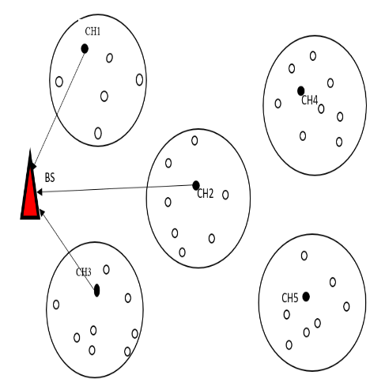
Figure. 1(a)Distribution of CH’s
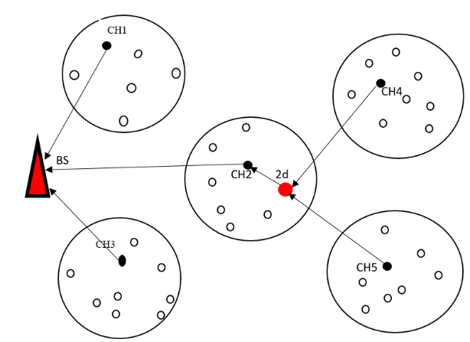
Figure. 1 (b)Selection of Relay node
III.SYSTEM MODEL
A. Network Organization
The network pattern depicted in this study is a HWSN model in which N nodes are randomly deployed MXM square area with BS. Base station has the capability to self-recharge the battery through energy harvesting mechanism.BS works continuously till death of last node in the network. The following are the assumptions about HWSN.
- All nodes in the network are immobilized and heterogenous.BS is located at centre of MXM square area.
- Initial energy of each node is expressed as E₀. Energy levels of each node is limited. Communication radius of CH is R.
- Cluster member (CM) in the cluster is identified based on unique identifier (ID). Cluster head maintains cluster table.
- BS is informed about position of every node after cluster formation. The information about ID and position of node is broadcasted through flooding mechanism in the network.
- Medium access control methods such as TDMA (Time division multiple access) is employed for simultaneous wireless transmission in allocated time slot.
B. Energy Consumption model
Since batteries have a finite amount of energy and can't be recharged, efficient energy use is the primary criterion for SN in HWSN. For computing energy dissipation at each node, the majority of researchers only use the First Order Radio Model (FORM). The primary flaw in FORM is that it only measures energy dissipation at the transmit and receive phases. FORM completely ignores energy dissipation at sensing and processing. The Hybrid First Order Radio Model (H-FORM) developed in our study resolves the FORM gap. Design factor of sensor node in our novel H-FORM approach can be considered as combination of 3 phases. (a) Sensing phase (b)operational phase(c)Transmission phase.
The total consumption of energy in a sensor node is given by following equation.
E_{SN}=E_{SP}+E_{OP}+E_{TP} (1)
Where E_{SP}, E_{OP} and E_{TP} indicates energy consumption cost of sensing, operational and transmission phases respectively. The tasks performed by sensing phase are 1) Sample the continuous-time signal 2) Analog to digital converter 3) Modulation and demodulation of signal. Energy consumption cost at sensing phase is calculated by following Boolean equation.
E_{SP}=E₀₀+E₀₁+E₁₀+E₁₁ (2)
Where E₀₀ is switching energy consumption. Sleep state indicates E₀₀ is in OFF state. E₁₀ is energy transition state from ON state to OFF state. E₀₁ is vice-versa, E₁₁ is calculated by the mathematical equation.
E₁₁=E_{SCT} +E_{ad} +E_{ms} (3)
Where E_{SCT} represents energy consumption cost due to signal sampling, E_{ad} denotes analog to digital conversion, E_{ms} indicates modulation of signal.
TABLE I. DESCRIPTION OF STATES
Value | Current state | Next state | Description
00 | 0 | 0 | NIL
01 | 0 | 1 | ON
10 | 1 | 0 | OFF
11 | 1 | 1 | ON
Operational phase is represented by "EOM," the second contributor of Equation 1. Operational module functions include sensor control, data pre-processing, and status transmission. According to our presumptions, there are three conceivable states: inactive, asleep, and awake.
E_{OM} =$\sum_{i=1}^{m}{P_{OP}^{stat}(i)}T_{OP}^{stat}$(i)+$\sum_{j=1}^{n}{χ_{OP}^{xion}}$(j) $e_{OP}^{xion}$(j) (4)
Where i=1,2,3,4…………..m is operation state of the processor and j=1,2,3……n is type of state transistion, $P_{OM}^{stat}$ denotes power consumption cost. $T_{OM}^{stat}$ represents time interval. $χ_{OM}^{xion}$ denotes state transistion frequency, $e_{OP}^{xion}$ denotes energy consumption cost.
The first order radio model serves as the source for Eqn1's third contributor, ETP. Energy is calculated as follows if a k-bit data packet is utilized for transmission over a distance d.
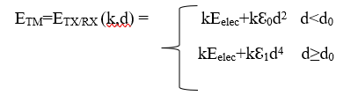 (5)
IV.DETAILS OF HDCS
In order to accurately represent our routing scheme, we propose several concepts.
a. Nodes at Level 1: Nodes in direct communication with BS.
b. Isolated CH: A CH is said to be isolated if it is outside the communication range of any adjacent neighbors.
c. Depth of CH is defined as one when a CH follows direct transmission routing to a BS.CH-two is defined as CH that transmits a data packet to BS using a single depth node.
d. Node depth: If a node wants to join a particular cluster, its depth D(i) is one plus the CH depth.e. Network Lifetime-Time until the first node exhausts its energy in the network.
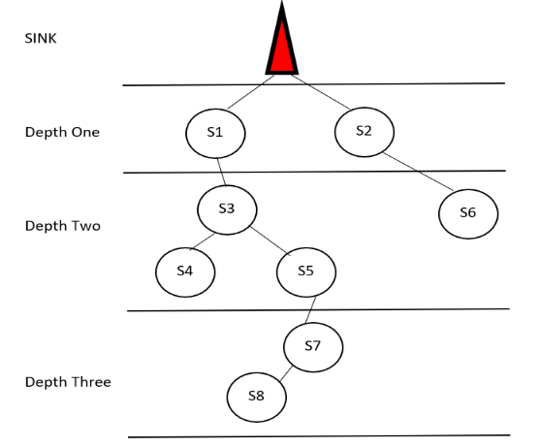
Figure 2: Depth of nodes in the network
A. Cluster Head Selection Strategy
The choice of a CH is crucial in the heterogeneous network. A sophisticated plan extends the network's lifetime and energy efficiency in HWSN. The 3 parameters for CH selection include number of neighbor nodes which do not participate in intracluster communication, residual energy and depth of any node in the network. A weight function W(k) is calculated to forecast whether or not node k can become CH.
W(k)= α $\frac{N(k)}{ Nmax}$ +β $\frac{1}{D(k)}$ +γ $\frac{E(k)}{E0}$ (6)
In equation (6), N(k) denotes number of neighbor nodes which do not participate in intracluster communication. Nmax is N(k)'s maximum value. D(k) represents the node's depth. E(k) is the node k's remaining energy.The initial energy of every node is E0.
To make the value of W(k) between 0 and 1, we let α+β+γ=1. If a node's weight is high in HDCS, there is a chance that node k will advance to the following round as a CH. If depth of a node (k) is low then node k is more likely to become CH. It is feasible for node k to transform into CH if it has more residual energy. The different ranges of α, β and γ determine the efficiency of HWSN. If α range is very small, the number of sub clusters in HWSN will be too larger. If β and λ are too small it worsens the energy efficiency of HWSN.
B. Data Packet Format
The format of packets are demonstrated in table2 and table3.Table2 depict the clustering packet and table3 illustrates data packet.
TABLE II. CLUSTERING PACKET
Type | Source ID | Destination ID | Depth | Residual energy | Neighbor nodes out of cluster
2 bits | 16 bits | 16 bits | 6 bits | 16 bits | 8 bits

TABLE III.DATA PACKET
Type | Depth | Source ID | Destination ID | Data
2 bits | 6 bits | 16 bits | 16 bits | 512 bits

In the HWSN, the multihop communication is used for clustering packet transmission from CH to BS.. Clustering packet holds 64 bits of storage and 6 fields: type, source ID, destination ID, Depth, residual energy, neighbor nodes out of cluster. Two bits are assigned for type field to differentiate type of packets:”00” denotes clustering packet and “10” denotes data packet. The source ID, Destination ID and depth of both packets are 16 bits,16 bits and 6 bits respectively. Residual energy and neighbor nodes out of cluster holds 16 bits and 8 bits. The data field in data packet uses 512 bits of storage.
C. Algorithm for Routing
The steps involved in clustering phase and data transmission phase are represented in detail.
a) Clustering Phase
Input: Cluster nodes and their ID’s in HWSN, Base station radius R.
Output: Clusters are formed with CH and W(i) of each CH is calculated.
Initialization: BS broadcasts start signal to indicate clustering phase.
if(d<R) then
Form first cluster with BS as cluster head.
CH_depth=0
else
Obtain residual energy, depth, neighbor nodes out of cluster information and transfer to BS.
Calculate W(k)=α $\frac{N(k)}{ Nmax}$ +β $\frac{1}{D(k)}$ +γ $\frac{E(k)}{E0}$
if W(k)=max
Form one depth cluster with nearby nodes.
CH_depth=CH_depth+1.
end if
Repeat the process until all cluster nodes are assigned to respective cluster.
end if
end
b) Cluster Formation and Clustering Period
The communication radius of each node is R (500 m). The coverage area of cluster is given by πR².Overall network size is 5000mX5000m. If a network holds m cluster head which means m clusters are available in the network.
T_{network}=πnR²-T_{overlap} (7)
Where the T_{overlap} is overlapping area of two clusters. T_{network} is 5000mX5000m.The intersection area of two clusters is given by.
T=2R²cos⁻¹$\left(\frac{d}{2R}\right)$-d$\sqrt{R^{2}-{(d}^{2}/4}$) (8)
Where d denotes distance of two clusters. The mathematical expectation of d [29] is given by.
E[d]=$\int_{0}^{R}{x f\left(x\right)dx}$ (9)
Where f(x)=$F^{'}\left(x\right)$ (10)
F(x)=P(x≤R) =$\frac{x^{2}}{R^{2}}$ (11)
From equations (9), (10), (11) we get E[d]=$\frac{2R}{3}$ and S≈1.83R²
T_{overlap}= S(n-1) (12)
From equations (12) and (7) we get n=85.So the number of clusters is 85.
The lifespan of HWSN depends on energy consumption of one depth nodes.
E_{per_round}=(N-m)E_{RX}(k)+kE_{elec}+kℇ₁d⁴ (13)
Where N is number of sensor nodes, m is one depth nodes in the network. Nodes near to BS receive packets from other nodes in the network. It is denoted by E_{RX}(k). In clustering phase E_{per-round-max} is 0.007210J and at transmission phase 0.06316J. The energy consumed in the network depends on sensing the data, processing, clustering and data transmission phase.500 nodes are distributed uniformly in the network. One-depth nodes are divided into 3 clusters with 5 nodes in each clusters. The initial energy of these nodes is 30J(E₀=2J). The total rounds for data transmission are 30J/0.06316J≈474 rounds. On average, the one-depth clusters in the network undergo 474/3≈158 rounds of data transmission. Any clusters which consume 20% of initial energy is defined as cluster restarting point.
c) Data Transmission phase
(1) BS broadcasts start signal to inform all nodes in HWSN that data transmission phase begins.
(2) Based on TDMA. Cluster member sense the data and transfer to CH in their respective time slot.
(3) CH transfers data in their allocated time slot to BS hop by hop.
(4) Repeat steps 2 and 3 until residual energy of node exceeds 20% of initial energy. In the above scenario data transmission phase is over and clustering phase begins.
V.SIMULATION RESULTS
500 sensor nodes are deployed randomly in square area of 5000mX5000m with BS. The major parameters of simulation are listed in Table 4.
TABLE IV. SUMMARY OF PARAMETERS
PARAMETER | VALUE
Type of Node | Heterogenous
No. of nodes | 500
Network size | 5000mX5000m
BS location | (500m,500m)
Initial energy of node E₀ | 2J
R(Communication Radius) | 500m
ℇ₀ | 10pJ/bit/m²
ℇ₁ | 0.0013pJ/bit/m⁴
A.Value of N_{max}
The max neighbor nodes out of cluster is represented by N_{max}. The simulation graph is shown in figure 4, where x-axis denotes number of clusters and y-axis represents the neighbor node out of each cluster. From the figure the value of N_{max} is 16. The mean and standard deviation of n(i) are calculated as follows.
E[n(i)] =$\frac{n\left(1\right)+n\left(2\right)+…n(74)}{74}$ ≈ 8 (14)
σ=$\sqrt{D[n\left(i\right)]}$=$\sqrt{E\{[n\left(i\right)-E{(n\left(i\right))]}^{2}\}}$=4.49 (15)

Figure 3: Maximum neighbor nodes out of cluster.
B. Performance analysis of α, β, γ
The network lifetime and delay in the HWSN is based on values of α, β, γ. On the one hand, the lower the mean number of clusters, the less energy is consumed by CHs to construct clusters, which benefits network endurance. On the other hand, the shorter the transmission delay, the lower the mean depth of CHs. The values of α, β, γ varies from 0.1 to 0.5. Several NS2 simulation investigation is carried out with different values of α,β,γ to manifest the mean number of clusters and mean depth of CHs.
In DCRP [29] the residual energy ,number of neighbor nodes, depth are considered for CH selection strategy. In DEBR, each CH holds a table where hop number and remaining energy of sensor node are updated in equal time intervals.CH which needs to transmit data will select nodes with lower hop and more residual energy for transmission. In EEUC, the cluster size optimization formation algorithm[29] is deployed with parameters such as edge of annular region ,distance between nodes and residual energy. EEUC extends network lifetime but produces isolated CH. In MOCH the energy distribution is based on optimal number of CH. The time complexity is O(N²) for above all algorithm has same time and space complexity but it prolongs network lifespan and reduce transmission delay.
TABLE V. PERFORMANCE ANALYSIS OF Α, Β, Γ
Values of α, β, γ | Mean no of clusters | Mean depth of CHs
α=0.2, β=0.4, γ=0.3 | 75.6 | 5.94
α=0.5, β=0.3, γ=0.2 | 72.8 | 6.37
α=0.4, β=0.3, γ=0.2 | 74.8 | 6.31
α=0.3, β=0.5, γ=0.2 | 77.0 | 5.96
α=0.5, β=0.2, γ=0.3 | 72.0 | 6.73
α=0.4, β=0.4, γ=0.3 | 74.8 | 6.47

Figure 4: Mean no of clusters

Figure 5: Mean depth of CHS
C. Network Lifespan
Two sets of simulation experiments N=500,700 are calculated to evaluate the network lifespan of HDCS, where results are shown in Figure 8 and 9. The horizontal axis denotes the rounds of data transmission and vertical axis represents number of one depth nodes.
BS broadcasts start signal to all nodes in the network. The nodes on receiving the signal calculate distance from BS based on Received signal strength intensity (RSSI). The clustering phase begins and one-depth cluster if formed with BS as cluster head. When there are 600 rounds of transmission the HDCS prolongs network lifespan by 75%.
TABLE VI. OVERALL NETWORK LIFETIME
Network Lifetime | 100 | 200 | 300 | 400 | 500
EEUC | 3000 | 2980 | 2400 | 1720 | 900
MOCH | 3780 | 3090 | 2500 | 1850 | 1000
DCRP | 4000 | 3340 | 2600 | 1900 | 1085
HDCS | 4400 | 3500 | 2750 | 2000 | 1300

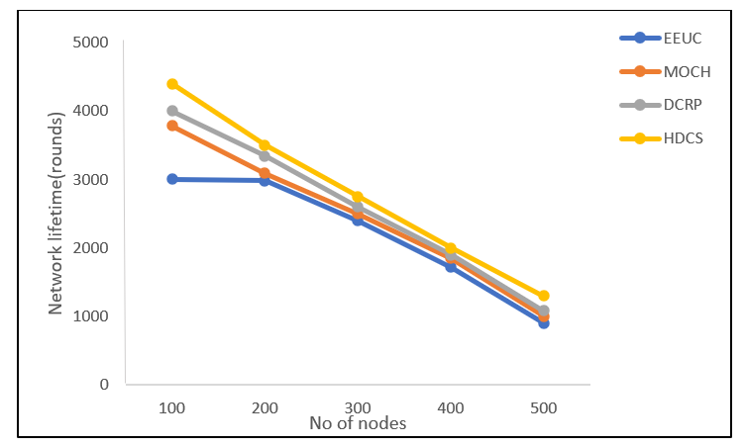
Figure 6: Overall Network lifetime
TABLE VII . NETWORK LIFESPAN (N=500)
PROTOCOL | No of one depth nodes | No of Rounds
EEUC | 14 | 450
MOCH | 14 | 325
DCRP | 14 | 425
HDCS | 14 | 486

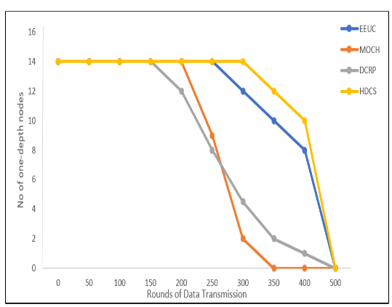
Figure 7: Network Lifespan N=500
TABLE VIII. NETWORK LIFESPAN (N=700)
PROTOCOL | No of one depth nodes | No of Rounds
EEUC | 23 | 550
MOCH | 23 | 375
DCRP | 23 | 525
HDCS | 23 | 657

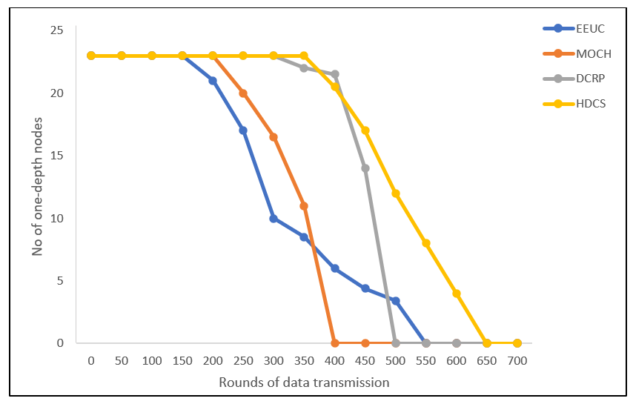
Figure 8: Network Lifespan N=700
VI.CONCLUSION AND FUTURE WORK
In proposed TDMA-HDCS, we use a new perception to create clusters, in which cluster is formed by diffusing outlying nodes from BS in hop by hop pattern. Relay nodes are not equipped in HWSN as the new CH is elected from cluster members of existing clusters. Isolated CHs can be averted because there are high chances that atleast one neighbor CM lies within the transmission radius(500m) of each Cluster head. Border nodes maintains border table to avoid redundancy data transmission. Residual energy, depth, neighbor nodes out of cluster are the parameters considered for CH selection. In transmission phase TDMA approach is used for intercluster and intracluster communication. HDCS approach balances energy dissipation and lowers transmission delay. Analysis and simulation results shows that HDCS assures no isolated CH and no redundant data transmission. The lifespan of our novel brand new HDCS is 75% compared with DCRP, EEUC, MOCH. In malicious nodes detection schemes, HDCS can be introduced to ensure neighbor node monitoring and information exchange.
REFERENCES
[1] A. A. Abbasi and M. Younis, “A survey on clustering algorithms for wireless sensor networks,” Computer Communications, vol. 30, no. 14–15, pp. 2826–2841, 2007
[2] S. V. Purkar and R. S. Deshpande, “A review on energy efficient clustering protocols of heterogeneous wireless sensor network,” International Journal of Engineering and Technology, vol. 9, no. 3, pp. 2514–2527, 2017.
[3] S. A. Nikolidakis, D. Kandris, D. D. Vergados, and C. Douligeris, “Energy efficient routing in wireless sensor networks through balanced clustering,” Algorithms, vol. 6, no. 1, pp. 29–42, 2013.
[4] Muhammad, I., Muhammad, N., Alagan, A. (2015). Wireless sensor network optimization: Multi-objective paradigm. Sensors, 15, 17572–17620.
[5] Akhtaruzzaman, M. A., Mohammad, A. R., Ishtiaque, A. (2014). Bio-mimic optimization strategies in wireless sensor networks: A survey. Sensors, 14, 299–345.
[6] K. Rana and M. Zaveri, “Synthesized cluster head selection and routing for two tier wireless sensor network,” Journal of Computer Network and Communications, vol. 2013, Article ID 578241, 11 pages, 2013.
[7] W. R. Heinzelman, A. Chandrakasan, and H. Balakrishnan, “Energy-efficient communication protocol for wireless microsensor networks,” in Proceedings of the Hawaii International Conference on System Sciences, pp. 1–10, Maui, HI, USA, January 2000
[8] M. Y. Wang, J. Ding, W. Chen, and W. Guan, “SEARCH: a stochastic election approach for heterogeneous wireless sensor networks,” IEEE Communications letters, vol. 19, no. 3,pp. 443–446, 2015
[9] W.B. Heinzelman, A.P. Chandrakasan, H. Balakrishnan, An application-specific protocol architecture for wireless microsensor networks. IEEE Trans. Wirel.Commun. 1(4), 660–670 (2002)
[10] P. Nayak, A. Devulapalli, A fuzzy logic-based clustering algorithm for WSN to extend the network lifetime. IEEE Sensors J. 16(1), 137–144 (2016)
[11] G.S. Arumugam, T. Ponnuchamy, EE-LEACH: development of energy-efficient LEACH Protocol for data gathering in WSN. EURASIP J. Wirel. Commun. Netw. 2015(1), 1–9 (2015).
[12] Paola G. N. V., Shojafar M., Mostafaei H. (2017). P-SEP: a prolong stable election routing algorithm for energy-limited heterogeneous fog-supported wireless sensor networks. The Journal of Supercomputing, 73, 733–755.
[13] Ahmadi A., Shojafar M., Hajeforosh S. F., Dehghan M. (2014). An efficient routing algorithm to preserve k-coverage in wireless sensor networks. The Journal of Supercomputing, 68, 599–623.
[14] Rani S., Talwar R., Malhotra J. (2015). A novel scheme for an energy efficient Internet of Things based on wireless sensor networks. Sensors, 15(11), 28603–28626.
[15] Lu, W. (2012). Distributed energy balancing routing algorithm in wireless sensor networks. Springer Berlin Heidelberg, 127, 227–232.
[16] Ahmed, G., Zou, J. H., Zhao, X. (2017). Markov chain model-based optimal cluster heads selection for wireless sensor networks. Sensors, 17, 440–469.
[17] Azharuddin, Md., Kuila, P., Jana, P. K. (2015). Energy efficient fault tolerant clustering and routing algorithms for wireless sensor networks. Computers and Electrical Engineering, 41, 177–190.
[18] Nayak, P., Devulapalli, A. (2016). A fuzzy logic-based clustering algorithm for WSN to extend the network lifetime. IEEE Sensors Journal, 16, 137-144.
[19] Bhatia, T., Kansal, S., Goel, S. (2016). A genetic algorithm based distance-aware routing protocol for wireless sensor networks. Computers and Electrical Engineering, 56, 441–455.
[20] Xiao, G.B., Sun, N., Lv, L.Y. (2015). An HEED-based study of cell-clustered algorithm in wireless sensor network for energy efficiency. Wireless Personal Communication, 81, 373–386.
[21] Maria, S., Tom, W., Fambirai, T. (2015). Energy Efficient medium access control protocol for clustered wireless sensor networks with adaptive cross-layer scheduling. Sensors, 15, 24026–24053.
[22] O. Younis and S. Fahmy, “HEED: a hybrid, energy-efficient, distributed clustering approach for ad-hoc sensor networks,” IEEE Transactions on Mobile Computing, vol. 3, pp. 366–379, 2004.
[23] S. Lindsey, “PEGASIS: power-efficient gathering in sensor information systems,” in Proceedings of the IEEE Aerospace Conference Proceedings, pp. 1125–1130, Big Sky, MT, USA, February 2002.
[24] H. K. Farhan, “Enhanced chain-cluster based mixed routing algorithm for wireless sensor networks,” University of Baghdad Engineering Journal, vol. 22, no. 1, pp. 103–117, 2016.
[25] S. Sasirekha and S. Swamynathan, “Cluster-chain mobile agent routing algorithm for efficient data aggregation in wireless sensor network,” Journal of Communications and Networks, vol. 19, no. 4, pp. 392–401, 2017.
[26] F. Tang, I. You, S. Guo, M. Guo, and Y. Ma, “A chain-cluster based routing algorithm for wireless sensor networks,” Journal of Intelligent Manufacturing, vol. 23, no. 4, pp. 1305–1313, 2012.
[27] S. Rani, S. H. Ahmed, J. Malhotra, and R. Talwar, “Energy efficient chain based routing protocol for underwater wireless sensor networks,” Journal of Network and Computer Applications, vol. 92, pp. 42–50, 2017
[28] Ashfaq Ahmad, Nadeem Javaid, Muhammad Imran, Mohsen Guizani, Ahmad A. Alhamed,” An advanced energy consumption model for terrestrial wireless sensor networks,” 978-1-5090-0304-4/16 ©2016 IEEE
[29] Liu Yinghong, Wu Yuanming, and Chang Jianyu,”The Diffusion Clustering Scheme and Hybrid Energy Balanced Routing Protocol (DCRP) in Multi-hop Wireless Sensor Networks,” Ad Hoc & Sensor Wireless Networks, Vol. 0, pp. 1–24 .

