TOOLS FOR DATA COLLECTION:
Ms. Muskan Thakur, Ms. Pooja, Ms. Yoshita
Akal College of Nursing, Eternal University, Baru Sahib
ABSTRACT
We have given an overview of the numerous tools utilized for different data collection methods in this chapter. Data gathering, which enables the researcher to discover answers to research questions, is one of the key phases in a research study. Data collection is the process of gathering information with the goal of learning more about the research issue. Various data kinds correspond to various data collection techniques. However, based on the type of data that will be utilized in the research, it may be difficult for researchers to choose the best type of data collecting. The purpose of this article is to offer a thorough source for data collection tools. Then, based on these categories, possible data collection strategies are described, along with the advantages and disadvantages of doing so. Comparatively to quantitative researchers, qualitative researchers prefer more flexible, less organised data collection methods. In experimental and qualitative research, participants are frequently observed directly; this is less prevalent in so-called survey research, which typically relies on self-report questionnaires. It is crucial that researchers employ resources that are trustworthy and appropriate for the target audience and the task at hand. The manuals for standardised tools include norms and reliability and validity indices. However, you might need to create your own if the characteristics and purposes for which these data are used differ from yours.
KEY TERMS: Data, Data Collection, Data Collection Tools.
INTRODUCTION
To answer specified research questions, test hypotheses, and assess results, data collection is the act of acquiring and measuring information on variables of interest in a systematic and defined manner. It is common knowledge that collecting primary data is expensive and time consuming. Observation, interviews, questionnaires, scheduling, and surveys are the basic methods for acquiring data.
The phrase "data collecting tools" describes the instruments or equipment used to collect data, such as a paper questionnaire or a system for computer-assisted interviews. Case studies, checklists, interviews, sporadic observation, surveys, and questionnaires are some of the instruments used to collect data. Quantitative research deals with numbers and statistics, whereas qualitative research concentrates on words and meanings, it allows for the systematic assessment of variables and the testing of hypotheses. Quantitative techniques allow for the systematic assessment of variables and the testing of hypotheses. Using qualitative approaches, you can explore concepts and experiences more thoroughly.
The methods mentioned above—probability sampling, interviews, questionnaire observation, and document review—are the most common and commonly used, whether gathering information offline or online, despite the fact that there are many more ways to obtain quantitative information. Mixed methods research refers to user research that uses both qualitative and quantitative methodologies. Mixed methods research blends insightful user data with practical statistics for better user insights.
TOOLS FOR DATA COLLECTION:
A research instrument is a tool used by researchers to assess public interest in their topics and to gather data.
S.NO. | TYPES OF METHODS/TECHNIQUES | TOOLS FOR DATA COLLECTION
1. | Interview | - Interview Schedule  - Opinionnaire
2. | Questioning | - Questionnaire  - Opinionnaire  - Attitude Scale/ Composite Scales (Likert Scale/ Semantic Differential Scale)  - Visual Analogue Scale
3. | Observation | - Rating Scales  - Checklists  - Anecdotes  - Videotapes/Films  - Closed Circuit TV
4. | Biophysiological Methods | - In vivo Biophysiological methods  - In vitro Biophysiological methods
5. | Other Methods | - Projectile techniques  - Q-Sorts  - Vignettes

1.INTERVIEW METHOD
DEFINITION:
The interview method is a way of gathering data in which one person (the interviewer) asks questions to another person (the respondent), either in person or over the phone
A conversation in which questions are posed by the interviewer in order gather information from the interviewee is referred to as an interview.
CHARACTERSTICS OF INTERVIEW:
- The relationship between the participants is short-term, as is the relationship between the interviewer and respondents.
- Interviewing is a method of getting verbal responses to questions that are asked verbally.
- Investigators keep informational records.
- Interviews can also be done over the phone.
- It is not a standardised method, and it is not usually restricted to a single respondent. It can be changed based on the circumstances.
BENEFITS:
- Provide comprehensive and thorough details
- Enables a deeper level of reaction
- The data from illiterate people
- Increased responses
- Make misunderstandings clear
- Pose inquiries at various depths.
Interview Formats:
1. The structured interview (interview with directions)
2. Unstructured interview (interview without direction)
3. Semi-Formal Interview
4. Detailed Interview
5. Focused group discussion
INTERVIEWING PROCESS:

ADVANTAGES OF INTERVIEWS: Finding learning about people's emotions, views, and opinions is helpful.
• It enables the asking of more in-depth queries.
• High response rates are obtained
We record the respondent's own words.
Ambiguities can be made clear.
• Questions' intentions can be made clear.
DIS ADVANTAGES: It takes a lot of time and money. High degree chances of interviews bias.

2.QUESTIONNAIRE METHOD
DEFINITION:
• A questionnaire is an organised instrument used to collect information from research subjects about their knowledge, attitudes, beliefs, and feelings. It consists of a set of questions that the researcher has prepared.
• A questionnaire is a structured self-report form that a study subject fills out using paper and a pencil.
QUESTIONNAIRE TYPES:
1. OPEN FORMAT QUESTIONS: Open ended questions are those that provide respondents the chance to express their thoughts and respond however they see fit.

Examples: Describe your friendships with your friends.
- What occurred during the meeting?
- How do I get to work?
- Why do you appear upset every time I speak with you?
- What do you hope to accomplish in five years?
1. CLOSED FORMAT QUESTIONS: In these questions, respondents are given a range of possible answers; they must select the one that most closely resembles the right response. Any question for which a researcher gives study participants options from which to select a response is referred to as a closed ended question.
Dichotomous questions: these call for a decision between two options,
such as "yes" or "no" or "male" or "female."
Example :
1. Have you ever been hospitalized?
a. Yes b. No
2. Please enter you gender:
a. Male b. Female

- Multiple choice question: these questions require respondents to make a choice between more than two responses alternatives.
Examples
1. What is the basic functional unit of the kidney?
a. Renal cortex b. Nephron c. Glomerulus d. Renal medulla

2. Who is known as Lady with the lamp?
a. Mother Teresa b. Sarojini Naidu c. Florence nightingale d. None of these

- Cafeteria questions: these are a special type of multiple-choice questions that ask respondents to select a response that most closely corresponds to their views.
Examples
Which of the following conveys your perspective on family planning given that everyone has different opinions?
a. It is essential for a good life.
b. It is immoral and has to be completely outlawed.
c. Its negative side effects indicate the need for prudence.
d. It should not be done since it is immoral.
- Rank order questions: these questions ask respondents to rank their responses from most favourable to least favourable.
Example
1. What according to you is most important for your life. Rank from most favourable to least favourable.
a. Money b. Education c. Family d. Health

- Contingency questions: A question that is asked further only if the respondent gives a particular response to previous questions.
Examples
1. Do you have children under 18 at home?
a. No b. yes, if yes please list ages

2. Did you buy anything in the hotel shop?
a. Yes b. no

3.What did you buy in the shop?
a. Clothes b. Stationery c. Other d. Toys

- Rating questions: These types of questions invite participants to evaluate an item along an order dimension. An issue is given a rating on a scale from poor to good, and respondents are asked to rank it. They might offer a variety of options.
Examples
- How do you rate the following?
Items | Very poor 1 | Poor 2 | Ok 3 | Good 4 | Very good5
Service
Cleanliness
Parking
Quality of food
Choice of food

- Importance questions: Respondents are prompted to assess the significance of a given topic on a scale of 1 to 5.
Knowing the matters or concerns that are significant to a respondent is helpful. Examples-
1 | 2 | 3 | 4 | 5
Extremely  important | Very  Important | Somewhat  important | Not very  Important | Not At all important

- Likert questions: It helps to know how strongly the respondents agrees with a particular statement. These questions help to assess how respondents feels towards a certain issues/ service.
- Person with multiple sex partners is at high risk of AIDS?
1 | 2 | 3 | 4 | 5
Strongly  Agree | Agree | Uncertain | Disagree | Strongly Disagree

- Bipolar questions: Bipolar questions are questions that have two extreme answers. Respondent has to mark his or her response between two opposite ends of the scale.
Examples
- What is your balance of preference here?
I like going for walks ( ) ( ) ( ) ( ) I like watching movie

- Matrix questions: It includes multiple questions and identical response categories are assigned. Questions are placed one under another, forming a matrix. Response categories are placed under along the top and a list of questions down the side.
Examples
- How satisfied or dissatisfied are you with each of the following attributes?
ITEMS | Very satisfied 5 | Satisfied 4 | Natural 3 | Dissatisfied 4 | Very dissatisfied 5
Staff behaviour at the reception
Food quality
Speed of service
Behaviour of the waiter
Cost of the food items
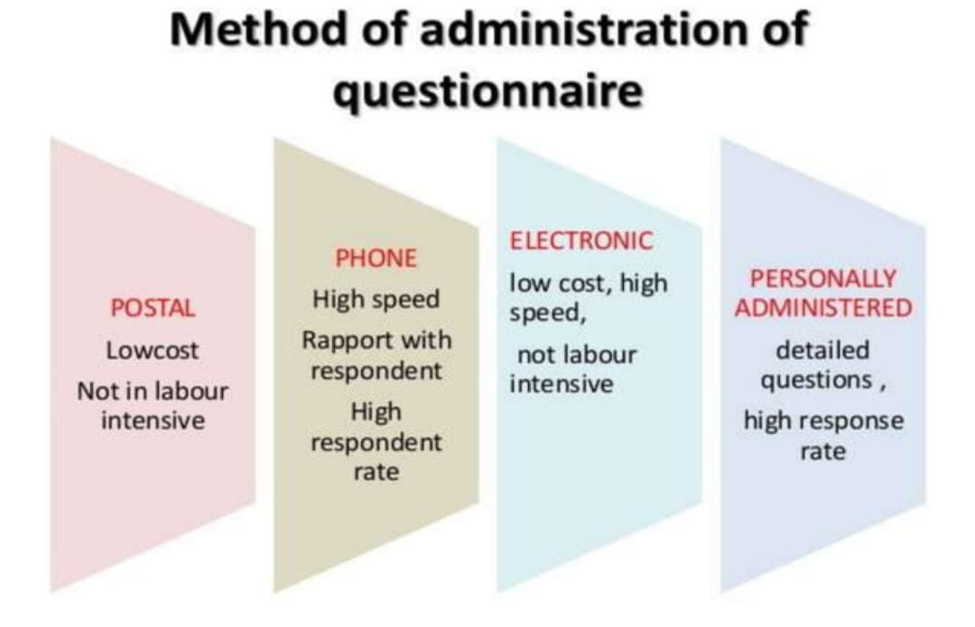
Guidelines for designing a good questionnaire: It needs to be developed precisely in line with the goals of the study. The directions for the responders to submit their responses ought to come first. The questionnaire needs to be quick, clear, and succinct. Language should reflect the respondent's understanding of a given topic. Steer clear of industry jargon. Open-ended inquiries should be avoided wherever feasible. Steer clear of questions containing complex notions. Questions that are debatable or unclear should be avoided. Questions that can cause responders to be biased should be avoided.
BENEFITS OF THE QUESTIONNAIRE:
- One, it is economical.
- Simple to analyse.
- Less effort and time required to administrate.
- Lessen bias.
- Applied to big sample sizes.
DISADVANTAGES: Not appropriate for all.
- A low rate of reaction.
- It might be completed by someone and mailed.
- It merely offers cursory information.
- Possibilities of misunderstandings.
- Lying and evasive responses are both possibilities.
COMPOSITE SCALE / ATTITUDE SCALE
DEFINITION: Composite scales are sociopsychological assessments used to quantify qualitative characteristics including feelings, attitude, self-concepts, perceptions, and beliefs, among others.
- An attitude scale is a unique kind of questionnaire created to generate results indicating the strength and direction (for/against) of a person's thoughts regarding a thing or event.
- The Likert scale was created by psychologist Rensis Likert in 1932 as a tool for measuring psychological concepts.
- It scale was created to gauge peoples' attitudes, values, and emotions.
- The original version of this scale included five possible outcomes: strongly agree, agree, uncertain, disagree, and disagree strongly
- How ever in recent times one can even observe the likert scale with 4 point scale (strongly agree, moderately agree, disagree, and uncertain) to 7 point scale (very strongly agree, strongly agree, agree, uncertain, disagree, strongly disagree and very strongly disagree).
Use of Likert scale: This scale is used to quantify the qualitative characteristics of people, such as feelings, values, and beliefs, by measuring attitudes, values, and feelings of people about specific concepts, such as situations, people, places, objects, programmes, practises, policies, and so forth. It may also be utilised to assess respondents' opinions.
Likert scale examples: •
Agreement  Question: “The checkout process was straightforward” | - Strongly Agree  - Agree  - Neither Agree nor Disagree  - Disagree  - Strongly Disagree

Likelihood  Question: “I would recommend this product to my friends” | - Very Likely  - Likely  - Neutral  - Not Likely  - Very Unlikely

Satisfaction  Question: “Please rate your satisfaction with your recent customer service experience:” | - Very Happy  - Somewhat Happy  - Neutral  - Not Very Happy  - Not at All Happy

Statement | Strongly agree | Agree | Uncertain | Disagree | Strongly Disagree
Positive statement:  Person with multiple sex partners is at high risk of AIDS | 5 | 4 | 3 | 2 | 1
Negative statement:  You can get AIDS by sharing utensils | 1 | 2 | 3 | 4 | 5
ADVANTAGES: This scale is simple to build.
- A more accurate tool for measuring psychological factors.
- Simple to administer because all respondents must do is tick boxes.
- Requires less time to administer and construct.
DISADVANTAGES
- Respondents may feel pressured to provide answers that address every pre-planned topic and each of its categories.
- Because of the researcher's preplanned categories and words, the respondents' feelings might not be adequately examined.
- The selection of the number of categories and the numerical allocation to these categories were difficult to justify.
- It takes time to establish positive attitude statements.
SEMANTIC DIFFERENTIAL SCALE
The Semantic Differential Scale is a seven-point rating system that asks respondents to choose between two bipolar adjectives (such as "warm" or "cold," "powerful" or "weak," etc.) to indicate how they feel about an object or event.
A sort of rating scale called a semantic differential scale is used to assess the connotative significance of things, events, and ideas. The respondent's attitude towards the things, events, and concepts is inferred from these connotations.
USAGE OF SEMANTIC DIFFERENTIAL SCALE - Employee surveys, customer satisfaction surveys, marketing surveys, personality assessments, and clinical psychology
The checkout process was:

Example of semantic differential scale: Assess the belief about HIV/AIDS-
Cure | 1 | 2 | 3 | 4 | 5 | 6 | 7 | Death
No punishment | 1 | 2 | 3 | 4 | 5 | 6 | 7 | Punishment
Social acceptance | 1 | 2 | 3 | 4 | 5 | 6 | 7 | Social rejection
Affordable treatment | 1 | 2 | 3 | 4 | 5 | 6 | 7 | Expensive treatment
Normal life | 1 | 2 | 3 | 4 | 5 | 6 | 7 | Miserable life
ADVANTAGES: It is a simple, easy-to-use approach for quantifying beliefs, attitudes, and values. It produces reasonable, valid, and accurate quantitative data.
DISADVANTAGES : The instrument is not standardised.
- Finding the right adjective combinations takes a lot of time.
VISUAL ANALOGUE SCALE :The Visual "Analogue" Scale is a psychometric response scale used to assess the intensity of a variety of emotions and sensations, including pain, discomfort, anxiety, sleep quality, the severity of clinical symptoms, functional ability, and attitude towards environmental conditions.
The ends of this 10 cm line indicate semantic opposites. (Alert-drowsy)
VAS is a tool that aids a person in assessing the intensity of particular feelings and sensations. A bipolar scale called the VAS is used to assess
The VAS is a bipolar scale used to determine the degree of stimuli a patient experiences. One side of the scale expresses the absence of stimuli, while the other expresses the presence of stimuli.
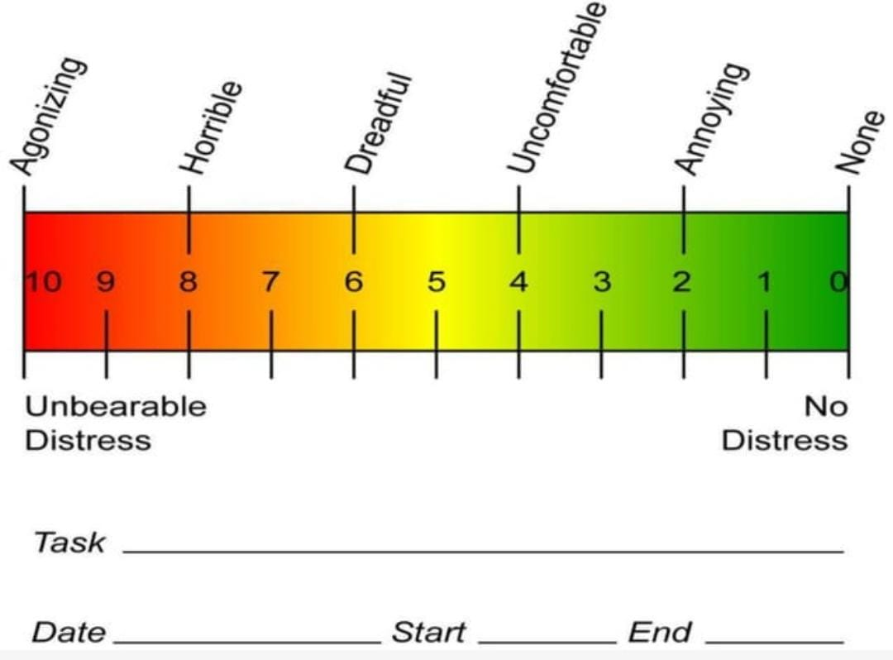
3.OBSERVATION METHOD
DEFINITION:
The Latin word "observere," which meaning "to notice," is the root of the English word "observation."Observation is a method for gathering data or learning about events that can be seen with or without the aid of mechanical instruments.The process of gathering data for a study consists of two parts: the observer (someone who is watching) and the observed (something that is being watched).
USES: To comprehend a condition or continuing activity.
- To compile information on individual behaviours or interpersonal interactions.
- to be aware of a physical environment.
- Data collecting in situations where alternative methods are impractical.

TYPES : Structured observation, first
- Free-form Observation
- Observation by a participant
- Independent Observation

STRUCTURED OBSERVATION: With this approach, the researcher creates an organised or loosely organised tool in preparation to examine the phenomenon they are studying. This makes it easier to analyse the data obtained during this technique of observation and helps researchers stay on track when doing an observation.
Checklist and rating system
Categorization system
UNSTRUCTURED OBSERVATIONS: This method, which makes use of minimally structured observations, is typically utilised in qualitative studies. It is used to fully and broadly observe phenomena that the researcher is well familiar with.
Field diary Log and field notes Anecdotes Video recording
- PARTICIPANT OBSERVATION: Fieldwork and ethnographic studies have historically been most firmly linked to participant observations, in which the observer lives or works in the field and actively takes part in current activities for an extended length of time.
- Log books
Fields notes : Field diary ,Tape ,Video recording
In this kind of observation, an effort is made to observe people without interacting with them by acting as an eavesdropper.
With this method, the observer simply observes the situations rather than taking part in them. It is common to observe someone without them being aware of it.
Additionally, the technique used here involves observing participants in their natural environments and is known as naturalistic observations. Observer bias is a challenge in naturalistic observation. For instance, a farmer may not labour naturally if he knows that a researcher is studying him; this is referred to be observer biasness. We can use some of the solutions to prevent this issue, such as
i.e.(i) Using one-way mirror: It means observer can see the participants but participants cannot see observer. (ii) Participant observation: In participant observation rather than bringing information to the participants, researcher himself can become one of the participants in the study and try to observe the participants and his activities
ADVANTAGES OF OBSERVATION METHOD: It offers direct, in-the-moment knowledge about behaviours, processes, situations, or events that are currently taking place and developing.
• Data acquired is accurate and dependable; it allows access to persons and circumstances when surveys and interviews are impractical or improper.
• It gives users access to people in real-world settings.
• It increases the accuracy of research findings.
• Researcher receives up-to-date information.

DIADVANTAGE OF THE OBSERVATION METHOD:• Hawthorne impact • Time-consuming and costly • Does not contribute to a more precise understanding of human behaviour.

OBSERVATION METHODS USED IN VARIOUS TYPES OF OBSERVATIONS:
S.NO. | CATEGORIES | OBSERVATION METHOD
1. | Narrative Observation | - Field notes  - Anecdotes
2. | Sample Observation | - Rating Scales  - Checklists  - Event sampling  - Time sampling
3. | Technology Assisted Observation | - Photographs  - CCTV/ Audiotapes/ Videography

- NARRATIVE OBSERVATION:
- FIELD NOTES:
A field note is a qualitative record of an observation made by a researcher while conducting study; it comprises descriptions and reflections of the behaviour, event, place, or person under observation. Even sketches, drawings, and diagrams could be included.
Factual information is being captured as descriptive information. includes the time and date, the location, the social and cultural context, a description of the subjects under study and their functions within the environment, and any potential environmental impacts made by the observer.

b) ANECDOTES: A concise, objective written account of a witnessed event. Anecdotes serve as a record of an event's what, when, where, how, and what was said and done.
A brief, objective, descriptive account of one occurrence or incident is known as an anecdotal record.
- SAMPLE OBSERVATION:
RATING SCALE: Rating is a phrase used to express assessment or opinion about a person, thing, circumstance, or character's performance. A rating scale is a tool that allows one person to quickly assess the performance of another. A three-point, five-point, seven-point, or more-point rating scale is possible.
RATING SCALE TYPES: 1. Graphic Rating Scale
2. A descriptive scale of ratings
3. A numerical scale of ratings
4. Comparative Scoring System
GRAPHIC RATING SCALE: The most straightforward and well-liked system for evaluating performance is the graphic rating scale. The performance is printed horizontally from lowest to highest on this scale at various times. The scale's numerical points were also presented.
The Likert Scale is a well-liked graphic evaluation system.
items | 1 | 2 | 3 | 4 | 5
To what extent staff nurse participates in clinical conference?

- DESCRIPTIVE RATING SCALE: These types of rating scale does not use number but divide the assessment into series of verbal phrases to indicate the level of performances.
Examples: Judge the level of performance of nursing personnel in medical ICU

Nursing personnel in a ward | Level of clinical performance
 | Very active | Active | Moderately active | Passive
Kiran
Tara
Jasveen
Karan

- NUMERICAL RATING SCALE:
In this scale, each statement is generally assigned a numerical score ranging from 1-10, or even more. It divides the evaluation criteria into a fixed number of points. Visual Analog Scale or a Semantic Differential Scale can be presented using a numerical rating scale.
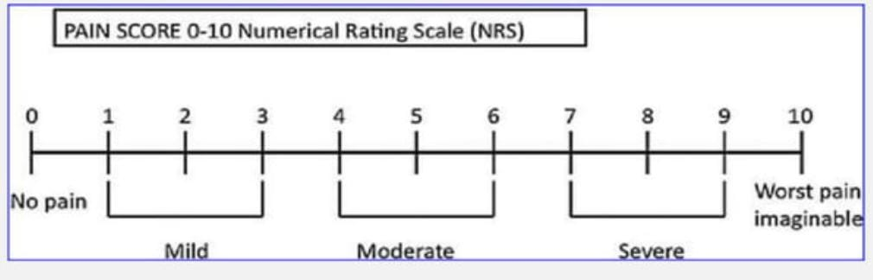
- COMPARATIVE RATING SCALE:
In this kind of rating scale, the researcher evaluates a characteristic of a person by contrasting it with a characteristic of a comparable other individual.
THE BENEFITS OF RATING SCALE:
It is used to evaluate performance and skills. It may be used for a wide range of disciplines. It is simple to administer and score. It is effective and cost-effective in terms of time and money. It helps to eliminate unreliability.
CHECK LIST:• A checklist is a straightforward tool made up of a prepared list of elements that the researcher believes to be pertinent to the issue under study. A list of things with a space to tick off or indicate yes or no makes up the checklist.
• A checklist is a list you construct to make sure you don't forget anything. It includes all the things you need to do, information you need to find out about, or items you need to carry somewhere.
CHECKLIST CHARACTERISTICS: Use only carefully crafted checklists to prevent more complex qualities; observe one respondent at a time.
The observer should receive training on what to see, how to record what they see, and how to conduct observations.
Construction of checklist: Express each item in plain, everyday words.
- The checklist's entries may be arranged alphabetically or in groups of similar items.
- When possible, stay away from negative language.

- Ensure that each item has a clear yes/no or true/false response.
- Examine each item separately.

Three Different Types of Checklists: List the steps that must be completed in order on procedural checklists. Encourage communication in organisations by using communication checklists.

Project Checklists: Compile a list of necessary tasks.
- Ex: PROCEDURAL CHECKLIST FOR HAND WASHING:
PROCEDURAL CHECKLIST FOR HAND WASHING
Sl. no. | STEPS/TASKS | 1 | 2 | 3 | 4 | 5
1. | Remove rings, bracelets and watch
2. | Get hands in clean running water, apply soap.
3. | Vigorously rub hands together in following manner: palms, fingers and web spaces
4. | Back of hands
5. | Fingers and knuckles
6. | Thumbs
7. | Fingertips and creases
8. | Wrist and forearm up to the elbow
9. | Thorough rinse hands in clean running water
10. | Dry hands using clean personal towel, paper towel, or allows to air dry.

ADVANTAGES OF CHECKLISTS:
- They are substantially less expensive to develop and can be done very quickly.
- They may have a very precise and suitable design.
- A checklist lowers the likelihood of observational mistake.
- It is helpful to gather a lot of data.
- Time is saved.
- It is helpful in assessing educational activities.
It aids in the evaluation of procedural work; • It is objective in the evaluation of qualities.
CONTRAINS OF A CHECK LIST:
• Does not identify performance quality, which limits the checklist's usefulness.
• It is very simple to leave out some crucial elements from a checklist.
CONCLUSION
Whether you are performing market research, surveys, scientific studies, or any other type of study, data collection is a crucial step in the research process. Depending on the research kind, the necessary sample size, and the resources available, several techniques and tools will be employed to collect the data. Whether you are performing scientific studies, market research, or surveys, data gathering is a crucial aspect of the research process. Depending on the research kind, the necessary sample size, and the resources available, several techniques and tools will be employed to collect the data. Surveys, observations, interviews, and focus groups are just a few of the data collection techniques. We discover that every method has benefits and drawbacks, making it crucial to select the one that best advances the intended objectives of the study. Many tools are now available thanks to the development of technology.

REFERENCES:
- DataCollectionHhs.gov: https://ori.hhs.gov/education/products/n_illinois_u/datamanagement/dctopic.html

- Simplilearn. What is collection of data? Methods, types & everything you should know [Internet]. Simplilearn.com. Simplilearn; 2021 https://www.simplilearn.com/what-is-data-collection-article

- Researchgate.net. https://www.researchgate.net/publication/359596426_Data_Collection_Methods_and_Tools_for_Research_A_Step-by-Step_Guide_to_Choose_Data_Collection_Technique_for_Academic_and_Business_Research_Projects

- Anupama.k. research methodology, IJNSPR (2017) 63–67 2016. https://www.researchgate.net/publication/343363376_Research_Methodology [accessed Jul 28 2023].

- Augustine R. Tools and methods of data collection. In: Nursing Research. Jaypee Brothers Medical Publishers (P) Ltd.; 2016. p. 108–108.

- Tools of data collection [Internet]. Slideshare.net. [cited 2023 Jul 27]. Available from: https://www.slideshare.net/sgisave/tools-of-data-collection

