MICROBIOLOGICAL ASSESSMENT OF SOME GROUND AND SURFACE WATER SAMPLES IN AND AROUND SCIENCE BLOCK, RANCHI WOMEN’S COLLEGE, RANCHI

Soma Roy*
Renuka Singh**
*Assistant Prof. Department of Biotechnology Ranchi Women’s College,
**Msc( Biotehnology), Ranchi Women’s College

INTRODUCTION
The importance of potable (drinking) water supplies cannot be over emphasized. With the increasing population and industrialization, water sources available for consumption and recreation have been adulterated with the industrial as well as animal and human wastes. Water is regarded as polluted when it changes in its quality or composition directly or indirectly.

The coliform group of bacteria includes all the aerobic and faculatative anaerobic ,gram negative,non-sporulating bacilli that ferment lactose with the acid and gas formation within 48 hours at 37°C are major indicators of water pollution.

Presence of coliforms and other pathogens in treated drinking water may be due to ineffective or poor application of water treatment techniques .As coliforms are the indicators of bacterial contamination their presence indicates fecal contamination of waterwhich may account for the severe water borne fatal diseases like chloera ,hepatitis and typhoid.
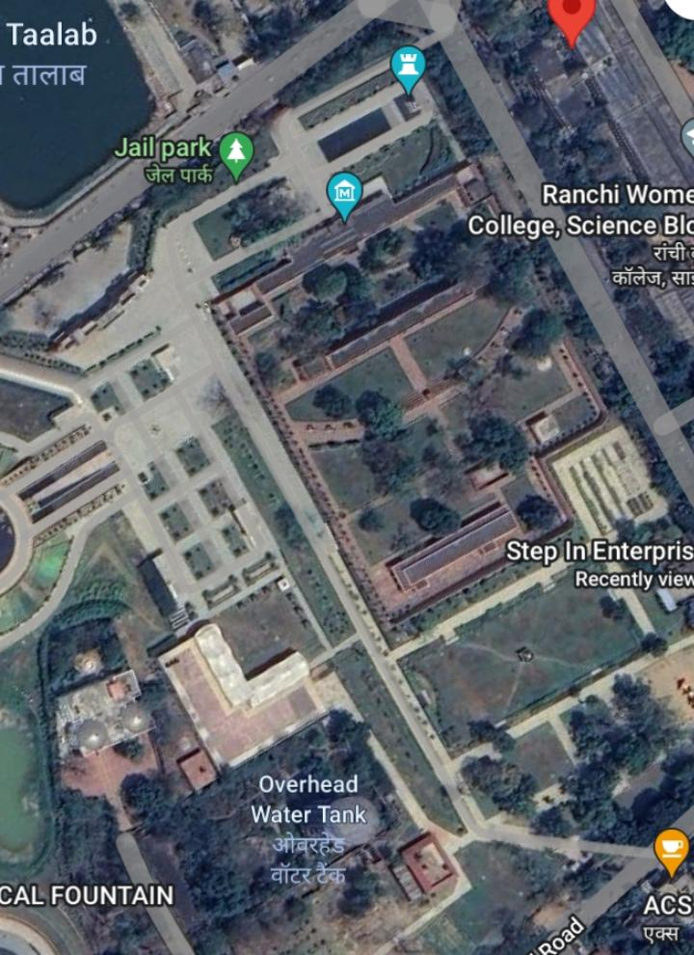
Study Area: Study area is situated at Nagra toli, Ranchi, Jharkhand, India. I have selected sampling location from Nagra toli and science block, Ranchi Women’s College which is situated in 85º 18ʹ41ʺ E and 23º 16ʹ40ʺ N.

Collection of water sample

Samples of ground water and surface water were collected monthly during the period March 2023 to May 2023 from different places in Nagra Toli and science block , Ranchi Women’s College in sterile plastic container for bacteriological analysis of these water samples during above given period.

The details of samples collected from different sources as follows: Table 1
SERIAL NUMBER | LOCATION | SOURCE
1 | Overhead water tank  Ahirtoli | Surface water
2 | Sintex plastic tank  Nagra tolli | Surface water
3 | Tap water  Nagra tolli | Surface water
4 | Pond  Jail more | Surface water
5 | Public well  Albert Ekka chowk | Ground water
6 | Handpump  Science block | Ground water
7 | Deep boring  BIT mesra | Ground water
8 | Deep boring  Lalpur | Ground water
9 | Packaged drinking water | Surface water
10 | Public well  Annapurna chowk | Ground water

All the samples were collected in sterilized bottles and were stored at 4°C till further investigation.
The water samples were labeled with date, time and source of sample . The samples were transported and analyzed within 24 hours.

Microbiological test

Colony Count Total viable count was carried out using the pour plate technique according to described by Harrigan and MacCance (1976).

10 ml of each sample was transferred to 90 ml of sterile diluent, as a first dilution 10-1 , serial dilutions were made up to 10-6 and 1 ml of each dilution was transferred aseptically in duplicate into sterile Petridishes.

10-15 ml melted plate count agar (45-46°C) was poured into the dishes.

The dishes were then thoroughly mixed to facilitate distribution of the sample throughout the medium, the medium was allowed to solidify and plates were incubated at 37°C for 48 hours.

Colony counter were used for the determination of the total bacterial counts in terms of colony forming units per ml (c.f.u. /ml)

MEDIA
- Lactose fermentation broth 1X and 2X (pH 6.9)

Beef Extract - 3.0
Peptone - 5.0
Lactose -5.0
Distilled water - 1000ml
For 2X broth twice the concentration of the ingredients were used.
- EOSIN METHYLENE BLUE (EMB) AGAR (pH 7.2)

Peptone - 10.0
Lactose - 5.0
Dipotassium phosphate – 2.0
Agar - 13.5
Eosin – 0.4
Methylene blue – 0.065
Distilled water - 1000ml
REAGENT
- Azide Dextrose Broth
- Selenite-F Broth
- Malachite green
- Hugh and Liefson’s medium
Stain : Gram staining and endospore Staining.

FOR TESTING YEAST AND MOULD :

Using pour plate method, potato dextrose agar was used for detection of yeast /moulds, using the serial dilutions from each sample .To increase the media acidity, 10% of tartaric acid was added during the pouring of the media in the plates. 0.1 ml from each dilution was taken; incubation was carried out at 28°C for 72 hours.

Preparation of potato infusion
Steps involved in potato infusion preparation
1. 200 gm of potato for 1L of PDA media preparation was taken.
2. Wash the potato to remove dirt.
3. Peel off the skin and dice them. The pieces to 1L of distilled water were added.
4.Boil for 20-25 min on a hot plate.
5.Collect the extract through the muslin cloth.

The preparation of the media by using the above raw materials is rather tedious. Hence in recent times, the infused form of potato is being replaced with commercially available potato starch/extract powder.
4 gm of the potato extract powder is equivalent to 200 gm of potato infusion.

Reagents
Along with the reagents mentioned in the table
1N KOH
1N HCl

Instruments and other requirements
Glass beaker
Conical Flask / Erlenmeyer Flask Spatula
Measuring Cylinder
pH meter
Weighing balance
Distilled Water
Butter Paper
Magnetic stirrer and pellet
Pipettes and tips
Petri plates and/or test tubes
Hot plate

Procedure :

- Iingredients were weighed separately with respect to the volume of the media. (Here, we are considering 1L of the media).

- Ingredients were suspended with potato infusion (200 gm) or potato extract (4 gm) and glucose (a.k.a dextrose) 20 gm in a glass beaker containing about 900mL of ddH2O.

- Components were dissolved in the beaker using a magnetic stirrer. (Heat may be applied to dissolve the medium completely).

- pH were adjusted of the medium to 5.6 using 0.1N HCl and 0.1N KOH.

- The broth were adjusted to a final volume of 1L using ddH2O.

- Broth were transferred to conical flask or aliquot into smaller volumes.

- Agar were added accordingly with respect to the volume of the media (i.e., 15 gms agar for 1L of the media., 3.75 gm for 250 ml).

- Closed the mouth of the flask with a cotton plug. Seal it further with paper and rubber band.

- Autoclaved for 20 min at 15.
Mix well and poured into sterile Petri plates or tubes for slant.

Fecal streptococci test:

Azide dextrose broth was used for the enumeration of fecal streptococcus. The tubes were incubated at 35°C and checked for turbidity after 48-72 hours, from dilutions 10⁻¹ , 10⁻² , 10⁻³from each dilution 3 tubes were prepared, and then results were recorded and compared with the most probable number table.

Medium preparation:

34.7 grams of dehydrated culture medium to 1 litre of distilled water was added . Mix thoroughly to completely dissolve the medium. Autoclave it for 15 minutes at 121°C.

Quality specifications:

1. The powder is homogeneous, free flowing cream to light beige
2. Ready to use medium: brilliant to clear, yellow to gold

Microbiological response at 37 °C after 18-48 hours incubation:

Organism Result

Escherichia coli inhibited
Enterococcus faecalis growth
Staphylococcus aures inhibited

Storage:

Store the sealed bottle containing the dehydrated medium at 2 to 30°C. Once opened and recapped, place the container in a low humidity environment at the same storage temperature. Protect it from moisture and light. The dehydrated medium should be discarded if it is not free flowing or if the colour has changed from the original light beige colour.

Detection of salmonella :

Selenite F Broth is the medium used for the selective enrichment of Salmonella spp from both clinical and food samples. It is a buffered Lactose Peptone Broth to which Sodium Biselenite is added as the selective agent.

Selenite-F Broth was devised by Leifson, who demonstrated that selenite was inhibitory for coliforms and certain other microbial species, such as fecal streptococci, present in fecal specimens, and thus, was beneficial in the recovery of Salmonella species. He found that the inhibited strains would eventually breakthrough, but if subcultures were made from the enrichment broth after 8–12 h incubation, the isolation of Salmonella was possible without overwhelming growth of many members of the intestinal flora.

F in Selenite F Broth is Faeces, because it is mostly used for the isolation of Salmonella and Shigella from faecal specimens.

Composition of Selenite F Broth
Composition
Casein enzymic hydrolysate 5 gm/L
Lactose 4 gm/L
Sodium phosphate 10 gm/L
Sodium hydrogen selenite (NaHSeO3) 4 gm/L
pH 7.1 ± 0.2 @ 25°C

Result was Interpreted on Selenite F Broth
After incubation, record growth of organisms, indicated by turbidity in the medium.

Positive Result: Colourless, Good Growth.
Examples: Salmonella Typhimurium, Shigella sonnei, Salmonella enteritidis, etc.

Negative Result: pink with bile precipitate, Inhibited or no growth.
Examples: Escherichia coli, Enterococcus faecalis, etc.

Identification of different bacteria:

The predominant microorganisms in drinking water samples were identified usingBiochemical tests. Isolates of morphologically different colony types were selected from plate count agar and subcultured. The cultures were then kept in a refrigerator at 4°C until used for further tests. These biochemical tests included: Gram staining, (according to William et al., 2001) and endosporeStaining, motility test according to Abualdahab and Gorani , 1983.

Biochemical tests:

Gram Stain:
The most common and useful staining procedure is the gram stain which separates Bacteria into 2groups according to the composition of their cell walls and was done as Described by (William et al,2001).
Endospore Staining:

Reagents used for Endospore Staining
Primary Stain: Malachite green (0.5% (wt/vol) aqueous solution)
0.5 gm of malachite green
100 ml of distilled water

Decolorizing agent
Tap water or Distilled Water
Counter Stain: Safranin
Stock solution (2.5% (wt/vol) alcoholic solution)
2.5 gm of safranin
100 ml of 95% ethanol

Procedure of Endospore staining

- A clean grease free slide was taken and make smear using sterile technique

- Air dried and heat fix the organism on a glass slide and covered with a square of blotting paper or toweling cut to fit the slide.

- Blotting paper was saturated with malachite green stain solution and steam for 5 minutes, keeping the paper moist and adding more dye as required. Alternatively, the slide may be steamed over a container of boiling water.

- Wash the slide in distilled water

- It was counterstained with 0.5% safranin for 30 seconds. Wash with distilled water. blot dried

- The slide was examined under microscope for the presence of endospores. Endospores are bright green and vegetative cells are brownish red to pink.(Abualdahab and Gorani, 1983).

Result of Endospore Staining

Endospores : Endospores are bright green.
VegetativeCells: Vegetative cells are brownish red to pink.

Spores were located in the middle of the cell, at the end of the cell, or between the end and middle of the cell. Spore shape may also be of diagnostic use. Spores may be spherical.

Motility test

The motility test is used to determine whether an organism is motile or non-motile. Motile organisms contain flagella which helps them to travel beyond the point of inoculation. Motile bacteria are generally bacilli although a few motile cocci do exist. Motile bacteria move with structures called flagella (a few exceptional bacteria move with the help of axial filaments, which cannot be seen in the microscope).

The test was used to distinguish between motile and non-motile bacteria, using a hanging-drop preparation.
First a little immersion oil was placed around the edge of the slide, then with a wire loop a small loopful of the culture was transferred to a clean dry covered slip.
After that the cover slide was inverted over the cover slip, so that the drop was in the centre of the cavity and the slide was pressed down gently but slimly so that the oil seals the cover slip in position.
The slide was inverted quickly and smoothly and the drop of culture was placed in the form of the hanging-drop, and the preparation was examined quickly.

It’s necessary to distinguish between Brownian movement (a continuous agitation of very small particle suspended in a fluid which is called unbalanced impacts with molecules of the surrounding fluid) or drift in one direction caused by the slide being slightly tilted and true motility (Abualdahab and Gorani, 1983).

Oxidation/Fermentation (O/F test) test :

Using Hugh and Liefson’s medium in two tubes, and by taking an inoculation from fresh cultures. One tube was covered with sterile paraffin oil and the other was left open. Incubation was carried out at 370C for 24-72 hours. Growth in both tubes was recorded as fermentation metabolism while growth in the open tube only was recorded as oxidative metabolism (William et al, 2001)

Carbohydrates are organic molecules that contain carbon, hydrogen and oxygen in the ratio (CH2O)n. Organisms use carbohydrate differently depending upon their enzyme complement.

The pattern of fermentation is characteristics of certain species, genera or groups of organisms and for this reason this property has been extensively used as method for biochemical differentiation of microbes.

Objective

To detect the oxidation or fermentation of carbohydrates by bacteria.

Hugh and Liefson’s medium:

Peptone 2.0gm/L, Sodium chloride 5.0gm/L, Dipotassium phosphate 0.30gm/L, Glucose (Dextrose) 10.0gm/L, Bromothymol blue 0.030gm/L, Agar 3.0gm/L, Final pH ( at 25°C) 7.1±0.2

Method

- Obtain, isolated pure colonies from an 18-24 hour culture.

- For each test organism, inoculate tubes in duplicate. Inoculate by stabbing the agar to approximately ¼ inch from the bottom.

- Apply sterile mineral oil, sterile melted paraffin, or sterile melted petroleum to one of each duplicate tubes. The cap of the overlaid tube was tightened, and loosened the cap of the non-overlaid tube.

- Both tubes were incubated aerobically at 35ºC. For up to 14 days.

- Examined tubes daily for color change.

Expected Results

Positive: A positive carbohydrate utilization test is indicated by the development of a. yellow color in the medium.

Oxidative:Development of a yellow coloration in the open tube only.

Fermentative: Development of a yellow coloration in both open and closed tubes.

Negative: A negative carbohydrate utilization test is indicated by the absence of ayellow color (media remains green or turns blue).

Non-oxidizer/Non-fermenter Uses

It aids in the identification of gram-negative bacteria on the basis of their ability to oxidize or ferment a specific carbohydrate.

It is used to determine whether an organism uses carbohydrate substrates to produce acid by-product’s.

Non fermentative bacteria are routinely tested for their ability to produce acid from six carbohydrates (glucose, xylose, mannitol, lactose, sucrose, and maltose).

·

OBSERVATION

TABLE 2 : MICROBIOLOGICAL PARAMETERS OF SURFACE WATER ( SCIENCE BLOCK ):

Sample | Total coliform  (MPN/100ml) | Fecal coliform  (MPN/1000ml) | Total viable count (CFU/100ml) | Yeast and Mould | Fecal strep. | Salmonella
Sintex plastic tank | 63 | 26 | 2.6 × 10⁴ | No growth | -- | _
Tap water | 94 | 34 | 2.8 × 10⁴ | Smooth yellow colonies | 5 | _
Overhead water tank | 70 | 31 | 4.2 ×10⁴ | Smooth white colonies | -- | _
Pond | 110 | 49 | 3.1 × 10⁴ | Smooth white colonies | 8 | _
Packaged drinking water | 31 | 21 | 2.0 × 10⁴ | No growth | ---- | _

TABLE 3 : MICROBIOLOGICAL PARAMETERS OF GROUND WATER (SCIENCE BLOCK ):

Sample | Total coliform  (MPN/100ml) | Fecal coliform  (MPN/1000ml) | Total viable count (CFU/100ml) | Yeast and Mould | Fecal strep. | Salmonella
Public well | 140 | 34 | 3.1 × 10⁴ | Smooth white colonies | 9 | _
Deep boring | 49 | 26 | 2.6 × 10⁴ | Smooth white colonies | 8 | _
Handpump | 34 | 24 | 2.8 ×10⁴ | Smooth white colonies | -- | _
Deep boring  (BIT meshra) | 34 | 31 | 2.0 × 10⁴ | No growth | -- | _
Well | 63 | 46 | 4.2 ×10⁴ | Smooth green colonies | 10 | _

Fig 1: Graph showing total coliform Vs fecal coliform in surface water sample

Figure 2: graph showing total coliform Vs fecal coliform in ground water sample

Results from Table (3) indicates that all groundwater samples were contaminated with coliform bacteria,with 100% faecal contamination, and in surface water samples total coliform, fecal coliform were detected. This means that the groundwater samples were contaminated with these microbial groups and the contamination was greater than the surface water samples. Although the groundwater must not be contaminated with coliform bacteria because the ground layers work as filters so water must be free from any organisms and the detection of these microbial groups could be attributed to the inefficiency of the treatment method or due to contamination during the distribution
According to the WHO standards, the groundwater samples of above areas were unfit for drinking. Yeasts and Moulds were detected in about 80% of groundwater samples and 60 % in surface water samples (Table 2). Detection of these microbial groups in the drinking water means that water was mixed with the wastewater or sewage. Table (3) also shows that sample of Nagra toli and science block, ranchi women’s college a groundwater sample which stored in a storage tank for distribution in an apartment building, was taken from the tap. Microbial examination of this sample indicated moderate numbers of total coliform and faecal coliform. This may refer to lack of cleaning of the storage tank or there is a defect on the pipe-lines (may be old) or the water has been contaminated during distribution.

Microbiological identification tests of water sample
The presence of a group of bacteria known as coliforms in water samples serve as indicators of water pollution. Among them pink with metallic sheen colony represent the colony of Escherichia coli, pink to red colony represent the colony of Enterococcus: From Table (5 ), results indicate that in 75% of ground water samples Bacillus were found. Sample from Table (5), showed the detection of the genus Enterobacter and this genus contains some pathogenic species which can affect on the human health. From all sample in Table (5) isolates showed different types of genus. Isolate detected were Bacillus and E.coli .Surface water showed 40% E.coli and 60% Bacillus.

Table 4.Microbiological identification test for surface water in Nagra toli and science block :

Sample | Gram stain | Shape | Endospore  staining | Growth  In Air | O/F  test | Motility | Genus
Sintex plastic tank | + | S | + | + | F |  | Bacillus
Tap water | + | S | + | + | F | - | Bacillus
Overhead water tank | - | R | - | + | F | + | E.coli
Pond | - | S | + | + | F | - | Ecoli
Packaged drinking water | - | S | + | + | F | - | Bacillus

+= Positive

--- = Negative

R= Rod shaped

S= Sphere shaped

F=Fermentative

O= Oxidative

Table 5. Microbiological identification tests of ground water in Nagra toli and science block :
Sample | Gram stain | Shape | Endospore  staining | Growth  In Air | O/F  test | Motility | Genus
Public well | + | R | + | + | F | - | Bacillus
Deep boring | + | R | - | + | F | - | Bacillus
Hand pump | + | S | - | + | F | - | Enterococcus
Deep boring | + | R | + | + | F | + | Bacillus
Well | + | R | _ | + | F | + | Bacillus
Fig 3: frequency of bacteria isolate identified in surface water sample

Figure 4: frequency of bacterial isolates identified ground water sample

Fig 5 : To determine the degree of fecal contamination, WHO standards were used to sort the samples based on the total fecal E. coli. The samples were graded Excellent (0 MPN/100ml), Suspicious (1--2 MPN/100ml) and Unsatisfactory (>2 MPN/100ml). The majority of the samples were unsatisfactory .

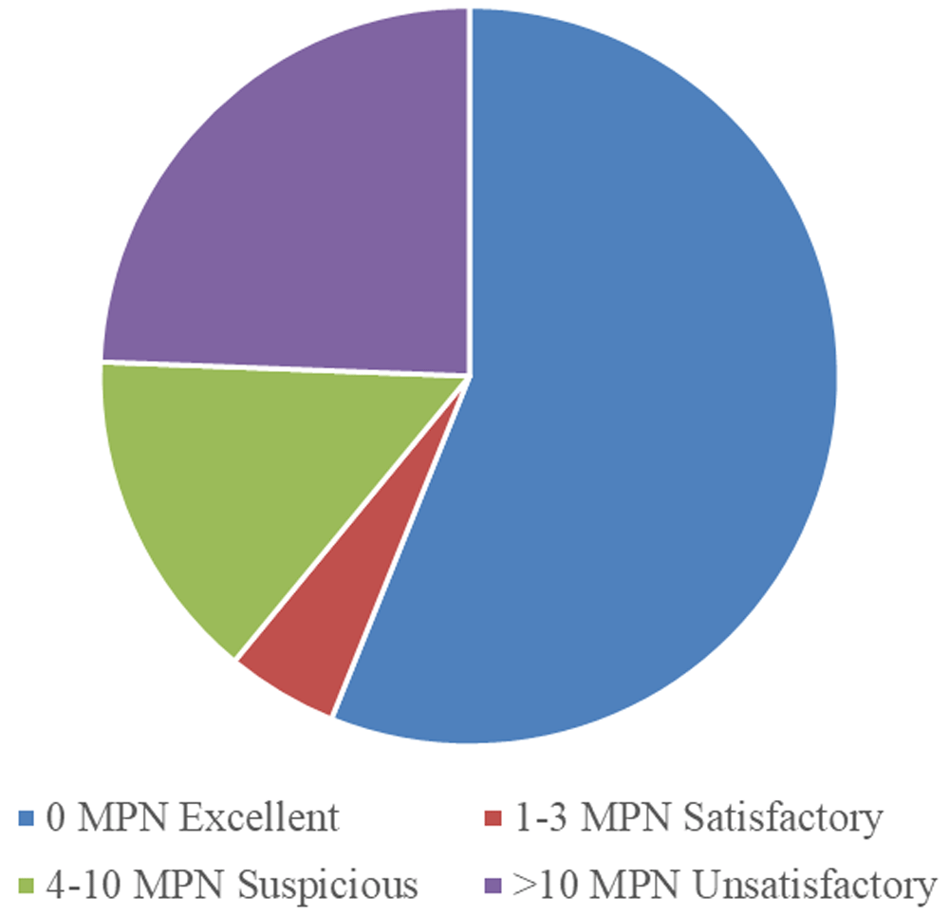

Figure 2. Grading of sampled water based on total coliforms.

Standard Deviation
Standard deviation is the positive square root of the variance. It is one of the basic methods of statistical analysis. Standard Deviation is commonly abbreviated as SDand denoted by the symbol 'σ’ and it tells about how much data values are deviated from the mean value. If we get a low standard deviation then it means that the values tend to be close to the mean whereas a high standard deviation tells us that the values are far from the mean value.
Standard deviation is the degree of dispersion or the scatter of the data points relative to its mean, in descriptive statistics. It tells how the values are spread across the data sample and it is the measure of the variation of the data points from the mean.
Formula to calculate standard deviation is ,
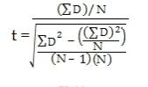
t- test

The t-test formula helps us to compare the average values of two data sets and determine if they belong to the same population or are they different. The t-score is compared with the critical value obtained from the t-table
Table 6: Mean and standard deviation of MPN values of ground water sample:

Sample | MPN /ml (xi) | (Xi - X) | (Xi -X)^2
Public well | 1.40 | 1.04 | 1.0
Deep boring | 4.9 | -1.36 | 1.8
Hand pump | 3.3 | -0.56 | 0.12
Deep boring (BIT MESHRA) | 3.4 | 2.5 | 6.25
Hand pump | 6.3 | -0.46 | 0.211
Total  Mean = 3.86 | 19.3 |  | 9.46
t-test = 2.3

Sample | MPN /ml (xi) | (Xi - X) | (Xi -X)^2
Sintex plastic tank | 6.3 | 0.92 | 0.84
Tap water | 9.4 | 4.02 | 16.1
Overhead water tank | 7.0 | 1.62 | 2.62
Pond | 1.10 | -4.28 | 18.3
Packaged drinking water | 3.1 | -2.28 | 5.19
Total  Mean = 5.38 | 26.9 |  | 27.07
t-test = 0.88
Table 7: Mean and standard deviation of MPN values of surface water sample :

Table 8: Mean and standard deviation from total viable count (TVC) values of surface water sample :
Sample | Total TVC  (CFU /g) (xi) | (Xi - X) | (Xi -X)^2
Sintex plastic tank | 2.6 × 10 ⁴ | -0.56 × 10 ⁴ | 0.3136 ×10 ⁴
Tap water | 2.8 × 10 ⁴ | -0.36× 10 ⁴ | 0.12 ×10 ⁴
Overhead water tank | 4.2 × 10 ⁴ | 1.04 × 10 ⁴ | 1.08 ×10 ⁴
Pond | 3.1 × 10 ⁴ | -0.06 × 10 ⁴ | 0.03× 10 ⁴
Packaged drinking water | 2.0 × 10 ⁴ | -0.06 × 10 ⁴ | 0.03 × 10 ⁴
Total  Mean = 3.16 | 15.8 × 10 ⁴ |  | 1.51 ×10 ⁴
t-test = 11.2

Dilution factor = 10 ⁴ , colony forming units = 3.16 × 10⁴ cfu/ml
Converting cfu /ml to log value
log cfu/ml
Log (3.16 × 10 ⁴)
= 4.49968408
Table 9: Mean and standard deviation from total viable count (TVC) values of groundwater

Sample | Total TVC  (CFU /g) (xi) | (Xi - X) | (Xi -X)^2
Public well | 3.1 × 10 ⁴ | -0.06 × 10 ⁴ | 0.01 ×10 ⁴
Deep boring | 2.6 × 10 ⁴ | -0.5 × 10 ⁴ | 6.35 × 10 ⁴
Hand pump | 2.8 × 10 ⁴ | -0.36 × 10 ⁴ | 1.9×10 ⁴
Deep boring | 2.0 × 10 ⁴ | -0.06 × 10 ⁴ | 5.38 ×10 ⁴
Well | 4.2 × 10 ⁴ | -1.04× 10 ⁴ | 12.81 × 10 ⁴
Total  Mean = 4.62 | 23.1 × 10 ⁴ |  | 26.44 × 10 ⁴
t-test = 8.10

Dilution factor = 10 ⁴ , colony forming units = 3.16 × 10 ⁴ cfu/ml
Converting cfu /ml to log value
Log cfu/ml
Here,
Log (3.16 × 10 ⁴)
= 4.66464198

RESULTS AND DISCUSSIONS

Water samples from Different areas ( Nagra toli and science block) were subjected to bacteriological analysis using most probable number (MPN) test. These examinations included: Detection of total coliform, fecal coliform and fecal streptococci, as well as total viable count and yeast and moulds count.

Tables 2 and 3 present the microbial load of surface water samples and groundwater samples, respectively. From Table (2), results indicate that 50% of surface water samples show the presence of coliform and fecal coliform, this means that samples were unfit for drinking according to the international standards (WHO, 1997) for drinking water, which stated that E.coli or thermotolerant coliform bacteria and pathogenic intestinal protozoa must not be detectable in any 100 ml sample. Detection of total coliform, E.coli and fecal Streptococci in these samples was an indication that water was exposed to contamination from human or animal feces. Coliform bacteria in these samples indicated that water treatment system was not operated satisfactorily or that water became contaminated within the distribution system

Results from Table (2) also show that Salmonella was not detected in the samples indicating (–)

DISCUSSION:

Microbial contamination of ground and surface water is the most common and wide spread health risk and therefore its control must always be of supreme importance. Monitoring microbial presence, especially faecal coliform bacteria (FC) determines the quality of water. In this study, the MPN index was high for surface waters when compared to groundwater. The water analysed in this study has clearly shown that they are loaded with indicator organisms which are the indication of faecal pollution and thus the human interference. The coliform bacterium is the primary bacterial indicator for faecal pollution in water(Parihar V.L., Sharma M.S. and Sharma L.L., 2003) .

Potable water must be free from pathogenic microorganisms and chemical substances that are hazardous to health (Lamikanra 1999). Bacteria indicative of faecal pollution or pathogens should not be found in ground and treated surface water. A sensitive method of quality assessment of drinking water is the detection of faecal indicator bacteria as it is not possible to examine water for every possible pathogen that might be present (WHO 2004). There has been an imbalance between supply and demand and it is the main reason which has led to competition and thereby resulted in pollution and environmental degradation. Failure of disinfection methods of raw water at the treatment area or mixing of sewage through cross-connections, leakages could cause bacteriological pollution of water supplies. Main cause of water pollution is due to human impact (Palit 2012).

By monitoring microbial presence, especially faecal coliform bacteria (FC) determines the quality of water. In this study, the MPN index was high for surface waters when compared to groundwater Mohan D., Gaur A. And Chodhary D .2007). The water analysed in this study has clearly shown that they are loaded with indicator organisms which are the indication of faecal pollution and thus the human interference. In our study, a total of 4 different bacterial species were identified from both ground and surface water samples. The prevalence of bacterial isolates was Staphylococcus aureus, Enterococcus faecalis, E. Coli, Enterobacter aerogenes According to EPA, the presence of E. Coli indicates recent sewage or animal waste contamination (EPA 2001). The temperature and the presence of nutrients in some areas favours the survival of enteric bacteria, like Enterococcus spp. And E. Coli (Leclerc et al. 2002). Enteric pathogens such as Salmonella, Shigella and Vibrio are principally transmitted through contaminated drinking water, as reported by Edberg et al. (2000). But in case of the samples discussed, Salmonella were not found in treated drinking water (Mena & Gerba 2009)

An assessment of the bacteriological quality of surface and ground water in the present study confirmed the presence of various bacterial species Enterococcusfaecalis , E.coli and streptococcus bacillus .

This drastic effect in the increase of microorganisms may be because of the recent increase in the population levels followed by improper treatment and sanitation. This has caused the mix up of sewage with the water bodies resulting in water pollution. This could have been the reason for all the water samples showing the presence of coliforms and other organisms. The high occurrence of multi-drug resistant organisms in the drinking water system may possibly pose a risk to humans consuming the sample water taken for testing.

CONCLUSION

The goal of the present study was to carry out a set of microbiological analyses as well as identification of the microbial groups dominating ground and surface water, to match the results with international standards for drinking water. The water samples were taken monthly from different sources (surface water and groundwater sources).
It is highly recommended to carry out bacteriological examination frequently and regularly for the water entering the distribution system and the water in the distribution system for the control of the hygienic quality of the water supply. Frequent examinations are essential for hygienic control. For the piped supplies, it is necessary to maintain a sufficiently high pressure throughout the whole distribution system to prevent contamination getting into the system; as it is necessary for every distribution system to have available means of chlorination to deal with accidental pollution, which is always a possibility Adequate monitoring and surveillance of these water sources should therefore be carried out regularly.

References:

- Abualdahab M. Kamal and Gorani M. Abdalgader, (1983). Bacteria, Eltamareen AlmamalyiaAlasaseeya (in Arabic), pp. 86-87, 107-108.

- Byamuka D., Kansime F., Mach R.L. and Farantiler A.H., Determination of Escherichia coli contamination with chromocult coliform agar showed a high level of discrimination efficiency for differing faecal population levels in tropical waters of Kampala, Uganda, Appl. Environ. Microbiol, 66, 864-868 (2000)

- Davis M.L. and Cornwell D.A., Introduction to Environmental Engineering, McGraw Hill, 3rd Ed., PWS, Publishers, New York, 93 (1991)

- Donovan, E., Unice, K., Roberts, J. D., Harris, M. And Finley, B. 2008. Risk of gastrointestinal disease associated with exposure to pathogens in the water of the Lower Passaic River. Applied and Environmental Microbiology, 74(4): 994-1003

- EPA 2001. Environment Public Authority Decision No. 210/2001 Pertaining to the Executive By-Law of the Law of Environment Public Authority.

- Gautam, B. (2020). Chemical evaluation of trace elements in bottled water. Journal of Healthcare Engineering, 2020, 8884700. 10.1155/2020/8884700 [CrossRef] [Google Scholar]

- Gautam, B. , & Adhikari, R. (2018a). Association of antibiotic and heavy metal resistant bacteria screened from wastewater.

- Gautam, B. , Aryal, L. , Adhikari, S. , Rana, M. , Rajbhanshi, A. , Ghale, S. , & Adhikari, R. (2018). Isolation of bacteriophage from Guheswori sewage treatment plant capable of infecting pathogens. Research in Pharmacy and Health Sciences, 4(2), 465–470.

- Gautam, B. , Dongol, E. , & Shrestha, A. (2017). In‐vitro antimicrobial activity of different toothpastes. Journal of Kathmandu Medical College, 13(20), 52–58. 10.3126/jkmc.v6i2.19803 [CrossRef] [Google Scholar]

- Gautam, B. , Gyanwali, G. , & Ussery, D. W. (2021). Assessment of bacterial load in polyethylene terephthalate (PET) bottled water marketed in Kathmandu Valley, Nepal. International Journal of Polymer Science, 2021, 6681249. 10.1155/2021/6681249 [CrossRef] [Google Scholar]

- Gautam, B. , Nepal, R. , Bhandari, R. , & Gyawali, S. (2019). Evaluation of ginger extract’s yield, using cold extraction method and its antimicrobial activity against pathogens. Asian Journal of Medical and Biological Research, 5(1), 8–13. 10.3329/ajmbr.v5i1.41039 [CrossRef] [Google Scholar]

- .Haniffa, M.A., Arockiasamy, S. And Martin, P. 1993. Physico-chemical and microbiological studies in the Perenial River Thabaraparani for the assessment of water quality. Indian J. Of Env. Protec., 13(7): 533-538

- Harrigan W.F., (1998). Laboratory Methods in Food Microbiology 3rd edition, pp. 200-220.

  - William A. Strohl, Harriet Rouse and Bruce D. Fisher, (2001). Lippincott’s illustrated Reviews, Microbilogy. Pp. 22-23, 26-27, 102-103.

  - Lamikanra, A. 1999. Essential Microbiology for Students and Practitioner of Pharmacy, Medicine and Microbiology. Amkra Books, pp. 406.

- Hodgkiss, I.J. 1988. Bacteriological monitoring of Hong Kong marine water quality. Environment International, 14(6): 495-499.

- International Journal of Environment, 7(1), 28–40.10.3126/ije.v7i1.21292 [CrossRef] [Google Scholar]

- Leclerc, H., Schwartzbrod, L. And Dei-Cas, E. 2002. Microbial agents associated with waterborne diseases. Critical Reviews in Microbiology, 28(4): 371-409.

- Mena, K.D. and Gerba, C.P. 2009. Risk assessment of Pseudomonas aeruginosa inwater. In: Reviews of Environmental Contamination and Toxicology, 201: 71-115

- Mohan D., Gaur A. And Chodhary D., Study of limnology and microbiology of Naya Talab, Jodhpur, Rajasthan, Proceed. Nat. Symp. On Limnology, 64-68 (2007)

- Moore, A.C.; Herwaldt, B.L.; Craun, G.F.; Calderon, R.L.; Highsmith, A.K.; Juranek, D.D., (1993).

- Mackenzie, W.R.; Hoxie, N.J.; Proctor, M.E.; Gradus, M.S.; Blair, K.A.; Peterson, D.E.; Kazmierczak.

- Musyoki, A.M., Abednego, M., Suleiman, M.A., Mbithi, J.N. and Maingi, J.M. 2013. Water-borne bacterial pathogens in surface waters of Nairobi river and health implication to communities downstream Athi river. International Journal of Life Science and Pharma Research, 3(1): 4-10

- Palit, A., Batabyal, P., Kanungo, S. And Sur, D. 2012. In-house contamination of potable water in urban slum of Kolkata, India: a possible transmission route of diarrhoea. Water Science and Technology, 66(2): 299-303.

- Parihar V.L., Sharma M.S. and Sharma L.L., Utility of bacteriological parameters for assessing best use and trophic status of seasonal water: A case study from Udaipur, Rjasthan. Poll. Res., 22(2), 163-167

- Payment, P.; Wait, M.; Dufour, A., (1991). Introducing parameters for assessment of drinking water Quality: In assessment microbial safety of drinking water, improving approaches and methods. IWA Publishing, London

- Risk assessment: a state of the art and perspectives. Rev. Epidominol. Sante Public., 47, 61-75.

- Surveillance for waterborne disease outbreaks—United States, 1991-1992. MMWR CDC Surveill Summ.

- WHO 2004. Guidelines for Drinking Water Quality: Recommendations, (Vol. 1). World Health Organization, Geneva.

