A FACILE SYNTHESIS OF NAPHTHYL CHITOSAN BASED COMPOSITE HYDROGELS AND THEIR SWELLING APPLICATIONS
P.V.Rithuparna¹, P.Kavitha², R.Menaka² and P.Divya³
¹Post Graduate Student, Department of Chemistry, Dr.N.G.P. Arts and Science College, Coimbatore, Tamil Nadu
²Assistant Professor, Department of Chemistry, Dr.N.G.P. Arts and Science College, Coimbatore, Tamil Nadu
³Assistant Professor, Department of Chemistry, KGISL Institute of Technology, Coimbatore, Tamil Nadu
Corresponding Author: Dr.R.Menaka, Email: menu.chem@gmail.com
ABSTRACT
Chitosan based hydrogels are effective vectors for biomedical applications with intrinsic valuable properties, such as: biocompatibility, biodegradability, low cost, easy availability, and high reactivity due to plenty of the reactive functional groups. Herein we report the synthesis of naphthyl chitosan based composite hydrogels with PVA and starch which can undergo rapid gelation in the presence of anchoring groups of naphthaldehyde. The prepared composite hydrogels were characterized ultra-visible spectroscopy, Fourier transform spectroscopy to predict the formation of composite hydrogels. The morphology and the thermal behavior of the composite hydrogels were analyzed using Scanning electron microscopy and thermogravimetric analyzer. The composite hydrogels were found to have stimuli-sensitive sequences and remarkable phase behavior in the solutions. Hence, the responsive behavior of these hydrogels in relative to specific external stimuli, such as salt solution, pH and physiological solutions were studied. The reversible swelling-deswelling behaviour of the hydrogels in two different pH solutions was also examined. These hydrogels can be recommended for use in biomedical applications.
Keywords: Chitosan, hydrogels, pH responsive, biomedical application
1. INTRODUCTION
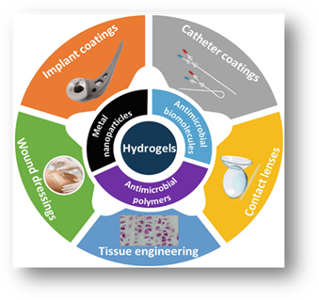
In the fast few decades, the progress in the field of biomaterials has lead to the several researches on the alternative biocompatible materials. Development of these materials and use of alternative resources for its preparation are also become a trend in the research field. The word hydrogels are used by food and biomaterials scientists to describe polymeric cross linked network structures. The term hydrogel means three-dimensional network structures obtained from a group of synthetic and/or natural polymers which can absorb significant amount of water.[1]. The networks are composed of homopolymers or copolymers and they are insoluble due to the presence of chemical or physical crosslinks like entanglements or crystallites. These hydrogels have the capability to exhibit thermodynamic compatibility with water which allows them to swell in aqueous media.[2]. Depending on their method of preparation, ionic charge, physical structure features, hydrogels may be classified in several categories like homopolymer hydrogels, copolymer hydrogels, multipolymer hydrogels, interpenetrating network hydrogels etc.[3].Apart from high water absorption capability, it has a other properties like porosity, stimuli-responsive, flexibility, soft structure, and its resemblance to living tissue. Nowadays hydrogels attain a great attention of scientific community for biomedical applications due to its biocompatibility, biodegradability, low immunogenicity and ease of usage. By changing their properties and crosslinking reactions hydrogels can be processed as solid, semi solid, liquid.[4]. So there are many researches are going on about hydrogels in the field of food industry, drug delivery, agriculture etc.

Figure 1: Applications of hydrogels. [Kasthuri et al., 2020].
The development of polysaccharides based hydrogels are increased in last few years. The polysaccharides posses various properties for development of biomaterials. Commonly used polysaccharides are alginate, carrageenan, and chitosan.[5]. Among them chitosan has been widely used for biomedical applications such as controlled protein delivery, drug delivery, tissue engineering.[6]. Chitosan is the only cationic polysaccharide of natural origin, which have bioactivities such as antioxidant, antimicrobial, anti-inflammatory, immunoregulatory.[7]. Chitosan is mainly prepared by the deacetylation of chitin. Chitin is usually insoluble in water so it is transformed in to chitosan to increase the solubility. These chitosan and its derivatives are widely used in the field of medicine, cosmetics, biochemical, tissue engineering and some other fields.[8].
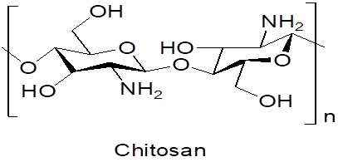
Chitosan is a versatile biomaterials among other natural polymers due to their non-toxicity, low allergenicity, biocompatibility and biodegradability allow it to use in various applications.

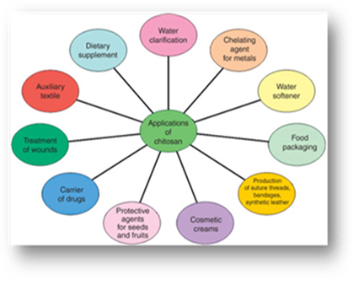

Figure 2: Various applications of Chitosan. [Monica et al., 2016].
Recently, there is a noticeable pull on the research activities related to the application of hydrogels in different fields. Polysaccharides have intrinsic functional moieties, thus polysaccharide-based hydrogels have been synthesized by employing various physical non-covalent or chemical covalent crosslinking strategies.[9]. Polysaccharides are excellent factor as vehicles for therapeutic biomolecules, due to their capacity to maintain conformation and activity of the biomolecule.[10]. pH sensitive hydrogels for an antiviral drug ACV by using pure polymer CS, XG, AMPS were synthesized and their swelling dynamics and drug release behavior were also investigated. SEM images shoes the porous structure of hydrogels. ACV were successfully encapsulated into hydrogels were confirmed by author through FTIR studies. The formed hydrogels properties were dependent on pH and concentration of pure reactant.[11].Natural and synthetic polymers are widely used for the synthesis of hydrogels. A number of chitosan derivative developed and widely applied in the pharmaceutical field. N-benzyl—N,O-Succinyl chitosan were reported by Prasopchai Tonglairoum Etal. This is used to form polymeric micelles incorporated with meloxicam for oral delivery.[12].
In these circumstances our present studies involves synthesis of naphthyl chitosan based composite hydrogels using starch and PVA respectively. The prepared hydrogels were subjected to swelling studied, pH studies, temperature studies. The hydrogels swelling performance were also analyzed in salt solution. The formation of composite hydrogels and also the extent of modification in polymer matrix are confirmed through spectral and morphological characterization.

2. Experimental:

2.1Materials and methods:
Chitosan was purchased from Himedia, α-Naphthaldehyde was purchased from Avra synthesis, Acetone was purchased from spectrum, Ethanol from Avra synthesis. Acetic acid, Polyvinyl alcohol and Starch was purchased from Himedia.
2.2. Synthesis of Chitosan Based composite hydrogels
For ease of characterization, the hydrogels were produced in thin film form. Two types of hydrogels were synthesized, one was of α-Naphthaldehyde Modified Chitosan – starch composite hydrogel and another one was α-Naphthaldehyde Modified Chitosan – PVA Bio composite Hydrogel.
α-Naphthaldehyde Modified Chitosan – starch composite hydrogel was synthesized by 0.2 g of Chitosan was dissolved in 20 ml of 1% acetic acid with magnetic stirring until the solution was clear. Separately, 0.2 g of starch was dissolved in 20 ml of distilled water. The two solutions were then mixed together while stirring for 30 minutes. Next, 0.2 g of α-Naphthaldehyde was dissolved in 2 ml of ethanol and added dropwise to the Chitosan-starch solution while stirring for 30 minutes at 60ºC. The resulting solution was cooled to room temperature and precipitated using acetone. The product was washed several times to eliminate any unreacted compounds, air dried, and weighed.
Synthesis of α-Naphthaldehyde Modified Chitosan – PVA Bio composite Hydrogel was by stirring 0.2 g of Chitosan in 20 ml of 1% acetic acid with a magnetic stirrer for approximately 15 minutes, a clear solution was achieved. Subsequently, 0.2 g of PVA was dissolved in 20 ml of distilled water, and the two solutions were mixed together for 30 minutes by magnetic stirring. Following this, 0.2 g of α-Naphthaldehyde was dissolved in 2 ml of ethanol and added dropwise to the Chitosan-PVA solution while continuously stirring for approximately 30 minutes at a temperature of 60oC. The final solution was permitted to cool to room temperature and then precipitated with acetone. After multiple washings to eliminate any unreacted compounds, the product was air-dried and weighed.
The percentage yield and degree of deacetylation were calculated using the following formulae.

2.3. UV- Visible and FTIR spectroscopy
Synthesized Chitosan based bio composite hydrogels were characterized using spectroscopic techniques such as UV visible and FTIR. The UV-Visible spectra were recorded in the range of 200-600 nm. The fundamental vibrations of Chitosan based composite hydrogels were identified using Fourier transform infrared spectroscopy (FTIR) in the range of 4000-400 cm⁻¹
2.4. Sample swelling and solvent solubility studies
2.4.1 Swelling test
Synthesized Chitosan based composite hydrogel samples were taken for the swelling test After 72 hrs, the final weight of hydrogels can be measured.
2.4.2. Solubility test
The solubility test was conducted in different solvents like water, acetone, ethanol, chloroform, dil.HCl and acetic acid.
2.4.3. Biodegradation test
The composite hydrogel samples were cut into small piece and weighed to test the degradability property. Approximately 0.02 gm of samples were taken for biodegradation and results were recorded after 3, 5, 7 and 11 days.
2.5. Swelling and thermo-responsive studies of Chitosan based composite hydrogels

2.5.1. Measurement of degree of swelling percentage
The swelling properties of composite hydrogels made from synthesized Chitosan were analyzed in double distilled water. To calculate the percentage of swelling, a gravimetric method is used. The dried samples were immersed in a specific amount of distilled water for different periods of time. At regular intervals, the swollen gels were taken out from the water and excess surface water was removed by gently blotting with a filter paper before being weighed. Using the obtained weight, the degree of swelling was calculated as the amount of water in grams per gram of polymer (g/g), using the following equation:
Degree of Swelling (g/g) = (W_{s} -W_{d}) / W_{d} × 100
where, W_{s} and W_{d} are the weights of percentage swollen gel at definite time and dry sample, respectively.
2.5.1. Thermoresponsive property of hydrogels

The hydrogel samples were immersed in distilled water and their thermoresponsive properties were evaluated at two distinct temperatures, namely 28°C and 50°C. The samples were allowed to swell for different time periods, namely 30 minutes, 60 minutes, 90 minutes, and 120 minutes, at each temperature. Following the swelling process, the samples were removed from the solution and dried using filter paper before being weighed. The swelling ratio was then determined to assess the swelling behavior of the hydrogels at different temperatures. The time duration for the experiments was limited to 2 hours since after this period, either de-swelling or gel dispersing occurs.
2.5.2. Swelling in salt solutions
To determine the swelling behavior of the hydrogels, the pre-weighed samples were immersed in salt solutions of NaCl and KCl at varying concentrations of 0.1 M and 0.3 M. The samples were left in the solutions for varying time periods. The swelling ratio of the hydrogels was then determined based on these experiments.
2.5.3. Swelling in some selected physiological solutions
Given the extensive use of hydrogels in biomedical engineering, it is imperative to assess their compatibility and swelling behavior in various physiological fluids. In this regard, physiological fluids such as saline water, synthetic urine, glucose, and urea were prepared as per the method described in the study by Zhao et al. (2006).

Table 2: Preparation procedure of different Physiological solutions

PHYSIOLOGICAL SOLUTIONS | PREPARATION PROCEDURE
Saline water | 8g NaCl dissolved in 1000 ml distilled water
Glucose | 50g glucose dissolved in 1 L distilled water
Urea | 50g urea dissolved in 1 L distilled water
Synthetic Urine | 8g NaCl + 1g MgSO₄ + 20g urea + 0.6g CaCl₂ was dissolved in 1L distilled water

2.6. Characterization of Swollen Hydrogels - Scanning Electron Microscopy (SEM)

The swollen hydrogels were subjected to morphological studies. It was examined with a JEOL JSM-5400 scanning electron microscopy (SEM) (JEOL, Tokyo, Japan).
3. RESULTS AND DISCUSSION
The results pertaining to the study, “A Facile synthesis of Naphthyl Chitosan based composite Hydrogels and their swelling applications” are being performed and analysed in the stage of the objectives set forth. The study attempted to synthesize eco-friendly biodegradable Naphthyl Chitosan/Starch/PVA composite Hydrogels and to analyse their swelling behavior and thermosresponsive properties.
A novel modified Chitosan Schiff base was synthesized using α- naphthaladehyde by following the procedure mentioned earlier in materials and methods. The schematic representation of the synthesis procedure is shown below in the Figure.

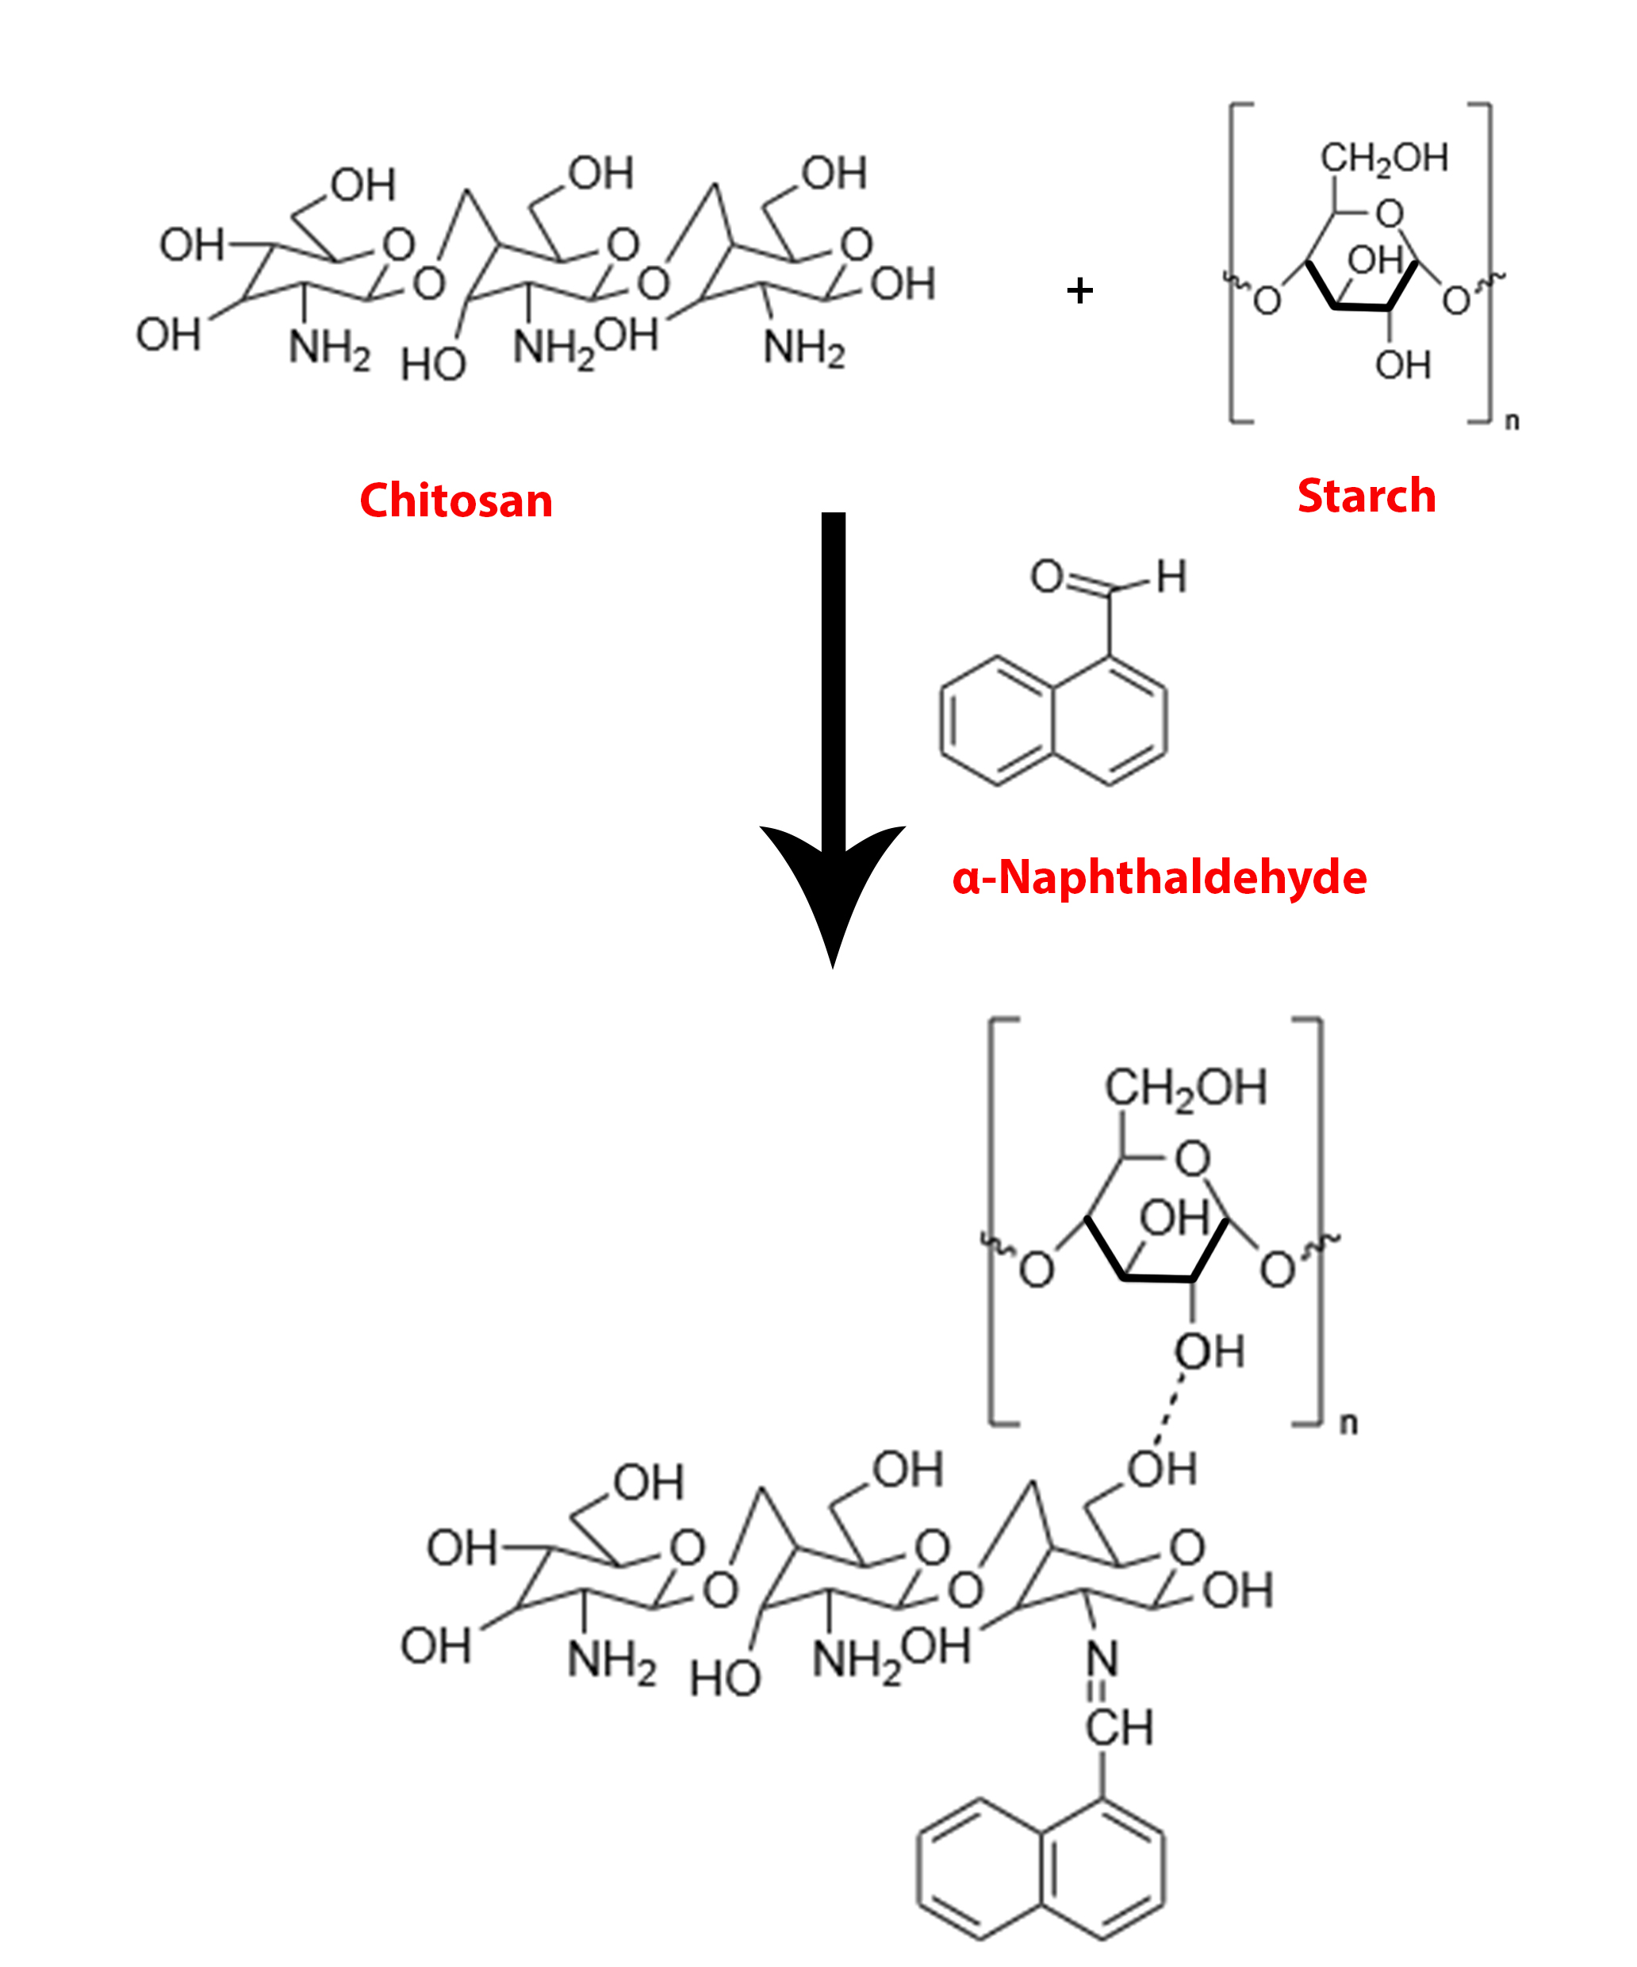

Figure3: Schematic representation for the synthesis of Naphthyl Chitosan/starch composite hydrogel
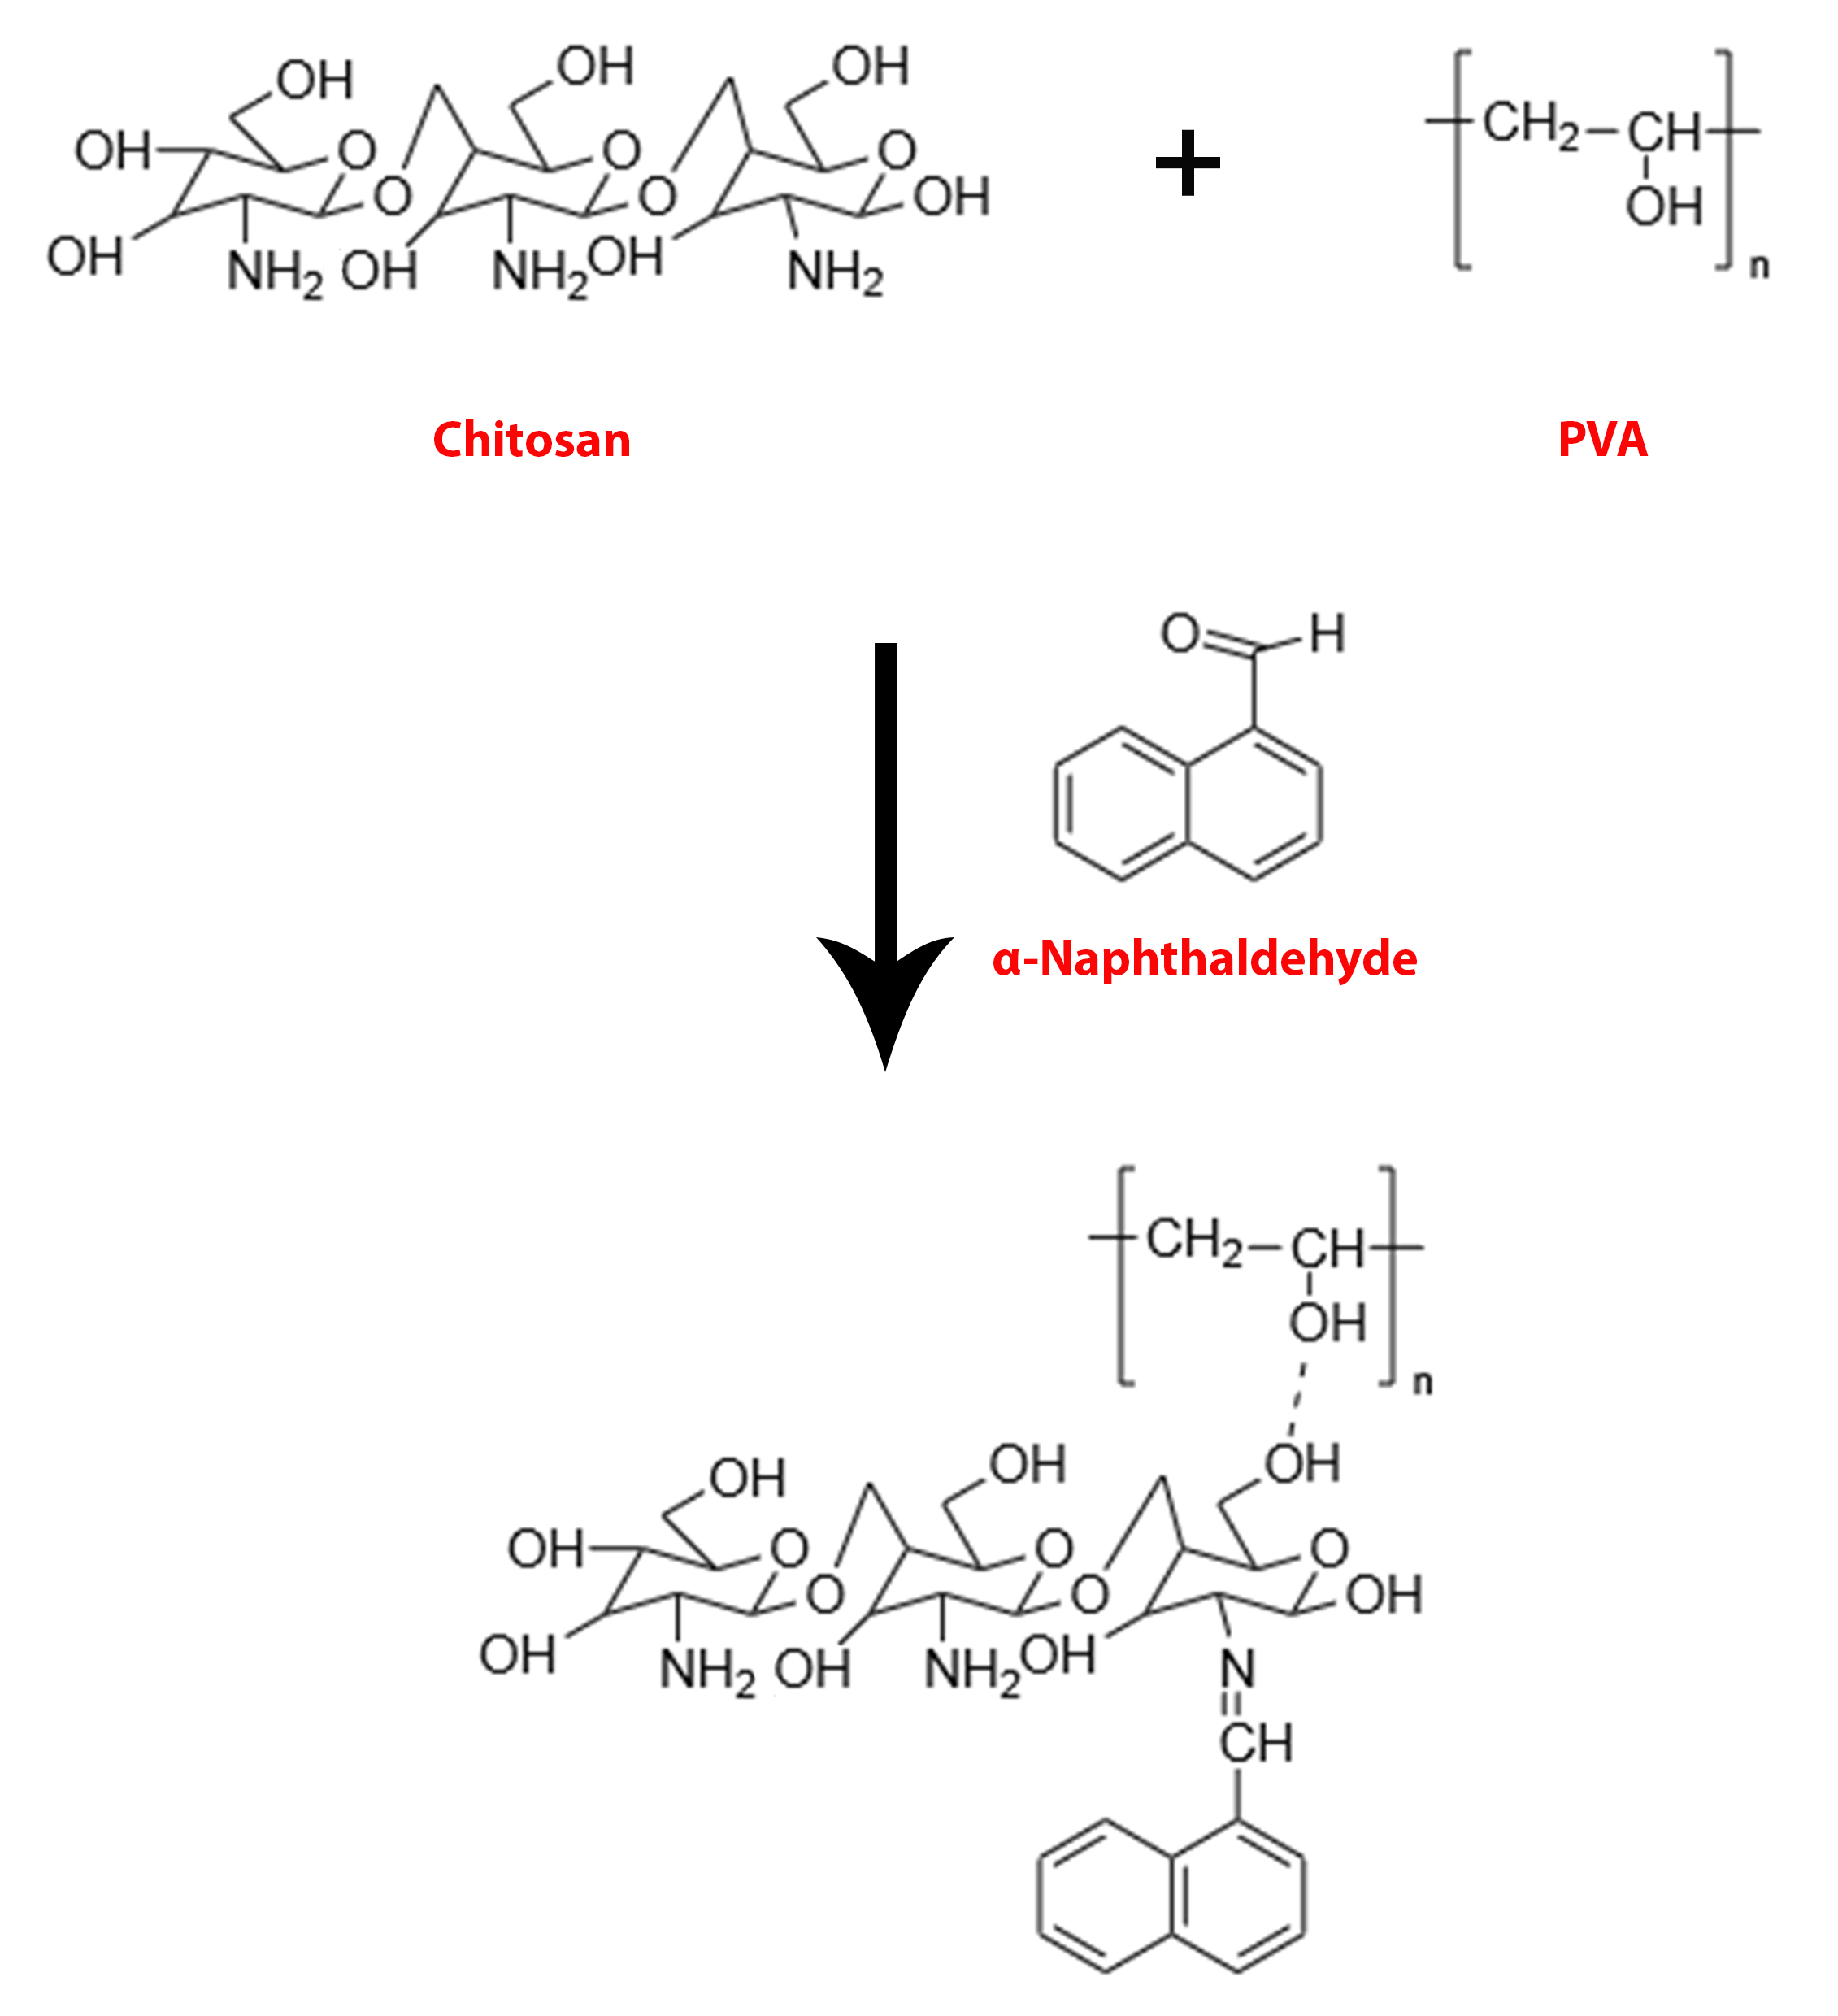

Figure 4: Schematic representation for the synthesis of Naphthyl Chitosan/PVA composite hydrogel

The wet sample images of Naphthyl Chitosan Schiff base, Naphthyl Chitosan/Starch and Naphthyl Chitosan/PVA Composite Hydrogels are shown below in Figure 5. The change of colour of the Chitosan from white to yellow shown in the image indicates the preliminary indication of the formation of Schiff bases inside the Chitosan matrix.

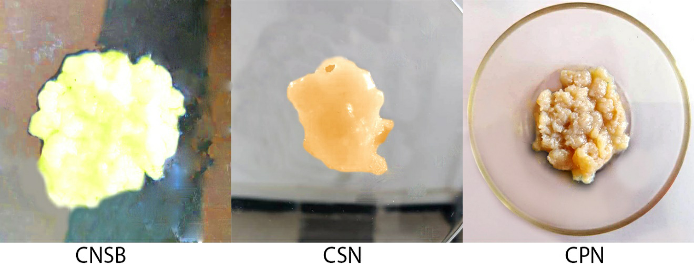

Figure 5: Wet hydrogel samples of CNSB, CSN& CPN

A set of two Naphthyl Chitosan based composite hydrogels were synthesized using the methodology mentioned in materials and method section. The resultant dried composite hydrogel products are shown below in the Figure 15.

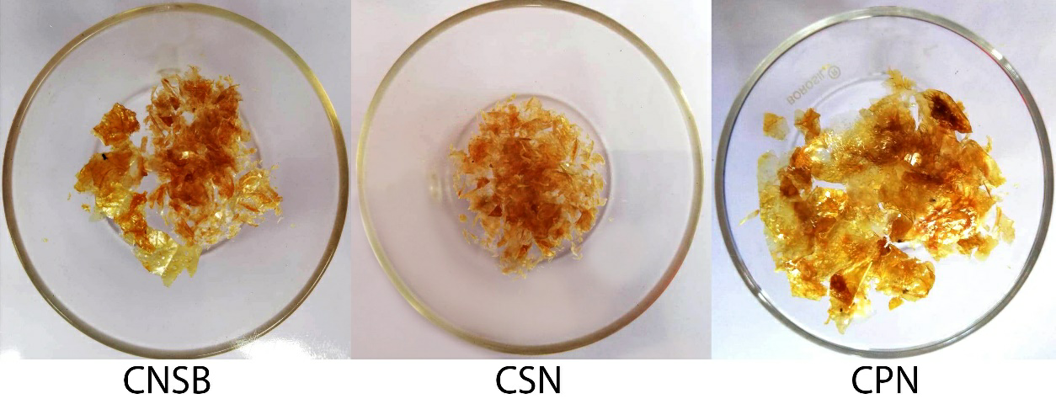

Figure 6 : Dry hydrogel samples of CNSB, CSN & CPN

During the synthesis process, α- naphthaladehyde is added to the Naphthyl Chitosan/Starch mixture and Chitosan/PVA mixture individually. Due to the basic nature of amino group, amino group of the Chitosan easily undergoes imine formation with α- naphthaldehyde rather than hydroxyl groups present in polymeric chains. Water accumulation property is facilitated by the rigidity nature of α- naphthaldehyde linked as pendent in between two polymeric chains. The polymeric mixture solutions creates active sites in glycosidic linkages of Chitosan and hydroxyl groups of PVA and starch, thus forming hydrogen bonding and electrostatic interaction among the polymeric chains.

3.1.Degree of Deacetylation
The degree of deacetylation of Chitosan refers to the percentage of primary amino groups present in Chitosan backbone after the chemical deacetylation of natural chitin. It is one of the important characteristic which affects the functional properties of Chitosan. As the deacetylation percentage increases the acid solubility, metal ion uptake capacity and overall reactivity of Chitosan increases. This is because of the presence of higher reactivity of primary amino groups present in the Chitosan backbone. The degree of deacetylation of commercial Chitosan used for the present work was calculated by using the equation mentioned in materials and method.

Since Chitosan exhibits poor solubility in most of the solvents, it is difficult to obtain NMR data so as to find the degree of deacetylation and degree of substitution. Hence elemental analysis was used to overcome this difficulty. The elemental composition of Chitosan was determined using CHNS analyser (instrument vario EL 111 CHNS serial number 11035060). The percentage composition of carbon, hydrogen, nitrogen and sulphur are being presented in Table 1. The degree of deacetylation was calculated based on the value of C/N ratio of Chitosan obtained from elemental analysis. The value of degree of deacetylation of Chitosan used in present work was found to be 76.99 %.

100 percentage substitutions cannot be achieved with the Chitosan matrix as its degree of de-acetylation still a considerable yield was obtained using the standardised procedure.

Table 3: Elemental analysis of Chitosan
S.NO | SAMPLE | ELEMENTS (%) |  |  |  | C/N ratio
 |  | C | H | N | S
1. | CH | 39.71 | 7.48 | 7.16 | - | 5.548106

Yield of the synthesized Chitosan based composite hydrogels was calculated using the equation given in materials and methods. The resultant yield is tabulated below:

Table 4: Colour and Yield of Napthyl Chitosan composite hydrogels.

SAMPLE | COLOUR | YIELD
CNSB | Yellow | 42.6 %
CSN | Yellow | 40.1 %
CPN | Yellow | 44.34 %
3.2 Characterization of Chitosan and its derivatives

3.2.1 Ultraviolet visible spectroscopy

When the polymer is subjected to some modification, by having UV-Vis spectra of the base matrix and the modified sample, it can be analyzed for the change occurred in the polymer matrix. The UV visible absorption spectra of Naphthyl Chitosan / PVA and Naphthyl Chitosan /Starch hydrogels were recorded in the wavelength region of 200-450 nm.
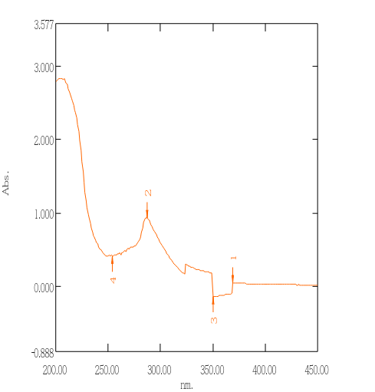
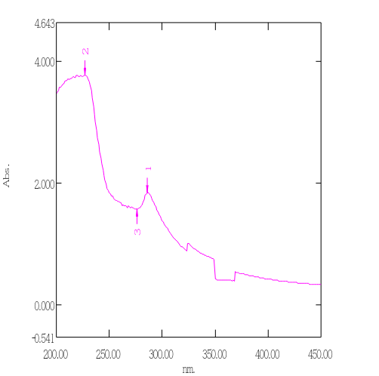
Figure7: UV spectra of CPN and CSN
Chitosan is transparent in the UV and visible region, so it is hard to characterize by UV spectroscopy. Chitosan exhibited no characteristics peaks in the examined UV-visible range of the absorption spectrum. On the contrary, all the two Naphthyl Chitosan /PVA and Naphthyl Chitosan/Starch composite hydrogels showed the characteristics peaks in the examined region. The electronic spectra of the synthesized composite hydrogels shows significant absorption bands and their respective spectra are shown in Table 5. The spectral data corresponds to the particular transition have been classified below. bel These transition below 400 nm are generally assigned to * and n-* bonds.
Table 5: UV spectral transitions corresponding to Naphthyl Chitosan derivatives

S.No | Samples | Absorption bands (nm)
 |  |  | n-*
1. | CH | - | -
2. | CNS | 227 | 276, 286
3. | CNP | 254 | 287, 350, 369

π -π* transition
This transition is a high energy transition occurs due to the presence of unsaturated groups in the investigated compounds. In the synthesized composite hydrogels, π-π*transition occurs due to the presence of the azomethine (-HC=N) groups and the C=C bonds present in the aromatic system of the aldehyde. Thus the absorption band in the region 220-250 nm is assigned to the π-π*transition of azomethine chromophoric group. The presence of the broad peak in the region around 300-350nm is the indication of presence of aromatic rings in their structure.
n- π* transition
Generally, n- π* transition is a forbidden transition since it requires high energy for excitation and appears as a low intensity signal. This transition is very slightly affected by substitution or conjugation. Naphthyl Chitosan /PVA and Naphthyl Chitosan/Starch composite hydrogels may undergo this type of transition in the region 250-290 nm. This absorption band can be attributed to the n- π* transition generated by the lone pair of electrons present on the O, N and S atoms in the incorporated aldehyde.
From the above results of UV spectra analysis, it is clear that the aldehydic groups are successfully anchored onto the Chitosan matrix to form Modified Chitosan through condensation reaction and then upon further reaction with PVA and starch individually to form corresponding composite hydrogels.

3.2.2 Fourier Transform Infrared spectroscopy
FTIR spectra of pure Chitosan, Chitosan Schiff base and its corresponding composite hydrogels with PVA and Starch are analyzed to identify the functional groups present in them. The spectra and the spectral data are presented in Figures 17,18,19,20,21,22 and Tables 6,7 respectively.

Characteristic vibrations of pure Chitosan
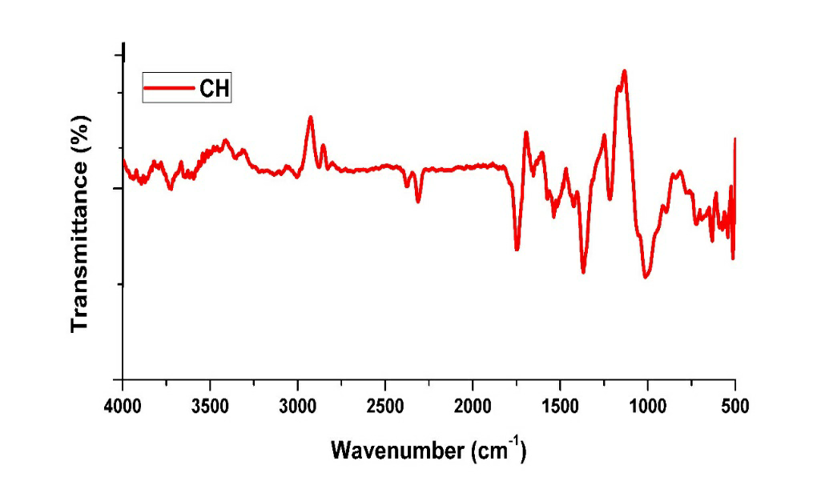
Figure8: FT-IR spectra of pure Chitosan

The FTIR spectrum of Chitosan exhibits a sharp characteristics absorption peak for the presence of free -OH groups in the region 3751 and 3637 cm⁻¹ and the presence of –NH₂ groups in the region 3371.6, 3100.5, 3012 cm⁻¹. The peak at 3459 cm⁻¹ can be assigned to the axial vibration of O-H that may be superimposed with the N-H stretching band. The peak at 3336 cm⁻¹ (N-H stretching), 2920 and 2880 cm⁻¹ (C-H stretching), 1652 cm⁻¹ (amide II band N-H stretching), 1425 cm⁻¹(asymmetrical C-H bending of CH₂ group) and 1066 and 1024 cm⁻¹ (C-O-C bridge stretching) represents the glucosamine residue (Biranje et al., 2017).

The peak at 1150-1040 cm⁻¹ is due to C-O-C bridge stretching and skeletal vibrations of C-O stretching. The peaks at 1220 and 820 cm⁻¹ are the characteristics peaks of saccharide moiety. The peak at 1380 and 1590 cm⁻¹ are due to the CH₃ in the amide group and NH₂ in amino group. (Pawlak et al., 2003).

Table 6: FTIR spectral indications of Chitosan
Frequency | Indications
3751, 3637 cm ⁻¹ | O-H stretching
3371.63, 3100, 3012 cm ⁻¹ | -NH₂ groups (symmetric and anti-symmetric NH stretching)
3459 cm ⁻¹ | Axial vibrations of O-H superimposed with N-H stretching.
2887.25, 2828.49, 1425.34 cm ⁻¹ | CH₂ symmetric & asymmetric stretching
1574.65 cm ⁻¹ | Amine –NH₂ Group
1536.54 cm ⁻¹ | Amide-II region
1656.29, 1367.8 cm ⁻¹ | Amide I, Amide III
1739.53 cm ⁻¹ | C=O stretching in secondary amide
1010.88 cm ⁻¹ | Ring, C-O-C bridge stretching
1216.89 cm ⁻¹ | β(1-4) Glycoside bridge

Characteristic vibrations of Naphthyl Chitosan Schiff base (CNSB)

Figure 9 : FTIR spectra of CNSB

The major changes that can be obtained for Chitosan Schiff base includes the adsorption peak at 3371cm⁻¹ shift to 3350 cm⁻¹ corresponds to the NH stretching in secondary amides. Peaks at 2925 shifts to 2978 cm⁻¹ confirms the presence of aliphatic CH stretching in aromatic ring and C=O stretching in amide (amide I band). The formation of Chitosan Schiff base (CNSB) is confirmed by the presence of strong absorption band at 1627.9 cm-1 attributed to the C=N vibrations of azomethine group which is a characteristic band of imines. Chethan et al., 2013, Dos Santos et al., 2005. This characteristic band is not observed in the FTIR spectrum of Chitosan. Thus the presence of this band reveals the formation of Schiff base in the Chitosan matrix. Also, there is no peak observed in the region 1660-1730 cm-1 related to the free aldehyde group indicating that the ⟨-napthaldehyde has been successfully anchored onto the Chitosan backbone to obtain Chitosan ⟨-napthaldehyde Schiff base (CNSB). Anan et al., 2011.

Certain absorption bands which were obtained at 1536.5 cm⁻¹shifts to 1550 cm⁻¹ corresponds to the N-H bending in secondary amides (amide II band).OH in plane bending is at 817cm⁻¹and symmetrical C-H bending in CH₃ at 1157cm⁻¹, a peak at 1033 corresponds to C-O-C linkage and C-H stretching is seen at 756.10 cm⁻¹ respectively. Sashikala et al., 2014.

Thus the FTIR results clearly shows the interactions which are formed between Chitosan matrix and ⟨-napthaldehyde.

Characteristic vibrations of Regular starch
The FTIR spectrum of starch is referred from Ali Hebeish et al., 2009, it shows a broad band at 3390cm⁻¹ which is due to stretching mode of O-H group. The sharp peak at 2928 indicates C-H stretch associated with the ring methane hydrogen atom. The absorption band at 1648 cm⁻¹ is attributed to an intermolecular hydrogen bond involving the carbonyl group. The bands at 1155 and 1420 cm-1 are assigned to C-O and CH₂ stretching respectively.

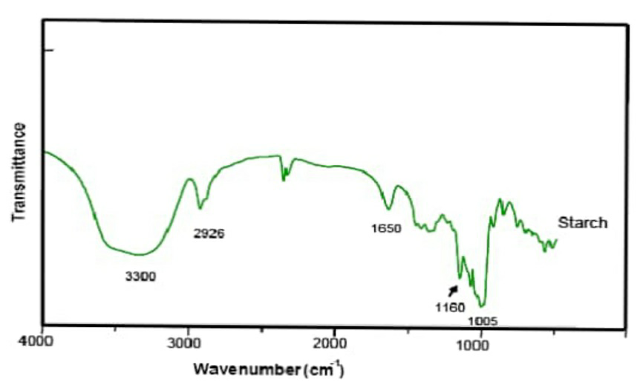
Figure 10: FT-IR of regular starch (Ramirez et al., 2014)
Characteristic vibrations of PVA

The FTIR spectra of PVA observed the main peaks at 3280, 2917, 1425, 1324, 1081, and 839 cm⁻¹ are assigned to be O-H stretching vibration of the hydroxyl group,CH₂ asymmetric stretching vibrations, C=O carbonyl stretch, C-H bending vibration of CH₂, C-H deformation vibrations, C-O stretching of acetyl groups and C-C stretching vibrations. Alireza Kharazmi et al., 2015.

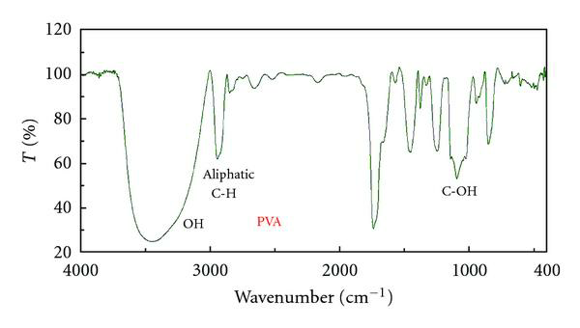
Figure 11: FT-IR spectrum of PVA (Hajian et al., 2011)

Characteristic vibrations of Naphthyl Chitosan/Starch Composite Hydrogel- (CSN)

Figure 12: FT-IR spectra of CSN
The FTIR spectra of Naphthyl Chitosan/starch composite hydrogel shows a peak at 1641.4 cm⁻¹ for C=O stretching of carbonyl and at 1546.9 cm⁻¹ for asymmetrical stretching of amide and new bands at 1344.38 cm⁻¹ and 1332.81 cm⁻¹ for bending of C-H and band at 1246.02, 1205.5 and 1149.5 cm⁻¹ illustrate C-O stretching. Neena singh et al., 2015.

A broad band around 3718 cm⁻¹ indicating the enhanced hydrogen bonding present in the composite hydrogel compared to that of raw Chitosan or starch. The imine group peak of Chitosan Schiff base shifted to 1627 to 1689 cm⁻¹. It is evident that the imine band was more intense as the content of aldehydic group was higher and significantly more intense compared to the band of the amide group of Chitosan which appeared only as a weak shoulder, highlighting the higher density of the imine units on the Chitosan. The increasing of the intensity of the imine band is accompanied by the diminishing of the amine band (vibration of the N H linkage at 1550 cm ⁻¹), again it is confirming the conversions of the amine functional groups into imine linkages during the condensation reaction. Maria Iftime et al., 2017. The peak located at 1149.5 cm⁻¹ is related to asymmetric vibrations of C-O-C which is produced during Chitosan deacetylation and the band at 1023 cm⁻¹ was due to the glycosidic bonds.( Moslam Alwaan et al., 2018).

The absorption at around 800 cm⁻¹ which corresponds to C-C stretching, which is absent in the spectrum of pure Chitosan indicates that when two or more polymers like Chitosan and starch are blended together, the occurrence of physical and chemical interactions will causes change in the characteristics peaks of the spectra. From all these observations, it is revealing that the presence of good miscibility between starch and modified Chitosan matrix. The reason is likely to be the formation of intermolecular hydrogen bonds between O-H and –NH groups in Chitosan and –OH group in starch.
Characteristic vibrations of Naphthyl Chitosan/PVA Composite hydrogel- CNP
Figure 13: FT-IR spectra of CPN

The FTIR spectra of Naphthyl Chitosan PVA composite hydrogel indicated at 611 cm⁻¹ and 1152 cm⁻¹ attributed to saccharide structures in polymer matrix. A strong absorption peaks at 1553, 1346 cm⁻¹ are characteristics of amide I and amide II linkages. The peak at 1643 cm⁻¹ confirms that the α -napthaldehyde is reacted with the Chitosan matrix through imine linkage. This can be attributed to the basic nature of amino group, i.e., amino group of the Chitosan easily undergoes imine formation with α- naphthaladehyde rather than hydroxyl groups present in polymeric chains. Sharp peaks at 1335 and 1452 cm ⁻¹ assigned to be CH₃ symmetrical deformation mode. Broad peaks at 1079 and1152 cm-1 indicates the C-O stretching vibrations in Chitosan and another peak at 3333.6 cm ⁻¹ is caused by amine N-H symmetrical vibrations. The peak at around 2936 cm⁻¹ is due to the typical C-H stretch vibrations. A broad band at 3753.62cm⁻¹ is associated with O-H stretching from the intermolecular hydrogen bonding arises due to the linkage of two polymer matrix. Maleki et al., 2018.

Table 7: Important indication in the FTIR spectra of Chitosan Schiff base and its Naphthyl Chitosan composite hydrogels.
FREQUENCY(CM⁻¹) |  |  | INDICATIONS
CNSB | CSN | CPN
3350 cm ⁻¹ | 3718.76 | 3379.29 | O-H stretching from inter and intra molecular hydrogen bonding.
2978.09, 2885.51 cm ⁻¹ | 2978.09,  2885.51 | 2924.09,  2970.38 | CH₂ symmetric and asymmetric stretching.
- | 1543.05 | 1550.77 | C=C stretching of aromatic system
1627.92 cm ⁻¹ | 1689.64 | 1643.55 | C=N vibrations of azomethine group.
1381.03 cm ⁻¹ | 1381.03 | 1373.32 | CH₃ symmetrical angular deformation.
756.10, 671.23, 624.94 cm ⁻¹ | 671.53 | 771.53 | C-H stretching of aromatic ring.
1033 cm ⁻¹ | 1023.5 | 1026.13 | Ring, C-O-C bridge stretching
1157.29, 817.82 cm ⁻¹ | 1149.57 | 1249.87, 894.97 | (1-4) glycoside bridge
3.3. Sample swelling and solvent solubility studies
3.3.1. Sample swelling
In order to examine the swelling ability of the synthesised Naphthyl Chitosan based composite hydrogels, sample swelling test was carried out by immersing the pre weighed dry samples in definite amount of deionized water for about 72 hours. The swelling percentage was calculated and found to be 89% for CSN and 72.6 % for CPN. The swelling percentage of the composite hydrogels confirms the swelling ability and it can be attributed to the water holding capacity of the synthesized compounds.

3.3.2. Solvent Solubility Test
The solubility of synthesised Naphthyl Chitosan based composite hydrogels was tested in different solvents and the results are presented in the Table. From the solubility table it is indicated that there is an increase in the weight of the samples when treated with solvents like water, chloroform and ethanol. However, when the samples treated with the acetone, it was surprise, instead of gaining weight, the gel becomes dispersed. All the samples prepared were either wholly or partially soluble in the above solvents used, which are desired results for the present work.
Table 8: Solubility in different solvents
SAMPLES | SOLVENTS
 | HCL | Acetic Acid | Ethanol | Acetone | Water | Chloroform
CNSB | + | + | ± | - | ± | -
CSN | + | + | ± | - | ± | -
CPN | + | + | ± | - | ± | -

(+) Indicates the completely soluble nature, ( - ) Indicates the insoluble nature, ( ±) Indicates the partially soluble nature.
Chitosan is hydrophobic in nature and it is soluble in aqueous acidic solutions due to its conversion in to an ionic structure. The insolubility of the Chitosan in most of the organic and aqueous solvents has been attributed to the extensive intramolecular and intermolecular hydrogen bonding between the chain and the sheets respectively in molecular structure. The solubility property depends on the substituents used for the modification of Chitosan. In the present work substituents like α -naphthaldehye, PVA, starch has been used. The synthesised Chitosan based composite hydrogels found to be insoluble in water due to the extent of substitution contributing to an increase in hydrophobicity (Jagadish et al., 2017). Also, the linkage of α -naphthaldehyde in the Chitosan matrix gives rigidity to the whole composite matrix that may attributes to the water accumulation capacity of hydrogels.

3.3.3. Biodegradation test

The composite hydrogels were subjected to biodegradable test by weighing dry sample of 0.01 g in container and recorded the weight of the samples after 3, 5, 7 and 11 days. The results were shown in Table. The composite CSN hydrogel tend to degrade quickly and the weight reduction is noticed for the number of days under examine. This confirms that the composite can be easily degradable by exposing with moisture and other factors in the environment. The composite CPN hydrogel exhibits constant weight for all the days under examination, which means no weight reduction in the sample. This can be explained that the composite CPN hydrogel can be degraded by prolonged time of exposure. Agustin et al., 2017 , Harish et al., 2005.
Table 9: Weight of Biodegradable composites
Composite | 1 day | 3days | 5days | 7 days | 11 days
CSN | 0.012g | 0.011g | 0.009g | 0.008g | 0.007g
CPN | 0.022g | 0.022g | 0.022g | 0.022g | 0.022g

Figure 14: Biodegradable weight of CSN & CPN composite hydrogels

3.4. Swelling behaviour and thermo responsive properties of synthesized Chitosan Based composite hydrogels:
3.4.1.Measurement of Degree of swelling:
The swelling behaviour of composite hydrogels was examined in deionized water for different intervals of time ranging from 1 h to 4 h. The swelling percentage was calculated and the trend of swelling is depicted in the Figure 24. From the results, the swelling capacity of CSN and CPN is found to be high and increase with increase in the immersion time. This could be attributed to the porous nature and types of functional group present in the polymeric matrix. David et al., 2004. The high swelling nature of the CSN composite hydrogel is due to the presence of polar groups causes more hydrogen bonds in turn increases the accumulation of water molecules. Subsequently, when swelling rate increases with increase in the immersion time.

Figure 15: Swelling behaviour of composite hydrogels

The swelling behaviour of Chitosan based composite hydrogel immersed in deionized water in different immersion period at room temperature is shown above.
In Chitosan / α-naphthaldehyde/starch biocomposite the water absorbency of hydrogel increases but in the case of chitosan/ α-naphthaldehyde/PVA biocomposites the water absorbency of hydrogel increases up to 120 min and afterward shows a slight decrease but still good swelling percentage. The swelling behavior of hydrogel can be attributed to the fact that they were more likely to associate with water molecule and formed more hydration layers around the polymeric chains through hydrogen bonding groups like OH.

The increase in swelling capacity can be due to the hydrophilic groups present in the starch polymeric chain which could easily form hydrogen bond between the water molecule. Geoffrey et al., 2006.

As the hydroxyl group of starch polymeric chain believed to facilitate the formation of hydrogen bond which substantially increases the swelling capacity the water binding ability of hydrophilic and hydrophobic group of chemically modified Chitosan based biopolymer composite hydrogel can be explained by adapting the above reasons.

Temperature Responsive Property of Hydrogels

To assess the temperature responsive property of the synthesized composite hydrogels, both the hydrogels were exposed to a room temperature of 28 ºC and a high temperature of 50 ºC. The variation in the swelling behaviour with temperature is shown in the Figure 25 & 26. It can be seen from the graph that an increase in temperature caused an increase in the swelling percentage take places for both the composite hydrogels. The reason is that the hydrogen bond formed between the imine nitrogen of Chitosan matrix and PVA as well as Starch matrix may dissociate with the water molecules inside the hydrogel network. As a result, the polymer chains in the composite hydrogel may relax, which leads to increased swelling. Anam et al., 2020.

Figure 16: Thermo-responsive studies in CSN

Figure 17: Thermo-responsive studies in CPN

The swelling percentage of two samples were measured at room temperature (28) and at higher temperature (50). As the temperature increases, the percentage of swelling samples also increases. Two samples prepared in the present work exhibit temperature responsive swelling behaviour in the immersion period. From the above practice, it is evident that the swelling percentage in higher temperature has greater swelling percentage than in the room temperature.

As temperature increases, the prepared hydrogels showed swollen configuration before dispersed. According to Khan et al., (2009), the diameter of hydrogels increases due to the interaction of acetyl group from chitosan becomes hydrophobic and results in aggregation. Zalifah et al., 2017.

3.4.2.Swelling behaviour in salt solutions
Hydrogels have become the topic of enhancement attention in numerous uses. In present research work, one of the key subjects related to swelling manners in salt solutions. The swelling behaviour of Naphthyl Chitosan based starch and PVA composite hydrogels was examined in different salt solutions viz., 0.1 M and 0.3 M of NaCl and KCl solutions respectively and the trend is depicted in the Figure 27 and Figure 28. The swelling capacity of hydrogels appreciably increased with growing NaCl concentration from 0.1 M to 0.3 M. The swelling behaviour of composite hydrogels in salt solutions is decided by two factors: cross-linking density and the polymer fraction. Salt solutions can gradually permeate into pores of the composite hydrogel to swell.

When composite hydrogels immersed in NaCl and KCl solution, the ionic solution pulls the water from the gel due to the osmosis effect. Hence, the gel exhibits low swelling at short times. As the time proceeds, the Na⁺, K⁺ and Cl⁻ ions diffuse into the gel due to the concentration gradient, the osmosis effect ceases and mixing dominates resulting in the exponential swelling of the gel. Present observations are consistent with those reported earlier. Baker et al., 1990, Hooper et al., 1990, Okay et al., 2000.

To explain the increase in swelling in salt solutions, it can be explained on the basis of the polymer–solvent interaction. The interaction between hydrogel and solvent decreases with increase in concentration of NaCl and it also depends on the substituent used for modification. The decrease of the hydrogel –solvent interaction with increase in concentration of NaCl implies decrease in polymer–polymer affinity or, in other words, increases in hydrophilicity. Sivanantham et al., 2012.
Polymer–polymer affinity decreases due to electrostatic screening by Na⁺ , K⁺ and Cl⁻ ions forming an electric double layer around the polar groups. This decrease in polymer–polymer affinity causes the gel to swell in NaCl solutions. As the concentration of the ions in the solution increases, both composite hydrogels increases due to increased screening resulting in the hydrogel network to turn more hydrophilic and causing increased swelling with increase in NaCl and KCl concentration. Therefore, the swelling ratio of the hydrogel in the studied salt solutions is in the order of monovalent > divalent > trivalent cations. Xingliang et al ., 2019.

Figure 18: Swelling studies of 0.1M & 0.3M NaCl and KCl in CSN

Figure 19: Swelling studies of 0.1M & 0.3M NaCl and KCl in CPN

3.4.3.Swelling behaviour in different Physiological solutions

The swelling behaviour of Naphthyl Chitosan based starch and PVA composite hydrogels was examined in different physiological solutions such as saline water, D-Glucose, Urea and Synthetic Urine respectively depicted in different time intervals as shown in the Figure 29 and Figure 30
The order of equilibrium swelling capacity for the above CSN solution in the decreasing order was ranked as D-Glucose solution > urea solution > physiological saline water > synthetic urine whereas for CPN solution is in the decreasing order as urea solution > physiological saline water > D-glucose solution > synthetic urine. Anam et al., 2020.
The swelling ratio of both CSN and CPN composite hydrogels is highest in D-glucose and urea solution which is caused by urea molecules in a state of cation by resonance and ionic interaction is conducted with carboxyl group in the network of hydrogel (ionic strength) Yashar et al., 2018. In CSN composite hydrogel, their occurs a shrinking behaviour of hydrogels in synthetic urine and physiological saline water is because of the charge screening effect of the counter ions (Na⁺ , K⁺ , Ca²⁺, and Mg²⁺) resulting in the decline of anion−anion repulsions, which reduces the osmotic pressure between the internal hydrogel network and the external solution. Muharam et al., 2017.

In CPN composite hydrogel, their occurs a shrinking behaviour of hydrogels showed in D-Glucose solution which is attributed to the presence of high amount of hydrophilic amines which is available for ionisation reaction and caused for the low cross linking density. Nicky et al., 2015.

Swelling ratio in NaCl solution could be smaller than its swelling in the water as known from figures 24, 29, 30 . This is because of the very low osmotic pressure due to the ions of Na+ and Cl- . There are a large difference between the concentration of those ions in salt solution and in the hydrogel network. When the hydrogels are immersed in water, there will be a maximum osmotic pressure which will enhances the rapid swelling of gels. Barleany et al., 2015.

Figure 20: Swelling studies of Different physiological solution of CSN

Figure 21: Swelling studies of different physiological solutions of CPN

3.5.Comparative study between Naphthyl Chitosan/PVA and Naphthyl Chitosan/Starch composite hydrogels

Figure 22: Comparative swelling studies of CSN and CPN

3.5.1. Morphological examination -Scanning Electron Microscopy (SEM)

From the swelling behaviour of the studied composite hydrogels, PVA incorporated hydrogels found to be more effective than the starch incorporated hydrogel. In order to examine the morphological difference exhibited in composite hydrogel, Naphthyl Chitosan/PVA was subjected to SEM analysis. The surface morphology of the Chitosan and Naphthyl Chitosan/PVA are examined using SEM analysis. The difference in structural morphology between the Chitosan and CPN is illustrated by their SEM image.

The SEM image of Chitosan shows small porous and rough membranous phases The surface of the Chitosan contains some microfibrils and crystal like structure. The surface morphology of pure Chitosan was uniform whereas Naphthyl Chitosan/PVA derivative do not have smooth and uniform but have uneven and rough surface.

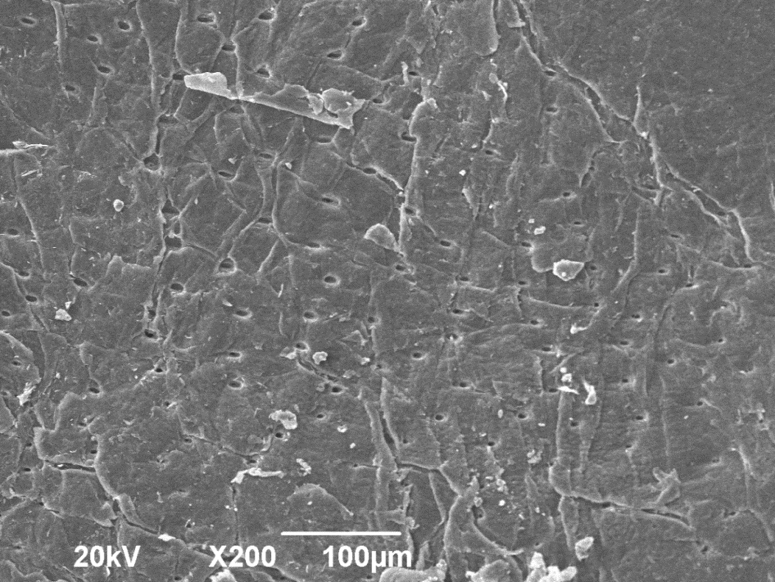

Figure 23: SEM analysis of pure Chitosan

Figure 24: SEM analysis of Naphthyl chitosan PVA hydrogel

The surface roughness and the small pores on the Chitosan found to be increased in Naphthyl Chitosan/PVA composite hydrogel. By the addition of PVA and Naphthyladehyde into the Chitosan matrix led to the increase in the size of the pores in the surface which in turn increases the rigidity and hydrophilicity of the composite hydrogel.

This morphological change in CNP as compared to the Chitosan can be caused due to its intermolecular and intramolecular interactions. The white folding structures seen in the SEM images, clearly shows the water holding capacity of the composite hydrogel.

6. CONCLUSIONS
Hydrogels are crosslinked hydrophilic polymer which will swells without dissolving in water or aqueous solutions. Hydrogels will responds to environmental stimuli such as pH, temperature , electric field etc. which had wide applications in all fields especially in biomedical applications. Natural polymers has excellent properties of non toxicity, biodegradability, swellability than the synthetic polymer. Hence, for my project I had choosen Chitosan as base polymer for the preparation of two new Naphthyl composite hydrogels by using PVA and starch individually.
In this current study of synthesis of Naphthyl Chitosan composite hydrogels there are few conclusions that can be deduced after completely performing the characterization tests. Composite hydrogels of Chitosan/starch and Chitosan/PVA were successfully prepared by condensation reaction with α-naphthaldehyde. Incorporation of starch and PVA individually into the Naphthyl Chitosan matrix modified the three-dimensional structure of Chitosan which favours the swelling properties of the materials. The yellowish colour of the hydrogel indicated the occurrence of a Schiff base between chitosan and α-naphthaldehyde, which was supported by the FTIR spectra. The characteristics and structure of prepared composite hydrogels were identifed using SEM, UV-VIS and FT-IR.
The FT-IR analyses performed indicated the interaction between the starch and chitosan molecules caused by the Schiff reaction between amino groups of chitosan with α-naphthaldehyde and the acetalization reaction between hydroxyl groups of chitosan with hydroxyl groups of starch. These composite hydrogels can be used as biodegradable packaging films for foodstuffs, fruits and vegetables.
The swelling percentage of distilled water for 72hrs were calculated and found to be 89% for CSN and 72.6 % for CPN. The swelling percentage of the composite hydrogels confirmed that the swelling ability and it can be attributed to the water holding capacity of the synthesized compounds. The swelling percentage will increases on increasing the temperature for both the composite hydrogel. was due to the hydrogen bond formed between the imine nitrogen of Chitosan matrix and PVA as well as Starch matrix may dissociate with the water molecules inside the hydrogel network. As a result, the polymer chains in the composite hydrogel may relax, which leads to increased swelling.
The swelling of prepared composite hydrogels was also investigated by various physiological solutions such as Saline water, D-glucose, urea, synthetic urine and salt solutions like KCl and NaCl. The best effect of the physiological solution to the swelling ratio of Naphthyl Chitosan composite hydrogels (CSN& CPN) were in urea solution and D-Glucose solution. The swelling ratio of composite hydrogels in urea solution was close to distilled water and D-glucose solution, because of the rise in ionic strength, an increase in salt concentration reduced swelling in salt solutions. Hydrogels perform excellent swelling behaviors in NaCl, KCl aqueous solutions, and their swelling ratio decrease with an increase of the salt concentration.
Scanning electron microscopy (SEM) showed the uniform distribution of components in the matrix which is an indicator of the structural integrity of the hydrogels. The Naphthyl Chitosan/PVA composite hydrogel possessed a non- porous structure and it clearly shows the water holding capacity of the composite hydrogel to a great extent.
Future works
Due to excellent properties of two newly prepared composite hydrogels, these were used in the field of biomedical application which includes drug delivery system, wound healing, tissue engineering. Pure PVA hydrogels had some limitations and are less effective in these applications. To enhance the properties of PVA hydrogels , it is required to explored creating the composite hydrogels containing both PVA and natural polymer Chitosan. This composite hydrogels will complement or enhance the property and make them more suitable as biomaterials for these above applications and comparing them to material derived from other sources to determine whether the PVA based composite provides the most effective method for biomedical application. This results in the identification of most effective material for biomedical application.
For future research, more attention should be devoted to synthesis through eco-friendly materials such as the selection of safe solvents and low energy consumption for synthesis process. The modified hydrogels with unique properties, such as superior elastic, highly stretchable, and self‐healing properties and to broaden novel biopolymer separation strategies with high molecular weights was necessary. Due to smaller size and faster stimuli‐responsive ability, a more insightful understand of delivery systems from microgels is very attractive. Moreover, controllable biodegradation of hydrogel in vivo should be carefully studied.
Reference
- Syed K.H.Gulrez, Saphwan Al- Assaf (2011), Glyn O Philips Hydrocolloids Research Centre Glyndwr university, Wexham,UK.
- N.A.Peppas, p. Bures(2000) Biomaterial and Drug delivery Laboratories, school of chemical engineering, Purdue university, West Lafayette.IN, USA.
- 2011)Nicholas A.Peppas, Allan.S.Hoffman(2012),Department of chemical engineering and Biomedical engineering ,Pediatrics, Surgery and Molecular Pharmaceutics and Drug Delivery, The University of Texas,Austin, TX, USA.
- S.H. Aswathy, U. Narendrakumar(2020), Department of Biosciences, School of Biosciences and Technology,Vellore Institute of Technology, vellore, India.
- Michelly C.G. Pellá , Michele K. Lima-Tenório(2018), Department of Chemistry, State University of Maringá, Av. Colombo, 5790, CEP 87020-900, Maringá, Paraná, Brazil.
- R. Jin, L.S. Moreira Teixeira(2009), Department of Polymer Chemistry and Biomaterials, Institute for Biomedical Technology (BMTI), Faculty of Science and Technology, University of Twente, P.O. Box 217, 7500 AE Enschede, The Netherlands.
- Jun Yang, Mingyue Shen(2021),State Key Laboratory of Food Science and Technology, Nanchang University, Nanchang, 330047, China.
- He LiuORCID logoa, Chenyu Wanga(2018), Orthopaedic Medical Center, The Second Hospital of Jilin University, Changchun 130041, P. R. China
- Zili L, Zhiqun,(2020),Lin School of Materials Science and Engineering Georgia Institute of Technology, Atlanta, Georgia,USA.
- M. Isabel Rial-Hermida, Ana Rey-Rico(2021),Department of chemistry, CICECO-Aveiero institute of materials, university of Aveiro, Portugal.
- Nadia Shamshad Malik, Mahamood AHMAD(2020), Department of pharmacy, Capital university of science and Tecnology, Islamabad, Pakistan.
- Preasopchai Tonglairoum, Thisirak Woraphatphadung(2016), Pharmaceutical development of Green Innovations group, Silpakorn university, Nakhon pathom, Thailand.
- Wong, J.Y. and Bronzino J.D (2007), Biomaterials, Taylor & Francis Group, New York, USA.

- Langer R. and Peppas N.A (2003), Advances in biomaterials, drug delivery and bionanotechnology, AIChE Journal, 49(12): 2990-3006.

- Bae YH and Kim SW (1998), Frontiers in Tissue Engineering, Drug Delivery, Elsevier Science & Technology Books, Oxford, UK.

- Kopecek, J, Jiyuan Yang (2007), Hydrogels as smart biomaterials, Polymer International, 56(9): 1078-1098.

- Williams D.F (2006), The Biomaterials: Silver Jubilee Compendium, Elsevier Ltd., Oxford, UK.

- Gupta P, Vermani K and Garg S(2002), Hydrogels: From controlled release to pH responsive drug delivery, 7(10): 569-79.

- O. Wichterle, D. Lím(1960), Hydrophilic Gels for Biological Use, Nature, 185: 117-118.

- A.S. Hoffman(2012), Hydrogels for biomedical applications, Advanced Drug Delivery Reviews, 64: 18–23.

- Garg A, Sweta G(2016), Hydrogel : Classification , Properties , Preparation and Technical Features, Asian Journal of Biomaterial Research, 2(6): 163–170.

- Varaprasad K, Malegowd G, Jayaramudu T, Mohan M, Sadiku R(2017), A mini review on hydrogels classification and recent developments in miscellaneous applications, Materials Science and Engineering: C, 79(1): 958–971.

- Takashi Iizawa, Hatsumi Taketa, Makoto Maruta, Takashi Ishido, Takehiko Gotoh, Sakohara S(2007), Synthesis of Porous Poly(N-isopropylacrylamide) gel beads by Sedimentation Polymerization and Their Morphology, Journal of Applied Polymer Science, 104 (2): 842–850.

- Vashist A, Y.K Gupta, S. Ahmad(2012), Interpenetrating biopolymer network based hydrogels for an effective drug delivery system, Carbohydrates Polymers, 87 (2): 1433–1439.

- Yahia LH (2015), History and Applications of Hydrogels, Journal of Biomedical Sciences, 4(2): 1–23.

- E Calo, V. V Khutoryanskiy(2015), Biomedical applications of hydrogels: A review of patents and commercial products, European Polymer Journal, 65: 252–267.

- S. Van Vlierberghe, P. Dubruel, E. Schacht(2011), Biopolymer-Based Hydrogels As Scaffolds for Tissue Engineering Applications: A Review, Biomacromolecules, 12 (5): 1387–1408.

- N. K. Singh, D. S. Lee(2014), In situ gelling pH and temperature-sensitive biodegradable block copolymer hydrogels for drug delivery, Journal of Controlled Release, 193(10): 214– 227.

- A. Giri, T. Bhunia, S.R. Mishra, L. Goswami, A.B. Panda, S. Pal, A. Bandyopadhyay, Acrylic acid grafted guargum-nanosilica membranes for transdermal diclofenac delivery., Carbohydr. Polym. 91 (2013) 492–501.

- C. Chang, M. Heng, J. Zhou, L. Zhang(2011), Swelling Behaviors of pH- and Salt Responsive Cellulose-based Hydrogels, Macromolecules. 44(6): 1642–1648.

- R. Kouser, A. Vashist, Md. Zafaryab, M.A. Rizvi, S.Ahmad(2018), Biocompatible and mechanically robust nanocomposite hydrogels for potential applications in tissue engineering, Materials Science and Engineering: C, 84: 168–179.

- K. Chrissafis, K. M. Paraskevopoulos, G. Z. Papageorgiou, D. N. Bikiaris(2008), Thermal and Dynamic Mechanical Behavior of Bionanocomposites: Fumed Silica Nanoparticles Dispersed in Poly(vinyl pyrrolidone), Chitosan, and Poly(vinyl alcohol), Journal of Applied Polymer Science, 110 (3): 1739–1749.

- G. Jung, J. Yun, H. Kim(2012), Temperature and pH-Responsive Release Behavior of PVA / PAAc / PNIPAAm/MWCNTs Nanocomposite Hydrogels, Carbon Letters, 13(3): 173–177.

- M. H. R. I.Iliescua, E. Andronescua, C. D. Ghitulicaa, G. Voicua, A. Ficaia(2014), Montmorillonite–alginate nanocomposite as a drug delivery system– incorporation and in vitro release of irinotecan, International Journal of Pharmacy, 463: 184-192.

- X. Wang, Y. Du, J. Luo(2008), Biopolymer/montmorillonite nanocomposite: Preparation, drug-controlled release property and cytotoxicity, IOP publishing, Nanotechnology. 19(6): 1-7.

- H. Zhang, M. Yang, Q. Luan, H. Tang, F. Huang, X. Xiang, C. Yang, Y. Bao(2017), Cellulose Anionic Hydrogels Based on Cellulose Nano fibers As Natural Stimulants for Seed Germination and Seedling Growth, Journal of Agricultural and Food Chemistry, 65 (19): 3785−3791.

- F. Ganji, E. Vasheghani-Farahani(2009), Hydrogels in controlled drug delivery systems, Iranian Polymer Journal, 18(1): 63-88.

- Morteza Bahram,Naimeh Mohseni,Mehdi Moghtader,An introduction to Hydrogels and some Recent Application(2016).

- B.Gupta, R.Agarwal(2011), Hydrogels for Wound healing applications.

- Kudaibergenov S.E., N. Dolya, G. Tatykhanova, Zh. Ibrayeva, B. Musabayeva, M. Yashkarova, and L. Bimendina.(2007), Semi-interpenetrating polymer networks of polyelectrolytes. Eurasian Chemico- Technological Journal, 9(3): 177–192.

- Wen Wu, Wenjing Li, L.Q. Wang, K. Tu, and W. Sun (2006), Synthesis and characterization of pHand temperature-sensitive silk sericin/poly(N-isopropylacrylamide) interpenetrating polymer networks, Polymer International, 55(5): 513–519.

- Zhang, Y.Xi, FeiPeng. Wu, M.Zh. Li, and E.J. Wang(2005), pH switching “on-off” semi-IPN hydrogel based on cross-linked poly(acrylamide-co-acrylic acid) and linear polyallylamine, Polymer, 46(18): 7695–7700.

- Faheem Ullah, Muhammad Bisyrul Othman(2015), Classification, processing and application of hydrogels, Materials Science and Engineering, 57: 414-433.

- Kasturi Joshi Navare,Loek J.Eggermont, Zachary J Rogers,Halimatu S Mohammed(2020), Antimicrobial hydrogels: key consideration and biomedical application: 511-542.

- Randy Chi Fai, Tzi Bun Ng, Jack Ho, Wai Yee Chan(2015), Chitosan: An update on potential biomedical and Pharmaceutical applications, Marine Drug, 13(8): 5156-5186.

- Manju Rawat Singh, Satish patel(2015), Natural polymer based hydrogels as scaffolds for tissue engineering, Nanobiomaterials in Soft Tissue Engineering, 5: 231-153.

- Pragnesh N Dave, Ankur Gor 2018. Natural Polysaccharide-based hydrogels and nanomaterials.

- Xiaoshan Liao, Xushan Yang, Hong Deng(2020), Injectable hydrogel based nano composite for cardiovascular diseases, Frontier bioengineering and biotechnology, 8: 251.

- Monica Gallo, L Ferrara(2016), Application of chitosan as a functional food, Novel Approaches of Nanotechnology in Food, 1: 425-464.

- Qiang Shi, Hao Liu, Feng Xu(2019), Bioactutors based on stimulus responsive hydrogels and their biomedical applications, NPG Asia Materials, 11(64).

- Y.X.Xu, K.M.Kim, M.A Hanna, D.Nag (2005), Chitosan-starch composite film : Preparation and characterisation, Industrial crops and products,21( 2): 185-192.

- Esam A. El-Hefian,Mohamed Mahmound Nasef , Abdul Hamid Yahaya(2010), The preparation and characterization of Chitosan/Polyvinyl alcohol blended films, E-journal of chemistry,7(4): 1212-1219.

- Kamlesh K and Usha Rani(2011), Controlled release of Metformin hydrochloride through crosslinked blends of chitosan-starch, Advances in Applied Research, 2(2): 48-54.

- M.O. Tuhin, Nazia Rahman, M.E.Haque, Ruhul A.Khan ,N.C.Dafader, Rafiqul Islam, M. Nurnabi, Wafa T(2012), Modification of mechanical and thermal property of chitosan-starch blend film, Radiation Physics and chemisty, 81: 1658-1668.

- Fenghong Li, Yanming Chen, Liang Li, XiaolinBai, Shu Li(2012), Starch-Chitosan blend films prepared by Glutaraldehyde cross linking, Advanced materials Resesarch, 415: 1626-1629.

- Virpal Singh, Kamlesh K(2014), Synthesis and characterization of Chitosan- Starch crosslinked film for controlled Drug Release, International Journal of Materials and Biomaterials Application, 4(1): 7-13.

- A Abraham, P.A Soloman,V.O. Rejini(2015), Preparation of Chitosan-Polyvinyl alcohol blends and studies on thermal and mechanical properties, Procedia Technology,24: 741-748.

- Firdos J, RD Mathad(2016),Mechanical studies on Chitosan/PVA blend with Calcium chloride as ionic crosslinker, International Journal of Advances in Science Engineering and Technology, 4(4): 2321.

- Haihong Li, Xiaochen Gao,Yan Wang, Xiaobo Zhang(2016), Comparison of Chitosan/starch Composite Film properties before and after cross linking, International Journal of Biological Macromolecules, 52(1).

- M.Z.I.Mollah, Nousin A, F.B. Quader(2016), Biodegradable colour polymeric film (starch-chitosan) Development, Open Journal of Organic Polymer Materials, 6(1): 11-24.

- Monserrat Escamilla- Garcia, Andrea R Basurto, Blanca G Almendarez, Elvia Hernandez(2017) ,Modified starch-chitosan edible films: Physiochemical and mechanical characterization, coatings, 7(12): 224.

- Yue Wang, Rui Li, Rui Lu, Jie Xu, Ke Hu, Yaowen Liu (2019), Preparation of Chitosan / corn starch/ Cinnamaladehyde Films for Strawberry Preservation.

- M.S. Hosseini , Issa Amjadi , Nooshin H(2012), Preparation of Poly (Vinyl Alcohol)/Chitosan-Blended Hydrogels: Properties, in Vitro Studies and Kinetic Evaluation, Journal of Biomimetics, Biomaterials & Tissue Engineering, 15: 63-72.

- Okolo, P.O.,Akakuru, O.U.,Suoji, O.U. and Jideonwo, A(2012), Studies on the properties of chitosan-starch beads and their application as drug release materials, Bayero Journal of Pure and Applied Sciences, 6(1): 118 – 126.

- Elbadawy A. Kamoun(2016), N-Succinyl chitosan-dialdehyde starch hybrid hydrogels for biomedical applications, Journal of Advanced Research,7(1): 69-77.

- Huanle Chen a , Xiaorong H, ,Enmin Chen , Shan Wu , David Julian M , Shilin Liu , Bin Li ,Yan Li (2016), Preparation, characterization, and properties of chitosan films with cinnamaldehyde nanoemulsions , Food Hydrocolloids, 61: 662-671.

- Merpiseldin Nitsae, Armeida Madjid, Lukman Hakim and Akhmad Sabarudin (2016), Preparation of chitosan beads using tripolyphosphate and ethylene glycol diglycidyl ether as crosslinker for Cr (VI), Adsorption chemistry & chemical technology, 10(1).

- E.Y. Yan, X.Y. Hao, M.L. Cao, Y.M. Fan and D.Q. Zhang(2016) ,Preparation and characterization of carboxymethyl chitosan hydrogel ,Pigment & Resin Technology, 45(4): 246 – 251.

- Akakuru OU and Isluku BO(2017), Chitosan hydrogels and their Glutaraldehyde crosslinked counterparts as potential drug release and tissue Engineering systems-Synthesis,Characteristics,Swelling Kinetics and mechanism, Journal of Physical Chemistry & Biophysics, 7(3).

- T.Thanyacharoen, P Chuysinuan, S.Techasakul, P. Nooeaid, S.Ummartyotin(2018), Development of a Gallic acid- loaded chitosan and Polyvinyl alcohol hydrogel composite:Release characteristics and antioxidant activity, International Journal of Biological Macromolecules, 107: 363-370.

- Swetha Muralidharan and Dr. Neetha J(2018), Studies on the Effect of Crosslinking of Chitosan/PVA Blend Based Hydrogel with Gluteraldehyde to be used as Thin Membranes, Asian Journal of Applied Science and Technology ,2( 2): 1111-1117.

- A.S. Montaser , Ahmed. R. Wassel , Oqba N. Al-Shaye (2018), Synthesis, characterization and antimicrobial activity of Schiff bases from chitosan and Salicylaldehyde/TiO2 nanocomposite membrane International ,Journal of Biological Macromolecules, 11: 229.

- T.C Sunarti , M. Irsan Febrian, Eka Ruriani , and Indah Yuliasih(2019) Some Properties of Chemical Cross-Linking Biohydrogel from Starch and Chitosan, International Journal of Biomaterials Volume , 6: 1-6.

- K. Kalantari, Ebrahim M, Bahram S, Pooneh S, Thomas J Webster(2020), Chitosan/PVA hydrogels incorporated with green synthesized cerium oxide nanoparticles for wound healing applications, European polymer Journal, 134: 109853.

- A.M.Abdel-Mohsen, A.S.Aly, A.Hebeish(2012), Eco-Synthesis of PVA/Chitosan Hydrogels for biomedical application, Journal of Polymer and the Environment, 19(4): 1005-1012.

- M. Hosseini, Issa Amjadi, Nooshin Haghighipour(2012), Preparation of polyvinyl alcohol/chitosan-blended hydrogels: Properties, In vitro studies and Kinetic Evaluation, Journal of Biomimetics Biomaterials and tissue engineering, 15: 63-72.

- E.Mirzaei B, A.Ramazani S.A, M.Shafiee and M. Danaei (2013), Studies on Glutaraldehyde crosslinked chitosan hydrogel properties for drug delivery systems, International Journal of Polymeric Materials and Polymeric Biomaterials , 62(11).

- Nadia A Mohamed,Nahed A.Abd El-Ghany(2017), Pyromellitimide benzoyl thiourea crosslinked carboxymethyl chitosan hydrogels as an antimicrobial agents, International Journal of Polymeric Materials and Biomaterials, 66(17): 861-870
.
- B Bahrami, Tayebeh B, Akram Zamani, Pejman Heidarian, Bijan Nasri-Nasrabadi(2019), Synthesis and chatracterization of carboxymethyl chitosan superabsorbent hydrogels reinforced with sugarcane bagasse cellulose nanofibers, Materials Research Express, 6(6).

- Liangquan Peng,Yong Zhou,Wei Lu,Weimin Zhu,Yusheng Li (2019), Characterization of a novel polyvinyl alcohol/chitosan porous hydrogels combined with bone marrow mesenchymal stem cells and its application, BMC Musculoskeletal Disorders,20: 257.

- Shahid Bashir Baig, Yin Yin Teo, Ramesh T subramaniam, (2019),N-succinyl chitosan preparation , characterization, properties and biomedical application, Journal of the Chilean Chemical Society, 64(3).

- A Ahsan, M A Farooq and Amna P(2020), Thermosensitive Chitosan based injectable hydrogels as an efficient anticancer drug carrier, ACS Omega, 5(38).

- Zhao Y, Kang J, Tang T (2006), Salt, pH and temperature-responsive semi interpenetrating polymer network hydrogel based on poly(aspartic acid) and poly(acrylic acid), Polymers, 47: 7702–7710.

- Harish P, Kshama , Lakshman, T.R.Shamla, R.N.Tharanathan(2005), Biodegradable of Chitosan graft polymethylmethacrylate film, International Biodeterioration, 56(2): 115-120.

- M Sivanantham and B V R Tata(2012), Swelling/deswelling of polyacrylamide gels in aqueous NaCl solution: Light scattering and macroscopic swelling study, Pramana-Indian Academy of Sciences, 79(3): 457-469.

- J P Baker, H W Blanch and J M Prausnitz(1995), Swelling properties of acrylamide-based ampholytic hydrogels: comparison of experiment with theory, Polymer, 36: 1061.

- H. H Hooper, J P Baker, H W Blanch and J M Prausnitz(1990), Molecular Thermodynamics of Aqueous Polymers and Gels, Studies in Polymer Science, 8: 203-221.

- O Okay and S B Sariisik(2000), Swelling behaviour of poly(acrylamide-co-sodium acrylate) hydrogels in aqueous salt solutions, European Polymer Journal, 36: 393.

- S Biranje, Pallavi Madiwale, Ravindra(2017), Preparation and characterization of chitosan/PVA polymeric film for its potential application as wound dressing material, Indian Journal of Scientific Research, 14(2): 250-256.

- A.Pawlak M Mucha(2003), Thermogravimetric and FTIR studies of Chitosan blends, Thermochimica Acta, 396(2): 153-166.

- P.D.Chetan, B.Vishalakshi(2013), Synthesis of ethylenediamine modified chitosan and evaluation for removal of divalent metal ions, Polymers, 97(2): 530-536.

- Jose E dos Santos, Edward R Dockal, Eder T.G. Cavalheiro(2005), Synthesis and Characterization of Schiff base from Chitosan and salicylaldehyde derivatives, Polymers, 60(3): 277-282.

- Neveen A Anan, S M Hassan, Eman M Saad, Ian S Butler, Sahar I Mostafa,(2011), Preparation, characterization and pH metric measurements of 4-hydroxysalicylidenechitosan schiff base complexes, Carbohydrates, 346(6): 775.

- Ali A Hebeish, Amal Aly, Amira Mohamed El-Shafei(2009), Synthesis and characterization of cationized starches for application in flocculation, finishing and sizing, Egyptian Journal of Chemistry, 52(1): 73-89.

- M.G.Lomeli Ramirez, A J Barrios-Guzman, Salvador Garcia, Jose De Jesus Rivera Prado, Chemical and mechanical evaluation of Bio-composites based on Thermoplastic Starch and Wood Particles Prepared by Thermal Compression, Bioresources, 9(2): 2960-2974(2014).

- Alireza K, Nastaran F, Roslina M Hussain, Elias Saion(2015), Structural, optical, opto-thermal and thermal properties of ZnS –PVA nanofluids synthesized through a radiolytic approach , Beilstein Journal of Nanotechnology,6(1): 529-536.

- Gholam AK, Morteza H, Hazhir Fallahi(2011), Graft copolymerization of Styrene from PVA via RAFT process, International Journal of Polymer Science, 8.

- M Maria Iftime, Simona M, Luminita M(2017), Salicyl-imine-chitosan hydrogels: Supramolecular architecturing as a crosslinking method towards multifunctional hydrogels, Carbohydrates polymers, 165(1): 39-50.

- Ismaeel M Alwaan(2018), Rheological characterization and modelling of vulcanization kinetics of natural rubber /starch blends, Journal of Applied Polymer Science, 23: 135.

- Abdolmaleki AY ,Zilouei H, Khorasani SN(2018), Characterization of electrospinning parameters of Chitosan/ PVA nanofibers to remove phenol via response surface methodology, Polymer Science, 4(1).

- Yuana Elly Agustin, KS Padmawijaya(2017), Effect of glyercol and ZnO addition on antibacterial activity of biodegradable bioplastics from chitosan- kapok banana peel starch, IOP Conference Series Materials Sciences and Engineering, 223(1).

- David R, Ashveen V Nan, Jagjit R Khurma(2004), Swelling properties of Chitosan hydrogels, The South Pacific Journal of Natural and Applied Sciences, 22(1).

- Geoffrey M Spinks, Chang Kee Lee, Gordon G Wallace, Sun I Kim, Seon J Kim(2006), Swelling Behaviour of Chitosan hydrogels in ionic liquid –water binary systems, 22: 9375-9379.

- Wenbo W, Jiang Wang, Yuru Kang, Aiqin Wang(2011), Synthesis, swelling and responsive properties of a new composite hydrogel based on hydroxyethyl cellulose and medicinal stone, 42: 809-818.

- Xingliang Li , Yihan Wang , Aoqi Li , Yingqing Ye , Shuhua Peng , Mingyu Deng and Bo Jiang(2019), A Novel pH- and Salt-Responsive N-Succinyl-Chitosan Hydrogel via a One-Step Hydrothermal Process, Biomolecules , 24: 4211.

- Yashar A, Asghar B, Hamed H, Hassan Namazi(2019), Synthesis of polyvinyl alcohol/CuO nanocomposite hydrogel and its application as drug delivery agent, Polymer Bulletin.

- S.Muharam, L.M.Yuningsih, M.R Sumitra(2017), Characterization of superabsorbent hydrogels based on epichlorohydrin crosslink and carboxymethyl functionalization of cassava starch, AIP Conference Proceedings, 1862.

- Nicky Mac Kenna, Paul Calvert, Aoife Morrin(2015), Impedimetric transduction of swelling in pH responsive hydrogels, Analyst, 140: 3003.

- Dhena R Barleany, Fida U, Shafina Istiqomah, Heri H Rahmayetty, Erizal, Swelling properties of cassava starch graft with poly(potassium acrylate-co-acrylamide)superabsorbent hydrogels prepared by ionizing radiation, AIP Conference Proceedings.

- Zalifah MD Rasib, Zulikifli Ahmad, Abbas Khan, Hazizan MD Akil(2017), Synthesis and evaluation on pH and temperature responsive Chitosan-p(MAA-co-NIPAM) Hydrogels, Macromolecules, 108.

- Neena Singh, Jaya Maitra (2015), Antibacterial Evaluation of starch and Chitosan based polymeric blend, Journal of Applied Chemistry, 8(4); 26 – 32.

- Jagadish C,Roy, Fabien Salaun, Stephane Giraud, Ada Ferri(2017), Solubility of Chitin: Solvents, Solution Behaviours and their Related Mechanism.

- Sudipta Chatterjee, Patrick Chi-Leung Hui(2018), Stimuli –Responsive Hydrogels:An interdisciplinary Overview.

- NazihaChirani,L.Hocine Yahia,Lukas Gritsch(2015),History and application of Hydrogels, Journal of Biomedical Science,4:2.

- Tomas Jesus Madera-Santana,Carlos Hernan Herrera-Mendez(2018),An overview of the chemical modification of Chitosan and their Advantages, Green Material,6(4):131-142.

- Sashikala.S, S.Syed Shafi(2014), Synthesis and Characterization of Chitosan Schiff base derivatives, Der.Pharmicia Lettre, 6(2): 90-97.

- Reynolds A.Frimpong, Stew Fraser,J.Zach Hilt(2006),Synthesis and temperature response analysis of magnetic –Hydrogel nanocomposite, Journal of Biomedical Materials Research , 80(1): 1-6.

