**PREPARATION AND CHARACTERISATION OF PVA BASED COMPOSITE FILM AND EVALUATION OF ITS ANTI MICROBIAL ACTIVITY**

**S.Varshini1, C.Kanishkar Raja1, P.Kavitha2, R.Menaka2 and M.R.Ezhilarasi2**

**1Post Graduate Student, Department of Chemistry, Dr.N.G.P Arts and Science College, Coimbatore, Tamil Nadu**

**2Assistant Professor, Department of Chemistry, Dr.N.G.P Arts and Science College, Coimbatore, Tamil Nadu**

**Corresponding Author: Dr.R.Menaka, Email:** [**menu.chem@gmail.com**](mailto:menu.chem@gmail.com)

**ABSTRACT**

This chapter reports the determination of eco-friendly, bio degradable polymer composite film by amalgamation of an edible, water soluble polysaccharide named as Carrageenan and based on PVA (polyvinyl alcohol). Polymers are macromolecules with long repeating chains of monomers made by the process of polymerization. Polymers possess multi-functionality and better film-forming capabilities, which could significantly improve protective barrier properties. Natural polymers are one among the major classes of polymers based on their origin. This class includes proteins, cellulose, poly peptides, and silk so on. They have certain advantages over the other classes of polymers because of their easy availability, potential-to bio-degrade, economic viability and their biocompatibility. Natural polymers are abundant and renewable. The biological properties like antibacterial anti-inflammatory and antioxidant efficacy of polymer based dressing can be enhanced by incorporating plant extract. PVA is a semi crystalline synthetic polymer. It can be fabricated into various forms like films and coatings which possess high tensile strength and flexibility. It is a promising biomaterial with high degree of swelling, bio degradability, non-toxicity, adhesiveness, bio inertness etc. Finally, after the composite film is developed, we characterize using FTIR and the solubility of synthesised composite film in different solvents is studied and its Antimicrobial activity is evolved.

KEYWORDS:

Polymers, natural polymers, eco-friendly, composite film, PVA.

**1. INTRODUCTION**

# **1.1 ABOUT POLYMERS**:

Natural polymers have similarities with extracellular matrix components which help them in avoiding toxicity, stimulation of reactions associated with synthetic polymers. Further they are subjected into metabolic degradation. Polysaccharides are readily available in nature from sources like algae (eg : alginate) , plants (eg: pectin, guar gum, mannan) , microbes (eg : dextran , xanthan gum ) and animals (eg: Chitosan , chondroitin). Monosaccharide polymers have signalling features like high stability, non-toxicity, bio degradability, ease to modify chemically, hydrophilicity, ability to form gels. The biological properties of natural extract loaded polymers like antibacterial anti-inflammatory and antioxidant efficacy of polymer based dressing can be enhanced by incorporating plant extract. Semi synthetic polymers are obtained from natural polymers by simple chemical treatment to change the physical properties of natural polymers like starch, silicones etc. whereas synthetic polymers are fibres synthesized in laboratory by polymerization of simple chemical molecules. Example: nylon polythene, polystyrene, synthetic rubber, PVC, Teflon etc. Biodegradable polymers or bio polymers are best alternative to petroleum based plastic products. Fiber reinforced polymer composite are signalled with high end applications such as medical science. Usage of bio based materials is a better way to develop environmentally safe products. Bio based materials are composed of substances from living matter. Green composite are natural fibres reinforced polymers. Even though they aren't that much stiff and strong as synthetic fibres, they are more attractive.

**1.2 POLYMER COMPOSITE**:

Polymer composite materials are the result of a mixture between two substances. This is done to obtain a product with a quality superior to the originals. In other words, the idea is to create a resource that meets the needs that pure polymers do not. The composite can be formed by two or more materials of different natures. Generally, they are composed of a polymer matrix and a support material, which can be organic or inorganic. Together, these materials form phases .It is also worth mentioning that polymer composites use thermoplastic or thermoset matrices at temperatures below 200 ºC.

When compared with conventional adsorbents such as activated carbon, synthetic ion exchange resins, adsorption of contaminants using polymer composite adsorbents have several advantages. Polymer composite adsorbents possess improved processability, reusability, selectivity to pollutants, stability etc

**1.3 PVA (POLY VINYL ALCOHOL)**

PVA is a semi crystalline synthetic polymer with chemical formula [CH2CH(OH)]n. It's molecular weight ranges from 20000-40000 Da. Molecular weight varies due to synthesis parameters such as initial chain length of vinyl acetate polymer and extend of hydrolysis to reduce acetate groups. Hydrolysis is allowed under alkaline or acidic conditions. It can be synthesized by hydrolysis from varieties of poly vinyl esters and poly vinyl ethers. Commercially available PVA is synthesized through partial or complete hydrolysis of poly vinyl acetate.

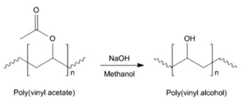

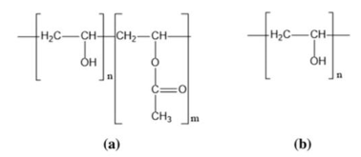**Fig-1: Hydrolysis of poly vinyl acetate to obtain poly vinyl alcohol**

**Fig-2: Structural formula for PVA which is a. Partially or moderately hydrolysed b. Completely hydrolyzed**

PVA's adsorption properties are due to abundant hydroxyl groups. Free hydroxyl groups of PVA serves as adsorption sites for heavy metal ions, anionic dyes, cationic dyes

**1.4 CARRAGEENAN**

Carrageenan is such a naturally occurring polysaccharide known for its gelling abilities. Based on alternating copolymers of 1,3-linked- β -D-galactose and 1,4-linked- β -D-galactose, it is possible to determine their linear primary structure. This unit are joined by alternating glycosidic linkages and it is the repeating unit of carrageenan.Carrageenan is categorized as strongly anionic polymers due to their half ester sulfate moieties. Most familiar types of carrageenan are Kappa (Κ), iota (γ) and Lambda (λ). These three forms differ only in the number of sulfate groups. Kappa (Κ) has one, iota (γ) has two and lambda (λ) has three sulfate groups respectively.

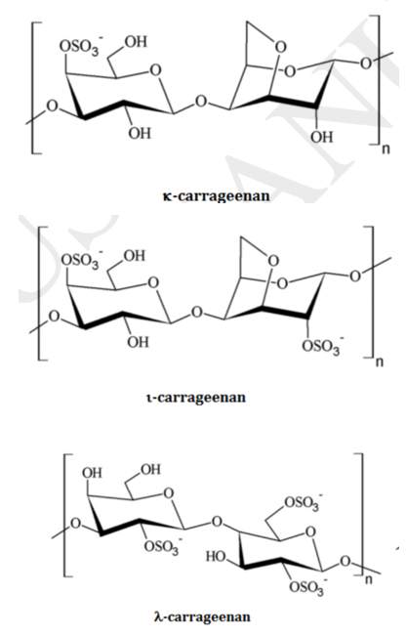

**Fig-3: Structures of a. Κ- Carrageenan , b. γ- Carrageenan , c. λ-Carrageenan**

Important feature of carrageenan is its biocompatibility and no induction of toxic reaction when used in appropriate concentrations.

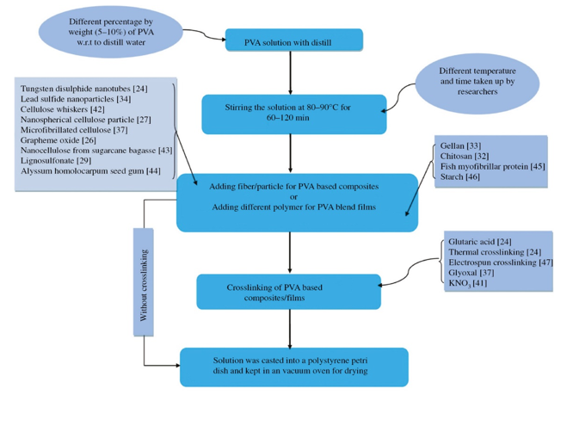

**Fig-4: Preparation of PVA based films or composite**

**2. MATERIALS AND METHODS**

**2.1 Chemicals Used:**

|  |  |  |  |
| --- | --- | --- | --- |
| Name of chemical used | Poly vinyl alcohol | Carrageenan | Acetone |
| Company | Himedia | La casa premium | Emplura |

* 1. **Selection of materials for preparation :**

Poly Vinyl alcohol (PVA), a water soluble synthetic bio polymer which possess good mechanical and thermal property as well as it possess good transparency.

Carrageenan is edible naturally occurring water soluble polysaccharides known for its gelling properties. It also possesses good mechanical properties that can be used for the preparation of film composites.

**2.3 Preparation for PVA based composites:**

0.5 g of PVA was dissolved in 5 ml of distilled water and heated for a few minutes for complete dissolution of PVA. It is stirred for some time in a magnetic stirrer. 0.5 g of carrageenan was dissolved in 5 ml of distilled water. Then the above two solutions were mixed together for about 2 hours by magnetic stirring at 60°C. The final solution was allowed to cool under room temperature. The product was precipitated using acetone and washed several times to remove unreacted compounds. The product was air dried and then weighed. The product was poured into a petridish and the polymer film was prepared by solution casting technique. The preparation of the film was carried out under both high and low temperatures.

**3 Characterization and confirmation of polymer composite films :**

**3.1 FTIR Technique:**

The synthesized PVA-Carrageenan based bio composite film were characterized using FTIR technique. The fundamental vibrations of PVA-Carrageenan based composite film was identified using Fourier transform infrared spectroscopy (FTIR) (Shimadzu) in the range of 4000-400 cm -1.

**4. EVALUATION OF ANTIMICROBIAL ACTIVITY BY MIC METHOD:**

**4.1. Principle of MIC method:**

In this method, graded amounts of antibiotics are incorporated in agar plates and inoculated in spots with the organisms under study. If the organism under study is susceptible to the incorporated antibiotic, no bacterial growth is expected in agar plates with higher amounts of the drugs. Inhibition of growth at the minimum or lowest concentration of antibiotic is regarded as the end point.

**4.2Materials required:**

* Culture media
* Solvent
* Antimicrobial agent
* Control stains
* Apparatus

**4.3. Procedure for MIC method:**

* + - **Preparation of anti-microbial stock solution:**

10 ppm of the polymeric sample were prepared by dissolving 0.01 g of polymer composite in 1 litre. This is taken as the stock solution for the experiment. Some drugs must be dissolved in solvents other than water.

Prepare stock solutions using formula

1000 xVxC=W

P

P-potency (µg/mg), V-Volume required (ml), C-Final concentration of solution (mg/L), W-Wt of antibiotics dissolved in volume V (mL).

* + - **Susceptibility testing :**

The prepared film was dissolved in water to make a concentration of 10 ppm. The stock solution was dispensed into sterile diluent using two fold dilution technique. Mueller Hinton Agar (MHA) was prepared and was kept in a water bath at 48-50°C prior to usage. Each empty sterile plate was labelled so as to identify the different concentration of the polymer compound.

0.5 ml, 1 ml and 1.5 ml dilutions of polymer compound was pipetted into each labelled plate and two replicates were prepared for each dilution. 9 ml of MHA was added to each labelled plates and mixed thoroughly. The agar was allowed to solidify at room temperature. Two control plates (without polymer compound) were prepared. By 18-24 hours the E.coli culture got 4-5 isolated colonies. It was shaked vigorously in a water bath at 30 °C until it achieves turbidity of 0.5 Mac farland standard [prepared by adding 0.5 moof 0.048 Bacl2 to 99.5 ml of 0.36 NH2SO4; commercially available].

The inoculum was standardized based on optical density [OD 625 of 0.08-0.1 (1 cm light path) using a spectrophotometer. The standardized inoculum was diluted 1:10 in sterile saline solution to obtain the desired concentration of 10^6 cfu /ml. 0.1 ml of 10^6 cfu /ml inoculum was pipetted and transferred to a well and sterile test tubes of same size. The plates were inoculated with 10 micro litre. The E.coli suspensions were introduced onto the surface of agar plate.

**4.4 Incubation**

The plates were incubated in an inverted position at 30 °C 18-24 hours. The MIC was recorded at the lowest concentration of polymer compound that completely inhibit the growth of organism as detected by the naked eye.

**5. RESULT AND DISCUSSION**:

The results are being discussed in the following phases:

**Phase 1:** Synthesis of PVA-Carrageenan based composite film

**Phase 2:** Characterizationof PVA-Carrageenan composite film

**Phase 3:** Solvent solubility studies for the prepared composite

**Phase 4:** Anti-microbial evaluation for the prepared composite

**Phase 5:** Thermal gravimetric analysis for the prepared PVA-Carrageenan based composite film.

**PHASE 1: Synthesis of PVA-Carrageenan based composite film**

PVA-Carrageenan composite was turned into a film. This is due to the good film forming ability of PVA and also because of its abundant hydroxyl groups. It also possesses good mechanical and thermal properties.

**SYNTHESIS OF PVA CARRAGEENAN COMPOSITE FILM**



**Fig-5: Synthesis of PVA-Carrageenan Composite**

**PHOTOGRAPHIC REPRESENTATION OF PREPARED COMPOSITE**

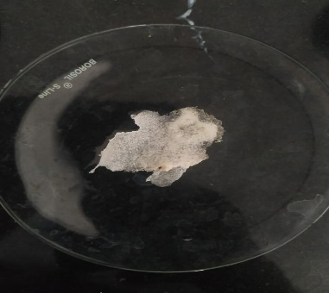

**Fig-5:PVA-Carrageenan composite film**

**Table-1:Conditions for preparing PVA-Carrageenan composite film**

|  |  |  |  |
| --- | --- | --- | --- |
| Polymer composite | Ratio of composite | Temperature | Nature of resulting polymer composite |
| PVA + Carrageenan | PVA – 0.5 g  Carrageenan-0.5 g | 30 °C | Solid flakes |
| 60 °C | Film |

The composite preparation was done using both PVA and Carrageenan polymers. The resultant PVA-Carrageenan came out as a good film at high temperature. At low temperature, it remained as solid flakes. At high temperature, the bond formed between the PVA and Carregeenan may exhibited as chemical interaction while at the low temperature, ther may be occurrence of weak vanderwaals force of interaction which might cause the composite to remain as flakes. TGA was taken for film formed at high temperature to ensure the formation of chemical bond formed between two polymers.

**PHASE 2: Characterization of PVA-Carrageenan composite film**

**Fourier Transform Infrared Spectroscopy**

FTIR spectra of Carrageenan, PVA and their composite are analyzed to identify the functional groups present in them. The spectra and the spectral data are presented below.

**Characteristic vibrations of PVA**

The FTIR spectra of PVA shows main peaks at 3300, 2940, 1731,1141and 1087 cm-1**.** The large bands observed between 3550 and 3200 cm− 1 are linked to the stretching O–H from the intermolecular and intramolecular hydrogen bonds .The vibrational band observed between 2840 and 3000 cm− 1 refers to the stretching C–H from alkyl groups and the peaks between 1750–1735 cm− 1 are due to the stretching C=O and C–O from acetate group remaining from PVA.

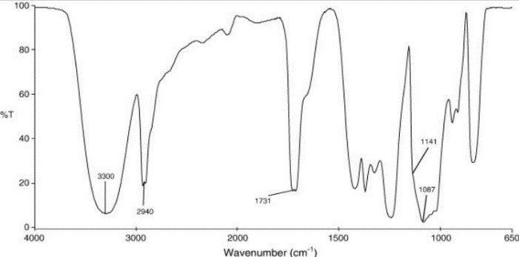

**Fig-6: FTIR of pure PVA**

**Characteristic vibrations of Carrageenan**

The FTIR spectra of Carrageenan shows major peaks at 3354,2935,1650,1231 and 1070 cm-1. A wide band in the region from 3000 to 3600 cm-1 attributed to the hydrogen bonding of the groups OH and band in 2994 – 2900 cm-1 of C-H stretching. Speciﬁc absorption bands may be observed in the carrageenan spectrum: band 845 cm-1 relative to the bonding C-O-SO3 in the position C4 of the galactose ring; band of 1234 cm-1 attributed to the bonding S=O of sulfate esters; band of 924 cm-1 relative to the bonding C-O of 3,6-anhydrogalactose and band of 1070 cm-1 attributed to the glycosidic bonding.

**Characteristic vibrations of PVA-Carrageenan composite film**

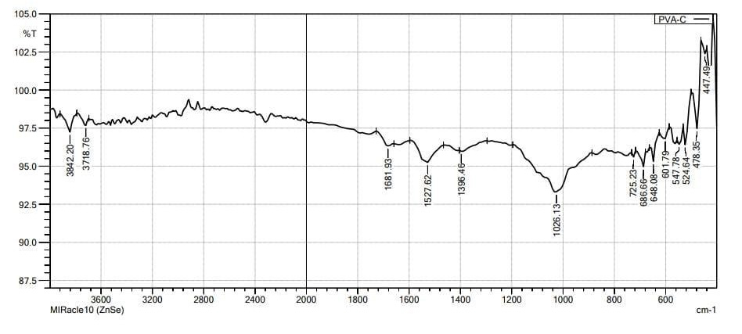The FTIR spectra of the PVA-carrageenan composite shows major peaks at 3842.20, 3718.16 , 1681, 1527 , 1396 and 1026 cm -1. The narrow sharp band at 3800-3700 are attributed to the OH stretching. A medium broad band in between 1680-1527 cm -1 is attributed to the C=O stretching from acetate group remaining in the PVA. The band at 1396 cm-1 is attributed to the S=O stretching of sulfate esters in carrageenan. The band at 1026.13 cm -1 may be an indication of glycosidic bonding in carrageenan.

**Fig-7: FTIR spectra of PVA-Carrageenan composite**

**Important indications from FTIR spectra of PVA-C composite**

1. The broad bands due to OH stretching in both PVA and carrageenan at 3300 and 3354 cm -1 changed to a narrow, sharp band in the composite.
2. The C=O stretching from acetate group in PVA at 1750 -1735 cm-1is changed to 1681.93 cm-1in the composite.
3. The band 1234 cm-1 attributed to the bonding S=O of sulfate esters in carrageenan is changed to 1396.46 cm -1 attributed to S=O stretching in the composite.
4. The band at 1026 cm -1 in the composite maybe a indication of glycosidic bonding in carrageenan at 1070 cm -1.

This specific vibrations indicates that a composite is formed by the reaction of PVA with Carrageenan.

**PHASE 3: Solubility test for the prepared PVA-Carrageenan film**

The solubility of synthesized PVA-Carrageenan based composite film was tested in different solvents are presented in the table. The solubility was tested in water, ethanol and acetone. The sample prepared was either wholly or partially soluble in the solvents used.

**Table 2:**  **Solubility studies in different solvents for the composite**

|  |  |  |  |
| --- | --- | --- | --- |
| Sample | Water | Ethanol | Acetone |
| PVA -Carrageenan | Completely soluble | Partially soluble | Partially soluble |

**PHASE 4 : Anti-microbial evaluation of the prepared composite:**

The Antimicrobial property of the synthesized PVA-Carrageenan composite film was evaluated using Minimum inhibitory concentration (MIC) method. In this method the polymer sample was observed under 540 nm in the spectrophotometer. The OD values was recorded for three different concentration of the sample; 0.5 ml,1 ml and 1.5 ml. The respective OD values for different concentrations are tabulated below.

**Table 3:**  **MIC values for the composite at different concentration**

|  |  |
| --- | --- |
| Concentration | OD values |
| 0.5 ml | 0.48 OD |
| 1 ml | 0.32 OD |
| 1.5 ml | 0.11 OD |

The OD value for the PVA-Carrageenan sample was decreasing when the concentration was increased. This indicates the presence of very low microbes in the living cell. 1.5 ml is the minimum inhibitory concentration of the prepared PVA-Carrageenan composite with the lowest OD value. The OD value may be decreased further if the concentration was increased. For this reason, the processed anti-microbial sample is effective.

In the MIC method, turbidity in the test solutions shows growth of microbes. In this dilution method, the lowest concentration which inhibits the turbidity (cloudiness) is the MIC. In the synthesized polymer sample, 1.5 ml is the lowest concentration which shows a clear solution (no turbidity) which indicates the inhibition of microbial growth. Turbidity may be further decreased beyond 1.5 ml.

**PHASE 5: Thermal gravimetric analysis for the prepared PVA-Carrageenan based composite film**

MF6CB5.wmfThe thermal stability of prepared anti-microbial PVA-Carrageenan was analyzed by TGA (thermal gravimetric analysis) (EX-STAR SII TG/DTA 6300) under nitrogen atmosphere at heating rate of 20 °C/ minute. The TG curve of prepared PVA-Carrageenan composite film is shown in the figure.

**Fig-8: TG Curve for PVA-Carrageenan composite**

An observation from the thermograph of PVA-Carrageenan film reveals that the first thermal degradation step occurring in the region 50-100°C with weight loss of about 16%. This degradation step is due to loss of water molecules bounded to the polymeric chain and some impurities. The second degradation step starts at 230°C and reaches at 370 °C and further another degradation step starts at 390-490°C.The former degradation correspond to the decomposition of PVA matrix and later correspond to the decomposition of carrageenan matrix. The above observation concluded that the prepared polymeric film showed good thermo stability till 230°C and the stability of the film with stands to the temperature greater than 400°C .Thus the good thermal performance of the prepared film can be applied in harsh environments.

**SUMMARY AND CONCLUSION**

PVA based composite film was prepared using PVA and carrageenan. The prepared film was characterized using FTIR spectroscopy. Solubility study was done using different solutions. FTIR spectroscopy confirmed formation of the film and spectral values indicated the hydrogen bond interactions. Anti-microbial studies for the film using MIC method which showed that the film have efficient activity. The decrease in the OD values on increasing concentration of the sample film showed the prepared film exhibited good anti-microbial property. TGA results showed that the film has good thermal stability till 230oC and the stability of the film withstands to the temperature greater than 400 oC. This composite film can be used in the field of food packaging and other applications since it have anti-microbial properties and good thermal stability.

**References:**

1. Kulkarni Vishakha S*, Butte Kishor D and RathodSudha S. Natural Polymers- A

comprehensive Review December 2012,International Journal of Research in Pharmaceutical

and Biomedical Sciences 3(4):1597-1613

3. J.F.Mano, VM Correlo, ME Gomes, K Tuzlakoglu, JM Oliveira, PB Malafaya,, NM Neves,

RL Reis ,Tissue engineering using natural polymers, Biomedical polymers, 197-217, 2007

4. Deb Jyotirmoy, Mrinmay Das, Arup Das. Excellency of natural polymer in drug delivery

system: a review. International Journal of Pharmaceutical and Biological Science Archive,

2017; 5(1): 17-22.

5. Gurusar Sadhar, Ludhiana. Natural polymers based drug delivery systems. World Journal of

pharmacy and pharmaceutical sciences, 2016; 5(4): 805-816

6. Krushnakumar J Gandhi, Subhash V Deshmane, Kailash R Biyani. Polymers in

pharmaceutical drug delivery system: A Review. International Journal of Pharmaceutical

Sciences Review and Research, 2012; 14(2): 57-66.

7. Kusum Kaushik, Ram Babu Sharma, Shwetha Agarwal. Natural polymers and their

applications. International Journal of Pharmaceutical Sciences Review and Research,

2016; 37(2): 30-35.

8. Ouellette, Robert J. (2015). Principles of Organic Chemistry || Synthetic Polymers. , (),

397–419.

9. Alven S, Khwaza V, Oyedeji OO, Aderibigbe BA. Polymer-Based Scaffolds Loaded with

Aloe vera Extract for the Treatment of Wounds. Pharmaceutics. 2021 Jun 26;13(7):961

10. A. Sun, X. He, L. Li, T. Li, Q. Liu, X. Zhou, X. Ji, W. Li, Z. Qian, An injectable

photopolymerized hydrogel with antimicrobial and biocompatible properties for infected skin

regeneration, NPG Asia Mater. 12 (2020) 1–11

11. K. Wang, H. Wang, S. Pan, C. Fu, Y. Chang, H. Li, X. Yang, Z. Qi, Evaluation of new film

based on Chitosan/Gold nanocomposites on antibacterial property and wound-healing

efficacy, Adv. Mater. Sci. Eng. 2020

12. H. Bakhsheshi-Rad, A. Ismail, M. Aziz, M. Akbari, Z. Hadisi, M. Daroonparvar, X. Chen,

Antibacterial activity and in vivo wound healing evaluation of polycaprolactone-gelatin

methacryloyl-cephalexin electrospun nanofibrous, Mater. Lett. 256 (2019), 126618,

13. S.P. Miguel, A.F. Moreira, I.J. Correia, Chitosan based-asymmetric membranesfor wound

healing: a review, Int. J. Bi ol. Macromol. 127 (2019) 460–475,

14. Prasathkumar M, Sadhasivam S. Chitosan/Hyaluronic acid/Alginate and an assorted

polymers loaded with honey, plant, and marine compounds for progressive wound healing-

Know-how. Int J Biol Macromol. 2021 Sep 1;186:656-685

15. Basheer Aaliya, Kappat Valiyapeediyekkal Sunooj &amp; Maximilian Lackner (2021)

Biopolymer composites: a review, International Journal of Biobased Plastics, 3:1, 40-84,

16. Christian SJ. Nat­ral fibre-reinforced noncementitio­s composites (biocomposites). In:

Nonconventional and vernac­lar constr­ction materials. Woodhead Publishing; 2016. p.

111–1

17. Bharathi SKV, M­r­gesan P, Moses JA, et al. Recent trends in nanocomposite packaging

materials. 2020.

18. Calori IR, Braga G, de Jes­s da CC P, et al. Polymer scaffolds as drug delivery systems. Euro Polym J. 2020

19. Bin PS, Lih E, Park KS, et al. Biopolymer-based functional composites for medical

applications. Prog Polym Sci. 2017;68:77–105

20. Lackner M. Bioplastics. In: Kirk-othmer encyclopedia of chemical technology. 2000. p. 1–41

21. Buchholz FL, Graham AT. Modern superabsorbent polymer technology New York: Wiley-VCH; 1998 [chapters 1–7]

22. Brannon-Peppas L, Harland RS. Absorbent polymertechnology. J Controlled Release

1991;17(3):297–8.6. Li Yuhui, Huang Guoyou, Zhang Xiaohui, Li Baoqiang,

ChenYongmei, Lu Tingli, Lu Tian Jian, Xu Feng. Magnetichydrogels and their potential

biomedical applications. . Adv Funct Mater 2013;23(6):660–72.5