**Anisotropic Stellar Model with Chaplygin equation of state**

Manuel Malaver1 and Rajan Iyer2

1Maritime University of the Caribbean, Department of Basic Sciences, Catia la Mar, Venezuela.

Email: [mmf.umc@gmail.com](mailto:mmf.umc@gmail.com)

2Environmental Materials Theoretical Physicist, Department of Physical Mathematics Sciences Engineering Project Technologies, Engineeringinc International Operational Teknet Earth Global, Tempe, Arizona, United States of America

Email: [engginc@msn.com](mailto:engginc@msn.com)

**Abstract:** In this research some analytical models of charged strange stars with anisotropy have been proposed. Choosing a particular form of metric potential, the Einstein-Maxwell field equations have been solved. The relationship between radial pressure and energy density is given by the generalized Chaplygin equation of state of strange quark matter We proposed some models consistent with stellar objects as GJ 832, LHS 43, SAO 81292, GJ 380, GJ 412 and SAO 62377.

**Keywords:** Einstein-Maxwell field equations; Chaplygin equation of state; Electric field

intensity; Compact structures; Charged strange stars; Quark matter.

1. **Introduction**

Research on compact objects and strange stars is a central issue of great importance in theoretical astrophysics in the last decades [1,2].Researches as Komathiraj and Maharaj [3], Ivanov [4], Malaver and Kasmaei [5], Bowers and Liang [6],Gokhroo and Mehra [7], Esculpi et al. [8], Malaver [9,10], Chan et al.[11], Malaver [12] and Cosenza et al. [13] have used numerous mathematical strategies to try to obtain exact solutions which indicates that the Einstein-Maxwell field equations is of great importance to describe compact objects.

In order to propose physical models of interest that behave well it is important to consider an adequate equation of state. Recently Malaver and Iyer [14] generated new models of compact stars considering the new version of Chaplygin equation of state proposed for Errehymy and Daoud [15]. Also the electric field intensity within a fluid sphere has been a subject of great interest because it has allowed studying the effect of electromagnetic fields on astrophysical stellar objects [16-20]. According Bhar and Murad [21] the existence of electric field modifies the values of redshifts, luminosities and mass for stars. Malaver and Iyer [22,23] have developed some stellar models with a well-defined electric field.

In recent decades, the theoretical research [24-34] in realistic stellar models show that the nuclear matter may be locally anisotropic in certain very high density ranges (ρ˃1015 gcm-3), where the relativistic treatment of nuclear interactions in the stellar matter becomes important. From the pioneering work of Bowers and Liang [6] that generalized the equation of hydrostatic equilibrium for the case local anisotropy, there has been an extensive literature devoted to study the effect of local anisotropy on the bulk properties of spherically symmetric static general relativistic compact objects [35-45]. Therefore it is always interesting to explore the consequences produced by the appearance of local anisotropy under variety of circumstances.

Presently there are efforts underway to understand the underlying quantum aspects with astrophysical charged stellar models [29-34]. How the energy matter quantum wavefunction creates situations with equation of state potential, expansions with quintessence field cosmologies with interior having dark energy matter generation compact stellar anisotropic gravitational potential and structure of many objects, especially strange quark stars as well have been key in Quantum Astrophysical projects ongoing [34-40]. There is also study of the symmetry group theory with authors advancing that will help to classify general field-particle metrics linking towards Standard Model Particle Physics String Theories with Hubble and James Webb Telescope observations of the expanding universe models that is supposed to manifest from natural astrophysical Big Bang Theory [36-45].

The principal motivation of this work is to develop some new analytical relativistic stellar models by obtaining of solutions of Einstein-Maxwell field equations with a generalized Chaplygin equation of state and with a particular shape of metric potential *Z(x)* . The solutions obtained by satisfying applicable physical boundary conditions provide a mathematically simple family of electrically charged strange stars. The paper is structured as follows: the next section, Sect.2, are presented the interior solutions of Einstein-Maxwell field equations of anisotropic fluid. In Sect. 3, we present the new interior solutions for the proposed model. In Sect. 4, physical acceptability conditions are discussed. The interior spacetime will be matched to the exterior spacetime described by the unique Reissner-Nordstrom metric, physically realistic fluid models will be constructed and analysis will be made on the obtained models in Sect. 5. Finally in Sect. 6 discusses and concludes the work.

**2. Einstein-Maxwell system of equations**

In this research the interior metric in Schwarzschild coordinates  [46,47] is given in the following form:

 (1)

For the metric (1), the Einstein-Maxwell field equations may be expressed as the following system of differential equations [6] :

 (2)

 (3)

 (4)

 (5)

where prime (') denotes the derivate with respect to *r*. *ρ*,   denote the energy density, radial pressure, tangential pressure, charge density of the fluid distribution respectively.

The mass of stellar object contained within a sphere of radius r is given by

 (6)

From Eqs. (3) and (4), we can obtain

 (7)

With the transformations,and suggested by Durgapal and Bannerji [39], Eqs. (2)-(7) take the following forms:

 (8)

 (9)

 (10)

 (11)

 (12)

 (13)

where dots denotes the derivate with respect to *x*,  >0 and *C*>0 are arbitrary constants and  is the anisotropic factor which measures the pressure anisotropy within the star. The system of equations (8)-(12) governs the gravitational behaviour for an anisotropic fluid.

In order to obtain physically realistic stellar models, in this paper we assume that the radial pressure and the energy density are related by the following equation:

 (14)

where *A* and *B* are constants parameters.

**3.** **Charged Anisotropic Model**

In this work, we take the form of the gravitational potential *Z(x)* as *Z(x)=1-ax*proposed for Thirukanesh and Ragel [47] and Malaver [48] where a is a real constant. This potential is regular at the origin and well behaved in the interior of the sphere. Following Liguda et al. [40] for the electric field ,we make the particular choice:

 (14)

This electric field is finite at the center of the star and remains continuous in the interior. Using  and eq.(14) in eq.(6), we obtain

 (15)

Substituting eq. (15) in eq. (13), the radial pressure can be written in the form:

 (16)

Using eq. (15) in eq. (12), the expression of the mass function is

 (17)

With eq. (14) and *Z(x)* in eq. (11), the charge density is

 (18)

With equations (13), (14), (15) and ,eq.(7) becomes:

 (19)

Integrating eq. (19) we obtain:

 (20)

where for the convenience we have let

 (21)



(22)

 (23)

and  is the constant of integration.

The metric functions and can be written as:

 (25)

 (26)

and the anisotropy Δ is given by:



(27)

1. **Elementary Criteria for Physical Acceptability**

A physically acceptable interior solution of the gravitational field equations must comply with the certain (not necessarily mutually independent) physical conditions [41,47] :

1. The solution should be free from physical and geometric singularities, i.e., ˃ 0, ˃ 0 and , , *ρ* are finite in the range 0 ≤ r ≤ R.
2. The radial and tangential pressures and density are non-negative , , *ρ ≥ 0*
3. Radial pressure  should be zero at the boundary *r= R* , i.e., , the energy density and tangential pressure may follow and .
4. The condition  be the condition that the speed of sound not exceeds that of light.
5. Pressure and density should be maximum at the center and monotonically decreasing towards the pressure free interface (i.e., boundary of the fluid sphere). Mathematically

 ≤ 0 and  ≤ 0 for 0 ≤ r ≤ R.

1. Electric field intensity *E* , such that *E(0) = 0* , is taken to be monotonically increasing, i.e., ˃ 0 for *0* *≤ r ≤ R*.
2. Pressure anisotropy vanishes at the centre, i.e., *Δ(0)=0* [47].

(viii) The charged interior solution should be matched with the [Reissner–Nordström](https://en.wikipedia.org/wiki/Reissner%E2%80%93Nordstr%C3%B6m_black_hole)  exterior solution, for which the metric is given by:

 (28)

through the boundary *r=R* where *M* and *Q* are the total mass and the total charge of the star,

respectively.

1. **Physical Analysis**

We now present the analysis of the physical characteristics for the new model. The metric functions and should remain positive throughout the stellar interior and in the origin , .We note in *r=0* that .This demonstrates that the gravitational potentials are regular at the centre *r=0* . The energy density and radial pressure are positive and well behaved inside the stellar interior. Also, we have the central density and pressure , . According to the expression of radial pressure, *pr(0)* will be non-negative at the centre as it is satisfied by the condition 3*AaC* ˃  .

In the surface of the star *r=R ,* we have  and

 (29)

For a realistic star, it is expected that the gradient of energy density and radial pressure should be decreasing functions of the radial coordinate 𝑟. In this model, for all *0 < r < R,*  we obtain respectively:

 ˂ 0 (30)

 ˂ 0

(31)

and according to the equations (29) and (30), the energy density and radial pressure decrease from the centre to the surface of the star.

From eq. (17), we have for the total mass of the star :

 (32)

The causality condition demands that the radial sound speed defined as should not exceed the speed of light and it must be within the limit in the interior of the star [3]. With the transformations of Durgapal and Bannerji [70] in this model we have:

 (33)

On the boundary *r=R*, the solution must match the Reissner–Nordström exterior space–time as:

 (34)

and therefore, the continuity of  and across the boundary *r=R* is

 (35)

Then for the matching conditions, we obtain:

 (36)

In Table 1 presents the values of the parameters chosen *K*, *A*, *B* and *a*. The masses of stellar objects are also shown

**Table 1**. Parameters *a*, *A*, *B* and stellar masses for different values of *k*

|  |  |  |  |  |
| --- | --- | --- | --- | --- |
| *k* | *A* | *B(x10-5)* | *a* | *M(Mʘ)* |
| 0.0011 | 0.2 | 1.5 | 0.011 | 0.60*Mʘ* |
| 0.0012 | 0.2 | 1.5 | 0.011 | 0.55*Mʘ* |
| 0.0013 | 0.2 | 1.5 | 0.011 | 0.48*Mʘ* |

Where *Mʘ* is the mass of the sun

The figures 1, 2, 3, 4, 5, 6, 7, 8 and 9 represent the graphs of *ρ* , *pr* , *M(x)* , *σ2* , *E2*, Δ ,

, and  with the radial coordinate, respectively. In all the cases we have considered *C*=1.

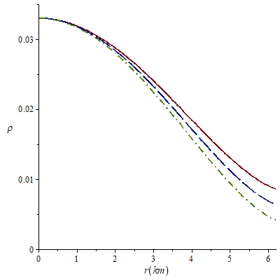

**Figure 1**. Variation of energy density with the radial coordinate for *k*=0.0011 (solid line), *k*=0.0012 (long-dash line) and *k*=0.0013 (dash-dot line).

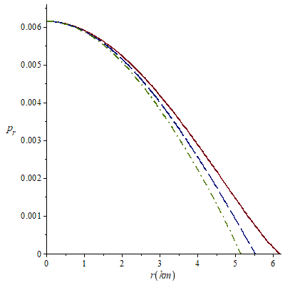

**Figure 2**. Variation of radial pressure with the radial coordinate for *k*=0.0011 (solid line), *k*=0.0012 (long-dash line) and *k*=0.0013 (dash-dot line).

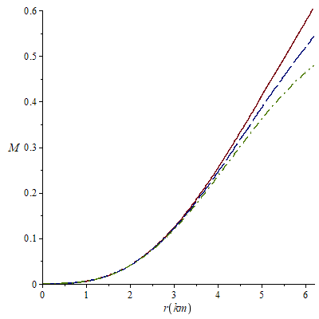

**Figure 3**. Variation of Mass function *M* with the radial parameter for *k*=0.0011 (solid line), *k*=0.0012 (long-dash line) and *k*=0.0013 (dash-dot line).

.

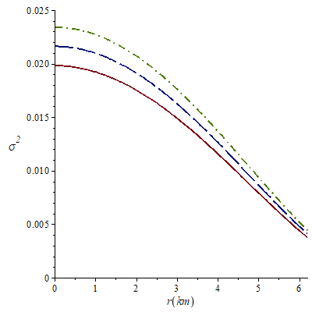

**Figure 4**. Variation of charge density with the radial parameter for *k*=0.0011 (solid line), *k*=0.0012 (long-dash line) and *k*=0.0013 (dash-dot line).

.

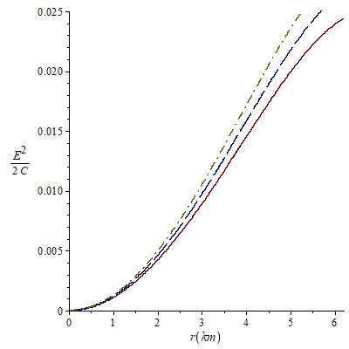

**Figure 5**. Variation of electric field intensity with the radial parameter for *k*=0.0011 (solid line), *k*=0.0012 (long-dash line) and *k*=0.0013 (dash-dot line).

.

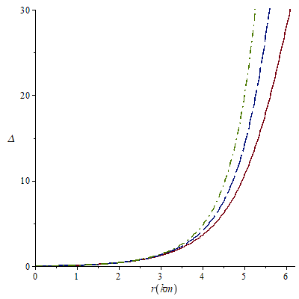

**Figure 6**. Variation of anisotropy with the radial parameter for *k*=0.0011 (solid line), *k*=0.0012 (long-dash line) and *k*=0.0013 (dash-dot line).

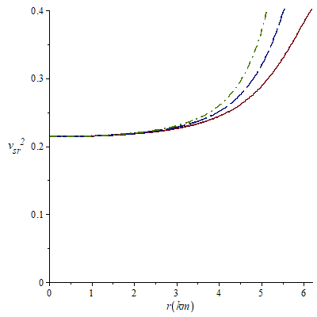

**Figure 7.** Variation ofradial speed sound with radial coordinate for *k*=0.0011 (solid line), *k*=0.0012 (long-dash line) and *k*=0.0013 (dash-dot line).

. 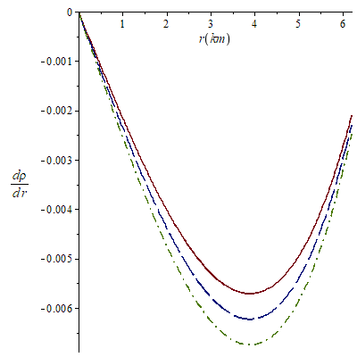

**Figure 8.** Variation ofgradient of density with radial coordinate for *k*=0.0011 (solid line), *k*=0.0012 (long-dash line) and *k*=0.0013 (dash-dot line).

.

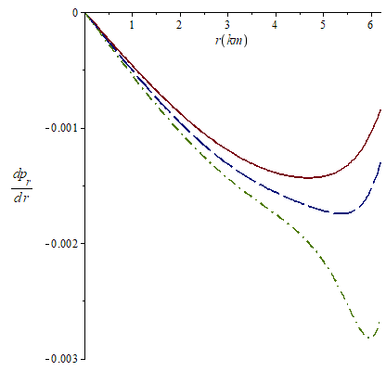

**Figure 9.** Variation ofgradient of radial pressure with radial coordinate for *k*=0.0011 (solid line), *k*=0.0012 (long-dash line) and *k*=0.0013 (dash-dot line).

.

The Fig. 1 shows that the energy density is continuous, finite, decreases radially outward and vanishes at the boundary. In Fig. 2, we note that the radial pressure *ρ* also is finite, continuous and monotonically decreasing function. In Fig. 3, it is observed that the mass function is regular, strictly increasing and well behaved. Fig. 4 shows that the charge density is regular at the centre, non-negative and decreases with the radial parameter for the chosen k values. In Fig. 5, the electric field intensity *E2* is positive and monotonically increasing throughout the interior of the star in all the considered cases. In Fig. 6, the anisotropy factor Δ vanishes at *r=0*, it monotonically increases and is continuous in the stellar interior. In Fig. 7, we note that the  is within the desired range  for the different values of *k*, which is a physical requirement for the construction of a realistic star [3]. The Figures 8 and 9 respectively show that the gradients of radial pressure  and energy density  are decreasing throughout the star.

We can compare the values calculated for the mass function with observational data. For *k*=0.0011 the values of *A*, *B* and *a* allow to obtain a mass of 0.6*Mʘ* which can correspond to astronomic object GJ 440 also known as LHS 43 [73] or could be associated with the orange dwarf GJ 380 [74]. For the case *k*=0.0012 we obtained comparable masses with the red dwarf Lacaille 8760 with a mass between (0.56-0.60)*Mʘ* [75]. With *k*=0.0013, the resulting mass is very similar to the red dwarf Lalande 21185 whose mass is 0.46*Mʘ* [76]. The values of the masses for these compact stars are tabulated is Table 2

|  |  |
| --- | --- |
| Compact Star | Masses *M*(*Mʘ*) |
| LHS 43 | 0.62*Mʘ* |
| GJ 380 | 0.64*Mʘ* |
| Lacaille 8760 | (0.56-0.60)*Mʘ* |
| Lalande 21185 | 0.46*Mʘ* |

**Table 2**. The reported values of the masses for the compact stars

There is also quantum contribution to these masses, since the state of the clock affects environment vacuum oscillations, like neutrino oscillations that change flavor of the quark-gluon-plasma as well as switching quaternion operation of gauge fields of light as well as sound outputs quantum activities [8, 52, 54, 61,62]. The underlying mass effects on dwarf compact stars perhaps will explain their variability with energy density, pressure, mass function, charge density, anisotropy, electric intensity of field, especially in the interior of these stellar objects, and radial sound aspects correlating results demonstrated successfully above [52, 55, 56, 57, 58, 59, 60, 62, 63, 64].

1. **Conclusion**

In this work, we have developed some simple relativistic charged stellar models obtained by solving Einstein-Maxwell field equations for a static spherically symmetric locally anisotropic fluid distribution with a particular form of gravitational potential and the generalized Chaplygin equation of state and presented a new class of solution that satisfies the physical requirements of a anisotropic charged stellar model.

How the energy matter wavefunction creates situations with equation of state potential, expansion with quintessence field cosmologies with interior having dark energy matter generation compact stellar anisotropic gravitational potential and structure of many objects, especially strange quark stars as well have been key in Quantum Astrophysical projects ongoing. The underlying mass effects on dwarf compact stars perhaps will explain their variability with energy density, pressure, mass function, charge density, anisotropy, electric intensity of field, especially in the interior of these stellar objects, and radial sound aspects correlating results demonstrated successfully above. quantum contribution to these masses, since the state_of_the_clock affects environment vacuum oscillations, like neutrino oscillations that change flavor of the quark-gluon-plasma as well as switching quaternion operation of gauge fields of light as well as sound outputs quantum activities.

**References**

[1] Kuhfitting, P.K.(2011). Some remarks on exact wormhole solutions, *Adv. Stud. Theor. Phys*., 5, 365-367.

[2] Bicak, J.(2006). Einstein equations: exact solutions, Encyclopaedia of Mathematical Physics, 2, 165-173.

[3] Komathiraj, K., and Maharaj, S.D. (2007). Analytical models for quark stars. *Int. J. Mod. Phys.* D16, 1803-1811.

[4] Ivanov, B.V. (2002). [Static charged perfect fluid spheres in general relativity](javascript:void(0)). *Phys. Rev.D65*, 104011.

[5] Malaver, M. and Kasmaei, H.D. (2020). Relativistic stellar models with quadratic equation of state. *International Journal of Mathematical Modelling & Computations*., 10(2), 111-124.

[6] Bowers, R.L. and Liang, E.P.T. (1974). Anisotropic Spheres in General Relativity. *Astrophys. J*, 188, 657-665.

[7] Gokhroo, M. K. and Mehra, A. L. (1994). Anisotropic Spheres with Variable Energy Density in General Relativity. *Gen. Relat.Grav,* 26(1), 75 -84.

[8] Esculpi, M., Malaver, M. and Aloma, E. (2007). A Comparative Analysis of the Adiabatic Stability of Anisotropic Spherically Symmetric solutions in General Relativity. *Gen. Relat.Grav*, 39(5), 633-652.

[9] Malaver, M. (2018). Generalized Nonsingular Model for Compact Stars Electrically Charged. *World Scientific News*, 92(2), 327-339.

[10] Malaver, M. (2018). Some new models of anisotropic compact stars with quadratic equation of state. *World Scientific News*, 109, 180-194.

[11] Chan R., Herrera L. and Santos N. O.(1992). Dynamical instability in the collapse of anisotropic matter. *Class. Quantum Grav*, 9(10), L133.

[12] Malaver, M. (2017). New Mathematical Models of Compact Stars with Charge Distributions. *International Journal of Systems Science and Applied Mathematics*, 2(5), 93-98.

[13] Cosenza M., Herrera L., Esculpi M. and Witten L.(1982). Evolution of radiating anisotropic spheres in general relativity. *Phys.Rev. D*, 25(10), 2527-2535.

[14] Malaver, M., Iyer, R.(2022). Analytical model of compact star with a new version of modified Chaplygin equation of state, *Applied Physics*, Volume 5, Issue 1, pp. 18-36. <https://arxiv.org/abs/2204.13108>

[15] Errehymy, A.; Daoud, M. A new well-behaved class of compact strange astrophysical model consistent with observational data. Eur. Phys. J. C. 2021, 81, 556, DOI: <https://doi.org/10.1140/epjc/s10052-021-09330-2>

[16] Malaver, M. (2009). Análisis comparativo de algunos modelos analíticos para estrellas de quarks, *Revista Integración*, 27(2), 125-133.

[17] Bombaci, I. (1997). Observational evidence for strange matter in compact objects from the x- ray burster 4U 1820-30, *Phys. Rev*, C55, 1587- 1590.

[18] Dey, M., Bombaci, I, Dey, J, Ray, S and. Samanta, B.C.(1998). Strange stars with realistic quark vector interaction and phenomenological density-dependent scalar potential, *Phys. Lett*, B438, 123-128.

[19] Takisa, P.M. and Maharaj, S.D.(2013). Some charged polytropic models. *Gen.Rel.Grav*, 45, 1951-1969.

[20] Malaver, M. (2013). Analytical model for charged polytropic stars with Van der Waals Modified Equation of State, *American Journal of Astronomy and Astrophysics*, 1(4), 37-42.

[21] Bhar, P. and Murad,M.H. (2016). Relativistic compact anisotropic charged stellar models with Chaplygin equation of state. *Astrophys. Space. Sci*, 361(10), 334.

[22] Malaver, M., Iyer, R.(2023) Some new models of anisotropic relativistic stars in linear and quadratic regime, *International Astronomy and Astrophysics Research Journal* Volume 5, Issue 1, pp. 1-19, <https://doi.org/10.48550/arXiv.2303.12161>.

[23] Malaver, M., Iyer, R. (2022). Charged Dark Energy Stars in a Finch-Skea Spacetime, arXiv:2206.13943 [gr-qc], <https://doi.org/10.48550/arXiv.2206.13943>

[24] Iyer, R., O’Neill, C., Malaver, M., Hodge, J., Zhang, W., Taylor, E. (2022). Modeling of Gage Discontinuity Dissipative Physics, *Canadian Journal of Pure and Applied Sciences*, 16(1), 5367-5377, Online @ www.cjpas.net.

[25] Markoulakis, E., Konstantaras, A., Chatzakis, J., Iyer, R., Antonidakis, E. (2019). Real time observation of a stationary magneton, *Results in Physics*. 15:102793.

[26] Iyer, R., Malaver, M., Taylor, E. (2023). Theoretical to Experimental Design Observables General Conjectural Modeling Transforms Measurement Instrumented PHYSICS Compendium. *Research Journal of Modern Physics*, 2(1):1-14.

[27] Malaver, M., Kasmaei, H., Iyer, R. Magnetars and Stellar Objects: Applications in Astrophysics, Eliva Press Global Ltd., Moldova, Europe, 2022, pp. 274, ISBN:978-99949-8-246-2.

[28] Malaver, M., Iyer, R., Kar, A., Sadhukhan, S. Upadhyay, S., Gudekli, E. (2022). Buchdahl Spacetime with Compact Body Solution of Charged Fluid and Scalar Field Theory, https://arxiv.org/pdf/2204.00981, 2022, ui.adsabs.harvard.edu.

[29] Malaver, M., Kasmaei, H., Iyer, R., Sadhukhan, S., Kar, A. (2021). Theoretical model of Dark Energy Stars in Einstein-Gauss Bonnet Gravity, *Applied Physics*, Volume 4, Issue 3, pp 1-21, https://doi.org/10.31058/j.ap.2021.43001/ arXiv:2106.09520.

[30] Malaver, M., Iyer, R.(2022). Analytical model of compact star with a new version of modified chaplygin equation of state, *Applied Physics*, Volume 5, Issue 1, pp. 18-36. <https://arxiv.org/abs/2204.13108>

[31] Iyer,R. (2022). Quantum Physical Observables with Conjectural Modeling: Paradigm shifting Formalisms II: A Review. *Oriental Journal of Physical Sciences*, 7(2).

[32] Iyer, R. (2023). Algorithm of time preliminary theoretical results pointing to space geometry physics transforms, *Canadian Journal of Pure and Applied Sciences*, 17(2): 5673-5685.

[33] Iyer, R. (2023). Strong gravity versus weak gravity: fiber transforms gravity- bundle - strings: preliminary results, *Canadian Journal of Pure and Applied Sciences*, 17(2): 5697-5703, Publishing Online ISSN: 1920-3853, Print ISSN: 1715-9997, Online @ www.cjpas.net.

[34] Malaver, M., Iyer, R., Khan, I. (2022). Study of Compact Stars with Buchdahl Potential in 5-D Einstein-Gauss-Bonnet Gravity, *Physical Science International Journal*, Volume 26, Issue 9-10, Page 1-18; Article no. PSIJ.96077ISSN: 2348-0130, arXiv preprint arXiv:2301.08860, 2023, arxiv.org.

[35] Caldwell, R.R., Dave, R. and Steinhardt, P.J . (1998). Cosmological Imprint of an Energy Component with General Equation of State. *Phys. Rev. Lett.* 80, 1582

### [36] Xu, L., Lu, J. and Wang, Y. (2012). Revisiting generalized Chaplygin gas as a unified dark matter and dark energy model. *Eur. Phys. J*. C 72, 1883.

### [37] Pourhassan, B. (2013). Viscous modified cosmic chaplygin gas cosmology. *Int. J. Modern Phys. D*, 22(9), 1350061.

##### [38] Bernardini, A.E. and Bertolami, O. (2005). Stability of mass varying particle lumps. *Phys. Rev. D.* 80, 123011.

[39] Durgapal, M.C. and Bannerji, R.(1983). New analytical stellar model in general relativity. *Phys.Rev. D27*, 328-331.

[40] Lighuda AS, Sunzu JM, Maharaj SD, Mureithi EW. Charged stellar model with three layers. *Res Astron Astrophys*. 2021;21(12):310. DOI: 10.1088/1674-4527/21/12/310

[41] Bibi, R., Feroze, T. and Siddiqui, A. (2016). Solution of the Einstein-Maxwell Equations with Anisotropic Negative Pressure as a Potential Model of a Dark Energy Star. *Canadian Journal of Physics*, 94(8), 758-762.

[42] Burleigh, M. R.; Clarke, F. J.; Hodgkin, S. T. (2002). [Imaging planets around nearby white dwarfs](http://adsabs.harvard.edu/abs/2002MNRAS.331L..41B). [*Monthly Notices of the Royal Astronomical Society*](https://es.wikipedia.org/wiki/Monthly_Notices_of_the_Royal_Astronomical_Society) **331** (4): L41-L45. DOI:[10.1046/j.1365-8711.2002.05417.x](https://dx.doi.org/10.1046%2Fj.1365-8711.2002.05417.x).

[43] Ségransan, D., Kervella, P., Forveille, T., Queloz, D. (2003). First radius easurements of very low mass stars with the VLTI. *Astronomy and Astrophysics*. 397 (3): L5–L8. [arXiv](https://en.wikipedia.org/wiki/ArXiv_(identifier)" \o "ArXiv (identifier)):[astro-ph/0211647](https://arxiv.org/abs/astro-ph/0211647).  [doi](https://en.wikipedia.org/wiki/Doi_(identifier)):[10.1051/0004-6361:20021714](https://doi.org/10.1051%2F0004-6361%3A20021714). [S2CID](https://en.wikipedia.org/wiki/S2CID_(identifier)) [10748478](https://api.semanticscholar.org/CorpusID:10748478).

[44]  Allen, C.; Herrera, M. A. ( 1998).The Galactic Orbits of Nearby UV Ceti Stars. Revista Mexicana de Astronomía y Astrofísica, 34: 37–46

[45] Holmberg, J., Nordström, B., Andersen, J. (2009). The Geneva-Copenhagen survey of the solar neighbourhood. III. Improved distances, ages, and kinematics. *Astronomy and Astrophysics*, 501 (3): 941–947, [arXiv](https://en.wikipedia.org/wiki/ArXiv_(identifier)):[0811.3982](https://arxiv.org/abs/0811.3982)

[46]Komathiraj, K. and Maharaj,S.D. (2008). Classes of exact Einstein-Maxwell solutions,*Gen. Rel.Grav.* 39(12), 2079-2093.

[47] Thirukkanesh, S. and Ragel, F.C. (2012). Exact anisotropic sphere with polytropic equation of state, *PRAMANA-Journal of Physics*, 78(5), 687-696.

[48] M. Malaver.Strange Quark Star Model with Quadratic Equation of State.Frontiers of Mathematics and Its Applications.1, 9-15. 2014.