IMPACT OF GOVERNMENT SCHEMES ON RURAL DEVELOPMENT: A STUDY OF KHAYRASOLE BLOCK IN BIRBHUM DISTRICT, WEST BENGAL
PARIMAL DAS
RESEARCH SCHOLAR
L.N. MITHILA UNIVERSITY, DARBHANGA, BIHAR
ABSTRACT:
The practice of raising the standard of life and economic prosperity of people in isolated and sparsely populated regions is referred to as "rural development" in many contexts. Global awareness of rural development is rising, particularly in poor countries. It is very significant for a nation like India. In order to increase their productivity, it speaks about the growth of rural economies, which are dealing with major poverty concerns. The research also emphasizes the significance of resolving several urgent challenges affecting village economies that hinder development and enhance these regions. To enhance rural areas, the Indian government has introduced a number of programs. The shortage of housing, the absence of infrastructure in towns and villages to link communities with all-weather highways, and the scarcity of work possibilities are a few of the main issues in rural India. The purpose of this paper is to analyze the government of India has announced the Pradhan Mantri Awaas Yoiana Gramin scheme to provide homes, Pradhanmantri Gram Sadak Yojana to build roads and to provide rural people with employment opportunities; the Mahatma Gandhi National Rural Employment Guarantee Act 2005 was passed. In this study, we learn about the function of these programs in India's rural development as well as their present level of development. The primary aim of this paper is to highlight the role of local government in rural development.
Key words: Rural development, Government Schemes, Programs, rural areas, Rural People
- INTRODUCTION
India's rural development is one of the most important aspects in the country's economic progress. Rural development focuses on the development of rural economies that are suffering from severe poverty and effectively seeks to increase their production. It also emphasizes the importance of addressing various pressing issues that impede village economies' growth and improvement. An agriculture sector is one of the most important primary activity in rural India and about two- third of India’s population depends on agriculture, the problem lies in the fact that the share in GDP of agriculture sector in on a constant decline. Rural development in India has undergone various changes in terms of emphasis, techniques, strategies, and programmes over the years. As a result, it has taken on a new dimension and opened up new possibilities. Only with the participation of development clients can rural development become richer and more meaningful. People's engagement is the centerpiece of rural development, just as execution is the benchmark for planning. From both a procedural and philosophical standpoint, people's engagement is one of the most important pre-requisites of the development process. It is critical for development planners and administrators to enlist the participation of various groups of rural people in order to make plans participatory. In India, the government has a number of rural development schemes in the works. In India, the Ministry of Rural Development is the apex authority for creating policies, rules, and laws related to rural development. The key contributors to the rural business and economy include agriculture, handicrafts, fishery, poultry, and dairy.
- OBJECTIVE OF THE STUDY
- To describe the different rural development schemes or programs in the study area.
- To examine the impact of rural development schemes in research area.
- To find the impact of the various rural development policies implemented by the Government of India.
- To study the presenting the growth of various schemes such as Pradhanmantri Awas Yojana Gramin scheme (PMAY-G) Pradhanmantri Gram Sadak Yojana scheme (PMGSY), The Mahatma Gandhi National Rural Employment Guarantee Act 2005 (MGNREGA).

- STYDY AREA
The community development block Khoyrasole (Figure 1) lies in the Suri Sadar sub division of Birbhum district. The geographical area of the district is 499 sq-kms. The north-western part of the district, particularly Rampurhat - Nalhati blocks, the contours are above 110m - 140m (MSL) while it comes down to 60-70m in eastern and south eastern part around Khoyrasole - Rajnagar - Suri blocks where topography is almost flat. The Lower Gondwana Barakar Formation occurs with pronounced unconformity over the Archeans and has faulted boundaries with Archean comprising leucocratic gneisses at Rajnagar - Khoyrasole. The ground mass comprises pebbly to coarse grained white feldspathic ferrugenous sandstone, grey carbonaceous shale and coal. In Birbhum, groundwater occurs under both water table condition in the near surface aquifers and under confined condition in deeper aquifers. The western part of the district around Khoyrasole, Dubrajpur, Rajnagar and Suri, west of Rampurhat and Nalhati area is underlain by hard rocks, which vary from basaltic (Rajmahal volcanics) rocks in the north and granite, gneisses and schists in the south. The weathered zone of the hard rocks forms the main repository of ground water in the area under study. In the eastern fringe of Khoyrasole, Dubrajpur, Rajnagar, sediments of Gondwana Super Group form the main repository of groundwater at deeper level. Lateritic soil also forms the groundwater source in parts of Suri, Md.Bazar, and further east. Khoyrasole lies between 23°42’ and 23°54’ N latitudes and 87°05’ and 87°22’ E longitudes. This block has been mapped on Topo Sheet nos. 73M/1, 73M/5 and 73M/6 (Figure 1). Three rivers, namely Sal, Hinglo and Ajay pass through this block. Sal flows along the northern side of Khoyrasole whereas Ajay forms the southern boundary of the block. This river also forms the boundary between Birbhum and Bardhaman districts. River Hinglo lies midway between Sal and Ajay. In summer time, the climate of the area becomes hot and dry with temperatures rising up to 40° C and above, whereas in winter, the temperature goes down to 10° C or below. Moderate to high rainfall is experienced in the district, during the monsoon season. In this study area there are so many government schemes followed for the development of local people.
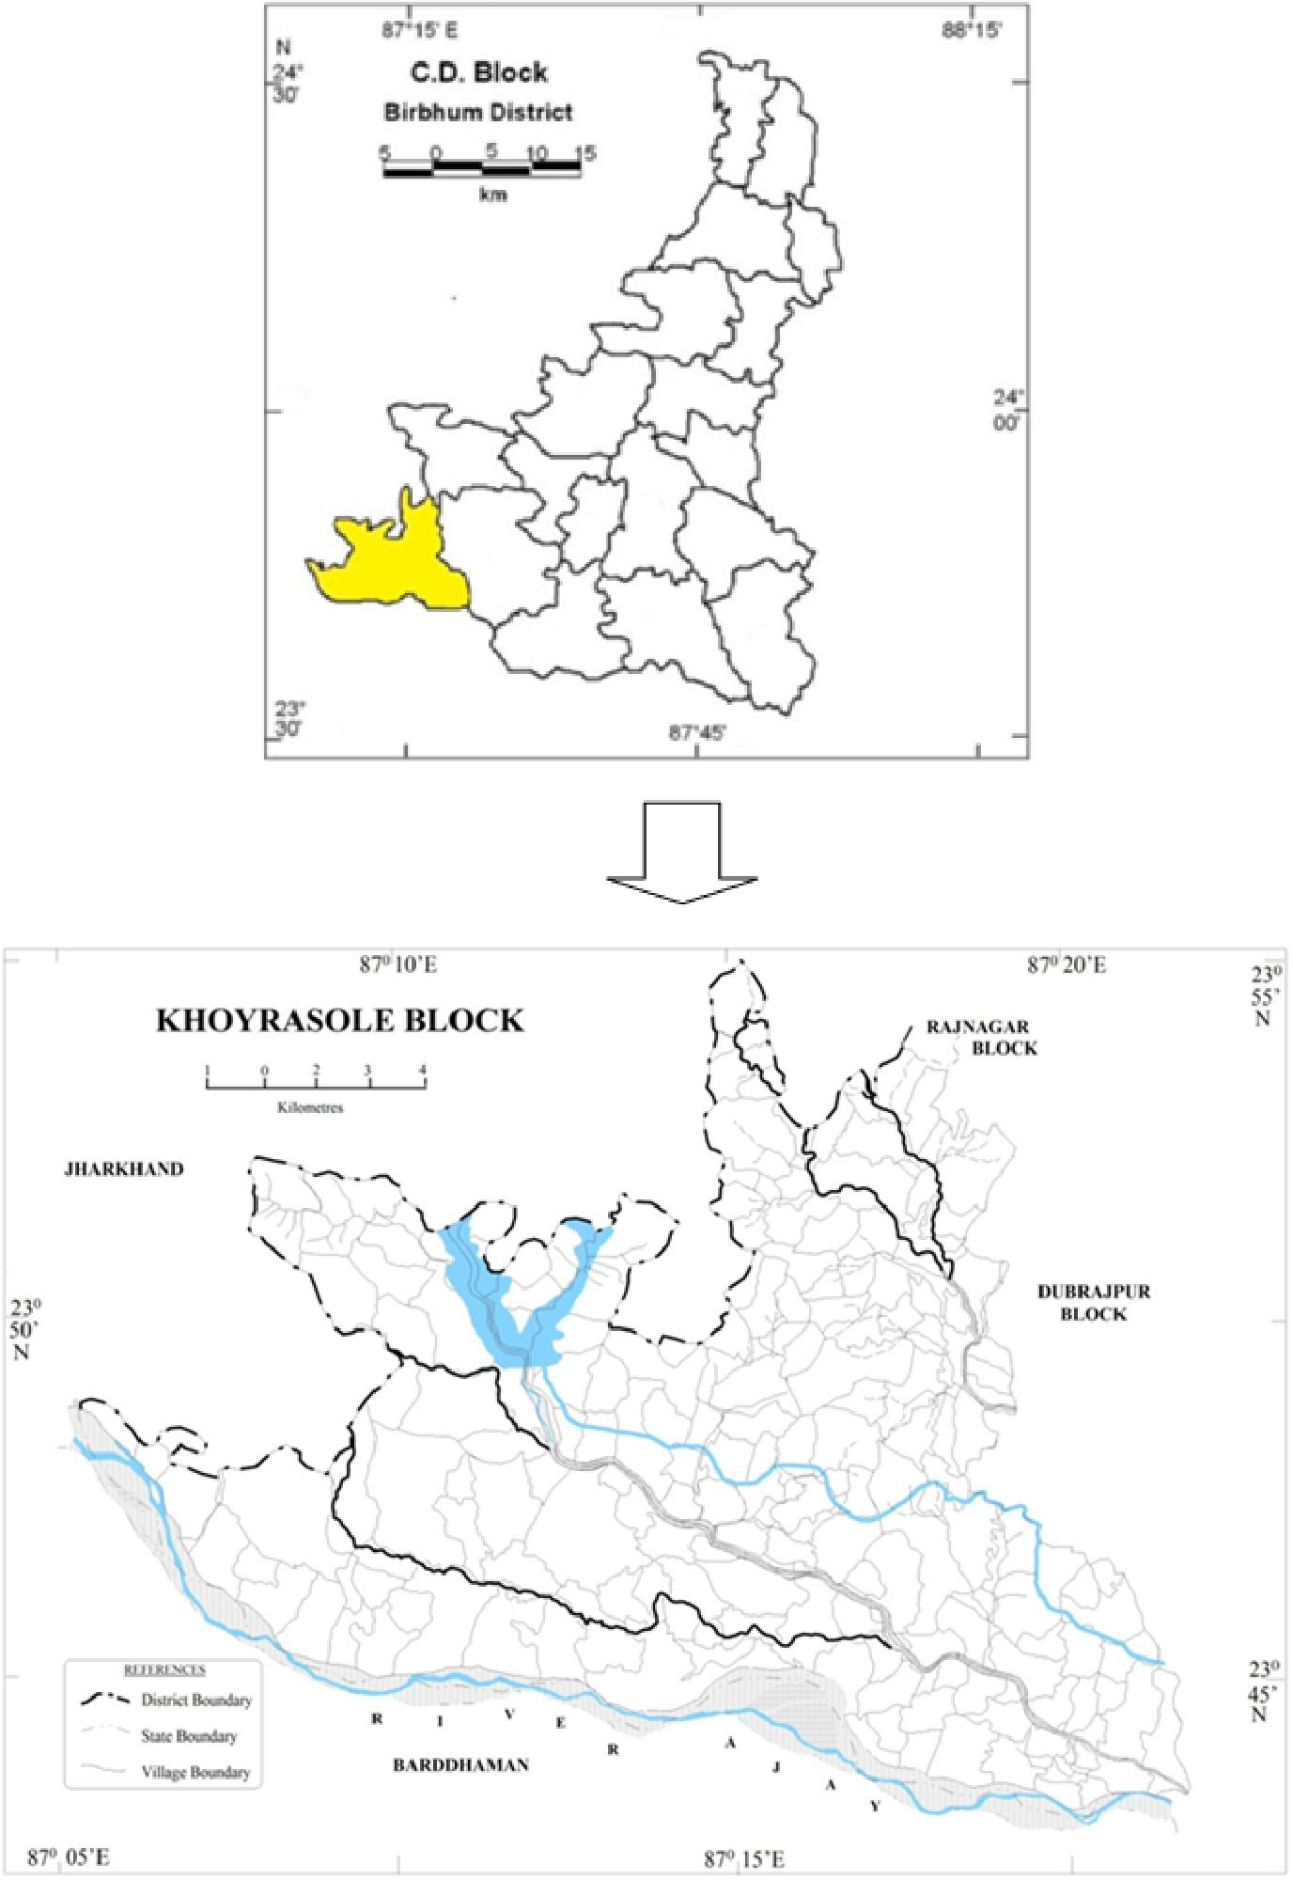
Fig. 1 Map Showing the Study Area

LITERATURE REVIEW
Mukundan (2008), is of the opinion that rural development is essential to inclusive and fair growth, and to unlocking the enormous potential of the currently impoverished population. The result was the creation of programs such as Swama Jayanthi Rojgar Yojana (SJRY), Sampooma Grameena Rojgar Yojana (SGRY), National Food for Work Programme (NFFWP), and National Rural Employment Guarantee Programme (NREGP). India's primary cause of social insecurity is poverty, which is largely a consequence of a lack of economic opportunity.
Rajamohan & Dhanbalan, (2013), to comprehend the changes that occur in human resource development, efforts from all areas of society are required. These efforts may have an impact on the effective implementation of more sustainable development ideas. Even though there have been advancements and improvements in society, there have been no advancement in public welfare. As a result, the government should be a key player in developing effective strategies to develop a nation through human development by adopting good governance at every level of scheme implementation. Because people are at the heart of a country's development, but their lives and the environment require greater improvement than what is now available. [1]
Panda and Mazumdar (2013), evaluate the development programmes started by the Government of India and analyse the performance of various schemes running in the development of rural population and area, such as the MGNRGA, IAY, SGRY, ITDP, PMGSY,
ICDS, and DWCRA, among others. These schemes have a positive impact on people's development, poverty reduction, and modernization of rural India. [2]
S. L. Kaushal et al. (2016), MGNREGS is assisting in the empowerment of women in rural areas, particularly in the hill state of H.P., despite wage delays and a lack of awareness being significant challenges in rural areas. [3]
Maria Navis Sorris et al. (2017), most beneficiaries in palayakayal panchayat have little awareness of MGNREGS. MGNRGES beneficiaries in Thoothukudi district also face difficulties with obtaining an employment card. [4]
Rao P. Srinivasa, (2019), To supply housing, the government of India announced the Pradhan Mantri Awaas Yoiana Gramin (PMAY-G) programme, the Pradhan Manthi Gram Sadak Yoiana (PMGSY) scheme to build roads, and the Mahatma Gandhi National Rural Jobs Guarantee Act (MGNREGA) to provide employment to rural people. These three programmes are critical to India's rural development. According to the report, 44.54 lakh residences were built under the Pradhan Mantri Awaas Yoiana Gramin (PMAY-G) scheme in 2017-18, against a target of 1.00 crore houses by March 2019. In 2017-18, the speed of PMGSY road construction hit an eight-year high of 134 kilometres per day, compared to an average of 73 kilometres from 2011 to 2014. As a result, building is now moving at a 93% faster pace. During the financial year 2017-18, MGNREGA generated about 234.25 crore person days of paid employment, encompassing 177 lakh jobs, providing employment to 5.12 crore households. The goal of eradicating such social ills can be achieved with the support of good education. The decline in rural India's literacy rates, particularly among women, is a major source of concern. Land and technological reforms are both necessary. To boost outputs and revenues, modern technology such as organic farming should be used. By enhancing the banking system in rural areas, consumers should have easier access to credit and loans. [5]
Mohapatra & Prusty, (2021) although we examine various rural development programmes, it is clear from the implementation approach that a scheme cannot be implemented properly without the cooperation of the community. Communities can effectively take charge of rural development methods of opportunities through social mobilization and the organization of rural people into functional groups. As a result, the Government of India has launched a number of rural development programmes aimed at assisting rural people in maintaining a good socioeconomic level. [6]

- RESEARCH METHODOLOGY
The study is descriptive in nature and based on the secondary data. The data has been taken from the government official websites like https://rural.nic.in; https://nrega.nic.in. Descriptive statistics tools like tables and charts are used in the study. There are various secondary data sources, including research papers, journal articles, and publications from the different government department of India were collected.

- RESULTS AND DISCUSSION

Rural Development Schemes in India

There are various important schemes launched by governments which are study of the research areas.
5.1.1 Mahatma Gandhi National Rural Employment Guarantee Scheme (MGNREGS) – Insuring a Minimum Wage Workforce (2006) Indian government established the Mahatma Gandhi National Rural Employment Guarantee Scheme on February 2, 2006. The program's stated goal is to secure at least 100 hours of minimum wage work every fiscal year. Everyone over the age of 18 participates in this plan by offering to do physical labour that requires no training or expertise. The number of individuals signing up for MGNREGA employment has almost doubled in the previous five years, from 38.91 million in 2017–18 to 63.92 million in 2021–22.
5.1.2 Swarnajayanti Gram SwarojgarYojana (SGSY) –The Self-Employment Promotion ('Swarnajayanti Gram SwarojgarYojana', or SGSY) Initiative was launched on April 1, 1999. The government of India implemented it to provide a secure source of income for the country's rural poor. Self-Help groups are formed as part of the SGSY so that locals may take advantage of chances for independent work in their communities. People's attitudes and skills are taken into account while choosing jobs and activities for self-help organizations. Money for the SGSY programme comes from foundations, banks, and other sources. Over 6.697 million persons in India have benefited from the over 2.25 million Self-Help groups that have been established with an investment of Rs.14403 Core (US$2.2 billion).
5.1.3 PradhanMantriGramSadakYojana (PMGSY) -The programme officially started up on December 25th, 2000, with the primary goal of providing reliable road access to formerly isolated rural communities. Almost 500 people found stable employment on the plains. Specifically, the National Rural Roads Development Agency is in charge of the task under the auspices of the Ministry of Rural Development.Through this program 4, 22,031 km lengths of roadways were connected surrounded by the unconnected rural areas.
5.1.4 Swajaldhara-Community-based rural water supply programmes were prioritised at the outset of the programme, which kicked off on December 25th, 2002, and reform efforts in the rural drinking water supply sector were made available. The endurance of this initiative is due to the active engagement of the neighbourhood. Piped Water Spot Source Scheme (PWSS) provides water to a wide area, whereas Spot Source Water Supply Sector Scheme (SSWSS) serves a more limited area.For this scheme, 90% of the capital cost is given by the Government of India and 10% of the cost is of Community contribution.
5.1.5 Provision of Urban Amenities to Rural Areas (PURA)-Concept developed by Dr. A.P.J. Abdul Kalam is the primary motivation for this plan. The scheme's stated goal is to "enhance the quality of life for rural people by offering livelihood possibilities and urban facilities via a Public Private Partnership framework for developing compact regions around a prospective growth centre in a Gram Panchayat." The program's primary goals are to improve access to transportation by building new roads, to information by developing a communications infrastructure, and to expertise by creating a new professional and technology institution.
5.1.6 Samagra Awass Yojana-The basic objective of the program is to improve the quality of rural people‘s life. The aim of the program is to create convergence to activities which are undertaken separately in different terms so far such as Drinking Water Schemes, Construction of Houses, sanitation facilities and ensure their effective implementation by suitable and sustainable initiation of technology.
5.1.7 Indira Awass Yojana-This initiative's stated goal is to provide access to affordable homes in underserved rural areas. The amount of money supplied by this programme is Rs. 70,000 in lowland regions and Rs. 75,000.00 in highland areas. To promote gender equality, the programme designated home ownership for women or for married couples. 2015 saw a reorganization of the Indira AwassYojana programme, which was renamed the Pradhan MantriGramin Awaas Yojana. Pradan Mantri Gramodaya Yojana-In order to improve people's living conditions and eradicate poverty, it has long been understood that providing them with access to basic infrastructure is crucial. Expansion of coverage and improvements in the indices of human development show that great strides have been achieved in recent years to increase access to basic health care, primary education, clean drinking water, and housing.
5.1.8 Credit cum Subsidy Scheme for Rural Housing-This initiative makes it easy for all rural households with an income of less than Rs. 32,000 in a year to build their home. The plan's ultimate goal is to put those in rural areas who can afford it into their own homes via building loans.
5.1.9 Rajiv Gandhi Grameen Vidhyukthikaran Yojana-In order to ensure that people in rural areas have access to energy, the initiative will focus on generating power for rural infrastructure and electrifying rural homes.The outcome of the scheme is 1.95 free electricity connections have been given to the rural populations.
5.1.10 Integrated Watershed Management Program-The plan's goal is to repair environmental damage by reviving and enhancing once-healthy soil, plant life, and water supplies. As a result of the plan, soil erosion will be reduced, natural flora will be revitalised, rain will be collected, and the aquifer will be refilled.
5.1.11 Land Reforms and Land Consolidation-The purpose of land reform is to redistribute unused land to individuals who live in rural areas but lack access to sufficient agricultural land. There is a lack of centralization and a prevalence of tiny, dispersed farms in India's land consolidation system. Consolidating land causes inefficient resource allocation. Thus, both voluntary and mandatory programmes need this crucial framework.
5.1.12 National Land Records Modernization Program-This program strengthens the revenue of administration and updates the land records through computerization.
5.1.13 National Social Assistance Program-Social pensions are a kind of financial aid provided by the federal government to eligible retirees, widows, and people with disabilities.
5.1.14 Antyodaya Anna Yojana-Food insecure people in rural areas may rest easy knowing that this programme issues 35 kilogrammes of rice and wheat at the cheap prices of Rs. 3 and Rs. 2, respectively.
5.1.15 ntegrated Child Development Scheme-In 1975, India launched its Integrated Child Development Scheme. The major goal of the programme is to assist low-income families with basic needs such as food, education, and healthcare.
5.1.16 Atal Pension Yojana-Through this programme, low-income seniors (those over the age of 60) get a monthly stipend. Individuals between the ages of 18 and 40 who are Indian nationals are eligible to participate in this plan, which primarily targets employees in the unorganised sector.
5.1.17 DeenDayalUpadhyaya Gram JyotiYojana ―Government of India programme DeenDayalUpadhyaya Gram JyotiYojana aims to deliver reliable electricity to remote areas of India. In order to provide electricity to rural areas, the government wants to spend a whopping 756 billion on this initiative. In its stead, the original Rajiv Gandhi GrameenVidyutikaranYojana will be replaced with this new programme. The NDA government of India has initiated a plan to give constant electricity to every household in the country.After researching all schemes the researcher comes to know that there is no scope for self-empowerment for women. This made the researcher think about the MGNREGS which has given a good impact for the upliftment of the rural women.

6. IMPACT OF GOVERNMENT SCHEMES ON RURAL DEVELOPMENT

There is a strong correlation between a high human development index and a high standard of living, therefore it makes sense that a major goal of rural development policies and programmes is to reduce poverty in rural areas, create jobs, and end hunger and malnutrition. Economic planners think that the challenge of rural development is not only about development of rural regions but the development of rural communities to dispel illiteracy and poverty and support the process of developing self-reliant and self-sustaining healthy contemporary communities. Increases in GDP or even per capita national income alone cannot be used to define rural development anymore. While the government has been given top attention to rural development and is spending hundreds of crores via different programmes, the problem is that not all the money allotted under the rural development plans reaches the recipient. Therefore, development has slowed to a crawl, and the poor have not seen any relief. The creation of productive assets like roads, water tanks, soil and water conservation work, etc., as part of rural development schemes, gives people in rural areas a chance to earn a living without having to leave their homes. This has the knock-on effect of reducing migration, limiting child labour, easing poverty, and making villages more self-sufficient.

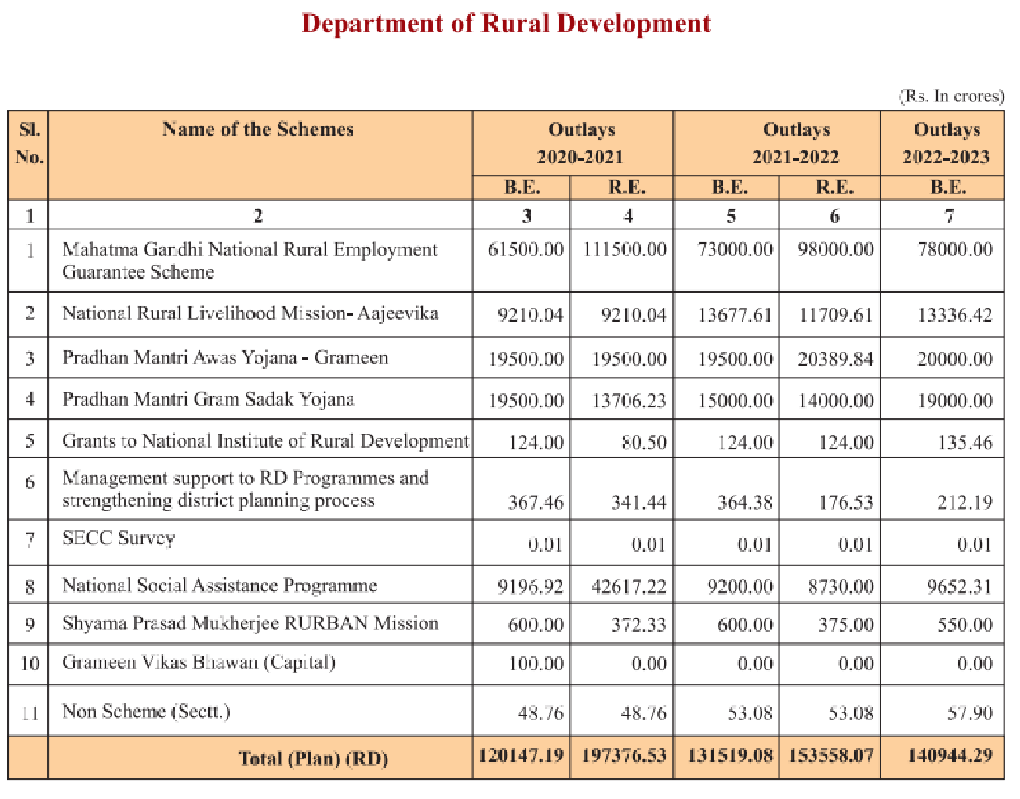
Table.1 Various Rural Development Schemes of India
To help India, national, and regional policymakers pick and defend the most effective programmes and policy measures, it is necessary to get insight into the connections between various rural development policy initiatives and their societal and economic effects. The proposed study aspires to provide empirically sound explanations for these issues. Rural development's potential social and economic effect will be evaluated, and the policies most suited to generate and maintain that impact will be analyzed.
All of the planned studies will be conducted in India. The study will begin with case studies of the most successful examples of rural development, examining the effects of this process on employment, income, investment, and inventiveness. After that, we'll use various economic and sociological methods to investigate whether or not these findings may be extrapolated to cover a greater region. As of this writing, the National Rural Livelihoods Mission (DAY-NRLM) has expanded into 6769 blocks over 706 districts in 30 states and 6 territories. More than 73.19 million women from low-income and marginalized backgrounds have been organized into SHGs thanks to this initiative. Up to the end of the year in 2021, RSETIs will have taught 39.17 million people in 64 different fields. Of those people, 27.34 million will have found gainful work. Twenty-two thousand and three hundred eighty-six people have been trained thus far, and twenty-two thousand and six hundred seven have been placed as of 30 November 2021, all as part of the DDU-GKY project for the fiscal year 2021-22. A total of 2.15 billion rupees have been allocated for the Pradhan Mantri Awaas Yojana-Gramin (PMAY-G), with 1.68 billion dwellings built. With a goal of completing 44.09 lakh homes in FY 2021-22, we have only managed to finish 31 lakh so far.
- CONCLUSION & SUGGESTIONS
As much as 70% of India's population lives in rural settings. Everyone, including those living in rural locations, deserves the same high standard of life experienced by those in more urban and suburban settings. More than that, economic hardship and urban poverty are the outward manifestations of underlying socioeconomic conflicts caused by poverty, unemployment, and insufficient infrastructure in rural regions. With this new strategy, the government will be able to pay the recipient directly, rather than going through a series of intermediaries. With this goal in mind, the Aadhaar card is a groundbreaking programme that has the potential to completely alter rural India. Most rural development programmes are aimed at below-poverty-line households, thus it's important that the government compile an accurate list of these households and make that information, organised by village, accessible over the internet. Despite the fact that there are many programmes meant to help us progress, we still lag behind in key areas like education, health, sanitation, and so on. This is because the general public is unaware of the many aid initiatives that have been created specifically for them. Therefore, it is crucial to use a variety of audio, video, and audio visual media to raise public awareness. The dissemination of information via various channels of communication may be of great benefit. Any plan to improve rural areas should centre on helping the poor make the most of their inherent talents while also providing them with the education, training, and support they need to join the workforce and contribute to the nation's expanding economy. This is essential if we want our democracy to be really representational and welcoming to all people. Training programmes for PRI officials and beneficiaries chosen from different programmes should be prioritized as a means of improving human capital. For the poor to get aid from various programmes and for there to be no blunders in the selection process, it is essential that the public have a voice in who receives assistance. In order to increase the number of people who benefit from rural development programmes, it is necessary to launch a public education campaign.

REFERENCES
1. Dr. S Rajamohan & T. Dhanbalan. (2013). Rural development schemes and their contribution towards the human resource development. Indian Journal of Applied Research.
2. Panda & Mazumdar. (2013). A review of rural development programmes in India. International Journal of Research in Sociology & Social Anthropology.
3. Kaushal, S L. & Balbir Singh. (2016). A study of women participation in MGNREGA in Himachal Pradesh. Productivity, 56(4), 382-390.
4. Maria Navis Sorris, A. & Sheeba, E. (2017). A study on knowledge and perceptions of beneficiaries towards MGNREGA in palayakayal panchayat of Thoothukudi district. International Journal of Informative & Futuristic Research, 4(9), 7499-7506.
5. Dr. P Shrinivas Rao. (2019). Rural development schemes in India – A study. International Journal of Research and Analytical Reviews (IJRAR).
6. Ajay Kumar Prusty. (2021). Rural development schemes of 21st century in India. ESN Publications ISBN: 978-81-950305-9-0.
7. Santanu Panda & Arup Majumder, A Review of Rural Development Programmes in India, International Journal of Research in Sociology and Social Anthropology, 2013, 1(2) : 37-40, ISSN 2321–9548
8. Rajalakshmi, Dr. V. Selvam, Rural Development Schemes In India Special Reference To Impact Of Mgnregs Vellore District In Tamil Nadu, International Journal of Scientific & Technology Research Volume 9, Issue 02 , February 2020 ISSN 2277-8616
9. AmarjeetSinha (2017). Transforming Lives Through Livelhoods. Kurukshetra, 65 (7), 5-9.
10. Harikumar, P.N., &Nirosha Joseph (2016). Impact of Mahatma Gandhi National Rural Employment Programme among Rural Residents. Southern Economist, 55 (14), 34-38.
11. Jyothi Sharma (2016). Digital India and its Impact on the Society. International Journal of Research in Humanities and Social Sciences, l4(4), 45-87.
12. Tripathy (2018). Rural Livelihood and Employment, Kurukshetra A Journal on Rural Development, 66 (5) , 42- 46
13. Mishra Publications, "District Administration and Rural Development". Oxford University Press, New Delhi, 1983.
14. Mathur L. (2007). Employment guarantee: Progress so far. Economic and Political Weekly, December 2007.
15. Carlsson, R., Otto, A., Hall, J.W. (2013). The role of infrastructure in macroeconomic growth theories. Civil Engineering and Environmental Systems, 30(3–4), 263–73.

