An IoT Framework for MRI-Based Brain Tumor Detection Using Optimized Modified ResNet-18

Abstract: Brain tumors constitute a grave health concern, significantly impacting individuals' lives. The severity lies in their potential to be either benign or malignant, with malignancies having the potential to be life-threatening if not accurately diagnosed. Recent analyses of human healthcare systems reveal a stark increase in the number of brain tumor cases, positioning it as the 10th leading cause of death. Consequently, early detection of brain tumors holds the potential to greatly enhance a patient's chances of complete recovery and successful treatment. The advancement of information and communication technology has propelled the Internet of Things (IoT) to a transformative phase within modern healthcare. This study conducts an in-depth exploration of methodologies for detecting brain tumors, presenting two distinct detection scenarios. Firstly, one scenario entails the direct application of a deep convolutional neural network to brain images. Conversely, the second scenario introduces an IoT-centered framework employing a multiuser detection system. This system uploads images to the cloud for early brain tumor detection, ensuring accessibility from anywhere for accurate categorization. The proposed convolutional neural network architecture is a refined iteration of the pre-trained ResNet18 CNN. Additionally, pivotal hyper parameters are employed to fine-tune the OMRES model. The initial phase tests diverse optimizers with varying learning rates, batch sizes, and a consistent number of epochs. Subsequently, the influence of altering dropout rates is assessed. Lastly, a comparison between the OMRES model and traditional pre-trained models is expounded upon. Simulation results reveal that the RMSProp algorithm, coupled with a dropout rate of 0.5, yields the most favourable outcomes when juxtaposed with other algorithms. The suggested model attains remarkable enhancement, achieving a peak accuracy rate of 98.67%, surpassing conventional CNNs.
Keywords: Brain tumor, Magnetic resonance imaging (MRI), IOT, Convolutional neural networks (CNN)
1 Introduction
The widespread integration of the Internet of Things (IoT) has found its way into various applications, significantly impacting our daily lives. This transformation is equally evident in the healthcare sector, where IoT technology is being harnessed to optimize patient services [1]. The realm of healthcare faces a formidable challenge in addressing brain tumors, necessitating the incorporation of modern technological solutions in the detection and classification processes. The accurate and swift classification of brain tumors is of paramount importance, as the choice of effective treatment methodologies is heavily reliant on the precise identification of the tumor's pathological type. However, the traditional approach to identifying and categorizing brain tumors in magnetic resonance imaging (MRI) scans primarily depends on human observation. Radiologists analyse and interpret image attributes, often resulting in inaccuracies in diagnosis. The adoption of computer-aided diagnostic methods is being actively pursued to mitigate these concerns [2]. Brain tumors manifest as undesirable masses of irregular brain cells, classified into two categories: noncancerous and malignant tumors [3]. Noncancerous (benign) tumors exhibit slower growth and do not infiltrate surrounding tissues or organs, in contrast to the more aggressive progression of malignant tumors [4]. Moreover, malignant tumors are further categorized into primary tumors originating within the brain and secondary tumors, referred to as brain metastasis tumors, which spread from other locations. The timely and precise determination of the grade of brain tumors profoundly impacts not only early-stage diagnosis but also treatment decisions and ongoing assessment of tumor growth for patients. The complexity of tumor classification arises from the diverse characteristics of tumor cells, including size, shape, contrast, and location. Tumor grading spans from I to IV, distinguishing between benign and malignant tumors. Medical images such as MRI, ultrasound, computed tomography (CT), X-rays, play a pivotal role in disease diagnosis and treatment planning. CT and MRI are the most prevalent modalities for assessing and diagnosing brain malignancies. Of these, MRI takes precedence due to its superior resolution, particularly in brain imaging [5].
  - Related work
A critical concern in the realm of brain tumor disease revolves around the timely detection of brain tumors to facilitate the implementation of appropriate therapies. This pivotal step enables the determination of the most suitable treatment, be it radiation, surgery, or chemotherapy, based on the diagnostic information. Consequently, the chances of survival for individuals afflicted by tumor-related conditions can be significantly enhanced when the tumor is identified during its early stages. A multitude of researchers have explored a range of methodologies for identifying tumor regions within MRI scans, utilizing both traditional machine learning (ML) and deep learning (DL) techniques, as exemplified in Table 1. For instance, Zacharaki et al. [6] introduced a system that employs support vector machines (SVMs) and K-nearest neighbors (KNN) for the differentiation of various glioma grades, alongside a binary classification scheme for distinguishing high and low grades. The reported accuracy for multi-classification stands at 85%, while the accuracy for binary classification reaches 88%. Meanwhile, Cheng et al. [7] devised an approach to enhance brain tumor identification by employing picture dilation to expand the tumor area and subsequently segmenting it into distinct subspaces. This innovative approach yielded a remarkable accuracy of 91.28% by combining ring form splitting with tumor region expansion. In another study [8], Shree and Kumar classified brain MRIs into normal and abnormal categories, leveraging the Grey-Level Co-occurrence Matrix (GLCM) for feature extraction. Their employment of a probabilistic neural network (PNN) classifier led to an impressive accuracy of 95% in brain MR image classification. The realm of artificial intelligence has witnessed a surge in the significance of deep learning techniques across diverse computational domains. Particularly, deep convolutional neural networks (DCNNs) have emerged as a highly favored and extensively utilized class of deep learning networks, offering exceptional accuracy without the need for manual feature extraction.
Nonetheless, achieving remarkable accuracy comes with a notable computational burden. Researchers explored an array of CNN models, including Google Net, Inception V3, DenseNet-201, Alex Net, and ResNet-50, yielding favorable accuracy outcomes.
M. K. AbdEllah et al. devised a deep CNN architecture for identifying brain tumors in MRI images [9]. They refined their approach by introducing a novel CNN architecture, which led to an impressive accuracy of 97.79%. Deepak and Ameer [10] harnessed a deep CNN coupled with a pre-trained Google Net to extract features from brain MR images, resulting in a 98% accuracy rate for classifying three distinct brain tumor types.
In their work [11], Saxena et al. employed Inception V3, ResNet-50, and VGG-16 models using transfer learning strategies. Among these, the ResNet-50 model achieved the highest accuracy rate at 95%. Hemanth et al. [12] employed a modified DCNN approach, specifically altering the fully connected layer of the conventional DCNN and determining layer weights through an allocation mechanism.
Researchers also transformed a pre-trained ResNet-50 CNN by discarding its final five layers and appending eight new layers. This adaptation achieved an accuracy of 97.2% [13]. Khwaldeh et al. [14] introduced a CNN model for categorizing brain MR images, encompassing both high-grade and low-grade glioma tumors. They utilized a modified version of the Alex Net CNN model as the foundational architecture, accomplishing an accuracy of 91%.
Furthermore, in [15], researchers effectively implemented transfer learning across various CNN architectures to classify MRI images with and without tumors. Notably, MobileNetV2, InceptionV3, and VGG19 achieved accuracy rates of 92%, 91%, and 88%, respectively.
To recap, the accuracy achieved through the utilization of deep learning and CNN network architectures for brain MRI classification far surpasses the results obtained from traditional methods, as demonstrated in the aforementioned studies. However, it's important to note that deep learning models demand a substantial volume of data for training to surpass the performance of conventional machine learning techniques.

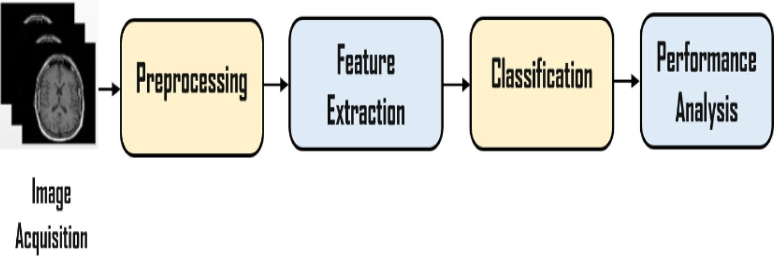
Fig. 1 Brain tumor detection system
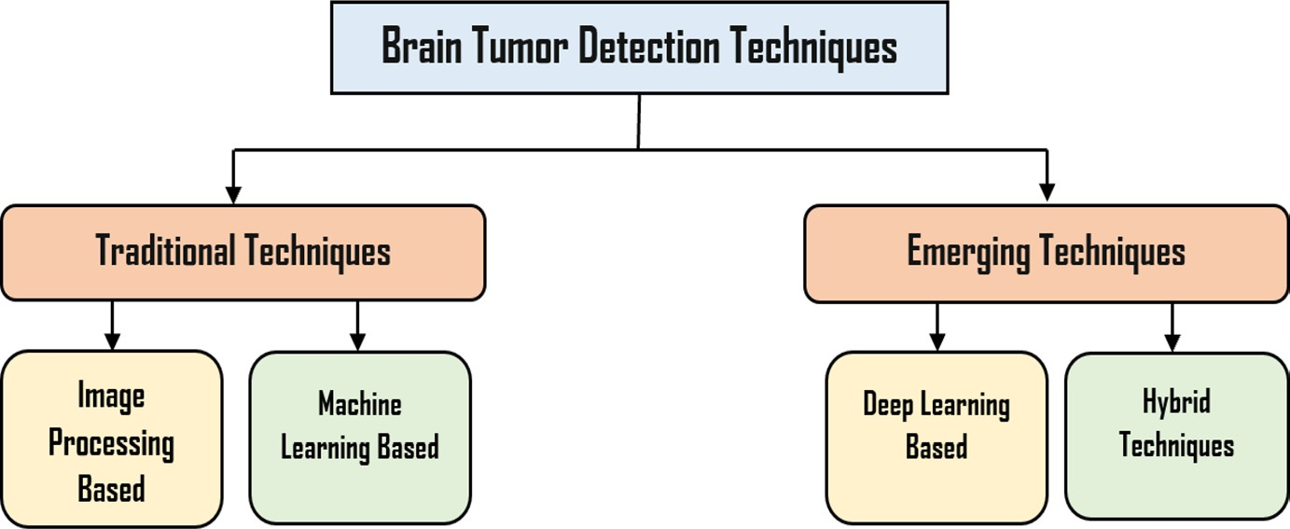

Fig. 2 Categorization of detection techniques

2. Categorizing Methods for Brain Tumor Detection

The brain tumor detection process encompasses various stages, including image acquisition, pre-processing, segmentation, feature extraction, classification algorithms, and culminates in performance analysis and module testing, all illustrated in Figure 1. These systems are broadly classified into two main categories: traditional techniques and emerging techniques, as depicted in Figure 2. Traditional techniques can be further subcategorized into algorithms based on image processing and those relying on machine learning. Conversely, emerging techniques are divided into two main groups: those rooted in deep learning and hybrid algorithms that amalgamate aspects of both traditional and emerging methods.

Categories of Brain Tumor Detection Techniques:
Traditional Techniques:
Image Processing-based Algorithms: These algorithms focus on using various image processing techniques like edge detection, thresholding, morphological operations, etc., to identify and characterize tumor regions.
Machine-based Algorithms: These are typically machine learning algorithms that involve training a model on extracted features and then using this model for classification. Examples include decision trees, support vector machines, and random forests.
Emerging Techniques:
Deep Learning-based Algorithms: These techniques use deep neural networks to automatically learn and extract features from the images. Convolutional Neural Networks (CNNs) are commonly used for this purpose, as they excel at image analysis tasks.
Hybrid Algorithms: These approaches combine elements of traditional techniques with emerging methods. For instance, a hybrid model might use traditional image processing for pre-processing and feature extraction, followed by a deep learning-based classification algorithm.
It's important to note that the field of medical image analysis, including brain tumor detection, is rapidly evolving. Deep learning techniques have shown promising results due to their ability to automatically learn complex patterns from data. However, traditional techniques still play a role, especially in scenarios where data is limited or interpretability is crucial. Hybrid approaches can leverage the strengths of both traditional and deep learning methods.

2.1 Techniques Based on Image Processing
Region-Based Methods: Within this category, regions consisting of similar features (pixels) are grouped together. A simple form of region growth, as introduced in [16, 17], is commonly employed.
Thresholding-Based Methods: These techniques involve partitioning pixels based on their intensity values, achieved by comparing these values with predefined intensity thresholds. Diverse thresholding approaches are explored in [18, 19].
Edge-Based Methods: These strategies focus on identifying the boundaries of the Region of Interest. One example of an edge-based approach is Watershed Segmentation [20].

2.2 Techniques Based on Machine Learning
Machine learning methods are categorized into two main types: unsupervised (clustering) and supervised (classification) techniques. In supervised approaches, the connection between labels and derived features is established using labeled data during training. Subsequently, during testing, unlabeled data is transformed into labeled data based on estimated features. Numerous studies have leveraged learning methodologies for brain tumor detection, such as self-organized maps (SOM) [21], fuzzy c-means (FCM) [22], K-means [23], support vector machine (SVM), and artificial neural networks (ANN) [24], which are expounded upon below:
Among the simpler grouping techniques is the K-nearest neighbor (KNN) algorithm, valued for its high stability and accuracy in MR image data analysis. However, it's noteworthy that its execution time can be considerably high.
The artificial neural network (ANN) constructs an image by connecting a network of neurons, akin to pixels. ANN conceptualizes detection as an energy minimization problem and strives to estimate not only connections but also weights between nodes during the training process.
Clustering entails classifying brain tissues into regions sharing the same label. Notable clustering techniques include fuzzy c-means, self-organized maps (SOM), and K-means.
Support Vector Machine (SVM) stands as a supervised learning model employed in both regression and classification analyses, providing an effective approach for data analysis.

2.3 Techniques Based on Deep Learning
Deep Learning (DL) constitutes a high-performance subset of machine learning. This learning model excels in extracting intricate features from query images. Within the realm of deep learning, various techniques stand out, including convolutional neural networks (CNNs) [25], deep neural networks (DNNs), and deep convolutional neural networks (DCNNs) [26, 27]. Notably, DCNNs have exhibited remarkable effectiveness in medical image classification [28].
CNNs, a particular type of multilayer neural network, find particular utility in image classification and object recognition. A notable property is their parameter sharing, which reduces the required parameter count compared to Artificial Neural Networks (ANNs). This parameter-efficient characteristic is particularly advantageous. Among the array of powerful network architectures, noteworthy mentions include GoogleNet, AlexNet, Residual Network (ResNet) 50, Inception V3, and ResNet 18. These state-of-the-art architectures have significantly contributed to the advancement of deep learning applications in various fields, including medical image analysis.

2.4 Hybrid Approaches
Hybrid techniques amalgamate two or more methodologies to yield enhanced results in comparison to individual methods. The notion of 'hybrid' within detection systems encompasses three core categories: segmentation-segmentation, classification-classification, and segmentation-classification. Notable examples of these hybrid methods include:
- A technique presented in [29] combines wavelets with SVM and SOM, effectively identifying brain MR images.
- In [30], a hybrid approach for classifying brain tumors as normal, benign, or malignant is introduced, utilizing a genetic algorithm (GA) in tandem with SVM.
- Addressing initialization and boundary constraints, an enhanced possibilistic fuzzy c-means (EPFCM) technique is proposed [31], adopting a region-based approach.
- The fusion of FKM with SOM results in a tumor detection method [32, 33].
- Brain tumor segmentation is approached using morphological operations and hybrid clustering, as proposed in [32, 33]. This encompasses adaptive Wiener filtering for denoising and morphological operations for the removal of non-cerebral tissues.
- The proposed system architecture

In this section, two distinct scenarios for the early detection of brain tumors are outlined. The first scenario involves the patient being physically present at the same location as the data center. Here, direct image diagnosis is conducted by applying the images directly to the DCNN. In the second scenario, brain images are transmitted to a cloud-based data center for tumor cell detection. This approach facilitates multi-user accessibility for image diagnosis from anywhere within the same city, as depicted in Figure 3.

- Scenario I: deep CNN architecture
Scenario I involves the utilization of a deep Convolutional Neural Network (CNN) to extract pertinent features from images. Given the inherent variance in dimensions across brain datasets, a standardization process is employed wherein images are loaded and resized to a uniform dimension of 224×224 pixels. This facilitates consistent input sizing for the CNN model. Following this, a pre-processing procedure is implemented, which serves multiple purposes. It enhances the quality of brain tumor MR images, rendering them suitable for subsequent analysis by clinical experts and imaging modalities. This step also contributes to the refinement of MR image characteristics.
The pre-processing procedure encompasses several crucial elements. It focuses on enhancing the signal-to-noise ratio and visual quality of MR images. This entails the removal of extraneous noise and unwanted background segments, as well as the smoothing of internal regions while preserving relevant edges. These actions collectively play a pivotal role in priming the images for subsequent stages.
Subsequently, the process of extracting quantitative data from images, encompassing attributes such as color properties, texture, shape, and contrast, is referred to as feature extraction. In this specific scenario, deep feature extraction is executed via Convolutional Neural Networks (CNNs). The aim is to unearth intricate patterns and meaningful features inherent in the images.
Ultimately, the classification algorithm steps in to ascertain whether the given input image exhibits normal or abnormal traits based on the final feature description. This involves the transformation of input data into a one-dimensional vector through a fully connected layer. The subsequent application of the SoftMax layer computes class scores, aiding in the classification process.

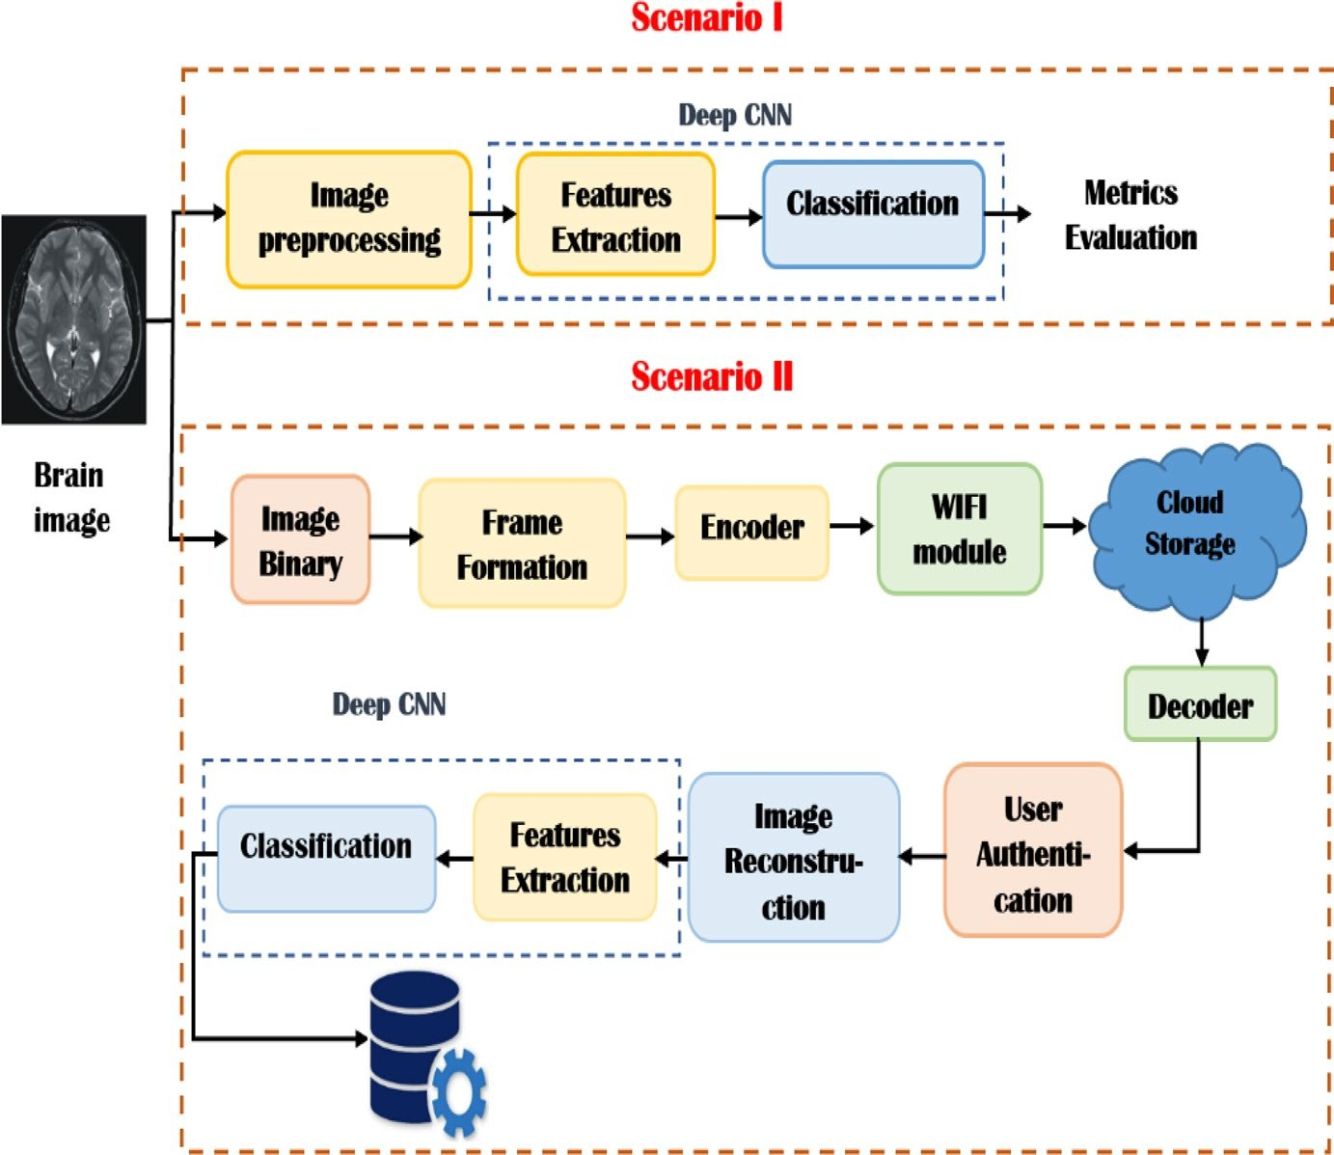
Fig. 3 The sequential structure for detecting brain tumors

- Scenario II: proposed IoT system architecture
Scenario II revolves around an IoT-based framework wherein brain images are transmitted to the cloud for classification, as depicted in Figure 4. This architectural design embodies a multi-user access system, facilitating concurrent cloud access by numerous individuals. Despite multiple users, a singular shared receiver serves all. The core objective centers on brain tumor categorization, achieved through an IoT setup integrated with cloud management. Leveraging the cloud proves paramount in medical contexts, enabling streamlined data accessibility for medical professionals due to its distributed nature [34]. Our proposed IoT model strives to curtail mortality rates by enabling early tumor cancer detection, encompassing four key phases: (1) data collection, (2) image processing and classification, (3) diagnosis, and (4) user interface.
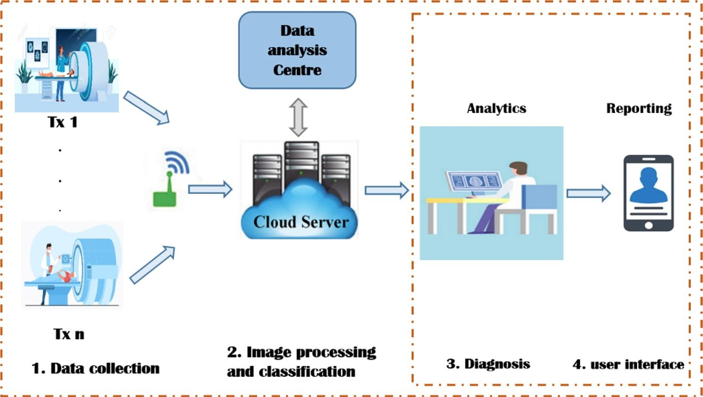
Fig. 4 The proposed architecture for an IoT system

The integrated IoT system we propose commences with the acquisition of brain images through MRI devices during the data collection phase. Subsequently, these images are conveyed via the WIFI module to the cloud. Within this cloud-based environment, the pre-processing and classification stage unfolds. Here, the MRI images undergo processing and resizing to conform to the dimensions suitable for the suggested CNN model known as OMRES. This model is responsible for feature extraction from the processed images, and its classification prowess relies on a SoftMax classifier to identify instances of brain cancer.
Moving on to the analytics phase, patients gain access to their individual databases, enabling them to ascertain the outcomes of classification. A noteworthy capability emerges for radiologists, who can detect potential tumor types by uploading an MRI scan and promptly receiving classification results within seconds. Finally, the process culminates in the transmission of the report to the patient's physician, who subsequently determines the most appropriate course of action based on the findings.
The system is structured to encompass both the transmitter and receiver components for each user. The transmitter holds the responsibility of readying the patient's scanned image for transmission via the cloud. On the other hand, the receiver's role involves decoding the received image and extracting its inherent features to enable early brain tumor detection.
At the transmitter stage, the patient's brain image undergoes initial scanning through the application of a magnetic field and computer-generated radio waves, resulting in the creation of high-fidelity images. Subsequently, the image is transformed into binary data, rendering it suitable for transmission. Following this, a binary data vector is formed, incorporating the patient's Identifier (ID) as a header. The next step involves encoding the data frame, preparing it for transmission. This encoding procedure employs convolutional codes with a defined code rate denoted as 'r,' with a specific value of 2/3. The code rate 'r' is defined by the relationship [35]:
r = k/n -------------------------- (1)
Here, 'k' signifies the count of parallel input bits, while 'n' represents the number of parallel output encoded bits within a singular time interval. The schematic depiction of the transmitter's data flow is outlined in Figure 5.

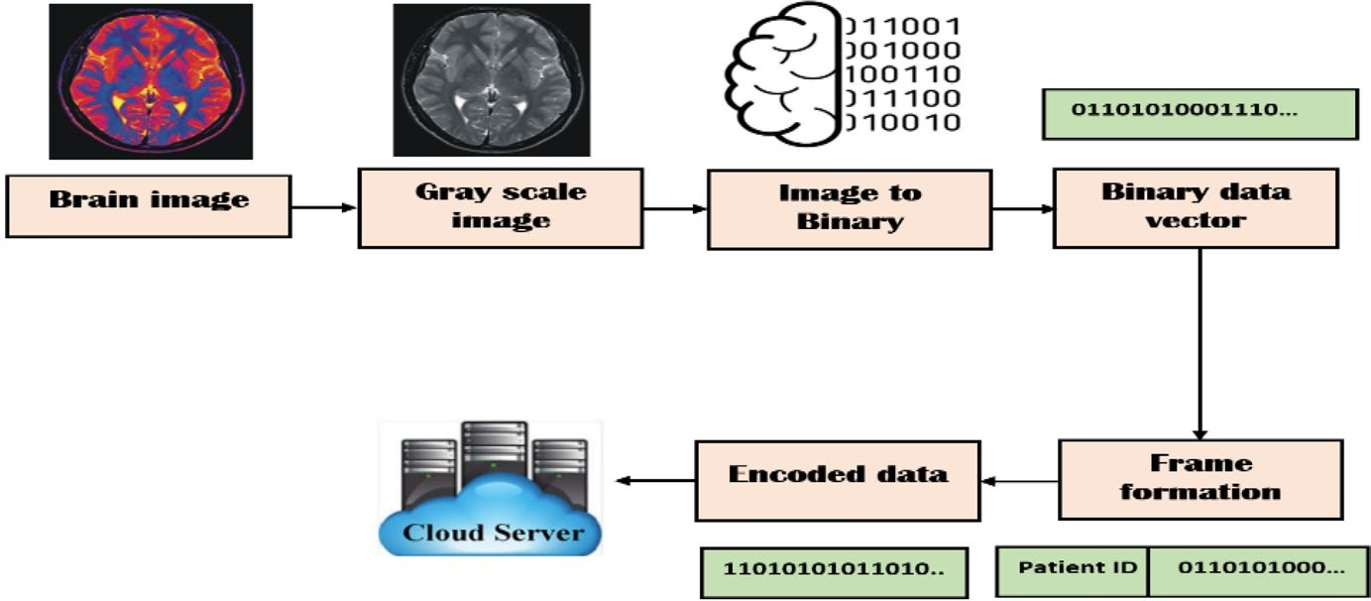
Fig. 5 Proposed system data flow

The receiver component operates through two distinct modes, namely the "Registration mode" and the "Operation mode," both illustrated in Figure 6.
The "Registration mode" is a one-time process designated for new users. During this phase, patients complete their initial registration, enabling subsequent seamless access to their accounts within the system through their unique ID numbers.

Switching to the "Operation mode," the initial step involves applying an authentication process to confirm the identity of the registered user. Subsequent to successful authentication, an image preparation sequence is initiated to ready the image for ensuing stages. Noise reduction is achieved through the application of a Weiner filter. Post-filtering, data scaling is carried out to align with the dimensions suitable for the recommended CNN model. This model then undertakes feature extraction from the processed images. The SoftMax classifier is subsequently employed to identify instances of brain cancers.
The culmination of this process allows patients to utilize their personal databases to access and interpret the classification outcomes, enhancing their understanding of their medical status.

4. The proposed CNN model approach
4.1 Residual network (ResNet18)
He et al. introduced a profound resident network model, ResNet, characterized by its deep architecture that showcases remarkable cohesion and precision. ResNet was conceptualized through the amalgamation of several residual units, with its structure being instantiated across diverse layer counts: 18, 34, 50, 101, 152, and 1202. While the computational load can fluctuate among these distinct architectures, ResNet 18 presents a favorable equilibrium between performance and complexity. The architecture specifics of ResNet 18 are expounded in Table 2.

4.2 The OMRES model architecture
The proposed model, denoted as OMRES, represents a customized iteration of the ResNet18 framework. Within the OMRES network architecture, there exists a preparatory module, followed by six instances of Module A, three instances of Module B, and finally, an output module. This distribution is visually presented in Figure 7.
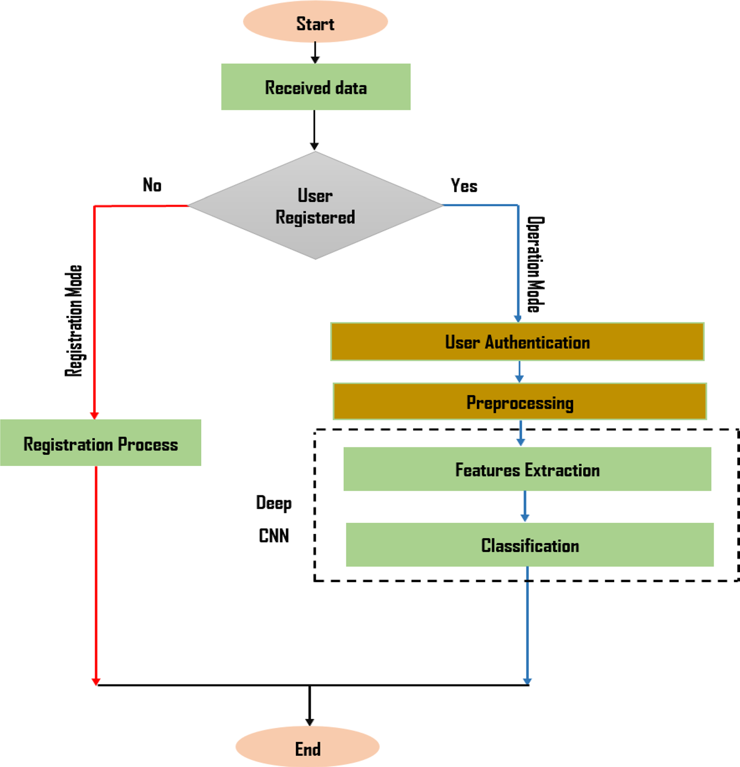

Fig. 6 Receiving mode flowchart

Table 2 ResNet 18 architecture
Layer name | Output size | Resent 18
Conv1 | 112 × 112 × 64 | 7 × 7, 64, stride 2
Conv3 | 28 × 28 × 128 | 128 3 × 3 convolutions
Conv4 | 14 × 14 × 256 | 256 3 × 3 convolutions
Conv5 | 7 × 7 × 512 | 512 3 × 3 convolutions
Avg. pool | 1 × 1 × 512 | 7 × 7 average pool
FC | 2 | 512 × 2 fully connections
SoftMax | 2

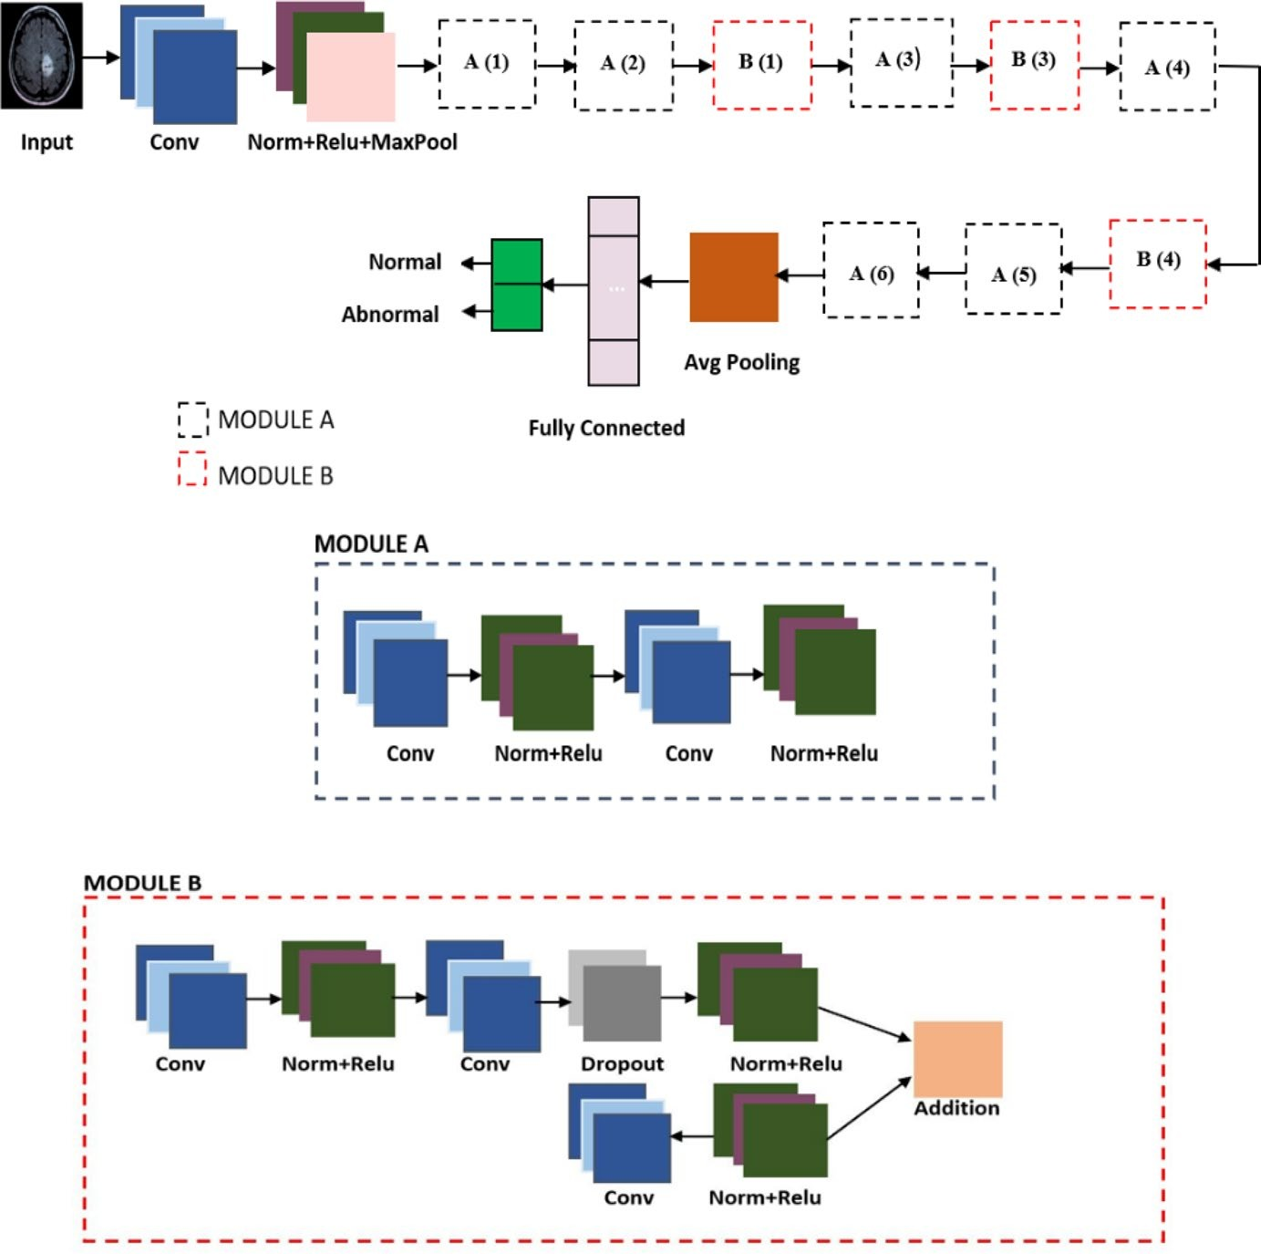
Fig. 7 Schematic representation of proposed architecture

The preparation module comprises a sequence of components, including a convolutional layer, batch normalization layer, ReLU activation layer, and a max-pooling layer with dimensions 3×3 and a stride of 2. Module A is constructed with a convolutional layer, batch normalization layer, and a subsequent ReLU activation layer. Following the ReLU activation, the output undergoes an additional convolutional layer and is subsequently combined with the previous max-pooling outcome through an added layer.
For the purpose of enhancing network accuracy and mitigating overfitting, Module B is introduced. This module introduces a Dropout layer [36] to yield more generalized outputs by introducing increased regularization. The Dropout layer replaces the conventional batch normalization, offering improved generalization. Furthermore, the module integrates a convolutional process, succeeded by a ReLU activation layer and a batch normalization layer.
The envisaged network structure comprises a preparatory module, six sets of Module A blocks, three sets of Module B blocks, and an output module, all organized as depicted in Figure 7. This configuration culminates with an extra layer dedicated to merging the two outputs. Within the classification segment, a duo of layers is present: a fully connected (FC) layer and a SoftMax layer. The collective arrangement results in an architecture comprising a total of 82 layers. A comprehensive breakdown of the proposed structure's specifications can be found in Table 3.

4.3 Performance evaluation metrics
Evaluating the system's performance involves considering a range of metrics including accuracy, confusion matrix, recall, specificity, precision, F1-score, and ROC curve. The application of a confusion matrix aids in assessing model accuracy and correctness. Specifically, accuracy quantifies the proportion of accurately classified samples as part of the evaluation process.
The calculation for accuracy is derived from the formula:

Accuracy = $\frac{TP+TN}{TP+FN+FP+TN}$ --------- (2)

wherein TP denotes true positives in malignancy situations, TN signifies true negatives in benign tumor scenarios, and FP and FN correspond to model predictions that are false. Precision serves as an evaluation of the algorithm's predictive capability, revealing the degree of "accuracy" exhibited by the model. This is quantified by the formula:
Precision = $\frac{TP}{TP+FP}$ ------------- (3)

The algorithm's performance can be assessed by employing sensitivity (recall) and specificity within a single class, as exemplified in the following manner:

Sensitivity = $\frac{TP}{TP+FN}$ ----------- (4)
Specificity = $\frac{TN}{TN+FP}$ ---------- (5)

Table 3 Proposed CNN architecture
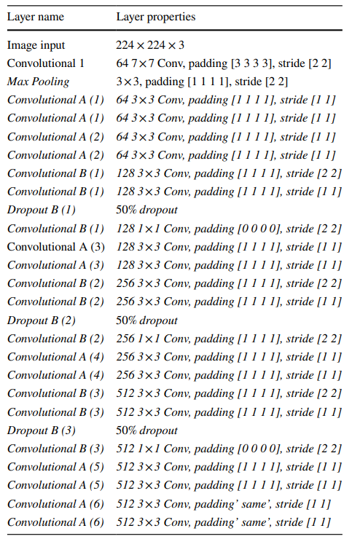
The F1-score is primarily concerned with evaluating the positive classes. It can be computed as the harmonic mean of both recall and precision, represented as:
F1 Score = $2×\frac{Precision × Recall}{Precision + Recall}$ --------- (6)

The Receiver Operating Characteristic Curve (ROC) illustrates the relationship between the true positive rate and false positive rate across various thresholds. The area under the curve (AUC) quantifies the classifier's capacity to differentiate between classes. To achieve optimal performance, diverse dropout rates and various optimizers are employed. These optimizers serve as algorithms for adjusting network parameters and minimizing the loss function by iteratively moving in the direction of the negative gradient (convergence) [37].

In the context of the suggested model, we will explore three primary optimizers:
Stochastic Gradient Descent with Momentum (SGDM): This optimizer, an enhancement of the widely used SGD optimizer, involves estimating momentum in each dimension using the current gradient and past momentum. Additionally, it accumulates gradients from preceding steps to determine the direction of movement.
Adaptive Moment (ADAM): ADAM is a Stochastic Optimization Method that combines momentum and RMSprop. An essential element of ADAM is the use of exponential weighted moving averages, which help estimate both gradient momentum and the second-order moment.
Root-Mean-Square Propagation (RMSProp): RMSProp is another optimizer under consideration.

- Result discussions and analysis
In this study, an MRI image dataset was utilized, accessible at reference [38]. Comprising a total of 253 images categorized as either normal or abnormal, the dataset underwent initial preprocessing. To standardize input dimensions, all images were resized to 224 × 224. Subsequently, a grayscale transformation was applied during the preprocessing phase. To facilitate experimentation, a random partition allocated 70% of the images for training and the remaining 30% for testing purposes.
  - Results of scenario I
As discussed before, the performance of the system is measured in terms of precision, recall, accuracy, and F1-score. To achieve the optimum performance of the system, different optimizers will be tested with different learning rates, different batch sizes, and a fixed number of periods.

Optimization algorithms
Exploration into the effects of employing different optimizers – namely, ADAM, RMSProp, ADAS, and SGDM – will be conducted. This investigation will encompass various hyper-parameter configurations, including mini-batch sizes of 32 or 64, learning rates (LR) set at 0.001 or 0.0001, and a maximum of 32 epochs, as depicted in Table 4. The process of fine-tuning these hyper-parameters will be executed using the RMSProp optimizer. This will involve optimizing the learning rate to 0.0001, selecting a mini-batch size of 64, and conducting training over 32 epochs, all aimed at achieving enhanced performance results.

Table 4 Performance of the OMRES Model for 32 Epochs
Optimization Algorithm | MB. Size | LR | Accuracy | Precision | Recall | F1-score
ADAM | 32 | 0.001 | 84.11 | 83.91 | 85.01 | 84.22
 | 32 | 0.0001 | 86.52 | 88.62 | 86.31 | 87.51
 | 64 | 0.001 | 85.22 | 84.92 | 83.23 | 84.75
 | 64 | 0.0001 | 88.92 | 89.91 | 91.13 | 90.41
RMSProp | 32 | 0.001 | 89.31 | 89.46 | 87.71 | 89.42
 | 32 | 0.0001 | 93.41 | 91.73 | 91.37 | 92.81
 | 64 | 0.001 | 95.93 | 93.44 | 94.52 | 95.22
 | 64 | 0.0001 | 98.66 | 94.65 | 100 | 98.83
SGDM | 32 | 0.001 | 89.31 | 87.11 | 88.41 | 89.33
 | 32 | 0.0001 | 93.31 | 90.51 | 92.31 | 92.84
 | 64 | 0.001 | 91.06 | 90.95 | 89.32 | 90.52
 | 64 | 0.0001 | 93.41 | 91.44 | 92.92 | 92.96
ADAS | 32 | 0.001 | 86.61 | 85.82 | 87.27 | 86.74
 | 32 | 0.0001 | 89.42 | 87.33 | 88.17 | 90.22
 | 64 | 0.001 | 90.12 | 89.93 | 89.05 | 90.77
 | 64 | 0.0001 | 93.66 | 92.88 | 91.22 | 93.92
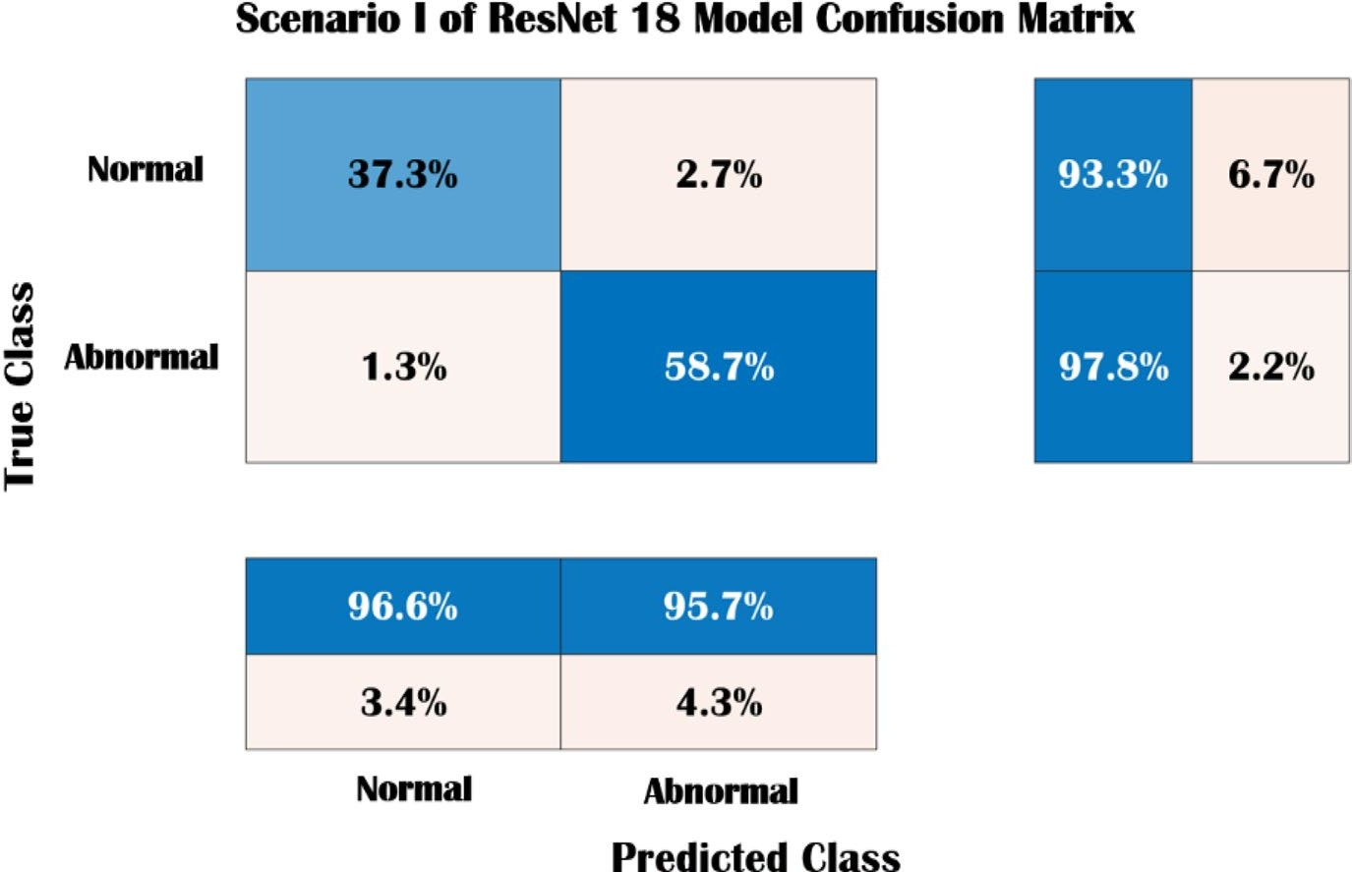

Fig. 8 Confusion Matrix for ResNet18 in Scenario I

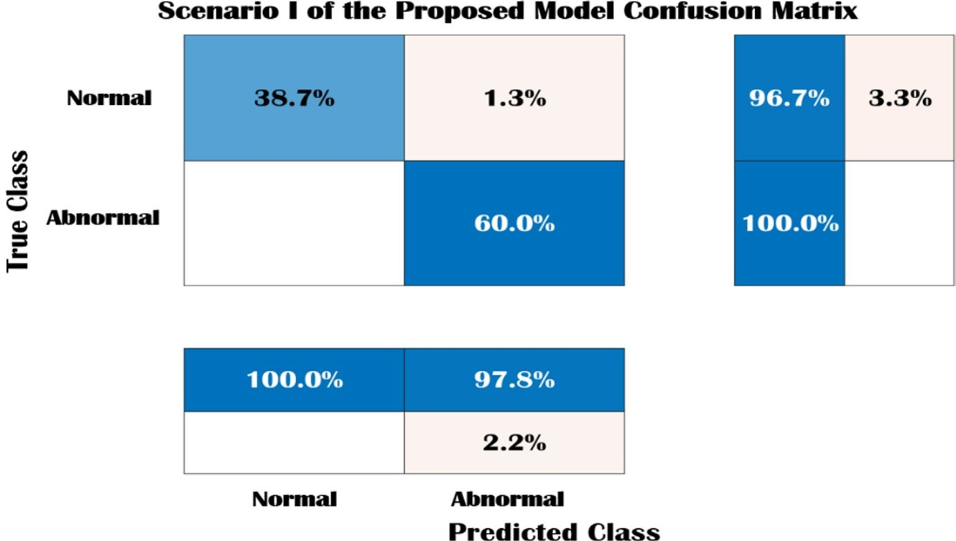

Fig. 9 Confusion Matrix for the OMRES Model in Scenario I

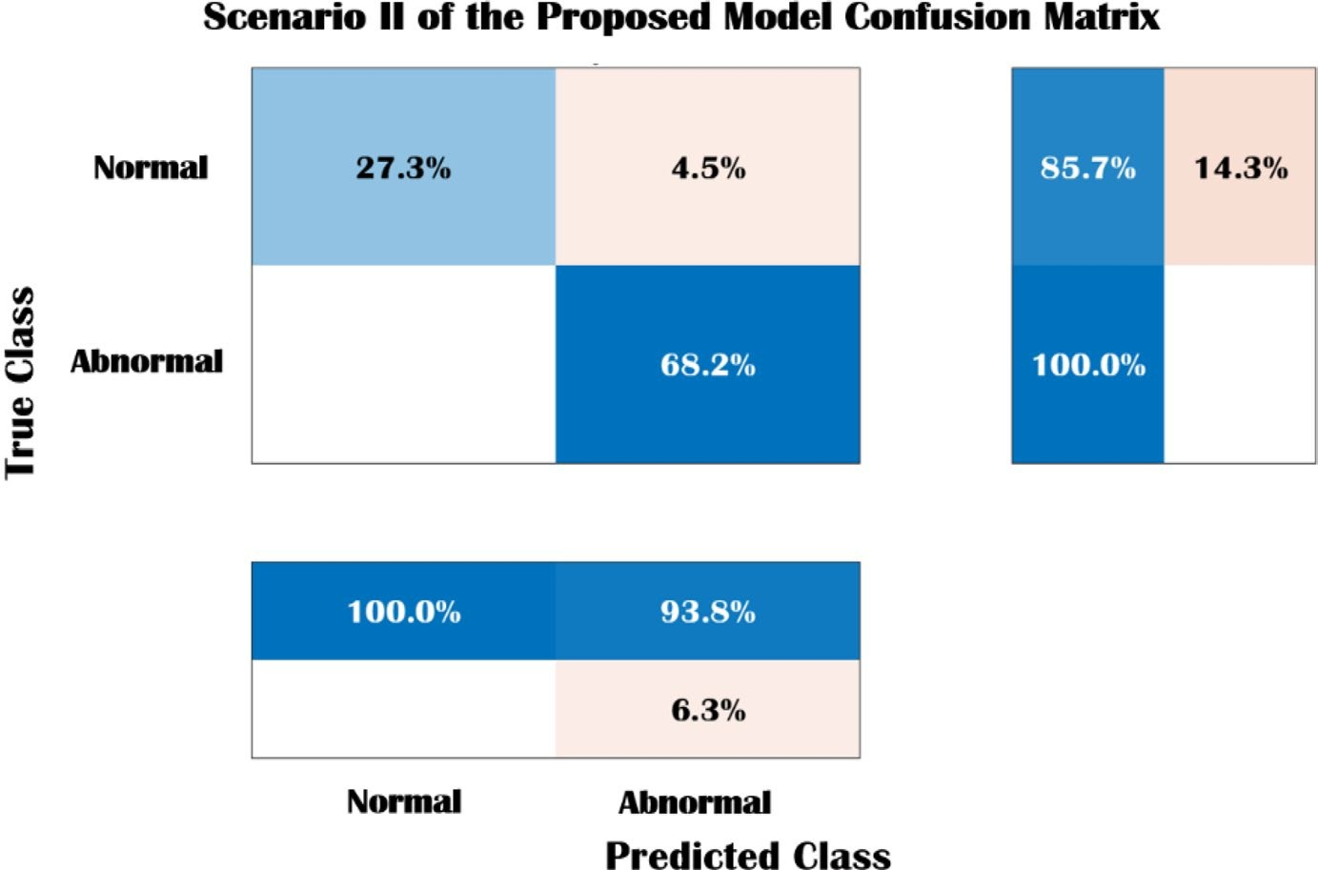
Fig. 10 Confusion Matrix for the OMRES Model in Scenario II

Figure 8 displays the confusion matrices corresponding to ResNet-18, while Figure 9 showcases the confusion matrix for Scenario I of the OMRES model. In these matrices, columns represent the expected classes, rows denote the true classes, and the diagonal entries signify instances correctly classified by the networks. Upon analysis, it is observed that the likelihood of accurately classifying the normal class as normal stands at 37.3%, whereas correctly identifying the abnormal class as abnormal is 58.7%. Additionally, the probability of misclassifying the normal class as abnormal is 2.7%, and the probability of an abnormal class being mistakenly identified as normal is 1.3%.
In a similar manner, considering Scenario I in the context of the OMRES model, the probability of accurately recognizing the normal class as normal stands at 38.7%, and the likelihood of correctly identifying an abnormal class as abnormal is 60%. Moreover, the chance of erroneously labeling the normal class as abnormal is 1.3%, while the probability of an abnormal class being inaccurately classified as normal is 0%. This implies that in Scenario I, the proposed model demonstrates greater effectiveness in predicting abnormal tumors.
Moving forward, the second scenario of the OMRES model is depicted in Figure 10. In this scenario, the probability of correctly identifying the normal class as normal is 27.3%, and the probability of accurately recognizing an abnormal class as abnormal is 68.2%. Additionally, the probability of misclassifying the normal class as abnormal is 4.5%, and the probability of an abnormal class being mistakenly categorized as normal is 0%.

- Conclusions and future work
This study introduces an innovative exploration of diverse techniques for detecting various brain tumors. Two distinct scenarios were pursued, employing a deep learning model rooted in CNN architecture to achieve tumor detection. This model, named OMRES, is an adapted version of ResNet18. The initial scenario involved directly applying brain images to the proposed model, while the second scenario introduced an IoT-based framework utilizing a multiuser detection system. This framework sends images to the cloud, enabling early brain tumor detection accessible to individuals globally, ensuring accurate classification.
Additionally, the paper delves into three optimization algorithms. The proposed model is extensively compared with other pre-trained models, evaluating F1-score, precision, recall, specificity, confusion matrix, and accuracy. Notably, in the first scenario, the proposed model exhibited superior performance with a maximum sensitivity of 100% and accuracy of 98.67%. In the second scenario, the model achieved an accuracy of 95.53% and a sensitivity of 94.2%. This emphasizes the efficacy of the proposed model in MRI brain image detection and classification.
Looking ahead, the study's future direction will encompass multi-class categorization for brain cancers. The exploration of multistage DL models for enhanced feature extraction on vast medical datasets is also in focus. Furthermore, experimentation with a single-image super-resolution stage is envisioned to elevate classification performance.

References
1. Mohammadi M et al (2018) Deep learning for IoT big data and streaming analytics: a survey. IEEE Commun Surv Tutor 20:2923–2960. https://doi.org/10.1109/COMST.2018.2844341
2. Abbas S, Mahmoud AM (2020) Deep learning-aided brain tumor detection: an initial experience based cloud framework. Indones J Electr Eng Inform (IJEEI) 8:770–780. https://doi.org/10. 52549/ijeei.v8i4.2436
3. Kapoor L, Thakur S (2017) A survey on brain tumor detection using image processing techniques. In: 7th International Conference on Cloud Computing, Data Science & EngineeringConfuence, pp 582–585. https://doi.org/10.1109/CONFLUENCE.2017.7943218
4. Kothari A, Indira B (2015) A study on classifcation and detection of brain tumor techniques. Int J Comput Eng Technol 6(11):30–35. https://doi.org/10.1007/s13735-020-00199-7
5. Goel N, Yadav A, Singh BM (2016) Medical image processing: a review. In: Second International Innovative Applications of Computational Intelligence on Power, Energy and Controls with their Impact on Humanity (CIPECH), pp 57–62. https://doi.org/10.1109/CIPECH.2016. 7918737
6. Zacharaki E, Wang S, Chawla S, Soo Yoo D, Wolf R, Melhem E, Davatzikos C (2009) Classifcation of brain tumor type and grade using MRI texture and shape in a machine learning scheme. Magn Reson Med 62(6):1609–1618. https://doi.org/10.1002/mrm.22147
7. Cheng J, Huang W, Cao S, Yang R, Yang W, Yun Z, Wang Z, Feng Q (2015) Correction: enhanced performance of brain tumor classifcation via tumor region augmentation and partition. PLoS ONE 10(12):e0144479. https://doi.org/10.1371/journal.pone.0140381
8. Shree NV, Kumar TNR (2018) Identifcation and classifcation of brain tumor MRI images with feature extraction using DWT and probabilistic neural network. Brain Inform 5:23–30. https://doi.org/ 10.1007/s40708-017-0075-5
9. Abd-Ellah M, Awad AI, Khalaf AAM, Hamed H (2020) Deep convolutional neural networks: foundations and applications in medical imaging. pp 233–260. https://doi.org/10.1201/9781351003 827-9
10. Deepak S, Ameer PM (2019) Brain tumor classifcation using deep CNN features via transfer learning. Comput Biol Med 111:103345. https://doi.org/10.1016/j.compbiomed.2019.103345
11. Saxena P, Maheshwari A, Maheshwari S (2019) Predictive modeling of brain tumor: A deep learning approach. arXiv 2019, arXiv:1911.02265. https://doi.org/10.1007/978-981-15-6067-5_30
12. Hemanth DJ, Anitha J, Naaji A, Geman O, Popescu DE (2018) A modifed deep convolutional neural network for abnormal brain image classifcation. IEEE Access 7:4275–4283. https://doi.org/10. 1109/ACCESS.2018.2885639
13. Çinar A, Yildirim M (2020) Detection of tumors on brain MRI images using the hybrid convolutional neural network architecture. Med Hypotheses. https://doi.org/10.1016/j.mehy.2020.109684
14. Khawaldeh S et al (2017) Noninvasive grading of glioma tumor using magnetic resonance imaging with convolutional neural networks. Appl Sci. https://doi.org/10.3390/app8010027
15. Tazin T, Sarker S, Gupta P (2021) A robust and novel approach for brain tumor classifcation using convolutional neural network. Comput Intell Neurosci. https://doi.org/10.1155/2021/2392395
16. Ge C, Gu IY, Jakola AS, Yang J (2018) Deep learning and multi-sensor fusion for glioma classifcation using multistream 2D convolutional networks. In: 40th Annual International Conference of the IEEE Engineering in Medicine and Biology Society (EMBC), pp 5894–5897. https://doi.org/10. 1109/EMBC.2018.8513556
17. Ilunga-Mbuyamba E, Avina-Cervantes JG, Cepeda-Negrete J, Ibarra-Manzano MA, Chalopin C (2017) Automatic selection of localized region-based active contour models using image content analysis applied to brain tumor segmentation. Comput Biol Med 91:69–79. https://doi.org/10. 1016/j.compbiomed.2017.10.003
18. Fan J, Yau DK, Elmagarmid AK, Aref WG (2001) Automatic image segmentation by integrating color-edge extraction and seeded region growing. IEEE Trans Image Process 10(10):1454–1466. https://doi.org/10.1109/83.951532
19. Bhattacharyya D, Kim T-H (2011) Brain tumor detection using MRI image analysis. In: International Conference on Ubiquitous Computing and Multimedia Applications, pp 307–314, Springer. https://doi.org/10.1007/978-3-642-20998-7_38
20. Mittal K, Shekhar A, Singh P, Kumar M (2017) Brain tumour extraction using otsu based threshold segmentation. Int J Adv Res Comput Sci Softw Eng. https://doi.org/10.23956/ijarcsse/V7I4/0145
21. Oo SZ, Khaing AS (2014) Brain tumor detection and segmentation using watershed segmentation and morphological operation. Int J Res Eng Technol 3(3):367–374. https://doi.org/10.15623/ijret. 2014.0303068
22. Mei PA, de Carvalho Carneiro C, Fraser SJ, Min LL, Reis F (2015) Analysis of neoplastic lesions in magnetic resonance imaging using self-organizing maps. J Neurol Sci 359(1–2):78–83.
https://doi. org/10.1016/j.jns.2015.10.032
23. Karthik R, Menaka R, Chellamuthu C (2015) A comprehensive framework for classifcation of brain tumor images using SVM and curvelet transform. Int J Biomed Eng Technol 17(2):168–177. https://doi.org/10.1504/IJBET.2015.068054
24. Kim J, Lee S, Lee G, Park Y, Hong Y (2016) Using a method based on a modifed k-means clustering and mean shift segmentation to reduce fle sizes and detect brain tumors from magnetic resonance (MRI) images. Wirel Pers Commun 89(3):993–1008. https://doi.org/10.1007/ s11277-016-3420-8
25. Madhusudhanareddy P, Prabha IS (2013) Novel approach in brain tumor classifcation using artifcial neural networks. Int J Eng Res Appl 3(4):2378–2381
26. Reddick WE, Glass JO, Cook EN, Elkin TD, Deaton RJ (1997) Automated segmentation and classification of multispectral magnetic resonance images of brain using artificial neural networks. IEEE Trans Med Imaging 16(6):911–918. https://doi.org/10.1109/42.650887
27. Havaei M, Davy A, Warde-Farley D, Biard A, Courville A, Bengio Y, Pal C, Jodoin PM, Larochelle H (2017) Brain tumor segmentation with deep neural networks. Med Image Anal 35:18–31. https:// doi.org/10.1016/j.media.2016.05.004
28. El-Feshawy SA, Saad W, Shokair M, Dessouky M (2021) Brain tumour classifcation based on deep convolutional neural networks. In: 2021 International Conference on Electronic Engineering (ICEEM), pp 1–5. https://doi.org/10.1109/ICEEM52022.2021.9480637
29. Vaishnavee K, Amshakala K (2015) An automated MRI brain image segmentation and tumor detection using SOM-clustering and proximal support vector machine classifer. In: IEEE International Conference on Engineering and Technology (ICETECH), pp 1–6. https://doi.org/10.1109/ICETE CH.2015.7275030
30. Kharrat A, Gasmi K, Messaoud MB, Benamrane N, Abid M (2010) A hybrid approach for automatic classifcation of brain MRI using genetic algorithm and support vector machine. Leonardo J Sci 17(1):71–82
31. Rajendran A, Dhanasekaran R (2013) Enhanced possibilistic fuzzy c-means algorithm for normal and pathological brain tissue segmentation on magnetic resonance brain image. Arab J Sci Eng 38(9):2375–2388. https://doi.org/10.1007/s13369-013-0559-4
32. Chahal PK, Pandey S (2020) An efcient hybrid approach for brain tumor detection in MRI images using Hadoop-MapReduce. In: International Conferences on Internet of Things (iThings) and IEEE Green Computing and Communications (GreenCom) and IEEE Cyber, Physical and Social Computing (CPSCom) and IEEE Smart Data (SmartData) and IEEE Congress on Cybermatics (Cybermatics), pp 926–931, https://doi.org/10.1109/iThings-GreenCom-CPSCom-SmartData-Cybermatic s50389.2020.00144
33. Zhang C, Shen X, Cheng H, Qian Q (2019) Brain tumor segmentation based on hybrid clustering and morphological operations. Int J Biomed Imaging. https://doi.org/10.1155/2019/7305832
34. Darwish A, Hassanien AE, Elhoseny M, Sangaiah A, Muhammad K (2019) The impact of the hybrid platform of internet of things and cloud computing on healthcare systems: opportunities, challenges, and open problems. J Ambient Intell Hum Comput 10:4151–4166. https://doi.org/10. 1007/s12652-017-0659-1
35. Grami A (2015) Introduction to digital communications. Springer, Cambridge
36. Srivastava G, Hinton A, Krizhevsky IS, Salakhutdinov R (2014) Dropout: a simple way to prevent neural networks from overftting. J Mach Learn Res 15(1):1929–1958
37. Bottou L (2010) Large-scale machine learning with stochastic gradient descent. In: Proceedings of COMPSTAT. Physica-Verlag HD, pp 177–186. https://doi.org/10.1007/978-3-7908-2604-3_16
38. https://www.kaggle.com/navoneel/brain-mri-images-for-brain-tumordetection accessed June 10, 2019
39. Vishnuvarthanan G, Rajasekaran MP, Subbaraj P, Vishnuvarthanan A (2016) An unsupervised learning method with a clustering approach for tumor identifcation and tissue segmentation in magnetic resonance brain images. Appl Soft Comput 38:190–212. https://doi.org/10.1016/j.asoc.2015. 09.016
40. Ullah Z, Farooq MU, Lee SH, An D (2020) A hybrid image enhancement based brain MRI images classifcation technique. Med Hypotheses. https://doi.org/10.1016/j.mehy.2020.109922
41. Siddiaue MAB, Sakib S, Khan MMR, Tanzeem AK, Chowdhury M, Yasmin N (2020) Deep convolutional neural networks model-based brain tumor detection in brain MRI images. In: Proceedings of the Fourth International Conference on I-SMAC (IoT in Social, Mobile, Analytics and Cloud) (ISMAC), IEEE, Palladam, India, November 2020. https://doi.org/10.1109/I-SMAC49090.2020. 9243461
42. Francisco JP, Mario ZM, Miriam RA (2021) A deep learning approach for brain tumor classifcation and segmentation using a multiscale convolutional neural network. Healthcare 9:153. https://doi. org/10.3390/healthcare9020153
43. Sultan HH, Salem NM, Al-Atabany W (2019) Multi-classifcation of brain tumor images using deep neural network. IEEE Access 7:69215–69225. https://doi.org/10.1109/ACCESS.2019.2919122
44. Pashaei A, Ghatee M, Sajedi H (2020) Convolution neural network joint with mixture of extreme learning machines for feature extraction and classifcation of accident images. J Real-Time Image Process 17:1051–1066. https://doi.org/10.1007/s11554-019-00852-3
45. Kaplan K, Kaya Y, Kuncan M, Ertunç HM (2020) Brain tumor classifcation using modifed local binary patterns (LBP) feature extraction methods. Med Hypotheses 139:109696. https://doi.org/10. 1016/j.mehy.2020.109696
46. El-Feshawy S, Saad W, Shokair M, Dessouky M (2022) Proposed Approaches for Brain Tumors Detection Techniques Using Convolutional Neural Networks. Int J Telecommun IJT’2022 2(1):1– 14. https://ijt-adc.org/articles/2805-3044/165806

