DFT Simulation of UV-Visible spectra and NLO characteristics of 2, 5- and 2, 6-dihydroxytoluenes

P. Venkata Ramana Rao^{1*},K. Srishailam¹
¹Department of Physics, SR University, Warangal-506371, Telangana, India
*Corresponding author: poladi.ramana@gmail.com
Abstract. UV-Visible signals were simulated for 2, 5-dihydroxytoluene (5DHT) and 2, 6-dihydroxytoluene (6DHT), Frontier molecular orbital (FMO) technique was employed to understand the origin of Ultraviolet-Visible spectra and chemical reactivity of the samples. Non-linear optical parameters like dipole moment and hyperpolarizability were calculated. DFT/B3LYP/6-311++G(d,p) level of speculation was used for computations of 5DHT and 6DHT.
- Introduction
2, 5- dihydroxytoluene (5DHT) and 2, 6- dihydroxytoluene (6DHT) are well-known in support of their employ in medicinal applications [1-5].It was revealed that cytotoxicity of 5DHToccurs from its methyl moiety [6]. Recently we reported DFT calculations of such biologically active molecules [7-15]. Hence, we undertook this work with the following aspects.
- simulated UV-Visible spectra and,
- FMO and chemical reactivity parameters and Non-linear optical properties,

to make the exploration complete.
- Computational aspects

Using DFT/6-311++G(d,p) level of assumption and employed in Gaussian Window 09 program suit [16, 17] simulated UV-Vis spectrum [18-20]. We computed Chemical reactivity [21-26] of selected compounds.
- Results and discussions
  - Most stable conformer
Geometry of chosen samples was optimized with the above selected method, and their minimum energy monomers depicted in figure 1.
  - UV-Visible peaks

Calculated Ultraviolet-Visible absorption signals are due to the electronic transitions. The frontier molecular orbitals are recognized as highest occupied molecular orbital (HOMO) and (LUMO) lowest un-occupied molecular orbital, and they determine the reactivity of the selected compounds [27]. Electron donor is HOMO and acceptor is LUMO [28, 29]. The estimated peaks at λ_{max} = 235.97 nm, its oscillator strength, f = 0.0012 and another one observed at λ_{max} = 271.41nm with f = 0.0002 for 5DHT and λ_{max} = 241.11 nm, its oscillator strength, f = 0.0021 and another one observed at λ_{max} = 247.37 nm with f = 0.0072 for 6DHT , and are shown in figure 2. The origin of the signals is mainly due to the shifts as of H→L+1, H→L+3 in 5DHT and H→L+1, H→L+2 in 6DHT.

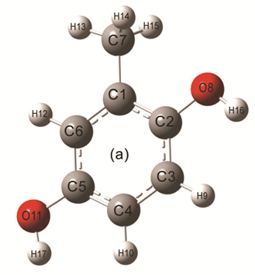 | 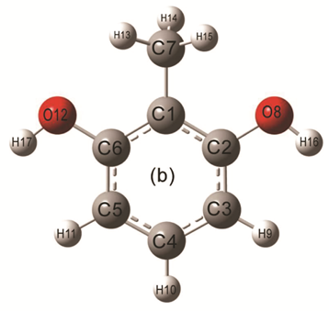

Figure 1: Optimized geometrical structure of (a) 5DHT and (b) 6DHT.

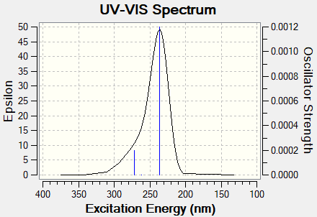 | 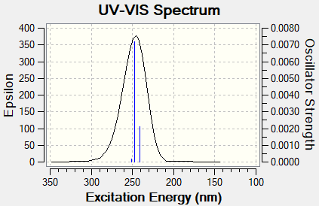

Figure 2: UV-Vis peaksof 5DHT and 6DHT.

  - Chemical reactivity of the molecules

Frontier molecular orbital energy gap plays vital role in understanding the chemical reactivity such as reactants kinetic characteristics and chemical reactions of the molecule. The calculated energy gap between the H and L values for 5DHT and 6DHT are 3.636eV and 4.404 eV. Their chemical potentials (μ = -6.862 eV and -7.000eV) are negative for both the molecules, and are chemically stable [30, 31]. These parameters describes, the aspects like drug design and toxicological behaviour of eco system.

  - NLO properties
When Electromagnetic radiation interacts with NLO material, then change occurse in phase, amplitude, frequency, or gives the new propagation field characteristics [32]. If this change is significant then the NLO material used in signal processing, optical inter-connections, telecommunications and optical memory [33-36].
The NLO behaviour of selected compoundsare judged by comparing the related quantities of Urea. For Urea, hyper polarizability (β_{t})and dipole moment(µ_{t}) are 372.8 × 10⁻³³ cm^{5/}esu and 1.3732 Debye, respectively. For 5DHT and 6DHT, these values are β_{t} = 98.594 × 10⁻³³ cm^{5/}esu, 299.729 × 10⁻³³ cm^{5/}esu, and µ_{t} = 0.938 Debye, 0.792 Debye. The estimated values are less compared with that of Urea; hence titled compounds are not NLO materials.
- Conclusion
Theoretical UV-Visible peak values, FMO and chemical reactivity parameters computed for the selected compounds and these are not NLO materials.
- References
- Sarkar S, Bhattacharya G, Bandyopadhyay S, Bhattacharjee S, Banerjee D, 2010 Identification of orcinol reactive substance in pleural fluid cell lysate-A new parameter for classification of pleural effusion,Clin.Chim.Acta.411,671-674.
- Horecker B. L, 1957 The orcinol reaction for mixtures of pentose and heptulose, Methods in Enzymology. 3, 105-107
- Slater T. F, 1958 Interference by sucrose in the estimation of RNA by the orcinol method, Biochim. Biophys. Acta. 27, 201-202.
- CockerJ, Mason H. J, Garfitt S. J, Jones K, 2002 Biological monitoring of exposure to organophosphate pesticides, Toxicology Letters. 177, 97-103.
- MannersG, JurdL., StevensK, 1972 Biogenetic-type syntheses of isoprenoid and diisoprenoid derivatives of orcinol, Tetrahedron, 28, 2949-2959.
- Xiang-Yu Cao, Jian-Li Liu, Tie-Min Li, Jiang-Bei Yuan, Cheng-Bin Xu, Xiu Juan Hui, Meng Zeng, 2011 Investigation on the interaction between3, 5-dihydroxytoluene and bovine serum albumin by fluorescence spectroscopy. IEEE International Symposium on IT in Medicine and Education.
- Srishailam K, Venkata Ramana Rao P, Ravindranath L, Venkatram Reddy B, Ramana Rao G 2019 Experimental and theoretical determination of structural and vibrational properties of pentachlorophenol and pentachlorothiophenol J. Mol. Struct. 1178 142-154.
- Venkata Ramana Rao P, Srishailam K, Ravindranath L, Venkatram Reddy B, Ramana Rao G 2019 Structural and vibrational properties of pentabromophenol and pentafluorophenol: A spectroscopic investigation using density functional theory. J. Mol. Struct. 1180 665-675.
- Ramaiah K, Srishailam K, Laxma Reddy K, Venkatram Reddy B, Ramana Rao G 2019 Synthesis, crystal and molecular structure, and characterization of 2-((2-aminopyridin-3- yl)methylene)-N-ethylhydrazinecarbothioamide using spectroscopic (1H and 13C NMR, FT-IR, FT-Raman, UV-Vis) and DFT methods and evaluation of its anticancer activity J. Mol. Struct. 1184 405-417.
- Srishailam K, Venkatram Reddy B, Ramana Rao G 2019 Investigation of torsional potentials, hindered rotation, molecular structure and vibrational properties of some biphenyl carboxaldehydes using spectroscopic techniques and density functional formalism J. Mol. Struct. 1196 139-161.
- Padmaja G, Devarajulu G, Deva Prasad Raju B, Turpu G R, Srishailam K , Venkatram Reddy B, Pavan Kumar G 2020 Synthesis of Sr1-xBaxBi2B2O7 glass ceramics: A study for structure and characterization using experimental techniques and DFT method J. Mol. Struct. 1220 128660.
- Venkata Ramana Rao P, Srishailam K, Ramesh G, Venkatram Reddy B, Ramana Rao G 2020 NMR & Electronic Spectra, NLO, FMO, NBO and Thermodynamic Properties of Pentachlorophenol: An Experimental and Theoretical Investigation, Asian Journal of Chemistry; 32, 12 , 3057-3062
- Venkata Ramana Rao P, Srishailam K, Rajesh A 2020 Electronic, NLO, and thermodynamic parameters and frontier molecular orbital investigation of pentafluoro phenol and pentachloro thiophenol with DFT approach. Mater.Sci.Eng.981.022087.
- Srishailam K, Ramaiah K, Laxma Reddy K, Venkatram Reddy B and G. Ramana Rao, 2021 Synthesis and evaluation of molecular Structure from torsional scans, study of molecular characteristics using spectroscopic and DFT methods of some thiosemicarbazones, and investigation of their anticanceractivity. Chem. Pap.Chemical Papers, 75(7), 3635-3647.
- Venkata Ramana Rao P, Srishailam K, Venkatram Reddy B, Ramana Rao G 2021 Theoretical (DFT) and experimental (FT-IR & FT Raman) approach to investigate the molecular geometry and vibrational properties of 2,5- and 2,6-dihydroxytoluenes J. Mol. Struc. 1240, 130617
- Gaussian 09, Revision B.01, M.J. Frisch M. J et al 2010 Gaussian, Inc., Wallingford CT
- Becke A. D 1993 Density-functional thermochemistry. III. the role of exact exchange J. Chem. Phys. 98 5648-5652
- Scalmani G , Frisch M. J, 2010 Continuous surface charge polarizable continuum models of solvation. I. General formalism, J. Chem. Phys., 132 1-15
- Improta R, Barone V, Scalmani G, and FrischM. J, 2006 A state-specific polarizable continuum model time dependent density functional method for excited state calculations in solution, J. Chem. Phys., 125 1-9.
- Improta R, Scalmani G, FrischM. J, and Barone V, 2007 Toward effective and reliable fluorescence energies in solution by a new State Specific Polarizable Continuum Model Time Dependent Density Functional Theory Approach, J. Chem. Phys., 127 1-9.
- Scalmani G, Frisch M. J 2010 Continuous surface charge polarizable continuum models of solvation. I. General formalism J. Chem. Phys. 132 1-15
- Improta R, Barone V, Scalmani G, and Frisch M. J 2006 A state-specific polarizable continuum model time dependent density functional method for excited state calculations in solution J. Chem. Phys. 125 1-9
- Improta R, Scalmani G, Frisch M J, and Barone V 2007 Toward effective and reliable fluorescence energies in solution by a new State Specific Polarizable Continuum Model Time Dependent Density Functional Theory Approach, J. Chem. Phys. 127 1-9
- Gece G 2008 The use of quantum chemical methods in corrosion inhibitor studies, Corros. Sci. 50 2981–2992
- Parr R. G, Szentpa´ly L. V, Liu S 1999 Electrophilicity Index, J. Am. Chem. Soc.121 1922-1924
- Ö zdemira N, Erenb B, Dinc¸era M and Bekdemir Y 2010 Experimental and ab initio computational studies on 4-(1H-benzo[d]imidazol-2-yl)-N,N-dimethylaniline, Mol. Phys. 108 13-24
- ChoiC.H, KertezM, 1997 Conformational Information from Vibrational Spectra of Styrene, trans-Stilbene, and cis-Stilbene, J. Phys. Chem A 101 3823-3831.
- Fukui K 1982 Role of frontier orbitals in chemical reactions, Science 218 747-754.
- Koopmans T. A, 1933 Ordering of wave functions and eigen energies of the individual electrons of an atom, Physica 1 104-113.
- Balachandran V, Karunakaran V,2013Quantum mechanical study of the structure and vibrational spectroscopic (FT-IR and FT-Raman), first-order hyperpolarizability, NBO and HOMO−LUMO studies of 4-bromo-3-nitroanisole Spectrochim. Acta, Part A 106 284-298.
- Politzer P, Murray J. S, 2002 The fundamental nature and role of the electrostatic potential in atoms and molecules Theor Chem Acc 108 134-142.
- Sun Y-X, Hao Q-L, Wei W-X, Yu Z-X, Lu L-D, Wang X, Wang Y-S, 2009 Experimental and density functional studies on 4-(3,4-dihydroxybenzylideneamino) antipyrine and 4-(2,3,4-trihydroxybenzylideneamino)antipyrine, J. Mol. Struct. Theochem 904 74-82.
- Andraud C, Brotin T, Garcia C, Pelle F, Goldner P, Bigot B, Collet A, 1994 Theoretical and Experimental Investigations of the Nonlinear Optical Properties of Vanillin, Polyenovanillin, and Bisvanillin Derivatives, J. Am. Chem. Soc. 116 2094-2102.
- Geskin V M, Lambert C, Bre´das J-L, 2003 Origin of High Second- and Third-Order Nonlinear Optical Response in Ammonio/Borato Diphenylpolyene Zwitterions: the Remarkable Role of Polarized Aromatic Groups, J. Am. Chem. Soc. 125 15651-15658.
- Nakano M, Fujita H, Takahata M, Yamaguchi K,2002Theoretical Study on Second Hyperpolarizabilities of Phenylacetylene Dendrimer: Toward an Understanding of Structure-Property Relation in NLO Responses of Fractal Antenna Dendrimers, J. Am. Chem. Soc. 124 9648-9655.
- Sajan D, Joe H, Jayakumar V.S, Zaleski J, 2006 Structural and electronic contributions to hyperpolarizability in methyl p-hydroxy benzoate, J. Mol. Struct. 785 43-53.

