Delination and Morphology Analysis of Watershed Catchment Areas of Tuggali Mandal, Kurnool District, Andhra Pradesh by using Toposheet
B Dileep Kumar Reddy1, Assistant Professor
JNT University, Anantapur, Civil Engineering dept. JNTUA College of Engineering, Pulivendula
YSR Kadapa, India
b.dilip92@gmail.com

G Sivanatha Reddy2, Assistant Professor
JNT University, Anantapur, Civil Engineering dept. JNTUA College of Engineering, Pulivendula YSR Kadapa, India

B L Niranjan Reddy3, Assistant Professor
JNT University, Anantapur, Civil Engineering dept. JNTUA College of Engineering, Pulivendula YSR Kadapa, India
bniranjancivil@gmail.com
ABSTRACT
Land and water resources are scarce in nations like India, where the strain from an expanding population is constant, making extensive use of them necessary. For appropriate planning and management of natural resources for sustainable development, watersheds must be clearly defined within a wide drainage basin and prioritised. It is not only uneconomical, but also difficult to delineate prospective zones for the adoption of conservation measures above the entire watershed. The practise of identifying the ridge border encircling a water body or runoff outlet is known as "watershed delineation" on a geographical area. Understanding of the fundamentals of topographical watershed delineation (based on contours and runoff outflow). watershed mapping and Geomorphology uses morphometry analysis to make quantitative measurements of the physical properties of landforms. It is done primarily to comprehend the composition, development, and processes of the landscape. It is possible to link the runoff features to the morphometric parameters by analysing the flow pattern in the basin. In this study, the investigation of the flow pattern and the morphometric elements of the streams and landforms of the Girigetla, Rampalli, and Chennampalli Villages drainage are both addressed. For the purpose of locating and analysing watershed borders, topographic maps with a scale of 1:50000 were employed. The drainage basin covers a total area of 100.7 km2. For the drainage basins, the areal aspects of morphometry—drainage density, stream frequency, form factor, elongation ratio, and circularity ratio—as well as the linear aspects—stream order, stream length, stream length ratio, and bifurcation ratio—were computed. The decision-making authorities can utilise the findings to develop and put the practises for managing the watershed into action.
Keywords: watershed delineation, Morphology, Catchment Area, Drainage basin, Toposheet

I INTRODUCTION
Land and water resources are scarce in nations like India where population pressure is continually rising, making extensive use of these resources essential. Catchments, drainage basins, and sub-catchments are the basic organisational units for managing the conservation of natural resources. The notion of watershed management acknowledges the connections between uplands, low lands, land use, geomorphology, slope, and soil. When managing watersheds and defining watersheds, soil and water conservation are the main concerns.[1]
For watershed planning, drainage basin analysis based on morphometric parameters is crucial because it provides insight into the basin's slope, topography, soil quality, runoff characteristics, potential for surface water, and other features. [1] Because it enables (i) an understanding of the relationship between various aspects within a drainage basin (ii) a comparative evaluation to be made of different drainage basins developed in different geomorphological and topographical regimes (iii), and (iv) the definition of some useful variables of drainage basins in numerical terms, morphometric analysis of the watershed is thought to be the most satisfactory method.[1]
Water availability in a watershed must be quantified, and the difference between supply and demand must be as little as possible, for water resources to be used sustainably. Hydro morphological analysis is an important aspect in determining the available water in a catchment.[5]
Nowadays, many topographical and morphometric features of drainage basins and watersheds are assessed using remote sensing and GIS techniques, since they offer a flexible basin environment and a potent tool for the manipulation and analysis of spatial data. [5]
In the present study Girigetla, Chennampalli and Rampalli Drainage basins. The geomorphology and flow pattern of each basin was analysed in detail by Manual method.
In the Survey of India (SOl) Topographic sheets/maps, topographic features including contour lines, other natural and man-made features like water bodies, drainage lines, benchmarks, etc. are adequately portrayed. The contour interval ranges from 10 metres to 20 metres depending on the scale of the map (topo-sheet), and is typically 20 metres for top sheets with a scale of 1:50,000.[3]
The practise of identifying the ridge border encircling a water body or runoff outlet is known as "watershed delineation" on a geographical area. Understanding of the fundamentals of topo-sheet-based watershed delineation (based on contours and runoff outflow). Here we shall use the topographic sheets as the main input to have the delineated boundaries of the watersheds as the final output.[8]
II METHODOLOGY
A. Study area
The selected catchment area for the study is an Girigetla, Chennampalli and Rampalli Drainage basins in Andhra pradesh state of India. The base map showing location of Tuggali Mandal has been given in Fig 1. The catchment area of the Drainage basins are 100.07 km2 and mean annual rainfall in the catchment is about 1433.1 mm. The dead storage capacity and gross storage capacity of reservoir are 11.33 Mm3 and 160.35 Mm3 respectively.[2] These watersheds are located within 15°15′ and 15°30′ N and 77° 30′ and 77°45′ E. [8]
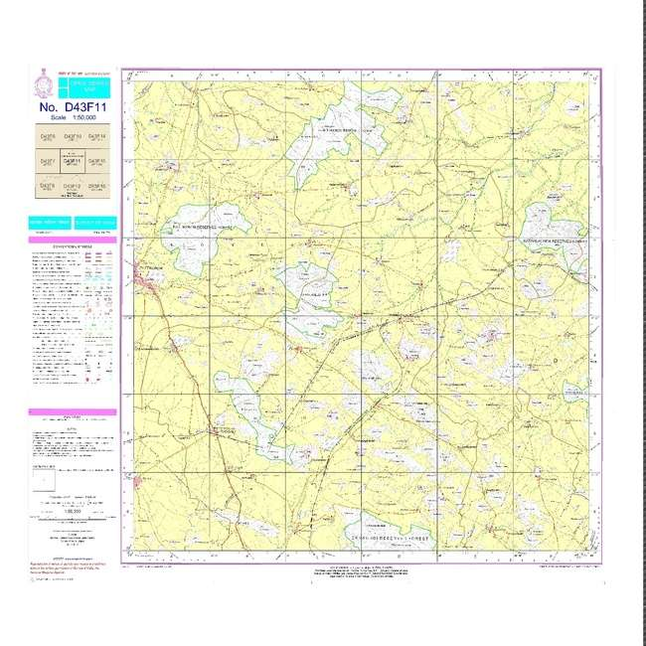
Fig-1: Toposheet of respective locations
B. Data collection:
In order to identify and prioritise the places most susceptible to soil erosion, this article focuses on the morphological evaluation of the watersheds. The toposheets produced by Survey of India (SOI) at a scale of 1:50,000 serve as the main source of data. The data utilised in this study are thoroughly described in Table 1. [8] The Girigetla, Chennampalli, and Rampalli Drainage Basins Catchments were prepared using the Survey of India (SOI) topographical maps at a scale of 1:50,000. The aforementioned catchments stream networks have been tracked and scanned. The present study's of catchments' morphometric characteristics were calculated using Strahler's (1957) system of stream ranking. [1]
C. Watershed delineation
The Following steps are used for watershed delineation:
Step 1: Mark the position of the water body or tributary that joins the main stream on a topographical map.
Step 2: Analyse the contour lines on the topo-sheet for the area, which link sites with the same elevation above mean sea level or the GTS Benchmark. Valleys are shown by contours (contour lines) pointing upstream, which also serve as the watershed's drainage line. Ridges are shown by outlines that point downward. The terrain appears to be more or less level, with gently sloping ground, based on the large distances between the contours. Contour lines that are closely spaced apart suggest a region with steep slopes or rapid changes (rise or decrease) in elevation over a short distance.
Step 3: Follow the drainage line or river from its inlet to its outflow, taking into account any tributaries. This process aids in establishing the drainage area's beginning and end points.
Step 4: A sequence of contour lines "pointing" in the direction of the greatest elevation are used to depict a valley line or drainage line (Fig. 1). By drawing arrows perpendicular to a set of contour lines that decrease in height, you may determine the direction of drainage in the region. Water runoff follows the route of least resistance as it descends a hill. The perpendicular path between contours is the runoff travel path.
Step 5: A succession of contour lines "pointing" in the direction of the lowest elevation depict a higher area or ridge line (Fig 1).
Step 6: Identify and record the highest elevations/divide points where some runoff would go to one body of water and the remainder would go to another.
Step 7: Connect the division points to create the watershed border, which is a line based on the area's highest elevations.
Step 8: The procedure of defining a watershed using a topo-sheet is now complete.
Step 9: You may now take this map of a delimited watershed or sub-watershed to the field for validation, if necessary.
Step 10: Convert various metrics, such as the number of channels, their lengths, watershed boundaries, etc., to real lengths according to map scale.
D. Measuring Watershed Areas:
There are two widely available methods for measuring the area of a watershed: a) Dot Grid Method, and b) Planimeter. These methods can also be used to measure the area of the wetland itself as required by The New Hampshire Method.
The usage of the dot grid approach stems from its simplicity and lack of expensive equipment. In this technique, the user covers the region of the map that needs to be measured with a sheet of acetate or mylar that has a series of dots printed on it that are roughly the size of the period at the end of this sentence. To calculate the area, the user counts the dots that are within the measurement region and multiplies the result by a multiplier.
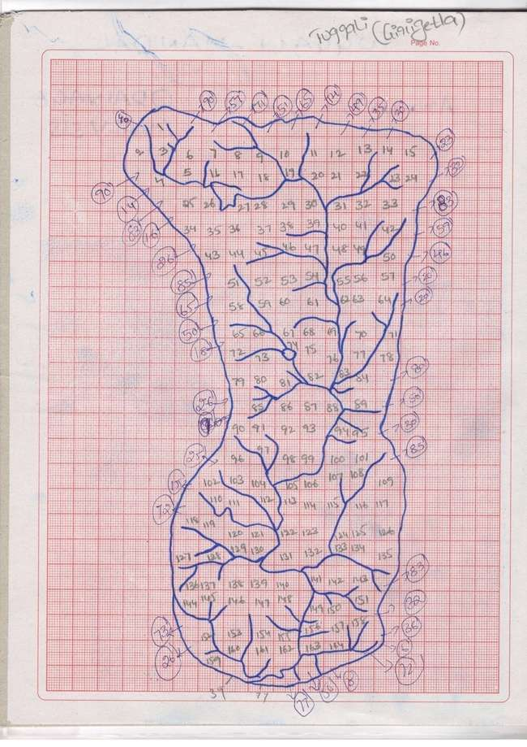
Fig-2: Watershed Delinated area of Girigetla village
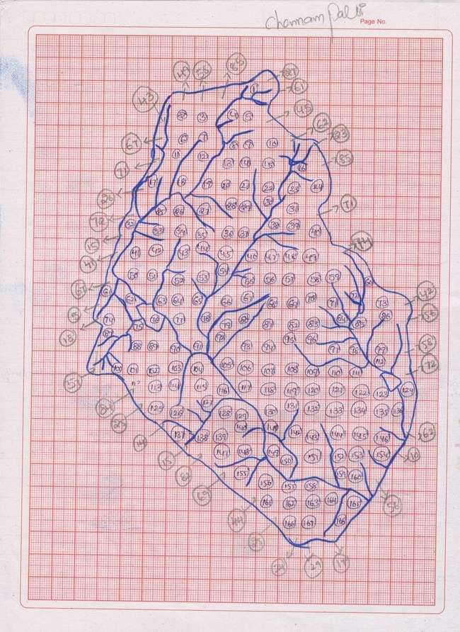
Fig-3: Watershed Delinated area of Chennampalli village
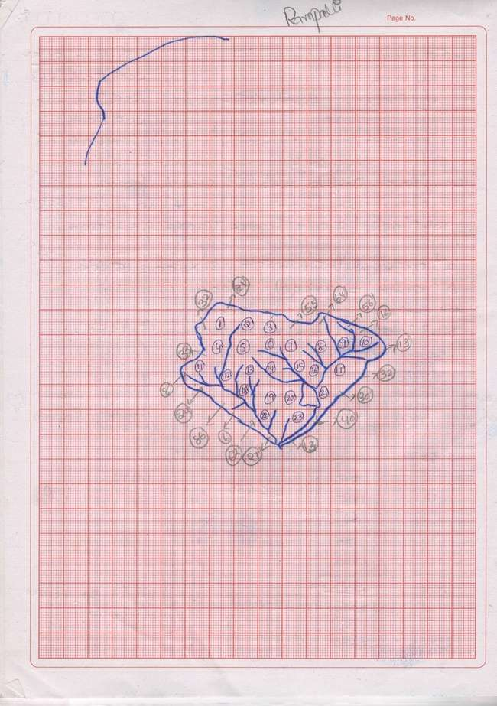
Fig-4: Watershed Delinated area of Rampalli village
E. Stream frequency (F): Horton introduced stream frequency as the number of stream segments Nu per unit area Au, thus, F = ěNu/Au (expressed per km2 ). The detailed analysis made by Melton (1957) for studying the relationship between drainage density and stream frequency for 156 drainage basins covering a vast range of scale, climate, relief, surface cover and geologic type showed that a remarkably small scatter existed, indicating that the relationship between density and frequently tends to be conserved as a constant in nature. On the basis of the drainage density, a drainage basin can be classified into any of the four different textures as 0 to 2 Very poor runoff , 2 to 4 Poor runoff, 4 to 6 Moderate runoff ,6 to 8 High runoff and >8 Very high runoff.[1]

F. Stream order and number (Nu): The first step for drainage-basin analysis is designation of stream orders. In the present study a system introduced by Horton and modified by Strahler (Strahler 1952b, Schumms 1956) has been adopted. Each segment of the stream was numbered starting from the first order to the maximum order present in each of the sub-basins. After numbering, the drainage-network elements are assigned their order numbers, the segments of each order are counted to yield the number Nu of segments of the given order u. the ratio of number of segments of a given order Nu to the number of segments of the higher order Nu+1 is termed the bifurcation ratio Rb, thus Rb = Nu/Nu+1. According to horton’s law of stream numbers, a plot of stream order (abscissa) against stream numbers (ordinate) plotted on a semi-log sheet reveals the slope of the fitted regression of order Vs numbers of stream segments. Bifurcation ratios normally range between 3.0 and 5.0.[2]
G. Stream Length (Lu): The mean length Lu of stream segment of order u is a dimensional property, which reveals the characteristic size of components of a drainage network and its contributing basin surfaces. Each of the channel lengths was measured using a digital curvimeter. According to Horton’s law of stream lengths a plot of logarithm of stream length (ordinate) as a function of order (abscissa) will yield a set of points lying along a straight line. This indicates that the basin evolution follows the erosion laws acting on geologic material with homogenous weathering-erosion characteristics. Any deviation in the points may be due to structural control of the streams. A graph of stream order (abscissa) against stream length (ordinate) plotted on a semi-log sheet reveals a linear relationship.[1]
H. Drainage density (Du): As per Horton’s definition drainage density is an important indicator of the linear scale of landform elements in stream-eroded topography and is the simply the ratio of total channel-segment lengths Lu cumulated for all orders within a basin to the basin area Au, thus, D = ěLu/Au (expressed in km/km2 ). High drainage density is favored in regions of weak or impermeable subsurface materials, sparse vegetation and mountainous relief. Low drainage density is favored in regions of highly resistant or highly permeable subsoil materials under dense vegetation cover and where relief is low. On the basis of the drainage density, a drainage basin can be classified into any of the four different textures as 0 to 2 Low infiltration, 2 to 4 Moderate infiltration,4 to 6 High infiltration and >6 Very high infiltration.[2]
III RESULTS:
Table-1: Morphology Details of Girigetla village
Stream order  (1) | Total no. of Stream order  (2) | Total length of each order in KM  (3) | Watershed area in Sq KM  (4) | Bifurcation ratio  (5) | Drainage Density  (6) | Stream frequency  (7)
1 | 63 | 38.75 | 46.635 | 3.93 | 1.474 | 1.80
2 | 16 | 15.5 |  | 4
3 | 4 | 7.0 |  | 4
4 | 1 | 7.5

Table-2: Morphology Details of Chennampalli village
Stream order  (1) | Total no. of Stream order  (2) | Total length of each order in KM  (3) | Watershed area in Sq KM  (4) | Bifurcation ratio  (5) | Drainage Density  (6) | Stream frequency  (7)
1 | 60 | 36 | 46.765 | 4 | 1.464 | 1.58
2 | 10 | 14 |  | 3.33
3 | 3 | 13 |  | 3
4 | 1 | 5.5

Table-3: Morphology Details Details of Rampalli village
Stream order  (1) | Total no. of Stream order  (2) | Total length of each order in KM  (3) | Watershed area in Sq KM  (4) | Bifurcation ratio  (5) | Drainage Density  (6) | Stream frequency  (7)
1 | 20 | 10.25 | 7.3 | 4 | 2.260 | 1.80
2 | 5 | 2.5 |  | 2.5
3 | 2 | 3.75 |  | 4

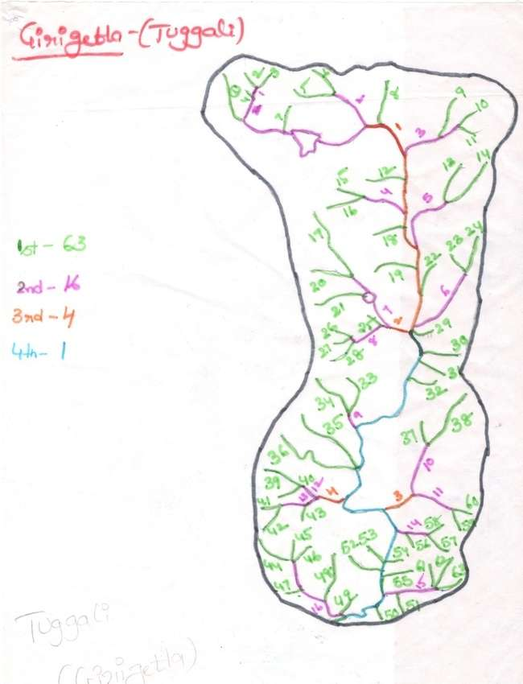
Fig-5: Stream orders and Numbering of Girigetla village Watershed area
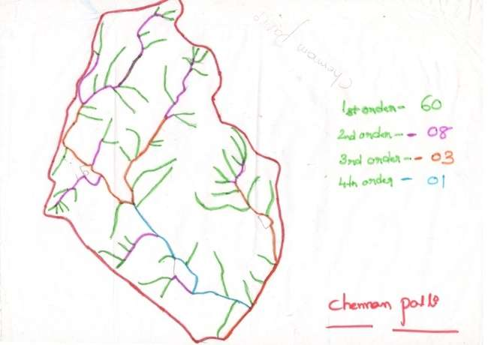
Fig-6: Stream orders and Numbering of Chennampalli village Watershed area
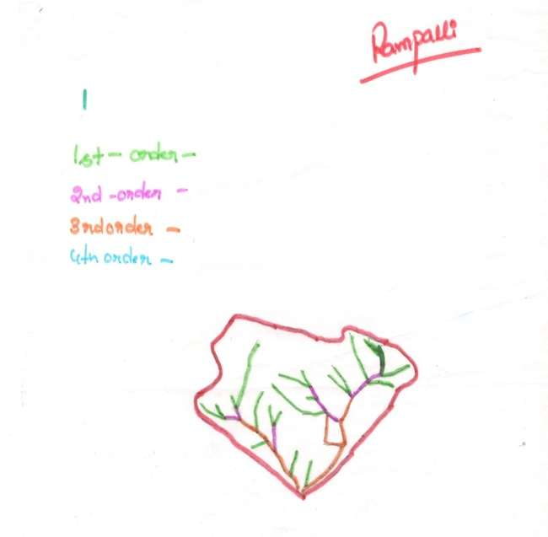
Fig-7: Stream orders and Numbering of Rampalli village Watershed area
IV DISCUSSIONS AND CONCLUSIONS:
A. Bifurcation ratio:
The drainage basin is characterised by homogenous materials if the bifurcation ratio (Rb) is less than 5, and streams are typically branched systematically with a high number of first, second, and third order streams. The Girigtela catchment has a bifurcation ratio of 4 and the Chennampalli catchment has a bifurcation ratio of 3.4 and the Rampalli catchment has a bifurcation ratio of 3.5; as a result, the catchments are characterised by homogenous materials, streams are often branched systematically, and there are many first, second, and third order streams.
B. Drainage density:
The drainage density of both Girigtela, Chennampalli catchments is less than 2 and Rampalli catchments is 2.26, hence both catchments fall under very coarse texture category.
C. Stream frequency: The drainage density of both Girigtela, Chennampalli and Rampalli catchments is 2. The catchments taken for study fall under very coarse texture category, hence catchments fall under very poor run-off.
- The results of morphometric analysis provide information about catchment development on priority basis and areas vulnerable for land degradation.
- The catchments taken for study fall under very coarse texture category.
- The higher value of stream frequency is observed in Girigetla, Chennampalli and Rampalli catchment indicates low conducting subsurface material, sparse vegetation and high relief.
- The stream flow at ungauged areas of the drainage basins can be estimated using these relationships.
- However, the applicability depends on the basin's land use pattern, lithology, structure, and regularity of rainfall patterns.
- Drainage density is effected by various factors, among which resistance to erosion of rocks, infiltration capacity of the land and climatic conditions rank high.
- It is indicate the close correlation with drainage density value of the sub watershed. Higher value of drainage frequency shows the high runoff. In this study watershed producing poor runoff.
- The complete morphology analysis of drainage basins indicates the given area is having Medium Ground water prospect.
- The complete morphometric analysis of drainage basin indicates that the given area is having good groundwater
prospect.

REFERENCES
- H. Chandrashekara, K.V. Lokeshb , M.Sameenac , Jyothi roopad ,G.rangannae, GIS –Based Morphometric Analysis of Two Reservoir Catchments of Arkavati River, Ramanagaram District, Karnataka: Aquatic Procedia 4 ( 2015 ) 1345 – 1353.
- R. K. Jaiswala, N. C. Ghoshb , R. V. Galkatea , T. Thomasa, Multi Criteria Decision Analysis (MCDA) for watershed Prioritization: Aquatic Procedia 4 ( 2015 ) 1553 – 1560.
- Berhanu G. Sinshaw , Abreham M. Belete , Agumase K. Tefera, Abebe Birara Dessie , Belay B. Bizuneh, Habtamu T. Alem, Simir B. Atanaw, Daniel G. Eshete, Tsegaye G, Prioritization of potential soil erosion susceptibility region using fuzzy logic and analytical hierarchy process, upper Blue Nile Basin, Ethiopia: Water-Energy Nexus Volume 4, 2021, Pages 10-24
- Aparna P, NigeeK , Shimna P and Drissia, Quantitative Analysis of Geomorphology and Flow Pattern Analysis of Muvattupuzha River Basin Using Geographic Information System: Aquatic Procedia 4 ( 2015 ) 609 – 616.
- A Bharatha, K Kiran Kumar, Ramesh Maddamsetty, M Manjunatha, Ranjitha,B Tangadagi , S Preethi, Drainage morphometry based sub-watershed prioritization of Kalinadi basin using geospatial technology: Environmental challenges 5(2021) 100277.
- SangitaMishra.S. andNagarajan,R., 2010, Morphometric analysis and priotization of sub- watersheds using GIS and Remote Sensing techniques: a case study of odisha, India, International Journal of Geomatics and Geosciences Vol 1, No3. pp501-510.
- Kafaky, B.S., Mataji, A., Naser, S.A. 2009. Ecological capability assessment for multiple-use in forest areas using GIS- based multiple criteria decision making approach. American Journal of Environmental Sciences 5(6), 714-721.
- Mishra, S.S., Nagarajan, R. 2010. Morphometric analysis and prioritization of sub-watersheds using GIS and Remote Sensing techniques: a case study of Odisha, India. International Journal of Geomatarics and Geosciences, 1(3), 501-510.
- Lee A.H.I., Chen, W.C., Chang, C.J. 2008. A fuzzy AHP and BSC approach for evaluating performance of IT department in the manufacturing industry in Taiwan. Expert Systems with Applications, 34, 96–107.
- De Steiguer, J.E., Duberstein J., Lopes V., 2003. The analytic hierarchy process as a means for integrated watershed management. In Renard, K. G. (Ed.). First Interagency Conference on Research on the Watersheds. Benson Arizona: U.S. Department of Agriculture, Agricultural Research Service Oct 27-30, 736–740.
- A.U., A., K.R., B., Thomas, P.K., Anns, M., P.B., R., Babu, S., 2021. Status of GIS-enabled morphometric analysis of river basins of Kerala, Southern India: a review and assessment.

- Nag, S., Roy, M.B., Roy, P.K., 2020. Optimum prioritisation of sub-watersheds based on erosion-susceptible zones through modeling and GIS techniques. Model. Earth Syst. Environ. 6, 1529–1544.

