IMPACT OF CLIMATE CHANGE ON BUMBLEBEES
Babita Kaushal¹, Meena Thakur², Diksha Devi^{1*} and Deepali Bakshi¹
¹PhD Research Scholar, ²Senior Scientist, College of Horticulture, Dr. YS Parmar University of Horticulture and Forestry, Nauni, Solan H.P.
*Email is: dikshakatna1996@gmail.com

Introduction
Bumblebees are highly efficient pollinators because of their unique characteristics. They can "buzz pollinate" certain plants, which involves vibrating their flight muscles to dislodge pollen from flowers that are difficult for other pollinators to access. This technique is particularly beneficial for crops like tomatoes, eggplants, peppers, and blueberries, which rely on buzz pollination for optimal fruit set. These are large, furry and hard-working bees that thrive best in temperate regions of the world. Bumblebees pollinate several important fruit and vegetable crops. Bumblebee pollination services are important in maintaining many agricultural crops and natural habitats. Bumblebees possess several benefits as they increase the quality of produce, increases yield, provide pollination throughout the year, ability to pollinate in enclosed & open area, are exceptional pollinator of greenhouse-grown crops, are easy to apply and are low maintenance. Temperatures are expected to rise substantially as a consequence of climate change, especially in higher elevations and latitudes [1]. Climate change has an impact on biodiversity's spatial distribution, often moving species towards greater elevations and latitudes [2]. Overall, probable variations in range shifts at high elevations involve the extinction of populations at lower elevations and the colonization of higher elevations by more species.
How climate change is affecting bumblebees?
Climate change has significant impacts on bumblebees, just as it does on many other species. Bumblebees are crucial pollinators, playing a key role in the reproductive success of various plants and crops. Warmer temperatures, decreased snow cover, more frequent droughts, and less predictable frost and flowering seasons are only a few of the repercussions of climate change. Climate change can lead to timing mismatches between bees and flowering times. Bumble bees are frequently more at danger in the warmer regions of their ranges because of their intolerance for extremely hot weather. However, they are vulnerable to changes in their environment, and the effects of climate change can disrupt their life cycles and habitat, leading to several adverse consequences:

- Shift in the geographic range: As temperatures rise, bumblebees may face challenges as they try to adapt to their changing environment. Some bumblebee species might find their historical habitats unsuitable due to increasing temperatures, while others might expand into new regions that were previously too cold for them. This could lead to changes in the distribution of bumblebee populations [3]. If elevation continues to rise, the more generalist (in habitat use and flower visits) bumblebees will probably start sharing the same space as the more specialized species, resulting in a decline in specialist species abundance [4].
- Decline in species richness: Bumble bees are at risk of becoming extinct due to climate change, hence efforts must be made to manage habitats to decrease exposure to the increasing frequency of temperatures that are high compared to the species tolerances. Bumble bee species richness declined in areas where increasing frequencies of climatic conditions exceed specie’s tolerances in both Europe and North America [5].
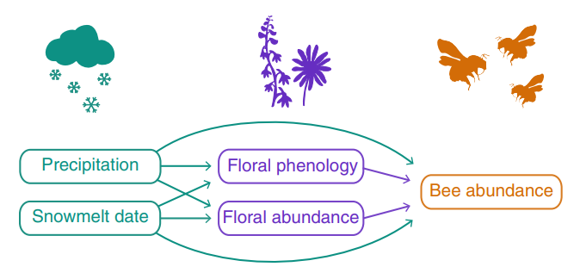
Fig.1. Path diagram showing all hypothesized direct and indirect links among climate variables, flower variables and bumble bee abundance [6].
- Altered flowering patterns: Climate change can influence bee populations either directly, by affecting survival and reproduction, or indirectly, by altering resources. It can cause shifts in the timing and duration of flowering in plants, impacting the availability of nectar and pollen for bumblebees. If the timing of flowering and bumblebee emergence becomes mismatched, it can disrupt the critical relationship between bees and plants, leading to reduced reproductive success for both. Over 43 years, aspects of floral phenology changed in ways that indicate species-specific effects on bees. Studies suggest that climate-driven alterations in floral resource phenology can play a critical role in governing bee population responses to global change [6].
- Plant-pollinator mismatch: Global warming is a major threat to biodiversity, impacting both species and their interactions. A fundamental interaction in terrestrial ecosystems is the mutualism between pollinators and their host plants. Climate change can induce spatial and temporal mismatches when species fail to co-occur. These can be due to morphological modifications, disruption to host attraction and foraging behaviors, as well as shifts in the quality of floral resources. which extent the mismatches do occur.
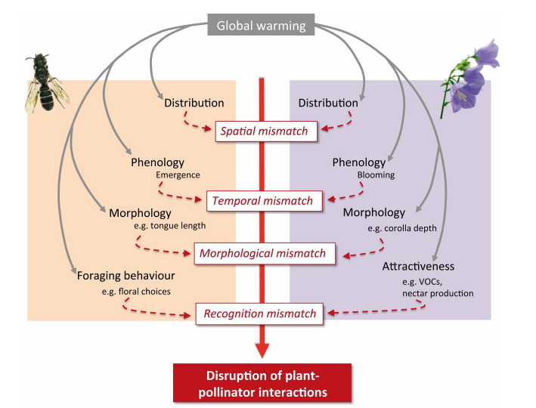
Fig 2. Potential impacts of global warming on plant-pollinator interactions [8].

- Functional mismatch: Mutualisms evolve through the matching of functional traits between partners, such as the tongue length of pollinators and the flower tube depth of plants. Long-tongued pollinators specialize in flowers with deep corolla tubes, whereas shorter-tongued pollinators generalize across tube lengths. Losses of functional guilds because of climate change may disrupt mutualisms and threaten partner species. A study found that in two alpine bumble bee species, decreases in tongue length have evolved over 40 years. Declining floral resources due to warmer summers have favored generalist foraging, leading to a mismatch between shorter-tongued bees and the longer-tubed plants they once pollinated [7].
- Changes in behavior and phenology: Bumblebees rely on environmental cues, such as temperature and day length, to time their life cycle events, like hibernation, emergence, and nesting. With climate change altering these cues, bumblebees may experience mismatches between their internal clocks and the availability of resources, affecting their ability to find food and establish new colonies [8].
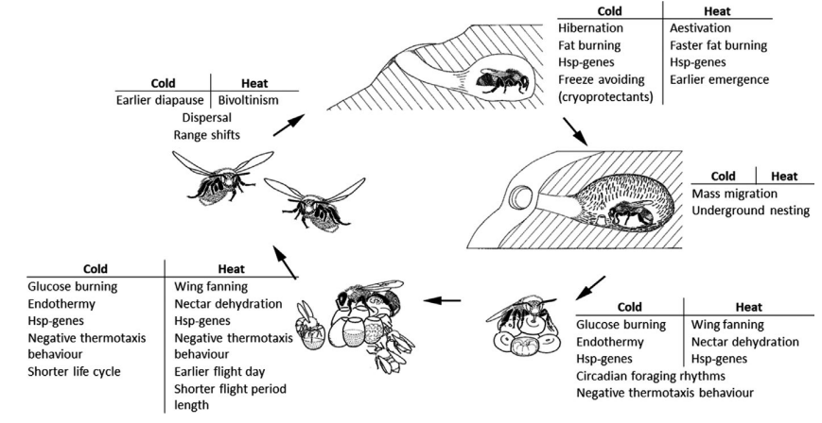
Fig.3 Bumblebee adaptive traits to cold and heat at different stages during their life cycle. Life cycle consists of five stages: a queen hibernating, a queen nesting, a colony developing, workers foraging, new queens, and males emerging. (Drossart et al, 2019) [9].

- Increased vulnerability to diseases and parasites: Warmer temperatures may facilitate the spread of diseases and parasites that affect bumblebees. Pathogens and pests that were previously limited to certain regions due to colder climates may now thrive in new areas, posing additional threats to already stressed bumblebee populations.
- Reduced genetic diversity: Climate change can create isolated populations of bumblebees, limiting gene flow between groups. Reduced genetic diversity can make populations more vulnerable to environmental challenges and less adaptable to changing conditions.
- Extreme weather events: Climate change can lead to more frequent and intense extreme weather events, such as heatwaves, droughts, and storms. These events can directly impact bumblebee populations by destroying their nests, disrupting foraging, and causing mortality.

- Loss of habitats: Changes in temperature and precipitation patterns can lead to shifts in plant communities, affecting the availability of suitable nesting sites and food sources for bumblebees. Additionally, human activities, such as land-use changes and urbanization driven by climate change, can further fragment and degrade bumblebee habitats.
What can we do to conserve bumblebees?
Habitat conservation: Conserve and create high-quality bumble bee habitats in your local area. Protecting, restoring, enhancing, and creating new bumble bee habitats is the best way to conserve populations of bumblebees and hopefully reverse population trends. Food resource conservation: Plant indigenous floral plants, particularly ones that can withstand drought and frost. Ensure you have a diverse plant selection, providing both early and late blooming nectar and pollen sources.
Overall, the combined effects of climate change on bumblebees can lead to population declines and potential extinctions, which can have cascading effects on ecosystems and agriculture, as many plants depend on bumblebees for pollination. Conservation efforts, including habitat protection, restoration, and climate change mitigation, are essential to support bumblebee populations and their critical role in ecosystems.
References:
- IPCC. 2014 Contribution of Working Groups I, II and III to the Fifth Assessment Report of the Intergovernmental Panel on Climate Change. In Climate change 2014: synthesis report (ed. IPCC). Geneva, Switzerland.
- Bellard C, Bertelsmeier C, Leadley P, Thuiller W, Courchamp F. 2012 Impacts of climate change on the future of biodiversity. Ecol. Lett. 15, 365–377.
- Marshall, L., Perdijk, F., Dendoncker, N., Kunin, W., Roberts, S. and Biesmeijer, J.C., 2020. Bumblebees moving up: shifts in elevation ranges in the Pyrenees over 115 years. Proceedings of the Royal Society B, 287(1938), p.20202201.
- MacLean SA, Beissinger SR. 2017 Species’ traits as predictors of range shifts under contemporary climate change: a review and meta-analysis. Glob. Change Biol. 23, 4094–4105.
- Soroye, P., Newbold, T. and Kerr, J., 2020. Climate change contributes to widespread declines among bumble bees across continents. Science, 367(6478), pp.685-688.
- Ogilvie, J.E., Griffin, S.R., Gezon, Z.J., Inouye, B.D., Underwood, N., Inouye, D.W. and Irwin, R.E., 2017. Interannual bumble bee abundance is driven by indirect climate effects on floral resource phenology. Ecology letters, 20(12), pp.1507-1515.
- Miller-Struttmann, N.E., Geib, J.C., Franklin, J.D., Kevan, P.G., Holdo, R.M., Ebert-May, D., Lynn, A.M., Kettenbach, J.A., Hedrick, E. and Galen, C., 2015. Functional mismatch in a bumble bee pollination mutualism under climate change. Science, 349(6255), pp.1541-1544.
- Gérard, M., Vanderplanck, M., Wood, T. and Michez, D., 2020. Global warming and plant–pollinator mismatches. Emerging topics in life sciences, 4(1), pp.77-86.
- Drossart, M., Rasmont, P., Vanormelingen, P., Dufrêne, M., Folschweiller, M., Pauly, A., Vereecken, N., Vray, S., Zambra, E., D'Haeseleer, J. and Michez, D., 2019. Belgian red list of bees.

