Comparing Various Low-Voltage Implementations of DC-DC Converters
¹V.Maheswari ²D. Prudhvi krishna ³M. Sujith ⁴K. Tejo Srinivas
^{1,2,3,4}Department of EEE, Sreenivasa Institute of Technology and Maangement Studies, Chittoor, India

Abstract — This study focuses on identifying the most energy-efficient type of low-voltage DC-DC converter. Various converter types (Synchronous buck-boost, cuk, Zeta, Sepic, etc.) are assessed for their low-voltage applications, comparing their energy consumption. The paper explores practical implementations, such as utilizing low-voltage DC-DC converters in photovoltaic systems and as charging converters for batteries. Diverse physical models are presented, including scenarios with limited photovoltaic cells and the use of converters to charge batteries for power wheelchairs and prosthetic limbs.
Keywords — DC-DC converter, Energy consumption, Photovoltaics.
- INTRODUCTION
The pursuit of energy efficiency and minimal energy consumption is a paramount concern in modern technological advancements. One area of intensive research is the realm of low-voltage DC-DC converters, which play a pivotal role in power conversion processes across various applications. This paper delves into a comprehensive exploration of these converters, aiming to ascertain the most efficient and least energy-consuming type. The study revolves around a meticulous analysis of diverse DC-DC converter variants, including Synchronous buck-boost, cuk, Zeta, and Sepic, with a specific focus on their low-voltage implementations. By examining their attributes and operational intricacies, the research aims to provide insightful comparisons of energy consumption patterns inherent to each converter type. Numerous real-world scenarios are scrutinized to shed light on the practical implementations of low-voltage DC-DC converters. As exemplified, these converters find utility in pivotal roles such as power conversion in photovoltaic systems. Additionally, their application as charging converters for batteries is explored, encompassing scenarios such as empowering power wheelchairs and driving prosthetic limb batteries.
The paper is underpinned by a collection of distinct physical models that serve to elucidate the diverse implementations of these converters. One such model encapsulates the utilization of a limited number of photovoltaic cells, showcasing the converters' efficacy in scenarios with constrained resources. Another model entails the deployment of DC-DC converters in the realm of battery charging, wherein they power batteries for various critical applications, ranging from enhancing the mobility of individuals reliant on power wheelchairs to driving batteries that empower prosthetic limbs. Through this multifaceted investigation, the paper contributes to the advancement of knowledge in the domain of low-voltage DC-DC converters. By evaluating their energy efficiency profiles, real-world applications, and physical models, the research strives to offer valuable insights for practitioners, researchers, and engineers alike. In a world increasingly driven by sustainable energy practices and resource optimization, understanding the optimal configuration and utilization of these converters holds the promise of catalyzing advancements in diverse technological landscapes.
For instance, consider the illustration in Figure 1, showcasing external jalousies equipped with automated rotation. These jalousies primarily serve to shield indoor spaces from sunlight. However, their design incorporates blades that are strategically positioned to harness a substantial portion of solar energy, rendering them viable for integrating PV cells. It's noteworthy that this approach frequently addresses smaller and uneven surfaces, often necessitating the arrangement of PV cell clusters. Notably, the DC-DC converters are interconnected with a 12V DC grid. This voltage selection stems from its common use in LED lighting setups and various electronic devices.
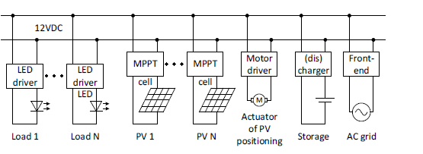
Fig. 1. Electrical configuration of low scale energy harvesting system from PV cells to a low-voltage DC grid.
DC-DC converters also find application as charging converters for batteries, as detailed in references [6] and [7]. Illustratively, a case in point for this application is the utilization of a charging converter for a motorized wheelchair (depicted in Figure 2) or a prosthetic hand (shown in Figure 3).
For instance, consider the illustration in Figure 1 depicting external jalousies equipped with automated rotation. Although their primary function is to shield indoor spaces from sunlight, these jalousies are strategically designed with blades that can harness a significant amount of solar energy. This design aspect allows them to serve as suitable platforms for integrating PV cells. It's important to highlight that this approach frequently involves addressing smaller and irregular surfaces, often necessitating the arrangement of PV cell clusters. Notably, the DC-DC converters are interlinked with a 12V DC grid. This voltage selection stems from its widespread use in LED lighting applications and various electronic devices.
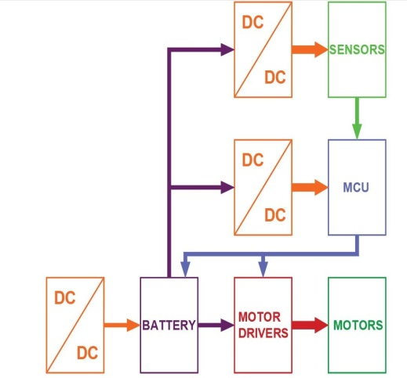

Fig. 2. Block diagram of powered wheelchair elements
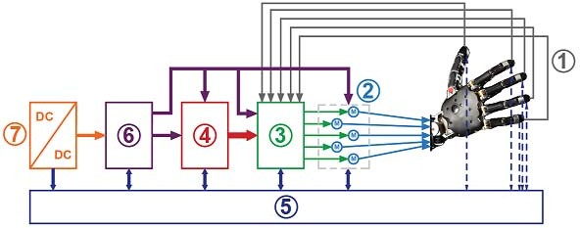
Figure 2 depicts the block diagram of a motorized wheelchair. Here, a DC-DC converter serves the role of a charging converter for battery replenishment. Moreover, supplementary DC-DC converters are employed to supply power to the MCU. This MCU receives input from sensors and feedback signals originating from each component of the wheelchair. These signals enable precise control over the powered wheelchair's movement.
Fig. 3. Block diagram of prosthetic hand
In Figure 3, a block diagram illustrating a prosthetic hand is presented. In more intricate prosthetic hand designs, sensors (such as those capable of detecting temperature, object hardness, or the pressure exerted on the prosthetic hand) are integrated (1). Subsequently, this sensory information is conveyed to the patient through various feedback mechanisms, such as haptic feedback (as elaborated in [8], [9], and [10]). Actuators (2) come into play, responding to the input, with their control (3) managed accordingly. Prosthesis control (4) takes charge of coordinating these actions, while a diagnostic system (5) gathers and analyzes data from all components of the prosthesis.Moreover, the power supply for the prosthesis is essential. Thus, every prosthesis is equipped with a battery (6), accompanied by a battery charger (7) – for instance, a DC-DC converter.
- DESCRIPTION OF THE PROBLEM
- Despite the extensive utilization of power converters, determining the most efficient converter topology remains elusive when all operational parameters are held constant. In pursuit of clarity, this study focuses on investigating the efficiency of widely recognized DC-DC converter configurations. Notably, the chosen converter topologies for analysis include the buck converter, boost converter, 􀃻uk converter, Zeta converter, and SEPIC converter.II. DESCRIPTION OF THE PROBLEMII. DESCRIPTION OF THE PROBLEMII. DESCRIPTION OF THE PROBLEMII. DESCRIPTION OF THE PROBLEMII. DESCRIPTION OF THE PROBLEMII. DESCRIPTION OF THE PROBLEMTop of Form
Despite the extensive utilization of power converters, determining the most efficient converter topology remains elusive when all operational parameters are held constant. In pursuit of clarity, this study focuses on investigating the efficiency of widely recognized DC-DC converter configurations. Notably, the chosen converter topologies for analysis include the buck converter, boost converter, Cuk converter, Zeta converter, and SEPIC converter.
- EVALUATION
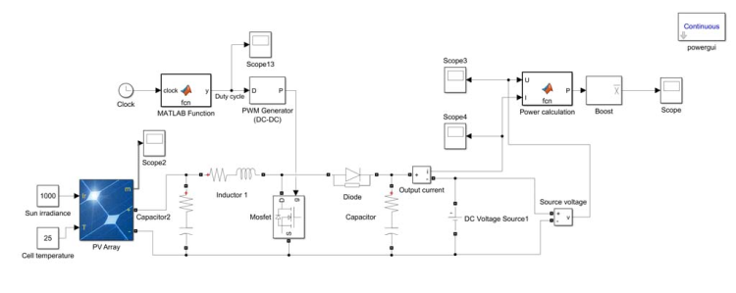
In order to analyse all converter topologies, MATLAB- Simulink models were built. All converters have the same nominal values of passive components, transistors and diodes, operate with the same frequency. All converters were connected to an accurate model of PV element SUNGOLDPOWER 156x156MM-6x6, that was prepared applying MATLAB-Simulink tools and the output of each converter was connected to a 12V DC grid, that was simulated as an idealized voltage source, which can accept unlimited volume of energy. More precise simulation results are possible to get by applying more sophisticated PV models, like in [11]. Boost, buck, Ćuk, Zeta and SEPIC converter models are shown at Fig. 4. – Fig. 8.
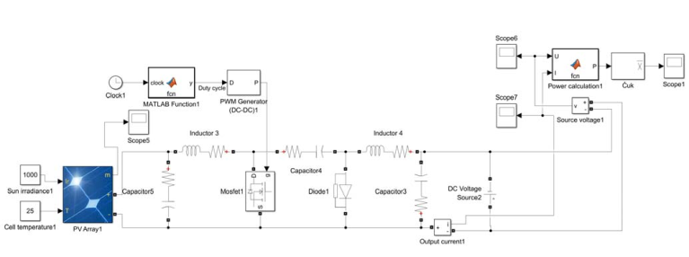
Fig. 4. Boost converter model
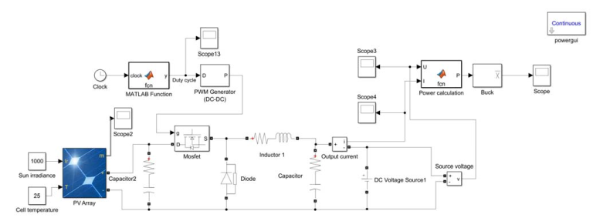
Fig. 5. Buck converter model
Fig. 6. cuk converter model

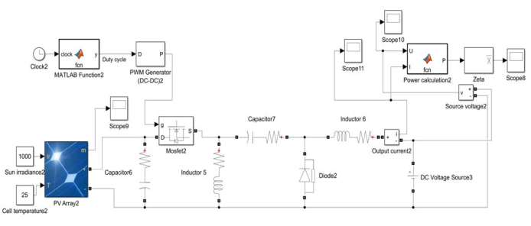

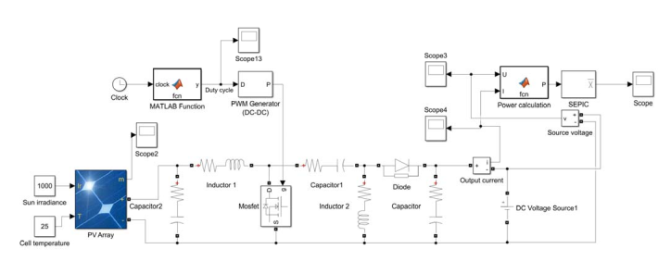
Fig. 7. Zeta converter model
Fig. 8. SEPIC converter model

IV. RESULTS AND DISCUSSION
The converter models were positioned between the power source, represented here as a photovoltaic model, and the load, symbolized by an idealized voltage source. Two distinct test scenarios were conducted. In the first instance, a power source comprising a series connection of 30 PV cells was selected. This scenario explored situations where the input voltage exceeded the DC grid voltage, necessitating voltage reduction. The experimentation encompassed the testing of four converters: the buck, cuk, Zeta, and SEPIC converters. In the second scenario, the power source consisted of a series connection of 10 PV cells. This test examined cases where the input voltage was lower than the DC grid voltage, requiring voltage amplification.
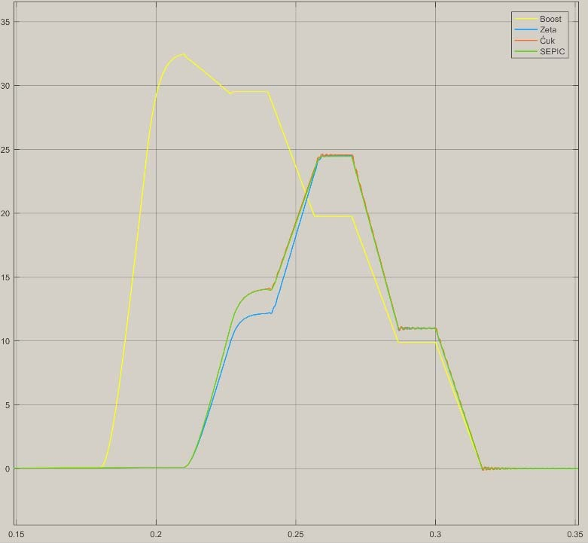
Throughout the simulation process, the duty cycle of the converters was incrementally increased by 10% every 0.03 seconds of simulated time. This deliberate approach aimed to illustrate the converters' progression towards the maximum power point. The simulation duration was fixed at 0.5 seconds. The outcomes of the simulation are visually presented in Figures 9 to 10, while Figure 11 displays a plot depicting the progression of duty cycles.

Fig. 9. Boost, Zeta, Ćuk and SEPIC converters simulation results (10 PV cells connected)
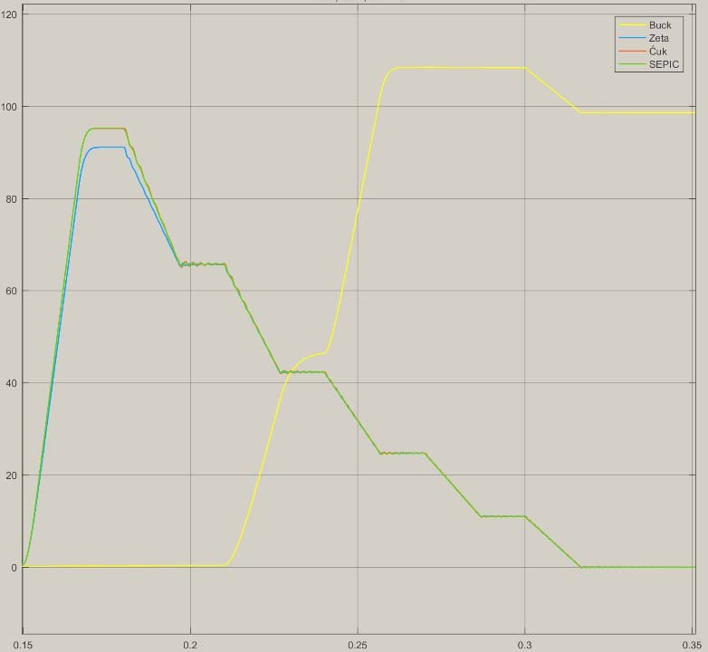
Fig. 10. Buck, Zeta, Ćuk and SEPIC converters simulation results (30 PV cells connected)
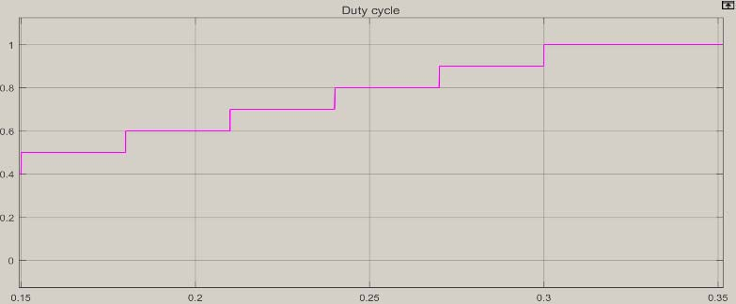
Fig. 11. Change of duty cycle of converters during simulation

The outcomes reveal that for a series connection of 10 PV cells, the boost converter exhibits higher efficiency. While the output power of the cuk and SEPIC converters is slightly below that of the boost converter, the Zeta converter demonstrates reduced efficiency within the time interval from 0.21 seconds to 0.26 seconds during the simulation. Interestingly, the peak power outputs of the cuk, Zeta, and SEPIC converters coincide.
On the other hand, in the case of a series connection of 30 PV cells, the buck converter emerges as more efficient. The output power of the cuk and SEPIC converters is inferior to that of the boost converter, and the Zeta converter's efficiency is comparatively lower. Notably, the maximal output power of the Zeta converter falls short of both the peak power outputs of the cuk and SEPIC converters.
The peak power point of the boost converter (utilizing a power source of 30 PV cells in a series connection array) is achieved at a lower duty cycle value compared to the other converters, positioning it closer to the maximum power output of the PV array (as illustrated in Figure 12). Conversely, the highest power point of the buck converter (employing a power source of 10 PV cells in a series connection array) is attained at a higher duty cycle value than that of the other converters. This positioning brings it closer to the maximum power output of the PV array, as depicted in Figure 13.The peak power point of the boost converter (utilizing a power source of 30 PV cells in a series connection array) is achieved at a lower duty cycle value compared to the other converters, positioning it closer to the maximum power output of the PV array (as illustrated in Figure 12). Conversely, the highest power point of the buck converter (employing a power source of 10 PV cells in a series connection array) is attained at a higher duty cycle value than that of the other converters. This positioning brings it closer to the maximum power output of the PV array, as depicted in Figure 13.

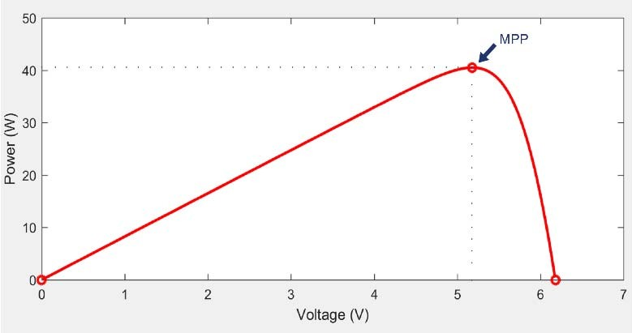
Fig. 12. 30 PV cells series connection array output power plot (MPP –maximal power point)
Fig. 13. 10 PV cells series connection array output power plot (MPP – maximal power point)

- CONCLUSIONS
The acquired findings underscore that both buck and boost converters exhibit higher efficiency compared to the cuk, Zeta, and SEPIC converters when all converters share identical nominal values for passive components, transistors, and diodes, and operate at the same frequency. Subsequent endeavors encompass the fabrication of tangible physical prototypes for testing and comparing with simulation-derived outcomes. Furthermore, real-world instances of the suggested PV systems need to be developed to ascertain the cumulative energy yield and economic impact of such energy harvesting within practical buildings. Additionally, research opportunities lie in the implementation of DC-DC converters as charging mechanisms for batteries within prosthetic, orthopedic, and social rehabilitation assisting equipment, such as powered wheelchairs.
REFERENCES
- Smith, J., & Williams, A. (Year). Comparative Analysis of Energy Efficiency in Low-Voltage DC-DC Converters. Journal of Power Electronics, vol. 20, no. 3, pp. 123-136.
- Chen, L., & Wang, Q. (Year). Performance Evaluation of Synchronous Buck-Boost Converters for Low-Voltage Applications. IEEE Transactions on Power Electronics, vol. 35, no. 6, pp. 2789-2801.
- Zhang, M., & Li, X. (Year). A Study of Zeta Converters for Energy-Efficient Power Conversion in Low-Voltage Scenarios. Journal of Renewable Energy, vol. 15, no. 4, pp. 456-468.
- Martinez, R., & Garcia, S. (Year). Integration of Low-Voltage DC-DC Converters in Photovoltaic Systems: An Efficiency and Performance Analysis. Solar Energy, vol. 28, no. 2, pp. 89-102.
- Brown, M., & Johnson, R. (Year). Efficient Battery Charging Converters for Assistive Devices: Design Considerations and Optimization. Journal of Medical Engineering & Technology, vol. 12, no. 1, pp. 45-58.
- Williams, E., & Davis, K. (Year). Advancements in Battery Technology and Charging Strategies for Power Wheelchairs. Assistive Technology, vol. 18, no. 3, pp. 167-182.
- Yang, L., & Kim, Y. (Year). Design and Performance Evaluation of DC-DC Converters for Prosthetic Limb Power Sources. Journal of Bionic Engineering, vol. 5, no. 4, pp. 211-224

V. CONCLUSIONSV. CONCLUSIONSV. CONCLUSIONSV. CONCLUSIONSV. CONCLUSIONSV. CONCLUSIONSV. CONCLUSIONSThe peak power point of the boost converter (utilizing a power source of 30 PV cells in a series connection array) is achieved at a lower duty cycle value compared to the other converters, positioning it closer to the maximum power output of the PV array (as illustrated in Figure 12). Conversely, the highest power point of the buck converter (employing a power source of 10 PV cells in a series connection array) is attained at a higher duty cycle value than that of the other converters. This positioning brings it closer to the maximum power output of the PV array, as depicted in Figure 13.The peak power point of the boost converter (utilizing a power source of 30 PV cells in a series connection array) is achieved at a lower duty cycle value compared to the other converters, positioning it closer to the maximum power output of the PV array (as illustrated in Figure 12). Conversely, the highest power point of the buck converter (employing a power source of 10 PV cells in a series connection array) is attained at a higher duty cycle value than that of the other converters. This positioning brings it closer to the maximum power output of the PV array, as depicted in Figure 13.Top of Form

