Title - Using AI Machine Learning and Big Data to calculate perioperative risk – the future is here

Authors – Dr. Farah Husain¹, Dr. Salman Durrani², Dr. Nazia Husain³

- Senior Specialist Anaesthesia, Department of Anaesthesia and Intensive Care, Lok Nayak Hospital, and Maulana Azad Medical College, New Delhi, India
- Specialist Orthopaedic, Department of Orthopaedics, Dr. Baba Saheb Ambedkar Medical College and Hospital, New Delhi, India
- Associate Professor, Paediatric Cardiology, Ann & Robert H Lurie Children’s Hospital, Chicago, Illinois, USA

Corresponding Author: Dr. Farah Husain
Email: farah.husain.durrani@gmail.com

Introduction
Artificial Intelligence (AI) systems have slowly, yet steadily ingrained themselves as an integral part of our daily routines in such a way that we sometimes do not even notice their presence. From Siri, to Alexa, to our Netflix movie choices or Amazon choices, AI has entered our homes in a big way. John McCarthy, an American Cognitive scientist along with Minsky, Nathanial Rochester, and Claude E. Shannon, introduced the term “artificial intelligence” at the famous Dartmouth conference, in 1956, where AI became a new field ⁽¹⁾.
Concepts of Artificial Intelligence
AI is when a machine learns to behave as smartly as a human. It is the machine’s capability to respond in a manner like human intelligence that mimics cognitive functions, such as learning and problem solving. Where humans can be overwhelmed by voluminous and complex data, AI models have the intrinsic capacity to provide valuable insights based on extensive analysis and computation.

Medical and healthcare related data contains an extremely large variety information. This data arrives in increasing volumes from electronic health records (EHR) of multiple healthcare and research centres, at such high velocity, that it creates an explosion of information. Considered as an extension of traditional statistics, AI differs from standard approaches for its ability to learn from examples and mistakes, to improve continuously with the introduction of new data, and to create a model for individualized patient care (Figure 1).
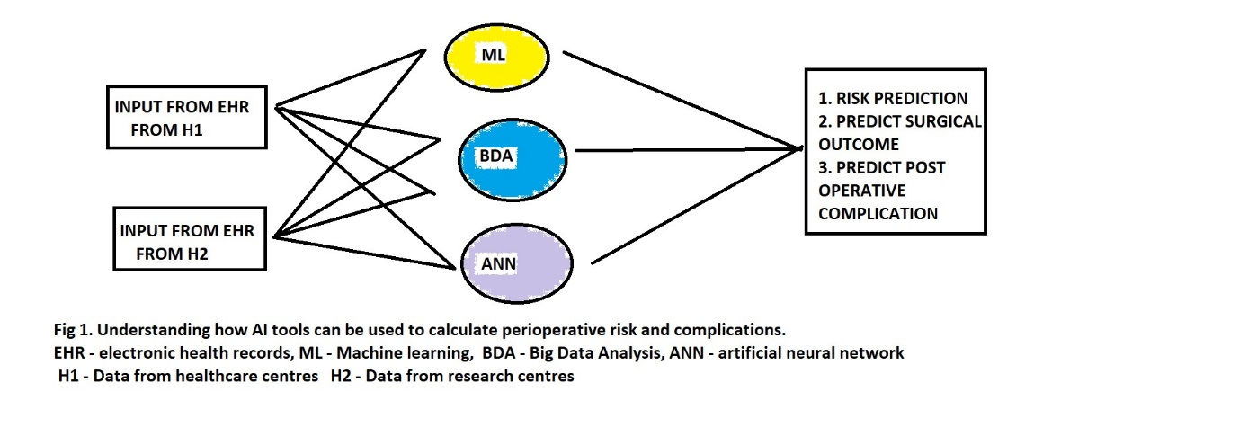
Machine Learning

Machine learning (ML) is one subcategory of AI, where computer has the ability to learn from data through appropriate algorithms, allowing them to identify hidden patterns (correlations) in data without being actually programmed to do so, in order to perform a concrete task. ML is defined as a series of mathematical algorithms that enable the machine to “learn” the relationship between the input and output data without being explicitly told how to do so. By broadly classifying ML into supervised, unsupervised, and reinforcement learning, it becomes useful to understand various clinical applications ⁽²⁾.

ML is the most widely applied arm of AI in medicine, confers the ability to analyse large volumes of data, find associations, and predict outcomes with ongoing learning by the computer (Figure 2). It involves:
- Algorithm creation
- Testing and analyses
- Ability to perform cognitive functions (association between variables)
- Pattern recognition
- Prediction of outcomes

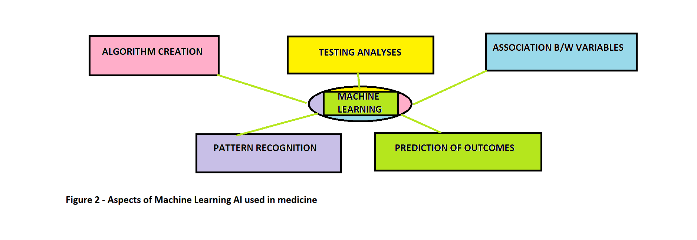Various ML models have been developed to answer single, relevant clinical questions by using representative data, such as using perioperative data to predict postoperative mortality and postinduction hypotension by analysing preoperative and induction data ^{(3,4)}.

Big Data

Big data usually includes too large or complex data sets with sizes beyond the ability of commonly used software tools to capture, curate, manage and process within a tolerable elapsed time. The classification of big data is divided into three parts, such as Structured Data, Unstructured Data, and Semi-Structured Data. The presence of large volume information rich electronic health records (EHR) also overwhelms clinicians to comprehend every detail of the patient’s profile. Advancements in BDA offer cost-effective opportunities to improve decision-making in critical development areas such as health care, employment, economic productivity, crime, security, and natural disaster and resource management.
Clinical applications of AI: The perioperative period

The suggested areas for AI application in anaesthesia today include risk assessment and clinical treatment strategies. AI supported closed loops have been designed for pharmacological maintenance of anaesthesia and hemodynamic management. Computers are set to become indispensable tools not only for delivery of anaesthetics (example, target controlled infusions, bispectral (BIS) index guided hypnosis, BIS guided autonomous systems, and closed loop fluid management) but also for providing help in day-to-day clinical care and decision-making in anaesthesia. Understanding the use of AI in perioperative management can help the anaesthesiologist in making relevant clinical decisions.

Perioperative Risk assessment and Predictive Models using ML

Peri-operative risk assessment is a very important aspect of the anaesthetic management. Through the identification of high-risk patients, it is possible to conduct a specific risk-benefit analysis, to reduce the risk of unexpected complications, to achieve a targeted perioperative optimization, to carefully plan the anaesthesiologic management, and to provide an accurate and precise informed consent ⁽⁵⁻⁷⁾. The identification of modifiable risk factors and the subsequent optimization of the preoperative phase appear to be a crucial factor to create an accurate anaesthesia plan, tailored to each patient and thereby decrease the incidence of post-operative complications ⁽⁸⁾.

ML is being studied for risk stratification based on analysis of millions of perioperative data and intervention-based outcomes extracted from EHRs of multiple centres. ML systems are well suitable for this context, where the possibility to collect a large amount of data and the choice of the variable selected by the model itself, allows the discovery of new factors and a different interpretations of already known items. Clinical decision support system (CDSS) may be knowledge-based with built-in algorithms or alternatively, non-knowledge based. Essentially designed to provide cognitive aids to the anaesthetist, they are not autonomous in execution ⁽⁹⁾.

Anaesthesia and assessment of perioperative risk appear to be excellent fields to develop and apply ML systems, as reported in literature ^{(10,11)}. Frequently utilised risk scores, like the American Society of Anaesthesiologists Physical Status (ASA-PS) ⁽¹²⁾, to the most specific ones, as the European system for cardiac operative risk evaluation (EuroSCORE) ⁽¹³⁾ or the General Surgery Acute Kidney Injury Risk Index Classification System ⁽¹⁴⁾ have some limits, mainly due to the lack of tailored predictions. Tourani et al used the logistic regression model, in the context of perioperative decision support, to understand if the use of intraoperative data improved the performance of 30-day postoperative risk models and found AI helped with risk prediction ⁽¹⁵⁾. Brennan et al assessed the usability and accuracy of the MySurgeryRisk algorithm for preoperative risk assessment, and compared the accuracy of perioperative risk assessment between physicians and MySurgeryRisk ⁽¹⁶⁾. Several studies evaluated intraoperative variables, as electroencephalography (EEG) pattern, or intraoperative vital signs ^{(17,18)}, for a real-time prediction of overly deep sedation, post-induction, and intraoperative hypotension. This type of “risk prediction” is especially useful for counselling, optimization, and planning the anaesthetic management of individual cases with rare co-morbidities and development of warning score systems.

The use of ML techniques for the creation of predictive models of perioperative complications is in continuous expansion and the availability of interpretations and predictions in real time could allow to enter a new era of anaesthesia ⁽¹⁹⁻²¹⁾.

Using Big Data Analytics to assess perioperative risk

Big Data Analytics (BDA) commonly refers to large volumes of data that can be generated, processed, and increasingly used by digital tools and information systems for making predictive, descriptive, and prescriptive analysis. Big data was originally associated with three key concepts: volume, variety, and velocity ⁽²²⁾. But the analysis of big data presented challenges in sampling, and thus a fourth concept, “veracity” referring to the quality or insightfulness of the data was also added. Current usage of the term big data tends to refer to the use of predictive analytics, user behaviour analytics, or certain other advanced data analytics methods that extract value from big data, and seldom to a particular size of data set. Its use in healthcare is rapidly being researched to improve patient outcome, with an estimated global spending on BDA having reached $215.7 billion in 2021⁽²³⁾.
BDA has been used in healthcare by providing personalized medicine and prescriptive analytics, clinical risk intervention and predictive analytics, waste and care variability reduction, automated external and internal reporting of patient data, standardized medical terms and patient registries ⁽²⁴⁾. The integration of analytical models and big data techniques poses a challenge in real-time clinical practise owing to the complexity of processing real-time streaming data. The viable alternative is utilizing data-friendly machine learning models that built on top of various features derived from data engineering approaches ⁽²⁵⁾. By applying these data on a distributed streaming data processing framework, the real-time perioperative risk prediction is calculated after aggregating and transforming the EHR data from different sources ⁽²⁶⁾.
The recent evolution of BDA techniques makes it possible to develop a real-time platform to dynamically analyse the surgery risk from large-scale patients’ information. Feng Z et al have created an Intelligent Perioperative System (IPS), a real-time system that collects EHR data, performs data integration, variable generation, surgical risk score prediction and risk score visualisation ⁽²⁶⁾.

Clinical applications of Machine Learning in Orthopaedics Surgery
AI and ML in orthopaedic surgery has gained mass interest over the last decade or so. While ML has traditionally been used in medicine for rule-based approaches such as safe drug prescription, recent use of ML in orthopaedic surgery has focused on clinical decision support such as risk assessment ⁽²⁷⁾. Harris et al, have reported that ML was moderately accurate in predicting 30-day mortality and cardiac complications after elective primary joint replacement ⁽²⁸⁾. The orthopaedic literature shows that ML continuously outperforms more traditional legacy risk-stratification measures such as ASA classification, Charlson Comorbidity Index, and modified 5-item frailty index, in predicting complications following a variety of orthopaedic procedures as well as identifying safe candidates for specific orthopaedic procedures like anterior cervical fusion and discectomy ⁽²⁹⁻³¹⁾. Navarro et al created a valid ML algorithm that predicted the length of stay and costs before primary total knee replacement ⁽³²⁾.

In most cases, ML has proven to be just as effective, if not more effective, than prior methods such as logistic regression in assessment and prediction. With the help of deep learning algorithms, such as artificial neural networks (ANN), AI in orthopaedics has been able to improve diagnostic accuracy and speed, flag the most critical and urgent patients for immediate attention, reduce the amount of human error, reduce the strain on medical professionals, and improve overall care ⁽³³⁾. By using ML methods to make better outcome predictions, orthopaedic surgeons can improve their decision-making ability, which not only leads to better patient care, but also more efficient utilization of healthcare resources ⁽³⁴⁾. Logistic regression is one of the most commonly used methods for identifying risk factors that can predict complications; however, in comparison, ANN allows for the identification of nonlinear patterns making predictions more accurate ⁽³⁵⁻³⁷⁾.

Conclusion
The use of these new AI technologies to analyse perioperative complications has been tested in almost all types of surgery (general, cardiac, orthopaedic, neurosurgical, vascular). Technologies are becoming more and more prevalent in health-care settings. Both clinical and organizational decision-making processes can take advantage of these technologies.
ML methods were used mainly to predict the following outcomes: mortality, cardiovascular complications, acute kidney injury, surgical complications, intensive care unit admission, respiratory complications, length of stay, venous thromboembolism, neurological complications, sepsis, pain, and post-operative nausea and vomiting. As stated before, most of studies considered preoperative variables, like demographic, medical history, clinical and laboratory values evaluation, to calculate perioperative risk.

With its surging trend of interest, AI and ML is expected to see an increase in use with risk assessment, outcomes assessment, imaging, and basic science applications in different fields such as anaesthesia and orthopaedics. Furthermore, because ML and BDA provides physicians the unique opportunity to understand their patients better. Physicians should be trained to use these methods effectively in order to reduce risk of perioperative complications and improve patient care.

References
- Ardi MY. Artificial intelligence: past and future. Commun ACM. 2012; 55(1):5
- Hashimoto DA, Walkowski E, Gao L, Meireles O, Rosman G.Artificial intelligence in anesthesiology. Anesthesiology. 2020;132:379-94.
- Lee CK, Hofer I, Gabel E, Baldi P, Cannesson M. Development and validation of a deep neural network model for prediction of postoperative in hospital mortality. Anesthesiology. 2018; 129:649-2.
- Kendale S, Kulkarni P, Rosenberg AD, Wang J. Supervised machine-learning predictive analytics for prediction of postinduction hypotension. Anesthesiology. 2018; 129:675-688.
- Bose S, Talmor D. Who is a high-risk surgical patient? Curr Opin Crit Care. 2018; 24(6):547-553.
- Rajkomar A, Dean J, Kohane I. Machine Learning in Medicine. N Engl J Med. 2019; 380(14):1347-1358.
- Wijeysundera DN. Predicting outcomes: Is there utility in risk scores? Can J Anaesth. 2016; 63(2):148–158.
- Chakravarthy M. Modifying risks to improve outcome in cardiac surgery: an anesthesiologist's perspective. Ann Card Anaesth. 2017; 20(2):226–233.
- Singh M, Nath G. Artificial intelligence and anesthesia: A narrative review. Saudi J Anaesth 2022;16: 86-93.
- Gambus P, Shafer SL. Artificial Intelligence for Everyone. Anesthesiology. 2018 ;128(3): 431-433.
- Liu Q, Ma L, Fan SZ, Abbod MF, Lu CW, Lin TY, Jen KK, Wu SJ, Shieh JS. Design and evaluation of a real time physiological signals acquisition system implemented in multi-operating rooms for anaesthesia. J Med Syst. 2018; 42(8):148.
- Mayhew D, Mendonca V, Murthy BVS. A review of ASA physical status - historical perspectives and modern developments. Anaesthesia. 2019;74(3):373–379.
- Nashef SA, Roques F, Michel P, Gauducheau E, Lemeshow S, Salamon R. European system for cardiac operative risk evaluation (EuroSCORE). Eur J Cardiothorac Surg. 1999; 16(1): 9-13.
- 6. Kheterpal S, Tremper KK, Heung M, Rosenberg AL, Englesbe M, Shanks AM, Campbell DA Jr. Development and validation of an acute kidney injury risk index for patients undergoing general surgery: results from a national data set. Anesthesiology. 2009; 110(3): 505-515.
- Tourani R, Murphree DH, Melton-Meaux G, Wick E, Kor DJ, Simon GJ. The value of aggregated high-resolution intraoperative data for predicting post-surgical infectious complications at two independent sites. Stud Health Technol Inform. 2019; 264: 398–402.
- Brennan M, Puri S, Ozrazgat-Baslanti T, Feng Z, Ruppert M, Hashemighouchani H, Momcilovic P, Li X, Wang DZ, Bihorac A. Comparing clinical judgment with the MySurgeryRisk algorithm for preoperative risk assessment: a pilot usability study. Surgery. 2019; 165(5): 1035– 1045.
- Lundberg SM, Nair B, Vavilala MS, Horibe M, Eisses MJ, Adams T, Liston DE, Low DK, Newman SF, Kim J, Lee SI (2018) Explainable machine-learning predictions for the prevention of hypoxaemia during surgery. Nat Biomed Eng. 2018; 2(10):749–760.
- Kang AR, Lee J, Jung W, Lee M, Park SY, Woo J, Kim SH. Development of a prediction model for hypotension after induction of anaesthesia using machine learning. PLoS One. 2020; 15(4): e0231172.
- Bellini V, Valente M , Bertorelli G, Pifferi B, Craca M , Mordonini M, Lombardo G , Bottani E , Rio PD, and Bignami E. Machine Learning in perioperative medicine: a systematic review. Journal of Anes, Analgesia and Critical Care. 2022; 2:2
- Hyland SL, Faltys M, Hüser M, Lyu X, Gumbsch T, Esteban C, Bock C, Horn M, Moor M, Rieck B, Zimmermann M, Bodenham D, Borgwardt K, Rätsch G, Merz TM. Early prediction of circulatory failure in the intensive care unit using machine learning. Nat Med. 2020; 26(3):364–373.
- Alimadadi A, Aryal S, Manandhar I, Munroe PB, Joe B, Cheng X. Artificial intelligence and machine learning to fight COVID-19. Physiol Genomics. 2020 52(4):200–202.
- The 5V’s of Big Data. Watson Health Perspectives. 17 September 2016
- Taylor P. Big Data and business analytics revenue worldwide 2015-2022. Statista 2023
- Huser V, Cimino JJ. Impending challenges for the use of Big data. International Journal of Radiation Oncology, Biology, Physics. 95(3): 890-894.
- Collin GS, et al. Transparent reporting of a multivariable prediction model for individual prognosis or diagnosis (tripod): the tripod statement. BMC Medicine. 2015; 13(1):1.
- Feng Z, Bhat RR, Yuan X, Freeman D, Baslanti T, Bihorac A, and Li X. Intelligent Perioperative System: Towards Real-Time Big Data Analytics in Surgery Risk Assessment. DASC PICom Dataom CyberSciTech; 2017: 1254-1259.
- Poduval M, Ghose A, Manchanda S, Bagaria V, Sinha A. Artificial Intelligence and Machine Learning: A New Disruptive Force in Orthopaedics. Indian J Orthop. 2020; 54: 109–122.
- Harris AHS, Kuo AC, Weng Y, Trickey AW, Bowe T, Giori NJ. Can Machine Learning Methods Produce Accurate and Easy-to-use Prediction Models of 30-day Complications and Mortality After Knee or Hip Arthroplasty? Clin Orthop Relat Res. 2019; 477:452–460.
- Kunze KN, Polce EM, Nwachukwu BU, Chahla J, Nho SJ. Development and Internal Validation of Supervised Machine Learning Algorithms for Predicting Clinically Significant Functional Improvement in a Mixed Population of Primary Hip Arthroscopy. Arthroscopy. 2021; 37:1488–1497.
- Kunze KN, Polce EM, Rasio J, Nho SJ. Machine Learning Algorithms Predict Clinically Significant Improvements in Satisfaction After Hip Arthroscopy. Arthroscopy. 2021; 37:1143–1151.
- Wang KY, Suresh KV, Puvanesarajah V, Raad M, Margalit A, Jain A. Using Predictive Modeling and Machine Learning to Identify Patients Appropriate for Outpatient Anterior Cervical Fusion and Discectomy. Spine (Phila Pa 1976) 2021; 46:665–670.
- Navarro SM, Wang EY, Haeberle HS, Mont MA, Krebs VE, Patterson BM, Ramkumar PN. Machine Learning and Primary Total Knee Arthroplasty: Patient Forecasting for a Patient-Specific Payment Model. J Arthroplasty. 2018; 33: 3617–3623.
- Lalehzarian SP, Gowd AK, Liu JN. Machine learning in orthopaedic surgery. World J Orthop. 2021;12(9):685-699.
- Visweswaran S, Cooper GF. Patient-specific models for predicting the outcomes of patients with community acquired pneumonia. AMIA Annu Symp Proc. 2005;759–763.
- Di Capua J, Somani S, Kim JS, Phan K, Lee NJ, Kothari P, Cho SK. Analysis of Risk Factors for Major Complications Following Elective Posterior Lumbar Fusion. Spine (Phila Pa 1976) 2017; 42:1347–1354.
- Lee NJ, Kothari P, Phan K, Shin JI, Cutler HS, Lakomkin N, Leven DM, Guzman JZ, Cho SK. Incidence and Risk Factors for 30-Day Unplanned Readmissions After Elective Posterior Lumbar Fusion. Spine (Phila Pa 1976) 2018; 43:41–48.
- Dreiseitl S, Ohno-Machado L. Logistic regression and artificial neural network classification models: a methodology review. J Biomed Inform. 2002; 35:352–359.

