Futuristic Trends in Gastroenterology and Hepatology

Authors:
- Sumaswi Angadi (MD, DrNB)
Assistant Professor,
Department of Gastroenterology,
Nizam’s Institute of Medical Sciences,
Hyderabad, India
sumaswia@gmail.com

- Shivaraj Afzalpurkar (MD, DrNB)
Consultant Gastroenterologist,
Institute of Gastrosciences and Liver,
Apollo Multispecialty Hospital,
Kolkata, India
drshivaraj62@gmail.com

- Dhiraj Agrawal (MD, DM)
Consultant Gastroenterologist,
PACE Hospital,
Hyderabad, India
dhirajagrawal24@gmail.com

- Sushrut Ingawale (MD, DNB)
Assistant Professor,
Department of General Medicine,
Seth G.S. Medical College and KEM Hospital,
Mumbai, India.
sushrutingawale2012@kem.edu

- Suprabhat Giri (MD, DM)
Assistant Professor,
Department of Gastroenterology,
Nizam’s Institute of Medical Sciences,
Hyderabad, India.
supg19167@gmail.com

Part A: Gut Microbiota

I. INTRODUCTION

Microbiota refers to the community of tiny living organisms (such as bacteria, fungi, and viruses) inhabiting a specific environment. Meanwhile, the microbiome encompasses the complete genetic material of these microorganisms. Every individual accommodates anywhere from 10 to 100 trillion mutually beneficial microbial cells. The genetic content within these cells forms the microbiome associated with humans. Over 95% of these genetic components are attributed to bacteria. A derivative of the human genome project, known as the human microbiome project, was initiated to investigate these microorganisms and their implications for human well-being and ailments [1]. The arrangement of microbiota in the digestive tract differs significantly among individuals. Microbial concentration gradually intensifies, ranging from 104 cells in the stomach and duodenum to 108 cells in the far end of the ileum, and ultimately reaching 1011 cells in the terminal colon (Figure 1) [2]. The predominant bacterial groups within the gastrointestinal tract consist of Bacteroidetes, Firmicutes, Proteobacteria, Actinobacteria, Fusobacteria, and Verrucomicrobia. Notably, Firmicutes and Bacteroidetes together constitute over 90% of the bacterial populace [3].

II. FUNCTIONS OF GUT MICROBIOTA

The gut microbiota maintains a mutualistic connection and provides metabolic, immunological, and intestinal protective functions within a healthy individual. The following are the documented functions based on the present comprehension [4-7]:

- The fermentation of undigested carbohydrates results in the production of short-chain fatty acids (SCFAs) like butyrate, propionate, and acetate. These SCFAs serve as energy reservoirs for the host and regulate the release of appetite-controlling hormones such as peptide YY (PYY) and glucagon-like peptide 1 (GLP1), influencing appetite management. Additional advantageous impacts, including anti-cancer properties, anti-inflammatory attributes, and modifications in gut motility, have been observed.
- The gut microbiota curbs the inhibition of lipoprotein lipase in adipocytes, favorably influencing lipid metabolism.
- The gut microbiota, through peptidases and proteinases, contributes to protein metabolism.
- Synthesis of essential compounds like vitamin K, folic acid, Vitamin B2, and Vitamin B12.
- The gut microbiota provides a protective role by attaching to binding sites on the brush border of the intestinal epithelium. They contend with detrimental microorganisms for accessible nutrients. Furthermore, they stimulate the production of antimicrobial proteins such as C-type lectins, Cathelicidins, and defensins by Paneth cells, induced through signaling via pattern recognition receptors (PRRs).
- The intestinal microbiota plays a pivotal role in immune regulation through both the innate and adaptive immune systems. Microbiota stimulation leads to the transition of B cells to IgA, initiation of regulatory T cells, and differentiation of T cells into Th17 cells.
- The gut microbiota significantly participates in the two-way communication connecting the central nervous system and the enteric nervous system. This gut-brain axis integrates intestinal activities and additionally establishes links between functions like motility, enteric reflex, entero-endocrine signaling, and intestinal permeability with the emotional and cognitive centers of the brain.

There are various factors affecting the variability of gut microbiota: Age, sex, genetics, diet, medications, and other factors like smoking, alcohol, and psychological stress also contribute to alterations in the gut microbiome [8].

III. TECHNIQUES FOR INVESTIGATING GUT MICROBIOTA

The examination of gut microbiota occurs through the assessment of individual stool samples. While conventional methods relied on cultivating microorganisms, the emergence of next-generation sequencing technology has led to the adoption of alternative approaches, including the utilization of 16S rRNA gene sequencing coupled with bioinformatics analysis. Metagenomics permits the comprehensive profiling of all genes within a microbial community, while metabolomics involves the analysis of microbiota-derived metabolites through spectroscopic or spectrometric methodologies. Fecal metabolomics has gained substantial attention for its role in uncovering the implications of gut microbiota across various medical conditions [9].

IV. CONSTITUENTS OF THE NORMAL GUT MICROBIOTA

Within a healthy adult, the prevailing bacterial categories encompass Firmicutes and Bacteroidetes, followed by Actinobacteria, Proteobacteria, and Verrucomicrobia. The arrangement of gut microbiota is contingent upon both the specific gastrointestinal tract location and the overall well-being of the host. Dysbiosis denotes a shift in the composition and abundance of the gut's microbial flora. Numerous conditions are linked with dysbiosis, including inflammatory bowel disease (IBD), irritable bowel syndrome, metabolic conditions like obesity and diabetes, liver disorders such as alcoholic liver disease and nonalcoholic fatty liver disease, and neurological ailments, among others [10].

V. MODULATION OF GUT MICROBIOTA

A plausible association exists between dysbiosis and its associated disorders. Addressing dysbiosis has demonstrated the potential to enhance the outcomes of these conditions. Approaches for influencing gut microbiota composition encompass dietary adjustments, probiotic supplements, prebiotic substances, and fecal microbiota transplantation (FMT). Modern Western diets characterized by high fat and sugar content have been linked to substantial shifts in gut microbiota, involving a decline in Bacteroides and an elevation in clostridium and Enterococcus spp. Conversely, adopting a plant-based diet encourages the proliferation of beneficial gut bacteria [11].

Probiotics denote live microorganisms that, upon administration in sufficient quantities, confer advantageous effects on the host's health. Prebiotics, on the other hand, refer to indigestible food components that, upon ingestion, foster beneficial impacts on the host by selectively promoting the growth and/or activity of specific bacterial residents within the colon. The fermentation of these components by the gut microbiota leads to the production of SCFAs, which yield a range of health benefits.

FMT is defined as the infusion of fecal suspension from a healthy individual to a patient with the disease with the aim of treating the disease. It repopulates the depleted gut microbiota, which further ameliorates dysbiosis. FMT is being used in the treatment of recurrent clostridium difficile infection. Super donors are those who have a higher diversity of gut microbiota. Specimen from super donors confers a greater benefit to the recipient. FMT requires stringent donor screening with a questionnaire, which includes proper medical and social history with blood and stool examination to rule out transmissible viral, bacterial, and parasitic infections. FMT can be administered through the nasoduodenal or nasojejunal tube or can be administered through colonoscope [12]. The route and volume of infusate depends on the indication and preference of the physician. (Figure 2) outlines the process of FMT. Currently, FMT for indications other than recurrent CDI is performed only as a part of research [13]. FMT, overall is microbial replacement therapy with few adverse effects that include transient gastrointestinal complaints. Serious adverse events such as bacteremia, ileus, perforation, aspiration, and pneumonia have been rarely reported [14]. However, long term safety and efficacy data are required before it can be widely practiced.

- Recurrent Clostridium Difficile Infection (CDI):
Clostridium difficile is commonly associated with antibiotic- associated colitis and is due to disruption of normal intestinal microbiota as a result of the usage of antibiotics. Treatment of CDI with antibiotics do not correct the basic pathophysiology of CDI, and antibiotic treatment is not effective in preventing relapse. Recurrent CDI is defined by the resolution of symptoms while on therapy, followed by the reappearance of symptoms and a confirmatory positive test within 2-8 weeks after treatment of an initial episode of CDI [15]. Patients who experience one recurrent CDI are at a risk for further recurrences. A systematic review of 45 studies revealed that the clinical effect week 8 following single FMT was 84% and for repeat FMT was 91% [16]. Delivery of FMT through lower GI tract was superior to other delivery methods. Due to the superior efficacy of FMT in treatment of recurrent CDI, guidelines recommend FMT in patients experiencing their second or further recurrence [15, 17]. Also, in severe and fulminant CDI refractory to antibiotic therapy, especially in poor surgical candidates, FMT is considered.

- Inflammatory bowel disease
- Ulcerative colitis:
Dysbiosis becomes evident in ulcerative colitis, as evidenced by the diminished abundance of Bacteroides and Firmicutes, coupled with heightened levels of proteobacteria and specific Clostridium species. The pathogenesis of ulcerative colitis (UC) revolves around an aberrant Th2 response. The development of UC involves an inappropriate immune activation that results from the interplay between the host and gut microbiota, occurring against a backdrop of genetic susceptibility, environmental factors, and a compromised intestinal barrier, all of which contribute to the onset of UC [18].
The inaugural fecal microbiota transplantation (FMT) was performed by Bennet and Brinkman in 1989, leading to remarkable improvement in Bennet's own UC after seven years of refractory disease [19]. A comprehensive meta-analysis of 41 studies conducted by Paramsothy et al., encompassing 555 patients, unveiled that clinical remission was achieved in 36% of UC patients [20]. Administration via the lower gastrointestinal tract enhanced the likelihood of remission. In cases of mild to moderately active UC, 32% attained steroid-free remission within eight weeks through donor FMT [21]. Among individuals with active UC, factors such as younger age, disease extent (E2), and an endoscopic Mayo score of 2 significantly predicted the attainment of clinical remission through FMT [22]. An extensive Cochrane systematic review involving 277 participants indicated that FMT elevated the rate of clinical remission compared to control groups (37% vs. 18%) [23]. The role of FMT in sustaining clinical remission was explored in a pilot study involving 61 patients who were already in clinical remission. Although there was no statistically significant difference in steroid-free clinical remission rates between patients subjected to FMT and those given a placebo (87.1% vs. 66.7%, p=0.11), the FMT group exhibited notably higher rates of endoscopic remission and histological remission [24]. In refractory UC cases, 43% of patients attained both clinical and endoscopic remission by week 12 after undergoing FMT [25]. The authors concluded that FMT could serve as a rescue therapy for refractory UC prior to contemplating surgical intervention. Notably, the existing evidence for FMT primarily applies to cases of mild to moderately active UC, with limited data available for severe UC cases. Rigorously controlled randomized studies are imperative before FMT can be widely integrated into clinical practice. Presently, clinical guidelines do not endorse the routine application of FMT in the treatment of UC [26].

- Crohn’s disease:
The development of Crohn's disease involves a complex interplay of multiple factors, including genetic predisposition, environmental influences, and alterations in the gut microbiome. The interaction between the host and the gut microbiome holds a pivotal role in the context of Crohn's disease. NOD2, an intracellular pattern recognition receptor for Damage and Pathogen-associated molecular patterns (DAMPs and PAMPs), serves as a regulator for cytokine and defensin secretion, thereby exerting control over the composition of the gut microbiome [27]. Non-functional mutations in NOD2, resulting in a loss of NOD2 function, are associated with disruptions in the gut microbiome characterized by an increase in Proteobacteria species and Actinobacteria [28].
The existing evidence for the utilization of fecal microbiota transplantation (FMT) in treating Crohn's disease is limited. A meta-analysis conducted by Paramsothy et al. revealed a pooled remission rate of 50.5% [20]. Another systematic review and meta-analysis encompassing 12 studies, which included only one randomized controlled trial, indicated an overall clinical remission rate of 0.62 and a clinical response rate of 0.79 post FMT in individuals with Crohn's disease [29]. These studies exhibited a notable degree of heterogeneity, particularly concerning disease location, behavior, route, and volume of infusion. Moreover, the overall quality of the studies was deemed low.
.

- Irritable bowel syndrome
Irritable bowel syndrome is a functional gastrointestinal disorder with complex pathophysiology that includes disturbed gut microbiota with dysregulation of gut- brain interaction, visceral hypersensitivity, gastrointestinal dysmotility, post-infectious state, increased intestinal permeability, and abnormalities in entero endocrine cells [30]. A meta-analysis showed an increase in the genus Bacteroidetes and family Enterobacteriaceae and Lactobacillaceae in IBS patients. There was a decreased abundance of genus bifidobacterium and faecalibacterium [31]. Rifaximin, a nonabsorbable antibiotic has been approved for treating diarrhea-predominant IBS [32]. Rifaximin reduces the load of gut microbiota and modulates intestinal permeability, thereby exerting its beneficial effects. A recent meta-analysis of 472 patients which included 7 randomised controlled trials showed that FMT was superior to placebo in improving quality of life in IBS patients [33]. However, FMT did not improve global symptoms in IBS. Further, it was seen that FMT using fresh/frozen fecal material was superior to capsules. A randomized controlled trial of 90 patients with moderate to severe IBS showed that there was a significant improvement of symptoms of IBS with FMT(65% vs 43%) [34]. The evidence to support FMT in IBS at present is heterogenous and limited and hence, further research is needed before it is incorporated in general practice.

D. Liver and metabolic diseases
Non-alcoholic fatty liver disease (NAFLD) is frequently linked to obesity and metabolic syndrome [35]. Investigations into gut microbiota have indicated reduced diversity and an abundance of Firmicutes in comparison to Bacteroidetes in individuals with obesity. Furthermore, studies in mice have demonstrated that diet-induced weight loss leads to a shift in the firmicutes-to-bacteroidetes ratio, marked by a decrease in the population of firmicutes [36]. The mechanisms through which gut microbiota contribute to NAFLD development are multifaceted and include the alteration of intestinal permeability, endotoxemia, modulation of bile acid metabolism, manipulation of dietary choline metabolism, and promotion of hepatic fat accumulation via increased endogenous ethanol production by bacteria [37]. Given that the liver predominantly receives its blood and nutritional supply from the intestine, it becomes the primary recipient of gut-derived metabolites. The interplay between host genetics, gut microbiome, and external factors like diet and lifestyle culminates in the manifestation of metabolic syndrome. Gut microbiota exert influence over host metabolism and hormone release, thereby fostering insulin resistance [38]. An evaluation of FMT in metabolic syndrome, based on a systematic review encompassing 6 studies involving 154 patients, indicated that 2 to 6 weeks post-intervention, the FMT group exhibited lower mean HbA1c levels [39].

In cases of alcoholic hepatitis, the pathogenesis is characterized by gut dysbiosis, heightened gut permeability, and the presence of microbial products in the portal circulation, subsequently impacting innate and adaptive immune systems [40]. A randomized controlled trial conducted by Bajaj et al. involving 20 patients, with 10 assigned to the FMT group, assessed the role of FMT in preventing recurring episodes of hepatic encephalopathy (HE) as compared to standard care [41]. Their findings demonstrated that a single enema of FMT from a suitable donor, administered after 5 days of antibiotics, enhanced cognition and reduced subsequent occurrences of HE. In another randomized controlled trial conducted by the same group, FMT administered via oral capsules led to enhancements in duodenal mucosal diversity, attenuation of dysbiosis, and augmented expression of antimicrobial peptides [42]. The improvement in cognitive function was correlated with the presence of beneficial taxa like Ruminococcaceae, Verrucomicrobiaceae, and Lachnospiraceae [43]. Substantial randomized controlled trials on a larger scale are necessary to definitively ascertain the benefits of FMT in hepatic encephalopathy.

VI. FUTURE PERSPECTIVES

The connection between the gut microbiome and its involvement in various diseases suggests a promising avenue for therapies aimed at manipulating gut microbiota. Among these therapies, fecal microbiota transplantation (FMT) holds promise for several conditions. However, with the exception of recurrent Clostridium difficile infection (CDI), current guidelines do not advocate for the routine use of FMT. To ascertain the effectiveness and safety of FMT across different conditions, more extensive large-scale randomized controlled trials are imperative.

REFERENCES

- Micah H, Claire FL, Rob K, Gordon Jeffrey I. The human microbiome project: exploring the microbial part of ourselves in a changing world. Nature. 2007;449(7164):804-10.
- Booijink CC, Zoetendal EG, Kleerebezem M, De Vos WM. Microbial communities in the human small intestine: coupling diversity to metagenomics.
- Mitreva M, Human Microbiome Project Consortium. Structure, function and diversity of the healthy human microbiome. Nature. 2012 Jun 14;486:207-14.
- Flint HJ, Scott KP, Louis P, Duncan SH. The role of the gut microbiota in nutrition and health. Nature reviews Gastroenterology & hepatology. 2012 Oct;9(10):577-89.
- Jandhyala SM, Talukdar R, Subramanyam C, Vuyyuru H, Sasikala M, Reddy DN. Role of the normal gut microbiota. World journal of gastroenterology: WJG. 2015 Aug 8;21(29):8787.
- Salzman NH, Underwood MA, Bevins CL. Paneth cells, defensins, and the commensal microbiota: a hypothesis on intimate interplay at the intestinal mucosa. InSeminars in immunology 2007 Apr 1 (Vol. 19, No. 2, pp. 70-83). Academic Press.
- Carabotti M, Scirocco A, Maselli MA, Severi C. The gut-brain axis: interactions between enteric microbiota, central and enteric nervous systems. Annals of gastroenterology: quarterly publication of the Hellenic Society of Gastroenterology. 2015 Apr;28(2):203.
- Capurso G, Lahner E. The interaction between smoking, alcohol and the gut microbiome. Best practice & research Clinical gastroenterology. 2017 Oct 1;31(5):579-88.
- Smirnov KS, Maier TV, Walker A, Heinzmann SS, Forcisi S, Martinez I, Walter J, Schmitt-Kopplin P. Challenges of metabolomics in human gut microbiota research. International Journal of Medical Microbiology. 2016 Aug 1;306(5):266-79.
- Carding S, Verbeke K, Vipond DT, Corfe BM, Owen LJ. Dysbiosis of the gut microbiota in disease. Microbial ecology in health and disease. 2015 Dec 1;26(1):26191.
- Brown K, DeCoffe D, Molcan E, Gibson DL. Diet-induced dysbiosis of the intestinal microbiota and the effects on immunity and disease. Nutrients. 2012 Aug 21;4(8):1095-119.
- Bhutiani N, Schucht JE, Miller KR, McClave SA. Technical aspects of fecal microbial transplantation (FMT). Current Gastroenterology Reports. 2018 Jul;20(7):1-6.
- Gupta A, Saha S, Khanna S. Therapies to modulate gut microbiota: Past, present and future. World Journal of Gastroenterology. 2020 Feb 28;26(8):777.
- Dailey FE, Turse EP, Daglilar E, Tahan V. The dirty aspects of fecal microbiota transplantation: a review of its adverse effects and complications. Current opinion in pharmacology. 2019 Dec 1;49:29-33.
- Kelly CR, Fischer M, Allegretti JR, LaPlante K, Stewart DB, Limketkai BN, Stollman NH. ACG clinical guidelines: prevention, diagnosis, and treatment of Clostridioides difficile infections. Official journal of the American College of Gastroenterology| ACG. 2021 Jun 1;116(6):1124-47.
- Baunwall SM, Lee MM, Eriksen MK, Mullish BH, Marchesi JR, Dahlerup JF, Hvas CL. Faecal microbiota transplantation for recurrent Clostridioides difficile infection: An updated systematic review and meta-analysis. EClinicalMedicine. 2020 Dec 1;29:100642.
- Johnson, S., Lavergne, V., Skinner, A.M., Gonzales-Luna, A.J., Garey, K.W., Kelly, C.P. and Wilcox, M.H., 2021. Clinical practice guideline by the Infectious Diseases Society of America (IDSA) and Society for Healthcare Epidemiology of America (SHEA): 2021 focused update guidelines on management of Clostridioides difficile infection in adults. Clinical Infectious Diseases, 73(5), pp.e1029-e1044.
- Guo XY, Liu XJ, Hao JY. Gut microbiota in ulcerative colitis: insights on pathogenesis and treatment. Journal of digestive diseases. 2020 Mar;21(3):147-59.
- Bennet J, Brinkman M. Treatment of ulcerative colitis by implantation of normal colonic flora. The Lancet. 1989 Jan 21;333(8630):164.
- Paramsothy S, Paramsothy R, Rubin DT, Kamm MA, Kaakoush NO, Mitchell HM, Castano-Rodriguez N. Faecal microbiota transplantation for inflammatory bowel disease: a systematic review and meta-analysis. Journal of Crohn's and Colitis. 2017 Oct 1;11(10):1180-99.
- Costello SP, Hughes PA, Waters O, Bryant RV, Vincent AD, Blatchford P, Katsikeros R, Makanyanga J, Campaniello MA, Mavrangelos C, Rosewarne CP. Effect of fecal microbiota transplantation on 8-week remission in patients with ulcerative colitis: a randomized clinical trial. Jama. 2019 Jan 15;321(2):156-64.
- Sood A, Singh A, Mahajan R, Midha V, Kaur K, Singh D, Bansal N, Dharni K. Clinical Predictors of response to Faecal Microbiota Transplantation in patients with active ulcerative colitis. Journal of Crohn's and Colitis. 2021 Feb;15(2):238-43.
- Imdad A, Nicholson MR, Tanner‐Smith EE, Zackular JP, Gomez‐Duarte OG, Beaulieu DB, Acra S. Fecal transplantation for treatment of inflammatory bowel disease. Cochrane Database of Systematic Reviews. 2018(11).
- Sood A, Mahajan R, Singh A, Midha V, Mehta V, Narang V, Singh T, Singh Pannu A. Role of faecal microbiota transplantation for maintenance of remission in patients with ulcerative colitis: a pilot study. Journal of Crohn's and Colitis. 2019 Sep 27;13(10):1311-7.
- Uygun A, Ozturk K, Demirci H, Oger C, Avci IY, Turker T, Gulsen M. Fecal microbiota transplantation is a rescue treatment modality for refractory ulcerative colitis. Medicine. 2017 Apr;96(16).
- Raine T, Bonovas S, Burisch J, Kucharzik T, Adamina M, Annese V, Bachmann O, Bettenworth D, Chaparro M, Czuber-Dochan W, Eder P. ECCO guidelines on therapeutics in ulcerative colitis: medical treatment. Journal of Crohn's and Colitis. 2022 Jan;16(1):2-17.
- Salzman NH. Paneth cell defensins and the regulation of the microbiome: detente at mucosal surfaces. Gut microbes. 2010 Nov 1;1(6):401-6.
- Frank DN, Robertson CE, Hamm CM, Kpadeh Z, Zhang T, Chen H, Zhu W, Sartor RB, Boedeker EC, Harpaz N, Pace NR. Disease phenotype and genotype are associated with shifts in intestinal-associated microbiota in inflammatory bowel diseases. Inflammatory bowel diseases. 2011 Jan 1;17(1):179-84.
- Cheng F, Huang Z, Wei W, Li Z. Fecal microbiota transplantation for Crohn’s disease: A systematic review and meta-analysis. Techniques in Coloproctology. 2021 May;25(5):495-504.
- Videlock EJ, Chang L. Latest insights on the pathogenesis of irritable bowel syndrome. Gastroenterology Clinics. 2021 Sep 1;50(3):505-22.
- Pittayanon R, Lau JT, Yuan Y, Leontiadis GI, Tse F, Surette M, Moayyedi P. Gut microbiota in patients with irritable bowel syndrome—a systematic review. Gastroenterology. 2019 Jul 1;157(1):97-108.
- Lacy BE, Pimentel M, Brenner DM, Chey WD, Keefer LA, Long MD, Moshiree B. ACG clinical guideline: management of irritable bowel syndrome. Official journal of the American College of Gastroenterology| ACG. 2021 Jan 1;116(1):17-44.
- Xu D, Chen VL, Steiner CA, Berinstein JA, Eswaran S, Waljee AK, Higgins PD, Owyang C. Efficacy of fecal microbiota transplantation in irritable bowel syndrome: a systematic review and meta-analysis. The American journal of gastroenterology. 2019 Jul;114(7):1043.
- Johnsen PH, Hilpüsch F, Cavanagh JP, Leikanger IS, Kolstad C, Valle PC, Goll R. Faecal microbiota transplantation versus placebo for moderate-to-severe irritable bowel syndrome: a double-blind, randomised, placebo-controlled, parallel-group, single-centre trial. The lancet Gastroenterology & hepatology. 2018 Jan 1;3(1):17-24.
- Cusi K. Role of obesity and lipotoxicity in the development of nonalcoholic steatohepatitis: pathophysiology and clinical implications. Gastroenterology. 2012 Apr 1;142(4):711-25.
- Mehal WZ. The Gordian Knot of dysbiosis, obesity and NAFLD. Nature reviews Gastroenterology & hepatology. 2013 Nov;10(11):637-44.
- Aron-Wisnewsky J, Gaborit B, Dutour A, Clement K. Gut microbiota and non-alcoholic fatty liver disease: new insights. Clinical Microbiology and Infection. 2013 Apr 1;19(4):338-48.
- Wang PX, Deng XR, Zhang CH, Yuan HJ. Gut microbiota and metabolic syndrome. Chinese medical journal. 2020 Apr 5;133(07):808-16.
- Proença IM, Allegretti JR, Bernardo WM, de Moura DT, Neto AM, Matsubayashi CO, Flor MM, Kotinda AP, de Moura EG. Fecal microbiota transplantation improves metabolic syndrome parameters: Systematic review with meta-analysis based on randomized clinical trials. Nutrition Research. 2020 Nov 1;83:1-4.
- Shasthry SM. Fecal microbiota transplantation in alcohol related liver diseases. Clinical and Molecular Hepatology. 2020 Jul;26(3):294.
- Bajaj JS, Kassam Z, Fagan A, Gavis EA, Liu E, Cox IJ, Kheradman R, Heuman D, Wang J, Gurry T, Williams R. Fecal microbiota transplant from a rational stool donor improves hepatic encephalopathy: a randomized clinical trial. Hepatology. 2017 Dec;66(6):1727-38.
- Bajaj JS, Salzman NH, Acharya C, Sterling RK, White MB, Gavis EA, Fagan A, Hayward M, Holtz ML, Matherly S, Lee H. Fecal microbial transplant capsules are safe in hepatic encephalopathy: a phase 1, randomized, placebo‐controlled trial. Hepatology. 2019 Nov;70(5):1690-703.
- Bajaj JS, Salzman N, Acharya C, Takei H, Kakiyama G, Fagan A, White MB, Gavis EA, Holtz ML, Hayward M, Nittono H. Microbial functional change is linked with clinical outcomes after capsular fecal transplant in cirrhosis. JCI insight. 2019 Dec 12;4(24).

Part B: Hepatology

I. TREATMENT OF HEPATOCELLULAR CARCINOMA

Over the last decade, the progress in developing and introducing new therapeutic approaches has significantly advanced the management of Hepatocellular carcinoma (HCC) across its stages, from early to advanced. Guided by the Barcelona Clinic Liver Cancer (BCLC) system, the management of HCC revolves around providing insights into survival and aiding treatment decisions. While the BCLC staging remains a valuable tool for the initial categorization of patients, there's a growing need for more personalized therapies to enhance treatment responses.

The potential of surgical intervention should not be underestimated for cases of HCC beyond the early stage, aligning with the principle of therapeutic hierarchy. The feasibility of liver resection for multifocal HCC, with or without tumor-related macrovascular invasion (MVI), has predominantly been investigated in Asian populations. A study encompassing multiple centers demonstrated that resection led to survival advantages over non-surgical treatments for HCC across various BCLC stages, assuming the absence of liver dysfunction and performance impairment [1].

The advancements in loco-regional therapies such as radiofrequency ablation (RFA), microwave ablation (MWA), transarterial chemoembolization (TACE), and transarterial radioembolization (TARE), as well as radiation therapies like external beam radiation therapy (EBRT) and stereotactic body radiation therapy (SBRT), have significantly improved localized tumor control while also preserving liver function. TACE can play a role as a downstaging approach for patients not initially meeting Milan criteria; achieving successful downstaging has been linked to favorable outcomes after liver transplantation [2-4].

Sorafenib was the exclusive standard first-line treatment for advanced HCC until 2017, covering a span of a decade. However, recent progress in systemic therapy, encompassing molecular targeted agents (MTAs) and immune checkpoint inhibitor (ICI) therapies, alongside novel sequential treatment approaches, has triggered a fundamental shift in the management of advanced or intermediate HCC. In the context of advanced HCC, Lenvatinib has demonstrated comparable effectiveness to sorafenib as a first-line therapy. Additionally, regorafenib, cabozantinib, and ramucirumab have gained approval as second-line treatments following sorafenib failure. Immune checkpoint inhibitors such as Nivolumab and Pembrolizumab have secured FDA endorsement as second-line options for HCC post sorafenib treatment. Their use has been associated with prolonged response rates, improved survival rates, and the potential for long-term remission. A combination therapy of Atezolizumab with bevacizumab surpasses sorafenib as a superior first-line therapy for advanced HCC.

Numerous experimental protocols combining various systemic therapies are currently undergoing clinical trials. Importantly, systemic therapy should not be limited solely to advanced HCC patients. Its utility extends to neoadjuvant, adjuvant, or initial treatment strategies for intermediate or early HCC due to its potential for extended overall survival (OS), reduced toxicity, and the potential for complete remission. The growing array of therapeutic choices bolsters the arsenal against HCC. Looking ahead, the clinical management of HCC patients should adopt personalized treatment strategies based on a hierarchy of effectiveness, adopting a multidisciplinary viewpoint, and considering cost-effectiveness. This novel approach, rooted in the 'therapeutic hierarchy' concept, aligns with principles of precision medicine and multidisciplinary care, expanding access to more effective therapeutic outcomes.

II. THE PARADIGM SHIFT FROM ‘NAFLD’ TO ‘MAFLD’

In the year 2020, an international panel of experts came to a consensus to thoroughly revise the existing definition of fatty liver disease, resulting in a notable update in nomenclature from non-alcoholic fatty liver disease (NAFLD) to metabolic-dysfunction-associated fatty liver disease (MAFLD). More significantly, this revision introduced a straightforward set of 'positive' diagnostic criteria designed for both adults and children [5-9]. A diagnosis of MAFLD is established if a patient displays hepatic steatosis and meets one of the following conditions: being overweight or obese, having type 2 diabetes mellitus, or exhibiting two or more of the following criteria: ethnic-specific waist circumference measurements indicating central obesity, blood pressure equal to or exceeding 135/85 mmHg or requiring specific drug treatment, plasma triglyceride levels equal to or surpassing 150 mg/dL or necessitating specific drug treatment, plasma HDL-cholesterol levels less than 40 mg/dL for men and less than 50 mg/dL for women, or needing specific drug treatment, fasting plasma glucose reaching or exceeding 100 mg/dL, 2-hour post-load glucose reaching or exceeding 140 mg/dL, or haemoglobin A1c reaching or exceeding 5.7%, homeostasis model assessment of insulin resistance equal to or exceeding 2.5, and plasma high-sensitivity C-reactive protein levels exceeding 2 mg/L [10,11].

This proposed redefinition of MAFLD represents a revolutionary stride, significantly simplifying the diagnosis and assessment of fatty liver disease and its associated extra-hepatic implications. The shift from NAFLD to MAFLD is expected to bring about improved healthcare within the context of the ongoing obesity pandemic.

III. DIRECT ORAL ANTICOAGULANT IN ADVANCED CHRONIC LIVER DISEASE

Over the past decade, Direct Oral Anticoagulants (DOACs) have gained prominence as a viable alternative to Vitamin K Antagonists. Their appeal stems from their oral administration route, exemption from routine INR monitoring, and effectiveness in treating thrombosis. Among them, Dabigatran directly inhibits factor IIa (thrombin), while apixaban, rivaroxaban, and edoxaban target factor Xa.

Several observational studies exploring patients with advanced Chronic Liver Disease (CLD) exhibiting atrial fibrillation, venous thromboembolism (VTE), and portal vein thrombosis (PVT) have indicated that DOACs demonstrate comparable efficacy and safety profiles to conventional anticoagulants. The rates of bleeding complications have been similar [12,13]. Consequently, the recent utilization of DOACs among cirrhosis patients has been primarily limited to those with compensated disease, specifically cirrhosis stage Child-Pugh A or B [14]. However, it's important to consider that DOACs are relatively pricier and should be administered cautiously in individuals with severe kidney impairment (creatinine clearance < 30 ml/min) and compromised liver function (Child-Pugh C patients). The bleeding risk associated with DOACs can be managed by discontinuing their use and employing available effective reversal agents such as idarucizumab (specific to dabigatran) and andexanet alfa (a reversal agent for factor Xa inhibitors).

In summary, the current observational data suggest that DOACs could serve as a safe and effective alternative to conventional anticoagulation for patients with advanced chronic liver disease (ACLD). While additional prospective studies are imperative to thoroughly evaluate the efficacy and safety of DOACs in ACLD patients, their application should be confined to individuals with moderate impairment in both liver function (Child-Pugh stage A-B) and renal function (creatinine clearance >30 mL/min).

IV. THERAPEUTIC PLASMA EXCHANGE IN LIVER FAILURE

In spite of the advancements in providing medical support for acute liver failure (ALF) and acute-on-chronic liver failure (ACLF), these patients continue to experience substantial morbidity and mortality due to the multi-organ failure syndrome. This syndrome is driven by overwhelming systemic inflammation triggered by a combination of microbial and non-microbial factors. The need for expanded treatment options is evident, aiming to bridge critically ill patients to liver transplantation (LT) or to sustain liver function in cases where LT is not feasible or contradicted.

Therapeutic plasma exchange (TPE) has emerged as a potentially effective treatment strategy for both ALF and ACLF. It functions by eliminating albumin-bound and water-soluble toxins such as cytokines, endotoxins, bilirubin, bile acids, ammonia, and aromatic amino acids. These substances have been identified as significant contributors to both hepatic encephalopathy (HE) and multiple organ failures (MOFs) observed in ALF and ACLF. The first randomized controlled trial (RCT) evaluating the efficacy of TPE in ALF patients was published in 2016 by Larsen et al. [15]. Figure 3 provides an overview of the common methods employed in plasma exchange.

On a different note, extracorporeal albumin dialysis (ECAD) systems encompass various approaches such as the molecular adsorbent recirculation system (MARS), single-pass albumin dialysis, and fractionated plasma separation and adsorption. When comparing the therapeutic distinctions between TPE and ECAD, it's notable that MARS tends to be more expensive and filters molecules of approximately 50 KDa in size. In contrast, TPE can effectively remove larger molecular proteins. Additionally, TPE offers a theoretical advantage through plasma exchange, which replenishes plasma proteins, including clotting factors that may be depleted due to impaired hepatic synthetic function in both ALF and ACLF.

As of now, there exists no direct clinical trial comparing TPE to MARS or any ECAD system. In a retrospective study focusing on pediatric patients conducted in a single center, comparing MARS with a combination of TPE and hemodialysis, the latter approach demonstrated superior reduction in bilirubin, ammonia, and the international normalized ratio [16]. Presently, TPE is most commonly utilized as a bridge to liver transplantation for patients with ALF and ACLF. In conclusion, until a definitive extracorporeal liver replacement therapy is established, future research should delve into the role of TPE, discern which etiologies of ALF and ACLF can benefit the most from TPE, and ascertain the optimal parameters including exchange volume, frequency, and treatment duration.

V. ARTIFICIAL INTELLIGENCE IN HEPATOLOGY

Artificial Intelligence (AI) encompasses a mathematical approach involving computer-mediated algorithm design to augment human intelligence. AI tools like machine learning, deep learning, and 'big data' are in a continuous state of evolution and are currently finding applications in both clinical and fundamental research. Within hepatology, there exists a multitude of prospects for AI/ML applications.

The amalgamation of diverse data types including clinical and laboratory information, multi-omics data, natural language processing (NLP), and image recognition (ranging from radiology-based to pathology-based) has significantly contributed to various areas. These include the assessment of hepatic fibrosis progression, the identification of non-alcoholic fatty liver disease, the differentiation of focal liver lesions, the prediction of hepatocellular carcinoma (HCC) risk, the prognosis of chronic liver disease, and the optimization of organ transplant protocols [17,18].

While traditional prediction models rely on a limited set of transparent variables, high-capacity ML algorithms have the potential to leverage a vast array of variables from substantial datasets. They can identify intricate, non-linear patterns—often referred to as 'black box' models—promising enhanced predictive accuracy [19].

An impending impact of AI is its integral role in the progression of precision and personalized medicine. This combination's ultimate aim is the prevention and early detection of individual-specific diseases. This could ultimately alleviate the disease burden on a larger scale and consequently reduce the preventable healthcare costs for the broader population. Nevertheless, there exist several challenges to surmount, a task that researchers are actively addressing through validation studies and molecular research.

VI. Alfapump® SYSTEM

The alfapump® (AP) stands as an implantable apparatus that effectively directs ascitic fluid from the peritoneal space to the urinary bladder, facilitating its excretion. This innovation minimizes the necessity for recurrent paracentesis among patients grappling with recurrent or refractory ascites. In the initial Randomized Controlled Trial (RCT) comparing AP with large volume paracentesis (LVP), the AP exhibited a notable reduction in LVP requirements and an improvement in the quality of life over a six-month period, accompanied by nutritional benefits [20].

Presently, the indications for implementing the AP system in cirrhotic patients are twofold: (i) refractory ascites stemming from liver cirrhosis with contraindications to transjugular intrahepatic portosystemic shunt (TIPSS), and (ii) recurrent ascites attributed to cirrhosis that remains inadequately controlled despite diuretics and dietary interventions (entailing more than three paracenteses per year) and contraindications to TIPSS [21]. The implantation of the pump can be carried out using either surgical or interventional radiological methods. However, due to its nature as an implantable device, there exists an escalated risk of infection, necessitating antibiotic prophylaxis until eventual explantation [21]. Infections such as bacterial peritonitis and urinary tract infections occur in approximately 27% and 20% of patients, respectively. Furthermore, acute kidney injury arises in up to 30% of patients [22]. Thus, forthcoming research and studies are imperative to enhance the long-term outcomes while concurrently mitigating the adverse events correlated with the AP system.

References:
- Vitale A, Burra P, Frigo AC, et al. Survival benefit of liver resection for patients with hepatocellular carcinoma across different barcelona clinic liver cancer stages: a multicentre study. J Hepatol. 2015;62(3):617-624.
- Yao FY, Kerlan RK, Hirose R, et al. Excellent outcome following down-staging of hepatocellular carcinoma prior to liver transplantation: an intention-to-treat analysis. Hepatology. 2008;48(3):819-827.
- Ravaioli M, Grazi GL, Piscaglia F, et al. Liver transplantation for hepatocellular carcinoma: results of down-staging in patients initially outside the Milan selection criteria. Am J Transplant. 2008;8(12):2547-2557.
- Mazzaferro V, Citterio D, Bhoori S, et al. Liver transplantation in hepatocellular carcinoma after tumour downstaging (XXL): a randomized, controlled, phase 2b/3 trial. Lancet Oncol. 2020;21(7):947-956.
- Eslam M, Newsome PN, Sarin SK, et al. A new definition for metabolic dysfunction-associated fatty liver disease: An international expert consensus statement. J Hepatol. 2020;73(1):202-209.
- Eslam M, Sanyal AJ, George J. Toward more accurate Nomenclature for fatty liver diseases. Gastroenterology. 2019;157(3):590-593.
- Eslam M, Sanyal AJ, George J. MAFLD: a consensus-driven proposed nomenclature for metabolic associated fatty liver disease.Gastroenterology. 2020;158:1999-2014. e1.
- Eslam M, Alkhouri N, Vajro P, et al. Defining paediatric metabolic (dysfunction)-associated fatty liver disease: an international expert consensus statement. Lancet Gastroenterol Hepatol.2021;6:864-873.
- Eslam M, Sarin SK, Wong VW, et al. The Asian Pacific Association for the Study of the liver clinical practice guidelines for the diagnosis and management of metabolic associated fatty liver disease. Hepatol Int. 2020;14(6):889-919.
- Shiha G, Alswat K, Al Khatry M, et al. Nomenclature and definition of metabolic-associated fatty liver disease: a consensus from the Middle East and North Africa. Lancet Gastroenterol Hepatol.2021;6(1):57-64
- Nagaoki Y, et al.: Efficacy and safety of edoxaban for treatment of portal vein thrombosis following danaparoid sodium in patients with liver cirrhosis. Hepatol Res Off J Jpn Soc Hepatol Jan. 2018, 48:51–58, https://doi.org/10.1111/hepr.12895.
- 17. Hanafy AS, Abd-Elsalam S, Dawoud MM: "Randomized controlled trial of rivaroxaban versus warfarin in the management of acute non-neoplastic portal vein thrombosis. Vascul Pharmacol Feb. 2019, 113:86–91, ttps://doi.org/10.1016/j.vph.2018.05.002.
- Steffel J, et al.: The 2018 European Heart Rhythm Association Practical Guide on the use of non-vitamin K antagonist oral anticoagulants in patients with atrial fibrillation: executive summary. Eur Eur Pacing Arrhythm Card Electrophysiol J Work Groups Card Pacing Arrhythm Card Cell Electrophysiol Eur Soc Cardiol Aug. 2018, 20:1231–1242, https://doi.org/10.1093/europace/euy054.
- "Multicenter Prospective Randomized Trial of the Effect of Rivaroxaban on Survival and Development of Complications of Portal Hypertension in Patients With Cirrhosis - Full Text View -ClinicalTrials.gov." https://clinicaltrials.gov/ct2/show/NCT02643212 (accessed May 01, 2021).
- Larsen FS, Schmidt LE, Bernsmeier C, Rasmussen A, Isoniemi H, Patel VC, Triantafyllou E, Bernal W, Auzinger G, Shawcross D, Eefsen M, Bjerring PN, Clemmesen JO, Hockerstedt K, Frederiksen HJ, Hansen BA, Antoniades CG, Wendon J. High-volume plasma exchange in patients with acute liver failure: An open randomized controlled trial. J Hepatol 2016; 64: 69-78 [PMID: 26325537 DOI: 10.1016/j.jhep.2015.08.018]
- Schaefer B, Schaefer F, Engelmann G, Meyburg J, Heckert KH, Zorn M, Schmitt CP. Comparison of Molecular Adsorbents Recirculating System (MARS) dialysis with combined plasma exchange and haemodialysis in children with acute liver failure. Nephrol Dial Transplant 2011; 26: 3633-3639 [PMID: 21421589 DOI: 10.1093/ndt/gfr115]
- Le Berre C, Sandborn WJ, Aridhi S, et al. Application of artificial intelligence to gastroenterology and hepatology. Gastroenterology 2020;158:76–94.
- Spann A, Yasodhara A, Kang J, et al. Applying machine learning in liver disease and transplantation: a comprehensive review. Hepatology 2020;71:1093–105.
- Nitski O, Azhie A, Qazi-Arisar FA, et al. Long-Term mortality risk stratification of liver transplant recipients: real-time application of deep learning algorithms on longitudinal data. Lancet Digit Health 2021;3:e295–305.
- Bureau C, Adebayo D, Chalret de Rieu M, Elkrief L, Valla D, Peck-Radosavljevic M, et al. Alfapump® system vs. large volume paracentesis for refractory ascites: A multicenter randomized controlled study. J Hepatol. 2017 Nov;67(5):940-949. doi: 10.1016/j.jhep.2017.06.010.
- Aagaard NK, Malago M, De Gottardi A, Thomas M, Sauter G, Engelmann C, et al. Consensus care recommendations for alfapump® in cirrhotic patients with refractory or recurrent ascites. BMC Gastroenterol. 2022 Mar 8;22(1):111. doi: 10.1186/s12876-022-02173-5.
- Lepida A, Marot A, Trépo E, Degré D, Moreno C, Deltenre P. Systematic review with meta-analysis: automated low-flow ascites pump therapy for refractory ascites. Aliment Pharmacol Ther. 2019 Nov;50(9):978-987.

Part C: Endoscopy

I. THIRD SPACE ENDOSCOPY

A. Introduction
First-space endoscopy refers to performing endoscopy within the natural lumen of the gastrointestinal (GI) tract, while second-space endoscopy involves venturing into the peritoneal cavity via natural orifice transluminal endoscopic surgery. On the other hand, third-space endoscopy (TSE), also known as submucosal endoscopy, allows access to the submucosal and deeper layers of the GI tract for procedures such as myotomy and tumor resection. This is achieved by creating a mucosal flap after injecting a diluted solution of methylene blue or indigo carmine proximal to the target area. The fundamental principle of TSE involves creating a submucosal tunnel while preserving the integrity of the overlying mucosa.

The exploration of TSE began with an animal experiment by Pasricha et al. in 2007, which proposed TSE as a treatment option for achalasia cardia. This experiment paved the way for subsequent clinical studies [1]. The concept of submucosal endoscopy and the importance of mucosal wall safety were introduced by Sumiyama et al. in 2008 [2]. In 2008 and 2010, Inoue et al. published the first human case and a subsequent case series of endoscopic esophageal myotomy [3,4]. This technique, known as per oral endoscopic myotomy (POEM), gradually brought about a paradigm shift in the treatment approach for achalasia cardia (AC).

B. Emerging Techniques for TSE:
- Per oral endoscopic myotomy (POEM)
POEM is most frequently studied and performed procedure for the treatment of AC which is a rare, idiopathic esophageal motility disorder characterised by failure of relaxation of lower esophageal sphincter and aperstalsis of esophageal body. Traditionally AC was treated by pneumatic balloon dilatation and laparoscopic Heller’s Myotomy. With more than 10,000 human cases reported in literature it is sufficient enough to suggest the POEM is the modality of choice in treatment of achalasia cardia. It not only requires short hospital stay as patients can be initiated with clear liquid diet after 24 hours of procedure and subsequently the semisolid diet but also has durable long-term efficacy of >85% [5,6]. It is done under general anaesthesia with patient kept nil per oral for at least 24hrs prior to procedure. With the unprecedented success achieved by POEM procedure further series of indications that can be treated with the submucosal or third space endoscopy were identified (Table 1).
- Gastric POEM (G-POEM) or Per-oral pyloromyotomy (POP)
With the introduction of TSE, the management approach for stubborn gastroparesis has transitioned from laparoscopic pyloroplasty to a non-incisional procedure known as G-POEM or POP. Following the fundamental steps of POEM, this technique is applied within the gastric region, commencing mucosotomy around 4 to 5 cm proximal to the pyloric rim. The reported success rate for the procedural execution stands at 100%, while the clinical effectiveness varies from 66% to 100%, accompanied by minimal adverse effects [7,12-18]. It's noteworthy that a significant portion of the available literature originates from non-randomized studies, leading to heterogeneous data, thereby necessitating cautious interpretation of the outcomes. To confidently advocate for G-POEM as a primary therapeutic choice for refractory gastroparesis, a more comprehensive dataset is imperative, characterized by enhanced robustness.
- Zenker’s-POEM (Z-POEM)
Zenker's diverticulum is an uncommon clinical condition that arises from the protrusion of the mucosa through an opening in the cricopharyngeal muscle. This results in the formation of a post-cricoid esophageal diverticulum. The management of this condition involves the endoscopic separation of the partition between the diverticular and esophageal lumens. This method, performed endoscopically, is termed submucosal tunneling endoscopic septum division (STESD or Z-POEM) [19]. According to findings from a multi-center international study, the reported rates of technical success and clinical success are 97.3% and 92%, respectively [20].
- Per rectal endoscopic myotomy (PREM)
Hirschsprung’s disease (HD), an infrequent congenital ailment occurring in approximately 1 in every 2000 to 5000 live births, is distinguished by the absence of ganglion cells within the myenteric and submucosal plexuses of the hindgut. This anomaly results in the inability of the anal sphincter to relax during defecation. In the treatment procedure, a mucosotomy is performed just above the anal verge, succeeded by the formation of a tunnel extending slightly proximal to the transition zone. Subsequently, a myotomy is executed along the entire length of the tunnel.
- Submucosal tunneling and endoscopic resection (STER)
Xu et al. first described STER which is a novel technique to resect tumors in muscularis propria layer [10]. It maintains the integrity of digestive tract mucosa as a tunnel is established between muscularis propria and submuocosal layers [21,22]. This procedure has shorter procedure time and hospital stay in comparison to other procedures available for submucosal tumors.
- Per oral endoscopic tunnelling for restoration of esophagus (POETRE)
POETRE is mainly used in situations with complete esophageal stenosis of more than 3 cm to restore the esophageal lumen. Here tunnels are created in antegrade and retrograde fashion across the stricture till the esophageal lumen is visualised followed by placement of fully covered self-expandable stent in the lumen of the neoesophagus.

C. Adverse Events of TSE
The common adverse events are mainly due to insufflation related events as the submucosal plane is close to mediastinum or peritoneum. Bleeding, perforation, capnomediastinum, cardiac arrhythmia, pneumothorax, pneumonia and empyema are few of the reported serious adverse events [23,24].
TSE is a novel method of clinical practice where the submucosal endoscopy is performed by preserving the integrity of the mucosa. Advances and developments in tools and techniques and also with the increasing experience of the endoscopists the complications are getting reduced paving the way for a promising future in TSE.

Table 1. Various conditions that can be treated by third space endoscopy
Sl No | Procedure | Condition | Author
1 | POEM | Achalasia Cardia | Inoue et al [3]
2 | G-POEM or POP | Refractory Gastroparesis | Khashab et al [7]
3 | Z-POEM | Zenker’s diverticulum | Li et al [8]
4 | PREM | Hirschprung’s disease | Bapaye et al [9]
5 | STER | Submucosal tumors | Xu et al [10]
6 | POETRE | Esophageal strictures | Wagh and  Draganov [11]

II. ENDOHEPATOLOGY

A. Introduction:
The role of endoscopy in diagnosis and treatment of liver related diseases was initially restricted to screening and therapy for gastric and esophageal varices. With the evolution in the application of diagnostic and therapeutic endoscopic ultrasound (EUS) the concept of endohepatology has evolved which is reducing the dependency of gastroenterologists and endoscopists on interventional radiologists. The scope of EUS and its potential role in liver diseases (Figure 4) is in liver biopsy, elastography, contrast enhanced EUS, intra-variceal coil/glue, portal pressure measurement and porto-systemic shunt.

B. EUS guided liver assessment and biopsy
Most of the liver parenchyma can be assessed by using a probe with frequencies between 5 and 10 MHz. Along with the liver surface or parenchyma imaging the Doppler studies of surrounding portal and mesenteric circulation can be done. Liver biopsy which is traditionally done by percutaneous approach is the gold standard for the diagnosis and differentiation of different types of liver diseases. Ultrasound or computed tomography are used to guide the needle insertion or tissue sampling [25]. Trans-jugular approach is safer alternative in situations of severe coagulopathy, massive ascites or obesity [26]. The advantage of EUS is that it not only offers detailed evaluation of liver biliary tract, stomach, esophagus and mediastinal structures but also provides three-dimensional view of liver dividing it into eight functional units. EUS guided liver biopsy has got comparatively lower rate of adverse effects in view of close proximity and direct endoscopic visualisation of liver during sampling [27,28]. Endoscopists can take the sample from right or left lobe of liver using fine needle aspiration needle.
The liver parenchymal stiffness can be measured with transient elastography which correlates well with the degree of liver fibrosis. Endoscopic shear wave elastography (SWE) of both the lobes of liver help in assessment of fibrosis. EUS SWE is reliable and feasibly diagnostic modality even in the patients with body mass index of more than 35 kg/m² [29].

C. Assessment of portal circulation
EUS is a very good modality in assessment of esophageal and gastric varices, assessment of azygous vein, perforating veins, left gastric vein and portal hypertensive changes in stomach and rectal mucosa. Portal vein catheterisation and pressure monitoring during EUS is successfully demonstrated in animal models [30] and then recreated in humans in a pilot study. The pressure measured by this method is the direct portal vein pressure rather than the wedge hepatic venous pressure measured by the conventional jugular route. Further studies and expertise are needed to make the EUS guided portal measurement a standard of practice.

D. Gastric varices treatment
Managing bleeding gastric varices poses a formidable challenge due to the considerable diversity in vascular anatomy, locations, bleeding susceptibility, and treatment responsiveness. The available treatment choices for gastric varices encompass variceal band ligation tailored for gastroesophageal varices (GOV) type 1, injection therapies such as cyanoacrylate delivered through endoscopy or EUS for GOV type 2 and isolated gastric varices. Alternatives extend to procedures like transjugular intrahepatic portosystemic shunt and balloon-occluded retrograde transvenous obliteration. EUS-guided interventions for gastric varices exhibit superiority over conventional endoscopy-guided approaches [31]. Furthermore, augmenting the glue with endovascular coils reduces the risk of embolization [32].

With the further advancement and expertise in interventional EUS the intersection between endoscopy and hepatology will broaden. Therefore, endohepatology is an emerging field in gastroenterology which will have great impact on vascular interventions in future.

III. ARTIFICIAL INTELLIGENCE IN GASTROENTEROLOGY

Artificial intelligence (AI) represents a fusion of diverse technologies with a wide array of applications within the medical realm. In simpler terms, AI involves the emulation of the cognitive functions of the human brain through computer instruction. This simulation of human-like abilities, encompassing learning and problem-solving, is a hallmark of AI's resemblance to the human brain's capabilities [33,34]. It becomes imperative for Gastroenterologists to acquaint themselves with the existing landscape of AI applications in Gastroenterology. This knowledge is essential prior to its incorporation in the diagnosis and management of diverse gastrointestinal (GI) and liver conditions. Appropriately harnessing AI can not only enhance productivity and efficiency but also curtail errors and discrepancies among observers. This, in turn, elevates the potential of human involvement in delivering optimal patient care. Within the field of Gastroenterology, AI is gaining prominence, as it utilizes both deep learning (DL) technologies and traditional machine learning (ML) methods. Algorithms rooted in ML, integrating multifaceted demographic, clinical, biochemical, and imaging data, are under development to prognosticate risks and outcomes for the diagnosis and prognosis of various GI and liver disorders. This segment delves into the realm of AI, the associated technological jargon, its evolving role within gastrointestinal endoscopy, its utilization in the diagnosis and treatment of assorted digestive ailments, and the potential avenues that lie ahead.

Common terminologies used in AI
- Machine learning (ML)- It is a technique of machining a decision in uncertain conditions by using mathematical algorithms which is automatically built from given data.
- Artificial neural networks- Interconnected multi-layered network that consists of input and output layer with a hidden connection between the two.
- Deep learning- It is composed of multiple layered neural network and act as a subset of machine learning
- Convolutional neural networks (CNN)- It consists of convolutional and pooling layers and fully connected layers making it a specific class of artificial neural networks which helps in making overall classification
Applications of AI in GI diseases
- Diagnostic Endoscopy: High quality endoscopy images are uploaded in CNN based AI for the training of the system for its utility in the diagnosis of the diseases related to GI tract. The following areas of AI endoscopy are currently being utilised or under investigation
- Polyp detection (Figure 5) [35]
- Characterisation of polyps [36]
- Histological inflammation in inflammatory bowel disease [37]
- Development of signature biomarkers for diagnosis of paediatric appendicitis [38]
- Diagnosis of colorectal cancer [39]
- Diagnosis of functional GI disorders [40]
- Classification of celiac disease [41]
- Characterization of small intestinal motility [42]
- Detection of gastrointestinal angiectasia [43]
- Capsule endoscopy [44]
- Therapeutic Endoscopy: With the recent advancement in diagnosis of GI and liver diseases the applications of AI in therapeutic endoscopy is expanding. Following are the few applications of AI in therapeutics in GI diseases.
- Classification of biliary strictures and to identify potential biomarkers in human bile [45]
- Prognosis of GI diseases including gastroesophageal reflux disease, atrophic gastritis, acute pancreatitis, carcinoma esophagus, acute lower GI and non-variceal upper GI bleeding [46]
- Predicting the response to neoadjuvant chemoradiotherapy using long non-coding RNA [47]
- Identification of gastric cancer subtype and establishment of therapeutic strategy [48]
- Inflammatory bowel disease: several laboratory parameters like haemoglobin, haematocrit, creatinine, blood urea nitrogen, C-reactive protein, liver enzymes and total leucocyte counts are included in the AI application along with the colonoscopy report for the diagnosis, classification and severity of inflammatory bowel disease [37]
- Liver diseases: AI is experiencing widespread adoption in the realm of diagnosing and forecasting various liver disorders, with particular emphasis on staging fibrosis in non-alcoholic fatty liver disease and predicting sustained virological remission in cases of viral hepatitis [49,50]. Machine learning leverages standard imaging techniques such as ultrasound, CT, MRI, and transient elastography. These techniques, although invaluable, are often constrained by inconsistencies between different observers and within the same observer at different times, especially in relation to fibrosis stages. ML is also emerging as a pivotal tool for the preliminary assessment and selection of liver transplant recipients. Additionally, it plays a significant role in predicting outcomes following transplant procedures.

The utilization of AI in the diagnosis and management of gastrointestinal (GI) and liver disorders is progressively broadening, contributing to the potential for early disease identification and treatment. However, certain reservations persist regarding the accuracy of AI-driven diagnoses and the establishment of therapeutic criteria. Despite the swift progress in the integration of AI within the domain of GI diseases, questions regarding diagnostic precision and therapeutic guidelines continue to arise.

References
- Pasricha PJ, Hawari R, Ahmed I, et al. Submucosal endoscopic esophageal myotomy: a novel experimental approach for the treatment of achalasia. Endoscopy 2007;39(9):761–764
- Sumiyama K, Tajiri H, Gostout CJ. Submucosal endoscopy with mucosal flap safety valve (SEMF) technique: a safe access method into the peritoneal cavity and mediastinum. Minim Invasive Ther Allied Technol 2008;17(6):365–369
- Inoue H, Minami H, Satodate H, Kudos E. First clinical experience of submucosal endoscopic esophageal myotomy for esophageal achalasia with no skin incision. Gastrointest Endosc 2009;69(5):AB122
- Inoue H, Minami H, Kobayashi Y, et al. Peroral endoscopic myotomy (POEM) for esophageal achalasia. Endoscopy. 2010;42:265–271.
- Li Q-L, Wu Q-N, Zhang X-C, et al. Outcomes of per-oral endoscopic myotomy for treatment of esophageal achalasia with a median follow-up of 49 months. Gastrointest Endosc 2018;87(6):1405–14e3
- Schlottmann F, Luckett DJ, Fine J, Shaheen NJ, Patti MG. Laparoscopic Heller myotomy versus peroral endoscopic myotomy (POEM) for achalasia: a systematic review and meta-analysis. Ann Surg 2018;267(3):451–460
- Khashab MA, Stein E, Clarke JO, et al. Gastric peroral endoscopic myotomy for refractory gastroparesis: first human endoscopic pyloromyotomy (with video). Gastrointest Endosc 2013;78(5):764–768
- Li Q-L, Chen W-F, Zhang X-C, et al. Submucosal tunneling endoscopic septum division: a novel technique for treating Zenker’s diverticulum. Gastroenterology 2016;151(6):1071–1074
- Bapaye A, Wagholikar G, Jog S, et al. Per rectal endoscopic myotomy for the treatment of adult Hirschsprung’s disease: First human case (with video). Dig Endosc 2016;28(6):680–684
- Xu M-D, Cai M-Y, Zhou P-H, et al. Submucosal tunnelling endoscopic resection: a new technique for treating upper GI submucosal tumors originating from the muscularis propria layer (with videos). Gastrointest Endosc 2012;75(1):195–199
- Wagh MS, Draganov PV. Per-oral endoscopic tunneling for restoration of the esophagus: a novel endoscopic submucosal dissection technique for therapy of complete esophageal obstruction. Gastrointest Endosc 2017;85(4):722–727
- Mekaroonkamol P, Li LY, Dacha S, et al. Gastric peroral endoscopic pyloromyotomy (G-POEM) as a salvage therapy for refractory gastroparesis: a case series of different subtypes. Neurogastroenterol Motil. 2016;28:1272–1277
- Mekaroonkamol P, Dacha S, Wang L, et al. Gastric peroral endoscopic pyloromyotomy reduces symptoms, increases quality of life, and reduces health care use for patients with gastroparesis. Clin Gastroenterol Hepatol. 2019;17:82–89.
- Gonzalez JM, Benezech A, Vitton V, et al. G-POEM with antro-pyloromyotomy for the treatment of refractory gastroparesis: mid-term follow-up and factors predicting outcome. Aliment Pharmacol Ther. 2017;46:364–370.
- Xu J, Chen T, Elkholy S, et al. Gastric peroral endoscopic myotomy (G-POEM) as a treatment for refractory gastroparesis: long-term outcomes. Can J Gastroenterol Hepatol. 2018: doi: 10.1155/2018/6409698
- Dacha S, Mekaroonkamol P, Li L, et al. Outcomes and qualityof- life assessment after gastric per-oral endoscopic pyloromyotomy (with video). Gastrointest Endosc. 2017;86:282–289.
- Kahaleh M, Gonzalez JM, Xu MM, et al. Gastric peroral endoscopic myotomy for the treatment of refractory gastroparesis: a multicenter international experience. Endoscopy. 2018; 50:1053–1058.
- Rodriguez JH, Haskins IN, Strong AT, et al. Per oral endoscopic pyloromyotomy for refractory gastroparesis: initial results from a single institution. Surg Endosc. 2017;31:5381–5388.
- Li QL, Chen WF, Zhang XC, et al. Submucosal tunnelling endoscopic septum division: a novel technique for treating Zenker’s diverticulum. Gastroenterology. 2016;151:1071–1074.
- Yang J, Novak S, Ujiki M, et al. An international study on the use of peroral endoscopic myotomy in the management of Zenker’s diverticulum. Gastrointest Endosc. 2019.
- Mao XL, Ye LP, Zheng HH, et al. Submucosal tunnelling endoscopic resection using methylene-blue guidance for cardial subepithelial tumors originating from the muscularis propria layer. Dis Esophagus. 2017;30:1–7
- Zhou DJ, Dai ZB, Wells MM, et al. Submucosal tunneling and endoscopic resection of submucosal tumors at the esophagogastric junction. World J Gastroenterol. 2015;21:578–583.
- Haito-Chavez Y, Inoue H, Beard KW, et al. Comprehensive analysis of adverse events associated with per oral endoscopic myotomy in 1826 patients: an international multicenter study. Am J Gastroenterol. 2017;112(8):1267-1276
- Du C, Linghu E. Submucosal tunneling endoscopic resection for the treatment of gastrointestinal submucosal tumors originating from the muscularis propria layer. J Gastrointest Surg. 2017;21(12):2100-2109.
- Mogahed EA, Mansy YA, Al Hawi Y, et al. Blind percutaneous liver biopsy in infants and children: Comparison of safety and efficacy of percussion technique and ultrasound assisted technique. Arab J Gastroenterol 2016; 17: 168-175
- Keshava SN, Mammen T, Surendrababu N, et al. Transjugular liver biopsy: What to do and what not to do. Indian J Radiol Imaging 2008; 18: 245-248
- Mohan BP, Shakhatreh M, Garg R, et al. Efficacy and safety of EUS-guided liver biopsy: a systematic review and meta-analysis. Gastrointest Endosc 2019; 89: 238-246.e3
- Johnson KD, Laoveeravat P, Yee EU, et al. Endoscopic ultrasound guided liver biopsy: Recent evidence. World J Gastrointest Endosc 2020; 12: 83-97
- Puigvehí M, Broquetas T, Coll S, et al. Impact of anthropometric features on the applicability and accuracy of FibroScan® (M and XL) in overweight/obese patients. J Gastroenterol Hepatol 2017; 32:1746-1753
- Giday SA, Ko CW, Clarke JO, et al. EUS-guided portal vein carbon dioxide angiography: a pilot study in a porcine model. Gastrointest Endosc 2007;66(4):814–9.
- Bick BL, Al-Haddad M, Liangpunsakul S, et al. EUS-guided fine needle injection is superior to direct endoscopic injection of 2-octyl cyanoacrylate for the treatment of gastric variceal bleeding. Surg Endosc 2019; 33: 1837-1845
- Cheng LF, Wang ZQ, Li CZ, et al. Low incidence of complications from endoscopic gastric variceal obturation with butyl cyanoacrylate. Clin Gastroenterol Hepatol 2010; 8:760-766.
- Liedlgruber M, Uhl A. Computer-aided decision support systems for endoscopy in the gastrointestinal tract: a review. IEEE Rev Biomed Eng 2011; 4: 73-88
- Topol EJ. High-performance medicine: the convergence of human and artificial intelligence. Nat Med 2019; 25: 44-56
- Häfner M, Brunauer L, Payer H, et al. Computer-aided classification of zoom-endoscopical images using Fourier filters. IEEE Trans Inf Technol Biomed 2010; 14:958–970
- Byrne MF, Chapados N, Soudan F, et al. Real-time differentiation of adenomatous and hyperplastic diminutive colorectal polyps during analysis of unaltered videos of standard colonoscopy using a deep learning model. Gut 2019;68:94–100
- Maeda Y, Kudo SE, Mori Y, et al. Fully automated diagnostic system with artificial intelligence using endocytoscopy to identify the presence of histologic inflammation associated with ulcerative colitis (with video). Gastrointest Endosc 2019; 89: 408-415
- Reismann J, Romualdi A, Kiss N, et al. Diagnosis and classification of pediatric acute appendicitis by artificial intelligence methods: An investigator independent approach. PLoS One 2019; 14: e0222030
- Reichling C, Taieb J, Derangere V, et al. Artificial intelligence-guided tissue analysis combined with immune infiltrate assessment predicts stage III colon cancer outcomes in PETACC08 study. Gut 2020; 69: 681-690
- Mukhtar K, Nawaz H, Abid S. Functional gastrointestinal disorders and gut-brain axis: What does the future hold? World J Gastroenterol 2019; 25: 552-566
- Zhou T, Han G, Li BN, et al. Quantitative analysis of patients with celiac disease by video capsule endoscopy: A deep learning method. Comput Biol Med 2017; 85: 1-6
- Seguí S, Drozdzal M, Pascual G, et al. Generic feature learning for wireless capsule endoscopy analysis. Comput Biol Med 2016; 79: 163-172
- Leenhardt R, Vasseur P, Li C, et al; CAD-CAP Database Working Group. A neural network algorithm for detection of GI angiectasia during small-bowel capsule endoscopy. Gastrointest Endosc 2019; 89: 189-194
- Urman JM, Herranz JM, Uriarte I, et al. Pilot Multi-Omic Analysis of Human Bile from Benign and Malignant Biliary Strictures: A Machine-Learning Approach. Cancers (Basel) 2020; 12
- Azer SA. Challenges Facing the Detection of Colonic Polyps: What Can Deep Learning Do? Medicina (Kaunas) 2019; 55
- Ferrando L, Cirmena G, Garuti A, et al. Development of a long non-coding RNA signature for prediction of response to neoadjuvant chemoradiotherapy in locally advanced rectal adenocarcinoma. PLoS One 2020; 15
- Tanabe S, Quader S, Cabral H, et al. Interplay of EMT and CSC in Cancer and the Potential Therapeutic Strategies. Front Pharmacol 2020; 11: 904
- Forlano R, Mullish BH, Giannakeas N, et al. High-Throughput, Machine Learning-Based Quantification of Steatosis, Inflammation, Ballooning, and Fibrosis in Biopsies From Patients With Nonalcoholic Fatty Liver Disease. Clin Gastroenterol Hepatol 2020; 18: 2081-2090.e9
- Leow WQ, Bedossa P, Liu F, et al. An Improved qFibrosis Algorithm for Precise Screening and Enrollment into Non-Alcoholic Steatohepatitis (NASH) Clinical Trials. Diagnostics (Basel) 2020; 10
- Qu H, Minacapelli CD, Tait C, et al. Training of computational algorithms to predict NAFLD activity score and fibrosis stage from liver histopathology slides. Comput Methods Programs Biomed 2021; 207: 106153.

Figure legends
Figure 1: Schematic representation of the density of microbiota in intestinal segments
Figure 2: Schematic diagram of the process of fecal microbiota transplantation
Figure 3: Illustrative examples of (A) membrane filtration therapeutic plasma exchange, (B) centrifugal therapeutic plasma exchange system
Figure 4: Evolving role of endoscopic ultrasound (EUS) in hepatology
Figure 5: Schematic diagram of use of artificial intelligence for detection and characterization of polyps
Figure 1: Schematic representation of the density of microbiota in intestinal segments

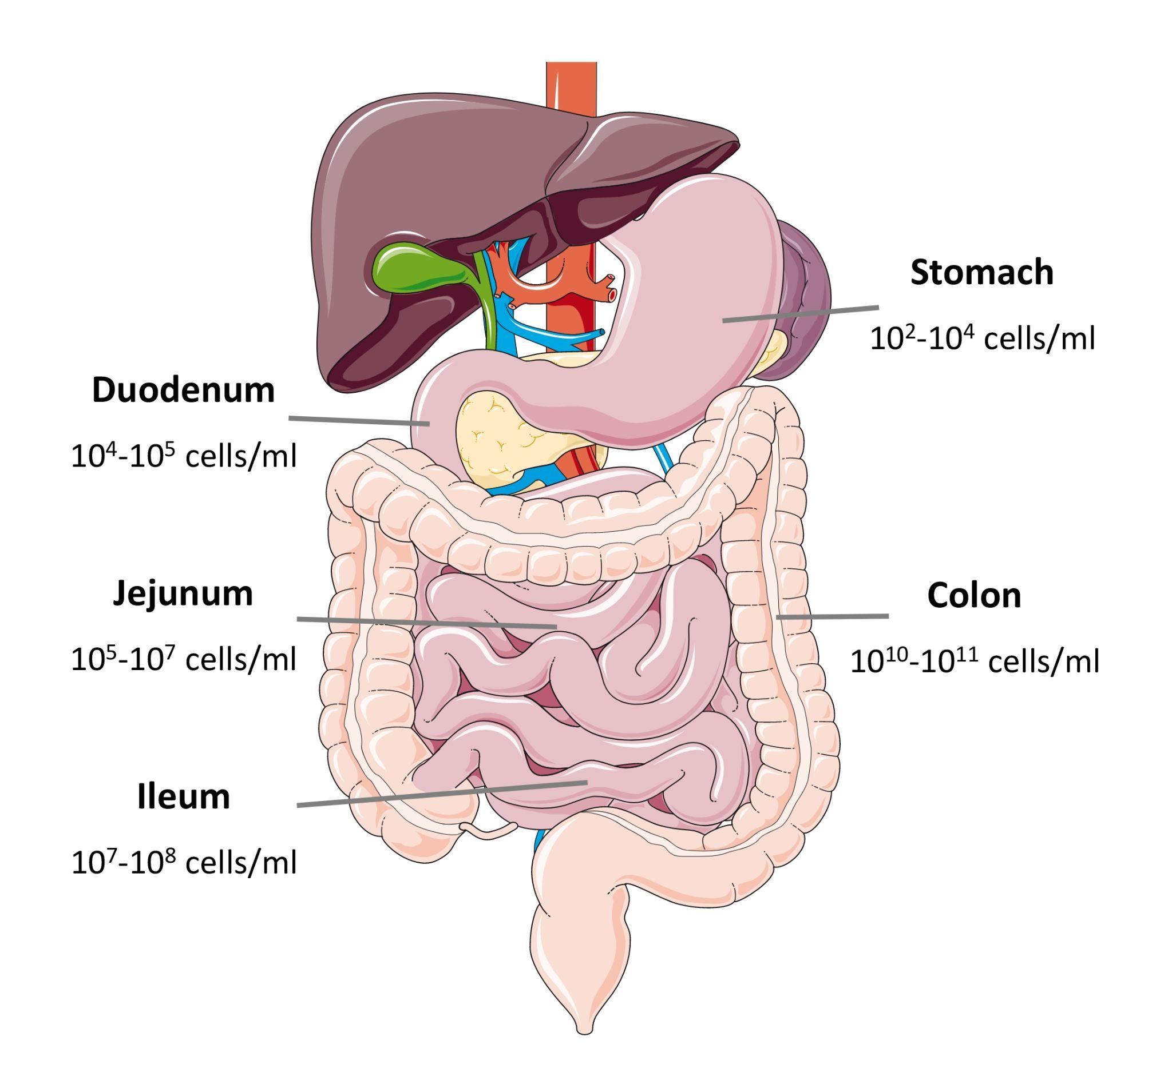

Figure 2: Schematic diagram of the process of fecal microbiota transplantation
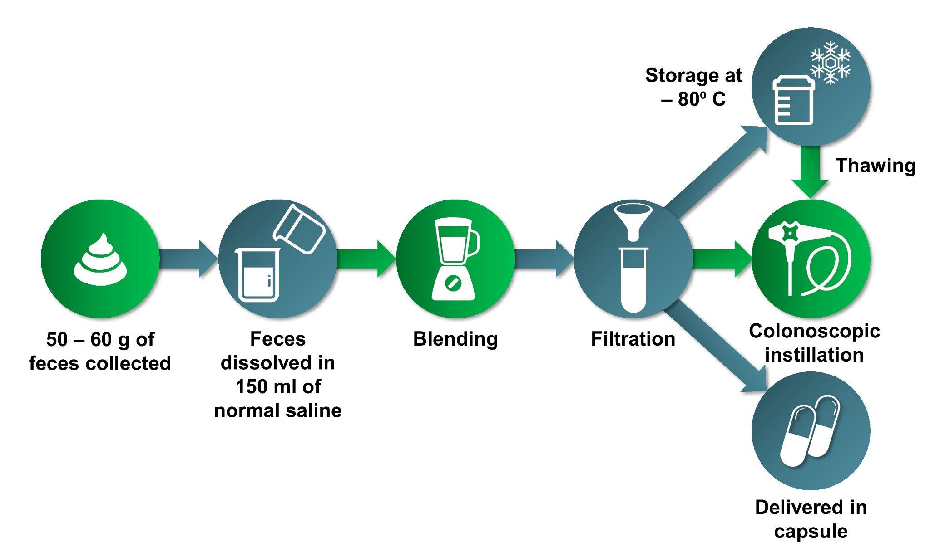

Figure 3: Illustrative examples of (A) membrane filtration therapeutic plasma exchange, (B) centrifugal therapeutic plasma exchange system

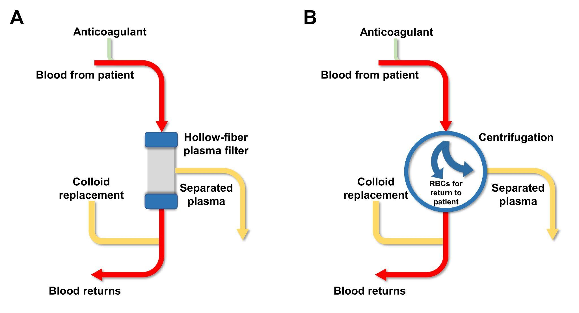

Figure 4: Evolving role of endoscopic ultrasound (EUS) in hepatology

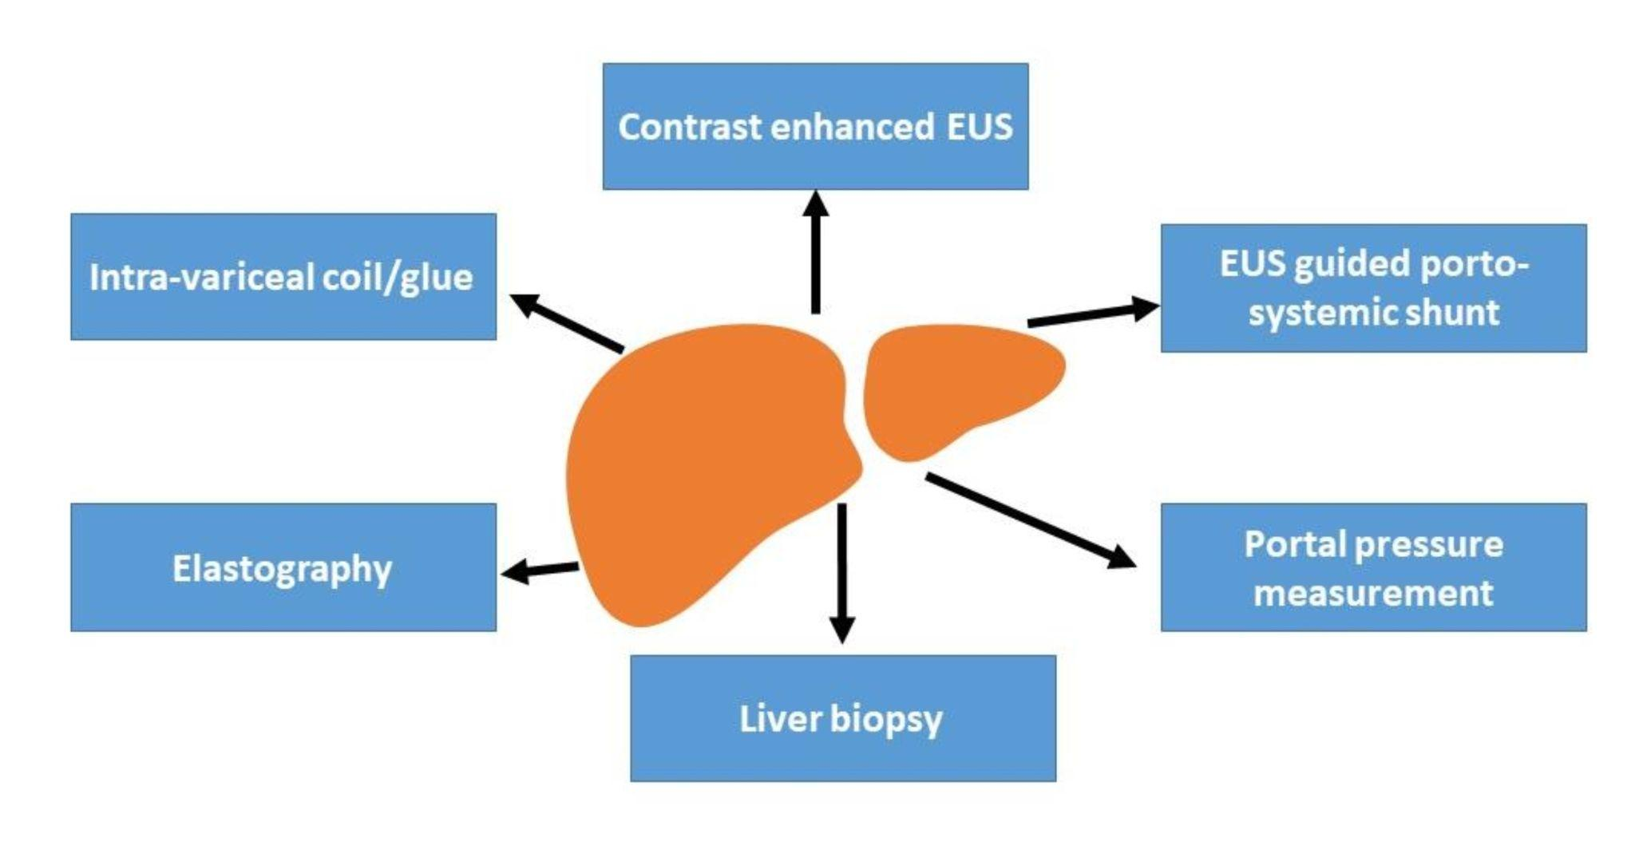

Figure 5: Schematic diagram of use of artificial intelligence for detection and characterization of polyps

