AUTOIMMUNE DISEASE-REVISITED
¹*S Hariprasadh B.Sc(Cardiovascular technology)., Faculty of allied health sciences, Meenakshi Academy of Higher Education and Research ( MAHER), Chennai, India
Prasadh9025@gmail.com
Dr Jennifer princy R.,M.Sc., (Ph.D), Asst Professor, Department of Microbiology Meenakshi Academy of Higher Education and Research ( MAHER), Chennai
jenniferprincy@gmail.com

Corresponding Author:

¹*S Hariprasadh B.Sc(Cardiovascular technology).,
Faculty of allied health sciences,
Meenakshi Academy of Higher Education and Research ( MAHER),
Chennai,Tamilnadu, India.
Mobile: 9025191218
Email: Prasadh9025@gmail.com

ABSTRACT

The illness that caused by the immune mediated attack of own tissue or organ is referred as autoimmune disease. Mostly it was seen in industrialized countries. i.e. reduced exposure to the microorganism due to improved sanitary practices which increases the immune reactivity and cause allergic reaction and autoimmune responses. It affects 5-10% of peoples in Europe and North America. Clinical manifestation differs from one person to another because it affects any site in the body. It results in inflammation of organ which leads to organ death. Patients may face lifetime of debilitating illness and costly treatment. Autoimmune disease affect the thyroid gland, pancreatic cells, adrenal gland, gastrointestinal tract, kidney, liver and neural transmitters. Head ache, blood in stools, fever, joint pain, inflammation, constipation are the some common symptoms of autoimmune disease. Autoimmune vasculitis, celiac disease, type 1 diabetes, rheumatoid arthritis are the some disease caused by autoimmune disease. Complete blood count and erythrocyte sedimentation rate is the two laboratory test taken for the diagnosis of autoimmune disease. Non-steroidal anti-inflammatory drug and glucocorticoids is the used drug for the autoimmune disease.

Key words: autoimmune disease; inflammation; symptoms; laboratory diagnosis; drugs.

INTRODUCTION

Abnormal response of the immune system is referred as autoimmune disease. [1] Normally immune system recognizes its own tissue antigen and it does not produce any antibody against it. But in autoimmune disease, the immune system produces antibodies and the T-lymphocytes against its own tissue, which results in functional damage in the body? [2] It mistakenly targets the own tissue or organs as if they were foreign cells. [1] Sometimes T cells are the reason for autoimmune disease condition. [3]

- CLASSIFICATION OF AUTOIMMUNE DISEASE
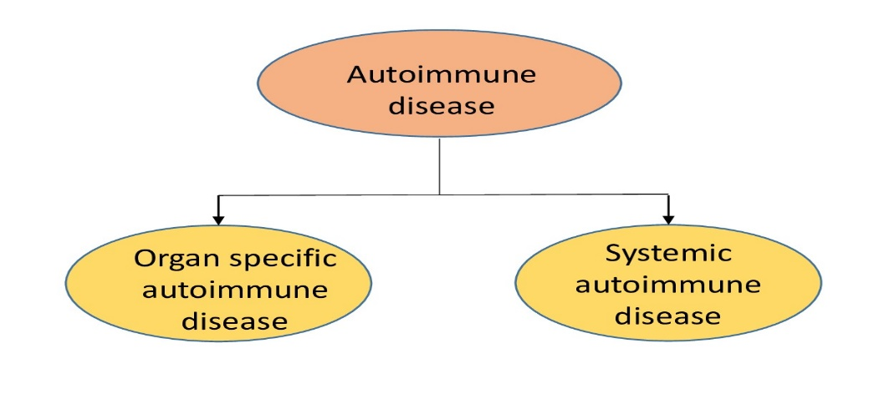
Figure 1 (shows the classification of autoimmune disease)
- Organ specific autoimmune disease
Where the specific or particular organ or tissue is targeted and attacked by the immune system is known as organ specific autoimmune disease.[4] Example : (Table 1) [3]
Organic specific autoimmune disease
Disease | Self-antigen | Immune response
Addison’s disease | Adrenal cells | Auto-antibodies
Myocardial infarction | Heart | Auto-antibodies
Hashimoto’s thyroiditis | Thyroid proteins and cells | T_{DTH} cells, auto-antibodies
Post streptococcal glomerulonephritis | Kidney | Antigen-antibody complexes
Table 1 (shows the disease, self-antigen and immune response of organ specific autoimmune disease)
- Systemic autoimmune disease
Where the autoantigen is present in the any type of cells in the body is known as systemic autoimmune system[4].
Systemic autoimmune disease
Disease | Self-antigen | Immune response
Multiple sclerosis | Brain or white matter | TH1 cells and TC cells, auto-antibodies
Rheumatoid arthritis | Connective tissue, IgG | Auto-antibodies, immune complexes
Sjogren’s syndrome | Salivary gland, liver, kidney, thyroid | Auto-antibodies

Example: Table 2 [3]
Table 2 (shows the disease, self-antigen and immune response of systemic autoimmune disease)

- SIGNS AND SYMPTOMS
Targeting of immune system towards the own tissue or cells results in inflammation and damage of organ. Due to wide range of autoimmune diseases the following symptoms vary from one to another according to the type of disease and condition of disease.[1] symptoms of autoimmune disease are shown in Table 3. Simultaneously a individual have more than one autoimmune disease is known as polyautoimmunity which further complicating the symptomatology.[1]

SIGNS AND SYMPTOMS OF AUTOIMMUNE DISEASE

Symptoms | Cause
Fatigue | Affect mental and physical health[6]
Fever | Shivering, cold and chillness
Swollen glands | Ex: swollen of thyroid glands
Skin problems | rashes
Abdominal pain | Pain in abdominal region
Digestive issue | Improper bowel movement
Joint pain or swelling[5] | Ex : Elbows, knee joint pain
Table 3 (shows the signs and symptoms of autoimmune disease)
Appearance of the symptoms is not only the diagnostic factor of the autoimmune disease. There is a specific biomarkers to diagnosis and monitor the disease condition.[7]
AUTOIMMUNE DISEASE SYMPTOMS
Joints and muscles | Digestive tract or gastrointestinal tract | Skin | Nervous system | Others
- Muscle pains.  - Joint pain, swelling.  - Muscle weakness.  - Inflammation. | - Bloating  - Constipation  - Blood in stools  - Acid reflux  - Abdominal pain | - Inflammation  - Rashes  - Hair loss  - Dry skin  - Dry mouth | - Dizziness  - Insomnia  - Memory loss  - Head aches  - Vision problems | - Weight  Loss / gain  - Chest pain  - Fever  - Irregular heart beat
Table 4 (shows the symptoms of autoimmune system according to affected areas.)[28]

- COMMONLY AFFECTED AREAS
Joints, muscle, connective tissue, blood vessels, skin, endocrine gland are the some commonly tissue level, differentiation in organ growth and function.[7]
V. TYPES OF AUTOIMMUNE DISEASE
It is estimated that there are over 80 recognized types of autoimmune disease exist, the recent scientific evidence shows that existence of potentially more than 100 distinct conditions. [8][9][10] (Figure 1.2 shows the types of autoimmune disease based on affecting region)
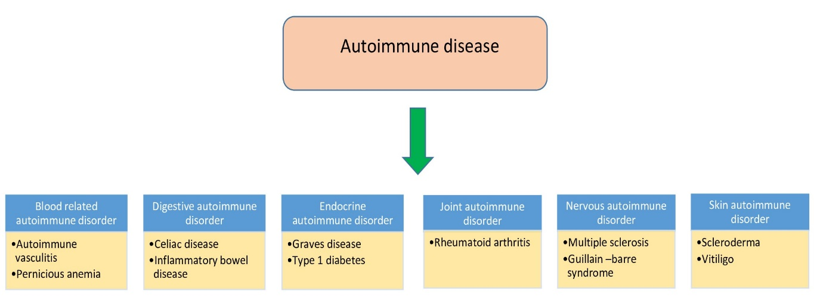
Figure 2 (shows types of autoimmune disease based on affected areas)
- Blood related autoimmune disorder
The blood or blood vessels are attack by the own immune system is known as blood related autoimmune disorder. In the severe case the organ failure or damage may occur.
- Autoimmune vasculitis
Vasculitis is rare disorder, in which the inflammation happens in blood vessels, arteries, veins, capillaries. It may cause narrowing, full or partial obstruction of blood vessels.[12]
- Pernicious anemia
The disease condition in which there is not enough production of red blood cells due to the deficiency of vitamin B₁₂.[13] Feeling tired and weakness is the common symptoms of pernicious anemia.[14]

- Digestive autoimmune disorder
The immune system mistakenly target the cells of gastrointestinal tract. There are many autoimmune disorder associated with digestive system.
- Celiac disease
The autoimmune condition which was triggered by the eating of gluten rich source is known as celiac disease. a protein which found in the grains like barley, rye and wheat is known as gluten.[11] It affect villi that lines the small intestine. It leads to abdominal discomfort, constipation or diarrhea.[15]
- Inflammatory bowel disease
Inflammatory bowel disease (IBD) is the chronic inflammation which leads to the damage in gastrointestinal tract. Chrohn’s disease and ulcerative colitis are the two disease condition comes under autoimmune IBD. It leads to diarrhea, fatigue, rectal bleeding, etc.[16]

- Endocrine autoimmune disorder
The immune system which targets the specific cells or organs that produce the hormones.
- Grave’s disease
The autoimmune disease that affect the thyroid gland [17] which results in hyperthyroidism[18] and enlargement of thyroid gland.[17] The symptoms of hyperthyroidism is mainly of insomnia, hand tremor, hyperactivity and hair loss.[19]
- Type 1 diabetes
The cells of pancreatic cells are affected by the immune system. In this condition the pancreas doesn’t produce the enough insulin, without enough insulin too much of glucose remains in the blood. It leads to the problem with eyes, kidneys, nerves and heart.[20].

- Joint autoimmune disorder
The inflammation which leads to damage of joints and connective tissue.
- Rheumatoid arthritis
It is the long term disease which affects the joint which results in painful joints, swollen and warm.[21] this disease affect the other part of the body, including skin, heart, lungs, nerves and blood.[21] it decreases the red blood cells count, and shows inflammation in the lungs and heart.[21]

- Nervous autoimmune disorder
The brain, spinal cord, or peripheral nerve are the affected part or organ in this autoimmune disease
- Multiple sclerosis
It slows down the communicable connection between the brain, spine and other parts of the body. It cause damage in myelin sheath of the brain, spinal cord. Multiple sclerosis results in muscle weakness, visual problem.[22]
- Guillain–Barré syndrome
It affects the nerve in the arms, legs and digestive organ which helpful in sensation and movement of body. The symptoms begin with weakness of muscle in legs and arms.[23]

- Skin autoimmune disorder (SKD)
The immune system shows the abnormal response to skin is known as SKD.
- Scleroderma
It is group of autoimmune response which changes the skin, blood vessels and muscles.[24][25][26] poor blood flow to the fingers and toes, stiffness, feeling tired are the some symptom seen in scleroderma disease condition. [27]

FACTORS | EXAMPLES
Genetics (may occur often within family members) | Multiple sclerosis, lupus[29]
Environmental factors (chemicals, diet, infectious agent, etc.)[30] | Rheumatoid arthritis,[31] dermatomyositis. [32]
Infections ( bacterial or viral).[33] | Rheumatic fever (streptococcus pyogenes is causative agent).[34]
Molecular mimicry (cross reactive with self-antigen by producing antibody against it.)[35] | Guillain–Barré syndrome ( C. jejuni infection )[36]
- CAUSES

- DIAGNOSIS
- Medical history
First step of diagnosing the autoimmune disease involves the collecting of past medical history of the patient and family history (genetic).[37] The physical examination of the patient may shows the inflammation of the organ which is first happen in autoimmune disease.

- Laboratory test
These laboratory tests are helps to identify the presence of certain biomarkers of autoimmune disease. Autoantibody testing,[38] complete blood count (CBC), C-reactive protein,[39] erythrocyte sedimentation rate (ESR)[40] are the some laboratory test which helpful in the identification of autoimmune disease.

- Approach the specialist
The patient who suffer from autoimmune disease must approach the multidisciplinary doctors (neurologist, rheumatologist, dermatologist, gastroenterologist, endocrinologist, etc.) According the affected organ the patient have to consult the specialist.

- TREATMENT
Treatment is based on the affected organ and severity of the disease. Most of the autoimmune disease have no cure, but we can stop the severity of the disease condition. [41]
- Non-steroidal anti-inflammatory drugs which are helpful to reduce the inflammation of the organ or tissue.[43] (example: aspirin, ibuprofen, naproxen, meloxicam.[45])
- Glucocorticoids (to reduce the inflammation).[43]
Example: prednisone, dexamethasone, hydrocortinisone [46]
- Disease-modifying anti-rheumatic drugs.[43]
Example: methotrexate, hydroxychloroquine.[47]
- Monoclonal antibodies (To block the pro-inflammatory cytokines.)[44]
Example: rituxan.[48]
- Transfusion of blood if it is a blood related disease, increase the intake of vitamin in the diet, increase the required hormonal supplement of the body which it requires.[42]
- Physical exercise if the disease is bone or joint related.[42]

REFERENCE
- Office on Women's Health. U.S. Department of Health and Human Services. 22 February 2021. Archived from the original on 5 October 2016. Retrieved 5 October 2016.
- Dr.C P Baveja, Textbook of microbiology for dental students
6th edition book
- Kuby immunology 6th edition book
- Classification of Autoimmune Diseases - Autoimmune Disease | Johns Hopkins Pathology (jhu.edu)
- What Are Common Symptoms of Autoimmune Disease? | Johns Hopkins Medicine
- ICD-11 for Mortality and Morbidity Statistics (who.int)
- National Research Council (US) Subcommittee on Immunotoxicology (1992). Autoimmune Diseases. National Academies Press (US)
- "List of Autoimmune Diseases". Autoimmune Registry Inc. Retrieved 2022-06-06.
- Angum, Fariha; Khan, Tahir; Kaler, Jasndeep; Siddiqui, Lena; Hussain, Azhar (2020-05-13). "The Prevalence of Autoimmune Disorders in Women: A Narrative Review". Cureus. 12 (5): e8094. doi:10.7759/cureus.8094. ISSN 2168-8184. PMC 7292717. PMID 32542149. S2CID 219447364
- "Assessment of NIH Research on Autoimmune Diseases". www.nationalacademies.org. Retrieved 2022-06-13.
- Diseases - Genetic and Rare Diseases Information Center (nih.gov)
- Vasculitis (arthritis.org)
- Anemia - Vitamin B12–Deficiency Anemia | NHLBI, NIH
- "What Are the Signs and Symptoms of Pernicious Anemia?". National Heart, Lung, and Blood Institute. April 1, 2011. Archived from the original on 14 March 2016. Retrieved 14 March 2016.
- What is Celiac Disease? | Celiac Disease Foundation
- Inflammatory bowel disease www.crohnscolitisfoundation.org
- "Graves Disease". www.niddk.nih.gov. August 10, 2012. Archived from the original on April 2, 2015. Retrieved 2015-04-02.
- . 314 (23): 2544–54. doi:10.1001/jama.2015.16535. PMID 26670972.
- N Burrow G, H Oppenheimer J, Volpé R (1989). Thyroid function & disease. ISBN 0721621902.
- American Autoimmune Related Diseases Association. Type 1 diabetes.
- "Handout on Health: Rheumatoid Arthritis". National Institute of Arthritis and Musculoskeletal and Skin Diseases. August 2014. Archived from the original on June 30, 2015. Retrieved July 2, 2015.
- American Autoimmune Related Diseases Association. Multiple sclerosis (MS).
- Guillain-Barre syndrome - Autoimmune Association
- "Scleroderma". GARD. 2017. Archived from the original on 25 January 2017. Retrieved 14 July 2017.
- "Handout on Health: Scleroderma". NIAMS. August 2016. Archived from the original on 4 July 2017. Retrieved 15 July 2017.
- Denton, Christopher P; Khanna, Dinesh (October 2017). "Systemic sclerosis". The Lancet. 390 (10103): 1685–99. doi:10.1016/s0140-6736(17)30933-9. PMID 28413064. S2CID 22247432
- "Scleroderma". NORD (National Organization for Rare Disorders). 2007. Archived from the original on 8 September 2016. Retrieved 14 July 2017.
- Autoimmune Diseases: Causes, Symptoms, What Is It & Treatment (clevelandclinic.org)
- Antonelli, Alessandro; Ferrari, Silvia Martina; Ragusa, Francesca; Elia, Giusy; Paparo, Sabrina Rosaria; Ruffilli, Ilaria; Patrizio, Armando; Giusti, Claudia; Gonnella, Debora; Cristaudo, Alfonso; Foddis, Rudy; Shoenfeld, Yehuda; Fallahi, Poupak (2020). "Graves' disease: Epidemiology, genetic and environmental risk factors and viruses". Best Practice & Research Clinical Endocrinology & Metabolism. Elsevier BV. 34 (1): 101387. doi:10.1016/j.beem.2020.101387. ISSN 1521-690X.
- "A Potential Link between Environmental Triggers and Autoimmunity". Autoimmune Diseases. 2014: 437231. doi:10.1155/2014/437231. PMC 3945069. PMID 24688790.
- , Meyer A, Sandler DP, Beane Freeman LE, Hofmann JN Parks CG (July 2017). "Pesticide Exposure and Risk of Rheumatoid Arthritis among Licensed Male Pesticide Applicators in the Agricultural Health Study". Environmental Health Perspectives. 125 (7): 077010. doi:10.1289/EHP1013. PMC 5744649. PMID 28718769
- Shah M, Targoff IN, Rice MM, Miller FW, Rider LG (July 2013). "Brief report: ultraviolet radiation exposure is associated with clinical and autoantibody phenotypes in juvenile myositis". Arthritis and Rheumatism. 65 (7): 1934–41. doi:10.1002/art.37985. PMC 3727975. PMID 23658122
- Getts, Daniel R.; Chastain, Emily M. L.; Terry, Rachael L.; Miller, Stephen D. (2013-08-15). "Virus infection, antiviral immunity, and autoimmunity". Immunological Reviews. Wiley. 255 (1): 197–209. doi:10.1111/imr.12091. ISSN 0105-2896
- Karthikeyan, Ganesan; Guilherme, Luiza (2018). "Acute rheumatic fever". The Lancet. Elsevier BV. 392 (10142): 161–174. doi:10.1016/s0140-6736(18)30999-1. ISSN 0140-6736.
- Rojas, Manuel; Restrepo-Jiménez, Paula; Monsalve, Diana M.; Pacheco, Yovana; Acosta-Ampudia, Yeny; Ramírez-Santana, Carolina; Leung, Patrick S.C.; Ansari, Aftab A.; Gershwin, M. Eric; Anaya, Juan-Manuel (2018). "Molecular mimicry and autoimmunity". Journal of Autoimmunity. Elsevier BV. 95: 100–123. doi:10.1016/j.jaut.2018.10.012. ISSN 0896-8411
- Jasti, Anil K.; Selmi, Carlo; Sarmiento-Monroy, Juan C.; Vega, Daniel A.; Anaya, Juan-Manuel; Gershwin, M. Eric (2016-06-21). "Guillain-Barré syndrome: causes, immunopathogenic mechanisms and treatment". Expert Review of Clinical Immunology. Informa UK Limited. 12 (11): 1175–1189. doi:10.1080/1744666x.2016.1193006. ISSN 1744-666X.
- Wang, Lifeng; Wang, Fu-Sheng; Gershwin, M. Eric (2015-07-25). "Human autoimmune diseases: a comprehensive update". Journal of Internal Medicine. Wiley. 278 (4): 369–395. doi:10.1111/joim.12395. ISSN 0954-6820.
- "Antinuclear Antibody (ANA)". labtestsonline.org. Retrieved 14 April 2020
- "Autoimmune disorders". MedlinePlus Medical Encyclopedia. U.S. National Library of Medicine. Retrieved 23 March 2020.
- "Autoimmune Diseases: Symptoms & Causes". Boston Children's Hospital. Archived from the original on 7 April 2021. Retrieved 23 March 2020.
- "Autoimmune disorders". MedlinePlus, US National Library of Medicine. 16 July 2013. Retrieved 12 July 2023
- Li P, Zheng Y, Chen X (2017). "Drugs for Autoimmune Inflammatory Diseases: From Small Molecule Compounds to Anti-TNF Biologics". Frontiers in Pharmacology. 8: 460. doi:10.3389/fphar.2017.00460. PMC 5506195. PMID 28785220
- Rosenblum MD, Gratz IK, Paw JS, Abbas AK (March 2012). "Treating human autoimmunity: current practice and future prospects". Science Translational Medicine. 4 (125): 125sr1. doi:10.1126/scitranslmed.3003504. PMC 4061980. PMID 22422994
- Smilek DE, Ehlers MR, Nepom GT (May 2014). "Restoring the balance: immunotherapeutic combinations for autoimmune disease". Disease Models & Mechanisms. 7 (5): 503–13. doi:10.1242/dmm.015099. PMC 4007402. PMID 24795433
- Shin S. Safety of celecoxib versus traditional nonsteroidal anti-inflammatory drugs in older patients with arthritis. J Pain Res. 2018;11:3211-3219. doi:10.2147/JPR.S186000
- Glucocorticoids: List, Uses, Side Effects, and More (healthline.com)
- David L. Scott, in Brocklehurst's Textbook of Geriatric Medicine and Gerontology (Seventh Edition), 2010
- American College of Rheumatology. Rituximab (Rituxan and MabThera).

