**“Food Fabrication by 3D Printer-Present Scenario and Future Prospects”**

Dr. Udaykumar Nidonia, Dr. Pramod Kattib and Er. Jambammac*

aProfessor and Head, Department of Processing and Food Engineering, University of Agricultural Science(UAS), Raichur, KA.

bProfessor, Department of Agricultural Entamalogy, University of Agricultural Science(UAS), Raichur, KA.

cIn-service PhD Scholar and Assistant Professor, Department of Agricultural Engineering, Agricutural College-Aswaraopet,

Badhradri Kothagudem(Distr.), Professor Jayashankar Telangana State Agricultural University(PJTSAU)-Hyderabad, TS.

*jammu2011@gmail.com

**1.0. Introduction**

Three D printing is an innovative manufacturing process which involves joining material to make an object from a 3D model data, usually layer-by-layer by a computer containing blue prints (package model) of the object, with a variety of printing technologies as opposed to subtractive manufacturing methodologies. It is also called additive manufacturing technology/ ‘Industry 4.0’/ rapid prototyping (Sun *et al.,* 2015).

Solid free-form food fabrication was first introduced by researchers from Cornell University using an extrusion-based printer (Fab@home, Lipton *et al.,* 2010) with Product innovation and differentiation, Customization, Direct-to-consumer relationships, Reliability of product and Speed of delivery.

**1.1. Subtractive Manufacturing V/S Additive Manufacturing**

Traditional manufacturing processes create objects by taking away material.

|  |  |
| --- | --- |
| **Subtractive Manufacturing**  Producing a part by removing raw material *via*: boring, drilling, milling, sawing, shaping, planning, reaming etc. | **Additive Manufacturing**  Additive manufacturing recreates an object layer-by-layer from scratch by adding materials. |

**1.2. Benefits & Limitations of Edible 3D Printing**

|  |  |
| --- | --- |
| * Minimizing food waste * Minimizing food preparation time * Adding vitamins and minerals as desired * Tracking calories accurately * Printing the exact form of traditional food * Customization * Creativity | **Type of food**  Not just any sort of food can be 3D printed. The food must be in the form of a paste, such as cream or mashed potatoes.  **Partial cooking**  The 3D printing process doesn’t encompass every step of a meal’s preparation.  **Price**  Food 3D printers are a bit expensive.  **Risk of failure**  Just like with any other type of 3D printing, food 3D prints can be unsuccessful. |

**2.0. History of 3D Printing**

**1981**: Hideo Kodama of Nagoya Municipal Industrial Research Institute documents the first photopolymer rapid prototyping fabrication process.

**1984**: French researchers Alain Le Mehute, Olivier De Witte, and Jean Claude Andre unsuccessfully file a patent for SLA stereolithography technology. Later Charles Hull developed the first SLA 3D printer.

**1990**: EOS GmbH builds the first Industrial-grade 3D printer.

**1992**: Stratasys patents its own version of FDM.

**1993**: Commercial organizations leverage MIT’s inkjet print head technology.

**1995**: Fraunhofer Institute launches its Selective Laser melting technology for 3D printing, achieving unparalleled levels of precision.

**1999**: 3D printing in used in biomedicine.

**2000**: Object Geometries develops the first Inkjet 3D printer.

**2000**: Z Corporation builds the first multicolor 3D printer.

**2001**: Solidimension introduces the first desktop 3D printer.

**2002**: The Wake Forest Institute for Regenerative Medicine produces the first 3D printed human kidney.

**2005**: The RepRap Project creates open-source 3D printers.

**2008**: The first 3D printed prosthetic leg is printed.

**2009**: Organovo produces the first 3D printed blood vessel.

**2011**: Urbee develops the first 3D printed car.

**2012**: The first 3d printable gun is released, sparking safety concerns.

**2014**: The first 3D printed house is completed in China.

**2014**: NASA  experiments with 3D printed food and clothing.

**2016**: The first human bones are 3D printed.

**2017**: Software is developed to enhance mass-production in 3D printing, leading to 3D printing farms.

**2.1. Evolution of Food Printers**

2006-Fab@Home (RapRep)

Paste extrusion by extrusion frostings, Nutella, chocolate (Cornell Univ.).

2006 -2009 -CandyFab

Sugar printing (EvilMad Scientist Lab).

2012 -2015- FP7 -PERFORMANCE,

Easy to chew and swallow senior food printing from pastes (Biozoon).

2013-3D Systems

Printing of advanced shapes by sugar (sugar sculptures).

2013-Modern Meadow

in vitro meat by bioprinter.

2014-Hershey’s & 3D Systems

Printing of chocolate.

2015-Barilla & TNO

Printed pasta.

2018-Chocobot at India First Chocoloate, Jam, Cheese

**3.0. D Printing 10-year challenge**

* Professional 3D Printers have Undergone a Remarkable Evolution

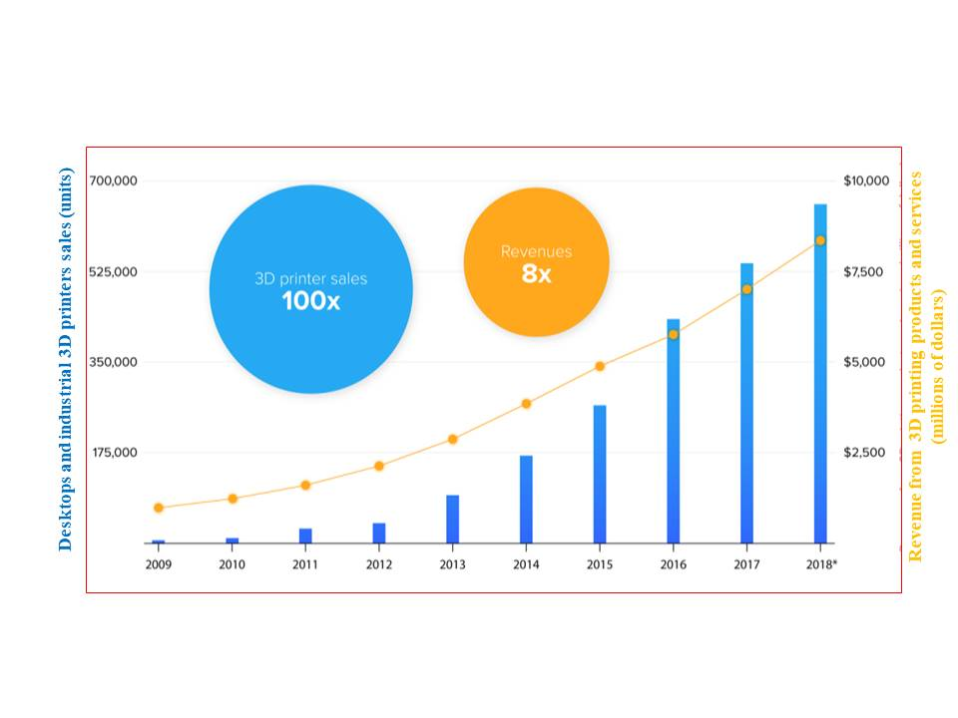

**3.1. Major Key Players:**

* FMCG sector Modern Meadow, 3D Systems, Electrolux, Nestle, Hershey’s, Natural Machines, Fab@Home, Philips, NASA, Barilla, ZMorph, and Choc Edge (<https://marketresearchposts.com/2020>).
* Market Segmentation: By Ingredients:

|  |  |
| --- | --- |
| * Proteins * Dairy Products * Carbohydrates * Dough | * Sugar * Sauce * Yard * Fruits & Vegetable |

**3.2. Leading 3d Food Printers**

|  |  |  |  |  |
| --- | --- | --- | --- | --- |
| **Printer** | **Prints** | **Uses** | **Print Volume (mm)** | **Price** |
| Print2Taste Mycusini | Chocolate | Home | 105 x 105 x 70 | ~$440 (398€) |
| byFlow Focus | Thick pastes | Catering | 208 x 228 x 150 | $4,300 (€3,900) |
| Choc Edge Choc Creator V2 Plus | Chocolate | Catering | 180 x 180 x 40 | $2,299 |
| Structur3D Discov3ry | Pastes | Home, Catering | Printer-dependent | $1,299 |
| MMuse Touchscreen | Chocolate | Catering | 160 x 120 x 150 | $5,700 |
| Natural Machines Foodini | Pastes | Catering | 257 (diameter) x 110 (height) | $4,000 |
| Print2Taste Procusini 4.0 | Pasta, Chocolate, Marzipan, Cassis, Fondant | Catering | 250 x 150 x 100 | $2,625 (€2,382) |
| Wiiboox Sweetin | Pastes | Catering | 95 x 80 x 90 | $1,999 |
| ZMorph VX + Thick Paste Extruder | Pastes | Home | 250 x 235 x 165 | $4,399 |
| Createbot 3D Food Printer | Pastes | Home, Catering | 150 x 150 x 100 | $2,115 |

**4.0. How to Print 3D Foods**

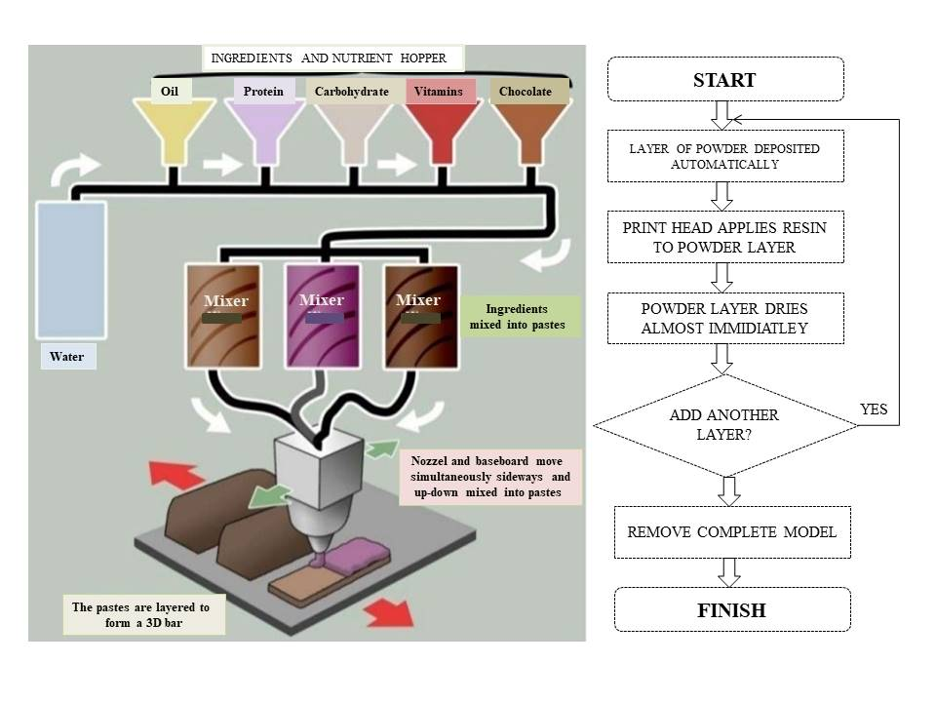**3. Procedure of 3DP Technology for Food Materials**

* Material: Material choice and deep understanding of its physicale, chemical and rheological properties.
* 3DP technique: The choice of the 3DP technique is based on the material properties, applicability and postprocessing requirements.
* 3D design and path planning: 3D content is necessary to be generated as a first step of implementing 3DP.
* A wide variety of software is available, from beginners to advanced, to design the construct to be printed (e.g., SketchUp, Tinkercad and OnShape).
* The design is then converted to an .stl file and ‘sliced’ by a slicing software (e.g., Cura, Repetier and Simplify3D).
* A G-code is generated with the commands necessary to guide the print head at predetermined conditions of speed, flow and temperature. This is an important step once successful printing is closely related to the path-planning choice for the design.
* Assessment of printing parameters and printed object quality: Printing parameters and printed material quality can be assessed regarding shape fidelity (in comparison with the original design) and mechanical properties.

**4.1. 3D Printing Process**

**Fig. 4.1. Computer-aided design systems to create 3D virtual models of food (Fernanda *et al*., 2019)**

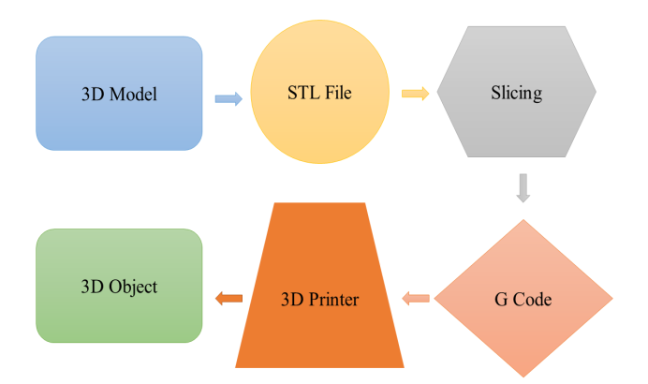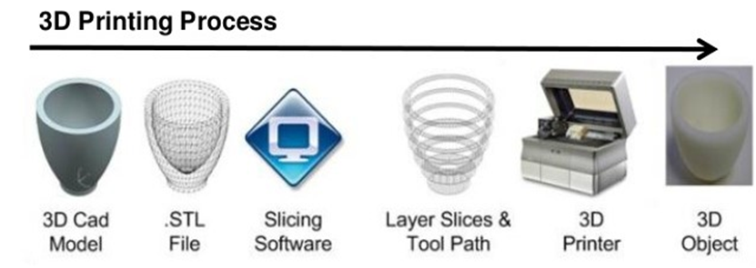

|  |  |  |  |  |
| --- | --- | --- | --- | --- |
| **Table 3.2 Main properties of free CAD software to use for 3D Food Modeling** | | | | |
| **Name** | **Level of user** | **Operating system** | **Type** | **Files formats** |
| 3D Builder | Beginner | Windows Mobile, Xbox One & Windows, HoloLens | 3D | 3mf, obj, ply, vrml, stl |
| Tinkercad | Beginner | Browser | 3D CAD | 123dx, 3ds, c4d, mb, obj, svg, stl |
| Sculptris | Intermediate | Windows, Mac | 3D CAD | obj, GoZ |
| Onshape | Advanced | Windows, Mac, Linux and browser | 2D/ 3D-CAD | sat, step, igs, iges, sldprt, stl, 3dm, dae,dfx, dwg, dwt, pdf, x_t, x_b,xxm_txt |
| OpenSCAD(L) | Advanced | Windows, Mac and Linux | 3D/CAD | dxf, off, st |

G-CODE: The Language to Drive Printers and to Optimize Printing Quality

* G28 e Move to Origin,
* G90 and G91 - Set positioning mode and
* G1 to Linear movements.

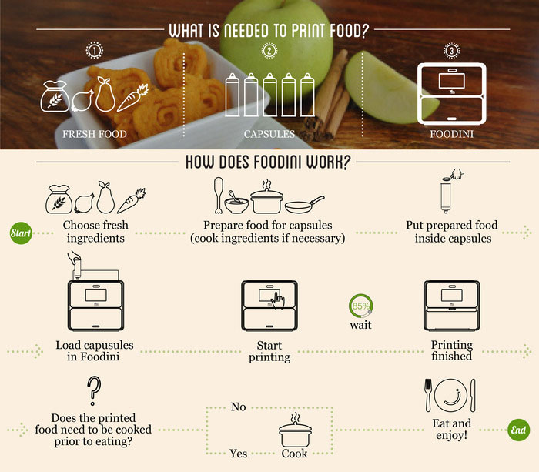Description: C:\Users\JAMMU\Pictures\o.png**4.2. Customisation of Food for 3D printing process**

**5.0. Structural Configuration of 3D Printers**

* 3D printers used for food may have Four different structural configurations: Cartesian, Polar, Delta and Scara(Stephanie and Jonathan, 2018).
* The printer’s configuration refers to how the printhead and/or print bed moves within the X-Y-Z space, allowing the printer to deposit material by following the pathways generated on the basis of the 3D virtual model.

**5.1. CartesianConfiguration**

* Cartesian printers have been the first generation of 3D printers, being the simplest to design configuration indicates a 3D printer that moves on the Cartesian axes X, Y and Z. Different sub configurations also exist.
* 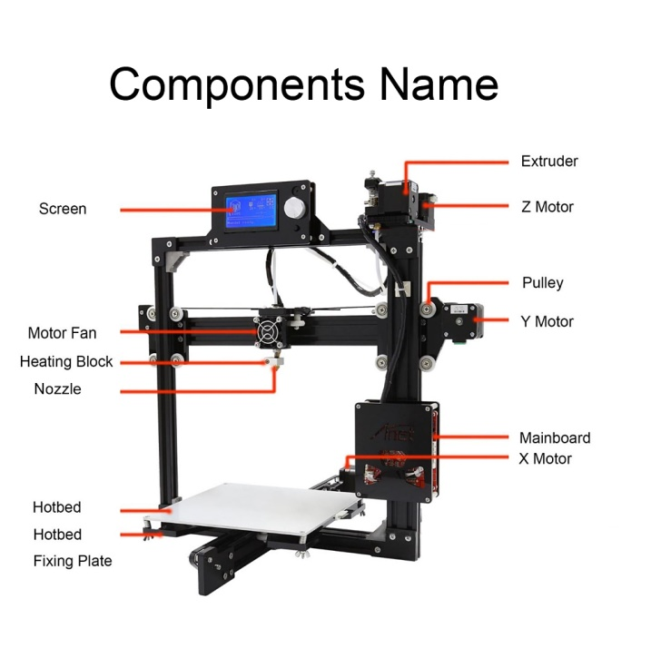As example, the printhead may move on the X-Y plane while the print bed moves along the Z axis (i.e., the ‘XY Head’ printers). Alternatively, the printhead may move on X and Z axes while the print bed moves along Y axis (the so-called ‘XZ Head’ printers).
* This configuration is the printer developed by the company ByFlow which uses a plastic syringe that each consumer may refill with their own recipes.

**Fig.7 Schematic representation of Cartesian 3D printers. (A) Z Head 3D printer (adapted from Madeira et al., 2017); (B) XZ Head 3D printer**

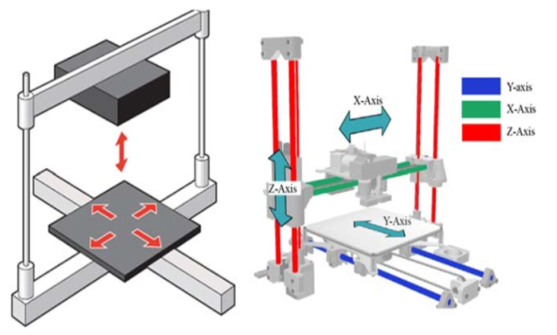

**5.2. Delta Configuration**

* Delta configuration is the second most popular and used commercial printers.
* The movements in the 3D space are allowed by three pairs of arms while the print bed is fixed
* Each arm is connected to a carriage which runs along the vertical direction.
* The movements of the printer head in X-Y-Z space are very easy because they follow the Pythagorean theorem (**Fig 3 B**).
* This is because the arm length may be considered as the diagonal of the triangle, so that the movements in X direction are the consequence of the movements of the arms along vertical direction.
* Figs. 3 B and C show two positions of the printhead along the X-axis obtained by the change of the diagonal and angle of the triangle build by the arm length, X and Z position. All three pairs of arms move at the same times.
* Advantages of this printer configuration are the possibility to build big objects and the high rate of printing because the mechanical parts are lightweight in comparison to Cartesian configuration printer.
* This configuration suffers from lower precision in positioning, particularly for very small objects.

**Fig 8. Schematic representation of a Delta 3D printer configuration**

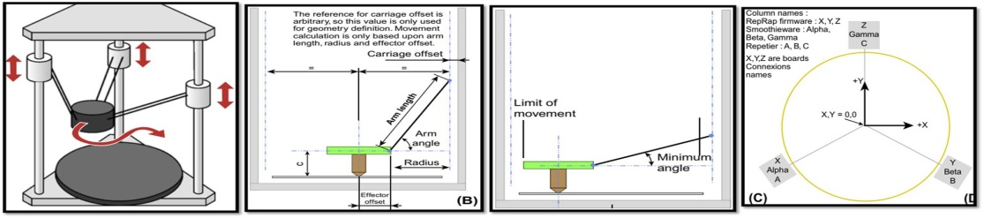

**5.3. Polar Configuration**

* Polar configuration means the use of polar coordinates for print bed movements around 360 degrees and along radial distance while another stepper motor moves the print head along the vertical direction.
* This configuration enables the printer to have a small size, and a bigger object may be printed since the print bed is a disk.
* For instance, keeping constant a length of 4 cm, a maximum square print bed of 16 cm2 is obtained for a Cartesian configuration, while a surface of 50.24 cm2 is available for Polar configuration.
* Notwithstanding some Polar 3D printers are available, only the XOCO 3D printer.

**5.4. SCARA Configuration**

* SCARA configuration is the acronym of Selective Compliant Assembly Robot Arm that means the use of a robotic arm able to move along XY plane while a separate motor assures the movement on the vertical direction.
* Nowadays, any application of this configuration for 3DFP has not been used.

**Fig 9. Various Structural Configurations of 3D Printers**

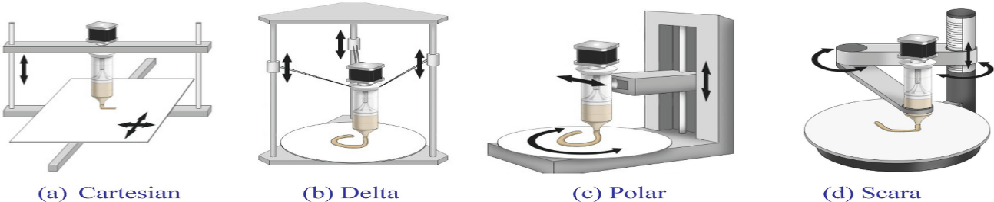

**6.0. 3D PRINTING TECHNIQUES**

They are classified according to the Driving mechanisms of printing

|  |  |  |
| --- | --- | --- |
| **Inkjet** | **Extrusion** | **Heating Mode** |
| 1. Continues 2. Drop on demand 3. Drop on drop 4. Drop on powder | 1. Non-phase change extrusion 2. Melting extrusion 3. Gel formation | 1. Powder layer binding |

Fig 2. Schematic diagram of various 3D food printing techniques.

**6.1. INKJET PRINTING**

* This one is used to decorate food, such as pizza, cookies, and cake, or create surface fillings as in meat paste, cheese, jam or sugar icing.
* Inkjet printing (IJP) can be applied to the formation of 2D and 3D patterns upon deposition of liquid droplet onto a substrate guided by computer-aided design systems.
* Usually a printhead of IJP, the ink is jetted through channels of typically 20-50µm.
* Inkjet printing (IJP) can be carried out continuously (C-IJP) or through drop-on-demand (DoD-IJP).
* Both methods occur by forcing a fluid through an orifice, which subsequently breaks up into a stream of droplets with the same volume but less surface area instability.
* The fluid dynamics behaviour of the droplet ejected from a small opening was previously obtained from an approximate solution to the Naviere Stokes equation.

**6.1.1. Three main parameters are adopted to predict the droplet jetting behaviour**

* Re/We: Ratio between the Reynolds number (Re) and the Weber number (We) which is representative of trends observed on the viscous, inertial and surface tension forces on fluid flow. In Eq. 1, a, *rho*, *gamma* and *eta* stand for the characteristic length, density, surface tension, and viscosity of the fluid, respectively.

$\frac{Re}{We}=\frac{{\left(γρa\right)}^{1}/2}{η}$---------------- (1)

* Droplet spreading in absence of solidification (ε): Eq. 2, derived by Bhola and Chandra, where rmax and r are the maximum splat radius and initial drop radius, respectively, Ɵ is the equilibrium contact angle that the droplet makes with the substrate. 𝛆= $\frac{rmax}{r}$ = ${\left\{\frac{We^{2}+ 12}{3\left(1-cosθ\right)+4\frac{We^{2}}{Re^{1}/2}}\right\}}^{1/2}$----------------- (2)
* Splashing of liquid drops (K): splashing of the droplet upon jetting results in dimensional instability and lack of uniformity. Splashing occurs when the parameter K exceeds a critical value, Kc (Eq. 3)

K=We*Re1/4 ----------------- (3)

**Table 6.1: Inkjet Printing Methods Sub-Classification**

|  |  |
| --- | --- |
| **Continuously (C-IJP)** | **Drop-on-demand (DoD-IJP)** |
| Forcing a fluid through an orifice | Forcing a fluid through an orifice |
| High-pressure pump directs 🡪droplets between 50 -80 µm dia. | Presents multiple heads range 100-1000.  70-0 dots per square inch (dpi) |
| Operates using electrically conducting fluid food | Operates using thermal or piezoelectric heads |
| * In a thermal inkjet printer, the print head is electrically heated to generate pulses of pressure that push droplets from the nozzle. * Piezoelectric inkjet printers contain a piezoelectric crystal inside the print head which creates an acoustic wave to separate the liquid into droplets at even intervals. | |

**6.1.2. Inkjet Printing -3D Food Printing Technology**

* Inkjet printing dispenses a stream of droplets from a thermal or piezoelectric head to certain regions for the surface filling or image decoration on food surfaces, such as cookie, cake and pizza .
* In a continuous jet printer, ink is ejected continuously through a piezoelectric crystal vibrating at a constant frequency.
* To get a desired flowability of the ink, it is charged by the addition of some conductive agents.
* In a drop-on-demand printer, ink is ejected out from heads under pressure exerted by a valve .
* DoD is slower than those of continuous jet systems, but the resolution and precision of produced images are higher.
* Most desired viscosity of inks in a continuous jet printer should be between about 2.8 to about 6 mPas .

**6.1.3. Application of Inkjet Printing Food Creation**

* Inkjet printing generally handles low-viscosity materials; thus, it is mainly used in the area of surface filling or image decoration on edible substrates such as biscuit, cake and crackers .
* Inkjet printers generally handle low-viscosity materials; therefore, IJP does not find application on the construction of complex food structure. The technology is normally used in graphical decoration, fillings, microencapsulation and, at much lower extension, nanoprinted 3D constructs (usually bioprinting applications).

|  |  |
| --- | --- |
| **Graphical Decoration, Fillings:** | |
| **i. FoodJet printing** | Dispensing a liquid onto layers a moving object . |
| **ii. Mars Inc.,** | Piezoelectric printhead to print high resolutions (100 dpi-300 dpi) of images that might be composed of fat or edible substrate are confectionary pieces with nonplanar and hydrophobic surfaces. |
| **iii. Procter and Gamble Co** | Flavour application on edible substrates. |
| **Microencapsulation;** | Developed by Netherlands Organisation for Applied Scientific Research (TNO) -a printhead (500) produces highly monodisperse droplets converted into highly monodisperse powders after drying. |
| **3D constructs ;** | The inkjet technology classified as drop-on-powder has been used to eject binder solution onto a thin layer of powder following a sliced 2D profile generated by a computer 3D model-Binder jetting. |
| * **ChefJet printer** | Which uses the Z-Corp inkjet process to produce a broad range of confectionary recipes including sugar, fondant and sweet and sour candy in a variety of shapes and flavours. |

**6.2. Extrusion-Based 3D Printing**

* Unlike DoD-IJP methods, extrusion-based techniques rely on the flow of a continuous ink in a layer-by-layer fashion.
* Generally suitable for highly concentrated colloidal inks of total solids can range from 5% to 50%.
* Capability of the material on forming gel or achieving paste consistency.
* The ink flows through the nozzle upon the application of a pressure gradient DP along with the length (l).
* Therefore, a radially varying shear stress (tau) develops as per Eq. 4, where r is the radial position within the nozzle. At the nozzle wall centre (r =R), there is zero velocity, and in the centre (r =0), the velocity is at a maximum (Lewis, 2002).

ζ=rΔP/2l ----------------(4)

* Pneumatic and mechanical (piston or screw) methods are usually used to extrude food materials for 3DFP applications.
* The piston-driven configuration generally provides more direct control over the flow of viscous materials through the nozzle, while the screw-driven system might favour the spatial control and can be beneficial for dispensing and mixing materials with higher viscosities.
* The **binding** mechanisms may happen by the accommodation of layers controlled by the rheological properties of the materials (nonphase change extrusion), solidification upon cooling (melting extrusion) or gel-forming extrusion.
* Non phase change 3DP extrusion: is usually performed without temperature control and has been applied to print 3D constructs made of materials such as **Dough** and **Meat** Paste.
* The viscosity of the material is critical to be both low enough to allow extrusion through a fine nozzle and high enough to support the structure post deposition.
* Thickener agents, or additives, can be used to achieve the desired rheological properties but must comply with food safety standards.
* In a multicomponent food system, the synergism within ingredients impart homogeneous distribution of the printing paste on the printer reservoir, uniform flow throughout the nozzle opening and instant recovery after extrusion.
* Rheological properties are also relevant in melting extrusion and gel-forming extrusion; however, the phase transitions taking place during extrusion will determine the quality of the final printed construct.

**6.2.1. Melting Extrusion/ Fusion Deposition Modeling(FDM)**

* Materials suitable for melting extrusion can be presented in three forms: paste, powder (or solid pieces) and filament (rare in food applications).
* The temperature control during extrusion-based 3D printing of pastes rich in fat or sugar (mostly amorphous) is essential to ensure printability.
* As an example, fatty acids with larger numbers of carbon atoms depict higher melting point. In an opposite way, a larger number of double bonds result in lower melting point.
* The chocolate deposition directly into a 3D object by means of extrusion was introduced by researchers from Cornell University using a Fab@home fabrication system.
* ChocEdge Ltd, a spin-off company from the University of Exeter, it pioneered the commercialization of 3D chocolateprinters.
* Production and printing of edible filaments are rare.
* The hot melt extruded presented by the invention shows a 1.75 or 3 mm.

**6.2.2. Gel-Forming Extrusion**

* The rheology of gels can be tailored based on the fraction and/or colloidal forces.
* When stressed beyond their gel yield point (*tau-*τ), they exhibit shear thinning flow behavior due to the attrition of particle to particle bonds within the gel by Eq.5 .

**τ=τy+kγn** --------- (5)

* + Where
    - τ is shear stress, *n* is the shear thinning exponent (<1),
    - *K* is the viscosity parameter and
    - *γ-gamma* is the shear rate.
* The ink flows with a three zone velocity profile:
  + - 1. The core (unyielded gel) flows at a constant velocity, surrounded by
      2. A yielded fluid (shell) experiencing laminar flow, and
      3. A thin slip layer devoid of colloidal particles at the nozzle wall.
* The Eq. 6 can be used to correlate the elastic parameter y (which can be shear YS or elastic modulus) with the mechanical equilibrium of colloidal gels depicted by the ratio Ɵ/Ɵgel, where Ɵ is proportional to the bond density, and Ɵgel scales inversely with bond strength. In Eq.6, k is constant and x is the scaling exponent.

**Y=k($\frac{ϕ}{ϕgel}-1)^x$**  ------------ (6)

The minimum elasticity required to produce self-supporting 3D construct.

**G’min ≥1.4 s4 D** --------------- (7)

In 3DP, the elastic properties should be taken into consideration together with the temporal control of the gelation mechanisms to prevent premature gelation of the material inside the nozzle.

The gelation mechanisms can be classified in five categories:

1. Thermal gelation,
2. Chemical cross-linking,
3. Ionotropic cross-linking,
4. Complex coacervate formation, and
5. Enzymatic cross-linking.

**6.2.2.1. Gelation Mechanisms**

|  |  |  |  |  |
| --- | --- | --- | --- | --- |
| 1 | **Thermal-gelation** | | Gelatin is a classic printing material.  Gelation is induced upon cooling due the formation of junction by small segments of polypeptide chains reverting to the collagen triple helix-like structure (within 15-20oC). It depends on adjust printing speed &temp. | |
| 2 | **Chemical cross-linking** | | This is a common strategy applied to promote thermal stability in gels, such as gelatin. An example is methacrylation of gelatin for bioprinting applications, which is further cross-linked by UV light | |
| 3 | **Complex coacervate formation** | | Xanthan gum and gelatin have been printed to simulate a broad range of mouthfeels.  hydrogel-forming mechanism of the combination between a polycation (xanthan) and an amphoteric polymer (gelatin) | |
| 4 | **Enzymatic cross linking** | | has used transglutaminase as cross-linking agent to increase the gelation temperature of the sodium caseinate (20% w/w , at 15 0C) and, in turn, enable printability of low-concentrated sodium caseinate dispersions. | |
| 4 | | Ionotropic cross-linking | | * Has been widely applied by the food industry, especially in microencapsulation processes. * The use of low methoxylated (LM) pectin gel as a promising edible ink for confectionary applications. |

Calcium chloride solution was used to cross-link the gel-like layers by following two strategies:

(1) postimmersion of the 3D construct in CaCl2 solution (concentration 300 mM) and

(2) concurrent crosslink by coaxial extrusion (CaCl2 ) of the outer flow ranging from 30 to 150 mM .

The coaxial extrusion allowed the gelation of the pectin during the printing and did not require any post treatment after printing.

**Fig.9 Schematic representation of coaxial extrusion (A) and picture of the coaxial extruder apparatus (B), In (C), it is shown a cross-section representation of pectin inside the nozzle being extruded with collateral flow of CaCl2 solution**

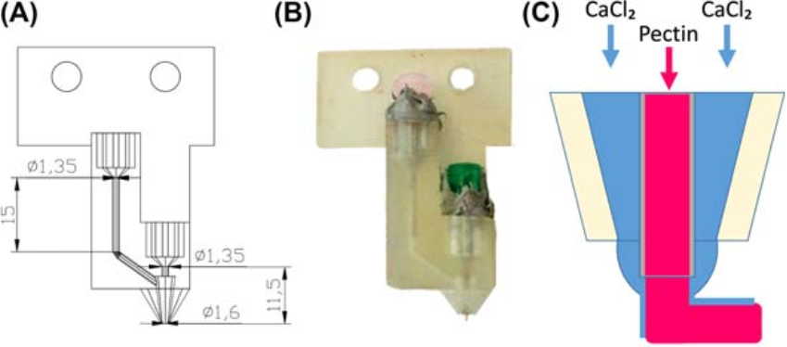

**6.2.3. FDM/Hot Melting Extrusion-3D Food Printing Technology**

* FDM/Hot Melting Extrusion-based printing has been widely applied to create customized 3D chocolate products
* Melted semisolid food polymer is extruded from a movable printhead and solidifies and welds to the previous layers almost immediately after extrusion.

**6.2.4. Mechanism of Formation of Self-Supporting Layers**

* The chocolate ink should be able to hold its structure during and after the layer-by-layer deposition process.
* The ‘self-supporting’ capacity relies on thermal properties like glass transition temperature (Tg) and melting point, which is critical in the postdeposition solidification process of the deposited layer.
* There are six major crystal polymorphs’ formation in cocoa butter.
* Form V, with melting temperature (Tm) ranging between 33.8 and 35 0C, is the most important crystal and will give the final chocolate product more stable characteristics, a glossy finish and better texture.

**6.2.5. Application of Melting Extrusion**

* The chocolate extrusion printing has been commercialized by Choc Edge’s Choc Creator, 3D System’s ChefJet, Hershey’s CocoJet and Chocabyte.
* A melting extrusion-based printer has been created by Natural Machines to be used for chocolate printing .
* Massachusetts Institute of Technology (MIT) used melting chocolate as a dispensing liquid and developed a printer named ‘Digital Chocolatier .

**Fig.10. Extrusion mechanism in the 3D food printing process, (A) Syringe-based extrusion; (B) air-compressed extrusion; (C) screw-based extrusion**

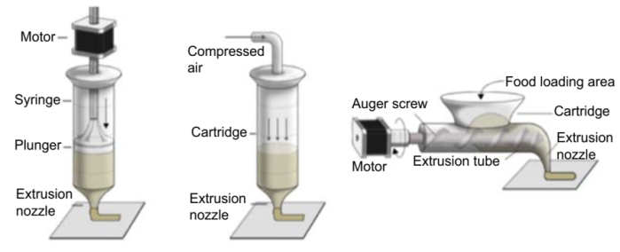

**6.2.6. Soft Materials Extrusion**

* During the soft materials extrusion-based printing process, the paste like food slurry is extruded out continuously from a moving nozzle and welds to the preceding layers on cooling, such as dough, mashed potatoes, cheese and meat paste.
* Three extrusion mechanisms have been applied in 3D food printing,

**Table 6.2: Different Methods of ExtrusionBased on Property of Materials**

|  |  |  |
| --- | --- | --- |
| **Screw-based extrusion** | **Air pressure-based extrusion** | **Syringe-based extrusion** |
| It is not suitable for the food slurry with high viscosity and high mechanical strength. | The food materials are pushed to the nozzle by air pressure, is suitable to print liquid or low viscosity materials. | Suitable to print food materials with high viscosity and high mechanical strength. Can be used to fabricate complex 3Dructures with high resolution. |

**6.2.7. Mechanism of Formation of Self-Supporting Layers**

To fabricate delicate and complex shapes during the soft material extrusion process, it is necessary to print the additional structural objects to support the product geometry.

* The supporting constructs must be manually removed in the final stage. This is a time consuming process.

**6.2.8. Pre and Post Treatment Methods**

* Ideally, the 3D food structures should be resistant to postprocessing of baking, cooking, frying, etc.
* Two main ways that have been applied to maintain the shape stability of objects after post processing are recipe control and addition of additives.
* Addition of 0.5% of transglutaminase by weight significantly increased the structure stability after cooking of meat cookies, confectioneries which is due to the formation of a new protein matrix over time.
* Soft Materials Extrusion-Based Printed Foods

|  |  |
| --- | --- |
| **Fabricated Organisation** | **3D Food** |
| Cornell University | Cake frosting , Processed cheese and Sugar cookies |
| Netherlands Organization for Applied Scientific Research (TNO) | Surface filling and graphical decoration |

**Fig.11 Netherlands Organisation for Applied Scientific Research (TNO)’s encapsulation printer and examples of core shell structures: mint syrup wax and linseed oil carrageenan (TNO, 2017).**

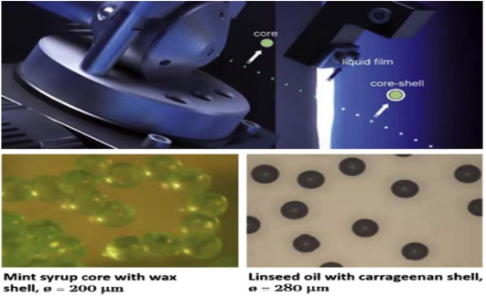

**Fig 12. Method 3D Printing based on material viscosity**

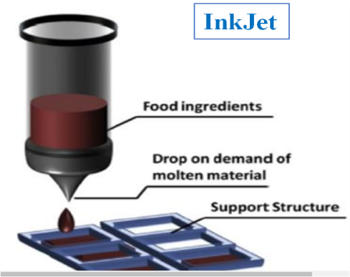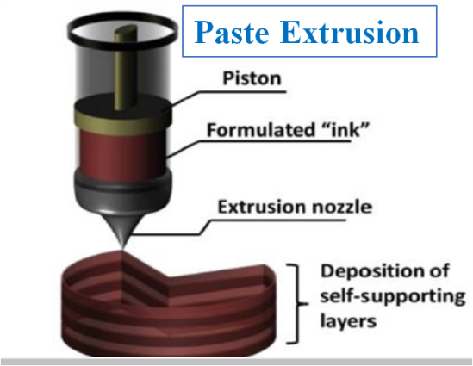

|  |  |
| --- | --- |
| * Medium to highviscosity * No supportneeded * Solidification upon cooling or gel forming before or during printing | * Low viscosity * Support needed |

**6.3. Heating Mode: Powder Layer Binding**

* CandyFab machines, a project by Evil Mad Scientist Laboratories (California, US), use selective hot air sintering and melting (SHASAM) technology to print sugar-based 3D objects. Sintering is compacting and forming a solid mass of material by heat or pressure without melting it to the point of liquefaction.
* Technology uses a narrow, directed, low-velocity beam of hot air to selectively fuse together sugar powder, building a 2D picture out of fused powder.
* First, the powder bed is slightly lowered; then a thin flat layer of particles is spread to the top of the bed, and hot air is directed by the software at localised areas to selectively fuse the media in the new layer.
* Upon finishing the 3D object, the bed is brought to its initial position, disinterring the manufactured model .

i. Selective Laser Sintering (SLS) -3D Food Printing Technology

* Generally, SLS allows for the production of free standing complex 3D structures with high resolution, but the available material is limited to **powder material**, such as sugar, fat or starch granule.
* The interaction time between the hot air gun and sugar powder was 1 to 3 s.
* Typically, the Tm or Tg of the binder component ranged between 10 and 200C. The binder should undergo melting and glass transition in less than 5 s.

**6.3.1Application of Laser-Based Printing in Food Creation**

* SLS has been utilized to fabricate complex structures using sugar or sugar-rich powders. Delicate and complex 3D structures have been created by researchers from **TNO** using sugars and **esQuik** powders .
* **CandyFab** Project has successfully created various attractive complex structures using sugar powders which could not be produced by conventional ways.

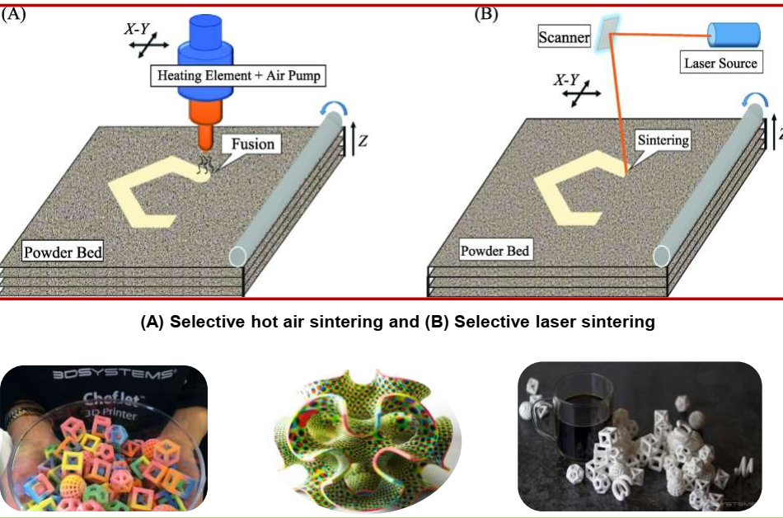**Fig13. A. Selective hot air sintering B. Selective laser sintering.**

**6.3.2. Binder Jetting**

* Binder jetting printing, also known as inkjet 3D printing, was first introduced by Sachs*et al.* (1994) - Complex and delicate 3D structure & material is only limited to powder stuff.
* Powdered materials were deposited layer by layer and the binder was selectively ejected upon each material layer at certain regions based on the data file for the object being produced.
* The binder fuses the current cross-sections to previous and afterward fused cross-sections.
* The unfused powder supported the fused parts at all times during the fabrication process, allowing for the production of intricate and complex structures.
* Finally, the unbound powder is removed and recycled for further use.
* Typically, the angle of repose of the powder should be low, e.g., smaller than 30 degrees.

**6.3.2.1. Application of Binder Jetting in Food Creation**

* Fast fabrication, building of complex structures and low material and fabrication of edible using sugars and starch mixtures.

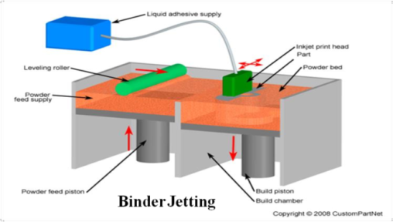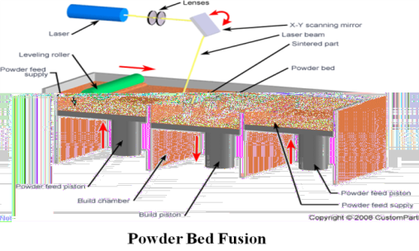 **Fig.14. Powder Bed Binder Jet Fig.15. Powder Bed Fusion Fig.16. Binder Jetting**

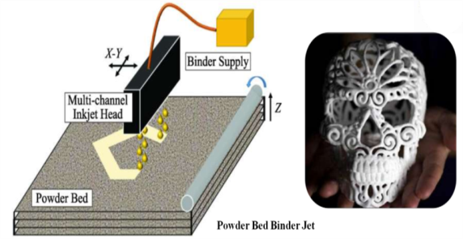

|  |  |
| --- | --- |
| Powder Bed Fusion   * Thermal energy selectively fuses regions of a powder bed. * Support structures are needed + many post processing phases. | Binder Jetting   * A liquid bonding agent is selectively deposited to join powder materials. * Might result in weak structures (good for design purposes). |

**7.0. Computer-aided design systems to create 3D virtual models of food**

|  |  |  |  |  |
| --- | --- | --- | --- | --- |
| **Table 7.0: Main properties of free CAD software to use for 3D food modeling** | | | | |
| **Name** | **Level of user** | **Operating system** | **Type** | **Files formats** |
| 3D Builder | Beginner | Windows, Windows Mobile, Xbox One & Windows, HoloLens | 3D | 3mf, obj, ply, vrml, stl |
| Tinkercad | Beginner | Browser | 3D CAD | 123dx, 3ds, c4d, mb, obj, svg, stl |
| Sculptris | Intermediate | Windows, Mac | 3D CAD | obj, GoZ |
| Onshape | Advanced | Windows, Mac, Linux and browser | 2D/ 3D-CAD | sat, step, igs, iges, sldprt, stl, 3dm, dae, dfx, dwg, dwt, pdf, x_t, x_b, xxm_txt, |
| OpenSCAD (L) | Advanced | Windows, Mac and Linux | 3D/CAD | dxf, off, st |

**G-CODE: The Language to Drive Printers and to Optimize Printing Quality**

* G28e Move to Origin,
* G90 and G91 - Set positioning mode and
* G1 to Linear movement**s.**

**Table7.1. Comparison of Different 3D Food Technologies**

|  |  |  |  |  |
| --- | --- | --- | --- | --- |
| **Factors affecting printing** | **Extrusion-Based Printing** | **Selective Laser Sintering** | **Binder Jetting** | **Inkjet Printing** |
| **Available** **material** | Chocolate, soft material such as dough, cheese, meat puree. | Powdered materials such as sugar, chocolate, fat. | Liquid binder & powder material like starch, sugar, protein. | Low-viscosity material such as pizza sauce. |
| **Material** **properties** | Rheological properties, mechanical strength, Tg. | Melting temperature, flowability, particle size, wettability, Tg. | Flowability, particle size, wettability & binder’s viscosity & surface tension. | Compatibility, ink rheological properties, surface properties. |
| **Processing** **factors** | Printing height, nozzle diameter, printing rate, nozzle movement rate | Laser types, power, thickness, spot diameter,energy density, scan speed | Head types, printing rate, nozzle dimeter, layer thickness | Temperature, printing rate, nozzle diameter, printing height |
| **Postprocessing** | Additive, recipe control | Removal of excess parts | Heating, baking, surface coating,rem- oval of excess part | No |
| **Advantages** | More material choices, simple device | Complex 3D food fabrication, varying textures | Complex 3D food fabrication, full colour,varying flavours, textures | More material choices, better printing quality, fast fabrication |
| **Limitations** | Incapable of fabricating of complex food designs, difficult to hold 3D structures in post process | Limited materials, less nutritious products | Limited material, less nutritious products | Simple food design, only for surface filling or image decoration |
| **Products** |  | | | |

**8.0. 3D Printing Technologies for Cereal-based Formulations**

* Regarding the field of cereals, two main technologies have been widely applied: material extrusion and powder bed fusion.
* In the extrusion process, a molten or semisolid filament of food is extruded out of a moving nozzle by the force produced by a hydraulic piston, by the pressure caused from a compressor or by an auger screw (Fig. 5).
* The nozzle tip moves in x and y directions while the platform moves down in z direction .

**Fig.17.Material extrusion mechanisms. (A) Syringe-based extrusion, Fig.18. Schematic representation of the selective laser**

**(B) air pressure-driven extrusion, and (C) screw-based extrusion. sintering technology (Sun *et al*., 2015)**

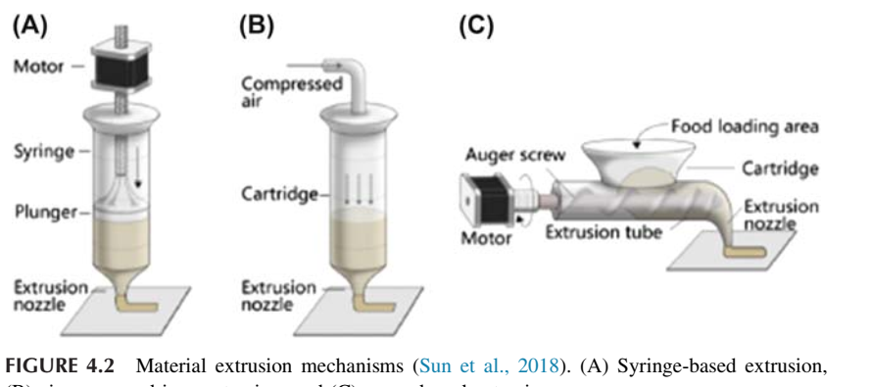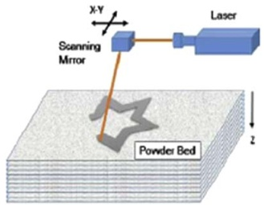

The binding mechanisms between layers that allow the creation of a 3D object involve the rheological properties of the materials, the solidification upon cooling and the hydrogel-forming extrusion too this technique well fit with the production of a multiple layers of food matrix, each of this containing different food ingredients.

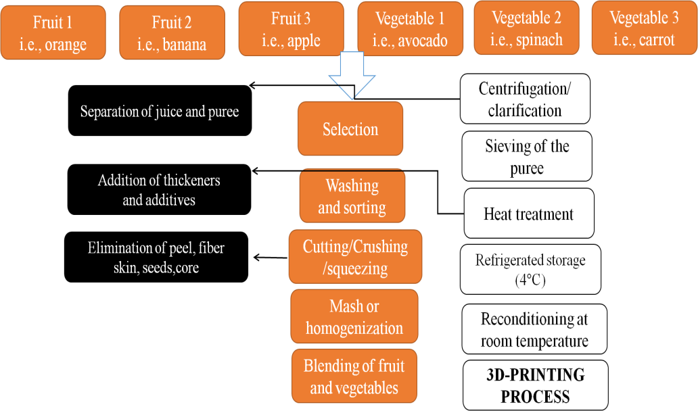**8.1. Use of Binding Agents to Improve the Printability of Dough**

Generally, hydrocolloids are used as rheological modifiers within food safety standards (Liu *et al.,* 2018), and they are often added in foods, like rice, meat, fruits and vegetables, which are nonprintable by nature (Sun *et al.,* 2015). Hydrocolloids, such as xanthan gum, gelatine and agar, are hydrophilic polymers that are used as thickening and gelling agents for water-based solutions

**Fig.19 Representative Scheme of technological steps to prepare a fruit vegetable paste for 3D printing.**

**9.0. 3D Food Printing Research in India**

|  |  |  |  |
| --- | --- | --- | --- |
| **Autor, Year, Place** | **Title** | **Result** | **Publisher** |
| Cinu Varghese *et al.,* 2020, IIT-Kharagpur | Influence of Selected Product and Process Parameters on Microstructure, Rheological, and Textural Properties of 3D Printed Cookies. | The 3D printed cookies were developed by extruding at 27 and 30 ◦C with fill density values of 50%, 70%, 90%, and 100% and water butter ratios of 3:10 and 6:5. | Foods |
| Prithvika Krishnaraj *et al.,* 2019, IIFPT-Thanjavur | 3D Extrusion Printing and Post-Processing of Fibre-Rich Snack from Indigenous Composite Flour | Optimized process parameters that gave best resolution and stability are nozzle diameter of 0.84 mm, nozzle height of 0.63 mm, printing speed of 2400 mm/min, extruder motor speed of 300 rpm, and movement speed of X/Yand Z axis of 6000 mm/min and 1000 mm/ min, respectively. | Food and Bioprocess Technology |
| K. Keerthana *et al*., 2020, IIFPT-Thanjavur | Development of fiber-enriched 3D printed snacks from alternative foods: A study on button mushroom | Optimization of extrusion printability of alternative food (Agaricus bisporus). Correlation between rheology and printability of material supply. | Journal of Food Engineering |
| Radhika Theagarajan *et al*., 2020, IIFPT-Thanjavur | 3D Extrusion Printability of Rice Starch and Optimization of Process Variables | Printing rice starch at higher motor speeds (180–240 rpm) with lower printing speeds (800–1500 mm/ min) resulted in better printability. | Food and Bioprocess Technology |
| T.Anukiruthika *etal*., 2020 IIFPT-Thanjavur | 3D printing of egg yolk and white with rice flour blends | The addition of filler agent (rice flour at 1:1 and 1:2 w/w) had a significant effect on the improvement of stability and strength of printed EY and EW. EY at 1:2 (EY: rice flour) could be 3D printed with fine precision and higher layer definition at 60  0 and 800 mm/min printing speeds at 180 rpm motor speed using a 0.84 mm nozzle at 0.005 cm3/s extrusion rate | Journal of Food Engineering |

**Fig. Future Prospects of 3D Food Printing**

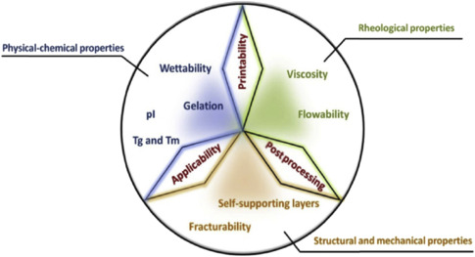

**6.0. References:**

Chen Jingwang, Taihua Mu, Dorothée Goffin, Christophe Blecker, Gaëtan Richard, Aurore Richel, Eric Haubruge, 2019, Application of soy protein isolate and hydrocolloids based mixtures as promising food material in 3D food printing. *Journal of Food Engineering*. 26(73):76-86.

Fanli Yang, Min Zhang, Bhesh Bhandari, Yaping Liu, 2017, Investigation on lemon juice gel as food material for 3D printing and optimization of printing parameters. *LWT - Food Science and Technology*. 87(34):67-76.

Fernanda C. G., Bhesh R. Bhandari, Sangeeta Prakash and Min Zhang, 2019, *Fundamentals of 3D Food Printing and Applications*. London*,* United Kingdom: Academic Press.

Godoi, F.C., Prakash, S., Bhandari, B.R., 2016, 3D printing technologies applied for food design: status and prospects*. J. Food Eng.* 179(5):44–54.

Horst Diogo José, Vieira Rogerio De Almeida and Duvoisin Charles Adriano, 2018, Additive Manufacturing at Industry 4.0: a Review. International *Journal of Engineering and Technical Research*. 8(50):3-8.

Lipton, J.I., Cutler, M., Nigl, F., Cohen, D., Lipson, H., 2015, Additive manufacturing for the food industry. *Trends in Food Science and Technology:* 43 (1), 114-123.

Lille Martina, Asta Nurmela, Emilia Nordlund, Sini Metsa-Kortelainen, Nesli Sozer, 2018, Applicability of protein and fiber-rich food materials in extrusion-based 3D printing. *Journal of Food Engineering*. 220(67):1-8.

Stephanie Torta and Jonathan Torta, 2018, *3D Printing: An Introduction*. Dulles, VA: Mercury Learning & Information.

Sun, J., Peng, Z., Yan, L., Fuh, J., Hong, G.S., 2015a, 3D food printing–An innovative way of mass customization in food fabrication. *Int. J. Bioprint.* 1:27–38.

https://3dfoodprintingconference.com/wp-content/uploads/2017/07/Nesli-Sozer-3D-Food-Printing-Conference_Sozer28062017.pdf

<https://mms.businesswire.com/media/20170418005579/en/581191/5/Global_3D_Printers_Market.jpg?download=1>

<https://marketresearchposts.com/2020/07/28/3d-food-printing-market-key-players-size-trends-growth-opportunities-analysis-and-forecast-to-2028-nasa-nestle-natural-machines-philips-3d-systems-hersheys/>

https://www.google.com/url?sa=i&url=https%3A%2F%2Flink.springer.com%2Fchapter%2F10.1007%2F978-3-319-94625-2_ 26&psig=AOvVaw38n2iWBCI0qgDWDqddvcIq&ust=1596264713832000&source =images&cd=vfe&ved=0CAIQjRxqFwoTCKCdvM3z9uoCFQAAAAAdAAAAABAD

<http://www.custompartnet.com/wu/images/rapid-prototyping/sls.png>

<https://3dprint.com/227364/3d-printing-to-reduce-sugar-in-cookies/>

[https://get-it-made.co.uk/blog/additive-vs-subtractive-manufacturing](https://get-it-made.co.uk/blog/additive-vs-subtractive-manufacturing/)