Evaluation of Germinated Rice Seed using Convolutional Neural Network

Hema Rajini N
Department of Computer Science and Engineering, Alagappa Chettiar Government College of Engineering and Technology,
Karaikudi – 630003, Tamilnadu, India
auhemasmith@yahoo.co.in

ABSTRACT
Rice is the most important cultivated crops in all over the world particular in Asian countries. The germination of good seed has a great impact in the production of rice and crop yield. Presently the evaluation of seed to be germinated is processed manually by experienced farmer which is a time consuming and tedious task and most importantly it is a destructive method where the rice seeds are destroyed by fungus contamination. In this proposed work a non destructive evaluation of germinated rice seed system based on deep learning. A Convolutional Neural Network (CNN) is used for classification and segmentation of germinated rice seed. The performance of CNN classification model is shown to be better than the Support Vector Machine (SVM) classification technique.
Keywords – Seed Germination, Preprocessing, Segmentation, Classification, SVM, CNN

- INTRODUCTION

Agriculture is the most widespread occupation in the world in which rice is the important agricultural product. The grade of the rice depends on the grade of the seed which is the important factor for successful farming. But it is hard to determine the standard of rice seeds only by using normal vision. The key to successful farming is selection of good seed, so the evaluation of the seed grade is the milestone in the agriculture. Germination test is one of the seed quality evaluation methods that play an important role in the farming of cereals, vegetables, fruits and specifically rice where the crop production depends on good seed. Hence, it is vital to standardize the quality of rice in order to fix best price in the market. The germination test is the well known indication method for evaluating quality of seed. The seed manufacturers make use of germination process to predict the grade of seed and farmers also using germination process to estimate the quantity of seeds required per area. The cost of farming is significantly reduced by using high germination rated seed, since it reduces the quantity of seeds required per area.
Conventionally the rate of germination is evaluated by spreading the seed on the clammy towel and following 7 days the seed which are developed are numbered, this amount is the germination count of the sample. So as to get high precise esteem, this procedure is repeated with the substantial number of seeds. There are 3 principle complications with this customary assessment technique. The primary issue is tallying, the evaluator must number the seed twice (when germinated), if mistake occurs in this step the blunder will gets doubled. The following issue is the grouping mistake, the evaluator should clearly classify the germinated and un-developed seed and this step requires professional evaluators. The last issue is the evaluator should utilize an immense number of seeds to get highly precise yield which is a tedious procedure.
To wipe out the above discussed issues, the image processing based programmed assessment of germination was proposed. This exploration plans to apply the seed germination test from the International Seed Testing Association with the highest point of paper technique for rice germination. In addition these images are gathered to anticipate rice seed image by utilizing image processing strategies which can recognize the nature of seeds.

- RELATED WORKS

The target of this exploration is to build up the deep learning system which can anticipate rice seed tiny images for rice germination by utilizing image processing strategies. Paween Khoenkaw proposed the first milestone in image processing based evaluation of rice seed germination by utilizing high definition digital camera to pick the images of rice, root and seed portions to segment the germinated seed [1]. Thuy Thi Nguyen et al, proposed vision basd approach for segmenting and classifying germinated rice seed using convolutional neural network [2]. The framework of this paper has three modules thus performances are better than the existing classification methods.
Rakhman and B.K. Cho made a review on several non destructive method of evaluating the germination of seed [3]. These methods can accurately assess the quality of seed. Hong et al, developed a computer based automatic classification of seed using powerful classifiers for analyzing color, shape and texture [4]. Vu et al, presented an automatic extraction of unwanted seed using hyper spectral image captured from IR camera [5]. The author has used SVM classifier for efficient result compared to visual inspection method. Scott Howarth provides an accurate measurement of growth rate using vision based technique [6]. The growth rate was measured for a complete germination cycle and was compared with traditional growth rate evaluation method.
Lurstwut combines digital image processing with artificial neural network to predict the germination of rice seed [7]. The system utilized non destructive image processing and ANN for prediction of germination. Ronneberger et al, presented CNN based method for training augmented data from the available samples [8]. The context capturing and localization enables the proposed method to perform in a best way. He et al, developed residual learning approach for training the samples more easily than the existing methods [9]. This method is easy to optimize and increases the accuracy. Viola et al, proposed face detection mechanism that can process at extremely high detection rate [10]. The integral image allows the detector to compute in a fast manner. An AdaBoost learning method is used for efficient classification.
Otsu has proposed an unsupervised nonparametric automatic threshold selecting technique to enhance the separation in grey level histogram [11]. This is a direct method for multiple threshold related problem. Belsare et al, made a research to analyze the seed using automatic seed quality technique [12]. Jedra et al, utilized speech recognition tolls such as TDNN and TOM for recognizing seed varieties from 1-D electrophoresis [13]. A high recognition rate can be achieved by ensuring the arrangements of gels. Yingrak Auttawaitkul et al, applied transparent image processing to identify the seed class [14]. Histogram based color separation is done through frequency light shine. Khunkhhett et al, presented non destructive evaluation of rice seed using image processing. This automatic classification approach uses segmented image and its feature for better result in classification.

- PROPOSED METHOD

In this proposed work CNN is used to evaluate the classification of rice seed germination. CNNs are a powerful deep learning model. They consist of a feed-forward artificial neural network (ANN) where individual neurons are arranged in a tiled manner to respond to overlapping regions in visual fields. CNNs belong to the class of learnable representation models and draw inspiration from biological neural systems. While several variations have been proposed in recent years, the fundamental components remain largely the same. CNNs comprise alternating convolution, pooling, and fully connected operations. Typically, convolutional layers are interspersed with pooling layers to reduce computation time and enhance spatial and configuration invariance. The last few layers, located close to the outputs, are fully connected 1-dimensional layers.

For the classification of germinated seed evaluation using the CNN architecture, several basic steps are employed to achieve maximum accuracy from the images. These steps include pre-processing, training, activation function selections, regularizations, and ensembling multiple methods. The block diagram of the proposed method is presented in Figure 1.

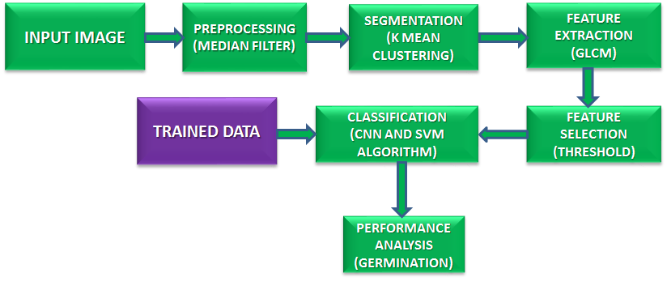
Figure 1: Block diagram of proposed method

The process begins by taking germinated seed images as input. Once the image is loaded, it proceeds to undergo preprocessing steps. Figure 2 illustrates the extraction of features from the germinated part of the seed..

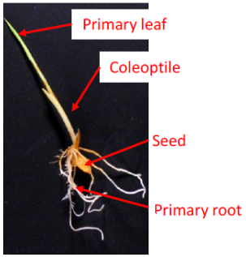
Figure 2: Components of germinated rice seed

Subsequently, the classification phase follows, where the program determines whether the image corresponds to a proliferative germinated seed, non-proliferative germinated seed, or a lingering seed. The program is developed using MathWorks MATLAB software, which is presented in a user-friendly Graphical User Interface (GUI). The concepts of digital imaging are encompassed, including digital image processing, image analysis, and classification, as depicted in the accompanying digital image.

- Preprocessing by median filter
The convolutional neural system operates on the spatial data of the germinated seed image. One of the crucial steps involved in preprocessing is resizing the images. Before feeding them into the architecture for classification, the images are converted into grayscale. Subsequently, they are transformed into the L channel, which represents a monochrome image that highlights the germination of rice seeds. Additionally, the images are flattened into a single dimension for further processing.
Pseudo Code
Pre process Image (A, X)
X= required size
A= image
Source: Original JPG image
Output: Pre-processed HSV image
Steps involved in preprocessing:
Step 1: For each Image X
Step 2: do
Step 3: Transform X to hsv format
Step 4: Add dark border of size 1x1 pixel
Step 5: Fuzz A to 10%
Step 6: Trim A
Step 7: Re page A
Step 8: Assume gravity centre for the image A
Step 9: Re-size X
Step 10: Dark background A
Step 11: Close loop
Step 12: Return A

Median Filter
A median filter, also known as a median smoother, is a non-linear order statistics filter that employs a sliding window. In each iteration, only the value of the center pixel is modified. The resulting filtered rice image, denoted as R = R(x, y), is obtained using the median filter and can be expressed as follows:
$R \left(x,y\right)={median}_{(k, l)∈W_{h, w}}\left\{D (x+z, y+l)\}\right.$ (1)

Where Wh, w is the sliding window.
The median filter is effective in reducing noise interference; however, it can introduce changes in the smooth pixel values. When the number of samples is large, the computation time for arranging the samples in ascending or descending order can be significant. To address this drawback, an indirect arrangement procedure is employed, utilizing a local histogram to calculate the median value. The sliding window approach minimizes the time required to generate the local histogram.

For image acquisition without distortion, a high-resolution color camera with an image sensor and a long photographic lens is utilized. Images are captured within a chamber with a black table serving as the background. Rice seeds are manually spread on the table. The initial step in image processing involves transforming the color images captured by the camera into the HSV format. Subsequently, the dark pixels are eliminated using a median filter, following the equation (2).

$Fg_{HSV}\left(x, y\right)= \left\{\begin{aligned}Im_{HSV}\left(x, y\right);where Im_{V}\left(x, y\right) > θ_{f} \\ 0 ;others\end{aligned}\right.$ (2)
where 𝐼𝑚𝐻𝑆𝑉 is the source image in HSV color space, 𝐼𝑚𝑉 is a V channel of 𝐼𝑚_{𝐻𝑆𝑉}, 𝜃𝑓 is the minimum brightness of the image and 𝐹𝑔_{𝐻𝑆𝑉} is the segmented image in HSV format.

- Segmentation using K-means clustering algorithm
This algorithm is utilized for partitioning a dataset into groups based on a specific distance measurement. Images serve as crucial sources of information, and the extraction of valuable information plays a vital role in machine learning. The clusters formed by this algorithm are non-hierarchical and do not overlap with each other. Each cluster's members are closer to their own group and not centered on other clusters. K-means clustering is an unsupervised learning approach that is easy to implement, making it applicable in various domains such as data mining, feature recognition, analysis, and image segmentation.

The k-means clustering algorithm aims to identify a set R of K clusters, denoted as Rj, with a cluster mean rj that minimizes the sum of squared errors. It can be described as follows:
$E= \sum_{j=1}^{k}{\sum_{X_{i}ϵC_{j}}{{∥C_{j}-X_{i}∥}^{2}}}$ (3)
where W is the sum of the square of the error of cluster mean. The above equation is the distance measure between data point X_{i} and cluster mean c_{j}. The Euclidean distance is expressed as
$∥x-y∥ = \sqrt{\sum_{i=1}^{V}{{|x_{i}-y_{i}|}^{2}}}$ (4)
The cluster means C_{i} is the vector defined as
$C_{j}= \frac{1}{C_{j}}\sum_{i∈C_{j}}{X_{i}}$ (5)
Algorithm steps
1: Arbitrarily choose k as center of cluster.
2: Assume initial value for cluster means.
3: Repeat above two steps till long changes disappears in cluster.
4: for i= 1 to n do
5: Let each data point x_{i} to cluster C_{j}
6: end
7: for j= 1 to k do
8: Re-evaluate cluster mean c_{j}
9: end
10: Return C
To segment the root and coleoptiles from images containing roots and seeds, a segmentation method is employed. The hue and saturation components are utilized to extract the images of roots and coleoptiles by identifying white color pixels. The segmentation of the root and coleoptiles can be described using the following equation:
$Root \left(x, y\right)= \left\{\begin{aligned}1 ; where θ_{r1 }<Fg_{s}\left(x, y\right) > θ_{r2} \\ 0 ;others\end{aligned}\right.$ (6)
where 𝐹𝑔_{𝑆} is a saturation channel of seed image, 𝜃𝑟₁ and 𝜃𝑟₂ are threshold value and 𝑅𝑜𝑜𝑡 is the binary image contained only root part.

- GLCM based Feature Extraction
Feature extraction is a fundamental technique employed to reduce the number of pixels required to describe a vast dataset. It serves as a general approach for developing combinations of variables that possess sufficient memory requirements, low power consumption, and achieve satisfactory accuracy. In the context of pattern recognition and image processing, the extraction of textual features holds significant importance. One widely used method for extracting second-order textual features is the Gray-Level Co-occurrence Matrix (GLCM), which finds application in various domains. The GLCM is a matrix with dimensions equal to the number of gray levels in the images, and it captures the relationships between reference pixels and neighboring pixels, representing distance and spatial relations within sub-regions of an image.

For implementation, features such as energy, inertia moment, entropy, and correlation are considered.

- Energy
The measurement of image homogeneity is determined by calculating the sum of squares of the second-order moment. When pixels are identical or when images exhibit homogeneity, the energy or second-order moment is high, indicating local homogeneity.

$Energy= \sum_{i=0}^{N_{g}-1}{\sum_{j=0}^{N_{g-1}}{P_{i j}^{2}}}$ (7)
where N_{g} is grey tone

- Inertia moment
This value is high for uniform gray levels and high inverse GLCM (Gray-Level Co-occurrence Matrix). Its weight value is the inverse of the weight of contrast.
$IM= \frac{\sum_{i=0}^{N_{g}-1}{\sum_{j=0}^{N_{g-1}}{P_{i j}}}}{1+ {(i-j)}^{2}}$ (8)

- Entropy
The amount of information present in a compressed image is measured as the loss of information in the transmitted message. It reflects the level of information loss in the compressed image.
$Entropy= \sum_{i=0}^{N_{g}-1}{\sum_{j=0}^{N_{g-1}}{P_{i j}}*log⁡(P_{i j})}$ (9)

- Correlation
The correlation is used to quantify the linear dependencies between the gray levels of neighboring pixels.

$Correlation= \frac{\sum_{i=0}^{N_{g}-1}{\sum_{j=0}^{N_{g-1}}{\left(i j\right) P_{i j}-μ_{x}}μ_{y}}}{σ_{x}σ_{y}}$ (10)

- CNN Classification
Image classification can be broadly categorized into two types: supervised and unsupervised. In supervised learning, training parameters are derived by analyzing the features of the training data. The data is then classified based on these training parameters. CNNs are an example of a supervised learning method. CNNs function similarly to feed-forward Artificial Neural Networks (ANNs), drawing inspiration from the neurons in the brain. They are a variant of multilayer perceptrons that require less preprocessing and are easier to train. Figure 3 illustrates the layers of a CNN.

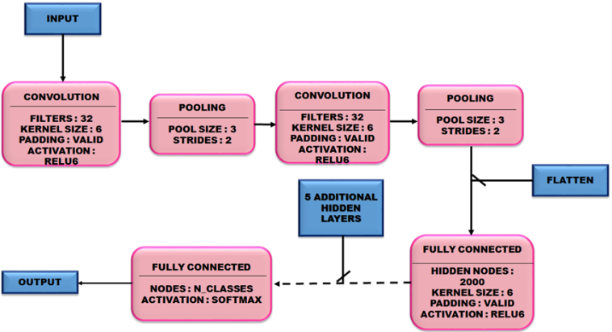
Figure 3: CNN architecture

- Training phase
During the training stage, the inputs to the CNN are preprocessed using the training data. The inputs (as shown in Figure 4) pass through all the layers iteratively, including convolutional, pooling, and fully connected layers, to identify the image features. Each stage's layers identify the most relevant features required for classification using feature maps. To construct the model, a minimum of six layers is necessary. Increasing the number of layers enhances the efficiency of the training stage. The proposed work combines approximately nine convolutional layers, eight pooling layers, and two fully connected layers to achieve higher accuracy and efficiency. This combination facilitates effective image classification.
- Convolutional layers
The fundamental building block of a CNN is the convolutional layer. This layer comprises filters with small receptive fields. During each forward pass, the convolutional layer generates a 2D map for each corresponding filter by computing the dot product between the input and filter entries. This process enables the network to learn which filters are activated when specific features occur at specific spatial positions. The output volume of the convolutional layer consists of the dimensional depth and activation maps for each filter, providing a comprehensive representation.
$X_{j}^{l}=f\left(\sum_{i∈M_{j}}{X_{i}^{l-1}*K_{ij}^{l}+ b_{j}^{l}}\right)$ (11)

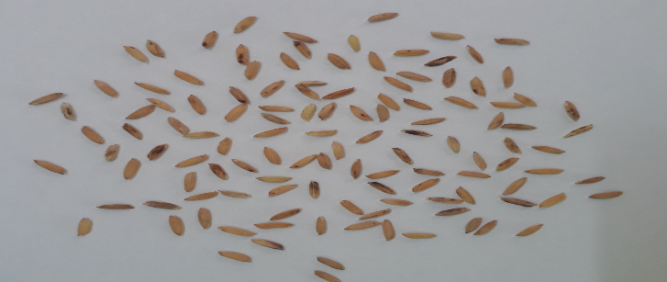
Figure 4: Input Rice image

- Pooling layers
Pooling refers to the non-linear sub-sampling process. Pooling layers utilize the most common non-linear function. A max pooling layer segments the input image into non-overlapping squares and identifies the maximum value within each sub-region. This technique helps determine the rough locations of features by reducing the intermediate spatial representation's dimensions without affecting the depth of the volume. Pooling layers are typically inserted between convolutional layers.
- Fully connected layers
Fully connected layers perform high-level reasoning within a neural network. These layers connect all the neurons from the previous layers, whether convolutional, pooling, or connected layers. The activation function is computed through matrix multiplication, followed by the addition of a bias offset. The fully connected layer transforms the 2D features into a 1D feature representation. The mathematical expression for the convolutional layer is described as

$Y_{i}^{l}=f\left(z_{i}^{l}\right)$ (12)

with $z_{i}^{l}=\sum_{j=1}^{m_{i}^{l-1}}{w_{i,j}^{l}}y_{i}^{l-1}$ (13)

Image classification using CNNs is employed in this study for the classification of germinated rice seeds. The entire dataset comprises images of rice seeds, which are scanned using the unit function. As supervised learning is utilized, both training and testing datasets are required. During the training phase, certain pre-processing steps are undertaken. Figure 5 illustrates the workflow of the current work.

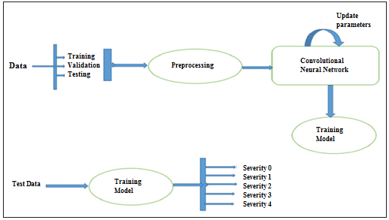
Figure 5: Workflow of the proposed method

Since CNN algorithm is employed, it requires minimal preprocessing. In this case, image resizing and rotation are sufficient. Rotating the images by 45°, 90°, and 180° adds more images to the training dataset, facilitating more effective model training. After the preprocessing step, the preprocessed dataset is given as input to the CNN algorithm.

The N×N square neuron layer followed by a convolutional layer. The filter used, denoted as ω, has dimensions of m×m. The output of the convolutional layer will have dimensions of (N-m+1)×(N-m+1). To introduce non-linearity, the outputs from the previous layer must be summed, as represented by the following equation:
x^{l}_{x y}.
$X_{x y}^{l}=\sum_{a=0}^{m-1}{\sum_{b=0}^{m-1}{ω_{ab}y_{\left(x+a\right)\left(y+b\right)}^{l-1}}}$ (14)

Then the nonlinearity of the convolution layer is
$y_{ij}^{i}=σ\left(X_{ij}^{l}\right)$ (15)
In addition to summing the weights, errors need to be backpropagated to the previous layers. The chain rule is employed to calculate the errors and propagate them backward.

- Testing phase
During testing, the model analyzes the features of the images and classifies them accordingly. The algorithm initially determines whether the rice seed is germinated or not. If the seed is germinated, it proceeds to evaluate the germination level of the seed. The output (as shown in Figure 6) provides the germination level of the seed, which can then be used to take appropriate actions based on the evaluation levels.

- SIMULATION RESULTS

In the detection of germinated rice seeds, the training model consists of nine classes, ranging from class 1 to class 9. Class 9 represents the most completely germinated seed. The effectiveness of the proposed method is tested. In this proposed work, a novel approach for evaluating germinated rice seeds is proposed. The seeds, including the primary root, coleoptiles, and primary leaf, are extracted using the HSV color format. This method enables the counting of seeds and their classification as germinated or not germinated. Seeds with roots are considered germinated. The performance of the proposed CNN technique is compared to that of Support Vector Machines (SVM). The accuracy of our method in seed counting is reported as 97.48% ± 2.52. This method significantly reduces the time required for seed counting and facilitates the organization of germinated rice seeds. Performance comparison and seed classification by the proposed method are given in Table 1 and 2 respectively.
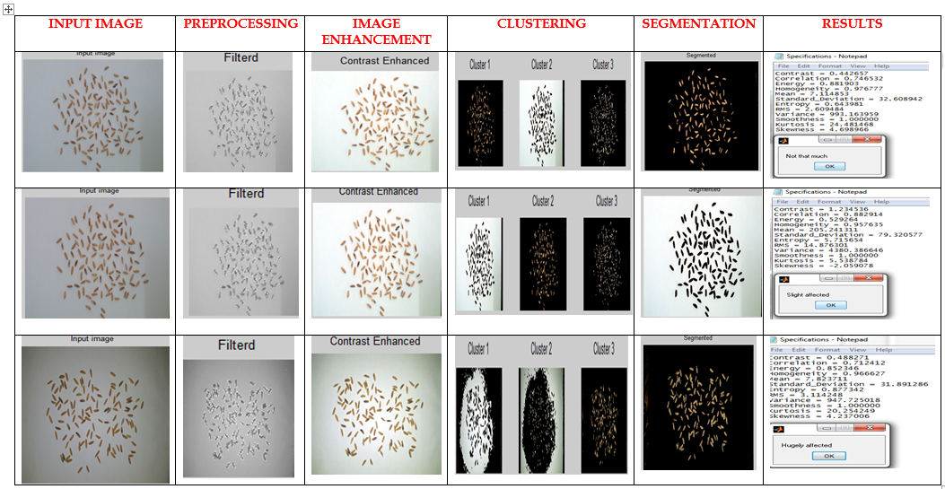
Figure 6: Output at each step in the proposed method

Table 1: Performance comparison
Method Used | Precision (%) | Recall (%) | Fscore (%)
Proposed CNN method | 94.76 | 92.12 | 93.26
SVM classifier method | 57.4 | 63.8 | 61.5

Table 2: Seed classification by the proposed method
 | Precision (%) | Recall (%) | Fscore (%)
Non germinated seed | 90.17 | 45.52 | 59.6
Germinated seed | 97.48 | 99.67 | 98.23

- CONCLUSION

The proposed method demonstrates promising results for the classification of germinated rice seeds. In this proposed work the performance comparisons for seed classification is made in which the proposed method is superior to the SVM classifier. In this approach, CNN model is used to reduce preprocessing requirements, proves to be effective in accurately classifying the germination level of rice seeds. It provides a valuable tool for farmers to streamline the counting process and effectively manage germinated rice seeds.

REFERENCES

[1] Paween Khoenkaw, “An image-processing based algorithm for rice seed germination rate evaluation,” in 2016 International Computer Science and Engineering Conference (ICSEC), Dec 2016, pp. 1–5.
[2] Thuy Thi Nguyen, Van-Nam Hoang, Thi-Lan Le, Thanh-Hai Tran, Hai-Vu, “A vision based method for automatic evaluation of germination rate of rice seeds,” 1st International Conference on Multimedia Analysis and Pattern Recognition, 2018
[3] A. Rakhman and B.K. Cho, “Assessment of seed quality using nondestructive measurement techniques: A review,” Seed Sci. Res., vol. 26, pp. 285 – 305, 2016.
[4] P. T. T. Hong, T. T. T. Hai, L. T. Lan, V. T. Hoang, V. Hai, and T. T. Nguyen, “Comparative study on vision based rice seed varieties identification,” in 2015 Seventh International Conference on Knowledge and Systems Engineering (KSE), Oct 2015, pp. 377–382.
[5] H. Vu, C. Tachtatzis, P. Murray, D. Harle, T. K. Dao, T. L. Le, I. Andonovic, and S. Marshall, “Spatial and spectral features utilization on a hyper spectral imaging system for rice seed varietal purity inspection,” IEEE RIVF International Conference on Computing Communication Technologies, Research, Innovation, and Vision for the Future (RIVF), Nov 2016, pp. 169–174.
[6] P. C. S. M. Scott Howarth, “Measurement of seedling growth rate by machine vision,” pp. 1836 – 1836 – 10, 1993.
[7] B. Lurstwut and C. Pornpanomchai, “Image analysis based on color, shape and texture for rice seed germination evaluation,” Agriculture and Natural Resources, 2017
[8] O. Ronneberger, P.Fischer, and T. Brox, “U-net: Convolutional networks for biomedical image segmentation,” in Medical Image Computing and Computer-Assisted Intervention (MICCAI), ser. LNCS, vol. 9351. Springer, 2015
[9] K. He, X. Zhang, S. Ren, and J. Sun, “Deep residual learning for image recognition,” CoRR, vol. abs/1512.03385, 2015
[10] P. Viola and M. J. Jones, “Robust real-time face detection,” International Journal of Computer Vision, vol. 57, no. 2, pp. 137–154, May 2004.
[11] N. Otsu, ''A threshold selection method from gray-level histograms," IEEE Transaction on Sys., Man., Cyber, Vol. 9, pp. 62-66, 1979.
[12] P. P. Belsare, S. k. Shah, “Evaluation of seeding growth rate using image processing,” IEEE International conference on computational intelligence and computing research, 2013
[13] M.Jedra, N. El Khattabi, M. Limouri, A. Essaid, “Recognition of seed varieties using neural networks analysis of Electrophoretic images,” IEEE International Joint Conference on neural networks, 2000.
[14] Yingrak Auttawaitkul, Sermsuk Buochareon,Thongchai Maneechukate and Natthawud Dussadee, “Non-destructive Identification of Breeder Rice Seed Using Transparent Image Analysis,” International Conference on Information and Communication Technology, Electronic and Electrical Engineering (JICTEE-2014)
[15] S. Khunkhett, T. Remsungnen, “Non-destructive identification of pure breeding rice seed using digital image analysis,” International Conference on Information and Communication Technology, Electronic and Electrical Engineering (JICTEE-2014)

