Title:- Wireless sensor based IoT application for protection of agriculture and vehicle protection from wild animal

1. Introduction: WSN also acts as the prime block of the Internet of Things (IoT) scenario, enabling the interoperability of sensor nodes using the internet, which makes easiness in every aspect of human life [6]. Nowadays, the consumption of electronics is leading due to the wide use of WSN in home automation, food production, etc., and it gives more than 50% contributions in the field of communication [7, 8]. Thus, the advancement in sensor nodes is needed.
The deployment cost of such node is low and has simple hardware that enables the wide use of WSN in industry, real-world monitoring, and traffic control remotely. Thus, WSN gives a potentially low-cost solution to the world for tracking and detecting any objects in various applications like enemy detection inthe military, etc.[3, 8]. Furthermore, WSN is widely used for environmental monitoring, weather monitoring, security, military, civilian, surveillance, and health care [9]. Several constraints are associated with WSN, i.e., memory, processing, capacity, and energy [8, 9]. Since the battery replacement of sensor nodes in various applications is impossible thus the energy becomes a critical factor [10]. Therefore, reducing the energy consumption of the nodes is considered as the prime challenge for extending the network lifetime. Since the transmissions of data consume more energy as compared to data processing, thus the sensors nodes may transmit their information to the intermediate node in a multi-hop manner for saving their energy [11, 12]. Thus, much research is being done for making energy-efficient communication among nodes [12, 13], and further advancement is needed.
2. Novelty and Contribution: In the previously reported works, major research has been done on the front end for the implementation of wireless sensor networks for agricultural land. However, the present research proposal will also deal with and investigate the possible energy-efficient early prediction methods for agricultural land and road accident protection. In this proposal, we will analyze various machine learning-based prediction methods and redundant data filtration methods for efficient event detection and early prediction. In the proposed research work, the various prediction methods are analyzed e.g., decision tree regression, random forest regression, logistic regression, and hybrid regression methods, for true event detection. In summary, a machine learning-based hybrid prediction algorithm will be used for the optimal decision. The research proposal will investigate and efficiently analyze the collected data from different types of event monitoring sensors.
3. Methodology: Sensor motes will be used for the collection of data and transfer of data to headquarters (monitoring station). Headquarters analyses the data with the help of efficient machine learning algorithms. Based on the processing of the data at the monitoring station, it transmits the command signals to the sensor motes, which control the actuators in the field. The actuators will be a protection method on the agriculture field or light signals on the road. For protection, we will use unpleasant noise signals to divert wild animals. In addition, the alert signal will be transmitted to
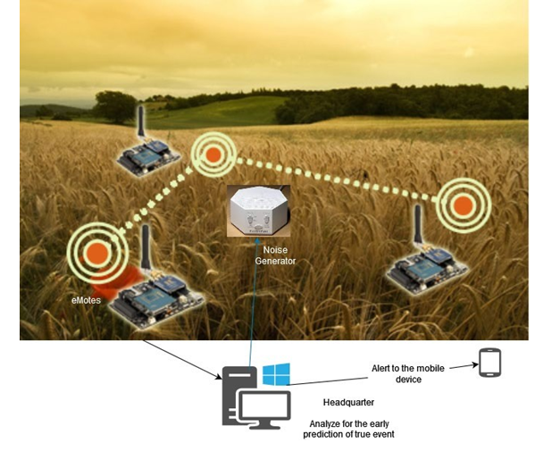
Fig.1 Agriculture land protection system from wild Animals
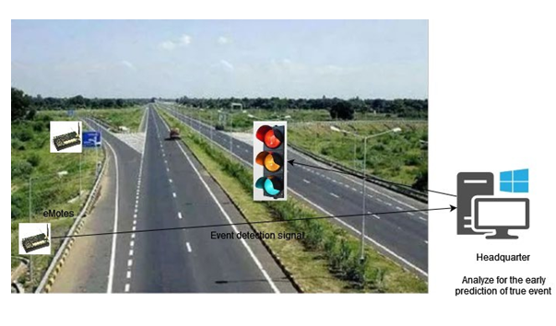
Fig 2 Vehicle protection system from wild Animals

Importance/ Rationale of Investigation-

In the current scenario, Wireless Sensor Network (WSN) is the growing field that is widely used in wireless communication by involving the tiny sensor nodes [1]- [3]. It provides the platform for accessing information in various applications and is very popular in the industry and commercial use. It was designed to detect and track any object using the sensor nodes and transmit its information to the external user via Base Station (BS) [3]. It provides this service at a reasonable cost without accessing the physical locations of the object needed in daily life and for business purposes [4]. Therefore, much research is continuously being performed in the WSN area, where sensor nodes play a critical role in providing such services. WSN consists of a large number of tiny sensor nodes, which are connected in an ad-hoc manner and transmit their information to the BS [5].
our research will propose energy-efficient techniques for better cluster and grid formation adaptively to reduce energy consumption in the setup process. The total number of clusters affects the energy consumption and lifetime of the network. Therefore to stabilize clustering, our work will add some optimization techniques.
As cluster and grid head selection affects the routing of packets, our research work will contribute some energy-efficient distance-based techniques for improving the CH and GH selection and packet routing in WSN.
For performing better cluster and grid formation as well as CH & GH selection, we will employ the K-means, FCM, Particle Swarm Optimization (PSO), Self Organization Map (MAP) techniques, energy and Euclidean distance of the nodes, and the location of cluster/grid centroid and the BS. We will employ the nodes' energy and their Euclidean distance from cluster/grid centroids, BS, and among them for efficient packet routing
- Result- For performing better cluster and grid formation as well as CH & GH selection, we will employ the K-means, FCM, Particle Swarm Optimization (PSO), Self Organization Map (MAP) techniques, energy and Euclidean distance of the nodes, and the location of cluster/grid centroid and the BS. We will employ the nodes' energy and their Euclidean distance from cluster/grid centroids, BS, and among them for efficient packet routing. investigate the cluster-based routing protocols by simulating them using the MATLAB Tool, and we will find their problems, which increase the network's energy consumption. Once the problems are identified, we will propose energy solutions for enhancing the network lifetimeOverall, our work will result in energy-efficient distance-based clustering and routing techniques for extending the network lifetime and optimum energy consumption in the network.
- References:-
- L. Mainetti, L. Patrono and A. Vilei (2011). Evolution of wireless sensor networks towards the Internet of Things: A survey. 19th Inter. Conf. on Soft., Telecommun. and Comput. Netw. (SoftCOM), Split. Page No 1-6.
- D.S. Deif and Y. Gadallah(2014). Classification of Wireless Sensor Networks Deployment Techniques. IEEE Commun. Surveys & Tutorials, vol. 16, no. 2, Page No. 834-855.
- A.A.A. Ari(2016). Bio-inspired Solutions for Optimal Management in Wireless Sensor Networks, Ph.D. Thesis, University Paris-Saclay, Cameroon.
- D.N.A. Amro(2019). Dynamic Energy-Efficient Routing Protocol for Wireless Sensor Networks. Master of Informatics, Palestine Polytechnic Univ. Palestinian.
- R. Sumathi(2011). Development and Analysis of Distinct Energy-Efficient Routing Protocols for Load Balancing, Service Differentiation, QoS Assurance and Localization in Wireless Sensor Networks. Ph.D. Thesis, Education and Research Institute University, Chennai, India.
- P. Koskela(2018). Energy Efficient Solutions for Wireless Sensor Networks.
Ph.D. Thesis, University of Oulo, Oulo.
- M.O. Oladimeji(2017). Computational Intelligence Algorithms for Optimization of Wireless Sensor Networks. Ph.D. Thesis, School of Engineering, London South Bank University, England.
- A. Attiah(2018). Energy Efficient and Secure Wireless Sensor Networks Design.
Ph.D. Thesis, University of Central Florida, United States.
- S. Sharma(2016). On Energy Efficient Routing Protocols for Wireless Sensor Networks. Ph.D. Thesis, NIT, Rourkela, Odisha, India.
- R. Yan, H. Sun and Y. Qian(2013). Energy-Aware Sensor Node Design With Its Application in Wireless Sensor Networks. IEEE Transactions on Instrumentation and Measurement, vol. 62, no. 5, Page No. 1183-1191.
- G. Anastasi, M. Conti, M. Di Francesco and A. Passarella(2009). Energy conservation in wireless sensor networks: A survey. Ad Hoc Netw., vol. 7, no. 3, Page No. 537-568.
- K. Akkaya and M. Younis(2005). A Survey on Routing Protocols for Wireless Sensor Networks. Ad Hoc Netw., vol. 3, no. 3, Page No. 325-349.
- A.A. Abbasi and M. Younis(2007). A survey on clustering algorithms for wireless sensor networks. Comput. Commun., vol. 30, no. 14, Page No. 2826- 2841.
- P. Kuila and P.K. Jana(2014). Approximation schemes for load balanced clustering in wireless sensor networks. J. of Supercomputing, vol. 68, Page No. 87-105.
- Puneet(2017). Energy Efficient Clustering Algorithm for Wireless Sensor Network. M.Tech Thesis, Lovely Professional University, Punjab, India.

