Electric and Hybrid Vehicles

Lakshmi Maneesha Raavi
Electrical and Electronics Engineering
Swarnandhra college of engineering and technology
Narsapur, INDIA
Rlmaneesha15@gmail.com

ABSTRACT

The advent of electric vehicles (EVs) marks the beginning of the end for automobiles with internal combustion engines. The necessity to reduce pollution is one of the main drivers for switching to EVs. engine pollution and decreasing reliance on expensive oil-based fuels. By The global stock of EVs reached two million at the end of 2016. mark. Several factors have contributed to the rising popularity of EVs. technical advances, increased storage capacity, and With traction batteries' declining price and rising public awareness government subsidies and charging stations. The two EV innovations The battery electric vehicles are still in first place at the moment. (PHEVs) and battery electric cars (BEVs). This essay gives a summary of the several EV technologies, their features, and restrictions and difficulties in their mass deployment as a replacement to conventional vehicles.

INTRODUCTION

The development of combustion engines (ICE) at the end of the nineteenth century was one of the greatest engineering feats. the accessibility of inexpensive fuels, simplicity of usage, Long driving range and enhanced dependability boosted the acceptability of these cars. Nevertheless, vehicles powered by Fuel efficiency for heat engines is quite low (20–25%). In addition to the hydrocarbon fuels that these vehicles burn, release a lot of harmful fumes. More than a century later, the extensive car fleet and the automotive industry are seriously worrying the public around the world and the surroundings.
In addition to the energy and heat producing industries, the transportation industry is a significant source of air pollution. Figure 1 illustrates that whereas the transport sector alone was responsible for 24% of CO2 emissions in 2015, the power and heat generation sectors account for 42% of worldwide CO2 emissions [1].
Depending upon the fuel type, driving style and road conditions, a typical medium size vehicle on an average emits about 411 grams of CO2 per mile of travel, leading to about 4.7 metric tons of CO2 yearly [2].
Besides CO2, liquid fuel engine vehicles also emit nitrogen oxides (NOx), carbon monoxide (CO), sulphur oxides (SOx), and unburned hydro-carbons (CxHy) from the tailpipe and hydro-fluorocarbon (HFC) emissions from leaking air conditioners. The shares of these gases are small as compared to CO2; however, the impact of these emissions can be significant because they have a higher Global Warming Potential (GWP) than CO2. The global warming potential of a gas relates the impact of that gas relative to an equivalent amount of CO2. Various Green-House Gas (GHG) emissions from automotive and their GWP are shown in Table 1. CO2emissions account for more than 95% of the total GHG emissions from a passenger vehicle. More than 95% of all GHG emissions from a passenger vehicle are CO2 emissions.

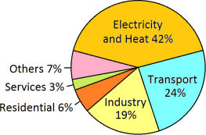
Fig. 1. World CO2 emissions from fuel combustion by sector (IEA report 2017).
The two main issues that the automotive industry must deal with today are (i) how to lessen the effects of climate change and (ii) how to reduce reliance on oil-based fuel. These concerns are being addressed with a variety of techniques. These include the usage of electric vehicles, better engine design, and the transition to eco-friendly bio-fuels. The transportation sector might become carbon-free with the use of bio-fuels. It was predicted at the beginning of the year 2000 that bio fuels would be the solution to the problems with fuel security and emissions. The sustainability and predicted reduction in emissions from bio-fuels have, however, come under scrutiny in recent years in relation to trade-offs between food and fuel, carbon accounting, and land usage [3].
Greenhouse Gas | GWP
Carbon Dioxide (CO2) | 1
Methane (CH4) | 25
Nitrous Oxide (N2O) | 298
AC Refrigerant (HFC-134a) | 1,430
Table 1 . VEHICLE LINKED GASES & GLOBAL WARMING POTENTIAL
EVs have the potential to drastically lower carbon emissions from the transportation sector. Many nations have established goals to halt the manufacture and sale of vehicles powered by petroleum. Norway had 29% of the market share for electric automobiles as of December 2016, followed by the Netherlands (6.4%), Sweden (3.4%), and China (1.5%) [4]. The EV30@30 campaign, which has set EV adoption goals of 30% by 2030, was recently established by the Electric Vehicles Initiative (EVI), a policy forum concentrating on the adoption of EVs [5]. By 2030, all new automobiles sold in Germany will be electric, and by 2040, sales of petrol and diesel vehicles will be completely outlawed in France and Great Britain. China, the largest auto market in the world, intends to prohibit the manufacture and sale of diesel/petrol vehicles and vans "in the near future."
By 2030, India hopes to have an entirely electric vehicle fleet. a goal of reducing gasoline import and vehicle operating costs. As a first step in this direction, the Government of India began implementing the National Electric Mobility Mission Plan.in the year 2013. It aspires to national fuel enhancing safety by encouraging the use of hybrid and electric cars nation [6]. The challenging goal is to generate sales of 6-7. commencing in 2020, a total of mn hybrid and EVs, out of 4-5 million of which are anticipated to be two-wheelers.
HISTORY OF ELECTRIC VEHICLES
The first electric vehicle powered by non-rechargeable batteries was built in 1834, much before the development of IC engines [7]. Electric vehicles were very popular during the 1890 to 1920 period despite their very high cost. In 1912, EVs have reached their prime, making up nearly 28% of the cars on the road. The advances in IC engine technologies coupled with mass-production resulted in low-priced lightweight vehicles. By 1920, the availability of cheap oil, electric starters, and a superior ability to travel long distances helped petrol cars to dominate the auto market and eventually led to the collapse of the EV market. The downfall of EVs was attributed to a number of factors, including the need for long travel range, limited motor power and the easy availability of cheap petrol. In the 1970s, however, worries about the rising price of oil due to the oil shock of 1973 together with the growing concerns of global warning resulted in renewed interests in EVs.
ELECTRIC VEHICLE TECHNOLOGIES
Electric vehicles use electric motors for propulsion in place of conventional IC engines. Engine driven vehicles work on the principle of combustion get their energy from carbon based fossil fuels. In contrast, EVs can use electricity generated through a wide range of resources such as fossil and non-fossil hydrocarbons, hydro/nuclear power and renewable . Electricity is transmitted to the vehicles through overhead power lines, direct connection through cables or wireless energy transfer. By using a storage system, the energy may then be stored onboard the vehicle. Basic structure of an EV is shown in Fig. 2. Major components of an electric vehicle include storage battery, drive motor, motor controller, power electronics converters, charge controllers and battery management system (BMS). Depending upon the complexity of design, drive motor of the EV can be a single reversible motor/generator or individual motors and generator.

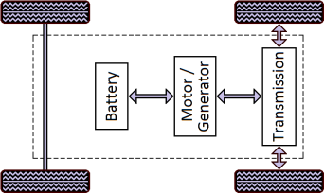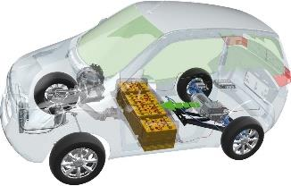
Fig.2. Basic structure of an electric vehicle.
EVs have relatively shorter driving ranges as compared to engine powered vehicles due to limited energy storage capacity. A brief comparison of IC engine vehicles vs. electric vehicles is shown in Table 2. Various terminologies associated with electric vehicles is described in Table 3.

IC Engine (ICE) Vehicles | Electric Vehicles (EV)
- Power train : IC engine  - High specific energy of fuel  - Power density: High  - Emits greenhouse gases  - Travels > 300 miles / fill  - Short refilling time (< 5 min.)  - Fuel tank takes less space  - Fuel weight is very less  - Higher maintenance costs  - Braking energy not recovered  - Running cost: high  - Engine efficiency: ~ 30%  - Needs complex gear system  - Noisy operation  - Ample refilling infrastructure  - Need to pick up some speed  to deliver maximum torque  - Uses only hydrocarbons | - Power train: Motor (+ Engine)  - Low specific energy of battery  - Power density: Low  - No tailpipe emissions  - Travels < 100 miles / charge  - Long charging time (0.5-8 hr.)  - Battery takes large space  - Batteries are very heavy  - Lesser maintenance costs  - Can recover braking energy  - Running cost: low  - Motor efficiency: ~ 80%  - Needs only one gear  - Quiet operation  - Lacks charging infrastructure  - Produce maximum torque  instantly after starting of motor  - Uses electricity from many  resources

kW | 1. Drive motor power, similar to hp of IC engine.  2. Rating of battery charger, which gives an idea of how  quick to recharge.
kWh | Size of battery: it gives the idea of how far the EV can  be driven (travel range), similar to petrol tank capacity
km/kWh | How far EV can be driven with a unit of electricity,  similar to ‘km/litre’
$/kWh | Cost of electricity determines the cost of travelling and charging.
Table 3. TERMINOLOGIES ASSOCIATED WITH EVS
Based on how and where the electricity is produced, EVs can be classified into three categories [8]:
1. Vehicles using continuous electric supply from an external power source. These include trolley buses and electric trams supplied by overhead line (shown in Fig. 3). Since they need continuous electricity, these vehicles are suitable only for very limited tasks.
2. Vehicles based on stored electricity from an off-board power source. These include vehicles using battery, flywheels, super capacitors etc.
3. Vehicles using on-board electricity generation to meet their needs. These include series electric hybrids, parallel electric hybrids, and fuel-cell electric vehicles

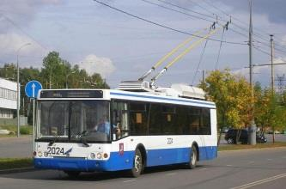

Fig.3.(a) A trolley bus and (b) An electric tram.

The drive train of an EV (Fig. 4) consists of three major subsystems: motor propulsion, energy source and auxiliary. The propulsion system consists of the controller, power electronic converter, motor, torque transmission and wheels. The energy source section includes the energy source, energy management unit and the energy refilling unit. The auxiliary subsystem consists of power steering unit, climate control unit, and auxiliary supply unit [9].

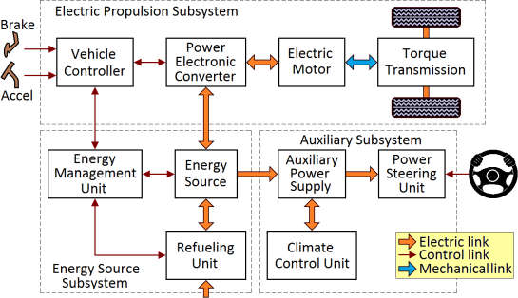

Fig . 4. Basic arrangement of an EV drive train.

EVs can be classified as Battery Electric Vehicles (BEV) and Hybrid Electric Vehicles (HEV). Pure EVs have only battery as their energy source. A vehicle that has two or more energy sources and energy converters is called a hybrid vehicle (HV). A HV with an electrical power train is called a hybrid EV. The sources of energy used in HEVs can be a combination of many resources such as battery, petrol, bio-fuels and fuel cells. Battery-powered EVs usually have larger storage batteries than HEVs. Travel range is one of the most important differences between BEVs and HEVs. A common feature of all electric vehicles is the capability for Regenerative Braking (regen-braking). Regen-braking is a process by which kinetic energy (KE) of the moving vehicle is converted into electricity by reversing the operation of the motor into generator. Conversion of KE in to electricity slows the vehicle, which otherwise would have lost as heat by friction in the mechanical brakes.
a. Battery Electric Vehicles
Battery electric vehicles are propelled by electric motors by using energy stored on board in batteries. There are many similarities between an IC engine vehicle and a battery EV, a brief list of which is summarized in Table 4. To recharge the batteries of a BEV, periodically they must be plugged into an external source of electricity.

Function | ICE Vehicle | Bat. Electric Vehicle
Energy storage | Fuel Tank | Battery
Replenish the energy | Petrol Pump | Charger
Production of motive force | IC Engine | Electric Motor
Controls speed and power | Carburetor | Electronic Controller
Auxiliary power supply | Alternator | DC/DC converter
Table 4. COMPARISON OF SYSTEMS AND FUNCTIONS OF ICEV & BEV

Based on the type of transmission, clutch, gearbox, differential and the number of motors, a variety of EV configurations are possible. This is shown in Fig. 5, starting from the oldest design (a) to most advanced design (f).

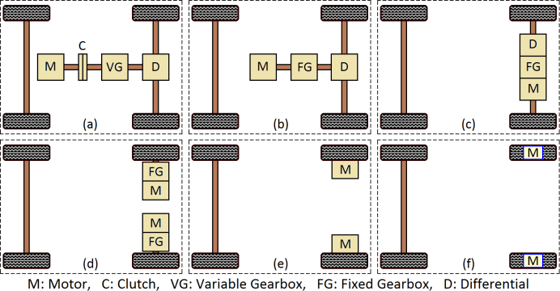

The latest innovation in electric vehicles is the in-wheel configuration. In this design, as shown in Fig. 6, separate motors (known as in-wheel motors) are installed at each wheel. Mounting the motor and power electronics within a wheel assembly can improve efficiency, save space and give designers more flexibility in body design. It is possible to regulate drive torque and braking force independently at each wheel without the need for any complex transmission or drive shaft. Regen-braking capability of in-wheels is very high, about 85% [10]. This design will require drive motors with higher torque to start and accelerate the vehicle. In-wheel motors of capacity up to 75 kW is currently available.
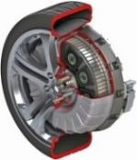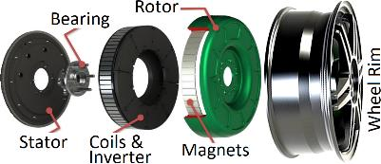
Fig.6. Arrangement of an in- wheel motor .
b. Hybrid Electric Vehicles
The biggest advantage of IC engine vehicles is the long driving range due to the high energy-density of petroleum fuels. Though battery EVs possess many advantages over conventional engine vehicles such as zero pollution, high efficiency etc., their travel range per battery charge is much less than engine vehicles due to the lower energy content of batteries. Hybrid electric vehicles have the benefits of both ICE vehicles and electric vehicles, and overcome their individual disadvantages.
An HEV typically houses a petrol engine with a fuel tank, a motor and a battery bank. The electric propulsion provides higher acceleration performance at low speed, which cannot be achieved in engine vehicles due to several mechanical constraints. The power flow in ICE drive is unidirectional from engine to wheel whereas in electric drive, power flow can be bidirectional: from motor to wheel and from wheel to battery.
The concept of a hybrid vehicle drive train and the possible power flow routes is shown in Fig. 7. There are five unique features generally common in hybrid EVs: idle-off, regenerative breaking, power assist, electric-only drive, and extended battery-electric range.
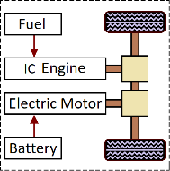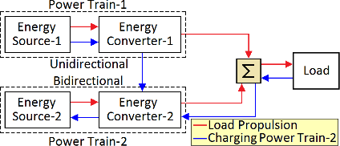

On the basis of the degree of hybridization, hybrid electric vehicles can be classified as (i) Micro Hybrid, (ii) Mild Hybrid and (iii) Full Hybrid
Full Hybrid Micro Hybrid (μHV):
Micro hybrid is the least electrified type of HEV. It is a conventional ICE vehicle with an oversized starter motor of about 3 to 5 kW at 12 V to assist the starting of IC engine. The motor cannot propel the vehicle, but can be used to assists accessories such as power steering and air conditioning. This type EV is generally used for frequent idlestop or stop-start mode operations. During idling of a μHV, the engine is shut down and during regenerative braking; the motor works as a generator to charge the battery.
Mild Hybrid (MHV):
This hybrid uses a 7–15 kW motor at 60–200 V. The motor does not independently move the car; rather, it only assists with engine starting, regeneration braking, and other adds additional torque when peak power is required during a braking. The IC engine will always be on in MHV. unless the vehicle has stopped or is moving at a very slow speed, when it comes to an abrupt halt. The degree of hybridization of 10% to 30% of hybrids are moderate. larger than average battery small hybrid. About 20% less energy is used when driving in cities.30%. Honda Civic and Honda Insight, as an example.
Full Hybrid (FHV):
A full hybrid EV is one that can move entirely on electricity. Since an FHV can only operate in electric mode, it requires a powerful motor with a capability of 30 to 50 kW at 200 to 600 V. Savings in energy range from 30% to 50%.
Example: Toyota Prius.
Hybrid Type | Micro Hybrid | Mild Hybrid | Full Hybrid
IC Engine | Conventional | Downsized | Downsized
Motor Power | 3-5 kW | 7-15 kW | > 30 kW
Motor Voltage | 12 V | 60-200 V | 200-600 V
Hybridization | < 10% | 10-30% | > 40%
Energy Saving | 5-10% | 20-30% | 30-50%
Functions | Start/Stop Reg. Braking Accessories powering | Start/Stop Reg. Braking Electric Assist | Start/Stop Reg. Braking Electric Traction
Relative Cost | Low | Medium | High
Examples | Mercedes Smart | Honda Insight | Toyota Prius
Table 5. COMPARISON OF HYBRID LEVELS OF EVS

Architecture of Hybrid EVs:
Hybrid EVs are popular for their enhanced efficiencies as compared to conventional vehicles. The improved efficiency of HEVs is attributed to the following reasons:
1. Operating ICE optimally independent of vehicle speed
2. Regenerative braking
3. Shutting off the ICE at low speeds to reduce idling loss
4. Minimizing vehicle accessory load and road load Based on the way the energy converters (i.e., IC engine, electric motor etc.) of an HEV are combined to propel the vehicle, many powertrain configurations are possible: i. Series Hybrid (SHEV)
ii. Parallel Hybrid (PHEV)
iii. Series–Parallel Hybrid (SPHEV)
iv. Complex Hybrids (CHEV)
v. Fuel Cell Hybrids (FCHEV)
vi. Plug-in Hybrid Electric Vehicles (PHEV)
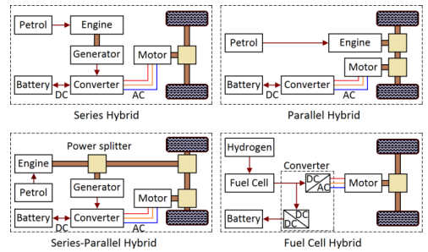
Fig. 8. Architecture of Hybrid EVs.
Series Hybrid EVs (SHEV)
Series drivetrain is the simplest hybrid configuration. In this design, the electric motor alone delivers the vehicle traction power as the engine is not connected to the drive train. The traction motor is powered by a battery or by an electric generator driven by the downsized IC engine. The generator powers the drive motor when the traction load demand is large or charges the batteries when the motor load demand is small.
Example: Nissan e-Power.
Parallel Hybrid EVs (PHEV)
In parallel hybrids, both IC engine and motor are directly connected to the drive system so that they can individually (during low traction power demand) or jointly (during high power demand) propel the vehicle. Most PHEV designs combine the generator and motor into one unit. In parallel drive mode, the supplied torques are added together. When only one of the two drives is in service, the other will be disconnected through a clutch. PHEVs are relatively more compact as they use a smaller battery pack than other hybrids and needs a smaller traction motor. The drawback of PHEV is the need for complex mechanical systems and control algorithms. Example: Honda: Insight and Civic.
Series-Parallel Hybrid EVs (SPHEV)
Series–parallel hybrids (or power-split hybrids) combine the benefits of both series and parallel architecture. The powersplit device divides the output from the engine into mechanical and electrical transmission paths. This design is capable of providing continuous high output power as compared to series or parallel powertrain. They use smaller motors.
Example: Toyota Prius.
Complex Hybrid EVs (CHEV)
The complex hybrids are similar to series-parallel hybrids but use more complex designs depending on the number of motors/generators and their configuration. Motor power flow in these designs is bi-directional as compared to unidirectional flow in the series-parallel hybrid.
Example: Ford Escape
Fuel Cell Hybrid EVs (FCHEV)
A fuel cell (FC) HEV is a series hybrid configuration in which fuel cell is the energy conversion system and a battery (or a supercapacitor) is the energy storage system to deliver peak acceleration power. The operating principle of fuel cells is the reverse process of electrolysis in which hydrogen and oxygen gases combine to generate electricity with water and heat as byproducts. FC vehicles are true zero-emissions vehicles as they do not emit any greenhouse gases. Since fuel cells can offer high specific energy but cannot accept regenerative energy, it is usually combined with battery or other storage systems. At present, FCHEV technology is very premature and they are very expensive as compared to other HEVs.
Example: Honda Clarity.
Plug-in Hybrid Electric Vehicles (PHEV)
The basic difference between a standard HEV and a plug-in HEV is shown in Fig. 9. Plug-in hybrid EVs are full-hybrids which use a smaller engine, a larger battery and a larger motor. Batteries of PHEVs can be recharged from any external power source unlike in standard HEVs in which batteries are recharged only by means of the engine driven generator or regen-braking. This feature of PHEV has the advantage of drawing electricity from any resource such as grid power including household supply, autonomous systems or even renewable energy. PHEVs have a shorter all-electric driving range per recharge as against battery EVs, but have a larger allelectric range as compared to standard HEVs because the engine-generator drive can assist the system when the batteries are depleted. Also, owing to the large electric motor, PHEVs have higher regen-braking capability compared to traditional HEVs. Fig. 9. Comparison of a standard HEV and a PHEV. Benefits of PHEV include: better fuel efficiency than regular HEV, long driving range than EVs, potential for distributed energy storage, low running cost compared to petrol, and environmentally friendly. Major disadvantages are: high cost and non-availability of fast charging stations.
Examples: Chevy Volt, Toyota Prius.

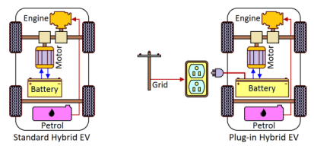
Fig. 9. Comparison of a standard HEV and a PHEV
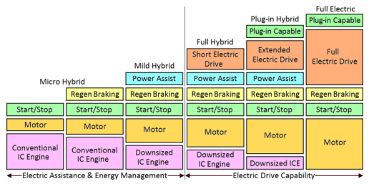
Fig. 10. Classification and features of Hybrid EVs.
CONCLUSIONS
The future is electric for surface transport as the Earth will run out of petroleum fuels within 50 to 60 years. Electric vehicles offer many advantages: increasing nation’s energy security by reducing oil consumption, supporting to climatechange initiatives by reducing harmful emissions, reduced public health risks on account of poor air quality and long-term economic growth through the introduction of new technologies and infrastructure. There are, however, many technical and socio-economic challenges to overcome before the widespread acceptance of EVs. This include high capital cost, shorter driving ranges, long charging time, heavy weight and large size of batteries, and the need for fast charging facilities. Electric vehicles are clean only at the point of use. Reduction in vehicular pollution through EV deployment will be more meaningful if they are powered by electricity produced from clean resources to avoid pollution otherwise caused by generating stations based on fossil fuels.
Thus, the role of renewable energy in transport sector is the need of the hour. In order to increase the share of RE in the transport sector, solar PV powered recharging stations are being developed by many nations. Several of these L1 or L2 recharging stations have already been deployed at highly concentrated areas including office premises, shopping malls and other public places where cars might be parked for long periods. Various initiatives to increase the share of RE in the road transport is shown in Fig. 17. This includes solar PV and wind turbine powered charging stations, both at residential areas and workplaces.

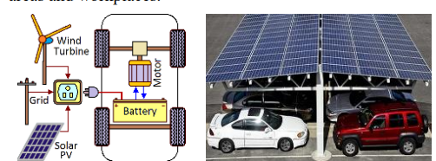
An upcoming technology in EV charging is the charging on the go. This scheme, as shown in Fig. 18, uses dynamic charging of EVs through induction while they are moving over dedicated lanes. The advantage of this design is that EVs can have smaller batteries leading to a lighter and efficient vehicle besides saving of time for charging.
REFERENCES
[1] CO2 Emissions from Fuel Combustion Highlights - 2017, International Energy Agency (IEA).
[2] https://www.epa.gov/greenvehicles/greenhouse-gas-emissions-typicalpassenger-vehicle-0
[3] K. Araújo, D. Mahajan, R. Kerr and M. da Silva, “Global Biofuels at the Crossroads: An Overview of Technical, Policy, and Investment Complexities in the Sustainability of Biofuel Development”, Agriculture, (7, 32); pp. 1-22, 2017.
[4] Global EV outlook 2017, International Energy Agency (IEA).
[5] http://www.cleanenergyministerial.org/Our-Work/CEMCampaigns/EV30at30
[6] http://pib.nic.in/newsite/PrintRelease.aspx?relid=116719
[7] C. D. Anderson and J. Anderson, Electric and hybrid cars: a history, North Carolina: McFarland & Company, 2010.
[8] A. Faiz, C. S. Weaver, and M. P. Walsh, Air Pollution from Motor Vehicles: Standards and Technologies for Controlling Emissions, World Bank Publications, Washington DC, Jan. 1996.

