ENVIRONMENT AND HEALTH-RELATED ISSUES IN TOBACCO CULTIVATION AND CONSUMPTION
Ch. Bhavya Padmini, PhD Research Scholar Dept. Resource Management and Consumer Science, College of Community Science, PJTSAU, Hyderabad.
Dr. V. Vijayalakshmi. Professor and Head,Dept. Resource Management and Consumer Science, College of Community Science, PJTSAU, Hyderabad
ABSTRACT
Global tobacco production reached approximately 7 billion kilograms, with China leading the way at 2.35 billion kilograms. India secured the second position in both tobacco production and exports worldwide. In India, tobacco cultivation covered 0.45 million hectares, accounting for a mere 0.31% of the country's total cultivated area, yet yielding a substantial 750 million kilograms of tobacco. The nation boasts ten distinct tobacco types cultivated across 15 states, encompassing both cigarette varieties (such as FCV, burley, and Oriental) and non-cigarette varieties (like Bidi, Chewing, Hookah, Natu, Cheroot, Cigar, and HDBRG).
The nicotine found in tobacco is known for its high level of addictiveness, and the use of tobacco poses a significant risk factor for a wide range of health issues, including cardiovascular and respiratory diseases, over 20 different types or subtypes of cancer, as well as various other disabling health conditions. Furthermore, there are severe health hazards associated with tobacco use, and tobacco farmers experience a higher prevalence of issues like Cardiovascular Disease (CVD) when compared to non-tobacco farmers and the general population.

The WHO estimates that every year, over 3.5 million hectares of land are cleared for the production of tobacco, which mostly occurs in developing countries and contributes to deforestation. Because of the damage caused by tobacco production, the soil is no longer suitable for supporting the growth of other crops or plants. Each year, tobacco use adds 84 megatons of carbon dioxide, a greenhouse gas, to the atmosphere.
Five crucial stages of the tobacco life cycle can be distinguished: product manufacture, distribution and transportation; product use, including exposure to second- and third-hand smoke; growing and curing; and disposal of waste from post-consumption tobacco products.
The cultivation of tobacco has adverse effects on the environment, including agro-biodiversity, water and soil quality, biodiversity, and traditional agricultural practices. Studies, such as Kutub et al. (2015), have revealed contamination of both soil and water with toxic pesticides and chemical compounds, resulting in diminished soil fertility and elevated water pollution. Moreover, the tobacco industry is responsible for an estimated annual contribution of 84 megatons of carbon dioxide to greenhouse gas emissions and the annual destruction of approximately 3.5 million hectares of land for tobacco cultivation, as indicated by research like Hammerich et al. (2020).
Farmers demonstrated a lack of awareness regarding the adverse consequences of tobacco cultivation on soil fertility, the environment, and even their own health. Their level of education also reflected their limited knowledge in this regard. In terms of soil effects, tobacco cultivation significantly depletes soil nutrients, necessitating frequent applications of chemical fertilizers and increased pesticide use. The repeated use of these inputs has detrimental effects on the cultivation of other crops, potentially endangering farm workers, leading to chronic health issues, and negatively impacting the environment, as documented by Karima et al. in 2016.
Health problems associated with tobacco cultivation: Nicotine poisoning, commonly known as Green Tobacco Sickness (GTS), can result from touching tobacco leaves and expose oneself to nicotine. Symptoms include nausea and vomiting. When nicotine from tobacco leaves combines with sweat, dew, or rain, it becomes more likely to seep into the skin and bloodstream, increasing the risk of nicotine poisoning (Saleeon et al., 2016).
Workers are at risk of inhaling dust from dried tobacco leaves during the curing process, which can concentrate nicotine and other potentially harmful chemical substances. This exposure poses a threat to the respiratory system, particularly when workers do not use personal protective equipment. Respiratory exposure can also occur during activities such as stacking and tying leaves, loading them for transportation, and when handling chemicals during mixing and spraying, as observed in the study by Saude et al. in 2012.
The tobacco farmers experienced higher proportion of sever health hazards, illnesses like CVD ( Cardio Vascular Disorders) and respiratory issues caused them higher share of out of pocket expenditures as compared to non-tobacco farmers and general population (Shahzad et al., 2021).
Health issues related to consumption of tobacco- Cigarette smoking increases the risk of developing several systemic conditions including cancer, cardiovascular and pulmonary diseases. Cigarette smoking was also detrimental to oral health (Ramoa et a.l, 2017). Evidence was found about smoking associated with lower BMD (bone mineral density), increased risk for fracture, periodontitis, alveolar bone loss, implant failure, increased joint disease, poor functional outcomes and poor therapeutic response (AL-Bashaireh et al., 2018). SLT (Smokeless Tobacco) consumption was related with several health issues such as oral cancers, cardiovascular diseases, low birth weight and mental illnesses.
Most of the research studies were conducted in different countries like Brazil, Thailand, India, China, Turkey and Bangladesh. The world health organization reported about the tobacco cultivation and consumption effects on environment and health. Very old research studies were found on consumption of chewing tobacco type compared with smoking type tobacco. Tobacco cultivation and consumption pollute the air, water and soil which will cause the environmentaldegradation.
Non-communicable diseases (NCDs) like heart diseases, cancers, diabetes, chronic respiratory diseases were the leading causes of death by tobacco consumption. The musculoskeletal disorders, green tobacco sickness, dehydration, nausea, vomiting, skin diseases and respiratory problems were identified in tobacco cultivation. From collected reviews, many researchers suggested that while working in tobacco field, usage of personal protective equipment kit reduces the health issues among field workers. But, no one had designed the personal protective equipment kit for tobacco field workers.

ENVIRONMENT AND HEALTH RELATED ISSUES IN TOBACCO CULTIVATION AND CUNSUMPTION
Ch. Bhavya Padmini, V. Vijaya Lakshmi and N. Pavani
Department of Resource Management and Consumer Sciences, College of Community Science, PJTSAU, Saifabad, Hyderabad.
Global tobacco production amounted to approximately 7 billion kilograms, with China leading the way, producing 2.35 billion kilograms. In India, tobacco was cultivated across 0.45 million hectares, representing a mere 0.31% of the nation's total cultivated area, yet yielding a substantial 750 million kilograms of tobacco. India boasts a diverse range of ten distinct tobacco types grown in 15 different states, encompassing both cigarette varieties (such as FCV - Flue Cured Virginia, burley, and Oriental) and non-cigarette types (including Bidi, Chewing, Hookah, Natu, Cheroot, Cigar, and HDBRG - Harvel De Bouxo Rio Grande).

India holds the second position globally in both tobacco production and exports. The tobacco industry annually generates Rs 4,402 crores in foreign exchange and contributes Rs 13,853 crores in excise revenue. This amounts to a total contribution of Rs 18,255 crores to the national economy. Within India, the tobacco crop provides direct or indirect support to approximately 36 million individuals engaged in various aspects of production, processing, marketing, and exports. This includes six million farmers and five million individuals involved in bidi-rolling and tendu leaf-plucking. For a significant portion of the population, particularly rural women, tribals, and other marginalized sections of society, the tobacco crop serves as a vital source of livelihood.
In India seven varieties of tobacco crops were cultivated in different states based on their suitability of soil.
S. No | Type of Tobacco | Cultivated States
1. | FCV Tobacco  (Flue-Cured Virginia) | Andhra Pradesh, Telangana & Karnataka
2. | Bidi Tobacco | Gujarat, Nipani area of Karnataka, Maharashtra & Andhra Pradesh
3 | Cigar & Cheroot | Tamil Nadu & West Bengal
4 | Hookah Tobacco | Assam, West Bengal, Bihar, Uttar Pradesh & Gujarat
5 | Chewing & Snuff | Tamil Nadu, West Bengal, Bihar, Assam, Uttar Pradesh, Gujarat & Madhya Pradesh
6 | Natu, Burley, Lanka  & HDBRG (Harvel De Bouxo Rio Grande )etc. | Andhra Pradesh, Telangana & Karnataka
7 | Pikka Tobacco | Orissa
The nation cultivates a diverse array of tobacco types, including Flue-cured Virginia tobacco, Country tobacco, Burley tobacco, Bidi tobacco, Rustica tobacco, Hookah, Cigar-wrapped Cheroot, Burley, Oriental, Chewing tobacco, and more. In comparison to tobacco produced in other countries, Indian-manufactured tobacco enjoys an advantage due to its lower levels of heavy metals, Tobacco Specific Nitrosamines (TSNAs), and pesticide residues..
India's primary tobacco-producing states include Gujarat, Andhra Pradesh, Uttar Pradesh, Karnataka, West Bengal, Telangana, and Bihar. Among these, Gujarat, Andhra Pradesh, and Uttar Pradesh contribute to approximately 45%, 20%, and 15% of the nation's total tobacco production, respectively. Karnataka represents around 8%, while the remaining states collectively contribute approximately 2-3% to the country's overall tobacco production.
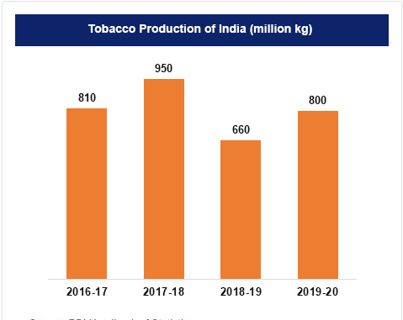
Up till August of 2022–2023, India exported 68,550 tons of FCV tobacco. 15,224 tons were exported overall in August 2022, a 192.2% increase over the same period the year before. In 2021–2022, FCV tobacco exports totaled Rs. 2,858 crores in value.
65,682 tons of unmanufactured tobacco were exported in 2022–2023 (up till August). The prior year saw a 51% increase in unmanufactured tobacco shipments in April 2022 and a 14% increase in May 2022. Over the same time period, total export value was Rs. 4,102 crores..
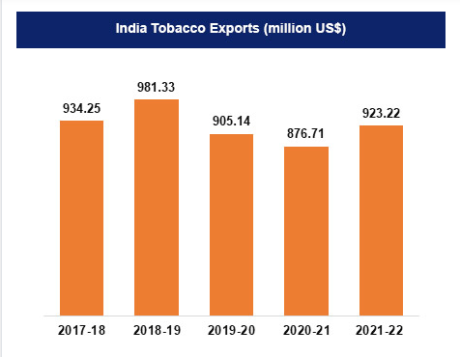
In all types of tobacco cultivation, the same type of cultivation activities were performed. The types of activities are explained below:
Activities involved in tobacco crop cultivation:
- Preparatory Cultivation:
- Primary Tillage:
- PloughingThe main tillage procedure was plowing, which was used to break, chop, and turn the soil such that it was either totally or partially ready for seeding.
- Secondary Tillage:
- Harrowing: Harrowing is a type of secondary tillage that is carried out at a shallow depth to mix materials with the soil, smooth out and crush the soil, and remove weeds.
- Puddling: Water from the puddling was agitating the earth. Following the initial plowing with a country plough, it was carried out in fields with standing water that was 5 to 10 cm deep. It agitates the soil and breaks up the clods.
- Levelling: It was anticipated that land leveling would increase the value of land permanently. In order to change the current land contours for an effective agricultural production system, leveling work was done.
- 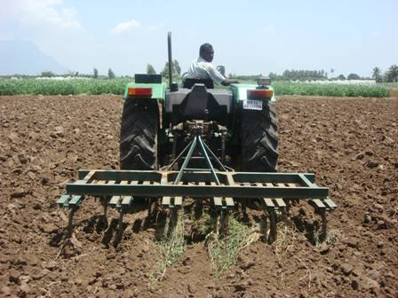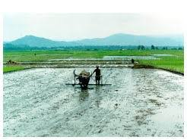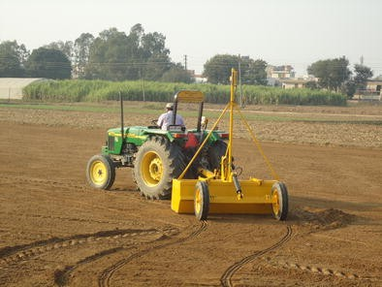
- Planting method:
- Ridge Planting Method: The ridge planting technique involves planting crops within ridges that were created during the cultivation of the preceding crop. Weed control within the rows is achieved by applying herbicide in a band behind the planter. Weeds situated between the rows are managed through crop cultivation, and the ridges are reconstructed to prepare for the following year.
- Flat Planting Method: In this approach, shallow furrows, typically 8-10 centimeters deep, are created using a local plough or cultivator, spaced at a distance of 75 to 90 centimeters apart. It is essential for the field to have sufficient moisture at the time of planting. The seedlings, referred to as "selts," are then planted end to end within these furrows, with careful attention to ensuring that one selt with three buds is placed along every 30-centimeter length of the furrow.
- Irrigation: The practice of artificially providing water to crops in order to meet their water needs is known as irrigation. Crops can also receive nutrients through irrigation. Water from ponds, lakes, canals, tube wells, wells, and even dams can be used for irrigation. Moisture is provided via irrigation, which is necessary for germination, growth, and other related processes.
- 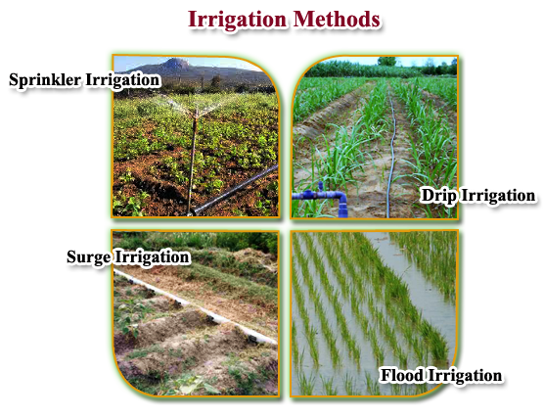
- Intercultural Operations: Intercultural activities encompass all lighter and finer soil procedures performed between seeding and harvesting. These consist of mulching, weeding, and applying fertilizer, among others. Intercultural equipment refers to the tools and machinery utilized for this aim.
- 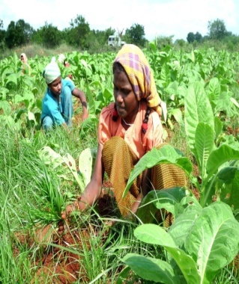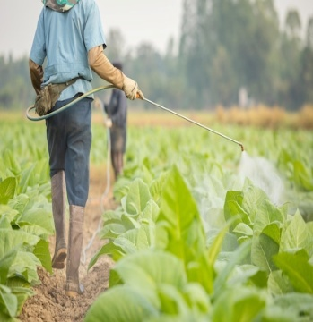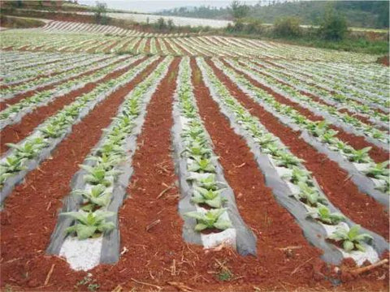
- Topping Activity: When the first inflorescence bloom develops, the tobacco plant's flowering head and young leaves are plucked in an effort to increase leaf quality and production. This method of growing tobacco is called topping.
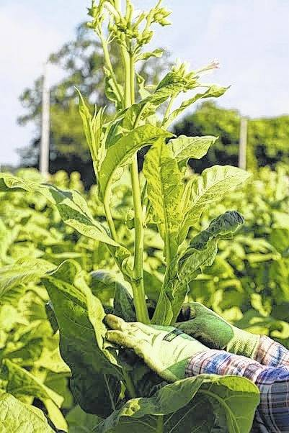
- Sucker Control: After topping, a chemical sucker control program was essential for controlling and getting rid of sucker growth. There is no one-size-fits-all method for managing suckers; instead, there are many different applications, strategies, and plans for appropriate chemical management of suckers. Sucker control is indirectly impacted by and made easier by crop management practices include limiting the amount of nitrogen applied, maintaining uniform plant growth, and controlling root development for upright plants.
- 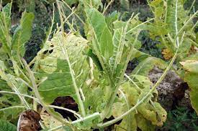
- Harvesting Harvesting uniform, fully developed, and ripe leaves is recommended. Ripe leaves are velvety to the touch, less sticky, and have a greenish-yellow color. A fully grown leaf has slightly dried tips and lies horizontally or bends downward. The center leaves were picked when they were almost ripe, the top leaves when they were completely ripe, and the bottom primings while the leaves were still slightly green. Three leaves or fewer should be picked at a time on average. It is necessary to harvest on days with clear weather.
Rain or irrigation should not be applied to the crop right away; instead, it should be harvested two or three days later. Normally, priming was carried out once every seven days. For a more accurate assessment of the color of the mature leaves, pluck the leaves in the opposite direction of the sun. Picking should be done with the midribs twisted sideways; a fully grown leaf will snap with a distinct sound. To reduce the likelihood of withering, the leaves had to be moved right away to the tying shed and handled gently without forcing them into a broad basket with tips facing upward.
- 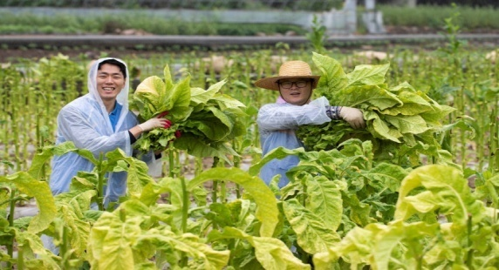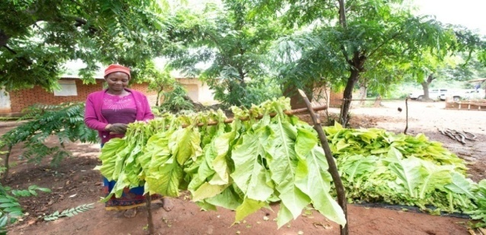
- Curing Practice: Because Virginia tobacco leaves might vary depending on a number of circumstances, including weather, plant location, leaf maturity, and disease prevalence, it is not always possible to cure the tobacco according to a set schedule. In these situations, a small process change was required.
Curing Principle: Early flue-curing should allow for ongoing leaf biological activity, which will enable the breakdown of chlorophyll, the conversion of starch to simple sugars, and the conversion of leaf proteins to soluble nitrogenous components. These biological reactions occur in completely turgid leaf cells in an aqueous media, and it is necessary to stop the thermal inactivation of these enzymes in order to complete enzymatic operations. This entails keeping the barn's temperature low and humidity high in order to promote these advantageous reaction patterns.
The leaf becomes yellow during this time and has a high soluble sugar content. Since cured leaves must have a high sugar content, it is now necessary to stop respiratory enzymes from further breaking down sugars. Both the biochemical conversion of soluble nitrogen to ammonia and the browning reaction brought on by polyphenol oxidase, which turns yellow leaves brown, need to be stopped because some of these eventually turn into fragrance molecules.
These were accomplished via thermal desiccation, which involved gradually increasing the barn's temperature and reducing its relative humidity through ventilation adjustments during later stages. Abrupt changes in the barn's temperature or humidity should never be performed while it is curing.
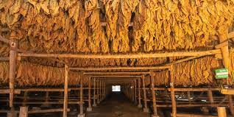
- Grading: One of the crucial production procedures in the manufacture of Virginia tobacco that was flue-cured was grading. It involved manually classifying cured leaves into uniform batches based on plant position styles for both outward recognition and production purposes. The factors taken into account are color, damage, flaw, texture, leaf length, and maturity. Depending on the type of tobacco, market conditions, and the style of each plant position, these will be applied to varying degrees. Plant position grading is used in light soils and farm grades in black soils. The primary goal of plant position grades for light soil tobacco and farm grades for black soil tobacco was to prevent dual grading at the farmer's and trader's levels, which would have decreased the cost of marketing. This saves time for exporters, helps growers realize more revenue from their produce, and aids the government in setting the minimum export price and minimum support price for each grade.
- 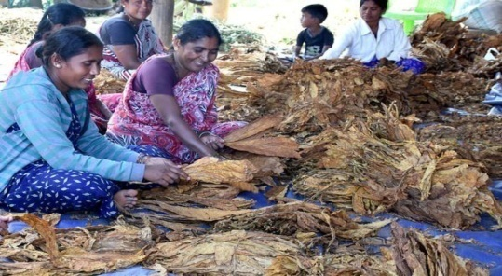
The nicotine present in tobacco is widely recognized for its high level of addictiveness. Tobacco use represents a significant risk factor for a range of health issues, including cardiovascular and respiratory diseases, over 20 various types or subtypes of cancer, numerous other incapacitating health conditions, severe health risks, and illnesses, such as Cardiovascular Disorders (CVD). These risks are notably elevated among tobacco farmers when compared to both non-tobacco farmers and the general population.

The World Health Organization (WHO) estimates that each year, over 3.5 million hectares of land are cleared for the production of tobacco. Deforestation is mostly caused by it in underdeveloped countries. Because of the damage caused by tobacco production, the soil is no longer suitable for supporting the growth of other crops or plants. Each year, tobacco use adds 84 megatons of carbon dioxide, a greenhouse gas, to the atmosphere.
Environment Related Issues in Tobacco Cultivation and Consumption
The process of growing tobacco has an impact on the environment. Negative effects of producing and distributing tobacco products include the usage of fossil fuels, the creation of hazardous waste, and the harm that tobacco products immediately inflict to the environment.
The life cycle of tobacco affects the environment. The life cycle steps of tobacco were cultivation, manufacturing of product, distributing tobacco products from cultivation, consuming tobacco to the waste products generated after consumption, such as smoke, discarded butts, and packaging.
Environment Related Issues in Tobacco Cultivation:
The five key stages of the tobacco life cycle are as follows: product manufacture, distribution, and transportation; product use, including exposure to second- and third-hand smoke; and disposal of waste from post-consumption tobacco products..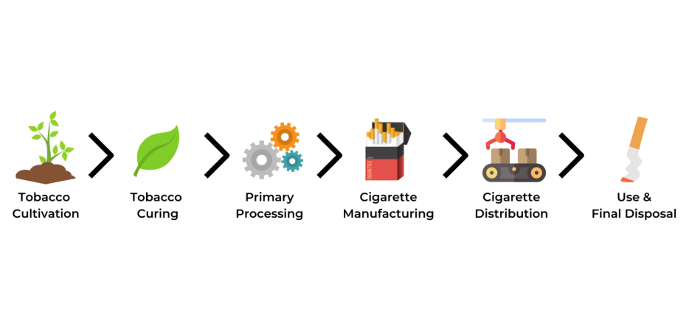
Research results indicate that the cultivation of tobacco has adverse effects on agro-biodiversity, as well as on water and soil quality, biodiversity, and traditional agricultural practices within the environment. Contamination of soil and water with toxic pesticides and chemical substances was observed, leading to a decline in soil fertility and an increase in water pollution. Both soil and water exhibited pH levels below the minimum acceptable standard, with the soil being more acidic and water having reduced dissolved oxygen levels, indicative of severe pollution. The excessive use of agrochemicals in tobacco cultivation also had detrimental effects on the flora and fauna species, as reported by Kutub et al. in 2015.
The environmental impacts of tobacco includes tobacco growing and curing; product manufacturing and distribution; product consumption; and post-consumption waste.
Tobacco had direct adverse effects on various individuals, including family members, both children and adults, as well as other workers involved with tobacco processing and production, and even neighboring individuals. The farmers themselves often lacked awareness regarding the detrimental impacts of tobacco cultivation on factors such as soil fertility, the environment, and their own health. Additionally, their level of education suggested a lack of knowledge in this area. One significant effect on the soil was the substantial depletion of soil nutrients caused by tobacco cultivation. This crop required regular applications of chemical fertilizers and more extensive use of pesticides. These successive applications had a negative impact on the cultivation of other crops and posed a risk of poisoning for farm workers, potentially leading to chronic health problems and environmental issues, as reported by Karima et al. in 2016.

- Environment related issues in tobacco growing and curing Process:
- Deforestation:
In India, around four million hectares of land were used for tobacco production, which also accounts for 4%, of yearly global deforestation. One hectare of forest wood was required to cure half hectare of tobacco crop. At this rate, 4,00,000 hectares of forest was being depleted every year for tobacco curing. Seven negative environmental effects of deforestation for tobacco farming include ecological damage, soil degradation and erosion, water contamination and a rise in greenhouse gases in the atmosphere. The loss of animal and plant species due to their loss of habitat was one of the most hazardous and distressing results ofdeforestation.
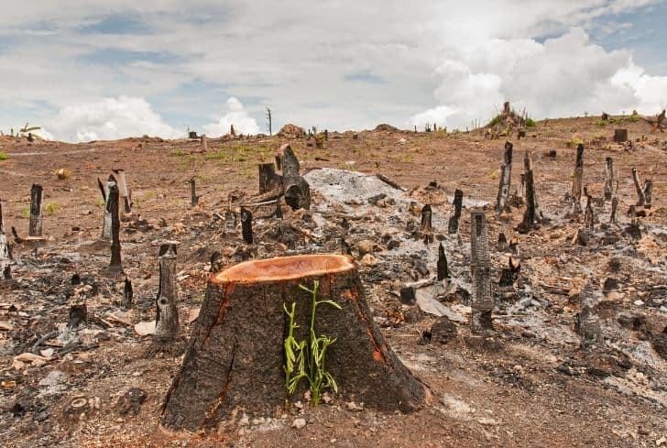
The primary environmental damage caused by tobacco production was soil and air pollution. The soil becomes barren due to the use of chemical fertilizers, pesticides, and the breakdown of tobacco leaves in the soil. The air becomes contaminated when tobacco is processed and burned. According to Ali et al. (2015), the growing of tobacco rendered the cultivated area unhealthy and environmentally fragile.
- Numerous research demonstrated the link between social and health issues and the detrimental environmental effects of local tobacco cultivation. Deforestation and soil degradation are caused by widespread agricultural methods associated with tobacco production, particularly in low- and middle-income nations. According to Lecours et al. (2012), agrochemical contamination and deforestation therefore result in ecological disruptions that diminish ecosystem services, such as food sources, biodiversity, and land resources. These losses have a detrimental effect on human health.
- Agrochemical Use:
Tobacco was frequently farmed without crop rotation (as a monocrop), leaving the tobacco plants and soil exposed to a range of pests and illnesses. Pesticides (insecticides, herbicides, fungicides, and fumigants) and growth regulators (inhibitors and ripening agents) were used on tobacco plants at various phases of development. Tobacco plants necessitate the application of chemical fertilizers in addition to insecticides and growth regulators and these chemicals were usually applied without any protective equipment make the farmers vulnerable to various adverse effects.
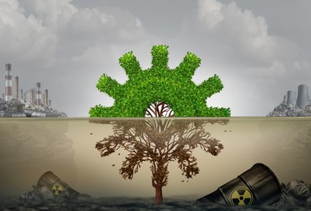
Persistent tobacco cultivation led to a decline in soil fertility, while the use of agrochemicals significantly deteriorated the fish population in freshwater bodies. The expansion of tobacco fields involved forest clearing and hill cutting, resulting in a decrease in the variety of animals that were once abundant in the region. The study indicated that over a span of 23 years (1989-2012), the total tobacco land area increased by approximately 1,921,322.79 square meters, representing a substantial 95.05% growth in tobacco cultivation at the expense of forests, hills, and other crop fields, as reported by Sultana et al. in 2020.

- Greenhouse Gas Emissions:
The habitat loss and lack of trees make it possible for more greenhouse gases to be emitted into the sky. A healthy forest serves as a valuable carbon sink by absorbing carbon dioxide (CO2) from the atmosphere. That capability is lost in deforested areas and more carbon was released. Tobacco curing creates CO2 emissions and air pollution. India, which manufactured 10,000 million cigarettes in 2010, was projected to emit roughly 6750 tons of CO2 to create cigarettes.
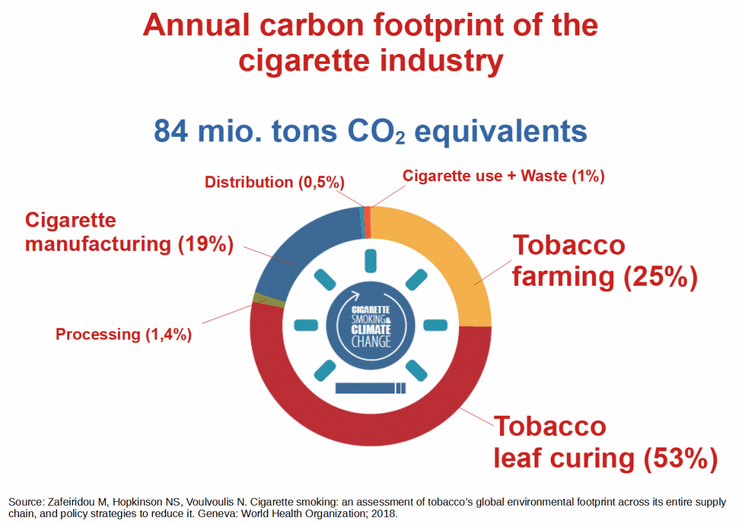
- Environment related issues in tobacco product manufacture:
Carbon Emissions:
The production and distribution of tobacco products represent environmentally harmful stages within the tobacco life cycle due to their substantial consumption of energy, water, and various resources. Collectively, these processes result in a significant volume of carbon emissions, estimated to be on par with the emissions generated by 3 million transatlantic flights. These processes encompass the energy and water usage in tobacco cultivation, the shredding and reconstitution of tobacco leaves, the freezing and artificial expansion of reconstituted tobacco surface area, the production of paper for commercial cigarettes or consumer rolling, the manufacturing of cigarette filters, as well as the creation of packaging and advertising materials. Furthermore, the logistics involved in importing and distributing tobacco leaves from manufacturers to wholesalers and retailers through various means of transport, including trucks, boats, rail, and others, contribute to an additional carbon footprint.
The tobacco industry has a detrimental impact on climate change, diminishing climate resilience through resource depletion and ecosystem harm. This industry is responsible for an estimated emission of 84 megatons of carbon dioxide into the annual greenhouse gas inventory while simultaneously consuming roughly 3.5 million hectares of land for tobacco cultivation annually. Safeguarding the environment from the destruction wrought by tobacco cultivation is a vital aspect of addressing the tobacco epidemic, and it should be an integral component of all national-level tobacco control programs, as emphasized by Hammerich et al. in 2020.
A review of reports from the tobacco industry was done by Hendlin and Bialous (2020) as part of their study on the environmental externalities of tobacco manufacture. Because of the industry's substantial environmental impact, tobacco should be considered in environmental evaluations as a contributing factor to the environmental deterioration that drives climate change. Governments must take action to lessen the harm that the tobacco business causes to the environment if they hope to meet the UN Sustainable Development Goals.
- Environment related issues in tobacco products transport and distribution:
According to WHO, one of the leading causes of disease-related air pollution was truck traffic. According to a recent study, ambient outdoor air pollution induces faster calcium deposition in arteries, which can increase the risk of heart attacks and strokes and the incidence of arteriosclerosis by 10–20%.
- Environment related issues in tobacco Consumption:
Active (Mainstream) and passive (side stream) smoke- tobacco smoke was a complex mixture of thousands of chemical components suspended in the atmosphere as gases and minuscule droplets. Passive smoke was emitted at the filter end of a cigarette when a smoker draws air through the burning cigarette to inhale, and the tobacco burns at a high temperature (up to 950 0C) due to the increased supply of oxygen. In comparison, second hand smoke was produced between puffs and released at the smoldering tip of the cigarette at a lower temperature (600–800 0C). As an example, second hand smoke includes 147 times more ammonia, 16 times more pyridine, 15 times more formaldehyde, 12 times more quinolone, three times more styrene, and twice as much nicotine than passive smoke. Second hand smoking was two to six times more cancerous and four times more hazardous than passive smoke when inhaled fresh.
- Post-consumer Waste:
Each year, the world produces between 340 and 680 million kg of waste tobacco products, with up to two-thirds of each smoked cigarette being dumped onto the ground. The waste from tobacco products contains over 7000 hazardous compounds, including known human carcinogens, which seep into the environment and build up over time. There are other waste products connected to tobacco usage in addition to trash, such as the 2 million tons of paper, ink, cellophane, foil, and glue used in wrapping for tobacco goods. This debris ends up anywhere, in our waterways, sewers, and other aquatic ecosystems in addition to our streets. Post consumption of tobacco products waste related environment issues discussed below, based on type of by-product of tobacco.
- Cigarettes:
Cigarette filters are crafted from cellulose acetate, a type of plastic known for its resistance to biodegradation, resulting in their persistence in the environment for extended periods. These discarded filters comprise the unsmoked tobacco remnants, the cigarette filter itself, and the paper wrapping. When these filters are thoughtlessly disposed of, they release toxic substances into the environment, leading to contamination with heavy metals and more than 4,000 harmful chemicals, including nitrosamines, polycyclic aromatic hydrocarbons, nicotine, and various others. This pollution also adversely impacts marine and aquatic ecosystems. Both cigarette and bidi butts are frequent triggers of forest and residential fires, posing risks to lives, properties, and forested areas.
- E-cigarettes:
E-cigarette waste may present a more significant environmental risk compared to cigarette butts due to its composition of metal, circuitry, disposable plastic cartridges, batteries, and the presence of toxic chemicals in e-liquids. Unlike cigarette butts, e-cigarette waste does not biodegrade, even under harsh conditions. Discarded e-cigarettes left in the environment will eventually disintegrate into microplastics and chemicals, which then make their way into storm drains, resulting in the pollution of our waterways and harm to wildlife.
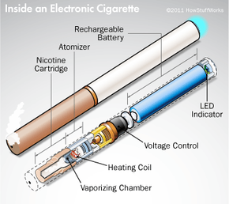
- Smokeless Tobacco:
The plastic wrapper of smokeless tobacco poses a serious threat to environment because these plastics are not biodegradable and it remains intact year after year. People who use smokeless tobacco spit everywhere, making the area unclean and contaminated, posing a severe threat to the ecosystem.
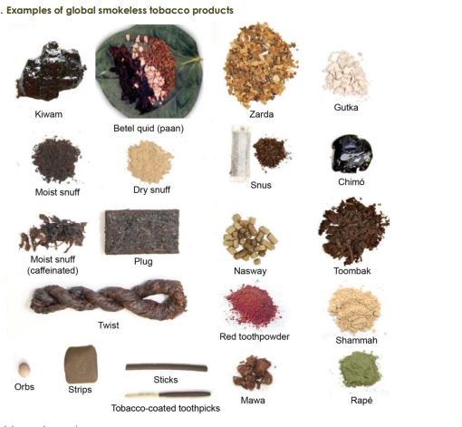
- Toxic Waste Polluting Water and Marine Life:
The vast majority of waste generated throughout the life cycle of tobacco products is deemed hazardous. The environmental threat posed by approximately 4.5 trillion discarded cigarette butts is significant, given the millions of tons of greenhouse gas emissions they produce. Cellulose acetate-based cigarette filters exhibit a lack of biodegradability, leading to their prolonged presence in the environment in the form of microplastics. This persistence can result in considerable harm to marine environments, as well as lake, river, estuary, and wetland aquatic ecosystems due to their uptake in these environments. Moreover, these filters release nicotine, heavy metals, and other absorbed chemicals into ecosystems, impacting the livelihoods and health of fishing communities in coastal regions and those who consume seafood products affected by contamination.
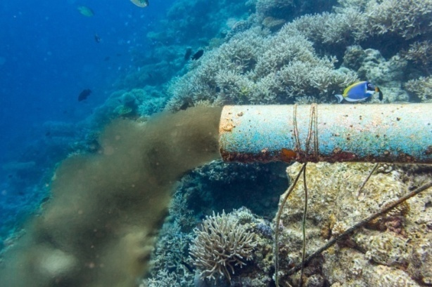
- Air Pollution:
Along with other air pollutants, tobacco smoke contains the three main greenhouse gases: CO2, methane, and nitrous oxides. Particulate matter pollution from tobacco smoke is more than that from diesel exhaust. Tobacco waste is still a significant contributor to unintentional fires, wildfires, and fire-related fatalities. A single cigarette butt started a large fire in India in 2010, resulting in the destruction of 60 hectares of forest.
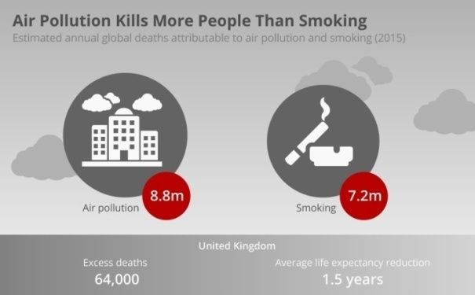
Tobacco exposure has significant implications for both health and air quality. The environmental impact of tobacco production and consumption necessitates substantial resources, including labor (often involving children), land, fertilizers, and water, all while introducing considerable toxicity to terrestrial and aquatic ecosystems. The clearance of land for cultivation and the combustion of wood and charcoal for tobacco curing are primary factors contributing to deforestation. It's worth noting that nine out of the ten most prominent tobacco producers are countries classified as low-income or middle-income, as highlighted by Hopkinson and Arnott in 2019.

Environment legislation in India:
Environmental legislation encompassed a range of legal measures and regulations that addressed various facets of the environment, including water quality, air quality, protection of endangered wildlife, and other environmental considerations. While environmental legislation comprises a multitude of laws and regulations, they all share a unified objective: to govern human interactions with the natural world, mitigating potential environmental risks and promoting public health. Given the diverse aspects within the natural environment, it's not surprising that environmental legislation is comprehensive in scope.

Need for environment legislation:
The origin of multiple national legislations can be traced back to environmental concerns. It is imperative to have robust legislation in place to safeguard the environment; otherwise, the expanding population could lead to significant disruptions and environmental degradation. Equally crucial is the enforcement of these laws. It is essential to vigorously and effectively enforce these regulations to shield our environment from further deterioration and pollution. Pollution transcended political boundaries and legislative jurisdictions, serving as a significant factor. Environmental issues displayed a global character. To avert such challenges, it is essential not only to establish environmental laws at the national level but also at the international level.
Contemporary society has been showing a growing interest in global environmental concerns, with developing nations experiencing intricate, significant, and swiftly escalating pollution challenges of their own. The potent amalgamation of industrial development and prevalent consumption patterns has been exacerbated by foreign corporations operating with scant consideration for the local environment's repercussions. Pollution was not merely a health matter; it extended to broader societal implications, as it had the capacity to disrupt families and communities. Pollution problems were intrinsically linked to the development approach in developing nations. In numerous cases, these nations either lack comprehensive pollution control policies or possess inadequate enforcement mechanisms to ensure the effectiveness of their policies.
Pollutant emissions have significantly increased as a result of robust economic growth, extraordinary urban expansion, and fast industrial development, particularly in the petrochemical and heavy industries.
Purpose of environment legislation:
The significance of environmental legislation lies in its role as a fundamental necessity for achieving environmental protection. Effective regulations and laws are indispensable in this regard. Environmental awareness raising and the promotion of environmental education serve as crucial means to steer people away from harming the environment and motivate them to safeguard it for the future. Legislation plays a pivotal role in translating environmental protection into everyday life. It imposes obligations on businesses, companies, public industries, and others to uphold environmental preservation and prevent environmental degradation. Moreover, it enforces stringent penalties on those who fail to comply with these laws and regulations. Ultimately, through this type of enforcement, ideas and plans are transformed into tangible efforts aimed at preserving the environment. These collective efforts are directed toward preserving the environment and achieving a harmonious balance between human development and environmental conservation.
Measures to ensure the industry are accountable for the environment call of tobacco:
- Strengthening the global evidence base : Research has unequivocally shown that in the lack of reliable environmental data from the tobacco industry, policymakers would face enormous challenges in successfully addressing and managing the issue, in addition to the fact that the true environmental impact will not be acknowledged. Studies have confirmed that the government should require the tobacco business to provide comprehensive and methodical reports on all of its operations and activities along the whole supply chain.Encouraging sustainable investment: In order to promote investment in sustainable alternatives as opposed to tobacco, governments must establish the necessary frameworks and regulations.
- Pricing of environmental externalities: Tobacco taxes need to take into account the environmental effects of tobacco use in order to hold the industry responsible and promote the transition to more environmentally friendly options.
- Tobacco waste and Extended Producer Responsibility: Regulations known as "Extended Producer Responsibility" would force tobacco companies to accept responsibility for the prevention and mitigation of waste from tobacco products, including post-consumer cigarette trash.
- Assist tobacco farmers in switching to alternative crops or activities: Policies should assist tobacco farmers in their transition, particularly those with limited skills or those bound by their outgrower contracts with the tobacco industry, in order to stimulate and facilitate their conversion to alternative crops or activities. According to the WHO FCTC Conference of the Parties' COP resolution FCTC/COP6(11), "Economically sustainable alternatives to tobacco growing" (according to Articles 17 and 18 of the WHO FCTC), a significant amount of work has already been done in this field.
- Minimizing environmental damage on farms: Encouraging farmers to adopt more sustainable farming practices requires equipping them with the right information and skills as well as giving them access to tools that will increase their output.
- Empowering the public and changing consumer behaviours: Reducing the demand for tobacco products would be the most efficient approach to cut their supply. Demand-side initiatives that seek to educate the public about the harmful effects of smoking on the environment and eventually alter consumer behavior are essential components of tobacco control programs.
- Fostering cooperation through partnerships: A swift shift away from tobacco use and toward the accomplishment of the Global Goals will require collaboration amongst public, business, and academic partners in addition to the active participation of environmental activists. Partnerships can foster the innovation required to monitor and safeguard the health of the tobacco-affected ecosystems when they are carried out in accordance with Parties' commitments under Article 5.3 of the FCTC.
- Health related issues in Tobacco Cultivationand Consumption
One of the most important agricultural crops in the world in terms of economics was tobacco. This crop was tough, drought-tolerant, and short-lived enough to be grown on soils unsuitable for other crops.
When compared to other tobacco-producing nations worldwide, the unique and advantageous qualities of Indian tobacco include far lower concentrations of heavy metals, extremely low levels of tobacco specific nitrosamines (TSNAs), and pesticide residues. India was able to create a wide range of tobacco styles, from colorful, neutral filler to flavorful leaf, to meet the demands of a diverse range of customers worldwide because of its diverse agroclimatic conditions. Moreover, India has very low production and processing expenses for tobacco, which contributes to the country's competitive and affordable tobacco prices.
Companies that hire tobacco workers are required to provide a safe workplace free from known risks that could endanger their employees' lives or seriously injure them. In tobacco fields, dehydration and nicotine are known risks.
Health related issues in Tobacco Cultivation:
- Green Tobacco Sickness (GTC):
Green Tobacco Sickness (GTS), often known as nicotine poisoning, is a condition where handling tobacco leaves exposes one to nicotine. Symptoms of GTS include nausea and vomiting. When nicotine from tobacco leaves combines with sweat, dew, or rain, it becomes more likely to get into the skin and bloodstream, increasing the risk of nicotine poisoning.
Nicotine was a hazard present in workplaces that require workers to handle tobacco leaves.
Nicotine was a chemical that is able to pass through the skin and enter the bloodstream causing GTS, a form of nicotine poisoning.
Nicotine absorption is more likely when it dissolves into rainwater, dew and sweat.
GTS symptoms include nausea and vomiting, dizziness, headaches and cramps.
Ali et al. (2022) did a comparative study of occupational health risks between tobacco and paddy farmers in Bangladesh. 384 respondents with a connection to tobacco growing were sampled by the researcher. According to the survey, headaches, vomiting, and low stamina were the three most prevalent health issues faced by paddy farmers, whereas green tobacco sickness was the most common issue among tobacco farmers. According to the study's findings, paddy farming poses less of a risk for occupational health issues than tobacco cultivation, and people are less concerned about wearing personal protective equipment (PPE).
In a concise examination of Green Tobacco Sickness (GTS) by Fotedar and Fotedar in 2017, the etiology, epidemiology, symptoms, and preventive measures associated with GTS were explored. GTS stems from the absorption of nicotine through the skin when workers handle uncured tobacco leaves. Symptoms of GTS encompass nausea, vomiting, pallor, dizziness, headaches, increased perspiration, chills, abdominal pain, diarrhea, heightened salivation, prostration, weakness, breathlessness, and occasional drops in blood pressure. The prevalence of GTS varies globally, ranging from 8.2% to 47%. To prevent its occurrence, it is advisable for tobacco farmers to employ personal protective equipment such as water-resistant clothing, chemical-resistant gloves, plastic aprons, and rain-suits with boots. There is a need for a global awareness campaign and the formulation of more stringent worker safety regulations at the international level.
Top of Form

Fiori et al. (2015) conducted a study concerning wheezing in tobacco farm workers in Southern Brazil, with the primary objective of investigating respiratory sensitizers associated with occupational factors in tobacco workers. This research involved a comprehensive cross-sectional study involving 2469 family farming tobacco growers. Multivariate analyses stratified by gender were employed to assess the relationship between wheezing and socio-demographic, behavioral, and occupational factors. The study determined that the prevalence of wheezing was 11.0%, with no significant gender difference. Among men, the risk factors for wheezing included factors such as age, smoking, strenuous work, pesticide use, exposure to vegetable dust and dried tobacco dust, the practice of lifting sticks with tobacco leaves to the curing barns, and Green Tobacco Sickness (GTS). For women, positive associations with wheezing were found with a family history of asthma, tying hands of tobacco, strenuous work, contact with chemical disinfectants, and GTS. Harvesting lower tobacco leaves was identified as a protective factor for wheezing in both genders.
Because nicotine permeates the skin of workers' hands while they grow and harvest tobacco, this study differed from others that found a correlation between GTS and salivary cotinine levels in workers who worked in humid settings. Lastly, even though the exposure's immediate effects might be GTS-defined nicotine poisoning symptoms, further research should be done to determine the exposure's long-term effects, and health education programs exposing farmers to health risks are advised to raise their awareness of these issues (Saleeon et al., 2016).
- Dehydration and Heat:
A typical symptom of GTS is vomiting, which increases the risk of heat illness in tobacco workers by dehydrating them. Especially in a hot and muggy setting, carrying on with work while vomiting might result in substantial water loss and dangerously elevated body temperature.
- If shade and frequent hydration are neglected, the risk of heat-related illnesses escalates, with symptoms ranging from heat cramps and rash to heat exhaustion and heat stroke.
- Heat stroke requires immediate medical attention and can result in death.
- Respiratory problems:
Workers are at risk of inhaling dust generated from dry tobacco leaves during the curing process, which can concentrate nicotine and other potentially harmful chemical substances. This exposure poses a threat to the respiratory system, particularly when workers do not use personal protective equipment. Additionally, respiratory exposure can occur during activities such as stacking and tying leaves, loading them for transportation, and when handling chemicals during mixing and spraying.

Tests of pulmonary function in workers exposed to tobacco dust and other categories of workers showed that the former, even in nonsmokers, had a higher chance of developing emphysema. The highly vascularized respiratory system in tobacco workers, whether they smoke or not, is particularly susceptible to permanent respiratory disorders due to its capacity to absorb minute particles (Saude et al., 2012).
- Musculoskeletal Disorders:
The worker when performing different activities in tobacco cultivation for longer time in constant posture or repetitive in activity causes high incidence of falls and musculoskeletal disorders (MSDs) were injuries or pain in the human musculoskeletal system, including the joints, ligaments, muscles, nerves, tendons, and structures that support limbs, neck and back.
Kongtawelert et al. (2022) conducted a study to investigate the prevalence and factors linked to musculoskeletal disorders (MSDs) among Burley tobacco farmers in Thailand. The findings indicated that the prevalence of MSDs among tobacco workers was comparable to that in other agricultural occupations. Furthermore, a reduction in working hours during the planting season was associated with a decreased risk of MSDs. Additionally, the use of machinery, as opposed to manual labor, was found to lower the occurrence of MSDs among tobacco farmers.

Fassa et al. (2020) conducted a study on the occurrence of neck pain among tobacco farm workers in Southern Brazil. This research comprised a cross-sectional examination of 2,469 tobacco farm laborers in the southern region of Brazil. The study employed an adapted version of the Nordic Questionnaire of Musculoskeletal Symptoms to assess and characterize neck pain. The findings indicated that various factors were associated with neck pain among both genders. In females, these factors included worker age, tobacco smoking, involvement in tobacco bundling, the use of heavy chainsaws, performing tasks at an intense or accelerated pace, and experiencing green tobacco sickness. For males, the variables associated with neck pain included age, the use of heavy chainsaws, working in a seated position on the ground, pesticide exposure, and experiencing green tobacco sickness.
Top of Form

Joshi et al. (2013) found that in bidi workers, most of them suffered from pain in shoulder for both the males and females (75% and 80.85%) followed by back pain and neck pain (76.60%). They were also suffering from cough (27%), breathlessness (20%), acidity (40%), generalized weakness (34%) and skin diseases (dermatitis) (21.27%) and tuberculosis (6.8%).
- Pesticide Poisoning:
In tobacco fields, chemical products are typically administered manually or through the utilization of acrylic backpack sprayers. In the absence of protective equipment, this can lead to exposure to concentrated pesticide doses that may be absorbed through the mouth, skin, or inhalation. This exposure has implications for both the central and peripheral nervous systems and involves commonly used pesticides in tobacco cultivation, such as organophosphates, carbamates, and dithiocarbamates.

Tobacco farmers encountered a greater prevalence of severe health risks, including conditions like Cardiovascular Diseases (CVD) and respiratory issues. These severe health problems translated to higher out-of-pocket expenses for them in comparison to non-tobacco farmers and the general population. The study's findings suggest that it is not solely tobacco consumption that is linked to various health conditions, but also the act of tobacco farming itself. As a result, the study recommends the provision of personal protective attire for tobacco farmers and workers to minimize their physical contact with hazardous chemicals and the surrounding environment, as highlighted by Shahzad et al. in 2021.
In Manisa province, tobacco growers faced the issue of green tobacco sickness. The absence of green tobacco sickness in the region could be attributed to several factors, including the use of protective equipment during the harvest, limited rainfall and drizzle during the vegetation period, and the cultivation of tobacco varieties with the lowest nicotine content in Turkey. However, it was observed that the tobacco producers in Manisa province had limited awareness of green tobacco sickness. To address this knowledge gap, there was a need for a training program aimed at educating them about green tobacco sickness and providing occupational health and safety training, as emphasized by Ekren et al. in 2017.

Tobacco farming had adverse effects on various aspects, including "Green tobacco sickness," respiratory ailments, musculoskeletal injuries, and mental disorders in human beings. It also had a detrimental impact on the environment. Detecting respiratory illnesses, musculoskeletal injuries arising from overexertion and repetitive movements, as well as occupational accidents, posed significant challenges. Furthermore, identifying the environmental consequences, such as water and soil contamination, proved to be a complex task, as highlighted by Riquinho and Hennington in 2012.
Health issues related to Consumption of Smoking type Tobacco:
Smoking leads to disease and disability that harms nearly every organ of the body.
Many chronic diseases, including as cancer, lung disease, cardiovascular disease, and stroke, were significantly increased by tobacco use. It is responsible for around 1.35 million fatalities annually and is one of the leading causes of illness and mortality in India. India ranked second in terms of both tobacco production and consumption. In the nation, a wide range of tobacco products were offered at extremely low costs.
According to the Global Adult Tobacco Survey India, 2016–17, about 267 million adults in India (15 years of age and older) use tobacco, making up 29% of all adults in the country. In India, smokeless tobacco is the most widely used type of tobacco product. Other popular products include zarda, gutkha, betel quid with tobacco, and khaini. The three main smoking tobacco products are bidi, cigarette, and hookah.
Tobacco usage is one of the largest dangers to public health worldwide. In addition to causing fatalities, it has significant negative social and financial effects. In India, the total economic expenditures of all diseases related to tobacco use for those 35 years of age and over in 2017–18 was INR 177 341 crore.
Cancer: Cancer describes conditions when aberrant cells proliferate uncontrollably and spread to other tissues. Through the blood and lymphatic systems, which aid in the body's detoxification process, cancer cells have the ability to spread to different areas of the body.
There are more than 100 different types of cancer. Most cancers are named for the organ or type of cell in which they were lung cancer begins in the lung and laryngeal cancer begins in the larynx (voice box).
Smoking of tobacco related to Cancer:
Poisons in cigarette smoke can weaken the body’s immune system, making it harder to kill cancer cells. When this happens, cancer cells keep growing without being stopped.
Poisons in tobacco smoke can damage or change a cell’s DNA. DNA is the cell’s “instruction manual” that controls a cell’s normal growth and function. When DNA is damaged, a cell can begin growing out of control and create a cancer tumor.
Smokers had a greater risk for lung cancer today than they did in 1964, even though they smoke fewer cigarettes. One reason may be changes in how cigarettes are made and what chemicals they contain. Smoking can cause cancer almost anywhere in your body, including the: Blood (acute myeloid leukemia), Bladder, Cervix, Colon and rectum, Esophagus, Kidney and renal pelvis, Larynx, Liver, Lungs, Mouth and throat, Pancreas, Stomach, Trachea, lung and bronchus
Heart Disease and Stroke :
Heart disease and stroke are cardiovascular (heart and blood vessel) diseases (CVDs).
Numerous heart problems fall under the category of heart disease. The most prevalent kind in the US is coronary heart disease, sometimes referred to as coronary artery disease, which is characterized by a narrowing of the blood arteries that supply the heart with oxygen. This may lead to:
- Chest pain
- Heart attack (when blood flow to the heart becomes blocked and a section of the heart muscle is damaged or dies)
- Heart failure (when the heart cannot pump enough blood and oxygen to support other organs)
- Arrhythmia (when the heart beats too fast, too slow, or irregularly)
A stroke happens when a blood vessel in the brain bursts, resulting in the death of brain tissue, or when the blood supply to the brain is cut off. Stroke can result in death or severe impairment, including paralysis, muscle weakness, difficulty speaking, and memory loss.
Smoking of Tobacco Related to Heart Disease and Stroke:
Smoking is a major cause of CVD and causes one of every four deaths from CVD. Smoking canleads to:
- Raise triglycerides (a type of fat in your blood)
- Lower “good” cholesterol (HDL)
- Make blood sticky and more likely to clot, which can block blood flow to the heart and brain
- Damage cells that line the blood vessels
- Increase the buildup of plaque (fat, cholesterol, calcium, and other substances) in blood vessels
- Cause thickening and narrowing of blood vessels
Breathing Secondhand Smoke Related to Heart Disease and Stroke:
Secondhand smoking is unhealthy to breathe in as well. The smoke from burning tobacco products is known as secondhand smoke. Smoke exhaled by a smoker is also considered secondhand smoke. Secondhand smoke inhalation can result in coronary heart disease, which can lead to heart attacks and strokes. In the US, nonsmokers die from coronary heart disease at an early age due to secondhand smoke around 34,000 times a year.
- Nonsmokers exposed to secondhand smoke in their homes or workplaces raise their heart disease risk by 25–30%. Secondhand smoke also elevates the risk of stroke by 20−30%. Annually, over 8,000 deaths from stroke are attributed to secondhand smoke exposure.
- Inhaling secondhand smoke disrupts the regular functioning of the heart, blood, and vascular systems, which heightens the likelihood of a heart attack. Even brief exposure to secondhand smoke can harm blood vessel linings and increase blood stickiness, leading to a potentially fatal heart attack.
Top of Form

Chronic Obstructive Pulmonary Disease (COPD)
A collection of illnesses collectively known as chronic obstructive pulmonary disease (COPD) result in breathing difficulties and airflow obstruction. Emphysema, chronic bronchitis, and asthma are conditions that are included in COPD (chronic obstructive pulmonary disease).
With COPD, less air flows through the airways—the tubes that carry air in and out of your lungs—because of one or more of the following:
- The airways and tiny air sacs in the lungs lose their ability to stretch and shrink back.
- The walls between many of the air sacs are destroyed.
- The walls of the airways become thick and inflamed (irritated and swollen).
- The airways make more mucus than usual, which can clog them and block air flow.
Smoking related to COPD (Chronic Obstructive Pulmonary Disease):
Smoking was the primary cause of chronic obstructive pulmonary disease, or COPD. Approximately eight out of ten deaths connected to COPD are caused by smoking. Smoking during adolescence and youth can impede the growth and development of the lungs. This may make having COPD as an adult more likely.
Smoking during Pregnancy:
Health Effects of Smoking and Secondhand Smoke on Pregnancies
- Women who engage in smoking encounter increased challenges in achieving pregnancy and face a heightened risk of remaining childless.
- Smoking while pregnant can lead to tissue damage in the developing baby, particularly affecting the lungs and brain. Some research indicates a potential association between maternal smoking and cleft lip.
- Furthermore, studies propose a connection between tobacco use and miscarriage. The presence of carbon monoxide in tobacco smoke can impede the developing baby's access to sufficient oxygen. Additionally, tobacco smoke comprises various other chemicals that can inflict harm on unborn infants.

Health Effects of Smoking and Secondhand Smoke on Babies:
- Maternal smoking increases the likelihood of delivering babies prematurely, a significant contributor to mortality, disability, and illness among newborns.
- Around one in five infants born to mothers who smoke during pregnancy are born with low birth weight. Maternal exposure to secondhand smoke during pregnancy also heightens the chances of delivering low birth weight babies. Infants born with insufficient weight or prematurely often experience compromised health.
- Both infants whose mothers smoke during pregnancy and those exposed to secondhand smoke after birth face a heightened risk of sudden infant death syndrome (SIDS) compared to those not exposed to cigarette smoke. Babies of smoking mothers are approximately three times more susceptible to SIDS.
- Babies whose mothers smoke during pregnancy or who encounter secondhand smoke after birth exhibit weaker lung function compared to their counterparts, which elevates the risk of various health complications.
Health issues related to Consumption of Smokeless/ Chew type Tobacco:
The use of smokeless tobacco (SLT) has been linked to a number of health problems, including mental disorders, low birth weight, cardiovascular disease, and oral malignancies.In India, SLT is widely used by both men and women. Men typically take gutka and khaini, while women typically use betel quid and tobacco, followed by oral application of both tobacco and khaini. About 50% of users in India utilize SLT, which is followed by dual tobacco usage and smoking. There is a general belief that the SLT improved dental health (Thakur and Paika, 2018).
- Levels of these chemicals, the greater the risk for cancer.
- Other chemicals found in tobacco can also cause cancer. These include:
  - A radioactive element (polonium-210) found in tobacco fertilizer
  - Chemicals formed when tobacco is cured with heat (polynuclear aromatic hydrocarbons—also known as polycyclic aromatic hydrocarbons)
  - Harmful metals (arsenic, beryllium, cadmium, chromium, cobalt, lead, nickel, mercury)
- Smokeless tobacco causes cancer of the mouth, esophagus, and pancreas.
Oral Disease:
- Smokeless tobacco can cause white or gray patches inside the mouth (leukoplakia) that can lead to cancer.
- Smokeless tobacco can cause gum disease, tooth decay, and tooth loss.
Reproductive and Developmental Risks:
- Using smokeless tobacco during pregnancy can increase the risk for early delivery and stillbirth.
- Nicotine in smokeless tobacco products that were used during pregnancy can affect how a baby’s brain develops before birth.
Other Risks:
Using smokeless tobacco increases the risk for death from heart disease and stroke.
Smokeless tobacco can cause nicotine poisoning in children.
There was a prevailing misconception among hookah users, who believed that it was less addictive than smoking traditional cigarettes and that hookah contained minimal to no nicotine. Some even thought that certain additives in hookah had health benefits. Despite studies investigating the limited health hazards of hookah, it has been revealed that the inhaled smoke contains substantial amounts of nicotine, tar, carbon monoxide, polyaromatic hydrocarbons, heterocyclic compounds, carboxylic compounds, and various inorganic compounds, including heavy metals—components that are also present in traditional cigarette smoking. Regular hookah use has been linked to an elevated risk of obstructive lung diseases, as well as the development of lung cancer and malignancies affecting the head and neck, as reported by Patel et al. in 2019.

People who use hookahs both actively and passively have consequences on their long-term cardiovascular and other systems, and they also contribute mechanistic insights regarding the harmful effects of hookah on health. Results indicated that public education campaigns and policy development pertaining to hookah control will be carried out (Qasim et al., 2019).
This systematic review offers compelling evidence regarding the detrimental impact of smoking on the musculoskeletal system. The findings indicate a strong association between smoking and lower Bone Mass Density (BMD), an increased fracture risk, periodontitis, alveolar bone loss, implant failure, heightened joint disease risk, suboptimal functional outcomes, and poor response to therapeutic interventions. Furthermore, despite the limited number of studies, evidence suggests adverse effects on muscles, tendons, cartilage, and ligaments. Given the ongoing significance of smoking as a public health concern, there is a pressing need for further research to elucidate the underlying mechanisms by which smoking affects the musculoskeletal system and to enhance awareness among healthcare providers and the community about the detrimental impact of smoking on musculoskeletal health, as highlighted by AL-Bashaireh et al. in 2018.
Smoking cigarettes raises the risk of a number of systemic illnesses, such as lung, cardiovascular, and cancer disorders. Additionally harmful to oral health, cigarette smoking raises the risk and severity of oral cancer, periodontal disorders, and peri-implantitis. It also has a negative effect on how well dental patients respond to treatment. The use of electronic cigarettes (ECIGs) and tobacco smoking through a waterpipe (also known as "hookah" or "shisha") have grown dramatically in recent years. As a result, dental professionals will probably treat a higher number of patients who utilize ECIG and/or waterpipes. Nicotine, the substance that causes dependence, is administered by both ECIGs and waterpipes. Waterpipe tobacco use has been linked to premalignant lesions, dry socket, periodontitis, and esophageal and oral cancer (Ramoa et al., 2017).
Cigarette smoking, tobacco chewing or alcohol drinking was not significantly associated with Gastric Cancer risk but bid smoking associated with Gastric Cancer (Jayalekshmi et al., 2015).
The following exposures are taken into account: using smokeless tobacco, smoking pipes and cigars, and smoking cigarettes and bidis. Tobacco use has been linked to a number of oral diseases and disorders that are taken into consideration, such as oral cancer and precancer, periodontal disease, caries and tooth loss, gingival recession and other benign mucosal disorders, and implant failure. The study discovered that there is strong epidemiologic data supporting the harmful consequences of tobacco use, including smoking, on dental health. (Warnakulasuriya et al., 2010).
Conclusion:
Most of the research studies were conducted in different countries like Brazil, Thailand, India, China, Turkey and Bangladesh. The world health organization reported about the tobacco cultivation and consumption effects on environment and health. Very old research studies were found on consumption of chewing tobacco type compared with smoking type tobacco. Tobacco cultivation and consumption pollute the air, water and soil which will cause the environment effect. Non-communicable diseases (NCDs) like heart diseases, cancers, diabetes, chronic respiratory diseases were the leading causes of death by tobacco consumption. The musculoskeletal disorders, green tobacco sickness, dehydration, nausea, vomiting, skin diseases and respiratory problems were identified in tobacco cultivation. From collected reviews, many researchers suggested that while working in tobacco field usage of personal protective equipment kit reduces the health issues among field workers. But, no one designed the personal protective equipment kit for tobacco field workers.
References:
AL-Bashaireh, A. M., Haddad, L.G., Weaver, M., Kelly, D. L., Chengguo, X and Saunjoo, Y. 2018. The effect of tobacco smoking on musculoskeletal health: a systematic review. Hindawi Journal of Environmental and Public Health. 106.
Ali, M.Y., Kafy, A.A., Rahaman, Z.A.,Islam, M.F., Rahman, M.R., Ara,I., Akhtari,M.R and Javed, A. 2022. Comparative occupational health risk between tobacco and paddy farming people in Bangladesh. SSM- Mental Health.

Ali, Y., Islam, F., Rahman, R., Sheema, M.K and Akhtar, R. 2015. Tobacco farming in
Bangladesh and its impact on environment. IOSR Journal of Environmental Science,
Toxicology and Food. 9(12): 27-33.

https://blog.ipleaders.in/environment-legislation-in-india/
https://www.cdc.gov/tobacco/basic_information/health_effects/cancer/index.htm
https://www.cdc.gov/tobacco/basic_information/health_effects/index.htm
https://www.cdc.gov/tobacco/data_statistics/fact_sheets/smokeless/health_effects/index.htm
Ekren,S., Kurt, D., Kinay, A and Mercimek, H.V.2017. A general discussion on green tobacco
sickness in tobacco producers living in Manisa province. Research Journal of Agricultural Sciences. 10(2): 08-14.

Fassa, A.G., Fiori, N.S., Meucci, R.D., Faria, N.M.X and Carvalho, M.P.D. 2020. Neck pain among tobacco farm workers in Southern Brazil. Salud Colectiva.
Fiori, N.S., Fassa, A.G., Faria, N.M.X., Meucci, R.D., Miranda, V.I. and Christiani, D.C. 2015.Wheezing in tobacco farm workers in Southern Brazil. American Journal of Industrial Medicine.
Fotedar, S and Fotedar, V. 2017. Green Tobacco Sickness: A Brief Review. Indian Journal of Occupational and Environmental Medicine. 21(3): 101-104.
Hammerich, A., El-Awa, F., Latif, N.A., El-Gohary, A and Borrero, M. D.L. 2020. Tobacco is a threat to the environment and human health. 28(5):319-320.
Hendlin, Y. H and Bialous, S. A. 2020. The environmental externalities of tobacco manufacturing: A review of tobacco industry reporting. 49:17-34
Hopkinson, N. S and Arnott, D. 2019. Environmental consequences of tobacco production and consumption. Correspondence. 394:1007-1008.
https://www.ibef.org/exports/tobacco-industry-india
Jayalekshmi, P. A., Hassani, S., Nandakumar, A., Koriyama, C., Sebastian, P and Akiba, S. 2015. Gastric cancer risk in relation to tobacco use and alcohol drinking in Kerala, India – Karunagappally cohort study. World Journal of Gastroenterol. 21(44): 12676–12685.

Joshi, K. P., Robins, M., Parashramlu, Venu, and Mallikarjunaih, K.M. 2013. An epidemiological study of occupational health hazards among bidi workers of Amarchinta, Andhra Pradesh. Journal of Academia and Industrial Research. 1(9):56-564.

Karima,R., Nahara, N., Shirinb, T and Rahman, A. 2016. Study on tobacco cultivation and its
impacts on health and environment at Kushtia, Bangladesh. Journal of Bioscience and
Agriculture Research. 8(2): 746-753.

Kongtawelert, A., Buchholz, B., Sujitrarath, D., Laohaudomchok, W., Kongtip, P and Woskie, S. 2022. Prevalence and factors associated with musculoskeletal disorders among Thai Burley tobacco farmers. International Journal of Environmental Research and Public Health.
Kutub, J.R and Falgunee, N. 2015. Environmental degradation due to tobacco cultivation in
Bangladesh: A case study of Doulathpur, Kushtia. Malaysian Journal of Society and Space. 11(7): 1 - 8.

Lecours,N., Almeida, G. E. G., Abdallah, J. M and Novotny, T. E. 2012. Environmental health
impacts of tobacco farming: a review of the literature. Tobacco Control. 21:191-196.

Pahari, S. 2022. Environment and its protection from tobacco: a step towards tobacco end game, a perspective from India. International Journal of Community Medicine and Public Health. 9(11):4273-4278

Patel, M. P., Khangoora , V. S and Marik, P.E. 2019. A Review of the pulmonary and health impacts of hookah use. Annals of the Merican Thoracic Society. 16(10).
Qasim, H., Alarabi, A. B., Alzoubi, K.H., Karim, Z. A., Alshbool, F. Z and Khasawneh, F. T. 2019. The effects of hookah/waterpipe smoking on general health and the cardiovascular system. Environment Health and Preventive Medicine. 24: 58

Ramoa, C. P., Eissenberg,T and Sahingur, S. E. 2017. Increasing popularity of water pipe tobacco smoking and electronic cigarette use: Implications for oral healthcare. Journal of Periodontal Research. 52(5): 813-823.

Riquinho, D.L and Hennington, E.A. 2012. Health, environment and working conditions in
tobacco cultivation: a review of the literature. Ciência&SaúdeColetiva. 17(6):1587- 1600.

Saleeon, T., Siriwong, W and Maldonado-pérez, H. L. 2016. Salivary cotinine levels as a
biomarker for green tobacco sickness in dry tobacco production among Thai traditional tobacco farmers. National Institute of Public Health. 67(2):121-130

Shahzad, M., Shah, and Chaloupka, A. J. 2021. Tobacco farming and illness induced poverty in
Pakistan. Journal of Applied Economics and Business Studies. 5(2):1-16.

Sultana, N.N., Nazir, N., Jabed, A and Paul, A. 2020. Environmental damage and land use change from tobacco farming: a spatio-temporal study in Bandarban, Bangladesh. Bangladesh Journal of Environmental Research. 11:22-37.
Warnakulasuriya, S., Dietrich, T., Bornstein, M. M., Peidro, E. C., Preshaw, P. M., Walter, C., Wennström, J.L and Bergstrom, J. 2010. Oral health risks of tobacco use and effects of cessation. International Dental Journal. 60(1): 7-30.
https://www.who.int/news-room/fact-sheets/detail/tobacco
https://www.who.int/india/health-topics/tobacco/economically-viable-alternatives-for-tobacco-growers-and-workers-(article-17-18-of-who-fctc)

