IoT-based Smart Helmet for Mining Worker Safety and Health Monitoring
Dr Kuppala Saritha
Associate Professor,
Department of CS&IS,
School of Engineering,
Presidency University,
Bangalore.
saritha.mphil@gmail.com
Bingi Manorama Devi
Assistant Professor,
Department of CSE,
KSRM College of Engineering (Autonomous),
Kadapa.
bingimanorama@gmail.com

Abstract
The internet of things (IOT) has recently attracted a lot of attention from both academic and commercial research. When IT was connected with industrial automation and regulator systems, the phrase “industrial or commercial IOT" was emerged. To gather, monitor, and analyse data from industrial activities, devices of ecosystem, sensors, apps, and related networking hardware is used by industrial IoT. Analysis of this data improves visibility and maintenance and troubleshooting abilities. Additionally, it can improve productivity, lower expenses, and enhance security. This chapter primary goals are the detection, notification, and providing the safety solution for workers at mining industry. Smart IoT helmets provide high end safety to mining workers with Smoke sensors for identifying harmful gases, Temperature Sensors, Cameras and alarm. This chapter review also contributes insights into the industrial internet of things (IIOT), its evolution, its conversion to IIOT, its architecture, various case studies, and its use in business.
Keywords: Internet of Things, Eco system, Smoke Sensors, Temperature sensor, Safety Helmet, Mining.
Introduction
The Internet of Things (IoT) is predicted to lead to the creation of billions of cheap, lightweight, low-power gadgets that will offer real-time information about every system, asset, and process that’s crucial to a specific organization. It was anticipated that the quantity of IoT devices will be more than the laptops and smartphones, and by 2025, there will be over 21 billion of them. Future IoT gadget generations are being created to support cutting-edge innovations like augmented & virtual reality, and machine learning, and cloud computing. With improvements in 4G, artificial intelligence, and advanced analytics, the industry is anticipated to expand and develop during the next five to ten years.
The prime issue in mining is safety. There isn't a good way to fix the issue. The safety of the public is not guaranteed during mining. The majority of the time, the issue is brought on by stressful jobs or poor health. Some accidents include persons falling from heights and going unreported, which results in death from a lack of medical care. Mining is top the list with 25.80 percent of all workplace fatalities, according to a global study that found that about 50000 people die each year as a result of working accidents. But the majority of fatalities could have been avoided. In order ensure the health and safety of workers at mining, smart wearables like helmet can be provided for mining workers by employing a variety of sensors.
Furthermore, the workers' vital signs like their temperature and heart rate are tracked and abnormal health problems are notified about. This IoT Based Smart Helmet's primary intension is to make mining sites safer and more secure for workers, which will decrease the frequency of fatal accidents there. The prototype performs with high accuracy under various situations. The sensors are then used to detect and characterise the detected gas level. A smart helmet model for the mining industry has been presented to identify that occurs with dangerous events whenever the sensed gas surpasses the specified level, notifying the miners and preventing an oncoming accident. The suggested IoT based smart helmet uses sensors to measure gas and humidity. Both the cutoff level of carbon monoxide and a humidity sensor that measures environmental humidity are used to determine the intensity of poisonous gas in the particular mining environment.
By embedding Internet of Things and Artificial intelligence, a mining helmet has to be restructured to enhance miner safety. The Arduino Software (IDE) is flexible enough to be used by both novice and advanced users. It's built on the Processing programming environment, which is helpful for teachers because it means that students learning to programme in that environment will be familiar with how the Arduino IDE operates. Programming environment that is easy to understand and use. Serious accidents frequently occur in underground mines. The creation of secure mining technologies is essential. Smart mining can be used to solve this issue. The autonomous electric locomotive is one of the most crucial elements in smart mining [1].
Literature Survey
According to a recent study by researchers at the Harvard School of Public Health, workers at construction sector are regularly stressed about work-related injuries and pain and not getting proper assistance, putting themselves at risk for additional injuries and psychological issues like depression, nervousness [2].
Use of protective equipment is required when a worker's safety is at danger. However, it is not always able to identify dangerous conditions in time, which results in accidents. Such occurrences raise concerns about a worker's health and safety, and they erode their trust in the employer [3].
Yedulla et al. study on job injuries in important sectors as manufacturing, agriculture, construction, and health care was conducted in 2020 [4].
Dhanalakshmi (2017) presented smart and safety system that can alert the control room when a collision occurs or a child removes their helmet. It can also provide environmental information like temperature and pressure [5].
A thorough analysis of IoT-based smart home systems has been provided by Hazarika Pranjal et al. This evaluation contains all the details on how an IoT-based smart home appliance's design, connection, and software should work together [6].
D Kock et al. [7] offered an automated technique while taking into account worker efficiency, health, and safety. For the purpose of detecting coal interfaces, they used two well used methods: vibration analysis and gamma radiation approach. They employed infrared, optical fibre communication channels, and carrier radio to send data in coal mines.
Jayasree et al. [8] suggests a flexible, intelligent helmet for construction workers as a security and rescue measure in the event of an emergency.
Alim et al. [9] proposed that GPS & GSM Technology is used for tracking the location of the bike rider and sending text message to the family members of the Bike rider when an accident occurs. Their suggested Smart Helmet is used for Accident Detection and Bike Rider's Safety.

Nasution et al. [10] perform study on LM35 and Time is chosen as the dependent variable (Causal Factor Variable) from the measurement data, and the percentage of error is chosen as the independent variable (Predictors), to calculate the constant and regression coefficient.
Lakshmi et al. [11] discussed about a time being IoT is being used to make energy consumption more efficient, making a smart environment in the mining sites, optimizing risk management and mitigation plans
Methodology
To help miners working in the mining industry, a conventional smart helmet type has been developed. The mining industry frequently has unsafe occurrences, many of which end in fatalities or serious injuries. Usage of ordinary helmet just to avoid general mishaps like water falling, these helmets do not ensure the safety of the mining worker. So, to overcome these problems and for providing safety and protection mining worker need to wear the smart helmet. One of the pieces of safety equipment that mine employees use the most frequently is a miner's helmet, so it needs to be equipped with more modern features. The smart helmet would be able to recognise potentially fatal conditions, such as the presence of dangerous gases like Carbon Monoxide, CH4, LPG, and natural gases, with the help of various sensors.
Any sensor that reaches the critical condition, activates the buzzer and illuminates the LEDs to alert the miners and supervisors. The GPS unit installed in the miners' helmets enables the mining officials to easily track their locations. Additionally, a alarm button has been installed, which, when touched, sends an emergency signal through mail to higher authorities outside the mines. To view all of the information transmitted wirelessly from the sensors, a smartphone application has also been developed. Subsequently, this smart helmet provides safety and security for mining workers from potential mishaps.
Making changes to the helmet's physical design without affecting its functionality presented another issue. When safety comes into the point, it became vital that minimum weight of the smart helmet will be increased.
Data from the helmet is gathered and transmitted through IoT, where it is displayed on a PC or mobile where it gets connected. The IOT module will enable us to receive mine updates while and when required.
a. Hardware Description
b Arduino
Arduino
An open-source electronics platform called Arduino is built on simple hardware and software. A motor can be started, an LED can be turned on, and something may be published online by using an Arduino board to receive inputs like light on a sensor, a finger on a button, or a tweet. Sending a set of instructions to the board's microcontroller will instruct your board what to do.
MQ-2 Gas Sensor
LPG, Propane, and Hydrogen can all be found in the presence of the MQ2 gas sensor. Methane and other combustible steam can also be detected by it. The sensor picks up smoke and dangerous gases. A 5-volt battery powers the smoke sensor. A smoke sensor's voltage output shows the presence of smoke. Production increases as the amount of smoke increases. A potentiometer can be used to change the sensitivity. When the air is clean, a sensor with a low conductivity called Sn02 is employed. However, when there is smoke, the sensor generates an analogue resistive output based on how much smoke is there. The circuit has a heater in it. The heater receives power from the power source through VCC and GND. Unsteady resistor
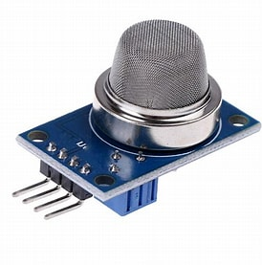
Fig 3. Gas Sensor

DHT11-The humidity Sensor
On the back of the sensor is an IC, together with an NTC temperature sensor (or thermistor) and a humidity sensor. This sensor available at affordable price and they provide great results. One reading per second, or 1Hz, is the sampling rate of the DHT11. The operating voltage of the sensor is between 3 and 5 volts, and the highest calculated current is 2.5 mA.
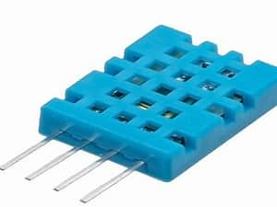
Fig 3. Humidity Sensor

Light Dependent Resistor (LDR)
It can also often referred to as photoresistor, photocell, or photoconductor. The amount of light that strikes its surface affects the resistance of this particular type of resistor. Light shining on the resistor causes it to alter in resistance. This resistor's power source is photo conductivity. For instance, a light can be turned ON or OFF using the LDR when it is in the light or in the darkness, respectively. A typical light-dependent resistor exhibits a resistance of 1 MOhm in darkness and a resistance of a few K Ohms in brightness.
Infrared Proximity Sensor
The IR sensor serves as a sensor for removing the helmet. The IR sensor is made up of an infrared LED transmitter and a receiver. An infrared transmitter is a light-emitting diode that radiates infrared energy. They are known as IR LEDs as a result. Although an IR LED looks like a standard LED, the radiation it emits cannot be seen with the human eye. Infrared sensors are another name for infrared receivers since they detect the radiation from an IR transmitter. Two different kinds of infrared receivers are photodiodes and phototransistors. Because they can only detect infrared radiation, infrared photodiodes are distinct from ordinary photodiodes.
By supplying a voltage to the onboard infrared light emitting diode, an IR proximity sensor produces infrared light. This light travels through the atmosphere, strikes an object, and then is reflected into the photodiode sensor. The reflected light will be stronger if the object is close by and weaker if the object is far away. When a sensor is activated, it provides a matching Low signal through the output pin, which an Arduino or other microcontroller can sense to carry out a specific operation.
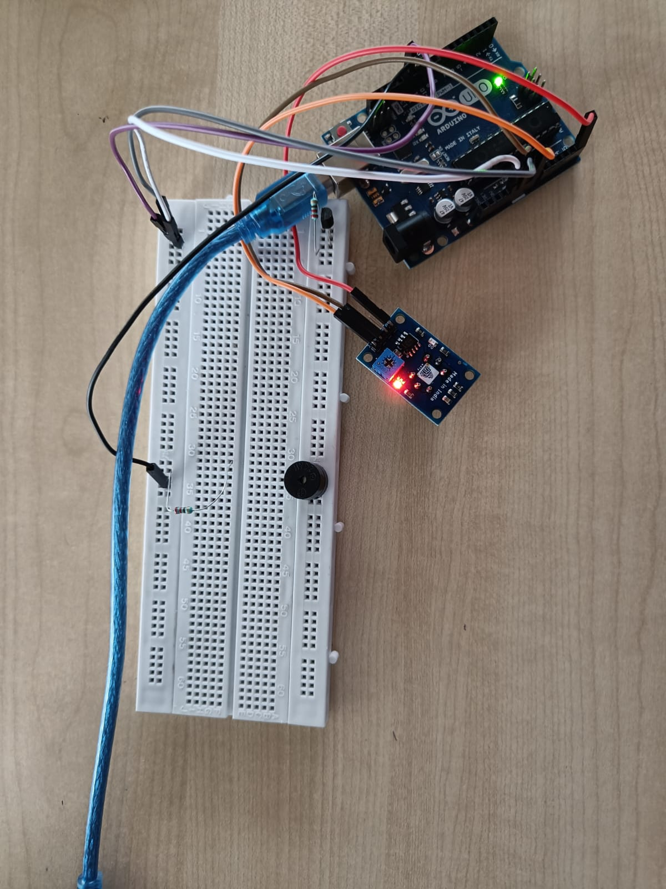
Fig 3. Infrared Sensors

Liquid Crystal Display (LCD)
On each of the two sides of a 16x2 LCD, 16 characters can be displayed per line. On this LCD, a 5x7 pixel matrix represents each character. On this LCD, there are two registers: Command and Data. The command register contains the LCD command instructions. A command instructs the LCD to carry out a particular action, such as initialising it, cleaning its screen, determining the location of the pointer, managing the display, etc. The data register contains the information that will be shown on the LCD. The data is the ASCII value of the character that will be displayed on the LCD.

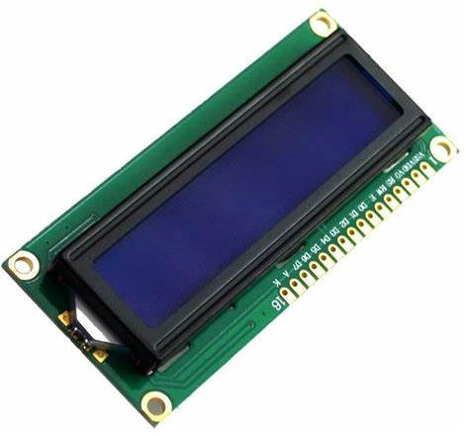
Fig 1. Liquid Crystal Display

Buzzer
Buzzer are also referred to as Piezoelectric buzzer. The Piezo buzzer is a sound generator that serves as an auditory indication in electronic circuits. It is frequently employed as an alarm generator in electronic gadgets. Inside a Piezo buzzer are an oscillator and a Piezo disc. A frequency of 2-4 kHz is produced by the oscillator, and the piezoelectric component vibrates in response to this. 3–12 volts DC are required for the Piezo buzzer to operate.
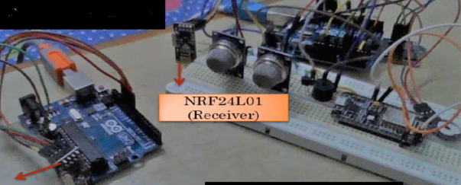
Fig 1. Buzzer

Temperature Sensor
Digital temperature sensors are developed by Maxim Integrated (formerly Dallas Semiconductor), and its model number is DS18B20. One of the most widely used temperature sensors available, it offers reasonable precision (0.5 °C) throughout a broad range of temperatures (-55 °C to + 125 °C). The sensor may be used with both the Arduino (which runs at 5 V) and electronics like the ESP32 and Raspberry Pi, which have 3.3 V GPIO pins, because its operational voltage ranges from 3.0 to 5.5 V.
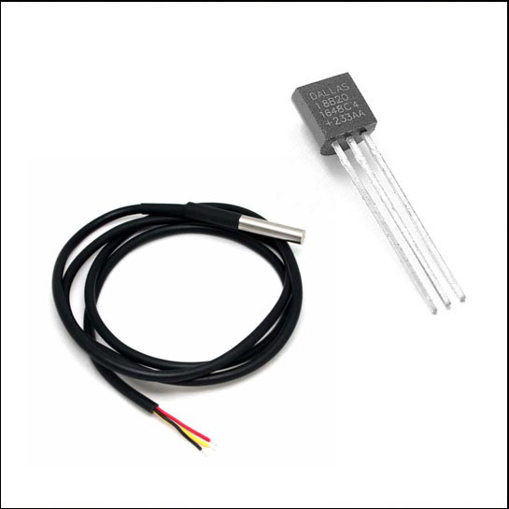
Fig 5. Temperature Sensor

Internet of Things (IoT)
Implementation of IOT The Internet of Things (IoT) is a technology that has been considered to be stimulating technology. It makes it possible for each and every individual to communicate virtually from everywhere at all times utilising any connection or provider. It offers a platform for the seamless integration of sensors and devices into a smart environment in order to deliver cutting-edge and intelligent human services. Sensors and gadgets sense various kinds of data are the core technologies of IoT. This data may then be processed and evaluated to derive beneficial information and enable intelligent services. Sensors will identify fluctuations in environmental factors like pressure, temperature, humidity, light, and light intensity. ng on or off a motor, opening or closing a valve, and other actions. IoT is centred on these components because they enable machine and device interaction with the real world. When sensors and actuators work together to solve problems devoid of human interaction, automation is conceivable.
Smart helmet embedded with the internet of things (IoT) will assure the safety of the mining worker by preventing mishaps at the mining site. Helmet is the most basic protection device and it is necessary for every worker has to wear it when he enters into mining environment.
This block design of a prototype incorporates the sensors that would be required in a coalfield and is coupled to a microcontroller to detect environmental variables, as shown in Fig. 1. The LM35 light bulb was attached to the Arduino Uno microcontroller. Block diagram of the safety and monitoring system for coal mines in Fig. 1 & 2. an IR flame sensor, a Mq2 gas sensor, a DHT11 humidity sensor, and a temperature sensor. We've programmed the Arduinoboard so that any abnormality in the above-mentioned parameters will cause an alert, and the buzzer will be turned on. This allows us to continuously monitor the temperature, humidity, gases present in the coalfield, and air density.
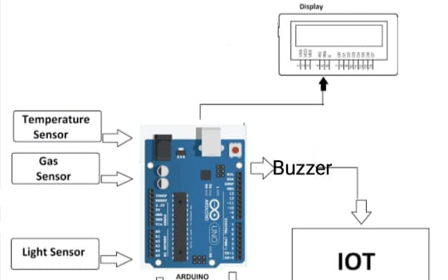
Fig 1. Block Diagram of Unified Sensors

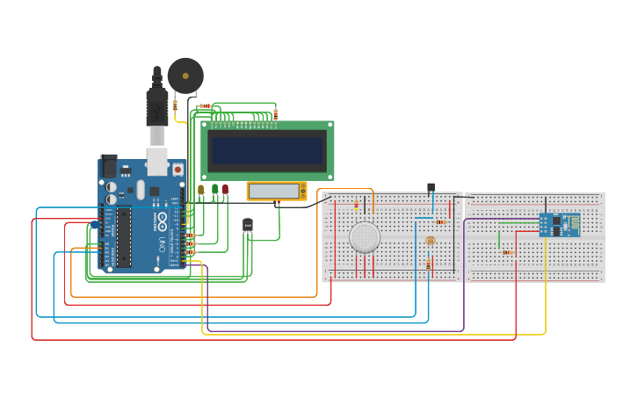
Fig 2. Block Circuit diagram for connections

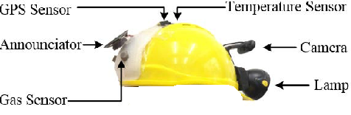
Fig 6. Smart Helmet
Conclusion
Smart Helmet is an intelligent device that will make mining worker safer at his working environment. For the protection mining worker safety, smart helmets are the only option given the state of environment, the high accident rate, the prevalence of mining, and the weak regulatory framework. It is essential to wear a helmet while working at mining because, in the event of an accident, it can prevent mining worker from suffering serious brain injuries. Thus, this is where the precise IR sensor will be used. It will make sure that in order to start the work, the rider must put on a helmet. smart helmet may cost a little bit more than a standard helmet, but the advantages far outweigh the disadvantages.
References
[1] Jiang Y, Li Z, Yang G, Zhang Y, Zhang X. Recent progress on smart mining in China: Unmanned electric locomotive. Advances in Mechanical Engineering. March 2017.R. K. Kodali, T. Devi B. and S. C. Rajanarayanan, "IOT Based Automatic LPG Gas Booking and Leakage Detection System," 2019 11th International Conference on Advanced Computing (ICoAC),(2019).
[2] Harvard School of Public Health study on “Construction workers struggle with pain stress from Ninjuries”, [online] Available: https://www.hsph.harvard.edu/news/features/construction-workers-struggle-with-pain-stress-from-injuries/.
[3] Hasle, P.; Limborg, H.J.; Granerud, L. Social responsibility as an intermediary for health and safety in small firms. Int. J. Workplace Health Manag. 2011, 4, 109–122. [Google Scholar]

[4] 16. Yedulla, N.R.; Koolmees, D.S.; Battista, E.B.; Raza, S.S.; Montgomery, Z.A.; Day, C.S. Upper-Extremity Injuries Are the 2nd Most Common Workplace Injuries from 1992 to 2018; Wayne State University: Detroit, MI, USA, 2020. [Google Scholar]

[5] Dhanalakshmi and Lathapriya, “A SMART HELMET FOR IMPROVING SAFETY IN MINING INDUSTRY,”. International Journal of Innovative Science and Research Technology, 2nd Vol 3rd Issue, 2017. [12]
[6] Hazarika Pranjal, Implementation of Smart Safety Helmet for Coal Mine Workers. In IEEE International Conference on Power Electronics. Intelligent Control and Energy Systems. Jorhat, India, ICPEICES, 2016.
[7] D Kock and J. W. Oberholzer, "The development and application of electronic technology to increase health, safety, and productivity in the South African coal mining industry," IEEE Trans. on Industry Applications, vol. 33, no. 1, pp. 100-105, Jan/Feb. 1997.
[8] Jayasree, V., & Kumari, M. N. (2020, July). IOT Based Smart Helmet for Construction Workers. In 2020 7th International Conference on Smart Structures and Systems (ICSSS) (pp. 1-5). IEEE.
[9] M E Alim , S Ahmad , M N Dorabati , I Hassoun, Design & Implementation of IoT Based Smart Helmet for Road Accident Detection 11th IEEE Annual Information Technology, Electronics and Mobile Communication Conference (IEMCON) , p. 576 - 581 Posted: 2020.
[10] T. H. Nasution and L. A. Harahap, "Predict the Percentage Error of LM35 Temperature Sensor Readings using Simple Linear Regression Analysis," (2020) 4rd International Conference on Electrical, Telecommunication and Computer Engineering(ELTICOM),(2020).
[11] Lakshmi, Sowmya Sista and, Ayush Dagar and, Neeraj Gupta and, Manjeet Kaur and, Rashmi Gupta, A Technical Review on IoT Based Mining Tracking and Safety Helmet (JUNE 10, 2021). International Journal of Innovative Research in Computer Science & Technology (IJIRCST), Volume-9, Issue-4, July 2021.

