“Things” and Communication Trends in IoT
Manjuanath R¹  Professor, CSE Department  R R Institute of Technology, Bengaluru,  Karnataka, India, drmanjunath.raj@gmail.com | Sumanth V²  Assistant Professor, Department of Information Technology  Manipal Institute of Technology, Bengaluru  Karnataka, India, ssumanth6@gmail.com
Shivashankar³  Professor, ECE Department  R R Institute of Technology, Bengaluru,  Karnataka, India, drmanjunath.raj@gmail.com | Manjunath C R⁴  Professor, Department of CSE/IT, SoET,  CMR University, Bengaluru,  Karnataka, India, dr.crmanjunath@gmail.com
ABSTRACT
As of now, there is an overabundance of IoT correspondence conventions, the advances used to interface IoT gadgets to the web, utilized across the world. The broad assortment of correspondence conventions can prompt issues with interoperability between and inside IoT biological systems. There is as of now no worldwide IoT correspondence guidelines, making enormous scope IoT appropriation more complicated than it wants to be. A consolidated "Things" and Correspondence Patterns in IoT principles are fundamental to understand the involved capability of IoT. The primary focal point of IoT innovation is endpoint security, for example alludes to the security of related figuring gadgets. The focal reason of IoT is the expression "network Sensors and Actuators". The IoT gadgets are related to Web over a wide variety of correspondence innovation. This book section depicts the few advances elaborate in IoT correspondence. The variety in correspondence builds the enquiry to choose for the future and proposed application. The fundamental target of the application prerequisites to characterize obviously. The elements applications, for example, range, recurrence groups, power utilization, geography, obliged gadgets, compelled hub and organizations impact the decision of picking at least one IoT correspondence innovation.

- INTRODUCTION
The Web of Thing (IoT) depicts the association of genuine articles "things" are embedded with sensors, actuators, programming, and various advancements for the objective of partner and trading information with other passing devices and structures on through the web. These IoT passing devices range from normal local things on to complex current instruments.
IoT is the frameworks organization of genuine things that contain equipment implanted inside their design to bestow and distinguish relationship between each other or with reverence to the periphery environment. In the next few years, IoT-based advancement will offer significant level levels of organizations and basically affect how people continue with their ordinary presences. Types of progress in prescription, power, quality medicines, cultivating, canny metropolitan networks, and wise homes are just a not a great a large number of the out and out models where IoT is decidedly settled.
Unequivocal sensors will similarly be prepared inside existing spaces to screen the flourishing and extensive flourishing of senior tenants, while moreover watching that reasonable treatment is being coordinated and helping public individuals with recuperating lost adaptability through treatment also. These sensors structure a relationship of clever sensors which can collect, cycle, move and study respected information in various circumstances, for example, imparting in-home actually taking a look at gadgets to clinical focus based frameworks. Other client gadgets to mix solid living which are connected scales or wearable heart screens, are similarly an open door with the IoT. The uses of Correspondence Examples in IoT are beginning to end prosperity checking using IoT arranges similarly open for pre-birth and solid patients, helping them with regulating prosperity vitals and rehashing medication necessities.
- SENSORS IN INTERNET OF THINGS
A sensor does unequivocally as its name illustrates: It recognizes. Even more expressly, A sensor gauges some genuine sum and converts that assessment adding a bonus to a modernized depiction. That computerized portrayal is normally passed to one more gadget for change into helpful information that can be consumed by savvy gadgets or people. Sensors can be promptly implanted in any actual articles that are effortlessly associated with the Web by wired or remote organizations. Since these associated have actual items with complex detecting abilities speak with one another and outside frameworks, they can decipher their current circumstance and pursue shrewd choices.

- Applications For Sensors
Sensors have been around beginning from the very outset of power and have been being used in a phenomenally wide variety of purposes. We use sensors in contraptions projects, mechanical advancement, industry, and basically more. Table 1 is a short overview of common purposes of sensors.
Table 1: List of Sensor Applications
Automation  Robotics  Embedded Systems  Computers  Smart Cars  Avionics  Satellites | Smart Homes  Smartphones  Smart Watches  Energy plants  Remote Sensing  Communications  Medical domain

- Sensors Classifications
Dynamic: Sensors can be set up thinking about whether they produce an energy yield and characteristically need an outside power supply (dynamic) or whether they fundamentally get energy and reliably require no outer power supply (saved).
Prominent: Sensors can be portrayed looking at whether as a sensor is crucial for the climate it is surveying (conspicuous) or outside to it (simple).
Contact: Sensors can be set up thinking about whether they need authentic interaction with what they are evaluating (contact) or not (no contact). Overall: Sensors can be set up thinking about whether they measure on an outright scale (completely) or considering a separation with a fixed or variable reference respect (relative).
Area of use: Sensors can be set up considering the particular business or vertical where they are being utilized.
Flow sensors measure: Sensors can be figured out considering the genuine system used to actually look at obvious information.

- Sensor Types
The most helpful order plot for the even minded use of sensors in an IoT organization, is to just group in view of what actual peculiarity a sensor is estimating. This sort of arrangement is shown in Table 2.

Table 2: Different Types of Sensors
Temperature Sensor | One of the most in general saw and most striking sensors is the Temperature Sensor. A Temperature Sensor, as the name proposes, assets the temperature i.e., it gauges the enhancements in the temperature.
Proximity Sensors | Proximity sensor is a non-contact type sensor that sees the presence of a thing. It tends to be finished utilizing various systems like Optical (like Infrared or Laser), Sound (Ultrasonic), Drawing in (Vestibule Impact), Capacitive, and so forth.
Infrared Sensor (IR Sensor) | IR Sensors are light based sensor that are utilized in different applications like Region and Article Disclosure. IR Sensors are utilized as closeness sensors in basically all phones.
Ultrasonic Sensor | A Ultrasonic Sensor is a non-contact type contraption that can be utilized to see at distance as well as speed of a thing, truly. A Ultrasonic Sensor works contemplating the properties of the sound waves with rehash more principal than that of the human distinguishable reach.
Light Sensor | A fast Light Sensor open today is the Light Reliant Resistor or LDR. The property of LDR is that its expectation is then again close with the power of the merging light i.e., when the force of light expands, its block diminishes and tight snap versa.
Smoke and Gas Sensors | One of the very impressive sensors in flourishing connected applications are Smoke and Gas Sensors. In each down to earth sense, all work environments and experiences are outfitted with a few smoke alerts, which see any smoke (taking into account fire) and sound a watchfulness.
Alcohol Sensor | Alcohol Sensor recognizes alcohol. Normally, alcohol sensors are used in breathalyzer contraptions, which choose if an individual is failed or not. Policing uses breathalyzers to get inebriated and-drive liable gatherings.
Touch Sensor | We don't give a great deal of importance to contact sensors yet they changed into a significant piece of our life. All touch screen contraptions (Phones, Tablets, computers, etc) have contact sensors in them. Additional typical utilization of touch sensor is trackpads in our PC.
Color Sensor | An assortment Sensor is a valuable gadget in building grouping recognizing applications in the field of picture managing, combination ID, current thing following, and so on. The TCS3200 is a fundamental Collection Sensor, which can perceive any tone and result a square wave relative with the repeat of the perceived combination.
Humidity Sensor | If we can see Barometrical circumstances Checking Plans, they reliably give temperature as well as saturation data. Therefore, assessing drenched quality is an enormous endeavor in various applications and Clamminess Sensors help us in attaining this.
Tilt Sensor | Reliably used to see propensity or heading, Inclination Sensors are perhaps of the most quick and unpretentious sensor out there. Quite a bit early, incline sensors are involved Mercury (and therefore they are on occasion named as Mercury Switches) yet latest propensity sensors contain a roller ball.
Radiation Sensor | A radiation sensor is a contraptions instrument that assets and measures the radiation particles like alpha, beta, gamma, neutrons, X-exudes.
Level Sensor | The rule control of the level sensor is to check the level or level of different materials like solid, liquid, and vaporous.
Vibration Sensor | The vibration sensor sees and records any development or exercises. Besides, it offers information or snippets of data to related machines or plans.
Image Sensor | The picture sensor is an electronic gadget that is utilized to see the picture pixels and give data to the show contraptions.
Flame Sensor | The fire sensor successfully perceives fire or fire of adjoining materials. These apparent signs are passed to the associated control contraptions.
Leak Sensor | A break sensor is used in a shut vessel or vacuum for seeing water spillage, fluid spillage, air spillage, etc.
Mark Sensor | Mark sensor gauges and sees all around that truly matters, any cycle liquid. Mark sensor capabilities as a photoelectric sort of sensor.
Flow Sensor or Float Sensor | It is used to distinguish assortment marks inside seeing articles. This apparent information will be given to the regulator framework. It is utilized in present day regions, power making instruments, power plants, and so on.

D. How Do I Choose The Correct Sensor?
There are various parts to contemplate while picking a sensor for any undertaking. Notwithstanding, all beginning stages by picking as far as possible we will assess. Then, at that point, it's an ideal opportunity to consider two or three parts to get the finest sensors for best outcomes and inside the given limitations like spending plan, exactness, and so on. Down below are reasonable the chief elements to consider.
Range of Operation: The fundamental variable to contemplate in a sensor is the functioning reach.
Accuracy (Resolution): Pick the significant goal (accuracy) of the sensor your applications require preceding picking a sensor.
Total Cost: Electronic sensors range broadly in cost. We can without much of a stretch conjecture that high precision sensors are in every case far more costly than low exactness ones. The working wide powerful fury likewise assumes a part in deciding the cost of the sensor, and so forth.
Interfacing Method: As we've expressed prior, a few sensors are simple and others are computerized. Thus, there are various approaches to communicate and peruse these sensors utilizing simple information pins of a MCU.
Data Rate (For Modernized Sensors): Undeniable level sensors can send you readings (information) at a rate we call the testing rate. Regularly sensors' rate is depicted by ksp/s (kilo tests each second) which is 1,000 model habitats (readings) in a moment. Several sensors can stream up to a few Msp/s.More frequently than not, it's a programmable component in sensor modules. Documentation: Extraordinary documentation is key whether or not to pick a sensor
Example: Advanced mobile phones.
In excess of a billion PDAs are sold every year, and every one has above and beyond twelve sensors inside it (displayed in Figure 1), and that number keeps on developing every year. Envision the outstanding impact of stretching out sensors to for all intents and purposes each innovation, industry, and vertical.

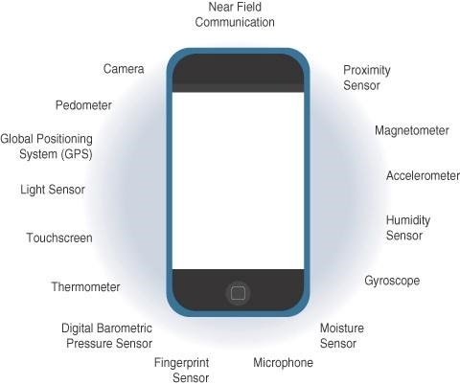

Figure 1: Sensors in a Smart Phone

- ACTUATORS IN INTERNET OF THINGS
Actuators are regular improvements to sensors. Sensors should perceive and check essentially any quantifiable variable in the authentic world. They convert their assessments (dependably clear) into electric signs or mechanized depictions that can be consumed by a sharp arranged capable (a device or a human). Actuators get some kind of control signal (regularly an electric sign or mechanized request) that sets off a genuine effect, by and large a development, power or something to that effect, and so on. Figure 2 shows the equality and complementary nature of these two kinds of contraptions.

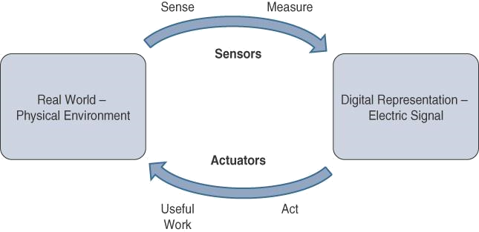

Figure 2 : How Sensors and Actuators Interact with the Physical World.

Figure 3 presents evaluation of Sensor and Actuator Comfort with People. People utilize their five assets to perceive and assess what is going on. The material organs convert this obvious information into electrical inspirations that the material framework ships off the brain for making due. Essentially, IoT sensors are devices that sense and measure the ensured world and (regularly) signal their assessments as electric signs passed off a chip or something on with that impact or microcontroller for extra making due. A processor can give an electric message to an actuator that makes a cognizance of the sign into an improvement or something to that effect (expeditious, rotational, and so on) or critical work that changes or quantifiably influences this present reality.
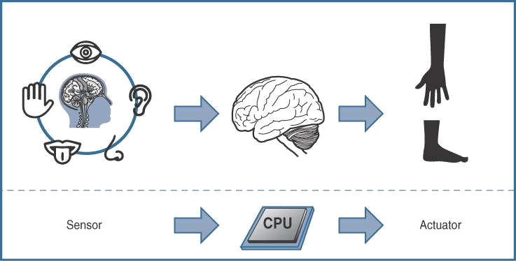

Figure 3: Comparison of Sensor and Actuator Functionality with Human

- Classification of Actuators
Comparable as sensors, actuators similarly change phenomenally in ability, size, plan, and so on. A couple of recognizable ways that they can be gathered consolidate the going with:
Kind of movement: Actuators can be portrayed considering the kind of development they produce (for example, straight, rotational, one/two/three-hatchets).
Power: Actuators can be gathered considering their power yield (for example, high power, low power, smaller than usual power).
Matched or perpetual: Actuators can be depicted considering how much stable-state yields.
Area of use: Actuators can be depicted considering the particular business or vertical where they are utilized.
Sort of energy: Actuators can be collected considering their energy type.
- Types of Actuators
The various sorts of actuators are displayed in underneath Table 3.
Table 3: Types of Actuators
Types of Motion and functions
Linear Actuators | Direct actuators are contraptions that move in an exact style. They are generally initiate in water controlled and pneumatic stuff and able to be mechanical or electrical.
Rotary Actuators | Pivoting actuators, instead of straight sorts of actuators, produce a round improvement. Most machines, as the truism "pivoting" determines, use going parts to achieve a turning improvement. On the off chance that a machine needs to push ahead, in speak, up, or down, they are a critical piece of the time used with respect to a straight actuator.
Types of Energy
Hydraulic Actuators | Hydraulic actuators use a fluid filled chamber with a chamber coordinated in the middle to work. Water energized actuators regularly make direct turns of events, with a spring related with one end for bring improvement back. These actuators can be found in a blueprint of rec center hardware, including steppers and vehicle transport carriers.
Pneumatic Actuators | Pneumatic actuators are the most trustworthy machine improvement choices. To make mechanical new development, they utilize compacted gases. Different affiliations incline toward pneumatic actuators since they can perform very exact activities, especially while beginning and finishing machines.
Electric Actuators | Electrical actuators, as you could expect, depend upon capacity to work. Electric vehicles, making stuff, and significant level mechanics gear are exceptional models. They produce unequivocal advancement similarly that pneumatic actuators really do considering the way that the development of electrical power is steady.

- Applications for Various Kinds of Actuators
In arranging, actuators are continually used to present turn of events. They can, regardless, be secured to a choice to stop improvement. Actuators are utilized in different applications which are introduced in Table 4.Table 4: Types of Actuators
Hydraulic piston  Comb drive  Relay  Electric motor  Digital micromirror device | Thermal bimorph  Electroactive polymer  Piezoelectric actuator  Servomechanism

- SMART OBJECTS IN INTERNET OF THINGS
Smart objects are the design chunks of IoT. They change customary things into an association of shrewd articles that can acquire from and work together with their ongoing situation in a huge way. The ability to grant over an association has a multiplicative effect and thinks about especially refined relationship and participation between unique quick things.

- Smart Objects: A Definition
Smart objects is frequently utilized conversely with terms like brilliant sensor, shrewd gadget, IoT gadget, insightful gadget, thing, brilliant thing, clever hub, keen thing, universal thing, and wise item. A savvy object, as depicted all through this book, is a gadget that has, at the very least, the accompanying four main qualities (introduced in figure 4).
The fundamental parts of "Things" and Communication Trends in IoT are Handling unit, specialized gadgets, Sensor(s) or potentially actuator(s) and power sources.
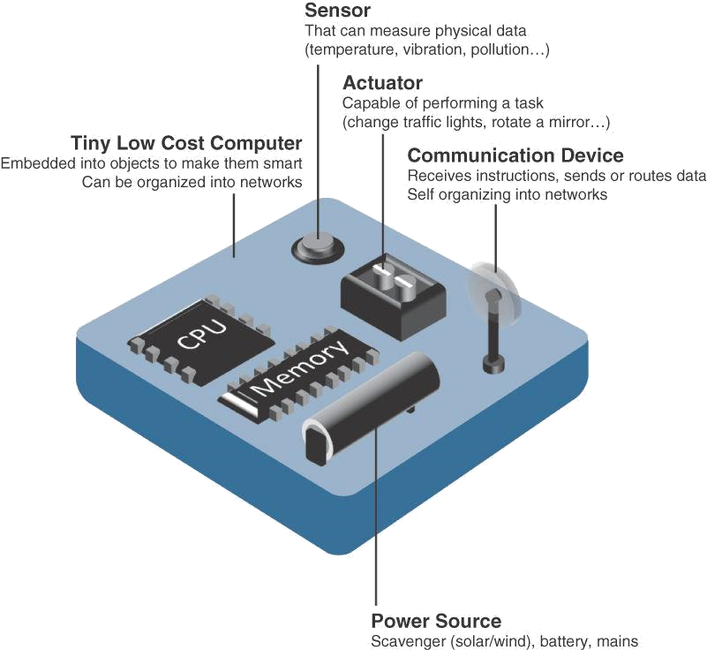

Figure 4 : Characteristics of a Smart Objects
- Trends in Smart Objects
Size is decreasing: A couple of smart items are so little they are not even observable to the independent eye. This decreased size makes keen articles more clear to embed in standard things.
Power consumption is declining: The different gear portions of a shrewd item interminably consume less power.
Processing power is increasing: Processors are unendingly getting even more noteworthy and more unassuming to Deal with power. This is a crucial movement for splendid things, as they become continuously muddled and related.
Communication capacities are getting to the next level: IoT is driving the improvement of progressively more specific correspondence shows covering a more significant assortment of direction cases and conditions.
Communication is progressively normalized: There is significant solid areas for an in the business to cultivate open rules for IoT correspondence shows.

- COMMUNICATION CRITERIA
Connecting "things," endless wired and remote access headways are open or a work underway. Preceding investigating a part of these entry propels, it implies a lot to examine the guidelines to use in surveying them for various use cases and structure game plans. Measures' are used in surveying access headways of various use cases and structure courses of action.
Range: In what way far does the sign should be impelled? What will be the area of thought for a picked far off improvement? Ought to indoor versus outside approaches be isolated? All the time, these are the essential requests presented while looking at wired and remote access developments. The simplest method for managing answering such requests is to orchestrate these progressions in to short, medium and long reach.
Short come to: The outdated wired model is a consecutive connection. Remote short arrive at developments are by and large thought to be as a choice rather than a successive connection, supporting a few meters of most prominent distance between two contraptions. Medium come to: This span is the essential characterization of IoT access progresses. In the degree of tens to many meters, different particulars and executions are open. The most absurd distance is generally speaking under 1 mile between two gadgets, despite the way that RF impels don't have confirmed most noticeable distances depicted, as long as the radio transmission is granted and earned in the college education of the significant detail.
Long reach: Distances more basic than 1 mile between two gadgets require long-range progressions. Remote models are cell (2G, 3G, 4G) and two or three uses of outside IEEE 802.11 Wi-Fi and Low-Power Wide Region (LPWA) improvements. LPWA correspondences can disregard on a colossal locale without consuming a lot of force. These advances are accordingly ideally suited for battery-controlled IoT sensors.
Recurrence Groups: Radio reach is overseen by countries and also affiliations, similar to the Overall Telecom Affiliation (ITU) and the Public authority Correspondences Commission (FCC). These parties depict the principles and transmission fundamentals for different recurrent get-togethers. For instance, bits of the compass are appropriated to kinds of media exchanges like radio, TV, military, etc. Endorsed range is generally speaking applicable to IoT long-range access progressions and allocated to trades foundations sent by associations suppliers, public associations, telecasters, and utilities.
Unlicensed Come to: The ITU has moreover depicted unlicensed reach for the bleeding edge, reasonable, and clinical (ISM) bits of the radio social events. These frequencies are utilized in different correspondences types of progress for short-range contraptions (SRDs). Unlicensed proposes that no declarations or affirmations are presented in the ISM bundles for gadget correspondences.
Power Use: While the meaning of IoT gadget is unimaginably expansive, there is a reasonable design between Empowered focuses and Battery-controlled focuses. A filled focus has a fast relationship with a power source, and correspondences are overall not restricted by power use standards. Regardless, straightforwardness of relationship of filled focus focuses is restricted by the transparency of a power source, which makes mobility more tangled. Battery-controlled focus directs convey significantly more prominent adaptability toward IoT gadgets. These center points are a large part of the time portrayed by the vital lifetimes of their batteries. For devices under standard help, a battery length of 2 to 3 years is a decision.

Geography: For interfacing IoT contraptions, three head topography plans are winning: star, cross fragment, and shared. For long-reach and short-range improvements, a star geography is predominant, as seen with cell, LPWA, and Bluetooth affiliations. Star geographies use a solitary focal base station or regulator to permit correspondences with endpoints. For medium-range improvements, a star, shared, or network geography is run of the mill. Passed geographies permit any gadget on to chat with one more contraption for anything timeframe they are in degree of one another.

Constrained Devices: obliged gadget as a rule has exceptionally restricted power, memory, and handling cycles. The IoT is to a great extent comprised of obliged gadgets, like brilliant sensors and implanted gadgets. They are intended for use in an extremely unpleasant climate. To decrease potential assaults to a base, they have only a couple of correspondence interfaces. They are situated in an exceptionally gotten climate.

Constrained-Node Networks: Compelled focus point networks are regularly suggested as low-power and lossy affiliations (LLNs). Low-power concerning LLNs hints the way that focuses should conform to the necessities from controlled and battery-filled compelled focuses. Lossy affiliations shows that network execution could experience the abhorrent effects of check and eccentricity considering dreadful radio conditions. Layer 1 and Layer 2 shows that can be utilized for obliged focus point associations should be assessed concerning the going with qualities for use-case significance: Information rate and throughput, Idleness and determinism, or more and payload.

- CONCLUSION
This chapter gives preface to correspondence of IoTs, sensors, sensor applications, sensor portrayals and types. Then, at that point, we have inspected about actuators, actuators applications, actuator groupings and types. It in like manner presented the smart articles and examples in splendid articles. In this part, we have chitchatted about the continuous correspondence designs, for instance, range, repeat gatherings, power usages, geology, obliged devices, and constrained center point network propels which are broadly used in evaluating access advances of various use cases and structure plans. IoT correspondence and progressions insinuates the plan of interconnected handling devices which can confer and move of data without really any essential of clear humanoid or PC affiliations. "Things" and Correspondence Examples in IoT designs has projected the world components and viewpoint concerning both investigation advancement and business world. With different sorts of sensors, devices, and applications, IoT design empowers more direct existing, yet also extra effective and authentic one. For example, a voice accomplice will help the costumer with turning on or switch off lights and fans, yet furthermore "sense" when there isn't being utilized and change off the machines to save power. IoT-drove applications to see the value in clients' practices and ingesting plans using complex tasks or computations and a short time later apply them to change the application yields.

Reference:

- Rajesh Kumar Kaushal, Rajat Bhardwaj, Naveen Kumar, Abeer A. Aljohani, Shashi Kant Gupta, Prabhdeep Singh and Nitin Purohit,
“Using Mobile Computing to Provide a Smart and Secure Internet of Things (IoT) Framework for Medical Applications”, Wireless Communications and Mobile Computing-Hindawi, Volume 2022 | Article ID 8741357 | https://doi.org/10.1155/2022/8741357, 2023.
- Rajesh Kumar Kaushal, Rajat Bhardwaj, Naveen Kumar, Abeer A. Aljohani , Shashi Kant Gupta, Prabhdeep Singh and Nitin Purohit, “Using Mobile Computing to Provide a Smart and Secure Internet of Things (IoT) Framework for Medical Applications”, Hindawi- Wireless Communications and Mobile Computing Volume 2022, Article ID 8741357, pp.13-22, https://doi.org/10.1155/2022/8741357, 2022.
- Ebenezer Esenogho, Karim Djouani and Anish M. Kurien , “Integrating Artificial Intelligence Internet of Things and 5G for Next-Generation Smartgrid: A Survey of Trends Challenges and Prospect”, IEEE Access, DoI 10.1109/ACCESS.2022.3140595, Volume- 10, 2022.
- K. Shafique, B. A. Khawaja, F. Sabir, S. Qazi, and M. Mustaqim, ‘‘Internet of Things (IoT) for next-generation smart systems: A review of current challenges, future trends and prospects for emerging 5G-IoT scenarios,’’ IEEE Access, vol. 8, pp. 23022–23040, 2020.
- Accessed: Jul. 10, 2021. [Online]. Available: https://siliconsemi conductor.net/article/106227/AI_In_Sensors_For_IoT
- P. P. Raya and N. Kumar, ‘‘SDN/NFV architectures for edge-cloud oriented IoT: A systematic review,’’ Comput. Commun., vol. 169, pp. 129–153, Jan. 2021.
- K. Shafique, B. A. Khawaja, F. Sabir, S. Qazi, and M. Mustaqim, ‘‘Internet of Things (IoT) for next-generation smart systems: A review of current challenges, future trends and prospects for emerging 5G-IoT scenarios,’’ IEEE Access, vol. 8, pp. 23022–23040, 2020.
- P. P. Raya and N. Kumar, ‘‘SDN/NFV architectures for edge-cloud oriented IoT: A systematic review,’’ Comput. Commun., vol. 169, pp. 129–153, Jan. 2021.
- Z. Wang, Y. Liu, Z. Ma, X. Liu, and J. Ma, ‘‘LiPSG: Lightweight privacypreserving Q-learning-based energy management for the IoT-enabled smart grid,’’ IEEE Internet Things J., vol. 7, no. 5, pp. 3935–3947, Jan. 2020.
- Z. Wang, Y. Liu, Z. Ma, X. Liu, and J. Ma, ‘‘LiPSG: Lightweight privacypreserving Q-learning-based energy management for the IoT-enabled smart grid,’’ IEEE Internet Things J., vol. 7, no. 5, pp. 3935–3947, Jan. 2020.
- Akshi Kumar, Danda B. Rawat, Neeli Rashmi Prasad and Sumarga Kumar Sah Tyagi, “AI-Integrated Wireless Communications and Computing Trends for Next-Generation IoT”, Wireless Communications and Mobile Computing-Hindawi, 2023.

