Local Village Tourism: An In-depth Analysis of the Entrepreneurial Opportunities and Community-based Tourism in Manger Village, Haryana

Ms. Jyoti Sehrawat

School Coordinator and Assistant Professor

Jyotisherawat@krmangalam.edu.in

School of Hotel Management and Catering Technology

K. R. Mangalam University

Gurgaon

Dr. Anjana Singh

Dean and Professor

Singhanjana@gmail.com

School of Hotel Management and Catering Technology

K. R. Mangalam University

Gurgaon

Abstract: The tourism industry in Haryana has a lot of room to grow thanks to the state's diverse array of attractions. One such new attraction point is the Mangar Village in Faridabad, located in the South Delhi Ridge of the Aravalli Mountain, Mangar Bani is a paleolithic archaeological site and sacred grove hill forest next to the Mangar village on the Delhi-Haryana border. The site and the stone tools found from this area date back to 100,000 years ago, and the cave paintings some 20,000-40,000 years ago(Indian Express, 2023)

Due to the increased number of tourists in the Mangar area; thanks to its naturescopic views and mountains, local tourism is flourishing, and with that, the local hotels, restaurants, and dhabas are setting a rise in revenue, the present study examines the rise of entrepreneurship spheres in the field of Hospitality in Mangar. This study will also focus on community-based tourism andaimed to understand the villager’s view on local sustainable Community-based Tourism in Mangar Village, Haryana.

Keywords: Local Tourism, Entrepreneurship, Hospitality, Mangar, community-based tourism

INTRODUCTION

The world is getting smaller day by day as people are traveling to farfetched destinations easily now, something that felt like a dream two decades back is now an easy reality for the travelers.

Some individuals travel to take advantage of economic possibilities, others do so for medical care, yet others do so to fulfil social commitments, still others go in quest of serenity and fulfilment, and many travel simply to survive. Whatever the cause, it is undeniable that individuals of all ages, socioeconomic classes, and nationalities are constantly on the go. Yet, the rise of tourism in our culture is not a relatively new development that followed the invention of the travel agency. The truth is that tourism has its roots at least as far back as Ancient Greece, when spectators from Europe and the Middle East congregated on Mount Olympus to compete in the inaugural Olympic Games. And now Tourism has grown into a sector with significant social and economic significance, and its impacts vary from local to global in scope (Mill and Kurec, 1980).
Till the year 2019, Tourism was one of the major contributors to our country’s GDP, over 17.9 million foreign tourists arrived in India in 2019 compared to 17.4 million in 2018, representing a growth of 3.5%. “In 2022, the Travel & Tourism sector contributed 7.6% to global GDP; an increase of 22% from 2021 and only 23% below 2019 levels”(WTTC, 2022). Due to Corona a sudden dip happened in Tourism not just in India but all over the world, and the moment the lockdown was lifted, people started traveling again giving birth to the term “Revenge Tourism”. But restrictions still prevailed in different parts of the country due to which people preferred to travel to nearby destinations, giving rise to Mangar Village as a tourist destination. Mangar Village in Faridabad, located in the South Delhi Ridge of the Aravalli Mountain, Mangar Bani is a paleolithic archaeological site and sacred grove hill forest next to the Mangar village on the Delhi-Haryana border.

Community-Based Tourism in developing countries is usually located in rural areas. The Tourism Policy of 2002 of the Government of India reflected the underlying forces of rural and community-based tourism and introduced the concept of rural tourism to showcase the rich cultural rural life of the Indian countryside to customers (Saayman and Giampiccoli,2016). Since then, the program has been implemented in 107 villages throughout the nation. The outcomes have been variable, but success stories show that host communities' cooperation was a key element in every case where it was effective (Ministry of Tourism, Government of India, 2012).

Due to the increased number of tourists in the Mangar area; thanks to its naturescopic views and mountains, local tourism is flourishing, and with that, the local hotels, restaurants, and dhabas are setting a rise in revenue,

Given that there has never been research done on Mangar Village, it may be said that this work is the first of its kind and can, in a respectful way, serve as the basis for any future research that might be done on the topic.

Objectives of the study:

1.To identify the untouched tourism potential of Mangar Village

2.To identify the Hospitality Entrepreneurship opportunities in Mangar Village

3.To analyze the challenges faced due to the promotion of tourism by the local residents of the village.

LITERATUREREVIEW:

According to Gee et al. (2008), keeping consumers is a crucial concern for businesses in the current global marketplace. A company needs to establish enduring relationships with profitable clients in order to keep customers. Yet given that the market is a buyer's market today and that consumers are becoming more demanding because they want value for their money, it is a very challenging endeavour. When a marketer fails to provide value for the customers' hard-earned money, it also loses those customers' hard-earned business. In the tourism sector, the process of producing tourism includes visitors. They interact with destinations and supply networks. A tourist's satisfaction might be characterized by his or her emotional state following the trip (Baker and Crompton, 2000). Guests frequently find it difficult to assess services before making a purchase, but they do form expectations. According to Miller (1977), there are four different types of expectations that can be compared based on the level of desire: the minimum tolerable level (must be), the deserved level (should be), the expected level (will be), and the ideal level. The contentment of the guest/tourist is positively and significantly influenced by his or her opinion of quality (Campo and Yague, 2009).

According to Asher (1989), customer happiness is the ultimate goal, and full customer satisfaction is only attainable when all parties who can have an impact on how the customer's needs are met have access to complete knowledge about those needs. Fornell (1992) argues that measuring customer happiness is crucial for marketers because it enables managers to improve services, which in turn enables performance comparisons between organisations and locations (Kotler, 1994). According to Alegre and Cladera (2009), contentment and the number of prior visits both have a favorable impact on the intention to return. Based on the interactions between many first-order elements, tourist expectations are a second-order component (i.e. past experience, external communication, word-of-mouth communication and destination image). Additionally, it is possible to say that a destination's image is what mostly determines traveler expectations (Bosque et. Al, 2009).

Tourism resources, which form the foundation of a tourist's experience and serve as the primary determinant of destination services, are the most alluring feature. The hypothesis put forth by Murphy et al. (2000) that destination services are a combination of two sets of characteristics is based on a thorough and methodical synthesis of earlier research.The first is service infrastructure, which includes accommodations, dining, transportation, shopping, and attractions and leisure activities. The second is the ambience and environment of the destination, which includes the physical surroundings as well as political, economic, technological, social, and cultural considerations. Tourists' perceptions of the destination experience will be influenced by the experiences of all these components combined. The importance of service infrastructure to total destination experience (both destination quality perception and trip value perception) was clarified by Murphy et al.'s (2000) research study.The findings suggested that the main factors luring travelers to a location are its attractions. But without appropriate and distinctive activities to provide an authentic tourist experience during their visit, this won't be enough. This is also completely consistent with Jefferson and Lickorish's (1988) classic idea, which holds that tourism products and services must be conceptualized from two perspectives: i) as a set of physical and service features with symbolic connotations that are supposed to realize the needs and wants of the tourists; and ii) as fulfilling engagement activities at a preferred destination. As a result, whereas the tourist behavior-based explanation claims that attractions are often the main qualities, the tourism product-based rationale believes that the attractions themselves are the primary attractive attributes that can be added value to through associated service activities.

According to Terencia (2018), "tourism conceived, managed, and supplied by the local communities of a given territory" is what is meant by "community-based tourism" (CBT). CBT was described more broadly as "tourism that is planned, developed, owned, and managed by the community for the community, guided by collective decision-making, responsibility, access, ownership, and benefits" (Tasci et al., 2013). By enabling and promoting community participation in the planning, assessment, and management of resources for tourist development, CBT builds up its potential (Giampiccoli, 2018).

The community is the primary beneficiary of tourism development, the community is a co-producer of tourism operations, and the community is a decision-maker and supervisor of tourism development of the destination where they live, despite the fact that the term CBT is conceptualized in various ways (Asker et al, 2010).Several programs would be planned, such as convergence with the "Adopt a Heritage" and "YUVA Tourism Clubs" projects of the Ministry, to instill a sense of responsibility in the community. 'Adopt a Destination' has been encouraged for other nearby colleges and universities. Additionally used for active branding and promotion will be celebrities and the Diaspora anchored in the destination.

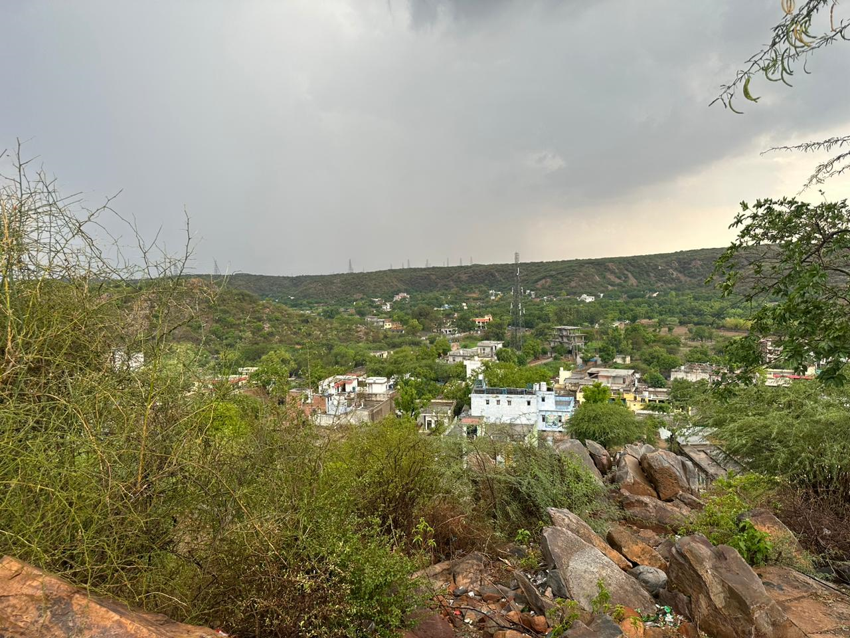
Mangar Bani is a sacred forest, which is located in Faridabad on the border of Delhi Haryana, next to Mangar village. Mangar Bani, a paleolithic archaeological site and sacred grove hill forest next to the Mangar village on the Delhi-Haryana border, which is dominated by Gurjar community; is in the South Delhi of Aravilimountain range in Faridabad district in the Indian state of Haryana. Mangar Bani has been studied by biologists who found it to be a high-diversity zone. It is one of the last remaining natural tropical forest in the Aravalli range. It has more than 30 native tree species thriving along with 100 native shrubs and herbs, all of which provide shelter to wildlife, animals and rare birds, and leopards.(Hindustan Times, 2015)

Methodology

In order to build the study using a case study methodology, documentary research was done. First, crucial information was gathered from academic publications on local tourism, community-based tourism, tourist entrepreneurship, and related topics. Next, information from websites of local tourism and CBT locations was gathered, and field surveys were used because they were more physically accessible. There is not a lot of literature available in these research fields because of their unique nature. Because this research incorporates qualitative components, observation and unstructured personal interviews were employed in the survey. Convenience sampling was also used. The following criteria are used to determine which CBT techniques will be used in the research, including field surveys and documentary research: Sustainability: The chosen CBT techniques should promote community engagement over the long term, improve community livelihoods consistently, and have a long-term tourism appeal. Compared to quantitative research, qualitative research frequently needs a lower sample size. Morse (1994) recommended a sample size of 30–50, while Creswell (1998) recommended a sample size of 20–30. The primary data serve as the article's theoretical framework. Tables were used to examine the data once it was collected to make it easier to understand. For research purposes, a small sample of 35 respondents, including 10 local Dhaba proprietors, 10 local inn/hotel owners, 10 transportation providers, and 5 village inhabitants, participated in an exploratory cum descriptive study.

FINDING AND ANALYSIS

PROFILEOFTHERESPONDENTS

S.  No. | Characteristics | Percentageof therespondents
1. | Respondent’sGender | Male:94%,Female:6%
2. | Age | 30-35: 58%,35-40:28% ,40 and above14%
3. | Respondent’sOccupation | Dhaba/Restaurant owners: 29%,Inn/Hotel owners:29%, Transport providers: 28%, Village Residents:14%

Table:1.1

FINDINGS:

More than 245 species of birds, 20 species of mammals, and around 300 species of trees have been recorded here, and Sunil tells me the forest cover has increased since mining within the forest stopped in 2007. “Nature is self-repairing,” he says, “The forest is resurrecting itself and the population of wildlife is increasing, but the land-use change in the surrounding areas needs to be controlled.” The conversion of forest land to real estate is a serious concern and is damaging the biodiversity and geology of the Aravalli ranges.

The region was declared a no-construction zone in 2016, which has helped, but the encroachment of land for construction activities continues to plague the Aravalli Hills around Mangar Bani. Cara Tejpal, head of the Sanctuary Nature Foundation’s Mud on Boot’s Project that supports Sunil’s work, explains: “The very vulnerable forest of Mangar is subject to degradation, encroachment, and ‘development’ interests, despite being one of very few green patches that provide invaluable ecosystem services to the horrifically polluted National Capital Region.” She points out that Sunil’s work is in the interest of the citizens of Delhi and Faridabad. “Sunil is a home-grown conservationist, and his relentless efforts to restore and protect the forest is inspiring,” she says.

Identify the untouched potential of Mangar Village:

Post the corona period as there has been a rise of visitors in Mangar Village, the village still does not haveany hotels or restaurants inside and since the village is covered majorly in the Forest area, tourists only prefer to visitthe outskirts of the village as it is considered to be the habitat of leopards, bear, deer, civets and 90 species of butterfly, besides the rare species of birds and peacocks, these statistics show that Mangar has huge hidden tourism Potential.
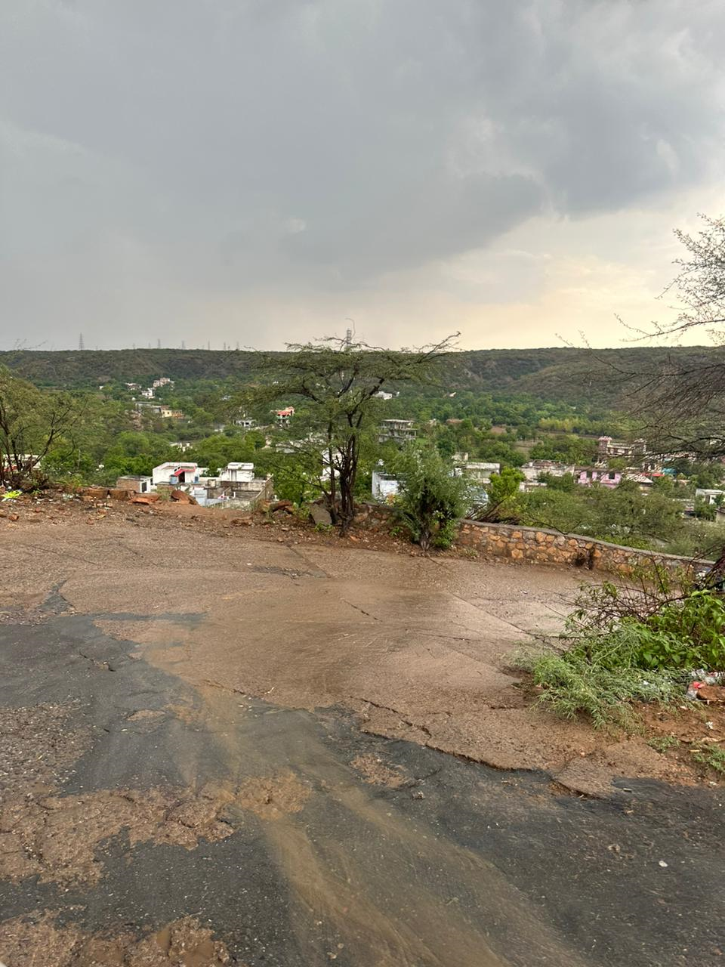

Identify the Hospitality Opportunities in Mangar Village:

The road leading to the village has around 10 dhabas, 12 hotels/inns/home-stays, however, there are no restaurants/eateries inside the village apart from that the village does not house any other kind of businesses like a Shopping Mart, Clothing store or even a flower shop for that matter, which proves that as Tourism increases the need for Eateries and Inns will increase as well. The Anupama Mangar, boutique property which was opened somewhere in 2017 is closed probably due to COVID. We need more simple, easily accessible properties which promote community-based tourism for guests to enjoy Mangar Village and Local Tourism. The locals have been protective about ecological conservation and respect the forest and have banned tree-cutting and grazing.

To analyze the challenges faced due to the promotion of tourism by the local residents of the village:

An increase in Tourism leads to the depletion of natural resources and an increase of pollution, vehicles etc, after speaking to one of the oldest residents of the village Mrs. GyanwatiBaisoya, a story was discovered about a sage named Gudariya Baba, It is said that the ghost of a local sage by the name of Gudariya Baba guards the forest of Mangar Bani. According to legend, a hermit by the name of Gudariya Baba visited the community many years ago and found enlightenment in a cave deep within this forest. After that, it became common knowledge that anyone who cuts down a tree for fuel, kindling, or livestock would suffer a curse. The inhabitants still zealously protect the forest, and not a single tree is chopped down or even manicured. As a result, in addition to unique bird species and peacocks, the forest is now home to leopards, bears, deer, civets, and 90 different types of butterflies! Bani is home to a lovely Dhau tree that formerly thrived widely throughout Rajasthan but is now all but extinct. The locals are constantly reminded of the vow made and the tradition upheld by a temple to Gudariya Baba that is tucked away in the middle of the forest. Locals from villages around Mangar visit the temple often.

The road to the temple itself is a very picturesque view as it is nestled in the forest covering the village.

The villagers do believe that the promotion of Tourism will bring in more people whowould love to see the local destinations of the village.

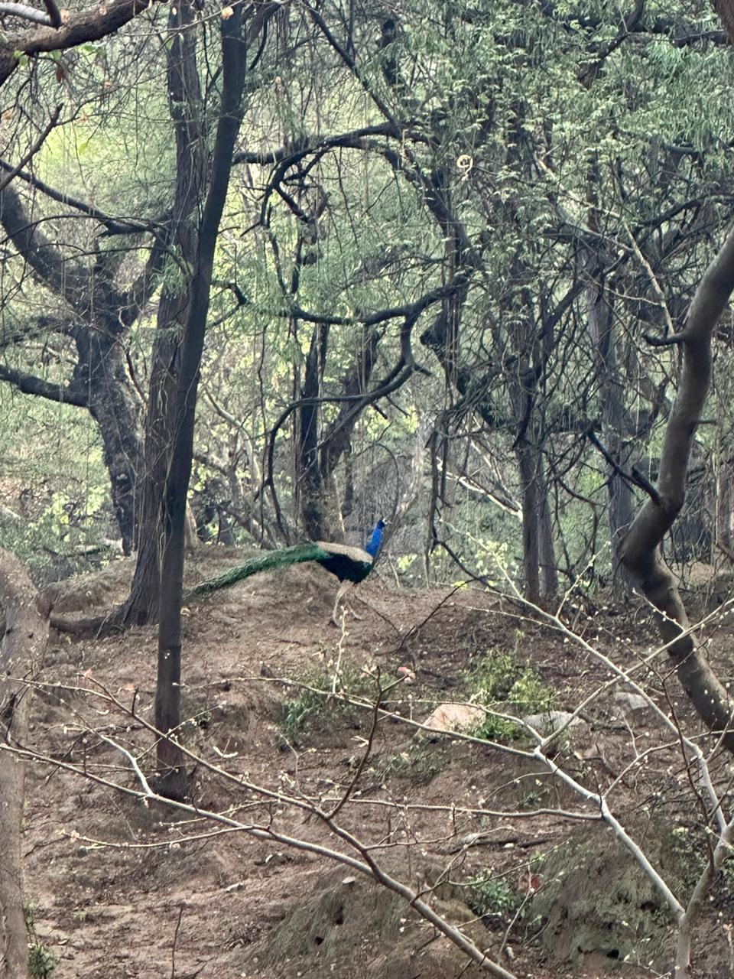

CONCLUSION:

One of India's industries with the quickest growth is tourism. Because of its infrastructure and history as a leader intourism, Haryana is lucky.Haryana as a state is very rich in every aspect for the development of Tourism. The Haryana Tourism Board has put into practice numerous cutting-edge techniques and policies that have drawn tourists and increased state revenue. The board is always trying to realize the full potential of the tourist industry, which is viewed as a very significant sector. Although the private Dhabas, Themes Resorts and some multinational Franchises are fierce competitors for the Haryana state-run tourist attractions, these local attractions also have their own charm that helps them draw large numbers of visitors. In addition, they provide such a wide range of travel packages that no private player can match.With its variety of attractions, Haryana may be inferred to have enormous potential for expansion in the tourism industry.

The State wants to take advantage of tourism's direct and indirect benefits on boosting the economy, reducing poverty, and empowering women while maintaining the environment. A friendly climate for private sector investment in the tourism industry is being created.

Most of the places of Haryana are already saturated with tourists like Chandigarh, Gurugram, Ambala etc. However Mangar still has the potential to grow a lot more and become one of the most loved Tourist destinations in the near future. It will also help in the growth of entrepreneurial opportunities, jobs and will bring in more funds for the development of the village as well.

REFERENCES:

- AlegreJoaquinandCladeraMagdalena(2009).Analysingtheeffectofsatisfaction and previousvisits on tourist intentions to return. Europeans JournalofMarketing. 43(5/6). 670-685.
- AsherMike(1989).MeasuringCustomerSatisfaction.TheTQMMagazine.1(2)
- Baker,DA.,&Crompton,J.L.(2000).Quality,SandBehavioralIntentions, AnnalsofTourism Research,27(3),785-804.
- Bowie David and Chang Jui Chi (2005). Tourist Satisfaction: A view from amixed international guided package tour. Journal of Vacation Marketing. 11(4)303-322.
- Fornell C. (1992). A National Customer Satisfaction Barometer: The Swedish Experience. Journal of Marketing, 56(1), 6–21.
- Ganapathy V. (2008): India, a Great Tourism Brand: Are we doing justice inmarketingit?:AdvertisingExpress: Volume:VIII,Issue:10.
- GnothJuergen,AndreuLuisa,KozakMetin(2009).Advancesintourismmarketingresearch:Introductiontoaspecialissueonconsumerbehaviorintourismdestinations.
- Gro¨nroos, C. (1990) Service Management and Marketing – Managing MomentsofTruthin ServiceCompetition.Lexington, MA:LexingtonBooks.
- Ignacio Rodriguez del Bosque, Hector San Martin, Jesus Collado, Maria del MarGarciadelosSalmones(2009).Aframeworkfortouristexpectations.InternationalJournalofCulture,Tourism andHospitalityResearch.3(2)139-147
- Joseph K. V (2008, December). Can Tourism Foster The Development Of IndianEconomy?TheICFAIUniversityJournalofGovernanceandPublicPolicy:Volume III,Issue: 4, 65-74.
- Kotler, P. (1994). Marketing Management: Analysis, Planning, ImplementationandControl(8th ed.).Englewood CliffsNJ: Prentice-HallInternational.
- Miller,J.A.(1977)„StudyingSatisfaction,ModifyingModels,IncitingExpectations,PosingProblemsandMakingMeaningfulMeasurements‟,inHunt,
- H. K. (ed.) Conceptualization and Measurement of Consumer Satisfaction andDissatisfaction,pp.72-91 Cambridge,M.A: MarketingScience Institute.
- NormannRichard(1978).ServiceManagement:StrategyandLeadershipinServicebusiness, 2d ed.(Chichester,UK: Jhon Wiley, 1991),16-17.
- Prof. Robert Christie-Mill, Tony Kurec (1980).Limits to the development ofTourism.Tourism Review. 35(4) 5-7
- RobertGee,GrahamCoates,MikeNicholson(2008).Understandingandprofitably managing customer loyalty. Marketing Intelligence & Planning. 26 (4)359 – 374.
- Sara Campo, Maria Jesus Yague (2009). Exploring non-linear effects of determinants on tourists' satisfaction. International Journal of Culture, Tourism and Hospitality Research. 3(2) 127-138.
- LovelockChristopher,WirtzJochen,ChatterjeeJayanta(2007).ServiceMarketingPeople,Technology,Perspective:AsouthAsianView(5thed).PearsonEducation.
- Singh, Praveen K (2008). Haryana grants industry status to hotel sector. RetrievedNovember 25, 2009, from http://www.expresshospitality.com/20080215/ market01.shtml.
- SinghAnand(2005).TourisminAncient India.SerialsPublications.
- WTTC (2022) Economic Impact Reports, (online). Available at Travel & Tourism Economic Impact | World Travel & Tourism Council (WTTC)
- Calderon, H., I. Gil, and M. G. Gallarza (2002) Destination Image: Towards a Conceptual Framework, Annals of Tourism Research, Vol. 29, No. 1, pp. 56-78,
- Donald Getz (1994) Residents' attitudes towards tourism: A longitudinal study in Spey Valley, Scotland, Tourism Management Vol. 15, Issue 4, pp 247–258
- Echtner, C. M., and J. R. B. Ritchie (2003) The Meaning and Measurement of Destination Image, The Journal of Tourism Studies Vol. 14, No. 1, pp. 33-48
- Saayman,M.;Giampiccoli,A. (2016) Community-basedandpro-poortourism:Initialassessmentoftheir relation tocommunitydevelopment. Eur. J. Tour. Res. 2016, 12, 145–190
- Ministry of Tourism, Government of India, (2012) India Tourism Statistics (online). Available from https://tourism.gov.in/sites/default/files/2020-04/India%20Tourism%20Statics%282012%29%20new.pdf
- Terencia, N. M. (2018). Community Based Tourism and Development in Third World Countries: The Case of the Bamileke Region of Cameroon. World Academy of Science, Engineering and Technology, International Journal of Social and Tourism Sciences, 12(1), 26-30.
- Tasci, A. D. S., Semrad, K. J., & Yilmaz, S. S. (2013). Community based tourism finding the equilibrium in COMCEC context: Setting the Pathway for the Future. Ankara: COMCEC Coordination Office
- Giampiccoli, A., &Mtapuri, O. (2020a). Towards a coalescence of the community-based tourism and ‘Albergo Difusso’ tourism models for Sustainable Local Economic Development. African Journal of Hospitality, Tourism and Leisure, 9(1), article 64:1-20. Retrieved from https://www.ajhtl.com/uploads/7/1/6/3/7163688/article_64_vol_9_1__2020_ukzn-dut. pdf

Hindustan Times (2015) Mangar Bani forest: Preserve biodiversity to ensure ecological security (online) Cited from Mangar Bani forest: Preserve biodiversity to ensure ecological security - Hindustan Times

- Morse, Janice M. (1994). Designing funded qualitative research. In Norman K. Denzin &Yvonna S. Lincoln (Eds.), Handbook of qualitative research (2nd ed., pp.220-35). Thousand Oaks, CA: Sage.

