Construction of efficient multifunctional enzymes for Bioethanol producion: Various approaches and Futuristic Developments
List of authors and their affiliations:
PriyankaNath *
¹School of Bioengineering Sciences and Research
MIT Art, Design and Technology University, Pune
Email-priyankanath2012@gmail.com

Ashily Rajendra²
²Department of Life Science and Biotechnology,
ChhatrapatiShivajiMaharaj University, Navi Mumbai, Maharashtra

Abstract:
Increase consumption of non renewable sources i.e. the fossil fuels has caused worldwide global warming and pollution. Bioethanol is one kind of biofuel produced from biological raw materials and lignocellulosic biomass. Bioethanol production can decrease the burden on non-renewable resources for energy. The chief constituents of the plant based lignocellulosic biomass are cellulose, hemicellulose and lignin. Cellulase and hemicellulases are responsible for hydrolysis of cellulose and hemicellulose components into monomeric sugars. The monomeric i.e. glucose and xylose can be fermented by using yeast for production of bioethanol. Moreover, the cellulases and hemicellulases are also used extensively for other industrial purposes such as biobleaching, food industry etc. However in spite of their larger industrial application, these present enzyme have low catalytic efficiency and high production cost of multiple enzymes, Due to these noteworthy efforts have been initiated for improving the performance and production rate of the present enzymes. Therefore, present chapter provides an overview of current scenario and development in the field of plant cell wall degrading enzymes and there application. The chapter discusses different approaches of protein engineering tool to study the underlying mechanism of action of these enzymes and the current techniques utilized for refining their activity. The chapter also discusses recent development in production of efficient multifunctional chimeras for degradation of complex polysaccharide in a single reaction. Furthermore, the chapter also highlights the synthetic biology approaches that have been used for designing artificial designer cellulosomes containing distinct cellulases and xylanases domains which showed enhanced synergistic action against plant based biomass. Finally, the chapter covers various challenges and futuristic applications of these engineered enzymes in the field of renewable energy production.
Keywords (4-5): Lignocelluloses bimoass, bioethanol, protein engineering, designer cellulosome

  - Introduction
The extensive use of fossil fuels is the leading cause of global warming and pollution worldwide. The use of renewable energy sources is one of the solution to decrease the increasing harmful effects.
Nowadays, the main focus of the mankind is to make activities and life on earth more at ease by addition of essential products generated through biological processes. In the current scenario, each year millions of tons of plant based raw materials or lignocellulosic biomass are unused by burning them without providing benefits to living organisms. Therefore, it is highly important that these raw materials and lignocellulosic biomass should be efficiently utilized for generating renewable energy source in the form biofuel by developing advanced scientific strategy. The lignocellulosic biomass are comprised of complex polysaccharides mostly cellulose, hemicelluloses and lignin. These complex polysaccharides are breakdown by different set of enzymes called cellulase, hemicellulase and laccase in simpler monomers. The monomers mostly glucose and xylose are utilized by yeast in fermentation process to produce alcohol known as bioethanol. The bioethanol is the alternative form of energy that can be used as energy source instead fossil fuels. The enzymatic process involved in depolymerization of complex polysaccharides is one of the critical step in the production of bioethanol. Moreover, the low catalytic efficiency and production multiple enzymes involved in complete degradation of carbohydrate polymer is one of the chief concern among scientific community.
Nowadays, major advancement in enzyme technology has resulted in development of efficient enzymes having high catalytic efficiency and multifunctionality. These efficient engineered enzymes are utilized for complete degradation of carbohydrate polymer into monomers.

    - Lignocellulosic biomass and its components
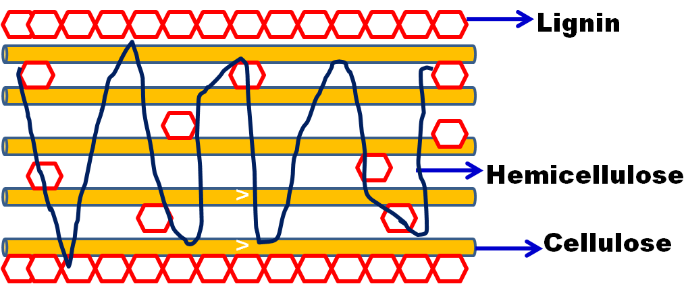
Figure: 1 Diagrammatic representations of components of the plant based lignocellulosic biomass

Plant based lignocellulosic biomass are cheap and readily available. From the biofuel production view lignicellulosic biomass is of particular interest. The major polymeric constituents of lignocellulosic biomass are cellulose, hemicelluloses and lignin as shown in Figure. 1 [1]. Generally, cellulose fibrils are encrusted with hemicelluloses forming an open system, the remaining open spaces are filled up with lignin (Figure. 1). The different components of lignocelluloses biomass are discussed below.
1.1.1.1 Cellulose
Cellulose is the chief component plant based biomass. The cellulose content in most plant based biomass is on an average 33% [2]. The cellulose is extracted from biomass materials for biofuel production [2]. Cellulose is an organic polymer consisting of linear chain of glucose moieties connected together by β (1→4) linkage as shown in Figure 2 [3].
The microfibrils of the cellulose are insoluble and are arranged into a cable-like structures (Figure 1) which comprised of around 24 hydrogen-bonded chains comprising β-(1,4)-linked glucose moieties as shown in Figure 2 (Guerrieroet al.. 2010, Fernandeset al., 2011, Nsoret al., 2017). The glucose polysaccharides chain is made up of glucose molecules forms parallel and successive chain of glucose moieties. The cellobiose is a disaccharide of glucose and is the repeating component of cellulose in which there is a 180° rotation of each glucose molecule with respect to its neighbouring glucose moeity as shown in Figure 3 [3]. The deconstruction of cellobiose is an estimation of β-glucosidase activity. The above arrangement described is responsible for a flat, inflexible and ribbon-like crystalline structure of glucan chains and is merged together by Van der Waals forces and hydrogen bonds to form microfibrils. Hydroxyl groups present in cellulose macromolecules are connected via enormous number of intra- and intermolecular hydrogen bonds, which caused in several ordered crystalline arrangements of cellulose chain into flat ribbon like conformations [4].
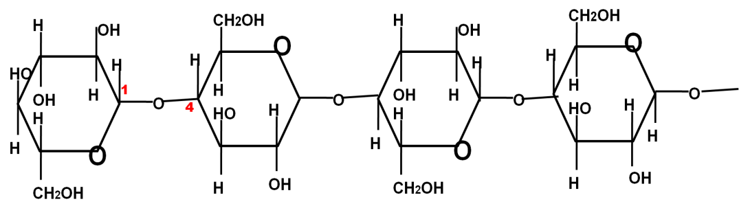
Figure 2: Demonstration of Cellulose chain in plant based lignocellulosic biomass
1.1.1.2 Hemicellulose
Hemicelluloses is the second most abundant polysaccharide representing 25-30% plant based biomass [5]. The hemicelluloses are made up of pentoses (xylose, arabinose), hexoses (mannose, glucose, galactose), and sugar acids [5]. The xylan is the most abundant hemicelluloses known. The hemicelluloses are not homogenous like cellulose, mostly they are heterogenous for example the hardwood hemicelluloses contains xylan however the softwood contains glucomannans [6]. The heteropolysaccharides xylan backbone is made up of homopolymaric chain of xylopyrranose units associated via β-1,4 linkages as shown in Figure 3. Based on the xylan source, the backbone chain of xylan constitutes branches of arabinose, glucuronic acid or its 4-O-methyl ether, and ferulic acetic and p-coumaric acids (Figure 3).
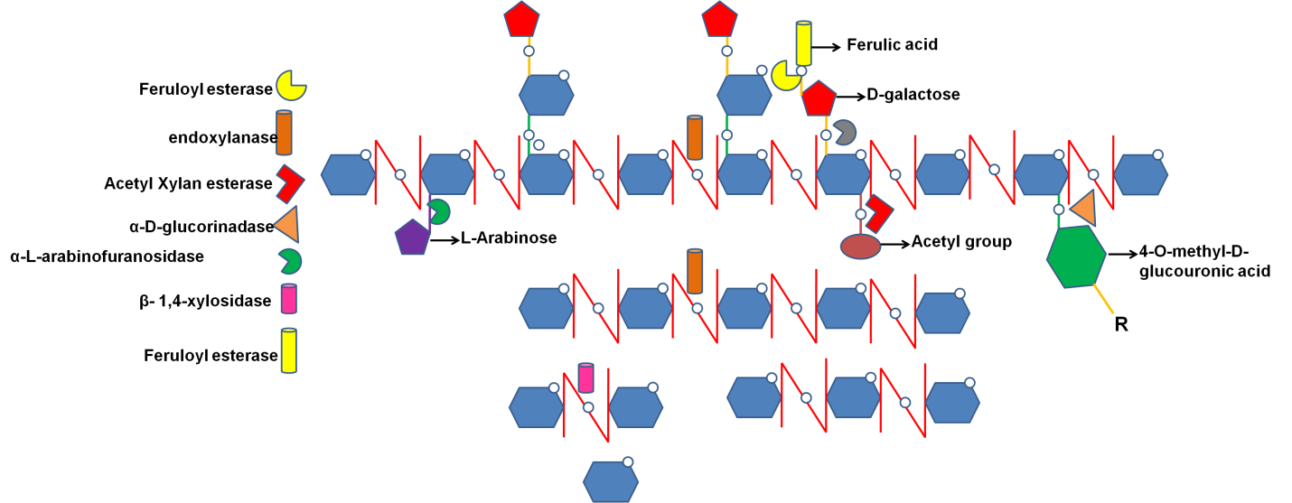
Figure 3. Xylan structure with different substituents and sites of attack by xylanases
1.1.1.3 Lignin
Lignin is the main non-carbohydrate polymer present in plant based biomass. It is constitute (15-40%) of lignocellulosic biomass [7]. Lignin is accountable for protecting the plant cell wall from degradation by action of microbial community. It provides mechanical strength and hydrophobicity to the plant cell wall. The lignin is made up of from polymerization of different aromatic groups Guaiacyl (G), Syringyl (S), and hydroxyphenyl (H) to form monolignols [7]. The lignin is responsible for recalcitration in plant based biomass. The cellulose accessibility is disrupted by higher content of lignin in lignocellulosic biomass thus reducing the avaibality of sugar residues for enzymatic saccharification reaction [7]. The lignin is connected to the carbohydrate polymer i.e. cellulose and hemicelluloses to form lignin carbohydrate complex or LCC through different linkages known as lignin carbohydrate complex linkages or LCC linkages (Figure. 4).The LCC linkages are mostly Benzyl ether and phenyl glycoside linkages. The Benzyl ether linkages connect the key OH groups of carbohydrates for example glucose, mannose galactose and arabinose to the α-position of lignin, while the Phenyl glycoside linkage is not well studied unlike Benzyl ether linkages [7].
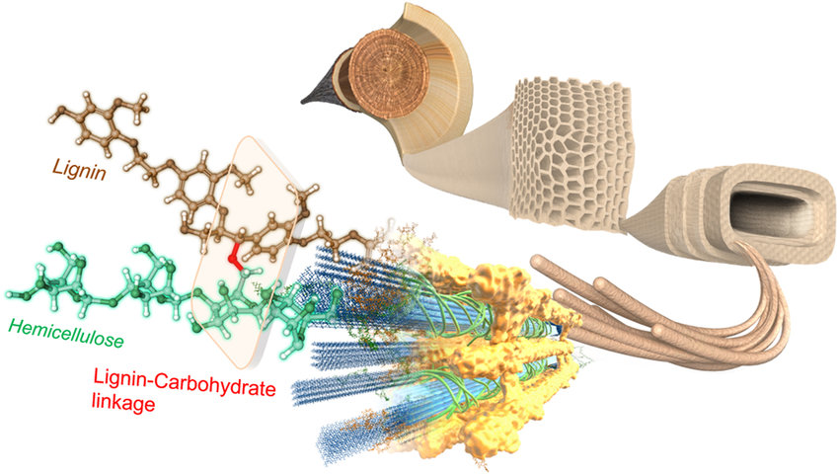

Figure 4 A 3D-dimensional interpretation of the lignin-carbohydrate complex (LCC) in the plant cell wall (Nishimura et al., 2018)

    - Enzymes for Lignocellulosic Hydrolysis
The plant based lignocellulosic biomass is recalcitrant in nature. Several factors are involved for biomass recalcitrant for example, high content of lignin, protection of cellulose by lignin, cellulose sheathing by hemicelluloses and high crystalinity and degree of polymerization [8]. The accessibility of plant carbohydrates for enzymatic saccharification is prevented by biomass recalcitration. However, various pretreatment strategies showed improved accessibility of plant carbohydrates thus increasing the enzymatic hydrolysis step for releasing total reducing sugars for further bioethanol production [8]. Moreover, the complete degradation of the plant carbohydrates mostly cellulose and hemicelluloses are achieved by utilizing multiple number of enzymes discussed in the subsequent sections [9].
      - Cellulases
Cellulose upon depolymerization by the combined action of endoglucanase, cellobiohydrolase and β-glucosidase gives the product glucose [9]. Cellulase enzymes belongs to different glycoside hydrolase families (GH) well described in CAZy database (www.cazy.org) [9]. Cellulase enzymes mostly constitute of two different modules namely, the catalytic module, which contains the active site and the non-catalytic carbohydrate binding module (CBM) as shown Figure 5. The two modules are connected by flexible linkers (Figure 5), comprising mostly of serine and threoninine residues [11].
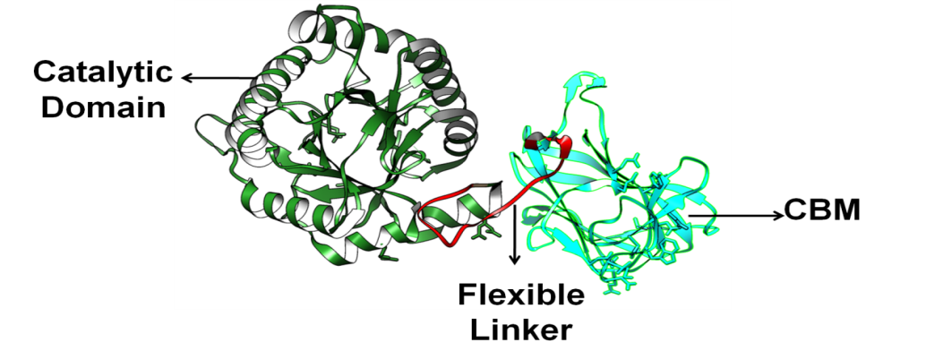
Figure: 6 Structure overview of a cellulase enzyme
Moreover, cellulolytic enzymes act synergistically, in which endo-β-1,4-glucanase randomly acts on the cellulose chain and generates cellodextrins which are the larger cellooligosacharides as a hydrolyzed products [12] (Figure 6). Cellobiohydrolase acts at the terminal of the cellodextrin chain and discharges cellobiose as the main product [12] (Figure 6).Moreover, ultimately the β-glucosidase acts on the cellobiose to release two molecules of glucose [12] (Figure 6). The following sections demonstrate different cellulases and their mode of actions.
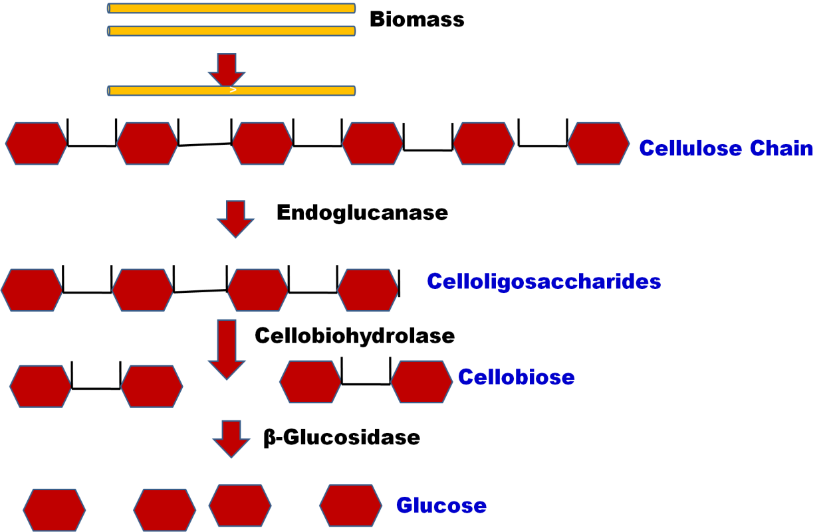
Figure 7: Demonstration of the action different cellulases in depolimerization of cellulose chain
      - Hemicellulases
Hemicelluases plays important role in degradation of plant based biomass. Hemicellulases depolarize xylans, xyloglucans, arabinoxylans and glucomannans of plant based biomass [5]. The hemicellulases are modular structure with catalytic and functional domains as shown in Figure. 7. In a previous study on extracellular β-L-arabinofuranosidase (HypBA2) which belong to glycoside hydrolase (GH) family 121 from Bifidobacterium longum [13] was found to be a multidomain protein consist of mostly N-terminal domain (amino acid residues 38-123, Brown), a N-domain from residue 124-303,Cyan followed by linker region from residue 304-347, yellow a catalytic region comprising of (α/α)₆ barrel domain (348–771, green) followed by a C-terminal domain (772–870, blue).
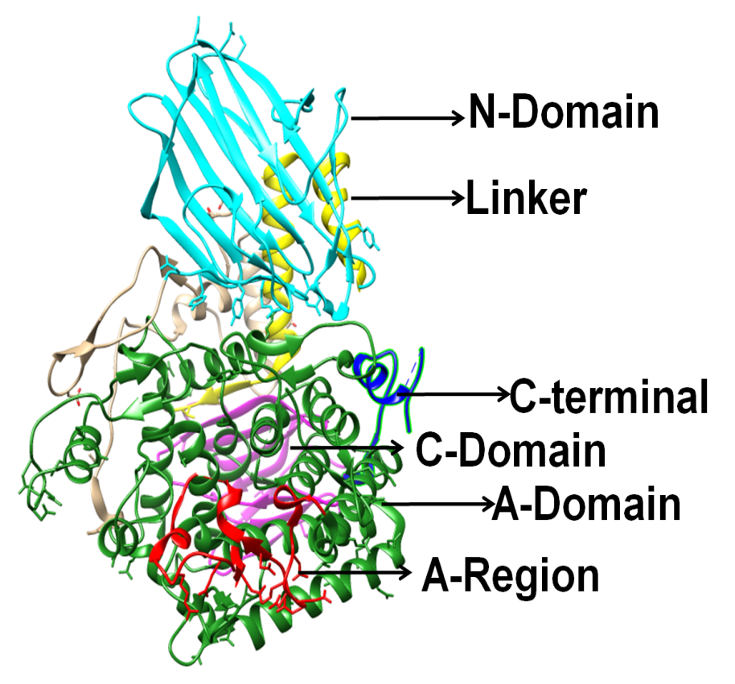
Figure 8: Multimodular structure of extracellular β-L-arabinofuranosidase (HypBA2) from glycoside hydrolase (GH) family 121 fo Bifidobacterium longum

The complete breakdown of hemicellulosic matter in plant biomass requires synergistic action of multiple enzyme due to its branched and organized structure as shown in Figure. 3
      - Lytic polysaccharide monooxygenases (LPMOs)
Lytic polysaccharide monooxygenases (LPMOs) are the mono-copper based enzymes which are broadly dispersed in nature that are responsible for catalysis of the glycosidic bonds hydroxylation in polysaccharide through oxidative reaction [14]. The LPMOs are auxillary enzymes and are distributed in CaZy database belonging to families AA9, AA10, AA11, AA13, AA14 and AA15 as demonstrated in Figure 9. In family AA10 the bacterial LPMOs are found which are responsible for cleaving cellulose and Chitin [15].
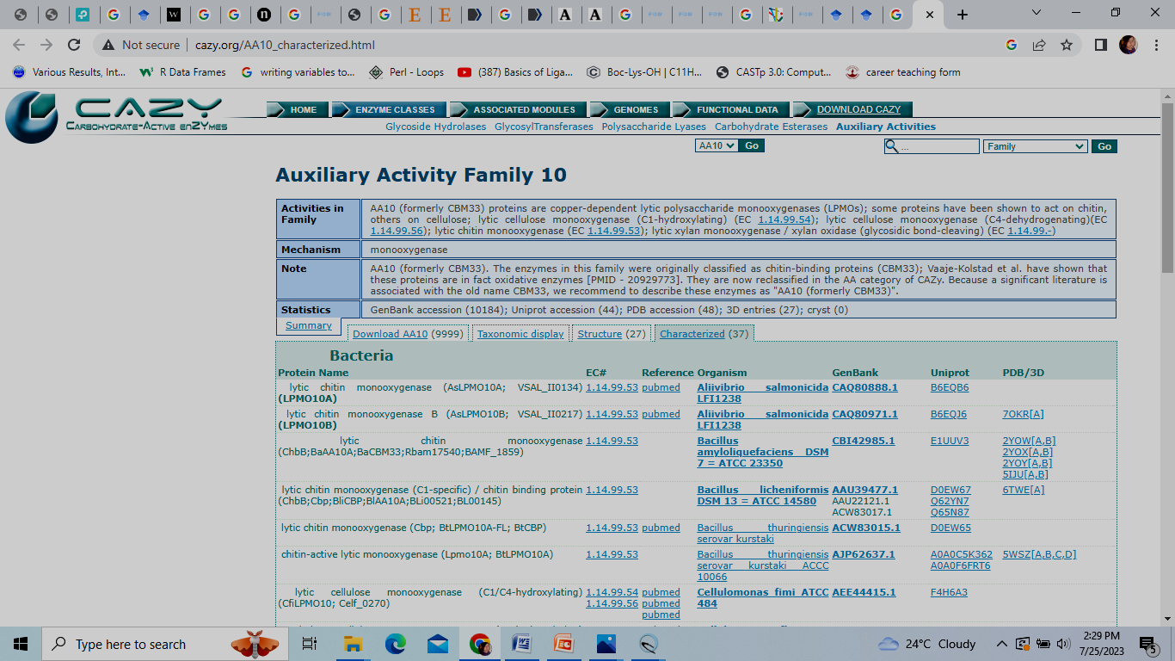
The LP

Figure 9: Demonstration of LPMOs are auxillary enzymes and are distributed in CaZy database
LPMOs produces holes on the crystalline surface of cellulose through oxidation reaction as shown in Figure 9. Thus LPMOs produce varied degree of cello-oligosaccharides [15]. Hence, the released cello-oligosaccharides are acted more efficiently by cellulases. The LPMOs acts synnergistically with cellulases for efficient breakdown of cellulose polymer in enzymatic hydrolysis reaction. Thus, nowadays the LPMOs act as a potent candidate in plant based biomass degrading enzyme cocktail [16].
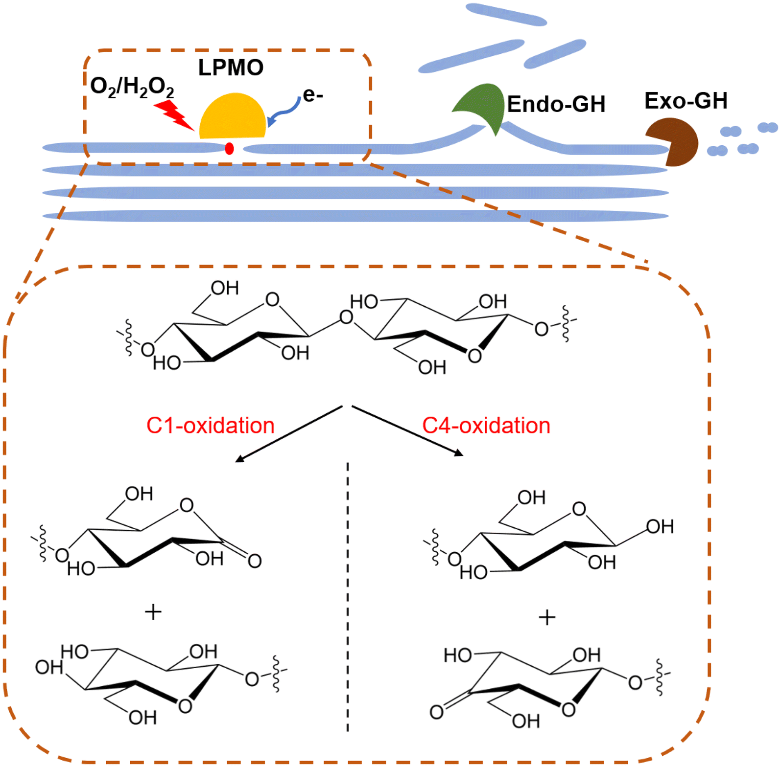

Figure 9: Diagramatic representations of LPMOs and glycosidase in synergestic degradation of carbohydrate polymer (Zhou et al., 2020)

  - Protein engineering existing plant cell wall degrading enzymes
      - Strategies for protein engineering
Cell wall degrading enzymes are widely used in enormous number of industrial purposes and therefore significant amount of efforts have been put for improving their performances and rate of production. Nowadays, protein engineering has been utilized to study the underlying mechanism of action of these enzymes, as well as efforts have been made for improving their activity. Protein engineering comprises the mutagenesis of potential binding site residues and their kinetic analysis. Moreover, inactive mutants are mostly utilized for studying the protein-ligand complexes at their three-dimensional level. The protein engineering can be achieved by three strategies mainly, the directed evolution, the rational designing and by construction of chimeras having multiple functionality. In the directed evolution strategy of protein engineering random mutations of the target genes were executed and the variant with the enhanced activity were selected [2] as shown in Figure.10. In rational designing, the three-dimensional complexes of enzymes have been used to design new strategies for modification and exploitation of the glycoside hydrolases for engineering the enzymes and modifying their functions [17] as shown in Figure.10. The chimeras with multifunctional activity were constructed by utilizing molecular biology techniques. In multifunctional chimeras two or more modules were fused in a single polypeptide chains [18] as shown in Figure.10. The multifunctional chimera constructed can result in reduction the cost of production of several which are required for complete degradation of plant based lignocellulosic biomass [19]
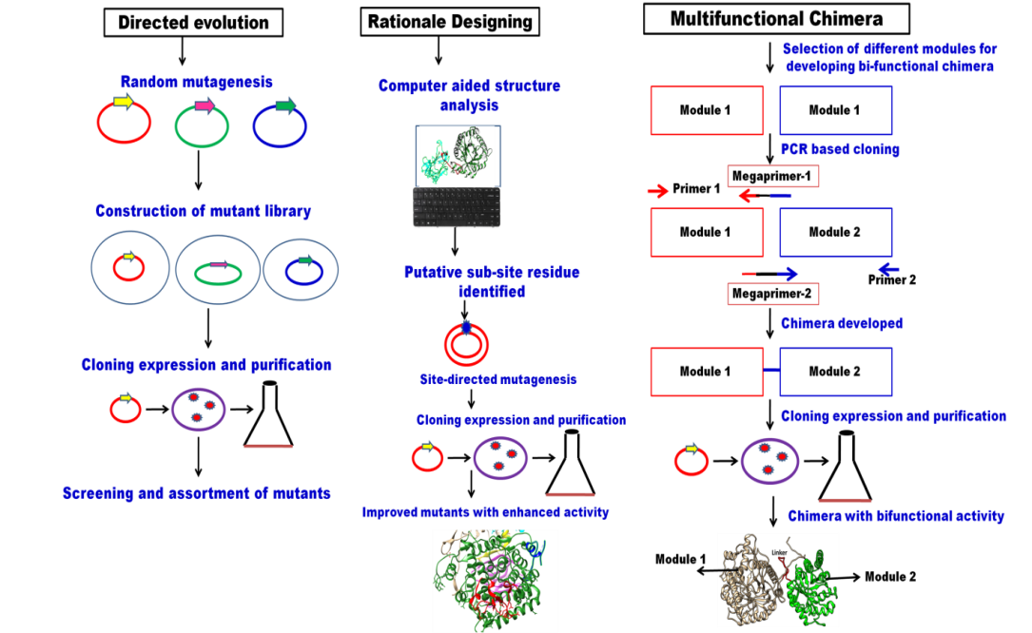

Figure 10: Diagrammatic representation of protein engineering strategies

      - Engineered multi enzyme complexes
Multi enzyme complex or cellulosome are large complex entity and are mostly found in anaerobic bacteria [20]. The multi enzyme complex or cellulosome is made up different carbohydrate degrading enzymes such as cellulase and xylanase [20]. The different domains in the cellulosome are attached by dockerin domain to a cohesion domain of main scaffoldin protein as shown in Figure 11. This complex structure is connected to the surface of microorganism. The cellulosome facilitates the microorganism to degrade the insoluble form of cellulose to soluble form so that the later could be absorbed by bacterial cell wall.
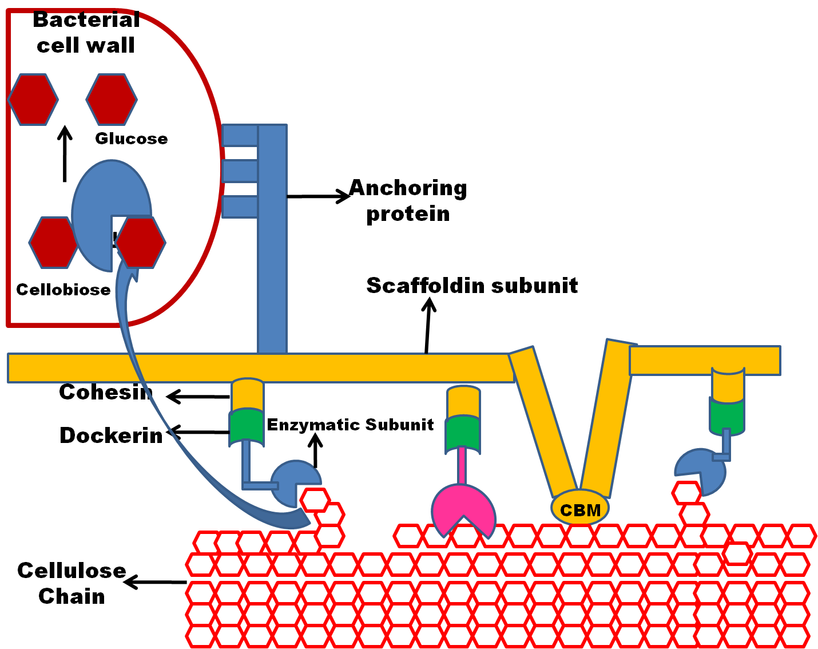

Figure 11: Structure and organization of cellulosome

        - Construction of designer cellulosome
Designer cellulosome or engineered multi enzyme complexes are developed by attaching carbohydrate active enzyme to a scafoldin discussed in the previous section with the help of strong cohesion and dockerin interaction [21]. Designer cellulosomes have efficient hydrolytic activity due to improved enzyme substrate closeness [21]. The designer cellulosome contains various domains which includes cellulases, hemicellulases, LPMOs and laccases [22]. The designer celluosome are constructed by meticulous incorporation of desired catalytic activities based on the target substrate. The designer cellulosome can be constructed using various steps discussed below in the flow chart (Figure 12). The first step includes selection of domains and designing of designer cellulosome enzymes and scafoldin protein. The second step consist of cloning of the cellulosome components by using their coding sequences. In the next steps the different components are assembled in the final multi enzyme complex. Lastly, in the final step the catalytic activity was determined for new assembled designer cellulosome.

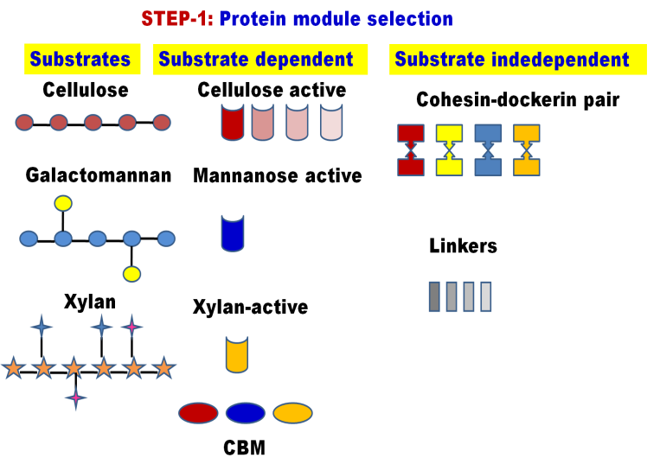
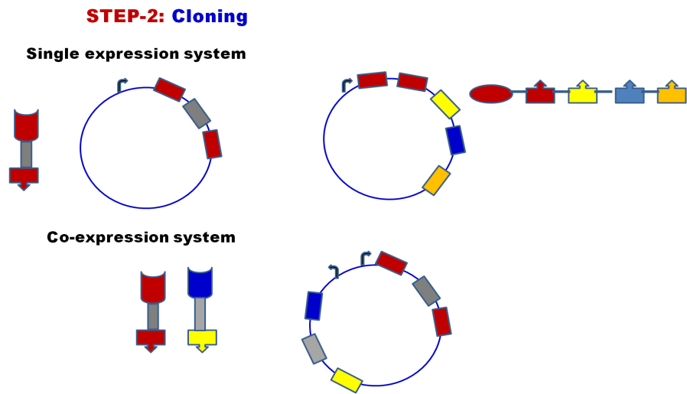
a
b

d
c
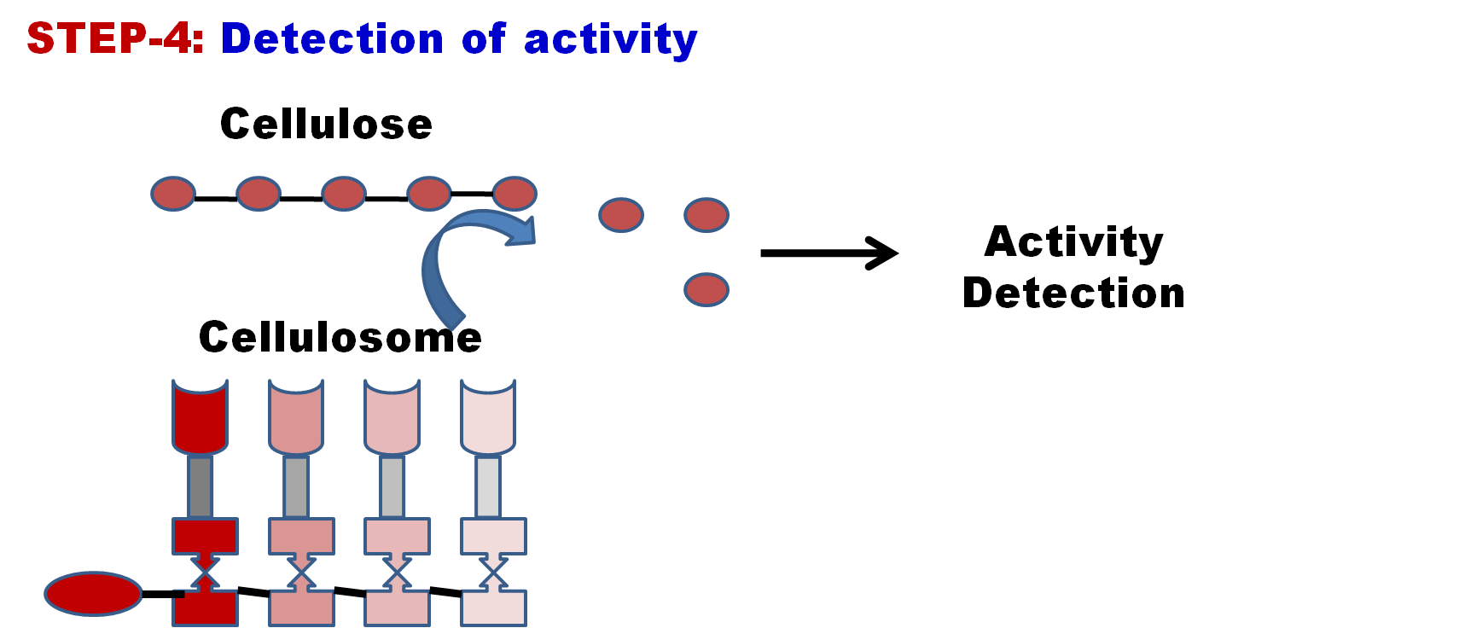
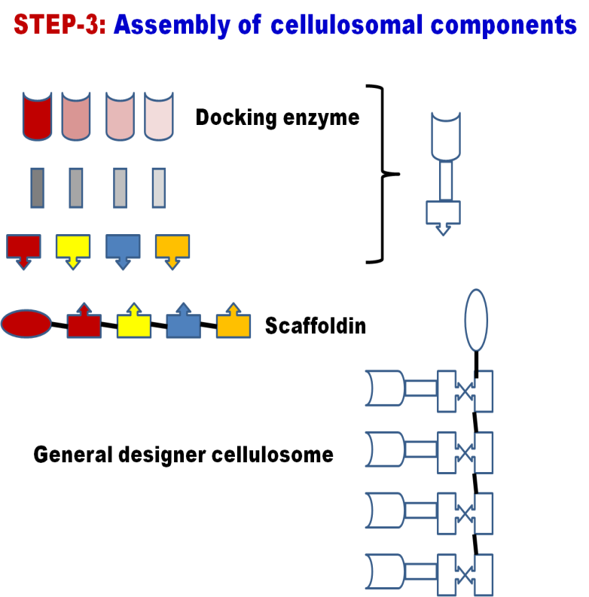

Figure: 12 Flow chart elaboratingthe steps for design, construction and evaluation of designer cellulosome

        - Applications of designer cellulosome
          - Lytic polysaccharide monoxygenases in designer cellulosome
The synthetic biology approaches are used for designing efficient cellulosomal complex. The LPMOs are responsible for boosting cellulose degradation. Moreover, in anaerobic bacteria the cellulase enzymes are assembled into large complex called cellulosome. Additionally, LPMOs are mostly known to be found in aerobic bacteria thus, it cannot be advantageous to the cellulosomal complex during cellulose degradation. In one of the study the LPMOs are incorporated into the cellulosomal complex through synthetic biology approach. In the study chimeric enzymes were developed by fusing LPMOs from the bacterium Thermobifidafusca using different dockerin in the cellulosomal system [23]. The study showed higher activity on the microcrystalline cellulose as compared to the wild-type enzymes (Table 1).
          - Xylan binding domain in designer cellulosome
The xylanase were employed to deconstruct the hemicelluloses component plant based lignocellulosic component [5]. Xylanases engineered in designer cellulosome system in deconstruct the cellulosic biomass more efficiently [5]. Xylanases are important because it is used in different industry for example textile, biorefinary, food and pharmaceutical [6]. In one of the study, an entire xylanolytic complex of the bacterium Thermobifida fusca has been incorporated into an artificial cellulosome using designer cellulosome approach [24].

  - Conclusion
The efficient enzyme with multi-functionality can be used for efficient degradation of cellulosic substrates. The multi-functionality can be introduced through protein engineering and designing artificial designer cellulosome. The engineered enzymes are utilized as cost effective process for enzymatic hydrolysis in deconstructing plant based lignocellulosic biomass and the technology can be transferred to biorefinery industry.
Reference
- Chapman, J., Ismail, A. E., & Dinu, C. Z. (2018). Industrial applications of enzymes: Recent advances, techniques, and outlooks. Catalysts, 8, 238
- Zhang, Y. H. P., Himmel, M. E., & Mielenz, J. R. (2006). Outlook for cellulase improvement: screening and selection strategies. Biotechnology Advances, 24, 452-481
- Huang, Y. B., & Fu, Y. (2013). Hydrolysis of cellulose to glucose by solid acid catalysts. Green Chemistry, 15(5), 1095-1111.
- Vietor, R. J., Newman, R. H., Ha, M. A., Apperley, D. C., & Jarvis, M. C. (2002). Conformational features of crystal‐surface cellulose from higher plants. The Plant Journal, 30(6), 721-731.
- Khangwal, I., Chhabra, D., & Shukla, P. (2021). Multi-objective optimization through machine learning modeling for production of xylooligosaccharides from alkali-pretreated corn-cob xylan via enzymatic hydrolysis. Indian Journal of Microbiology, 61, 458-466.
- Beg, Q., Kapoor, M., Mahajan, L., & Hoondal, G. S. (2001). Microbial xylanases and their industrial applications: a review. Applied microbiology and biotechnology, 56, 326-338.
- Nishimura, H., Kamiya, A., Nagata, T., Katahira, M., & Watanabe, T. (2018). Direct evidence for α ether linkage between lignin and carbohydrates in wood cell walls. Scientific reports, 8(1), 6538.
- Nanda, S., Azargohar, R., Dalai, A. K., & Kozinski, J. A. (2015). An assessment on the sustainability of lignocellulosic biomass for biorefining. Renewable and Sustainable Energy Reviews, 50, 925-941.
- Nath, P., Maibam, P. D., Singh, S., Rajulapati, V., & Goyal, A. (2021). Sequential pretreatment of sugarcane bagasse by alkali and organosolv for improved delignification and cellulose saccharification by chimera and cellobiohydrolase for bioethanol production. 3 Biotech, 11, 1-16.
- Kumar, K., Singal, S., & Goyal, A. (2019). Role of carbohydrate binding module (CBM3c) of GH9 β-1, 4 endoglucanase (Cel9W) from Hungateiclostridium thermocellum ATCC 27405 in catalysis. Carbohydrate research, 484, 107782.
- Zhang, Y. H. P., Himmel, M. E., & Mielenz, J. R. (2006). Outlook for cellulase improvement: screening and selection strategies. Biotechnology advances, 24(5), 452-481.
- Urbanowicz, B. R., Bennett, A. B., Del Campillo, E., Catalá, C., Hayashi, T., Henrissat, B., ... & Rose, J. K. (2007). Structural organization and a standardized nomenclature for plant endo-1, 4-β-glucanases (cellulases) of glycosyl hydrolase family 9. Plant Physiology, 144(4), 1693-1696.
- Saito, K., Viborg, A. H., Sakamoto, S., Arakawa, T., Yamada, C., Fujita, K., & Fushinobu, S. (2020). Crystal structure of β-L-arabinobiosidase belonging to glycoside hydrolase family 121. PLoS One, 15(6), e0231513.
- Kont, R., Bissaro, B., Eijsink, V. G., & Väljamäe, P. (2020). Kinetic insights into the peroxygenase activity of cellulose-active lytic polysaccharide monooxygenases (LPMOs). Nature Communications, 11(1), 5786.
- Forsberg, Z., Mackenzie, A. K., Sørlie, M., Røhr, Å. K., Helland, R., Arvai, A. S., & Eijsink, V. G. (2014). Structural and functional characterization of a conserved pair of bacterial cellulose-oxidizing lytic polysaccharide monooxygenases. Proceedings of the National Academy of Sciences, 111(23), 8446-8451.
- Zhou, X., & Zhu, H. (2020). Current understanding of substrate specificity and regioselectivity of LPMOs. Bioresources and Bioprocessing, 7(1), 1-19.
- Hwang, H. T., Qi, F., Yuan, C., Zhao, X., Ramkrishna, D., Liu, D., & Varma, A. (2014). Lipase‐catalyzed process for biodiesel production: Protein engineering and lipase production. Biotechnology and bioengineering, 111(4), 639-653.
- Nath, P., Sharma, K., Kumar, K., & Goyal, A. (2020). Combined SAXS and computational approaches for structure determination and binding characteristics of Chimera (CtGH1-L1-CtGH5-F194A) generated by assembling β-glucosidase (CtGH1) and a mutant endoglucanase (CtGH5-F194A) from Clostridium thermocellum. International journal of biological macromolecules, 148, 364-377.
- McKee, L. S., Peña, M. J., Rogowski, A., Jackson, A., Lewis, R. J., York, W. S., ... & Marles-Wright, J. (2012). Introducing endo-xylanase activity into an exo-acting arabinofuranosidase that targets side chains. Proceedings of the National Academy of Sciences, 109(17), 6537-6542.
- Bayer, E. A., Belaich, J. P., Shoham, Y., & Lamed, R. (2004). The cellulosomes: multienzyme machines for degradation of plant cell wall polysaccharides. Annu. Rev. Microbiol., 58, 521-554.
- Moraïs, S., Barak, Y., Caspi, J., Hadar, Y., Lamed, R., Shoham, Y., ... & Bayer, E. A. (2010). Cellulase-xylanase synergy in designer cellulosomes for enhanced degradation of a complex cellulosic substrate. MBio, 1(5), e00285-10.
- Arfi, Y., Shamshoum, M., Rogachev, I., Peleg, Y., & Bayer, E. A. (2014). Integration of bacterial lytic polysaccharide monooxygenases into designer cellulosomes promotes enhanced cellulose degradation. Proceedings of the National Academy of Sciences, 111(25), 9109-9114.
- Arfi, Y., Shamshoum, M., Rogachev, I., Peleg, Y., & Bayer, E. A. (2014). Integration of bacterial lytic polysaccharide monooxygenases into designer cellulosomes promotes enhanced cellulose degradation. Proceedings of the National Academy of Sciences, 111(25), 9109-9114.
- Moraïs, S., Barak, Y., Hadar, Y., Wilson, D. B., Shoham, Y., Lamed, R., & Bayer, E. A. (2011). Assembly of xylanases into designer cellulosomes promotes efficient hydrolysis of the xylan component of a natural recalcitrant cellulosic substrate. MBio, 2(6), 10-1128.

