Smart Bra Device for Detecting Breast Cancer Using Machine Learning

Dr. P.G.K. Sireesha¹, Dr. Venkata Kishore Kumar Rejeti², Shaik Johny Basha³

^{1,2}Professor, Department of CSE, KKR & KSR Institute of Technology and Sciences,
Guntur, Andhra Pradesh, India
³Sr. Assistant Professor, Department of CSE, Lakireddy Bali Reddy College of Engineering,
Mylavaram, NTR Dt., Andhra Pradesh, India

Abstract:
The most prevalent cancer in women globally, especially in young patients, is breast cancer. Breast tumours in young women are typically discovered at later stages than tumours developing in older individuals. In the past, breast cancer diagnoses at young ages have been associated with poor prognoses, especially for breast malignancies. Without the need of any scans, such as CT or MRI scans, Smart-Bra is used to identify breast cancer at an early stage. In this smart-bra technology, we use temperature, lumps and blood flow sensors by using Arduino can detect breast cancer. Unlike mammograms, which use low energy X-rays, the Smart Bra uses sensors which does not produce any harmful radiation effect. Smart Bra is non-invasive and painless method comparing to mammogram screening. Doctor suggests mammogram screening for only women older than 50 years. Smart Bra is completely safe and comfortable for the women.

Keywords: Smart Bra, Temperature Sensor, Lump detection, Machine Learning.

INTRODUCTION
One of the most prevalent malignancies in women and the second leading cause of cancer mortality in women is breast cancer. The low diagnostic accuracy is a significant contributor to the high incidence and death of breast cancer, despite the absence of effective treatments. Traditional methods for detecting breast cancer include mammography. A late diagnosis or misdiagnosis may occur in many situations, including those involving clinician carelessness or incompetence in addition to a mammography mistake, which might be deemed a cause of breast cancer death. It is crucial to boost the accuracy of breast cancer diagnosis since, in the long run, early-stage detection might dramatically raise the survival rate of breast cancer. Our project's major focus is improving survival rates by identifying breast cancer early.
Treatment is also challenging due to lack of knowledge. Breast cancer is the most prevalent malignancy in women due to ignorance and late detection. The incidence and death rates of cancer in women are consistently quite high. One of the most prevalent diseases in women, breast cancer is brought on by a variety of clinical, lifestyle, social, and economic variables. Based on traits buried in data, machine learning has the ability to predict breast cancer. Breast tumours in young women are typically discovered at later stages than tumours developing in older individuals. In the past, breast cancer diagnoses at young ages have been associated with poor prognoses, especially for breast malignancies. Annually, more than 1.15 million new instances of breast cancer are discovered globally. Only a few reliable prognostic and predictive indicators are now applied in clinical practise to the treatment of breast cancer patients.
The importance of early identification in reducing mortality and lengthening patient life for this lethal disease cannot be overstated. The most frequent sort of health problem among women, particularly among middle-aged women, is breast cancer. Breast cancer can be cured and the death rate can be decreased with early identification. According to the most recent cancer statistics, breast cancer is thought to be the sole cause of 15% of all cancer deaths in women and 25% of all new cancer diagnoses globally. Breast cancer affects 1 in 8 American women throughout the course of their lifetimes. People often seek medical attention right away for any indication or symptom, and the doctor may recommend another doctor to you if necessary. Breast cancer can be identified by a doctor by extensively reviewing the patient's medical history, physically inspecting both breasts, and even looking for any swollen or hardened lymph nodes in the armpits. In this research, the Smart Bra will be utilised to identify breast cancer, and machine learning algorithms will be used to forecast a patient's prognosis using the dataset. The early symptoms and diagnosis of the illness are made known to women by the smart bra. Women over 40 cannot have a mammogram or participate in the screening. Compared to a mammogram, a smart bra is really affordable.

LITERATURE REVIEW
[1] "Early Detection and Screening for Breast Cancer" was the suggestion of Cathy Coleman. Breast cancer is still a difficult, diverse condition. The best way to identify early-stage illness and reduce mortality is through serial mammography screening. Although organised mammography screening programmes may be hindered by politics and finances in many nations, skilled clinical and self-breast inspection can also detect tiny tumours when used sensibly.

[2] The study "Breast cancer detection using mammogram segmentation" by Badawy, Samir M. Hefnawy, Alaa A. Zidan, and Hassan E. explains that mammography is a specialised kind of medical imaging used to scan the breasts. Breast cancer is easier to identify and diagnose early when using a mammogram. Breast cancer areas can be found using mammogram image segmentation, improving diagnosis. They used an improved double thresholding-based strategy in this research to segment mammogram images. Additionally, scientists overlaid the final segmented picture's boundaries as a contour to the original image, making it simpler for doctors to find breast cancer in various Mammograms. The end outcome is an improved smart influence on mammography' ability to identify breast cancer.

[3] In the proposal titled "Breast cancer detection using deep learning" by Priyanka and Kumar Sanjeev, deep learning is referred to as a subfield of machine learning. Deep learning is a method for learning from data that is unsupervised. The breast cancer dataset is classified using a convolution neural network. A convolutional neural network is used to classify the photographs. The database of breast cancer image inputs is utilised. CNN receives the images and the pertinent weights as input. The weights are adjusted in order to decrease errors and boost performance.

[4] Maged A. Aldhaeebi and Khawla Alzoubi presented "Microwave imaging for Breast cancer detection". Microwave-based detection methods have a variety of advantages over other detection methods, including being less expensive, non-invasive, non-ionizing, and a pleasant kind of therapy. The electrical differences between normal and tumorous breast tissues are the basis for MI techniques, which also provide better sensitivity and the ability to detect small breast tumours. These detection techniques are based on the notion that the permittivity and conductivity of malignant breast tissues differ from those of healthy breast tissues in the microwave band. Three methods have been studied in the literature for microwave-based breast detection. Rongrong Guo and Baowei Fei proposed "Ultrasound Imaging Technologies for Breast Cancer Detection and Management".

[5]. Breast cancer screening and diagnosis frequently employ ultrasonic imaging. We sum up ultrasonic imaging technologies and their therapeutic uses for the treatment of patients with breast cancer in this study.

[6] "Pre-Trained Convolutional Neural Networks for Breast Cancer Detection Using Ultrasound Images" was the idea put out by Mehedi Masud and M Shamim. In this study, pre-trained convolutional neural network-based models for breast cancer detection utilising ultrasound pictures are implemented. With a classifier on the top layer, we specifically optimised the pre-trained models for extracting important information from ultrasound pictures. Through fivefold cross validation, we evaluated the accuracy of seven well-known, cutting-edge pre-trained models employing various optimizers and hyper-parameters. In addition, we investigate how successfully the models extract important information from the ultrasound pictures to identify tumours by taking into account Grad-CAM and occlusion mapping methods.

Sebastien Jean proposed the concept of "Breast Cancer Detection Using Infrared Thermal Imaging and a Deep Learning Model" [7]. The first area of research we examined in our assessment of the literature was infrared digital imaging, which holds that a straightforward thermal comparison between a healthy breast and a breast with cancer always shows an increase in thermal activity in the precancerous tissues and the regions around growing breast cancer. Our research led us to the additional conclusion that the well-known hemispheric model was essential to the successful completion of a Computer-Aided Diagnostic (CAD) that included infrared image processing. The original contribution of the study is the development of a comparative analysis of several breast cancer detection techniques.

[8] Samuels Maar and Dianna "Detection of Cancer DNA in Plasma of Patients with Early-Stage Breast Cancer" was a proposal made by Leslie Cope. Studies have shown that, particularly in individuals with metastatic illness, it is possible to accurately identify and measure circulating cell-free cancer DNA and RNA. This is based on the idea that somatic mutations, or DNA modifications exclusive to cancer cells and absent in normal cells, exist in cancer DNA. It is believed that both healthy and cancerous cells shed or release DNA into the bloodstream.

[9] Y. Ireaneus The study "Early Detection of Breast Cancer Using SVM Classifier Technique" was suggested by Anna Rejani and S. Thamarai Selvi. An method for cancer identification using mammograms is presented in this research. Two difficulties are the main emphasis of the suggested system. One is learning how to identify cancers as suspicious areas that contrast extremely weakly with their surroundings, and the other is learning how to extract attributes that classify tumours.

[10] "The Pre-Processing Techniques for Breast Cancer Detection in Mammography Images" was proposed by R. Ramani and S. Valarmathy. Due to the low quality of the mammogram images that were acquired, pre-processing is the most crucial phase in the mammography analysis. To rectify and alter the mammography picture for further analysis and processing, pre-processing is crucial. There are several filtering methods that may be used for pre-processing.

[11] Professor Monica Morrow proposed the use of MRI for the detection, diagnosis, and treatment of breast cancer. MRIs are frequently used for therapy selection as well as breast cancer screening of women at greater risk. Prospective studies have demonstrated that in women with known or suspected genetic abnormalities, MRI screening is more sensitive than mammography in identifying cancer. On the other hand, there are no statistics on survival. MRI detects malignancy in people with breast cancer that traditional screening approaches miss.
Background
1) Breast cancer detection with mammography
Mammography is a type of medical imaging specifically used to scan the breasts. Breast cancer is easier to identify and diagnose early when using a mammogram. Breast cancer areas can be found using mammogram image segmentation, improving diagnosis. Mammogram idea is employed in the current breast cancer diagnostic method. The mammogram procedure is risky and emits dangerous radiation that has an impact on the body. The most significant point is that physicians advise against mammograms for anybody under the age of 50. Little girls cannot benefit from it.

2) Breast Imaging
One method for detecting breast cancer is ultrasound screening, which uses a transducer to transmit sound waves into the breast and detect echoes from within it. These echoes are utilised to create ultrasound pictures.

3) Magnetic Resonance One way for finding breast cancer is MRI imaging scanning. MRIs are frequently used for therapy selection as well as breast cancer screening of women at greater risk. Prospective studies have demonstrated that in women with known or suspected genetic abnormalities, MRI screening is more sensitive than mammography in identifying cancer. MRI detects malignancy in people with breast cancer that traditional screening approaches miss. In two randomised investigations, this increased sensitivity did not lead to better surgical treatment selection or a reduction in the number of procedures.

4) Breast Examination
Breast Examinations is one of the techniques, where we take the blood samples of the patient. If we find the cancer cells in the tumor of breast, it tests positive. In existing systems, we identified many problems.
Mammogram is very expensive, which uses the harmful radiations. Mammogram screening is not possible for women above 40 can undertake the screening. Mammogram have a lot of side effects. Women who receive false-negative mammography results may feel insecure when they actually do have breast cancer. Breast ultrasonography cannot provide or pinpoint the precise outcome. If the transducer passes over a delicate or sensitive part of your breast, the client experiences discomfort.
MRI scans have a lot greater price tags as well as patient pain throughout the operation. The MRI scanner exposes the patient to extremely strong electromagnets, necessitating the shielding of the scan chamber. Breast-Self Exam indicates a self-examination in which there may be a number of drawbacks, such as overestimating the advantages of self-examinations and becoming frightened if you uncover something suspicious in your breast.
• False-negative mammography results.
• Not all women will benefit from mammograms.
• Mammograms are pricey.
• Breast ultrasound cannot detect many malignancies.
• Breast exams make people more anxious.

Methodology
Smart Bra is our proposed system which can be used for detection of breast cancer at an early stage. The life-sharing bra has sensors like temperature, lumps and blood flow sensor. Temperature sensor is used as the cancer cells have a high metabolic rate, and so, have a higher temperature than normal cells. If there is an abnormality it shows up a temperature difference. The bra is worn for 15 to 20 minutes. This bra is completely safe and also convenient method comparing to mammogram. Health care professional can easily carry them easily in their bags during field visits hence it is portable device. We came up with the solution of Smart Bra which is an intelligent device is used to detect the breast cancer at an early stage of life. Smart Bra Produces the result to the phone or tablet by giving guidance to the women to consult doctors. By which many women detect breast cancer at an early stage. The smart bra uses temperature sensors for detecting temperature specifically in the breasts. Our model predicted the possibility of differentiation of cancerous breasts from healthy breasts by significantly different skin temperature variation. In proposed system we came up with the new solution which the Smart Bra includes Temperature sensors and through symptoms. This Smart Bra is applicable to any age group whereas in existing systems it is not like that. It is applicable to particular age group. This is one of the biggest advantages in our proposed system.

The methodology involves for detecting breast cancer is as follows:
- Take the Smart Bra.
- Place the temperature sensor inside the Bra.
- Predicting the temperature.
- Sending notification to the mobile application.
- Check the symptoms and temperature in the mobile application.
- If the temperature and symptoms will match then it displays that the person is affected with Breast cancer.
Process taking place for detection of breast cancer is as follows:
- Inside the smart bra we are placing a temperature sensor.
- After placing the temperature sensor, it predicts the temperature.
- If temperature is too high or too low, then it sends the notification to the mobile application named as MIT APP INVENTOR.
- These sensors produce the results accurately. In that application, we have to select the symptoms of a person.
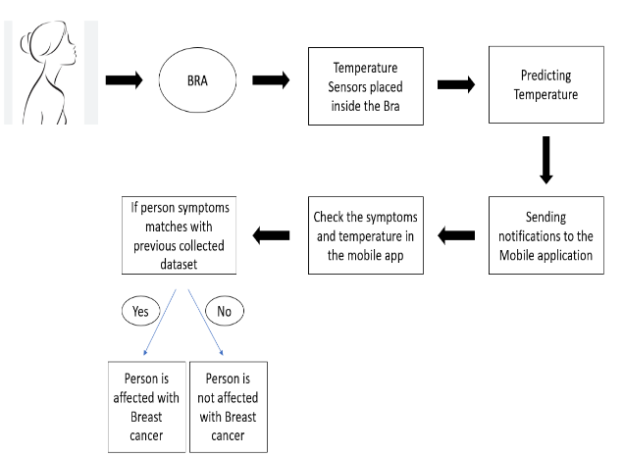
- Previously we collected the data sets which consists of symptoms of breast cancer.
Fig: A Smart Bra device System for detecting Breast Cancer

Results:
The result of the Temperature sensor that is shown when it is going to predict the temperature is shown in the below figure.
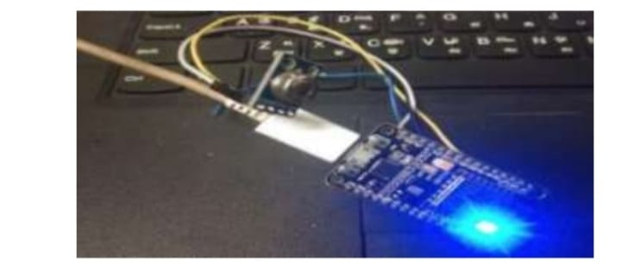
Fig: Temperature Sensor
Now, the below figure shows the Temperature variation in the form of graph when she wears a Smart Bra where the Temperature Sensor placed inside the smart Bra.
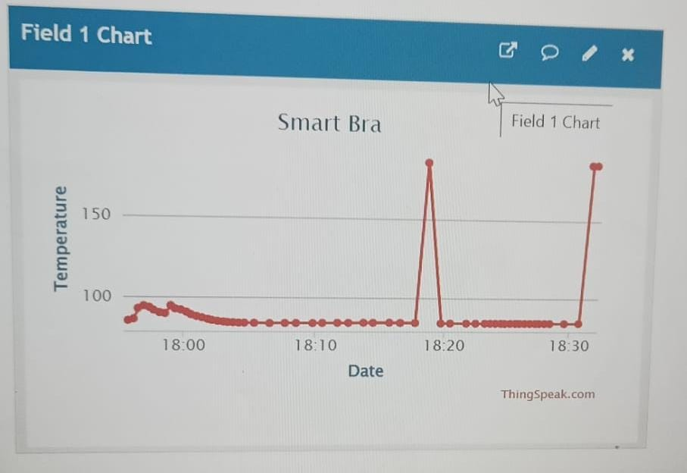
Fig: Temperature variation of a woman
The Fig shows the notification sent to mobile when the temperature is in abnormal condition. It sends to a woman as an alert message where the woman can react quickly and have to select symptoms.

Fig: Alert message sends to mobile
After recieveing the alert message the woman have to select the symptoms after login into the MIT App Inventor. The below figure shows the login page to select the symptoms.

Fig: Login Page
After login into the MIT App Inventor the woman have to select symptoms. The below figure shows to select symptoms.

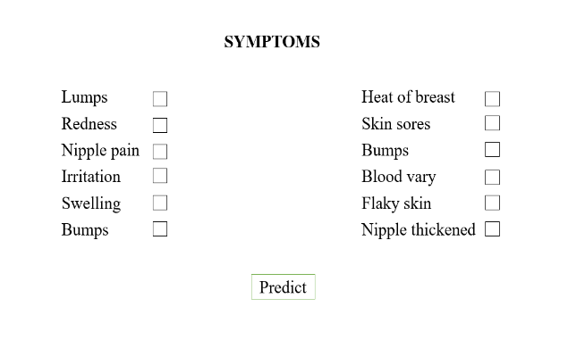

Fig: To Select Symptoms of a woman
CONCLUSION
Our paper major goal is to improve survival rates by employing a Smart Bra to identify breast cancer at an early stage. Microwave sensors and other imaging methods like deep learning and machine learning are frequently employed in breast cancer imaging approaches. However, in this study, we proposed a novel method that enables more accurate lump and malignant tissue diagnosis. For Analysing the breast cancer Temperature Sensor have been used. And finally, visualization of breast will be processed as alert message to mobile phone. Future scope for this project will be effective than previous method, like graphical representation to analyse the depth and stage of the tumour.

REFERENCES
[1] M. Tahmooresi, A. Afshar, B. Bashari Rad, K.B. Nowshath, M.A. Bamiah,” Early Detection of breast cancer using machine learning techniques, ”Journal of Telecommunication, Electronic and Computer Engineering, vol. 10, no. 3-2, pp. 21-27, 2018.
[2] Puspanjali Mohapatra, Baldev Panda, Samikshya Swain, “Enhancing histopathological Breast cancer image classification using mammography,” International Journal of Innovative technology and Exploring Engineering, vol. 8, no. 7, pp. 2024-2032, 2019.
[3] Shwetha K, Spoorthi M, Sindhu S S, Chaithra D, “Breast cancer detection using deep learning technique,” International Journal of Engineering Research & Technology, vol. 6, no. 13, pp.1-4, 2018.
[4] Sivapriya J, Aravind Kumar V, Siddarth Sai S, Sriram S, “Breast cancer prediction using
Microwave imaging,” International Journal of Recent Technology and Engineering, vol. 8, no. 4, pp.4879-4881, 2019.
[5] Muhammet Fatih Aslam, YunusCelik, KadirSabanci, AkifDurdu, “Breast cancer diagnosis by different machine learning method using thermal imaging data,” International Journal of Intelligent System and Applications in Engineering, vol. 6, no. 4, pp. 289-293, 2018.
[6] Rossano Girometti & Martina Zanotel & Viviana Londero & Anna Linda & Michele Lorenzon & Chiara Zuiani, “Automated breast volume scanner in assessing breast cancer size. A comparison with conventional ultrasound and magnetic resonance imaging”, European Society of Radiology 2017.
[7] Muhammet Fatih Aslam, YunusCelik, KadirSabanci, AkifDurdu, “Breast cancer diagnosis by different machine learning method using thermal imaging data,” International Journal of Intelligent System and Applications in Engineering, vol. 6, no. 4, pp. 289-293, 2018.
[8] Bilal Majeed, Hafiz Talha Iqbal, Uzair Khan and Muhammad Awais Bin Altaf, A Portable Thermogram based Non-contact Non-invasive Early Breast-Cancer Screening Device, IEEE-2018.
[9] Vishal Deshwal, Mukta Sharma, “Breast cancer detection using SVM classifier with grid search techniques,” International Journal of Computer Application, vol. 178, no. 31, pp. 18-23, 2019.
[10] J Malone S Snguon, MA Adams, Breast cancer screening and cancer among black sexual minority women using mammography, A scoping review of the literature from 1990-2017, Journal of women’s- 2019-Liebertpub.com.
[11] Lulu Wang, Microwave Resonance Imaging for Breast Cancer Detection, Sensors, 2018.

