PROMOTING SUSTAINABLE AGRICULTURE IN SEMI-ARID VERTISOLS: SYNERGISTIC INTEGRATION OF MANURE AND FERTILIZER PRACTICES FOR ENHANCING SOIL FERTILITY AND CROP PRODUCTION

Sindhu R Rathod*, S.D. Jadhao, Pratik Ramteke
Department of Soil Science and Agricultural Chemistry, Dr. Panjabrao Deshmukh Krishi Vidyapeeth, Akola, 444104, Maharashtra, India *Corresponding author Email: sindhurrathod9@gmail.com
Abstract
Improving soil nutrients are essential for the sustainable agriculture. Manure is an excellent source of supplying nutrients such as organic matter that can help in enhanced production. Manure provides higher organic matter to the soil and hence impact on soil quality. The addition of organic manures in soil has been evidenced to improve soil characteristics, in addition to improving nutrient availability. Fertilization is an important management strategy for crop yields by mediating soil fertility. Fertilization showed profound impacts on soil health by altering soil chemical, physical, and biological processes. Balanced and integrated use of organic and inorganic fertilizers may enhance the accumulation of soil organic matter and improves soil physical properties.
Keywords: Manuring, fertilization, INM, soil physico-chemical properties, crop productivity.
I. INTRODUCTION
Over the past six decades, India has witnessed a remarkable surge in food production, primarily attributed to the adoption of modern agricultural technologies. Among these advancements, fertilizers stand out as a pivotal component contributing to this transformative progress. Nutrient inputs, particularly Nitrogen (N) and Phosphorus (P), have emerged as critical determinants in unlocking the productivity potential of high-yielding crop varieties [1].
Modern agricultural practices have witnessed widespread utilization of chemical fertilizers, which, unfortunately, has brought about adverse consequences for the environment and land quality. In order to mitigate these repercussions and ensure a more harmonious coexistence between agricultural productivity and environmental well-being, a paradigm shift towards balanced fertilization strategies is imperative. This entails the application of carefully calibrated fertilizers that not only foster enhanced crop yields but also uphold the integrity of the soil ecosystem.
The paramount significance of balanced fertilization becomes evident in its twofold impact: augmenting agricultural output and safeguarding soil health. The intricate interplay between nutrient availability and crop productivity is mediated by the judicious use of fertilizers. Achieving an optimal equilibrium in nutrient supply not only leads to increased crop productivity but also acts as a safeguard against soil degradation. Sustainable agriculture hinges upon the preservation and enhancement of soil quality, a feat that hinges on the integration of various nutrient sources.
Organic manure emerges as a cornerstone of this integrated approach. Laden with organic matter and essential nutrients, manure contributes significantly to soil fertility enhancement and crop yield amplification. The enrichment of soil with organic matter through manure application has a profound impact on soil structure and quality. Moreover, the incorporation of organic manures augments nutrient availability, nurturing a soil environment conducive to robust plant growth.
However, the continuous application of imbalanced fertilizers, especially within the intensive rice-wheat cropping system of the Indo-Gangetic Plains, has exerted deleterious effects on soil health. To counteract this, the practice of integrated nutrient management emerges as a viable solution, demonstrating the potential to rejuvenate soil's physical structure and chemical fertility. This, in turn, contributes to the enhancement of soil organic carbon content, ultimately fostering sustainable productivity within the agricultural system. While existing literature extensively examines the influence of organic matter on soil structure and other properties, the focus often centers on the bulk soil level. Regrettably, less attention has been directed towards comprehending soil mechanical properties at the scale of aggregates, which presents distinct manifestations that can substantially impact bulk soil characteristics [3].
The application of organic manures engenders improvements in soil structure, manifesting in enhanced air capacity, potential root extension, and exploitation of a larger soil volume. Additionally, it bolsters water retention within the soil profile [4], [5]. This augmentation in water retention subsequently translates to increased moisture availability for crops [6]; [7]; [8]. solidifying the acknowledged significance of organic matter in relation to soil's physical fertility [9]; [10]. Remarkably, the incorporation of organic matter into soil induces positive effects on aggregation [11].
Concurrently, the judicious incorporation of inorganic fertilizers complements the organic facet of nutrient management. Fertilization regimes, when properly tailored, exert transformative effects on soil health by influencing its chemical, physical, and biological attributes. The strategic integration of organic and inorganic fertilizers holds the promise of fostering enriched soil organic matter accumulation and refining key soil physical properties.
Conversely, inorganic fertilizers have been documented to stimulate root proliferation and depth in cereal crops [12]; [13]. with their impact on soil aggregation also observed [14]. Furthermore, the application of composted manure has been linked to the improvement of water-stable aggregates in soil [15].
The integration of organic manures and fertilizers presents a promising avenue, not only for sustaining heightened productivity but also for enhancing yield stability [2].
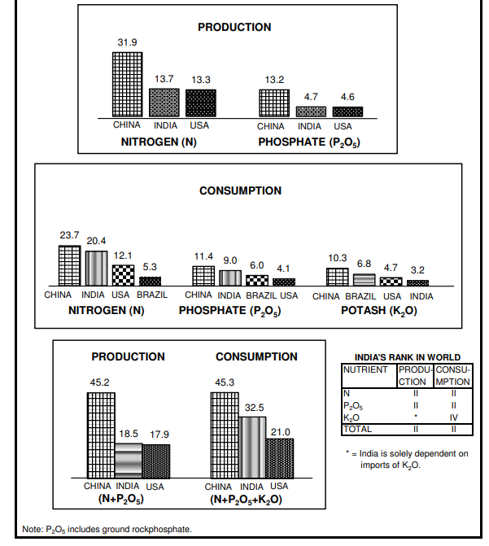
Fig. 1: Rank of India in world production and consumption of fertilizer nutrients
2020 (million tonnes)
(Source: Fertiliser-Stat-Book-2021-22)

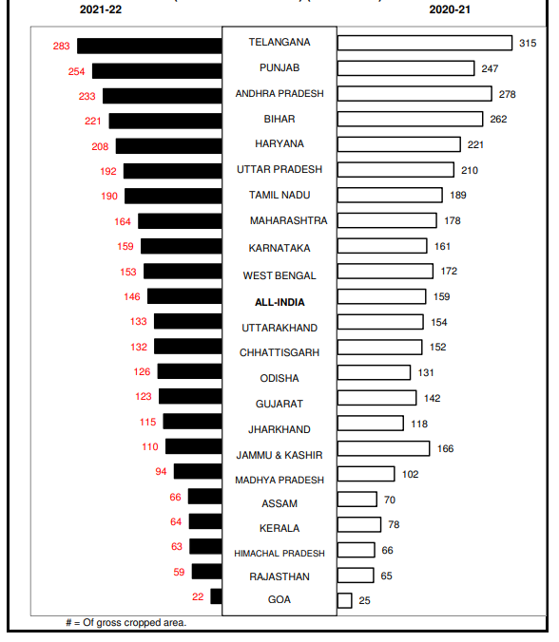
Fig.2: Consumption of plant nutrients in major states (N+P₂O₅+K₂O kg ha⁻¹) (Source: Fertiliser-Stat-Book-2021-22).
Consumption of plant nutrients (N+P₂O₅+K₂O kg ha⁻¹) in major states of India 2021-22:
In India Telangana states recorded highest consumption of plant nutrient i.e., 283 kg ha⁻¹ followed by Punjab (254 kg ha⁻¹), Andhra Pradesh (233 kg ha⁻¹), Bihar (221 kg ha⁻¹), Haryana(208 kg ha⁻¹), Uttar Pradesh(192 kg ha⁻¹), Tamil Nadu (190 kg ha⁻¹), Maharashtra (164 kg ha⁻¹), Karnataka (159 kg ha⁻¹), West Bengal (153 kg ha⁻¹), Uttarakhand (133 kg ha⁻¹), Chhattisgarh (132 kg ha⁻¹), Odisha (126 kg ha⁻¹), Gujrat (123 kg ha⁻¹), Jharkhand (115 kg ha⁻¹), Jammu And Kashmir (110 kg ha⁻¹), Madhya Pradesh (94 kg ha⁻¹), Assam (66 kg ha⁻¹), Kerala (64 kg ha⁻¹), Himachal Pradesh (63 kg ha⁻¹), Rajasthan (59 kg ha⁻¹), and the state which is the least number for consumption of plant nutrients is Goa (22 kg ha⁻¹) (Source: Fertiliser-Stat-Book-2021-22).
Total fertilizer nutrient consumption (N+P2O5+K2O) was estimated at 29.80 million metric tonnes (million MT) as against 32.54 million MT in the previous year registering a negative growth of 8.4%. The consumption of N, P2O5 and K2O at 19.44 million MT, 7.83 million MT and 2.53 million MT during 2021-22 declined by 4.7%, 12.8% and 19.8%, respectively, over 2020-21. In terms of products, consumption of urea at 34.18 million MT, DAP at 9.27 million MT, MOP at 2.46 million MT and NP/NPK complex fertilizers at 11.48 million MT during 2021-22 witnessed decline of 2.5%, 22.2%, 28.3% and 2.8%, respectively, over 2020-21. However, consumption of SSP at 5.68 million MT recorded a sharp increase of 26.6% during the period. Total consumption of fertilizer products 63.94 million MT during 2021-22 showed a decline of 5.4% over 2020- 21. All-India NPK use ratio widened from 6.5:2.8:1 during 2020-21 to 7.7:3.1:1 during 2021-22. Per hectare use of total nutrients (N+P₂O₅+K₂O) reduced from 160.1 kg in 2020-21 to 146.7 kg in 2021- 22 (Annual review of fertilizer production and consumption 2021-22).
Effect of different treatments on soil properties:
Reference | Location and soil texture | Cropping system | Impact on soil fertility
 |  |  | Soil properties |  | control |  | Only fertilization | Only manuring | INM
Gabhane et al., 2022 | Central India Clayey | Cotton + greengram intercropping | pH |  | 8.10 |  | 8.05-8.02 | 7.98-8.0 | 7.98-7.99
 |  |  | OC (g kg-1) |  | 4.50 |  | 6-5.10 | 6.10-5.90 | 6.90-6.90
Kharche et al., 2013 | Central India Clayey | Sorghum+  wheat | Available nutrients (kg ha⁻¹) | N: |  | 117 | 153-271 | 152-235 | 246-283
 |  |  |  | P: |  | 6.4 | 15.2-20.5 | 15-17.7 | 16.5-24.6
 |  |  |  | K: |  | 484 | 513-579 | 515-575 | 586-606
KATKAR et al., 2011 | Central India Clayey | Sorghum+  wheat | Available S (mg kg⁻¹) |  | 28.67 |  | 34.05-58.08 | 31.58 | 63.39
 |  |  | Total N (%) |  | 0.0331 |  | 0.0428- 0.0516 | 0.0512 | 0.0594

Reference | Location and soil texture | Cropping system | Impact on soil physical properties
 |  |  | Soil properties | control | Only fertilization | Only manuring | INM
Nandapure et al., 2011 | Central India Clayey | Sorghum+  wheat | BD (Mg m⁻³) | 1.38 | 1.24- 1.36 | 1.24 | 1.22
 |  |  | HC (cm hr⁻¹) | 0.23 | 0.28-0.60 | 0.60 | 0.71
Ramteke et al., 2022 | Central India Clayey | Cotton + greengram intercropping | WSA (%) | 78.76 | 81.00-85.37 | 80.80-83.37 | 90.88- 91.10`
Katkar et at.,2012 | Central India Clayey | Sorghum+  wheat | AWC (cm m⁻¹) | 15.86 | 17.48-21.31 | 21.59 | 21.95
 |  |  | MWD (mm) | 0.737 | 0.772- 1.169 | 1.254 | 1.412
Dhamak et al., 2020 | Central India Clayey | Sorghum+  wheat | Porosity (%) | 56.32 | 56.51- 56.89 | 58.32- 58.35 | 58.12 -58.48

Reference | Location and soil texture | Cropping system | Impact on biological properties
 |  |  | properties | control | Only fertilization | Only manuring | INM
Meshram et al., 2016 | Central India Clayey | soybean-safflower | Bacteria (CFU X 107 g ⁻¹ soil) | 95.26 | 124.62- 175.20 | 198.69 | 211.06
 |  |  | Fungi i (CFU X 104 g ⁻¹ soil) | 5.06 | 5.33-8.19 | 11.17 | 8.22
 |  |  | Actinomycetes (CFU X 106 g ⁻¹ soil); | 30.05 | 32.53-  45.87 | 51.36 | 53.16
KATKAR et al., 2012 | Central India Clayey | Sorghum+  wheat | SMBC (mg kg⁻¹) | 139 | 179- 227 | 222 | 247
 |  |  | SMBN (mg kg⁻¹) | 8.86 | 11.98-16.03 | 15.18 | 17.53
 |  |  | DHA ug gm⁻¹ 24hr⁻¹ | 32.51 | 36.97-45.69 | 45.08 | 49.78

Reference | Location and soil texture | Cropping system | Impact on crop productivity
 |  |  |  | control | Only fertilization | Only manuring | INM
Jadhao et al., 2020 | Central India Clayey | Sorghum+  wheat | Wheat Grain yield (q ha⁻¹) | 5.6 | 8.2-32.4 | 10.9 | 34.0
Jadhao et al., 2019 | Central India Clayey | Sorghum+  wheat | Sorghum grain yield (t ha⁻¹) | 0.38 | 1.76-4.22 | 3.61 | 4.60
 |  |  | Sorghum fodder yield (t ha⁻¹) | 0.83 | 4.18-10.14 | 5.82 | 8.48-11.05
CHAUHAN et al., 2014 | Central India Clayey | Soybeans-wheat | Sustainability yield index of soybean | 0.131 | 0.145- 0.369 | 0.326 | 0.394
Meshram et al., 2017 | Central India Clayey | soybean-safflower | Soybean grain yield (q ha⁻¹) | 11.62 | 14.20-26.30 | 19.62 | 26.58
 |  |  | Safflower grain yield (q ha⁻¹) | 10.78 | 11.81-18.36 | 13.15 | 18.52

II. IMPACT OF MANURES AND FERTILIZATION MANAGEMENT ON SOIL HEALTH AND CROP PRODUCTIVITY
- EFFECT ON SOIL PHYSICAL PROPERTIES:
The physical properties of soil viz., bulk density, aggregate stability, hydraulic conductivity, and mean weight diameter and water retention were significantly improved due to integration of chemical fertilizers with organics as compared to only chemical fertilizer [16].
- Effect on soil structure and water stable aggregate distribution
Fertilizer N management significantly affected soil bulk density (BD) as did the depth by rotation interaction. 75 kg N/ha had a significantly lower BD than the other N fertilizer managements (p < 0.05). In the depth by rotation interaction, BD was not significantly different between 0 and 10 cm and 10–20 cm depths in mono-cropping, while 10–20 cm had significantly lower BD than 0–10 cm in rotation (p < 0.05). Fertilizer N management and the depth by rotation interaction significantly affected the MWD and GMD. Aggregate size fractions were affected, significantly, by N fertilizer management, rotation, depth and their interactions, but to different extents. Generally, the proportion of large and small macroaggregates increased within 10–20 cm soil depth, while that of microaggregates and silt-clay size fractions decreased. Manure application had the highest large macroaggregate proportion, with other aggregates being a lower proportion than in the chemical fertilizer treatments [19].
Fertilization significantly improved soil aggregation and aggregate stability in both surface and subsurface soil over control [26]. Fertilization enhanced aggregation by its effect on plant growth and ultimately, biomass returned to soil [14].
2. Effect on Aggregate associated Carbon and Nitrogen.
Organic material incorporation improves the relative abundance of macroaggregates at the expense of other fractions and also results in higher C in macroaggregate fractions. While fertilizer treatment effect in promoting soil aggregation is less pronounced, C content is similar across aggregate fractions [17]. Long-term application of a fertilizer in conjunction with organic manures induced a significant increase in the organic carbon status of the soil. This was clearly reflected by aggregate properties and stability. Manure amendment increased SOC concentration signiﬁcantly more than the three chemical N fertilization treatments (p < 0.05). At the 10–20 cm depth, tobacco-rice rotation still had higher SOC concentration than monocropping, except for the 0 kg N/ha treatment. Soil depth signiﬁcantly aﬀected all aggregate-associated TSN concentrations (p < 0.05), except for the whole soil. Both large and small macroaggregate and microaggregate associated TSN concentrations were numerically higher at 0–10 cm than 10–20 cm depth. Nitrogen fertilizer management signiﬁcantly aﬀected whole-soil and small macroaggregates and microaggregates and silt-clay fraction associated SOC (p < 0.05), except for large macroaggregates [19].
Manure provides soil organic addition [20]. This SOM can serve as a core for soil aggregation based on the aggregate-SOM models proposed by [21]. In addition, prior studies show manure promotes soil microbial community diversity and enzyme activity [22]; [23], which would also produce fungal hyphae to further cause coarse aggregate formation [24]; [25]. Manure amendment practices and tobacco-rice rotation could synergistically increase SOC and TSN, benefit soil structure and soil quality [19].
Greater aggregate-N concentration due to fertilizer application was also reported by [27]. Continuous cropping without nutrient management led to decreased N in all aggregate fractions in paddy soil [28].
3. Effect on soil bulk density and hydraulic conductivity:
The OM treatment significantly decreased soil BD and increased SOC compared with control treatment. The OM treatment generally increased soil organic concentration, leading to a decrease in soil BD and increased organic carbon content, because application of OM to the soil increases soil organic matter [31]. The reduction in bulk density of soil under integrated nutrient management is due to better aggregation, increased porosity and improvement in soil structure caused due to increase in soil organic matter [16]. [29] also observed that application of FYM along with fertilizers decreases the BD of soil.
Balanced fertilization with FYM markedly improved the hydraulic conductivity due to more organic matter content which increased biological activity, improved soil aggregation, and optimum pore volume as well as the effective connectivity of the pores [30].
4. Effect on Soil water content:
Fertilization systems had significant (p < 0.05) effects on SWC, in addition to factors of local climates and soil types. OM treatment had a greater impact on SWC than NPK and NPK + S at all soil depths (p < 0.05) [31]. [32] found that OM plots recorded higher SWC than the inorganic fertilizer, irrespective of soil depths. SWC further confirmed the soil water retention trends, i.e., at most sampling dates the OM treatment soil had significantly higher water contents than CK at 0–10 cm depth, but not at 10–20 cm.
B) EFFECT ON SOIL FERTILITY:
1. Soil pH and EC:
Soil pH values did not change significantly even after 46 years of soybean and wheat cultivation and continuous use of chemical fertilizers and/or organic manure Use of chemical fertilizer like urea, though it possesses net residual acidity could not create significant alteration in the soil pH values. This effect appears to have been controlled by the presence of calcium carbonate. However, the electrical conductivity has been observed that no significant changes have occurred due to imposed treatments with values ranging from 0.16 to 0.19 dSm⁻¹ [33]. Similar, results on soil pH and EC has been earlier reported by [34], and [35].
2. Effect on soil organic carbon (SOC):
Application of manure or straw on the farmyard increased the concentration of SOC significantly in depths of 0-20, 20-40 and 40-60 cm. At soil depths of 0-20 and 20-40 cm, SOC was the highest in NP+FKM followed by treatments with NP+S and FYM and the least in treatment with CK [36]. The application of fertilizers and/or FYM resulted in greater C sequestration and also increase the accumulation of SOC was higher in the surface layer of the soil as compared to subsurface layer due to the greater accumulation of the organic residues and external additions of organic matter at the surface layer [37]. [38] showed that addition of farmyard manure (FYM) with Nitrogen (N) or NPK fertilizers increased SOC contents. [39] observed that the plots with 50% NPK fertilizers + 50% farmyard manure (FYM) had significantly higher SOC content followed by 50% NPK fertilizers + 50% Green manure (GM) in topsoil.
[40] Revealed that treatments which received organic manure had significantly higher SOC concentrations compared to the mineral and control treatments as much as 35.39 Mg ha⁻¹ more C in the top 20cm than the CK treatment. Furthermore, SOC concentrations significantly increased with increasing manure input rates. Increasing levels of fertilizer application has helped in increasing the organic carbon content, which is due to increased contribution from the biomass, as it is also observed that with increasing levels of fertilizer application, the crop yields had increased [33]. applying organic manure along with NPK fertilizer was beneficial because it supplemented NPK and added some secondary and micronutrients and also improved the physical and biological characteristics of the soil. These findings indicate that organic carbon plays an important role in maintaining and improving soil health [41].
3.Correlations between soil organic carbon and physical properties:
The soil BD showed a negative correlation with SOC, which indicated that the organic matter addition produced a decrease in BD. Also, there was a negative correlation between the soil Penetration Resistance (PR) and SOC, indicating that the soil PR decreased with addition of organic matter. The BD also showed a negative correlation with the SWC and a positive correlation with PR and indicating that a decrease in BD improved the soil structure [31]. The high negative correlation observed between the SOC and the BD and the PR (p < 0.01) is due to different factors such as the reduced or no tillage in organic treatments, and the increase in the labile fraction of the organic carbon that is released through the microbial decomposition of organic matter deposited on the soil mineral fraction as a surface coating, yielding soil aggregation as reported by [42].
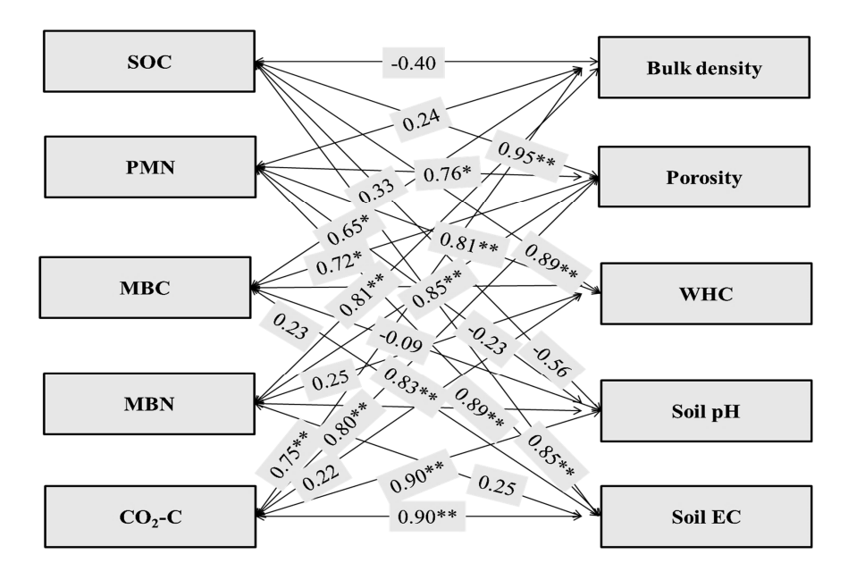
Fig. 3: The correlation coefficient of soil OC and microbiological community with soil properties (**-correlation is significant at the 0.01 level; *-correlation is significant at the 0.05 level), (Source: Dhaliwal et. al., 2021).
4. Effect on nutrient status of soil:
- Soil available Nitrogen:
Continuous use of nitrogenous fertilizers for forty-six years tended to increase the available nitrogen status of soil [33 Nilesh Patidar 2021]. [43] who observed that available N content in soil increased significantly with the use of recommended fertilizer dose in combination with manure. [44] also reported an increase in available nitrogen contents due to graded application of NPK fertilizers.
- Soil available Phosphorous:
The concentration of P in available pool further increased due to the P addition from FYM. The FYM besides being a direct source of nutrients, might have also solubilized the insoluble phosphate in the soil through release of various organic acids [34].
- Soil available Potassium:
The highest available K status of soil was found associated with 100% NPK + FYM followed by 150% NPK treatments [33 Nilesh Patidar2021]. The application of organic manure may have caused reduction in K fixation and consequentially increased K content due to interaction of organic matter with clay besides the direct addition of K to the soil [45].
- Available Sulphur:
The application of NPK with FYM resulted in significantly higher available S content (38.6 kg ha⁻¹) than initial value (15.6 kg ha⁻¹) after 46 years of experimentation due to the application of single super phosphate and FYM, which contained sulphur [33]. The continuous use of diammonium phosphate as P source has resulted in S deficiency in 100% NPK-S; causing reduction in crop yields [34].
- SUSTAINABLE CROP PRODUCTIVITY
The continuous use of only chemical fertilizers was observed to be responsible for decline in yields which is also reflected in terms of deterioration in soil quality attributes while enhanced soil quality attributes observed under INM practices encouraged increase in crop yields [16]. Integrated use of inorganic fertilizers and organic manure found better under the long term which sustained crop productivity and enhanced soil quality in sorghum- wheat cropping sequence grown on Vertisol [46]. Increasing levels of fertilizer application has helped in increasing OC content, which is due to increased contribution from the biomass, as it is observed with increasing levels of fertilizers application also increased the crop yield [48]. [49] reported that an optimal level of SOC stock is an essential determinant of soil quality to support relatively high crop yield and a strong relationship between agronomic production and the SOC stock, especially in low-input agriculture (none or low rate of fertilizer input).
CONCLUSION
Applications of organic and mineral fertilizers to a soil improved soil physical property. Generally, the organic fertilizers yielded significant increase in SWRC at most potential and plant-available water content. In particular, SWC was increased at all soil depths with organic fertilizers under dry and wet periods. Furthermore, hydraulic conductivity (saturated and unsaturated), soil BD, and PR showed significant decrease with organic fertilizers than other treatments.
Balanced use of fertilizers alone or in combinations with organic manure resulted significant builds up of organic carbon content and in the available N, P, and K. Further, imbalance use of inorganic fertilizers reduced crop yields and deteriorated soil fertility. Hence, it is recommended that balance application of fertilizers integrating with FYM is necessary to maintain soil fertility, productivity.
REFERENCES
- Randhawa, N.S. and Tandon, H.L.S. (1982) Advances in soil fertility and fertilizer use research in India. Fertiliser News 27, 11-26.
- Nambiar, K.M.M. and Abrol, I.P. (1989) Long Term Fertilizer Experiment in India (1972-82). Indian Agriculture Research Bulletin, New Delhi, 101p.
- Bappa Das, Debashis Chakraborty, V.K. Singh, P. Aggarwal, R. Singh, B.S. Dwivedi, R.P. Mishra (2014) Effect of integrated nutrient management practice on soil aggregate properties, its stability and aggregate-associated carbon content in an intensive rice–wheat system. Soil and tillage research 136 (2014)-9-18.
- Sarkar, S., Singh, S.R., Singh, R.P., 2003. The effect of organic and inorganic fertilizers on soil physical condition and the productivity of a rice–wheat cropping sequence in India. J. Agric. Sci. 140, 419–425.
- Pernes-Debuyser, A., Tessier, D., 2004. Soil physical properties affected by long-term fertilization. Eur. J. Soil Sci. 55, 505–512.
- Dexter, A.R., 1988. Advances in characterization of soil structure. Soil Till. Res. 11, 199–238.
- Ekwue, E.I., 1992. Effect of organic and fertilizer treatments on soil physical properties and erodibility. Soil Till Res. 22, 199–209.
- El-Shakweer, M.H.A., El-Sayad, E.A., Ewees, M.S.A., 1998. Soil and plant analysis as a guide for interpretation of the improvement efficiency of organic conditioners added to different soil in Egypt. Comm. Soil Sci. Plant Anal. 29, 2067–2088.
- Mokwunge, A.U., deJager, A., Smaling, E.M.A., 1996. Pestoring and maintaining the productivity of west African soil: key to sustainable development. In: Miscellaneous Fertilizers Studies No.
- Barzegar, A.R., Yousefi, A., Daryashenas, A., 2002. The effect of addition of different amounts and types of organic materials on soil physical properties and yield of wheat. Plant Soil 247, 295– 301.
- Rose, D.A., 1991. The effect of longcontinued organic manuring on some physical properties of soils. In: Wilson, W.S. (Ed.), Advances in Soil Organic Matter Research. Special Publication no. 90. Royal Society of Chemistry, Cambridge, pp. 197–205.
- Belford, R.K., Klepper, B., Rickman, R.W., 1987. Studies of intact shoot root systems of field grown winter wheat. II. Root and shoot developmental patterns as related to nitrogen fertilizer. Agron. J. 79, 310–319.
- Brown, S.C., Keatinge, J.D.H., Gregory, P.J., Cooper, P.J.M., 1987. Effect of fertilizer, variety and location on barley production under rainfed condition in northern Syria. I. Root and shoot growth. Field Crops Res. 16, 53–66.
- Campell, C.A., Selles, F., Lafond, G.P., Biederbeck, V.Q. and Zenter, R.P. 2001. Tillage-Fertilizer changes: effect on soil quality attributes under longterm crop rotations in a thin Black Chernozem. Can J. Soil Sci. 81(10):157–165.
- Whalen, J.K., Hu, Q. and Liu, A. 2003. Manure applications improve aggregate stability in conventional and no tillage systems. Soil Sci. Soc Am J 67:1842– 1847.
- Kharche V.K., S.R. Patil, A.A. Kulkarni, V.S. Patil and R.N. Katkar 2013. Long-term Integrated Nutrient Management for Enhancing Soil Quality and Crop Productivity under Intensive Cropping System on Vertisols. Journal of the Indian Society of Soil Science, Vol. 61, No. 4, pp 323-332 (2013).
- Yu, H., Ding, W., Lue, J., Geng, R., Cai, Z., 2012. Long-term application of organic manure and mineral fertilizers on aggregation and aggregates associated carbon in as sandy loam soil. Soil Till. Res. 124, 170–177.
- Bappa Das, Debashis Chakraborty, Vinod K. Singh, Pramila Aggarwal, Ravender Singh, and Brahm S. Dwivedi 2014 Effect of organic inputs on strength and stability of soil aggregates under rice-wheat rotation Int. Agrophys., 2014, 28, 163-168 doi: 10.2478/intag-2014-0004.
- Congming Zoua, Yan Lia, Wei Huanga, Gaokun. Zhaoa, Guorui Pua, Jiaen Sua, Mark S. Coynec , Yi Chena, Longchang Wangb, Xiaodong Hua, Yan Jina, 2018 Rotation and manure amendment increase soil macro-aggregates and associated carbon and nitrogen stocks in flue-cured tobacco production. Geoderma 325 (2018) 49-58.
- Spaccini R, Piccolo A. 2013. Effects of field managements for soil organic matter stabilization on water-stable aggregate distribution and aggregate stability in three agricultural soils. Journal of Geochemical Exploration, 129, 45–51.
- Tisdall JM, Oades JM (1982) Organic matter and water stable aggregate in soils. J Soil Sci 33:141–163. doi:10.1111/ j.1365-2389. 1982.tb01755.
- Duan, Y.Q., Chen, D.M., Jin, Y., Wang, H.B., Yang, Y.H., You, C.H., Tian, W.X., Lin, W.X., 2012. Effect of different fertilizers on continuous tobacco cropping rhizospheric soil microorganisms and enzyme activities. J. Agric. Sci. Technol. 14 (03), 122–126.
- Govaerts, B., Mezzalama, M., Unno, Y., Sayre, K.D., Luna-Guido, M., Vanherck, K., Dendooven, L., Deckers, J., 2007. Influence of tillage, residue management, and crop rotation on soil microbial biomass and catabolic diversity. Appl. Soil Ecol. 37 (1), 18–30.
- Jin, Y., Yang, Y.H., Duan, Y.Q., Yuan, L., 2012. Influence of the long-term fertilization on organic matter and N,P,K nutrients in aggregates of flue-cured tobacco grown red soil. Guizhou. Agric. Sci. 40 (3), 142–146.
- Zhang, S., Wang, R., Yang, X., Sun, B., Li, Q., 2016. Soil aggregation and aggregating agents as affected by long term contrasting management of an Anthrosol. Sci. Rep. 6, 3910.
- Joshi, S.K., R.K. Bajpai, Prahalad Kumar, Alok Tiwari and Vinay Bachkaiya. 2017. LongTerm Effect of Fertilization and Algalization on Aggregate Stability, Aggregate Associated Carbon and Nitrogen Under Rice-Wheat Cropping System. Int.J.Curr.Microbiol.App.Sci. 6(8): 3289-3295. doi: https://doi.org/10.20546/ijcmas.2017.608.392.
- Manna, M.C., Bhattacharyya, P., Adhya, T.K., Singh, M., Wanjari, R.H., Ramana, S., Tripathi, A.K., Singh, K.N., Reddy, K.S., SubbaRao, A., Sisodia, R.S., Dongre, M., Jha, P., Neogi, S., Roy, K.S. Rao, K.S. Sawarkar, S.D. and Rao, V.R. 2013. Carbon fractions and productivity under changed climate scenario in soybean– wheat system. Field Crops Research 145: 10–20.
- Wei, W., Wei-cai, C., Kai-rong, W., Xiao-li, X., Chun-mei, Y. and An-lei, C. 2011. Effects of long-term fertilization on the distribution of carbon, nitrogen and phosphorus in water soluble aggregates in paddy soils. Agricultural Science in China, 10(12): 1932-1940.
- Pant, P.K., Ram, S. and Singh, V. 2017. Yield and soil organic matter dynamics as affected by the long-term use of organic and inorganic fertilizers under rice– wheat cropping system in subtropical mollisols. Agric Res. 6(4):399–409.
- Pawan Kumar Pant and Shri Ram. 2018. Long-Term Manuring and Fertilization Effects on Soil Physical Properties after Forty Two Cycles under Rice-Wheat System in North Indian Mollisols. Int.J.Curr.Microbiol.App.Sci. 7(07): 232-240. doi: https://doi.org/10.20546/ijcmas.2018.707.028
- Mohamed Bassouny & Jiazhou Chen (2016) Effect of long-term organic and mineral fertilizer on physical properties in root zone of a clayey Ultisol, Archives of Agronomy and Soil Science, 62:6, 819-828, DOI: 10.1080/03650340.2015.1085649.
- Subramanian S, Rajeswari M, Chitdeswari T. 2000. Effect of organic fertilizers on soil moisture conservation in rainfed vertisol. Madras Agric J. 87:345–347.
- Nilesh Patidar, A. K. Dwivedi, B. S. Dwivedi, R. K. Thakur, Jalendra Bairwa and Abhishek Sharma 2021 Impact of Long-Term Application of Inorganic Fertilizers and Organic Manure on Soil Fertility and Crop Productivity under Soybean-Wheat Cropping System in a Vertisol. International Journal of Environment and Climate Change 11(8): 24-30, 2021; Article no. IJECC.73943 ISSN: 2581-8627.
- Thakur Risikesh, DL Kauraw, Singh Muneshwar. Effect of continuous applications of nutrient inputs on spatial changes of soil physicochemical properties of a medium black soil. Journal of Soils and Crops. 2009;19(1):14 – 20.
- Panwar S, Dwivedi AK, Dwivedi BS, Nagwanshi Anil. Distribution of zinc pools as influenced by long-term application of fertilizers and manure in a Vertisol. International Journal of Chemical Studies. 2017;5(6):1931-1934.
- Liu E, Yan C, Mei X, Zhang Y, Fan T. Long-term effect of manure and fertilizer on soil organic carbon pools in Dryland Farming in Northwest China. PLoS One. 2013;8(2):e56536.
- Sharath Chandra M, Naresh RK, Chandra Sheker B, Mahajan NC, Vijay J. Aggregate associated carbon, aggregation and storage of soil organic carbon respond to organic and synthetic fertilizers in cereal systems: A Review. Current Journal of Applied Science and Technology. 2020; 39(12):86-99.
- Bhattacharyya Ranjan, Kundu S, Ved Prakash, Gupta HS. Sustainability under combined application of mineral and organic fertilizers in a rainfed soybean- wheat system of the Indian Himalyas. Eur J Agron. 2008;28(1):33–46.
- Ghosh BN, et al. Effects of fertilization on soil aggregation, carbon distribution and carbon management index of maize-wheat rotation in the north-western Indian Himalayas. Ecological Indicators; 2018. Available:https://doi.org/10.1016/j.ecolind.2 018.02.050
- Li J, Wen Y, Li X, Li Y, Yang X, Zhian Lin Z, et al. Soil labile organic carbon fractions and soil organic carbon stocks as affected by long-term organic and mineral fertilization regimes in the North China Plain. Soil Tillage Res. 2018;175:281-290.
- Thakur RK, Sawarkar SD, Vaishya UK and Singh. Impact of continuous use of inorganic fertilizers and organic manure on soil properties and productivity under soybean-wheat intensive cropping of a Vertisol. J. Indian Soc. Soil Sci. 2011;59(1):74-81.
- Herencia F, Garcia-Galavis A, Maqueda C. 2011. Long-term effect of organic and mineral fertilization on soil physical properties under greenhouse and outdoor management practices. Pedosphere. 21:443–453.
- Dwivedi AK and Dwivedi BS. Impact of long-term fertilizer management for sustainable soil health and crop productivity: Issues and challenges. JNKVV Res Journal. 2015;49(3):387-399.
- Khandagle A, Dwivedi BS, Dwivedi AK, Panwar S, Thakur RK. Nitrogen fractions under long-term fertilizer and manure applications in soybean – wheat rotation in a Vertisol. Journal of the Indian Society of Soil Science. 2020;68(2):186-193.
- Sawarkar SD, Khamparia NK, Thakur R, Dewda MS, Singh M. Effect of long-term application of inorganic fertilizers and organic manure on yield, potassium uptake and profile distribution of potassium fractions in Vertisol under soybean-wheat cropping system. Journal of the Indian Society of Soil Science. 2013;61:94-98.
- KATKAR R. N., V. K. KHARCHE, B. A. SONUNE, R. H. WANJARI2 AND MUNESHWAR SINGH. Long term effect of nutrient management on soil quality and sustainable productivity under sorghum-wheat crop sequence in Vertisol of Akola, Maharashtra. Agropedology 2012,22 (2), J03-JJ4.
- Dhaliwal, S.S.; Sharma, S.; Sharma, V.; Shukla, A.K.; Walia, S.S.; Alhomrani, M.; Gaber, A.; Toor, A.S.; Verma, V.; Randhawa, M.K.; et al. Long-Term Integrated Nutrient Management in the Maize–Wheat Cropping System in Alluvial Soils of North-Western India: Influence on Soil Organic Carbon, Microbial Activity and Nutrient Status. Agronomy 2021, 11, 2258. https:// doi.org/10.3390/agronomy11112258.
- Jadhao S.D., Mali D.V., Kharche V.K., Muneshwar Singh , S.M. Bhoyar, P.R. Kadu, R.H. Wanjari and B.A. Sonune. Impact of Continuous Manuring and Fertilization on Changes in Soil Quality under Sorghum-Wheat Sequence on a Vertisols. Journal of the Indian Society of Soil Science, Vol. 67, No. 1, pp 55-64 (2019) DOI: 10.5958/0974-0228.2019.00006.9
- Lal, R. (2010) Beyond Copenhagen: mitigating climate change and achieving food security through soil carbon sequestration. Food Security 2, 169-177.
- KATKAR R N, B A SONUNE and P R KADU 2011. Long-term effect of fertilization on soil chemical and biological characteristics and productivity under sorghum (Sorghum bicolor)– wheat (Triticum aestivum) system in Vertisol. Indian Journal of Agricultural Sciences 81 (8): 734–9, August 2011.
- Nandapure S.P., B.A. Sonune, V.V. Gabhane, R.N. Katkar and R.T. Patil 2011. LONG TERM EFFECTS OF INTEGRATED NUTRIENT MANAGEMENT ON SOIL PHYSICAL PROPERTIES AND CROP PRODUCTIVITY IN SORGHUM-WHEAT CROPPING SEQUENCE IN A VERTISOL. Indian J. Agric. Res.., 45 (4) : 336 - 340, 2011.
- Annual review of fertilizer production and consumption 2021-22.
- Ramteke Pratik and Gabhane V. V. 2022. Long-term nutrient management effects on soil aggregation and C stabilization in Vertisols of Central India. Vegetos https://doi.org/10.1007/s42535-022-00539-4.
- Dhamak AL, Waikar SL and Shilewant SS. Long – term effect of integrated nutrient management on soil organic carbon fractions in vertisol under sorghum wheat cropping system. International Journal of Chemical Studies 2020; 8(4): 1971-1974.
- Meshram N.A., Syed Ismail and V.D. Patil 2016. Long-Term Effect of Organic Manuring and Inorganic Fertilization on Humus Fractionation, Microbial Community and Enzymes Assay in Vertisol. JOURNAL OF PURE AND APPLIED MICROBIOLOGY, March 2016. Vol. 10(1) 139-150.
- Jadhao S.D., Rahul J. Patil, B.A. Sonune, S.M. Bhoyar, Muneshwar Singh1 , V.K. Kharche2 , R.N. Katkar, P.R. Kadu, N.M. Konde and D.V. Mali. 2020.Effect of Long-term Nutrient Management on Root Chemical Properties and Morphology, Grain Yield and Phosphorus Use Efficiency of Wheat under Sorghum-Wheat Sequence. Journal of the Indian Society of Soil Science, Vol. 68, No. 1, pp 54-61 (2020) DOI: 10.5958/0974-0228.2020.00006.7
- CHAUHAN S.S. AND BHATNAGAR , 2014. Influence of long term use of organic and inorganic manures on soil fertility and sustainable productivity of wheat in Vertisols of Madhya Pradesh. Volume 9 | Issue 1 | June, 2014 | 113-116 | α e ISSN–0976–7231 | Open Access | www.researchjournal.co.in
- Meshram N.A., Syed Ismail and P.K Rathod, 2017. Effect of organic manuring and fertilization on soil fertility, yield attributes and productivity of soybean-safflower cropping system in vertisol. Vol.12/TECHSEAR-10/2017/0000-0000.

