An Ingenious Fire Protection System (IFPS)

G.GEO JENEFER, P. AGNES ALEX RATHY
Assistant Professor,
Department of Information Technology,
St.Xaviers Catholic College of Engineering,
Chunkankadai, India, 629003
geo@sxcce.edu.in

ABSTRACT
Our project is to develop an Ingenious Fire Protection System (IFPS) using IoT. The purpose of this system is to detect the fire as early as possible. Fire detection is done by using sensors such as a flame sensor, a gas sensor, and a temperature sensor. For the alert purpose, we are using the buzzer and Wi-Fi module for giving notifications about fire detection to the owner and authorized parties and also for sending the location of the fire accident. The camera is also used for alert purposes. After the fire is detected, a link will be sent to the owner, and he or she can watch the live stream using the camera. The sensors in this system are connected to a NodeMCU, allowing for data collection and communication with the cloud platform for real-time monitoring and control. The output of this IoT home fire and safety project will be a connected system that integrates gas, temperature, and flame sensors with a NodeMCU, buzzer, sprinkler, GPS, and cloud platform, providing real-time monitoring and alerts for potential fire hazards, enhancing home safety and security. It also saves energy and money by automating sprinklers, cameras, and buzzers. IoT sensors can be installed in various parts of a building or facility to monitor temperature, smoke, and other parameters that can trigger a fire. Cameras can also be strategically placed to monitor the building or facility and provide real-time video feeds to the system. The data collected by the IoT sensors and cameras are then transmitted to a central control unit or a cloud-based platform. The platform analyzes the data and sends alerts to relevant stakeholders in the event of any abnormalities or hazards detected. Additionally, the video feeds from the cameras can be used for live monitoring and to identify potential hazards. This provides real-time insights for facility managers and security personnel to take immediate action if necessary. Overall, the integration of cameras with IoT sensors offers a comprehensive fire and safety management solution that enhances the safety of building occupants and protects valuable assets. As technology continues to evolve, these systems are expected to become even more sophisticated and effective in safeguarding against fire-related incidents.

Keywords— IoT, NodeMCU, GPS, Sensors,Buzzer,Sprinkler.

INTRODUCTION

The Internet of Things (IoT) has become increasingly popular across various sectors, as it allows organizations to operate more efficiently, understand their customers better, make better decisions, and enhance their overall value. The evolution of IoT can be attributed to the convergence of several technologies, including machine learning, ubiquitous computing, sensors, and more advanced embedded systems. Embedded systems, wireless sensor networks, control systems, and automation, including building and home automation, have enabled the IoT.
Incorporating fire safety measures in buildings is essential for the safety of the people and assets within and the broader community. Fires can occur without warning and spread quickly, causing significant damage and endangering lives. Fire safety measures such as smoke detectors, fire alarms, sprinkler systems, emergency exits, and fire extinguishers are critical to ensuring the safety of building occupants. Implementing these measures can prevent significant harm or damage. Thus, integrating fire safety measures in buildings is vital to minimize the impact of fires on the surrounding community and safeguard the lives and assets of the building occupants.

A. Fire Safety evolution
Before the advent of IoT, fire safety was mostly focused on physical measures such as the installation of fire alarms, smoke detectors, sprinklers, and fire extinguishers. These systems were often monitored by human operators who would manually respond to alarms and take appropriate action.
However, with the emergence of IoT technology, fire safety has become more advanced and sophisticated. IoT-enabled devices can detect and monitor fires in real time, allowing for faster response times and more effective firefighting efforts. For example, IoT sensors can detect before they become visible and alert authorities and emergency services automatically. Additionally, IoT devices can be integrated with other systems such as Heating, Ventilation, and Air Conditioning (HVAC) and lighting systems to provide a more comprehensive fire safety solution. Overall, IoT has revolutionized fire safety, making it more efficient, reliable, and effective.
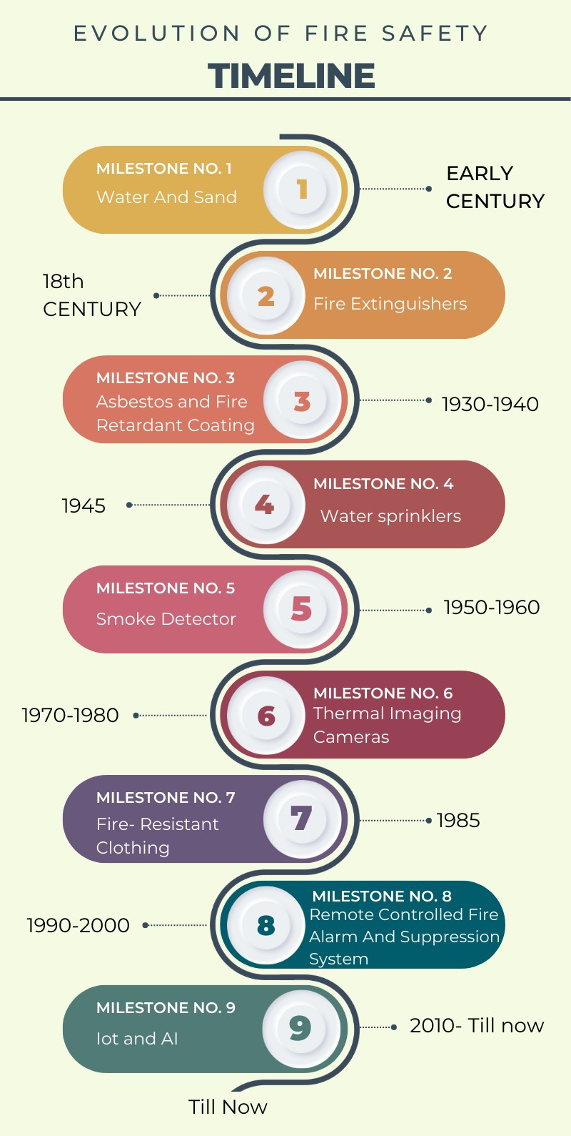

Figure 1: Evolution of fire safety

B. Purpose of Fire Safety
Fire safety is of utmost importance in public buildings, schools, hospitals, and other high-risk environments where large numbers of people gather, as well as in industrial settings. Fire safety measures in these environments include the installation of smoke detectors, fire alarms, fire extinguishers, and sprinkler systems. Additionally, fire drills and emergency evacuation plans are regularly practiced to ensure that everyone knows how to react in case of a fire. In industrial settings, fire safety measures may also include the use of flame-resistant materials, explosion-proof equipment, and the implementation of strict fire safety protocols. By implementing these fire safety measures, the risk of fires is reduced, and people are better protected in case of an emergency.

C. Benefits of Fire Safety
Fire safety is crucial because fires can have devastating consequences, resulting in loss of life, injuries, and damage to property. It is estimated that fires cause thousands of deaths and injuries globally every year, along with billions of dollars in property damage. Effective fire safety measures can prevent fires from starting in the first place, or at least reduce their impact by detecting and controlling them early. Fire safety is particularly used in public buildings, schools, hospitals, and other high-risk environments where large numbers of people gather, as well as in industrial settings where flammable materials are present. Regular fire safety training, equipment maintenance, and emergency response planning can help ensure that individuals are prepared to prevent and respond to fires, minimizing their impact and protecting lives and property.

E. Internet of Things (IoT)
The IoT refers to the network of physical objects, devices, vehicles, buildings, and other items embedded with sensors, software, and connectivity that enable them to collect and exchange data with one another and with other systems over the internet. The data generated by IoT devices can be used to gain insights, optimize operations, and improve efficiency in various industries such as manufacturing, healthcare, transportation, and smart homes. The potential applications of IoT are vast and constantly expanding, with new innovations and use cases emerging every day.
IoT involves connecting these objects and devices to the internet and enabling them to communicate with each other, with humans, and with cloud-based systems. This enables the devices to gather and share data in real time, allowing for more efficient and effective monitoring, management, and control of various systems and processes. IoT technology involves a combination of hardware, software, and networking technologies that enable devices to communicate and interact with each other. These technologies include sensors, embedded systems, wireless communication protocols, cloud computing, and data analytics.
Overall, the basic concept of IoT is to create a network of interconnected devices and systems that can work together to improve efficiency, enhance automation, and enable new applications and services. Organizations across a range of sectors are increasingly utilizing IoT to run more smoothly, better understand their consumers provide better customer service, boost decision-making, and raise the value of the company. The discipline has changed because of the confluence of several technologies, including machine learning, ubiquitous computing, commonplace sensors, and more powerful embedded systems. The IoT is enabled by the traditional disciplines of embedded systems, wireless sensor networks, control systems, automation (including home and building automation), and so on.

F. IoT in fire safety
The IoT can play a significant role in fire safety by enabling interconnected systems and devices to monitor, detect, and respond to potential fire hazards. IoT sensors can collect data on temperature, smoke, and other environmental factors and transmit that data to central control systems for analysis. These systems can then trigger alarms, alerts, and other responses to mitigate potential fire risks and provide early warning to occupants. Overall, IoT can enhance fire safety by providing real-time monitoring and automation, enabling more effective risk management and response to potential hazards.

II LITERATURE SURVEY

The literature survey on fire and safety using IoT aims to explore the potential of IoT technology in enhancing fire safety measures. The survey discusses various IoT-based fire safety applications such as fire detection, extinguishing, and monitoring systems, as well as the use of sensors and other IoT devices to detect fire hazards in real-time. Additionally, the survey examines how the data collected from these devices prevent fires before they occur and improve emergency response measures in the event of a fire. Overall, the survey highlights the potential benefits of using IoT technology in fire and safety management to reduce the risk of injury and property damage. It also examines the challenges associated with the implementation of IoT-based fire safety systems, including issues related to data privacy, cyber security, and interoperability. It further explores the potential benefits of using machine learning and other advanced analytics techniques to analyze data collected from IoT devices and improve fire safety measures. This survey concludes by highlighting the need for further research in the field of fire and safety using IoT to address the challenges and harness the full potential of this technology.

A. Remote Sensing and Geographic Information Systems
Remote Sensing and Geographic Information Systems have been introduced for fire management and assessment. In this paper, the fire was detected using image processing with the help of satellites to know the exact location. It concentrated on the most recent developments in near real-time fire monitoring, fire hazard and danger prediction, fuel moisture monitoring, fuel type mapping, and post-fire assessment of the effects of fires. It was found that differentiating between stable lights like cities, power stations, and dynamic lights, mostly fires, is difficult. [5]

B. Wireless Sensor Network
Wireless Sensor Network (WSN) deployment has been proposed for detecting and verifying rural and forest fires. WSN deployment was designed to be scalable and adaptable to different scenarios, such as rural and forest areas with different levels of vegetation density and topography. They described the communication protocols used by the sensor nodes to send data to the base station, which is responsible for processing the data and detecting fire events. This paper presented a WSN deployment for detecting and verifying rural and forest fires, which was evaluated through field tests in a rural area. The system demonstrated high accuracy in fire detection and verification, and could potentially reduce the damage caused by these types of disasters. [15]
A Fire Detection System has been proposed that incorporates indoor localization using a ZigBee-based Wireless Sensor Network (ZB-WSN). The system consists of multiple sensor nodes that are equipped with temperature and smoke sensors, as well as ZigBee modules for wireless communication. The proposed system used a combination of temperature and smoke sensors to detect fire events and then uses the ZigBee network to communicate the event to a central monitoring system. Overall, the paper presents a promising approach to using a ZigBee-based WSN for fire detection, with the added benefit of indoor localization to aid emergency responders in locating and extinguishing fires more quickly. [10]
A Fire Warning Program for cotton has been introduced in order to reduce the risk of fire accidents in cotton storage facilities. This system proposed a fire warning program that includes a multi-sensor system for detecting temperature, humidity, and carbon monoxide levels in the storage facility. It presented experimental results that demonstrate the effectiveness of the fire warning program in detecting abnormal conditions and triggering early warning alarms to prevent fires. Overall, the paper provides a useful framework for developing a fire warning program for cotton storage facilities and highlights the importance of implementing effective fire prevention measures in industries where flammable materials are present. [11]
A new approach to forest fire prevention and detection using Wireless Sensor Networks and Fuzzy Logic techniques (WSN-FL) has been proposed. This paper introduced the use of WSNs, which consist of a large number of small, low-cost sensors that can be deployed in remote areas to detect fires and transmit data wirelessly to a central control system. The paper proposes a fuzzy logic-based system for forest fire prevention and detection using wireless sensor networks. It emphasized the use of low-power wireless communication protocols and efficient data processing techniques for early detection and the reduction of false alarms. [26]
A new fire warning and detection technique using the IoT and Adaptive Neuro-Fuzzy Inference System (ANFIS) has been proposed. This paper proposed a new system that integrates IoT sensors, which can collect data on temperature, smoke, and other relevant parameters, with an ANFIS algorithm that can analyze this data and provide accurate predictions of fire risk. It presented experimental results that demonstrate the effectiveness of their approach in detecting fires and providing early warnings. It also compares this system to traditional fire detection systems and demonstrates its superiority in terms of accuracy and response time. [21]
Multimedia Sensor Networks (MSNs) have been proposed to detect forest fires. The importance of early detection of forest fires and the challenges associated with traditional fire detection methods has been discussed. This system proposed the use of WMSNs, which consist of multimedia sensors that can collect data on temperature, humidity, smoke, and video imagery, to provide early warnings of forest fires. The challenges associated with the deployment of such a system, include power management, network connectivity, and data processing. [17]

C. Fibre Optic Sensors
Fibre Optic Sensors (FOS) have been introduced in structural fire engineering. In this paper, the principles behind each type of sensor and their specific applications in fire engineering, such as measuring temperature, strain, and displacement have been discussed. The advantages of FOS over traditional sensors include their ability to withstand high temperatures and their immunity to electromagnetic interference. The challenges and limitations of using FOS in structural fire engineering, such as the need for calibration, potential damage from fire or smoke, and the high cost of some types of sensors, were also discussed. This system also provided examples of real-world applications of FOS in fire engineering, such as monitoring the behavior of steel and concrete structures during fire exposure.[3]

D. Internet of Things in Fire Safety
The adoption of Fire Safety Management strategies has been introduced to improve the fire safety level of existing hotel buildings. This paper explores the challenges faced by hotels in ensuring fire safety compliance and provides practical recommendations to enhance the fire safety level of hotel buildings. The challenges faced by hotels in implementing fire safety management strategies, such as the lack of awareness among hotel staff, inadequate fire safety training, and the high cost of implementing fire safety measures, suggest that hotels should prioritize fire safety management as a critical component of their overall safety management system and invest in fire safety training and education for their staff. [4]
A Smart Fire Safety System has been proposed to detect and prevent fires. The system consists of various sensors and devices, including temperature sensors, smoke detectors, and water sprinklers, which are connected to a central control unit. Its ability to detect fires in their early stages, reduce response time, and prevent damage to property and lives. The system can also be remotely monitored and controlled through a mobile application, making it convenient and accessible. Limitations of the system, such as false alarms and the need for regular maintenance. [7]
A fire Monitoring System has been introduced using IoT. IoT technology in fire monitoring systems become increasingly popular due to their ability to detect and respond to fires quickly. It then delves into the various components of a fire monitoring system, including sensors, connectivity devices, and data analytics tools. The limitations associated with IoT technology, such as security and privacy concerns. [25]
IoT technology and Artificial Intelligence (AI) have been combined to prevent and mitigate the risks of fire in smart home environments. The system includes a variety of sensors and devices, such as smoke detectors, temperature sensors, gas detectors, and cameras, which continuously monitor the environment and collect data. The data is then processed and analyzed by an AI model to detect any abnormal behavior or potential fire hazards. A false alarm can also be generated when there is no threat. [19]
Fire safety in industries with the help of IoT technology has been proposed. The paper discussed the importance of fire safety in industrial settings and highlighted the potential hazards and consequences of fires in such environments. It then introduced the concept of IoT and its potential for improving fire safety measures in industries. The paper also explored the challenges and limitations of IoT-based fire safety systems, such as the reliability of sensors and communication networks, and the need for robust and secure data analytics techniques. [21]
A Fire Safety system using Arduino sensors with IoT integration has been introduced. The system also incorporates IoT technology, allowing users to remotely monitor the sensor data and receive alerts through a web-based application. The application provides real-time updates on the status of the sensors and sends alerts when any sensor detects a potential fire hazard. There is no GPS tracker in this system, so it will be difficult for the firefighters to locate the exact location. [18]
An IoT fire detection system has been introduced to detect fires using a combination of sensors and the Arduino platform. The paper might also discuss the potential benefits of this type of system, such as early detection of fires, reduced damage and loss of property, and increased safety for occupants. Additionally, the paper might outline the limitations of the system and areas for further research and development. Overall, the IoT fire detection system using sensors with Arduino is an innovative and potentially valuable application of IoT technology for fire safety. The paper would provide a comprehensive overview of the project, including its design, implementation, and potential benefits. [14]
IoT-based Safe Assembly Point Alert System has been introduced to detect and alert individuals to the presence of danger and guide them to safe assembly points. The sensors were used to detect the presence of danger and collect data, which is processed by the microcontrollers and communicated to the server using communication modules. It may produce false detection due to heavy work. Overall, the IoT-based Safe Assembly Point Alert System is an innovative solution to ensure the safety of individuals during emergencies. The paper provides a comprehensive overview of the system’s components and benefits, making it a valuable resource for researchers and practitioners in the field of IoT-based safety systems. [16]
IoT-based fire detection and prevention system has been introduced. It was designed to detect and prevent fires in various settings, such as homes, offices, factories, and public places. The system used a combination of sensors, actuators, and communication technologies to monitor the environment for potential fire hazards and take appropriate action when necessary. In this, some tweaks and remodeling are needed. Overall, the IoT-based fire detection and prevention system has the potential to significantly improve fire safety in various settings, by providing early warning of potential fire hazards and enabling a quick and effective response in the event of a fire. [9]
IoT and Fog computing technologies have been proposed to improve forest fire management. The IoT sensors are deployed in the forest to collect real-time data on various environmental parameters such as temperature, humidity, and smoke density. The fog nodes use machine learning algorithms to detect patterns in the data and identify potential fire hazards. If a fire hazard is detected, the fog nodes can trigger an alarm and send a notification to the cloud-based platform. The cloud-based platform can then alert the appropriate authorities and provide them with real-time data on the location and severity of the fire. The main disadvantage of this is that high energy is required. [22]
A Smart Fire Detection system that uses IoT technology has been proposed to prevent and control fire accidents and an automatic water sprinkler. The system consists of various sensors that are placed in different parts of a building to detect uses smoke, heat, and flame. These sensors are connected to a central control unit that processes the data and activates the water sprinkler if a fire is detected. Its ability to detect fires early and prevent them from spreading. The automatic water sprinkler system can also help control the fire and reduce damage to the building and its occupants. The system can also be integrated with other building automation systems to improve overall building safety. [1]
An IoT-based home fire detection system has been proposed. The system is to detect and prevent fires in homes by using various sensors and IoT technology. The system is also equipped with a data logger that can record and store the sensor data. This data can be analyzed later to identify any patterns or trends that could help improve the system's performance. Its ability to detect fires early and prevent them from spreading. The data logger can also help in improving the system’s performance and identifying any issues that need to be addressed. The system can also be integrated with other home automation systems to improve overall home safety. [12]
An IoT-based message alert system has been proposed for emergency situations. The system uses sensors and IoT technology to detect and monitor emergencies like fires, floods, and earthquakes. It can send messages through SMS, email, or mobile apps to provide instructions on how to respond. The system is scalable and customizable to meet different needs. It can reduce response time and minimize the impact of emergencies in various settings. [2]
A system that uses IoT technology has been presented to detect fires and automatically activate water sprinklers to extinguish them. The system uses wireless communication to transmit sensor data to a microcontroller, which activates the water sprinkler system through a decision-making algorithm if a fire is detected. The system is designed to be efficient and reliable, with the ability to detect fires quickly and accurately. It can also be remotely monitored and controlled, allowing for real-time monitoring and control from a central location. [23]
The development and implementation of a fire safety management system using IoT technology has been presented in educational buildings. The paper presents an IoT-based fire safety management system in an educational building, composed of sensors connected to a central hub via a wireless network for data analysis and action triggering in case of emergency. The challenges faced during the implementation of the system and the solutions adopted to overcome them have been presented. The results of the system's evaluation in terms of reliability, scalability, and effectiveness have been shown. [13]
An IoT-based intelligent fire prevention system has been implemented for residential kitchens. This paper presents an IoT-based intelligent fire prevention system for residential kitchens that detects potential fire hazards using various sensors and machine learning algorithms. A smart kitchen hood automatically turns on or off based on the level of fire hazard detected, and a mobile app provides real-time alerts. The paper provides detailed system architecture, sensor usage, and machine learning algorithms used for data analysis, and discusses implementation challenges and solutions. The proposed system can reduce kitchen fires and related injuries and is a useful reference for fire prevention systems. [26]
An IoT-based fire alarm navigation system has been proposed for fire-rescue departments. The system aims to enhance the speed and accuracy of emergency response and reduce the risks associated with firefighting operations. The problem of emergency response in firefighting operations and the need for an effective navigation system. [8]

E. Summary
Several researchers have presented their solutions. Here are some highlights. The fire department is often late to the scene of a fire, which has been a problem so far. Two reasons can explain this. One is the lack of preparation of the staff. Second, information is delayed by residents, who live in or near the disaster site, and heavy traffic is felt at the scene of the fire. It is expected that fires can be detected at the earliest through smoke, temperature, and fire detection systems; and the local fire department can be notified automatically. In the event of an unexpected fire, this is the first step toward human safety. In addition to the temperature sensor (LM35), a microcontroller and GSM components were used. The sensors register an accident, then, via GSM, it sends an SMS to the police at the place of the event. Several hardware components (sensors (shock sensors), microcontrollers, GSM, LCDs, buzzers, and microprocessors) are already used in the existing systems. If it receives a signal from the sensor, the receiving device will send an SMS to the family members. This SMS will also be displayed on the LCD screen. While these systems have these advantages, there is no method to verify false alarms and avoid serious fire damage.

III. PROPOSED SYSTEM

The FIPS has been proposed to improve the effectiveness of fire safety measures by integrating various sensors and smart devices. False alarms and malfunctioning devices can lead to unnecessary panic and failure in detecting and responding to fires. To overcome these issues, a live streaming camera and a sprinkler system are installed in the proposed system. Through the camera, the incident that happened can be viewed and so false alarms can be avoided.

A. Proposed IFPS
Our project aims to develop a home fire and safety management system using IoT technology. The system includes sensors such as flame, gas, and temperature sensors connected to a NodeMCU for data collection and communication with a cloud platform for real-time monitoring and control. Alerts are provided via a buzzer and Wi-Fi module, and a camera is used for live streaming and video feeds. The system integrates various devices such as sprinklers, GPS, and cloud platforms, providing a comprehensive solution for potential fire hazards and enhancing home safety and security.
The use of IoT sensors and cameras offers real-time insights for facility managers and security personnel to take immediate action if necessary. The data collected from the sensors and cameras are transmitted to a central control unit or cloud-based platform, which analyzes the data and sends alerts to relevant authorities in the event of any abnormalities or hazards detected.
The integration of cameras with IoT sensors offers a comprehensive fire and safety management solution that enhances the safety of building occupants and protects valuable assets.

B. Block Diagram
Figure 2 explains the whole mechanism of IFPS. The whole connectivity helps to identify the working principle of the block diagram.
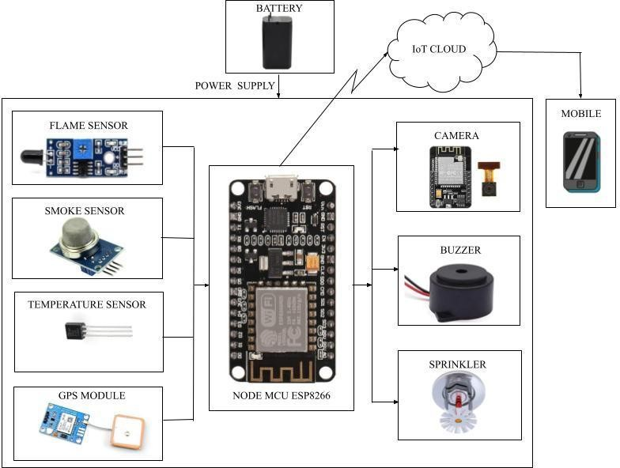

Figure 2: IFPS Block Diagram

The block diagram shown above illustrates the complete functioning of the system. It employs three sensors, namely flame, temperature, and gas sensors, to detect flame, temperature, and gas respectively.
Flame Sensing system comprises a flame sensor that detects flames and immediately sends an alert notification while turning on an automatic sprinkler to minimize damage, accompanied by a buzzer to alert the surrounding area and a live stream using a camera. When the flame sensor detects a flame, the sensor will trigger a signal to blink a light, indicating that a flame has been detected. If no fire is detected it will not do the procedures. Gas Sensing system comprises a gas sensor that detects gas and immediately sends an alert notification while turning on a buzzer to alert the surrounding area and a live stream using a camera. If no gas is detected it will not do the procedures. Temperature Sensing system comprises a temperature sensor that detects the rise in temperature and immediately sends an alert notification while turning on a buzzer to alert the surrounding area and a live stream using a camera. If no abnormality in temperature is detected it will not do the procedures.
The system operates on a 5V power supply. Once any of these sensors detect any abnormality, the system triggers a buzzer alert and activates an automatic sprinkler. Additionally, the system can be monitored using a camera and all the collected data is transmitted to a NodeMCU board. Moreover, the system sends an alert message to the user along with the location details via the IoT platform. Which helps in minimizing damages caused by fire accidents.

C. Location Sharing using Cloud
One way to implement location sharing using cloud technology is through the use of GPS-enabled devices that periodically transmit their location data to a cloud server. This data can then be accessed by authorized users through a web-based interface or mobile app. Cloud-based location sharing can also be integrated with other applications and services, such as mapping and routing software, to provide real-time location information and personalized recommendations based on a user's current location. Overall, location sharing using cloud technology offers a convenient and scalable solution for managing and sharing location data across multiple devices and platforms.

D. Working Principle
An IFPS using IoT is a technology that detects and prevents fire-related hazards in homes. It works by collecting data from sensors, analyzing it to determine the likelihood of a fire, and sending real-time alerts to occupants' devices. In case of an outbreak, it activates alarms, notifies the fire department, and can take pre-defined actions to prevent the spread of fire and smoke. Its purpose is to provide a quick and dependable response to fire hazards, enhancing the safety and security of homes and occupants. Fire hazards can be detected using a temperature sensor, gas sensor, and flame sensor.
To connect a temperature sensor, a digital temperature sensor like the DHT11, has been used which can be connected to the NodeMCU ESP8266. The DHT11 sensor is a basic digital temperature and humidity sensor that is commonly used in DIY electronics projects. It works by measuring the temperature and humidity in the surrounding environment and outputting a digital signal that can be read by a microcontroller or other digital device.
To connect a gas sensor, an analog gas sensor like the MQ-2, can be connected to the NodeMCU ESP8266 using the ADC pins. The MQ2 sensor is a gas sensor that is commonly used in detecting various types of gasses such as methane, propane, alcohol, smoke, and other gasses. It works by measuring the concentration of target gasses in the surrounding environment and outputting an analog voltage signal that can be read by a microcontroller or other digital device.
To connect a flame sensor, use a digital flame sensor like the Flame Sensor Module, which can be connected to the NodeMCU ESP8266 using the GPIO pins. A flame sensor is a device that is designed to detect the presence of a flame in a furnace or other combustion system. The flame sensor detects the infrared radiation emitted by flames. The digital Read function has been used in the Arduino IDE to read the values from the flame sensor. It is an important safety feature that helps to prevent fires and other hazards. The basic principle of a flame sensor is to detect the ultraviolet (UV) light emitted by a flame. The sensor is typically mounted in close proximity to the burner or pilot flame and is connected to a control module that monitors the sensor’s output.
To connect temperature, gas, and flame sensors and also connect with GPS and GSM to NodeMCU ESP8266, use the appropriate pins and interfaces. NodeMCU ESP8266 is a microcontroller board that can be easily programmed using the Lua scripting language or the Arduino IDE. It has built-in Wi-Fi, making it an excellent choice for IoT projects. The WiFi module in the NodeMCU board works by transmitting and receiving data over a wireless network using the IEEE 802.11 protocol. It communicates with the router or access point to establish a connection and send or receive data. The module has a built-in antenna and uses radio waves to transmit and receive data. The NodeMCU board also has firmware that allows for easy configuration and setup of the WiFi module.
A buzzer and a sprinkler system are two common fire safety devices that can be installed in homes to help prevent and mitigate fires. A buzzer is typically a simple, battery-operated device that emits a loud, audible alarm when it detects smoke or heat. When smoke or heat is detected, the buzzer will trigger and alert the occupants of the home to evacuate immediately. This early warning system can be crucial in allowing people to escape their home before the fire grows out of control. A sprinkler system, on the other hand, is a more complex fire safety device that uses water to extinguish fires. A typical home sprinkler system consists of a network of pipes, sprinkler heads, and a control panel. When a fire is detected by the sprinkler system, the control panel will activate and release water through the sprinkler heads. The sprinkler heads will then spray water directly onto the fire, helping to extinguish it or at least control it until the fire department arrives. A buzzer is similar to an alarm clock. It makes an output sound like an alarm sound, then turns on the machine. Two pins make up the whistle. IC L293D is a popular motor driver IC that allows DC motors to run in any direction. This IC has 16 pins and is used to instantaneously control a pair of DC motors in any direction. That means two DC motors can be controlled with one L293D IC. This IC can also drive small and quite large motors. The motor driver takes a low current signal from the control circuit and amplifies it into a high current signal, in order to drive the motor properly. The water pump is connected to an integrated circuit. If a flame is detected, the IC will activate the DC motor and the water pump. The sprinklers attached to the pump will spray water over the area affected by the fire.
The necessary code for this system has been programmed in Arduino IDE. Arduino IDE provides a platform for programming microcontrollers, while Push Bullet can be used to send notifications and alerts to users.
A power supply with a 12V output is a type of power supply that provides a constant voltage of 12 volts. It is commonly used to power electronic devices that require a stable source of DC voltage, such as computers, routers, and other electronic devices. There are several types of 12V power supplies available, including linear power supplies, switching power supplies, and regulated power supplies.
Linear power supplies are the simplest type and are based on a transformer, rectifier, and voltage regulator. They are relatively inexpensive, but not very efficient, and can generate a lot of heat. Switching power supplies are more efficient and can be smaller in size compared to linear power supplies. They use a switching regulator to convert the input voltage into a high-frequency AC signal, which is then rectified and filtered to produce a stable DC output voltage.

IV EXPERIMENTAL RESULT AND DISCUSSION

A working model of the proposed system using GPS and push bullet application has been implemented successfully. The greatest advantage of our research is when the sensor detects something it immediately sends an acknowledgement to the given mail id of the owner and it also alerts the surrounding using a buzzer alert.
To minimize the damage caused to the surrounding area an automatic sprinkler is added to the system. This system will give the exact location of the place of accident and make the rescue process easier and earlier. This system includes a camera that helps in the detection of false alarms through which the owner can see the live stream. This system is mainly designed to save lives and properties.

B. Experimental Setup
An experimental setup typically involves the physical and/or virtual assembly of hardware and software components to test a particular hypothesis or idea. The setup should include detailed information about the components used, such as their make and model, specifications, and any necessary drivers or libraries. It should also include a description of the software used, such as the programming language, development environment, and any relevant code or scripts.
The experimental setup should be carefully designed and documented to ensure that it is reproducible and provides accurate and reliable results. This may involve testing and troubleshooting the setup to identify and address any potential issues or limitations, as well as documenting any modifications or adjustments made during the course of the experiment.

C. Hardware Assembly
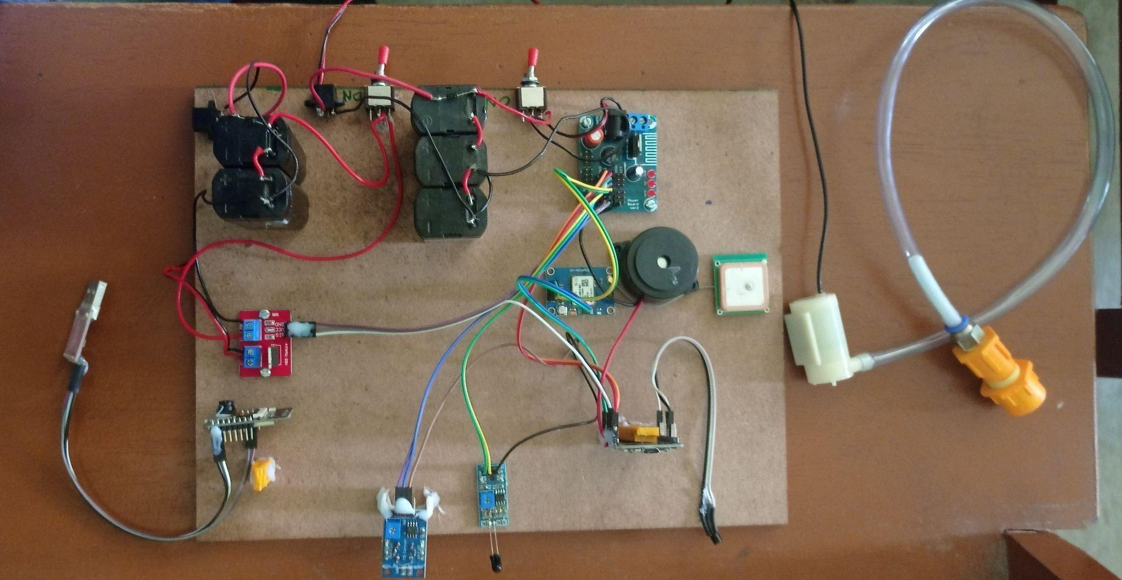
An integrated system is formed by connecting various hardware components together, including gas sensors, flame sensors, temperature sensors, buzzers, cameras, sprinklers, and WiFi modules. This integration aims to achieve a specific expected outcome. The gas sensors detect the presence of gas, while the flame sensors identify any flames present in the vicinity. The temperature sensors measure the temperature of the environment, while the sprinklers activate if necessary, to extinguish any fires. Finally, the cameras capture visual data, and the WiFi module allows for remote access to the system. Figure 3 shows the entire circuit connection. It shows the connections of all components.

Figure 3: Hardware assembly

D. Software Setup
To implement the circuit, it is necessary to write the code in Arduino IDE. To set up Arduino software for an integrated fire safety system, connect the sensors for gas, flame, and temperature, as well as the buzzer, sprinkler, and WiFi module to the nodeMCU. The software should read data from these sensors and activate the appropriate response mechanisms based on the sensor readings. If the gas sensor detects hazardous gas levels, the system should activate the buzzer to alert individuals in the area. The software should enable real-time monitoring and control through the WiFi module. Rigorous testing of the software is crucial to ensure reliable detection and response to fire hazards. Figure 4 shows the Fire system Program in Arduino IDE.

Figure 4 : Fire systems Program in Arduino ID

To set up Arduino software for a camera-integrated system, connect the camera OV2640 to the NodeMCU and install the appropriate libraries like ESP32-CAM. The OV2640 is a popular camera module used with microcontrollers like Arduino and Raspberry Pi. It can capture higher-resolution images and even record video. The OV2640 supports various configurations and settings to control image quality, resolution, frame rate, and other parameters. Capture images or video feed from the camera and process the data to detect any flames or smoke, allowing for real-time monitoring through a cloud-based platform or other remote device via WiFi. Instead of a user interface, the OV2640 camera module is typically controlled and configured through the hardware and software of the host microcontroller or development board, such as Arduino or Raspberry Pi. Thorough testing should be conducted to ensure that the system accurately detects and responds to fire hazards. Figure 5 shows the Camera Program in ArduinoIDE.

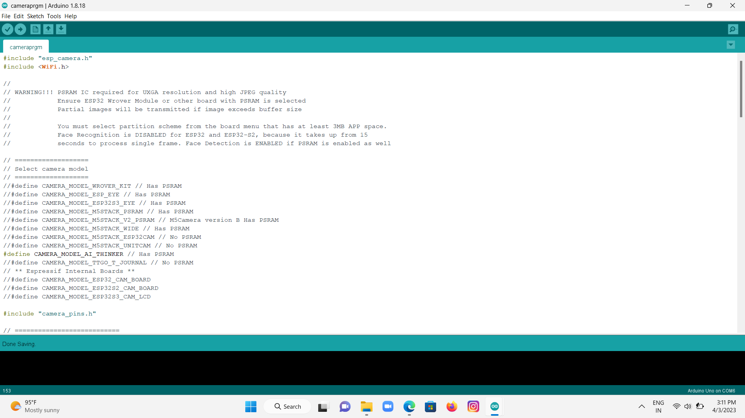

Figure 5: Camera Program in Arduino IDE

E. Screenshots
The following Figures 6,7 and 8 show the output screenshots produced while implementing this system. Whenever an incident happens, an alert notification is sent to respective contacts. The alert notification includes the location of the incident that happened. Figure 6 shows the alert notification send to the contacts as links when the sensors detect a flame, gas, or abnormal temperature.
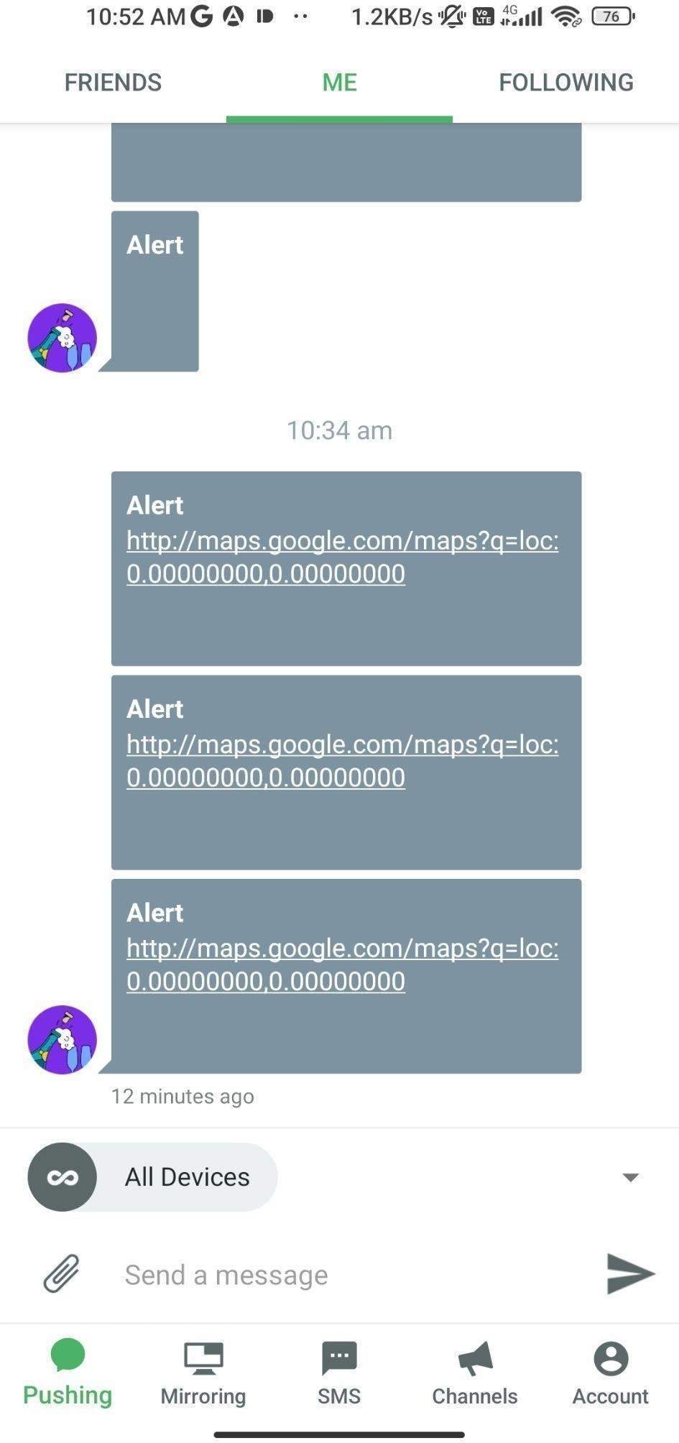

Figure 6: Pushbullet Notification

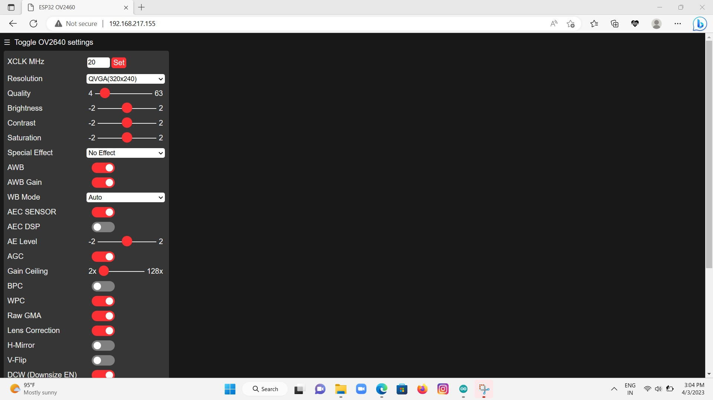

Figure 7 : Camera Home Screen

The above Figure 7 shows the Camera Home Screen. It captures images and videos based on the configuration settings provided to it. When the sensors detect hazards, the camera gets ready to capture the incident.

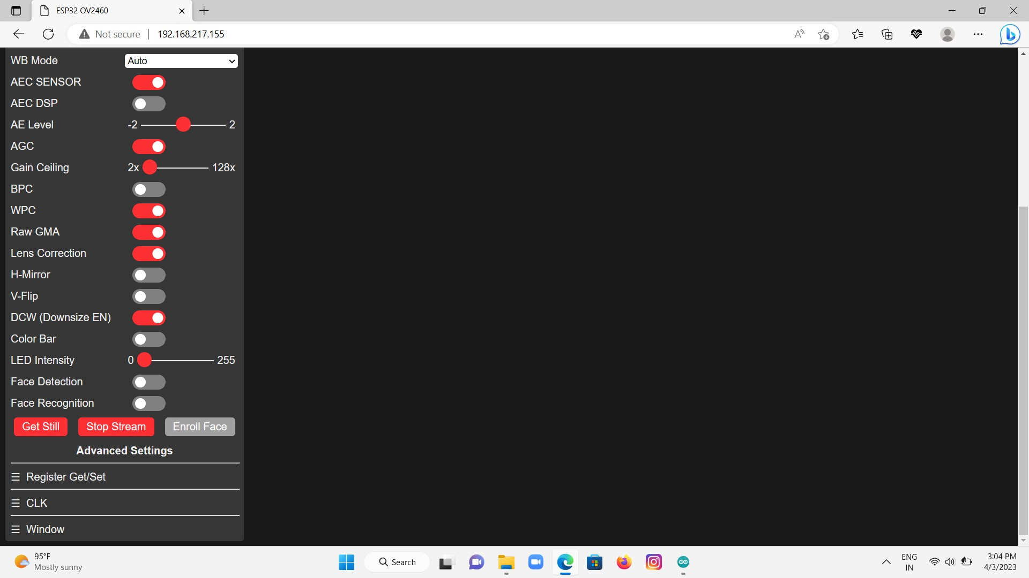
Figure 8 : Camera Streaming Screen

The above Figure 8 shows the camera streaming screen. The camera captures the incident and creates frames. The frames from the camera are captured and streamed to the display screen in real time.

V. CONCLUSION AND FUTURE WORK

Traditionally, fire extinguishers were used manually to put out fires. Later, many fire safety systems were designed. The existing fire safety systems used a combination of sensors and sprinklers to extinguish fires. However, a problem with these systems is that if a fire is caused by a short circuit, the breaker may cut off power to the sensors, rendering them ineffective in detecting the fire. Additionally, the sensors may produce false alarms, leading to unnecessary panic. To address these issues, we proposed an IFPS system that sends alerts to the homeowner when a fire is detected, including the location of the fire. The pump-up motor automatically sprays water to reduce the spread of fire, and the camera enables the homeowner to verify if there is an actual fire or not, to prevent unnecessary panic. In real-time, we intended to use a water sprinkler instead of a pump-up motor. The system is connected to a battery, ensuring that it remains functional during a power outage. These features provide a comprehensive solution for fire safety and security, enhancing the safety of homes. IFPS will integrate AI, image processing, and call request capabilities in the future. AI algorithms can predict potential fire risks, while image processing can detect smoke and fire visually. Call request technology allows homeowners to request emergency assistance in real-time. These advanced technologies will lead to a more comprehensive and efficient approach to managing fire risks, improving safety and security. AI can detect and predict hazards, image processing can identify fire hazards, and call requests can connect homeowners with emergency responders. The integration of these technologies will provide homeowners with peace of mind and a greater sense of control over their environment. Overall, the future of IFPS will be characterized by increased efficiency and accuracy in detecting and preventing fire hazards and also focus on the integration of advanced technologies, increased connectivity, and personalization to enhance safety, convenience, and peace of mind for homeowners.

REFERENCES

[1] Alqourabah, Hamood, Amgad Muneer, And Suliman Mohamed Fati. 202‘A Smart Fire Detection System Using IoT Technology with An Automatic Water Sprinkler.’ International Journal of Electrical & Computer Engineering (2088-8708) 11, No. 4 (2021).
[2] Alsaad, Saad Najim, And Nadia Mahmood Hussien. ‘IoT Based Message Alert SystemfFor Emergency Situations.’International Journal of Computing and Digital Systems 9 (2020): 1-7.
[3] Bao, Yi, Ying Huang, Matthew S. Hoehler, And Genda Chen. ‘Review of Fiber Optic Sensors for Structural Fire Engineering.’ Sensors 19, No. 4 (2019): 877.
[4] Chen, Ying-Yueh, Ying-Ji Chuang, Chin-Hsing Huang, Ching-Yuan Lin, And Shen-Wen Chien.2012 ‘The Adoption of Fire Safety Management for Upgrading the Fire Safety Level f Existing Hotel Buildings.’ Building and Environment 51 (2012): 311-319.
[5] Chuvieco, Emilio, And Eric S.Kasischke.(2007 ‘Remote Sensing Information For Fire Management and Fire Effects Assessment.’ Journal of Geophysical Research: Biogeosciences 112,No. G1 (2007).
[6] Chuvieco, Emilio, and Eric S.Kasischke.2007 ‘Remote sensing information for fire management and fire effects assessment.’ Journal of Geophysical Research: Biogeosciences 112, no. G1(2007).
[7] Dangrach, Meeral, Syed Mazhar Ali Shah, Agha Zain Ul Abdin, Adeel Ali, And Mukhtiar Ahmed. "IoT Based Fire System." Journal of Applied Engineering & Technology (Jaet) 5,No. 1 (2021): 19-30.
[8] Ehsan, Ibtisam, Asia Mumtaz, Muhammad Irfan Khalid, Jawaid Iqbal, Saddam Hussain, Syed Sajid Ullah, and Fazlullah Umar. 2022 "Internet of Things-Based Fire Alarm Navigation System: A Fire-Rescue Department Perspective." Mobile Information Systems.
[9] Hariveena, Ch, K. Anitha, And Potharaju Ramesh. 2020 "IoT-Based Fire Detection and Prevention System." In IOP Conference Series: Materials Science and Engineering, Vol. 981, No. 4, P. 042080. IOP Publishing.
[10] Islam, Taoufikul, Hafiz Abdur Rahman, And Minhaz Ahmed Syrus. ‘Fire Detection System with Indoor Localization Using Zigbee Based Wireless Sensor Network.’ In 2015 International Conference On Informatics, Electronics & Vision (ICIEV), Pp. 1-6.Ieee, 2015.
[11] Jiang, Jia, Zhe Gao, Huanhuan Shen, And Changsheng Wang. ‘Research on The Fire Warning Program of Cotton Warehousing Based on IoT Technology.’ In 2015 International Conference on Logistics, Informatics and Service Sciences (LISS), Pp. 1-4. Ieee,2015.
[12] Juwariyah, T., S. Prayitno, L. Krisnawati, And S. Sulasminingsih. 2021 ‘Design of IoT-Based Home Fire Detection System Equipped with A Data Logger.’ In IOP Conference Series: Materials Science and Engineering, Vol. 1125, No. 1, P. 012079. IOP Publishing, 2021.
[13] Kamel, Souad, Amani Jamal, Kaouther Omri, And Mashael Khayyat. (2022) ‘An IoT Based Fire Safety Management System for Educational Buildings: A Case Study.’ International Journal of Advanced Computer Science and Applications 13, No. 7.
[14] Khalaf, Osamah Ibrahim, Ghaida Muttashar Abdulsahib, And Noor Abdul Khaleq Zghair. ‘IoT Fire Detection System Using A Sensor with Arduino.’ Aus 26 (2019): 74-78.
[15] Lloret, Jaime, Miguel Garcia, Diana Bri, And Sandra Sendra. ‘A Wireless Sensor Network Deployment for Rural and Forest Fire Detection and Verification.’ Sensors 9, No. 11 (2009): 8722-8747.
[16] Mangayarkarasi, T., K. Umapathy, A.Sivagami, And D. Subitha. 2021 ‘An IoT Based Safe Assembly Point Alert System.’ In Journal of Physics: Conference Series, Vol. 1964, No. 7, P.072013. IOP Publishing.
[17] Noureddine, Houache, And Kechar Bouabdellah. 2020 ‘Field Experiment Tested for Forest Fire Detection Using Wireless Multimedia Sensor Network.’ International Journal of Sensors Wireless Communications and Control 10, No. 1 (2020): 3-14.
[18] Perilla, Fernandino,S. George R.Villanueva Jr, Napoleon M. Cacanindin, And Thelma D. Palaoag. 2018 ‘Fire safety and alert system using arduino sensors with IoT integration." In Proceedings of the 2018 7th International Conference on Software and Computer Applications, pp. 199-203. 2018.
[19] Saeed, Faisal, Anand Paul, Abdul Rehman, Won Hwa Hong, And Hyuncheol Seo. 2018 ‘IoT-Based Intelligent Modeling Of Smart Home Environment For Fire Prevention And Safety.’ Journal Of Sensor And Actuator Networks 7, No. 1 (2018): 11.
[20] Sarwar, Barera, Imran Sarwar Bajwa, Noreen Jamil, Shabana Ramzan, And Nadeem Sarwar. 2019 ‘An Intelligent Fire Warning Application Using IoT And An Adaptive Neuro-Fuzzy Inference System.’ Sensors 19, No. 14 (2019): 3150.
[21] Savitha, N., and S. Malathi. 2018 ‘A survey on fire safety measures for industry safety using IOT.’ In 2018 3rd International Conference on Communication and Electronics Systems (ICCES), pp. 1199-1205. IEEE.
[22] Srividhya, S., And Suresh Sankaranarayanan. 2020 ‘IoT–Fog Enabled Framework for Forest Fire Management System.’ In 2020 Fourth World Conference on Smart Trends In Systems, Security, And Sustainability (Worlds4), Pp. 273-276. IEEE.
[23] Teja, D., M. Suraj Kiran, A. V. Sudheer, I. Anil Kumar Reddy, And K. Jyothi. April 2022 ‘IoT Based Fire Detection and Automatic Water Sprinkler System.’ International Journal of Engineering Applied Sciences and Technology, 2022 Vol. 6, Issue 12, ISSN No. 2455-2143, Pages 312-317
[24] Toledo-Castro, Josué, Iván Santos-González, Pino Caballero-Gil, Candelaria Hernández-Goya, Nayra Rodríguez-Pérez, and Ricardo Aguasca-Colomo. 2019 "Fuzzy-based forest fire prevention and detection by wireless sensor networks." In International Joint Conference SOCO’18-CISIS’18-ICEUTE’18: San Sebastián, Spain, June 6-8, 2018 Proceedings 13, pp. 478-488. Springer International Publishing, 2019.
[25] Vijayalakshmi, S. R., And S. Muruganand. ‘Internet of Things Technology For Fire Monitoring Systems.’ Int. Res. J.Eng. Technol 4, No. 6 (2017): 2140-2147.
[26] Yépez, Juan, And Seok-Bum Ko.2020 ’IoT-Based Intelligent Residential Kitchen Fire Prevention System.’ Journal Of Electrical Engineering & Technology 15, No.6 (2020): 2823-2832.

