SYNTHESIS, METHODOLOGY AND CHARACTERIZATION OF SILVER NANOPARTICLES
¹Mr. Vikas Chaubey, ²Dr. Aakash Singh, ³Dr. Atul Kumar and ⁴Dr. Shailendra Sinha
¹ vikaschaubey0111@gmail.com ² aakashsingh.ucst@gmail.com ³ atulkumar.iitr@gmail.com ⁴ shailendra.sinha@ietlucknow.ac.in
^{1,2,3}IET, Dr. Shakuntala Misra National Rehabilitation University, Lucknow, Uttar Pradesh.
⁴Institute of Engineering and Technology, Lucknow, Uttar Pradesh.
1. Introduction:
1.1 Nano-technology:
Nano-technology is a significant and quickly expanding field of research focused on designing, synthesizing, and manipulating particles spanning roughly 1 to 100 nm in one dimension. This innovation has made possible new frontiers in various areas, including fundamental research and practical applications. Nanoscale materials possess special physicochemical & optoelectronic characteristics that render them highly valuable in numerous industries. The alternative uses of nanotechnology are vast and diverse. It plays a crucial role in various domains, including medical care, beauty products, nourishment and animal sustenance, ecological well-being, mechanical systems, optical technology, life sciences, chemical production, electronic engineering, space exploration, pharmaceutical transport, energy research, photonics, chemical transformation, imaging techniques, specialized electronic components, light emission mechanisms, intricate optical apparatus, and applications involving light-driven chemical processes. Overall, nanotechnology's progress and its applications promise exciting opportunities for advancements across various fields and industries [1-2]. Nanomaterials present hopeful answers to different technological and environmental issues in fields like solar energy conversion, catalysis, healthcare, and water purification. As the world strives to reduce hazardous waste, the growing demand for nanomaterials necessitates the development of green synthesis methods. Nanotechnology is revolutionizing the synthesis of materials and fabrication of devices. Utilizing "the approach that starts from fundamental components," nanoscale fundamental elements have the potential to become assembled into functional structures and devices with multiple functions. The exploration of nanosized materials' synthesis is particularly intriguing due to their distinct properties, such as optoelectronic, magnetic, and mechanical characteristics, which differ from bulk materials [3]. "Nanotechnology is bringing about a fundamental transformation in the synthesis of materials and fabrication of devices. It enables the incorporation of nanoscale building blocks into functional assemblies and the development of multifunctional devices using a 'bottom-up approach.' The research on synthesizing nanosized materials is particularly captivating due to their distinctive properties, including optoelectronic, magnetic, and mechanical attributes that set them apart from bulk materials."
1.2 Nanoparticles:
The expression "nanoparticles" pertains to particles falling within the range of 1nm to 100nm, in at least one of their three dimensions. In this size bracket, nanoparticles demonstrate unique physical, chemical, and biological characteristics in contrast to individual atoms/molecules and large-scale substances. These nanoparticles have the potential to consist of a variety of materials, encompassing metals, metal oxides, silicates, non-oxide ceramics, polymers, organic substances, carbon, and biomolecules. They can adopt diverse forms like spheres, cylinders, platelets, and tubes. Additionally, surface modifications are commonly applied to nanoparticles to suit specific applications.
Due to the swift pace of industrialization and urbanization, our environment is undergoing considerable harm, resulting in the emission of harmful substances. This necessitates a thorough exploration of natural resources and their potential to enhance nanoparticle synthesis methods. Nanotechnology, especially when applied to biological molecules, offers a sustainable and effective approach for producing metal nanoparticles. The controlled assembly of these molecules has proven to be both dependable and environmentally friendly in the synthesis of metal nanoparticles [4]. Research into the creation of metal and semiconductor nanoparticles is a vast field, driven by their significant application potential and their contributions to innovative technologies [5]. Nanotechnology is quickly gaining prominence in modern material science research. Nanoparticles showcase distinct and improved characteristics, encompassing size, distribution, and structure. This leads to the continuous emergence of fresh applications for nanoparticles and nanomaterials across diverse domains [6]. Metal nanoparticles have a remarkable specific surface area and a significant proportion of surface atoms. These nanoparticles display unique physicochemical traits, including catalytic functionality, optical behavior, electronic attributes, antibacterial qualities, and magnetic properties [7-10]. Scientists are deeply intrigued by metal nanoparticles due to their inventive production techniques. Recent times have witnessed substantial attention towards researching the synthesis of metal nanoparticles, representing a pivotal aspect of modern material science. Among these, nano-crystalline silver particles have displayed immense promise in diverse applications such as sensitive biomolecular detection, diagnostics, antimicrobial functions, therapeutic applications, catalysis, and microelectronics. Nonetheless, a compelling necessity exists for an economically sustainable and eco-friendly pathway to synthesize silver nanoparticles. Silver is celebrated for its ability to inhibit numerous bacterial strains and microorganisms prevalent in medical and industrial settings [11]. In the medical field, both silver and silver nanoparticles find extensive applications, including their use in skin ointments and creams to prevent infection in the case of burns and open wounds [12], Medical devices and implants often utilize silver-impregnated polymers for their preparation [13]. In the textile industry, the implementation of silver-embedded fabrics has become prevalent, especially in the manufacturing of sports gear [14].
Nanoparticles can be created using diverse techniques, encompassing chemical, physical, and biological methods. While the chemical route enables swift production of substantial nanoparticle quantities, it demands the use of stabilizing agents to control their size. Unfortunately, these agents and the synthesis chemicals frequently generate harmful byproducts that are not environmentally friendly. Consequently, there's an escalating interest in investigating biological methodologies that exclude toxic substances and their resultant products. This escalating demand for ecologically safe nanoparticle synthesis methods has catalyzed the growth of green nanotechnology [15]. Several biological means, both extracellular and intracellular, have been documented for generating nanoparticles. These methods involve microorganisms such as bacteria, fungi, and plants. Plants, in particular, offer a valuable avenue for nanoparticle synthesis, given their lack of toxic elements and the presence of natural stabilizers [16-17]. Moreover, employing plant extracts reduces the expense associated with isolating and cultivating microorganisms, rendering nanoparticle synthesis more economically competitive than microorganism-based approaches [17]. In certain cases, utilizing various plant species and their extracts for nanoparticle synthesis can yield advantages over other biological procedures, which often entail intricate measures to maintain microbial cultures [18-19]. Numerous experiments have already been conducted, including the synthesis of various metal nanoparticles using fungi like Fusarium oxysporum [20] and Penicillium sp. [21], as well as some bacteria such as Bacillus subtilis [22-23]. However, the most widely adopted method for green, eco-friendly nanoparticle production is through plant extracts. This approach holds a special advantage as plants are widely distributed, easily accessible, safer to handle, and serve as a source of several metabolites [24]. Numerous studies have explored the synthesis of silver nanoparticles using medicinal plants such as Oryza sativa, Helianthus annus, Saccharin officinarum, Sorghum bicolour, Zea mays, Basella alba, Aloe vera, Capsicum annuum, Magnolia kobus, Medicago sativa (Alfalfa), Cinamomum camphora, and Geranium sp., especially for pharmaceutical and biological purposes. Additionally, research has been conducted on producing silver nanoparticles through environmentally friendly methods, including the use of methanolic extracts from Eucalyptus hybrid [25]. Recent achievements include the successful synthesis of silver nanoparticles from naturally occurring sources like green tea (Camellia sinensis), Neem (Azadirachta indica), leguminous shrub (Sesbania drummondii), various leaf extracts, natural rubber, starch, Aloe vera, lemongrass leaves, and more [26]. In terms of their antimicrobial attributes, silver nanoparticles bind to microbial cell walls, disrupting their integrity and respiration. These nanoparticles can even penetrate deep into cell walls, interacting with compounds rich in phosphorus and sulfur, such as DNA and proteins, leading to cellular damage. The release of silver ions from the nanoparticles contributes to their bactericidal effects, thus granting antimicrobial properties [27]. The effectiveness against bacteria varies with nanoparticle size, with smaller particles displaying greater antibacterial potency due to an equivalent mass of silver. Furthermore, nanoparticles synthesized using biological methods, whether intra or extracellularly by microorganisms like diatoms, fungi, bacteria, and yeast, tend to be more compatible with living systems, offering potential for medical applications [28].
1.3 Nanoparticle Classification:
Nanoparticles are commonly divided into three categories: organic, inorganic, and carbon-based.
- Organic Nanoparticles:
Organic nanoparticles or polymers include structures like dendrimers, micelles, liposomes, and ferritin [29]. These possess beneficial traits such as biodegradability and non-toxicity. Micelles and liposomes, with hollow cores known as nanocapsules, are sensitive to thermal and electromagnetic radiation, making them suitable for drug delivery applications. Factors like drug carrying capacity, stability, and delivery mechanisms influence their effectiveness, along with attributes like size, composition, and surface morphology. Organic nanoparticles are extensively utilized in biomedicine, especially for targeted drug delivery due to their efficiency and ability to pinpoint specific body areas.
- Inorganic Nanoparticles:
Inorganic nanoparticles can be further categorized into metal-based and metal oxide-based.
    - Metal-Based-
Metal-based nanoparticles result from reducing metals to nanoscale dimensions through various methods [30]. Practically all metals can be transformed into nanoparticles. Examples include aluminum (Al), cadmium (Cd), copper (Cu), gold (Au), silver (Ag), and more. These nanoparticles exhibit unique properties with sizes ranging from 10 to 100 nm. They have distinct surface characteristics, such as high surface area to volume ratio, pore size, and surface charge. Different shapes like spherical and cylindrical contribute to varying reactivity and sensitivity to environmental factors.
    - Metal oxide-Based-
Metal oxide-based nanoparticles are derived from corresponding metal-based nanoparticles. For instance, iron (Fe) nanoparticles readily oxidize to iron oxide (Fe2O3), enhancing their reactivity compared to plain iron nanoparticles [31]. Commonly synthesized metal oxide nanoparticles include Aluminum oxide (Al2O3), Cerium oxide (CeO2), Iron oxide (Fe2O3), and more. These nanoparticles exhibit superior properties compared to their metal counterparts.
    - Carbon Based-
Carbon-based nanomaterials include forms like fullerenes, graphene, carbon nanotubes (CNT), carbon nanofibers, and carbon black [32]. These materials primarily consist of carbon atoms and exhibit various shapes and structures. Carbon-based nanoparticles have extensive applications in fields like coatings, materials strengthening, and electronics.
- Fullerenes:
Fullerenes (C60) are spherical carbon molecules with around 28 to 1500 carbon atoms. Single-layer fullerenes have diameters up to 8.2 nm, while multi-layered ones range from 4 to 36 nm.
- Graphene:
Graphene is a two-dimensional carbon allotrope with a hexagonal network of carbon atoms in a honeycomb lattice. Its thickness is approximately 1 nm.
- Carbon Nano Tube (CNT):
Carbon nanotubes are formed by rolling graphene sheets into hollow cylinders. They come in single-layered and multi-layered variations with diameters as small as 0.7 nm and lengths ranging from micrometers to millimeters.
- Carbon Nano Fiber:
Similar to CNTs, carbon nanofibers are created from graphene nanofoils but wound into cone or cup shapes.
- Carbon Black:
Carbon black is an amorphous carbon material with a spherical shape and diameters of 20 to 70 nm. Interactions between particles lead to aggregates, forming agglomerates around 500 nm in size.
1.4 Synthesis of nanoparticles:
Nanoparticles can be synthesized using two main approaches: bottom-up and top-down methods. Synthesis of nanoparticles involves various methods that can be categorized as either bottom-up or top-down approaches. The bottom-up approach involves building up materials from atoms to clusters and nanoparticles, while the top-down approach involves reducing bulk materials to nanoscale particles.
1.4.1 Bottom-up methods-
Bottom-up methods involve assembling materials from the nanoscale, such as molecules and atoms, to construct nanoparticles. Common bottom-up methods include:
  - Sol-gel method:
Spinning is performed in a spinning disc reactor (SDR), where a rotating disc inside a controlled chamber enables nanoparticle synthesis [33]. Precursor liquid and water are pumped in as the disc rotates at various speeds, causing atoms or molecules to fuse together and precipitate as nanoparticles. The synthesized nanoparticles' characteristics depend on factors like liquid flow rate, disc rotation speed, and liquid-to-precursor ratio [34].
  - Spinning:
Spinning is performed in a spinning disc reactor (SDR), where a rotating disc inside a controlled chamber enables nanoparticle synthesis [31]. Precursor liquid and water are pumped in as the disc rotates at various speeds, causing atoms or molecules to fuse together and precipitate as nanoparticles [35]. The synthesized nanoparticles' characteristics depend on factors like liquid flow rate, disc rotation speed, and liquid-to-precursor ratio.
  - Chemical Vapor Deposition (CVD):
CVD involves depositing a thin film of gaseous reactants onto a substrate. The process takes place in a reaction chamber at ambient temperature, where gas molecules react on a heated substrate to form a thin product film [32]. CVD yields pure, uniform, and strong nanoparticles, but it requires specialized equipment and generates toxic by-products [36].
  - Pyrolysis:
Pyrolysis is an industrial process for nanoparticle production, involving the combustion of a precursor with a flame or alternative heat source [37]. The resulting gases are collected and used, and nanoparticles are recovered through air classification [38]. Pyrolysis is cost-effective and continuous, with potential for high yield.
  - Biosynthesis:
Biosynthesis is an eco-friendly approach utilizing biological agents like bacteria, plant extracts, and fungi, along with precursors, to synthesize nanoparticles. This method is nontoxic, biodegradable [39], and yields nanoparticles with enhanced properties suitable for biomedical applications.
1.4.2 Top-Down Method-
Top-down methods involve reducing bulk materials to nanoscale particles. Various methods fall under this category, including:
a. Mechanical Milling:
Mechanical milling is a widely used top-down method where nanoparticles are produced by milling and post-annealing in an inert atmosphere [40]. Plastic deformation, fracture, and cold-welding contribute to particle size and shape changes during the process.
b. Nanolithography:
Nanolithography is the fabrication of nanoscale structures using processes like optical, electron-beam, multiphoton, nano imprint, and scanning probe lithography [41]. These methods involve selectively removing material to create desired shapes and structures [42].
c. Laser ablation:
Laser Ablation Synthesis in Solution (LASiS) involves irradiating a metal submerged in a liquid solution with a laser beam, forming a plasma plume that produces nanoparticles [43]. This method offers an alternative to conventional chemical reduction for metal-based nanoparticle synthesis.
d. Sputtering:
Sputtering deposits nanoparticles onto a surface by ejecting particles from it through ion collisions [44]. A thin nanoparticle layer is deposited, followed by annealing to influence nanoparticle size and shape [45].
e. Thermal decomposition:
Thermal decomposition involves breaking chemical bonds in a compound through heat, resulting in nanoparticles' formation [30]. Specific temperatures trigger chemical reactions that produce secondary products as nanoparticles.

Table- 1.1 Categories of the Nanoparticles synthesized from the various methods
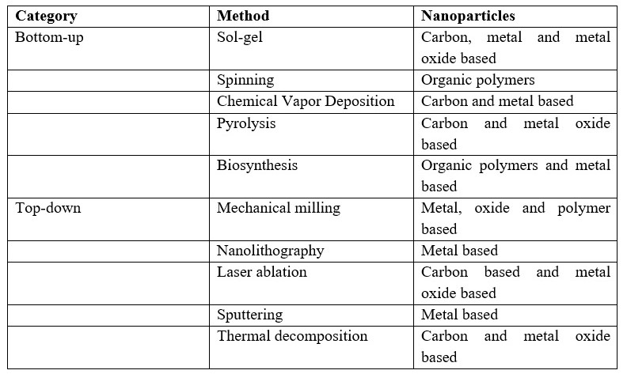
1.5 Properties of Nanoparticles:
Nanoparticles display a range of properties that can be divided into physical and chemical characteristics.
1.5.1 Physical Properties:
The physical attributes of nanoparticles encompass optical traits like color, light interaction (penetration, absorption, and reflection), as well as distinct mechanical features including elasticity, ductility, tensile strength, and flexibility. These mechanical properties significantly influence their applications. Nanoparticles also possess qualities like hydrophilicity, hydrophobicity, suspension behavior, diffusion capabilities, and settling tendencies, which are advantageous in numerous modern applications. Due to their large surface area relative to their small bulk, nanoparticles often exhibit unique contributions. For example, zinc oxide nanoparticles are more effective at blocking UV radiation compared to their bulk counterparts, finding utility in sunscreens. Noteworthy physical properties of nanoparticles include:
Color: Nanoparticles of materials like yellow gold and gray silicon exhibit a red color.
Melting Point: Gold nanoparticles have lower melting points (around 300 °C for a size of 2.5 nm) compared to bulk gold slabs (1064 °C).
Solar Radiation Absorption: Nanoparticles absorb more solar radiation in photovoltaic cells compared to continuous sheets of bulk materials, owing to their smaller size.
1.5.2 Chemical Properties:
Chemical properties determine nanoparticles' reactivity with specific targets, stability, and responsiveness to external factors such as moisture, atmosphere, heat, and light. These attributes hold significance in various fields, including biomedicine and the environment. Nanoparticles can exhibit antibacterial, anti-fungal, disinfection, and toxicity properties, contributing to their versatile applications.

1.5.3 Suspension Formation:
An essential physical property of nanoparticles is their ability to form suspensions. Strong interactions between the particle surface and the solvent overcome density disparities, enabling nanoparticles to remain suspended in liquids.
1.5.4 Optical Properties of Nanoparticles:
Nanoparticles often present unexpected optical behaviors due to their small size, which confines electrons and leads to quantum effects. For instance, gold nanoparticles appear deep red to black when in solution.
1.5.5 Nanoparticle Diffusion Properties:
Particularly at elevated temperatures, nanoparticles exhibit diffusion properties. Sintering, which can lead to particle agglomeration, occurs at lower temperatures and shorter time scales for nanoparticles compared to larger particles.
1.5.6 Magnetization and Other Unique Properties:
Nanoparticles display distinctive traits such as quantum confinement in semiconductor particles, surface plasmon resonance in certain metal particles, and superparamagnetism in magnetic materials. However, whether specific properties like magnetization are desirable in nanoparticles depends on their intended applications.
1.6 Why Silver?
Silver is a naturally occurring element renowned for its numerous advantageous attributes. It possesses slightly greater hardness than gold while maintaining exceptional ductility and malleability. Among all metals, silver boasts the highest electrical and thermal conductivity, coupled with the lowest contact resistance. While silver can exist in different oxidation states, the most prevalent forms are metallic silver (Ag0) and silver ions (Ag2+, Ag3+), with the latter being less stable in aquatic environments [46]. While metallic silver exhibits insolubility in water, certain silver salts like AgNO3 and silver chloride display solubility (WHO, 2002). The applications of silver span various domains, including surgical prostheses, fungicides, and coinage. Silver compounds that dissolve in water have been historically employed for treating conditions like mental illnesses, epilepsy, nicotine addiction, gastroenteritis, and infectious diseases such as syphilis and gonorrhea [46]. Studies indicate that the acute toxicity of silver in the environment primarily hinges on the availability of free silver ions, which, in most cases, remain at concentrations too low to induce toxicity (WHO, 2002). The risk posed by metallic silver to health is minimal, whereas soluble silver compounds could potentially be more easily absorbed, potentially leading to adverse effects [47]. Silver serves multiple purposes and can enter the body through various avenues like ingestion. Importantly, it is not deemed toxic to the immune, cardiovascular, nervous, or reproductive systems, and it is not classified as a carcinogen, thus establishing its relative safety [48, 49].
1.7 Synthesis of Silver Nanoparticles by Plants:
The utilization of plant extracts in the synthesis of silver nanoparticles presents numerous benefits, including their ready availability, safety, and lack of toxicity. Plants encompass a diverse array of metabolites that facilitate the reduction of silver ions, expediting the synthesis process in comparison to microbial techniques. Various phytochemicals, among them terpenoids, flavones, ketones, aldehydes, amides, and carboxylic acids, significantly contribute to the reduction and capping processes during nanoparticle synthesis. Specific phytochemicals, like flavones, organic acids, and quinones, demonstrate a direct role in the prompt reduction of silver ions. Research has underscored the presence of anthraquinones and benzoquinones in xerophytes and mesophytes, respectively, which actively participate in the generation of silver nanoparticles. These phytochemicals directly participate in the reduction of ions, ultimately leading to the formation of silver nanoparticles [50].
1.8 Need for Green Synthesis:
The synthesis of nanoparticles adopts a bottom-up approach, predominantly encompassing reduction/oxidation reactions. The demand for nanoparticle biosynthesis emerged due to the expense associated with physical and chemical methodologies. Conventional chemical synthesis approaches often lead to the presence of toxic substances adsorbed onto the nanoparticle surface, posing potential drawbacks in medical applications [51]. This concern is effectively addressed by utilizing nanoparticles produced through environmentally friendly biosynthesis methods, commonly referred to as green synthesis. Researchers have turned their attention to microbial enzymes and plant extracts rich in antioxidant or reducing properties. These properties play a pivotal role in transforming metal compounds into nanoparticles. Notably, Author A. Singh has previously detailed various eco-friendly techniques, including heterocyclic bioactive compound synthesis and nanoparticle production as a green catalyst, yielding remarkable results. This underscores the numerous advantages offered by green synthesis in contrast to chemical and physical procedures, including cost-effectiveness, environmental compatibility, scalability for large-scale synthesis, and the absence of elevated pressure, excessive energy, high temperatures, and hazardous chemicals [52].
1.9 Nano-Silver:
Nano-silver plays a pivotal role in nano formulations owing to its remarkable antimicrobial attributes. It has been integrated into water filters for purifying drinking water and maintaining clean swimming pool water. The production of nano-silver involves transforming metallic silver into ultrafine particles using various techniques, including spark discharging, electrochemical reduction, solution irradiation, and cry-chemical synthesis [53]. The majority of nano-silver particles possess sizes smaller than 100 nm and are composed of approximately 20-15,000 silver atoms [53]. These particles can adopt diverse nanostructures such as tubes, wires, multicasts, or films. At the nanoscale, silver particles exhibit distinct physicochemical properties, including pH-dependent partitioning into solid and dissolved particulate matter, along with different biological activities compared to conventional metals [54]. Due to their exceptional antimicrobial efficacy, nano-silver finds increasing application in consumer and medical goods, encompassing areas like food packaging materials, food supplements, textiles with odor-resistance, electronics, household appliances, cosmetics, medical devices, water disinfectants, and air fresheners.
1.10 Why Thuja Occidentalis Plant?
Thuja Occidentalis, a plant with recognized medicinal utility, sees its leaves and leaf oil deployed across various treatments. It serves to address conditions like respiratory tract infections (bronchitis), bacterial skin infections, and cold sores. Moreover, it finds application in alleviating discomfort associated with osteoarthritis and trigeminal neuralgia, a nerve-related facial disorder. Thuja is employed as an expectorant to facilitate phlegm expulsion, an immune stimulant to enhance immune response, and a diuretic to increase urine production. Historical use includes its application for inducing abortions. On the topical front, thuja finds application for joint pain, osteoarthritis, muscle discomfort, as well as addressing skin issues, warts, and even cancer. The plant's fragrance is harnessed in cosmetic and soap manufacturing processes.
2. Literature Survey:
The history of nanomaterials dates back several decades, with notable strides in nanoscience occurring in the last two decades. The inception of nanotechnology was introduced by Nobel laureate Richard Feynman during his renowned lecture at the California Institute of Technology on December 29, 1959. His thoughts on nanomaterials were published in the article "There is plenty of room at the bottom" in 1960. The term "Nanotechnology" was first defined by Norio Taniguchi in 1970. Nanoparticles have found applications across diverse fields such as electronics, biology, textiles, and chemistry. The size and shape of colloidal metal particles are pivotal in various applications, encompassing magnetic and electronic devices, wound healing, antimicrobial functions, the creation of bio composites, and noble metal colloids with optical and catalytic electromagnetic characteristics.
Nanotechnology, focused on designing, synthesizing, and manipulating particles within the range of approximately 1-100 nm in one dimension, has experienced remarkable growth, ushering in new fundamental and applied frontiers [26-27]. It has penetrated fields ranging from healthcare, cosmetics, and food to environmental health, optics, mechanics, electronics, energy, and more. Nanomaterials are positioned as solutions to diverse technological and environmental challenges in domains such as solar energy conversion, catalysis, medicine, and water treatment. To meet the demand for nanomaterials in a sustainable manner, green synthesis methods are becoming crucial, aligned with global endeavors to mitigate hazardous waste. Nanotechnology revolutionizes materials synthesis and device fabrication through a "bottom-up approach." Research into nanoscale materials is captivating due to their distinct optoelectronic, magnetic, and mechanical properties compared to bulk materials [28].
The history of nanotechnology extends far, with silver nanoparticles historically employed to impart colored glass windows with a yellow hue. Nanoparticles are in high demand due to their captivating attributes and diverse technological applications [Liz-Marzan and Kamat, 2003]. As nanoparticles' dimensions decrease from macro/micro scales to the nanoscale, their properties undergo transformations [Caruso, 2004]. Reduced dimensions lead to an elevated surface area per unit mass, which alters the physical and chemical properties of materials. Nanocrystals bear a considerable surface area and surface energy, influencing their thermal stability and catalytic characteristics. Remarkably, nanoparticles exhibit lower melting points and enhanced mechanical strength due to crystal defects in comparison to bulk materials [Buffat and Borel, 1976; Allen et al., 1986; Meyers et al., 2006].
2.1 Characterization Techniques:
a) UV-Vis Spectroscopy –
UV-Vis spectroscopy gauges a solution's optical properties by passing light through the sample and quantifying absorbed light. The absorbance aids in determining solution concentration using Beer-Lambert's Law.
b) Fourier Transform Infrared (FTIR) Spectroscopy –
FTIR assesses infrared intensity across wavelengths, aiding in identifying functional groups and structural features in biological extracts involving nanoparticles.
c) Scanning Electron Microscope (SEM) –
SEM provides high-resolution images of a sample's surface, aiding in understanding material morphology.
d) Energy-Dispersive X-Ray Spectroscopy (EDX) –
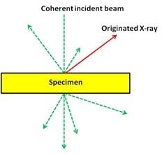
EDX analyzes the elemental composition of silver nanoparticles by measuring emitted X-rays upon bombarding the sample with charged particles or X-rays.

Fig-2.1 X-Ray Emission
Illustration depicting X-ray emission occurring upon the sample being struck by an electron beam. Various forms of electron scattering from a thin specimen are depicted as dashed arrows.
XEDS employs silicon (Si) as a semiconductor to convert X-ray energy into electric signals. When X-rays interact with the semiconductor, electrons transfer from valence to conduction bands, generating numerous electron-hole pairs. The count of created electron holes is directly proportional to the X-ray photon's energy, contingent on the element generating the X-ray. Thus, XEDS facilitates the analysis of specimen chemical composition.
e) X-Ray Diffraction (XRD)-
XRD is a conventional method for determining material crystallographic structure and morphology. Diffracted X-ray intensity offers insight into a sample's composition. XRD validates the metallic nature of particles, extracts information on translational symmetry, unit cell size, and shape from peak positions, and deciphers electron density within the unit cell based on peak intensities.
f) Antibacterial Activity-
Various techniques are used to evaluate the antibacterial effectiveness of silver nanoparticles. The broth dilution method is common, involving plates with bacterial culture broth dilutions mixed with silver nanoparticles, incubated in appropriate agar medium. It's noted that antibacterial efficacy is size-dependent, with smaller particles exhibiting increased potency. Mechanistically, silver nanoparticles penetrate bacterial cells, generating reactive oxygen species that impair cellular function. The soft acid nature of silver nanoparticles enables interaction with sulfur and phosphorus in bacterial cells and DNA, leading to cell death and disrupting bacterial signaling.
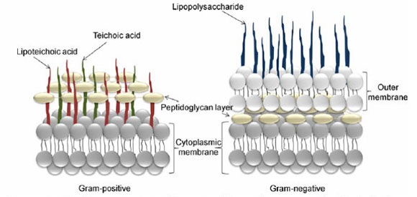
Fig. 2.2 Membrane structure of gram-positive and gram-negative bacteria
(Reproduce with permission from Espitia et.al., 2012)
In conclusion, nanotechnology's evolution, potential applications of nanomaterials, emphasis on green synthesis, historical use of silver nanoparticles, and characterization techniques' significance are elucidated in the literature survey.
The literature survey highlights the significant advancements in nanotechnology and the potential applications of nanomaterials in various fields. The utilization of green synthesis methods is emphasized to meet the increasing demand for nanomaterials while reducing hazardous waste. The use of silver nanoparticles in history and their unique properties at the nanoscale are also discussed. Various characterization techniques play a vital role in understanding and analyzing nanoparticles in terms of their size, shape, and elemental composition.

3. Methodology
In this study, a green synthesis approach was employed to produce silver nanoparticles in a controlled laboratory setting. The synthesis and characterization experiments took place at two key locations: the Faculty of Engineering and Technology at Dr. Shakuntala Misra National Rehabilitation University in Lucknow, Uttar Pradesh, and the Institute of Engineering & Technology in Lucknow, Uttar Pradesh. Additionally, experimentation was conducted at the Materials Research Center (MRC) located at Malviya National Institute of Technology in Jaipur.
3.1 Materials and Reagents:
The chemicals used for the synthesis process were:
a) Silver Nitrate – Sourced from a retail establishment.
b) Nutrient Agar Powder – Obtained from chemical suppliers.
c) Sample Collection-
During the month of March, fresh leaves of Thuja occidentalis were harvested from the premises of Dr. Shakuntala Misra National Rehabilitation University in Lucknow, Uttar Pradesh. After collection, these samples were subjected to a careful drying process and subsequently stored within a refrigerator to uphold their structural integrity.
d) De-ionized Water-
To ensure the purity of the water utilized throughout the synthesis procedure, de-ionized water was procured from the DI plant.
Table - 3.1- Instrument Required
S.No | Instrument
1 | Heating mantle and Muffle Furnace
2 | Magnetic Stirrer
3 | Uv-Vis Spectrophotometer
4 | Weighing balance
5 | Autoclave and Laminar air flow

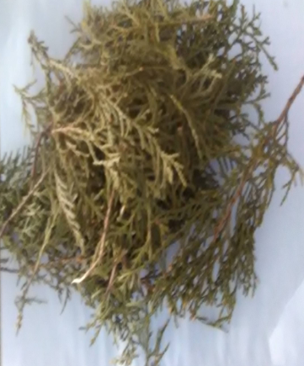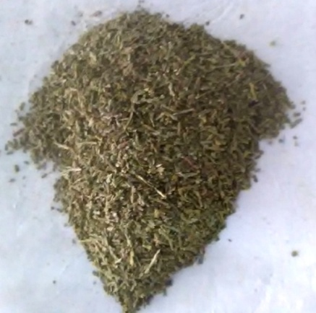
Fig-3.1Thuja Occidentalis Plant Fig-3.2 Powdered form Fig-3.3 Preparation of Leaf Extract

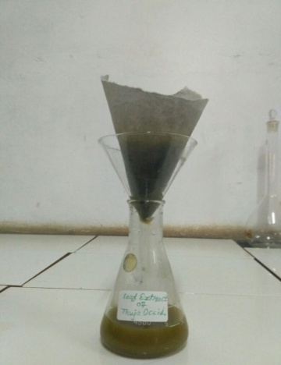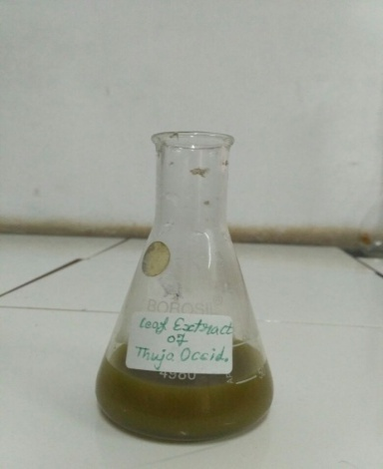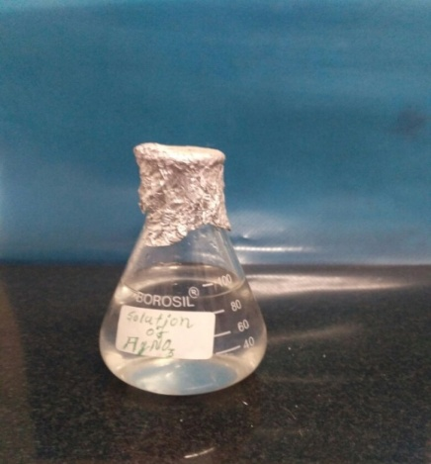
Fig-3.4 Filter of plant extract Fig-3.5 Leaf extract Fig-3.6 AgNO₃ Solution
Table- 3.2 Apparatus Required
S.No. | Apparatus | Make
1 | Round bottom flask | Borosil
2 | 250 ml Beaker | Borosil
3 | Measuring Cylinder | Borosil
4 | Conical Flask | Borosil
5 | 100ml Beaker | Borosil
6 | Glass rod | Borosil
7 | Test tube | Borosil
8 | Petri dish | Borosil
9 | Funnel | Borosil

3.2 Preparation of Thuja Occidentalis Plant Extract:
Fresh leaves of Thuja occidentalis were collected from the premises of Dr. Shakuntala Misra National Rehabilitation University, Lucknow Uttar Pradesh. Following a thorough wash with distilled water, the leaves were subjected to a drying process in an oven set at 50°C for a duration of three hours. Once adequately dried, the leaves underwent meticulous grinding using a mortar and pestle. A quantity of five grams of the powdered leaves was then combined with 100 ml of distilled water within a 250 ml conical flask. This mixture was subsequently heated to 60°C for a period of 30 minutes. The resulting extract was subjected to filtration using Whatman filter paper and was subsequently stored at a temperature of -4°C within a refrigerator for future utilization.
3.3 Preparation of Silver Nitrate Solution:
For the formulation of a 0.1M stock solution of AgNO3 in chloride-free distilled water, an exact weight of 1.6 grams of AgNO3 was meticulously measured and subsequently transferred into a 100 ml volumetric flask. Gradually, the flask was filled with double-distilled water while being continuously stirred. This process continued until complete dissolution of the salt and the solution reached the designated mark on the flask. To ensure protection from light, the prepared solution was shielded by encasing the containers with carbon paper and was thereafter stored in a dimly lit environment.

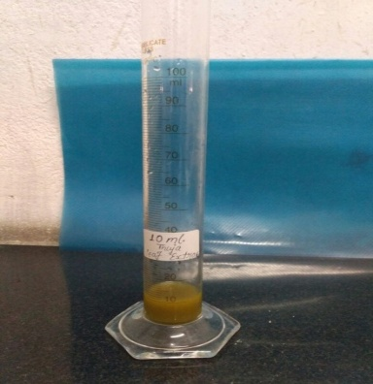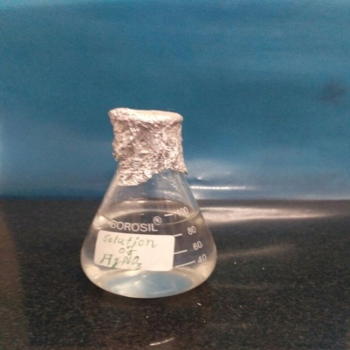
Fig-3.7 10 ml Leaf Extract Fig-3.8 100 ml ${AgNO}_{3}$ solution

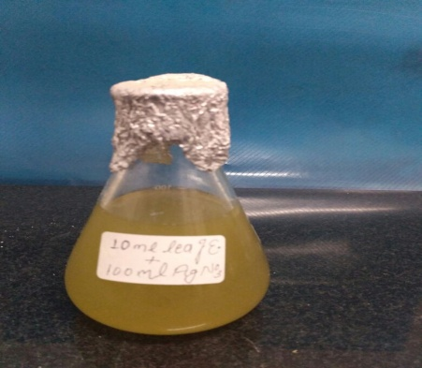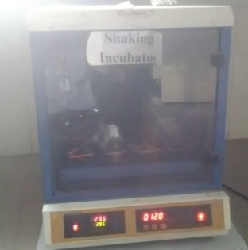
Fig-3.9 Leaf Extract+ ${AgNO}_{3}$sol. Fig-3.10 Solution in shaking incubator
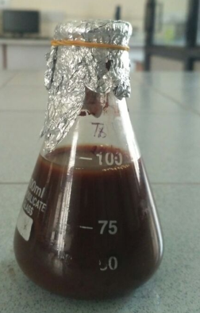
Fig-3.11 Solution after incubated
3.4 Green Synthesis of Silver Nanoparticles:
Within a conical flask, a fusion of 10 ml of leaf extract and 100 ml of AgNO3 solution was created. Subsequently, this mixture was positioned within a shaking incubator. Following a duration of 24 hours, the experimental specimen (formed through the amalgamation of silver nitrate and leaf extract) exhibited a shift in hue to a light, dark-brown shade, thereby signifying the successful generation of silver nanoparticles. To achieve additional refinement of the specimen, it underwent centrifugation using a research centrifuge set to 9000 rpm for a duration of 20 minutes, all executed at temperatures ranging from 0 to 4°C.
4. Results and Discussion
The investigation titled 'Synthesis and Characterization of Silver Nanoparticles' centered on exploring the green synthesis process of silver nanoparticles using plant extracts, while also examining the influence of diverse reaction conditions. The acquired outcomes have been systematically displayed via tables and figures, with a comprehensive discourse provided within this section.
4.1 UV-Vis Spectroscopy:
UV-Vis spectroscopy serves as a tool for assessing the absorption of radiation by molecules, prompting the transition of electrons from lower to higher energy orbitals. The pivotal information is derived from the peak absorption wavelength showcased in the intensity-versus-wavelength graph. Within the realm of silver nanoparticles, the arrangement and contour of the surface Plasmon band are dictated by the nanoparticles' dimensions and structure. Notably, the absorption band's placement shifts towards extended wavelengths when dealing with larger particle sizes. Conventionally, silver nanoparticles manifest absorbance within the span of 300 to 800 nm. Particularly, particle sizes ranging from 20 to 30 nm exhibit heightened absorbance, prominently situated between 420 and 460 nm.
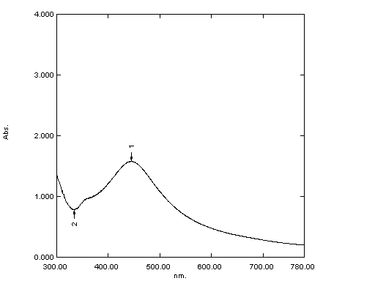
Fig- 4.1 UV-Vis Spectra of synthesized AgNPs of Thuja plant
4.2 Fourier Transform Infrared (FTIR) Analysis:
The purpose of FTIR analysis was to discern the biomolecules responsible for effectively encasing and stabilizing the produced metal nanoparticles. The FTIR spectrum of aqueous silver nanoparticles revealed distinctive transmittance peaks at specific wavenumbers. At 3412 cm⁻¹, an observable peak arose due to O-H stretching attributed to alcohol groups. A peak at 1384 cm⁻¹ was indicative of -CH2 bending in alkenes, while another at 1121 cm⁻¹ denoted C-O stretching in alcohols. A further peak at 610 cm⁻¹ emerged from C-H bending in alkenes. Notably, the peak detected at 1631 cm⁻¹ served as affirmation of the successful formation of silver nanoparticles.
The findings unveiled that proteins and metabolites, notably terpenoids, enshrouded the synthesized nanoparticles. These compounds carried functional groups. Insight derived from the FTIR data illuminated the strong affinity of carbonyl groups originating from amino acid residues and proteins towards binding with the metal. This binding propensity implied that proteins could fulfill the role of capping agents for the silver nanoparticles. Through this capping mechanism, agglomeration was thwarted, thereby ensuring stability within the medium. Thus, the biological molecules undertook a dual function, playing pivotal roles in both the genesis and stabilization of the silver nanoparticles within the aqueous milieu.
The presence of carbonyl groups alluded to the potential absorption of flavanones or terpenoids onto the metal nanoparticles' surface. Plausible interactions might have transpired through carbonyl groups or π-electrons, especially in instances devoid of other potent ligating agents in adequate concentration. In parallel, the reduction of metal ions and subsequent nanoparticle formation might have been attributed to reducing sugars present within the solution. Additionally, terpenoids could have facilitated the reduction of metal ions via the oxidation of aldehydic groups within the molecules, culminating in the creation of carboxylic acids.
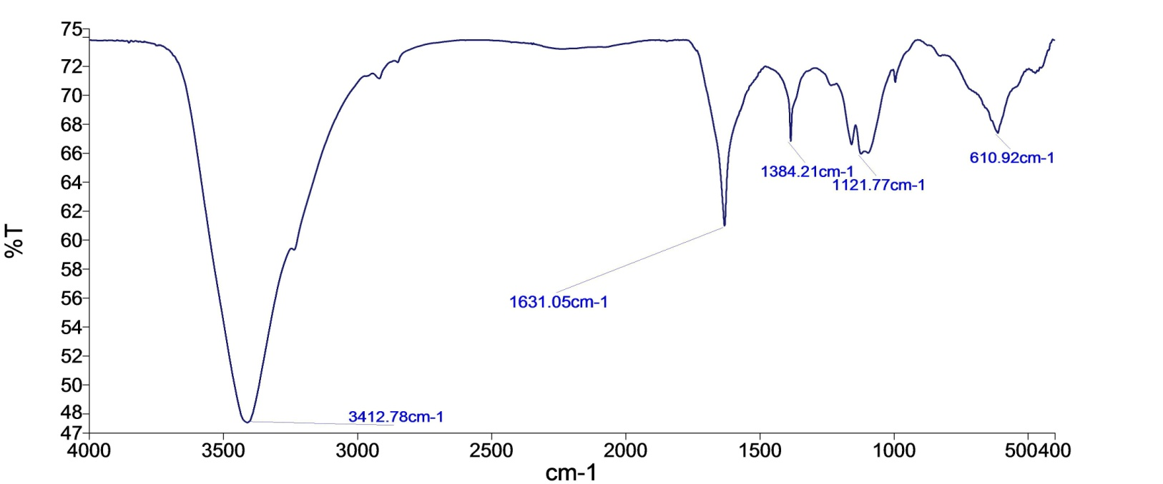
Fig- 4.2 FTIR Spectral representation of synthesized silver Nanoparticles

4.3 Scanning Electron Microscopy (SEM) Analysis:
To delve into the morphological attributes, shape, size, and surface characteristics of the silver nanoparticles, Scanning Electron Microscopy (SEM) was harnessed. As vividly depicted in Figures 4.3 and 4.4, the SEM visuals unveiled the silver nanoparticles that materialized from the leaf extract of Thuja occidentalis. Insight extracted from SEM scrutiny divulged that the silver nanoparticles possessed an average dimension of approximately 54 nm, portraying a marked uniformity in their spherical form.
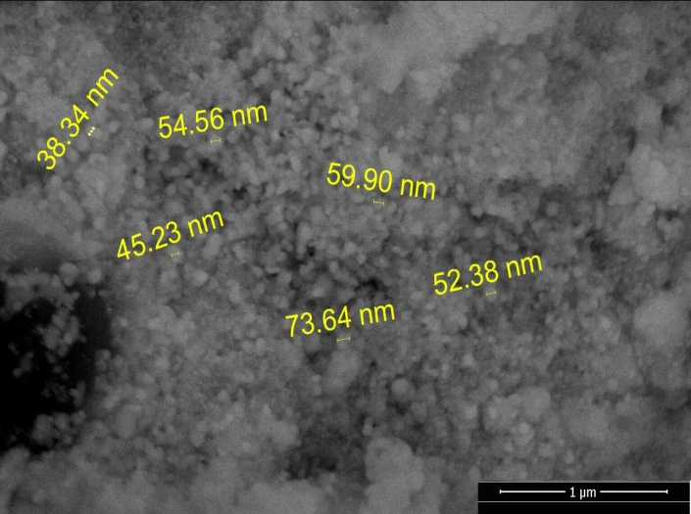
Fig-4.3 SEM Image of synthesized silver Nanoparticles
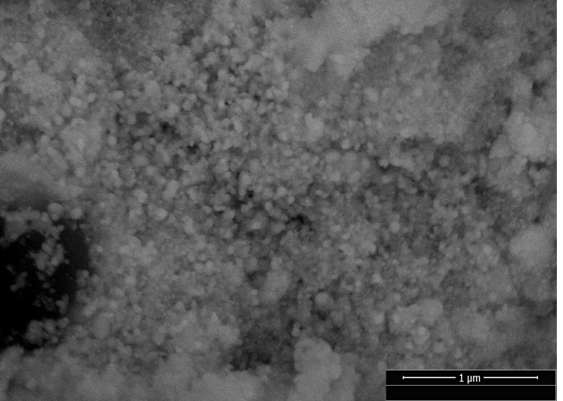
Fig-4.4 SEM image of synthesized silver Nanoparticles
4.4 Energy Dispersive X-Ray (EDX) Analysis:
Energy Dispersive X-Ray Analysis (EDX), also acknowledged as EDS or EDAX, emerged as an x-ray technique with the function of deciphering the elemental composition of substances. EDX systems are seamlessly integrated into Electron Microscopy instruments like Scanning Electron Microscopy (SEM) or Transmission Electron Microscopy (TEM). In this setup, the microscope's imaging prowess centers on the specimen of interest. Through EDX exploration, spectra are generated, encapsulating peaks synonymous with the components prevalent in the sample's authentic composition.
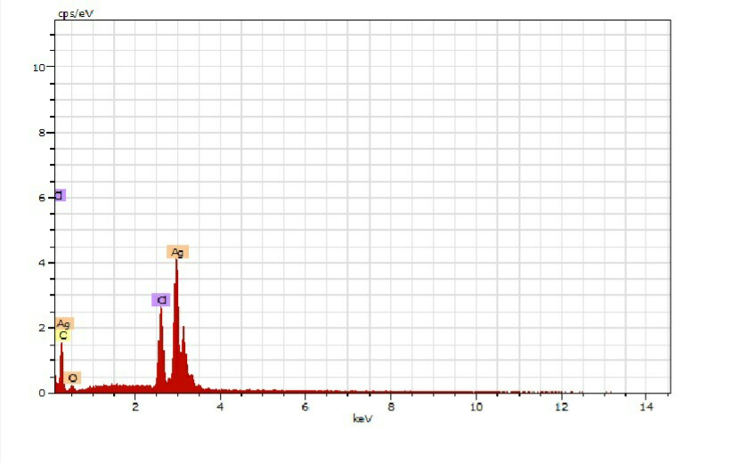
Fig- 4.5 EDX spectra of synthesized silver Nanoparticles
The data gleaned from EDX inspection yields crucial insights into the elemental constitution of the material undergoing scrutiny. Oxygen, carbon, and chlorine were observed in addition to the silver nanoparticles, unveiling their presence and contributing to our understanding of the nanoparticles' metallic structure.
4.5 X-Ray Diffraction (XRD) Analysis:
The adoption of X-Ray Diffraction (XRD) was instrumental in dissecting the crystal structure and phase composition of the generated silver nanoparticles, as elucidated in Figure 4.6. XRD, an invaluable tool in nanoparticle analysis, dissects key details encompassing crystal structure, crystallite size, and strain. In instances involving Nano-crystalline materials, diffraction peaks manifest as broadened entities, a phenomenon attributed to the random orientation of crystals. This broadening stems from the absence of comprehensive constructive and destructive X-ray interferences within a finite-sized lattice. Further exacerbating peak broadening are inhomogeneous lattice strain and structural irregularities. The XRD analysis employed a Bruker D8-Advance diffractometer equipped with monochromatic Cu Kα1 radiation (λ = 1.54056 Å).

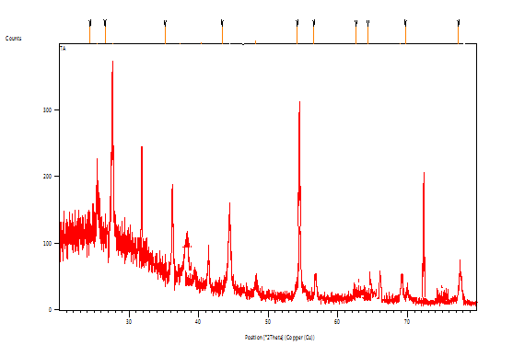
Fig- 4.6 XRD Spectra of synthesized silver Nanoparticles
The XRD data confirmed the synthesis of silver nanoparticles with a face-centered cubic structure (JCPDS 036-0664 & 08-01268). This confirmation was substantiated by the presence of characteristic peaks at 37.23º, 44.44º, 64.58º, and 77.58º, corresponding respectively to the crystal planes (111), (200), (220), and (311). These discernible peaks bolster the affirmation of triumphant silver nanoparticle synthesis accompanied by specific crystallographic orientations. The broadening of X-ray diffraction lines accentuates the nanoparticles' nanoscale nature, a distinct hallmark of the sample.

5. Conclusion:
In this current study, the biosynthesis of AgNps employing Thuja Occidentalis plant extract was successfully demonstrated, as indicated by the initial color alteration from pale yellow to brown. The UV-VIS spectra analysis of Ag nanoparticles unveiled absorption at 444nm. In-depth bonding insights were attained through FTIR spectrum analysis. The FTIR spectra of AgNps illustrated distinct IR peak bands at approximately 3415cm^-1, 1384cm^-1, 1631cm^-1, 1114cm^-1, and 621cm^-1. The attributes of the obtained Ag-NPs were thoroughly examined through an array of techniques encompassing FTIR, XRD, UV-visible, SEM, and EDX.

6. Future Directions:
The trajectory for future research can span a wide spectrum, including diverse topics ranging from the fabrication of metal-doped nanoparticles to their application in varied contexts. Manipulation of distinct capping and reduction agents, control over size, shape, and morphology of silver nanoparticles, and refining separation and purification processes are all potential avenues for exploration. The establishment of an inert gas environment to prevent oxidation and enhance the synthesis of pristine metal nanoparticles could be a notable advancement. This study paves the way for the synthesis of other potential nanomaterials in subsequent endeavors.

7. Author Conflicts:
No conflicts among the authors have been identified.

8. Acknowledgment:
We extend our gratitude to Mr. Vikas Chaubey, Dr. Aakash Singh, and Dr. Atul Kumar for their valuable contributions and cooperation throughout the research process. Special acknowledgments are extended to the research laboratory at the Institute of Engineering and Technology (IET), Dr. Shakuntala Misra National Rehabilitation University, Lucknow, Uttar Pradesh. Additionally, we thank Dr. Shailendra Sinha and the Institute of Engineering and Technology, Lucknow, Uttar Pradesh, for their generous provision of indispensable resources in support of this endeavor.
References:
- Colvin, V.L.S., M.C. & Alivisatos, A., "mild emitting diodes made from cadmium selenide nanocrystals and a semiconducting polymer.". Nature, 1994. 370: p. 354-357.
- Wang Y.H.N., "Nanometer-sized semiconductor clusters: materials synthesis, quantum size consequences, and photophysical properties.". J Phys Chem, 1991. Ninety five: p. 525-532.
- Atul. R. Ingole, S.R.T., N.T. Khati, Atul V. Wankhade, D. Okay. Burghate "green synthesis of selenium nanoparticles under ambient condition.". Chalcogenide Letters, 2010. 7: p. 485-489.
- Harekrishna Bar, D.Okay.B., Gobinda sahoo P, priyanka Sarkar, Sankar PD., "green synthesis of silvernanoparticles the use of latex of Jatropha curcas.". Colliod surface A, 2009. 39(3): p. 134-139.
- Cassandra D, N.N., Jodi H, Linfeng G, Tan, Li, et al. , "inexperienced synthesis of gold and silver nanoparticles from plant extracts.".
- Kaviya S, S.J., Viswanathan B., "inexperienced Synthesis of silver nanoparticles the use of Polyalthia longifolia Leaf extract together with D-Sorbitol.". Magazine of nanotechnology, 2011: p. 1-five.
- Catauro M, R.M., De Gaaetano FD, Marotta A, "Sol–gel processing of drug shipping substances and launch kinetics.". J Mater Sci Mater Med, 2005. 16(three): p. 261-265.
- Crabtree JH, B.R., Siddiqi Ra, Huen IT, Handott LL, Fishman A, "The efficacy of silver-ion implanted catheters in reducing peritoneal dialysis-related infections.". Perit Dial Int, 2003. 23(four): p. 368-374.
- Krolikowska A, ok.A., Michota A, Bukowska J, "SERS research at the shape of thioglycolic acid monolayers on silver and gold.". Surf Sci, 2003. 532: p. 227-232.
- Zhao G, S.J., "a couple of parameters for the comprehensiveevaluation of the susceptibility of Escherichia coli to the silver ion.". Biometals, 1998. 11: p. 27.
- Jiang H, M.S., Wong ACL, Denes FS, "Plasma more advantageous deposition of silver nanoparticles onto polymer and metal surfaces for the generation of antimicrobial characteristics.". J Appl Polym Sci, 2004. Ninety three: p. 1411-1422.
- Duran N, M.P., Alves OL, De Souza GIH, Esposito E, "Mechanistic components of biosynthesis of silver nanoparticles by way of numerous Fusarium oxysporum strains.". J Nanobiotechnol, 2005. Three: p. 8-14.
- RO, B., "Silver ions inside the treatment of neighborhood infections.". Met based capsules, 1999. 6: p. 297-300.
- Klaus T, J.R., Olsson E, Granqvist C-G, "Silverbased crystalline nanoparticles, microbially fabricated.". Proc Natl Acad Sci usa, 1999. Ninety six: p. 13611-13614.
- Garima Singhal , R.B., Kunal Kasariya , Ashish Ranjan Sharma , Rajendra pal Singh, "Biosynthesis of silver nanoparticles the usage of Ocimum sanctum (Tulsi) leaf extract and screening its antimicrobial hobby.". J Nanopart Res, 2011. Thirteen: p. 2981-2988.
- Mukherjee P, A.A., Mandal DS, Senapati S, Sainkar R, Khan MI, Parishcha R, Ajaykumar PV, Alam M, Kumar R, Sastry M, "Fungus-mediated synthesis of silver nanoparticles and their immobilization within the mycelial matrix: a singular organic method to nanoparticle synthesis.". Nano Lett, 2001. 1: p. 515-519.
- Spring H, S.Okay., "diversity of magnetotactic bacteria.". Syst Appl Microbiol, 1995. 18(2): p. 147-153.
- Sastry M, A.A., Islam NI, Kumar R., "Biosynthesis of metal nanoparticles the use of fungi and actinomycetes.". Modern-day Sc., 2003. Eighty five(2): p. 162-a hundred and seventy.
- Sastry M, A.A., Khan MI, Kumar R., "Microbial nanoparticle manufacturing in Nanobiotechnology.". Nanobiotechnology, 2003. 85(2): p. 163-169.
- Nelson D, P.D., Oswaldo la, Gabriel IHDS, Elisa E., "Mechanical components of biosynthesis of silver nanoparticles with the aid of several Fusarium oxysporum lines.". Journal of Nanobiotechnology, 2005. Three: p. 8.
- Hemanth NKS, k.G., Karthik L, Bhaskara RKV., "Extracellular biosynthesis of silver nanoparticles the usage of the filamentous fungus Penicillium sp.". Arch Appl Sci Res, 2010. 2(6): p. 161-167.
- Natarajan okay, S.S., Ramchandra M., "Microbial manufacturing of silver nanoparticles.". Dig J Nanomat Bios, 2010. 5(1): p. One hundred thirty five-140.
- Elumalai EK, P.T., Hemachandran J, Vivivan Therasa S, Thirumalai T, David E., "Extracellular synthesis of silver nanoparticles the use of leaves of Euphorbia hirta and their antibacterial activities.". J Phram Sci, 2010. 2(nine): p. 549-554.
- Ankamwar B, D.C., Ahmad A, Sastry M., "Biosynthesis of gold and silver nanoparticles the usage of Emblics Officinalis Fruit extract and their section switch and Transmetallation in an natural solution.". J nanosci nanotechnol, 2005. 5(10): p. 1665-1671.
- Kasthuri J, k.Okay., Rajendran N., "Phyllanthin assisted biosynthesis of silver and gold nanoarticles a unique biological method.". J Nanopart Res, 2009. 11: p. 1075-1085.
- Vijayaraghavan okay, k.N.S., Udaya Prakash N, Madhankumar D., "Biomimetic synthesis of silver nanoparticles via aqueous extract of Syzygium aromaticum.". Colloids Surf B Biointerfaces, 2012. 75: p. 33-35.
- Amarendra DD, k.G., "Biosynthesis of silver and gold nonoparticles using Chenopodium album leaf extract.". Colloid floor A, 2010. 369(3): p. 27-33.
- Guidelli EJ, R.M., Zaniquelli D, Baffa O., "green synthesis of colloidal silver nanoparticles the usage of herbal rubber latex extracted from Hevea brasiliensis.". Mol Biomol Spectrosc, 2011. Eighty two(1): p. A hundred and forty-145.
- Tiwari D ok, Behari J and Sen P 2008 application of Nanoparticles in Waste Water treatment 3417–33.
- Salavati-niasari M, Davar F and Mir N 2008 Synthesis and characterization of metallic copper nanoparticles thru thermal decomposition Polyhedron 27 3514–8.
- Tai C Y, Tai C, Chang M and Liu H 2007 Synthesis of Magnesium Hydroxide and OxideNanoparticles using a Spinning Disk Reactor 5536–forty one.

- Bhaviripudi S, Mile E, Iii S A S, Zare A T, Dresselhaus M S, Belcher A M and Kong J 2007CVD Synthesis of single-Walled Carbon Nanotubes from Gold Nanoparticle Catalysts 1516–7.
- Ramesh S 2013 Sol-Gel Synthesis and Characterization of 2013.
- Mann S, Burkett S L, Davis S A, Fowler C E, Mendelson N H, Sims S D, Walsh D and Whilton N T 1997 Sol - Gel Synthesis of organized depend 4756 2300–10.
- Mohammadi S, Harvey A and Boodhoo k V okay 2014 Synthesis of TiO 2 nanoparticles in aspinning disc reactor Chem. Eng. J. 258 171–eighty four.
- Seek H, Journals C, contact A, Iopscience M and cope with I P Nanoparticle Synthesis byIonizing supply gasoline in Chemical Vapor Deposition Nanoparticle Synthesis by way of IonizingSource gas in Chemical Vapor Deposition 77 four–7.
- Kammler B H okay, Mädler L and Pratsinis S E 2001 Flame Synthesis of Nanoparticles 24 583–96.
- Amato R D, Falconieri M, Gagliardi S, Popovici E, Serra E, Terranova G and Borsella E 2013 journal of Analytical and applied Pyrolysis Synthesis of ceramic nanoparticles by laserpyrolysis : From studies to programs J. Anal. Appl. Pyrolysis 104 461–9.
- Kuppusamy P, Yusoff M M and Govindan N 2014 Biosynthesis of metal nanoparticles using plant derivatives and their new avenues in pharmacological programs - An up to date document SAUDI Pharm. J.
- Yadav T P, Yadav R M and Singh D P 2012 Mechanical Milling : a pinnacle Down technique for the Synthesis of Nanomaterials and Nanocomposites 2 22–48.
- Pimpin A and Srituravanich W overview on Micro- and Nanolithography techniques and theirApplications 16 37–fifty five.
- Hulteen J C, Treichel D A, Smith M T, Duval M L, Jensen T R and Duyne R P Van 1999Nanosphere Lithography : size-Tunable Silver Nanoparticle and floor Cluster Arrays 3854–sixty three.
- Amendola V and Meneghetti M 2009 Laser ablation synthesis in answer and length manipulation of noble metal nanoparticles 3805–21.
- Shah P and Gavrin A Ã 2006 Synthesis of nanoparticles the usage of high-stress sputtering formagnetic domain imaging 301 118–23.
- Lugscheider E, Bärwulf S, Barimani C, Riester M and Hilgers H 1998 Magnetron-sputteredhard material coatings on thermoplastic polymers for clean room packages Surf. CoatingsTechnol. 108-109 398–402.
- M Ramya, M.S.S., "inexperienced Synthesis of Silver Nanoparticles". Int. J. Pharm. Med. & Bio. Sc., 2012. 1.
- J, D.P.L.A.H.K., “publicity-associated health results of Silver and Silver Compounds: A assessment”. Ann Occup Hyg., 2005. 49: p. 575-585.
- C, F.A.A.S.M., “inaction of two Noble Metals as cancer causing agents”. J. Environ Patho. Toxicol, 1978. 1: p. Fifty one-57.

- Chen X , S.H.J., “Nanosilver: A Nanoproduct in scientific applications”. Toxicol Lett. , 2008. 176: p. 1-12.
- K, Prasad, k, Kulkarni, AR, "Plant gadget: nature's nanofactory". Colloids Surf. B Biointerfaces, 2009. Seventy three: p. 219-223.
- Parasharu k, S.A.S.A., “Bioinspired Synthesis of Silver Nanoparticles”. Digest journal of Nanomaterials and Biostructures, 2009. 4: p. 159-166. (b). Begum N A, M.S.A.B.L.R.A., “Mondal Colloids and floor B”. Biointerfaces, 2009. 71: p. 113-118.
- (a) D. Bhardwaj, A. Singh, R. Singh, Eco-compatible sonochemical synthesis of 8-aryl-7,8-dihydro- [1,3]- dioxolo[4,5-g] quinolin-6(5H)-ones using green TiO2. Heliyon, vol. 5, no. 2, 1256-62, 2019. (b) S. Munjal, A. Singh, Facile and Green Synthesis of Iron and Silver supported Iron Nanoparticles from Novel Plant Extract of Aegle marmelos: Anti-bacterial and Anti-fungal Activity, Journal of Drug Delivery and Therapeutics, vol 9, no(3-s), 334-341, 2019. (c) S. Bhatt, A. Singh, S. Munjal and P. Kumar Poonia, Plant mediated bio synthesis of silver nanoparticles: Characterization and antimicrobial activity. Int. J. Chem. Stud.,vol 6, no 6, 2163-2167, 2018. (d) S. Munjal, P. Srivastava, A. Singh, P. Jyani, P. S. Gour, Synthesis And Bio-Physical Characterization Of Mg Doped Zn Nanoparticles From Novel Plant , IJIRG, vol 9, no 3, 13-20, 2020. (e) R. Singh, S. A. Ganaie, A. Singh, A. Chaudhary, Carbon-SO₃H catalyzed expedient synthesis of new spiro-[indeno[1,2 b]quinoxaline-[11,2′]-thiazolidine]-4′-ones as biologically important scaffold, Synth. Commun. 2019, 49, 80–93. (f) R. Singh, A. Singh and D. Bhardwaj, Selective and Solvent‐Free Synthesis of Isoxazole‐Containing Spiro Thiazolidinones Using TiO₂‐SO₃H as Solid Catalyst Chemistry Select, 2019, 4, 9600–9607.
- J, C.X.A.S.H., “Nanosilver: A Nanoproduct in medical packages”. Toxicol Lett., 2008. 176: p. 1-12.
- C, L., "Proteomic analysis of the mode of antibacterial movement of silver nanoparticles". J Proteome Res, 2006. Five: p. 916-924. Nanoparticles via thermal decomposition Polyhedron 27 3514–eight.

