CANCER THERAPEUTIC TARGETS: AN OVERVIEW OF DIFFERENT TYPES OF PROTEASES
Govindaraju Archunan¹ and Renganathan Senthil²*

¹Maruthupandiyar College (Affiliated to Bharathidasan University), Thanjavur – 613403, Tamilnadu, India
²Vels Institute of Science Technology and Advanced Studies, Pallavaram, Chennai, Tamilnadu, India

*Correspondence: Dr. Renganathan Senthil - renganathansenthil@gmail.com; rsenthil.sls@velsuniv.ac.in

ABSTRACT
In healthy cells, proteases play an important part in the execution of biological processes. Proteases and associated anti-proteases coexist in equilibrium in biological systems, and disruption of this balance results in a variety of illnesses, including cancer. Serine, cysteine, aspartate, threonine, and matrix metalloproteases are five different types of proteases that contribute to the progression of a tumor from its early stages through growth, metastasis, and eventually invasion into a new place. The term "cancer degradome" refers to a group of peptides' roles in the course of the disease. Multiple studies have demonstrated a correlation between the enzymatic activity of lysosomal cysteine proteases and tumorigenesis. Trypsin, a well-known digestive serine protease that promotes invasion, proliferation, and metastasis, has also been linked to a number of malignancies. The prognosis and length of disease-free life are poor for colorectal cancers that express trypsin. Protease inhibitors' usage in the treatment of cancer is suggested by the role of proteases in cancer. Protease inhibitor-based therapies and their impact in different carcinogenesis processes will be the emphasis of this chapter.

Key words: Proteases, tumorigenesis, cancer degradome, Metastasis, Intravasion, Extravasion, Colonization, Prognosis.

INTRODUCTION
Proteolysis constitutes one of the most essential biological processes. Proteases are a class of enzymes known for their proteolytic action. These enzymes are widely distributed and carry out important biological functions (1,2). According to new studies, proteases, which have been related to tumor formation and proliferation in both primary and metastatic sites (3). There is a direct link between tumor aggressiveness and the release of different proteases. Proteases are in normal cells serve an important role in critical physiological processes, but influenced malignant cells cause the most impact. The production of several particular proteases by tumor cells further complicates the prognosis (4–6). Proteolytic enzymes are often expressed by tumor cells in nearby nonneoplastic cells, where their activity is then hijacked to support tumor growth. The recent release of the genomic sequences of many species has made it easier to identify their whole protease repertoire, or degradome, which has been dubbed (7,8).
In total, approximately 569 protease and homologs available, which is categorized into 5 catalytic groups: Metalloprotease, serine, cystine, threonine and aspartic proteases. (9). However, those enzymes have not been fully identified in the progression of cancer. After many generations and several mutations, the normal cell transforms, causing a localized tumor before having the capacity to infect adjacent tissues and metastasis (10). In reality, the process of forming a tumor is quite complicated and includes several variations in the normal cell. Genetic drift and subsequent cycles of mutation are vital in tumor growth (11). Cancer cells slowly evolve from minimally abnormal cells. Tumor development and proliferation are brought on by alterations such epigenetic modifications that affect normal epithelial cells (NEC). In the tumor cell, epithelial mesenchymal transitions may take place sometimes. The disruption of cellular connections and acceleration of cell mobility during epithelial-mesenchymal transition indicates that cells are being liberated from the so-called epithelial tissue (12). The subsequent mesenchyme-like morphology could migrate, allowing tumor invasion and dissemination and facilitating metastatic progression. In order for a tumor to continue to grow unchecked, the tumor cells also need to promote the growth of blood vessels that will transport nutrition and oxygen. Endothelial cells multiply and infiltrate in the direction of the tumor site, stimulating the development of neo vessels (13). Tumor vasculature expands through a number of approaches: 1. The complexity of vascular networks grows through the creation of bridges or endothelial sprouts. 2. Tumor arteries change and grow by introducing interstitial tissue columns into the lumen of previously present vasculature. 3. Endothelial cell progenitors called angioblasts shift from the peripheral blood or bone marrow, which develop into tumors and contribute to the endothelial coating of cancer arteries (14). In order to initiate distant metastasis, the tumor cells are required to undergo a series of sequential steps, including intravasation into the bloodstream, arrest at a secondary site, extravasation into the surrounding tissue, and subsequent colonization of the local microenvironment. (Figure 1). The interactions between tumor cells (TC), endothelial cells (EC), fibroblasts, and infiltrating inflammatory cells (IC), such as macrophages, as well as the extracellular matrix, result in these metastasis phases. Microphages contribute to both tumor angiogenesis and proliferation.
Instead of producing immune responses against them, tumor-associated macrophages secrete growth factors that aid in the development of tumors. They aid in the development of the tumor by influencing endothelial cells and encouraging neovascularization (15). The traditional understanding of tumor growth and progression has been significantly altered by studies that have revealed that these enzymes target a variety of substrates and regulate a number of processes that are crucial for cell life and death in all organisms. These findings also show that these enzymes promote tumor evolution.
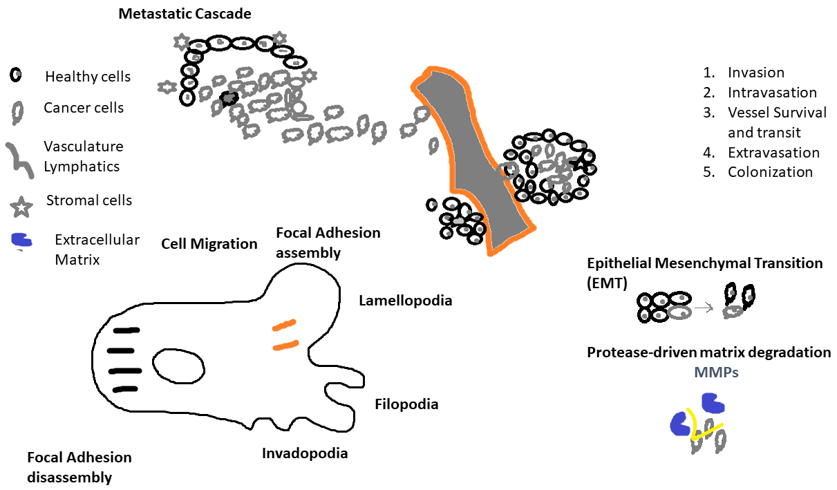
Figure 1. The schematic view of mechanism of tumor cells dispersing and colonizing.
PROTEASES: ROLE AND FUNCTION IN TUMOR GROWTH AND METASTASIS
The term "cancer degradome" refers to the action of a group of peptides (proteases) implicated in the development of cancer. At first, invasion and metastasis were thought to be late stages of the cancer growth process, involving proteases (16). Yet, investigations have shown that invasion and metastasis are not just late-stage occurrences but may also happen early on. Moreover, other processes involved in the advancement of cancer, such as the cell proliferation, the apoptosis, the participation of white blood cells, angiogenesis, and the formation of multi-drug resistance, are also protease dependent (17). Proteases are involved in many aspects of cancer development, including the control of cell growth and death, the recruitment of immune system cells, the promotion of blood vessel growth, and the generation of treatment resistance (18). In vitro and animal models suggested that proteases play a critical role in a number of pathways underlying the development of cancer.
Cysteine proteases
A cysteine residue in the active site distinguishes the varied group of proteolytic enzymes known as mammalian cysteine proteases (19). In pathological circumstances, they are released by various cell types and may be localized in the lysosome or the cytoplasm (20). Cysteine proteases mediate both broad processes like the catabolism of intracellular proteins and specialized processes like the selective activation of signaling molecules or the destruction of extracellular proteins (21). Several investigations have revealed an association involving lysosomal cysteine protein protease activity and the growth of tumors. Both internal and extracellular matrix (ECM) proteins may be broken down by the cathepsin family of cysteine proteases (22). The balance between endogenous inhibitors of cathepsins and activation of their inactive versions controls how they work (23). Cathepsins stand out from a majority of proteases in that they have been demonstrated to function both intracellularly and extracellularly. Cancer cells may assault neighboring tissues, blood arteries, and lymph nodes thanks to cathepsins' extracellular activity and spread to distant areas. As a result, cathepsins are thought to represent viable targets for cancer treatment (24). Progressive breast cancer tumor tissue samples release the protease and is discovered in the blood of individuals with Vaginal intraepithelial neoplasia, according to early findings linking cathepsin B to cancer (25).
Cathepsin B was previously established to have a role in the remodeling and disintegration of connective tissue and basement membrane during the development, invasion, and metastasis of tumors via the degradation of extracellular matrix by podosomes and invasion by secreted lysosomes (26). Higher cathepsin B and L levels have been linked to longer disease-free and overall survival times and may thus be used to predict a patient's prognosis for cancer. Moreover, cathepsins are helpful indicators for detecting people with tongue cancer, pancreatic cancer, breast cancer, and colorectal cancer (27). According to Kawasaki et al. (2002), oral squamous cell carcinoma invasion and progression were highly linked with cathepsin D and B expression (28). In chronic atrophic gastritis with dysplasia, the overexpression of cathepsins B and L is more common. Laryngeal cancer typically overexpresses the cathepsin B protein as well.
The function of cathepsin in the regulation of angiogenesis suggests another distinct role in tumor formation. In healthy tissues and cells, the natural cysteine protease inhibitor known as cystatin may control the activity of cathepsins (29). Cystatins are a particular kind of reversible, competitive inhibitor that interacts highly with cysteine peptidases notably cathepsins B, H, L, and S. Cysteine protease inhibitors may have an impact on cancer, which has been linked to changes in the proteolytic system. In experimental settings, recent research have shown that cystatins may prevent the invasion or metastasis of several malignancies (30). Cystatin C has been connected to the regulation of cell differentiation and suppresses tumor cell motility and in vitro invasion.
Cystatin C, when present in free form in the blood or various body fluids, suppresses cysteine peptidases, diminishing tissue damage under inflammatory or tissue-degrading conditions. While cystatin activity and concentration seem to vary in various cancer tissues, research on its interactions with cathepsin B is extensive (31). The lack of similarity in concentrations between cathepsin B and its natural inhibitors raises the possibility that it may play a role in the unchecked proteolysis and subsequent malignant development of tongue cancer (32).
Serine proteases
Serine proteases are frequently found in the form of zymogens, which are activated by restricted and selective proteolysis, a process that effect regulates enzyme activity (33). Furthermore, physiological inhibitors that control cellular activity are present. Serine protease activities must be properly regulated for the cell to function normally, and improper control of these activities might result in pathological diseases (34). One class of serine proteases that has been thoroughly studied for its connection to tumor invasion and metastasis is urokinase-type plasminogen activators. Several studies have shown a strong correlation between their expression and the control of enzyme activity and the malignancies (35). Matriptase, type II transmembrane serine protease, has a role in the development of several epithelial malignancies as well as angiogenesis and the breakdown of extracellular matrix. Yet, hepatocyte growth factor activator inhibitor-1 inhibits it in healthy cells (HAI-1) (36).
Matriptase is expressed when human prostate cancer (CaP) progresses, and HAI-1 is lost, which may be a significant development. The ratio of these two gene products has been proposed to be a a potential indicator for CaP progression and a possible diagnostic for determining the success rate of therapeutic and chemo preventive medicines (37). One of the most well studied serine proteases is trypsin. These proteases are crucial for numerous biological procedures, including metabolism, Coagulation, regulation, as well as a variety of significant pathological processes, including atherosclerosis, inflammation, and cancer. Trypsin was formerly thought to be a digestive enzyme produced exclusively by pancreatic acinar cells (38). However, the finding of the enzyme in patients who had undergone pancreatectomy stimulated investigation into trypsin production in other regions of the human body.
Trypsinogen-1, Trypsinogen-2, Trypsinogen-3 (present in diverse epithelial tissues), and Trypsinogen-4 are the four distinct trypsinogen isoforms that have been described in humans (found in the brain) (39). The many trypsinogens exhibit high nucleotide and protein homology (>90%). Arginine and lysine contributes carboxyl groups to the linear structure formation in protein molecules, which trypsin specifically targets(40). Second, an enteropeptidase present in duodenal enterocytes has the potential to convert trypsinogen into active trypsin. It's interesting to note that trypsin-activating enteropeptidase is present in the adenocarcinoma cells of the duodenum and other tissues that produce trypsin (41). Moreover, the pancreatic secretory trypsin inhibitor (PSTI), an antiprotease mediator, guards against premature activation.
An imbalance in the "protease-antiprotease-system" system seems to enhance the risk of developing pancreatic adenocarcinoma and has a misconception in the development of pancreatitis (42). The mucosa of the typical gastrointestinal tract excretes pancreatic secretory trypsin inhibitor (PSTI), which works to shield cells from proteolytic degradation. The same peptide, also known as "tumor-associated trypsin inhibitor" (TATI), which is the same as PSTI, is released by tumor cells (43). Trypsin promotes growth, invasion, and metastasis and is implicated in the development of colorectal cancer. Moreover, trypsin-expressed colorectal tumors have a worse prognosis and a shorter disease-free survival time (44). Trypsin's role in the development of cancer is becoming more understood biologically. By a "protease-antiprotease-system" and the activation of other protease cascades, it seems to operate both directly and indirectly. Trypsin digestion of type I collagen may directly encourage cancer cell invasion of the basal membrane (39).
MMPs, which are known to promote migration and dissemination and are co-expressed, get triggered by trypsin. Trypsin and MMP-2, 7 and 9 co-express and seem to have a special role in invasion, progression, and proliferation (45). MMPs may contribute to invasion and metastasis as well as the transition from adenoma to cancer. Trypsin's detrimental impact on the prognosis of colorectal cancer may be explained by the cosegregation of trypsin and MMPs within the tumor milieu, which is critical for the activation of MMPs (46). Prostaglandin production is a key method through which trypsin and protease-activated receptor 2 (PAR-2) collaborate in an autocrine loop to promote proliferation, invasion, and metastasis (Figure 2) (47).
In the analysis of breast cancer, researchers have also looked at how the ambient body rate of proteases (including trypsin and trypsin-like ones) and antiproteases, which results in a "certain" degree of proteolytic activity, influences PAR-2 compared to tumor cells (48). Both MMP and PAR-2 may activate the mitogenic MAPK-ERK pathway by stimulating the epidermal growth factor receptor when trypsin is present. Due to its widespread distribution, trypsin is unlikely to be a viable target for therapeutic treatment. Experimental trypsin suppression is possible but not particularly effective (49). Yet, as trypsin and coactivated protein cascades become more well-understood, biological knowledge of colorectal carcinogenesis may be improved. This might open the door to prognosticators, predictors, and new therapeutic targets. Potential cancer therapies may be developed by doing research on the biological significance of trypsin and how it functions.
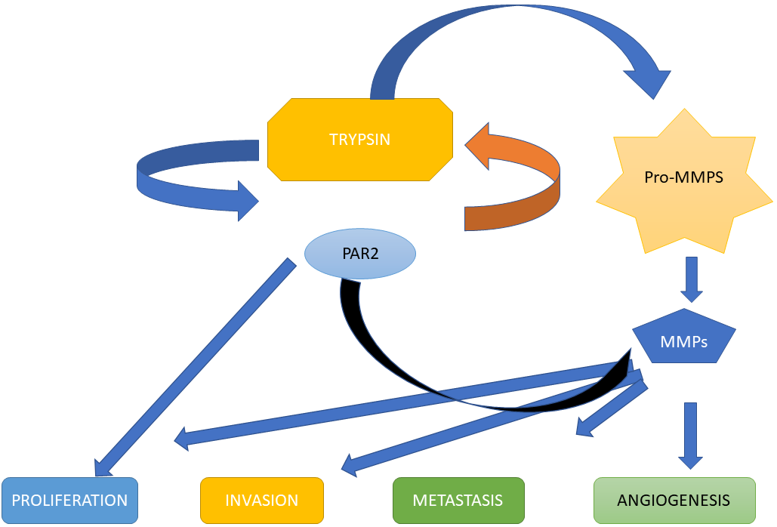

Figure 2. An illustration of the interactions of trypsin with matrix metalloproteinases (MMPs) and proteinase-activated receptor 2 (PAR-2).
Aspartate proteases
A group of recognized enzymes known as aspartic proteases has two lobes separated by a cleft that houses the catalytic site, which is made up of two aspartate residues. An aspartic endo-protease known as cathepsin-D (Cath-D) is widely distributed in lysosomes. For a very long time, it was believed that cath-primary D's job was to break down proteins in lysosomes at an acidic pH (50). Recent studies have shown a wide variety of roles for cathepsins outside of the lysosome, in the cytosol and the extracellular space. But pathological situations significantly upregulate extracellular cathepsins, and these enzymes have been linked to a broad variety of illnesses, notably cancer and cardiovascular disorders (51). However throughout the last three decades, cathepsin D has been researched primarily in relation to its function in the formation of cancer and as a potential independent tumor marker (52). The definition of Cath-physiological D's function has also been influenced by this study, which also assisted in the identification of additional Cath-D functions. Human epithelial breast cancer cells overexpress and produce large quantities of the aspartic protease cathepsin D (cath-D), a hallmark of poor prognosis in breast cancer (53).
Cath-D promotes angiogenesis, metastasis, fibroblast expansion, and cancer cell proliferation. The first evidence for cath-direct D's involvement in cancer metastasis came from rat tumor cells, where transfection-induced cath-D overexpression improved the cells' capacity for in vivo metastasis (54). The cath-D pathway that stimulates metastasis seemed to have a favourable impact on cell proliferation in that rat tumor model, favouring the creation of micro-metastases rather than boosting the capacity for invasion (55). Many studies have shown the independent predictive value of pCD/CD level in a wide range of malignancies, and as a result, it is being considered as a possible target of anti-cancer treatment (56). Research on the roles of cathepsin D were confounded by the presence of many forms of CD in a cell at the same time, including mature heavy and light chain CD, intermediate enzymatically active CD, and pCD. So, it became clear that these shapes may control the aforementioned processes in many ways. Several other research have shown that pCD released by cancer cells influences different phases of tumor formation and that pCD secretion inhibition from cancer cells may reduce the growth of cancer cells in vitro and in vivo, raising the prospect of employing inhibition of pCD in clinical contexts (57).
Threonine proteases
Threonine proteases, also known as proteasomes, are responsible for removing cellular proteins that have been flagged for breakdown via a complicated process called polyubiquitination (58). It is the process of adding a number of ubiquitin molecules to a protein that is intended to be degraded. A multicatalytic threonine protease with three unique catalytic activity, the 26S proteasome (59). In eukaryotic cells, it is in charge of the processing and degradation of short- and some long-lived proteins necessary for the control of many cellular activities. It was proposed that pharmacological suppression of proteasome activity may be effective as a new class of anticancer medicines since abnormal proteasome dependent proteolysis seems to be linked with the pathogenesis of various cancers (60). As a result, numerous organizations have been doing extensive research into how to target specific aspects of protein function that are crucial for the development and spread of cancer.
The first proteasome inhibitor authorized by the US FDA for the treatment of mantle cell lymphoma, relapsed/refractory multiple myeloma, and newly diagnosed multiple myeloma was bortezomib (61). Proteasome inhibition may encourage the breakdown of anti-apoptotic proteins while inhibiting the degradation of pro-apoptotic proteins, which causes malignant cells to undergo programmed cell death (62).
Metalloproteases in the matrix
The family of Zn 2+ endopeptidases known as matrix metalloproteases (MMPs) consists of nine or more highly similar enzymes that cleave the majority, if not all, of the extracellular matrix's components (63). Protease and MMP activity levels are closely regulated. This makes sense since excessive proteolysis would not be an effective means of preserving homeostasis.
Yet, in disease settings, both the number of distinct expressed proteases and the degree of individual protease expression rise. In many different tumor forms, MMP expression is increased, and the rise often correlates with reduced survival (64). Extracellular matrix proteins are subject to turnover and modification by MMPs. The activity of MMPs is tightly regulated, as one would anticipate for enzymes with such a propensity for degradation (65). In addition to being controlled through the regulation of gene expression, matrix metalloproteases are secreted as latent proenzymes that need a 10 KDa amino terminal domain to be modified or removed in order to exhibit enzyme activity (66). In physiological processes like morphogenesis or wound healing, where significant extracellular remodelling must follow a well-programmed path, this precise control of enzyme activity is crucial.
The discovery that the human genome contains more than 500 genes producing proteases or proteins that are similar to proteases provides evidence of the amazing complexity of the proteolytic systems that function in human tissues (67). Due to their capacity to break down all significant protein components of the extracellular matrix (ECM) and basement membranes, these enzymes were first linked to the invasive characteristics of tumor cells(68). Further research has shown the role of MMPs in the development of tumors early on, including the promotion of cell proliferation and the control of angiogenesis (69). MMPs enable the invasion of blood arteries and lymphatics by metastatic cells, allowing local development of the tumor mass by disruption of normal tissue structure. The release and activation of matrix metalloprotease seems to be the outcome of a particular interaction between tumor and stromal cells (Figure 3).
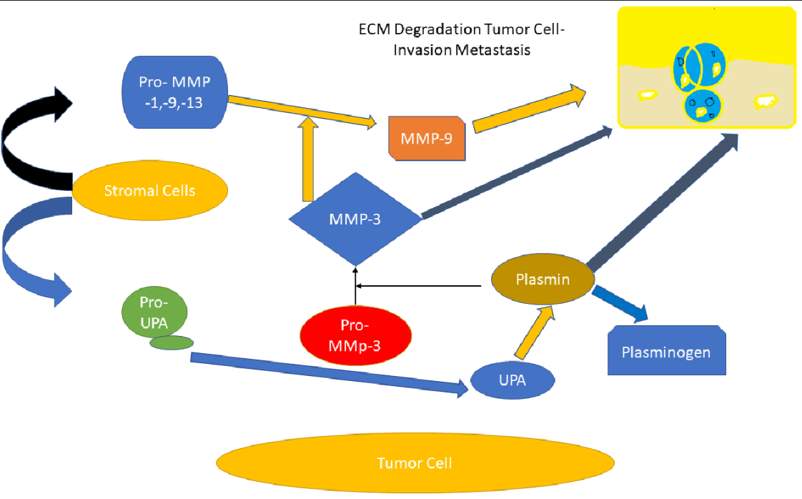
Figure 3. An illustration for matrix metalloproteinases plays in the degradation and invasion of extracellular matrix.
The activity of matrix metalloproteases also seems to promote invasive development in these secondary locations. Depending on the properties of the various cells' capacity to manufacture these enzymes, MMP induction processes seem to vary. Several substances, including as cytokines, growth hormones, and oncogene products, affect MMP expression differently in space and time (70). Nevertheless, MMP gene activation in many tumors is often linked to TNF- (Tumor necrosis factor-) and IL-1 (Interleukin-1), while TGF- (Transforming growth factor-) or retinoids typically suppress MMP transcription (71). There are a few exceptions to this rule, however, since in specific cell types, these factors may stimulate rather than repress certain family members like Mmp11 or Mmp13 (72). Moreover, attempts have been made to compare the signal transduction routes used to induce various MMPs. Matrix metalloprotease inhibitors (MMPI) may halt tumor development and metastasis and limit the breakdown of extracellular matrix in the regions of proteolysis. Many studies showing how TIMPs may reduce tumor development in transgenic mice models originally supported the idea that they might be used to suppress MMP activity in cancer (73). Technical challenges exist when employing TIMPs in cancer treatment, as they do with other macromolecules, which emphasizes the necessity for creating synthetic MMPIs that specifically target certain MMPs (74). Pseudopeptides that mimicked the cleavage sites of MMP substrates made up the first batch of synthetic inhibitors.
As a result, the first MMPI to be studied in humans was the broad-spectrum hydroxamate-based inhibitor Batimastat (BB-94). Batimastat was replaced by Marimastat (BB-2516), another peptido-mimetic MMPI that is accessible orally, after clinical studies with the drug delivered intraperitoneally failed to demonstrate any appreciable effects. Several MMPs, including MMP-1, -2, -3, -7, -9, -12, and -13, are inhibited by marimastat (75). The musculoskeletal discomfort seen in patients after a continuous therapy with Marimastat may be explained by the variety of different enzymes that this MMPI can target. Despite this drawback, Marimastat is just as successful in treating patients with pancreatic cancer as standard therapy (gemcitabine) (76). Moreover, this inhibitor and temozolomide together increased survival in glioblastoma multiforme patients. Last but not least, Marimastat improved survival and delayed the onset of illness in individuals with advanced gastric cancer. New non-peptidomimetic MMPI series have recently been created, and they are based on the 3D structure of MMP zinc-binding sites and have enhanced selectivity and oral bioavailability (77).
Because to its absence of musculoskeletal side effects, BMS-275291 stands out among the group since it has been studied for advanced lung cancer, prostate cancer, and Kaposi's sarcoma linked to AIDS (78). Clinical studies are also being conducted on non-peptidic compounds, such as bisphosphonates and tetracycline derivatives, that have inhibitory effects on MMPs. Notwithstanding some early issues with MMPIs, Marimastat's encouraging findings on matrix metalloproteases in cancer serve as a proof-of-concept for the therapeutic potential of these drugs in the treatment of cancer (79).
CONCLUSION
Now, we are aware that the evolution of tumors is linked to changed location, increased expression, and activity of numerous proteases from all five classes. Even the release of certain particular proteases by tumor cells makes prognosis very challenging. As a tumor grows, invades, and metastasizes, cysteine proteases like cathepsin B contribute to the destruction and remodeling of connective tissue and basement membrane. The enhanced production of cathepsin B in tumor cells that are close to the extracellular matrix and the redistribution of cathepsin B inside tumor cells show that proteases may be transported to sites of tumor cell invasion. Aspartate protease cathepsin D also contributes to the development of cancer. The MMP family members, however, stand out among all of these proteolytic processes because they may cleave almost any part of the basement membrane and ECM, enabling cancer cells to invade and infiltrate the stromal cells nearby. As a result, the role of proteases in cancer proposes the use of protease inhibitors (PIs), which may lessen the ability of tumor cells to invade and spread. Protease inhibitors may have a direct impact on tumor invasion by preventing the breakdown of the extracellular matrix or an indirect impact by preventing the initiation of a proteolytic cascade. Tumor cells represent just one component of the tumor environment. In order to create target-specific PI medicines for therapeutic application, a thorough understanding of proteases and their PIs is thus urgently required. For certain types of cancer, specific protease inhibitors may be useful in conjunction with standard anticancer agents.

REFERENCES
1. Zhang J, Qiao W, Luo Y. Mitochondrial quality control proteases and their modulation for cancer therapy. Med Res Rev [Internet]. 2023;43:399–436. doi: https://doi.org/10.1002/med.21929.
2. Koblinski JE, Ahram M, Sloane BF. Unraveling the role of proteases in cancer. Clin Chim Acta [Internet]. 2000;291:113–135. doi: https://doi.org/10.1016/S0009-8981(99)00224-7.
3. Duffy MJ, McGowan PM, Gallagher WM. Cancer invasion and metastasis: changing views. J Pathol [Internet]. 2008;214:283–293. doi: https://doi.org/10.1002/path.2282.
4. Duffy MJ. Proteases as prognostic markers in cancer. Clin Cancer Res. 1996;2:613–618.
5. Mutharasu G, Murugesan A, Konda Mani S, Yli-Harja O, Kandhavelu M. Transcriptomic analysis of glioblastoma multiforme providing new insights into GPR17 signaling communication. J Biomol Struct Dyn [Internet]. 2022;40:2586–2599. doi: 10.1080/07391102.2020.1841029.
6. Sundaram KKM, Bupesh G, Saravanan KM. Instrumentals behind embryo and cancer: a platform for prospective future in cancer research. AIMS Mol Sci [Internet]. 2022;9:25–45. doi: 10.3934/molsci.2022002.
7. Johnsen M, Lund LR, Rømer J, Almholt K, Danø K. Cancer invasion and tissue remodeling: common themes in proteolytic matrix degradation. Curr Opin Cell Biol [Internet]. 1998;10:667–671. doi: https://doi.org/10.1016/S0955-0674(98)80044-6.
8. Silzle T, Randolph GJ, Kreutz M, Kunz-Schughart LA. The fibroblast: Sentinel cell and local immune modulator in tumor tissue. Int J Cancer [Internet]. 2004;108:173–180. doi: https://doi.org/10.1002/ijc.11542.
9. Choi KY, Swierczewska M, Lee S, Chen X. Protease-Activated Drug Development. Theranostics [Internet]. 2012;2:156–178. doi: 10.7150/thno.4068.
10. van Zijl F, Krupitza G, Mikulits W. Initial steps of metastasis: Cell invasion and endothelial transmigration. Mutat Res Mutat Res [Internet]. 2011;728:23–34. doi: https://doi.org/10.1016/j.mrrev.2011.05.002.
11. Khong HT, Restifo NP. Natural selection of tumor variants in the generation of “tumor escape” phenotypes. Nat Immunol [Internet]. 2002;3:999–1005. doi: 10.1038/ni1102-999.
12. Owens RB, Smith HS, Nelson-Rees WA, Springer EL. Epithelial Cell Cultures From Normal and Cancerous Human Tissues2. JNCI J Natl Cancer Inst [Internet]. 1976;56:843–849. doi: 10.1093/jnci/56.4.843.
13. Solimando AG, Summa SD, Vacca A, Ribatti D. Cancer-Associated Angiogenesis: The Endothelial Cell as a Checkpoint for Immunological Patrolling. Cancers (Basel). 2020.
14. Djonov V, Andres A-C, Ziemiecki A. Vascular remodelling during the normal and malignant life cycle of the mammary gland. Microsc Res Tech [Internet]. 2001;52:182–189. doi: https://doi.org/10.1002/1097-0029(20010115)52:2<182::AID-JEMT1004>3.0.CO;2-M.
15. Schmitt-Sody M, Strieth S, Krasnici S, Sauer B, Schulze B, Teifel M, Michaelis U, Naujoks K, Dellian M. Neovascular Targeting Therapy: Paclitaxel Encapsulated in Cationic Liposomes Improves Antitumoral Efficacy1. Clin Cancer Res. 2003;9:2335–2341.
16. Rakash S. Role of proteases in cancer: A review. Biotechnol Mol Biol Rev. 2012;7:90–101. doi: 10.5897/BMBR11.027.
17. Neophytou CM, Trougakos IP, Erin N, Papageorgis P. Apoptosis Deregulation and the Development of Cancer Multi-Drug Resistance. Cancers (Basel). 2021.
18. Tripathi M, Billet S, Bhowmick NA. Understanding the role of stromal fibroblasts in cancer progression. Cell Adh Migr [Internet]. 2012;6:231–235. doi: 10.4161/cam.20419.
19. McGrath ME. THE LYSOSOMAL CYSTEINE PROTEASES. Annu Rev Biophys Biomol Struct [Internet]. 1999;28:181–204. doi: 10.1146/annurev.biophys.28.1.181.
20. Verma S, Dixit R, Pandey KC. Cysteine Proteases: Modes of Activation and Future Prospects as Pharmacological Targets. Front Pharmacol [Internet]. 2016;7. doi: 10.3389/fphar.2016.00107.
21. Lowe G. The Cysteine proteinases. Tetrahedron [Internet]. 1976;32:291–302. doi: https://doi.org/10.1016/0040-4020(76)80040-3.
22. Joyce JA, Baruch A, Chehade K, Meyer-Morse N, Giraudo E, Tsai F-Y, Greenbaum DC, Hager JH, Bogyo M, Hanahan D. Cathepsin cysteine proteases are effectors of invasive growth and angiogenesis during multistage tumorigenesis. Cancer Cell [Internet]. 2004;5:443–453. doi: https://doi.org/10.1016/S1535-6108(04)00111-4.
23. Yadati T, Houben T, Bitorina A, Shiri-Sverdlov R. The Ins and Outs of Cathepsins: Physiological Function and Role in Disease Management. Cells. 2020.
24. Siklos M, BenAissa M, Thatcher GRJ. Cysteine proteases as therapeutic targets: does selectivity matter? A systematic review of calpain and cathepsin inhibitors. Acta Pharm Sin B [Internet]. 2015;5:506–519. doi: https://doi.org/10.1016/j.apsb.2015.08.001.
25. Nouh MA, Mohamed MM, El-Shinawi M, Shaalan MA, Cavallo-Medved D, Khaled HM, Sloane BF. Cathepsin B: a potential prognostic marker for inflammatory breast cancer. J Transl Med [Internet]. 2011;9:1. doi: 10.1186/1479-5876-9-1.
26. Aggarwal N, Sloane BF. Cathepsin B: Multiple roles in cancer. PROTEOMICS – Clin Appl [Internet]. 2014;8:427–437. doi: https://doi.org/10.1002/prca.201300105.
27. Foekens JA, Kos J, Peters HA, Krasovec M, Look MP, Cimerman N, Meijer-van Gelder ME, Henzen-Logmans SC, van Putten WL, Klijn JG. Prognostic significance of cathepsins B and L in primary human breast cancer. J Clin Oncol [Internet]. 1998;16:1013–1021. doi: 10.1200/JCO.1998.16.3.1013.
28. Kawasaki G, Kato Y, Mizuno A. Cathepsin expression in oral squamous cell carcinoma: Relationship with clinicopathologic factors. Oral Surgery, Oral Med Oral Pathol Oral Radiol Endodontology [Internet]. 2002;93:446–454. doi: https://doi.org/10.1067/moe.2002.122834.
29. van Kasteren SI, Berlin I, Colbert JD, Keane D, Ovaa H, Watts C. A Multifunctional Protease Inhibitor To Regulate Endolysosomal Function. ACS Chem Biol [Internet]. 2011;6:1198–1204. doi: 10.1021/cb200292c.
30. Kędzior M, Seredyński R, Gutowicz J. Microbial inhibitors of cysteine proteases. Med Microbiol Immunol [Internet]. 2016;205:275–296. doi: 10.1007/s00430-016-0454-1.
31. Barrett AJ. The cystatins: a diverse superfamily of cysteine peptidase inhibitors. Biomed Biochim Acta [Internet]. 1986;45:1363–1374.
32. Reiser J, Adair B, Reinheckel T. Specialized roles for cysteine cathepsins in health and disease. J Clin Invest [Internet]. 2010;120:3421–3431. doi: 10.1172/JCI42918.
33. Poddar NK, Maurya SK, Saxena V. Role of Serine Proteases and Inhibitors in Cancer BT - Proteases in Physiology and Pathology. In: Chakraborti S, Dhalla NS, editors. Singapore: Springer Singapore; 2017. p. 257–287. Available from: https://doi.org/10.1007/978-981-10-2513-6_12.
34. Murray AS, Varela FA, List K. Type II transmembrane serine proteases as potential targets for cancer therapy. 2016;397:815–826. doi: doi:10.1515/hsz-2016-0131.
35. Martin CE, List K. Cell surface–anchored serine proteases in cancer progression and metastasis. Cancer Metastasis Rev [Internet]. 2019;38:357–387. doi: 10.1007/s10555-019-09811-7.
36. Friis S. Matriptase (ST14, Suppressor of Tumorigenicity 14 Protein) BT - Encyclopedia of Signaling Molecules. In: Choi S, editor. New York, NY: Springer New York; 2016. p. 1–7. Available from: https://doi.org/10.1007/978-1-4614-6438-9_101517-1.
37. Steiro I, Vandsemb EN, Elsaadi S, Misund K, Sponaas A-M, Børset M, Abdollahi P, Slørdahl TS. The serine protease matriptase inhibits migration and proliferation in multiple myeloma cells. Oncotarget; Vol 13 [Internet]. 2022;
38. Pan Z, Jeffery DA, Chehade K, Beltman J, Clark JM, Grothaus P, Bogyo M, Baruch A. Development of activity-based probes for trypsin-family serine proteases. Bioorg Med Chem Lett [Internet]. 2006;16:2882–2885. doi: https://doi.org/10.1016/j.bmcl.2006.03.012.
39. Soreide K, Janssen EA, Körner H, Baak JPA. Trypsin in colorectal cancer: molecular biological mechanisms of proliferation, invasion, and metastasis. J Pathol [Internet]. 2006;209:147–156. doi: https://doi.org/10.1002/path.1999.
40. Nyberg P, Ylipalosaari M, Sorsa T, Salo T. Trypsins and their role in carcinoma growth. Exp Cell Res [Internet]. 2006;312:1219–1228. doi: https://doi.org/10.1016/j.yexcr.2005.12.024.
41. Koivunen E, Ristimäki A, Itkonen O, Osman S, Vuento M, Stenman U-H. Tumor-associated Trypsin Participates in Cancer Cell-mediated Degradation of Extracellular Matrix1. Cancer Res. 1991;51:2107–2112.
42. Mayerle J, Sendler M, Hegyi E, Beyer G, Lerch MM, Sahin-Tóth M. Genetics, Cell Biology, and Pathophysiology of Pancreatitis. Gastroenterology [Internet]. 2019;156:1951-1968.e1. doi: https://doi.org/10.1053/j.gastro.2018.11.081.
43. Stenman U-H, Koivunen E, Itkonen O. Biology and Function of Tumor-Associated Trypsin Inhibitor, Tati. Scand J Clin Lab Invest [Internet]. 1991;51:5–9. doi: 10.3109/00365519109104618.
44. Halila H, Huhtala M-L, Haglund C, Nordling S, Stenman U-H. Tumour-associated trypsin inhibitor (TATI) in human ovarian cyst fluid. Comparison with CA 125 and CEA. Br J Cancer [Internet]. 1987;56:153–156. doi: 10.1038/bjc.1987.175.
45. Barillari G. The Impact of Matrix Metalloproteinase-9 on the Sequential Steps of the Metastatic Process. Int. J. Mol. Sci. 2020.
46. Quintero-Fabián S, Arreola R, Becerril-Villanueva E, Torres-Romero JC, Arana-Argáez V, Lara-Riegos J, Ramírez-Camacho MA, Alvarez-Sánchez ME. Role of Matrix Metalloproteinases in Angiogenesis and Cancer. Front Oncol [Internet]. 2019;9. doi: 10.3389/fonc.2019.01370.
47. Heuberger DM, Schuepbach RA. Protease-activated receptors (PARs): mechanisms of action and potential therapeutic modulators in PAR-driven inflammatory diseases. Thromb J [Internet]. 2019;17:4. doi: 10.1186/s12959-019-0194-8.
48. Broek I, Sparidans R, Winden A, Gast M-C, Dulken E, Schellens J, Beijnen J. The absolute quantification of eight inter-α-trypsin inhibitor heavy chain 4 (ITIH4)-derived peptides in serum from breast cancer patients. Proteomics Clin Appl. 2010;4:931–939. doi: 10.1002/prca.201000035.
49. Drag M, Salvesen GS. Emerging principles in protease-based drug discovery. Nat Rev Drug Discov [Internet]. 2010;9:690–701. doi: 10.1038/nrd3053.
50. Kadek A, Tretyachenko V, Mrazek H, Ivanova L, Halada P, Rey M, Schriemer DC, Man P. Expression and characterization of plant aspartic protease nepenthesin-1 from Nepenthes gracilis. Protein Expr Purif [Internet]. 2014;95:121–128. doi: https://doi.org/10.1016/j.pep.2013.12.005.
51. Garcia M, Platet N, Liaudet E, Laurent V, Derocq D, Brouillet J-P, Rochefort H. Biological and Clinical Significance of Cathepsin D in Breast Cancer Metastasis. Stem Cells [Internet]. 1996;14:642–650. doi: 10.1002/stem.140642.
52. Liaudet-Coopman E, Beaujouin M, Derocq D, Garcia M, Glondu-Lassis M, Laurent-Matha V, Prébois C, Rochefort H, Vignon F. Cathepsin D: newly discovered functions of a long-standing aspartic protease in cancer and apoptosis. Cancer Lett [Internet]. 2006;237:167–179. doi: https://doi.org/10.1016/j.canlet.2005.06.007.
53. Tandon AK, Clark GM, Chamness GC, Chirgwin JM, McGuire WL. Cathepsin D and Prognosis in Breast Cancer. N Engl J Med [Internet]. 1990;322:297–302. doi: 10.1056/NEJM199002013220504.
54. Rochefort H. Cathepsin D in breast cancer. Breast Cancer Res Treat [Internet]. 1990;16:3–13. doi: 10.1007/BF01806570.
55. Zaidi N, Maurer A, Nieke S, Kalbacher H. Cathepsin D: A cellular roadmap. Biochem Biophys Res Commun [Internet]. 2008;376:5–9. doi: https://doi.org/10.1016/j.bbrc.2008.08.099.
56. Johnson MD, Torri JA, Lippman ME, Dickson RB. The Role of Cathepsin D in the Invasiveness of Human Breast Cancer Cells1. Cancer Res. 1993;53:873–877.
57. Benes P, Vetvicka V, Fusek M. Cathepsin D—Many functions of one aspartic protease. Crit Rev Oncol Hematol [Internet]. 2008;68:12–28. doi: https://doi.org/10.1016/j.critrevonc.2008.02.008.
58. Lecker SH, Solomon V, Mitch WE, Goldberg AL. Muscle Protein Breakdown and the Critical Role of the Ubiquitin-Proteasome Pathway in Normal and Disease States. J Nutr [Internet]. 1999;129:227S-237S. doi: 10.1093/jn/129.1.227S.
59. Burger AM, Seth AK. The ubiquitin-mediated protein degradation pathway in cancer: therapeutic implications. Eur J Cancer [Internet]. 2004;40:2217–2229. doi: https://doi.org/10.1016/j.ejca.2004.07.006.
60. Soave CL, Guerin T, Liu J, Dou QP. Targeting the ubiquitin-proteasome system for cancer treatment: discovering novel inhibitors from nature and drug repurposing. Cancer Metastasis Rev [Internet]. 2017;36:717–736. doi: 10.1007/s10555-017-9705-x.
61. Chen D, Frezza M, Schmitt S, Kanwar J, P. Dou Q. Bortezomib as the First Proteasome Inhibitor Anticancer Drug: Current Status and Future Perspectives [Internet]. Curr. Cancer Drug Targets. 2011. p. 239–253. Available from: http://www.eurekaselect.com/article/18280.
62. Wong RSY. Apoptosis in cancer: from pathogenesis to treatment. J Exp Clin Cancer Res [Internet]. 2011;30:87. doi: 10.1186/1756-9966-30-87.
63. Klein T, Bischoff R. Physiology and pathophysiology of matrix metalloproteases. Amino Acids [Internet]. 2011;41:271–290. doi: 10.1007/s00726-010-0689-x.
64. Roy R, Yang J, Moses MA. Matrix Metalloproteinases As Novel Biomarker s and Potential Therapeutic Targets in Human Cancer. J Clin Oncol [Internet]. 2009;27:5287–5297. doi: 10.1200/JCO.2009.23.5556.
65. Köhrmann A, Kammerer U, Kapp M, Dietl J, Anacker J. Expression of matrix metalloproteinases (MMPs) in primary human breast cancer and breast cancer cell lines: New findings and review of the literature. BMC Cancer [Internet]. 2009;9:188. doi: 10.1186/1471-2407-9-188.
66. Costa S, Ragusa MA, Lo Buglio G, Scilabra SD, Nicosia A. The Repertoire of Tissue Inhibitors of Metalloproteases: Evolution, Regulation of Extracellular Matrix Proteolysis, Engineering and Therapeutic Challenges. Life. 2022.
67. Stamenkovic I. Extracellular matrix remodelling: the role of matrix metalloproteinases. J Pathol [Internet]. 2003;200:448–464. doi: https://doi.org/10.1002/path.1400.
68. Decock J, Thirkettle S, Wagstaff L, Edwards DR. Matrix metalloproteinases: protective roles in cancer. J Cell Mol Med [Internet]. 2011;15:1254–1265. doi: https://doi.org/10.1111/j.1582-4934.2011.01302.x.
69. Sang QXA. Complex role of matrix metalloproteinases in angiogenesis. Cell Res [Internet]. 1998;8:171–177. doi: 10.1038/cr.1998.17.
70. Sternlicht MD, Werb Z. How Matrix Metalloproteinases Regulate Cell Behavior. Annu Rev Cell Dev Biol [Internet]. 2001;17:463–516. doi: 10.1146/annurev.cellbio.17.1.463.
71. Schroen D, Brinckerhoff CE. Nuclear hormone receptors inhibit matrix metalloproteinase (MMP) gene expression through diverse mechanisms. Gene Expr. 1996;6 4:197–207.
72. Folgueras A, Pendás A, Sánchez L, López-Otín C. Matrix metalloproteinases in cancer: From new functions to improved inhibition. Int J Dev Biol. 2004;48:411–424. doi: 10.1387/ijdb.041811af.
73. Chambers AF, Matrisian LM. Changing Views of the Role of Matrix Metalloproteinases in Metastasis. JNCI J Natl Cancer Inst [Internet]. 1997;89:1260–1270. doi: 10.1093/jnci/89.17.1260.
74. Levin M, Udi Y, Solomonov I, Sagi I. Next generation matrix metalloproteinase inhibitors — Novel strategies bring new prospects. Biochim Biophys Acta - Mol Cell Res [Internet]. 2017;1864:1927–1939. doi: https://doi.org/10.1016/j.bbamcr.2017.06.009.
75. Laronha H, Carpinteiro I, Portugal J, Azul A, Polido M, Petrova KT, Salema-Oom M, Caldeira J. Challenges in Matrix Metalloproteinases Inhibition. Biomolecules. 2020.
76. Rangasamy L, Di Geronimo B, Ortín I, Coderch C, Zapico JM, Ramos A, de Pascual-Teresa B. Molecular Imaging Probes Based on Matrix Metalloproteinase Inhibitors (MMPIs). Molecules. 2019.
77. Overall CM, Kleifeld O. Towards third generation matrix metalloproteinase inhibitors for cancer therapy. Br J Cancer [Internet]. 2006;94:941–946. doi: 10.1038/sj.bjc.6603043.
78. Yarchoan R, Uldrick TS. HIV-Associated Cancers and Related Diseases. N Engl J Med [Internet]. 2018;378:1029–1041. doi: 10.1056/NEJMra1615896.
79. Hoekstra R. Matrix Metalloproteinase Inhibitors: Current Developments and Future Perspectives. Oncologist. 2001;6:415–427. doi: 10.1634/theoncologist.6-5-415.

