**A Review Paper on Self-Driving Car Using Machine Learning and Artificial Intelligence**

**Neha Jain,jainneha818@gmail.com**

**Department Of Computer Science & Engineering, SRGI, Jabalpur**

**Richa shukla ,rsichasharma68@gmail.com**

**Department Of Computer Science & Engineering, SRIST, Jabalpur**

**Deepesh Tamrakar,deepesh.tamrakar@gmail.com**

**Department Of Computer Science & Engineering, SRGI, Jabalpur**

**ABSTRACT**

A self-driving automobile is one that can perceive its surroundings and navigate traffic and other obstacles without much help from a person. TESLA has effectively manufactured this most recent developing technology in the automotive industry despite years of debate and development. These cars have just recently begun to appear on international markets for use in both private and public transportation (taxis etc.). Many companies are participating in the product development, including Waymo, UBER, Nissan, and Nvidia. With this type of vehicle, all motor transportation is more efficient, secure, and safe, and human mistake may be avoided while driving is done at its best. The project's objective is to speed up the procedure.

Keywords: Artificial Intelligence, Machine Learning, Human Input, Self Driving Car.

**I. Introduction**

In particular, a self-driving radio control automobile is the focus of this paper's discussion of building an autonomous vehicle from scratch. The goal of the project is to build a model that can drive on a track by itself while demonstrating the capacity to perform actions like lane changes. The project will cover every stage of developing such a vehicle, from the original RC car model and embedded hardware platform to the end-to-end machine learning pipeline needed for automated data collection, labelling, and model training [1]. The decision to focus on this issue was primarily motivated by the rapidly advancing state of applied artificial intelligence (AI) and the anticipated impact of autonomous vehicles on humanity's future, including independent mobility for non-drivers and low-income people as well as decreased pollution, reduced traffic, and increased road safety. The most challenging human-planned endeavors, including space exploration, are expected to rely on autonomous vehicles. The fast development of AI and deep learning (DL) techniques and frameworks allowed for the creation of such an autonomous vehicle without the need for costly laboratories or extensive study. The development of autonomous cars and its integration into existing norms, laws, and regulations are now the focus of several private enterprises and academic institutions [2].

The advantages of autonomous vehicles and improvements to quality of life include safer and less congested roads, less parking, and fewer cars per person, as well as up to several thousand dollars in annual travel savings. time, fuel efficiency, parking advantages, and collision expenses. The area of autonomous cars is only getting started and will have a substantial long-term influence on society in terms of both the financial and ethical repercussions, given the above and the well-known advent of artificial intelligence. One of the reasons why the topic of this paper was chosen is because the field has to be made more publicly available to academics and students if it is to develop via increased discussion on important topics and avoid stagnating in a winter of autonomous cars [3].

II. Approaches In Machine Learning



A. Supervised learning employs an algorithm that needs outside assistance. The specified input database is used to construct training and testing datasets. The output variable is predicted or categorized using the training database. Algorithms seek to learn specific shapes during database training and then apply these learned patterns to the testing database in order to achieve results in estimating [4].

B. Unsupervised learning, a method of machine learning, recognizes some characteristics of the input data. It employs previously learned characteristics to identify the data class when presenting a fresh database. It is mostly recommended for both feature reduction and clustering [4].

C Action-based decision-making via reinforcement learning Reinforcement learning is another name for idea learning. In this learning, choices are made, then actions are taken to improve the value of the results at the desired outcome or advantageous circumstance. Yet, the learner has no prior knowledge of the information. It learns to pick the proper course of action after being provided with the circumstance. The decision made or the action taken by the learner affects the situation both now and in the future. Just two circumstances are used in reinforcement learning: delayed outcome and trial-and-error searching [5].

III. Machine Learning Algorithms Used By Self-Driving Cars

Scale-invariant feature transform (SIFT) is used to extract features.

SIFT algorithms search for objects by analyzing photos. For example, the three points of a triangle symbol are entered as features. An car may then swiftly recognize the sign using those criteria [6].

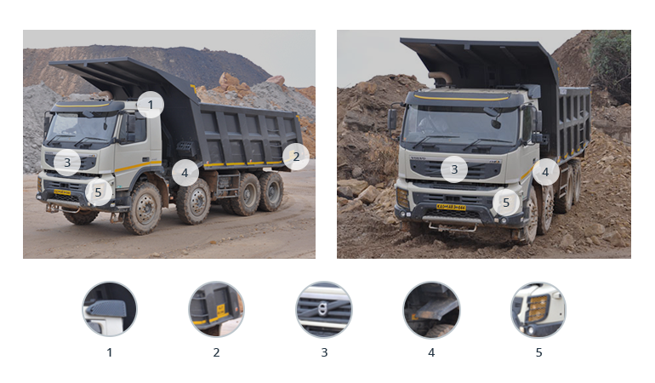

b. Data categorization using AdaBoost

This application collects and organises data to enhance vehicle performance and learning. It combines numerous low-performing classifiers to produce a single high-performing classifier for enhanced decision-making [6].

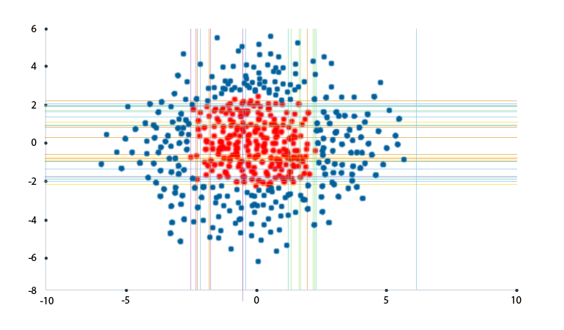

TextonBoost, which recognises objects

The TextonBoost approach, like AdaBoost, improves learning using textons by utilising information from shape, context, and appearance (micro-structures in images). It assembles visual data that contains recurrent components [7].

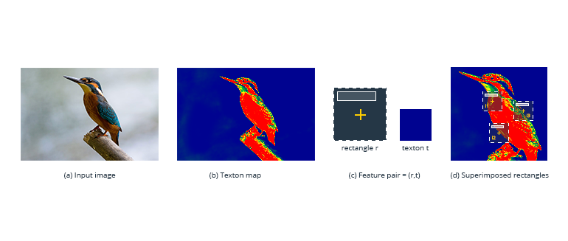

c. An oriented gradients histogram (HOG)

HOG makes it simpler to examine a cell—where an object is located—and ascertain how it shifts or moves. [7]

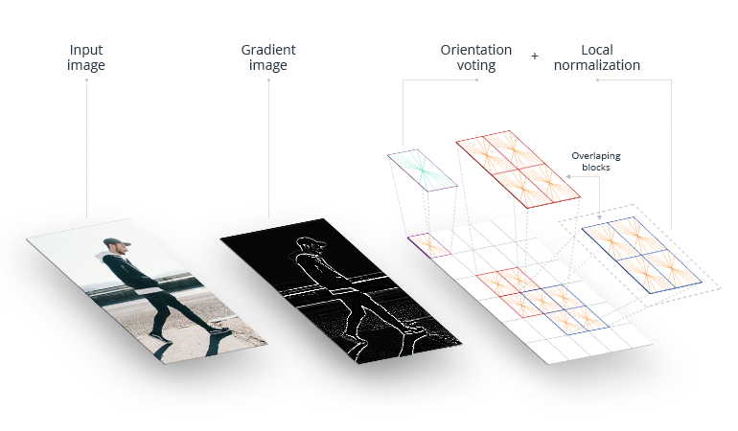

e. YOLO (You Only Look Once)

This algorithm detects and groups objects, such as people, plants, and cars. It assigns distinctive characteristics to each kind of object it groups in order to make objects easier for the car to recognise. YOLO is effective at categorising and recognising goods [8].

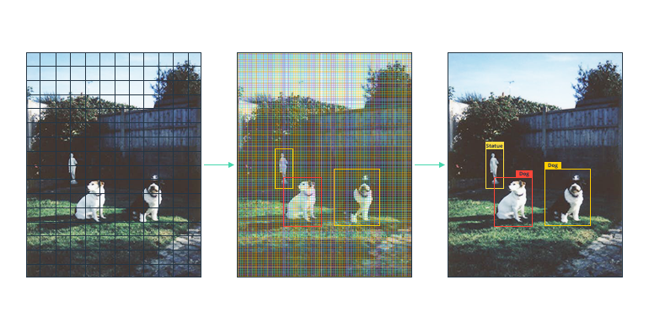

f. Summary

Algorithms for machine learning enable self-driving vehicles. They allow a car to gather data about its surroundings from cameras and other sensors, comprehend it, and decide what to do. Machine learning allows even cars to learn to perform these tasks as well as (or better than) people [8].

IV. LITERATURE SURVEY

A. George Hotz, Eder Santana, and the University of Florida used a driving simulator to learn.

The self-driving car artificial intelligence technique utilised by Comma.ai is based on an agent that mimics driver actions and anticipates manoeuvres by modelling impending traffic circumstances. This essay is an illustration of one of our research strategies for driving simulation. the one where we simulate is the one we use. Here, utilising generative adversarial networks with both classical and learning cost functions, we investigate variation auto encoders for embedding road frames. [9]

B. Learning for Self-Driving Cars from Start to End, NVIDIA Collaborations, Mariusz Bojarski, and Davide Del Testa. In order to translate front-facing camera data straight from raw pixels to driving commands, they used a convolution neural network (CNN). This end-to-end approach proved to be quite successful. On local roads with or without lane markings, on highways, and with the least amount of training data from people, the computer learns to drive in traffic. Also, it functions in dimly light areas like parking lots and gravel roads. [9]

C. The Perception of 3D Vision in Self-Driving Cars Lionel Heng, Christian Häne, and the University of Trier in Germany used a multi-camera system. Cameras are a crucial exteroceptive sensor for self-driving automobiles due to their accessibility, small size, ability to function in a range of weather situations, and capacity to provide appearance information about the surroundings. They may be used for many different things, such as visual navigation and obstacle detection. The whole 360-degree field of vision around the automobile may be recorded with a surround multi-camera system. To lower the number of cameras needed for surround perception, we employ fisheye cameras. Common vision pipelines are therefore available for 3D mapping, visual localization, obstacle detection, etc. [10].

V. CONCLUSION

Self-driving vehicles are the main development in the automatable sector in the future, therefore this project focuses on making improvements in road safety and commuting and substantially lowering accidents and human errors through continuous learning by the system. The way that people with disabilities and the blind travel will change thanks to this programmeable to drive independently. Our solution may be used as the basis for mobile applications, enabling consumers to request a car through an app and produce a completely autonomous vehicle once the law has been approved (totally autonomous vehicles are currently illegal, but they will soon become the norm for transportation).

VI.FUTURE SCOPE

Future autonomous vehicles offer a lot of promise. Automakers are working quickly to improve the accuracy and security of their autonomous models. Using a large number of cameras and sensors improves accuracy. Future delays can be avoided by designing a system where each car is connected to surrounding vehicles.

VII .REFERENCES

[1].Raivo Sell, Anton Rassõlkin, Mairo Leier, Juhan-Peep Ernits, “Self-driving car ISEAUTO for research and education”in 19th international conference on Research and Education in Mechatronics (REM), IEEE, 2018, pp: 111-116.

[2] T. Banerjee, S. Bose, A. Chakraborty, T. Samadder, Bhaskar Kumar, T.K. Rana, “Self Driving Cars: A Peep into the Future”, IEEE, 2017, pp: 33-38.

[3] Qudsia Memon, Muzamil Ahmed and ShahzebAli, “Self Driving and Driver Relaxing Vehicle”, in IEEE 2016, pp: 170-174.

[4] U. o. M. Centre for Sustainable Systems, "Autonomous Vehicles Factsheets," 2018.

[5] 3D Visual Perception for Self-Driving Cars using a Multi-Camera System, Christian Häne, Lionel Heng, University of Trier, Germany.

[6] Artificial Intelligence: A Modern Approach Stuart J. Russel and Peter Norvig.

[7] A dynamic k-means based clustering algrothim using fuzzy logic for CH selection and data transmission based on machine learning https://doi.org/10.1007/500500-023-07964-w 14 march 2023.

[8]”.DDos attack detection using cross domain challenges and research “, IJEAT vol9.issue 1pp.2373-2382, Oct 2019, scopus indexed.

[9] Student Performance Prediction using Machine Learning by Havan Agrawal , Harshil Mavani . International Journal of Engineering Research & Technology (IJERT) ISSN: 2278-0181 IJERTV4IS030127 www.ijert.org l. 4 Issue 03, March-2015 .

[10] M. Chen, W. Saad, C. Yin, and M. Debbah, “Echo state networks for proactive caching in cloud-based radio access networks with mobile users,” IEEE Transactions on Wireless Communications, vol. 16, no. 6, pp. 3520–3535, 2017.