Advancements and Challenges in Conducting Polymer and its Composites for Energy Storage Applications: A Comprehensive Study

Ashwini Rayar¹, Thrinethra S N³, Gangadhar Babaladimath² and Sharanappa Chapi³*

¹Department of Studies in Physics, Davangere University, Davangere, Karnataka – 577007, India
²Post-Graduation Department of Chemistry, KLE Society’s, Raja Lakhamagouda Science Institute (Autonomous), Belagavi-590001, Karnataka, India

³*Department of Physics, B.M.S. College of Engineering, Bull Temple Road, Bengaluru- 560019, Karnataka, India

*Corresponding author E-mail: sharanappac.phy@bmsce.ac.in

Abstract
The present article highlights a wide range of surveys on the potential applications of nanocomposites comprised of nanoparticles and innately conducting polymers in energy storage areas. In this review article the fabrication, Limit of discovery, target analytes and possible interactions of nanomaterials through conducting polymers are outlined. The different sizes and shapes of nanoparticles can be combined with conductive polymers resulting, diverse in nanocomposites having fascinating physical characteristics in conjunction with novel practical applications. In order to select a variety of nanoparticles, the inclusion method is employed with the use of both electrochemical and chemical routes. This article deliberates various kinds of conducting polymer-based supercapacitors, appropriate designing concepts and fabrication techniques. The Polyaniline (PANI) and polypyrrole (PPy) composites have been discussed in detail. It describes current advances as well as enduring difficulties and pertinent device fabrications.
Keywords: Conducting polymers, nanocomposites, supercapacitors, charge-discharge, carbon materials.

1. Introduction
Conducting polymers (CPs) came forward as an attractive area of research since they have exceptional characteristics of having organic resources with electrical conductivity. From the time of their innovation, they have fascinated the interest of a huge researcher’s faction who is operating in the frame of applications technology [1, 2]. In 1977, the organic conducting polymers were newly discovered by MacDiarmid’s innovative effort which has gained wide interest because of promising applications [1, 2]. Rigorous research efforts are caught up in the Synthesis along with the characterization of CPs like polyaniline (PANI), polypyrrole (PPy), diamionaphthalene (DAN). They can be found highly useful in the field of applications like sensors, electrochromic displays, batteries and electronic devices [3-5].
The unique materials of the twenty first century include, “Carbon nanomaterials (CNMs) together with fullerenes, carbon nanofibres (CNFS), single-walled carbon nanotubes (SWCNT), multi-walled carbon nanotubes (MWCNT), graphene, graphene oxide (GO) and carbon nanospheres (CNs)” [6] due to their good environmental stability [7], large area of surface, extraordinary mechanical, chemical, thermal and electrical properties [8]. For the reason that of all these special characteristics CNMs grabbed an immense attention in the areas of energy conversion [9] and composite materials, nanoscale electronic components [13], electromagnetic shielding, [12], medicine [11], and sensors [10].
From the perspective of basics and technology, numerous efforts have been made to mix polymers and CNMs in order to build possible nanocomposite materials with greater behavior [10]. Polyaniline (PANI), polythiophene (PTh), polypyrrole (PPy) and poly(3,4-ethylenedioxythiophene) (PEDOT) were investigated like matrices for creating a variety of carbon nanomaterials including carbon nanofibres (CNFs) [17, 18], fullerenes [14], carbon nanospheres (CNs) [19,20], single and multi-walled carbon nanotubes (CNTs) [15,16], graphene and graphene oxide [21-23]. Combining mechanical and electrical characteristics with carbon nanoparticles embedded into polymer matrices is the most interesting method [24]. The novel nanocomposites can be applied in various fields like sensors [25-27], molecular electronic devices, transistors [31], electrochemical capacitors [28, 29], and solar cells [30]. Nanocomposites based on conducting polymers and metal nanoparticles (MNPs) such as gold, platinum, palladium, and silver with various compositions and dimensions have recently received a lot of attention [32-36]. Metal nanoparticles incorporated into polymer matrices will produce a host nanocomposite with additional nanocomposites that have been synthesized by various techniques [34-40]. Electrochemical methods have been used to incorporate metal nanoparticles through polymer electrodeposition, electrosynthesis of metal nanoparticles on formulated polymer electrodes, reduction of metal salts dissolved in a polymer matrix, and amalgamation of performed nanoparticles through monomer polymerization. “Sonochemical method [42], Chemical preparation [41], ultrasonic irradiation [44], sol-gel method [43] and photochemical preparation [45] are also employed”. In terms of understanding their basic aspects and potential uses, conductive polymers and nanoparticle composites (CNMs or MNPs) have been a topic of growing number of studies and reviews [46].
Nanocomposites can be prepared by combining carbon-conducting polymers and nanoparticles. Carbon nanomaterials (CNMs) and conducting polymer matrix combinations such as graphene, carbon nanotubes (CNTs), and carbon nanofibres (CNFs) on the road to create polymer nanocomposites serve extremely vital part because of their functional and structural characteristics like high mechanical strength, high aspect ratio as well as elevated electrical characteristics [24, 47, 48]. Over the past few years, significant improvement has been done, ensuing new possibilities for the application of these properties within a spectrum of uses. The complete behavior of CNMs/polymer nanocomposites is determined by the spreading of Carbon nanomaterial in the polymer matrix. Thus, uniform CNM spreading is crucial in the manufacturing of polymer nanocomposites/CNM [17, 22, 49, 50, 51]. To date, a large number of studies on conducting polymer and CNM composites for usage in supercapacitors and chemical sensors have been published [52-54, 55]. Poly[3, 4-ethylenedioxythiophene] (PEDOT) [56-58], polypyrrole (PPy) and polyaniline (PANI) be the majority of conducting polymers employed. CNM/polymer nanocomposites are able to be produced through electrochemical or chemical techniques.
The most common technique of processing is chemical polymerization which can be done in situ or by solution mixing. Solution mixing is a process that involves combining CNMs and polymers with a suitable solvent and then evaporating the solvent under regulated conditions to produce nanocomposites. As oxidizing agent is used to oxidize matched monomers in situ, resulting in chemical polymerization. The chief benefit is it generates polymer-grafted CNMs which are combined by means of the free polymer chains. Additionally, given the miniature size of monomeric molecules, the uniformity of consequential composite conjugate will be consistently greater than amalgamation polymer chains with CNTs in solution [59]. Therefore, this will not produce a polymerized product with the very same uniformity and fidelity as electrochemical polymerization [56]. Electrochemical polymerization consumes very few minutes in place of many hours in comparison with chemical polymerization. Enhanced dispersion and interactions between CNMs with polymers arise from the electrochemical deposition of polymers on electrodes altered with CNMs. Higher uniformity is achieved by electrochemically co-depositing composites from a solution containing monomers and dispersed CNMs, resulting in the majority consistent network structure. The representation of chemical methods used for preparing CNM/polymer nanocomposites is shown in Figure 1.
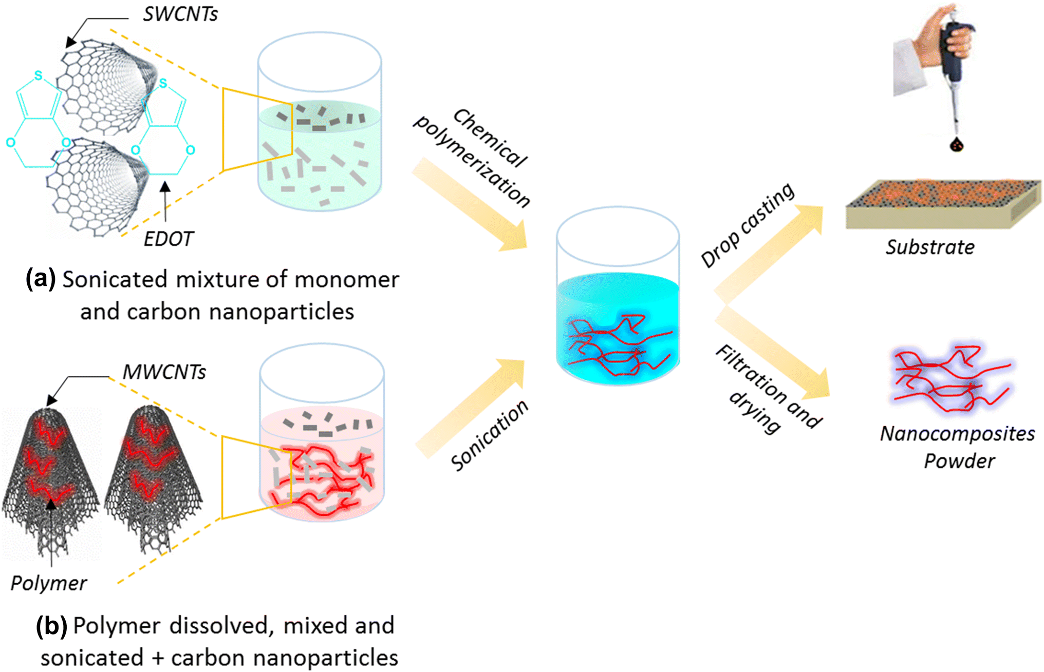
Figure 1: The schematic representation of chemical techniques employed for synthesis CNM/polymer nanocomposites [60].
(a) The nanocomposites were made by in-situ chemical polymerization using monomer and carbon nanomaterials in different weight ratios after being sonicated to create a homogeneous mixture [60, 61].
(b) The commercial polymers were dissolved in appropriate organic solvents, mixed, and sonicated in a mixed manner. To dissolve PEDOT: PSS in a volume ratio 3:1, Mangu et al. used N, N-dimethylformamide (DMF), dimethyl sulfoxide (DMSO), and 2-propanol, ethylene glycol, DMSO, and DMF [62]. Carbon nanoparticles were then sonicated and added to the solution. These solution-based nanocomposites can be poured onto a suitable substrate or precipitated by filtration before drying.
2. Different processes used for the synthesis of metal nanoparticles
The bottom-up and top-down methods are generally employed for the synthesis of metal nanoparticles. In a bottom-up approach, the metal nanoparticles are produced from metal atoms that are dissolved in an organic solution or aqueous solution later deposed under suitable investigational conditions. In case of top-down method, the metal nanoparticles are fabricated by division of heavy metals by physical techniques [63, 64]. Depending open above said methods, metal nanocomposite fabrication techniques might be classified into 6 types, as depicted in Figure 2.
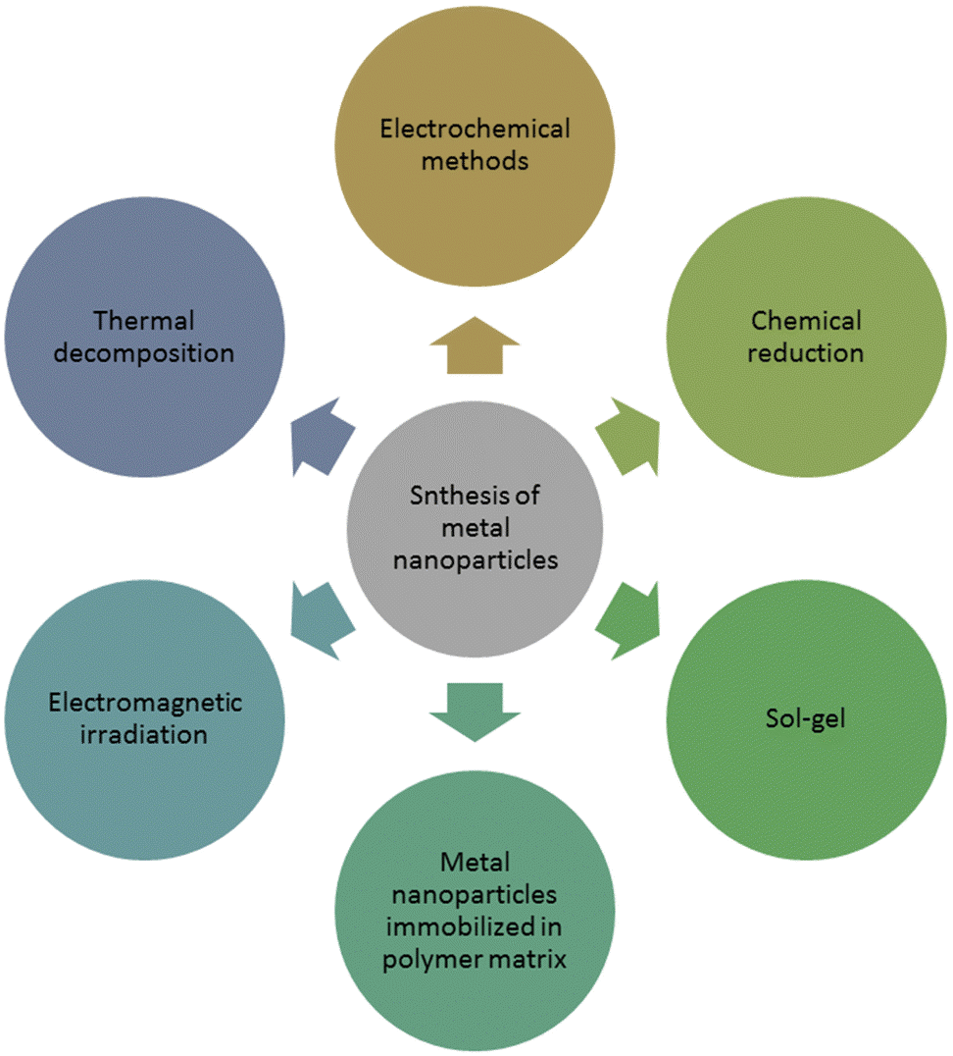
Figure 2: Different techniques employed for metal nanoparticles synthesis
According to literature survey, the often used method for preparation of metal nanoparticles is chemical reduction. It entails reducing metal salts within vicinity of proper reducing agent and a stabiliser, which is typically precise polymer, surfactant, or ligand.
Most extensively employed technique used for the creation of metal nanoparticles are electrochemical methods. After being dissolved in organics or aqueous solution, metal ions are reduced on a proper substrate via continuous reduction potential or cyclic voltammetry.
- Immobilized Metal nanoparticles in polymer matrix: Generally, for synthesizing the metal nanoparticles within polymer matrix three methods can be used. They are deposition, immersion, and dispersion. The dispersion process begins with the mixing of a metal precursor through a protective polymer, followed by reduction of metal ions in solution. For deposition method, metal precursor was combined by means of protective polymer is deposited on the top of substrate.
- Sol-gel: Sol-gel techniques are regarded as potential techniques for obtaining metal nanoparticles [65]. Throughout their preparation, the investigational environment like temperature, pH, and nature of solvent greatly impacts the characteristics of prepared metal nanoparticles.
- Electromagnetic irradiation: Electromagnetic irradiation techniques like microwave, UV, laser and ultrasonic irradiation can also be employed in the synthesis of metal nanocomposites [66, 67].
- Thermal decomposition: Heating volatile metal compounds in organic media or gas phase is one more method for the preparation of metal nanoparticles. In the dispersed phase, the compounds decompose with release metal or the identical metal oxide.
3. Flexible supercapacitors fabricated from conducting polymers and its composites
CPs are organic polymers through a conjugated bond structure that conducts electricity along the polymer chain. Because of their reversible Faradaic redox nature, high charge density, and reduced cost as measured up to the pricey metal oxides, CPs have been widely investigated for ES applications during the last two decades [68-70]. Because of their extreme flexibility and simplicity of manufacture, CPs have recently been identified as the chief capable electrode materials used for applications of flexible supercapacitors [71].
3.1. Polyaniline
It’s changing oxidation state and outstanding doping-dedoping capabilities make it an excellent doping-dedoping material including polyaniline (PANI), a very high specific pseudocapacitance is enticing conducting polymers are often utilized as low-cost positive electrode fabric for ES applications [68, 72, 73]. Polyaniline’s conductivity is determined by the dopant concentration, and it only exhibits metal-like conductivity when pH is less than 3. Polyaniline comes in various forms (Figure 3). They are categorized as pernigraniline, leucoemeraldine, and emeraldine, via oxidation state, i.e., leucoemeraldine is found in an adequate reduced state, pernigraniline occurs in an abundant state. When polyaniline is partially oxidized, it becomes conductive, but when completely oxidized it behaves as an insulator. Despite its low conductivity, the protonated emeraldine type of polyaniline is prominently examined conducting polymers because of environmental stability and high doping level [68, 74]. The highest doping stage of p-type PANI may theoretically be increased to 0.5, furthermore the functioning feasible window will be expanded to roughly 0.7 V, among a theoretical-specific capacitance of up to 2000 F/g [75].
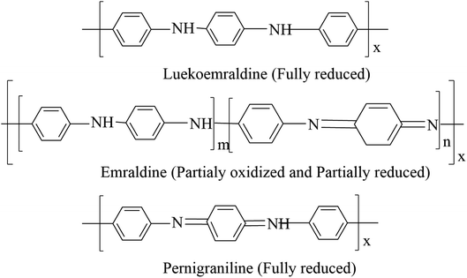
Figure 3: Structural representation of various forms of polyaniline
With the help of many substrates mixed among a variety of materials for ES purposes, PANI is being prepared by chemical and electrochemical techniques. A variety of literature publications on PANI-based supercapacitors show that specific can range from 30 to 3000 F/g.
Polymerization procedure structural morphology, dopant concentration, and the ionic diffusion length of electroactive material are all elements that influence this variation. The large nanoscale and surface area structures that are obtained in the existence of diverse dopants in optimal conditions are the ideal criteria for the creation of PANI-based pseduocapcitors. Li et al. [76] used a simple solution approach to make the nanostructured polyaniline/sodiumalginate (PANI/SA) composite in bulk quantities, as illustrated in Figure 4. The outstanding electrochemical characteristic is exhibited by PANI/SA nanofibres through diameters ranging starting with 50 to 100 nm (Fig. 4B).
The specific capacitance of electropolymerized PANI (2093 F/g) is seemed to be greater than chemically polymerized pure PANI. Electropolymerized PANI in presence of Triton X-100 on a Ni-electrode was reported to have a very high specific capacitance of roughly 2300 F/g and a steady charge-discharge cycle stability upto 1000 cycles [77]. A further work used the potentiodynamic technique to deposit PANI on porous carbon, reaching a extremely high specific capacitance of 1600 F/g at a current density 2.2 A/g. Above a considerable number of cycles (1000) at a high current density (19.8 A/g), the PANI coated porous carbon demonstrated reasonably adherent, steady electrochemical capacitance [78].
Fabrication of aligned and ordered nanostructures, such as PANI nanostructures have got a huge amount of interest in current years because of its better energy storage applicability [73]. Kulia et al. [79] used nanotemplate based on supramolecular gathering of block copolymer on a transparent ITO substrate to exhibit ordered arrays of vertically associated PANI nanorods, as seen in Figure 5.
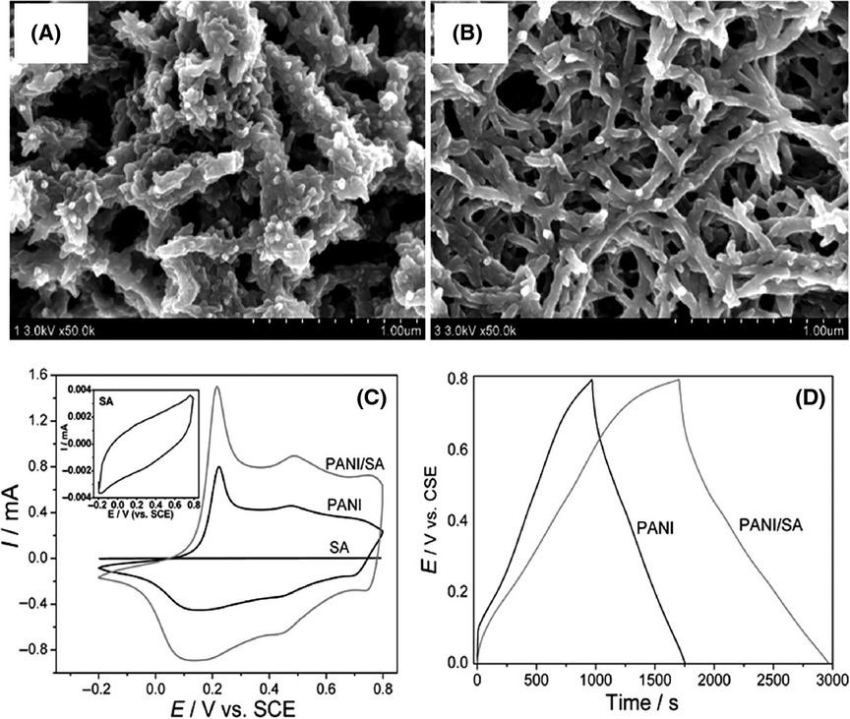
Figure 4: Scanning electron microscope (SEM) images (A and B) of pure PANI and PANI/SA, (C) Cyclic votammograms of SA, pure PANI, and PANI/SA electrodes at a scan rate of 100 mV/s, (D) Galavanostatic charge/discharge curves of pure PANI and PANI/SA nanofiber electrodes at a current density of 1 A/g in 1 mol/L H₂SO₄ [76].

PANI nanorod arrays through Nano -spacing shown exceptional electrochemical characteristics, among the maximum capacitance value of 3407 F/g. This ultra-high specific capacitance finding for PANI rods, on other hand is congruent and calls into question the fundamental understanding of PANI-based supercapacitors. Peng et al. [80] revealed the fact that Faradaic charge storage stoichiometry and current knowledge of PANI electrochemistry could not match such a high specific capacitance value.
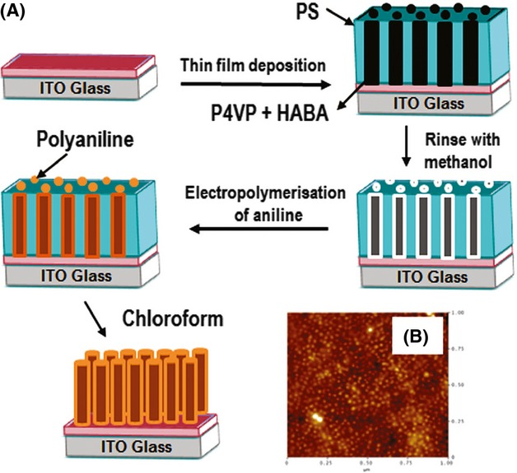
Figure 5: (A) Schematic representation of PANI nanorods preparation (B) AFM image of PANI nanorods [79].
3.2. Polypyrrole
Due to some special properties like high conductivity, fast charge-discharge mechanism, low cost, good thermal stability and high energy density, polypyrrole is considered as the major p-type conducting polymers for the Faradaic pseudocapacitor [73, 81-85]. The electrochemical behavior of PPy-based electrode, like that of PANI, is influenced by electrode preparation processes and the active electrode’s effective surface area. A single charge and multiple-charge ions are often doped in PPy [86]. In the past years, the conducting polymers-based study is widely made on PPy for the synthesis of the pseudocapacitor electrode by both electrochemical or chemical techniques. In the free surfactants presence, chemical oxidation-polymerization can synthesize broad variety of PPy nanostructures, but fabricating an electrode for ES applications is difficult owing to high internal resistance in the occurrence of binders, as formerly studied.
As depicted in the Figure 6, Dubal et al. [87] presented PPy nanostructures on stainless steel through use of electropolymerization technique for ES application in 2012. The PPy nanosheets exhibited the most excellent specific capacitance (586 F/g) in comparison to the other nanostructures. For upcoming flexible supercapacitor applications, PPy nanosheet lying on a suitable flexible substrate could be a viable option. A special technique is demonstrated by Kim et al. [82] to synthesize firm nafion-doped PPy electrode for ES purposes.
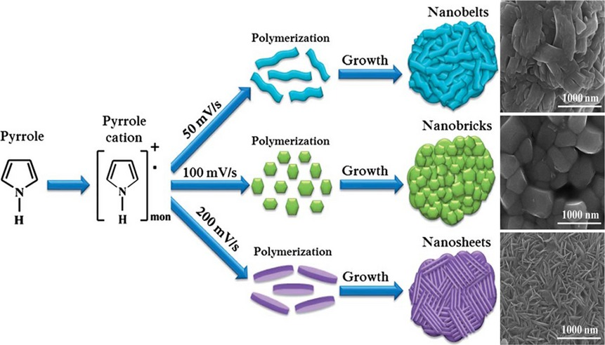
Figure 6: Preparation of PPy nanostructures by electropolyemrization. Figures on right show SEM images of nanobelt, nanobrick and nanosheet architectures of PPy [87].
3.3. Carbon nanotube-based composites
The excellent conductivity and good mechanical property of carbon nanotubes (CNTs) are widely recognized. SWCNTs and MWCNTs (single-wall and multiwall CNTs, respectively) have together investigated as EDLCs. It has been widely stated that thin amorphous faulty layer resting on the outer surface of the CNTs can perk up specific capacitance owing to enhanced charge accrual [43]. Critical reading on CP electrodes revealed the benefit of having a greater pseudocapacitance.
Unfortunately, the mechanical instability of CP-based ES electrode is owing to significant recurrent swelling-shrinking, volume change, and ion inclusion in addition to release in frequent charge-discharge cyclic procedure. Consequently, the binary composites of CPs with CNTs have been intensively investigated, with studies demonstrating an amazing increase in mechanical stability and supercapacitor electrode efficiency [89, 90]. PANI/ SWCNTs composite electrode is effectively synthesized by Gupta et al. and acquired a mass-normalized specific capacitance of 463 F/g and normalized specific capacitance of 2.7 F/cm² [91]. Sivakumar et al. [92] used in situ chemical polymerization to create a PANI/MWCNTs composite electrode with high starting mass-normalized specific capacitance of 606 F/g. Zhang et al. [93] effectively deposited PANI against vertically aligned CNTs for supercapacitor preparation, yielding a high mass-normalized specific capacitance of 1030 F/g. CNTs/polymer nanocomposite can successfully be synthesized with the help of electropolymerization method on conducting flexible substrates supplement to oxidative chemical polymerization method.
3.4. Graphene/graphene oxide-based composites
For its high thermal, unusual one-atom-thick 2D structure or electric conductivity, intrinsic flexibility, remarkable mechanical strength and large specific surface area, graphene offers a broad array of potential uses in energy-related systems. In present years, at hand occurs an exhaustive development to combine CPs amid graphene materials to create composites to manufacture flexible ES electrodes [94]. The permeable stratum structures of graphene not merely increase specific capacitance by facilitating the movement of electrolyte ions inside the electrodes, but they also influence the shape of CPs into graphene/polymer composite.
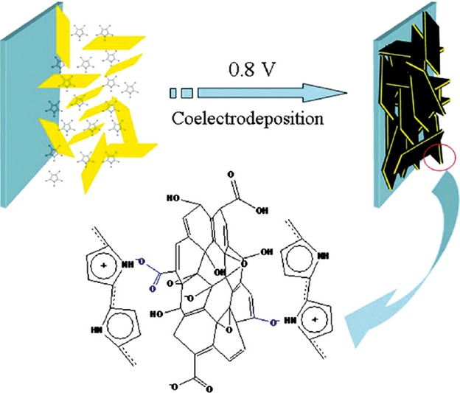
Figure 7: For the manufacture of GO/PPy nanocomposites, a conventional one-stem co-electrodeposition approach is used [96].
In 2010 [95], earliest graphene/CPs composite was published in which PANI nanostructures have vertically developed on the graphene surface via electrodeposition technique, accomplish notable high specific capacitance (550 F/g). Subsequently, noncovalent with covalent approaches have been employed for the synthesis of graphene/polymer composites for advancement of flexible supercapacitors.
Zhou et al. [96] used a one-step co-electrodeposition approach to make GO/PPy nanocomposite films, as illustrated in Figure 7. Even during electrochemical polymerization, the comparatively enormous anionic GO functioned as frail electrolyte and ensnared in the PPy nanocomposites, as well as acting as the efficient charge-balancing doping inside PPy. Davies et al. [97] have also generated flexible, homogeneous graphene/PPy composite film as supercapcitor electrodes via pulsed electropolymerization (Fig. 8). Owing to the advantageous nucleation of the PPy chains at deficiency spots in the graphene surface, this flexible supercapacitor film could reach high energy and power densities.
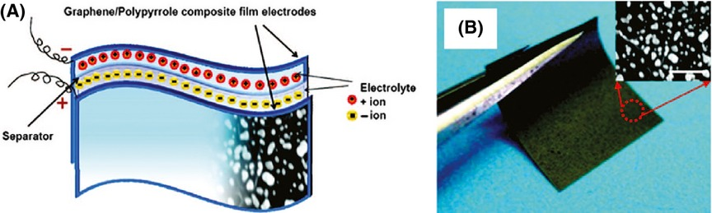
Figure 8: (A) Schematic representation of Graphene/PPy composite based flexible supercapacitors, (B) SEM picture of the G/PPy [97].
Zhang et al. [98] recently produced a flexible composite film made of reduced graphene oxide and polypyrrole nanowire (RGO-PPy) by reducing GO in the vicinity of PPy nanowires in-situ (PPy-NWs). Without the need for any glue or conductive additive, a symmetric supercapacitor was created by directly linking two membrane electrodes. The supercapcitor has a areal capacitance (175 mF/cm²) and good cycle stability.
3.5. Metal oxides-based composites
Metal oxides (MO_{x}) are the majority potential resources for the subsequent era of ES [99-102], since they provide better pseudocapacitance via bulk redox processes than carbonaceous material’s surface charge storage. On the other hand, the significant volume modification-induced structural transformation restricts electrode materials’ steadiness, resulting in fast capacity loss over successive charge/discharge cycles. MO_{x} too undergoes from low capacitive behaviors because of poor electrical conductivity. CPs, on the other hand, blends strong electrical conductivity through a flexible polymeric nature. Consequently, notable synergistic impacts be anticipated among MO_{x} and CPs while mixed at molecular level, as well as they result in precious flexible supercapacitors with enhanced capacitive characteristics better to those each separate materials [103-105]. The goal is to make the most of the benefits of both CPs and MO_{x} as active ES components in order to increase electrochemical energy storage and eliminate the existing ES electrode difficulties that those using pure CPs or MO_{x} as active materials are experiencing. CPs give polymeric flexibility and high electrical conductivity in a composite, allowing for facile processing of MO_{x} in the composite for high performance and increased cycle stability in the use of flexible supercapacitors. Because of its redox characteristics and structural morphologies, the MO_{x} component primarily provides high specific capacity. The MO_{x}/CPs composite that results is more than the sum of its parts; supercapacitor material with unique functions and features.
Zhau et al. [106] reported an inspiring 2223 F/g for a composite by means of 3D CoO and PPy nanowire. They produced an aqueous asymmetric supercapacitor device by a highest possible window of 1.8 V through an extremely high energy density (43.5 Wh/kg), high power density (5500 W/kg @ 11.8 Wh/kg), and excellent cycle ability in their research. According to reports, the core-shell or hybrid nanostructure composite has the ability to increase the performance of flexible supercapacitors. These ternary as well as binary MO_{x} composites among CPs, we consider, could pave the way intended for a flexible energy storage device.

4. Challenges
Various C-based and metal oxide materials (CFs, CNTs, RGO, GOs and MO_{x}) composites by conducting polymers may definitely accelerate prospect of CPs-based nanohybrids, furthermore flexible electrode engineering is an efficient way to optimize the CPs-based high performance flexible supercapacitors. According to studies, the composite synthesis is able to impact entire electrochemical Faradaic charge transfer course, also the electroactive material’s ultimate supercapacitive stability along with performance. Furthermore, while CPs-based composites have a high specific capacitance, their device capabilities, such as cycle stability, and power density are beyond those required actual commercial applications. Additionally, while the majority of research has concentrated on the exceptional productivity of supercapacitor materials, the optimization of supercapacitor cell manufacture plus its impact on device efficiency, such as energy density, power density, and stability, has received fewer attentions. Therefore, research into the power density and energy density of the entire capacitor cell, as well as more advance description of the interfacial resistance, should be prioritized within this area since this will extremely useful to real-world as well as industrial energy storage device applications.
Finally, this is essential on the way to do different endeavor on stating the commercial standards for the industrialization of ES [107]. Even if in present marketplace, the carbon-based ES (basically EDLCs kinds) becomes accessible commercially, there is loss of some standards for ES (for both EDLCs and pseudocapacitors) at this instant. Thus, it is important to launch few universal industrial standards like electrode structural and dimensional parameters, performance, and so on, based on types of ES and its relevance.
5. Current Efforts and upcoming advances
The prospect of CP-based flexible energy storage systems seems even better with novel, lightweight, cheap, and really flexible devices. Such CPs-based supercapacitors are likely to obtain an incredible measure of market-share of the current Li-ion batteries in upcoming 10 being to satisfy massive demand of the flexible electronic devices. High conductivity, high flexibility, high Faradaic capacitance, and effortless-in manufacture are some unique properties of CPs-based supercapacitors for wearable and thin electronic devices. Due to these distinct properties, the CPs-based flexible supercapacitors be able to directly integrated or mounted into clothing that can be rolled up or else stretchable and plugged into an electrical storage device [73]. While current developments in CPs-based flexible supercapacitors appear to be very powerful, there are still numerous barriers that avoid their use in real-world applications.
Many future solutions have been planned with the aim of accomplishing the following:
- Higher mechanical stability through highly flexible pantographs.
- Enhanced cycle stability of flexible CP-based supercapacitor with the help of compounds with ionic polymers for self healing.
- Flexibility of nanoscale active materials with high-performance properties and solid/ gel or ionic or organic electrolyte systems that guarantee safety and improve power density.
- Improved ionic/charge transport, reduction of the interfacial and/or internal resistance through direct production of active materials on the current collector without affected binders.
- Hybrid asymmetric flexible supercapacitors depending on n-type and p-type CPs. Despite the fact that in the current situation, n-type CPs derivatives have depreciated greatly in value compared to their p-type counterparts.

It is well known that the effectiveness of the CPs-based supercapcitor relies primarily on the interaction of active electrode materials via current collectors. CC, CFs, porous GOs, porous CFs composites are relatively used as current collectors for the upcoming flexible ES applications. With respect to the electrode designing fact, besides suitable alternate of active electrode materials, the proper choice of electrolytes is vital to enhance the ES performance. It is widely known that increasing the working potential window is the most effective technique to increase supercapacitors’ energy and power density. Owing to the electrochemical resilience of the electrolytes and the formation of gaseous products at the cathode and anodes (positive and negative electrodes) through voltammetric measurements, the safe or withstanding working potential window is limited in each electrochemical process. As per innovative supercapacitor electrolyte studies, organic (propylene carbonate, acetonitrile, linear sulfones, and so on) and ionic liquid imidazolium, pyrrolidium, and so on)-based electrolytes [73, 108] could promote a better potential window by almost 1.5-2 times compared to acid-based aqueous electrolytes, despite having poor ionic conductivity (by a factor 1/2) than the aqueous type.
A further key consideration is the electrodes’ equivalent series resistance (ESR), which is inversely related to supercapacitor’s maximum power density. As a result, lowering internal resistance of the active materials (CPs) as well as the contact (interfacial) resistance among the CPs and the current collector feasible critical for improving ionic/charge transport and therefore achieving high power density. Numerous methods have previously been tried address the aforementioned problem, including developing coreshell-type CPs/C or CPs/MO_{x} composites on the current collector, growing C-based nanostructures or MO_{x} nanostructures straight onto the current collector [109], and then coating CPs on carbon or MO_{x} nanostructures.The complete process is depicted in Figure 9 in diagrammatic form. Unlike supercapacitors composed of powder-type active materials, the direct electrode-design technique be able to increase high power efficiency by lowering ESR due to low contact resistance between the CPs-collector and the components of CPs/C or CPs/MO_{X} composites and lack of insulating binders.
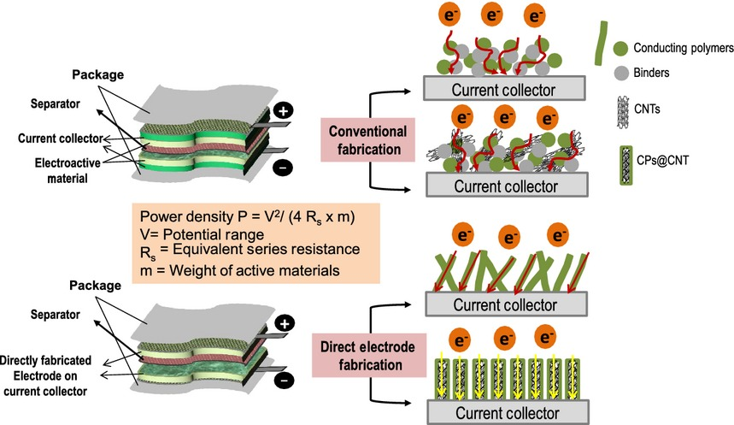
Figure 9: Schematic diagram of the CPs-based flexible electrode fabrication procedure. CPs, conducting polymer [109]
CPs are divided into two types based on their doping process: p-type and n-type CPs. Based on their electronic features, these two types of CPs also work in distinct potential levels. Because of these features, an asymmetric hybrid supercapacitor can be designed, as shown in Figure 10.
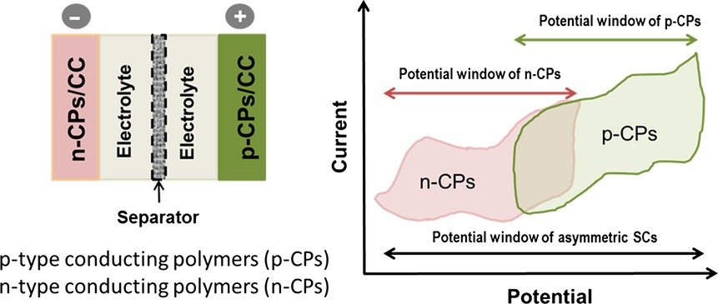
Figure 10: Schematic representation of asymmetric supercapacitors based on conductive polymers [73]

The highest durability voltage limits (cell working potential window) of the supercapacitor be enhanced and the specific power density would be increased by combining the positive potential window of p-type polymers with the comparably negative potential window of n-type derivative. Throughout idea, various hurdles remained, despite the fact that based on recent developments in CPs-based flexible supercapacitor research; significant improvement may be expected in the near prospect.
6. Main Applications of CPs
Because of their electrical characteristics, high theoretical capacitance, efficient wave absorption [110], strong redox action, and outstanding electrochemical behavior [111], conducting polymers have a broad range of application. Conducting polymers come in a variety of sizes and shapes, including particles, rod-like structures, hydrogels, and sheets, etc [112]. These various morphologies own special mechanical, optical and electrical characteristics (Fig. 11) [113].
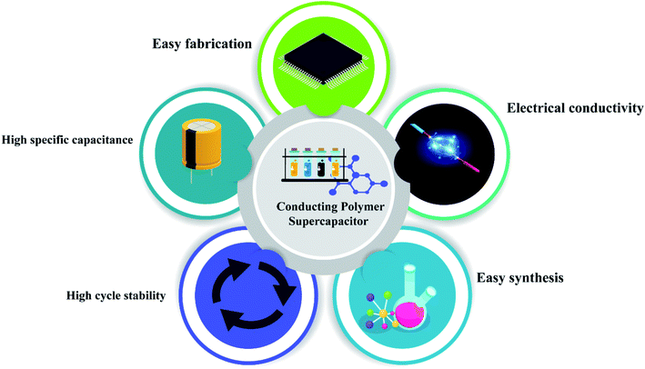
Figure 11: Schematic depiction of fundamental properties of conducting polymer based supercapacitors [114]
The material shape has a significant impact on the specific capacitance of a composite. Zhang et al. studied the fabrication of porous carbon polyaniline nanowires/carbon nanosheets for high-performance supercapacitor applications and reviewed their efficiency. To alleviate polyaniline’s cycle stability issue, carbonaceous elements such as activated carbon, graphene or graphite are usually composited with it. The fundamental disadvantage of polyaniline carbonaceous composite materials is that they agglomerate during synthesis, reducing active sites and increasing ion mobility, lowering supercapacitor capacity. Researchers concentrated on 3D porous carbons to tackle this challenge [115]. The composite was prepared via in situ chemical oxidative process using ammonium persulfate. The concentration of aniline has a great importance as well, because aniline concentration enhances the specific capacitance.
Conducting polymers, such as polyaniline, polypyrrole, and PDOT (Fig. 12), have a high capacity to absorb IR while having a low cytotoxicity. Because of this reason these polymers are largely employed for in vitro as well as in vivo cell examinations. Mei Chen et al. investigated the use of polypyrrole as a photothermal material for tumour growth control in 4TI model. In this case, they examined it practically by in vivo and in vitro investigation, and it was found that polypyrrole possess a photothermal efficiency of 44.7% and it has remarkable cancer cell ablation property under NIR irradiation of 1 W cm⁻². The tumour size was assessed at 60-day intervals, and it was discovered that all irradiation tumours had vanished and that no tumour development had occurred.
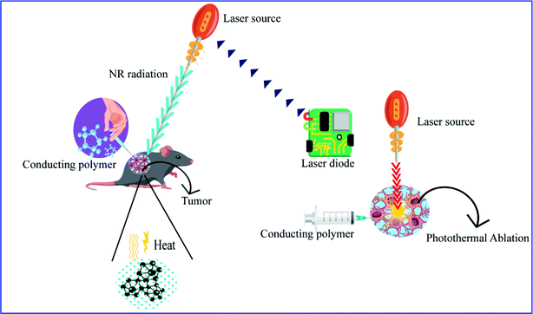
Figure 12: Schematic representation of photothermal treatment using a conducting polymer [114].
The fabricated polyaniline composites serve to be prospective in photothermal treatment because of their large amount of strong NIR absorption, good water dispersion, optimum size and high photothermal efficiency of 48.5%. In case of in vivo studies, the zero-toxicity property is useful [116]. For the cancer cells polypyrrole exhibits high photothermal activity. Again, with no surface alteration, Chen and his colleagues studied the photothermal effectiveness of polypyrrole against 4T1 cancer cells.
The biocompatibility of polypyrrole laid a path for in vivo and in vitro studies. From studies they found that polypyrrole possess 44.7% photothermal conversion efficiency and has high ablation efficiency owing to its greater NIR absorption [117]. Conducting polymers have possible applications in biomedical and other various smart materials as they exhibits antimicrobial activity. The production of hydroxyl radicals results in antimicrobial action as they improve H₂O₂ level.
Conducting polymers are widely employed as antibacterial and antifungal agents in a variety of industries, including medicine, food and coatings. Antimicrobial activity of polyaniline and other conducting polymers against Staphylococcus aureus, E. coli, Campylobacter jejuni, Pseudomonas aeruginosa, and Enterococcus faecalis. An Au@PANI–IA–Fe₃O₄ composite has been examined against Staphylococcus aureus (Gram +ve) and Escherichia coli (Gram $-$ve) microbes in Mueller–Hinton agar (MHA) plates. In the case of Staphylococcus aureus, the composite displays a better zone of inhibition as the composite concentration increases, but the composite exhibits no significant inhibition zone for E. coli bacteria. The antifungal characteristic of the composite was investigated against Candida albicans. These results reveal that the composite purse a pattern of increased inhibition zone when the composite concentration is increased [118]. Owing to the reactivity towards gases, effortlessness in deposition on substrates, doping-dedoping behavior and ease of synthesis, the polyaniline has been successfully employed in sensing area amongst conducting polymers.
Doping increases the conductivity range with high reversibility; therefore, it is largely utilized for the sensing of toxic gases like NO₂, CO, etc. In the conducting polymer composites, secondary components can be bimetallic, transition metal chalcogenides, polymers, carbonaceous materials, metallic, etc. A small coulombic force or van der waals force stabilizes these secondary nanoparticles with polymer matrix. The chemical and physical characteristics of the conducting polymers are changed by the introduction of secondary particles and this nature can be used for different applications. Kumar et al. investigated the sensing activity of PANI/Au NS as an NH₃ gas sensor, finding that Au NS acts as a catalyst and the composite has a reaction time of 15 seconds, which is faster than that pure Au NS. When the composite is prepared with polyaniline the sensing response increases by 52% [119].
Hydrogen gas is detected accurately and effectively using polyaniline-based sensors. Sharma et al. fabricated Al-SnO₂/PANI nanofibers through an electrospinning method, and their sensing activity was examined carefully. A 1% Al-SnO₂/PANI sensor exhibits an elevated sensitivity range of ~275% to H₂ gas at 1000 ppm. At 40 ⁰C the sensor had a quick sensing and recovery time of 2 s at 1000 ppm concentration range [120].
The transition metal dichalcogenide TaS₂ in the matrix of PPy has exhibited superior humidity sensing properties and thus offering it as a competent material to develop an efficient impedance-type humidity sensor [121]. PANI/TaS₂ composite has exhibited best humidity sensing characteristics, which in turn prove to be a promising material for the fabrication of humidity sensing device [122].
Bioelectronic devices are the fundamental component for the manufacture of wearable/implantation devices for tissue response controlling. Because of their capacity to convert mechanical impulses to electrical signals, conducting polymer hydrogels are utilized to make pressure and strain sensors. Flexible electrodes composed of conducting polymer hydrogels are extensively utilized to observe electrophysiological signals, including ECG, [123] electromyography and electroencephalography signals [124]. Normally, electrophysiological signals are extremely feeble. The major confront for device fabrication is to improve the signal-to-noise ratio and conductivity. Biocompatibility, long-term stability, and Skin adhesion are also taken into explanation. To sense different electrophysiological signals, PAA/PEDOT hydrogels have been designed. Polyaniline based hydrogels are utilized for real-time lactate and glucose controlling [125].
A wide variety of polymeric nanocomposites are employed for biomedical applications like drug delivery, cellular therapies and tissue engineering. “A variety of feature combinations may be produced to reproduce natural tissue structure and characteristics owing to unique interactions between polymer and nanoparticles. By synthesizing conducting polymers in nanostructure form, the poor sensitivity and selectivity of conductivity polymers for biological and chemical sensing may be increased”. Conductive polymer composites create the best hybrid materials that open up great prospective to discover their possible applications in the areas of humidity, gas sensors, and low-to-medium frequency devices [126].
7. Conclusion
Despite having a short history, conducting polymer nanocomposites are noteworthy additions to the list of innovative materials and composites. These materials have attracted scientific and technological interest because of their variety in synthesis procedures, characteristics, and broad spectrum of application, and have steered materials science research in a new path. In recent years, investigation and development of conducting polymer-based flexible supercapacitors has advanced at a rapid pace. Conducting polymer-based supercapacitors have received a lot of attention as a potential raised area for flexible energy storage devices. This article has briefly reviewed current developments, including few prosperous and optimistic research activities using CPs-based flexible supercapacitors to achieve high specific capacitance and also various applications.
Declaration of Conflicting Interests
The author(s) declared no potential conflicts of interest with respect to the research, authorship, and /or publication of this article.
Funding
The author(s) received no financial support for the research, authorship, and/or publication of this article.
ORCID iD
Sharanappa Chapi: https://orcid.org/0000-0002-1798-5278
References
- MacDiarmid, A.G., Angew., Chem. Int. Ed., 2001,40, 2581–2590.
- Shirakawa, H., Louis, E.J., MacDiarmid, A.G., Chiang, C.K., Heeger, A. Journal of the Chemical Society, Chemical Communications 1977, 16, 578.
- Salih, F.E., Oularbi, L., Halim, E., Elbasri, M., Ouarzane, A., El Rhazi, M., Electroanalysis 2018, 30 (8), 1855-1864.
- Chandrasekhar, P., Conducting Polymers, Fundamentals and Applications, Springer, Berlin, 2018.
- Heeger, A.J., Angew. Chem. Int. Ed. 2001, 40, 2591–2611.
- Tagmatarchis, N., CRC, Boca Raton, 2012.
- Navarro-Pardo, F., Martínez-Hernández, A.L., Velasco-Santos, C., Polymer Nanocomposites Based on Inorganic and Organic Nanomaterials Wiley, Oxford, 2015, 347–399.
- Sattler, K.D., CRC, Fullerenes 2016.
- Kumar, S., Nehra, M., Kedia, D., Dilbaghi, N., Tankeshwar, K., Kim, K.-H., Prog. Energy Combust. Sci., 2018, 64, 219–253.
- Yu, X., Zhang, W., Zhang, P., Su, Z. Biosens Bioelectron., 2017, 89, 72–84.
- Chrand, A.M., Springer, Cham, 2016, 3–29.
- S. Manjunatha., T. Machappa., Y.T. Ravikiran., B. Chethan., A. Sunilkumar., Physica B., 2019, 561, 170-178.
- Kong, L.B., Yan, W., Huang, Y., Que, W., Zhang, T., Li, S., Springer, New Delhi, 2016, 25–101.
- Zhang, F., Inganas, O., Zhou, Y., Vandewal, K., Natl. Sci. Rev. 3, 2016, 222–239.
- Meer, S., Kausar, A., Iqbal, T., Polym.-Plast. Technol. Eng., 2016, 55, 1416–1440.
- Srikanth, V.V.S.S., Ramana, G.V., Kumar, P.S., J. Nanosci. Nanotechnol., 2016, 16, 2418–2424.
- Feng, L., Xie, N., Zhong, J., Materials, 2014, 7, 3919–3945.
- Oularbi, L., Turmine, M., Rhazi, M.E., J. Solid State Electrochem., 2017, 21, 3289–3300.
- Li, X., Rao, M., Li, W., J. Solid State Electrochem., 2016, 20, 153–161.
- Zhang, P., Qiao, Z.A., Chem. Commun., 2015, 11, 1620–1636.
- Alvi, F., Ram, M.K., Basnayaka, P.A., Stefanakos, E., Goswami, Y., Kumar, A., Electrochim. Acta, 2011, 56, 9406–9412.
- Mittal, G., Dhand, V., Rhee, K.Y., Park, S.-J., Lee, W.R., J. Ind. Eng. Chem., 2015, 21, 11–25.
- Zhang, J., Zhao, X.S., J. Phys. Chem., 2012, C 116, 5420–5426.
- Liu, Y., Kumar, S., ACS Appl. Mater. Interfaces., 2014, 6, 6069–6087.
- Huang, L., Huang, Y., Liang, J., Wan, X., Chen, Y., Nano Res. 2011, 4, 675–684.
- Randriamahazaka, H., Ghilane, J., Electroanalysis, 2016, 28, 13–26.
- Yang, N., Swain, G.M., Jiang, X., Electroanalysis 2016, 28, 27–34.
- Li, M., Zhang, Y., Yang, L., Liu, Y., Ma, J., J. Mater. Sci.: Mater. Electron., 2015, 26, 485–492.
- Lota, K., Lota, G., Sierczynska, A., Acznik, I., Synth. Met., 2015, 203, 44–48.
- Sekkarapatti Ramasamy, M., Nikolakapoulou, A., Raptis, D., Dracopoulos, V., Paterakis, G., Lianos, P., Electrochim. Acta., 2015, 173, 276–281.
- Gao, Y., Yip, H.-L., Chen, K.-S., O’Malley, K.M., Acton, O., Sun, Y., Ting, G., Chen, H., Jen, A.K.-Y., Adv. Mater.,2011, 23, 1903–1908.
- Holze, R., Wu, Y.P., Electrochim. Acta., 2014, 122, 93–107.
- Jimena Monerris, M., D’Eramo, F., Javier Arevalo, F., Fernandez, H., Alicia Zon, M., Gabriela Molina, P., Microchem. J., 2016, 129, 71–77.
- Kondratiev, V.V., Malev, V.V., Eliseeva, S.N., Russ. Chem. Rev., 2016, 85, 14.
- Zhu, R., Chung, C.-H., Cha, K.C., Yang, W., Zheng, Y.B., Zhou, H., Song, T.-B., Chen, C.-C., Weiss, P.S., Li, G., Yang, Y., ACS Nano., 2011, 5, 9877–9882.
- Zou, H., Shang, M., Ren, G., Wang, W., Polym. Sci. 2016, 133, 43933.
- Reznickova, A., Novotna, Z., Kvitek, O., Kolska, Z., Svorcik, V., J. Nanosci. Nanotechnol. 2015, 10053–10073.
- Reznickova, A., Novotna, Z., Kolska, Z., Ulbrich, P., Svorcik, V., polymer. Chem. Listy., 2014, 108, 865–874.
- Yang, Y., Yuan, W., Li, S., Yang, X., Xu, J., Jiang, Y., Electrochim. Acta, 2015, 65, 323–329.
- Saleh, T.A., Gupta, V.K., Polymer Membranes, Elsevier, New York, 2016, 83–133.
- Reddy, K.R., Lee, K.-P., Lee, Y., Gopalan, A.I., Mater. Lett., 2008, 62, 1815–1818.
- Park, J.-E., Atobe, M., Fuchigami, T., Electrochim. Acta., 2005, 51, 849–854.
- Bagheri, H., Banihashemi, S., Anal. Chim. Acta., 2015, 886, 56–65.
- Gniadek, M., Malinowska, S., Rapecki, T., Stojek, Z., Donten, M., Synth. Met., 2014, 187, 193–200.
- Samu, G.F., Visy, C., Rajeshwar, K., Sarker, S., Subramanian, V.R., Janáky, C., Electrochim. Acta, 2015, 151, 467–476.
- Tang, C., Chen, N., Hu, X., Conducting Polymer Nanocomposites: Recent Developments and Future Prospects 2017.
- Du, J., Cheng, H.-M., Macromol. Chem. Phys., 2012, 213, 1060–1077.
- Sun, X., Sun, H., Li, H., Peng, H., Adv. Mater., 2013, 25, 5153–5176.
- Gupta, S., Price, C., Compos. Part B Eng., 2016, 105, 46–59.
- Huang, Y.Y., Terentjev, E.M., Polymers., 2012, 4, 275–295.
- Kumar, S., Rath, T., Mahaling, R.N., Das, C.K., polymer. Compos. Part Appl. Sci. Manuf., 2007, 38, 1304–1317.
- Salavagione, H.J., Díez-Pascual, A.M., Lázaro, E., Vera, S., Gómez-Fatou, M.A., Mater. Chem. A., 2014, 2, 14289–14328.
- Rahman, M.M., Hussein, M.A., Alamry, K.A., Al Shehry, F.M., Asiri, A.M., Talanta, 2016, 150, 71–80.
- Kaur, N., Thakur, H., Prabhakar, N., J. Electroanal. Chem., 2016, 775, 121–128.
- Yan, J., Wang, Q., Wei, T., Fan, Z., Adv. Energy Mater., 2014, 4(4), 1300816.
- Peng, C., Zhang, S., Jewell, D., Chen, G.Z., Prog. Nat. Sci., 2008, 18, 777–788.
- Shown, I., Ganguly, A., Chen, L.-C., Chen, K.-H., Energy Sci. Eng., 2015, 3, 2–26.
- Li, J., Cheng, X., Shashurin, A., Keidar, M., Graphene, 2012, 01, 1.
- Spitalsky, Z., Tasis, D., Papagelis, K., Galiotis, C., Prog. Polym. Sci., 2010, 35, 357–401.
- Mama El Rhazi, Sanaa Majid,Miloud Elbasri, Fatima Ezzahra Salih, Larbi Oularbi & Khalid Lafdi, International Nano Letters 2018, 8, 79–99.
- Gu, Z., Li, C., Wang, G., Zhang, L., Li, X., Wang, W., Jin, S., Polym. Phys. 48, 2010, 1329–1335.
- Mangu, R., Rajaputra, S., Singh, V.P., Nanotechnology, 2011, 22, 215502.
- Jia, C.-J., Schüth, F., Phys. Chem. Chem. Phys., 2011, 13, 2457–2487.
- Adlim, A., Indo. J. Chem., 2006, 6(1), 1–10.
- Wang, H.-H., Zhang, B., Li, X.-H., Antonietti, M., Chen, J.-S., Inorg. Chem. Front., 2016, 3, 1124–1129.
- Nadagouda, M.N., Speth, T.F., Varma, R.S., Acc. Chem. Res., 2011, 44, 469–478.
- Park, H., Reddy, D.A., Kim, Y., Lee, S., Ma, R., Kim, T.K., Chem.: A Eur. J, 2017, 23, 13112-13119.
- Ryu, K. S., K. M. Kim, N.-G. Park, Y. J. Park, and S. H. Chang., J. Power Sources 2002, 103, 305–309.
- Rudge, A., I. Raistrick, S. Gottesfeld, and J. P. Ferraris., Electrochim. Acta 1994, 39, 273–287.
- Burke, A. Electrochim. Acta 2007, 53, 1083–1091.
- Lota, K., V. Khomenko, and E. Frackowiak., J. Phys. Chem. Solids 2004, 65, 295–301.
- Khomenko, V., E. Frackowiak, and F. Beguin., Electrochim. Acta 2005, 50, 2499–2506.
- Shown, A. Ganguly, L.C. Chen, K.H. Chen, Energy Sci. Eng., 2014, 3, 2–26.
- Ryu, K. S., K. M. Kim, Y. J. Park, N.-G. Park, M. G. Kang, and S. H. Chang. Solid State Ionics 2002, 152–153, 861–866.
- Li, H., J. Wang, Q. Chu, Z. Wang, F. Zhang, and S. Wang, J. Power Sources 2009, 190, 578–586.
- Li, Y., X. Zhao, Q. Xu, Q. Zhang, and D. Chen., Langmuir 2011, 27, 6458–6463.
- Girija, T. C., and M. V. Sangaranarayanan, J. Power Sources 2006, 159, 1519–1526.
- Mondal, S. K., K. Barai, and N. Munichandraiah, Electrochim. Acta 2007, 52, 3258–3264.
- Kuila, B. K., B. Nandan, M. Bohme, A. Janke, and M. Stamm., Chem. Commun., 2009, 38, 5749–5751.
- Peng, C., D. Hu, and G. Z. Chen., Chem. Commun. 2011, 47, 4105– 4107.
- An, H., Y. Wang, X. Wang, L. Zheng, X. Wang, L. Yi, et al., J. Power Sources 2010, 195, 6964–6969.
- Kim, B. C., J. M. Ko, and G. G. Wallace., J. Power Sources 2008, 177, 665–668.
- Sultana, I., M. M. Rahman, S. Li, J. Wang, C. Wang, G. G. Wallace, et al. Electrochim. Acta 2012, 60, 201–205.
- Wang, J., Y. Xu, X. Chen, and X. Du., J. Power Sources 2007, 163, 1120–1125.
- Wang, J., Y. Xu, J. Wang, and X. Du., Synth. Met. 2011, 161, 1141–1144.
- Suematsu, S., Y. Oura, H. Tsujimoto, H. Kanno, and K. Naoi., Electrochim. Acta 2000, 45, 3813–3821.
- Dubal, D. P., S. H. Lee, J. G. Kim, W. B. Kim, and C. D. Lokhande., J. Mater. Chem. 2012, 22, 3044–3052.
- Ghosh, A., and Y. H. Lee., Chemsuschem 2012, 5, 480–499.
- Fan, H., H. Wang, N. Zhao, X. Zhang, and J. Xu., J. Mater. Chem. 2012, 22, 2774–2780.
- Wu, T.-M., Y.-W. Lin, and C.-S. Liao., Carbon 2005, 43, 734–740.
- Gupta, V., and N. Miura., J. Power Sources 2006, 157, 616–620.
- Sivakkumar, S. R., W. J. Kim, J.-A. Choi, D. R. MacFarlane, M. Forsyth, and D.-W. Kim., J. Power Sources 2007, 171, 1062–1068.
- Zhang, H., G. Cao, Z. Wang, Y. Yang, Z. Shi, and Z. Gu., Electrochem. Commun. 2008, 10, 1056–1059.
- Stankovich, S., D. A. Dikin, G. H. B. Dommett, K. M. Kohlhaas, E. J. Zimney, E. A. Stach, et al., Nature 2006, 442, 282–286.
- Xu, J., K. Wang, S.-Z. Zu, B.-H. Han, and Z. Wei., ACS Nano 2010, 4, 5019–5026.
- Zhu, C., J. Zhai, D. Wen, and S. Dong., J. Mater. Chem. 2012, 22, 6300–6306.
- Davies, A., P. Audette, B. Farrow, F. Hassan, Z. Chen, J.-Y. Choi, et al., J. Phys. Chem. C 2011, 115, 17612–17620.
- Zhang, J., P. Chen, B. H. L. Oh, and M. B. Chan-Park., Nanoscale 2013, 5, 9860–9866.
- Huang, H.-S., K.-H. Chang, N. Suzuki, Y. Yamauchi, C.-C. Hu, and K. C. W. Wu., Small 2013, 9, 2520–2526.
- Li, S.-M., Y.-S. Wang, S.-Y. Yang, C.-H. Liu, K.-H. Chang, H.-W. Tien, et al., J. Power Sources 2013, 225, 347–355.
- Hsu, C.-T., and C.-C. Hu., J. Power Sources 2013, 242, 662–671.
- Chen, Y.-C., Y.-K. Hsu, Y.-G. Lin, Y.-K. Lin, Y.-Y. Horng, L.-C. Chen, et al., Electrochim. Acta 2011, 56, 7124–7130.
- Sharma, R. K., A. C. Rastogi, and S. B. Desu., Electrochim. Acta 2008, 53, 7690–7695.
- Sivakkumar, S. R., J. M. Ko, D. Y. Kim, B. C. Kim, and G. G. Wallace., Electrochim. Acta 2007, 52, 7377–7385.
- Su, Z., C. Yang, C. Xu, H. Wu, Z. Zhang, T. Liu, et al., J. Mater. Chem. A 2013, 1, 12432–12440.
- Zhou, C., Y. Zhang, Y. Li, and J. Liu., Nano Lett. 2013, 13, 2078–2085.
- Wang, G., L. Zhang, and J. Zhang., Chem. Soc. Rev. 2012, 41, 797–828.
- Sellam, and S. A. Hashmi., ACS Appl. Mater. Interfaces 2013, 5, 3875–3883.
- Simon, P., and Y. Gogotsi., Nat. Mater. 2008, 7, 845–854.
- J. Huo, L. Wang and H. Yu, J. Mater. Sci., 2009, 44, 3917–3927.
- J. Heinze, B. A. Frontana-Uribe and S. Ludwigs, Chem. Rev., 2010, 110, 4724–4771.
- S. P. Armes, M. Aldissi, M. Hawley, J. G. Beery, S. Gottesfeld, Langmuir, 1991, 7, 1447–1452.
- V. Bansal, P. K. Sharma, N. Sharma, O. P. Pal, R. Malviya, Biol. Res., 2011, 5, 28–37.
- Namsheer K, Chandra Sekhar Rout, RSC Adv., 2021, 11, 5659.
- Y. Meng, K. Wang, Y. Zhang, Z. Wei, Adv. Mater., 2013, 25, 6985–6990.
- J. Zhou, Z. Lu, X. Zhu, X. Wang, Y. Liao, Z. Ma, F. Li, Biomaterials, 2013, 34, 9584–9592.
- M. Chen, X. Fang, S. Tang and N. Zheng, Chem. Commun., 2012, 48, 8934–8936.
- E. Parthiban, N. Kalaivasan and S. Sudarsan, Arab. J. Chem., 2020, 13, 4751–4763.
- V. Kumar, V. Patil, A. Apte, N. Harale, P. Patil, S. Kulkarni, Langmuir, 2015, 31, 13247–13256.
- H. J. Sharma, D. V. Jamkar, S. B. Kondawar, Procedia Mater. Sci., 2015, 10, 186–194.
- A. Sunilkumar, S. Manjunatha, B. Chethan, Y.T. Ravikiran, T. Machappaa, Sensors and Actuators A, 2019, 298, 111593.
- S. Manjunatha, Y.T. Ravikiran, A.Sunilkumar, Physica B: Condensed Matter, 2019, 561, 170-178.
- H. Yang, S. Ji, I. Chaturvedi, H. Xia, T. Wang, G. Chen, L. Pan, C. Wan, D. Qi, Y. S. Ong, X. Chen, ACS Mater. Lett., 2020, 2, 478–484.
- Q. Wang, X. Pan, C. Lin, D. Lin, Y. Ni, L. Chen, L. Huang, S. Cao, X. Ma, Chem. Eng. J., 2019, 370, 1039–1047.
- L. Li, L. Pan, Z. Ma, K. Yan, W. Cheng, Y. Shi, G. Yu, Nano Lett., 2018, 18, 3322–3327.
- Sunilkumar, A., S. Manjunatha, Y. T. Ravikiran., M. Revanasiddappa., M.
Prashantkumar., T. Machappa., Polym. Bull., 2021, 1-17.

***

