UNICYSTIC AMELOBLASTOMA

ABSTRACT
Unicystic ameloblastoma (UA) is an invasive polymorphic lesion with an unclear origin. It is considered to arise from the epithelial remains of Malassez from the Hertwig epithelial sheath. It is characterised by local invasion and recurrence. It usually affects men more than women and appears in their second and third decades of life. Clinically, it is asymptomatic, although it can induce swelling and facial asymmetry by expanding the bony cortex and permitting soft tissue invasion. UA has a well-defined, radiolucent, unilocular look on radiography, and histologically, it can be luminal, intraluminal, or mural, depending on the pathologic cavity characteristics. The majority of treatments depend on surgical excision of the lesion, which allows
Keywords: Ameloblastoma, mandible, mural, odontogenic tumours, unicystic.

I. INTRODUCTION
Ameloblastomas defines as a real enamel organ type tissue neoplasm that does not differentiate to the stage of enamel development. Robinson described a lesion as unicentric, non-invasive, intermittently growing, anatomically benign, and clinically persistent. The word 'ameloblastoma' was proposed by Churchill in 1934 to replace the term 'adamantinoma', coined by Malassez in 1885, because the latter term implies the production of hard tissue, which is not present in this lesion. Ameloblastoma is a combination of the English term amel, which means enamel, and the Greek word blastoma, which means germ. It is the second most frequent odontogenic neoplasm, with only odontoma outnumbering it in terms of documented occurrence [1]. They are commonly characterised as unicystic, multicystic, peripheral, or mixed and malignant subtypes.
The UA is a rare variant of ameloblastoma that refers to cystic lesions that have clinical and radiographic characteristics of an odontogenic cyst but histologically show a typical ameloblastomatous epithelium lining part of the cyst cavity, with or without luminal and/or mural tumour proliferation [2].

II. CLASSIFICATION
Modified classification of odontogenic tumour which was given by WHO in the year 2022 [3].
TABLE 1: ODONTOGENIC TUMOURS
A.Benign epithelial odontogenic tumours
Adenomatoid odontogenic tumour
Squamous odontogenic tumour
Calcifying epithelial odontogenic tumour
Ameloblastoma, unicystic
Ameloblastoma, extraosseous/peripheral
Ameloblastoma, conventional
Adenoid ameloblastoma
Metastasizing ameloblastoma
B.Benign mixed epithelial & mesenchymal odontogenic
Odontoma
Primordial odontogenic tumour
Ameloblastic fibroma
Dentinogenic ghost cell tumour
C.Benign mesenchymal odontogenic
Odontogenic fibroma
Cementoblastoma
Cemento-ossifying fibroma
Cemento-ossifying fibroma
D.Malignant odontogenic tumours
Sclerosing odontogenic carcinoma
Ameloblastic carcinoma
Clear cell odontogenic carcinoma
Ghost cell odontogenic carcinoma
Primary intraosseous carcinoma, NOS
Odontogenic carcinosarcoma
Odontogenic sarcomas

Table 2: Types of ameloblastoma
TYPES: | FREQUENCY: | HISTOLOGICAL VARIANTS:
Solid/Conventional type | 91% | Follicular, Plexifom, Acanthomatous, Granular Cell, Basal Cell, Desmoplastic, Hemangiomatous, Keratopapillary.
Unicystic type | 6% | Luminal, Intraluminal, Mural.
Extraosseous/Peripheral type | 2%
Metastasizing type | 1%

III. PATHOGENESIS
The cause of ameloblastoma is unknown, although it can induce mutations or modifications in the genetic material of cells planned for dental embryological development, according to neoplasm principles. A "BRAF" type activation mutation in the axon of chromosome 15 has been described, resulting in the substitution of valine by glutamic acid on codon 600, giving rise to the mutant name "BRAF600E." According to research, this biomarker is present in 63% of UAs; such mutant gene can be employed as a biomarker to diagnose this pathology using an immunohistochemistry approach [4,5].
However, three mechanisms for its pathogenesis have been proposed:
- Basal cells of the reduced enamel epithelium associated with a developing tooth, Malassezia remnants from the Hertwig lamina, and heterotopic epithelials in extraoral sites that undergo an ameloblastic transformation to give rise to a unicystic cavity.
- It develops as a result of epithelial changes in a Dentigerous Cyst (DC) or other form of odontogenic cyst, in which the neoplastic ameloblastic epithelial tissue is preceded by a non-neoplastic stratified squamous epithelial lining.
- A conventional ameloblastoma experiences island deformation, followed by the merger of its numerous cysts, creating a cystic cavity [4].
Similarly, 50-80% of occurrences of this condition are associated with an unborn tooth, most commonly the third molar. The parasymphysis, the anterior and posterior regions of the jaw, and the posterior part of the jaw include 90% of the lesions [4].

IV. CLINICAL FEATURES

Usually asymptomatic; may be discovered by chance during radiographic examination.
When symptoms do appear, they are typically restricted or nonspecific.
Age: Most often it occurs in younger patients, 50% of these cases are diagnosed during second decade of life. That is between
age group 20 to 30 years [6].
Sex: There is no preference based on gender [6].
Location: The mandibular area accounts for more than 90% of instances. And frequently seen in the posterior region of mandible [6].
Pain: The affected jaw grows slowly and painlessly. Pain and discharge are seen among secondarily infected lesions.
Expansion and Cortical Thinning: Neoplasm expands cortical plates and causes bone thinning (egg shell crackling), erodes them, and invades soft tissue. Ameloblastoma manifests clinically as a smooth-surfaced local enlargement of the jaw that causes facial asymmetry.
Other signs: Malocclusion and loosening of teeth may be seen. Usually associated with impacted mandibular 3rd molar [7].

V. RADIOGRAPHIC FEATURES
Radiographic examinations, such as panoramic radiography and computed tomography (CT) scans, are required for an initial diagnosis. UA has a well-defined radiolucent unilocular appearance on radiography [4].
Radiographically, UA may be seen unilocular or multilocular, with a soap bubble or honeycomb appearance; buccal and lingual cortical enlargement invariably occurs with ameloblastoma. Thinned and undamaged cortex exhibits an appearance of an egg shell [8]. Sometimes, a confined radiolucency that surrounds the crown of an unerupted mandibular third molar and clinically resembles a dentigerous cyst [6].
Additionally, most UAs exhibit a homogenous interior density and signal intensity with clearly defined margins on computed tomography (CT) and magnetic resonance imaging (MRI). Imaging professionals may be misled by such features when seeking to distinguish this form of cystic lesion from others like dentigerous cyst (DC) and Orth keratinized odontogenic cyst (OKOC)/odontogenic kerato cyst (OKC). However, CT is efficient in quantitatively estimating the internal characteristics of lesions, making it useful for UA diagnosis. Due to its enhanced soft-tissue contrast and multiplanar capabilities, magnetic resonance imaging offers the ability to reveal much more about the internal structure of a unilocular ameloblastoma [9].

VI. HISTOPATHOLOGY
Finding a unicystic area covered in an odontogenic epithelium is one of the key indicators for diagnosing UA. In the year 1970, Vicker and Gorlin gave the criteria to identify odontogenic epithelium which are as follow: Tall columnar cell, Hyperchromatic nucleus, Palisaded nuclei, Reverse polarity of nuclei and subnuclear vacuole formation [10].
UA has three types of histopathological variants which was given by Ackermann: 1) Luminal 2) Intraluminal 3) Mural
LUMINAL UA: The tumour is restricted to the cyst's luminal surface. The lesion is formed up of a fibrous cyst wall containing a lining made up entirely or partially of ameloblastic epithelium. This exhibits a basal layer of columnar or cuboidal cells with hyperchromatic nuclei and reversal polarity, as well as basilar cytoplasmic vacuolization. Overlying epithelial cells resemble stellate reticulum and are only weakly cohesive. (Figure:1)
INTRALUMINAL UA: One or more ameloblastoma nodules protrude into the cyst lumen from the cystic lining. The cystic lumen may just contain a few of these nodules or it may be completely filled. In some cases, the tumor's nodules that protrude into the lumen exhibit an edematous, plexiform pattern resembling the plexiform pattern found in conventional ameloblastomas. So sometimes it is referred to as plexiform unicystic ameloblastoma.
MURAL UA: Cystic lesion with epithelial invasion of connective tissue in follicular or plexiform form, the latter requiring considerably more rigorous treatment; it can be separated as islands [4,6].
Table 3: Philipsen and Reichart described another histologic subgrouping [11]
Subgroup 1: | Luminal UA
Subgroup 1.2: | Luminal and Intraluminal
Subgroup 1.2.3: | Luminal, Intraluminal and Intramural
Subgroup 1.3 | Luminal and Intramural

The subtypes with the mural component are the most aggressive type of UA. Increased expression of CD 34, MMP 2, and MMP 9 in the mural variant. And now the research is going on to keep the mural type of unicystic ameloblastoma into the conventional ameloblastoma [12].

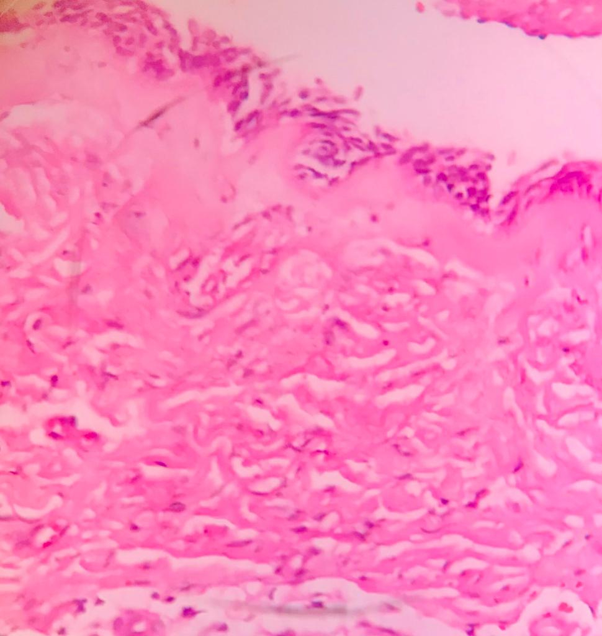
Figure1: Microphotograph (40x) of Luminal Unicystic Ameloblastoma

VII. IMMUNOHISTOCHEMISTRY
According to research, BRAF V600E is the most common mutation in the luminal, intraluminal, and mural subtypes of UA. We further show that rat sarcoma virus (RAS) and fibroblast growth factor receptor 2 (FGFR2) mutations are present in ameloblastoma but not in UA, and that BRAF V600E is slightly more common in UA (94%) than in ameloblastoma (74%). We can conclude that alteration of the Mitogen-activated protein kinase (MAPK) pathway is a substantial contribution to the pathogenesis of both UA and ameloblastoma. As a result, it is possible to conclude that UA and ameloblastoma are genetically and histomorphologically related odontogenic neoplasms. BRAF V600E analysis could be taken into consideration in standard ameloblastoma diagnostics in light of the diagnostic and prognostic implications of the mutant status [13].

VIII. DIFFERENTIAL DIAGNOSIS
Differential diagnosis can be given as: 1) Odontogenic Keratocyst 2) Dentigerous cyst 3) Calcifying odontogenic cyst.
The UA’s lining has been attempted to be distinguished from the lining of other cysts on numerous occasions in the past. Nevertheless, proliferating cells (PCNA and Ki-67) and lectins (Ulexeuropaeus agglutinin I and Bandeiraea simplicifolia agglutinin I) may help in their differential diagnosis. Due to the UA’s varied reactivity to tissue markers, Eversole et al. claim that the gold standard for diagnosis for UA is still unaided histologic evaluation. Histologically, the presence of a single cystic sac lined with odontogenic (ameloblastomatous) epithelium, which is frequently present only in isolated areas, is the minimal requirement for classifying a lesion as UA [14].

IX. TREATMENT AND RECURRENCE
The current standard of care for ameloblastomas is the surgical path of resection, which entails the removal of the block tumour with a wide bone margin and the delayed or immediate bone reconstruction of the defect with grafts or prosthetic rehabilitation. However, this "radical treatment" has a high patient morbidity rate. Treatment for ameloblastoma is determined by its location, size, extent, histological subtype, damaged bone type, and mandibular region. When it comes to accepted treatment options for UA, these include: either radical or conservative. Another option is marsupialization followed by enucleation. Although the "unique ameloblastoma" is less aggressive than the solid type; this has a high recurrence (10% to 25%), many studies agree that the rate of recurrence of this tumour is lower when performing radical treatment. Thus, resection causes a recurrence of 3.6% and enucleation causes a recurrence of 30.5%; thus, it is possible to conclude that eliminating an adequate bone margin is expected to reduce the possibility of a recurrence; additionally, adequate discernment is recommended when selecting the type of treatment to achieve maximum success. It is important to note that radical surgery is often associated with masticatory dysfunctions, abnormal jaw movement, and tooth extraction; additionally, in young patients, changes in mandibular growth can result in severe deformities that affect the patient's quality of life. According to certain research, the differential diagnosis between neoplasms and odontogenic cysts is critical, and conservative marsupialization of cysts is not an option for UA. The differential diagnosis between dentigerous cyst and UA is an exceptional case in which neoplasia is enucleated with the provisional preoperative clinical diagnosis of dentigerous cyst, because both pathologies have radiographic similarities, clinical, and incisional biopsy may not have characteristics consistent with the definitive diagnosis. In contrast to intraluminal and luminal variations, where the treatment of choice is enucleation with peripheral osteotomy followed by the application of Carnoy solution, the treatment for "mural ameloblastoma" should be a resection with a safe margin of 1 cm. The treatment options are simplified by using the UA subtypes as a guideline; type I and II lesions can be treated conservatively with simple enucleation. Type III and IV patients require more intrusive and vigorous therapies; however, the definitive diagnosis is established after the surgical procedure and its following review.
The statistics show a 3.6% recurrence rate for resection, 30.5% for enucleation alone, 16% for enucleation followed by the Carnoy solution, and 18% for marsupialization. The jaw is the site of greatest recurrence in 80% of cases; preferably in the mandibular angle or gonion, there is a 3 to 1 relationship linked to antero mandibular zones, it should be noted that this recurrence is recorded according to racial groups, where Asians show a lower predilection for injuries at the mandibular angle level compared to whites and blacks, while black people show a higher. Conservative therapy is suggested for children and adolescents because most lesions are unique at this age and recurrence in these situations is rare [4].

X.PROGNOSIS
UA has a less aggressive biological behaviour and a fair prognosis, even following conservative surgical treatment. Some studies suggest that the prognostic-treatment association is more essential than the prognostic-histological type relationship, however other studies show that the histological type and the prognosis of UA have an important relationship. Although "UA" has a favourable prognosis, the literature indicates that luminal UA is a less aggressive variety of ameloblastoma, hence this variant has a better prognosis. Furthermore, it is stated that the luminal and intraluminal subtypes have the greatest prognosis due to the absence of ameloblastomatous proliferation in the cyst wall [4].

XI. CONCLUSION
The UA is one of the most common odontogenic tumours in the maxillae, with a male sex bias, by particular racial groups, and is usually discovered in the second and third decade of life. To date, no definitive cause has been identified; nonetheless, most ideas point to an epithelial mutation that results in a single cystic cavity. Its prognosis and recurrence are tightly tied to its therapy and histological type; the "gold standard" of treatment and the mode of diagnosis are ambiguous. More research is thus required to establish a stable therapy guideline.

REFERENCES
- Gupta N, Saxena S, Rathod VC, Aggarwal P. Unicystic ameloblastoma of the mandible. Journal of oral and maxillofacial pathology: JOMFP. 2011 May;15(2):228.
- Sivapathasundharam B, Rajendran A. Shafer's textbook of oral pathology. Elsevier Health Sciences; 2020 June 23.
- Soluk-Tekkesin M, Wright JM. The World Health Organization Classification of Odontogenic Lesions: A Summary of the Changes of the 2022 (5th) Edition. Turk patoloji dergisi. 2022 Jan 1;38(2):168-84.
- Pinos LS, Ortiz JA, Calle MF, Mendoza FM. Unicystic ameloblastoma: Literature review. World Journal of Advanced Research and Reviews. 2021;10(3):095-103.
- Pereira NB, Pereira KM, Coura BP, Diniz MG, de Castro WH, Gomes CC, Gomez RS. BRAFV 600E mutation in the diagnosis of unicystic ameloblastoma. Journal of Oral Pathology & Medicine. 2016 Nov;45(10):780-5.
- Neville BW, Damm DD, Allen CM, Chi AC. Oral and maxillofacial pathology. Elsevier Health Sciences; 2015 May 13.
- Anne C. McLean-Holden, D.M.D., M.S., Kelly Magliocca, D.D.S., M.P.H. Mandible & maxilla Benign odontogenic tumors Ameloblastoma. Pathology outlines.com. 2021 May 17.
- Rayamajhi S, Shrestha S, Shakya S, Bhandari S, Twayana AR, Shahi K. Unicystic Ameloblastoma of Mandible: A Case Report. JNMA: Journal of the Nepal Medical Association. 2022 Jul;60(251):657.
- Wakoh M, Matsuzaka K, Imoto K, Goto T, Kamio T, Shibahara T. Luminal, Intramural Unicystic Ameloblastoma with Marked Fluid-Fluid Level: Validity of CT and MRI Findings. The Bulletin of Tokyo Dental College. 2020;61(1):61-9.
- Woolgar JA. Odontogenic tumors and allied lesions: Peter A. Reichart, Hans P. Philipsen, Quintessence Books, 388 pp., Price£ 106, 290 illustrations (146 colour), 9 sections, 42 chapters, ISBN 1-85097-059-9. British Journal of Oral and Maxillofacial Surgery. 2004 Oct 1;42(5):462-3.
- Ramesh RS, Manjunath S, Ustad TH, Pais S, Shivakumar K. Unicystic ameloblastoma of the mandible-an unusual case report and review of literature. Head & neck oncology. 2010 Dec;2:1-5.
- Panneerselvam K, Kavitha B, Panneerselvam E, Parameswaran A. Mural unicystic ameloblastoma mimicking odontogenic cyst. Journal of Family Medicine and Primary Care. 2020 May;9(5):2524.
- Heikinheimo K, Huhtala JM, Thiel A, Kurppa KJ, Heikinheimo H, Kovac M, Kragelund C, Warfvinge G, Dawson H, Elenius K, Ristimäki A. The mutational profile of unicystic ameloblastoma. Journal of dental research. 2019 Jan;98(1):54-60.
- Nagalaxmi V, Sangmesh M, Maloth KN, Kodangal S, Chappidi V, Goyal S. Unicystic mural ameloblastoma: an unusual case report. Case reports in dentistry. 2013 Apr 23;2013.
- Chaudhary Z, Sangwan V, Pal US, Sharma P. Unicystic ameloblastoma: a diagnostic dilemma. National journal of maxillofacial surgery. 2011 Jan;2(1):89.
- Kalmegh PP, Hande AH, Gawande MN, Patil SK, Sonone AM, Hande A, Gawande M. Unicystic Ameloblastoma (UA): A Case Series. Cureus. 2022 Nov 3;14(11).

