Copper Deficiency Affects On Morphology And Reproductive Biology Of Blackgram

Abstract-Black gram(Vigna mungo L)CV T-9plants were grown till maturity i. e. 74days at 0.0065, 0.013(deficient) and0.065(adequate)mg cu l⁻¹ of cu in refined sand. Cu deficiency i. e. 0.0065,0.013 cu l⁻¹ caused phenotypes are that
Compared to control 0.065mg cul⁻¹ cu supply the plants were stunted ,leaves were discoloured and old leaves became
Necrotic and withered and the number of flowers, pods and seeds are highly reduced. The size and number of pods were significantly reduced in cu deficiency. The seed weight marginally decreased at both the cu deficient levels. All the stages of determinations(day 24,60,74)the decrease in total dry weight was 29-30% at 0.0065mg cu l⁻¹and14-17% at 0.013 mg cu l⁻¹as compared to that of control. The concentration of cu in both leaves and seeds increased with an increase in cu supply, the cu concentration in deficient cu was higher in younger leaves than that of older leaves. Cu deficiency reduces growth , male and female fertility and this effectsthe seed quality of a plant.The cu deficiency also effect the economy of the crops .The delayed flowering,senescence and entirely abolished gynoecium fertility were also seen in cu deficient (o.o65ml cu l⁻¹ blackgram plants)

The cu deficiency affects the pollen producing capacity when the pollen grains were germinated in an artificial medium the observation showed that 30-35%pollen grains were viable in deficiency as compared to 61% at normal cu and the tube length was also decreased at deficient cu .

The pollen grains sticked to stigma surface also showed esterase activity and the esterase activity was studied in stigma under control condition was much higher than that of deficient cu supply.After clearing with NAOH and staining with aniline blue the whole mount of ovule showed that phenolic compounds were localized more in micropylar region of the outer integument on the placental side in cu deficient material ,whereas in control this type of deposition was not observed ,cell division in this region of integument is more frequent in the control(0.065mgl⁻¹)cu supply.As compared to deficient(0.0065mg cul⁻¹),on the protein basis the activities of peroxidase ,acid phosphatase and alkaline phosphatase decreased in both male and female parts i. e. stamen, ovaries, stigma and style.While on the fresh weight basis the activity of peroxidase increased in cu deficient supply. The activity of acid phosphatase and alkaline phosphatase increased in ovary stigma style and stamen. In the stamen the acid phosphatase activity decreased in cu deficient level.Compared to control the concentration of sugars both reducing and non-reducing in leaves (source)as well as developing pods(sink)decreased at deficient cu at 0.0065mgl⁻¹ this indicates of lower synthesis and lesser incorporation of sugars in biosynthesis of starch at deficient cu.
The decrease in starch content was 43-49% from that of the control cu supply both leaves (source) and pods (sink). The concentration of soluble nitrogen compounds (non-protein nitrogen) lowered as compared to control cu supply while the decrease in total and protein nitrogen in seeds ranged from 30-32% in both deficient levels of cu .
The decreased pod : leaf ratio of non-protein nitrogen and increased that of protein nitrogen at deficient cu indicates hampered translocation of soluble nitrogenous compounds from source to sink.
The ovaries of mature buds showed accumulation of sugars and phenols was more pronounced at the lower cu level i.e (0.065 mg cu l⁻¹)
In mature seeds the decrease in protein content in cu deficient blackgram seeds ws maximum in albumins and vicilins and minimum in legumins . The sulphur containing amino acid i.e lysine , methionine and cysteine : increased with an increase in cu supply from 0.0065 to 0.065 mg cu l⁻¹
Keywords:Black gram; Copper; Pollen grains; Peroxidase; Protiens; Seed quality; Seed reserves
INTRODUCTION

Black gram is a sustainable and inexpensive source of protein , unsaturated fat , dietary fiber , complex carbohydrates , micronutrients and important bioactive phytochemicals , therefore , their consumption could contribute to a healthier life style .It is also used as a key ingredient in vegan meat and are growing in the use as a plant based protein source in the world market place.
Cu is an essential metal for plants development . It plays key role in photosynthesis and respiratory electron transport chains in ethylene sensing cellwall metabolism , oxidative stress protection and biogenesis of molybdenum cofactor thus deficiency in the cu supply can change the essential functions in plants metabolism. Cu is one of the micronutrients needed in very small quantity by plants. The deficiency of copper affects the plant growth , protein content, antioxidant , enzyme activity , and reproductive physiology of leguminous and non –leguminous plants. It participates in numerous physiological processes and is essential cofactor for many metallo-protiens. Copper deficiency has been reported to cause in the reproductive physiology of several plant species^{4,5}.
Both male and female reproductive parts are affected by low copper and this indirectly affects the economic yield of plants. In low copper condition the plumule and radical length decreased and the excess copper was found to be inhibitory , not only for vegetative growth but also reproductive growth of plants. Reports are also available on premature sprouting of cereal grains in low copper conditions.¹ In addition to the development of characteristic visible symptoms of either deficiency or toxicity of copper in several crop plants , copper stress was found to affect the growth, biomass, nitrogen metabolism, grain yield and quality of leguminous plants. In this chapter an effort has been made to grow the plants of black gram till maturity in refined sand at variable levels of copper mainly to observe the effect of low copper in reproductive physiology and quality of seeds.

BLACK GRAM
Origin-Black gram originated in south Asia , where it has been in cultivation from ancient times and is one of the most highly prized pulses of India. In India the black gram is one of the important pulses grown in both Kharif and Rabi season. The product sold as black lentil is usually the whole urad bean , where as the split bean (the interior being white) is called white lentil. Vigna mungo (black gram) is one of the important pulses crops grown throughout India. India produces almost 70 percent of the world s total production of a black gram ,it contributes 10 percent to the total pulse production in the country. It is grown in Madhya Pradesh, Uttar Pradesh, Andhra Pradesh, Maharashtra, and Rajasthan . The black gram(a legume) have capacity to fix atmospheric nitrogen in the soil, it is widely used pulse in India with high phosphoric acid content. It is one of the most valued pulses due to its culinary values. It is also known as urad dal, black bean, black lentil, uddu , black matpe etc..
Morphological characters of black bean-Vigna mungo, it is an annual drought tolerant, dicotyledonous legume pulse. The black gram or Vigna mungo beans are small, black dry beans featuring prominently in the Asian cuisine . It is a small ,4-7 cm long hairy cylindrical pods establish after 60-70 days of the seedling. Each pod enclose 6-10 seeds that are black, grayish or dark brown. Inside they are a white creamy colour.
The flowers of black gram plants are very small and yellow , while fruits are cylindrical. The seed is an ellipsoid form ,rounded and slightly elongated.
Suitable conditions for Cultivation of Black gram - Black gram can be grown as a pure or mixed crop during the Kharif season . It is generally grown in Kharif/rainy and summer season . It grows best in hot, and humid conditions with an ideal temperature level between 25 to 35⁰c.
Sowing Time-Second week of july (15 to 30thjuly) is the proper time of black gram sowing in Kharif season. If sown early the more foliage and less flowering and sometimes no flowering In, summer , sowing should be done from third week of February to first week of april. Late sowing should be avoided. Black gram harvested when 70 to 80%of pods matured and most of the pods turn black order.at the time of harvesting , at least 20 to 22% of moisture requires in the blackgram cereal and harvest the pods when it is mature.

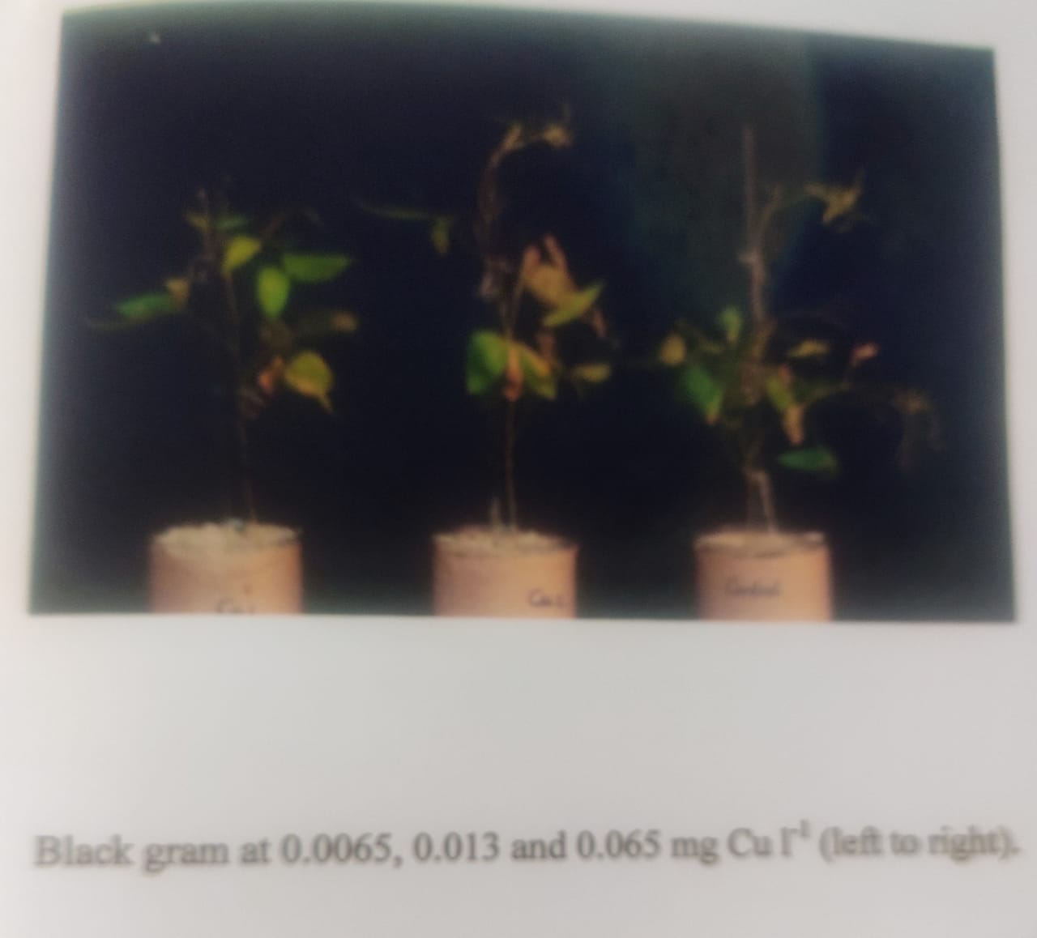
Classification-Kingdom-Plantae
Order-Fabales

Classification-Kingdom-Plantae
Order-Fabales
Family-Fabaceae
Genus-Vigna
Species-mungo
Nutritional Value of black gram(Vigna mungoL.)cvT-9—Raw mature seeds have Nutritive value per 100gm is------
PRINCIPLE NUTRIENT VALUE
Energy 341kcal
Carbohydrates 58.99gm
Protein 25.21gm
Total Fat 1.64gm
Cholestrol 0.0gm
Dietary Fiber 18.32gm
Vitamins
Foliates 215 µg
Niacin 1,45mg
Pantothenic acid 0.9mg
Pyridoxine 0.28mg
Riboflavin 0.25mg
Thiamin 0.28mg
Vitamin-A 23IU
Vitamin-C 0.0mg
Electrolytes
Sodium 38mg
Potassium 98mg
Minerals
Calcium 14mg
Copper 0.99mg
Iron 7.6mg
Magnesium 27mg
Phosphorus 38mg
Zinc 3.4mg
Unit-kal(kilocalorie)
gm(gram)
mg(milligram)
IU(international unit)
Benefits of Black gram- magnesium, phosphorus, calcium, iron, potassium,copper etc. are found in black bean , hence the black gram strengthen the bone mineral density and reduces the chance of getting osteoporosis.

COPPER-Copper a micronutrient and an elemental mineral which is essential for the health growth and development of a plant in a very small amount and plays an important role in agriculture. Copper concentration in soil are not uniform around the world. In many areas , soils have in sufficient levels of copper . Soils that are naturally deficient in copper often require copper supplements before agricultural crops such as cereals can be grown.
Copper deficiency in soil can lead to crop failure . Copper deficiency is a mazor issue in global food production , resulting in losses in yield and reduced quality of output. Nitrogen fertilizers can worsen copper deficiency in agricultural soils. The world’two most important food crops , rice and wheat , are highly susceptible to copper deficiency. So are other important foods including citrus ,oats , spinach and carrots . On the other hand , some foods including coconuts asparagus are not particularly sensitive to copper deficient soils.
The most effective strategy to counter copper deficiency is to supplement the soil with copper usually in the form of copper sulphate. Sewage sludge is also used in some areas to replinshagricultural land with oragincs and trace metals including copper.
Role Of Copper in Reproduction of Plants-Copper effects the development of anthers and ovules ,and the growth of an embryo and endosperm. Inadequate copper , the legumes have delayed flowering and reduce the number of mature flowers. This copper shows a much greater copper need not only for fruit formation but higher demand for copper by anthers, pollen and ovaries of flowers. Adequate copper is important and essential during fertilization for final seed yield . Accumulation of phenolic compounds in low copper condition, one of the cause of inhibition of the flowering. In copper deficiency seed, the concentration of sugars and starch is an affected which might be due to impaired growth and reduced number of cotyledonary cells per seed having low storing capacity for carbohydrates and proteins , this ultimately effected the boldeness of seeds and at the same time reduces the length of grain filling period(days between anthis and maturity) and thus deformed light weight seed are produced this might be due to poor development of generative organs Nevertheless, copper stresses can cause disorders in plant growth and development by adversely affecting important physiological processes.

RESULT AND DISCUSSION
Growth and Visible Symptoms-Compared to the control the height of black gram plants decreased in copper deficiency . Owing to copper deficiency the plants were stunted, leaves were discoloured and old leaves became necrotic and withered . The number of flowers ,seeds, pods are highly reduced at deficient copper supply.
Pods and Seed yield-The size and number of pods were significantly reduced in copper deficiency. The total weight of seeds increased with increase in copper levels. Compared to that of control the 100 seed weight was marginally decreased at both the copper deficient levels.
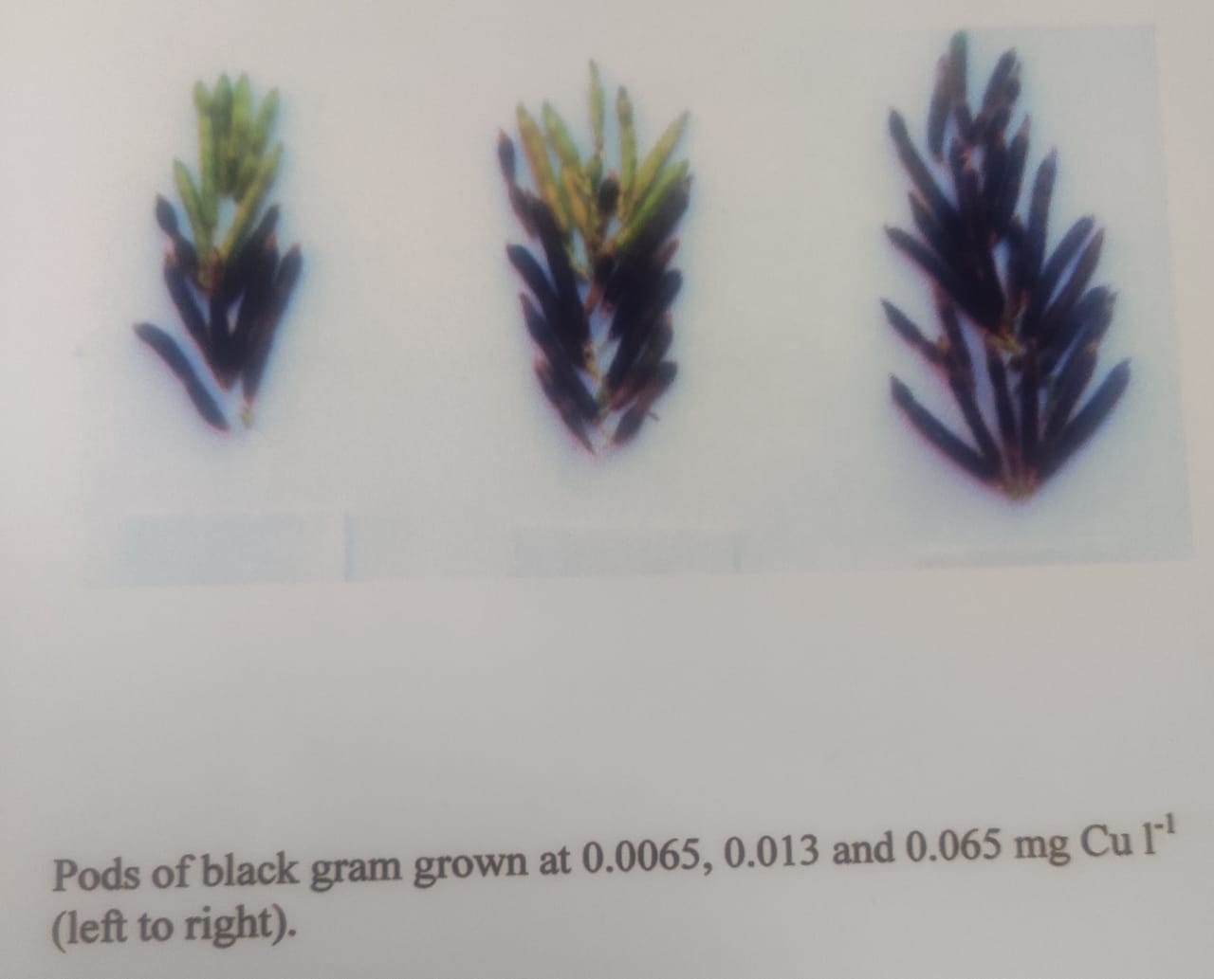
Total Dry Weight-At all stages of determinations (day 24. 60. 74), the decrease in total dry weight was 29-30 percent at 0.0065mg cul⁻¹ and 14-17 percent at 0.013mg cul⁻¹ as compared to that of control.
Copper Concentration-The concentration of copper in both leaves and seeds increased with increase in copper supply from 0.0065 to 0.065mg l⁻¹.The copper concentration in leaf was highest at day 24 than that of day 60 and 74. At day 60 , the copper concentration at deficient copper was higher in younger leaves than that of older leaves .
Morphological Changes-The pollen producing capacity of anthers was maximum at 0.065mg cul⁻¹and compared to this it decreased in copper deficiency more at 0.0065 than 0.013mg cul⁻¹. When the mature pollens were germinated in artificial medium the tube length was also decreased at deficient copper.
Pollen Grains- The pollen grains obtained from control(0.065mg cul⁻¹showed comparatively much higher viability than that of cu deficient (0.0065mg cul⁻¹) flowers. Pollens were dimorphic, the smaller ones were vacuolated, less stained and non-viable, whereas larger ones were viable. The pollen grains from both copper deficient and control were grown in artificial medium and it was found that germination occurred in both the conditions. However, the non-viable pollens formed in copper deficiency failed to germinate. The observation showed that 30-35 percent pollen grains were viable in copper deficiency as compared to 61 percent at normal.
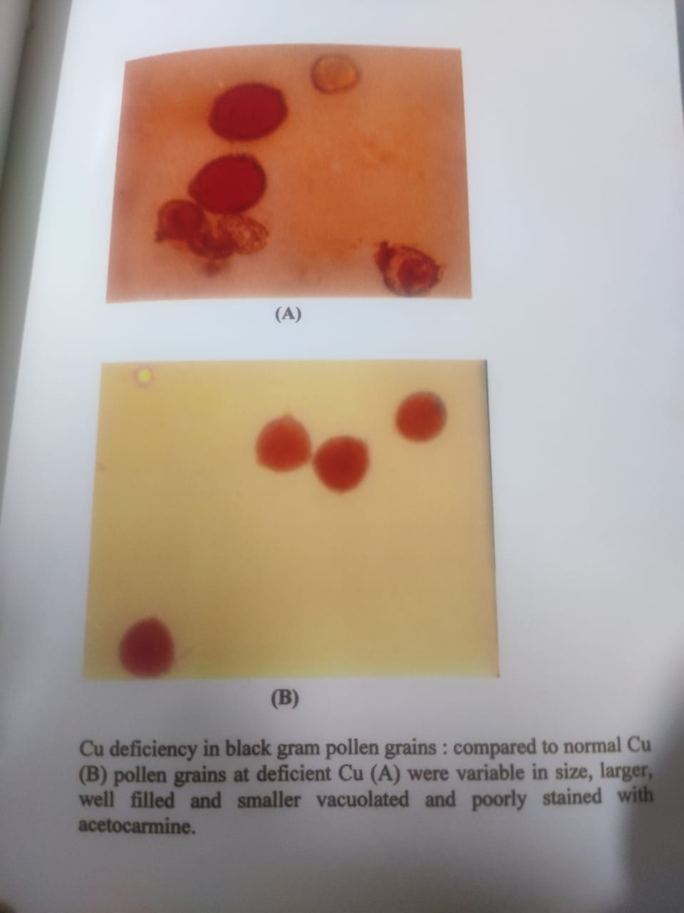
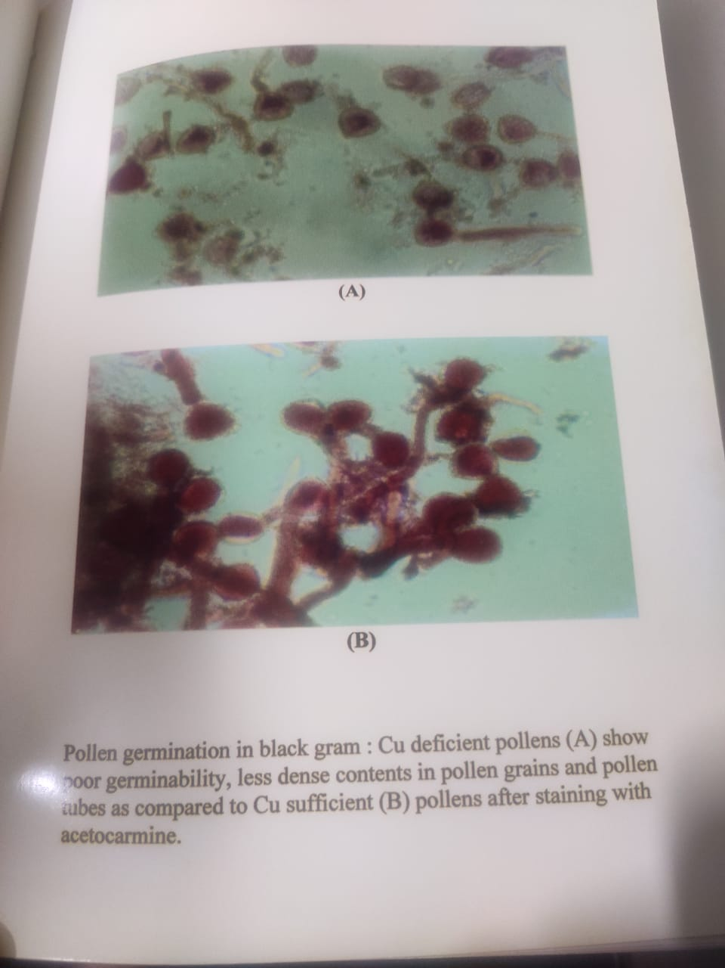
Stigma and Style-The esterase activity was studied in stigma under control as well as in copper deficient condition. It was found that esterase activity was much higher in stigma of control(0.065mg cul⁻¹) flower as compared to that of copper deficient (0.0065mg cul⁻¹) flower. The pollen grains sticked to stigma surface also showed esterase activity.
The whole mount of ovule after clearing with NaOH and staining with aniline blue , showed that phenolic compounds were localized more in micropylar region of the outer integument on the placental side in copper deficient material, whereas in control this type of deposition was not observed . In this region of integument the cell division was more frequent in control (0.065mg cul⁻¹) as compared to deficient(0.0065mg cul⁻¹) copper.
BIOCHEMICAL CHANGES
Stamens-Compared to the control the activities of peroxidase acid phosphatase and alkaline phosphatases decreased in copper deficiency on protein basis . The decrease in enzyme activity was more pronounced at 0.0065 than 0.013mg cul⁻¹. On the basis of fresh weight the activity of peroxidase and alkaline phosphatase increased , whereas the activity of acid phosphatase was decreased at deficient copper(0.0065-0.013mg cul⁻¹)levels.
Stigma and Style-The specific activity of peroxidase , alkaline phosphatase and acid phosphatases decreased in copper deficient stigma and style as compared to control plants. The activity of these enzymes were depressed more at 0.0065 than 0.013mg cul⁻¹on protein basis. On fresh weight basis the activity of peroxidase increased ,whereas the activity of acid phosphatase and alkaline phosphatases decreased.
Ovary-The activity of acid phosphatase and peroxidase increased in cu deficient ovaries . Compared to that of control on fresh weight basis ,whereas on protein basis the activity of these enzymes was markedly decreased .
SOURCE AND SINK RELATIONSHIP
Carbohydrates and Nitrogen Fractions
Sugars-Compared to control, the concentration of sugars both reducing and non-reducing in leaves (source) as well as developing pods(sink) decreased at deficient copper at 0.0065mg cul^{-l} but remained almost unchanged or increased at 0.013mg cul^{-l}. A gradual decrease in ratio of reducing sugars in pods (sink) and leaves(source) with an increase in copper supply is indicative of lower synthesis and lesser incorporation of sugars in biosynthesis of starch at deficient copper.
In mature bud the concentration of sugars and phenols were increased with increase in copper levels i. e. from 0.0065-0.065mg cul⁻¹.
Starch-The decreased in starch concentration due to low copper was higher (82-85%) at 0,0065mg cul⁻¹ than 0.013mg cul⁻¹ (41-78%)in leaves and pods . In copper deficient seeds the decrease in starch content was 43-49% from that of the control.
Nitrogen-The concentration of soluble nitrogen compound(non-protein nitrogen)was decreased as compared to the control copper (0.065mg cul⁻¹) , it was less at 0.0065 than 0.013mg cul⁻¹ in both leaves(source) and developing pods (sink). At 0.0065mg cul⁻¹the total protein nitrogen was 66-79% while at 0.013mg cul⁻¹it was 40-42%. In copper deficient seeds non-protein content showed a decline from that of control. The decrease in total and protein nitrogen in seeds ranged from 30-32%at both deficient levels of copper.
The decreased pod leaf ratio of non-protein nitrogen and increased that of protein nitrogen at deficient copper indicates hampered translocation of soluble nitrogenous compounds from source to sink.
Phenols-The phenol concentration also showed a decrease in copper deficient levels and developing pods more at 0.013(39-48%) than 0.0065(30-44%)mg cul⁻¹. The decrease in total phenols of copper deficient seeds was 40-42% from that of the control.
Ovaries-Compared to control plants supplied with 0.065mg cul⁻¹, ovaries of mature buds at deficient copper(<0.065mg l⁻¹) showed accumulation of sugars and phenols was more pronounced at the lower copper level i. e. 0.0065mg l⁻¹than 0.013mg cu l⁻¹.
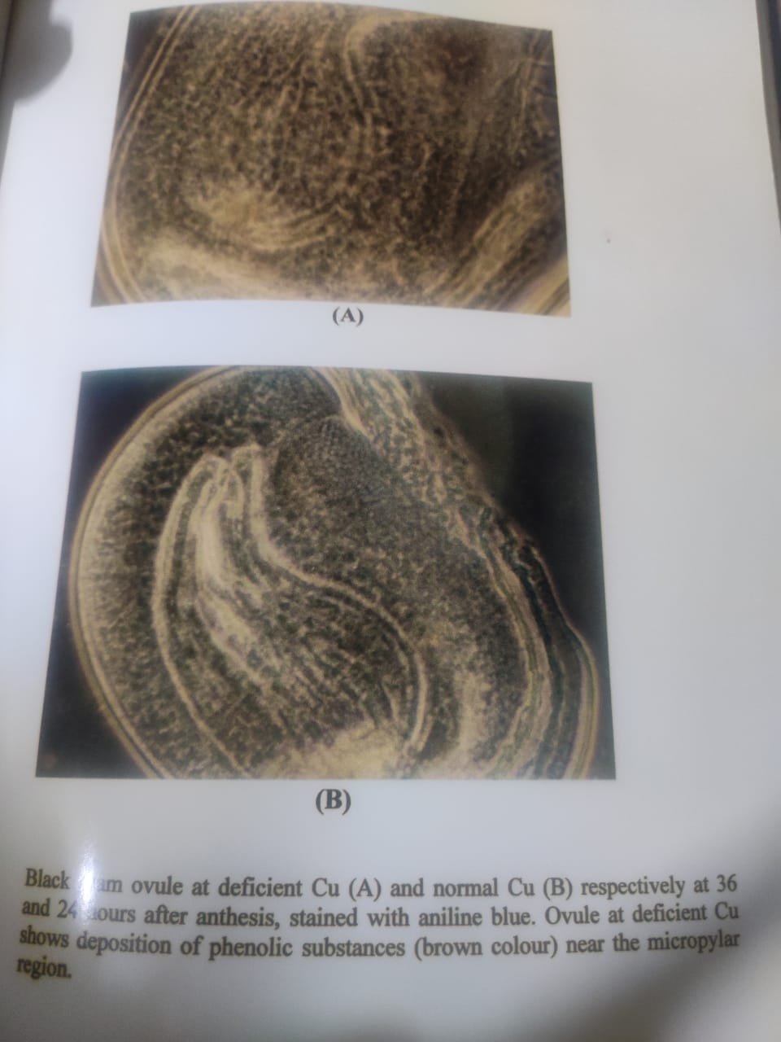
SEED RESERVES
Seeds- In mature seeds total protein content decreased by 52-54% at deficient copper. The decrease in protein content in copper deficient black gram seeds was maximum in albumins and vicilins and minimum in legumins.
Amino Acids-The concentration of lysine, methionine and cysteine with an increase in copper supply from 0.0065 to 0.065mg cul⁻¹.
CONCLUSION-
Plants of black gram was grown in refined sand at deficient copper to see the ill effects of low copper not only on vegetative characters but also on reproductive phase. The black gram showed , that young leaves subjected to severe copper deficiency became discoloured and bleached , part of lamina failed to unrolled and turned necrotic. In black gram , the symptoms of copper deficiency appeared first on young leaves. Severe copper deficiency in legumes has been described to result in low grain yield , induced wilting , increased leaf diffusive resistance and at the same time increased leaf water potencial , hence there is decrease in dry weight of plants, pod number, pod weight , seed number, seed weight , number of buds and flowers decreased with deficient copper levels It shows that a much greater copper need not only for fruit formation but higher demand for copper by pollens and ovaries of flowers before fertilization, the adequate copper is important and essential during fertilization for final seed yield . In copper deficient black gram , (lower pod and seed yield might be the result of poor fertilization due to impaired development of generative organs
The decline in biomass in low copper in legumes might reflect sink limitations and which in turn might be responsible for poor development of reproductive parts . The depression in growth, biomass and economic yield in copper deficient legumes is due to disturbed carbohydrate and protein metabolism in such conditions . The reduction in seed number and weight in low copper might be due to less lignifications of tapetum resulting in lower supply of nutrients and reduced formation of starch. As a consequence of which deformed and under developed seeds were finally produced In copper deficient seeds, the concentrations of total sugars, starch and protein decreased significantly . Lowered synthesis of soluble carbohydrates and low proteins in copper deficiency are responsible for lower economic yield and poor quality of its seeds. A gradual decrease in ratio of reducing sugars and increase in non-reducing sugars in pods(sink) and leaves(source) with an increase in copper supply is indicative of lower synthesis and lesser incorporation of sugars in biosynthesis of starch . TThis might be due to high acid invertase activity in the apoplasm , the phloem loading of sucrose is drastically decreased and sucrose and other carbohydrates accumulate in the leaves as has been observed in black gram under low copper conditions.
The decreased pod /leaf ratio of non-protein nitrogen and increased that of protein nitrogen at deficient copper indicates hampered translocation of soluble nitrogenous compounds from source to sink, has been observed in the legume(black gram) here. The biomas and economic yield of black gram was reduced by low copper . Reduced pod and seed production in the plants might be the consequence of copper deficiency and is probably associated with depressed floral initiation and diminished production of viable pollens as has been reported in various plant species . Accumulation of phenolic compounds in low copper condition as observed in black gram has also been suggested as one of the cause of inhibition of flowering . Also the accumulation of phenols might be due to decreased phenolase activity as has been reported earlier.
The decrease in pod and seed formation in the legumes corroborate the finding of Nautiyal et al. and might be attributed to the lower sink activity as a result of aborted flowers in addition to male sterility . The reduced seed weight in copper deficiency might be due to decline in polyphenol oxidase activity , indirectly responsible for delay in flowering.
Low copper in black gram resulted in poor seed quality , Under stress condition pod and seed number , their size and weight , sugars(reducing and non-reducing), starch protein , methionine, lysine and cystiene and protein nitrogen were lowered and that of non-protein nitrogen and phenols increased in seeds. The lower content of reserves (sugars and starch) reflects the poor quality of seeds, which may account for increased activity of proteinase and decrease in that of invertase and starch phosphorylase at the time of filling as has been observed in legume. The decrease in concentration of proteins might be the consequence of the accumulation of non-protein nitrogen in seeds of the legumes under cu stress conditions. These results also substantiate the disturbed protein metabolism in copper deficiency.
The quality of black gram seeds deteriorated in copper deficiency as the seed proteins were low in lysine and methionine and thereafter not good for human consumption.
REFERENCES
Agarwal, S.C,Sharma,P.N, Chatterjee,C.,and Sharma, C.P 1980. Copper deficiency induced changes in wheat anther. Proc.Indian.Nat.Sci.Acad., part B, 466:172-176.
Agarwal, S.C,Sharma,C.P.1976.Pot and sand culture techniquefor the study of mineral nutrient element deficiencies underIndian condition. Geophytology 6:356-367
Agarwal, S.C,Sharma,C.P.1980, Chatterjee,C.,and Sharma, C.P 1980. Copper deficiency induced changes in wheat anther. Proc.Indian.Nat.Sci.Acad., part B, 46:172-176.
Agarwal, S.C, Chatterjee,C.,and Sharma, C.P and Nautiyal,N 1985. Copper nutrition of sugarbeet.J.Exp.Bot.36:881-888.
Agarwal, S.C,., Nautiyal,N, and Sharma, C.P and Chatterjee,C 1993.Studies on copper deficiency in mango,guava and jackfruit.Indian J.Hort.48:192-200.
Baranov,V.I 1980.Combined effects of the trace elements –copper and iron,phenols,amino acids and their oxidation products on the decomposition indoleacetic acid and growth processes.Mikroleum Okruzhayushchei Srede,107-111.
Brown,J.C. and Clark ,R.B.1977.Copper as essential to wheat production.Plant.Soil,48:509-523.
Bruce,D.and Bewley,J.D.2000 Soluble sugar content of white spruce (Picea glauca) seeds during and after germination.Physiol.Plant.110:1-12
Chesire,M.V.,Bick,w.,Dekock,P.C and Inkson,R.H.E 1982.The effect of copper and nitrogen on the amino acid composition of cat straw.Plant Soil,66:139-147.
Dell,B.1981.Male sterility and anther wall structure in copper-deficient plants.Ann.Bot.48:599-608
Fathi, A.A. andEI-Shahed, A.A. 2000. Response of tolerant and wild strains of Scenedesmus biguja to copper, Biol. Plant. 43:99-103.
Graham, R.D. 1980. The distribution of copper and soluble carbohydrates in wheat plants grown at high and low levels of copper supply. Z.Pflanzenernahr Bodenk. 143:161-169’
Geaham,R.D.1986. Induction of male sterility in wheat using organic ligands with high specificity for binding copper. Euphytica35:621-629.
Graham, R.D. and Nambiar, E.K.S. 1981. Advances in research on copper deficiency in cereals. Aust. J.Agric.Res. 32:1009-1037.
Graves, C. J., Adams, P. and Winsor, G. W. 1979. Some effects of copper deficiency on the flowering copper status and phenolase activity of different cultivars of Chrysanthemum morifolium. J. Sci. Food Agric.30:751-758.
Hewitt, E. J. 1966. Sand and Water culture method used in the study of plant nutrition. Rev. 2nded. Common W. Agric. Bureaux, England.
Hussain, S, Noor, .R,and Iqbal, J. 2001. Studies on the inactivation of soluble and immobilized papain by the ascorbic acid –cu²⁺system :Amodel to propose the effect of free radicals on membrane bound enzymes in vivo. Biotech. Appl. Biochem. 34:205-209.
Isave,B.M. and Rustamov,K.1975.Effects of the trace element copperon some physiological and biochemical processes and productivity of cotton.ab.Biol.Zh.19:27-30
Jewell,,A.W.,alloway,B.J. and Murray,B.G. 1985.The effect of copper deficiency o pollen formation and yield in cereals.J.Sci.Food Agric.36:53-538
Lidon,F.C. and Henriques,F.S.1993.Copper mediated inhibition of protein synthesis in rice rice shoots.J.Plant.Nutr.169:1619-1630
Marschner,H. 1995.Mineral Nutrition of Higher Plants(2nd edn.),Academic Press Limited, London
Nautiyal,N.,Chaterjee,C. and Sharma,C.P.1999a. Copper stress affects grain filling in rice.Commun.Soil Sci.Plant anal.30:1625-1632
Nautiyal,N, and Sharma, C.P and Chatterjee,C. 1999a. Role of copper in improving the seed quality of sunflower (Helianthus annuus). Ind.J.Agric Sci.69:210-213.
Sommer,A.L.1931. Copper as an essential for plant growth. Plant Physiol. 6:339-345.

Name-Dr. Soni Singh
Affiliation -B.S.N.V.P.G.College
Charbagh, Lucknow
Address-Shri, Infratech And Associates, Kanpur Road,
Gauri Bazar , Sarojini Nagar
Kanpur Road, Lucknow, Uttar Pradesh(226008)
Email id-0522soni4444@gmail. Com
Contact-no.-6386370378
The theme is –
- Action@75
- Field of science and technology

