Community analysis of Nematodes, Modeling of population dynamics in relation with crop performance, data interpretation and system simulation
Manisha*, Ramavath Abhi, Vinit Kumar Meena¹ and Santosh K. Meena^{2**}
Research Scholar, Department of Nematology, MPUAT, Udaipur
¹Assistant Professor, Department of Agriculture, Vivekananda Global University, Jaipur
^{**2}Senior Research Fellow, SKN College of Agriculture, SKNAU, Jobner

Corresponding Author’s E-mail: *manishameena4361@gmail.com, **msantosh674@gmail.com,

ABSTRACT

Analyzing the community of plant nematodes holds significant importance when evaluating their potential to cause disease in a specific region and identifying areas where nematode attacks are prevalent. The communities of soil nematodes offer valuable and distinct insights into various soil processes. Due to the year-round activity of most nematodes in the soil, they can offer a comprehensive measure of the overall biological and functional health of the soil. Unlike other microbial groups in the soil, collecting representative samples of soil nematode communities is comparatively straightforward. However, the existing information on nematode ecology has primarily relied on surveys and observations, with a consistent emphasis on detailed taxonomic examinations of nematode communities.

COMMUNITY ANALYSIS OF NEMATODE

Terminologies to be acquainted

Population: a group of organisms of the same species occupying a particular area.

Community: an assemblage of population living in area/habitat.

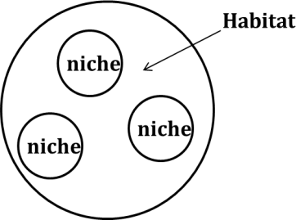
In addition to their morphological differences, nematodes can be categorized into different trophic groups according to their feeding habits. These groups include herbivores (ecto-, endo-, sedentary/migratory, semi-endo), fungivores, bacterivores, omnivores, predators, and substrate ingestors, among others. As the availability of various food sources is influenced by the ecological environment within microcosms, the proportional representation of different functional groups or nematode taxa offers a way to estimate the biodiversity of nematodes in a specific habitat.

Numerical analysis of nematode community structure

Nematode relative abundance and distribution are typically assessed through metrics such as absolute and relative frequencies, densities, and importance values assigned to various encountered species.

Absolute frequency:

= (No. of samples containing the species/No. of samples collected) × 100

Relative frequency:

= (frequency of the species/sum of frequency of all spp. present in the samples) × 100

Absolute density:

= (No. of specimens of the species in the sample/volume or mass of the sample)

Relative density:

= (No. of specimens of the species/total number of individuals of all spp.) × 100

Biomass:

= a²b/16 × 10⁶ µg

a = average greatest body width of the particular species in µm;

b = average body length in µm)

Prominence value :

= Relative density × (Relative frequency)^{0.5}

Importance value :

= Relative frequency + Relative density + Relative biomass.
Modeling of population dynamics in relation with crop performance
Nematode damage :-
Nematodes, hosts, and the environment constitute the three interconnected factors that collectively determine the degree of yield loss in soils afflicted by infestations. Grasping the mechanisms and fundamental principles governing these interactive relationships is fundamental for projecting yield decreases based on assessments of pre-planting nematode population densities (Pi).
Damage models :
When constructing models to understand the harm inflicted on plants by root-feeding nematodes, several fundamental principles come into play. These include:
- Damage is proportional to the nematode population density.
- The degree of damage is influenced by environmental factors.
The harvested yield is influenced by three primary factors: the quantity of light captured by the crop, the efficiency of converting intercepted light into dry matter, and the distribution of that dry matter into harvested and non-harvested yield components. In certain crops, notable fluctuations in moisture content can also impact the eventual yield outcome. While, the aforementioned principles can be succinctly summarized, their practical application is more intricate. The extent of damage might appear to correlate with the density of nematode populations, but this assertion is subject to various nuances. Typically, the connection follows a curved trajectory, where higher nematode numbers lead to proportionally reduced effects. Some indications suggest that at low densities, the host plant could initiate repairs to the damage, and in some instances, growth might even experience a mild boost.
In 1965, Seinhorst introduced the term "tolerance limit" (T) to describe the nematode population density (Pi) at which observable damage first emerges. Likewise, at extremely elevated Pi values, the escalation in nematode numbers might not continue to decrease dry matter productivity. Seinhorst referred to this as the "minimum yield" (m). Several factors could contribute to the occurrence of m; growth might transpire before the onset or after the cessation of nematode attack, and a substantial biomass could be introduced, such as potato tubers. However, m pertains to the overall dry matter, and due to impacts on distribution, the harvest worth of m could be higher or lower than that for the complete dry matter.
- Population Dynamics:
Population dynamics encompasses the examination of variations in nematode population size and composition over time. Understanding population dynamics is crucial for forecasting nematode population expansion and foreseeing potential nematode-induced damage. During a growing season, nematodes do not readily migrate between locations, allowing us to predict the ultimate nematode population size (Pf) from the initial population size (Pi) within a site, without complications arising from migration. The determination of Pf can occur at crop harvest or at specific time intervals.
Several approaches rely on classical models borrowed from population ecology, adapted for nematology. Simulation models, some rooted in classical population models, are employed to update population estimates through successive time intervals, varying from seconds to years depending on the context.
Yield losses are affected by the pathogenicity of the nematode species, the population density of nematodes at planting, the host's susceptibility and tolerance, and a spectrum of environmental factors. Nematode population dynamics are also density-dependent and subject to the influences of host growth, the reproductive capacity of the species, and diverse environmental elements. Consequently, modeling nematode population dynamics is a highly intricate field. While solid field data is necessary, challenges arise due to the interplay of factors like biological control agents, variations in host susceptibility, environmental conditions, and errors in measuring initial population densities. This complexity might make it exceedingly difficult to reliably predict the multiplication rates of most nematodes, particularly those undergoing multiple generations per season.
2 Classical Models
A. Theoretical Models :- Relatively simple classical models have been used to describe population growth for a variety of organisms, and these are applicable to nematode populations as well.
- Exponential growth
- Logistic growth
- Exponential decline
- Exponential growth :- Exponential growth, which is independent of population size, is a special case that applies only when environmental conditions are optimal and the food supply is unlimited. Under these conditions
Pf = Pi e"
Where, Pf= final population size after a specified time interval, Pi= initial population size. = the time interval between Pi and Pf. r= the intrinsic rate of increase of the population (a constant), and e= the natural logarithm base. According to this model, population size increases exponentially over time. An equivalent form of
Pf = In Pi + n
Note that if In Pf is plotted against In Pi, the graph is linear for a constant time interval. While the assumption of an unlimited food source is unrealistic, a large root system is an almost limitless resource to a single microscopic nematode. Therefore, low nematode numbers in highly favorable biotic and abiotic environments may increase exponentially, as observed on several occasions.

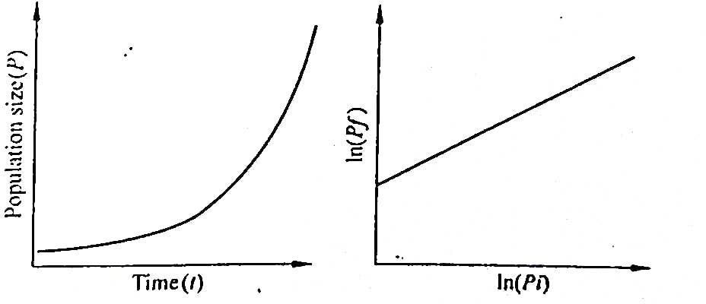
Exponential growth. (A) Increase in population size over time. (B) Relationship between Pf and Pi.
Life tables can be most easily constructed and used if the population can be divided into cohorts, or groups of individuals of similar age. Therefore this approach may be more useful with nematodes that deposit large numbers of t eggs at once and have synchronized generations, rather than with nematodes. that have overlapping generations and deposit a few eggs at a time over several weeks.
- Logistic Growth:-
In reality, food sources become limited as populations grow, and so the logistic growth model, used to describe density-dependent population growth. is often applied to nematode population growth (McSorley, 1998a; Seinhorst, 1966). According to the logistic model:
dp/dr = rp E-P/E
Where, P population size, dP/dr = change in population density with time (i.e. growth rate of the population), r= intrinsic rate of increase, and E equilibrium density.
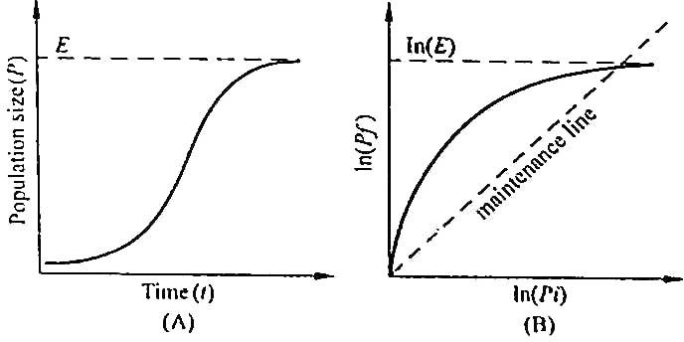
(A) Increase in population size over time. E = equilibrium density. (B) Relationship between Pf and Pi, shape varies with host. Pf Pi on the maintenance line.
c) Exponential decline :
Although the previous models are descriptive of population growth, nematode populations can be expected to decline on non host crops, during clean fallow, or during winter. In these instances, an exponential decline equation may be appropriate
Pf = a e ^{bt}.
Where, Pf population size, = time, and a and b are constant, for a particular set of conditions, with b< 0. Population size decreases over time.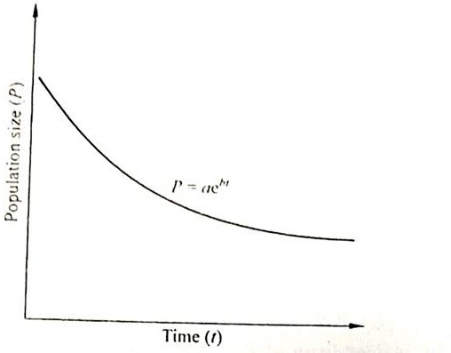
Figure : Exponential decline of population size over time, with b <0.

- Application of classical models :-
- Critical point models relating pf and pi
- Simulation models
- Design of cropping system
- Critical point models relating pf and pi:-
Critical point models are characterized by their ability to predict Pf based on an initial Pi estimation (Ferris, 1981). Relationships like the one depicted are fundamental for estimating Pf from Pi, specifically tailored to certain nematodes on particular crops. When Pi values are high, populations are inclined to reach a point termed "E," and at exceedingly high nematode densities, root damage could become so extensive that maintaining point E becomes unattainable. Nevertheless, in the majority of cases, the connection between Pf and Pi at lower to moderate Pi values proves particularly valuable for assessing the status of plant hosts and the potential for population escalation in real-world field conditions.
b) Simulation model :-
Simulation models utilize iterative algorithms to predict conditions at various points in a chronological sequence. These time intervals can span from momentary instances to multiple years. Consequently, critical point models integrated into algorithms for forecasting nematode population changes throughout a multi-year crop rotation cycle, as outlined below, constitute integral elements of simulation models. Notably, modeling shorter time intervals compared to the duration between successive crops offers the distinct advantage of incorporating various factors known to impact populations. In theory, a model could simulate the effects of temperature, soil moisture, soil oxygen, root growth, and more.
Simulation models serve two main purposes: comprehending nematode biology and identifying areas where management interventions are viable. By analyzing projections from a temperature-driven model depicting the development of Heterodera schachtii populations, uncertainties regarding the influences of specific physical factors on root and nematode development, the distribution of nematodes and roots within the soil profile, egg hatching and survival rates in relation to their cyst position, and nematode movement between different soil layers come to light.
c) Design of cropping system :-
- If models exist for forecasting Pf from Pi for a specific nematode on a particular crop, it's important to recognize that the projected Pf at the harvest of that crop can serve as the Pi for an immediately following crop planting. This way, nematode population levels across a sequence of crops can be interconnected and modeled over time. This approach proves useful in designing cropping systems and sequences that optimize nematode management. For instance, it has facilitated a convenient way to assess the impacts of different three-year sequences involving maize (Zea mays), resistant soybean (Glycine max), and susceptible soybean on Meloidogyne incognita populations (Kinloch, 1986). Similarly, this approach has been applied to studying the effects of cotton (Gossypium hirsutum) and soybean on Hoplolaimus columbus populations.
- Issues in population dynamics:-
- Sample variability and forecasting
- Population dynamics and pest management strategies
- Population dynamics and sustainable agriculture
- Toward sustainable management : potato cyst nematode
Population predictions can originate from various sources, including simulation models, classical models, critical point Pf/Pi models, or even be inferred directly from data obtained in prior experiments. Irrespective of the origin of these nematode population estimates, several crucial factors impact their accuracy and practical applicability.
- Sample variability and forecasting :-
Population dynamics models and nematode forecasts typically rely on an initial Pi estimate, acquired through field sampling. Unfortunately, nematode populations in the field often exhibit irregular horizontal dispersion, leading to challenges in sampling and consequently resulting in a notable degree of error or imprecision in Pi estimates.
b) Population dynamics and pest management strategies :-
The logistic model of population growth offers a fundamental framework to analyze the impact of pest management strategies and tactics as time progresses. For instance, consider a scenario where a proliferating nematode population receives treatment with a nematicide at a specific time point. In this case, a swift reduction in population size could be anticipated.
c). Population dynamics and sustainable agriculture :-
Sustainable agriculture is a dynamic concept aimed at sustaining adequate food production while minimizing harm to the environment and depletion of resources. It achieves this by cultivating techniques that curtail improper or excessive utilization of agricultural resources. The application of these principles to pest control is referred to as integrated pest management (IPM). In simple terms, IPM involves:
- Evaluating pest population densities and deciding whether these densities must be lowered below an economically viable threshold.
- Implementing the required alterations using the most suitable available tactics.
- Persistently innovating new tactics that align with economic and environmental prerequisites.
d) Toward sustainable management : potato cyst nematode :-
Nematode management within the context of potato cultivation offers notable instances of the competing concerns inherent in sustainable agriculture and the strategic development of integrated pest management (IPM). In the United Kingdom, conventional crop rotations involving potatoes and non-host crops allowed potatoes to be cultivated once every eight years, effectively maintaining nematode population densities below harmful levels. While crop rotation is a highly effective management approach, the available agricultural land is inadequate to sustain sufficient potato production solely through rotation.
As a result, growers have opted to shorten the conventional rotations by incorporating additional management tactics, including the use of nematicides, resistant potato varieties, and trap crops. This integration of multiple tactics has propelled a greater reliance on modeling, aiding in the creation of economically viable cropping systems. Moreover, recent efforts have focused on utilizing modeling to diminish the environmental risks associated with nematicide overuse. This illustrates how the principles of sustainable agriculture and IPM necessitate strategic approaches to balance productivity and environmental stewardship in complex agricultural systems like potato cultivation.
References :-
Seinhorst, J.W. 1965. The relation between nematode density and damage to plants. Nematologica, 11:137-154.
Seinhorst, J.W. 1966. The relationship between population increase and population density in plant parasitic nematodes. Introduction and migratory nematodes. Nematologica 12: 157-169.
Ferris 1985. Density-dependent nematode seasonal multiplication rates and overwinter survivorship: a critical point model. Journal of Nematology, 17(2): 93-100.

