WONDER OF ARTIFICIAL INTELLIGENCE
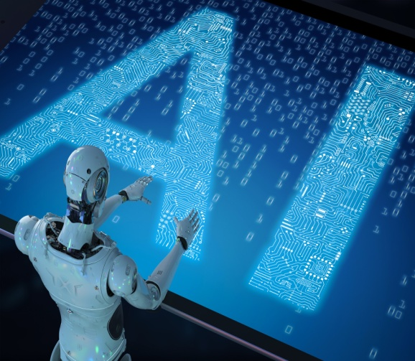
Artificial Intelligence (AI) is a term that we use often, but most of us are unaware of what it is and what AI is capable of. Artificial Intelligence is considered as a machine’s ability to solve problems that humans perform using natural intelligence. Applications in our daily life are numerous like Alexa, OTT platforms, Amazon etc. Artificial Intelligence is becoming quite natural these days. Nearly 77 per cent of today’s devices use AI technology in one form or other. Machine learning (ML), Deep learning and Natural language processing (NLP) are the major technologies that power AI. Machine learning is the process by which machines learn to perform better, make predictions and decisions based on training data, human interactions and practice. Deep learning is a more advanced kind of machine learning where it learns through presentation. Here all data need to be structured. Natural language processing (NLP) is a linguistic tool in computer science that aids in human computer interactions. NLP enables machines to process and interpret natural human language. NLP enables translate human language into computer inputs.

The latest marvel of AI is “ChatGPT”, which cliked off a wave of interest in AI . Chatbot is a conversational AI or simply, an Artificial Intelligence program that can chat with you in the digital format of your choice, as text or voice-based applications ready to revolutionize the digital interactions .We just need to chat with a bot to get information on any topic or book a ticket, assistance, help in business, buy a book and other daily life support. They are 'programs' which help to ease and reduce work in the 'digital' world. Chatbots have marked their presence in healthcare, travel advice, e-commerce transactions etc. Movie studio giants like Disney and Marvel entertain their fans with their favorite characters.
ChatGPT was launched on 30th November, 2022 by San Francisco based AI and Research Company called Open AI. The company was founded by Elon Musk and has funding from Microsoft as well. ChatGPT has a wide variety of applications. Some of them are:
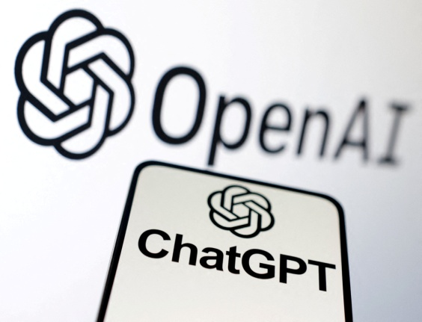
- Automated customer service
- Online shopping
- Personalized communication
- Product recommendations
- Virtual assistance
- Corporate operations
- Content generation
- Translation from one language to another and so.

When Google search lists a web of sites that can provide us the most relevant answers to our query; ChatGPT on the other hand gives us to- the - point answers with a natural flow. So we can get readymade answers from ChatGPT.
There are limitations of ChatGPT. The main limitation is that ChatGPT is not a search engine. It relies on the information from its trained data to generate response. It may not provide in-depth information on a topic. Also, it may sometimes fail to understand the context, so there are chances for errors, accuracy, relevance and timeliness of the responses. Similarly, if the ChatGPT data is biased, the bots’ responses will be biased too.
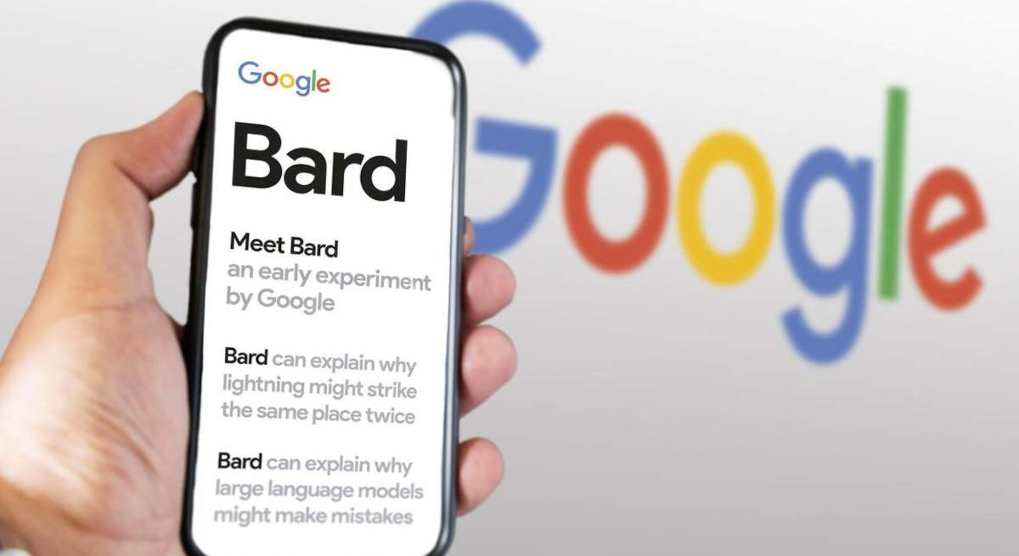
ChatGPT was viewed as a revolutionary technology potent enough to shift the scepter of Google search. On February 6, 2023, Google announced the launch of “Google Bard”. Bard is a Google chatbot, powered by the LaMDA large language model. This AI accepts prompts and performs text-based tasks. Bard also has certain features of Google Search. It summarizes information, provides links to further information. Bard was also suspected for errors right from the time of its launch. ELIZA, the first ever chatbots was developed by MIT professor Joseph Weizenbaum in the 1960s. ELIZA could interact with people like a psychotherapist.

Types of Artificial Intelligence
Artificial Intelligence is broadly divided into weak and strong. Weak AI also known as Narrow AI is designed for and trained on a specific type of task. Examples are Alexa and Siri. The term weak AI does not mean that the computer program is inferior but it is too specific and lacks versatility in function.

Strong AI is known as artificial general intelligence. It has cognitive abilities to perform unfamiliar tasks and commands. It is said to develop a human-like consciousness rather than simulate it. Visual perception, speech recognition, decision making, translations between languages etc are examples of strong AI.

Applications of Artificial Intelligence
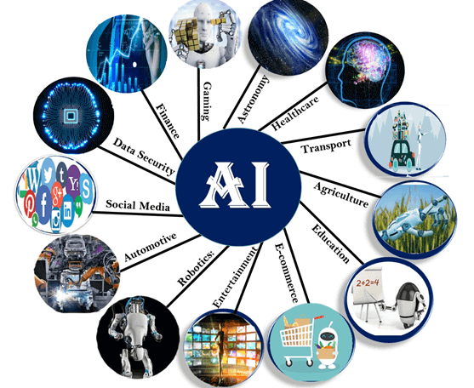

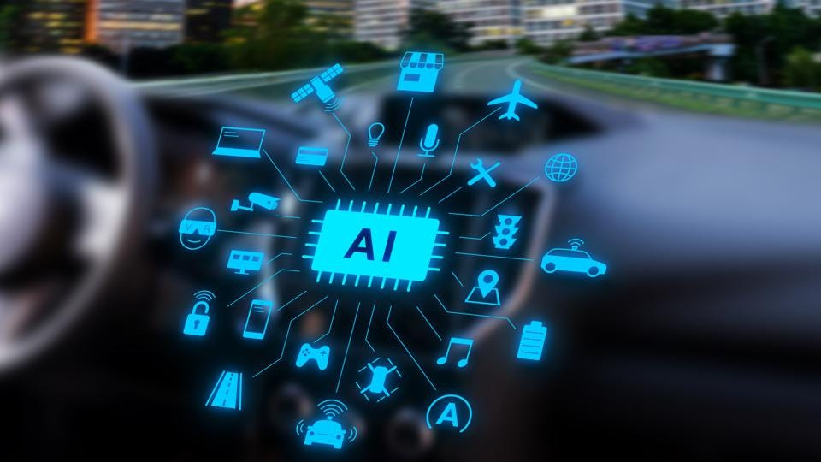
Self Driving Cars: Self driving AI cars are one of the topics of discussion among AI enthusiasts. These cards are completely autonomous and can co-ordinate without human interference or any other extra assistance. Autonomous vehicles are trained on deep convolution neural networks with a large set of training parameters. Tesla Inc., led by Elon Musk is the fore-runner in this technology. These cars installed with AI technologies will be future assets as it can avoid accidents caused by human errors completely. Electric cars will also minimize air pollution.
AI in Banking: Banks are largely employing artificial intelligence for improved customer services. Intelligent algorithms have made it possible to open account, make deposits or transfer money from anywhere with AI powered security and privacy controls. Many banks resort to AI Chatbots to better handle customer interactions. AI assisted banking system generates an alert to verify transactions. The notifications regarding the services and products of the banks are also applications of AI.
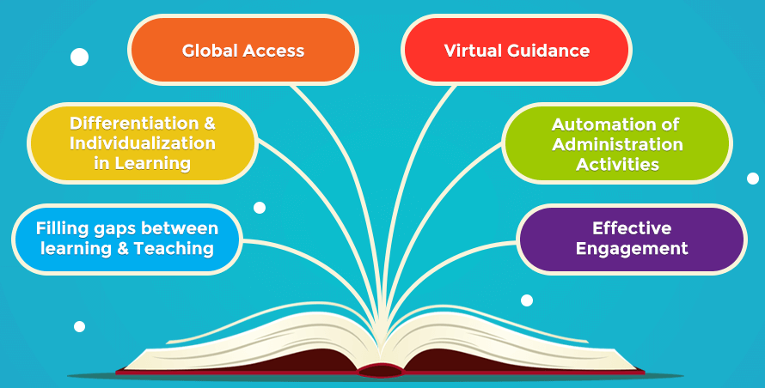
AI in Education Sector: There is a surge of AI in the field of education. It increases productivity of faculty and makes them available for teaching and mentoring. AI has revolutionized education by creating smart content, systemized learning pattern through audio and video summaries, integrated lesson plans and test sessions. Voice assistance is yet another gift from AI. It designs hyper- personalized lessons plans, study guides, reminders, flash notes, revisions etc based on our needs and aptitudes.
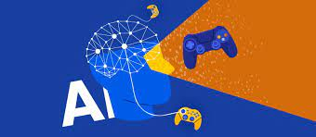
AI and Gaming Platforms: Advancement in AI has taken gaming very close to realistic perfections. Non playable characters and other game characters give more realistic performances in high- end AI powered games. The recently released RTX 3080 graphics card by NVIDIA took the gaming terrain by storm for its superior artistry and incredible performance. The advancements in the field of AI are clearly reflected in the tremendous evolution of all sorts of gaming platforms.
AI and Smartphones: The smartphones has artificial intelligence integrated into it. The voice assistants, smart photo functions, face lock system, computer vision, deep learning are all AI magic. The smart phone helps you send messages, track locations via Global Positioning System (GPS), do online transactions, track devices, Bluetooth systems, social media access, web browsing and what not with the aid of AI. The Smartphone is equipped with natural language processing and machine learning features. These features are Ai driven and provide enhanced efficiency, uniqueness and ease to the users. Tool like “Grammarly” is another example of artificial intelligence.
AI in Social Media: Instagram has customized machine learning algorithms that highlight your stories and posts, while ‘Explore’ page show quality content from the users, you do not follow. Facebook uses AI to track and serve the contents that generally interests you. Ai tools recognize your face in photos, recommends tag options, identifies visuals etc. It also helps to translate from different languages automatically. Twitter AI comes in very handy in fraud detection and removing hateful content. AI also recommends tweets that the users are most likely to enjoy, that usually catch their attention. LinkedIn relies on AI machine learning to predict suitable candidates for a practical job. AI also helps to probe and highlight candidates who are active on the job hunt in the respective area.
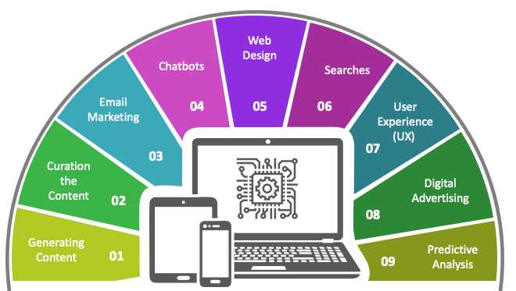
AI in Marketing: AI enables marketers to deliver highly targeted and personalized ads. AI provides users with real time personalization; helps edit and optimize marketing campaigns to fit market needs. AI helps to design content marketing suiting a brands style, prepares campagn reports and related data analysis easier.
AI in Tourism: Tour planning, finding affordable transportation, accommodation and making reservations were very difficult but ever since AI crept into tourism industry things are simplified nowadays. With chatbots we can get suggestions on ideal places of visit according to our interests, displays websites of travel and accommodation with options to reserve. AI has become the most trusted travel agent these days. There are AI applications that predict price patterns and alert travelers on best ticket rates and reservations. AI will guide us through our dream destinations.

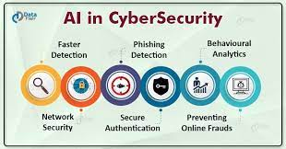
AI in Data Security: all information is getting digitalized nowadays. This helps storage and retrieval easier and accessible too. In today’s digital era, keeping the information confidential and secure is the greatest challenge! With cyber attacks and malware we depend on AI to effectively prevent data theft. AI driven security tools like Security Information and Event Management (SIEM) which can handle security threats in real time, User and Entity Behaviours Analytics (UEBA) which analyses patterns of legitimate access to detect suspicious behaviours, are extremely beneficial in protecting cyber security. SOAR (Security, Orchestration, Automation and Response) is yet another cyber security solution employed by organizations for both data collection and alert on low-level threats. As cyber attacks are becoming a common phenomenon, AI is coming up with sophisticated tools to tackle them .AI identifies unknown threats and provides the most effective security solutions for mapping and preventing unexpected threats from causing potential harms. AI assists in detecting buffer overflow. AI watches for any malware that has the potential to exploit these flaws. AI responds to threats by removing the infection, repairing the fault and takes care of the damage caused by the threat. AI continuously scans the system and gathers enough amounts of data to detect any unusual behaviour in the system.
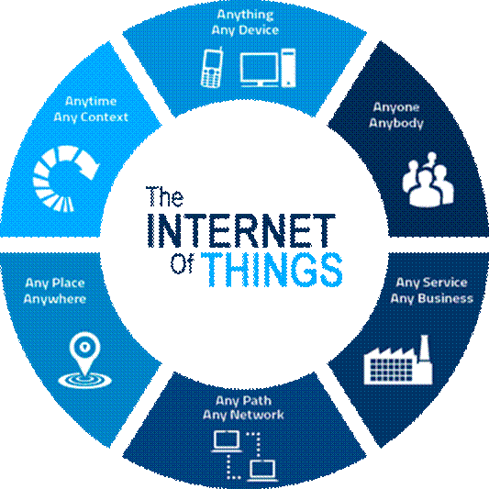
AI associated with Internet of Things: Internet of Thongs (IoT) denotes a network of devices equipped with implanted sensors, embedded software and necessary technologies to connect with other devices and exchange data over the internet. All IoT services undergo five basic steps- create, communicate, aggregate, analyze and act. AI teaches the IoT devices to learn from experience and practice to better respond to human stimuli and requirements. AI an IoT engaging in a symbiotic relationship can revolutionize business and industry.
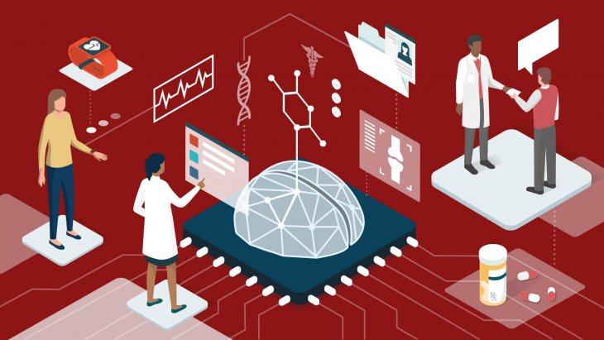
AI in Medical Field: By analyzing large amount of medical data, AI enables early detection of diseases. Drug discovery process has been boosting since AI has stepped into this field. AI helps to identify new targets for drug development by analyzing genetic data, and helps to predict the efficacy and toxicity of new drug developed; which accelerates the processes drug design, drug testing etc. Telemedicine became popular during COVID-19 pandemic and AI chatbots helps book appointments and triage patients. AI algorithms analyze the patient’s medical data for effective online virtual consultations. AI-powered remote monitoring systems are extremely advantageous for patients with chronic conditions. AI assisted digital healthcare system improve the patient’s access to healthcare, especially those who live in remote areas.
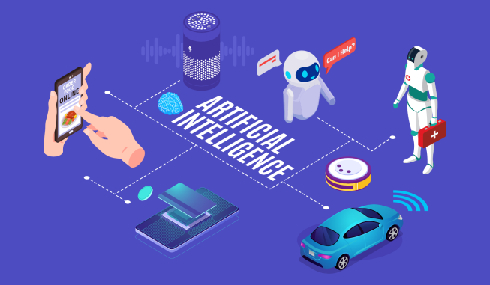
AI in daily life: AI is playing a significant role in the day- to-day interactions.
- Smart Virtual Assistants- Siri or Alexa or Google Assistant are daily used intelligent virtual assistants which we can’t do without. These AI powered tools enable us to perform tasks hands free.
- AI assisted Customer Service – Today firms are employing AI- powered chatbots for better customer services and relieving burden on customers care representatives. These chatbots have many applications like helping customers with bank inquiries, assisting in online shopping and delivery queries etc.
- Personalized E-commerce with AI – E- commerce websites employ AI algorithms to track customer behavior and preferences to render enhanced shopping experience. Ai can surprise us with shopping suggestions which are totally in tune with our interests.

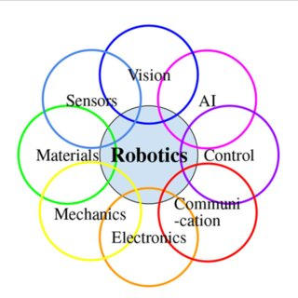
AI in Robots: Artificial intelligence intends to make robots intelligent and enable them to mimic the way human responds. AI bestows robots with the ability to learn, adapt and make decisions on their own.AI algorithms help robots to process data from their surroundings, interpret it and take action. These algorithms help the robot to ‘think’ and react without human input. The advantage of Ai powered robots are Minimal errors, increased productivity, improved safety, better quality, excellent assistance and so. Ai enabled robots make excellent assistance during surgery in medical field.

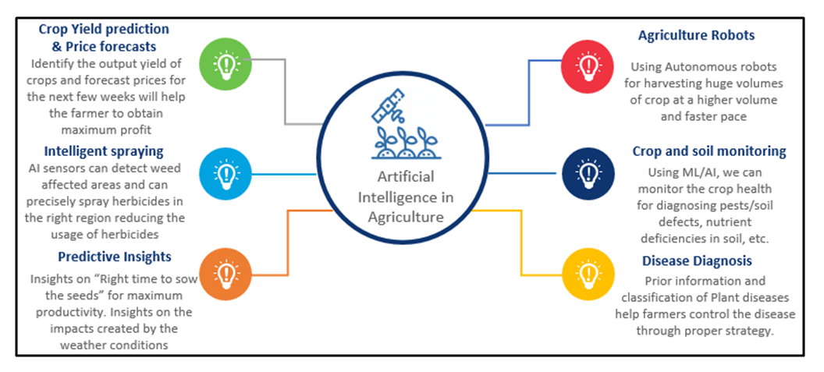
AI in Agriculture: Agricultural industry is benefitted from task-specific machines that run on AI algorithms. These robots have inbuilt lasers and cameras to detect weeds and are programmed to dispose them off. Ai powered robots can be trained to detect farm animal diseases, identify pests, crop infections etc. AI can help track and regulate food supply chain from production to delivery. AI–enabled robots can also be employed for food inspection to ensure safety and quality.

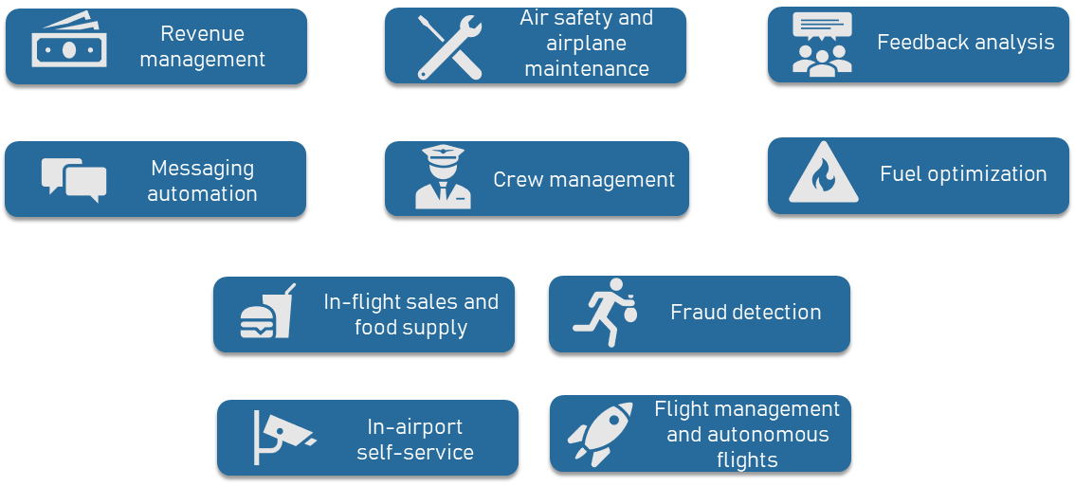
AI application in Aerospace: Ai enabled robots find great use in aircraft production .autonomous helicopters, air taxis, and passenger planes are being programmed to transport across various destinations with hardly any human involvement. Robotic arms are capable of assembling components with high precision, thus minimizing human errors and ensuring utmost safety. They give alerts on potential issues. AI-enabled robots are the best for space exploration as they are not affected by heat, cold or radiation as humans and can work extensively in space to gather information.
Threats of AI
In any new invention, there is always an element of unpredictability. There are several issues associated with the safety of AI. Experts are also speculating hypothetical issues that might spring in future. Real-life risks include things like consumer privacy, legal issues, AI bias, AI developing destructive behaviours, Ai being programmed for harm and so.

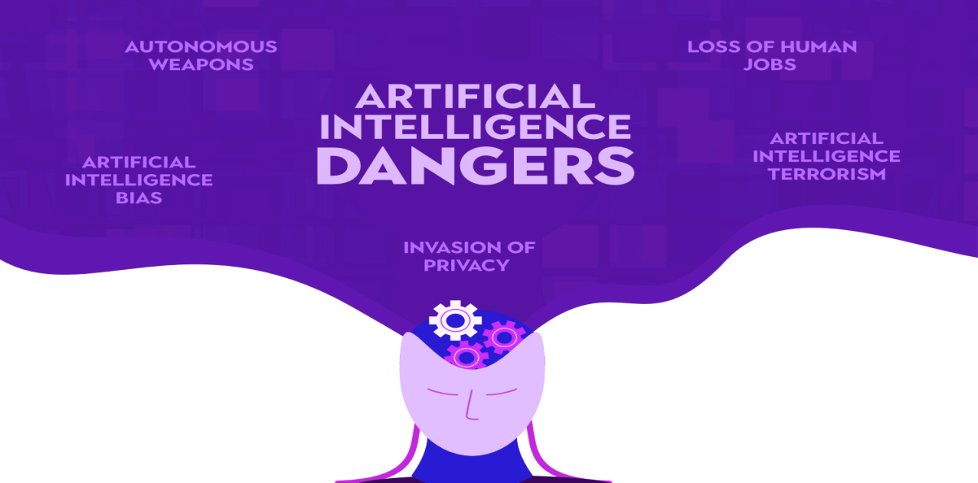

Data privacy is the foremost concern. AI could be subject to both data bias and societal bias. Data bias occurs when the data used to develop and train Ai is incomplete. Societal bias occurs when the assumptions and biases present in every day society creeps into Ai through the blind spots in programming. As AI is becoming more integral part of our daily life, it may influence the human though patterns, behaviours and expectations which cannot be neglected.

Everyday risks of AI are not threats but can be rectified when identified. Hypothetical threats are of great concern and experts are always on watch to keep Ai within its boundaries. A great possible risk is that someone can re-programme the AI to do something devastating.
Another concern is that AI is trained to be goal- oriented and experts worry that this would prompt it to adopt destructive behaviours in order to accomplish that goal.AI needs to be free of ambiguous and ambitious goals so as to align with human goals, which will be the greatest challenge for AI programmers in future.

Conclusion
The term Artificial Intelligence was first coined in 1956 by John McCarthy, who is known as the father of Artificial Intelligence .Alan Turing, who is also considered as father of artificial intelligence because he is credited for laying the groundwork for many concepts that foster AI today. June 23 marks the 111th birth anniversary of the luminary English mathematician and computer scientist whose paved way or the development of AI over the years.
The ability of AI to measure and improve performance on every input of training and real-world data places makes it distinguished among technologies. Artificial Intelligence will bring a huge revolution in the history of mankind. Human civilization will flourish with artificial intelligence, as long as we manage to keep the technology beneficial.
Artificial Intelligence may seem to be a new technology but research studies show that it has roots deep in the past. To conclude, Artificial Intelligence will be the future of the world. We won't be able to keep away ourselves from this technology as it is becoming an integral part of our lives

Authors
Sarita S Rajan¹
Research Scholar
Department of Library & Information Science
Annamalai University, Chidambaram.

Dr. Mohammed Esmail²
Department of Library & Information Science
Annamalai University, Chidambaram.

