QR CODE BASED ASSET MANAGEMENT SYSTEM

Dr. Vishal Shrivastava ¹ , Dr. Vibhakar Pathak ², Er. Sangeeta Sharma ³
Dept of Computer Science ^{1,2,3}
Arya College of Engineering & IT
vishalshrivastava.cs@aryacollege.in , vibhakar@aryacollege.in²,sangeetayuwansh1@gmail.com³

Abstract - At the moment almost surely in all establishments or companies having an inventory system, especially about the processing assets, to get information about the asset takes time and cannot be instantly able to display the data. Based on the above problem, the author doing research is to obtain information about the asset information easily, quickly. The method used is to add a QR Code on a label pasted on each asset. Data from the QR code scanned through Android Smartphone in the get information directly. In the research tried to research by optimizing the existing inventory system in the modification by adding a web address in the QR Code labels. Using the scan QR has become the default standard Android smart phone in every new. The author sure this article could be useful for anyone who uses the Inventory can be optimal. The results of this application are anyone able to get the status of existing asset information about QR Code, once done testing and implementation results are 99.9% valid.

Keywords – Introduction, Literature Review, Research Model, Process QR

Scanning from Smart Phone, Advantages, and Disadvantages.
1. Introduction - A QR Code-based asset management system is a technological solution that uses QR (Quick Response) codes to track and manage assets. Assets can be anything from physical objects such as equipment, machinery, and inventory to digital resources such as software licenses and documents.
QR codes are two-dimensional barcodes that can be easily scanned by a smartphone camera, allowing users to access information quickly and easily. By implementing QR codes into an asset management system, organizations can streamline the process of tracking and managing assets, making it more efficient and effective.
The basic principle of a QR code-based asset management system is to attach a unique QR code label to each asset, which contains all relevant information about that asset. This information can include its location, maintenance schedule, purchase date, warranty information, and any other relevant details.
Using a smartphone or other mobile device equipped with a QR code reader app, users can scan the code to retrieve this information and update the asset's status as needed. This allows organizations to track the lifecycle of each asset, monitor its maintenance needs, and ensure that it is being used efficiently and effectively.
Overall, a QR code-based asset management system can help organizations save time and money, increase productivity, and improve their ability to manage their assets effectively.

2. Literature Review –There are a few forms of QR code going from rendition 1 up to form 40.Figure 1 shows the QR code adaptation for renditions 1,2 and 40. Every form contains different modules design or some modules. Modules in this setting are alluding to a square example of high contrast that makes up the QR Code. The modules are parted into different segments; Blunder remedy, Information, Configuration data, Arrangement design, Timing design, Separators, Locater example, and remaining portion bits, and each segment has its job/usefulness where QR code scanners are utilized to unravel the information . These different eight segments are shown in Figure 2 underneath.

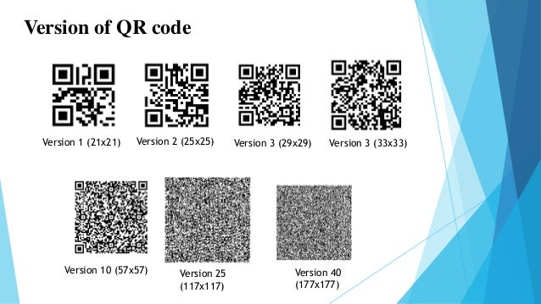
Fig 1: Versions of QR code

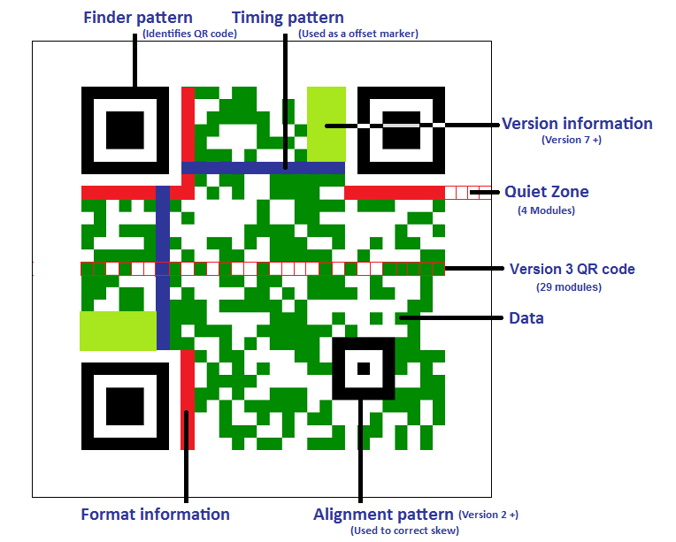
Fig 2:Different sections/pattern of a QR Code

3. Research Model:
● Verify the assets that need to be tracked and managed.
● Determine the information that needs to be tracked for each asset (e.g., location, maintenance schedule, purchase date, etc.).
● Select a QR code generator software that can create unique QR codes for each asset and link them to a centralized database.
● Develop a mobile app that can scan QR codes, retrieve asset information from the database, and allow users to update asset information as needed.
● Test the system with a pilot group of assets and users to identify any issues or areas for improvement.
● Refine the system based on feedback and testing results.
● Deploy the system to the organization and provide training and support for users.

3.1. Stages of application system Flowchart
Start

Analysis

Design

Evaluation

Implementation

Stop

Figure 3.1. Steps of application system Flowchart.

● Analysis: In the analysis stage, the organization identifies its asset management needs and requirements. This involves identifying the assets that need to be tracked, the information that needs to be collected about each asset, and any other specific requirements that the organization has. This stage also involves assessing the current asset management system, if any, to identify any inefficiencies or gaps that need to be addressed.
● Design: The design stage involves creating a system architecture and designing the user interface for the QR code-based asset management system. This stage includes determining the QR code labelling strategy, creating a database schema to store asset information, designing the mobile app interface, and designing the workflows and processes that will be used to track and manage assets.
● Evaluation: In the evaluation stage, the system is tested to ensure that it meets the requirements identified in the analysis stage. This includes testing the QR codes to ensure they scan properly, testing the database to ensure that it accurately stores asset information, and testing the mobile app to ensure that it properly retrieves and updates asset information.
● Implementation: The implementation stage involves deploying the QR code-based asset management system to the organization. This includes installing the QR codes on assets, configuring the database and mobile app, and providing training to users on how to use the system. It also involves creating processes for ongoing maintenance, upgrades, and support.

3.2. Workings of Quick Response Code:
Figure 3.2. Quick Response Code
A QR code, or Quick Response code, is a two-dimensional barcode that can be scanned by a smartphone or other mobile device to quickly access information. QR codes were first developed in 1994 by Denso Wave, a subsidiary of Toyota, to track vehicles during the manufacturing process.

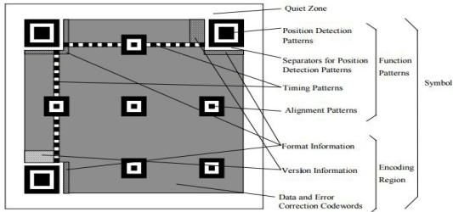

The workings of the QR Code QR is to do a scan with a smart phone will automatically be able to yield information about the asset in the scan, with your smart phone QR code labels direct to it. QR codes work by encoding information into a two-dimensional pattern of black and white squares. The pattern can be read by a QR code scanner or app using a smart phone camera or other optical sensor:
Here's how a QR code works in more detail:
● Encoding Information: To create a QR code, the information that needs to be encoded is first translated into a binary format. The binary data is then divided into groups of fixed length and each group is converted into a specific pattern of black and white squares using a specific QR code encoding algorithm.
● generating the Code: Once the encoding is complete, a QR code generator software or website can be used to generate the QR code image. The generator software creates the black and white pattern that represents the encoded data.
● scanning the Code: To read a QR code, the user needs to have a QR code scanner app installed on their mobile device. When the user points their smart phone camera at the QR code, the scanner app recognizes the black and white pattern and decodes the data into a readable format.
● Retrieving Information: The decoded information can be used for a variety of purposes, depending on how the QR code was created. For example, a QR code on a business card might contain the person's contact information, while a QR code on a product might contain a link to the product's website
3.3 Flowchart QR Code:

Start

Scan QR Code

QR Code Match
Data not Match

yes
Information Asset

Stop

Figure 3.4. Flowchart Quick Response Code
Scan of the smart phone QR, QR Code if the match with a QR Code that is in the system inventory will automatically display the asset information. Otherwise, the message will show.
3.4. Architecture QR Code:

Figure 3.5. Architecture QR Code
The architecture of a QR code system typically involves several components working together to encode and decode QR codes. Here are some of the key components of a typical QR code system:
● Encoding Algorithm: The encoding algorithm is the method used to convert the data to be encoded into a QR code. There are several standard QR code encoding algorithms available, such as the Reed-Solomon algorithm.
● QR Code Generator: The QR code generator is a software program or website that generates the QR code image based on the data to be encoded and the encoding algorithm used. The generator typically provides various options for customizing the QR code, such as size, colour, and error correction level.
● QR Code Scanner: The QR code scanner is an app or software program that reads and decodes QR codes. The scanner typically uses the smart phone camera or other optical sensor to capture the QR code image and then processes it to retrieve the encoded data.
● Data Storage: The encoded data may be stored in a database or other storage system for later retrieval and processing. The data can be used for a variety of purposes, such as tracking assets or providing access to online resources.
● User Interface: The user interface is the visual and interactive component of the QR code system that allows users to generate and scan QR codes, as well as retrieve and process the encoded data. The user interface may be a mobile app, a web-based interface, or a standalone software program.
● Network Connectivity: Some QR code systems may require network connectivity to transmit or receive data, such as when using QR codes for online transactions or remote asset tracking.

4. Process QR Scanning from Smart Phone:

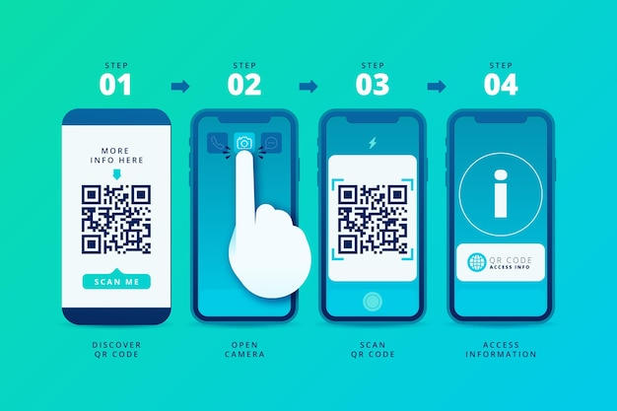
Figure 4.1. Process QR Scanning from Smart Phone:
The process of scanning a QR code from a smart phone typically involves the following steps:

● Install a QR code scanner app on your smart phone: There are many free QR code scanner apps available for download from app stores. Once you've installed a QR code scanner app, open it and allow the app to access your camera.
● Point your smart phone camera at the QR code: Position your smart phone so that the QR code is cantered within the camera viewfinder. The QR code should be in focus and well-lit.
● the scanner app will detect the QR code: Once the QR code is in focus, the scanner app will automatically detect it and begin decoding the data encoded in the QR code.
● the decoded data will be displayed: Depending on the type of QR code and the information it contains, the scanner app may display the decoded data in various formats, such as a website URL, contact information, or a text message.
● Take action on the decoded data: Depending on the information contained in the QR code, you may be able to take action directly from the scanner app, such as opening a website, adding a contact to your address book, or sending a message.

5. Advantages:
There are several advantages of using a QR code-based asset management system, including:
● Improved efficiency: QR codes can be scanned quickly and easily, allowing for efficient identification and tracking of assets. This can save time and reduce the need for manual data entry, improving overall efficiency in asset management processes.
● Increased accuracy: QR codes provide a reliable and accurate method of asset tracking, with built-in error correction capabilities. This can reduce the risk of errors and inconsistencies in asset data, improving the accuracy of asset management processes.
● Enhanced transparency: QR code-based asset management systems can provide real-time data and analytics, giving organizations greater visibility and transparency into their asset management processes. This can help identify inefficiencies and areas for improvement.
● Cost-effective: QR codes are a low-cost solution for asset tracking and management, requiring only a simple QR code scanner and a smartphone or other device with a camera.
● Easy integration: QR code-based asset management systems can be easily integrated with other technologies, such as mobile apps and cloud-based software, to provide a comprehensive asset management solution.

6. Disadvantages:
While there are several advantages to using a QR code-based asset management system, there are also some potential disadvantages, including:
● Reliance on technology: A QR code-based asset management system relies on technology, including QR code scanners and mobile devices, which may not always be available or functioning properly. This can create delays or interruptions in asset management processes.
● Limited information: While QR codes can store a large amount of data, they may not be suitable for all types of asset information. Some types of asset data, such as images or videos, may be too large to be stored in a QR code.
● Limited compatibility: QR codes may not be compatible with all types of asset management software or systems, which can limit their usefulness in certain situations.
● Security concerns: QR codes can be easily copied or counterfeited, which can raise security concerns in some asset management applications.
● Need for maintenance: QR codes can become damaged or worn over time, which can make them difficult to scan and require periodic maintenance or replacement.

Conclusion:
In conclusion, a QR code-based asset management system offers several benefits over traditional asset management systems. By using QR codes to track and manage assets, organizations can improve efficiency, accuracy, and transparency in their asset management processes. QR codes allow for easy and quick asset identification, tracking, and maintenance. They can store a large amount of data and provide built-in error correction, making them reliable and accurate for asset management purposes.
Additionally, QR code-based asset management systems can be integrated with other technologies, such as mobile apps and cloud-based software, to provide real-time data and analytics. This allows organizations to make informed decisions about their assets and optimize their asset management processes.
Overall, a QR code-based asset management system is a cost-effective and practical solution for organizations looking to improve their asset management processes and increase efficiency and accuracy.

References:
[1]https://tse2.mm.bing.net/th?id=OIP.v13LZtvg6zloWw39JAEnVwHaHa&pid=Api&P=0:figure-3.2.
[2]https://www.interestingfacts.org/wpcontent/uploads/2020/01/howdoesaqrcodework.jpg:figure-3.3.
[3]https://tse1.mm.bing.net/th?id=OIP.p4xoy9F2PBYWcNmV2rnPTgHaDe&pid=Api&P=0:figure-3.5
[4] https://image.freepik.com/free-vector/qr-code-scan-steps-smartphone-illustrated_23-2148625455.jpg:figure 4.1.
[5]SerliMareta, HaidraMirza, EkaPujiAgustini, ”SistemInformasiPersediaanBarangPadaOptikParham Berbasis Android MengunakanKode Quick Response (QR Code)’ UniversitasBinaDarma, Palembang. February 2017.
[6] IpanAsharyWulung, Ekojono, ST., M.Kom, AtiqahNurulAsri, ”SistemInformasiLogistikStokOpnameMenggunakan Quick Responses Code Berbasis Android.” Program StudiTeknikInformatika, JurusanTeknikElektro, PoliteknikNegeriMalang.Volume: 1 November 2015.
[7] FiqriZaenuriTriwijaya, “Aplikasi QR Code Generator UntukMempermudahPencarianInformasi Data Barang Di TokoKurniaBerbasis Android.” Program StudiInformatika, FakultatIlmuKomputer.November 2015.
[8] Yohana Tri Widayati, “AplikasiTeknologi QR (Quick Response) Code Implementasi Yang Universal” FakultasIlmuKomputer, Universitas AKI Volume : 3 No.1 February 2017.
[9] Murtiwiyati, & Lauren G. (2013). RancangBangunAplikasiPembelajaranBudaya Indonesia UntukAnakSekolahDasarBerbasis Android, JurnalIlmiah KOMPUTASI, 12(2), December 2013, ISSN: 1412-9434.
[10] Yuda Ricky Damara, AgusMamanAbadi, Musthofa, “Penerapan QR Code PadasystemPemesananBarang Di Industri” Fmipa UNY,2017.

