IMPACT OF GOVERNMENT SCHEMES ON RURAL DEVELOPMENT: A STUDY OF KHAYRASOLE BLOCK IN BIRBHUM DISTRICT, WEST BENGAL
PARIMAL DAS
RESEARCH SCHOLAR
L.N. MITHILA UNIVERSITY, DARBHANGA, BIHAR
ABSTRACT:
The exercise of elevating the popular of existence and financial prosperity of human beings in remoted and carefully populated areas is referred to as "rural development" in many contexts. Global attention of rural improvement is rising, in particular in terrible countries. It is very sizable for a kingdom like India. In order to enlarge their productivity, it speaks about the boom of rural economies, which are dealing with important poverty concerns. The lookup additionally emphasizes the magnitude of resolving various pressing challenges affecting village economies that prevent improvement and decorate these regions. To beautify rural areas, the Indian authority has added a quantity of programs. The scarcity of housing, the absence of infrastructure in cities and villages to hyperlink communities with all-weather highways, and the shortage of work probabilities are a few of the foremost troubles in rural India. The cause of this paper is to analyze the authorities of India has introduced the Pradhan Mantri Awaas Yoiana Gramin scheme to grant homes, Pradhanmantri Gram Sadak Yojana to construct roads and to supply rural humans with employment opportunities; the Mahatma Gandhi National Rural Employment Guarantee Act 2005 was once passed. In this study, we examine about the feature of these packages in India's rural improvement as nicely as their existing stage of development. The main intention of this paper is to spotlight the function of nearby authorities in rural development.
Key words: Rural development, Government Schemes, Programs, rural areas, Rural People
- INTRODUCTION
India's rural development is one of the most important aspects of the country's economic progress. Rural development focuses on the development of poverty-stricken rural economies and seeks to increase output efficiently. It also emphasizes the importance of addressing pressing problems that impede the growth and improvement of the village economy. Agriculture is one of the most important primary activities in rural India and around two thirds of the Indian population depends on agriculture. The problem is that the share of the agricultural sector in GDP is continuously decreasing. Rural development in India has undergone various changes in direction, technique, strategy and program over the years. As a result, it took on a new dimension and opened up new possibilities. Only with the participation of development clients can rural development become richer and more meaningful. Citizen participation is central to rural development, just as implementation is the standard for planning. From a procedural and philosophical point of view, participation is one of the most important prerequisites of the development process. It is essential that development planners and managers engage different groups of rural people for participatory planning. In India, the government has a number of rural development projects underway. In India, the Ministry of Rural Development is the highest authority responsible for formulating policies, regulations and laws related to rural development. The main contributors to enterprises and the rural economy are agriculture, handicrafts, fishing, poultry and dairy.
- OBJECTIVE OF THE STUDY
- To describe the different rural development schemes or programs in the study area.
- To examine the impact of rural development schemes in research area.
- To find the impact of the various rural development policies implemented by the Government of India.
- To study the presenting the growth of various schemes such as Pradhanmantri Awas Yojana Gramin scheme (PMAY-G) Pradhanmantri Gram Sadak Yojana scheme (PMGSY), The Mahatma Gandhi National Rural Employment Guarantee Act 2005 (MGNREGA).

- STYDY AREA
The Khoyrasole Community Development Block (Figure 1) is located in the Suri Sadar subdivision of Birbhum district. The geographical area of ​​the district is 499 km². The northwest part of the district, especially the Rampurhat - Nalhati blocks, the contour lines are higher than 110m - 140m (MSL) while it drops to 60-70m in the eastern and southeastern part around the Khoyrasole - Rajnagar blocks - Suri where the terrain is almost flat. The Lower Gondwana Barakar Formation exhibits marked Archean mismatch and exhibits Archean fault boundaries consisting of volcanic rocks called leucocratic at Rajnagar - Khoyrasole. The underground mass consists of cobblestone to coarse white iron-bearing sandstone, gray carbon shale, and coal. In Birbhum, groundwater is found both below the groundwater table in near-surface aquifers and as limited in deeper aquifers. The western part of the district around Khoyrasole, Dubrajpur, Rajnagar and Suri, western Rampurhat and the Nalhati region, is covered with hard rocks, ranging from basalt (Rajmahal volcano) in the north and granite, gneiss rock and shale in the south. The hard rock weathering zone is the main reservoir of groundwater in the study area. At the eastern edge of Khoyrasole, Dubrajpur, Rajnagar, the Gondwana Sedimentary Super group forms the main groundwater reservoir in the deeper layers. Laterite soils also form groundwater in parts of Suri, Md. Bazar and further east. Khoyrasole lies between latitudes 23°42' and 23°54' North and longitudes 87°05' and 87°22' East. This block is mapped on the Topo nos plate. 73M/1, 73M/5 and 73M/6 (Figure 1). Three rivers, Sal, Hinglo and Ajay flow through this block. Sal flows along the north side of Khoyrasole while Ajay forms the southern boundary of the block. This river also forms the boundary between Birbhum and Bardhaman districts. The Hinglo River lies between Sal and Ajay. In summer, the region's climate becomes hot and dry with temperatures reaching 40°C or more, while in winter, temperatures drop to 10°C or below. Moderate to high rainfall is recorded in the district, during the monsoon season. In this study area, there are many government programs aimed at developing local people.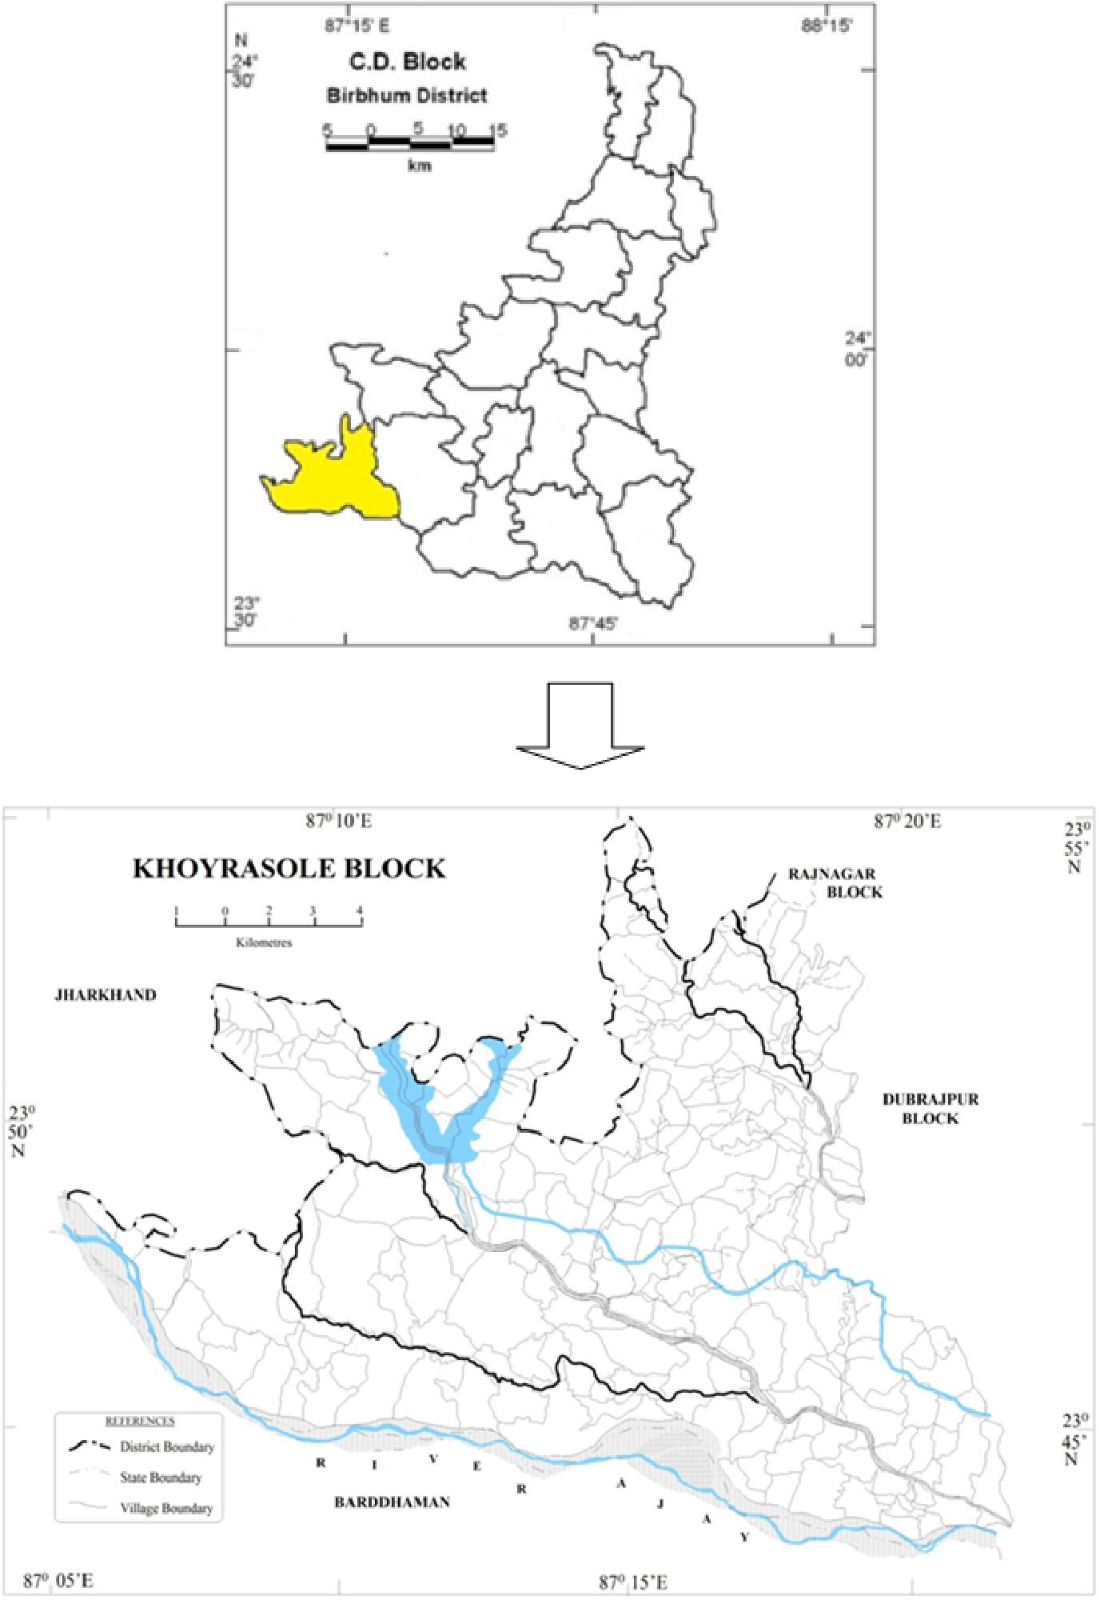
Fig. 1 Map Showing the Study Area

LITERATURE REVIEW
Mukundan (2008) argues that rural development is essential for inclusive and equitable growth and to unleash the enormous potential of the currently impoverished population. The result has been the creation of programs such as Swama Jayanthi Rojgar Yojana (SJRY), Sampooma Grameena Rojgar Yojana (SGRY), the National Food for Employment Program (NFFWP) and the National Rural Employment Guarantee Program (NREGP). The main cause of social insecurity in India is poverty, largely the result of a lack of economic opportunities.
Rajamohan & Dhanbalan, (2013), to understand the changes taking place in human resource development requires the efforts of all sectors of society. These efforts can have an impact on the effective implementation of more sustainable development ideas. Although there have been advances and improvements in society, there has been no progress in public welfare. Accordingly, the government should play a key role in formulating effective strategies for national development through human development by applying good governance at all levels of program implementation. Because people are at the center of a country's development, but their life and environment require to be improved much more than at present. [First]
Panda and Mazumdar (2013), evaluate development programs launched by the Indian government and analyze the performance of various on-going programs in the development of people and rural areas, such as MGNRGA, IAY, SGRY, ITDP, PMGSY,
ICDS and DWCRA, among others. These programs have had a positive impact on population development, poverty alleviation and rural modernization in India. [2]
SL Kaushal et al. (2016), MGNREGS helps empower women in rural areas, especially in H.P., although wage lag and lack of awareness are significant challenges in rural areas. [3]
Maria Navis Sorris et al. (2017), most recipients of palayakayal panchayat were unfamiliar with MGNREGS. Beneficiaries of MGNRGES in Thoothukudi district also face difficulties in obtaining work cards. [4]
Rao P. Srinivasa, (2019), To provide housing, the government of India has announced the Pradhan Mantri Awaas Yoiana Gramin (PMAY-G) plan, the Pradhan Manthi Gram Sadak Yoiana (PMGSY) plan for road construction and Mahatma Gandhi National Rural Employment Guarantee Act (MGNREGA) ) create jobs for rural people. These three programs are essential to India's rural development. According to the report, 44.54 lakh apartments were built under the Pradhan Mantri Awaas Yoiana Gramin (PMAY-G) plan in 2017-18, compared to the target of 1.00 million homes in March 2019. In In 2017-18, the PMGSY road construction rate reached an 8-year high of 134 km per day, compared with an average of 73 km between 2011 and 2014. As a result, construction is now progressing. at 93% faster speed. During the 2017-2018 financial year, MGNREGA created approximately 234.25 million people-paid workdays, including 177 thousand jobs, providing employment to 5.12 million households. The goal of eradicating these social evils can be achieved with the support of a good education. The declining literacy rate in rural India, especially among women, is a major concern. Land and technology reform is needed. To increase production and income, it is recommended to use modern technologies such as organic farming. By improving the banking system in rural areas, it will be easier for consumers to access credit and loans. [5]
Mohapatra & Prusty, (2021) although we consider different rural development programs, it is clear from the implementation approach that a program cannot be properly implemented without the cooperation of community. Communities can effectively take on rural development opportunities through social mobilization and organization of rural people into functional groups. As a result, the Indian government has launched a number of rural development programs aimed at helping rural people maintain a good socioeconomic level. [6]
- RESEARCH METHODOLOGY
The study was descriptive in nature and based on secondary data. Data is extracted from official government websites like https://rural.nic.in; https://nrega.nic.in. Descriptive statistics tools such as tables and graphs were used in the study. There are various sources of secondary data including research papers, articles and publications from various government departments of India.
RESULTS AND DISCUSSION

Rural Development Schemes in India

There are various important schemes launched by governments which are study of the research areas.
5.1.1 Mahatma Gandhi National Rural Employment Guarantee Scheme (MGNREGS) – Ensuring minimum wage for employment (2006) The Mahatma Gandhi National Rural Employment Guarantee Scheme was launched by the Government of India on February 2, 2006. To be working for minimum wage at least 100 hours each financial year. Anyone over the age of 18 can participate in the project by doing volunteer work that does not require training or skills.
The number of people participating in the MGNREGA program has nearly doubled over the past five years, from 38.91 million in 2017-18 to 63.92 million in 2021-22.
5.1.2 Swarnajayanti Gram Swarojgar Yojana (SGSY) - Self Employment Incentive ("Swarnajayanti Gram Swarojgar Yojana" or SGSY) was launched on April 1, 1999. The initiative was launched by the Government of India to ensure income security for the rural poor of the country. Self-help groups are part of the SGSY so that villagers can benefit from independent work in the community. People's attitudes and skills are taken into account when selecting jobs and activities for self-help organizations. SGSY is financed from foundations, banks and other sources.
More than 6,697 million people in India have benefited from an investment of Rs 14,403 (US$2.2 billion) in more than 2.25 million self-help groups.
5.1.3 Pradhan Mantri Gram Sadak Yojana (PMGSY) - This program was launched on December 25, 2000 to provide reliable infrastructure to ancient rural communities. About 500 people saw steady work on the plains. In particular, the National Rural Road Development Agency is responsible for this project with the support of the Ministry of Rural Development. Of these 4 routes, 22,031 kilometers of rural roads are not connected.
5.1.4 Swajaldhara - Community Based Rural Water Supply Project since 25 December 2002, it has been important and reorganized in rural drinking water. This initiative is supported by environmental cooperation. Piped water point water supply schemes (PWSS) supply water to large areas, while point source water sector schemes (SSWSS) serve small areas. For the programme, 90% of the cost of capital is provided by the Government of India and 10% by the Government of India. % of cost is community involvement.
5.1.5 Provision of Rural Services to Rural Residents (PURA) - Dr. APJ Abdul Kalam was the main reason behind the idea. The stated aim of the plan is to "improve the quality of life of the rural population by providing livelihoods and urban opportunities through public and private partnerships to create a compact space around the future growth center of Gram Panchayat.
"The main purpose of the plan is to improve transportation by building new roads, improve access to information by improving communication infrastructure.
5.1.6 Indira Awass Yojana - The stated purpose of this program is to provide affordable housing in underserved areas. The amount of funds provided by this program is Rs. Rs 70,000 for plain areas 75,000,00 for the plateau area. To promote gender equality, the program selects housing for women or married couples. In 2015, the Indira Awass Yojana program was renewed and renamed as Pradhan Mantri Gramin Awaas Yojana. Pradan Mantri Gramodaya Yojana - It has long been recognized that in order to improve people's livelihoods and eradicate poverty, it is necessary to provide them with basic infrastructure. Further support and improvements in the Human Development Index show that progress has been made in recent years in increasing access to health care, primary education, drinking water sanitation and housing.
5.1.7 Rural Home Loan Subsidy Scheme - This initiative provides easy access to rural home loan and subsidy schemes to all rural households earning less than Rs. 32,000 people build their homes annually. The ultimate goal of the program is that people in rural areas can own their homes by borrowing money to build them.
5.1.8 Rajiv Gandhi Grameen Vidhyukthikaran Yojana - To ensure access to electricity for people living in rural areas, the initiative will focus on rural housing development and electrification of rural households. The result of this program is 1.95 free electricity connections were provided to the rural population.
5.1.9 Integrated Watershed Management Plan – The purpose of this plan is to repair environmental damage by restoring and rehabilitating once healthy soil, crops and water-utilizing crops. Completion of the plan will reduce soil erosion, restore native vegetation, collect rainwater and recharge groundwater.
5.1.10 Land Reform and Land Consolidation – The purpose of land reform is to redistribute unused land to people in regions where there is not enough agricultural land. India's land consolidation system is decentralized and consists of small, fragmented farms. Gathering of land leads to inefficient allocation of resources. Therefore, both volunteering and effort are required to carry out this important work.
5.1.11 National Land Registry Modernization Program - This program improves income management and updates land records through computerization.
5.1.12 National Social Assistance Program - Social Pension is a financial benefit provided by the Federal Government to the elderly, widowed and disabled people.
5.1.13 Antyodaya Anna Yojana- Food insecure humans in rural areas can also relaxation effortless understanding that this programme issues 35 kilogrammes of rice and wheat at the low cost expenditures of Rs. three and Rs. 2, respectively.
5.1.14 Integrated Child Development Program - In 1975 India launched the Integrated Child Development Programme. The main aim of the program is to help low-income families meet their basic needs such as food, education and health.
5.1.15 Atal Emeklilik Yojana - Through this scheme, low-income seniors (over 60) receive a monthly pension. Citizens of India between the ages of 18 and 40 can participate in the program for those working in the unorganized sector.
5.1.16 Deen Dayal Upadhyaya Gram Jyoti Yojana – The Indian government's Deen Dayal Upadhyaya Gram Jyoti Yojana program aims to provide reliable electricity to remote areas of India. To provide electricity to rural areas, the government wants to spend $756 billion initially. Instead, the original Rajiv Gandhi Grameen Vidyutikaran Yojana will be replaced by this new scheme. India's NDA government has launched a program to provide continuous electricity to every household in the country. After reviewing all the services, the researchers discovered that there was no place for women to support themselves. This leads researchers to think that MGNREGS is effective in empowering rural women.

6. IMPACT OF GOVERNMENT SCHEMES ON RURAL DEVELOPMENT

There is a sturdy correlation between a excessive human improvement index and a excessive fashionable of living, consequently it makes feel that a essential aim of rural improvement insurance policies and programmes is to decrease poverty in rural areas, create jobs, and cease starvation and malnutrition. Economic planners assume that the undertaking of rural improvement is no longer solely about improvement of rural areas however the improvement of rural communities to dispel illiteracy and poverty and help the method of growing self-reliant and self-sustaining healthful cutting-edge communities. Increases in GDP or even per capita countrywide earnings on my own can't be used to outline rural improvement anymore. While the authorities has been given pinnacle interest to rural improvement and is spending heaps of crores by means of distinct programmes, the trouble is that now not all the cash distributed underneath the rural improvement plans reaches the recipient. Therefore, improvement has slowed to a crawl, and the negative have no longer viewed any relief. The introduction of productive belongings like roads, water tanks, soil and water conservation work, etc., as phase of rural improvement schemes, offers human beings in rural areas a threat to earn a dwelling barring having to depart their homes. This has the knock-on impact of decreasing migration, limiting toddler labour, easing poverty, and making villages greater self-sufficient.

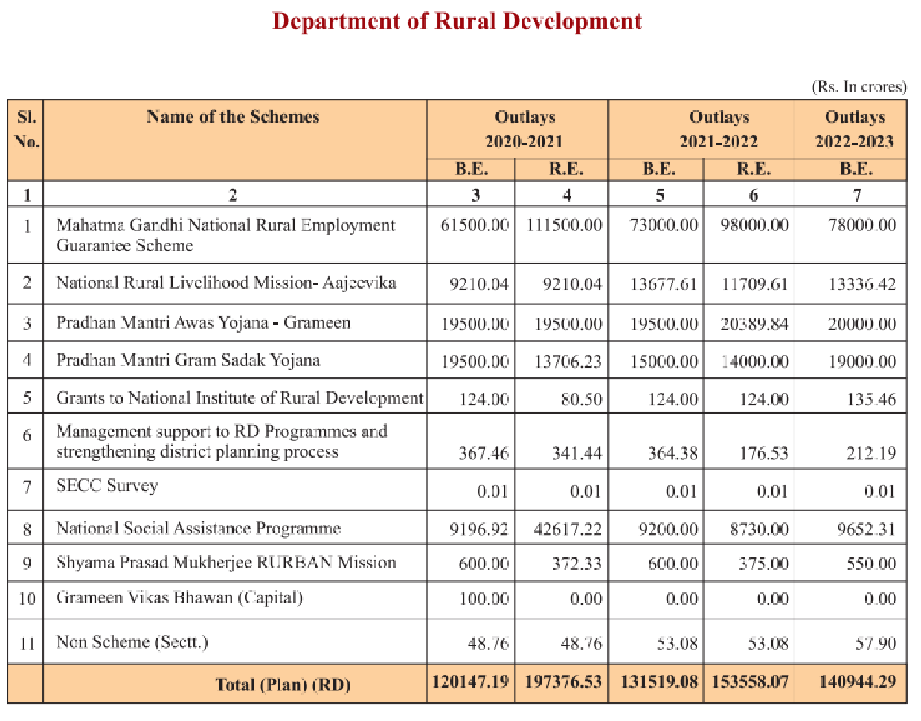
Table.1 Various Rural Development Schemes of India

To assist India, national, and regional policymakers pick out and protect the most high quality programmes and coverage measures, it is indispensable to get perception into the connections between a number of rural improvement coverage initiatives and their societal and monetary effects. The proposed find out about aspires to supply empirically sound explanations for these issues. Rural development's conceivable social and monetary impact will be evaluated, and the insurance policies most appropriate to generate and hold that affect will be analyzed.

All of the planned research will be carried out in India. The find out about will start with case research of the most successful examples of rural development, analyzing the results of this system on employment, income, investment, and inventiveness. After that, we are going to use more than a few financial and sociological strategies to look into whether or not or no longer may these findings also be extrapolated to cowl a larger region. As of this writing, the National Rural Livelihoods Mission (DAY-NRLM) has multiplied into 6769 blocks over 706 districts in 30 states and 6 territories. More than 73.19 million girls from low-income and marginalized backgrounds have been equipped into SHGs thanks to this initiative. Up to the cease of the 12 months in 2021, RSETIs will have taught 39.17 million human beings in sixty four one-of-a-kind fields. Of these people, 27.34 million will have discovered gainful work. Twenty-two thousand and three hundred eighty-six humans have been educated as a consequence far, and twenty-two thousand and six hundred seven have been positioned as of 30 November 2021, all as section of the DDU-GKY assignment for the fiscal 12 months 2021-22. A complete of 2.15 billion rupees has been allotted for the Pradhan Mantri Awaas Yojana-Gramin (PMAY-G), with 1.68 billion dwellings built. With a intention of finishing 44.09 lakh residences in FY 2021-22, we have solely managed to end 31 lakh so far.
- CONCLUSION & SUGGESTIONS
As an awful lot as 70% of India's populace lives in rural settings. Everyone, such as these residing in rural locations, deserves the equal excessive well known of existence skilled through these in greater city and suburban settings. More than that, monetary problem and urban poverty are the outward manifestations of underlying socioeconomic conflicts precipitated with the aid of poverty, unemployment, and inadequate infrastructure in rural regions. With this new strategy, the authorities will be in a position to pay the recipient directly, as a substitute than going via a sequence of intermediaries. With this purpose in mind, the Aadhaar card is a groundbreaking programme that has the manageable to absolutely alter rural India. Most rural improvement programmes are aimed at below-poverty-line households, as a consequence it is necessary that the authorities collect an correct listing of these households and make that information, organized via village, on hand over the internet. Despite the reality that there are many programmes supposed to assist us progress, we nonetheless lag in the back of in key areas like education, health, sanitation, and so on. This is due to the fact the conventional public is unaware of the many resource initiatives that have been created especially for them. Therefore, it is vital to use a range of audio, video, and audio visible media to increase public awareness. The dissemination of records through more than a few channels of conversation might also be of splendid benefit. Any format to enhance rural areas must centre on supporting the negative make the most of their inherent abilities whilst additionally supplying them with the education, training, and assist they want to be part of the team of workers and make a contribution to the nation's increasing economy. This is critical if we choose our democracy to be in reality representational and welcoming to all people. Training programmes for PRI officers and beneficiaries chosen from one of kind programmes must be prioritized as a skill of enhancing human capital. For the bad to get resource from a number of programmes and for there to be no errors in the decision process, it is fundamental that the public have a voice in who receives assistance. In order to make bigger the quantity of humans who advantage from rural improvement programmes, it is essential to launch a public training campaign.

REFERENCES
1. Dr. S Rajamohan & T. Dhanbalan. (2013). Rural development schemes and their contribution towards the human resource development. Indian Journal of Applied Research.
2. Panda & Mazumdar. (2013). A review of rural development programmes in India. International Journal of Research in Sociology & Social Anthropology.
3. Kaushal, S L. & Balbir Singh. (2016). A study of women participation in MGNREGA in Himachal Pradesh. Productivity, 56(4), 382-390.
4. Maria Navis Sorris, A. & Sheeba, E. (2017). A study on knowledge and perceptions of beneficiaries towards MGNREGA in palayakayal panchayat of Thoothukudi district. International Journal of Informative & Futuristic Research, 4(9), 7499-7506.
5. Dr. P Shrinivas Rao. (2019). Rural development schemes in India – A study. International Journal of Research and Analytical Reviews (IJRAR).
6. Ajay Kumar Prusty. (2021). Rural development schemes of 21st century in India. ESN Publications ISBN: 978-81-950305-9-0.
7. Santanu Panda & Arup Majumder, A Review of Rural Development Programmes in India, International Journal of Research in Sociology and Social Anthropology, 2013, 1(2) : 37-40, ISSN 2321–9548
8. Rajalakshmi, Dr. V. Selvam, Rural Development Schemes In India Special Reference To Impact Of Mgnregs Vellore District In Tamil Nadu, International Journal of Scientific & Technology Research Volume 9, Issue 02 , February 2020 ISSN 2277-8616
9. AmarjeetSinha (2017). Transforming Lives Through Livelhoods. Kurukshetra, 65 (7), 5-9.
10. Harikumar, P.N., &Nirosha Joseph (2016). Impact of Mahatma Gandhi National Rural Employment Programme among Rural Residents. Southern Economist, 55 (14), 34-38.
11. Jyothi Sharma (2016). Digital India and its Impact on the Society. International Journal of Research in Humanities and Social Sciences, l4(4), 45-87.
12. Tripathy (2018). Rural Livelihood and Employment, Kurukshetra A Journal on Rural Development, 66 (5) , 42- 46
13. Mishra Publications, "District Administration and Rural Development". Oxford University Press, New Delhi, 1983.
14. Mathur L. (2007). Employment guarantee: Progress so far. Economic and Political Weekly, December 2007.
15. Carlsson, R., Otto, A., Hall, J.W. (2013). The role of infrastructure in macroeconomic growth theories. Civil Engineering and Environmental Systems, 30(3–4), 263–73.

