ChatGPT: The Evolution of Conversational AI

Vrinda Tandon
Department of Computer Science and Engineering
Dev Bhoomi Uttarakand University
Dehradun, India
vrinda1804tandon@gmail.com

Tanishq Mehra
Scholarly Contributor
Brightlands School, Dehradun
Uttarakhand, India

LEARNING OBJECTIVE

This chapter aims to provide readers a comprehensive understanding of an influential language model ‘ChatGPT’, exploring its background, fundamentals, implications, strengths, limitations and potential future advancements. By the end of this chapter, readers will gain a better understanding of technology behind ChatGPT’s natural language processing, its capabilities, constraints and transformative impact of ChatGPT on human-computer interactions.

Keywords—NLP (Natural Language Processing); NLU (Natural Language Understanding), NLG (Natural Language Generation), Conversational AI, Virtual representative, Text generation

INTRODUCTION

The remarkable advancements in the field of artificial intelligence are quite evident lately. Among these forward leaps stands ChatGPT, a state-of-the-art language model created by OpenAI. ChatGPT addresses a vital achievement in the evolution of conversational AI boasting extraordinary language comprehension and generation capabilities. This chapter will allow readers to explore ChatGPT workings, delving into its architecture, significance, strengths and limitations, ethical considerations/moral contemplations and future.

WHAT IS CONVERSATIONAL AI?
Conversational AI, also referred to as virtual assistant or say chatbots, is a branch of AI focused on empowering human-like conversations via natural language communications. It includes improvement of cutting-edge language models and chatbots frameworks capable of understanding and creating text to carry significant and logically relevant conversations.
Conversational AI systems utilize complex algorithms and NLP methods for apprehending user queries, extracting important and relevant information and generating fitting responses. These systems can be leveraged into distinct platforms like messaging apps, voice-empowered devices as well as websites in order to deliver interactive, intuitive and customized user experience [1].

KEY COMPONENTS OF CONVERSATIONAL AI
Key components work together to create a sophisticated conversational AI system and with advancement in technology, these components keep on being refined and improvised, prompting seamless human and AI system communication.
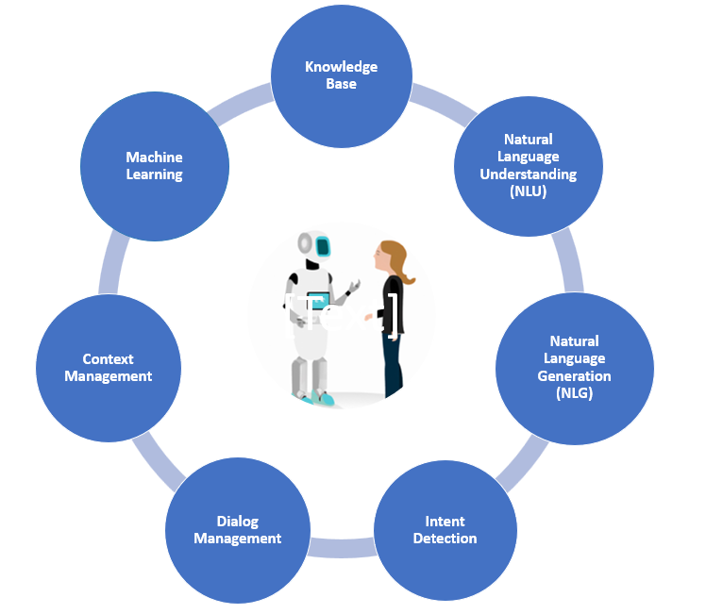

Figure 1: Key Components of Conversational AI

- Knowledge Base: A knowledge base is a repository of information that a conversational AI system can allude to while answering queries. IT stores facts, data, meta data and other significant information, assisting the framework to provide precise and informative responses.
- Natural Language Understanding (NLU): It is considered as the foundational component of conversational AI. NLU enables the system to process and interpret inputs in natural language by extracting intent and context from messages generated by the user.
- Natural Language Generation (NLG): It converts structured data and processed information into sentences in natural language that are simple to comprehend and interact. In simpler words, NLG is responsible for generating human-like responses as per the context of conversation.
- Intent Detection: It is a process of determining the current purpose of the user behind a specific message. It helps to drive a discussion appropriately grasping the user’s objective. For example in a travel booking assistance system, a statement like ‘Book a flight to California from Delhi for next week’ will detect the intent as ‘Flight booking’ and will enable the user to find suitable options [10].
- Dialog Management: It handles the flow of conversation between conversational system and user. It guarantees appropriate response as per the user's inputs, keeps up with the context and ushers the conversation to accomplish desired response.
- Context Management: It is the essence of Conversational AI. Context management assists the AI system to remember previous conversations, comprehend references made by the user and generate desired responses [10].
- Machine Learning: ML enables continuous improvement in language comprehension and response generation capabilities. For this to happen, models are trained on large datasets to figure out patterns and context in natural human language.

BACKGROUND OF CONVERSATIONAL AI

The history of language models can be traced back to the early days of AI and NLP. For decades, the idea of associating machines via conversations has always fascinated researchers as well as developers. Let’s take a historical overview, following the foundation from early chatbots to the cutting-edge conversational AI [9][11]:

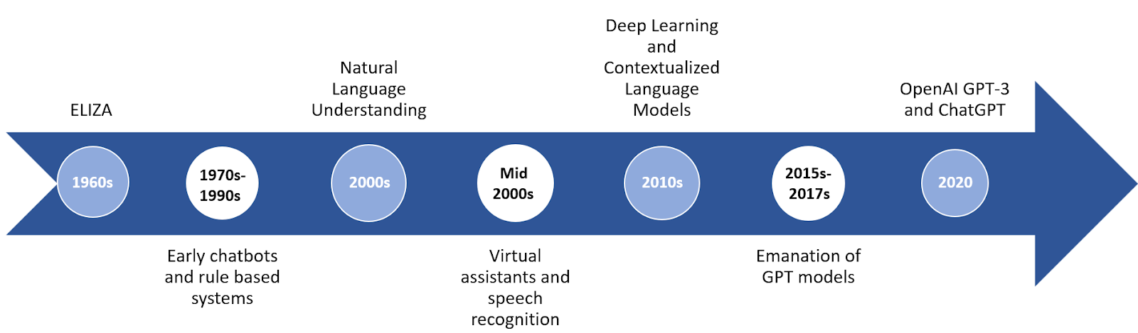

Figure 2: Emanation of Conversational AI

ELIZA: Conversational AI emerged in the 1960s with ELIZA, developed at MIT by Joseph Weizenbaum. It was one of the prominent chatbots which utilized pattern matching and rule-based techniques to stimulate a Rogerian psychotherapist, engaging text-based conversations. Though the capabilities of ELIZA were limited, it demonstrated a potential interactive language-based system.

- Early chatbots and rule-based systems: More rule-based chatbots emerged throughout the next few decades, each with its own set of capabilities and uses. These early language systems operated within well-defined areas and generated replies using specified rules. PARRY and Jabberwacky are two of the notable instances for dynamic and comprehensible conversations wherein PARRY stimulated a paranoid patient, and Jabberwacky allowed for more dynamic and context-driven conversations [1][2].
- Natural Language Understanding (NLU): With research advancement, the emphasis switched to adding NLU into conversational AI. The applications of statistical approaches and machine learning algorithms were explored to improve language comprehension and provide contextually pertinent responses.
- Virtual assistants and speech recognition systems: Advent of virtual assistants was seen in the mid-2000s like Siri, introduced by Apple in 2011. These voice-enabled AI systems incorporated speech recognition and NLP. Undoubtedly, conversational AI reached a wider audience because of its user-friendly interfaces and widespread adoption.
- Deep Learning and Contextualized Language Models: In the 2010s, the introduction of deep learning and neural network architectures reformed natural language processing. Recurrent Neural Networks (RNNs) and transformers enabled AI systems to better comprehend context and language dependencies. ELMo and BERT contextualized language models further enhanced the quality of conversational interactions by collecting contextual information.
- Emanation of GPT models: The Generative Pre-trained Transformer (GPT) architecture was unveiled by OpenAI in 2015, making a significant leap in conversational AI. By employing pre-training on enormous datasets, models like GPT-1 and GPT-2 exhibited the capacity to generate coherent and contextually appropriate text.
- OpenAI GPT-3 and ChatGPT: OpenAI introduced GPT-3, a language model with 175 billion parameters in 2020, setting a new benchmark for conversational AI. The characteristics of GPT-3, specifically in generating human-like text and engaging in interactive discussions, propelled conversational AI to new heights. With OpenAI’s ChatGPT, users can personally experience the potential of the GPT-3 model, allowing creative and dynamic language model interactions.

The historical journey of conversational AI discussed above showcases a fascinating progression, from simple rule based chatbots to the sophisticated and contextually knowledge models. With continuous research and development, the advancement in conversational AI will keep on evolving which will eventually bring more customized models capable of performing personalized human-like communication improvising the overall quality of AI interactions.

UNDERSTANDING ChatGPT

There are several options and applications of ChatGPT. Its adaptability is astonishing, helping to facilitate both artistic activities and improve consumer relations. Customer support, content generation, language translation, idea generation, creative collaboration, coding assistance, medical counseling, and even emotional support are all services that ChatGPT may offer. It's a productivity tool that can also be used for entertainment, and it can help with marketing, research, and many other things. Its potential is only constrained by our imagination and the moral principles that govern its usage.
There are several interesting things that you can do with ChatGPT. It can work on any browser. All we need to do is go-to chat.openai.com and sign up for a free account. A lot of deal with things like building a resume, making a cover letter, practicing for an interview. It makes you wonder about its real-time text general capabilities. In this section we will discuss some interesting stuff we can do with the help of ChatGPT.

BRAINSTORMING TOOL TO CREATE ORIGINAL CONTENT

It can be used to brainstorm ideas for work or entertainment. For instance, if you are looking for a gift for a person, a brief description would help a lot to recommend some ideas.

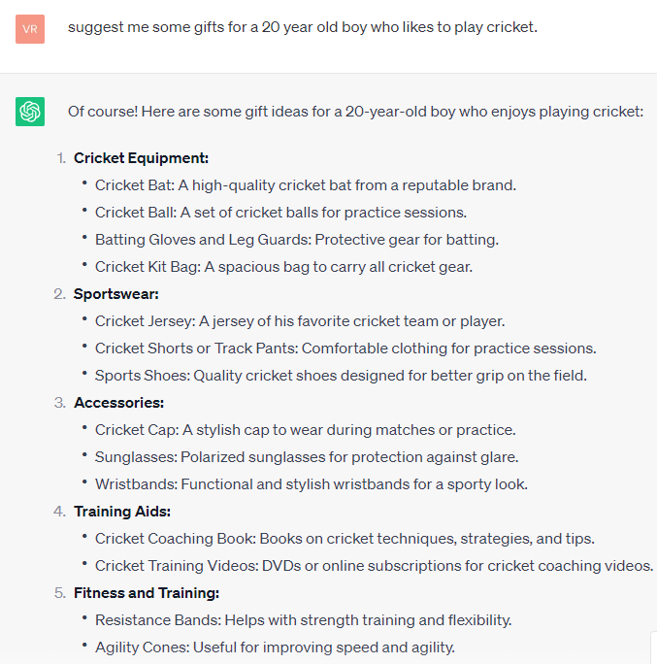

Figure 3: Personalized recommendation example

In case you are not getting a satisfactory answer just keep on asking the question with more description like you are chatting and interacting with a human. Like in the above example we can modify the response in ongoing chat- ‘He also likes to travel’.

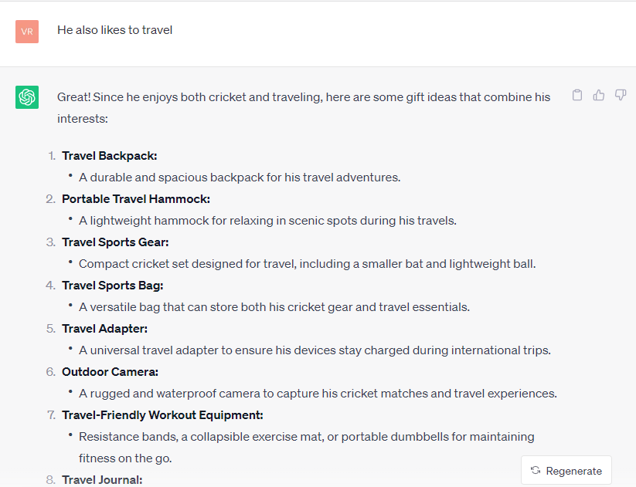

Figure 4: Getting a modified response in on-going conversation

WRITING POEMS
ChatGPT is indeed capable of generating poems. Utilizing its considerable training data, it can compose verses in a variety of genres and subject matters. It's crucial to remember that, while the generated poems may be imaginative and captivating, they are produced based on patterns that the computer has learnt and may not have the same depth of meaning as poetry written by human poets. However, ChatGPT's lyrical creations might act as models for further development, points of inspiration, or simply as proof of its creative capabilities. We can also convert normal textual information into a sonnet for fun!

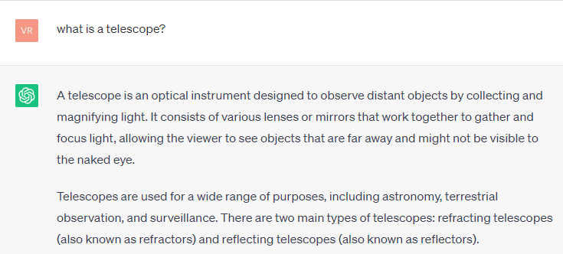
Figure 5: Simple definition in text

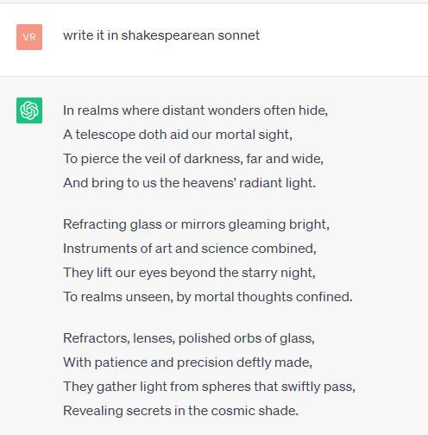

Figure 6: Text converted into sonnet for fun learning

PLANNING A HOLIDAY
ChatGPT can provide day-to-day activities that you can do on a trip without any hustle. For generating desired and appropriate response one can add certain descriptions related to- trip destination, duration, budget, travel companion, types of activities in which you are interested in, food preferences and much more.

WRITING REGULAR EXPRESSIONS
Remembering how to create a regular expression isn't an easy task. Luckily ChatGPT can now help with the same with detailed explanation.

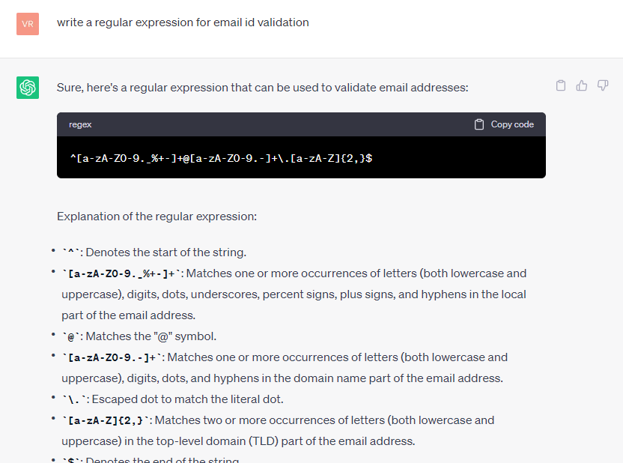

Figure 7: Regular expression generation via ChatGPT

MOVIE AND BOOK RECOMMNEDATION

By describing the desired genre, theme or mood one can share our preferences and get tailored suggestions accordingly. Again for accurate and desired result we can add some more description like illustrated in the example below:
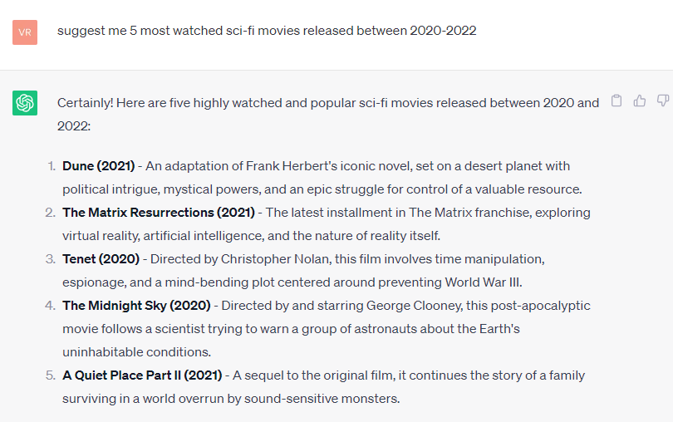

Figure 8: Movie recommendation list based on personalized genre

REPHRASING FORMAL AGREEMENTS FOR BETTER UNDERSTANDING
ChatGPT can be utilized to simplify and rephrase formal agreements into more informal language to gain a better understanding of the context. For that we need to provide the text of the formal agreement and simply ask ChatGPT to make it more casual. It's important to retain the meaning and intent of the agreement while making long formal agreements into informal ones.

PLAYING GAMES
You can ask for a list of gaming options to play on ChatGPT for fun like 20 questions, word association, trivia, story building, riddles, would you rather, guess the movie/book, role playing, math challenges and poetry duel. Not only this, it also enables you to code a game for you which you can play in the browser!
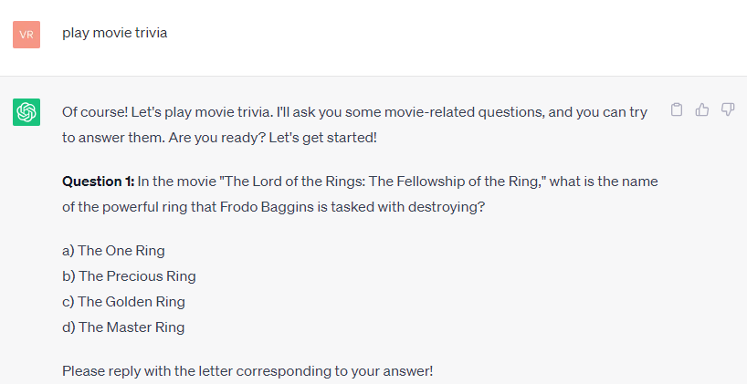

Figure 9: Movie trivia gaming example

GENERATE BETTER RESPONSES
We can get better responses by specifying the question in an improvised way just like the way in which we communicate to another human. For instance, instead of asking a question directly like- ‘what is the product of 2 and 5?’ one can ask- ‘why exactly the product of 2 and 5 equals 10?’

APPLICATIONS

ChatGPT, being an advanced language model, has a wide range of applications in distinct sectors. Its language understanding and text generation capabilities enable it to execute tasks and conversations that the AI systems previously found challenging. Some of the prominent examples of ChatGPT applications are:

VIRTUAL CUSTOMER SERVICE REPRESENTATIVE
ChatGPT may be utilized as a virtual customer service representative, answering user enquiries, offering assistance, and addressing frequent problems. It provides 24-hour availability and consistency in responding to consumer inquiries, hence increasing customer satisfaction [11].

CREATIVE CONTENT CREATION AND STORYTELLING
ChatGPT can help you create content for a variety of reasons, such as blog entries, articles, social media and marketing posts. It can assist authors in brainstorming ideas and developing captivating content. ChatGPT's creative features make it a great tool for creative writing as well as interactive storytelling.

LANGUAGE TRANSLATION
By analyzing text inputs in one language and creating accurate translations in another, ChatGPT can provide real-time language translation, increasing communication across language boundaries.

PROGRAMMING ASSISTANCE
ChatGPT may be used by developers to acquire coding help, debug bugs, produce code snippets, and seek programming concept explanations.

MARKET RESEARCH
ChatGPT can engage individuals in market research surveys, gathering information, views and insights for organizations and research purposes.

LEGAL COMPLIANCE AND REGULATION INFORMATION

ChatGPT can offer basic legal explanations, definitions of legal words, and advice on compliance issues in the legal matters.

THERAPEUTIC SUPPORT
A platform can be leveraged where users can express their ideas, feelings and thoughts, serving as a type of therapeutic interaction or assistance in stress and anxiety management [7].

EDUCATIONAL TOOL
ChatGPT can be used as an interactive educational tool, assisting students with explanations, answering questions about various subjects, giving study resources, and providing individual coaching [8].

GAMING
By generating dynamic and interesting in-game chats and interactions, ChatGPT can be used to offer a new level of involvement to gaming experiences.

These are some of the diverse applications of ChatGPT. With the advancement in technology, new applications will emerge increasing its potential in a variety of domains and sectors.

STRENGTHS AND LIMITATIONS

Recognizing the strengths of ChatGPT is crucial as it marks a significant advancement in conversational AI. Its capability to conduct dynamic and contextually appropriate interactions has led to opportunities for plenty of applications like content creation, healthcare and legal assistance as discussed in the above section. In this section we will discuss strengths and limitations of ChatGPT as it has significantly revolutionized the way in which machine-human interactions take place.

STRENGTHS
- Exceptional Language Comprehension: ChatGPT has a remarkable capacity for comprehending minute details and contextual subtlety, which enables it to offer replies that are in tune with the complexity of diverse interactions. It’s astounding knowledge includes not only the words' literal meaning but also the implications, references, and emotional overtones. As a result, it can engage in meaningful conversations even when dealing with complex or intricate interactions.
- Creative Text Generation: ChatGPT has a surprising strength in producing text that is both imaginative and contextually relevant. It can narrate stories, come up with creative solutions, and mimic various tones and styles of discussions.
- Distinct Topics Adaptability: ChatGPT is adaptive to different user inquiries and themes because of its pre-training on a variety of content available digitally, which enables it to communicate and deliver knowledge about a wide range of topics.
- Contextual Consistency: ChatGPT preserves context throughout several turns of a discussion, making sure that the replies match up with past interactions and user inquiries, resulting in more natural and interesting conversations.
- Rapid Response: ChatGPT is well suited for situations requiring immediate feedback and help because of its real-time response generating capacity, which provides a quick and smooth interaction experience. It is particularly suited for applications where prompt interactions and timely support are essential, such as customer service, troubleshooting, and time-sensitive decision-making situations, because of its capacity to produce fast replies, which stimulates dynamic dialogues.

LIMITATIONS
Users can examine the data and replies ChatGPT offers critically by being aware of its limitations. This is crucial in situations when accuracy, precision and reliability are paramount. Some of the limitations of ChatGPT are:
- Meaningless responses: While ChatGPT has many advantages, it occasionally has drawbacks in the form of responses that are inconsistent or irrelevant, sometimes deviating from the intended subject, or giving responses that do not meet the user's expectations. These instances of inconsistency highlight the complex problem of perfect text creation and highlight the requirement for users to thoroughly evaluate the context and correctness of its outputs, understanding the trade-off between its capabilities and its sporadic fallibility.

- Input Phrasing Sensitive: The answer provided by ChatGPT might vary greatly depending on how a question or prompt is worded. Its sensitivity to input formulation is shown by the fact that a slight change in wording might provide different results.

- Insufficient Explicit Knowledge: Despite the fact that ChatGPT can provide data based on its training data, it only knows what it has learnt from the text. It could give incorrect answers to queries regarding current affairs or specialist fields.

- Possibility of Making Assumptions: The tendency of ChatGPT to make assumptions includes its propensity to predict omitted information from user input, which could result in errors when context is murky. ChatGPT may unintentionally create replies based on assumptions taken from its training data if a user's question is vague, underscoring the significance of giving explicit and thorough instructions to guarantee correct and contextually relevant answers.

- Biased Responses: ChatGPT may unintentionally provide replies that reflect distorted viewpoints if it is trained on biased or unbalanced data, and it may even produce objectionable content. This emphasizes how important it is to incorporate rigorous content screening and effective bias mitigation mechanisms to guarantee that the AI's outputs are impartial, fair, and in line with moral principles.

Users are effectively empowered to maximize ChatGPT's capabilities by being aware of its limitations. Making decisions based on this information ensures meaningful interactions and the best possible usage of the AI. Users may effectively handle potential risks, promote fruitful conversations, and properly utilize the technology by being aware of its limitations. This will maximize advantages while lowering related threats.

ETHICAL DELIBERATION

When exploring the world of ChatGPT and conversational AI in general, ethical issues are crucial since these technologies present a number of difficulties that need careful scrutiny [6]. The following four major ethical problems require special attention are:

TRANSMITTING MISINFORMATION
ChatGPT and other conversational AI systems may unintentionally transmit false information. Users may accept false information if the model produces plausible-sounding but factually erroneous replies. This has significant implications for critical domains like health, economics, and education where bad advice can have real-world repercussions [6].

PRIVACY AND CONFIDENTIALITY CONCERNS
Interactions with AI agents like ChatGPT frequently entails disclosing private or delicate information. These interactions run the danger of being saved or utilized without the required authorization, thus breaching the privacy of users [6]. Maintaining user confidence depends critically on ensuring clear data usage regulations and safe data management procedures.

BIAS AMPLIFICATION
ChatGPT may unintentionally pick up biases from its training data that are representative of society stereotypes. Responses that reinforce preconceptions or even contain discriminatory language might be a manifestation of this prejudice. By undermining justice, inclusion, and reiterating existing inequalities, biased AI deployment creates ethical conundrums that need to be resolved.

IMPACT ON INTERPERSONAL COMMUNICATION SKILLS
Relying too heavily on conversational AI might lead to the loss of important interpersonal communication skills. Face-to-face relationships, emotional ties, and critical thinking may be hampered if individuals depend more and more on AI for company or knowledge. Long-term social and psychological repercussions of this change are possible.

FUTURE ADVANCEMENTS

The development of ChatGPT marks a transformative shift in human-computer interactions that has the potential to fundamentally improvise this field. Future developments are expected to fundamentally alter how humans interact with AI-powered technology. These developments signify a departure from traditional communication towards a world in which technology is effortlessly integrated into our daily lives [3][4].

ENHANCED CONTEXTUAL UNDERSTANDING

The first pillar, which anticipates this trajectory, is enhanced contextual understanding. By embracing multi-turn talks with sophisticated comprehension and emulating human dialogues, ChatGPT is poised to go beyond one-dimensional enquiries. This progression promises to replace one-sided replies with immersive interactions that mirror real discussions [4].

MULTIMODAL CAPABILITIES
The merging of multimodal capabilities, where communication goes beyond text, is another promise for the future. ChatGPT will interact with pictures, movies, and sounds by fusing visual and aural processing, extending the range of expression. Additionally, the trajectory suggests mastery of the relevant area. As ChatGPT develops, it will become a virtuoso in a particular field, providing solutions and insights relevant to different businesses and increasing the skills of specialists [5].

COLLABORATIVE CREATIVITY
ChatGPT may be more than simply a chat companion; it might also contribute ideas, co-author textual works, compose music, and participate in artistic co-creation [4].

ENHANCED EMOTIONAL RESONANCE
In the future, it will be possible for AI to respond to feelings by recognizing emotional context. Interactions will have a deeper resonance with human understanding as emotional intelligence becomes essential [4].

PERSONALIZED LEARNING EXPERIENCE
The integration of ChatGPT and other AI systems into education will result in more individualized learning opportunities. Additionally, its capacity for mundane activities might change the nature of professional responsibilities, requiring a move towards positions that value traits that are exclusively human, such creativity and complicated decision-making.
ChatGPT, as an epitome of advancement in conversational AI, promises to increase the interface between people and AI, enhancing interactions and rethinking what engagement really is. This trend points to a day when AI will significantly transform how we interact with technology, not simply coexist with humans but also seamlessly integrate into our daily lives.

CONCLUSION

ChatGPT's development serves as a shining example of innovation and change in the field of human-computer interactions. Looking ahead, it is clear that this trend represents a significant change in how humans interact with AI-powered systems, not just a development of technological capabilities. A persuasive vision of a future in which technology becomes an extension of human connection is painted by the promise of improved contextual comprehension, multimodal capabilities, collaborative creativity, personalized learning experience and emotional resonance. But this journey entails a duty to navigate ethical issues, provide unbiased results, and protect user privacy. Transparency and accountability must be put first as ChatGPT develops in order to preserve a delicate balance between its promise and its constraints.

REFERENCES

[1] Ram, A., Prasad, R., Khatri, C., Venkatesh, A., Gabriel, R., Liu, Q., ... & Pettigrue, A. (2018). Conversational ai: The science behind the alexa prize. arXiv preprint arXiv:1801.03604.
[2] Jadeja, M., & Varia, N. (2017). Perspectives for evaluating conversational AI. arXiv preprint arXiv:1709.04734.
[3] Kulkarni, P., Mahabaleshwarkar, A., Kulkarni, M., Sirsikar, N., & Gadgil, K. (2019, September). Conversational AI: An overview of methodologies, applications & future scope. In 2019 5th International Conference On Computing, Communication, Control And Automation (ICCUBEA) (pp. 1-7). IEEE.
[4] Kusal, S., Patil, S., Choudrie, J., Kotecha, K., Mishra, S., & Abraham, A. (2022). AI-based conversational agents: A scoping review from technologies to future directions. IEEE Access.
[5] Mead, R. (2017, January). Semio: Developing a cloud-based platform for multimodal conversational AI in social robotics. In 2017 IEEE international conference on consumer electronics (ICCE) (pp. 291-292). IEEE.
[6] Ruane, E., Birhane, A., & Ventresque, A. (2019, December). Conversational AI: Social and Ethical Considerations. In AICS (pp. 104-115).
[7] Sedlakova, J., & Trachsel, M. (2023). Conversational artificial intelligence in psychotherapy: A new therapeutic tool or agent?. The American Journal of Bioethics, 23(5), 4-13.
[8] Baidoo-Anu, D., & Owusu Ansah, L. (2023). Education in the era of generative artificial intelligence (AI): Understanding the potential benefits of ChatGPT in promoting teaching and learning. Available at SSRN 4337484.
[9] Song, X., & Xiong, T. (2021, March). A survey of published literature on conversational artificial intelligence. In 2021 7th International conference on information management (ICIM) (pp. 113-117). IEEE.
[10] Alshahrani, H. J., Tarmissi, K., Alshahrani, H., Ahmed Elfaki, M., Yafoz, A., Alsini, R., ... & Ahmed Hamza, M. (2022). Computational Linguistics with Deep-Learning-Based Intent Detection for Natural Language Understanding. Applied Sciences, 12(17), 8633.
[11] Som, B., & Nandi, S. (2019, June). Survey of Textbased Chatbot in Perspective of Recent Technologies. In Computational Intelligence, Communications, and Business Analytics: Second International Conference, CICBA 2018, Kalyani, India, July 27–28, 2018, Revised Selected Papers, Part II (Vol. 1031, p. 84). Springer.

