ADVANCES IN DRUGS DELIVERY THERAPY FOR DISEASE CONDITIONS

SAKTHI MAGESWARY M, HARI RITHANYAA K, ABARNADEVIKA A, KAMALESWARI B
KMCH COLLEGE OF PHARMACY, COIMBATORE 641048
Email:abarnadevika@gmail.com,Ph:9500499400
Editor Reference ID:IIPER1655893677

Introduction
The delivery of drugs has changed significantly from the simple basic pill with uncontrolled release to various systems with enhanced bioavailability and very few side effects. Numerous targeted drug delivery systems have been developed to regulate the delivery of therapeutic agents in a variety of chronic diseases, including diabetes, cancer, atherosclerosis, myocardial ischemia, asthma, pulmonary tuberculosis, Parkinson's disease, and Alzheimer's disease.

Chronic diseases, which are also referred to as chronic non-communicable diseases, have complicated root causes. Most often incurable, they need ongoing medical care. Chronic conditions are a significant medical and financial burden on society because they are responsible for 73.4% of all deaths globally in recent years.⁽¹⁾
A treatment strategy known as targeted therapy aims to deliver the therapeutic drug to sites of necessary action or pathogenic organs at a cellular or molecular level. Targeted drug delivery systems can concentrate a drug's active ingredient at the site of a lesion or anatomical target and maintain the drug in the targeted organ at an effective concentration for a longer period of time, allowing patients to be prescribed drugs at a lower dose. Targeted therapy can help to reduce and eliminate drug-related side effects, which enhances patient compliance and safety.⁽²⁾
Targeted Treatment of Type 2 Diabetes Mellitus
Diabetes is mainly divided into four categories: -
- Type 1 Diabetes
- Type 2 Diabetes
- Gestational Diabetes
- Maturity onset diabetes of the young (MODY)
Type 2 diabetes is characterized by low degrees of inflammation, insulin resistance, glucose intolerance and an inadequate compensatory insulin secretory response. Glucagon-like peptide 1 (GLP-1) is an insulin stimulating hormone that is secreted by intestinal L-cells in the postprandial period which promotes insulin release, delays gastric emptying, reduces food intake, and thereby helps maintain blood glucose homeostasis.GLP-1 is easily degraded by dipeptidyl peptidase-4 (DPP-4) in vivo and has a short half-life of about two minutes.
Low levels of inflammation, insulin resistance, glucose intolerance, and an insufficient compensatory insulin secretory response are the hallmarks of type 2 diabetes. Intestinal L-cells secrete glucagon-like peptide 1 (GLP-1), an insulin-stimulating hormone, during the postprandial period. GLP-1 encourages insulin release, postpones gastric emptying, decreases food intake, and thus aids in the maintenance of blood glucose homeostasis. Dipeptidyl peptidase-4 (DPP-4) can quickly break down GLP-1 in vivo, and it has a half-life of only two minutes.⁽³⁾
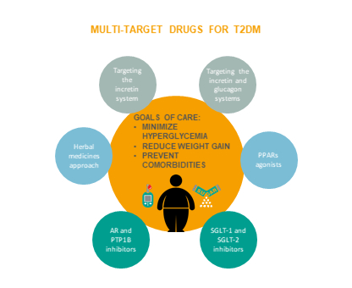
Currently, GLP-1R agonists and DPP-4 inhibitors, two classes of anti-diabetes medications that target GLP-1 receptor (GLP-1R) signalling, have been created.
- GLP-1R agonists – Exenatide, Lixisenatide, Albiglutide, Dulaglutide and Semaglutide
- DPP-4 inhibitors –Sitagliptin, Vildagliptin, Saxagliptin, Linagliptin and Alogliptin
Among the many benefits of targeted therapies based on GLP-1R agonists and DPP-4 inhibitors are the following:
- Encourage the release of insulin and have lower risks of hypoglycemia than other diabetes treatments like sulphonylureas.
- Reduce the loss of pancreatic beta cells and postpone the progression of diabetes.
- Offer cardiovascular and renal protection.
Puerarin, Astragalus polysaccharides, and Berberine have been shown by some researchers to improve type 2 diabetes, highlighting the potential value of conventional Chinese medicines as anti-diabetic agents.
Targeted Treatment of CKD
A chronic kidney disease is characterised by abnormalities in kidney structure or function lasting longer than three months and having an impact on health. High incidence and mortality rates as well as low awareness levels are linked to CKD. Additionally, strategies to stop the growth or worsening of CKD are currently being implemented insufficiently. Current CKD treatments only slow the disease's progression, and the cost of care can be prohibitive for patients. In the progression of CKD, glomerular cells are particularly affected, along with endothelium cells, podocytes, macrophages, and tubular epithelial cells.There is a lot of research being done on creating new therapies to treat CKD, some of which include:
- Gary et al. recently showed that carboxymethyl-terminated poly (20–200nm) modified nanoparticles can more effectively deliver drugs to the kidney for the treatment of glomerular kidney disease, allowing a higher concentration of drug to accumulate in diseased glomeruli.
- Bruni et al. produced new drug-loaded ultra-small colloidal nanocarriers with a tunable size of 5–30 nm using four-arm star-shaped polymers as their raw material. These ultra-small colloidal nanocarriers can decrease albumin permeability in vitro drug models and repair podocyte damage.
- According to Tripathy et al., transdermal microneedles can target the folate receptors on renal epithelial cells in vitro.
- Li et al. developed a system to deliver Celastrol (CEL) specifically to interstitial myofibroblasts using PEGylated liposomes (CREKA-Lip), which have a high affinity for the fibronectin-binding pentapeptide Cys-Arg-Glu-Lys-Ala (CREKA). CREKA-Lip accumulates in fibrotic kidneys after systemic administration in mice with unilateral ureteral obstruction, effectively treating renal fibrosis, injury, and inflammation with less toxicity to other major organs than free CEL.⁽⁴⁾
Targeted Treatment of COPD
Over 250 million people worldwide suffer from chronic obstructive pulmonary disease (COPD), which is the third leading cause of death globally. Therapeutic methods for COPD can only now reduce symptoms. Targeted therapies may offer patients with COPD new treatment options and serve as vital adjuvant therapies. Lung administration of targeted therapies has a number of benefits over oral administration, including faster absorption rates, a concentrated distribution of metabolic enzymes throughout the lung, and slower rates of active ingredient degradation.
According to studies, drug delivery systems that generate more particles with a diameter of between 1.0 and 3.0 m cause more of the drug to settle in the alveoli and bronchioles, improving therapeutic effects. The diameter of the drug delivery particles has a significant impact on how the drug is deposited in the respiratory system.⁽⁵⁾
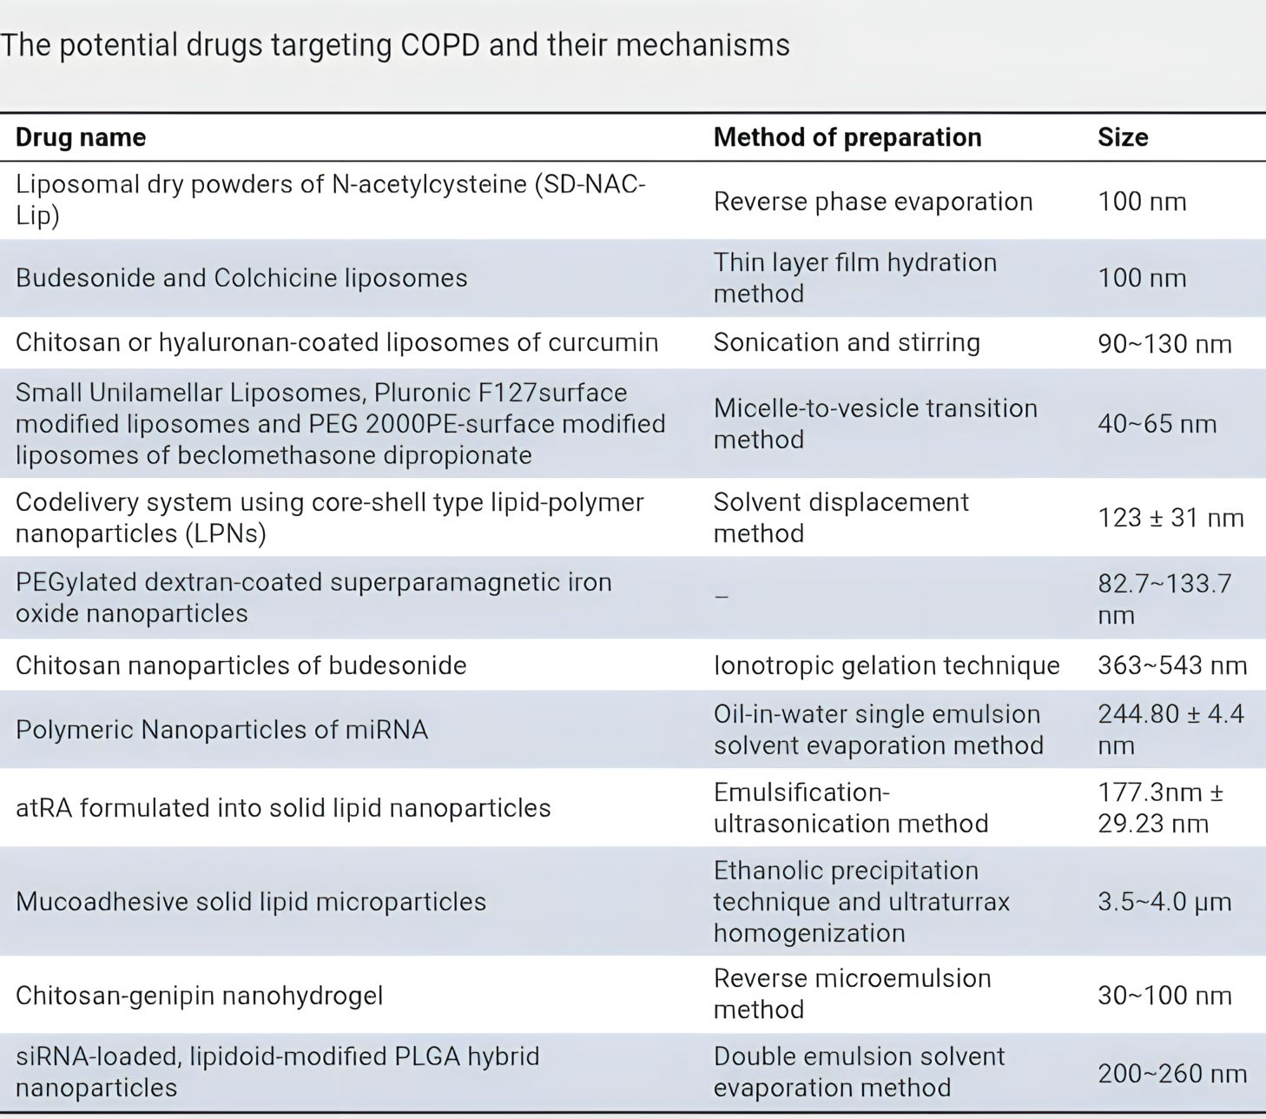
Targeted Treatment of CAHD
Atherosclerotic lesions in the coronary arteries that stenosis or obstruction of the vascular lumen, causing myocardial ischemia, hypoxia, or necrosis, and causing heart disease are the main pathogenesis of coronary atherosclerotic heart disease. Worldwide, the incidence and mortality rates of coronary heart disease are rising yearly, resulting in significant economic costs.
Lipid deposition and macrophage infiltration in the arterial wall, which cause chronic inflammation, are the primary causes of coronary atherosclerosis. As a result, one of the most important targets for the treatment of coronary heart disease is inflammation. There are currently no specific anti-inflammatory medications available for CAHD patients, and drug therapy for the condition is mainly focused on reducing risk factors and administering antithrombotic therapy.⁽⁶⁾
- A monoclonal anti-IL-1 antibody called canakinumab has the ability to reduce IL-1-mediated inflammatory reactions. Additionally, IL-1 can stimulate the production of endogenous platelet-derived growth factor (PDGF) and the proliferation of smooth muscle cells by activating downstream IL-6 receptor transduction pathways.
- Tocilizumab, an IL-6 inhibitor, can stop this inflammatory cascade and slow the development of atherosclerosis.
- Even with high levels of total cholesterol and low-density lipoprotein, tozizumab can significantly improve endothelial function in high-risk rheumatoid arthritis while reducing IL-6 activity.

References
1.Tewabe A, Abate A, Tamrie M, Seyfu A, Abdela Siraj E. Targeted Drug Delivery — From Magic Bullet to Nanomedicine: Principles, Challenges, and Future Perspectives. JMDH. 2021 Jul;Volume 14:1711–24.
2.Junyi K. Future Prospects of Targeted Drug Delivery System.
3.Kanwal A, Kanwar N, Bharati S, Srivastava P, Singh SP, Amar S. Exploring New Drug Targets for Type 2 Diabetes: Success, Challenges and Opportunities. Biomedicines. 2022 Jan 31;10(2):331.
4.Breyer MD, Susztak K. The next generation of therapeutics for chronic kidney disease. Nat Rev Drug Discov. 2016 Aug;15(8):568–88.
5.Anderson D. Targeted treatment in COPD: a multi-system approach for a multi-system disease. COPD. 2009 Aug;321.
6.Xu M, Zhang K, Song J. Targeted Therapy in Cardiovascular Disease: A Precision Therapy Era. Front Pharmacol. 2021 Apr 16;12:623674.
7.Jain KK. Current Status and Future Prospects of Drug Delivery Systems. In: Jain KK, editor. Drug Delivery System [Internet]. New York, NY: Springer New York; 2014 [cited 2023 Jul 31]. p. 1–56. (Methods in Molecular Biology; vol. 1141). Available from: https://link.springer.com/10.1007/978-1-4939-0363-4_1
8.Gao J, Karp JM, Langer R, Joshi N. The Future of Drug Delivery. Chem Mater. 2023 Jan 24;35(2):359–63.

