EXOSOMES - NATURALLY OCCURING DRUG DELIVERY VEHICLES: AN INSIGHT
T. Naga Aparna,
Assistant Professor,
Department of Pharmaceutics,
Sri Indu Institute of Pharmacy,
Sheriguda, Ibrahimpatnam,
INDIA
nagaaparna4@gmail.com
naga_aparna@yahoo.co.in

ABSTRACT
Exosomes are small intracellular membrane-based vesicles with a diameter of 40-100 nm that are secreted into the extracellular milieu by many cell types and are involved in a variety of physiologic and pathological processes. Exosomes offer significant advantages over other nanoparticulate drug delivery technologies such as liposomes and polymeric nanoparticles; exosomes are non-immunogenic in nature due to their similar composition to the body's own cells. Exosomes have a high potential for use as drug delivery vehicles because of their natural material transportation properties, intrinsic long-term circulatory capability, and excellent biocompatibility, making them suitable for delivering a wide range of chemicals, proteins, nucleic acids, and gene therapeutic agents. However, significant concerns and challenges remain, such as producing exosomes on a large scale for clinical application, determining which cell type to employ for exosome derivation, and determining in vivo exosome potency and toxicology. Exosomal therapeutics must be clinically translated by improving our understanding of exosome biology and function and developing nanotechnologies to precisely separate well-characterized clinical-grade exosomes and load them with a variety of therapeutic payloads.
Key Words: Drug Delivery Vehicle, Therapeutic agent, Nano technology, Biocompatible, Clinical application
INTRODUCTION
Chemical messengers are the primary means through which cells communicate with one another. Extracellular vesicles (EVs) are the most common type of these. Because of their unique structure, EVs can be modified to contain specific proteins, genetic lipids, and genetic materials such as messenger RNA (mRNA), microRNA (mRNA), and other small non-coding RNAs, and genomic DNA (gDNA) from their progenitor cell.[1]
Apoptotic bodies, Microvesicles, and Exosomes are the three categories of EVs based on their intracellular origins. Apoptotic bodies are 50 to 5000 nm in size and include biological components such deoxyribonucleic acid (DNA), ribonucleic acid (RNA), and histone proteins. Apoptotic bodies convey these contents to macrophages during apoptosis, resulting in cell engulfment [2,3]. Other names for microvesicles include ectosomes, shedding vesicles, microparticles, plasma membrane-derived vesicles, and exovesicles. Microvesicles range in size from 50 nm to 1000 nm and are generated by the outward budding and fission of plasma membranes. When microvesicles are created, they transport certain proteins and lipids to a selected destination cell [4]. Exosomes, the final class of EV, vary from microvesicles primarily in their intracellular origin and size (Fig 1). Exosomes are thought to be the most promising as a method for medication delivery to targeted organs due to their nanoscale dimensions, hence they have gained the greatest scientific focus in recent years.
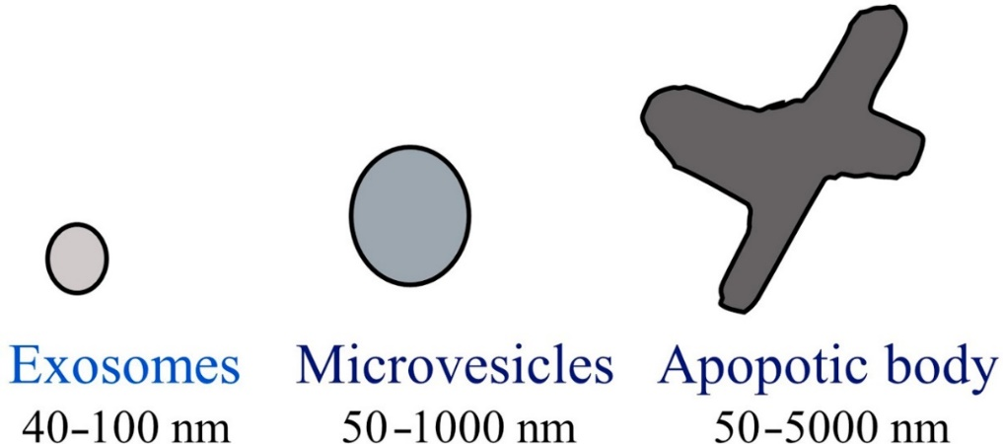

Fig 1. Types of Microvesicles
- Discovery of Exosomes
Rose Johnstone and her colleagues coined the term "exosome" in 1970. They observed the production of "an intracellular sac filled with small membrane-enclosed structure of nearly uniform size" while dealing with maturing reticulocytes. In contrast to endocytosis, when external molecules are internalised into the membrane-bound structure, they formed intracellular vesicles and discharged contents outside the cell. As a result, these intracellularly produced vesicles were given the name "EXOSOME" [5].

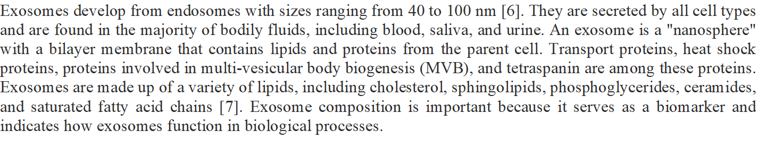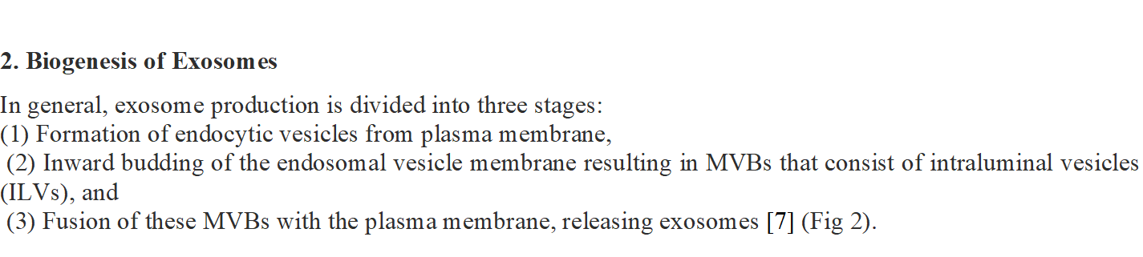Early endosomes are produced from plasma membrane endocytic vesicles and mature into late endosomes. Late endosomes create lumen vesicles by budding inward. MVBs are late endosome ILV accumulations. Two pathways produce MVBs. ESCRT-dependent and ESCRT-dependent pathways exist. MVBs can merge with lysosomes to destroy them or with the plasma membrane to release ILVs as exosomes [8].
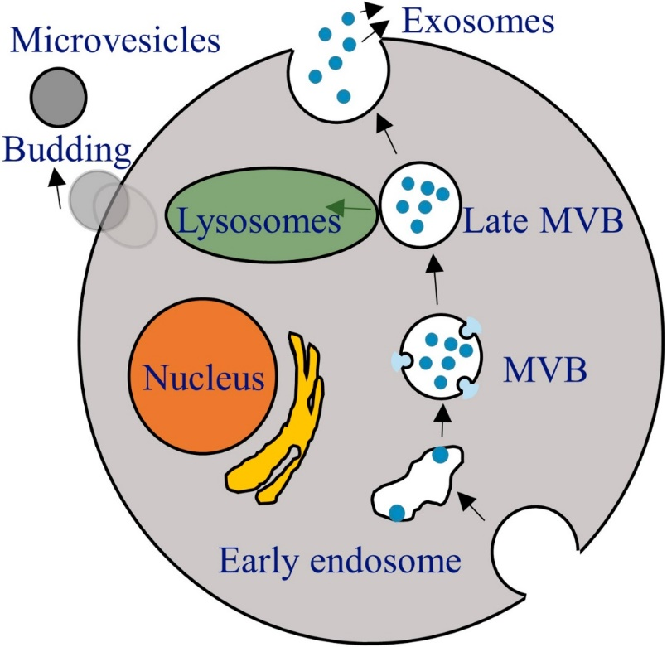
Fig 2. Formation of Exosome and Microvesicle.
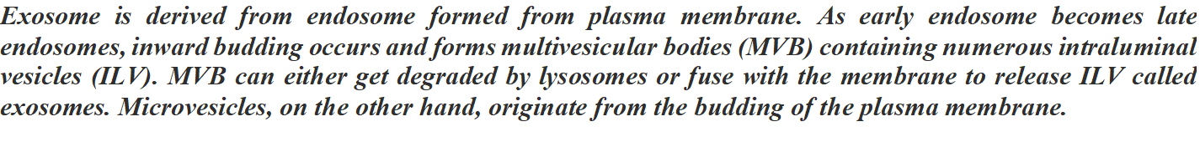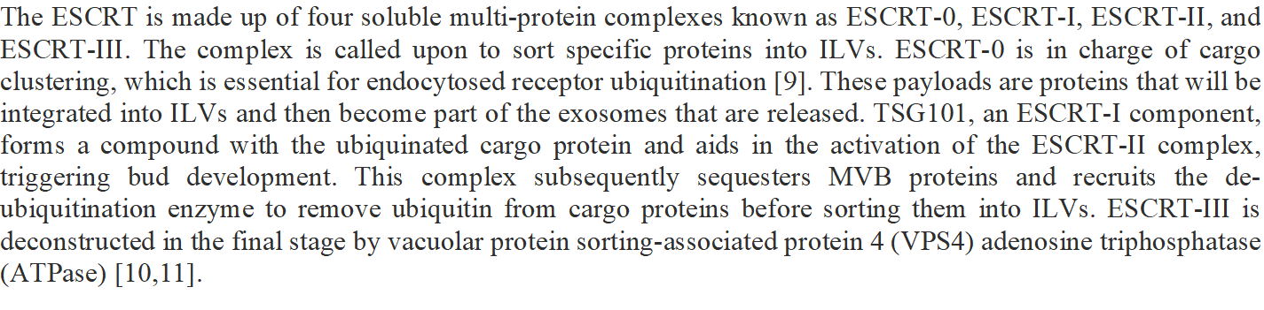Exosome secretion can be inhibited by chemicals that inhibit ESCRT, according to research. Four independent studies, for example, found that inhibiting the HRS member of ESCRT-0 reduced exosome secretion in a variety of cell types, including Henrietta Lacks cells (HeLa)—a cancer human epithelial cell lineage, mouse dentritic cells, human embryonic kidney cell line 293 (HEK293), and squamous carcinoma cells [12-15]. TSG101 deletion has also been found to inhibit exosome release in tumour cells and immortalised retinal pigment epithelial cells 1 (RPE1) [12,16]. Furthermore, despite ESCRT suppression, multiple investigations have shown the generation of exosomes, indicating the existence of an ESCRT independent mechanism. Lipids, tetraspanins, and heat shock proteins are among the components involved in this separate mechanism [17]. It has been postulated that lipids like as ceramides cause the inward curving of the limiting membrane of MVBs, resulting in the formation of ILVs. Cholesterol and phosphophatidic acid are two more lipids linked to the production of exosomes via ESCRT-independent pathways. Aside from lipids, proteins like tetraspanins have been linked to exosome cargo sorting [18] and the integration of melanosomal proteins into ILVs in an ESCRT-independent way [19].
3. Fundamentals of the Exosomes

3.1. Structure and Composition of Exosomes
Exosomes build a phospholipid outer coat, and the inner core contains a collection of chemicals that are biologically active. Proteins, lipids, nucleic acids, and glycoconjugates make up exosomes. (Fig 3).
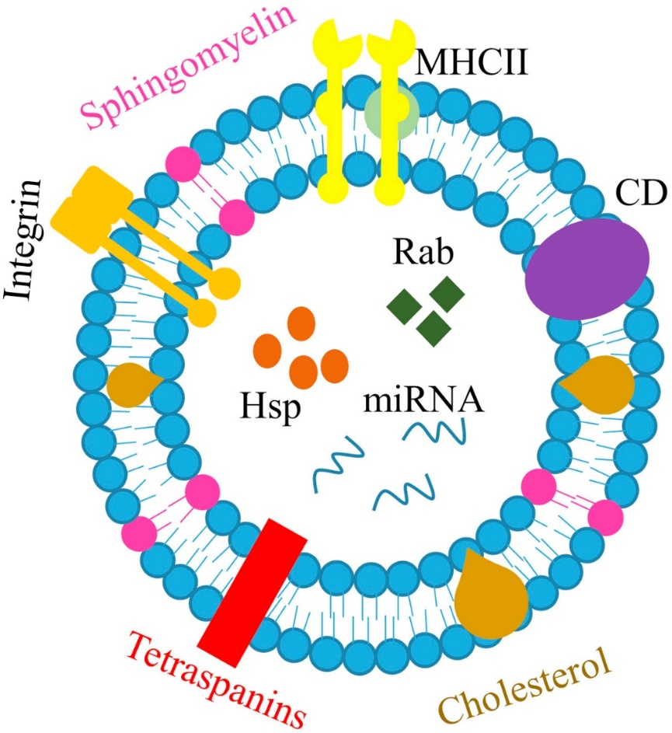
Fig 3. Exosome composition
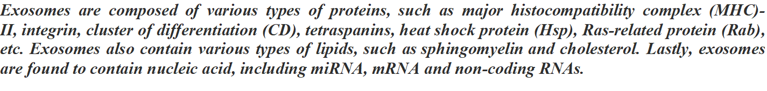

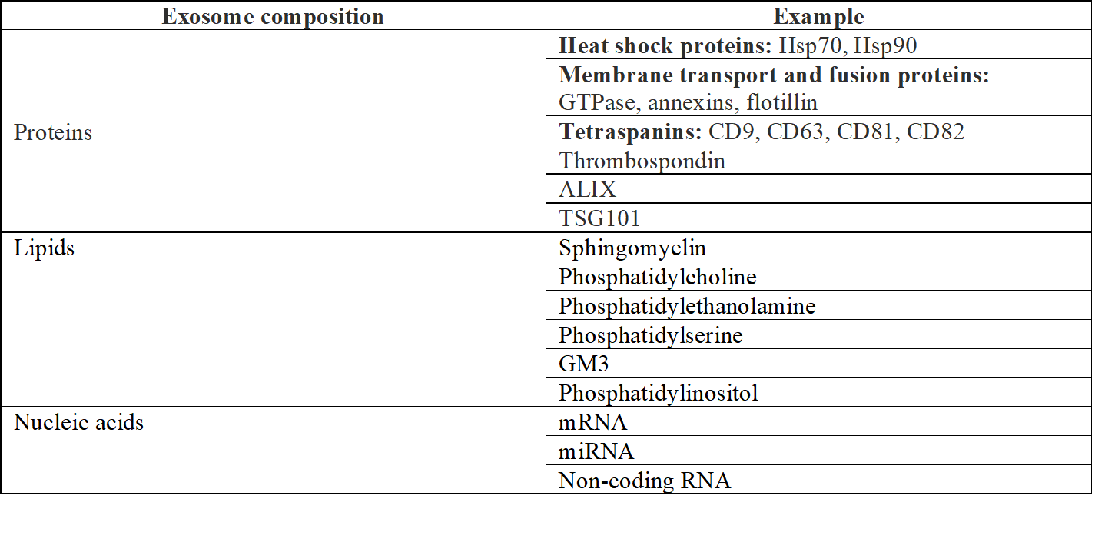
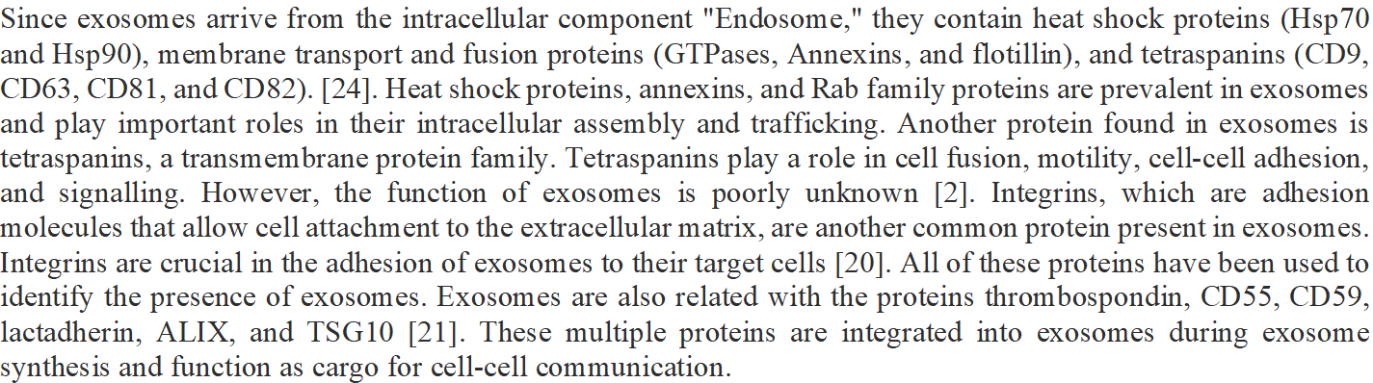

Exosomes contain lipids and proteins. Exosome lipid bilayers are mostly composed of lipids found in cell plasma membranes, such as sphingomyelin, phosphatidylcholine, phosphatidylethanolamine, phosphatidyl serine, mono sialo tetra hexosyl ganglioside (GM3), and phosphatidylinositol [22]. Sphingo-myeline and GM3 are responsible for exosome rigidity [23], whereas phosphatidylserine is expressed on the plasma membrane of exosomes via several phospholipid transporter enzymes. It is crucial in binding the outside proteins, allowing the exosome to communicate and fuse with the plasma membrane [24]. Cholesterol, ceramide, phosphoglycerides, and saturated fatty acids form exosomes. Exosomes include miRNA, mRNA, and non-coding RNAs.

3.2. Exosome Sources
Exosomes are separated from biological fluids such as blood, urine, and saliva. [25,26] They can also be obtained from the tumour microenvironment, as tumours produce a greater number of exosomes than normal cells. Exosomes can also be produced by HEK293 cells (human embryonic kidney cells), HeLa cells, and a variety of other cells. Exosomes, in addition to being a source of cancer, are also a source of other important chemicals. The primary sources of vaccine development are DCs, NKs, and exosomes secreted by tumour cells. Exosome-based cancer vaccines derived predominantly from mesenchymal stem cells and macrophages have also been reported. [27,28]
3.3 Isolation and characterization of exosomes
Differential centrifugation, filtration, size-exclusion chromatography, and polymer precipitation are used to isolate exosomes (Fig. 4). An immunomagnetic isolation approach targeting exosomal markers can be used to extract ultrapure exosomes or isolate a possible subpopulation of exosomes.

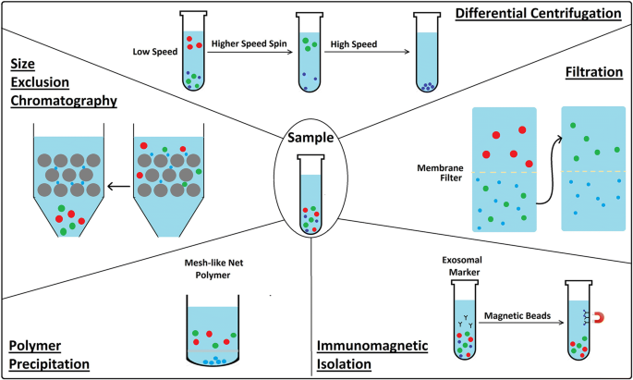
Differential centrifugation
Differential centrifugation is the most used method for isolating exosomes from bodily fluids and is consistent. A low-speed centrifugation removes cells and apoptotic debris, a higher-speed spin removes larger vesicles, and a high-speed spin precipitates exosomes.
Analysing plasma and serum reduces technique efficiency. Each rotor type must optimise centrifuging speed and time to maximise EV collection. [29].

Filtration
To separate cells and big EVs in biological samples, utilise commercial membrane filters or polycarbonate. Ultracentrifugation is frequently employed in conjunction with filtration techniques to separate exosomes from proteins. Membranes are utilised to sift cells and big EVs. A number of research teams have looked into commercial ultrafiltration as a way to separate exosomes from protein impurities in order to do away with the necessity for ultracentrifugation. Using matrices with set molecular weight or size exclusion criteria, exosomes can be isolated from other soluble proteins and aggregates. Based on a molecular weight larger than 2 million Daltons and a diameter less than 200 nm, these vesicles can be extracted selectively. This makes it possible to separate exosomes from smaller aggregates and soluble components [30].

In size-exclusion chromatography (SEC), often referred to as molecular sieve chromatography, various substances are separated based on their hydrodynamic volume, which is determined by how well they enter the pores of the stationary phase. Two fundamental types of size exclusion chromatography exist. The procedure is known as gel permeation chromatography (GPC) when carried out using organic solvents. GPC's primary area of use is polymer analysis. Gel filtration is the term used to describe size-exclusion chromatography that is carried out with aqueous solvents. This method has three drawbacks:
(1) the chromatography column is susceptible to contamination, so aseptic working conditions must be maintained, especially if the isolated EVs are intended for therapeutic use;
(2) numerous fractions must be collected and analysed to ensure complete separation of EV subtypes and contaminating proteins; and
(3) in contrast to the separation protocol's simplicity and time effectiveness, post-isolation amplification is required.[31]

Polymer precipitation
Polymers are isolated and purified via a process called polymer precipitation. The foundation of polymeric precipitation techniques is the development of a mesh-like net into which EVs with sizes ranging from 60 to 180 nm are included. These techniques can be used on body fluids or on culture media. Polymeric precipitation techniques may be particularly advantageous for finding biomarkers in vesicles made from tiny biological samples [32].

The exosomes are separated from other substances using the immunoisolation or immunoaffinity approach, which employs magnetic beads covered with antibodies to recognise specific proteins on the lipid bilayer membrane [33]. According to reports, biomarkers including CD34, CD63, and CD326 are frequently employed to identify human exosomes, tumour exosomes, and acute myeloid leukaemia blasts, respectively [34]. An immunoaffinity isolation tool (microplate-based ELISA) can isolate exosomes using tetraspanin proteins and exosome surface markers, which are hypothesised to determine immunoisolation. [35]. The immunoisolation approach is better than ultracentrifugation in capturing a tiny amount of plasma with excellent specificity. As a result, it is frequently utilised to further separate the particular exosomes that have already been isolated using conventional methods. However, this method can be used to isolate exosomes that are particular to the desired biomarkers [36,37].

The separation of exosomes has recently been made possible via microfluidics-based chip isolation techniques. These techniques are based on the distinction between the exosomes' physical and biochemical characteristics, including their size, density, and immunoaffinity. The three purification and isolation techniques utilising microfluidics-based chip isolation techniques are immunoaffinity for exosome trapping techniques, sieving techniques, and exosomes being adsorbed into the porous structure techniques [79]. All three methods necessitate sample preparation processes performed off-chip, such as reagent mixing and plasma extraction, which raises the level of processing complexity. This method specifically entraps exosomes that are between 40 and 100 nm in size, and the exosome specificity is strong, especially for the microfluidic-chip-based immunoaffinity capture approach. Exosomes can be separated from whole blood using the sieve method based on pressure or electrophoresis [80]. Some benefits of this technology are low cost, mobility, and quick sample processing. The capacity to effectively separate, purify, and inexpensively generate exosomes in large enough quantities, however, would restrict the use of this approach in clinical applications.

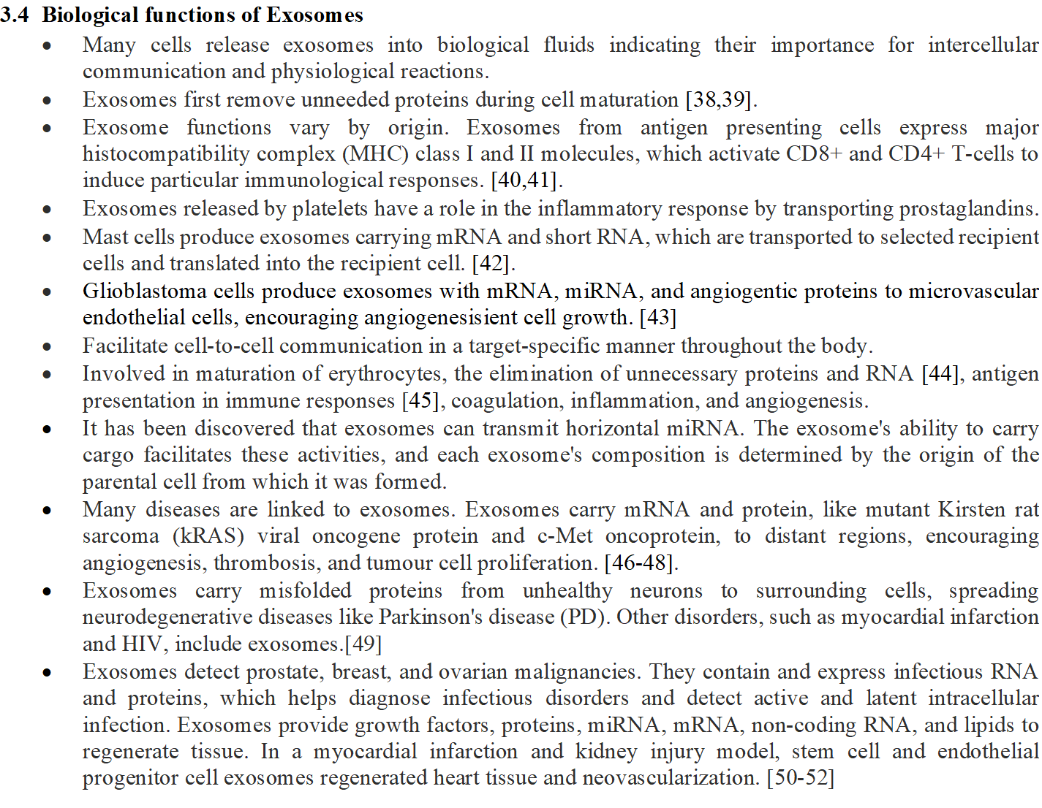3.5 Exosome Cellular Recognition
There are three different mechanisms for cells to recognise exosomes: free floating, adhesion, and antigen recognition. Similar to liposomes, exosome cellular recognition by free floating may be mediated by opsonization of exosomes during circulation. Leukocytes are drawn to the exosomes' location by chemokines. A wide variety of chemokines that are expressed by exosomes may draw T cells and other cell types.
Exosome adhesion is the first step in exosome-T cell interaction. Exosome adhesion requires the conformational change of integrins from low affinity to high affinity, which allows oligomerization and coupling with cytoskeletal components.
According to molecular profiling and proteomic study, target cell specificity for exosomes is determined by a combination of antigen and MHC class I and II molecules in the case of cellular identification by antigen recognition. Exosome MHC expression is reliant on the parent cell's expression of these molecules. [12].

3.6 Exosome uptake
Exosome uptake can be described as a three-step process that involves receptor interaction, membrane fusion, and endocytosis/phagocytosis to deliver exosome signals to the destination cell (Fig. 5). Numerous studies have also suggested that internalisation, which is influenced by cell type and exosomal surface proteins, is the main way of exosome uptake. Exosome uptake by a recipient cell is cell-specific, and exosome targeting and adherence depend on the interaction of certain cells' surface chemicals with exosomes [13].

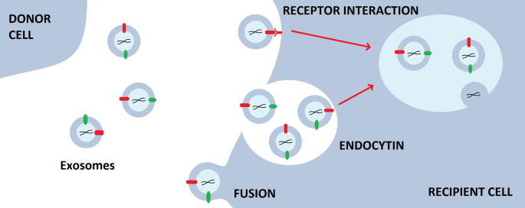
3.7 Derived Exosomes
Progenitor cells determine exosome functions. Exosome roles have been studied extensively.
Macrophage-derived exosomes
Since their discovery, macrophages have been recognised for their phagocytic activity in the immune system of the body [55]. As they identify and eradicate harmful microbial products and tumour cells, they play a critical part in the prevention of the progression of many diseases [56]. They contribute significantly to heart damage both as an inflammatory component and as a primary regulator.

The purpose of recent research has been to understand the function of exosomes produced by macrophages. The findings indicate that the connection between the integrins ICAM-1 and LFA-1 was responsible for the unbiblical vein endothelial cell's uptake of macrophage exosomes, and that the c-type lectin receptor mediated this process in hCMEC/D3 cells. The study also discovered that macrophage exosomes can cross the blood-brain barrier to reach the brain parenchyma in healthy mice; they can even enter the brain on their own, without the assistance of immune cells that have infiltrated the brain, and the increased accumulation in the inflamed brain was caused by improved exosome-brain endothelium interaction.[57]

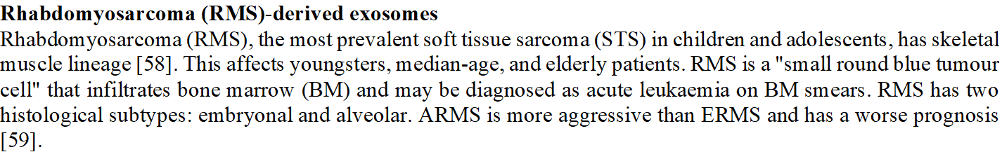
Rhabdomyosarcoma cells release exosomes. Exosomes can transport cancer signalling network-related miRNA. RMS-derived exosomes increase human recipient fibroblast and RMS cell proliferation. Exosomes enhance angiogenesis and normal human fibroblast migration and invasion. [60].

Exosomes affect tumour growth, angiogenesis, invasion, metastasis, and cell motility. They enhance cell development, adhesion, and polarity [61]. Aggressive cancer cell exosomes can impact endothelial cells and metastatic tumour morphology and function. Thrombin-exporting exosomes mediated intracellular communication. Exosomes trigger recipient cell RhoA/Rock pathway [62]. Exosomes modulate host stromal responses to create a protumorigenic or antitumorigenic environment [63].

Malignant mesothelioma, which develops from uncontrolled cellular growth of mesoderm tissue lining the chest, heart, lungs, abdominal cavity, and intra-abdominal organs, is rare [64]. Asbestos-related mesothelial pleural or peritoneal cancer is aggressive and has a poor prognosis. Malignant mesothelioma is fatal and difficult to treat due to its low occurrence, resistance to most chemotherapies, and tumour intricacy. The 5-year survival rate for peritoneal mesothelioma is less than 15%, and pleural tumour survival is less than 1 year [65].

Human malignant mesothelioma cell exosomes immune-regulate cancer progression. They govern tumour microenvironment recipient cells and include metastatic factors. MM-derived exosomes contain 111 immunoregulation-related proteins, 26 of which were found in mEXOS, including OSMR, ABCC1, and SAE1. OSMR, a multifunctional cell surface cytokine receptor, promotes malignancy by increasing cell motility, invasiveness, and angiogenesis [66].

Osteoclast-derived exosomes
Hematopoietic/monocytic lineage osteoclasts are large multinucleated cells that specialise in bone resorption and bone remodelling [67]. They are tightly coupled to primary osteogenesis cells (osteoblasts). MCSF and RANKL from osteoblasts and osteocytes influence myeloid precursors to become osteoclasts. Osteoprotegerin (OPG) from the osteoblast lineage inhibits osteoclast development. Osteoclasts polarise proteolytic enzyme and acid secretion, degrading bone. They hydrolyze and solubilize bone organic and inorganic components [68].

Exosomes release miR-214 to decrease osteoblast activity during osteoclastogenesis. Osteoclast effects on osteoblasts are reduced by exosome inhibition. Cell recognition molecules on exosomes help recipient cells target and absorb them. MiR-214-containing exosomes inhibit osteoblasts via linking. Osteoclast-derived ephrinA2 acts on osteoblasts through its Eph receptor [69].

Smoking, obesity, frequent drinking, and a family history of pancreatic cancer might cause it [70]. Pancreatic cancer is difficult to treat due to its rapid progression, lack of early symptoms, and low response to standard therapy. Pancreatic cancer cells (PCCs) release exosomes to communicate [71].
Cancer cells alter nearby and distant cells via secreting exosomes. PCC-derived exosomes enhance cancer cell proliferation and migration. PCC-derived exosomes also activate and profibrogenize pancreatic stellate cells [72].
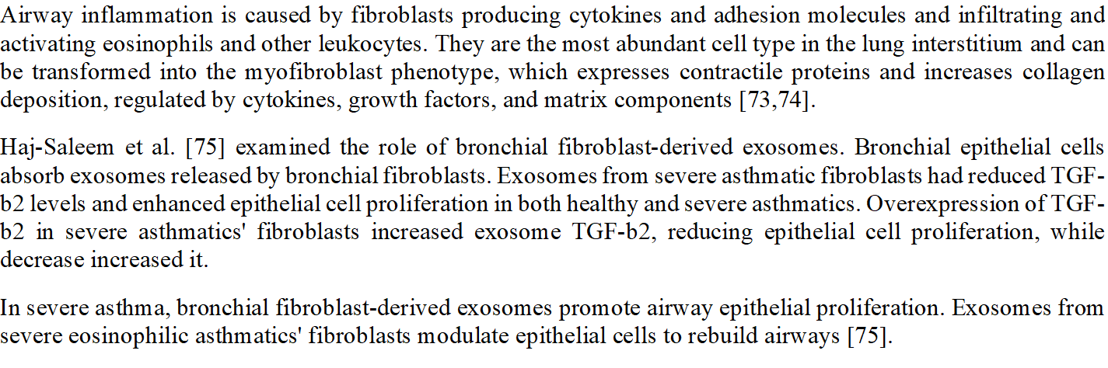MSC are heterogeneous stromal regeneration cells that can be collected from different adult organs [76,77].
MSC-derived exosomes transport nucleic acids, proteins, and lipids. MSC-derived exosomes, rich in proteins and RNAs, can maintain tissue homeostasis and respond to external stimuli. Another study found MSC-derived exosomes may treat liver disease. MSC-derived exosomes may protect against myocardial I/R injury by anti-apoptosis, cardiac regeneration, cardiac remodelling, anti-inflammatory effects, neovascularization, and anti-vascular remodelling [78].

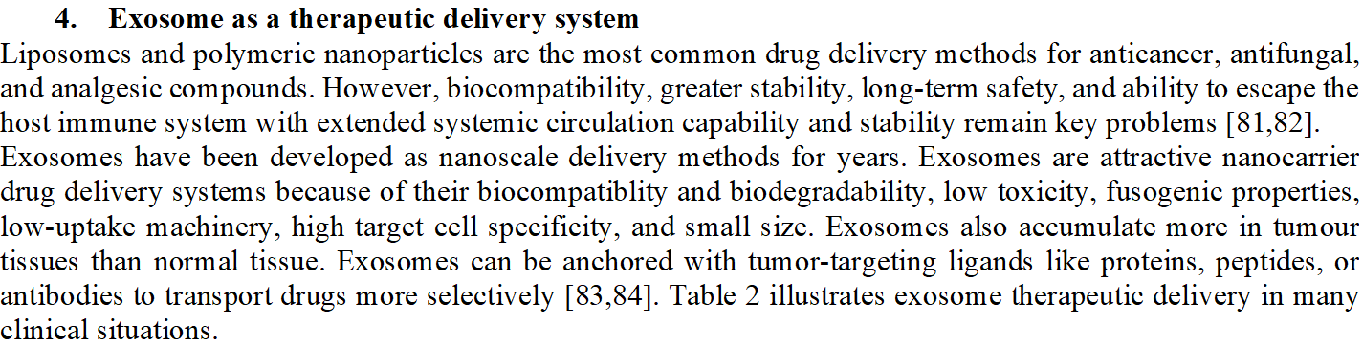

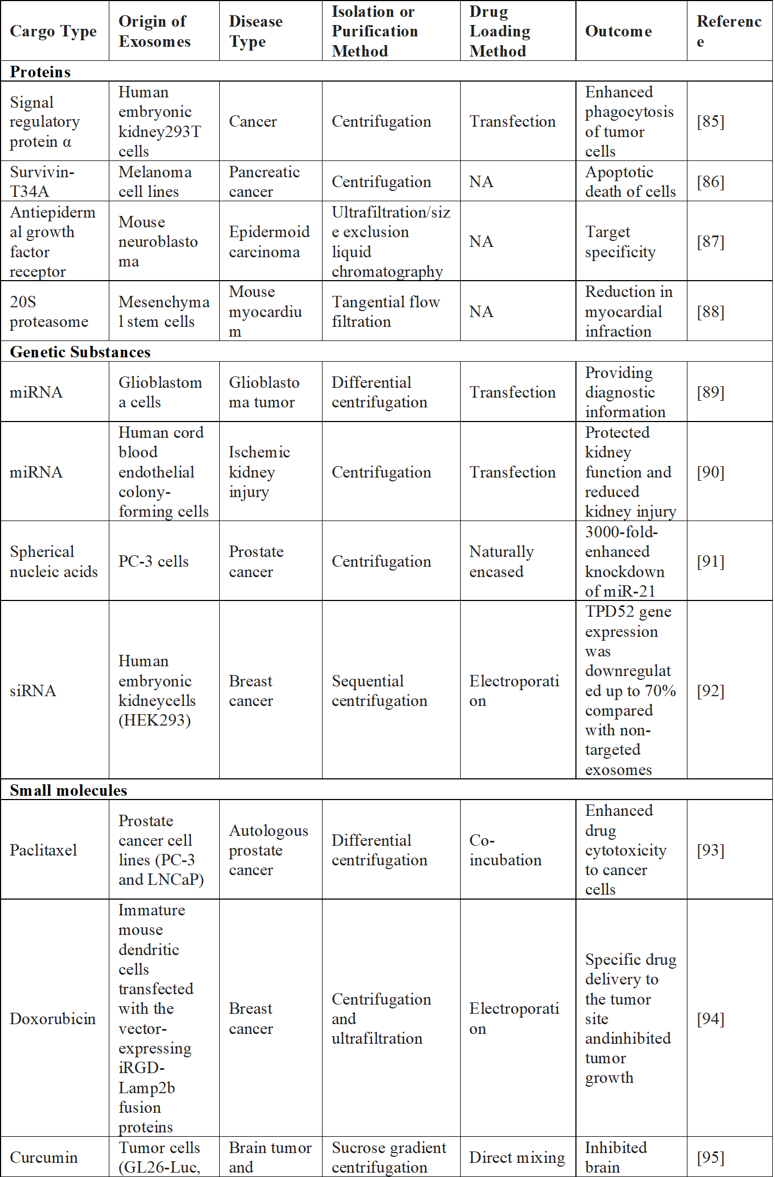
4.1. Protein and Peptide Delivery
Protein or peptide delivery using exosomes is advantageous. Exosomes were initially studied as a garbage bin collecting cell-unwanted proteins, lipids, and nucleic acids. Exosomes have carried biological substances for diagnostic and therapeutic reasons for years. Most cells' exosomes carry endogenous protein molecules, suggesting they could transfer proteins or peptides. Exosomes deliver enzymes, transmembrane, and cytoskeletal proteins. Exosome vesicles can carry macromolecules like lipids, proteins, and genetic material from mother cells to neighbouring cells [97].

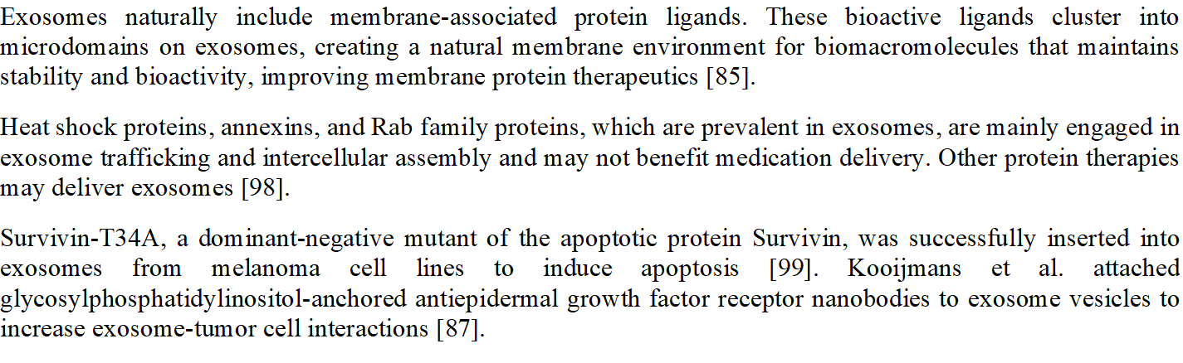
GALA-modified exosomes were made by mixing dendritic cell-derived SAV (a protein that binds biotin with high affinity) and LA (an exosome-tropic protein) with pH-sensitive GALA peptides. These modified exosomes affect tumour cell intercellular trafficking and antigen presentation [100]. Alphagalactosylceramide or ovalbumin-loaded exosomes may also produce an adaptive immunological response without inducing natural killer T-cell anergy [101].
Tian et al. [102] attached exosomes to the c(RGDyK) peptide utilising bio-orthogonal chemistry to cure ischemic stroke by targeting the brain lesion. These modified exosomes also contained curcumin to reduce inflammation and cellular death in the lesion. cRGD–exosome administration showed promising therapeutic effectiveness and targeting in vivo.
Cytosolic proteins like tubulin and actin, protein kinases, Annexin and Rab family proteins, tetraspanins (CD9, CD63, CD81), heat shock proteins (HSP 70, HSP 90), and transmembrane proteins are found in all exosomes [103]. Antigen-presenting cell exosomes mimic CD8+ and CD4+ T cells by carrying tetraspanin CD86 and major histocompatibility complex components I and II. Pathogen-associated molecular patterns on the exosome membrane may activate immune cells [104]. New vaccine formulations may use exosomes to boost and modify immune responses. Nanoscale exosomal vesicles can activate granulocytes or NK cells and interact with CD8+, CD4+, and B cells to produce antigen-specific immune responses [105].
Sandra et al. [106] examined exosomes as vaccine adjuvants. LPS-stimulated THP-1 human monocytic cells produced exosomes. HBsAg-loaded poly--caprolactone–chitosan nanoparticles and isolated exosomes were homogenised. Exosomes containing HBsAg generated a humoral immune response similar to the control group. Their study suggests that exosomes co-ingested with antigens may increase vaccination immune responses.
Exosomes were tested for neuronal recovery following ischemic stroke by Liu et al. [107]. To target the BBB, enkephalin-tar-exo exosomes were created. In a transient middle cerebral artery occlusion–reperfusion scenario in rats, enkephalin-tar-exo penetrated the BBB and lowered lactate dehydrogenase, p53, and caspase-3. The enkephalin-tar-exo system also increased brain neuron density and neurological score following stroke.
Trastuzumab–emtansine was delivered to HER2-positive malignancy by Barok et al. [108]. Ultracentrifugation and trastuzumab–emtansine therapy identified exosomes from HER2+ (SKBR-3 and EFM-192A breast cancer), HER2 (MCF-7 breast cancer), and gastric cancer (SNU-216) cell lines. Trastuzumab–emtansine bound to HER2+ cancer cells via antibody–drug-conjugated exosomes, inhibiting proliferation and activating caspase-3.
Cho et al. [85] compared the efficacy of exosomes and the ferritin nanocage carrier in signal regulatory protein α delivery. Because macrophages phagocytose tumour cells more than nanocages, exosomes inhibited tumour growth more than nanocages. Exosome vesicles may have an advantage over alternative delivery platforms because their abundance of proteins and lipids creates a perfect membrane protein activity and distribution milieu.
Exosomes' assembly, binding, fusion with targeted cells, and interactions with the extracellular matrix are complex. For example, paraformaldehyde-mediated crosslinking of proteins on exosome surfaces decreased fusion with parental cells by 20%. Exosomes solubilized with octylglucoside and rebuilt by dialysis to remove membrane proteins were less able to merge with target cells [109]. Exosomes with decreased proteins showed comparable fusion efficacy to large unilamellar vesicles with lipid compositions identical to natural exosomes, indicating the role of exosome-associated proteins in fusion events. Kim et al. [110] investigated genetically engineered exosomes that express a targeting ligand to increase exosome delivery to a target organ and reduce systemic toxicity. Briefly, cardiac-targeting peptide, a targeting ligand generated from genetically modified exosomes, was tested for tissue and heart cell delivery in vitro and in vivo. Exosomes obtained from HEK293 cells by differential centrifugation were genetically edited by fusing cardiac-targeting peptide (CTP)–Lamp2b on the membrane (CTP–Exo), while CTL–Exos were used as controls. H9C2 rat cardiomyocytes delivered more CTP–Exo than CTL–Exo in the in vitro investigation. CTP–Exo delivered 15% better than CTL–Exo in vivo, indicating that genetic alteration of exosomes with targeting peptides can be used to treat heart disorders due to improved delivery and less systemic toxicity. Exosomes containing catalase improved Parkinson's disease in patients after crossing the BBB. Catalase distribution over the BBB is difficult, however putting it into the exosome carrier system may help treat Parkinson's disease.
Haney et al. [111] used incubation with or without saponin permeabilization, freeze–thaw cycles, extrusion, and sonication to integrate catalase into exosomes. Western blot examination showed that extrusion and sonication best incorporate catalase into exosomes. To validate BBB catalase delivery, exosomes were labelled with lipophilic fluorescent dye. Pheochromocytoma (PC12) cells were treated with fluorescent exosomes. Confocal pictures showed PC12 cells absorbing labelled exosomes. In in vitro-activated macrophages, exosomal catalase neutralised reactive oxygen species (ROS).
4.2. Exosomes in Gene Delivery
Exosomes deliver DNA and RNA to targeted cells, causing genetic changes in physiologic and pathological processes. Exosomes are used as medication delivery vehicles to deliver therapeutic genetic elements that change gene expression in certain disorders and improve genetic therapy.

4.2.1 Small interference RNA (siRNA)
Genetic treatment disrupts genes with siRNA. However, these siRNA breakdown swiftly in the systemic circulation. However, exosomes protect and distribute siRNA to targeted cells. Exosomes may deliver exogenous siRNA, but additional research is needed. The first published study, by Alvarez-Erviti et al.[112], used exosomes to deliver siRNA to mouse brains. Another work used human exosomes to deliver siRNA to T and monocytes [113]. Safe, effective, and target-specific genetic material delivery vehicles are scarce. That study sought to deliver gene therapy vectors. Exosomes are non-immunogenic and naturally transfer RNA between cells. The study sought a gene therapy vector delivery mechanism.

Differential centrifugation was used to isolate exosomes from healthy donor peripheral blood, TB-177 lung cancer cells, and HeLa cells. Chemical transfection and electroporation introduced siRNA into exosomes. Chemical transfection was ineffective and inconclusive. Western and northern blotting, confocal imaging, and flow cytometry revealed siRNA was introduced into exosomes. Plasma exosomes were electrophoretically transfected with Alexa Fluor 488-tagged siRNA against mitogen-activated protein kinase 1 (MAPK-1) and co-cultured with healthy donor peripheral blood monocytes and lymphocytes. Exosomes fluoresced siRNA in recipient cells' cytoplasm. Flow cytometry confirmed siRNA distribution to PBMC. Immunoblotting assessed whether exosome-delivered siRNA produced post-transcriptional gene-silencing in recipient cells. Exosomal siRNA downregulated MAPK-1 expression, indicating gene silence. The study proved that exosomes can deliver genetic therapy [57].
Exosomes delivered siRNA to human cells in another in vitro investigation. RAD51, a eukaryotic gene protein that repairs DNA double strand breaks, may suppress cancer cell proliferation [114]. Exosomes-delivered RAD51 siRNA worked in human cells in an in vitro investigation. After ultracentrifugation, HeLa exosomes were chemically loaded with Alexa-flour 488-labeled siRNA and co-cultured with recipient cells (HeLa and HT1080 cells). Confocal microscopy and flow cytometry demonstrated exosome siRNA delivery. The study also examined siRNA efficiency and RAD51/RAD52 downregulation. Western blot examination indicated a significant decrease in RAD51 and RAD52 protein levels, confirming gene downregulation [115]. These findings demonstrated exosomes' therapeutic potential by maintaining cargo function. Exosomes from different cell types have slightly varying compositions and functions. Endothelial exosomes cause vascular inflammation and atherosclerosis. Exogenous content delivery is unknown. Another work used endothelial exosomes to deliver siRNA to endothelial cells [116]. Exosomes were extracted from endothelial cells by filtration and ultracentrifugation and tested for interactions. Electroporation was used to load endothelium exosomes with siRNA. Luciferase-expressing endothelial cells were treated with siRNA-loaded exosomes. siRNA silenced a vector expressing luciferase (pGL2) in transiently transfected endothelial cells. Endothelial exosomes with siRNA had considerably lower luciferase expression than controls. In vitro, endothelial exosomes can carry foreign substances to cells and operate at the intended spot.
4.2.2. Non-Coding RNA (miRNA)
Eukaryotic cells have non-coding RNA called miRNA with non-protein nucleotides. MiRNAs influence post-transcriptional gene expression by binding to complementary regions on targeted mRNA [117]. Exosomes naturally carry miRNA, therefore they can be used to deliver miRNA to particular cells. Ohno et al. [119] used exosomes to deliver miRNA targeting EGFR in breast cancer cells. Epithelial tumours expressed high levels of EGFR, suggesting that EGFR ligand could be cancer therapeutic targets [118]. MiRNAs like let-7a may prevent cancer growth by lowering RAS and HMGA2 expression. Epidermal growth factor (EGF) and EGFR-specific peptide (GE11) were added to exosomes carrying let-7a to transport it to EGFR-expressing cancer tissue60. Transfected HEK-293 cells with a pDisplay vector expressing GE11 or EGF produced GE11- and EPF-positive exosomes. Differential centrifugation separated exosomes from cloned cells. Anti-hemagglutinin and western blot examination assessed exosome GE11 or EGF expression. Fluorescence-activated cell sorting and anti-Myc-tag antibodies confirmed GE11 or EGF on exosomes. GE11- or EGF-positive exosomes were examined for EGFR binding in HCC70, HCC1954, and MCF-7 breast cancer cell lines. PKH67 dye was used to demonstrate exosomes entering recipient cells. EGFR-dependent exosome uptake was confirmed by several tests. The modified exosomes entered recipient cells. Cell proliferation experiments were also used to determine if GE11- or EGF-positive exosomes altered cell growth. GE11-positive exosomes did not promote EGFR signalling like EGF, therefore they may be better.
Lethal-7 gene (let-7a) was lipofected into GE11 exosomes in vivo. Then, tumor-bearing animals received intravenous let-7a-containing GE11 exosomes. Since previous research demonstrated let-7a suppressed tumour growth by reducing RAS and HMGA2 expression, real-time reverse transcription-PCR, immunoblotting, and immunostaining were performed on injected tumor-bearing animals. GE11-exosome-delivered let-7a substantially suppressed HMGA2 expression in cancer cells. This suggests that exosomes can deliver drugs to target cells [119].

4.2.3 Small molecules
Therapeutic medication delivery using exosomes has been extensively studied. Exosomes delivered curcumin to cure an inflammatory disease53. Turmeric rhizomes contain curcumin, a polyphenol with anti-inflammatory, antineoplastic, antioxidant, and chemopreventive effects [120]. Curcumin is enhanced by complexing with exosomes. Cancer patients have benefited from clinical trials. Hydrophobicity and preferential interaction with lipid membranes decrease its solubility and bioavailability [121].
This work used sucrose-gradient centrifugation to integrate curcumin into exosomes from EL-4 mouse tumour cells. TSG101 and CD81 were employed to identify the exosome curcumin complex (Fig. 6). Curcumin was incorporated into the exosome and increased in solubility, stability, and bioavailability in subsequent trials. Exosomal curcumin was tested for anti-inflammatory effects in vitro and in vivo. In vitro, macrophages treated with exosomal curcumin generated less inflammatory cytokines like IL-6 and TNF-α than those treated with curcumin alone, showing that it increases anti-inflammatory activity. In an LPS-induced septic shock animal model, exosomal curcumin improved survival relative to curcumin alone. Finally, exosomal curcumin reduced CD11b+Gr-1+ cells, which promote lung inflammation and LPS-induced septic shock53. Exosomes can contain hydrophobic medicines like curcumin, boosting their anti-inflammatory properties.

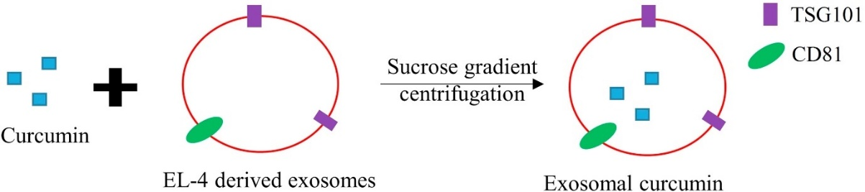
Exosomes transport tiny molecular drugs across the blood–brain barrier (BBB) and enhance therapeutic characteristics. 98% of potent central nervous system medications cannot penetrate the BBB, and their conceptual potency in labs has failed in clinical trials [122]. Drug permeability through the BBB has been addressed by many nano-formulations. Nano-toxicity and MPS medication clearance are also issues [123]. PEG reduces MPS medication absorption to address these issues. This decreased target cell contact and cerebral drug distribution68, 69. Exosomes, a natural component of the body, can be modified to cross the BBB and improve medication delivery to the brain by lowering MPS drug clearance (Fig. 7).
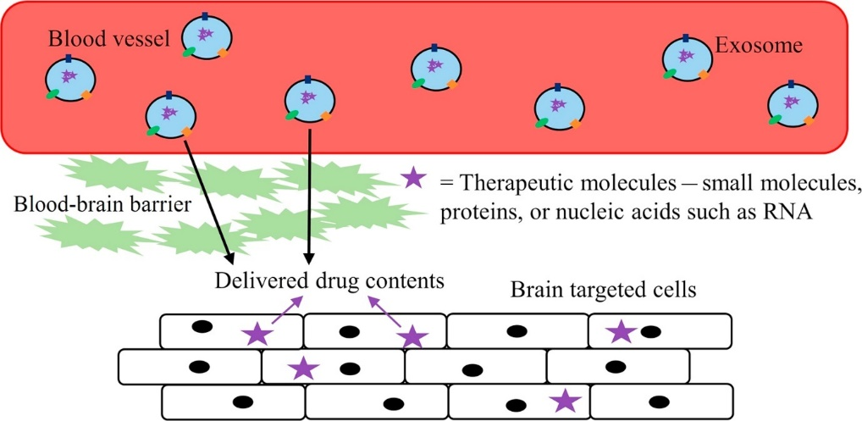
Fig 7. Ability of exosome and its drug contents to cross the blood–brain barrier.

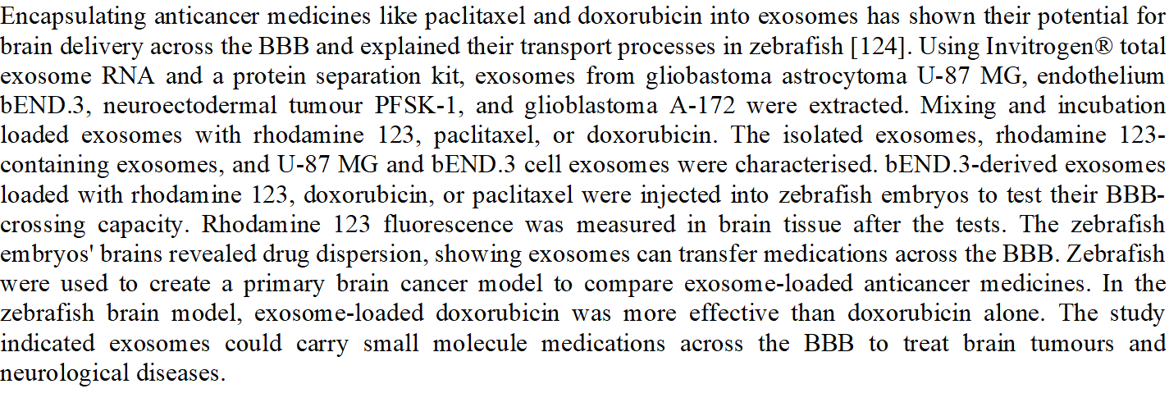The researchers avoided phagocytosis, cell membrane fusion, and lysosome engulfment by using small, native exosomes. The immunological reaction was modest since exosomes are bodily products. Due to nonspecific tissue targeting and a short half-life, most chemotherapeutic medicines, including doxorubicin, have limited solubility and toxicity and poor efficacy. Exosomes delivered doxorubicin to a mouse tumour tissue model in vitro and in vivo [125]. Exosomes were extracted and purified from pEGFP-C1-RVG-Lamp2b plasmid-containing immature murine dendritic cells by centrifugation and ultrafiltration. Electroporation loaded exosomes with doxorubicin for nanoparticle tracking analysis. Encapsulated exosomes were fused with human breast cancer MDA-MB-231 cells to assess doxorubicin delivery. Fluorescence and overlap demonstrated exosome transport inside cells. These exosomes inhibited in vitro cancer proliferation in MDA-MB-231 by measuring cell viability with cell counting kit-8 (CCK-8). Doxorubicin-encapsulated exosomes inhibited cells similarly to free doxorubicin, demonstrating their anticancer properties. Injecting fluorescent exosomes tested their ability to deliver doxorubicin to tumour tissue and prevent tumour growth in vivo. The data demonstrated doxorubicin-containing exosome accumulation at the targeted organ and significant tumour growth suppression. The results showed exosomes efficiently target and deliver doxorubicin.
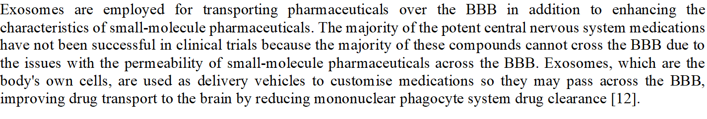

- Exosomes Drug Loading Techniques
The exosome vesicle's lipid bilayer wall prevents blood circulation cargo breakdown. The lipid bilayer membrane and endogenous composition of exosomes make medication loading difficult. Active and passive drug loading strategies can sort exosomes. Active loading involves incubating the medication with isolated exosomes. Passive drug loading, or preloading, involves drug-sorted exosomes from pretreated donor or source cells. This approach does not involve exosome vesicle medication addition. Due to its active pumping mechanisms, active loading can achieve a greater drug/vesicle ratio. Postloading works best for hydrophobic drugs [127]. Fig 8 shows exosome drug loading methods, while Table 3 lists their pros and cons.

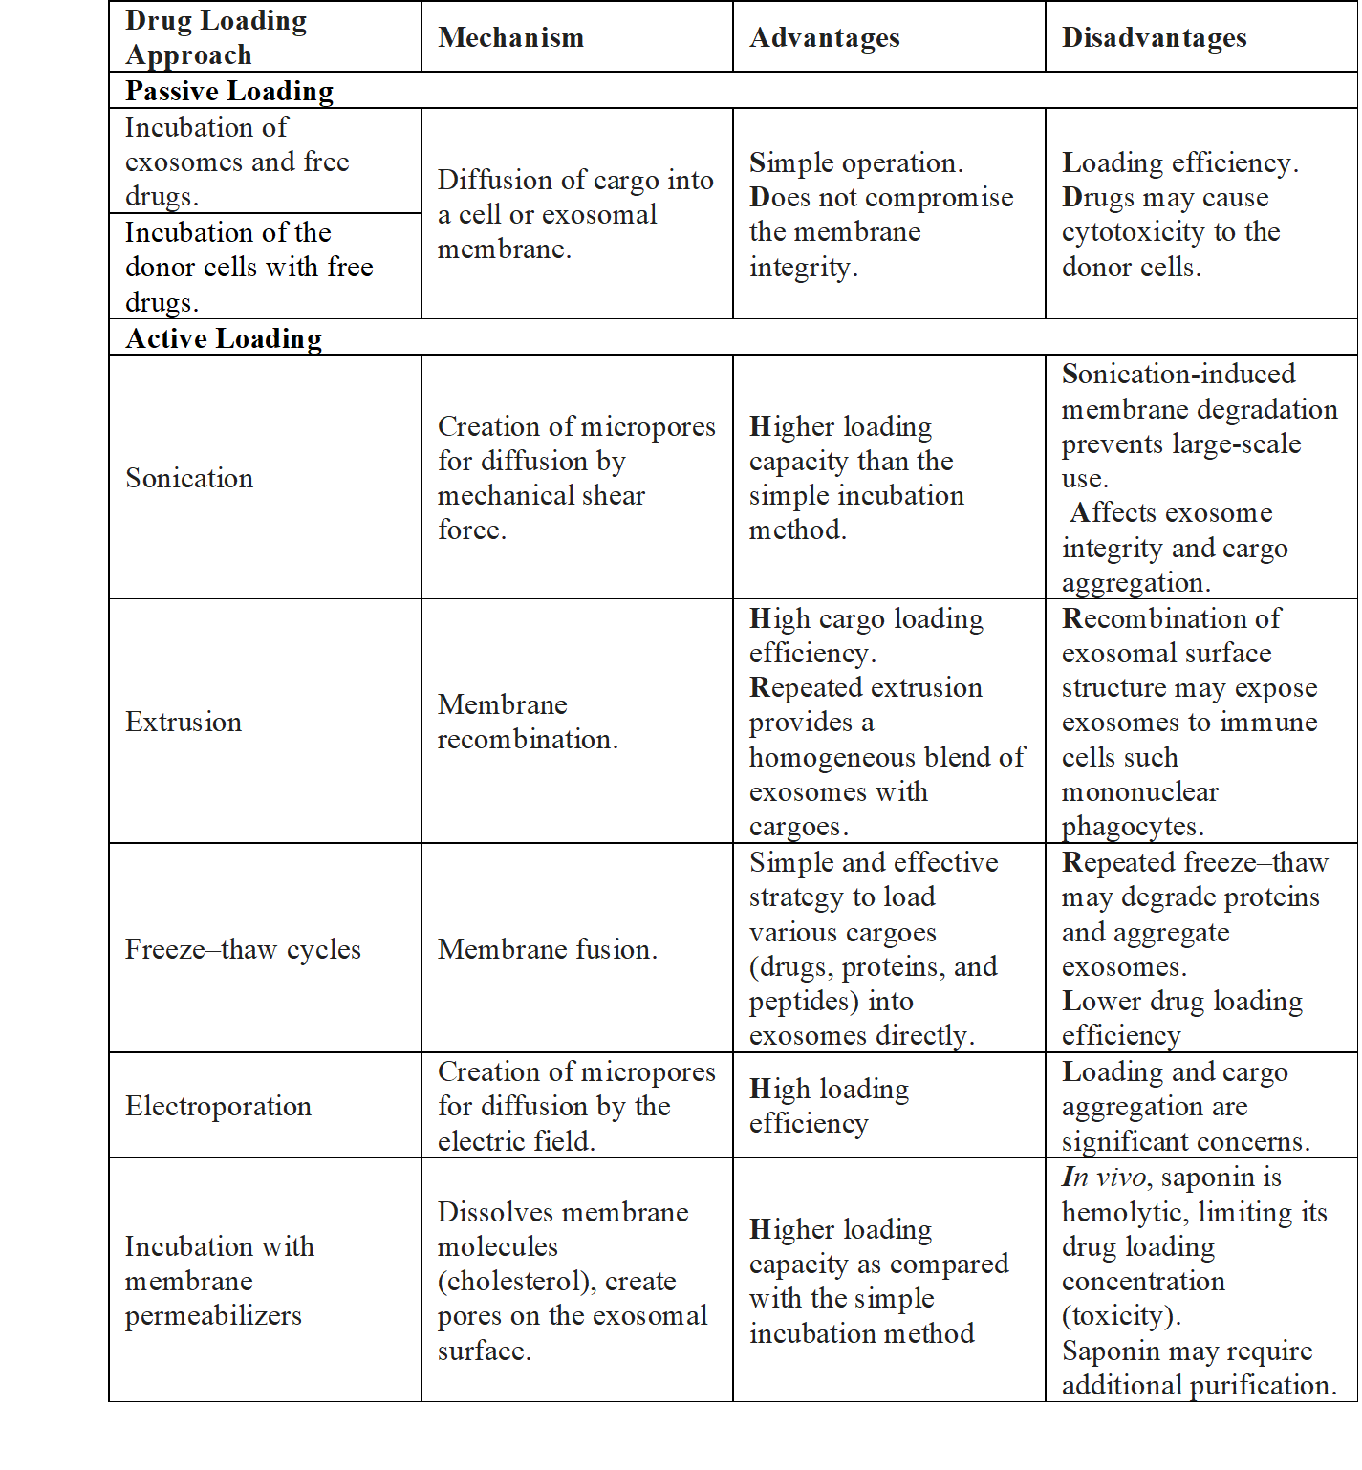

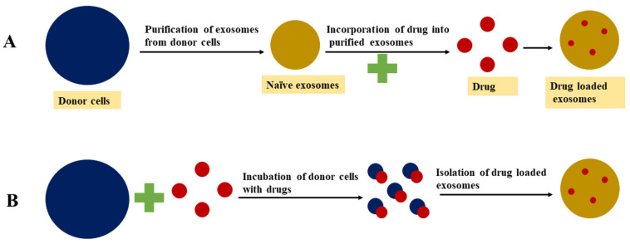
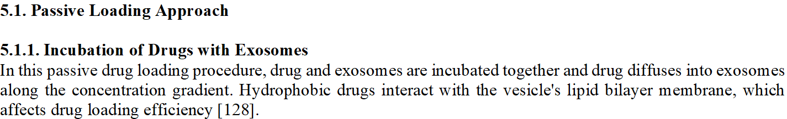

This method treats selected exosome donor cells with a drug molecule and secretes drug-loaded exosomes. Donor cells acquire bioactive or therapeutic chemicals and release exosomes that may retain them. This untargeted method may yield few exosomes [128].

Active medication loading temporarily disrupts the exosome membrane so active cargo can diffuse into the vesicles. Loading the required chemicals into exosomes restores membrane integrity. Sonication, extrusion, and freeze–thaw cycles break exosome membranes [129]. Active drug loading increased exosome vesicle drug loading capacity by 11 times compared to passive loading [127]. This method risks damaging exosome targeting characteristics and native structure during membrane disruption [129].

Homogenizer probes sonicate donor or target cell exosomes with a drug or protein of interest. Sonication deforms the exosome membrane and permits bioactive chemicals to permeate in [128].

Extrusion is a drug loading technique that uses a syringe-based lipid extruder. Exosomes that have been extracted from donor cells are combined with a specific medication and fed into a syringe-based lipid extruder with a membrane that has pores between 100 and 400 nm at a specific temperature. The medication and the damaged exosome membrane are forcefully mixed together during extrusion [130].

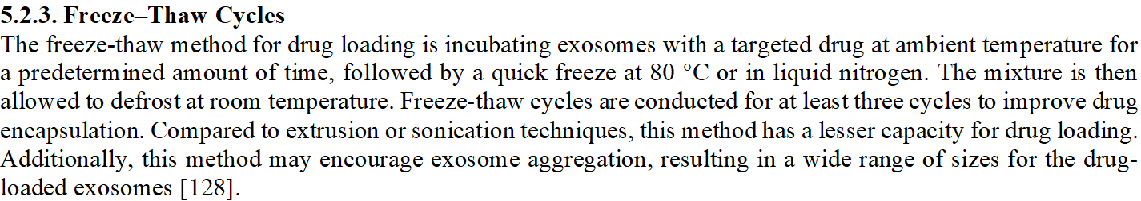

Electroporation disrupts the phospholipid bilayer of exosomes, creating pores that allow drug molecules to enter the lumen [131]. After electroporation, drug molecules diffuse through the exosome lipid bilayer membrane pores, restoring membrane integrity. Loading big molecules like nucleotides (siRNA or miRNA) into exosomes is common using this strategy. RNA aggregation and exosome instability limit electroporation loading. This method increases exosome RNA and hydrophilic small molecule loading [127].

5.2.5. Incubation with Membrane Permeabilizers
Exosomal membrane permeability is caused by interactions between surfactants and membrane permeabilizers with the cholesterol in cell membranes, which result in the formation of pores. The membrane permeability method can improve the catalase loading efficiency into exosomes in comparison to the incubation method [132]. An earlier study found that the passive loading method without saponin resulted in an 11-fold increase in drug loading of hydrophilic compounds into exosomes [127]. This technique calls for exosomes to be isolated following an adequate amount of saponin incubation for drug loading.

- Exosomes Administration Routes
Several delivery methods, including intravenous and intratumoral ones that could result in systemic dispersion of exosomes, have been tested to deliver the therapeutic agent or cargo-loaded exosomes to the target tissue or organ. The tissue distribution of exosome-loaded drugs can be affected by the route of delivery in vivo. Table 4 lists the benefits and diseases that exosomes supplied by various ways target.

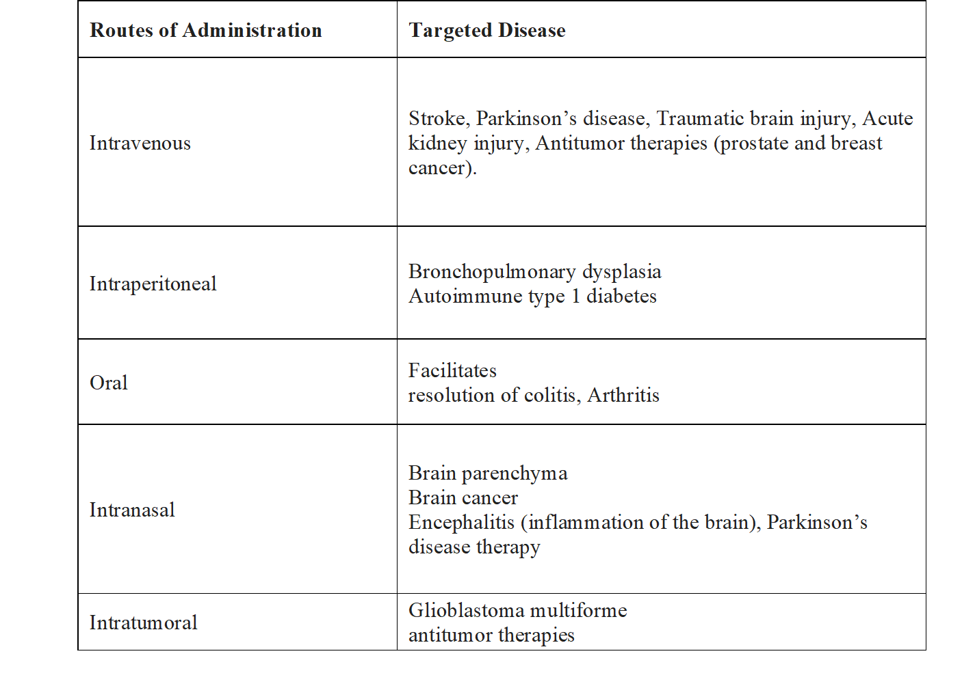
6.1. Intravenous Administration
Exosome-based medication administration should bypass immune cell and hepatic clearance because it is endogenous. Intravenous exosome-loaded medicines can reach the brain, pancreas, and tumour tissues [133]. Intravenous injection of exosomes may favour extravasation and retention inside solid tumours due to poor lymphatic drainage and leaky blood arteries [131]. Thus, exosomes should be given intravenously, especially in cancer. After intravenous injection, exosomes had a half-life of 2 minutes in systemic circulation and were barely detectable after 4 h [134]. The liver and lungs accumulate exosomes, suggesting that they are cleared from systemic circulation like liposomes. Intravenous delivery permits exosomes to reach the target region, although their short half-life in circulation is a drawback [134]. However, PEGylation of exosome particles can prolong their circulatory half-life and prevent fast clearance following intravenous injection.

6.2. Intratumoral Injection
Exosomes laden with a therapeutic drug can be injected intratumorally for some cancer types so that the tumour can be reached without the need for significant invasive manipulation. Following intratumoral injection of exosome-loaded therapeutic cargo to the tumour mass, prior investigations have documented decreases in tumour volume or dimensions [135]. The benefit of this strategy is that the treatments can be delivered specifically to tumour cells by directly injecting exosomes [131].

6.3. Intraperitoneal Route
Compared to other systemic administration methods, exosome delivery via the intraperitoneal route enables the loading of higher exosome dosages. Due to the size of the peritoneal cavity, exosomes injected through this route, however, rapidly diluted and expanded to distant regions [136].

6.4. Oral Administration
Exosome delivery via oral administration entails a number of challenges, including enzymatic activity, changes in the pH, and changes in the intestinal barrier along the gastrointestinal system, despite the fact that it is convenient, simple, and helps patients comply with treatment. Intestinal microbiota traits and the presence of significant acid-base fluctuations are obstacles that must be overcome for exosomes to reach the target tissue of interest. Exosome distribution via oral ingestion is more effective at reaching intestinal luminal epithelial surfaces than non-gastrointestinal tissues [136]. Paclitaxel was delivered orally using exosomes produced from bovine milk by Agrawal et al. [137] for increased efficacy and less toxicity. Exosomes containing paclitaxel displayed remarkable stability when simulated gastrointestinal fluids were present. Significant tumour growth suppression was seen against human lung tumour xenografts after oral administration in nude mice. Oral administration of paclitaxel-loaded exosomes reduced systemic toxicity and inflammation in comparison to intravenous therapy.

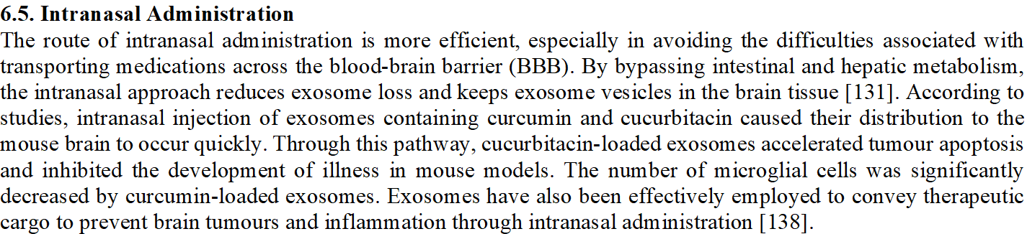
- Characterization Techniques
Exosome samples should be properly characterised after they have been isolated in order to validate the isolation technique. The accuracy of the methods used to measure the quantity and purity of exosomes is one of the main problems in exosome biology. Marker-based, biophysical, and imaging-based methods make up the three categories of characterization techniques used to gauge exosome purity. Table 5 lists the benefits and drawbacks of exosome characterisation methods.

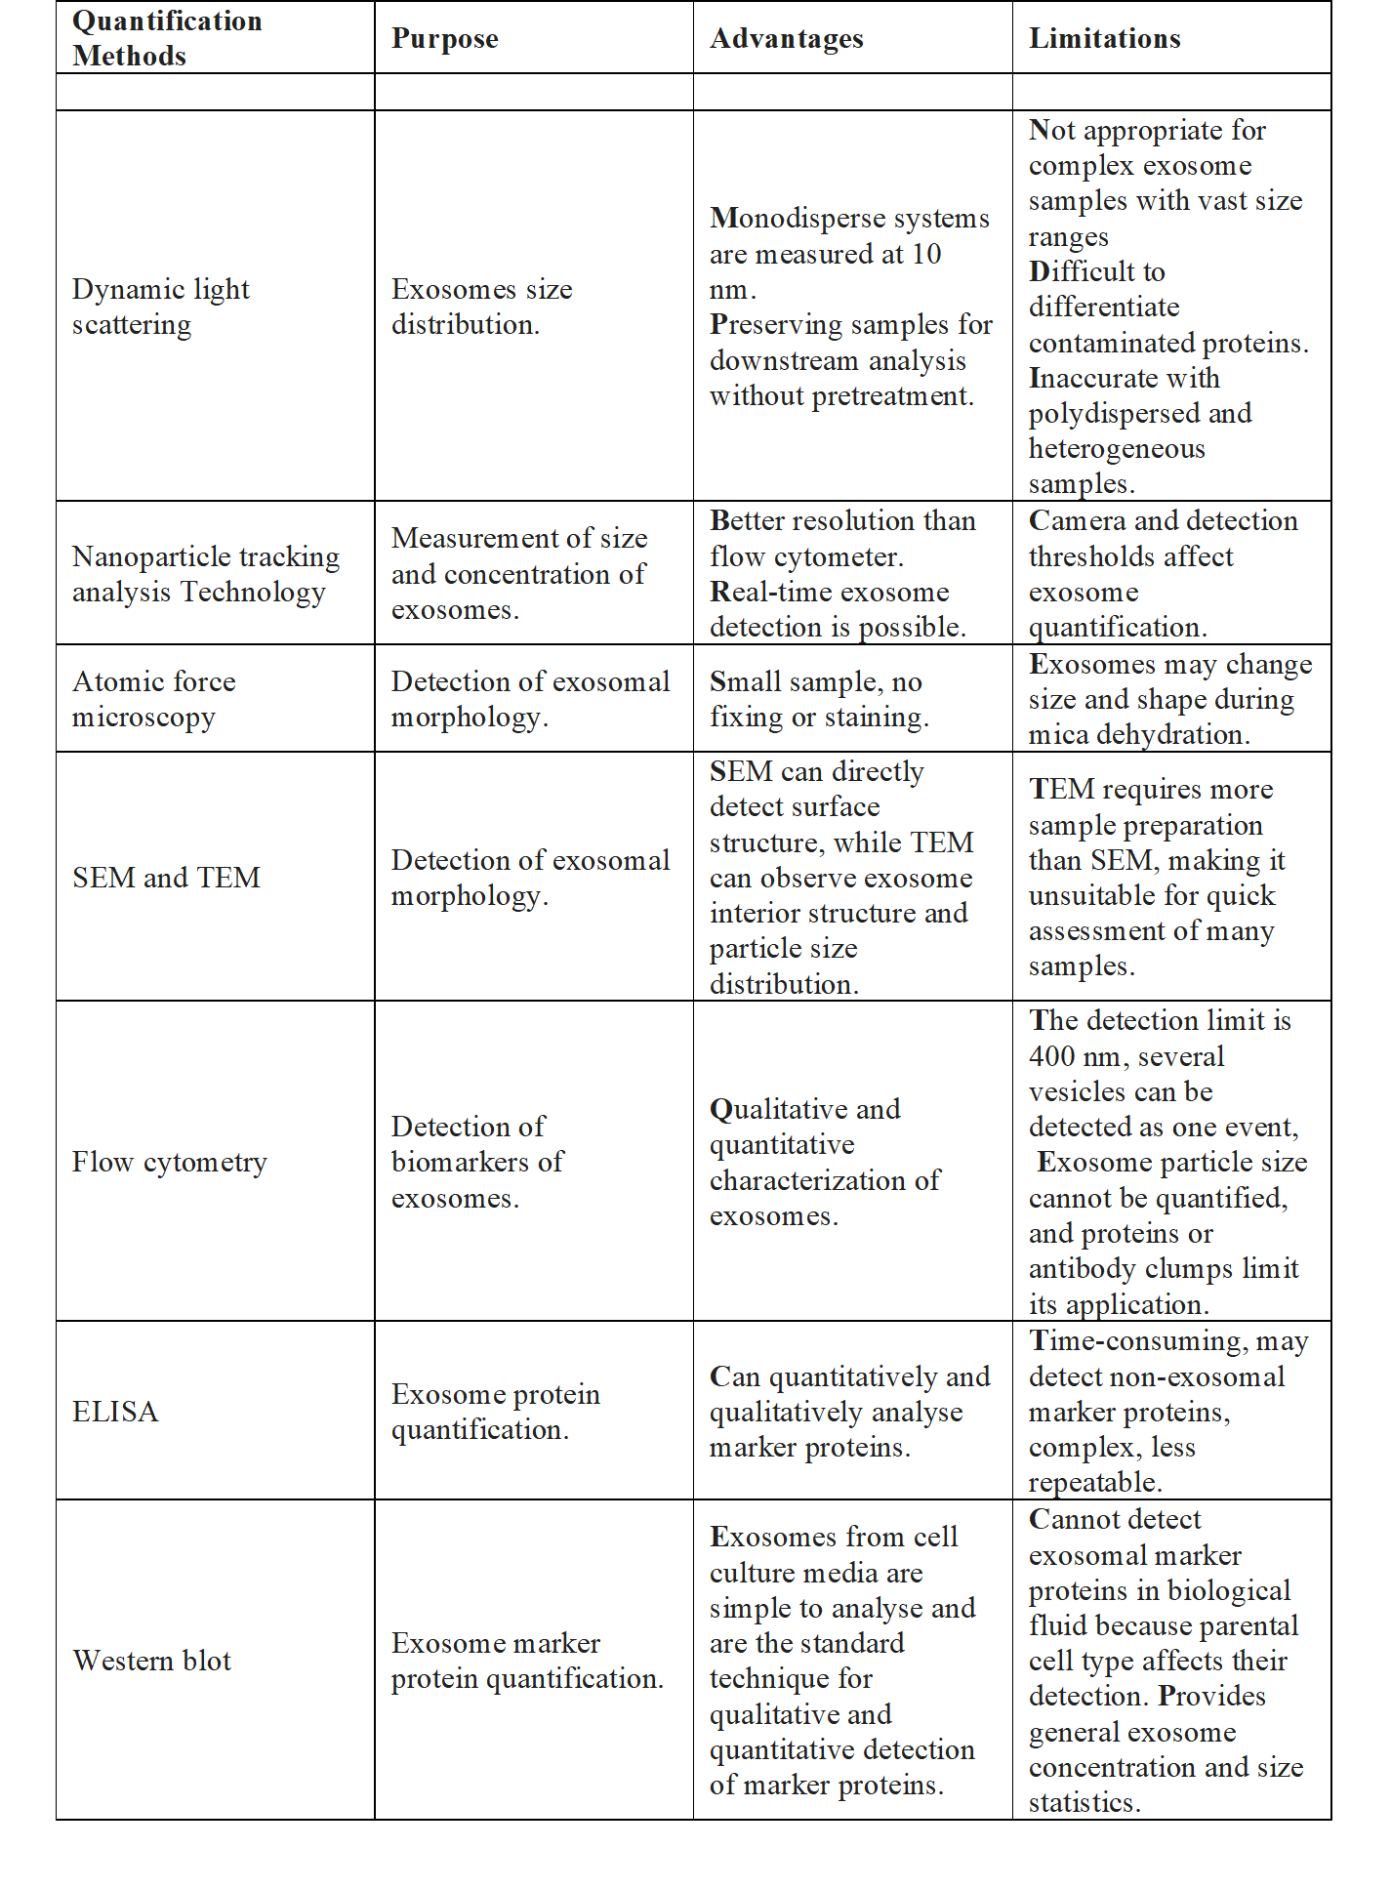
7.1. Imaging

Qualitative imaging tools determine exosome morphology. Exosome vesicles are too large for microscopic imaging. High-resolution exosome imaging is possible with AFM, SEM, and TEM.
7.1.1. Atomic Force Microscopy (AFM)
AFM imaging creates a topological map by measuring the force between the probing tip and sample surface. AFM surface scans with a sharp cantilever tip. The cantilever deflects towards the sample surface and delivers sub-nanometer, high-resolution imaging at less than 1 nm [139]. A mica substrate with an exosome vesicle is dried at ambient temperature, then washed and dried in liquid nitrogen. Using a silicon probe and software, the dried material may be seen under AFM [140]. AFM can non-destructively quantify the exosome vesicle in native settings with little sample preparation. This method gives exosome shape, biomechanics, and biomolecular data. Several investigations have used AFM to characterise cell-derived exosome membrane composition, mechanical characteristics, morphologies, and sizes [141].
7.1.2. Transmission Electron Microscopy (TEM)
TEM is used to detect exosomes in solution and assess their quality by studying their structure, size, and morphology [142]. TEM determines structure and morphology using an accelerated electronic beam with a shorter wavelength than light. The image is formed by a stream of electrons passing through a material, generating a secondary electron [141]. Exosome vesicles are treated with paraformaldehyde (2% w/v) and placed on formvar–carbon-coated grids for 20 min. After washing with PBS, the carbon-coated grids are incubated with glutaraldehyde, a crosslinking agent, and rinsed. Finally, exosome vesicles are dyed with uranyl acetate solution (2% w/v) and air-dried [143]. Multiple stages and electron beams can modify exosome shape during TEM sample preparation. Thus, Cryo-TEM can be used to reduce sample preparation effects [121].

7.1.3. Scanning Electron Microscopy (SEM)
Accelerated electrons in the SEM technique contain a lot of kinetic energy, which is dissipated as various signals via electron sample interactions as the incident electrons decelerate in the solid sample. Exosome samples are glutaraldehyde-fixed and ethanol-dehydrated on a carbon-coated or copper grid. SEM analysis follows air-drying and sputter-coating the grids with gold at 2–10 nm. SEM pictures of exosomes were spherical and bulging [144,145].

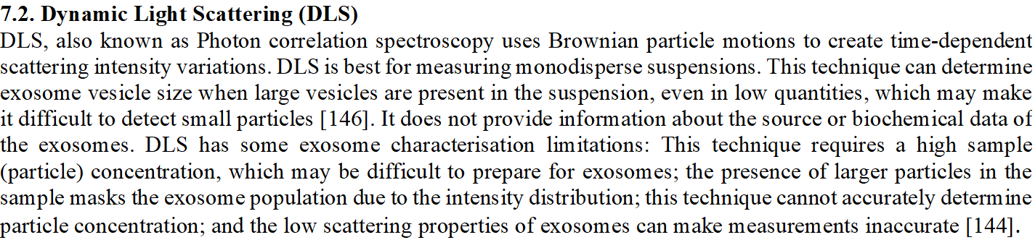

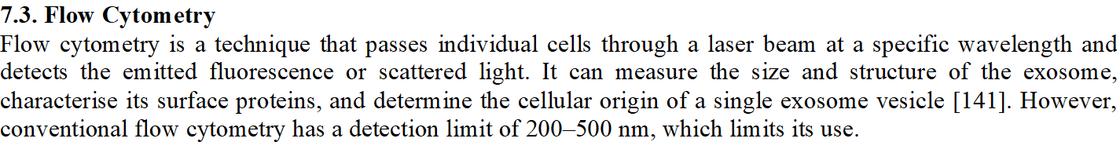

NTA is based on DLS. In NTA, a microscope captures Brownian motion particles. NTA measures exosome concentration and size distribution from 10 nm to 2μm. Image analysis can follow exosomal particles and estimate hydrodynamic sizes. This method can detect sample particles of varying sizes by imaging a particle in distinct areas. NTA can also identify exosome antigens using fluorescently labelled antibodies. NTA pre- and postprocessing variables, such as camera sensitivity and particle detection threshold, can affect outcomes. NTA performance depends on sample preparation and dilution. NTA is interesting due to its speed, capacity to detect exosomes as small as 30 nm, and ease of sample preparation and recovery in their native state [148].

TRPS biophysically passes single particles through nanoscale pores. Particles passing through holes detect resistance pulse duration and frequency. This determines concentration, size, and zeta potential. TRPS can measure colloidal particles from 50 nm to cell size, which is important for studying cellular functioning and uptake. Exosome size and particle concentration match TRPS better than NTA. Particles obstruct TRPS pores and cause system appropriateness difficulties [149].

7.6. Protein Characterization
Protein or marker-based approaches can demonstrate that isolated exosomes have minimal quantities of possible contaminants and exosome signals. Total protein assay measures exosome protein. This approach is difficult to use because exosomes are co-isolated with non-exosomal proteins. Exosomes from most sources contain membrane or intraluminal proteins from endosome development. Western blot or ELISA can characterise protein markers [150].

7.6.1. ELISA
The protein content of the exosomes is detected and measured using the plate-based assay method known as ELISA. Some of this technique's drawbacks include the necessity for a high sample volume and its limited sensitivity. Exosome numbers can be precisely measured using the ELISA method [151].

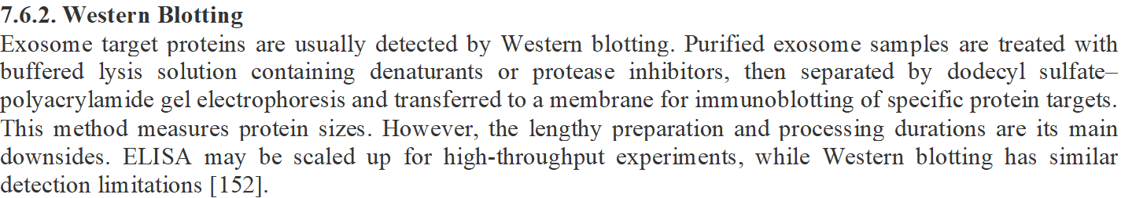

8. Manufacturing of Exosomes
Exosomes, a revolutionary biotherapeutic, are made via cell culture and purification, like biologics. Exosome manufacturing requires culturing the parent cell line, extracting from the conditioned medium, and purifying from process-related impurities as extracellular vesicles. Upstream and downstream pathways make exosomes. Fig. 9 shows the exosome-based drugs production method.
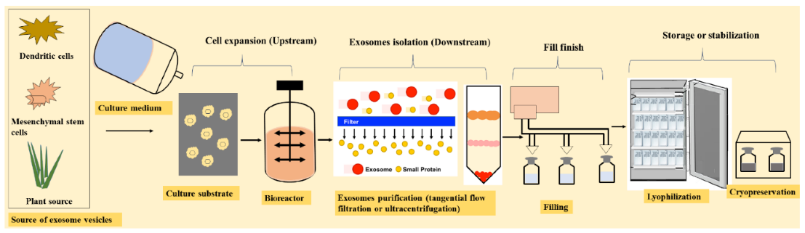
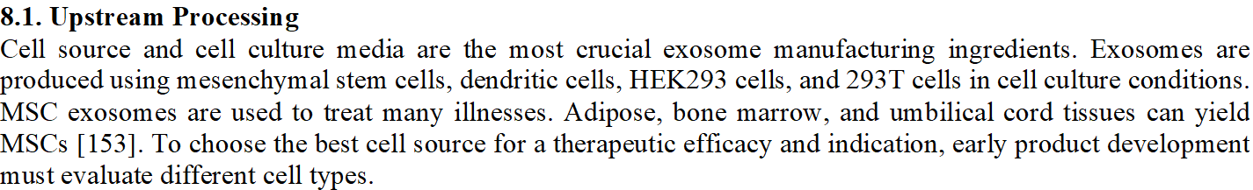Cell culture medium isolates and grows the parent cell line. Cell culture media contains FBS and hPL. Dissociation enzymes used in manufacturing classify the cultivation medium as animal-free or animal-derived [154].
Endogenous exosomes in FBS and hPL can contaminate the released exosome product [155]. For high-quality exosomes, use a serum-free medium (SFM). Early medium selection, especially for serum-depleted media, can impact cell line protein concentration and function [156]. Cell culture uses flasks and bioreactors. In a recent investigation, a stand tissue culture flask and CellBIND® surface with a negative surface charge were prepared with an oxygen-containing functional group [157]. Large-scale production using dynamic bioreactors. The bioreactor's cell density, secretion, and reuptake affect exosome yield. T-flask or hollow fibre bioreactors are utilised to make exosomes [158]. Harvesting exosomes requires a hollow fibre bioreactor with a molecular weight cutoff membrane due to their size (60–200 nm). Bioreactor systems provide a dynamic cell culture environment and continuous medium collection for downstream purification [157]. Oxygen, carbon dioxide, temperature, and homogenous feed delivery in the bioreactor can alter exosome quality.

8.2. Downstream Processing
Filtration removes cell detritus, concentrates cell culture condition media, and isolates exosomes. Ultracentrifugation, microfiltration, size exclusion chromatography, and immunoaffinity may purify exosomes after cell harvest.
Current methods separate exosome vesicles from cells, media, and proteins based on density, size, and surface indicators. There is no standard method for separating exosomes because each method isolates a slightly different population. The target product profile and complexity of the upstream material determine downstream processing [159].

After purification, exosomes must be cryopreserved in an appropriate container closure system in a storage buffer that ensures vesicle stability. Cryoprotectants are used to minimise osmotic damage and stabilise proteins and cells after freezing at −80 °C [160].

Exosomes have garnered interest as cell-derived biotherapeutics and drug delivery vehicles, but preservation and storage remain important difficulties that must be overcome to permit their usage in delivery systems. Exosomes can be frozen at −80 °C. Storage impacts depend on isolation source. The paucity of knowledge about exosome storage and stabilisation conditions and storage-mediated effects may limit their clinical use for medication delivery [161].

Even at −80 °C, exosomes are usually unstable, depending on their source. When held at −80 °C for 4 days, exosome shape changed from newly separated. Briefly, new BALF exosomes have a distinct shape and mean diameter. Multilamellar structure development increases BALF exosome diameter by 10% at +4 °C and 25% at −80 °C. Exosomes maintained at different temperatures can also leak protein groups or dissociate pre-exosomal proteins. Storage conditions destabilise BALF exosome morphology, surface characteristics, and protein content [162].

Preserving exosomes during preparation and storage is essential for medication delivery. Maintaining biological activity and repeatability in downstream processing requires various exosome preservation methods in solution and solid state. Exosome delivery systems frequently have issues with particle aggregation during high-speed centrifugation, interactions of highly enriched extracellular vesicle suspensions during storage, and freezing damage. A good preservation approach can increase exosomes' clinical therapeutic potential. Exosomes are stored at −80 °C, but this may not be optimum for shipping and handling. Thus, exosome storage stability requires alternative strategies. Cryopreservation and lyophilization or freeze-drying can preserve exosomes [163]. Exosome functions are preserved by freezing, thawing, and refreezing after use.

Cryopreservation is simple and available, but exosomes cannot be preserved above −20 °C and repetitive freezing and thawing may damage them. Thus, lyophilization may preserve exosomes [164].
Lyophilization preserves exosomal formulations for long-term room-temperature storage. Lyophilization is favoured over freezing because it removes freezable water from exosome contents, making them more stable [165].

Lyophilization reduces physical deterioration of vesicles by preventing phospholipid hydrolysis. It may also stabilise exosome active components. Sugars, especially trehalose, have been utilised as cryo- or lyoprotectants during lyophilization to prevent leakage and preserve membrane integrity. Trehalose is an α-1,1-glycosidic connection between two glucose units. Trehalose narrows exosome particle size distribution and increases particle count per microgram of protein. Trehalose also reduces freeze–thaw vesicle aggregation and preserves lyophilized exosome particle properties. Trehalose reduces vesicle fusion and exosome loss during lyophilization in in vitro electroporation experiments [166].

Intracellular and extracellular cryoprotectants are typically classified as such. Dimethyl sulphoxide, glycerol, and ethylene glycol penetrate cells to prevent ice crystals and membrane disruption. Sucrose, trehalose, and other extracellular sugars function differently [167]. Trehalose replaces water and vitrifies exosomes during lyophilization. The water replacement mechanism replaces water molecules with a stable hydrogen bond between sugars (trehalose) and exosome lipids at the bilayer surface without changing the lipid bilayer structure. Sugars also diminish van der Waals interactions between phospholipid acyl chains and maintain membrane structure after lyophilization [168]. Vitrification involves the immobilisation of molecules (proteins or lipids) by the stabilizer's glassy matrix (trehalose) after water removal. Thus, the glassy matrix, with poor mobility and high viscosity, prevents aggregation or fusion and protects lipid bilayers and protein molecules from ice crystal damage. Trehalose suppresses lipid phase transition conformational alterations [169].

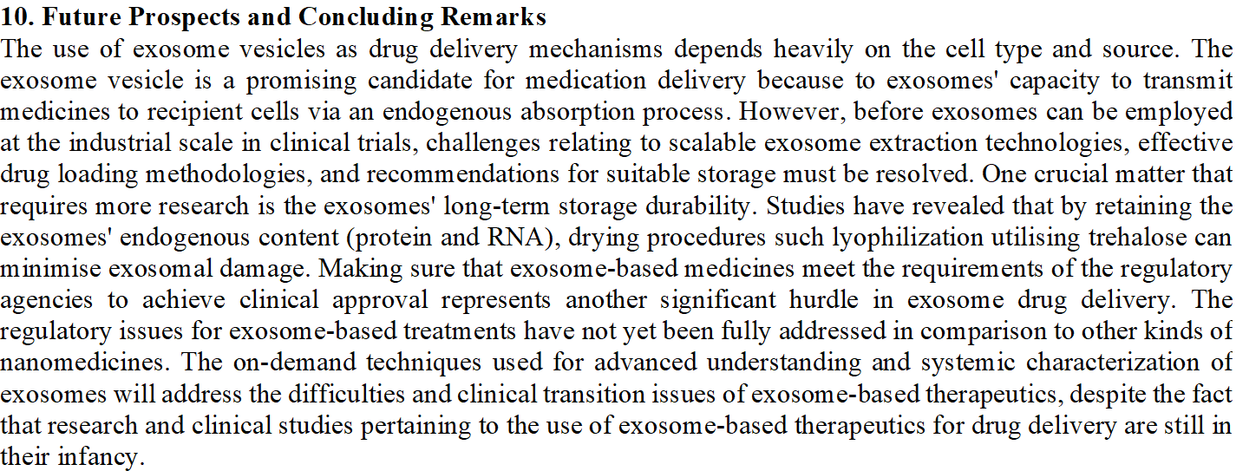

REFERENCES
- Rufino-Ramos D, Albuquerque PR, Carmona V, Perfeito R, Nobre RJ, Parera de Almeida L. Extracellular vesicles: novel promising delivery systems for therapy of brain diseases. J Control Release. 2017;262:247–58.
- M. Schiller, I. Bekeredjian-Ding, P. Heyder, N. Blank, A.D. Ho, H.M. Lorenz
Autoantigens are translocated into small apoptotic bodies during early stages of apoptosis, Cell Death Differ, 15 (2008), pp. 183-191
- Microenvironmental influences of apoptosis in vivo and in vitro, Apoptosis, 15, 2010, pp. 1029-1049
- Exosome mimetics: a novel class of drug delivery systems, Int J Nanomed, 7, 2012, pp. 1525-1541
- Revisiting the road to the discovery of exosomes, Blood Cells Mol Dis, 34, 2005, pp. 214-219
- Exosomes-vesicular carriers for intercellular communication, Curr Opin Cell Biol, 21, 2009, pp. 575-581
- Functions and applications of exosomes, Acta Pol Pharm, 71 (2014), pp. 537-543
- L. Urbanelli, A. Magini, S. Buratta, A. Brozzi, K. Sagini, A. Polchi, et al., Signaling pathways in exosomes biogenesis, secretion and fate, Genes, 4, 2013, pp. 152-170
- D.J. Katzmann, G. Odorizzi, S.D. Emr, Receptor downregulation and multivesicular-body sorting, Nat Rev Mol Cell Biol, 3 , 2002, pp. 893-905
- B. Février, G. Raposo, Exosomes: endosomal-derived vesicles shipping extracellular messages, Curr Opin Cell Biol, 16, 2004, pp. 415-421
- C. Raiborg, T.E. Rusten, H. Stenmark, Protein sorting into multivesicular endosomes, Curr Opin Cell Biol, 15, 2003, pp. 446-455
- M. Colombo, C. Moita, G. van Niel, J. Kowal, J. Vigneron, P. Benaroch, et al., Analysis of ESCRT functions in exosome biogenesis, composition and secretion highlights the heterogeneity of extracellular vesicles, J Cell Sci, 126 (2013), pp. 5553-5565
- K. Tamai, N. Tanaka, T. Nakano, E. Kakazu, Y. Kondo, J. Inoue, et al., Exosome secretion of dendritic cells is regulated by Hrs, an ESCRT-0 protein, Biochem Biophys Res Commun, 399, 2010, pp. 384-390
- J.C. Gross, V. Chaudhary, K. Bartscherer, M. Boutros, Active Wnt proteins are secreted on exosomes, Nat Cell Biol, 14, 2012, pp. 1036-1045
- D. Hoshino, K.C. Kirkbride, K. Costello, E.S. Clark, S. Sinha, N. Grega-Larson, et al., Exosome secretion is enhanced by invadopodia and drives invasive behavior, Cell Rep, 5, 2013, pp. 1159-1168
- L. Abrami, L. Brandi, M. Moayeri, M.J. Brown, B.A. Krantz, S.H. Leppla, et al., Hijacking multivesicular bodies enables long-term and exosome-mediated long-distance action of anthrax toxin, Cell Rep, 5, 2013, pp. 986-996
- J. Kowal, M. Tkach, C. Théry, Biogenesis and secretion of exosomes, Curr Opin Cell Biol, 29 (2014), pp. 116-125
- H.F.G. Heijnen, A.E. Schiel, R. Fijnheer, H.J. Geuze, J.J. Sixma, Activated platelets release two types of membrane vesicles: microvesicles by surface shedding and exosomes derived from exocytosis of multivesicular bodies and α-granules, Blood, 94, 1999, pp. 3791-3799
- G. van Niel, S. Charrin, S. Simoes, M. Romao, L. Rochin, P. Saftig, et al., The tetraspanin CD63 regulates ESCRT-independent and-dependent endosomal sorting during melanogenesis, Dev Cell, 21, 2011, pp. 708-721
- C. Théry, L. Duban, E. Segura, P. Véron, O. Lantz, S. Amigorena, Indirect activation of naïve CD4⁺ T cells by dendritic cell-derived exosomes, Nat Immunol, 3, 2002, pp. 1156-1162
- A. Kalani, A. Tyagi, N. Tyagi, Exosomes: mediators of neurodegeneration, neuroprotection and therapeutics, Mol Neurobiol, 49, 2014, pp. 590-600
- C. Subra, K. Laulagnier, B. Perret, M. Record, Exosome lipidomics unravels lipid sorting at the level of multivesicular bodies, Biochimie, 89, 2007, pp. 205-212
- I. Parolini, C. Federici, C. Raggi, L. Lugini, S. Palleschi, A. De Milito, et al., Microenvironmental pH is a key factor for exosome traffic in tumor cells, J Biol Chem, 284, 2009, pp. 34211-34222
- A. Piccin, W.G. Murphy, O.P. Smith, Circulating microparticles: pathophysiology and clinical implications, Blood Rev, 21, 2007, pp. 157-171
- Jiang, Y.; Wang, F.; Wang, K.; Zhong, Y.; Wei, X.; Wang, Q.; Zhang, H. Engineered Exosomes: A Promising Drug Delivery Strategy for Brain Diseases. Curr. Med. Chem. 2022, 29 (17), 3111– 3124
- Goh, C. Y.; Wyse, C.; Ho, M.; O’Beirne, E.; Howard, J.; Lindsay, S.; Kelly, P.; Higgins, M.; McCann, A. Exosomes in triple negative breast cancer: Garbage disposals or Trojan horses?. Cancer Lett. 2020, 473, 90– 97
- Zhou, X.; Li, T.; Chen, Y.; Zhang, N.; Wang, P.; Liang, Y.; Long, M.; Liu, H.; Mao, J.; Liu, Q.; Sun, X.; Chen, H. Mesenchymal stem cellderived extracellular vesicles promote the in vitro proliferation and migration of breast cancer cells through the activation of the ERK pathway. Int. J. Oncol. 2019, 54 (5), 1843– 1852
- Wang, S.; Li, F.; Ye, T.; Wang, J.; Lyu, C.; Qing, S.; Ding, Z.; Gao, X.; Jia, R.; Yu, D.; Ren, J.; Wei, W.; Ma, G. Macrophage-tumor chimeric exosomes accumulate in lymph node and tumor to activate the immune response and the tumor microenvironment. Sci. Transl Med. 2021, 13 (615), eabb6981
- Kang H, Kim J, Park J. Methods to isolate extracellular vesicles for diagnosis. Micro Nano Syst Lett. 2017;5:15.
- Taylor DD, Shah S. Methods of isolating extracellular vesicles impact down-stream analyses of their cargoes. Methods. 2015;87:3–10.
- Kotmakçı M, Akbaba GE. Exosome isolation: is there an optimal method with regard to diagnosis or treatment?, chap 8. In: Wang J, editor. Novel implication of exosome in diagnosis and treatment of cancer and infection disease. London: Intech; 2017. p. 163–82.
- Deregibus MC, Figliolini F, D’Antico S, Manzini PM, Pasquino C, De Lena MD, Tetta C, Brizzi MF, Camussi G. Charge-based precipitation of extracellular vesicles. Int J Mol Med. 2016;38:1359–66.
- Clayton A., Court J., Navabi H., Adams M., Mason M.D., Hobot J.A., Newman G.R., Jasani B. Analysis of Antigen Presenting Cell Derived Exosomes, Based on Immuno-Magnetic Isolation and Flow Cytometry. J. Immunol. Methods. 2001;247:163–174.
- Yáñez-Mó M., Barreiro O., Gordon-Alonso M., Sala-Valdés M., Sánchez-Madrid F. Tetraspanin-Enriched Microdomains: A Functional Unit in Cell Plasma Membranes. Trends Cell Biol. 2009;19:434–446.
- Gebeyehu A., Kommineni N., Meckes D., Sachdeva M. Exosome Vehicles as Nano-Drug Delivery Materials for Chemotherapeutic Drugs. CRT. 2021
- Wubbolts R., Leckie R.S., Veenhuizen P.T.M., Schwarzmann G., Möbius W., Hoernschemeyer J., Slot J.-W., Geuze H.J., Stoorvogel W. Proteomic and Biochemical Analyses of Human B Cell-Derived Exosomes. Potential Implications for Their Function and Multivesicular Body Formation. J. Biol. Chem. 2003;278:10963–10972.
- Liao W., Du Y., Zhang C., Pan F., Yao Y., Zhang T., Peng Q. Exosomes: The next Generation of Endogenous Nanomaterials for Advanced Drug Delivery and Therapy. Acta Biomater. 2019;86:1–14.
- R.M. Johnstone, M. Adam, J. Hammond, L. Orr, C. Turbide, Vesicle formation during reticulocyte maturation. Association of plasma membrane activities with released vesicles (exosomes), J Biol Chem, 262 (1987), pp. 9412-9420
- R.M. Johnstone, A. Mathew, A.B. Mason, K. Teng, Exosome formation during maturation of mammalianand avian reticulocytes: evidence that exosome release is a major route for externalization of obsolete membrane proteins, J Cell Physiol, 147 (1991), pp. 27-36
- A.E. Morelli, A.T. Larregina, W.J. Shufesky, M.L.G. Sullivan, D.B. Stolz, G.D. Papworth, et al., Endocytosis, intracellular sorting, and processing of exosomes by dendritic cells, Blood, 104 (2004), pp. 3257-3266
- J. De Toro, L. Herschlik, C. Waldner, C. Mongini, Emerging roles of exosomes in normal and pathological conditions: new insights for diagnosis and therapeutic applications, Front Immunol, 6 (2015), p. 203
- H. Valadi, K. Ekström, A. Bossios, M. Sjöstrand, J.J. Lee, J.O. Lötvall, Exosome-mediated transfer of mRNAs and microRNAs is a novel mechanism of genetic exchange between cells, Nat Cell Biol, 9 (2007), pp. 654-659
- J. Skog, T. Würdinger, S. vanRijn, D.H. Meijer, L. Gainche, W.T. Curry, et al., Glioblastoma microvesicles transport RNA and proteins that promote tumour growth and provide diagnostic biomarkers, Nat Cell Biol, 10 (2008), pp. 1470-1476
- K. Laulagnier, D. Grand, A. Dujardin, S. Hamdi, H. Vincent-Schneider, D. Lankar, et al., PLD2 is enriched on exosomes and its activity is correlated to the release of exosomes, FEBS Lett, 572 (2004), pp. 11-14
- A. Aharon, Brenner B. Microparticles thrombosis and cancer, Best Pract Res Clin Haematol, 22 (2009), pp. 61-69
- P. Kucharzewska, H.C. Christianson, J.E. Welch, K.J. Svensson, E. Fredlund, M. Ringnér, et al., Exosomes reflect the hypoxic status of glioma cells and mediate hypoxia-dependent activation of vascular cells during tumor development, Proc Natl Acad Sci U S A, 110 (2013), pp. 7312-7317
- J. Webber, R. Steadman, M.D. Mason, Z. Tabi, A. Clayton, Cancer exosomes trigger fibroblast to myofibroblast differentiation, Cancer Res, 70 (2010), pp. 9621-9630
- S. Rana, K. Malinowska, M. Zöller, Exosomal tumor microRNA modulates premetastatic organ cells, Neoplasia, 15 (2013), pp. 281-295
- R. Ghidoni, L. Benussi, G. Binetti, Exosomes: the Trojan horses of neurodegeneration Med Hypotheses, 70 (2008), pp. 1226-1227
- J. Nilsson, J. Skog, A. Nordstrand, V. Baranov, L. Mincheva-Nilsson, X.O. Breakefield, et al., Prostate cancer-derived urine exosomes: a novel approach to biomarkers for prostate cancer, Br J Cancer, 100 (2009), pp. 1603-1607
- C. Corcoran, A.M. Friel, M.J. Duffy, J. Crown, L. O׳Driscoll, Intracellular and extracellular microRNAs in breast cancer, Clin Chem, 57 (2011), pp. 18-32
- J.H. Li, C.A. Sherman-Baust, M. Tsai-Turton, R.E. Bristow, R.B. Roden, P.J. Morin, Claudin-containing exosomes in the peripheral circulation of women with ovarian cancer, BMC Cancer, 9 (2009), p. 244
- Mckelvey KJ, Powell KL, Ashton AW, Morris JM, Mccracken SA. Exosomes: mechanisms of uptake. J Circ Biomarkers. 2015;4:1.
- He C, Zheng S, Luo Y, Wang B. Exosome theranostics: biology and translational medicine. Theranostics. 2018;8:237–55.
- Corliss BA, Azimi MS, Munson J, Peirce SM, Murfee WL. Macrophages: an inflammatory link between angiogenesis and lymphangiogenesis. Microcirculation. 2016;23:95–121.
- Malyshev I, Malyshev Y. Current concept and update of the macrophage plasticity concept: intracellular mechanisms of reprogramming and M3 macrophage “switch” phenotype. Biomed Res Int. 2015;2015:341308
- Wang C, Zhang C, Liu L, Xi A, Chen B, Li Y, Du J. Macrophage-derived mir-155-containing exosomes suppress fibroblast proliferation and promote fibroblast inflammation during cardiac injury. Mol Ther. 2017;25:192–204.
- Monti E, Fanzani A. Uncovering metabolism in rhabdomyosarcoma. Cell Cycle. 2015;15:184–95.
- Poniewierska-Baran A, Schneider G, Sun W, Abdelbaset-Ismail A, Barr FG, Ratajczak MZ. Human rhabdomyosarcoma cells express functional pituitary and gonadal sex hormone receptors: therapeutic implications. Int J Oncol. 2016;48:1815–24.
- Ghayad SE, Rammal G, Ghamloush F, Basma H, Nasr R, Diab-Assaf M, Chelala C, Saab R. Exosomes derived from embryonal and alveolar rhabdomyosarcoma carry differential miRNA cargo and promote invasion of recipient fibroblasts. Sci Rep. 2016;6:37088.
- Sung BH, Weaver AM. Exosome secretion promotes chemotaxis of cancer cells. Cell Adhes Migr. 2017;11:187–95.
- Schillaci O, Fontana S, Monteleone F, Taverna S, Di Bella MA, Di Vigio D, Alessandro R. Exosomes from metastatic cancer cells transfer amoeboid phenotype to non-metastatic cells and increase endothelial permeability: their emerging role in tumor heterogeneity. Sci Rep. 2017;7:4711.
- Kalluri R. The biology and function of exosomes in cancer. J Clin Invest. 2016;126:1208–15.
- Nabavi N, Bennewith KL, Churg A, Wang Y, Collins CC, Mutti L. Switching off malignant mesothelioma: exploiting the hypoxic microenvironment. Genes Cancer. 2016;7:340–54.
- Kalra N, Zhang J, Thomas A, Xi L, Cheung M, Talarchek J, Burkett S, Tsokos MG, Chen Y, Raffeld M, Miettinen M, Pastan I, Testa JR, Hassan P. Mesothelioma patient derived tumor xenografts with defined BAP1 mutations that mimic the molecular characteristics of human malignant mesothelioma. BMC Cancer. 2015;15:1–378.
- Greening DW, Ji H, Chen M, Robinson BW, Dick IM, Creaney J, Simpson RJ. Secreted primary human malignant mesothelioma exosome signature reflects oncogenic cargo. Sci Rep. 2016;6:32643.
- Abdelmagid SM, Sondag GR, Moussa FM, Belcher JY, Yu B, Stinnett H, Novak K, Mbimba T, Khol M, Hankenson KD, Malcuit C, Safadi FF. Mutation in osteoactivin promotes receptor activator of NFκB ligand (RANKL)-mediated osteoclast differentiation and survival but inhibits osteoclast function. J Biol Chem. 2015;290:20128–46.
- Charles JF, Aliprantis AO. Osteoclasts: more than ‘bone eaters’. Trends Mol Med. 2014;20:449–59.
- Sun W, Zhao C, Li Y, Wang L, Nie G, Peng J, Wang A, Zhang P, Tian W, Li Q, Song J, Wang C, Xu X, Zhao D, Xu Z, Zhong G, Han B, Ling S, Chang YZ, Li Y. Osteoclast-derived microRNA-containing exosomes selectively inhibit osteoblast activity. Cell Discov. 2016;2:16015.
- Klein AP. Genetic susceptibility to pancreatic cancer. Mol Carcinog. 2012;51:14–24.
- Neesse A, Michl P, Frese KK, Feig C, Cook N, Jacobetz MA, Lolkema MP, Buchholz M, Olive KP, Gress TM. Stromal biology and therapy in pancreatic cancer. Gut. 2011;60:861.
- Masamune A, Yoshida N, Hamada S, Takikawa T, Nabeshima T, Shimosegawa T. Exosomes derived from pancreatic cancer cells induce activation and profibrogenic activities in pancreatic stellate cells. Biochem Biophys Res Commun. 2017;495:71–7.
- Swonger JM, Liu JS, Ivey MJ, Tallquist MD. Genetic tools for identifying and manipulating fibroblasts in the mouse. Differentiation. 2016;92:66–83.
- James AJ, Penrose JF, Cazaly AM, Holgate ST, Sampson AP. Human bronchial fibroblasts express the 5-lipoxygenase pathway. Respir Res. 2006;7:102.
- Haj-Salem I, Plante S, Gounni AS, Rouabhia M, Chakir J. Fibroblast-derived exosomes promote epithelial cell proliferation through TGF-β2 signaling pathway in severe asthma. Allergy. 2018;1416:55–87.
- White IA, Sanina C, Balkan W, Hare JM. Mesenchymal stem cells in cardiology. Methods Mol Biol. 2016;1416:55.
- Samsonraj RM, Raghunath M, Nurcombe V, Hui JH, Van Wijnen AJ, Cool SM. Concise review: multifaceted characterization of human mesenchymal stem cells for use in regenerative medicine. Stem Cells Transl Med. 2017;6:2173–85.
- Lou G, Chen Z, Zheng M, Liu Y. Mesenchymal stem cell-derived exosomes as a new therapeutic strategy for liver diseases. Exp Mol Med. 2017;49:e346.
- Chen C., Skog J., Hsu C.-H., Lessard R.T., Balaj L., Wurdinger T., Carter B.S., Breakefield X.O., Toner M., Irimia D. Microfluidic Isolation and Transcriptome Analysis of Serum Microvesicles. Lab Chip. 2010;10:505–511.
- Davies R.T., Kim J., Jang S.C., Choi E.-J., Gho Y.S., Park J. Microfluidic Filtration System to Isolate Extracellular Vesicles from Blood. Lab Chip. 2012;12:5202–5210.
- Sercombe L., Veerati T., Moheimani F., Wu S.Y., Sood A.K., Hua S. Advances and Challenges of Liposome Assisted Drug Delivery. Front. Pharmacol. 2015;6:286.
- Ha D., Yang N., Nadithe V. Exosomes as Therapeutic Drug Carriers and Delivery Vehicles across Biological Membranes: Current Perspectives and Future Challenges. Acta Pharm. Sin. B. 2016;6:287–296.
- Milman N., Ginini L., Gil Z. Exosomes and Their Role in Tumorigenesis and Anticancer Drug Resistance. Drug Resist. Updates. 2019;45:1–12.
- Tan A., Rajadas J., Seifalian A.M. Exosomes as Nano-Theranostic Delivery Platforms for Gene Therapy. Adv. Drug Deliv. Rev. 2013;65:357–367.
- Cho E., Nam G.-H., Hong Y., Kim Y.K., Kim D.-H., Yang Y., Kim I.-S. Comparison of Exosomes and Ferritin Protein Nanocages for the Delivery of Membrane Protein Therapeutics. J. Control. Release. 2018;279:326–335.
- Aspe J.R., Diaz Osterman C.J., Jutzy J.M.S., Deshields S., Whang S., Wall N.R. Enhancement of Gemcitabine Sensitivity in Pancreatic Adenocarcinoma by Novel Exosome-Mediated Delivery of the Survivin-T34A Mutant. J. Extracell. Vesicles. 2014;3
- Kooijmans S.A.A., Aleza C.G., Roffler S.R., van Solinge W.W., Vader P., Schiffelers R.M. Display of GPI-Anchored Anti-EGFR Nanobodies on Extracellular Vesicles Promotes Tumour Cell Targeting. J. Extracell. Vesicles. 2016;5:31053.
- Lai R.C., Tan S.S., Teh B.J., Sze S.K., Arslan F., de Kleijn D.P., Choo A., Lim S.K. Proteolytic Potential of the MSC Exosome Proteome: Implications for an Exosome-Mediated Delivery of Therapeutic Proteasome. Int. J. Proteomics. 2012;2012:971907.
- Skog J., Würdinger T., van Rijn S., Meijer D.H., Gainche L., Sena-Esteves M., Curry W.T., Carter B.S., Krichevsky A.M., Breakefield X.O. Glioblastoma Microvesicles Transport RNA and Proteins that Promote Tumour Growth and Provide Diagnostic Biomarkers. Nat. Cell Biol. 2008;10:1470–1476.
- Viñas J.L., Burger D., Zimpelmann J., Haneef R., Knoll W., Campbell P., Gutsol A., Carter A., Allan D.S., Burns K.D. Transfer of MicroRNA-486-5p from Human Endothelial Colony Forming Cell-Derived Exosomes Reduces Ischemic Kidney Injury. Kidney Int. 2016;90:1238–1250.
- Alhasan A.H., Patel P.C., Choi C.H.J., Mirkin C.A. Exosome Encased Spherical Nucleic Acid Gold Nanoparticle Conjugates as Potent MicroRNA Regulation Agents. Small. 2014;10:186–192.
- Limoni S.K., Moghadam M.F., Moazzeni S.M., Gomari H., Salimi F. Engineered Exosomes for Targeted Transfer of SiRNA to HER2 Positive Breast Cancer Cells. Appl. Biochem. Biotechnol. 2019;187:352–364.
- Saari H., Lázaro-Ibáñez E., Viitala T., Vuorimaa-Laukkanen E., Siljander P., Yliperttula M. Microvesicle- and Exosome-Mediated Drug Delivery Enhances the Cytotoxicity of Paclitaxel in Autologous Prostate Cancer Cells. J. Control. Release. 2015;220:727–737.
- Tian Y., Li S., Song J., Ji T., Zhu M., Anderson G.J., Wei J., Nie G. A Doxorubicin Delivery Platform Using Engineered Natural Membrane Vesicle Exosomes for Targeted Tumor Therapy. Biomaterials. 2014;35:2383–2390.
- Sun D., Zhuang X., Xiang X., Liu Y., Zhang S., Liu C., Barnes S., Grizzle W., Miller D., Zhang H.-G. A Novel Nanoparticle Drug Delivery System: The Anti-Inflammatory Activity of Curcumin Is Enhanced When Encapsulated in Exosomes. Mol. Ther. 2010;18:1606–1614.
- Qu M., Lin Q., Huang L., Fu Y., Wang L., He S., Fu Y., Yang S., Zhang Z., Zhang L., et al. Dopamine-Loaded Blood Exosomes Targeted to Brain for Better Treatment of Parkinson’s Disease. J. Control. Release. 2018;287:156–166.
- Van Dommelen S.M., Vader P., Lakhal S., Kooijmans S.A.A., van Solinge W.W., Wood M.J.A., Schiffelers R.M. Microvesicles and Exosomes: Opportunities for Cell-Derived Membrane Vesicles in Drug Delivery. J. Control. Release. 2012;161:635–644.
- Théry C., Zitvogel L., Amigorena S. Exosomes: Composition, Biogenesis and Function. Nat. Rev. Immunol. 2002;2:569–579.
- Khan S., Bennit H.F., Wall N.R. The Emerging Role of Exosomes in Survivin Secretion. Histol. Histopathol. 2015;30:43–50.
- Peng H., Ji W., Zhao R., Yang J., Lu Z., Li Y., Zhang X. Exosome: A Significant Nano-Scale Drug Delivery Carrier. J. Mater. Chem. B. 2020;8:7591–7608.
- Gehrmann U., Hiltbrunner S., Georgoudaki A.-M., Karlsson M.C., Näslund T.I., Gabrielsson S. Synergistic Induction of Adaptive Antitumor Immunity by Codelivery of Antigen with α-Galactosylceramide on Exosomes. Cancer Res. 2013;73:3865–3876.
- Tian T., Zhang H.-X., He C.-P., Fan S., Zhu Y.-L., Qi C., Huang N.-P., Xiao Z.-D., Lu Z.-H., Tannous B.A., et al. Surface Functionalized Exosomes as Targeted Drug Delivery Vehicles for Cerebral Ischemia Therapy. Biomaterials. 2018;150:137–149.
- De Toro J., Herschlik L., Waldner C., Mongini C. Emerging Roles of Exosomes in Normal and Pathological Conditions: New Insights for Diagnosis and Therapeutic Applications. Front. Immunol. 2015;6:203.
- Anand P.K. Exosomal Membrane Molecules Are Potent Immune Response Modulators. Commun. Integr. Biol. 2010;3:405–408. doi: 10.4161/cib.3.5.12474.
- Gehrmann U., Näslund T.I., Hiltbrunner S., Larssen P., Gabrielsson S. Harnessing the Exosome-Induced Immune Response for Cancer Immunotherapy. Semin. Cancer Biol. 2014;28:58–67. doi: 10.1016/j.semcancer.2014.05.003.
- Jesus S., Soares E., Cruz M.T., Borges O. Exosomes as Adjuvants for the Recombinant Hepatitis B Antigen: First Report. Eur. J. Pharm. Biopharm. 2018;133:1–11.
- Liu Y., Fu N., Su J., Wang X., Li X. Rapid Enkephalin Delivery Using Exosomes to Promote Neurons Recovery in Ischemic Stroke by Inhibiting Neuronal P53/Caspase-3. BioMed Res. Int. 2019;2019:e4273290.
- Barok M., Puhka M., Vereb G., Szollosi J., Isola J., Joensuu H. Cancer-Derived Exosomes from HER2-Positive Cancer Cells Carry Trastuzumab-Emtansine into Cancer Cells Leading to Growth Inhibition and Caspase Activation. BMC Cancer. 2018;18:504.
- Parolini I., Federici C., Raggi C., Lugini L., Palleschi S., De Milito A., Coscia C., Iessi E., Logozzi M., Molinari A., et al. Microenvironmental PH Is a Key Factor for Exosome Traffic in Tumor Cells. J. Biol. Chem. 2009;284:34211–34222.
- Kim H., Yun N., Mun D., Kang J.-Y., Lee S.-H., Park H., Park H., Joung B. Cardiac-Specific Delivery by Cardiac Tissue-Targeting Peptide-Expressing Exosomes. Biochem. Biophys. Res. Commun. 2018;499:803–808.
- Haney M.J., Klyachko N.L., Zhao Y., Gupta R., Plotnikova E.G., He Z., Patel T., Piroyan A., Sokolsky M., Kabanov A.V., et al. Exosomes as Drug Delivery Vehicles for Parkinson’s Disease Therapy. J. Control. Release. 2015;207:18–30.
- L. Alvarez, Y. Seow, H.F. Yin, C. Betts, S. Lakhal, M.J.A. Wood, Delivery of siRNA to the mouse brain by systemic injection of targeted exosomes, Nat Biotechnol, 29 (2011), pp. 341-345
- J. Wahlgren, T.D.L. Karlson, M. Brisslert, F.V. Sani, E. Telemo, P. Sunnerhagen, et al., Plasma exosomes can deliver exogenous short interfering RNA to monocytes and lymphocytes, Nucleic Acids Res, 40 (2012), p. e130
- T.A. Shtam, E.Y. Varfolomeeva, E.V. Semenova, M.V. Filatov, Role of human RAD51 recombinase in the cycle checkpoint and survival of a cell, Cell Tissue Biol, 2 (2008), pp. 463-467
- T.A. Shtam, R.A. Kovalev, E.Y. Varfolomeeva, E.M. Makarov, Y.V. Kil, M.V. Filatov, Exosomes are natural carriers of exogenous siRNA to human cells in vitro, Cell Commun Signal, 11 (2013), pp. 1186-1196
- A.B. Banizs, T. Huang, K. Dryden, S.S. Berr, J.R. Stone, R.K. Nakamoto, et al. In vitro evaluation of endothelial exosomes as carriers for small interfering ribonucleic acid delivery, Int J Nanomed, 9 (2014), pp. 4223-4230
- D.P. Bartel, MicroRNAs: genomics, biogenesis, mechanism, and function, Cell, 116 (2004), pp. 281-297
- The epidermal growth factor receptor and its inhibition in cancer therapy, Pharmacol Ther, 82 (1999), pp. 241-250
- S. Ohno, M. Takanashi, K. Sudo, S. Ueda, A. Ishikawa, N. Matsuyama, et al., Systemically injected exosomes targeted to EGFR deliver antitumor microRNA to breast cancer cells, Mol Ther, 21 (2013), pp. 185-191
- J. Ravindran, S. Prasad, B.B. Aggarwal, Curcumin and cancer cells: how many ways can curry kill tumor cells selectively?, AAPS J, 11 (2009), pp. 495-510
- P. Anand, A.B. Kunnumakkara, R.A. Newman, B.B. Aggarwal, Bioavailability of curcumin: problemsand promises, Mol Pharm, 4 (2007), pp. 807-818
- W.M. Pardridge, Drug transport across the blood–brain barrier, J Cereb Blood Flow Metab, 32 (2012), pp. 1959-1972
- Q. Peng, S. Zhang, Q. Yang, T. Zhang, X.Q. Wei, L. Jiang, et al., Preformed albumin corona, a protective coating for nanoparticles based drug delivery system, Biomaterials, 34 (2013), pp. 8521-8530
- T.Z. Yang, P. Martin, B. Fogarty, A. Brown, K. Schurman, R. Phipps, et al., Exosome delivered anticancer drugs across the blood–brain barrier for brain cancer therapy in Danio Rerio, Pharm Res, 32 (2015), pp. 2003-2014
- Y.H. Tian, S.P. Li, J. Song, T.J. Ji, M.T. Zhu, G.J. Anderson, et al., A doxorubicin delivery platform using engineered natural membrane vesicle exosomes for targeted tumor therapy, Biomaterials, 35 (2014), pp. 2383-2390
- Ha D., Yang N., Nadithe V. Exosomes as Therapeutic Drug Carriers and Delivery Vehicles across Biological Membranes: Current Perspectives and Future Challenges. Acta Pharm. Sin. B. 2016;6:287–296.
- Fuhrmann G., Serio A., Mazo M., Nair R., Stevens M.M. Active Loading into Extracellular Vesicles Significantly Improves the Cellular Uptake and Photodynamic Effect of Porphyrins. J. Control. Release. 2015;205:35–44.
- Luan X., Sansanaphongpricha K., Myers I., Chen H., Yuan H., Sun D. Engineering Exosomes as Refined Biological Nanoplatforms for Drug Delivery. Acta Pharmacol. Sin. 2017;38:754–763.
- Akuma P., Okagu O.D., Udenigwe C.C. Naturally Occurring Exosome Vesicles as Potential Delivery Vehicle for Bioactive Compounds. Front. Sustain. Food Syst. 2019
- Gebeyehu A., Kommineni N., Meckes D., Sachdeva M. Exosome Vehicles as Nano-Drug Delivery Materials for Chemotherapeutic Drugs. CRT. 2021
- Johnsen K.B., Gudbergsson J.M., Skov M.N., Pilgaard L., Moos T., Duroux M. A Comprehensive Overview of Exosomes as Drug Delivery Vehicles—Endogenous Nanocarriers for Targeted Cancer Therapy. Biochim. Biophys. Acta. 2014;1846:75–87.
- Podolak I., Galanty A., Sobolewska D. Saponins as Cytotoxic Agents: A Review. Phytochem. Rev. 2010;9:425–474.
- El-Andaloussi S., Lee Y., Lakhal-Littleton S., Li J., Seow Y., Gardiner C., Alvarez-Erviti L., Sargent I.L., Wood M.J.A. Exosome-Mediated Delivery of SiRNA In Vitro and In Vivo. Nat. Protoc. 2012;7:2112–2126.
- Takahashi Y., Nishikawa M., Shinotsuka H., Matsui Y., Ohara S., Imai T., Takakura Y. Visualization and In Vivo Tracking of the Exosomes of Murine Melanoma B16-BL6 Cells in Mice after Intravenous Injection. J. Biotechnol. 2013;165:77–84.
- Kosaka N., Iguchi H., Yoshioka Y., Hagiwara K., Takeshita F., Ochiya T. Competitive Interactions of Cancer Cells and Normal Cells via Secretory MicroRNAs. J. Biol. Chem. 2012;287:1397–1405.
- Rezaie J., Ajezi S., Avci Ç.B., Karimipour M., Geranmayeh M.H., Nourazarian A., Sokullu E., Rezabakhsh A., Rahbarghazi R. Exosomes and Their Application in Biomedical Field: Difficulties and Advantages. Mol. Neurobiol. 2018;55:3372–3393.
- Agrawal A.K., Aqil F., Jeyabalan J., Spencer W.A., Beck J., Gachuki B.W., Alhakeem S.S., Oben K., Munagala R., Bondada S., et al. Milk-Derived Exosomes for Oral Delivery of Paclitaxel. Nanomedicine. 2017;13:1627–1636.
- Zhuang X., Xiang X., Grizzle W., Sun D., Zhang S., Axtell R.C., Ju S., Mu J., Zhang L., Steinman L., et al. Treatment of Brain Inflammatory Diseases by Delivering Exosome Encapsulated Anti-Inflammatory Drugs from the Nasal Region to the Brain. Mol. Ther. 2011;19:1769–1779.
- Paolini L., Zendrini A., Di Noto G., Busatto S., Lottini E., Radeghieri A., Dossi A., Caneschi A., Ricotta D., Bergese P. Residual Matrix from Different Separation Techniques Impacts Exosome Biological Activity. Sci. Rep. 2016;6:23550.
- Parisse P., Rago I., Ulloa Severino L., Perissinotto F., Ambrosetti E., Paoletti P., Ricci M., Beltrami A.P., Cesselli D., Casalis L. Atomic Force Microscopy Analysis of Extracellular Vesicles. Eur. Biophys. J. 2017;46:813–820.
- Gurunathan S., Kang M.-H., Jeyaraj M., Qasim M., Kim J.-H. Review of the Isolation, Characterization, Biological Function, and Multifarious Therapeutic Approaches of Exosomes. Cells. 2019;8:307.
- Wu Y., Deng W., Ii D.J.K. Exosomes: Improved Methods to Characterize Their Morphology, RNA Content, and Surface Protein Biomarkers. Analyst. 2015;140:6631–6642.
- Jung M.K., Mun J.Y. Sample Preparation and Imaging of Exosomes by Transmission Electron Microscopy. J. Vis. Exp. 2018
- Sokolova V., Ludwig A.-K., Hornung S., Rotan O., Horn P.A., Epple M., Giebel B. Characterisation of Exosomes Derived from Human Cells by Nanoparticle Tracking Analysis and Scanning Electron Microscopy. Colloids Surf. B Biointerfaces. 2011;87:146–150.
- Brinton L.T., Sloane H.S., Kester M., Kelly K.A. Formation and Role of Exosomes in Cancer. Cell. Mol. Life Sci. 2015;72:659–671.
- Gercel-Taylor C., Atay S., Tullis R.H., Kesimer M., Taylor D.D. Nanoparticle Analysis of Circulating Cell-Derived Vesicles in Ovarian Cancer Patients. Anal. Biochem. 2012;428:44–53.
- Pospichalova V., Svoboda J., Dave Z., Kotrbova A., Kaiser K., Klemova D., Ilkovics L., Hampl A., Crha I., Jandakova E., et al. Simplified Protocol for Flow Cytometry Analysis of Fluorescently Labeled Exosomes and Microvesicles Using Dedicated Flow Cytometer. J. Extracell. Vesicles. 2015;4:25530.
- Szatanek R., Baj-Krzyworzeka M., Zimoch J., Lekka M., Siedlar M., Baran J. The Methods of Choice for Extracellular Vesicles (EVs) Characterization. Int. J. Mol. Sci. 2017;18:1153.
- Anderson W., Lane R., Korbie D., Trau M. Observations of Tunable Resistive Pulse Sensing for Exosome Analysis: Improving System Sensitivity and Stability. Langmuir. 2015;31:6577–6587.
- Théry C., Witwer K.W., Aikawa E., Alcaraz M.J., Anderson J.D., Andriantsitohaina R., Antoniou A., Arab T., Archer F., Atkin-Smith G.K., et al. Minimal Information for Studies of Extracellular Vesicles 2018 (MISEV2018): A Position Statement of the International Society for Extracellular Vesicles and Update of the MISEV2014 Guidelines. J. Extracell. Vesicles. 2018;7:1535750.
- Rissin D.M., Kan C.W., Campbell T.G., Howes S.C., Fournier D.R., Song L., Piech T., Patel P.P., Chang L., Rivnak A.J., et al. Single-Molecule Enzyme-Linked Immunosorbent Assay Detects Serum Proteins at Subfemtomolar Concentrations. Nat. Biotechnol. 2010;28:595–599.
- Shao H., Im H., Castro C.M., Breakefield X., Weissleder R., Lee H. New Technologies for Analysis of Extracellular Vesicles. Chem. Rev. 2018;118:1917–1950.
- Dominici M., Le Blanc K., Mueller I., Slaper-Cortenbach I., Marini F., Krause D., Deans R., Keating A., Prockop D., Horwitz E. Minimal Criteria for Defining Multipotent Mesenchymal Stromal Cells. The International Society for Cellular Therapy Position Statement. Cytotherapy. 2006;8:315–317.
- Chen Y.-S., Lin E.-Y., Chiou T.-W., Harn H.-J. Exosomes in Clinical Trial and Their Production in Compliance with Good Manufacturing Practice. [(accessed on 3 April 2021)]; Available online: https://www.tcmjmed.com/article.asp?issn=1016-3190;year=2020;volume=32;issue=2;spage=113;epage=120;aulast=Chen
- Soekmadji C., Hill A.F., Wauben M.H., Buzás E.I., Di Vizio D., Gardiner C., Lötvall J., Sahoo S., Witwer K.W. Towards Mechanisms and Standardization in Extracellular Vesicle and Extracellular RNA Studies: Results of a Worldwide Survey. J. Extracell. Vesicles. 2018;7:1535745.
- Li J., Lee Y., Johansson H.J., Mäger I., Vader P., Nordin J.Z., Wiklander O.P.B., Lehtiö J., Wood M.J.A., Andaloussi S.E. Serum-Free Culture Alters the Quantity and Protein Composition of Neuroblastoma-Derived Extracellular Vesicles. J. Extracell. Vesicles. 2015;4:26883.
- Andriolo G., Provasi E., Lo Cicero V., Brambilla A., Soncin S., Torre T., Milano G., Biemmi V., Vassalli G., Turchetto L., et al. Exosomes From Human Cardiac Progenitor Cells for Therapeutic Applications: Development of a GMP-Grade Manufacturing Method. Front. Physiol. 2018;9:1169.
- Doyle L.M., Wang M.Z. Overview of extracellular vesicles, their origin, composition, purpose, and methods for exosome isolation and analysis. Cells. 2019;8:727.
- Adlerz K., Patel D., Rowley J., Ng K., Ahsan T. Strategies for Scalable Manufacturing and Translation of MSC-Derived Extracellular Vesicles. Stem Cell Research. 2020;48:101978.
- Witwer K.W., Buzás E.I., Bemis L.T., Bora A., Lässer C., Lötvall J., Nolte-’t Hoen E.N., Piper M.G., Sivaraman S., Skog J., et al. Standardization of Sample Collection, Isolation and Analysis Methods in Extracellular Vesicle Research. J. Extracell. Vesicles. 2013;2
- Jeyaram A., Jay S.M. Preservation and Storage Stability of Extracellular Vesicles for Therapeutic Applications. AAPS J. 2017;20:1.
- Maroto R., Zhao Y., Jamaluddin M., Popov V.L., Wang H., Kalubowilage M., Zhang Y., Luisi J., Sun H., Culbertson C.T., et al. Effects of Storage Temperature on Airway Exosome Integrity for Diagnostic and Functional Analyses. J. Extracell. Vesicles. 2017;6:1359478.
- Charoenviriyakul C., Takahashi Y., Nishikawa M., Takakura Y. Preservation of Exosomes at Room Temperature Using Lyophilization. Int. J. Pharm. 2018;553:1–7.
- Bahr M.M., Amer M.S., Abo-El-Sooud K., Abdallah A.N., El-Tookhy O.S. Preservation Techniques of Stem Cells Extracellular Vesicles: A Gate for Manufacturing of Clinical Grade Therapeutic Extracellular Vesicles and Long-Term Clinical Trials. Int. J. Vet. Sci. Med. 2020;8:1–8.
- Yadava P., Gibbs M., Castro C., Hughes J.A. Effect of Lyophilization and Freeze-Thawing on the Stability of SiRNA-Liposome Complexes. AAPS PharmSciTech. 2008;9:335–341
- Hood J.L., Scott M.J., Wickline S.A. Maximizing Exosome Colloidal Stability Following Electroporation. Anal. Biochem. 2014;448:41–49.
- Motta J.P.R., Paraguassú-Braga F.H., Bouzas L.F., Porto L.C. Evaluation of Intracellular and Extracellular Trehalose as a Cryoprotectant of Stem Cells Obtained from Umbilical Cord Blood. Cryobiology. 2014;68:343–348.
- Wang Y., Grainger D.W. Lyophilized Liposome-Based Parenteral Drug Development: Reviewing Complex Product Design Strategies and Current Regulatory Environments. Adv. Drug Deliv. Rev. 2019;151–152:56–71.
- Chen C., Han D., Cai C., Tang X. An Overview of Liposome Lyophilization and Its Future Potential. J. Control. Release. 2010;142:299–311.

