"Unravelling the Threads: Exploring the Epidemiology, Pathogenesis and Diagnostic Strategies of HPV Infection"
Anusha Gopinathan, Pittala Kiranmai, Maheswary D, Leela KV

Human papillomavirus (HPV) is a virus with a double-stranded DNA structure. These viruses lack an envelope and measure between 50 to 55 nm in diameter. They feature icosahedral capsids and target the squamous epithelium found in both skin and mucous membranes. This includes the upper respiratory and anogenital tracts. There are more than 200 distinct HPV types known, distinguishable by variations in their genetic sequences. The majority of these HPV types primarily infect the cutaneous epithelium, resulting in common skin conditions like plantar warts, palmar warts, and other similar growths. Approximately 40 out of the 200 types specialize in infecting the mucosal epithelium. These types can be categorized based on their link to the development of cancer.
HPV infecting the mucosal epithelium

LOW-RISK HPV
- Types 6,11
- Lesions of genital tract (low grade)
- Anogenital warts
- Respiratory tract papillomas
HIGH-RISK HPV
- Types 16 and 18
- Lesions of the genital tract (high/low grade)
- Cervical, vaginal, anal, penile, vulvar & oropharyngeal cancers (oral, tonsil and throat)

EPIDEMIOLOGY OF HUMAN PAPILLOMA VIRUS INFECTION:
HPV infection has become prevalent on a global scale, especially among women, where it stands as the leading cause of cancer. Consequently, addressing HPV has gained significant importance in public health. Over 2,910 lakh population were affected by HPV infection across the world in the year 2007. The prevalence of HPV was 9.9% in 2019. The highest prevalence of HPV(22%) was recorded in Oceania and Africa with 22% and 21% respectively. The highest prevalence of HPV carriers was recorded among women living in Asia(46%) and Africa(30%).
Geographically, the HPV prevalence within continents varies significantly and is seen higher in developing countries(42%) compared to developed countries(23%). While, women aged 25 years and below were were commonly infected with HPV compared to the other age groups but in Africa rebound was seen in women aged >45 years. In both men and women, certain individuals quickly eliminate the infection due to strong immunity, sexual behavior, and stable financial conditions. Consequently, HPV prevalence diminishes after age 25. Persistent HPV infection was seen in older women due to multiple sexual partnerships attributed to illiteracy and poverty.It's notable that men may have a lower clearance rate for HPV, compared to women. It's plausible that men's slower clearance rate results from a decreased likelihood of developing immune response against HPV which prevents the elimination of the infection.
There is geographical variation in the prevalence of the various genotypes of HPV. Knowing the prevalence of genotypes within specific continental regions can aid policy-making for bolstering vaccination programs and potentially designing broad-spectrum vaccines. Amongst high rish HPV(HR-HPV), genotypes 16, 18, 59, 45, 31, 33, 52, 58, 35, are most prevalent. Among LR-HPVs, HPV 6 and 11 are prominently responsible for genital warts. It is known that the African subtypes of HPV are more virulent than those seen in other geographical regions.
Ultimately, the prevalence of HPV genotypes across regions doesn't directly correlate with the burden of the diseases associated with it. The HPV-related burden is instead linked to molecular and genetic traits of HPV, revealing regional variations within the virus, a concept explored further below.
PATHOGENESIS OF HPV INFECTION:
HPVs belong to the Papillomaviridae family. They have a small circular double stranded DNA.
VIRAL GENOME:
The small circular dsDNA has three regions which encode for different proteins.
1) Early gene region: Encodes for functional early proteins (E-E7)
2) Late gene region: Two structural late proteins (L1 & L2)
3) Long control region (LCR)

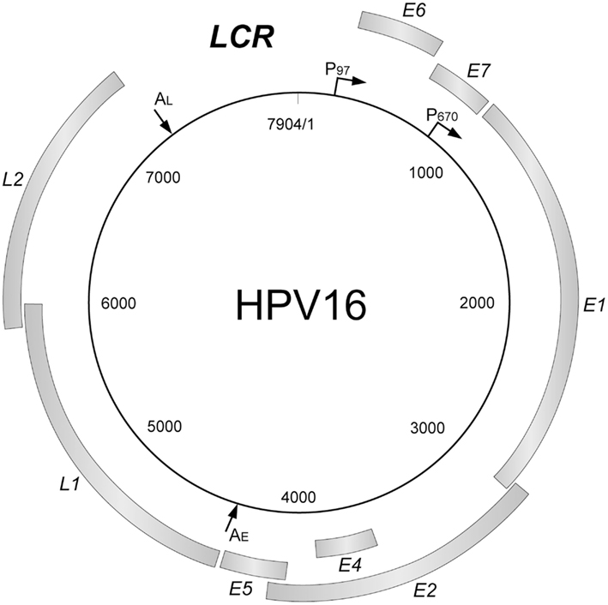

Figure 1: HPV VIRAL GENOME SHOWING THE THREE DIFFERENT REGIONS

EARLY GENE CODING REGION:
E1, E2, E4, E5, E6 & E7
- The function of E1 and E2 proteins is to regulate the replication of viral genome and transcription of early proteins.
- E6 and E7 have the potential to induce oncogenesis.
LATE GENE CODING REGION:
L1 and L2
- Both L1 and L2 code for structural protein like capsid
- Major viral capsid protein is coded by L1
- Minor viral capsid protein is coded by L2
LONG CONTROL REGION (LCR) OR NON-CODING REGION (NCCR) OR UPSTREAM REGULATORY REGION (URR)
- There are no protein coding sequences on the LCR.

HPV E6 & HPV E7 ONCOPROTEINS & CARCINOGENESIS
HPV E6 AND HPV E7 play a major role in directing the host cells toward malignancy. Both E6 and E7 deregulate the growth suppressors thereby achieving uncontrolled proliferation of cells. E6 targets a major growth suppressor protein, p53. E7 targets pRb (retinoblastoma protein) and related other proteins.
INHIBITION OF p53 BY E6
p53 is a tumor suppressor protein which is often called ‘Guardian of the genome’ which is very efficient in jumping into action under conditions such as cellular stress and decides the fate of the cell. p53 transcribes the genes that are required for the arrest of cell cycle or apoptosis under such cellular stress conditions thereby protecting our cells. It regulates gene expression to control DNA repair, cell death and cell division. Therefore, E6 disrupts p53 to induce continuous and uncontrolled proliferation of the cells.
DNA damage
Ubiquitination
Uncontrolled proliferation of cells & resistance to cell death

Degradation of p53
p53
E6AP
E6
E6 binds with E6AP (E6 associated protein)
E6
HPV Genome
Entry of HPV

FIGURE 2: INHIBITION OF P53 BY E6

INHIBITION OF RETINOBLASTOMA PROTEIN (pRB) BY E7
To achieve uncontrolled cell proliferation, inhibition of retinoblastoma protein (pRb) is a crucial step. During cell division, pRb binds to E2F (genes encoding a family of transcription factors), in order to prevent the transcription of genes that are required in the S phase. When the cells are not fully prepared to enter the S-phase from G1 phase, this pRb-E2F interaction is quite mandatory. E7 targets pRb for ubiquitination which breaks the pRb-E2F interaction, leading to forced entry of the cells from G1 to S phase through premature S-phase entry. This forced entry of cells occurs due to the release of E2F from pRb which results in the release of E2F transcription factors/cyclin genes.

DNA damage

Unrestricted entry of the cells into S-phase
Degradation of prb
Transcribes S-phase cyclin genes (Cyclin A/ Cyclin B)
Ubiquitination
pRb
E7
pRb
E2F gets free
E2F
E2F
pRb
E7
HPV Genome
Entry of HPV
FIGURE 3: INHIBITION OF RETINOBLASTOMA PROTEIN (pRB) BY E7

Co-expression of E6 and E7 can be seen in the HPV infected cells; which can be considered as the suitable environment for persistent cell proliferation. p53 has the ability to stabilize the growth stimulus initiated by pRb disintegration, but p53 is also being degraded by E6. This provides HPV a chance to direct the cells toward uncontrollable cell division. In order to eliminate cancer cells, our body’s immune system exerts a natural protective measure wherein a cell undergoing any unrepairable cellular damage, opts to die either by apoptosis or by autophagy or necrosis. Therefore, to escape this apoptotic protection and to establish malignancy, the HPV infected cells depend both on E6 and E7.

HPV and its replication in the epithelial cells
The basal epithelial cells undergo asymmetrical division in a normal cell cycle to renew the basal layer and cutaneous or mucosal epithelium. This cell division is limited to a certain number which is necessary for the formation of apical epithelium. In case of High risk HPV infection this cell division is constantly maintained which becomes an origin for long term HPV related diseases. In molecular terms, this maintenance of cell division is due to the over expression of E6 and E7 oncoproteins.

DIAGNOSIS OF HPV:

Nucleic Acid-Based Detection Methods:
1. Nucleic Acid Amplification-Based Methods: Polymerase chain reaction is utilized for the detection, amplification, and classification of HPV RNA. Here, degenerate primers are used for the amplification of HPV viral capsids.
a. Conventional PCR: Traditional PCR techniques include nested and multiplex PCR in combination with RFLP assays. Subsequently, DNA sequences of HPV subtypes are used to amplify the PCR product.
b. Hybridization Techniques: Methods for amplifying target DNA following hybridization encompass various techniques, including in situ hybridization, reverse line hybridization, the microplate colorimetric hybridization assay, and genotyping using a linear array. PCR using in situ hybridization involves performing standard PCR on a slide containing preserved paraffin-embedded tissue onto which specific DNA probes are hybridized. In the microplate colorimetric hybridization assay, PCR is performed followed by hybridization of HPV probes on the microplate using the technique of colorimetry. Membrane strips with immobilized amplified sequences are detected using HPV probes in the reverse line blot assay and linear array for HPV genotyping.
c. PCR-Based Fluorescent Array: Methods based on microarrays for HPV genotyping involve amplifying viral genome fragments using PCR and then hybridizing them with multiple HPV-specific oligonucleotide probes attached to an insoluble support like beads or DNA chips. Beads with fluorophores are utilized in suspension array genotyping. In this method, each bead is attached to a specific HPV DNA probe. The amplified HPV DNA is denatured and then hybridized with the probes attached to the beads. These amplicons are labeled using streptavidin and phycoerythrin and act as reporter molecules that are read using a Luminex analyzer.
d. Real-time PCR-Based HPV Genotyping Methods: Real-time PCR is used for quantification of HPV viral load. Fluorescent probes are hybridized with primers and are used for quantification.
e. HPV E6/E7 mRNA-Based Screening Assays: This involves E6/E7 transcript-mediated amplification using the technology of target capture. This is used both for the diagnosis and monitoring of cancer.
2. Signal Amplification: Here, probes are hybridized to the target DNA, and the signals produced as a result of this are used to quantify amplification. Branched DNA and hybrid capture assays utilize signal amplification methods. The Digene HCII technology and Cervista HPV test utilize hybrid capture and bDNA methods, respectively.
3. Nucleotide Hybridization-Based Methods: This involves Southern blot or dot blot and in situ hybridization methods. These methods are inferior to molecular methods due to their sensitivity, reliability, time consumption, and requirement of expensive instruments. In situ hybridization involves the hybridization of DNA directly on the infected cells followed by microscopic examination. In Southern blot, restriction enzymes are used to digest DNA, which is then electrophoresed and bound to a nitrocellulose membrane. This digested DNA is hybridized with labeled HPV probes.
Immune-Biochemical-Based Methods:
1. HPV Serology - ELISA Assay: Direct, indirect, and competitive ELISA are used to identify antibodies to HPV. This has a sensitivity of only 50%. The assays utilize virus-like particles for the detection of antibodies.
2. HPV Neutralization Assay: The assays use pseudovirions to detect anti-HPV antibodies. They are considered the gold standard method for estimating the efficiency of HPV vaccines in clinical trials. These tests offer high reproducibility and repeatability compared to ELISA.
The Potential Biomarkers for HPV Detection:
Supplemental detection of high-risk HPV biomarkers is a necessity to decrease the false negativity produced by cytology screening in the estimation of HPV and its associated diseases. The upcoming biomarkers for screening cervical cancer include p16INK4a, Ki-67, miR-22, miR-16, miR-25, miR-378, to name a few. The dysregulation of the various miRNAs results in cellular proliferation, migration, and invasion of cervical cancer.
Molecular techniques are considered the benchmark for the diagnosis of HPV infection. They can be used for the identification of the prevalence of HPV at district and state levels. HPV infection results in a modification in the function and expression of cellular genes which are utilized for the monitoring of this infection. The biomarkers for high-risk HPV are a huge leap in the diagnostic methods available for the detection and screening of cervical cancer. The various diagnostic methods available for the detection of high-risk HPV must be used in combination to decrease the false negativity of the tests.

References:
1. Soheili M, Keyvani H, Soheili M, Nasseri S. Human papilloma virus: A review study of epidemiology, carcinogenesis, diagnostic methods, and treatment of all HPV-related cancers. Med J Islam Repub Iran. 2021 May 22;35:65. doi: 10.47176/mjiri.35.65.
2. Hebner CM, Laimins LA. Human papillomaviruses: basic mechanisms of pathogenesis and oncogenicity. Rev Med Virol. 2006 Mar-Apr;16(2):83-97. doi: 10.1002/rmv.488.
3. Longworth MS, Laimins LA. Pathogenesis of human papillomaviruses in differentiating epithelia. Microbiol Mol Biol Rev. 2004 Jun;68(2):362-72. doi: 10.1128/MMBR.68.2.362-372.2004.
4. Abreu AL, Souza RP, Gimenes F, Consolaro ME. A review of methods for detect human Papillomavirus infection. Virol J. 2012 Nov 6;9:262. doi: 10.1186/1743-422X-9-262.
5. Aboulnasr A, Sherif N, Ali M, Elmahy M, Shalaby M, Soliman A, Salem M. Molecular Diagnosis of Human Papilloma Virus Infection. Med. J. Cairo Univ. 2020; 88(1): 471-480.

