Role of Parkin gene in breast cancer: A molecular Approach
Dr.R. Selvam ¹* & Dr.D.Anandhi ²

1*Department of Biochemistry, St. Peter's Institute of Higher Education and Research
Avadi, Chennai 600 054, Tamilnadu, India
2. Department of Biochemistry, Meenakshi Ammal Dental College, (Meenakshi Academy of Higher Education & Research),Maduravoyal, Chennai 600095

Breast

The breast, also known as the mammary gland, is an organ primarily responsible for producing milk. Mammary glands are a type of exocrine glands, which are specialized versions of sweat glands. Positioned one on each side, the breasts are conical in shape and located within the subcutaneous layer of the thoracic wall, anteriorly to the pectoralis major muscle. Both males and females have mammary glands, but they are more actively functional in females. The natural and essential function of the mammary gland is to secrete milk to nourish and feed a newborn baby. This milk provides crucial antibodies that protect the baby from infections, contributing to the early immune system development of the infant.

Anatomy
Internally, the mammary gland is composed of 15-25 lobes arranged around the nipple. Each lobe contains approximately 20-40 lobules, which are clusters of cells resembling grapes and are responsible for milk production. Supporting the lobules are small milk ducts that connect to form larger ductules. These ductules further merge to create lactiferous ducts, which are larger ducts located beneath the areola and nipple. Milk is collected from the lactiferous ducts into lactiferous sinuses, which then narrow to form small openings known as nipple pores. The breast's glandular tissue plays a crucial role in the production and transfer of milk, with four main components: Alveoli: These are clusters of cells where milk production occurs. Ductules: Branch-like tubules extending from the alveoli and connecting to form larger ducts. Lactiferous ducts: Larger ducts located beneath the areola and nipple, responsible for transporting milk. Lactiferous sinuses: These collect milk from the lactiferous ducts and lead to the nipple pores. Connective tissues attach and support the breast to the chest wall. Blood circulation within the breast plays an essential role in nourishing the tissue and providing nutrients required for milk production. Additionally, the breast contains numerous nerves, making it sensitive to touch. A baby's suckling can stimulate hormones like prolactin and oxytocin, which aid in milk production and ejection. Externally, each breast has a pigmented area known as the areola, located at the center of the breast. The nipple, protruding from the areola, is where the lactiferous duct of the mammary gland empties. Adipose tissue (fat) in the breast serves to protect the gland from injuries and shocks. It provides cushioning and support to the delicate structures within the breast. (Fig. 1)
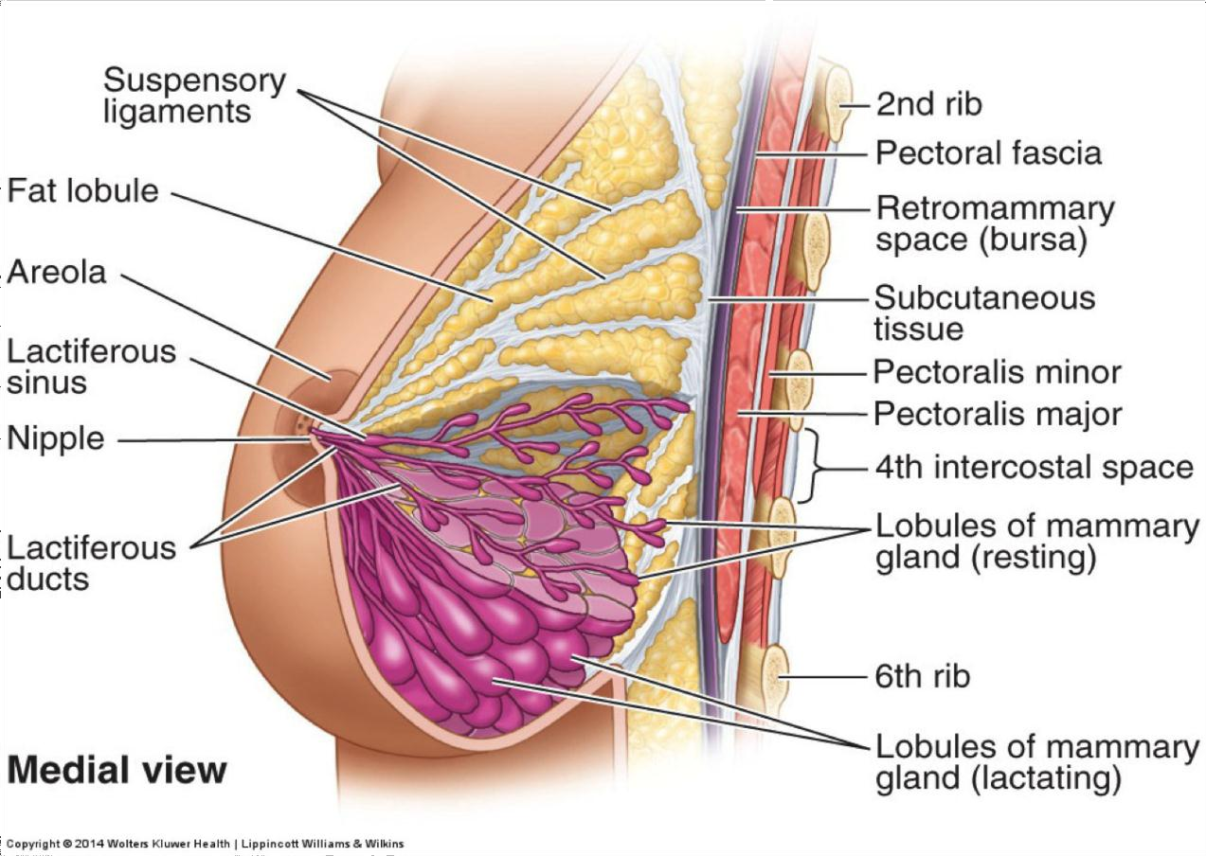
Fig. 1: Anatomy of female breast. Diagrammatic representation of normal female breast showing location and different parts of it. (image adapted from clin. Obstet. Gynecol. 2011 March 54 (1) 91-5)

Physiology

During puberty, the development of female breasts is triggered by the hormone estrogen, which induces the growth of glandular tissue. Another hormone called progesterone plays a key role in stimulating the growth and maturation of the breast ducts. Once a woman becomes pregnant, hormones continue to influence the breast. Prolactin, a hormone produced by the pituitary gland, stimulates milk production in the glandular tissues of the breast. As a result, the mammary glands start producing and accumulating milk. After childbirth, the hormone oxytocin comes into play. Oxytocin is responsible for facilitating milk ejection, also known as the let-down reflex. When the baby suckles at the breast, the release of oxytocin causes the muscles around the milk-filled alveoli to contract, pushing the milk through the ducts and out of the nipple, making it available for the baby to feed. Thus, the interplay of estrogen, progesterone, prolactin, and oxytocin orchestrates the development of the breasts during puberty and enables lactation and breastfeeding during and after pregnancy.

Breast Cancer

Breast cancer is characterized by the abnormal and uncontrolled proliferation of mammary cells, leading to the formation of tumors that can be detected as a lump or through x-ray imaging. If these cells invade nearby tissues or spread to other parts of the body, it is classified as malignant cancer. While breast cancer predominantly affects women, it is important to note that men can also develop breast cancer. There are two primary types of breast cancer based on their origin within the breast tissue: Ductal Breast Cancers: These cancers originate in the milk-carrying ducts of the breast. Lobular Breast Cancers: This type of cancer arises in the lobules, which are the glands responsible for producing breast milk. It is essential to be aware of the symptoms and undergo regular screenings for early detection, as early diagnosis and treatment can significantly improve the prognosis for individuals with breast cancer. (Fig. 2)

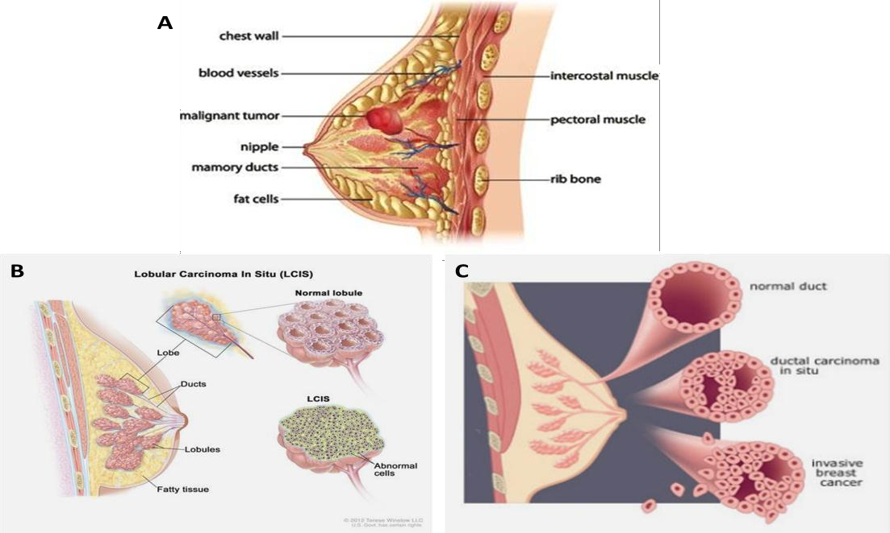
Fig. 2 Female breast cancer and its types. A. Diagram of female breast showing malignant tumor B. Lobular breast carcinoma; cancer arising from lobules. C. Ductal breast carcinoma; cancer starting from the ducts of breast. (Image adapted from breastcancersource.com, green-beauty.info).

Worldwide Incidence of Breast Cancer
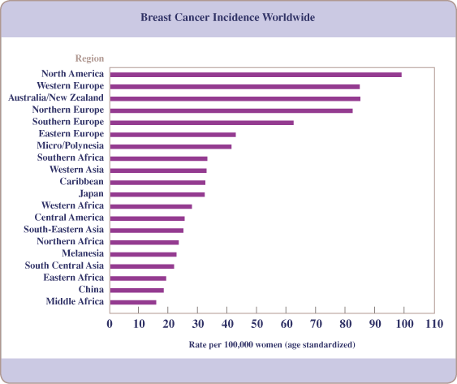
Breast cancer is the most commonly diagnosed cancer among women worldwide. In the United States, approximately 182,000 women are detected with breast cancer annually, accounting for around 26% of all cancers in women. Sadly, breast cancer contributes to about 40,000 deaths each year, making it the second leading cause of cancer-related deaths in American women, following lung cancer. The lifetime risk of dying from breast cancer in women is approximately 3.4%, and one in every eight women has a lifetime risk of developing breast cancer. However, there is hope for breast cancer patients as advancements in treatment and early detection have significantly improved survival rates. In the UK alone, an estimated 491,300 breast cancer survivors were alive at the end of 2010, and in Europe, over 464,000 new cases were detected in 2012. The incidence rate of breast cancer varies across the globe, with the highest rates seen in the United States and Northern Europe, intermediate rates in Southern and Eastern Europe and South America, and the lowest rates in Asia. Developed countries generally have higher incidence rates than developing countries, with Western Europe having the highest incidence rate. However, the mortality rates for breast cancer show smaller regional differences, as countries with higher incidence rates often have better prognosis and treatment options. Despite this, breast cancer remains a significant cause of death among women worldwide, both in developing and industrialized nations. It is worth noting that breast cancer diagnosis is less common in Asian and Black females compared to White females (Fig. 3). These disparities highlight the importance of raising awareness, promoting early detection, and providing accessible healthcare to all populations, regardless of ethnicity or race.
Fig. 3: Breast Cancer Incidence Worldwide. Graphical representation of breast cancer frequency distribution at international level. (MMG 233 2016 Genetics & Genomics Wiki - Fandom).

Breast Cancer Scenario in Indian
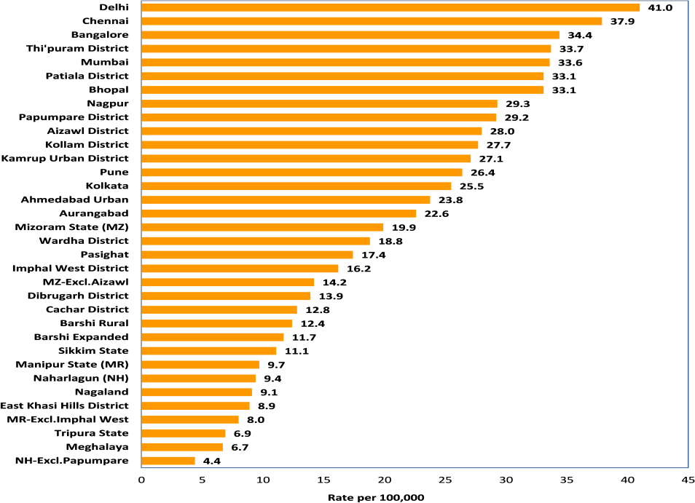
India, together with China and the United States, contributes to approximately one-third of the global burden of breast cancer. Unfortunately, India is facing a challenging situation with an alarming increase of 11.54% in breast cancer incidence and 13.82% in mortality during the period from 2008 to 2012. This rise in mortality can be attributed to the lack of improved breast cancer screening, timely diagnosis at earlier stages, and inadequate treatment options. Interestingly, breast cancer ranks as the top cancer among females in all major cities' registries (New Delhi, Mumbai, Bangalore, Chennai, and Dibrugarh) during the years 2012-2014. A survey conducted by the Indian Council of Medical Research (ICMR) from 1982 to 2005 revealed that the incidence rate of breast cancer in metropolitan cities is approximately double. The percentage of breast cancer incidence varies across different registries, ranging from 30.7% in Chennai to 19% in Dibrugarh. Major metropolitan areas like Delhi, Chennai, Bangalore, and Thiruvananthapuram District have the highest crude rates of breast cancer per 100,000 individuals. This trend is likely influenced by changing lifestyles and dietary habits due to increasing urbanization and westernization. Breast cancer has now surpassed cervical cancer as the most common type of cancer among Indian women, even though cervical cancer still remains frequent in rural areas. Breast cancer diagnosis in Indian women tends to occur about a decade younger compared to women in Western countries, indicating that breast cancer tends to affect Indian women at a younger age. Overall, the increasing incidence of breast cancer in India necessitates the implementation of better screening programs, early detection strategies, and improved access to effective treatment options to combat the growing burden of this disease (Fig. 4)
Fig. 4: Incidence rate of breast cancer in India. Comparison of age adjusted rates in population-based cancer registries (ICMR 2017)

Target Therapy

Targeted therapy is a sophisticated form of cancer treatment that focuses on specific genes, proteins, or environmental factors within the tissue that play a role in the growth and survival of cancer cells. This approach aims to precisely target and inhibit the molecular pathways that drive the cancer's progression. Trastuzumab and Pertuzumab are examples of drugs used in targeted therapy. These medications are designed to bind to the product of the Her-2 gene, blocking its function and thereby reducing the growth rate of cancer cells. By targeting this specific gene and its associated protein, these drugs can be effective in treating certain types of cancer, particularly those that overexpress the Her-2 protein. Targeted therapy offers the advantage of potentially being more effective and causing fewer side effects compared to traditional chemotherapy, as it selectively targets cancer cells while sparing healthy cells. It has become an important treatment option in the fight against cancer, leading to improved outcomes for many patients.

Parkin Gene

The Parkin (PARK-2/PRKN) gene is an E3 ubiquitin ligase that was initially associated with Autosomal Recessive Juvenile Parkinsonism (ARJP), a type of Parkinson's disease (PD). It belongs to a group of proteins known as RBR (RING, in between RING, RING) proteins, which include both of the main groups of E3 ligases. Parkin has been found to function with a catalytic cysteine as well as with the classical RING motif for binding to E2, a protein-conjugating enzyme. Numerous studies have focused on understanding the role of the Parkin gene in PD. However, it has also been implicated in other diseases, such as transient focal cerebral ischemia and leprosy. Additionally, altered Parkin function has been associated with the progression of various forms of human cancers. While there is evidence suggesting a putative role of Parkin alterations in cancer, the actual mechanism and its link to cancer susceptibility remain topics of ongoing debate.

Organization of Gene and Its Regulation
Parkin is encoded by one of the largest genes found in the human genome; PARK2, spans more than 1.43Mb on chromosome 6q26 (Fig. 5). It contains 12 exons that translate into a 52kDa protein having 465 amino acid. The gene contains relatively small coding exons, separated by the long non-coding introns, which makes it the third largest human gene after the two huge genes dystrophin and titin. At present, the function of these large introns are still unidentified.

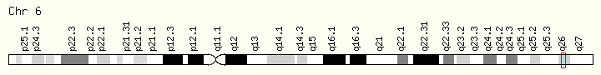Fig. 5: Location of human Parkin (Park-2/PRKN) gene. Full map of chromosome 6 showing Parkin at long arm (6q26) (Credit: Genome
Decoration Page/NCBI)

The promoter region of the Parkin gene is notably short, spanning only 204 base pairs. This gene is regulated by a bi-directional promoter that also controls the expression of the PACRG gene, which is located adjacent to Parkin and is approximately 0.6 megabases in size. While the exact components that regulate Parkin transcriptionally are not well understood, several studies have revealed certain conditions and factors that can lead to the upregulation or downregulation of Parkin mRNA. For instance, Parkin mRNA levels have been found to increase in response to cellular stress caused by unfolded proteins. Additionally, the introduction of certain agents like haloperidol (a dopamine-D2 receptor antagonist) and methamphetamine (a neurotoxin) has also been linked to increased Parkin mRNA expression. On the other hand, the transcription factor N-myc, which is involved in neuronal development, has been shown to negatively control Parkin expression by binding to its promoter. Moreover, hypermethylation of the Parkin promoter at CpG islands has been associated with the loss of Parkin expression, observed in patients with acute lymphoblastic and chronic myeloid leukemias. Despite these findings, there is still much to be discovered regarding the complex regulatory mechanisms that control Parkin gene expression under various conditions and in different diseases.

Protein Structure and Localization

Parkin protein is encoded by one of the largest known genes but translates to a relatively short amino acid sequence of 465 amino acids, resulting in an apparent molecular weight of 52 kDa. It comprises distinct domains, including an N-terminal ubiquitin-like (UBL) domain, a central distinctive region, and a RING box domain that terminates with a PDZ binding motif at the C-terminus. The RING box domain is a crucial region responsible for Parkin's ubiquitin activity and is composed of three domains: RING1, RING2, and an In-Between-Ring (IBR) domain. The RING1 domain contains an E2 binding site and binds two Zn2+ ions. The IBR domain, located between RING1 and RING2, also contains two zinc ions and helps maintain the conformation and structure of the RING domains within Parkin. The UBL domain is noteworthy for its similarity to ubiquitin, with 62% similarity and 30% identity to the ubiquitin molecule. It interacts with a subunit of the 26S proteasome called Rpn10, facilitating the transfer of polyubiquitinated substrates to the proteasome. Moreover, the UBL domain activates the 26S proteasome by contacting the 19S subunits, promoting stronger binding between these subunits. In addition to its role in proteasome interaction, the UBL domain regulates Parkin's activity by controlling its autoubiquitination. Notably, a RING0 domain is situated between the UBL and RING1 regions of Parkin. RING0 maintains Parkin in an inactive state by covering the catalytic cysteine residue C431, making it unavailable as an ubiquitin acceptor. Removing RING0 results in higher reactivity of C431 and increased autoubiquitination. (Fig. 6)
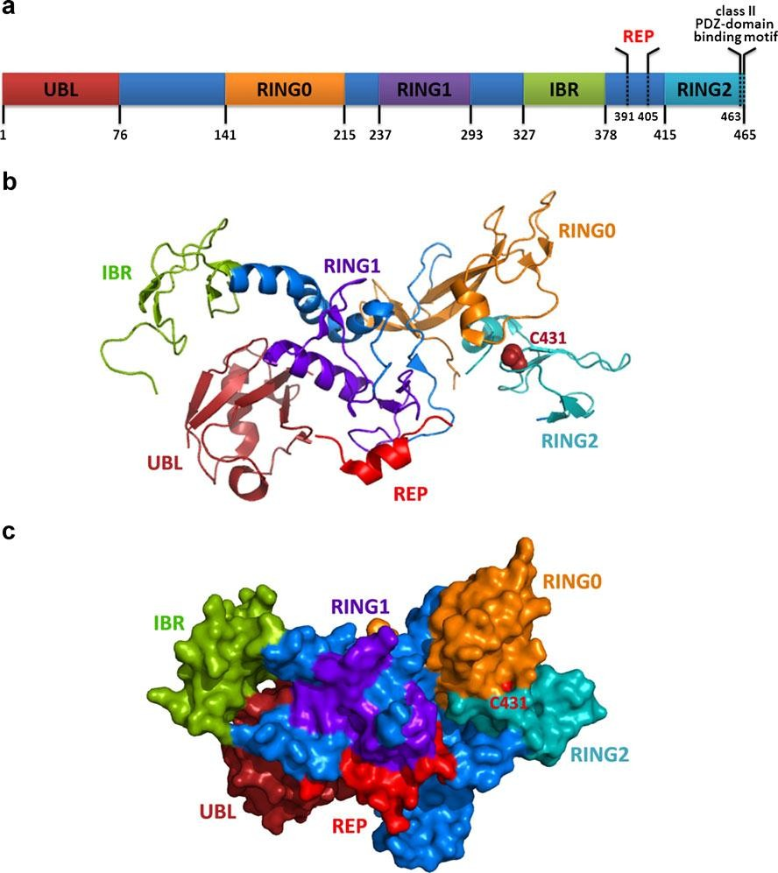
Fig. 6: Schematic diagram of Parkin (PARK-2) structure. A. Various domains of Parkin protein. B. Ribbon structure of PARK2 (PDB 4K95). C. Surface representation of PARK2 (remodeling of PDB 4K95) protein demonstrating intra- molecular interactions and buried catalytic C431 subunit. Adapted from (Xu et al., 2014).

The Parkin protein contains four domains: RING1, IBR, RING2, and RING0, each of which binds two zinc ions. Structural evidence has been presented for the IBR domain's zinc binding. The IBR domain plays a significant role in stabilizing the orientation of the Parkin protein by acting as a bridge that connects the RING1 and RING0 domains. The RING2 domain of Parkin shares topological similarity with the IBR domain and also binds two zinc ions. Two zinc-coordinating residues (Cys457 and His461) within the RING2 domain are well conserved. The catalytic cysteine, C431, in the RING2 domain acts as an acceptor of ubiquitin from E2-ubiquitin, forming an intermediate E3-ubiquitin complex that transfers ubiquitin to the substrate or Parkin itself during autoubiquitination. Parkin is considered an octuple zinc-binding protein since all four domains (RING0, RING1, IBR, and RING2) bind two Zn2+ ions each. Deletion of any zinc ion from Parkin results in the loss of its protein structure. Therefore, the binding of zinc ions is crucial for the proper folding of the Parkin protein. The extreme C-terminal end of Parkin contains three residues (FDV) that form a class II PDZ binding motif, which is essential for its interaction with CASK, a mammalian homolog of Caenorhabditis elegans Lin-2. Interestingly, Parkin does not ubiquitinate CASK upon interaction. Instead, this interaction leads to Parkin's translocation to the postsynaptic complex and lipid rafts in the human brain, suggesting that it regulates Parkin's activity in sub-cellular compartments.

Parkin Activation

In vitro studies of Parkin have made significant progress in understanding the mechanisms of Parkin activation. It has been observed that various effectors can induce the activity of Parkin through point mutations disrupting interactions between domains or deletions at the N-terminal region. The UBL domain of Parkin plays a crucial role in the activation process. Binding of partners to the UBL domain is linked to the activation of Parkin. Partners such as SH3 domain, Eps15, UIMs of endophilin A1, proteasomal subunits, and ataxin-3 interact with the UBL domain, and this interaction is similar to the hydrophobic region around Ile44 that typically binds with the RING1 domain. Upon Parkin activation, the UBL domain detaches from RING1. PINK1 functions upstream of Parkin and is essential for Parkin activation and recruitment to depolarized mitochondria. PINK1 phosphorylates the Ser65 residue of the UBL domain, leading to Parkin activation. This phosphorylation significantly increases Parkin's binding affinity for ubiquitin, making it ~20-fold more efficient in binding ubiquitin. The recruitment of Parkin to depolarized mitochondria can be disrupted by expressing non-phosphorylatable S65A ubiquitin, and Parkin activation is abolished when mutations are present at Ser65 of both Parkin and ubiquitin. Furthermore, PINK1 has the ability to phosphorylate ubiquitin chains, and phospho-ubiquitin can be activated by E1 enzymes and linked to E2 enzymes. However, its role in the ubiquitination process depends on E3 enzymes. Interestingly, Parkin shows higher activity with ubiquitin-E2 than with phospho-ubiquitin-E2 due to conformational changes in phospho-ubiquitin. The detailed structural changes that occur in Parkin during its activation are not fully understood, but the evidence suggests a proposed two-state system. Various factors can shift the equilibrium of Parkin conformation from the inactive to active state. It is currently believed that the disturbance in the RING0-RING2 interface enhances ligase activity and disrupts the interaction of REP-RING1, leading to Parkin activation.

Parkin in Cancer

The surprising role of Parkin as an emerging tumor suppressor gene has been supported by numerous studies. Parkin is located within the common fragile site (CFS) of chromosome 6, FRA6E (6q26), which is commonly deleted in various types of tumors. This genomic region, FRA6E, is often targeted by hemizygous and homozygous deletions. Studies have reported alterations in Parkin gene expression in different types of tumor tissues and cell lines from various cancers, including lung, ovarian, breast, liver, colorectal, lymphomas, melanomas, and leukemias. Experimental evidence supports Parkin's tumor suppressive role, as its ectopic expression in breast cancer and melanoma cell lines led to decreased tumorigenicity and restoration of the ability of these cells to undergo senescence. Furthermore, studies using Parkin null mice models have demonstrated an increase in hepatocyte proliferation and progression of hepatic tumors, reinforcing the tumor suppressive function of Parkin. Loss-of-heterozygosity (LOH) and aberrant methylation at the promoter of Parkin have also been linked to its downregulation in certain types of leukemias. Somatic mutations of the Parkin gene have been observed in various human cancer samples, such as glioblastoma, lung, and colon cancer. Interestingly, some of these somatic mutations were found to be situated at the same domains or even the same amino acids as those associated with Parkinson's disease (PD) germline mutations. The tumor suppressive function of Parkin is primarily associated with its ubiquitin ligase activity (Fig. 7). It regulates the level of cyclin E, an important substrate, which is found to be increased in breast, ovarian, and other tumors. Additionally, Parkin has been identified as a target gene of the classical tumor suppressor p53, which regulates glucose metabolism and the Warburg effect. Parkin's involvement in mitochondrial regulation and homeostasis contributes to its role in preventing the Warburg effect and mitochondrial dysfunction.

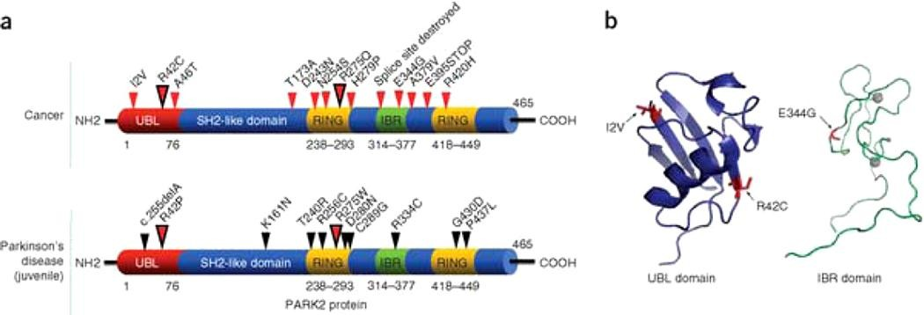
Fig. 7: Parkin gene mutations in human. (a) Parkin somatic mutations found in cancer (top) and germline mutations in early-onset Parkinson's disease (bottom). Small arrows indicate the position of mutations and their corresponding amino acid changes. Large red color arrows designate amino acids that are altered in both cancer and PD but their resultant amino acids are different. (b) Structural analysis of somatic mutations in the UBL and IBR domains of Parkin. Mutations found in cancer are shown in red while gray circles represent zinc.

Parkin Gene and Different Pathways of Cancer
Several accumulating evidences revealed the potential role and involvement of Parkin
gene in different pathways of cancer.

Organization of Microtubule

Microtubules play a crucial role in various cellular functions and are often targeted for cancer therapy. Parkin, a protein associated with both cancer and neurodegenerative diseases, interacts with microtubules through its three-independent microtubule/tubulin binding domains: RING0 (along with the linker region between UBL), RING1, and RING2. Parkin's interaction with microtubules contributes to their polymerization, leading to increased stabilization, especially in combination with paclitaxel treatment. Additionally, Parkin counteracts the effects of depolymerizing drugs, thereby promoting microtubule stability. Remarkably, when microtubule-depolymerizing drugs are introduced, Parkin inhibits the subsequent activation of MAPKs (microtubule-associated protein kinases) such as ERK, JNK, and p38. This regulatory function further highlights the significance of Parkin in microtubule dynamics. In breast cancer cell lines, the ectopic expression of Parkin enhances the sensitivity of the cells to various anti-cancer drugs like paclitaxel, docetaxel, and epothilone B. This suggests that Parkin's role in microtubule stabilization may have implications in cancer treatment strategies.

Regulation of Cell Cycle

Parkin exhibits dynamic localization within subcellular compartments during different stages of the cell cycle (Sun et al., 2013). During interphase, Parkin is primarily localized around the nucleus, while in the mitotic phase, it transfers to centrosomes and mitotic spindles. Furthermore, during cytokinesis, Parkin is found at the midbody. In the cell cycle, Parkin plays a role in the ubiquitination and degradation of Cyclin E in complex with FBXW7 and Cullin1, contributing to the maintenance of Cyclin E/D1 levels and potentially exerting indirect transcriptional repression. Parkin's expression level influences cell cycle progression. Overexpression of Parkin induces G1-phase arrest and delays mitotic entry, whereas the loss of Parkin enhances the S and G2-M phases of the cell cycle. In breast cancer cell lines, Parkin upregulates the expression of CDK6, leading to cell cycle arrest and growth repression. Parkin's involvement in regulating centrosomes and mitotic spindles is also notable. It interacts with the protein γ-tubulin, which is crucial for the nucleation and orientation of microtubules involved in spindle formation. Loss of Parkin may lead to misorientation of spindles, formation of multipolar spindles, and micronuclei, indicating a potential fault in the spindle assembly checkpoint. Parkin also plays a role in maintaining the assembly of bipolar spindles by regulating the transcription of Eg5, ensuring proper chromosome segregation during cell division.

Mitochondrial Homeostasis

Mitochondria play a crucial role in various cellular processes, including cell metabolism and cell death, and alterations in mitochondrial function can directly contribute to the development of cancer. There is a growing body of evidence demonstrating the significant role of Parkin in mitochondrial function. Parkin enhances mitochondrial transcription by binding to mitochondrial DNA (mtDNA), thereby promoting mitochondria biogenesis. Additionally, Parkin plays a vital role in protecting the mitochondrial genome from damages caused by reactive oxygen species (ROS) and helps in maintaining mtDNA integrity and recovery. Long-term overexpression of Parkin has been shown to selectively eliminate mitochondria with harmful mutations, leading to an enrichment of the wild-type mtDNA population. This highlights the essential role of Parkin in maintaining the integrity of the mitochondrial genome and suggests its potential significance in tumorigenesis.

Role in Apoptosis Pathway

While Parkin has been primarily associated with Parkinson's disease, its role in apoptosis cannot be overlooked. Although it is well-known for its protective role in neurons, its function in regulating apoptosis in cancer cells is still not fully understood. Parkin has been found to control the activity of several key proteins associated with apoptosis, including BAX, MCL1, and BCL-2. Interestingly, after the onset of apoptosis, Parkin is often observed to be cleaved by caspase 1 and caspase 8. Studies have shown that in liver or breast cancer cell lines, the expression of Parkin increases apoptosis induced by HDAC inhibitors and microtubule-stabilizing drugs. Conversely, Parkin-deficient hepatocyte cells have been found to be more resistant to anticancer drugs compared to their wild-type counterparts. Additionally, Parkin has been shown to sensitize Hela cells to TNF-α-induced apoptosis.

Role in Cancer Cell Metabolism
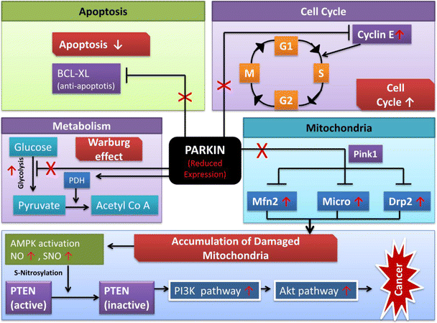
During cancer progression and transformation, cancer cells often rely on aerobic glycolysis instead of mitochondrial respiration to meet their energy and biosynthetic needs, a phenomenon known as the Warburg effect. Interestingly, Parkin has been identified as a target gene of the tumor suppressor protein p53, which plays a role in controlling glycolysis, glucose uptake, oxygen consumption, and lactate production, all contributing to the Warburg effect. Numerous proteomic studies have suggested that Parkin may regulate mitochondrial processes and the expression of metabolic enzymes, which could contribute to its inhibitory function in cancer cells. Specifically, Parkin has been shown to positively regulate the expression of PDHA1 (Pyruvate dehydrogenase-1), an enzyme that reduces mitochondrial oxidative phosphorylation and promotes glycolysis. Moreover, recent research has revealed a connection between Parkin deficiency and the inactivation of the PTEN gene in human cancers, further implicating Parkin's role in metabolic regulation and tumor development. Overall, Parkin appears to play a multifaceted role in cancer cell metabolism, affecting various processes that contribute to the Warburg effect and potentially influencing cancer cell growth and survival. Further investigation into these mechanisms could offer valuable insights for the development of targeted cancer therapies (Fig. 8).

Fig. 8: The role of Parkin in different pathways of cancer. Effect of reduced/altered Parkin expression in different pathways leading to cancer. Red X shows the reduced or altered expression; red boxes show the potential resultant effect.
References:
- Abdulrahman, G. O., & Rahman, G. A. (2012). Epidemiology of Breast Cancer in Europe and Africa. Journal of Cancer Epidemiology, 2012, 1–5. http://doi.org/10.1155/2012/915610.
- Agarwal, G., Pradeep, P. V., Aggarwal, V., Yip, C.-H., & Cheung, P. S. Y. (2007). Spectrum of Breast Cancer in Asian Women. World Journal of Surgery, 31(5), 1031–1040. http://doi.org/10.1007/s00268-005-0585-9.
- Agirre, X., Román-Gómez, J., Vázquez, I., Jiménez-Velasco, A., Garate, L., Montiel-Duarte, C., Prósper, F. (2006a). Abnormal methylation of the common PARK2 and PACRG promoter is associated with downregulation of gene expression in acute lymphoblastic leukemia and chronic myeloid leukemia. International Journal of Cancer, 118(8), 1945–53. http://doi.org/10.1002/ijc.21584.
- Ali, I., Wani, W. A., & Saleem, K. (2011). Cancer Scenario in India with Future Perspectives Article in Cancer Therapy. 173 Cancer Therapy (Vol. 8). Retrieved from https://www.researchgate.net/publication/230560896.
- American Cancer Society. (2016a). Treating Breast Cancer. Retrieved September 9, 2018, from https://www.cancer.org/cancer/breast-cancer/treatment.html.
- American Cancer Society. (2016b). Understanding a Breast Cancer Diagnosis Types of Breast Cancer. Retrieved from https://www.cancer.org/content/dam/CRC/PDF/Public/8580.00.pdf.
- American Cancer Society. (2017). What Is Breast Cancer? Retrieved September 4, 2018, from https://www.cancer.org/cancer/breast-cancer/about/what-is-breast-cancer.html
- Bartek, J., & Hodny, Z. (2014). PARK2 orchestrates cyclins to avoid cancer. Nature Genetics, 46(6), 527–528. http://doi.org/10.1038/ng.2992.
- Beasley, S. A., Hristova, V. A., & Shaw, G. S. (2007). Structure of the Parkin in-between-ring domain provides insights for E3-ligase dysfunction in autosomal recessive Parkinson’s disease. Proceedings of the National Academy of Sciences of the United States of America, 104(9), 3095–100. http://doi.org/10.1073/pnas.0610548104.
- Bednarek, A. K., Keck-Waggoner, C. L., Daniel, R. L., Laflin, K. J., Bergsagel, P. L., Kiguchi, K., … Aldaz, C. M. (2001). WWOX, the FRA16D gene, behaves as a suppressor of tumor growth. Cancer Research, 61(22), 8068–73. Retrieved from http://www.ncbi.nlm.nih.gov/pubmed/11719429.
- Chappuis, P., Goffin, J., Wong, N., C. P.-J. of medical, & 2002, undefined. (n.d.). A significant response to neoadjuvant chemotherapy in BRCA1/2 related breast cancer. Jmg.Bmj.Com. Retrieved from http://jmg.bmj.com/content/39/8/608.short.
- Chaugule, V. K., Burchell, L., Barber, K. R., Sidhu, A., Leslie, S. J., Shaw, G. S., & Walden, H. (2011a). Autoregulation of Parkin activity through its ubiquitin-like domain. The EMBO Journal, 30(14), 2853–67. http://doi.org/10.1038/emboj.2011.204.
- Chaugule, V. K., Burchell, L., Barber, K. R., Sidhu, A., Leslie, S. J., Shaw, G. S., & Walden, H. (2011b). Autoregulation of Parkin activity through its ubiquitin-like domain. The EMBO Journal, 30(14), 2853–67. http://doi.org/10.1038/emboj.2011.204.
- Chaugule, V. K., Burchell, L., Barber, K. R., Sidhu, A., Leslie, S. J., Shaw, G. S., & Walden, H. (2011c). Autoregulation of Parkin activity through its ubiquitin-like domain. The EMBO Journal, 30(14), 2853–2867. http://doi.org/10.1038/emboj.2011.204
- Edge, S. B., & American Joint Committee on Cancer. (2010). AJCC cancer staging manual. Springer. Retrieved from https://www.springer.com/in/book/9780387884424.
- Eifel, P., Axelson, J. A., Costa, J., Crowley, J., Curran, W. J., Deshler, A., Roter, D. (2001). National Institutes of Health Consensus Development Conference Statement: adjuvant therapy for breast cancer, November 1-3, 2000. Journal of the National Cancer Institute, 93(13), 979–89. Retrieved from http://www.ncbi.nlm.nih.gov/pubmed/11438563.
- Globocan 2012 - Home. (2012). Retrieved September 4, 2018, from http://globocan.iarc.fr/Default.aspx.
- Gong, Y., Schumacher, S. E., Wu, W. H., Tang, F., Beroukhim, R., & Chan, T. A. (2017). Pan-Cancer Analysis Links PARK2 to BCL-XL-Dependent Control of Apoptosis. Neoplasia, 19(2), 75–83. http://doi.org/10.1016/j.neo.2016.12.006.
- Gong, Y., Zack, T. I., Morris, L. G. T., Lin, K., Hukkelhoven, E., Raheja, R., Chan, T. A. (2014). Pan-cancer genetic analysis identifies PARK2 as a master regulator of G1/S cyclins. Nature Genetics, 46(6), 588–94. http://doi.org/10.1038/ng.2981.
- Gould, S. F. (1983). Anatomy of the Breast. In Lactation (pp. 23–47). Boston, MA: Springer US. http://doi.org/10.1007/978-1-4613-3688-4_2.
- Hedrich, K., Kann, M., Lanthaler, A. J., Dalski, A., Eskelson, C., Landt, O., Klein, C. (2001). The importance of gene dosage studies: mutational analysis of the parkin gene in early-onset parkinsonism. Human Molecular Genetics, 10(16), 1649–56. Retrieved from http://www.ncbi.nlm.nih.gov/pubmed/11487568
- Hershko, A., & Ciechanover, A. (1998). THE UBIQUITIN SYSTEM. Annual Review of Biochemistry, 67(1), 425–479. http://doi.org/10.1146/annurev.biochem.67.1.425.

