Biopharmaceutics: Basic Introduction & Future Trends
Vineet Joshi and Ankit Kumar
College of Pharmacy, Shivalik campus, Dehradun, 248197
Email Id: vntjoshi94@gmail.com

Abstract
Pharmaceutical research and medication development depend significantly on the multidisciplinary area known as biopharmaceutics. The study's primary objective is to understand how physiological factors, pharmaceutical properties, and formulations affect drug distribution, absorption, metabolism, and excretion. The basic ideas of biopharmaceutics are covered in this chapter, including medication absorption, dissolution, permeability, and bioavailability. The role of biopharmaceutics in developing novel medication formulations, enhancing drug candidate efficacy, and determining drug safety is highlighted. Research is being done on the connection between biopharmaceutics and pharmacokinetics, as well as on upcoming innovations that will have an impact on drug development, such as personalized medicine, targeted drug delivery, and improved pharmacokinetic analysis.
Key Words: Biopharmaceutics, Medication development, pharmacokinetics, Drug Safety.
Introduction
Biopharmaceutics is a multidisciplinary field that has a considerable impact on medication development and pharmaceutical research. The main objective of this study is to determine how drug physicochemical qualities, pharmaceutical formulation, and biological components affect drug absorption, distribution, metabolism, and excretion (ADME) in the human body. The name "biopharmaceutics" originated by combining the words "bio" and "pharmaceutics," which refer to the science of developing dosage forms and medication delivery. This area of pharmaceutical sciences aims to enhance drug delivery methods in order to produce focused therapeutic results while lowering side effects and treatment response variability [1, 2].
Objectives of Biopharmaceutics:The following are some of the key objectives of biopharmaceutics:
  - Recognizing the factors affecting drug distribution, metabolism, and excretion.
  - Producing therapeutic formulations that ensure delivery of the medication to specified regions of action.
  - Evaluating the bioavailability of drugs to determine their rate and extent of absorption.
  - Assessing the impact of pharmaceutical excipients on drug performance and stability.
  - Investigating drug-drug interactions and their influence on drug efficacy and safety.
  - Developing novel drug delivery methods in order to improve patient compliance and therapeutic results.
Concepts in Biopharmaceutics:To understand how medications are administered and behave throughout the human body, it is necessary to understand several essential concepts included under the general category of biopharmaceutics. These ideas spotlight the variables that affect drug distribution, metabolism, excretion, and ultimately, pharmacological efficacy and safety. The following are some fundamental ideas in biopharmaceutics [3-5]:
- Drug Absorption: The process by which a medicinal product reaches the bloodstream from its site of administration is usually referred to as drug absorption. Drug solubility, particle size, formulation, and mode of administration are merely a few examples of various factors that affect how rapidly, and the amount of medication is absorbed.
- Drug Dissolution: Dissolution is the process of drug release from its dosage form into a solution in the gastrointestinal tract. The rate of drug dissolution significantly impacts drug absorption, as only dissolved drugs can be absorbed effectively.
- Drug Permeability: The ability of a medication molecule to penetrate biological barriers, such as cell membranes or the blood-brain barrier, is referred to as drug permeability. Drug permeability is influenced by the physicochemical characteristics of the drug and the features of the biological barrier.
- Bioavailability: The proportion of a drug delivered in a dose that can produce a pharmacological effect when it enters the systemic circulation intact is known as bioavailability. Determining the speed and extent of drug absorption, it is a significant measure.
- First-Pass Metabolism: First-pass metabolism occurs when a medication undergoes a significant amount of liver metabolism before entering the bloodstream. The bioavailability of medicines taken orally may be greatly decreased by this process.
- Drug Distribution: Drug distribution refers to the movement of a substance from the bloodstream to several body tissues and organs. The distribution of pharmaceuticals is influenced by elements such as tissue perfusion, plasma protein binding, and drug partitioning.
- Drug Metabolism (Biotransformation): The liver is the primary site of drug metabolism, involving the enzymatic breakdown of a drug into metabolites. Drug metabolism can change its pharmacological action, increase, or decrease its effectiveness, and affect how quickly it leaves the body.
- Drug Excretion: The process of eliminating medicinal products and their metabolites from the body is known as drug excretion. While bile and faeces can also be routes of excretion, the kidneys are the main organs in charge of drug excretion in urine.
- Drug-Drug Interactions: Drug interactions happen when the pharmacokinetics or pharmacodynamics of one drug are impacted by the presence of another. For drug therapy to be safe and successful, it is crucial to understand drug-drug interactions.
- Pharmacokinetic Parameters: Pharmaceutical activity in the body is measured mathematically using pharmacokinetic parameters. Clearance, volume of distribution, elimination half-life, and area under the concentration-time curve (AUC) are typical pharmacokinetic characteristics.
- Biopharmaceutical Classification System (BCS): The BCS classifies drugs based on their solubility and permeability characteristics, providing information on their bioavailability and possibilities for the development of generic medications. BCS classified the drugs into 4 categories: BCS Classes I, II, III, and IV.
Table 1: BCS Classification System

BCS Class | Solubility | Permeability | Example Drugs
Class I | High solubility | High permeability | Metoprolol, Atenolol
Class II | Low solubility | High permeability | Ketoconazole, Carbamazepine
Class III | High solubility | Low permeability | Cimetidine, Ranitidine
Class IV | Low solubility | Low permeability | Danazol, Griseofulvin

- Drug Delivery Systems: Systems for delivering medications to specified body locations are referred to as drug delivery systems. These systems include a variety of formulations and technology. These systems increase treatment efficacy, improve drug absorption, and minimize adverse consequences.
Role of Biopharmaceutics in Drug Development:The importance of biopharmaceutics in facilitating the discovery of novel medications is unable to be emphasized. It is crucial at several stages of the drug development process, from pre-marketing surveillance to early discovery. The following key points serve as the best illustrations of the significance of biopharmaceutics in the creation of medications:[4, 6][7]
- Optimization of Drug Candidates:Biopharmaceutics makes it easier to choose and improve therapeutic candidates by comprehending the characteristics of a drug candidate's absorption, distribution, metabolism, and excretion (ADME). Early assessment of these pharmacokinetic parameter’s aids in both the creation of therapeutic molecules with beneficial pharmacological profiles and the early identification of potential issues.
- Formulation Development:The manner a medicine is formulated affects both its medicinal efficacy and patient compliance. Biopharmaceutics offers insights into the physicochemical properties of drug molecules, enabling the creation of ideal therapeutic formulations that enhance medication stability, solubility, and bioavailability.
- Bioavailability and Bioequivalence:The scientific investigation of a drug's bioavailability, or the percentage of an administered dose that delivers it to the systemic circulation, is known as biopharmaceutics. Bioavailability information is crucial to assessing a drug's effectiveness and creating dose-response relationships. To ensure that generic alterations are therapeutically equivalent to the reference product, it also helps to determine the bioequivalence of innovator and generic drug products.
- Drug Delivery Systems:Biopharmaceutics facilitates the design and assessment of drug delivery systems. By comprehending drug absorption methods and biological obstacles, researchers can develop targeted drug delivery systems that release pharmaceuticals at specific locations, increasing therapeutic benefits and reducing side effects.
- Pharmacokinetic Modeling:Pharmacokinetic models, which are promoted in the setting of biopharmaceutics, can be used to precisely estimate drug behavior in the body. These models simplify the selection of the appropriate dosages, calculation of the frequency of administration, and prediction of pharmaceutical interactions, all of which are crucial for patient safety and effective pharmacological therapy.
- Drug-Drug Interactions:Drug interactions are monitored via biopharmaceutics when the presence of one drug influences the pharmacokinetics or pharmacodynamics of another. To optimize medicine combinations and prevent side effects, it is essential to understand these interactions.
- Regulatory Compliance:Regulations for drug approval include a necessity for biopharmaceutics data. To assure a medication candidate's safety, effectiveness, and consistency of performance across several formulations, regulatory agencies assess its biopharmaceutical profile.
- Personalized Medicine:In the developing field of personalized medical care, where therapies are customized to a patient's genetic makeup, lifestyle, and disease characteristics, biopharmaceutics plays an important role. It contributes to making treatment regimens more effective and helps patients avoid negative side effects to understand drug metabolism and pharmacokinetics in certain patient populations.
- Drug Safety and Risk Assessment: Biopharmaceutics contributes to the identification and mitigation of potential safety concerns associated with drug development. By understanding how drugs are metabolized and eliminated, researchers can anticipate and address safety issues early in the development process.
- Post-Marketing Surveillance:Biopharmaceutics is still crucial for keeping updated on a drug's effectiveness and safety after it has been licensed and placed on the market. Post-marketing surveillance is analyzing actual data to find any previously undiscovered interactions, negative effects, or drug delivery problems.
Relationship between Pharmacokinetics and Biopharmaceutics:Within the scope of pharmaceutical sciences, pharmacokinetics and biopharmaceutics are closely connected disciplines that serve complementary roles in understanding how medications interact with the human body. Pharmacokinetics deals with the quantitative evaluation of drug absorption, distribution, metabolism, and excretion (ADME), whereas biopharmaceutics focuses on the factors influencing these processes. Let's delve more into the connection between pharmacokinetics and biopharmaceutics [8, 9]:
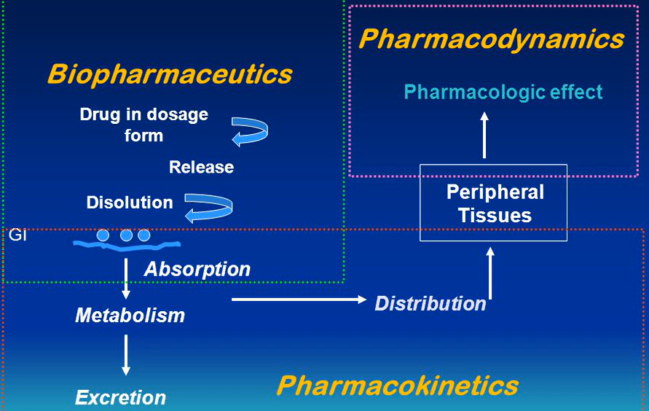
Figure 1: Relationship between Pharmacokinetics and Biopharmaceutics
- Biopharmaceutics and Drug Absorption:Biopharmaceutics examines whether drugs are absorbed, considering variables like drug solubility, permeability, and dissolution rate. Understanding how a drug is liberated from its dose form, dissolves in body fluids, and is absorbed into the systemic circulation requires this knowledge. Contrarily, pharmacokinetics measures the amount of drug absorption through variables like the absorption rate constant (ka) and the bioavailability of the drug. Researchers can optimize drug formulations to improve drug absorption and bioavailability by combining biopharmaceutics and pharmacokinetics.
- Drug Distribution and Pharmacokinetics:Biopharmaceutics investigates how medications move throughout the body after absorption, considering things like membrane permeability, tissue binding, and plasma protein binding. Understanding how medications are delivered to their target areas and tissues depends on this information. Drug distribution in the body is quantitatively described by pharmacokinetics using distribution parameters like the volume of distribution (Vd) and half-life (t_{1/2}).
- Drug Metabolism and Pharmacokinetics:The study of drug metabolism, particularly in the liver, and how drug biotransformation impacts a medication's pharmacological activity and elimination are topics covered in biopharmaceutics. Drug metabolism is described by pharmacokinetics including parameters like clearance (CL) and elimination rate constant (K_{E}). Researchers can better understand how metabolism affects a drug's concentration-time profile and general pharmacokinetic behavior due to the connection between biopharmaceutics and pharmacokinetics.
- Drug Excretion and Pharmacokinetics:The area of biopharmaceutics investigates the methods through which drugs are excreted from the body, including biliary and renal excretion. Pharmacokinetics quantifies drug excretion through parameters like renal clearance (CL_{R}) and the elimination half-life (t_{1/2}). By studying drug excretion from both perspectives, researchers gain insights into the factors affecting drug elimination and the duration of drug action.
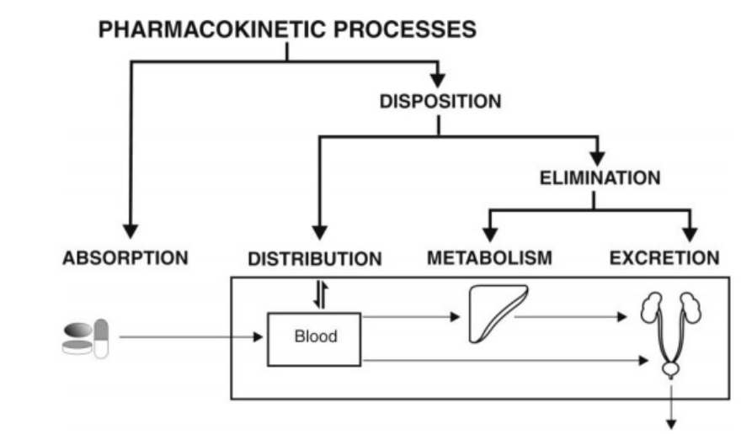
Figure 2: Pharmacokinetic Process

- Bioavailability and Pharmacokinetics: Bioavailability, a key parameter studied in biopharmaceutics, represents the fraction of an administered dose that reaches the systemic circulation unchanged. Pharmacokinetics utilizes bioavailability data to calculate drug exposure (area under the concentration-time curve, AUC) and determine drug clearance (CL). The relationship between drug dosage and the achieved drug concentrations in the body must be established using accurate bioavailability assays.
- Drug Delivery Systems and Pharmacokinetics:The development of drug delivery systems that optimize drug release and absorption characteristics depends extensively on biopharmaceutics. Pharmacokinetics examines methods for delivering drugs by analyzing how drug concentrations are affected over time. This information is used to identify the appropriate dosing strategy and evaluate the therapeutic response.
FutureTrends in Biopharmaceutics: advancements in technology, greater awareness of biological processes, and consumer demand for more individualized and effective medication therapy will all influence future trends in biopharmaceutics. Future developments in biopharmaceutics include the following:[10][11][12]
- Personalized Medicine:Biopharmaceutics continues to move towards more individualized pharmacological therapy as genomes and precision medicine improve. By taking the patient's genetic makeup, lifestyle, and disease features into account, researchers may improve pharmaceutical treatment to be more effective and personalized to the particular needs of the patient.
- Targeted Drug Delivery:In biopharmaceutics, novel pharmaceutical delivery systems that specifically target body regions are being researched. Advances in nanotechnology and other innovative methods of administration currently make it feasible to deliver drugs directly to the site of action, minimizing side effects and improving therapeutic outcomes.
- Biologics and Biopharmaceuticals:The development and commercialization of biologics, including gene therapies, cell-based medications, and monoclonal antibodies, is a key trend in biopharmaceutics. These complicated compounds have specific stability, production, and immunogenicity issues that call for special delivery methods.
- Continuous Manufacturing:The rising popularity of continuous manufacturing techniques in the pharmaceutical sector is an occurrence that also extended to the field of biopharmaceutics. Continuous manufacturing offers advantages like higher productivity, lower production costs, and improved process control for biopharmaceuticals and other therapeutic products.
- Advanced Pharmacokinetic Modeling:The application of artificial intelligence and computer technology to pharmacokinetic modelling has been growing. Advanced modelling techniques, which give a more detailed understanding of drug behavior, dose-response relationships, and patient variability, permit optimal pharmaceutical dosing regimens.
- 3D Printing of Pharmaceuticals:The potential benefits of 3D printing for individualized dose forms and medication formulations are being investigated. This strategy makes it possible to produce medications on demand with precise dosages and release profiles, which could revolutionize drug manufacture and distribution.
- Improved Drug Solubility and Permeability:Increasing drug permeability and solubility is still a challenge in medication development. Biopharmaceutics is continually developing new formulations and delivery systems to address these issues and enhance the absorption and bioavailability of poorly soluble drugs.
- Microbiome-based Therapies:The human microbiome, which comprises of the microorganisms that reside in and on our bodies, is a crucial element in the metabolism and response to drugs. Biopharmaceutics is the study of how the microbiome impacts these parameters. Researchers are exploring microbiome-based medicines to improve the efficacy and safety of pharmaceuticals.
- Real-Time Monitoring of Drug Response:Technologies for continuous monitoring and wearable biosensors have advanced, providing prospects for real-time drug response evaluation. These methods can be used by biopharmaceutics to personalize medicine doses and improve treatment plans based on data from specific patients.
- Regulatory Considerations:Laws and regulations will continue to have an impact on biopharmaceutics. For drug approval, safety evaluations, and the approval of difficult pharmaceutical products, regulatory agencies are emphasizing biopharmaceutical data increasingly.
Conclusion:Pharmaceutical sciences continue to depend significantly on biopharmaceutics for developing effective medications and patient-centered treatments. Its thorough comprehension of how drugs behave in the human body makes it easier to optimize drug candidates, devise formulations, and determine the safety of medications. Researchers can quantitatively assess drug attributes and determine dose regimens because of the interaction between biopharmaceutics and pharmacokinetics. As the discipline develops, specific drug delivery and personalized medicine hold promise for better treatment outcomes. Adopting cutting-edge technology, like 3D printing and continuous manufacturing, promotes effective medicine delivery. To satisfy the demands of contemporary healthcare, biopharmaceutics must harness innovation and adapt to changing regulatory environments.
Reference:
1. Notari, R.E., Biopharmaceutics and clinical pharmacokinetics: an introduction. 2017: Routledge.
2. Chen, Y.-C. and M.-K. Yeh, Introductory chapter: biopharmaceuticals, in Biopharmaceuticals. 2018, IntechOpen.
3. Macheras, P. and A. Iliadis, Modeling in biopharmaceutics, pharmacokinetics and pharmacodynamics: homogeneous and heterogeneous approaches. Vol. 30. 2016: Springer.
4. Krishna, R. and L. Yu, Biopharmaceutics applications in drug development. 2007: Springer Science & Business Media.
5. Batchelor, H., An introduction to biopharmaceutics. Biopharmaceutics: From Fundamentals to Industrial Practice, 2022: p. 1-8.
6. Hill, R.G. and D. Richards, Drug discovery and development E-book: technology in transition. 2021: Elsevier Health Sciences.
7. Ahmed, T.A., Basic Pharmacokinetic Concepts and Some Clinical Applications. 2015: BoD–Books on Demand.
8. Talevi, A. and P.A. Quiroga, Introduction. Biopharmaceutics and pharmacokinetics. ADME Processes in Pharmaceutical Sciences: Dosage, Design, and Pharmacotherapy Success, 2018: p. 3-10.
9. Tekade, R.K., Biopharmaceutics and Pharmacokinetics Considerations. 2021: Academic Press.
10. Shukla, S., et al., Emerging and advanced drug delivery systems for improved biopharmaceutical attributes of gallic acid: A review. Phytomedicine Plus, 2022: p. 100369.
11. Orive, G., et al., Techniques: new approaches to the delivery of biopharmaceuticals. Trends in Pharmacological Sciences, 2004. 25(7): p. 382-387.
12. Narayanan, H., et al., Machine learning for biologics: opportunities for protein engineering, developability, and formulation. Trends in pharmacological sciences, 2021. 42(3): p. 151-165.

