A SURVEY ON IOT AND DEVICES REQUIRED
TO COLLECT DATA

Shalini S  Dept. Computer Science and Engineering  DSATM,Bangaluru, India shalini.siddamallappa@gmail.c om | Sheela S Dept. Computer  Science and Engineering  Global Academy of Technology Bangaluru, India sheela.s@gat.ac.in | Akshay D  Dept. Computer Science Engineering  Global Academy of Technology Bangaluru, India  akshay70224@gmail,com | Arbeena Hassan Dept. Computer Science  Engineering Global Academy of  Technology Bangaluru, India  arbeenahassan4@gmail.com
Noor Ayesha Dept. Aeronautical  Engineering  Global Academy of Technology Bangaluru,India zulfiayesha1@gmail.com | Syed Mezan Naimuddin  Dept. Aeronautical Engineering Global Academy of Technology Bangaluru, India mezan990@gmail.co  m | Prathyusha S Dept. Aeronautical Engineering  Global Academy of Technology Bangaluru, India  prathyushas354@gmail.co m | Vivek N  Dept. Aeronautical Engineering Global Academy of Technology Bangaluru, India viveknanjudaiah2003@gmail.c om

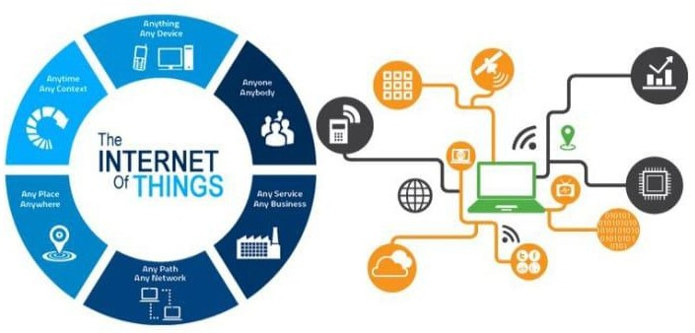
Abstract— The Internet of things popularly called IoT is a network of connected devices that can collect and exchange data. In recent years, the number of IoT devices has rapidly increased, leading, to a growing demand for data collection from these devises. They are used in everyday life such as vehicles, home appliances and smart devices etc. The data collected from these devices is essential for various applications such as predictive maintenance, real-time monitoring, and decision-making. To effectively collect, store, and analyze this data, various tools and technologies are required. To collect data from IoT devices, various tools and technologies are required. These may include data collection device network infrastructure data storage and management system, analytics tools, security tools. The paper begins by providing an overview of the IoT and its applications, followed by a discussion of the types of data that are collected by IoT devices. Also, this paper focuses on the various devices used to collect data in the IoT.
appliances, that are equipped with electronics, software, sensors, and network connectivity. This technology enables these objects to gather and share data. IoT's fundamental goal is to make it possible for devices to exchange data and communicate with one another without the need for human involvement. Smart homes, industrial automation, health monitoring, and smart cities are a few examples of IoT applications. IoT systems are constructed using a variety of technologies and protocols, including cloud computing, data analytics, and cellular, Bluetooth, and Wi-Fi networks.

Keywords— Internet of things, analytics tools, embedded system, sensors

I INTRODUCTION

Fig.1.1: The internet of things rapidly growing.
The term "Internet of Things" (IoT) describes the expanding network of physical objects, including furniture, cars, and home

XXX-X-XXXX-XXXX-X/XX/$XX.00 ©20XX IEEE

IMPORTANCE OF IOT
It is very crucial to know the importance of IOT, because these days people are habituated living and working with smart devices such as connected equipment(devices), smart home security systems (smart refrigerators), smart factory tools so on. This actually enables companies to perform by automation and reduce labor cost and to bring productivity. Importance of IOT in different aspects is following:

- Efficient resource utilization: IOT improves its efficiency by enabling smart devices to communicate and exchange data mutually with each other. Using a resource very efficiently consumes less time with smart work.

- Reduced Human effort: These IOT smart devices connect and communicate with one another and perform variety of tasks without need of human involved.

- Improved Decision-Making: The large amount of data is produced by smart devices can be analyzed to produce insights. It is also named as decision analytics since informs decision making.
- Improve safety and security: Safety is major aspect of smart devices used for monitoring and control safety and certain security system [5] to provide present information, alerted in emergency conditions. It monitors high value assets and also to protect data from the hackers and operators.
- Better Customer Experience: IOT smart devices are used to improve the customer experience by providing different kinds of services like personalized and convenient services(empathy). By personal contact with customers and take the feedback for better features to be modified.
- New Business Models: This is allowed to create new and different business models [3] by collecting the data and insights from connected devices like sensors, on device software etc.
- High quality data: To evaluate sensor data streams, it is necessary to analyses the gathered data using specific standards that guarantee the data's accuracy, confidence, completeness, volume, and timeliness.
- Realtime-Marketing: Real time marketing [3] is the thing that we react instantly to events from remote sensors and that type of products marketing is called real time marketing.

LITERATURE SURVEY

In the 2015 IEEE article "Internet of Things: A study on Enabling Technologies, Protocols, and Applications," a
horizontal overview of IoT is provided along with some technical information that is pertinent to IoT enabling technologies, protocols, and applications. They have offered a thorough assessment of the most important protocols and application issues in comparison to many previous survey articles in this field.

  - : The fresh and creative IoT applications were addressed in the paper "CRAIoT: Concept, Review and Application(s) of IOT" published in 2019 by IEEE, coupled with a thorough systematic literature review. They also assert that IoT is a rapidly expanding area with a wide range of potential and future directions.

  - : In 2020, IEEE released the study "A Survey on Trend and categorization of Internet of Things Reviews." According to six study categories, including application, architecture, communication, problems, technology, and security, the article gave IoT review trends and classification.

DEVICES USED IN IOT

  - Sensor:

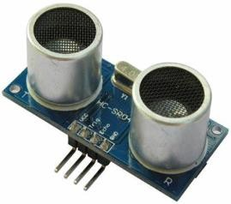
A sensor [6] is a piece of technology, a machine, a system, or a component that monitors its surroundings and transmits information to other electronics, typically a computer processor.

Fig.4.1: Sensor Some of the sensors are following:

    - Temperature Sensor
Temperature sensor is a device that measures and collects temperature data and sends it to the internet for monitoring and analysis. Applications for this technology include HVAC systems, refrigeration systems, and environmental monitoring.
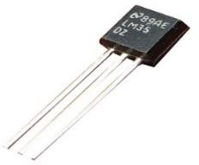

Fig.4.2: Temperature sensor DHT11

    - Soil Sensor:
A low-cost electrical sensor used to detect the specifics of the soil is a soil sensor [2]. The sensor primarily consists of two components: sensing probes and a sensor module. Soil sensors come in four different varieties. The soil pH sensor value represents the soil ph. Its concentration has an impact on both the availability and ionic form of both major and trace elements in the soil.
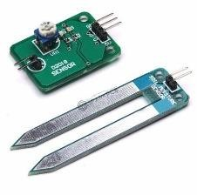
Fig.4.3: Soil Sensor

    - Fire Sensor:
Fire sensor [2] created to recognize and react to the presence of one or more flames. Fire sensor with a PIN diode base that turns on when it senses fire. It was divided into ionic, optical, and photoelectric smoke detectors. Flame is picked up at wavelengths between 760 and 1100 nm from the source.
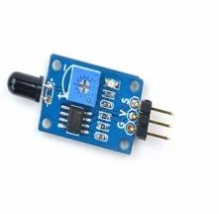
Fig.4.4: Fire Sensor

    - Humdidity Sensor:

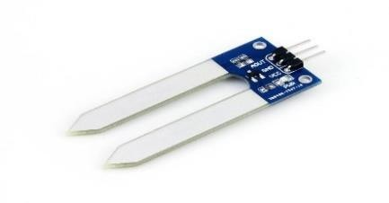
A humidity sensor, also known as a hygrometer, is an electronic device that measures the relative humidity [2] of the air. It typically use one of two technologies to measure humidity: capacitive and resistive [2]. Capacitive humidity sensors measure changes in capacitance, or the ability of a material to store electrical energy, as the amount of water vapor in the air changes. Resistive humidity sensors measure changes in resistance, or the degree to which a material opposes the flow of electrical current, as the amount of water vapor in the air changes.
  - Microcontroller:

An embedded system's microcontroller is a small integrated circuit that is used to operate particular devices or operations. On a single chip, it often houses a processor, memory, and input/output peripherals. Consumer electronics, autos, industrial control systems, and medical devices are just a few of the many applications for microcontrollers.

Microcontrollers belong under the category of Arduino [2], an open-source platform that is always easy to update and programmed [1]. The Arduino microcontroller was initially created to help professionals and students create gadgets that can use sensors to interact with the environment.

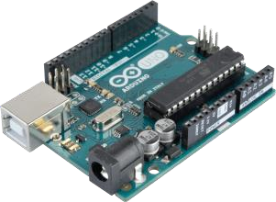
Fig.4.6: Arduino.

  - Microprocessor:

A microprocessor [1] is a type of computer processor where the logic and control for data processing are housed on a single integrated circuit or a few interconnected integrated circuits. Microprocessors come in three different flavors: CISC, RISC, and EPIC.
Raspberry Pi [1] is a small, inexpensive computer the size of a credit card that connects to a computer monitor or TV and operates with a regular keyboard and mouse. With the help of this competent small gadget, individuals of all ages may learn about computing and how to programmed in languages like Scratch and Python.
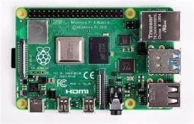
Fig.4.7: Raspberry Pi.

CASE STUDY

  - Fire Alarm

Fig.4.5: Humidity Sensor
A fire alarm sensor is a tool used to spot a fire and warn building occupants of a possible threat.
Case Study: A mid-sized office building equipped with a fire alarm sensor system was recently renovated. During the renovation, new fire alarm sensors were installed to

replace the older models. The sensors were connected to the existing alarm control panel, but the building occupants reported that the alarm system was not functioning properly.

Investigation: The maintenance team investigated the issue and found that the newly installed fire alarm sensors were not compatible with the existing alarm control panel. As a result, the alarm system was not able to receive signals from the sensors and trigger the alarm in case of a fire.
Solution: The maintenance team replaced the newly installed fire alarm sensors with compatible models that were able to connect to the existing alarm control panel. The building occupants were informed that the fire alarm system was now functioning properly and they were advised to regularly test the system to ensure that it was working correctly.

Conclusion: The case study highlights the importance of ensuring compatibility between different components of a fire alarm system. In this case, the incompatible fire alarm sensors caused the system to fail, which could have resulted in a dangerous situation in case of a fire. It also highlights the importance of regular maintenance and testing of fire alarm systems to ensure that they are working correctly.

5.2 Humidity Sensor:

Case Study: A greenhouse in a rural area was equipped with an IoT-connected humidity sensor system to monitor the humidity levels and control the watering of the plants. The system consisted of a network of humidity sensors connected to a central control unit, which was used to control the watering system based on the humidity readings.
Problem: The greenhouse owner noticed that the plants were not growing as well as expected, even though the watering system was functioning properly. Upon investigation, the owner found that the humidity levels were consistently too low, leading to poor plant growth.
Investigation: The maintenance team investigated the issue and found that the humidity sensors were not accurately reading the humidity levels in the greenhouse. The sensors were located near the watering system, which was causing them to be affected by the mist from the watering system. Solution: The maintenance team relocated the humidity sensors to a different part of the greenhouse, away from the watering system, to avoid interference. The system was then recalibrated to ensure accurate readings.

CONCLUSION

The IoT has the ability to significantly expand the accessibility of information and is expected to change
businesses [3] [6]and organizations across almost every industry. Regardless of their area of emphasis, most technology businesses will include discovering ways to harness the power of the IoT in their strategic objectives. Interoperability [6] is important because there are many different technologies needed to support the IoT's implementation [6] and future growth. As a result, organizations like the OIC, the Thread Group, the NFC [3] Forum, and the Air Fuel Alliance have been established. The use of sensor networks and IoT gateways, which are the most prevalent IoT devices, has increased along with the demand for real-time data. It is anticipated that as IoT technology develops further, it will become more sophisticated and effective at gathering data from a variety of sources.

REFERCENCES

- K. Gupta and R. Johari, "IOT based Electrical Device Surveillance and Control System," 2019 4th International Conference on Internet of Things: Smart Innovation and Usages (IoT-SIU), Ghaziabad, India, 2019, pp. 1-5, Doi: 10.1109/IoT-SIU.2019.8777342.
- V. Puranic, Sharmila, A. Ranjan and A. Kumari, "Automation in Agriculture and IoT," 2019 4th International Conference on Internet of Things: Smart Innovation and Usages (IoT-SIU), Ghaziabad, India, 2019, pp. 1-6, Doi: 10.1109/IoT-SIU.2019.8777619.
- H. Muhd Aman, E. Yadegaridehkordi, Z. S. Attarbashi,
R. Hassan and Y. -J. Park, "A Survey on Trend and Classification of Internet of Things Reviews," in IEEE Access, vol. 8, pp. 111763-111782, 2020, doi: 10.1109/ACCESS.2020.3002932.A survey on trend and classification of internet of things review
- E. P. Yadav, E. A. Mittal and H. Yadav, "IoT: Challenges and Issues in Indian Perspective," 2018 3rd International Conference On Internet of Things: Smart Innovation and Usages (IoT-SIU), Bhimtal, India, 2018, pp. 1-5, doi: 10.1109/IoT-SIU.2018.8519869.
- Al-Fuqaha, M. Guizani, M. Mohammadi, M. Aledhari and M. Ayyash, "Internet of Things: A Survey on Enabling Technologies, Protocols, and Applications," in IEEE Communications Surveys & Tutorials, vol. 17, no. 4, pp. 2347-2376, Fourthquarter 2015, doi: 10.1109/COMST.2015.2444095.

