FUTURISTIC TRENDS IN SKIN DELIVERY: TRANSFEROSOMES
H.GAYATHRI*
*SRM College of Pharmacy, SRMIST, Kattankulathur campus, Tamil Nadu, India, gayathrh@srmist.edu.in

Transferosomes are specialized lipid-based vesicles or nanoparticles that are used in drug delivery systems. They are designed to enhance the delivery of drugs through the skin (transdermal delivery) or other biological barriers. Transferosomes are composed of phospholipids, similar to liposomes, but they also contain edge activators such as surfactants or bile salts. These edge activators destabilize the lipid bilayers of the transferosomes, making them more flexible and deformable. This property allows transferosomes to squeeze through narrow pores and penetrate the skin more efficiently. The main advantage of transferosomes is their ability to improve the transdermal delivery of drugs, especially those with poor permeability through the skin. They can encapsulate both hydrophilic (water-soluble) and lipophilic (fat-soluble) drugs, making them suitable for a wide range of therapeutic compounds.When applied to the skin, transferosomes can fuse with the stratum corneum, the outermost layer of the skin, and release the encapsulated drug into the underlying layers. The flexibility of transferosomes helps them adapt to the skin's topography, improving drug penetration. This makes them particularly useful for delivering drugs that have difficulty crossing the skin barrier, such as large molecules or those with low skin permeability.Transferosomes have potential applications in various fields, including transdermal drug delivery, cosmetic formulations, and vaccines. Their ability to enhance drug absorption through the skin can improve the bioavailability of drugs, reduce systemic side effects, and provide a non-invasive alternative to injections. It's important to note that while transferosomes show promise in drug delivery, further research and development are still ongoing to optimize their formulation, stability, and efficacy.
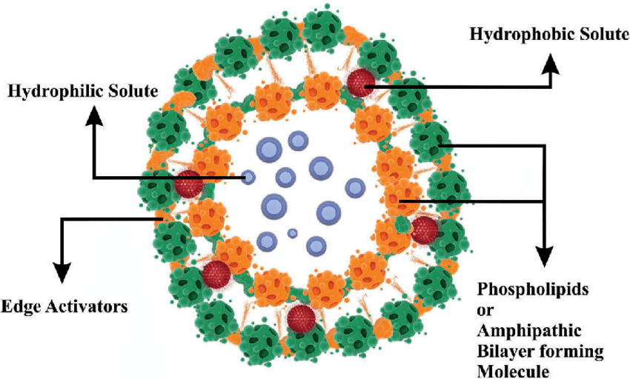
Figure: 1 Structure of Transfersomes
RECENT TRENDS ON TRANSFEROSOMES
Transferosomes have been an active area of research and development in drug delivery systems. Some recent advancements and trends in the formulation of transferosomes:
- Novel lipid components: Researchers are exploring the use of novel lipid components to enhance the stability, flexibility, and drug-loading capacity of transferosomes. For example, the incorporation of lipids such as ethosomes or niosomes into transferosomes has been investigated to improve their performance[1
].
- Surface modifications: Surface modification of transferosomes with various polymers, such as polyethylene glycol (PEG), has gained attention to improve their stability, prolong circulation time, and reduce clearance by the immune system. These modifications can also provide targeted drug delivery by attaching ligands or antibodies specific to certain cells or tissues.
- Combination with other delivery systems: Transferosomes can be combined with other drug delivery systems, such as hydrogels or nanoparticles, to create hybrid systems with enhanced properties. For instance, the incorporation of transferosomes into hydrogels can improve drug retention and controlled release.
- Vesicle engineering: Researchers are investigating techniques to engineer transferosomes with specific properties. This includes controlling the size, charge, and deformability of transferosomes to optimize their performance in drug delivery. Techniques like sonication, extrusion, and microfluidics are employed to precisely control the vesicle characteristics.
- Active loading methods: Efforts are being made to develop efficient methods for active loading of drugs into transferosomes. This includes using techniques like remote loading, where an external stimulus (e.g., pH change or temperature) triggers drug encapsulation, improving drug entrapment efficiency.
- Stability enhancement: Stability is a crucial factor for the practical application of transferosomes. Researchers are exploring strategies to improve their stability during storage and upon application, such as freeze-drying techniques, lyophilization, and the use of stabilizing agents.
- Clinical translation: While transferosomes have shown promise in preclinical studies, efforts are being made to translate them into clinical applications. Clinical trials are being conducted to evaluate the safety, efficacy, and patient compliance of transferosome-based formulations.

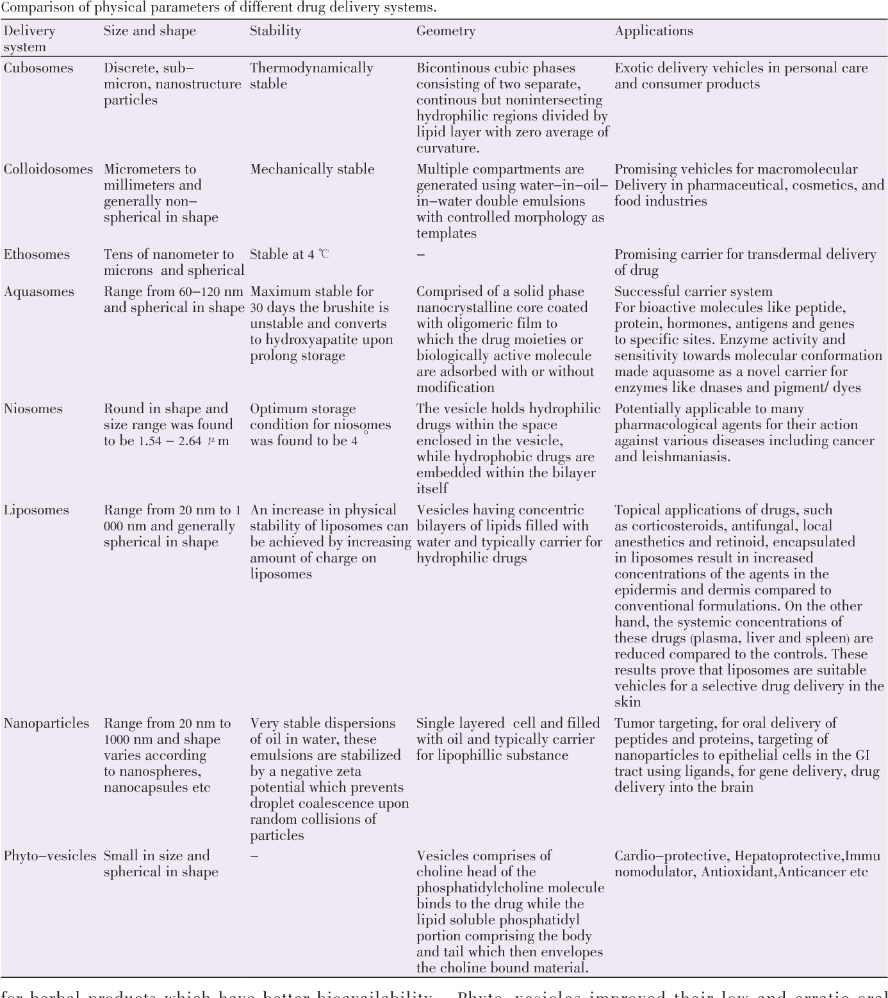
Figure : 2 Difference between novel drug delivery system
HERBAL TRANSFEROSOME
Herbal transferosomes, also known as phyto-transferosomes or phytosomes, are specialized lipid-based delivery systems that are used to improve the delivery and bioavailability of herbal extracts or phytochemicals.
Phytosomes are formed by complexing herbal extracts or phytochemicals with phospholipids. The phospholipids used are usually derived from soybean or lecithin and possess both hydrophilic and lipophilic properties. This complexation process enhances the solubility and stability of the phytochemicals and improves their absorption into the body[2].

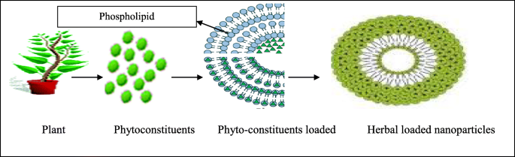
Figure: 3 Herbal transferosomes
The formation of herbal transferosomes involves the following steps:
- Complexation: The herbal extract or phytochemical is mixed with phospholipids under appropriate conditions. The hydrophilic portion of the phospholipid forms bonds with the water-soluble constituents of the herbal extract, while the lipophilic portion interacts with the lipophilic components.
- Vesicle formation: The complexed mixture undergoes a self-assembly process to form vesicles, similar to liposomes. These vesicles consist of a lipid bilayer with the herbal extract or phytochemical embedded within or on the surface[3].
Herbal transferosomes offer several advantages:
- Enhanced bioavailability: The complexation with phospholipids improves the solubility and stability of herbal extracts or phytochemicals, leading to better absorption and bioavailability when administered orally or topically.
- Targeted delivery: Phytosomes can be modified to target specific cells or tissues by surface modification with ligands or antibodies. This enables the delivery of herbal compounds to specific sites in the body, enhancing their therapeutic effects.
- Improved stability: Herbal transferosomes provide protection to the encapsulated phytochemicals from degradation by enzymes, pH, or oxidation, thereby enhancing their stability during storage and administration.
- Controlled release: Phytosomes can be designed to release their contents in a controlled manner, allowing sustained drug release and prolonged therapeutic effects.
Herbal transferosomes have found applications in various areas, including traditional medicine, nutraceuticals, and cosmeceuticals. They can be used to deliver herbal extracts with therapeutic properties, such as anti-inflammatory, antioxidant, anti-cancer, or antimicrobial activities.
It's important to note that the formulation and characterization of herbal transferosomes are still subjects of ongoing research, and their effectiveness and safety may vary depending on the specific herbal extract and formulation. As with any herbal product, it's advisable to consult with healthcare professionals or experts in the field for guidance on the appropriate use and dosage of herbal transferosomes[4].

LIFE THREATENING DISEASES AND TRANSFEROSOMES
Transferosomes have shown promise in the field of drug delivery for various life-threatening diseases. Their ability to enhance drug absorption, improve bioavailability, and provide targeted delivery makes them a valuable tool for the treatment of such conditions. Here are a few examples of how transferosomes can be utilized in the management of life-threatening diseases:
- Cancer: Transferosomes have been investigated as a delivery system for anticancer drugs. They can encapsulate chemotherapeutic agents and improve their accumulation in tumor tissues while minimizing systemic toxicity. Transferosomes can be modified with targeting ligands specific to cancer cells, allowing for selective drug delivery and enhanced therapeutic efficacy[5].
- Cardiovascular diseases: Transferosomes have been explored for the targeted delivery of drugs used in the treatment of cardiovascular conditions, such as heart failure, hypertension, and atherosclerosis. They can improve the delivery of cardiac drugs, including vasodilators and antiarrhythmic agents, leading to better therapeutic outcomes[6].
- Infectious diseases: Transferosomes have potential applications in the treatment of life-threatening infectious diseases. They can be employed to improve the delivery of antimicrobial agents, such as antibiotics or antiviral drugs, to target sites of infection. This can enhance drug concentration at the infection site, increase efficacy, and reduce the development of drug resistance.
- Neurological disorders: Transferosomes have been explored for drug delivery in neurodegenerative diseases, such as Alzheimer's disease, Parkinson's disease, and brain tumors. They can improve the transport of therapeutic agents across the blood-brain barrier, enabling better drug penetration into the brain and potentially enhancing treatment outcomes.
- Respiratory diseases: Transferosomes have been investigated for pulmonary drug delivery in conditions like asthma, chronic obstructive pulmonary disease (COPD), and cystic fibrosis. They can improve the delivery of bronchodilators, anti-inflammatory agents, and gene therapy vectors to the lungs, enhancing drug deposition and local therapeutic effects[6].
It's important to note that the specific drugs, formulations, and applications of transferosomes in these life-threatening diseases are actively researched and may vary based on the particular disease and therapeutic objectives. While transferosomes offer potential benefits, their clinical application requires extensive evaluation, including rigorous preclinical and clinical studies, to assess safety, efficacy, and long-term outcomes[7].
Ultimately, the use of transferosomes in life-threatening diseases should be determined by healthcare professionals and researchers who can assess the specific needs of each disease and tailor the approach accordingly.
Transferosomes can be prepared using a variety of drugs depending on the therapeutic purpose. Here are some examples of drugs commonly used to prepare transferosomes:
- Anticancer drugs: Chemotherapeutic agents such as doxorubicin, paclitaxel, methotrexate, and cisplatin are often encapsulated in transferosomes for targeted delivery to cancer cells.
- Anti-inflammatory drugs: Nonsteroidal anti-inflammatory drugs (NSAIDs) like diclofenac, ibuprofen, and indomethacin are frequently used to prepare transferosomes for localized delivery and treatment of inflammatory conditions.
- Antibiotics: Antibiotics such as gentamicin, ciprofloxacin, and vancomycin have been encapsulated in transferosomes to improve their delivery to specific infection sites.
- Antifungal drugs: Antifungal agents like miconazole, fluconazole, and ketoconazole can be incorporated into transferosomes for targeted treatment of fungal infections.
- Cardiovascular drugs: Cardiac drugs like verapamil, propranolol, and nifedipine have been used to prepare transferosomes for targeted delivery to the heart or blood vessels.
- Anti-hypertensive drugs: Drugs used to manage hypertension, such as captopril and enalapril, can be encapsulated in transferosomes for enhanced delivery and localized action.
- Analgesics: Pain-relieving drugs like lidocaine and bupivacaine have been incorporated into transferosomes for transdermal or local delivery to provide localized analgesia.
It's important to note that the choice of drug depends on the therapeutic application, intended route of administration, and the specific requirements of the disease or condition being treated. The selection of a drug for transferosome formulation is based on factors such as its physicochemical properties, therapeutic efficacy, and compatibility with the transferosome formulation process[8,9].

Interesting facts about transferosomes:
- Discovery: Transferosomes were first introduced by Dr. Gregor Cevc and his colleagues in the 1990s as an innovative approach to enhance drug delivery through the skin. Their research focused on improving the skin permeation of drugs using flexible lipid vesicles[10].
- Deformability: One of the unique properties of transferosomes is their deformability. Due to the presence of edge activators, such as surfactants or bile salts, transferosomes can adapt and squeeze through narrow pores or channels, including the intercellular spaces of the stratum corneum, the outermost layer of the skin. This property enables improved drug penetration and absorption[11].
- Size and Structure: Transferosomes are typically in the size range of 100 to 1000 nanometers, allowing them to encapsulate a significant amount of drug molecules. They consist of a lipid bilayer structure similar to liposomes, but with added edge activators that disrupt the lipid structure and enhance flexibility[12].
- Versatility: Transferosomes are versatile carriers that can encapsulate a wide range of drug types, including hydrophilic and lipophilic drugs. This flexibility makes them suitable for delivering a variety of therapeutic compounds, ranging from small molecules to proteins and peptides[13].
- Non-Invasive Delivery: Transferosomes offer a non-invasive route of drug administration, particularly for transdermal delivery. By applying the transferosome formulation topically to the skin, drugs can bypass the gastrointestinal system and the liver's first-pass metabolism, potentially reducing side effects and improving therapeutic outcomes[14].
- Targeted Drug Delivery: Transferosomes can be modified to incorporate targeting ligands on their surface, enabling specific delivery to desired tissues or cells. This targeted drug delivery approach enhances drug efficacy, reduces off-target effects, and improves overall therapeutic outcomes[15].
- Stability Challenges: One of the challenges in transferosome formulation is maintaining their stability during storage and application. Transferosomes may undergo aggregation, fusion, or leakage of encapsulated drugs over time. Researchers are actively working on developing strategies to improve the stability and shelf-life of transferosome formulations[16].
- Clinical Applications: Transferosomes have been investigated for a range of clinical applications, including transdermal delivery of pain medications, anti-inflammatory drugs, hormones, and anticancer agents. Clinical trials have evaluated their safety, efficacy, and patient compliance, with promising results in various therapeutic areas[17].

- Influence of Edge Activators on Transferosome Structure and Function
Edge activators play a crucial role in influencing the structure and function of transferosomes. Transferosomes are specialized lipid-based vesicles designed to enhance the transdermal delivery of drugs. They consist of phospholipids, edge activators, and often additional components such as cholesterol.
Edge activators are surfactants that possess the ability to destabilize the lipid bilayers of transferosomes. By reducing the interfacial tension between the lipid bilayers and the aqueous environment, they increase the deformability and flexibility of the vesicles. This improved flexibility enables transferosomes to squeeze through narrow pores, including the skin's pores, facilitating drug penetration[18].
The presence of edge activators in transferosomes has several notable effects on their structure and function:
- Increased deformability: Edge activators disrupt the regular packing of lipid molecules in the bilayer, leading to the formation of transient pores or lipidic channels. These pores increase the fluidity and deformability of the vesicles, allowing them to penetrate through the skin more easily.
- Enhanced drug encapsulation: Edge activators can solubilize hydrophobic drugs, which can then be incorporated into the lipid bilayers or encapsulated within the aqueous core of transferosomes. This feature enables transferosomes to carry a wide range of drugs, including both hydrophobic and hydrophilic compounds.
- Improved drug release: The presence of edge activators influences the release kinetics of drugs from transferosomes. Depending on the specific properties of the edge activator used, the drug release rate can be modulated, allowing for controlled and sustained release of the drug over an extended period.
- Increased skin permeation: Edge activators reduce the barrier function of the skin by interacting with its lipid matrix and modifying its structure. They disrupt the highly ordered arrangement of lipids in the stratum corneum, facilitating the penetration of drugs across the skin barrier. This property is particularly advantageous for transdermal drug delivery, as it enhances the bioavailability of drugs and avoids the first-pass metabolism associated with oral administration.
- Biocompatibility considerations: While edge activators can improve the functionality of transferosomes, their selection is crucial to ensure biocompatibility and minimize any potential skin irritation or cytotoxic effects. Various edge activators have been studied, including surfactants such as sodium cholate, Tween, or Span series, among others. The choice of edge activator depends on factors such as the specific drug, desired release profile, and compatibility with the targeted application.
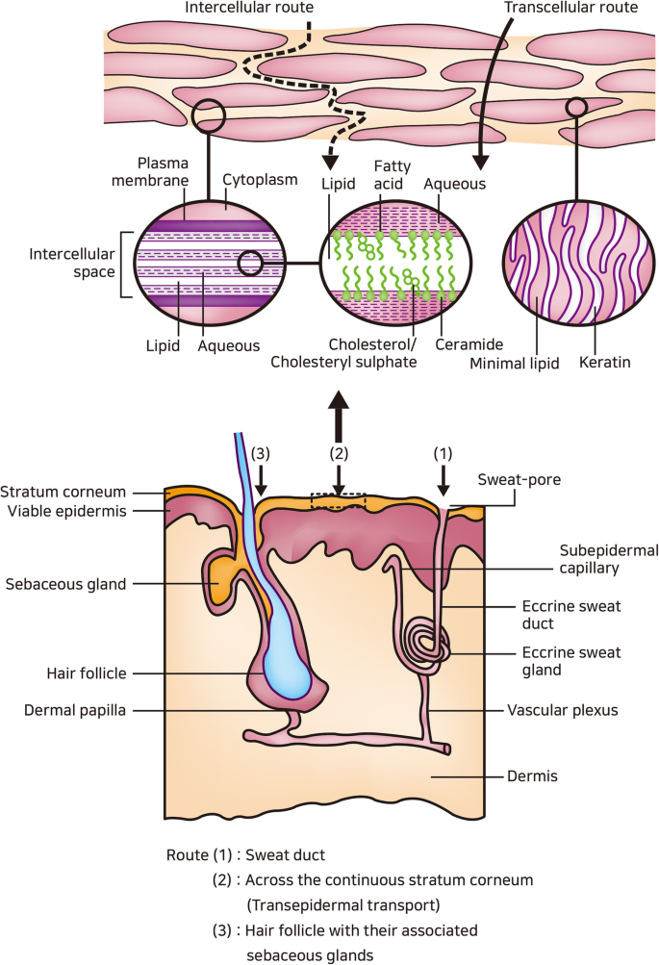
Figure: 4 Transferosomes on skin delivery

- Transdermal Delivery of Drugs using Transferosomes
Transdermal drug delivery has emerged as an attractive alternative to traditional routes of administration such as oral or injectable routes. It offers several advantages, including avoidance of first-pass metabolism, improved patient compliance, and controlled release of drugs. Transferosomes, a type of lipid-based vesicle, have garnered significant attention as a promising carrier system for transdermal drug delivery. This note provides an overview of the transdermal delivery of drugs using transferosomes, highlighting their advantages, formulation considerations, and potential applications[19].
Advantages of Transferosomes in Transdermal Drug Delivery:
- Enhanced Penetration: Transferosomes possess unique properties that enhance their ability to penetrate the skin's barrier. They are flexible and deformable lipid vesicles capable of squeezing through narrow pores, including the skin's micropores. This property allows for improved drug delivery through the skin.
- Increased Drug Loading: Transferosomes offer high drug-loading capacity, enabling the encapsulation of both hydrophobic and hydrophilic drugs. The lipid bilayers of transferosomes can incorporate lipophilic drugs, while the aqueous core can entrap hydrophilic drugs, facilitating the delivery of a wide range of therapeutic agents.
- Controlled Release: Transferosomes enable controlled and sustained release of drugs, providing a favorable pharmacokinetic profile. The lipid bilayers act as a barrier, regulating the diffusion of drugs, leading to prolonged release kinetics and reducing the need for frequent dosing.
- Targeted Delivery: Transferosomes can be tailored to achieve targeted drug delivery. Surface modifications, such as ligand conjugation or antibody attachment, allow specific targeting of drugs to desired tissues or cells, enhancing therapeutic efficacy and minimizing systemic side effects.
Formulation Considerations:
- Lipid Composition: The selection of appropriate lipids is crucial to ensure the stability and functionality of transferosomes. Phospholipids, such as phosphatidylcholine or phosphatidylserine, are commonly used due to their biocompatibility and ability to form stable vesicles. Additional components like cholesterol may be incorporated to optimize transferosome properties.
- Edge Activators: Edge activators, such as surfactants, play a critical role in enhancing the deformability and flexibility of transferosomes. They disrupt the regular packing of lipids, increasing the vesicles' ability to penetrate the skin barrier. The choice of edge activator depends on factors such as drug compatibility, biocompatibility, and desired release kinetics.
- Size Optimization: The size of transferosomes is an important consideration for transdermal delivery. Ideally, they should be small enough to penetrate the skin's pores but large enough to prevent rapid clearance. Optimization of size can be achieved through appropriate selection of lipid composition and formulation techniques.

Applications:
- Localized Therapy: Transferosomes enable the targeted delivery of drugs to specific sites of action, making them suitable for localized therapy. Conditions such as dermatological disorders, pain management, and wound healing can benefit from the localized application of drugs via transferosomes.
- Systemic Delivery: Transferosomes have the potential for systemic drug delivery, particularly for drugs with poor oral bioavailability or drugs that undergo extensive first-pass metabolism. Transdermal delivery using transferosomes bypasses these limitations and provides a convenient and controlled route for drug administration.

- Transferosomes for the Treatment of Skin Diseases and Disorders
Skin diseases and disorders encompass a broad range of conditions, including dermatitis, psoriasis, acne, fungal infections, and more. Effective treatment often requires targeted delivery of therapeutic agents to the affected skin layers. Transferosomes, specialized lipid-based vesicles, have emerged as a promising carrier system for the treatment of various skin diseases and disorders. This note explores the potential applications and advantages of transferosomes in addressing these conditions[20].
Advantages of Transferosomes in Skin Disease Treatment:
- Enhanced Skin Penetration: Transferosomes possess excellent skin penetration capabilities due to their deformability and flexibility. These vesicles can effectively penetrate the skin's barrier and reach the deeper skin layers where the disease pathology occurs, improving drug delivery and therapeutic outcomes.
- Improved Drug Loading and Stability: Transferosomes offer a high drug-loading capacity and can encapsulate a wide range of therapeutic agents, including both hydrophobic and hydrophilic drugs. The lipid bilayers of transferosomes provide stability to the encapsulated drugs, protecting them from degradation and enhancing their efficacy.
- Controlled and Sustained Release: Transferosomes facilitate controlled and sustained release of drugs, ensuring a prolonged therapeutic effect. The lipid bilayers act as a barrier, regulating the diffusion of drugs into the skin layers, resulting in a controlled release profile and reducing the frequency of application.
- Targeted Therapy: Transferosomes can be modified to achieve targeted delivery of drugs to specific skin regions or cell types. Surface modifications, such as ligand conjugation or antibody attachment, enable precise targeting of drugs to affected areas, increasing therapeutic efficacy while minimizing systemic side effects.
- The marketed products are yet to come to the market. Since it is novel drug delivery system.
Applications of Transferosomes in Skin Disease Treatment:
- Dermatitis and Eczema: Transferosomes can effectively deliver anti-inflammatory agents and immunomodulatory drugs to manage dermatitis and eczema. These vesicles facilitate the localized delivery of drugs, reducing inflammation, itching, and other symptoms associated with these conditions.
- Psoriasis: Transferosomes can encapsulate drugs like corticosteroids or calcipotriol, which are commonly used in psoriasis treatment. By enhancing drug penetration into the skin layers affected by psoriasis, transferosomes offer improved therapeutic efficacy and potentially reduce side effects associated with systemic drug administration.
- Acne: Transferosomes can deliver anti-acne agents, such as benzoyl peroxide or retinoids, to the pilosebaceous units where acne pathology occurs. By improving drug penetration and targeting, transferosomes provide an effective approach for controlling sebum production, reducing inflammation, and preventing bacterial growth.
- Fungal Infections: Transferosomes can encapsulate antifungal agents, such as azoles or terbinafine, for the treatment of fungal infections like athlete's foot or candidiasis. By enhancing drug penetration into the affected skin layers, transferosomes offer improved efficacy in eradicating fungal pathogens and relieving associated symptoms.

- Transferosomes in Cancer Therapy: Overcoming Barriers and Enhancing Efficacy
Cancer therapy poses significant challenges due to the complex nature of tumors and the need for effective drug delivery to target cancer cells while minimizing systemic toxicity. Transferosomes, specialized lipid-based vesicles, have gained attention as a promising drug delivery system in cancer therapy. This note explores the potential of transferosomes in overcoming barriers associated with cancer treatment and enhancing therapeutic efficacy.
Overcoming Barriers in Cancer Therapy:
- Enhanced Tumor Penetration: Transferosomes exhibit excellent penetration capabilities, enabling them to permeate through tumor tissues more efficiently. The deformable nature of transferosomes allows them to squeeze through narrow intercellular gaps, facilitating deeper tumor penetration and improved drug distribution.
- Avoiding Multidrug Resistance (MDR): Multidrug resistance is a significant challenge in cancer therapy, where cancer cells develop resistance to multiple chemotherapeutic agents. Transferosomes can encapsulate a combination of drugs to overcome MDR. Additionally, the lipid bilayers of transferosomes can bypass drug efflux pumps, reducing the chances of drug resistance development.
- Targeted Drug Delivery: Transferosomes can be modified to achieve targeted drug delivery to cancer cells. Surface modifications, such as ligand conjugation or antibody attachment, enable specific recognition and binding to cancer cell receptors, increasing drug accumulation in tumor cells while minimizing uptake by healthy cells.
- Protection of Drugs: Transferosomes provide a protective environment for drugs, shielding them from enzymatic degradation and premature clearance. This enhances the stability and bioavailability of drugs, allowing for prolonged circulation time and improved drug delivery to the tumor site.
Enhancing Efficacy in Cancer Therapy:
- Combination Therapy: Transferosomes allow for the co-encapsulation of multiple drugs, facilitating combination therapy. This approach can synergistically enhance therapeutic efficacy by targeting different pathways or mechanisms involved in tumor growth and survival, thereby increasing the chances of tumor regression.
- Sustained Release: Transferosomes can be engineered to provide sustained drug release, maintaining therapeutic drug concentrations over an extended period. This sustained release profile ensures prolonged exposure of cancer cells to therapeutic agents, maximizing their cytotoxic effects and minimizing the chances of tumor recurrence.
- Personalized Medicine: Transferosomes offer a versatile platform for personalized medicine in cancer therapy. The lipid composition and surface modifications can be tailored to specific patient profiles or tumor characteristics, allowing for customized treatment approaches and optimizing therapeutic outcomes.
- Minimizing Systemic Toxicity: Transferosomes have the potential to reduce systemic toxicity associated with conventional chemotherapy. By enhancing tumor targeting and minimizing drug exposure to healthy tissues, transferosomes help mitigate off-target effects, leading to improved safety profiles and reduced side effects[21].

- Regulatory and Safety Considerations in the Development of Transferosome-based Therapeutics
Regulatory and safety considerations play a crucial role in the development of transferosome-based therapeutics to ensure their efficacy, quality, and safety for patient use. Here is a brief explanation of the key regulatory and safety aspects that need to be considered:
Regulatory Considerations:
- Preclinical Studies: Preclinical studies are essential to assess the pharmacokinetics, pharmacodynamics, and safety profile of transferosome-based therapeutics. These studies provide important data on drug release, biodistribution, and potential toxicity in animal models, aiding in determining the dosage, formulation, and route of administration for further development.
- Good Manufacturing Practices (GMP): Transferosome-based therapeutics must be manufactured under strict adherence to GMP guidelines. GMP ensures that the products are consistently produced, controlled, and tested according to quality standards, minimizing the risk of contamination, errors, or inconsistencies during manufacturing.
- Stability and Shelf Life: Stability studies are necessary to evaluate the long-term stability and shelf life of transferosome-based therapeutics. These studies assess factors such as drug degradation, vesicle integrity, and changes in physicochemical properties under various storage conditions, ensuring the product's quality and efficacy throughout its shelf life.
- Regulatory Submission: Before transferosome-based therapeutics can be approved for clinical use, regulatory submissions must be made to the appropriate regulatory authorities (e.g., FDA, EMA). These submissions include comprehensive data on preclinical studies, manufacturing processes, stability studies, and proposed clinical trial plans, following the regulatory guidelines specific to each jurisdiction.
Safety Considerations:
- Toxicity Evaluation: Safety assessments are crucial to evaluate the potential toxicity of transferosome-based therapeutics. These evaluations involve studying acute and chronic toxicity, local and systemic adverse effects, and determining the maximum tolerated dose to establish the safety margin for human use.
- Immunogenicity: Transferosome-based therapeutics may induce an immune response in patients. Immunogenicity studies assess the potential for immunogenic reactions, such as the development of antibodies against the therapeutic agents or transferosome components. These studies help evaluate any potential adverse immune reactions and guide appropriate risk mitigation strategies.
- Skin Irritation and Sensitization: As transferosome-based therapeutics are often applied topically, it is essential to assess skin irritation and sensitization potential. Skin irritation studies determine the likelihood of adverse skin reactions upon application, while sensitization studies evaluate the potential for inducing allergic sensitization.
- Drug-Drug Interactions: Transferosome-based therapeutics may interact with other medications, leading to altered pharmacokinetics or increased toxicity. Evaluating potential drug-drug interactions is crucial to identify any interactions that may affect the safety and efficacy of the transferosome-based therapeutic, especially in the case of combination therapies[22].

- Future Perspectives and Emerging Trends in Transferosome Research
Transferosomes, lipid-based vesicles with deformable properties, have shown significant potential as a drug delivery system. As researchers continue to explore and refine their characteristics, several future perspectives and emerging trends in transferosome research have emerged. These advancements aim to overcome existing challenges and further enhance the capabilities and applications of transferosomes. Here, we delve into some of the exciting directions in transferosome research:
- Nanotechnology Integration: Integration of transferosomes with nanotechnology holds promise for advanced drug delivery systems. The combination of transferosomes with nanoparticles, such as quantum dots or magnetic nanoparticles, allows for multifunctional platforms. These hybrid systems offer enhanced drug targeting, imaging capabilities, and the potential for theranostics (combined therapy and diagnostics).
- Stimuli-Responsive Transferosomes: Researchers are actively exploring the development of stimuli-responsive transferosomes. By incorporating stimuli-responsive materials into the lipid bilayers, such as temperature-sensitive polymers or pH-responsive components, transferosomes can release drugs in response to specific environmental cues. This approach enables controlled and triggered drug release at the target site, enhancing therapeutic efficacy and reducing off-target effects.
- Combination Therapy: Combination therapy involving multiple drugs or modalities is gaining attention in transferosome research. By co-encapsulating different therapeutic agents within transferosomes, synergistic effects can be achieved. Additionally, combination therapy involving transferosomes with other treatment modalities, such as phototherapy or immunotherapy, holds promise for enhanced cancer treatment and personalized medicine approaches.
- Targeted Delivery Strategies: Efforts are underway to develop innovative strategies for targeted delivery using transferosomes. This includes the use of ligands, antibodies, or peptides on the surface of transferosomes to specifically target receptors overexpressed on cancer cells or disease-specific biomarkers. Furthermore, strategies for targeting specific tissues, such as the brain or lymphatic system, are being explored, opening up possibilities for the treatment of neurological disorders and immune-related diseases.
- Continuous Manufacturing Techniques: To improve scalability and streamline production, continuous manufacturing techniques are being investigated for transferosome production. Continuous flow systems offer benefits such as increased control over particle size, improved reproducibility, and reduced production time and cost. Implementing continuous manufacturing in transferosome production could facilitate large-scale production and commercialization.
- Genetic Engineering of Transferosomes: Genetic engineering techniques, such as gene editing or mRNA-based approaches, are being explored to modify transferosomes. This includes incorporating genetic material within the transferosomes for gene therapy applications or utilizing mRNA-loaded transferosomes for protein expression. Such advances offer novel avenues for personalized medicine and targeted therapeutics.
- Biocompatible and Sustainable Materials: Researchers are focusing on developing transferosomes using biocompatible and sustainable materials. This includes exploring natural lipid sources, such as plant-derived lipids or lipids obtained from microbial fermentation processes. The use of biocompatible materials ensures safety and reduces the environmental impact associated with transferosome production[22].
- Microfluidics and 3D Printing: Microfluidics and 3D printing technologies are being integrated into transferosome research. Microfluidic platforms enable precise control over vesicle size, uniformity, and encapsulation efficiency, while 3D printing techniques allow for the fabrication of complex structures and customizable transferosome formulations. These technologies offer improved reproducibility, scalability, and versatility in transferosome development[23].
- Theranostic Applications: Transferosomes hold potential as theranostic carriers that combine therapy and diagnostics. By incorporating imaging agents, such as fluorescent dyes or contrast agents, transferosomes can enable real-time monitoring of drug release, biodistribution, and therapeutic response. This integration of diagnostics with therapeutic delivery can guide personalized treatment strategies and improve patient outcomes[24].
- Clinical Translation and Commercialization: As transferosome research progresses, efforts to advance from preclinical studies to clinical translation and commercialization are gaining momentum. Addressing regulatory requirements, conducting robust clinical trials, and establishing scalable manufacturing processes are essential steps to bring transferosome-based therapeutics to the market[25].
In conclusion, transferosome research is evolving rapidly, driven by the need for improved drug delivery systems. Future perspectives and emerging trends in transferosome research encompass various areas, including nanotechnology integration, stimuli-responsive systems, combination therapy, targeted delivery, continuous manufacturing, genetic engineering, biocompatible materials, microfluidics and 3D printing, theranostic applications, and clinical translation. These advancements hold immense potential to revolutionize drug delivery, enable personalized medicine approaches, and enhance therapeutic outcomes in diverse fields ranging from cancer treatment to neurodegenerative diseases.

BIBLIOGRAPHY
1] Kilts CD. Potential New Drug Delivery Systems for Antidepressants: An overview. J Clin Psychiatry. 2003;64:31–33. http://www.ncbi.nlm.nih.gov/pubmed/14700453. [PubMed] [Google Scholar]
[2] Kim A, Lee EH, Choi SH, Kim CK. In vitro and in vivo transfection efficiency of a novel ultra deformable cationic polymer. Biomatetrials. 2004;25:305–313. http://dx.doi.org/10.1016/S0142-9612(03)00534-9 [PubMed] [Google Scholar]
[3] Vijaya R, Ruckmani K. In vitro and In vivo characterization of the transdermal delivery of sertraline hydrochloride Films. Daru. 2011;19:424–432. http://www.ncbi.nlm.nih.gov/pubmed/23008688. [PMC free article] [PubMed] [Google Scholar]
[4] Jain S, Jain P, Umamaheshwari RB, Jain NK. Transfersomes–A novel vesicular carrier for enhanced transdermal delivery: Development, characterization and performance evaluation. Drug Dev Ind Pharm. 2003;29:1013–1026. http://dx.doi.org/10.1081/DDC-120025458. [PubMed] [Google Scholar]
[5] Mishra D, Garg M, Dubey V, Jain S, Jain NK. Elastic liposomes mediated transdermal delivery of an anti-hypertensive agent: Propranolol hydrochloride. J Pharm Sci. 2007;96:145–155. http://dx.doi.org/10.1002/jps.20737. [PubMed] [Google Scholar]
[6] Garg T, Jain S, Singh HP, Sharma A, Tiwary AK. Elastic liposomal formulation for sustained delivery of antimigraine drug: in vitro characterization and biological evaluation. Drug Dev Ind Pharm. 2008;34:1100–1110. http://www.ncbi.nlm.nih.gov/pubmed/18663655. [PubMed] [Google Scholar]
[7] Layek B, Mukherjee B. Tamoxifen Citrate Encapsulated Sustained Release Liposomes: Preparation and Evaluation of Physicochemical Properties. Sci Pharm. 2010;78:507–515. http://dx.doi.org/10.3797/scipharm.0911-11. [PMC free article] [PubMed] [Google Scholar]
[8] El-Maghraby GMM, Williams AC, Barry BW. Skin delivery of 5-Fluorouracil from ultra deformable and traditional liposomes in vitro. J Pharm Pharmacol. 2001;53:1069–1076. http://dx.doi.org/10.1211/0022357011776450. [PubMed] [Google Scholar]
[9] Malakar J, Sen SO, Nayak AK, Sen KK. Formulation, optimization and evaluation of transferosomal gel for transdermal insulin delivery. Saudi Pharm J. 2012;20:355–363. http://dx.doi.org/10.1016/j.jsps.2012.02.001. [PMC free article] [PubMed] [Google Scholar]
[10] Guo J, Ping Q, Sun G, Jiao C. Lecithin vesicular carriers for transdermal delivery of cyclosporine A. Int J Pharm. 2000;194:201–207. http://dx.doi.org/10.1016/S0378-5173(99)00361-0. [PubMed] [Google Scholar]
[11] Patel MR, Patel RB, Parikh JR, Solanki AB, Patel BG. Effect of formulation components on the in vitro permeation of microemulsion drug delivery system of fluconazole. AAPS PharmSciTech. 2009;10:917–923. http://dx.doi.org/10.1208/s12249-009-9286-2. [PMC free article] [PubMed] [Google Scholar]
[12] Gupta A, Prajapati SK, Balamurugan M, Singh M, Bhatia D. Design and development of a proniosomal transdermal drug delivery system for Captopril. Trop J Pharma Res. 2007;6:687–693. http://dx.doi.org/10.4314/tjpr.v6i2.14647 [Google Scholar]
[13] Bachhav YG, Patravale VB. Microemulsion-based vaginal gel of sertraline: Formulation, in vitro evaluation, and stability studies. AAPS PharmSciTech. 2009;10:476–481. http://dx.doi.org/10.1208/s12249-009-9233-2. [PMC free article] [PubMed] [Google Scholar]
[14] Jain S, Jain N, Bhadra D, Tiwary AK, Jain NK. Transdermal delivery of an analgesic agent using elastic liposomes: Preparation, characterization and performance evaluation. Curr Drug Deliv. 2005;2:222–233. http://dx.doi.org/10.2174/1567201054368020 [PubMed] [Google Scholar]
[15] Ammar HO, Ghorab M, El-Nahhas SA, Higazy IM. Proniosomes as a carrier system for transdermal delivery of tenoxicam. Int J Pharm. 2011;405:142–152. http://dx.doi:10.1016/j.ijpharm.2010.11.003. [PubMed] [Google Scholar]
[16] Bhowmik M, Sanchita D, Chattopadhyay D, Ghosh LK. Study of thermo-sensitive in-situ gels for ocular delivery. Sci Pharm. 2011;79:351–358. http://dx.doi.org/10.3797/scipharm.1010-04. [PMC free article] [PubMed] [Google Scholar]
[17] Schreier H, Bouwstra JA. Liposomes and niosomes as topical drug carriers: Dermal and transdermal drug delivery. J Control Release. 1994;30:1–15. http://dx.doi.org/10.1016/0168-3659(94)90039-6 [Google Scholar]
[18] Touitou E, Dayan N, Bergelson L, Godin B, Eliaz M. Ethosomes- novel vesicular carriers for enhanced delivery: characterization and skin penetration properties. J Control Release. 2000;65:403–418. http://dx.doi.org/10.1016/S0168-3659(99)00222-9. [PubMed] [Google Scholar]
[19] Lichtenberg D, Robson RJ, Dennis EA. Solublization of phospholipids by detergents: structural and kinetic aspects. Biochim Biophys Acta. 1983;737:285–304. http://dx.doi.org/10.1016/0304-4157(83)90004-7. [PubMed] [Google Scholar]
[20] Lasch J, Laub P, Woblrab W. How deep do intact liposomes penetrate into human skin? J Control Release. 1991;18:55–58. http://dx.doi.org/10.1016/0168-3659(92)90211-9 [Google Scholar]
[21] Lopez C, Maza A, Coderch L, Lopez Iglesia C, Wehrli E, Parra JL. Direct formation of mixed micelle in the solublization of phospholipid liposomes by Triton X-100. FEBS Lett. 1998;426:314–318. http://dx.doi.org/10.1016/S0014-5793(98)00363-9. [PubMed] [Google Scholar]
[22] Kirajavainen M, Monkkonen J, Saukkasaari M, Valjakka-Koskela R, Kiesvaara J. Phospholipids affects stratum corneum lipid bilayer fluidity and drug partitioning into the bilayers. J Control Release. 1999;58:207–214. http://dx.doi.org/10.1016/S0168-3659(98)00152-7. [PubMed] [Google Scholar]
[23] "Recent Advances in Drug Delivery Systems" by James M Anderson and Sung Wan Kim
[24] "Fundamentals and Applications of Controlled Release Drug Delivery (Advances in Delivery Science and Technology)" by Michael J Rathbone and Juergen Siepmann
[25] "Drug Delivery Systems: Advanced Technologies Potentially Applicable in Personalised Treatment" by Jorge Coelho

