RECOMBINANT DNA TECHNOLOGY AND ITS APPLICATIONS
Rajendra B. Kakde
Department of Botany, Swami Vivekanand Senior College, Mantha
Dist. Jalna (M.S.) India
Email: kakderb@gmail.com

What is Recombinant DNA Technology?
Recombinant DNA technology means joining together of two DNA molecules from two different species which are later on inserted into a host organism to produce new genetic combinations which have importance in science, medicine, agriculture and industry.

STEPS IN RECOMBINANT DNA TECHNOLOGY
Following are the basic steps involved in recombinant DNA technology:
1. Selection and Isolation of foreign DNA (gene of interest)
2. Insertion of foreign DNA (gene of interest) into vector to form recombinant DNA molecule
3. Introduction of recombinant DNA molecule into a suitable host
4. Selection of transformed host cell
5. Expression and multiplication of foreign DNA into host
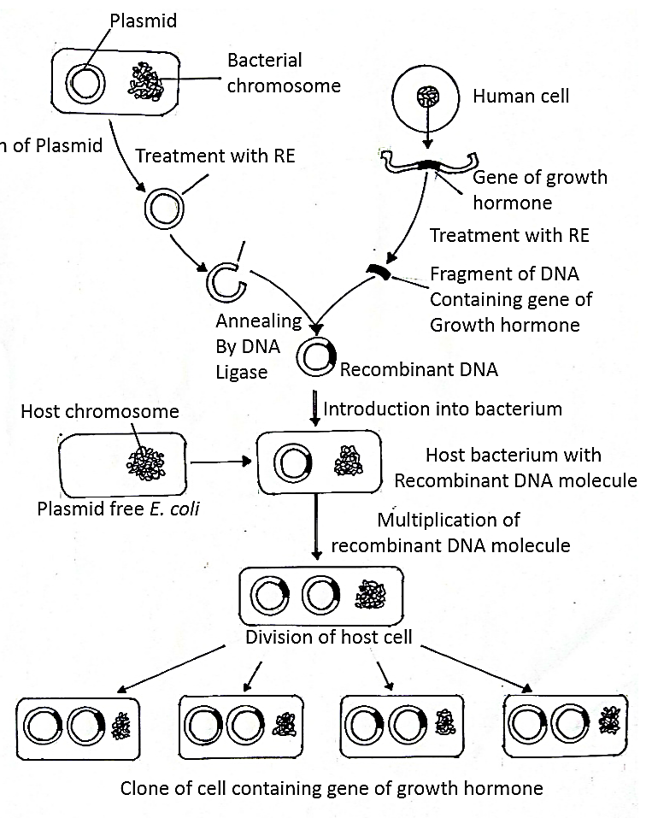
Fig 92: Steps in recombinant DNA technology

1. Selection and Isolation of foreign DNA (gene of interest)
The first step for DNA isolation is to open cells and release DNA by the gentlest possible method to prevent DNA from fragmenting by mechanical shearing. Due to variability in cell structure, the methods to break the cells are different.
The bacterial cell such as E. coli can be lysed by the enzyme lysozyme and the chemical ethylenediamine tetraacetate (EDTA). This EDTA chelates the Mg++ which needed to degrade DNase enzyme. DNase enzyme breaks the DNA so that it should be degraded. Then SDS (sodium dodecyl sulphate) detergent is used.
Cultured animal cell can be directly opened by the treatment of SDS. But plant cell has strongest cell wall which require harsh treatment to break open. The cells are frozen and ground in morter and pestle. This is an effective way to break the cell wall.
Further, except DNA all the cellular components are completely removed. To achieve this cellular extract is centrifuged at a low speed to remove the debris of cell wall. This forms the pellet at the bottom of the tube. The supernatant is collected and treated with phenols or with phenol/choloroform mixture to precipitate proteins between the organic and aqueus layer. The aqueus layer containing DNA and RNA is collected and treated with RNase (ribinuclease). The RNA is degraded while DNA can be precipitated by adding ethanol and isolated after centrifugation. Later on, DNA pellet is redissolved in a buffer containing EDTA to inactivate DNase present. This solution can be stored at 4⁰C.
Then to obtain desired gene the restriction digestions and gel electrophoresis are carried out. Restriction digestions are performed by incubating purified DNA molecule with the restriction enzyme. Further, by using agarose gel electrophoresis activity of restriction enzyme can be checked.
Agarose gel electrophoresis:
It is the most widely used technique to isolate the nucleic acid fragments of various length. It can separate the DNA upto 20 kb in size, but larger DNA cannot be separated or do not enter the gel. Reducing the agarose concentration to 0.1% allows the separation of DNA as large as 500 kb. But such low percentage agarose gels are very fragile and extremely difficult to handle. In this method DNA is forced to migrate through a highly cross-linked agarose matrix in response to an electric current. Size of the DNA and ionic strength of the running buffer are the factors that affects the migration rate of DNA through the gel. In solution, the phosphate of the DNA are negatively charged and therefore, DNA migrate to positive pole.
Protocol:
Preparation of the gel:
1. Weigh the appropriate amount of agarose into a flask. Add appropriate amount of water to form gel. Concentration of agarose in a gel is depend on the size of the DNA fragments to be separated. Most of the gel concentration is between the range of 0.5-2% and most of the laboratories use 0.8% gel concentration, which are suitable for separating DNA molecule in the range of 0.5-10 kb.
2. Add running buffer to agarose containing flask. Swirl to mix. Most common gel running buffer are TAE (40 mM Tris-acetate and 1 mM EDTA) and TBE (45 mM Tris-borate and 1 mM EDTA).
3. Melt the agarose buffer mixture by heating in a microwave. At 30 seconds regular intervals, remove the flask and swirl the contents to mix well. Repeat this till agarose has completely dissolve.
4. Add ethidium bromide (EtBr) to a concentration of 0.5μg/ml to the gel. Gel will stained after electrophoresis in running buffer containing 0.5μg/ml EtBr for 15-30 minutes.
5. Place the gel tray into casting apparatus. Then seal the open edges of the gel tray with the help of molten agarose. Then appropriately place the comb into gel mold to create the wells.
6. Pour the molten agarose into the gel mold. At room temperature allow the agarose to set. General purpose gels are approximately 25 cm long and 12 cm wide.
7.Remove the comb and place the gel into gel box.
8. Add loading dye to the DNA samples to be separated. Loading dye is made up of 6X concentration (0.25 % bromophenol blue, 0.25% xylene cyanol, 30% glycerol). Loading dye helps to track how far DNA sample has traveled and also allows the sample to sink into the gel.
9. Run the gel with power supply to desired voltage 1.5 V/cm overnight.
10. Add enough buffer to cover the surface of the gel. Use the same running buffer as the one used to prepare the gel.
11. With the help of micropipette slowly and carefully load the DNA sample into the gel. Standard DNA marker should be loaded along with experimental sample.
12.The cathode (black knob) should keep closer to the wells than the anode (red knob).
13. Turn on the power supply and verify that both gel box and power supply are working. Run the gel until the dye has migrated to an appropriate distance. On application of current, the negatively charged DNA travels to the positive electrode and is separated out based on the DNA size.
14. Turn off the power supply and remove the lid of the gel box when electrophoresis is completed.
15. Remove the gel from the gel box. From the surface of the gel remove the excess buffer. Place the gel tray on paper towels to absorb any extra running buffer.
16. Remove the gel from the gel tray and visualize under the UV light of 300 nm wavelength. Under the UV light EtBr build up at the site of DNA bands and these bands fluoresce orange-red. As little as 10 ng of DNA can be visualized as a 1 cm wide DNA. Wear goggle while observing the DNA bands because the UV light may damage the eye.
17. The standard DNA should be separated to use determination of the sizes of the sample bands.
18. Cut out the gel along with DNA bands by a scalpel blade. DNA is recovered by electroelution method. The gel fragment of desired DNA band is placed into a dialysis bag with buffer. The bag is then placed into a gel box containing buffer and start electric current. The extracted DNA is precipitated from the solution and dissolve the gel into agarase enzyme to digest the agarose and we get pure DNA.
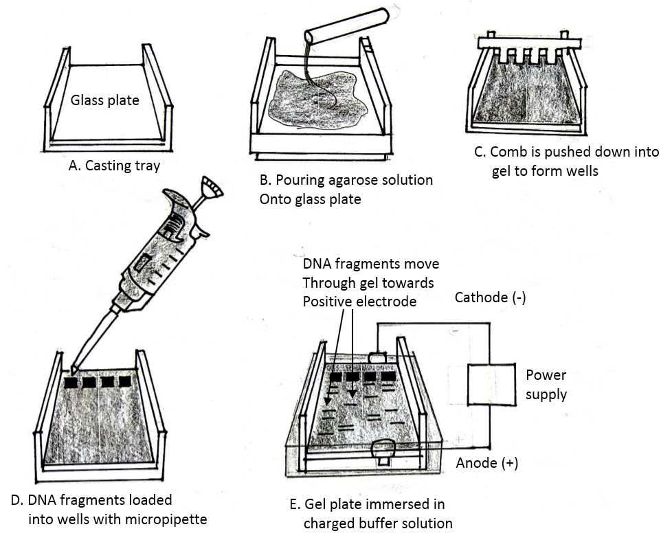
Fig 93: Agarose gel electrophoresis

Polymerase Chain Reaction (PCR)
PCR is a laboratory technique to generate large quantities of gene (DNA) of interest. It is developed by Karry Mullis in 1983.
Principle: Double stranded DNA of interest is denatured to separate into two individual strands. Each strand is allowed to hybridize with primers (renaturation). This primer-template complex is used to synthesize DNA. Three steps such as denaturation, renaturation and synthesis are repeated again and again to generate multiple forms of DNA of interest.
Materials and Reagents:
1. Target DNA or DNA of interest
2. Forward and reverse Primers: 0.2μM,
3. Deoxynucleoside triphosphates: 50-200μM each dNTP (dATP, dTTP, dGTP,dCTP), these
are building blocks from which DNA polymerase synthesizes a new DNA strand.
4. Taq DNA polymerse
5. Buffer solution to provide a suitable chemical environment for optimal activity and stability
of DNA polymerase.
6. Bivalent magnesium or manganese ions which are necessary for maximum Taq DNA
polymerase activity and influences the efficiency of primer to template annealing.
Procedure:
1. Prepare the reaction mixture into PCR tube by following way:
Ingredients for PCR | Volume in μl
Molecular biology grade water | 30.5 μl
10X assay buffer | 5 μl
Template DNA (DNA of interest) | 2 μl
Forward primer | 1 μl
Reverse primer | 1 μl
25 mM MgCl₂ | 5 μl
2.5 mM dNTP mix | 5 μl
Taq DNA polymerase | 0.5 μl
Total volume | - Μl

2. Tap the tube for 2-3 seconds to mix the contents thoroughly.
3. PCR consist of three defined steps such as denaturation, renaturation or annealing and
synthesis or extension. Each of these steps is repeated 30-40 times, termed as cycles. All
the cycles are run in the thermal cycler.
4. In the first cycle double stranded template DNA is denatured by heating the reaction above
90⁰C for about 1 minute.
5. Temperature of the mixture is then slowly cooled down to 40-60⁰C for 1 minute. The
primers then complementary pairs to the flanking regions of the target DNA. This process is
called renaturation or annealing.
6. The initiation of DNA synthesis occurs at 3’hydroxyl end of each primer. The primers are
extended by joining the bases complementary to the DNA strand. The temperature for the
synthesis step is 75⁰C for 2 minutes, which is optimum for the stability of Taq DNA
polymerase enzyme.
7. In this way 30-40 cycles of denaturation, renaturation and synthesis are run in the
thermal cycler. New strand extend beyond the target DNA it will contain the
complementary regions to the primers at the 3’ end. Thus, if another round of DNA
synthesis is allowed to take place, the original strand as well as new strand used as template.
All the new strands will act as template so that there will be exponential increase in the
amount of DNA produced.

2. Insertion of foreign DNA (gene of interest) into vector to form recombinant DNA molecule
The DNA of interest and suitable vector are cut with same restriction enzyme in order to obtain sticky ends. Both are ligated by mixing vector DNA, DNA of interest and enzyme DNA ligase to form recombinant DNA or chimeric DNA or hybrid DNA.

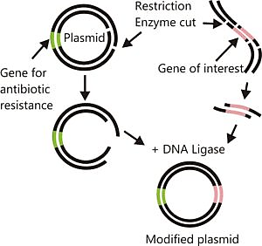
Fig 94: Restriction enzyme digestion followed by ligation

Enzyme DNA ligase is obtain from bacteriophage T4 and termed T4 DNA ligase. This enzyme forms covalent bond between the 5’ phosphate at the end of one strand and then 3’ hydroxyl of the adjacent strand.

3. Introduction of recombinant DNA molecule into a suitable host i.e. transformation
Introduction of recombinant DNA into host is achieved by two methods such as chemical methods and physical methods.
Chemical methods:
1. Polyethylene glycol mediated
2. Calcium chloride mediated
3. DEAE dextran mediated
Physical methods:
1. Electroporation
2. Microinjection
3. Liposome mediated
4. Particle bombardment
5. Sonoporation

4. Selection of transformed host cell
After the step of introduction of recombinant DNA into host, three types of cells are formed, these are, cells without plasmid, cells with only plasmid and cells with recombinant DNA i.e. chimeric DNA. Only small number of bacterial cells has taken recombinant DNA, not all cells. Plasmids used in cloning have an antibiotic resistance gene. Therefore, all bacterial cell are placed on an antibiotic plate to select the transformed cell with recombinant DNA plasmid. Bacteria without recombinant DNA plasmid die. Each bacterium with transformed plasmid gives rise to a cluster of identical bacterial colony. Several colonies are checked to identify cell with recombinant plasmid by PCR or restriction digest.

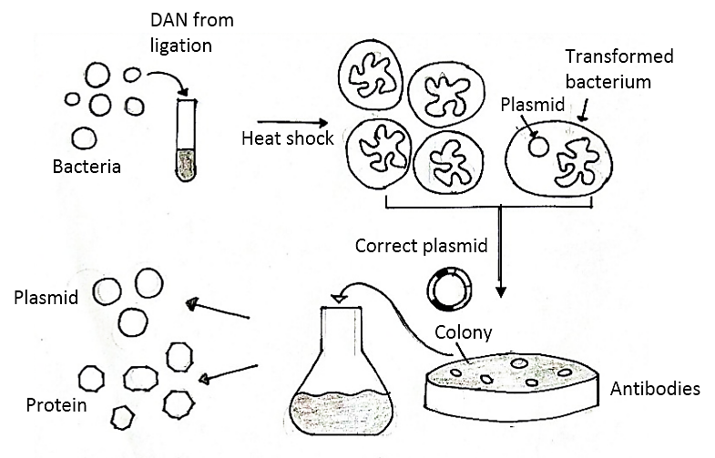

Fig 95: Bacterial transformation and selection

5. Expression and multiplication of foreign DNA into host
Colony containing transformed plasmid is grown in bulk and used for protein expression.Recombinant DNA multiplies in the host and gene of interest produces the mRNA, which is expressed as a protein under optimal conditions. This is now called as recombinant protein. Small amount of cell culture will not yield a large amount of recombinant protein. Therefore, large scale production is necessary to generate products that benefit humans. To achieve this, vessel called bioreactors are used. Bioreactors are large containers with a continuous culture system, in which fresh medium is added from one side and used medium is taken out from other side. Bioreactors provides optimum conditions such as temperature, oxygen, pH and vitamins to convert raw materials into specific proteins, enzymes, etc.
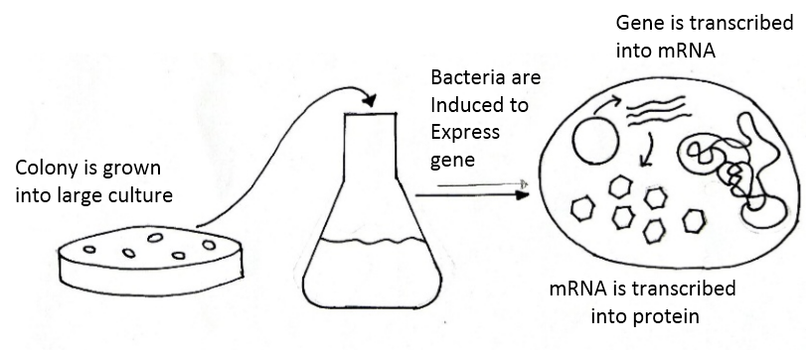
Fig 96: Expression of DNA of interest into host

Purification of recombinant proteins:
Bacteria contain many proteins and macromolecules. So that newly formed proteins are need to be purified before it can be used. There are several methods are available for the purification of recombinant protein. One of the technique called affinity chromatography used for this purpose. It is a mixture of molecules extracted from the lysed bacteria is poured through the column which is packed with beads. These beads are coated with antibodies. Therefore, an immune system protein binds specifically with target molecule. Only recombinant protein binds to beads but no other macromolecules. Thus, recombinant protein is trapped in the column, while other molecules are washed away. In the final step recombinant protein is released from the column and collected for use.
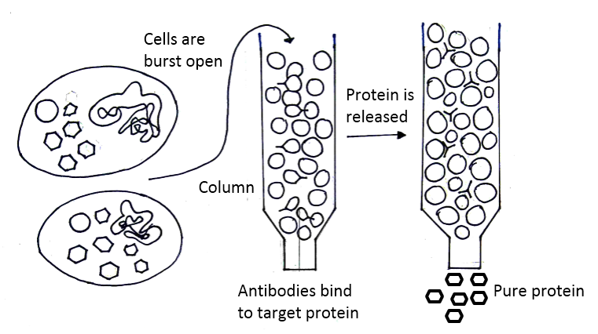
Fig Purification of recombinant protein by affinity chromatography technique

APPLICATIONS OF RECOMBINANT DNA TECHNOLOGY
There are three important applications of recombinant DNA technology:
1. Applications in crop improvement
2. Applications in medicine
3. Applications in industry

1. Applications in crop improvement
rDNA technology has several potential applications in crop improvement.
a. Distant hybridization:
With the improvement of rDNA technology, it is now possible to transfer the genes between distantly related species. Problems regarding gene transfer between the species or genera have been overcome. Gene of interest can be transfer from lower organisms to higher organisms through recombinant DNA technology.
  - Development of transgenic crops:
The crop which carries a foreign gene of desired function of other organism and express itself is called as transgenic crop or genetically modified crop (GM crop). Through rDNA technology one can achieve, resistance to disease, insects and pests, herbicides, drought; metal toxicity; high yield; induction of male sterility for plant breeding purpose and improvement of quality. For example, Bt-cotton and Bt brinjal are produced to with stand pest attack and reduces the pesticide use. Golden rice which is rich in vitamin A and lysine rich pulse are produced by recombinant DNA technology.
  - Development of root nodule in cereal crops:
Root nodules of leguminous plants have nitrogen fixing bacteria Rhizobium. In the root nodules Rhizobium bacteria converts atmospheric nitrogen into nitrates. The bacterial genes responsible for this nitrogen fixation can be transferred to cereal crops such as wheat, rice, maize, barley etc. by rDNA technology. Thus making these cereal crops too capable of fixing atmospheric nitrogen.
  - Development of C4 plants:
Through protoplast fusion or recombinant DNA technology, C3 plant can be converted into C4 plants, so that photosynthetic rate can be increased. This result into increase in the yield. C4 plants have higher potential rate biomass production than C3 plants.

2. Applications in health care
By the use of rDNA technology scientist can produce antibiotics, hormones, vaccines and interferon in the field of medicines.
a. Production of antibiotics:
Penicillium fungus and Streptomyces bacteria are used for the mass production of well known antibiotics penicillin and streptomycin respectively. Genetically efficient strains of these organisms are produced through rDNA technology so as to increase in the yield of these antibiotics.
  - Production of hormone insulin:
Insulin is extracted from pancreas of cows and pigs. This insulin has slightly different structure than human insulin. Therefore, it causes allergic reactions in patient. Human gene which is responsible for insulin production has been incorporated into bacterial DNA and such recombinant bacteria are used to produce insulin in large scale. This insulin does not cause allergic reactions.
  - Production of vaccines:
Vaccines are produced by transfer of antigen coding genes to disease causing bacteria. Such bacteria produces antibodies which provide protection against the infection by the same bacteria or virus.
  - Production of interferon:
Natural interferon are produced in very small quantity from human blood cells. Thus, it is very costly also. Interferon are produced against the viral infection and act as first line of defense against virus. It is now possible to produce interferon by rDNA technology at much cheaper rate.
e. Production of enzyme:
Some useful enzyme such as urikinase can be produce by rDNA technology. Urikinase enzyme used to dissolve blood clots.
f. Gene therapy:
Replacement of faulty gene with normal healthy gene is called as gene therapy. It is used to correct rare diseases like sickle cell anemia, hemophilia, phenylketonuria, alkaptonuria which are caused by the mutation in the single gene. rDNA technology is also used to produce human blood clotting factor VIII C. To treat the hemophilia, the clotting factor VIII C gene is cloned to express in mammalian cell lines and produce the protein VIII C which is responsible for blood clotting. In in vivo approach of gene therapy genes are direct introduced into target organ of patient. Therefore, this gene therapy is also called as patient therapy. On other hand, in in vitro approach of gene therapy, cells are isolated from the patient for the transfer of desired gene. Such transgenic cell are injected back into patient.

3. Applications in industry
a. With help of recombinant DNA technology, a number of synthetic medical peptides are produced. All such products show least side effects. For example, octreotide, help in controlling diarrhea.
b. Genes of biodegradable plastic polyhydroxylbutyrate (PHB) is isolated from bacterium Alcaligenes eutrophus and transferred to model plant Arabidopsis thaliana. Chloroplast of this plant produce PHB without producing plant’s growth and development. This transgenic plant is used for the biodegradable plastic production.
c. In oil industries such as groundnut, mustard, rapeseed, sesame, soybean and sunflower fatty acid quality and yield can be improved by recombinant DNA technology.
d. By recombinant DNA technology, chemical compounds of commercial importance are also produced. Improvement of existing fermentation process and production of proteins from wastes can be achieved by developing more efficient strains of microorganisms. Some microbes are used to clean up the pollutants.

