Utility and conservation of medicinal and aromatic plants in India

Brijesh Kumar Agri¹, Prawal P S Verma², Amit Kumar Tiwari³, Sonveer Singh³, Dipender Kumar³, R C Padalia³

¹ Department of Botany, Soban Singh Jeena University, Mall Road, Almora, Uttarakhand, India

²CSIR-Central Institute of Medicinal and Aromatic Plants, Regional Research Centre Purara, Bageshwar, Uttarakhand, India

³CSIR-Central Institute of Medicinal and Aromatic Plants, Regional Research Centre Pantnagar, Dairy Farm Nagla, U S Nagar, Uttarakhand, India

ABSTRACT
In this book chapter, we examine the enduring and multifaceted relationship between humanity and plants. Over the course of biological and cultural evolution, plants have been integral to meeting our fundamental life needs. They have provided sustenance, medicinal remedies, flavorings, and materials for clothing and shelter. We delve into the rich tapestry of traditional systems of medicine, such as Ayurveda, Unani, and Siddha in India, as well as indigenous healthcare practices worldwide, highlighting their continued significance in addressing healthcare needs, especially in developing countries. Furthermore, we explore how pharmaceutical and chemical sciences have harnessed the potential of medicinal plants. Through rigorous analysis, bioactive compounds have been isolated, leading to the discovery of new drugs. Currently, approximately 125 prescription drugs, each with known structures, are derived from over 100 plant species. Additionally, roughly 5,000 plant species globally have been examined as potential sources of novel treatments. India's pharmaceutical industry has been at the forefront of producing modern drugs from plants, underlining the importance of traditional knowledge in contemporary medicine. This chapter underscores the profound influence of plants on human existence and healthcare, both historically and in the present day, while also acknowledging their continued role in shaping our future.

Keywords: Medicinal plants, Traditional medicine, Ayurveda, Pharmaceutical science, Bioactive compounds

- Introduction
Throughout the course of human biological and cultural evolution, humanity has acquired an extensive knowledge of harnessing the power of plants to meet a myriad of fundamental life needs. These versatile organisms have played a central role in sustaining human existence by providing us with a rich array of resources and solutions. Plants have been our source of sustenance, offering diverse and nutritious foods that have been integral to our diets since time immemorial. In addition to nourishment, plants have been harnessed for their medicinal properties, offering remedies and treatments for various health ailments. Traditional systems of medicine in India, such as Ayurveda, Unani, and Siddha (Singh et al., 2019), have relied on plant-based medicines for centuries, recognizing the healing potential of botanical ingredients. This deep-rooted knowledge has been a cornerstone of healthcare in many cultures. Plants have not only influenced our physical well-being but have also enriched our sensory experiences. They have provided us with an assortment of condiments and flavorings, enhancing the taste and variety of our culinary creations (Swathi & Venkatesh, 2022). From aromatic herbs to spices that tickle the palate, plants have made our meals more flavorful and enjoyable. Beyond sustenance and healthcare, plants have been vital in providing raw materials for clothing and shelter. Fibrous plants like cotton and flax have been woven into fabrics for clothing, while timber from trees has been used in construction for dwellings and other structures (Mukherjee, 2001). This reliance on plants for shelter and clothing has deep historical roots, demonstrating our intricate connection to the plant kingdom. Plants have further served as a source of tools and implements, enabling humans to shape their environment. From ancient farming implements to modern machinery, plant-derived materials have been instrumental in crafting the tools necessary for survival and progress. Additionally, the utilization of plants extends to furnishings, as wood and other plant-based materials have been employed in creating furniture and household items. This practice highlights the integral role of plants in enhancing our daily lives and surroundings. In the realm of medicine, plants continue to play a crucial role in three distinct systems of healthcare in India: Ayurveda, Unani, and Siddha. These traditional systems of medicine rely heavily on botanical ingredients for healing and wellness. Furthermore, the field of homeopathy, originally developed in Germany, incorporates plant-based substances into its remedies. Even in the modern era, the western medical system, practiced widely worldwide, relies on plant-derived compounds for pharmaceuticals and treatments. This illustrates the enduring importance of plants in contemporary healthcare.
The practice of traditional or indigenous medical systems is a global phenomenon, reflecting the distinct cultural traditions of each nation. These systems are rooted in specific principles and traditions that have been passed down through generations. They have evolved over time and can be traced back to the earliest days of human civilization when ancient people employed various methods and therapies to address health concerns. As humans migrated to different environments, these practices underwent transformations, eventually solidifying into recognized medical systems within various civilizations (Redvers & Blondin, 2020). The acceptance of these medical traditions has been greatly influenced by cultural factors, making them challenging to transplant from one culture to another. In spite of the progress made in modern medicine and the development of synthetic drugs, indigenous, traditional, and folk medicine persist as valuable cultural legacies in societies worldwide. These systems continue to play a significant role in meeting the healthcare needs of many developing countries, home to approximately 80 percent of the world's population (Castillo-Santana et al., 2017). Additionally, there has been a renewed interest in herbal remedies in recent times. Global organizations like the World Health Organization (WHO) acknowledge the potential of traditional and folk medicine in promoting healthcare self-sufficiency. WHO actively promotes and encourages the integration of herbal medicines into the healthcare programs of all nations. Two of the world's oldest and most well-established traditional or indigenous medical systems are Chinese traditional medicine and Ayurveda, the ancient Indian system of medicine. Chinese traditional medicines have contributed to the maintenance of the health of the Chinese population, with more than 80 percent of Chinese people utilizing these traditional remedies, which number over 10,000 (Xiong et al., 2020). Ayurveda, a centuries-old traditional system of medicine, has maintained its prominence in India over many generations but experienced a somewhat diminished application in the previous century. India stands out globally due to its diverse population practicing several well-recognized indigenous medical systems. These encompass Ayurveda, Siddha, Unani, Homeopathy, Yoga, and Naturopathy, collectively providing comprehensive healthcare. Ayurveda, often referred to as "the science of life," is one of the world's oldest documented medical systems, dating back to the dawn of civilization and the Vedic period. It operates on a holistic approach, addressing the physical, chemical, biological, and spiritual aspects of life (Redvers, 2021). Ayurveda's primary goal is not only to cure diseases but also to maintain a positive state of health encompassing the body, mind, and spirit, all in harmony with the environment and the universe. The Siddha system of medicine, with its origins in the pre-Vedic period, focuses primarily on therapeutics. Its principles closely resemble those of Ayurveda and emphasize iatrochemistry. Siddha medicine is predominantly practiced in the southern states of India, particularly Tamil Nadu. An essential aspect of Siddha medicine involves the liberal consumption of metals, minerals, such as mercury, sulfur, and specific salts, alongside herbal drugs. Unani medicine, or the Graeco-Arabic system, was introduced to India during the medieval period by the Arabs. It amalgamated with Ayurveda and became known as "Unani Tibb." Unani medicine is rooted in the four-humor theory of Hippocrates, as developed in the Arab world (Hoosen et al., 2022). It assesses a patient's needs based on temperament, with the aim of maintaining a proper balance between the innate power of self-preservation and adaptability. Homeopathy, a system of medicine introduced to India only in the mid-19th century, has seen sporadic use. In India, these diverse medical traditions collectively contribute to the rich tapestry of healthcare, embodying a blend of ancient wisdom and contemporary understanding (Mujeeb, 2017).
The Ayurvedic system of medicine extends its influence on neighboring countries such as Nepal, Bhutan, Sri Lanka, and Bangladesh(Pandey et al., 2013). Furthermore, the principles and practices of traditional medicine systems in other cultures and countries within the region, such as Tibet, Mongolia, Thailand, Indonesia, and Malaysia, seem to have roots in Ayurveda. These systems share common features with Ayurveda and the Chinese medical system, as well as the Kampo system practiced in Japan and Korea. They make use of substances derived from plants, animals, and minerals, both in simple, single-drug preparations and complex compound formulations. Typically, practitioners of these indigenous therapies prefer compound prescriptions, believing them to be more effective due to synergistic interactions (S. B. Tiwari et al., 2021). This preference makes it more challenging to meet international standards compared to simpler preparations. In India, until a few decades ago, medicines in indigenous medical systems were generally prepared by the practicing physicians themselves. However, in recent decades, this practice has largely transitioned to the establishment of organized indigenous drug industries. Currently, there are approximately 10,000 licensed pharmacies for the Indian system of medicine and nearly 400,000 registered practitioners of Ayurveda, Siddha, and Unani medicine (Kaliappan et al., 2013).
The Ayurvedic system of medicine does not restrict the use of any plant substances as medicines, and there are approximately 1,000 single drugs and 8,000 compound formulations of recognized merit in use today. Similarly, Siddha, Unani, and Amchi systems of medicine employ around 600, 700, and 600 medicinal plants, respectively(Kumar et al., 2022). While there are common plants used across these systems, quantifying the usage of individual plant materials in traditional medicine is challenging due to the absence of reliable data on the availability, supply, and demand of medicinal plants in the country.
In recent times, pharmaceutical and chemical sciences have played a significant role in harnessing the potential of medicinal plants. Through rigorous chemical analysis, researchers have isolated and thoroughly assessed bioactive compounds from these plants, leading to the discovery of new drugs and expanded applications for these compounds. Presently, there are approximately 125 clinically useful prescription drugs, each with known structures, derived from around 100 different species of higher plants. This underscores the rich pharmacological diversity that nature offers. Additionally, an estimated 5,000 higher plant species worldwide have been meticulously studied as potential sources of novel drugs for various human ailments. Over the past three and a half decades, India's pharmaceutical industry has made substantial progress in producing modern drugs derived from plants. Notable pharmaceuticals produced in India include opioids like morphine, codeine, and papaverine extracted from Papaver somniferum; antimalarial drugs such as quinine and its derivatives from various plant sources; gout medication colchicine obtained from several plant species; heart medications digoxin and lanatoside sourced from Digitalis lanata; caffeine from tea (Thea sinensis) and coffee (Coffea arabica); berberine from species of the genus Berberis, Coptis, and Coscinium; xanthotoxin from plants like Ammi majus and Heracleum lanatum; psoralen from Psoralia corylifolia; rutin from Fagopyrum esculentum; vinblastine, catharanthine, and ajmalicine from Rauvolfia serpentina; ephedrine and pseudoephedrine from Ephedra gerardiana; diosgenin from various Dioscorea species; solasodine extracted from Solanum species; sennosides from Cassia angustifolia and Cassia acutifolia; cephaeline and emetine from Cephaelis ipecacuanha; podophyllotoxin from Podophyllum hexandrum; guggulipid sourced from Commiphora wightii; artemisinin from Artemisia annua; and taxol derived from certain Triticale plant species (Krupa Samuel et al., 2022). Furthermore, beyond isolating pure chemical constituents, various crude and standardized extracts from medicinal plants are utilized as medicinal agents. These include extracts from belladonna (Atropa acuminata), opium (Rheum emodii), aloe vera (Aloe vera), and valerian (Valeriana species), among others. This comprehensive exploration of medicinal plants and their compounds continues to drive advancements in pharmaceutical science and the development of new treatments for various medical conditions.

- Conservation challenges
Conservation efforts for medicinal and aromatic plants face an array of formidable challenges, with the looming threat to these plant species in their natural habitats at the forefront. Factors such as rampant urbanization, deforestation, and the relentless expansion of agriculture pose existential risks as they encroach upon and diminish the habitats critical for the survival of these vital species (Heywood, 2017). One of the primary challenges is overharvesting and habitat degradation, which represent twin perils that demand urgent attention. The insatiable demand for these plants, whether for their medicinal properties or aromatic allure, has led to indiscriminate and unsustainable collection practices that can deplete populations and disrupt fragile ecosystems (Breman et al., 2021). Concurrently, habitat degradation resulting from practices like deforestation and land-use changes further exacerbates the problem, pushing many species perilously close to the brink of extinction. In addition to these immediate threats, the far-reaching impacts of climate change cast a long shadow over the conservation efforts. Shifts in temperature and precipitation patterns directly affect the growth and reproductive cycles of medicinal and aromatic plants. These changes challenge the adaptability of these species, posing substantial threats to their long-term survival. Furthermore, legal and ethical issues loom large on the conservation landscape. Concerns over biopiracy, where traditional knowledge is exploited without adequate recognition or fair benefit-sharing, underscore the need for robust legal frameworks that safeguard the interests of local communities and indigenous peoples who have been stewards of these plants for generations(Rai & Singh, 2021) . The conservation of medicinal and aromatic plants is a complex and multifaceted challenge. Addressing the threats posed by urbanization, deforestation, overharvesting, habitat degradation, and climate change while ensuring the protection of traditional knowledge and the rights of local communities is essential for the continued existence of these valuable plant species. Effective conservation strategies must be holistic, interdisciplinary, and guided by a strong commitment to preserving both biodiversity and cultural heritage (Agrawal et al., 2022).

- Genetic diversity
Biodiversity encompasses the richness of species and the genetic variability inherent in all living organisms, spanning plants, animals, and microorganisms. This diversity arises from variations in their DNA content and sequences, giving rise to unique genetic traits and characteristics. Notably, different species are reproductively isolated from one another, and their adaptive responses to varying environments can diverge significantly (Nayyar et al., 2021). The importance of biodiversity is profound, as it offers essential ecological services to humanity. It plays a pivotal role in climate regulation, acts as a natural filter for purifying water, soil, and air, contributes significantly to food production through the vital process of crop pollination, enriches soil fertility, and serves as a linchpin for various life-sustaining functions within ecosystems. Each species represents a repository of distinct genetic information, and unlocking the secrets of their unique biochemical capabilities holds the promise of designing new products with medicinal, agricultural, and industrial significance for human use. Yet, in the face of these remarkable opportunities, understanding, harnessing, and preserving biodiversity stands as one of the greatest scientific challenges of our time (Vaishnav et al., 2023). The ongoing efforts to unravel the complexities of genetic diversity, exploit its potential benefits, and ensure its conservation are at the forefront of contemporary scientific exploration, as they hold the key to sustaining the delicate balance of our interconnected world.

- Richness of species in India
India stands as a beacon of both considerable biodiversity and cultural diversity. Geographically, it spans a subcontinent, enveloping an astonishing array of ecological diversity. With 15 distinct agroclimatic zones, 10 vegetation zones, 25 biotic provinces, and 426 biomes, India has rightfully earned its status as one of the world's top twelve mega-diversity countries. It is a land of extremes, ranging from the blistering Thar desert to the icy expanse of the Himalayas (Wani et al., 2022), with all conceivable gradations in between. Remarkably, despite occupying only 2% of the world's land area, India hosts more than 5% of all known species of higher plants and animals. Yet, the full extent of India's biodiversity remains far from catalogued. While some reliable data exists for higher plants and land-dwelling animals, there remains a vast knowledge gap concerning microorganisms, lower plants, and terrestrial animal species. Similarly, the oceans surrounding India hold a wealth of biodiversity yet to be comprehensively explored (Deomurari et al., 2023). India boasts an estimated 15,000-17,000 species of angiosperms (flowering plants), 23,000 fungal species, 2,500 algae species, and 1,600 more within the realm of agri-horticultural crops, including a substantial number of endemic species. Additionally, over 800 species of ethnobotanical significance further contribute to the mosaic of India's rich biodiversity (Shrivastava et al., 2022). These numbers underscore the urgent need to continue documenting and understanding India's extraordinary biological wealth, a vital endeavor in the pursuit of conserving and harnessing its immense ecological and cultural treasures (Walsh et al., 2021).

- The rarity and plants endemism
The profound impact of human activities across various domains has taken a significant toll on biodiversity, placing the future of numerous species in jeopardy. These detrimental effects have identifiable causes, including the loss and fragmentation of habitats due to urbanization, industrialization, and agricultural expansion, the haphazard introduction of exotic species, the unsustainable exploitation of natural resources, inadequate management of water resources, and the pervasive pollution of soil, water, and the atmosphere(Carbutt, 2019). Compounding these challenges is the ongoing global climate change phenomenon, further imperiling delicate ecosystems and species. The rate at which species are vanishing is a cause for global concern, underscoring the urgency of conservation efforts. Distressingly, it is estimated that tropical forests alone lose one higher plant species daily (A. Tiwari et al., 2019). If this alarming trend persists, it is projected that roughly 25% of the approximately 250,000 higher plant species may be lost within the next few decades, with an additional 25% facing extinction by the close of the twenty-first century. One widely accepted estimate, endorsed by the International Union for Conservation of Nature and Natural Resources (IUCN) and the Worldwide Fund for Nature (WWF), warns that as many as 60,000 higher plant species could teeter on the brink of extinction or face near-extinction by the middle of the next century. These sobering statistics emphasize the imperative to take proactive measures to safeguard and preserve the extraordinary diversity of plant life that graces our planet.

- The escalating plight of endangered plant species in India
Unsurprisingly, the number of plant species facing endangerment or threats in India has witnessed a relentless rise, marking a stark contrast from a mere few hundred species just a few years ago to now encompassing thousands. The concern looms that a substantial portion, potentially 15-20% of the entire flora, equating to over 3,000 higher plant species, may now be classified within one of the categories reserved for threatened plants (Ravikanth et al., 2018).

  - Extinct (Ex)
This category encompasses species that have vanished entirely from the wild, despite rigorous searches of their typical habitats and other known or probable locations. Additionally, in accordance with IUCN criteria, species declared as extinct in the wild but surviving through cultivation are included.

  - Endangered (E)
Species falling under this classification are teetering on the brink of extinction, with their survival highly uncertain if the factors driving their decline persist. Such taxa have experienced such severe reductions in population numbers that they face immediate jeopardy.

  - Vulnerable (V)
Taxa that are expected to transition into the endangered category in the near future due to ongoing causal factors for depletion are classified as vulnerable. This includes (a) taxa facing population declines due to over-exploitation, extensive habitat destruction, or other environmental disruptions, (b) taxa with seriously depleted populations whose long-term security is uncertain, and (c) taxa with still-abundant populations but under imminent threat from significant adverse factors throughout their range.

  - Rare (R)
This group encompasses taxa with limited global populations that, while not endangered or vulnerable presently, are at risk. Typically, such taxa are localized within specific geographical areas or habitats or are sparsely distributed across a wider range. They may be endemic to a small island or single mountain, with their rarity often attributed to small population sizes.

  - Indeterminate (I)
This category includes taxa known to be extinct, endangered, vulnerable, or rare but lacks sufficient information to definitively assign them to one of these four categories.

  - Insufficiently known (K)
Taxa suspected of belonging to one of the categories but lacking concrete evidence due to insufficient information are classified here.

  - Out of danger (O)
Taxa previously categorized in one of the above risk categories but now considered relatively secure due to effective conservation measures or the alleviation of previous threats to their survival are deemed out of danger or not threatened.

  - Endemic
This term is ascribed to taxonomic units or taxa confined to restricted regions, often isolated by geographical or temporal barriers. Various levels of endemicity exist based on theoretical and reproductive considerations.

- Varieties of endemism
Endemism in the realm of biodiversity manifests in various forms, each bearing its unique ecological and historical significance.

7.1. Relic endemism
This form of endemism harkens back to ancient times when geological and climatic conditions were markedly different. Relic endemics are species that once had a more extensive distribution but now survive only in specific isolated areas due to changing environmental factors. These survivors offer glimpses into the past, providing valuable insights into the evolutionary history and adaptation of organisms. The pockets where relic endemics persist are often referred to as "living fossils," as they harbor species that have persisted virtually unchanged for millions of years.

7.2. Neoendemics
Unlike relic endemics, neoendemics are species that have recently evolved and are unique to specific geographical regions. These endemics may have arisen due to geographic isolation, genetic divergence, and adaptation to local ecological conditions. They exemplify ongoing evolutionary processes and contribute to the diversification of life forms. Studying neoendemics sheds light on the mechanisms driving speciation and the role of geography in shaping genetic diversity.

7.3. Anthropogenic endemism
Anthropogenic activities, primarily human-induced changes in land use and habitat modification, have led to the emergence of anthropogenic endemics. These species have adapted to newly created environments, often influenced by human interventions such as urbanization, agriculture, or industrialization. Anthropogenic endemism highlights the profound impact of human actions on ecosystems and serves as a testament to nature's capacity for resilience and adaptation in the face of rapid environmental transformations.

- Endemicity in India
Endemic species, characterized by their unique presence within restricted geographic regions, hold a pivotal role in the realm of conservation (Table 1). These species, owing to their distinctiveness and limited distribution, offer crucial insights into the intricate tapestry of biodiversity (Mukhopadhyay, 2016). Understanding and preserving them are essential for safeguarding our planet's biological heritage. Recent scientific studies have shed light on the prevalence of endemism, particularly among higher plant species, where approximately 35% are considered endemic (Patel et al., 2021). This statistic underscores the rich diversity of plant life confined to specific regions, highlighting the importance of focused conservation efforts. India, with its vast and varied landscape, stands out as a hotspot for endemic flora. Among the 18 globally recognized "hot spots" of biodiversity, India proudly hosts two: the Eastern Himalayas and the Western Ghats. These regions serve as the exclusive habitats for a staggering 3,500 and 1,600 endemic higher plant species, respectively. Collectively, these species account for over 5% of the world's total endemic higher plant species (Saha & Ganguly, 2021). The significance of endemic species extends beyond their uniqueness; they also provide valuable insights into evolution, adaptation, and ecological processes. These species often exhibit specialized adaptations to their specific environments, shedding light on the mechanisms of natural selection and survival. Moreover, endemic species are indicators of the health of their ecosystems. Their survival is intricately linked to the preservation of their habitat, making them valuable barometers of ecosystem stability. When endemic species thrive, it is indicative of a balanced and healthy ecosystem. However, the conservation of endemic species presents unique challenges (Shenoy et al., 2022). Their limited distribution makes them susceptible to localized threats, including habitat destruction, climate change, and invasive species. Therefore, protecting these species necessitates targeted conservation measures that address the specific risks they face.

- Conservation of medicinal and aromatic plants in India
In the present era, many commercially important medicinal and aromatic plant species are facing the risk of extinction or significant genetic loss (Fig. 1). This alarming situation results from the growing global demand for their products, the rapid increase in the human population, and the extensive destruction of plant-rich habitats such as tropical forests, wetlands, Mediterranean ecosystems, and parts of arid zones (Negi et al., 2018). While there has been considerable focus on exploring the potential of medicinal and aromatic plants for discovering new drugs and commercially valuable compounds, there has been little to no coordinated effort to conserve most of these endangered or threatened species. Recognizing this pressing issue, several national and international organizations have taken the initiative to formulate policies and strategies for the conservation of medicinal and aromatic plants. Notably, organizations such as the World Health Organization (WHO), the International Union for Conservation of Nature and Natural Resources (IUCN), the Worldwide Fund for Nature (WWF), the United Nations Educational, Scientific and Cultural Organization (UNESCO), and the Food and Agriculture Organization (FAO) have made commendable efforts in this regard. Moreover, in 1992, over 155 countries, including India, signed the treaty on the conservation of biological diversity at the Earth Summit in Rio de Janeiro (Luiz-Silva & Oscar-Júnior, 2022). Article 7 of this convention mandates each participating party to identify and prioritize components of biological diversity essential for their conservation and sustainable use (Šatović et al., 2012). In 1998, WHO, IUCN, and WWF jointly organized an international consultation on the conservation of medicinal plants in Chiang Mai, Thailand, from March 21 to 27. This gathering brought together leading experts from various countries who discussed the challenges, identified priorities, and made recommendations for action. The outcome was the issuance of The Chiang Mai Declaration, emphasizing the significance of medicinal plants and urging the United Nations, its agencies, member states, and other international organizations to take proactive steps for their conservation. Subsequently, a report titled "Guidelines on the Conservation of Medicinal Plants" was published, aiming to establish a framework for the conservation and sustainable utilization of medicinal plants. The forty-first World Health Assembly in 1988 also highlighted the importance of the Chiang Mai Declaration and emphasized the need to ensure an adequate supply of medicinal plants for future generations. This underscored the vital role of medicinal plants, their rational and sustainable use, and their conservation within the realm of public health policy and concern.

- Strategy for the conservation of medicinal and aromatic plants
Certainly, here are the key points summarizing the strategy for the conservation of medicinal and aromatic plants: 1. Develop a national strategy: Create a comprehensive national strategy that outlines the conservation and sustainable use of medicinal and aromatic plants, assigning specific tasks to the most suitable institutions; 2. Collaborative effort: Engage experts from diverse disciplines and institutions to collaboratively address the multifaceted challenges of conserving these plant species; 3. Identify and prioritize species: Identify medicinal and aromatic plants, map their distribution, and assess their abundance or scarcity. Prioritize the conservation of threatened species; 4. Establish a comprehensive database: Develop a computerized database following international data standards to gather, manage, and continuously update information on these plants; 5. Domestication and cultivation: Promote the domestication and cultivation of medicinal plants to ensure a stable supply of high-quality materials and reduce pressure on wild populations. Develop agrotechnologies for species with high demand; 6. Breeding programs: Launch urgent breeding efforts to develop high-yielding varieties, especially for medicinal crops used extensively in modern and traditional medicines; 7. Ex-situ conservation: Give priority to establishing medicinal plant gardens and nurseries for ex-situ conservation; 8. Regulate collection: Properly regulate the collection of medicinal plants, issue permits, and adopt sustainable harvesting practices. Entrust collection to trained individuals and implement effective management and rotational systems; 9. Protect local interests: Safeguard the ethical, legal, and social interests of communities residing in areas with medicinal plants; 10. Prohibit commercial exploitation: Strictly prohibit the commercial exploitation of threatened medicinal and aromatic plants from the wild; 11. Habitat-based conservation: Focus on conserving medicinal plant species in their natural habitats (in-situ conservation). Designate protected areas like nature reserves and national parks and reintroduce depleted species; 12. Ex-situ cultivation: Cultivate high-value medicinal plants outside their natural habitats (ex-situ conservation), especially for species with destroyed or safeguarded habitats; 13. Seed banks: Develop seed banks for native and cultivated medicinal plants within the country; 14. Gene banks: Establish gene banks for medicinal and aromatic plants to preserve their genetic diversity; 15. Research and education: Use medicinal and aromatic plants as model systems for studying life processes, secondary metabolite biosynthesis, and discovering new therapeutic agents and industrial commodities and 16. Public awareness: Promote awareness among the public through communication, cooperation, and education to garner broad support for conservation efforts.

Conclusion
In conclusion, this book chapter has delved into the fascinating world of medicinal and aromatic plants, exploring their taxonomy, distribution, conservation challenges, and the profound impact they have on our lives. We have learned about the rich diversity of plant species, each offering unique bioactive compounds that play crucial roles in traditional and modern medicine, perfumery, and flavoring. India, with its diverse agroclimatic zones and unique ecosystems, stands as a global hotspot for biodiversity and endemism, particularly in the Eastern Himalaya and the Western Ghats. These regions house a significant percentage of the world's endemic plant species, highlighting the importance of conservation efforts in these areas. The book chapter has shed light on the threats facing medicinal and aromatic plant species, including habitat loss, overexploitation, climate change, and legal and ethical issues. It has emphasized the need for a comprehensive strategy to safeguard these invaluable botanical resources. In an ever-changing world, where the demand for medicinal and aromatic plants is on the rise, it is crucial to strike a balance between utilization and conservation. With concerted efforts, including those led by international organizations like WHO, IUCN, WWF, and UNESCO, we can hope to ensure the availability of these plants for future generations. In the face of ongoing challenges, it is imperative to recognize that the conservation of medicinal and aromatic plants is not only a matter of preserving biodiversity but also a vital component of public health policy and sustainable development. As we continue to unveil the secrets of these plants, their potential to provide solutions to global health and environmental challenges becomes increasingly evident. The journey of discovery, conservation, and sustainable use of medicinal and aromatic plants is a dynamic and essential endeavor that promises to benefit humanity and the natural world alike.

Acknowledgment
We extend our gratitude to the experts, organizations, and readers for their contributions to the study and conservation of medicinal and aromatic plants. Additionally, we express our sincere thanks to Google, Elsevier, and the countless books that served as vital sources of information during the writing of this book chapter, helping us shape and share the knowledge that lies at the heart of our work.

References

Agrawal, K. K., Jha, S. K., Mittal, R. K., & Vashishtha, S. (2022). Assessment of floating solar PV (FSPV) potential and water conservation: Case study on Rajghat Dam in Uttar Pradesh, India. Energy for Sustainable Development, 66. https://doi.org/10.1016/j.esd.2021.12.007
Berv, J. S., Campagna, L., Feo, T. J., Castro-Astor, I., Ribas, C. C., Prum, R. O., & Lovette, I. J. (2021). Genomic phylogeography of the White-crowned Manakin Pseudopipra pipra (Aves: Pipridae) illuminates a continental-scale radiation out of the Andes. Molecular Phylogenetics and Evolution, 164. https://doi.org/10.1016/j.ympev.2021.107205
Breman, E., Ballesteros, D., Castillo-Lorenzo, E., Cockel, C., Dickie, J., Faruk, A., O’donnell, K., Offord, C. A., Pironon, S., Sharrock, S., & Ulian, T. (2021). Plant diversity conservation challenges and prospects—the perspective of botanic gardens and the millennium seed bank. In Plants (Vol. 10, Issue 11). https://doi.org/10.3390/plants10112371
Carbutt, C. (2019). The Drakensberg Mountain Centre: A necessary revision of southern Africa’s high-elevation centre of plant endemism. South African Journal of Botany, 124. https://doi.org/10.1016/j.sajb.2019.05.032
Castillo-Santana, P. T., Vallejo-Rodríguez, E. D., Cotes-Cantillo, K. P., & Castañeda-Orjuela, C. A. (2017). Salud materna indígena en mujeres Nasa y Misak del Cauca, Colombia: Tensiones, subordinación y diálogo intercultural entre dos sistemas medicos. Saude e Sociedade, 26(1). https://doi.org/10.1590/S0104-12902017168743
Cubas, J., Irl, S. D. H., Villafuerte, R., Bello-Rodríguez, V., Rodríguez-Luengo, J. L., Del Arco, M., Martín-Esquivel, J. L., & González-Mancebo, J. M. (2019). Endemic plant species are more palatable to introduced herbivores than non-endemics. Proceedings of the Royal Society B: Biological Sciences, 286(1900). https://doi.org/10.1098/rspb.2019.0136
Demissew, S., Friis, I., & Weber, O. (2021). Diversity and endemism of the flora of Ethiopia and Eritrea: state of knowledge and future perspectives. Rendiconti Lincei, 32(4). https://doi.org/10.1007/s12210-021-01027-8
Deomurari, A., Sharma, A., Ghose, D., & Singh, R. (2023). Projected Shifts in Bird Distribution in India under Climate Change. Diversity, 15(3). https://doi.org/10.3390/d15030404
Fine, P. V. A., & Baraloto, C. (2016). Habitat Endemism in White-sand Forests: Insights into the Mechanisms of Lineage Diversification and Community Assembly of the Neotropical Flora. Biotropica, 48(1). https://doi.org/10.1111/btp.12301
Heywood, V. H. (2017). Plant conservation in the Anthropocene – Challenges and future prospects. In Plant Diversity (Vol. 39, Issue 6). https://doi.org/10.1016/j.pld.2017.10.004
Hoosen, M., Roman, N. V., & Mthembu, T. G. (2022). The Development of Guidelines for the Inclusion of Spirituality and Spiritual Care in Unani Tibb Practice in South Africa: A Study Protocol. Journal of Religion and Health, 61(2). https://doi.org/10.1007/s10943-020-01105-5
Kaliappan, I., Kammalla, A. K., Ramasamy, M. K., Agrawal, A., & Dubey, G. P. (2013). Emerging need of pharmacokinetics in Ayurvedic system of medicine. In International Journal of Research in Ayurveda and Pharmacy (Vol. 4, Issue 5). https://doi.org/10.7897/2277-4343.04503
Kessler, M. (2001). Maximum plant-community endemism at intermediate intensities of anthropogenic disturbance in Bolivian montane forests. Conservation Biology, 15(3). https://doi.org/10.1046/j.1523-1739.2001.015003634.x
Krupa Samuel, Anuradha Medikeri, Tanveer Pasha, Moh. Faruque Ansari, & Ashafaq Saudagar. (2022). Centella asiatica: A traditional herbal medicine. World Journal of Advanced Research and Reviews, 15(1). https://doi.org/10.30574/wjarr.2022.15.1.0726
Kumar, A., Negi, A. S., Chauhan, A., Semwal, R., Kumar, R., Semwal, R. B., Singh, R., Joshi, T., Chandra, S., Joshi, S. K., & Semwal, D. K. (2022). Formulation and evaluation of SGLT2 inhibitory effect of a polyherbal mixture inspired from Ayurvedic system of medicine. Journal of Traditional and Complementary Medicine, 12(5). https://doi.org/10.1016/j.jtcme.2022.03.003
Lendvay, B., & Kalapos, T. (2014). Population dynamics of the climate-sensitive endangered perennial Ferula sadleriana Ledeb. (Apiaceae). Plant Species Biology, 29(2). https://doi.org/10.1111/1442-1984.12003
López-Pujol, J., Zhang, F. M., Sun, H. Q., Ying, T. S., & Ge, S. (2011). Centres of plant endemism in China: Places for survival or for speciation? Journal of Biogeography, 38(7). https://doi.org/10.1111/j.1365-2699.2011.02504.x
Luiz-Silva, W., & Oscar-Júnior, A. C. (2022). Climate extremes related with rainfall in the State of Rio de Janeiro, Brazil: a review of climatological characteristics and recorded trends. Natural Hazards, 114(1). https://doi.org/10.1007/s11069-022-05409-5
Mujeeb, H. (2017). Temperament – an important principle for health preservation in Tibb an-Nabawi and Unani-Tibb. In Bangladesh Journal of Medical Science (Vol. 16, Issue 4). https://doi.org/10.3329/bjms.v16i4.33600
Mukherjee, P. K. (2001). Evaluation of indian traditional medicine. Therapeutic Innovation & Regulatory Science, 35(2). https://doi.org/10.1177/009286150103500235
Mukhopadhyay, C. (2016). Melioidosis endemicity in India. International Journal of Infectious Diseases, 45. https://doi.org/10.1016/j.ijid.2016.02.102
Nayyar, N., Gracy, R. G., Ashika, T. R., Mohan, G., Swathi, R. S., Mohan, M., Chaudhary, M., Bakthavatsalam, N., & Venkatesan, T. (2021). Population structure and genetic diversity of invasive Fall Armyworm after 2 years of introduction in India. Scientific Reports, 11(1). https://doi.org/10.1038/s41598-021-87414-5
Negi, V. S., Kewlani, P., Pathak, R., Bhatt, D., Bhatt, I. D., Rawal, R. S., Sundriyal, R. C., & Nandi, S. K. (2018). Criteria and indicators for promoting cultivation and conservation of Medicinal and Aromatic Plants in Western Himalaya, India. Ecological Indicators, 93. https://doi.org/10.1016/j.ecolind.2018.03.032
Pandey, M. M., Rastogi, S., & Rawat, A. K. S. (2013). Indian traditional ayurvedic system of medicine and nutritional supplementation. In Evidence-based Complementary and Alternative Medicine (Vol. 2013). https://doi.org/10.1155/2013/376327
Patel, A., Dharsandiya, M., Savaj, P., Munim, F. C., Shah, K., & Patel, K. (2021). Footprints of human melioidosis in the north western Indian states, expanding endemicity in India. Indian Journal of Medical Microbiology, 39(3). https://doi.org/10.1016/j.ijmmb.2021.04.003
Rai, P. K., & Singh, J. S. (2021). Plant invasion in protected areas, the Indian Himalayan region, and the North East India: progress and prospects. In Proceedings of the Indian National Science Academy (Vol. 87, Issue 1). https://doi.org/10.1007/s43538-021-00013-w
Ravikanth, G., Jagadish, M. R., Vasudeva, R., Uma Shaanker, R., & Aravind, N. A. (2018). Recovery of critically endangered plant species in India: Need for a comprehensive approach. Current Science, 114(3). https://doi.org/10.18520/cs/v114/i03/504-511
Redvers, N. (2021). Patient-Planetary Health Co-benefit Prescribing: Emerging Considerations for Health Policy and Health Professional Practice. Frontiers in Public Health, 9. https://doi.org/10.3389/fpubh.2021.678545
Redvers, N., & Blondin, B. (2020). Traditional indigenous medicine in North America: A scoping review. In PLoS ONE (Vol. 15, Issue 8 August). https://doi.org/10.1371/journal.pone.0237531
Saha, G. K., & Ganguly, N. K. (2021). Spread and Endemicity of Cholera in India: Factors beyond the Numbers. Journal of Infectious Diseases, 224. https://doi.org/10.1093/infdis/jiab436
Šatović, Z., Carović-Stanko, K., Grdiša, M., Jug-Dujaković, M., Kolak, I., & Liber, Z. (2012). Conservation of Medicinal and Aromatic Plants in Croatia. NATO Science for Peace and Security Series C: Environmental Security, 122. https://doi.org/10.1007/978-94-007-2953-7_24
Shenoy, B., Andani, A., Kolhapure, S., Agrawal, A., & Mazumdar, J. (2022). Endemicity change of hepatitis A infection necessitates vaccination in food handlers: An Indian perspective. In Human Vaccines and Immunotherapeutics (Vol. 18, Issue 1). https://doi.org/10.1080/21645515.2020.1868820
Shrivastava, P., Rather, H. A., & Gautam, V. (2022). Study on avifaunal diversity and species richness in and around upper lake, Bhopal, India. International Journal of Applied Research and Studies, 8(2).
Singh, A., Kalaivani, M., Chaudhary, P., Srivastava, S., Kumar Goyal, R., & Gupta, S. K. (2019). Opportunities and Challenges in Development of Phytopharmaceutical Drug in India- A SWOT Analysis. Journal of Young Pharmacists, 11(3). https://doi.org/10.5530/jyp.2019.11.66
Swathi, J., & Venkatesh, D. N. (2022). A Review of Herbal Regulations in India and Worldwide. In Research Journal of Pharmacy and Technology (Vol. 15, Issue 3). https://doi.org/10.52711/0974-360X.2022.00225
Tiwari, A., Uprety, Y., & Rana, S. K. (2019). Plant endemism in the Nepal Himalayas and phytogeographical implications. In Plant Diversity (Vol. 41, Issue 3). https://doi.org/10.1016/j.pld.2019.04.004
Tiwari, S. B., Singh, S. D., Verma, A. K., Awasthi, D., & Rastogi, A. K. (2021). History of Ayurvedic System of Medicines: From Prehistoric to Present. Journal of Drug Delivery and Therapeutics, 11(1-s). https://doi.org/10.22270/jddt.v11i1-s.4689
Vaishnav, K., Tiwari, V., Durgapal, A., Meena, B., & Rana, T. S. (2023). Estimation of genetic diversity and population genetic structure in Gymnema sylvestre (Retz.) R. Br. ex Schult. populations using DAMD and ISSR markers. Journal of Genetic Engineering and Biotechnology, 21(1). https://doi.org/10.1186/s43141-023-00497-7
Walsh, M. G., Bhat, R., Nagarajan-Radha, V., Narayanan, P., Vyas, N., Sawleshwarkar, S., & Mukhopadhyay, C. (2021). Low mammalian species richness is associated with Kyasanur Forest disease outbreak risk in deforested landscapes in the Western Ghats, India. One Health, 13. https://doi.org/10.1016/j.onehlt.2021.100299
Wani, Z. A., Khan, S., Bhat, J. A., Malik, A. H., Alyas, T., Pant, S., Siddiqui, S., Moustafa, M., & Ahmad, A. E. (2022). Pattern of β-Diversity and Plant Species Richness along Vertical Gradient in Northwest Himalaya, India. Biology, 11(7). https://doi.org/10.3390/biology11071064
Xiong, Y., Sui, X., Ahmed, S., Wang, Z., & Long, C. (2020). Ethnobotany and diversity of medicinal plants used by the Buyi in eastern Yunnan, China. Plant Diversity, 42(6). https://doi.org/10.1016/j.pld.2020.09.004
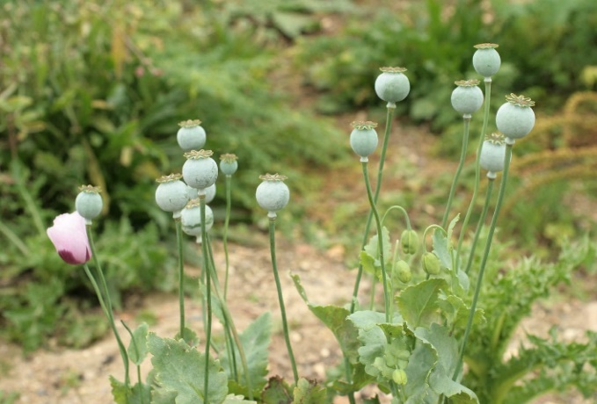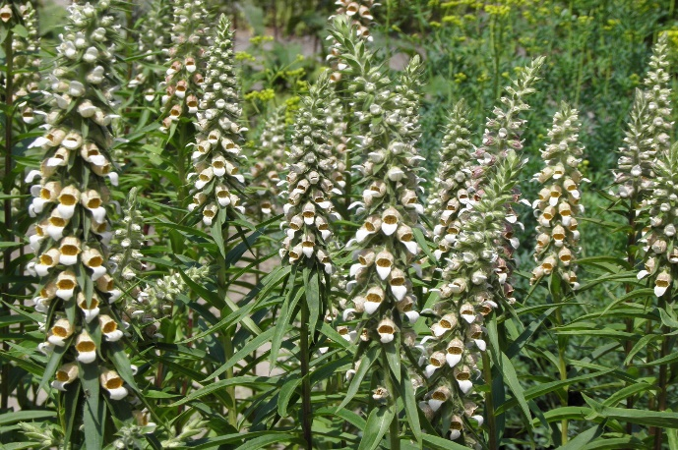
B
A
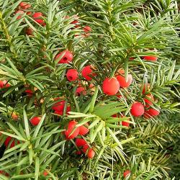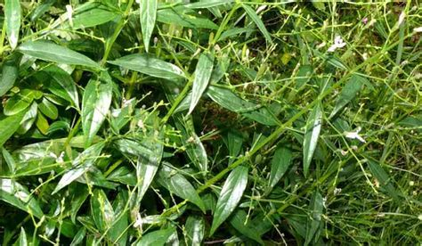
D
C
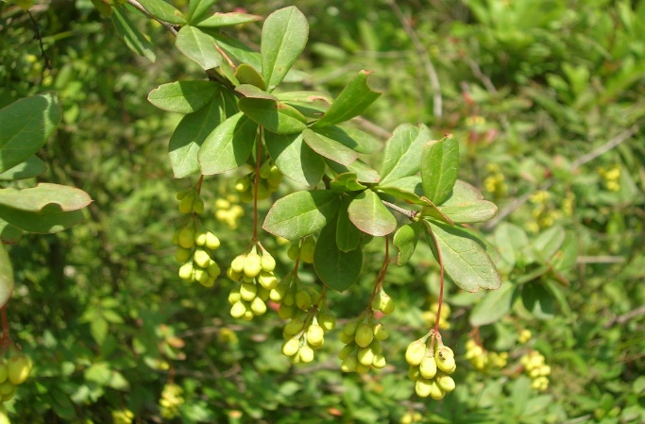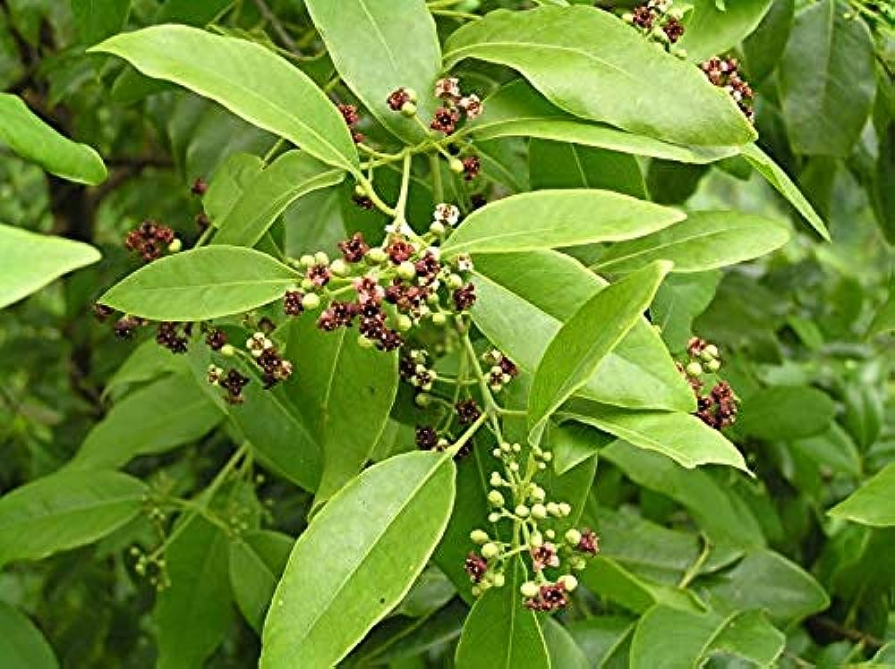
F
E
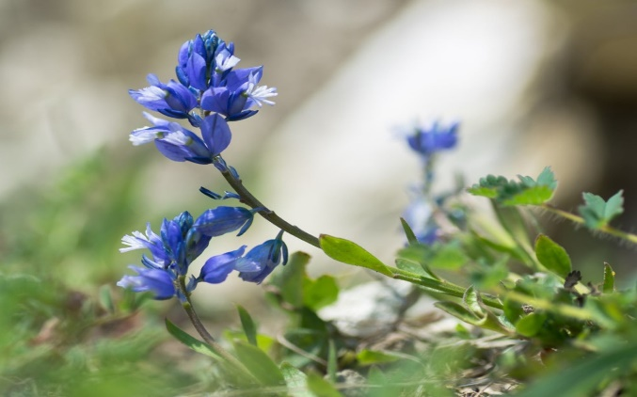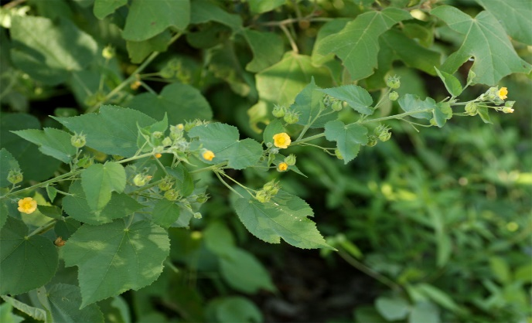
H
G

Fig: 1. Images of endangered and rare species in the Indian subcontinent; [A] Opium poppy (Papaver somniferum); [B] Foxglove (Digitalis lanata); [C] Taxus (Taxus baccata); [D] Chirayita (Swertia chirayita); [E] Daruharidra (Berberis aristata); [F] Nilgiri Sandalwood (Santalum album); [G] Milkwort (Polygala vulgaris); [H] Dholi kapat (Abutilon ramosum (Cav.) Guill. & Perr.)

Table 1. Endemicity categories in India

Category | Description | Examples | Ref
Relic Endemism | Species found in India and nowhere else, often relictual in nature | Neelakurinji (Strobilanthes kunthiana), Sacred Lotus (Nelumbo nucifera) | (Lendvay & Kalapos, 2014)
Neoendemics | Recently evolved species unique to India | Nilgiri Balsam (Impatiens nilgirica) and Sikkim Gentian (Gentiana sikkimensis) | (López-Pujol et al., 2011)
Anthropogenic Endemism | Species that have become endemic due to human activities | Tea Plant (Camellia sinensis) | (Kessler, 2001)
Hybrid Endemism | Resulting from hybridization between native and introduced species | Eucalyptus Tree (Eucalyptus globulus) | (Berv et al., 2021)
Island Endemism | Species unique to specific Indian islands | Kokum (Garcinia indica), Nicobar Palm (Nypa fruticans) | (Cubas et al., 2019)
Habitat Endemism | Restricted to specific ecosystems or microhabitats | Rhododendron arboreum (Himalayan region), Desert Date (Balanites roxburghii) | (Fine & Baraloto, 2016)
Altitudinal Endemism | Found only in certain altitude ranges within India | Rhododendron (Alpine region), Khasi Pine (Pinus kesiya) | (Demissew et al., 2021)

